Study of the Magneto-sonic Mach number for the magnetosphere of the Earth

ABSTRACT
The Magnetosonic Mach number is a non-dimensional parameter that computes the velocity of the solar wind in relation to the velocity of magnetosonic waves within the same medium, which plays an important role for magnetospheric interactions. It influences the efficiency between planetary and interplanetary magnetic fields, affecting phenomena like the solar-wind magnetosphere interaction. The magnetosonic Mach number in correlation with the Disturbance Storm Time index, plays a crucial role in comprehending and forecasting the energy transfer dynamics occurring during magnetic storms. This study aims to investigate the variation of Magnetosonic Mach Number with disturbance storm time index (Dst-index) for the moderate and intense geomagnetic storms. The superposed epoch method and correlation analysis are used to find the variation between different parameters and the Dst-index. According to this study for the solar cycle 25, the Magnetosonic Mach number not strongly correlated with the Dst-index for solar cycle 25 shows a weak correlation such 0.3.

Keywords. Interplanetary magnetic field, magnetosphere, solar wind, geomagnetic storm.

Introduction
The Martian bow shock, upon examination, effectively separates the solar wind from the downstream shocked solar wind. The solar wind plasma experiences deceleration and redirection as it circumvents the planet, thereby forming a shock wave in the upstream region, consistent with the dynamics observed during the interaction between a solid body and a supersonic magnetized plasma. “As the solar wind undergoes deceleration and redirection around Mars, it concurrently experiences an increase in temperature” (Luhmann, 1992; Luhmann et al., 1992). “A notable increase in both the magnitude and the orientation of the magnetic field is frequently observed at the bow shock” (Mazelle et al., 2004). “In the downstream area of this shock, the magnetic field exhibits heightened wave activity. The domain characterized by the shocked solar wind is designated as the magnetosheath of Mars” (e.g., Nagy et al., 2004). In contrast to other planetary bodies, both Mars and Venus are devoid of a global intrinsic magnetic field. The presence of a strong remanent crustal magnetic field serves as evidence that Mars once possessed an internal magnetic field, which is no longer operational (Acuna et al., 1998).
Earth-directed Coronal Mass Ejections (CMEs) exhibit a significant correlation with the occurrence of geomagnetic storms. The magnetic energy emitted by the sun gives rise to CMEs. This energy release is characterized by electromagnetic luminescence across various wavelengths, commonly referred to as solar flares. A specific subset of CMEs, identified as magnetic clouds, displays rotational dynamics that are analogous to flux ropes within their magnetic field configurations. CMEs are alternatively designated within the context of solar wind ejecta (Gopalswamy et al., 2000). Owing to their dynamic and magnetic characteristics, these electromagnetic emissions are potentially geoeffective upon their arrival at Earth (Augusto et al., 2018). “The interaction between solar phenomena and the Earth's magnetosphere is mediated by magnetic reconnection and viscous processes, including Kelvin-Helmholtz instability” (Nykyri & Otto, 2001; Tujia et al., 2018). In the conclusions drawn by Giri et al. (2024), it is posited that while plasma beta, Alfven Mach number, and magnetosonic Mach number do not possess the capability to reliably forecast geomagnetic storms in isolation, they hold significant importance for elucidating the fundamental physical mechanisms that govern space weather phenomena. By integrating these variables into predictive models and employing them as components of a comprehensive monitoring strategy, one can enhance the accuracy of predictions and mitigate the impacts of geomagnetic storms on technological infrastructure and satellite operations. Through continued research utilizing diverse methodologies and extensive datasets, these findings may contribute to the prediction of moderate to severe geomagnetic storms.
The magnetosonic Mach number (M_{MS}) is derived from the solar wind data secure through the ACE satellite positioned upstream of Earth and extrapolated to Mars during two distinct intervals, when Mars and Earth were in proximity to opposition. The ACE satellite orbits the L1 Lagrange point upstream of Earth, continuously monitoring the solar wind proton density, velocity, and temperature in addition to the vector magnetic field, albeit not the electron temperature. When Mars and Earth are situated within an approximately identical solar wind sector, the solar wind emanating from a specific region on the Sun remains temporally constant. In such instances, it can be posited that the solar wind maintains constancy along a Parker spiral trajectory, or a solar wind streamline, whereby the frozen interplanetary magnetic field (IMF) will also align with the streamlines (Edberg et al., 2010). As elucidated by Gonzalez et al. (1994), “the predominant characteristic of the solar wind that contributes to the induction of geomagnetic storms is a protracted phase of a southward-directed interplanetary magnetic field (IMF)”. During a geomagnetic storm event, the ring current experiences a significant enhancement, resulting in a reduction of the intensity of Earth's horizontal magnetic field, which is quantified by the Dst or SYM-H index”. “The peak magnitude of the Dst index has commonly been employed to categorize the severity of the storms. The total energy encompassed within the ring current is quantitatively linked to the Dst index through the application of the Dessler-Parker-Skopke relation” (Dessler and Parker, 1959; Skopke, 1966). Geoeffectiveness pertains to the efficacy of energy transfer from the solar wind into the magnetosphere. As previously articulated, during storm events characterized by a low Mach number, the ionospheric potential reaches a state of saturation, such that any further increase in the magnitude of the interplanetary magnetic field (IMF) leads to a greater deviation of the magnetosheath flow from the merging line, consequently diminishing the geoeffective length and constraining the global merging rate. In our investigation, the minimal magnitude of the Magnetic Moment Signal (M_{MS}) is recorded at 3-3.5 (on day zero), where a reduced correlation has been noted for the moderate geomagnetic storm that occurred in 2022 (Figure 1). Nevertheless, as previously noted, the empirical observation that the rate of ring current injection does not reach saturation indicates that, for storm events with low Mach numbers, geoeffectiveness is likely to exhibit a diminished correlation with the ionospheric potential in contrast to events with high Mach numbers (Bagheri et al., 2022).

Methodology
IMF-By and other components have been recorded by the OMNI (Operating Mission as a Node on the Internet) database of NASA (National Aeronautics and Space Administration) since 1963, on the basis of systematic records by several spacecraft from near-earth orbits. In our study, geomagnetic storm criteria used for moderate (-50<Dst<-100) and intense (-100<Dst<-200) geomagnetic storms. The superposed analysis and correlation analysis used for ± 24 events. The daily mean data was retrieved from the OMNI repository of NASA. In the context of solar cycle 25 (spanning from 2019 to 5 September 2023), the data was scrutinized with respect to Dst (Disturbance Storm Time), and the correlation coefficient was computed, which varies from -1 to +1; in this scenario, -1 and +1 signify the presence of maximal correlation, while a value of zero indicates the absence of correlation. A substantial negative correlation denotes a strong association, albeit in the opposite direction of one of the series. To elucidate the statistical interrelationship of the requisite parameters in conjunction with a temporal lag function, employing correlation is deemed the most effective methodology (Silwal et al., 2021).
Result and discussion
The magnetosphere of celestial bodies functions as an impermeable barrier to the incessant influx of solar plasma (Burgess, 1995). The intricate interplay between the solar plasma stream and the geomagnetic field of Earth is contingent upon a multitude of controlling factors that influence geomagnetic disturbances. Among these factors is plasma beta, a parameter that characterizes the magnetic cloud, as well as Mach numbers, which represent the ratio of the relative velocity to a characteristic wave speed (Pope et al., 2019). The Mach number associated with the shock wave escalates in response to an increase in differential velocities. The relative importance of plasma pressure in relation to magnetic pressure within magnetized plasma is articulated by the dimensionless quantity referred to as plasma beta, wherein fluctuations in plasma beta can significantly alter the behavior of plasma waves and instabilities during geomagnetic storms, thereby playing an essential role in shaping the characteristics of plasma dynamics. Plasma beta is quantitatively defined as the ratio of thermal energy density to magnetic energy density. “Due to the intricacies and fluctuations inherent in Earth's magnetosphere and the solar wind, the structures associated with the solar wind give rise to geomagnetic storms of diverse magnitudes. The magnitude and severity of these geomagnetic storms are contingent upon several variables, encompassing solar wind velocity, particle density, orientation of the magnetic field, composition (which includes the presence of solar flares and coronal mass ejections), the intensity of Earth's magnetic field, and the variability associated with the solar cycle” (Russell, 2000; McPherron et al., 2008).
“Reduced values of the solar wind M_{MS} play a critical role in the reduction of the geo effective length of the reconnection line and the saturation phenomena observed within the polar cap potential. The dominant framework utilized for the classification of geomagnetic storms is predominantly based on the Dst index. However, this current model overlooks crucial physical processes: the injection rate of the ring current does not display saturation, whereas the transpolar potential attains a saturation threshold” (Russell et al., 2001; Lopez et al., 2009). In the investigation of the correlation between the Magnetosonic Mach number (M_{MS}) and the geomagnetic Dst index amid the occurrence of geomagnetic storms, a statistical evaluation spanning the years 2021 to 2023 within Solar Cycle 25 reveals significant trends that highlight the fluctuating impact on geomagnetic activity. In instances of moderate geomagnetic storms, the empirical data demonstrate a weak positive correlation between M_{MS} and Dst, evidenced by a correlation coefficient of +0.19 in 2021. This minor positive relationship persisted yet experienced a modest intensification over the ensuing years, with the correlation coefficient ascending to +0.33 during 2022 and 2023, coinciding with the observation of the period characterized by maximum inclination—occurring 0 to 5 days post-geomagnetic event—during which the M_{MS} recorded an elevated value of 8.5, suggesting that the intensity of the shock and its associated downstream phenomena were remarkably pronounced in the post-event interval.

Figure 1. M_{MS} with moderate geomagnetic storm M_{MS} (-50nT<DST<-100nT)
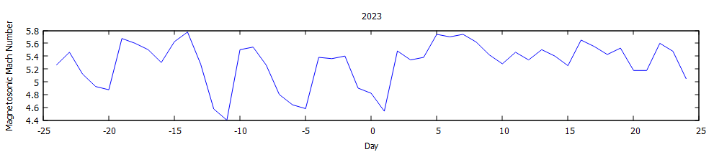
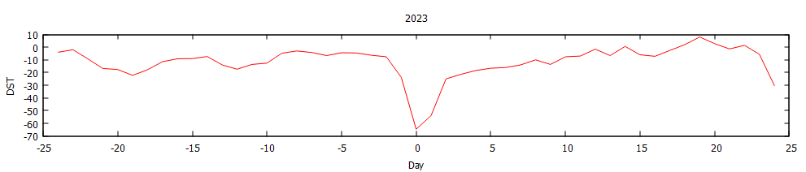
(a)
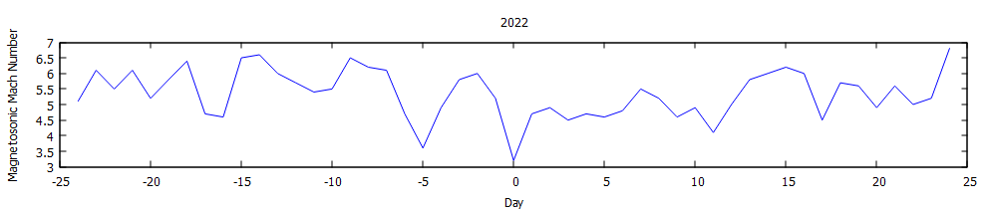
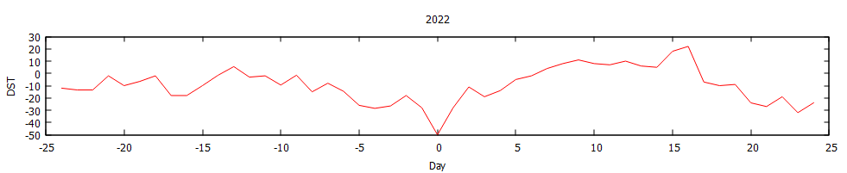
(b)

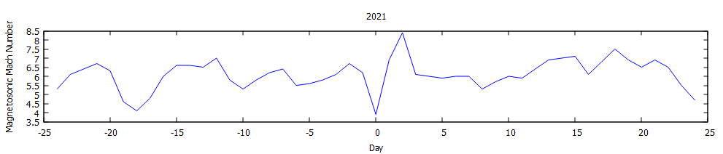
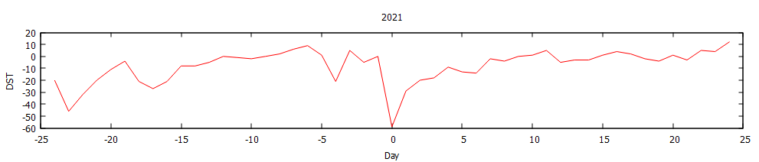
(c)

Figure 2. MMS with Intense storm (-100nT<DST<-200nT)
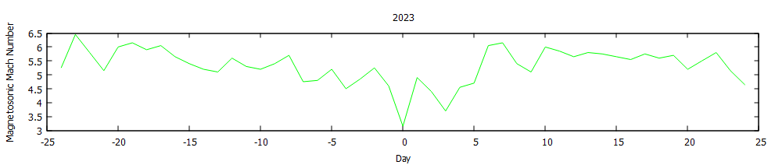
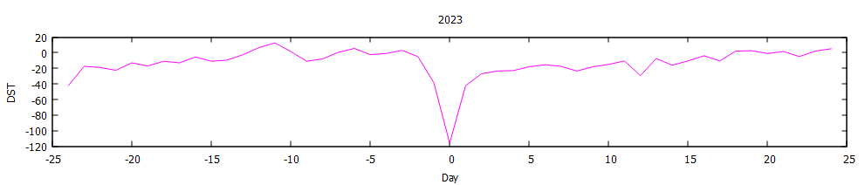

When the analysis is broadened to encompass intense geomagnetic storms, the association between M_{MS} and Dst becomes significantly more pronounced. Specifically, a more robust positive correlation is observed, with a coefficient of +0.42 recorded in 2023, thereby distinctly differentiating these severe events from their moderate counterparts. This enhanced association indicates that, under conditions of intense storms, variations in the M_{MS} are more consistently correlated with alterations in the Dst index. Concurrently, this epoch of heightened geomagnetic disturbance is characterized by a marked minimum declaration, which temporally coincides with the moment of the Dst index minimum, as depicted in Figure 2. These results are contextualized within a broader body of research that establishes a higher correlation between the Dst index and solar wind parameters, particularly with respect to shock-associated characteristics, during phases of stronger storms as opposed to weaker activity intervals. This trend implies that, as the severity of a geomagnetic storm escalates, the sensitivity of the Earth's magnetic environment to upstream solar wind dynamics, as measured by indices such as the M_{MS}, also increases.

Conclusion
Particularly, extensive statistical evaluations carried out on an annual basis and in connection with specific storm phenomena have determined that the association between the M_{MS} of the solar wind and the Dst index—considered a primary metric for evaluating the intensity of the ring current and the overall depression of the magnetosphere—exhibits a notably feeble correlation during moderate geomagnetic storms. This attenuated correlation is consistent with findings from longitudinal investigations that have documented a diminished responsiveness of the inner magnetospheric system to solar wind drivers originating from upstream sources when the polar cap potential is observed to attain saturation at lower Mach Numbers. Essentially, as the dynamic pressure of the solar wind declines, the mechanisms that facilitate the conversion of solar energy into enhancements of the ring current become increasingly intricate, allowing alternative magnetospheric processes to dominate in the dissipation of energy. Conversely, the dynamics experience substantial modifications under the influence of potent and historically significant geomagnetic storms. During such formidable events, as evidenced by data from 2023, the correlation between the M_{MS} and Dst index exhibits a marked strengthening, reportedly achieving a correlation coefficient of +0.42. This observation intimates a revitalization of direct coupling, thereby underscoring the significance of coherent energy transfer pathways between upstream solar wind structures and the inner magnetosphere. Consequently, the observation of minimal magnetic declination during intervals of Dst minimum amidst these storms acts as a compelling indicator of globally intensified current systems and a more homogeneous geomagnetic configuration. When contextualized within the framework of recent multi-index investigations, it becomes evident that with increasing storm intensity, not only do conventional proxies for geomagnetic activity (Dst) exhibit enhanced occurrence, but there also exists a robust interdependence among these parameters. In the context of moderate storm activity, predictions that rely exclusively on upstream factors, such as M_{MS}, exhibit a relatively weak correlation with Dst for the years 2021, 2022, and 2023. Furthermore, an examination of a 24-day interval indicates that M_{MS}, and consequently the strength of the bow shock, diminishes on the day of the storm (designated as Zero-day) and subsequently experiences a recovery during the post-event phase.
Disclaimer (Artificial intelligence)
Author(s) hereby declare that generativ AI technologies such as Large Language Models, etc. have been used during the writing or editing of manuscripts. This explanation will include the name, version, model, and source of the generative AI technology and as well as all input prompts provided to the generative AI technology
Details of the AI usage are given below:

1. SCISPACE (We use scispace AI tool to rephrase some sentences, but there is not any copy past process)

References:
Acuña, M. H., Connerney, J. E. P., Wasilewski, P. J., Lin, R. P., Anderson, K. A., Carlson, C. W., et al. (1998). Magnetic field and plasma observations at Mars: Initial results of the Mars Global Surveyor mission. Science, 279(5357), 1676–1680. https://doi.org/10.1126/science.279.5357.1676
Augusto, C., Navia,C. E., and de Oliveira, M. N. “The 2015 summer solstice storm: one of the major geomagnetic storms of solar cycle 24 observed at ground level,” Solar Physics, vol. 293, no. 5, pp. 84–28, 2018.
Bagheri F and Lopez RE (2022) Solar wind magnetosonic mach number as a control variable for energy dissipation during magnetic storms. Front. Astron. Space Sci. 9:960535. doi: 10.3389/fspas.2022.960535
Burgess D. Introduction to space physics. Cambridge, UK: Cambridge University Press; 1995. Collisionless shocks; pp. 129–163.
Dessler, A., and Parker, E. N. (1959). Hydromagnetic theory of geomagnetic storms. J. Geophys. Res. 64, 2239–2252. doi:10.1029/jz064i012p02239
Edberg, N. J. T., M. Lester, S. W. H. Cowley, D. A. Brain, M. Fränz, and S. Barabash (2010), Magnetosonic Machnumber effect of the position of the bow shock at Mars in comparison to Venus, J. Geophys. Res., 115, A07203,doi:10.1029/2009JA014998
Giri, S. A., Adhikari, B., Baral, R., Uga, C. I., and Calabia, A. Wavelet Coherence Analysis of Plasma Beta, Alfven Mach Number, and Magnetosonic Mach Number during Different Geomagnetic Storms. The Scientific World Journal Volume 2024, Article ID 1335844, 11 pages. https://doi.org/10.1155/2024/1335844
Gonzalez, W., Joselyn, J. A., Kamide, Y., Kroehl, H. W., Rostoker, G., Tsurutani, B., et al. (1994). What is a geomagnetic storm? J. Geophys. Res. 99, 5771–5792. doi:10.1029/93ja02867
Gopalswamy, N., Lara, A., Lepping, R. P., Kaiser, M. L., Berdichevsky, D., and O. C. St Cyr, “Interplanetary acceleration of coronal mass ejections,” Geophysical Research Letters, vol. 27, no. 2, pp. 145–148, 2000.
Lopez, R., Lyon, J., Mitchell, E., Bruntz, R., Merkin, V., Brogl, S., et al. (2009). Why doesn’t the ring current injection rate saturate? J. Geophys. Res. 114. doi:10.1029/2008ja013141
Luhmann, J. (1992). Comparative studies of the solar wind interaction with weakly magnetized planets. Advances in Space Research, 12(9), 191–203. https://doi.org/10.1016/0273-1177(92)90331-Q
Luhmann, J. G., Russell, C. T., & Brace, L. H. (1992). The intrinsic magnetic field and solar-wind interaction of Mars. In Mars (pp. 1090–1134). Tucson, AZ: University of Arizona Press.
Mazelle, C., Winterhalter, D., Sauer, K., Trotignon, J., Acuña, M., Baumgärtel, K., et al. (2004). Bow shock and upstream phenomena at Mars. Space Science Reviews, 111(1/2), 115–181. https://doi.org/10.1023/B:SPAC.0000032717.98679.d0
McPherron R. L., Weygand J. M., Hsu T.-S. Response of the Earth’s magnetosphere to changes in the solar wind. Journal of Atmospheric and Solar-Terrestrial Physics. 2008;70(2-4):303–315. doi: 10.1016/j.jastp.2007.08.040.
Nagy, A., Winterhalter, D., Sauer, K., Cravens, T., Brecht, S., Mazelle, C., et al. (2004). The plasma environment of Mars. Space Science Reviews, 111(1/2), 33–114. https://doi.org/10.1023/B:SPAC.0000032718.47512.92
Nykyri, K., and Otto, A. “Plasma transport at the magnetospheric boundary due to reconnection in Kelvin-Helmholtz vortices,” Geophysical Research Letters, vol. 28, no. 18, pp. 3565–3568, 2001.
Pope S. A., Gedalin M., Balikhin M. A. The first direct observational confirmation of kinematic collisionless relaxation in very low Mach number shocks near the Earth. Journal of Geophysical Research: Space Physics. 2019;124(3):1711–1725. doi: 10.1029/2018ja026223.
Russell, C., Luhmann, J., and Lu, G. (2001). Nonlinear response of the polar ionosphere to large values of the interplanetary electric field. J. Geophys. Res. 106, 18495–18504. doi:10.1029/2001ja900053
Russell C. T. The solar wind interaction with the Earth’s magnetosphere: a tutorial. IEEE Transactions on Plasma Science. 2000;28(6):1818–1830. doi: 10.1109/27.902211.
Sckopke, N. (1966). A general relation between the energy of trapped particles and the disturbance field near the Earth. J. Geophys. Res. 71, 3125–3130. doi:10.1029/jz071i013p03125
Silwal, A., Gautam, S. P., Chaudhary, K., Khanal, M., Joshi, S., Dangaura, S., & Adhikari, B. (2021). Study of Solar Wind Parameters during Geomagnetic Storms of 26 August 2018 and 28 September 2017. Thai Journal of Physics, 38(2), 54-68.
Tuija, I. P., Lakka, A., and Dimmock, A. P. “Magnetosheath and magnetopause under low Mach number conditions,” AGU Fall Meeting Abstracts, vol. 2018, pp. SM11D–2821, 2018

