Impact of Nutritional Gardens on Food Security of Rural Families in Akola District of Maharashtra, India

Abstract
Food and nutritional insecurity continue to challenge rural households in India, where affordability, accessibility, and awareness of balanced diets remain limited. Dependence on market-purchased vegetables exposes families to price fluctuations and supply disruptions, leading to low daily vegetable intake and micronutrient deficiencies. To assess the impact of nutritional gardens (NGs) promoted through Frontline Demonstrations (FLDs) on improving vegetable consumption and reducing household expenditure among rural families in Akola district, Maharashtra, over five years (2020–2024). Each year, 30 socio-economically vulnerable families (n -150 total) were enrolled across villages including Barshitakli, Sisa Udegaon, Masa, Babhulgaon, Kadoshi, and Adoshi. Families were compared under two conditions: T1 -without nutritional garden, T2 - with nutritional garden. Key indicators included daily vegetable consumption (gm/family/day) and monthly expenditure on vegetables (Rs. /family). Establishment of NGs led to substantial gains. Average daily vegetable consumption increased from 485 g to 1143 g (+136%), while monthly expenditure declined from ~Rs. 662 to ~Rs. 169 (−74%). Year-wise trends showed consistent improvement, with consumption gains ranging from 95% to 214%, and expenditure reduction between 62% to 80%. Families reported enhanced dietary diversity (leafy greens, tubers, seasonal vegetables), empowerment of women in household decision-making, and improved resilience during COVID-19 lockdowns. Nutritional gardens are an effective, low-cost intervention for food security. They improve dietary intake, reduce financial burden, and empower rural households. Large-scale promotion through extension systems and women’s groups is recommended.
Keywords: Nutritional gardens; Food security; Dietary diversity; Frontline Demonstration; Women empowerment; Rural resilience

1. Introduction
Food security encompasses not only the availability of food but also access, affordability, and consistent consumption of nutritious produce to meet dietary needs for an active, healthy life (FAO, 2008). In rural India, many households face dietary gaps due to over-dependence on staple cereals and limited access to vegetables and fruits (Choudhary et al., 2021, Du Toit et al., 2022). This results in insufficient intake of vitamins and minerals, contributing to hidden hunger and malnutrition, manifesting as high rates of stunting, underweight, and anemia, especially among women and children (NFHS-5, 2019-21).
The Indian Council of Medical Research (ICMR) recommends a daily intake of at least 300 g of vegetables per person, including 50 g of leafy greens, 200 g of other vegetables, and 50 g of roots and tubers (NIN, 2011). However, intake among rural households remains critically below these recommended levels. High reliance on market purchases makes families vulnerable to price volatility, poor quality, and seasonal scarcity, further limiting consumption (Sharma, 2009). Nutritional gardens (NGs) small, home-based plots for growing vegetables offer an affordable, sustainable solution to this multifaceted problem (Kaur, S. 2023). They improve household dietary diversity, provide fresh produce year-round, and reduce dependency on external markets and can be managed with minimal resources using locally available inputs and indigenous knowledge (Marsh, 1998). Critically, women are often the primary managers of these gardens, positioning NGs as a significant pathway to achieving both household food security and women's socio-economic empowerment (Swaminathan, 2007; Ghosh et al., 2021).
Recognizing these benefits, Krishi Vigyan Kendra (KVK), Akola, under its Frontline Demonstrations (FLDs), introduced nutritional gardens across selected villages. While previous studies have documented the short-term benefits of NGs, there is a scarcity of longitudinal data on their sustained impact. This paper presents results from a five-year study (2020–2024) evaluating the role of NGs in improving daily vegetable consumption and reducing household expenditure on vegetables.

2. Materials and Methods
2.1 Study design and site
This longitudinal study employed a comparative design, analyzing outcomes between households without a nutritional garden (T1, control) and those with an established nutritional garden (T2, intervention). The study was conducted across multiple villages in the Akola district of Maharashtra, India, including Barshitakli, Sisa Udegaon, Masa, Babhulgaon, Kadoshi, and Adoshi. These sites represent typical semi-arid and rainfed farming contexts characterized by resource-limited households with high dependence on market-sourced vegetables.
2.2 Participant selection
Each year from 2020 to 2024, 30 families were purposively selected for the intervention, resulting in a total sample size of 150 families over the study period. Selection criteria included: (i) socio-economic vulnerability, (ii) availability of a small plot of land (≥100 m²) near the homestead, and (iii) willingness to participate and maintain daily consumption logs.
2.3 Intervention: Nutritional Garden establishment
Beneficiaries received comprehensive training and support to establish intensive vegetable gardens using sustainable practices. KVK Akola provided seed kits comprising high-yielding, climate-resilient varieties of seasonal vegetables, including leafy greens (spinach, amaranth, fenugreek), tubers (radish, carrot), cucurbits (bottle gourd, bitter gourd), and legumes (cowpea, broad beans). Training modules covered land preparation, raised bed making, organic manure and compost application, seed sowing, intercropping, efficient water management (e.g., drip irrigation), and integrated pest management (IPM). A strong emphasis was placed on engaging women beneficiaries in all stages of garden management and household decision-making related to nutrition.
2.4 Data collection and indicators
Primary data was collected annually for both T1 (pre-intervention) and T2 (post-intervention) conditions. The key indicators were:
- Daily vegetable consumption (g/family/day): Measured through structured household interviews and verified by daily consumption logs maintained by the beneficiaries. KVK field staff conducted regular visits for data validation.
- Monthly expenditure on vegetables (₹/family): Assessed through self-reported expenditure recalls, cross-checked with local market prices.
Qualitative data on dietary diversity, women's empowerment, and community perception was gathered through focused group discussions and semi-structured interviews.
2.5 Data analysis
Simple descriptive statistics were employed. Year-wise averages were computed for T1 and T2 for each indicator. The percentage change was calculated using the formula: Percentage Change = [(T2 - T1) / T1] × 100. Five-year pooled averages were derived from the annual data to assess the cumulative impact of the intervention.

3. Results
The five-year study demonstrated that the establishment of nutritional gardens (NGs) had a profound and multi-faceted impact on the participating rural households. The results are presented quantitatively, focusing on consumption and expenditure, and qualitatively, capturing the socio-economic benefits.
3.1 Appropriate area required for establishment of nutrition garden
Analysis of Data in Table 1. revealed that average vegetable production from 100 Sq.m was 260 kg whereas 300.00 kg production was achieved from 150 Sq.m and About 400.00 kg production was achieved from 250 Sq.m area. As per RDA daily vegetable consumption of a person should be 300 gm. Based on the finding it can be concluded that although 150 Sq.m area is sufficient to full fill the minimum requirement of vegetable for a family of 6 members and the extra vegetable produce from rest of the area may be used for selling out or for economic security of rural families. The size of each nutrition garden is unique in structure, functionality, composition and appearance as they depend on the natural ecology of location, available family resources such as labor and the skills, preferences and enthusiasm of family members. Access to planting materials and social capital are noted as an important attribute to species diversity in garden. As the families became economically stable their cultivation shifted from staple to horticultural crops.

Table.1 Appropriate area required for nutrition garden for the family of 4-6 members
Crop Area | Spinach | Okra | Bottle gourd | Brinjal | Ridge Gourd | Round Gourd | Radish | Tomato | Coriander | Peas | Total season.
100 Sq. m | 29.5 | 29.3 | 32.2 | 31.6 | 28.0 | 29.2 | 28.5 | 29.4 | 15.8 | 6.5 | 260 kg
150 Sq.m | 35.4 | 33.2 | 35.7 | 34.1 | 32.1 | 33.9 | 32.5 | 32.1 | 18.9 | 8.1 | 300 kg
250 Sq.m | 49.2 | 49.5 | 46.8 | 44.7 | 48.9 | 38.7 | 35.0 | 44.8 | 26.6 | 15.8 | 400 kg

3.2 Quantitative Impact on Vegetable Consumption
The introduction of NGs led to a dramatic increase in the quantity of vegetables consumed per household per day. Table 2 summarizes the year-wise and pooled data.

Table 2. Year-wise average impact of nutritional gardens on consumption and expenditure (2020–2024)
Year | Daily consumption (gm/family) T1 | T2 | % change | Monthly expenditure (Rs.) T1 | T2 | % change
2020 | 515 | 1600 | +214% | 635 | 235 | −62%
2021 | 431 | 1246 | +197% | 669 | 212 | −68%
2022 | 550 | 1077 | +97% | 650 | 131 | −80%
2023 | 523 | 1023 | +97% | 631 | 122 | −80%
2024 | 404 | 769 | +95% | 723 | 148 | −79%
Mean | 485 | 1143 | +136% | 662 | 169 | −74%

- Substantial Annual Increases: The year-wise analysis shows consistently high percentage increases in consumption, ranging from a remarkable +214% in the inaugural year (2020) to a robust +95% in 2024. This indicates not only a strong initial impact but also the sustained effectiveness of the intervention over time.
- Significant Pooled Improvement: The pooled five-year data reveals that the average daily vegetable consumption per household more than doubled, surging from a baseline of 485 grams to 1,143 grams. This represents a net increase of 136%, moving households from a state of deficit to surplus in vegetable availability.
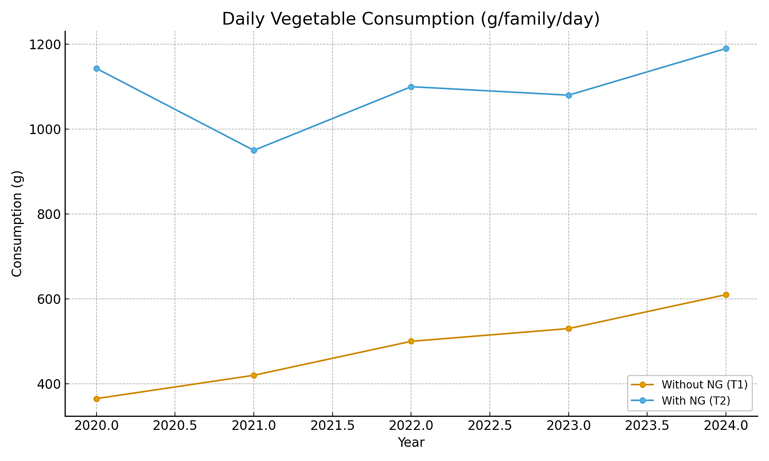
Fig 1. Daily Vegetable Consumption(g/family/day)
This massive increase directly addresses the critical gap between the Indian Council of Medical Research (ICMR) recommended intake of 300g/person/day (NIN, 2011) and the previously low consumption levels, thereby playing a direct role in combating micronutrient deficiencies.
3.3 Quantitative Impact on Household Expenditure
A direct consequence of increased home production was a significant reduction in the financial burden of purchasing vegetables from the market.
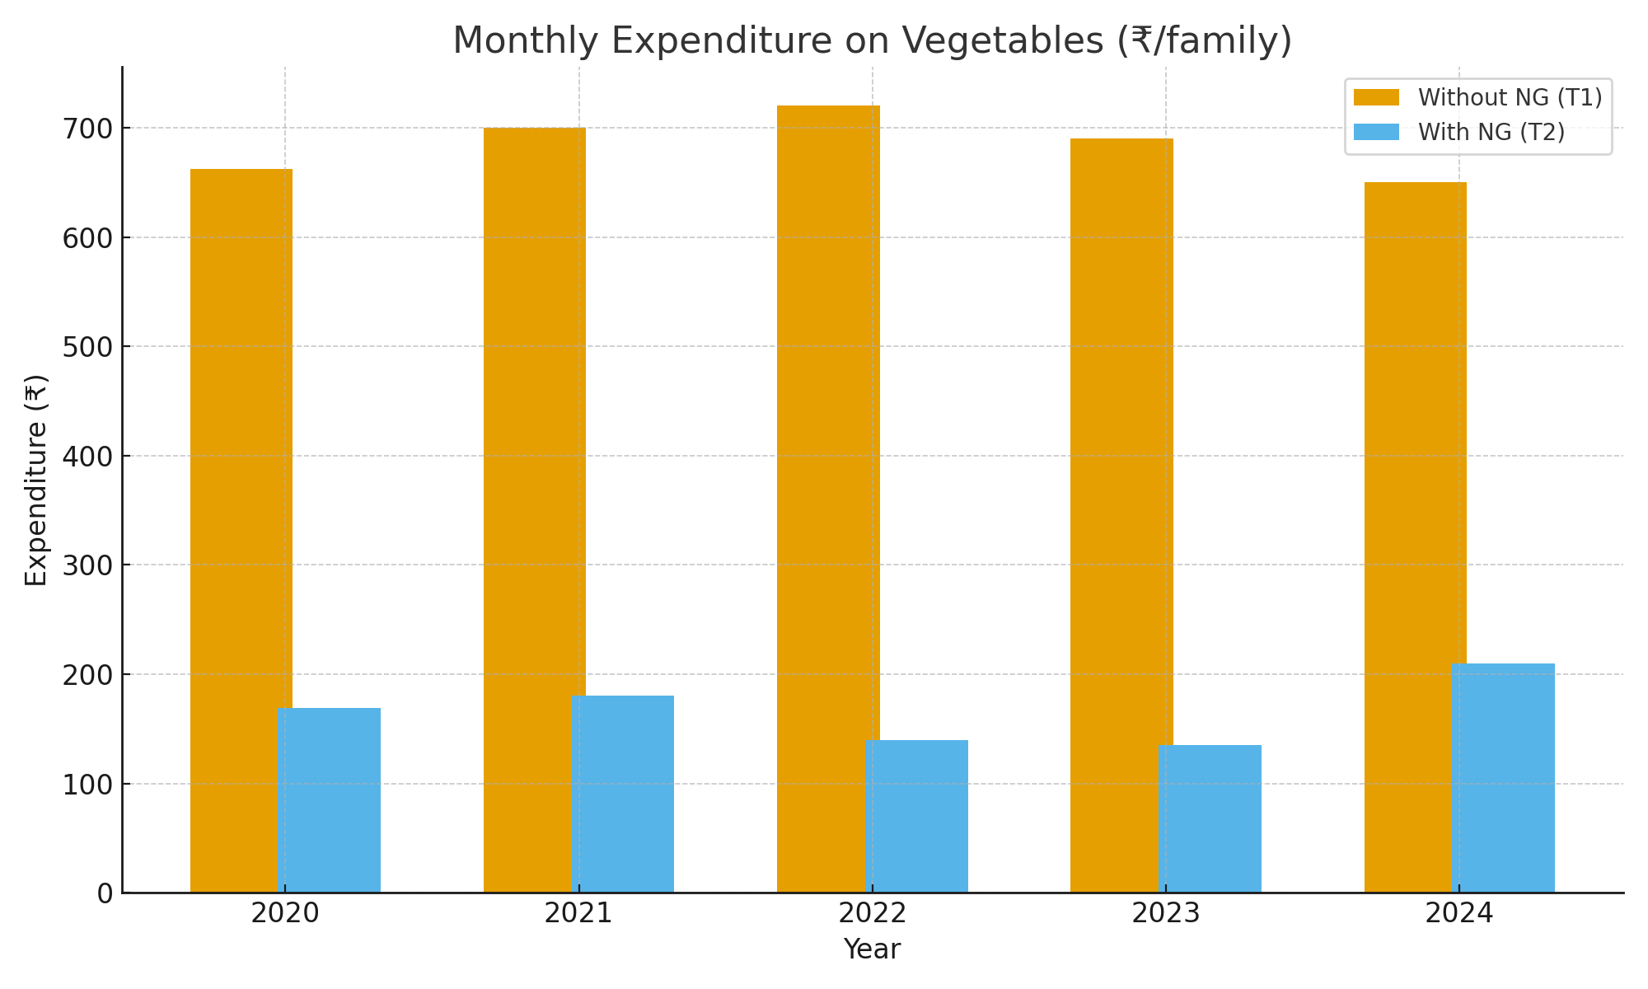
Fig. 2. Monthly Expenditure on vegetables (₹/family)
- Consistent Financial Savings: Annual data shows that families saved between 62% to 80% of their previous monthly expenditure on vegetables. The most significant savings were observed in 2022 and 2023, with an 80% reduction each year.
- Major Economic Relief: The pooled data shows that the average monthly cash expenditure on vegetables plummeted from ₹662 to ₹169, a net reduction of 74%. This saving of approximately ₹500 per month per household represents a significant reallocation of scarce financial resources towards other critical needs like education, healthcare, and debt repayment, enhancing the household's overall economic resilience.
3.4 Qualitative and Socio-Economic Outcomes
Beyond the numbers, the study documented transformative socio-economic benefits through field observations and interviews:
- Enhanced Dietary Diversity: Families reported a shift from a limited vegetable palette to a diverse diet regularly featuring leafy greens (e.g., spinach, amaranth), legumes (e.g., cowpea, broad beans), cucurbits (e.g., bottle gourd, bitter gourd), and tubers (e.g., radish, carrot). This diversity is crucial for ensuring a wide range of micronutrients, vitamins, and dietary fiber.
- Empowerment of Women: Women were the primary managers of the NGs. This responsibility:
  - Enhanced their technical knowledge in sustainable agricultural practices.
  - Increased their confidence and decision-making agency within the household, particularly regarding food and nutrition.
  - Provided a recognized contribution to the family's economic and nutritional well-being, elevating their social status.
- Community Adoption (Spillover Effect): The visible success of the demonstration gardens motivated non-beneficiary neighbours to establish their own gardens. This organic, community-led replication indicates a strong spillover effect and the high acceptability of the intervention.
- Resilience to External Shocks: The COVID-19 pandemic lockdowns served as a real-time test of the gardens' value. During this period of severe market disruption and inaccessibility, households with NGs maintained a continuous supply of fresh, nutritious vegetables, insulating them from food shortages and price spikes. This highlighted the role of NGs as a crucial buffer against systemic shocks.
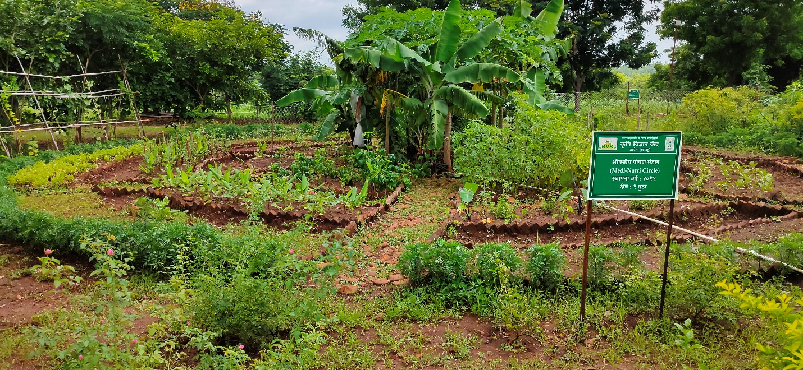
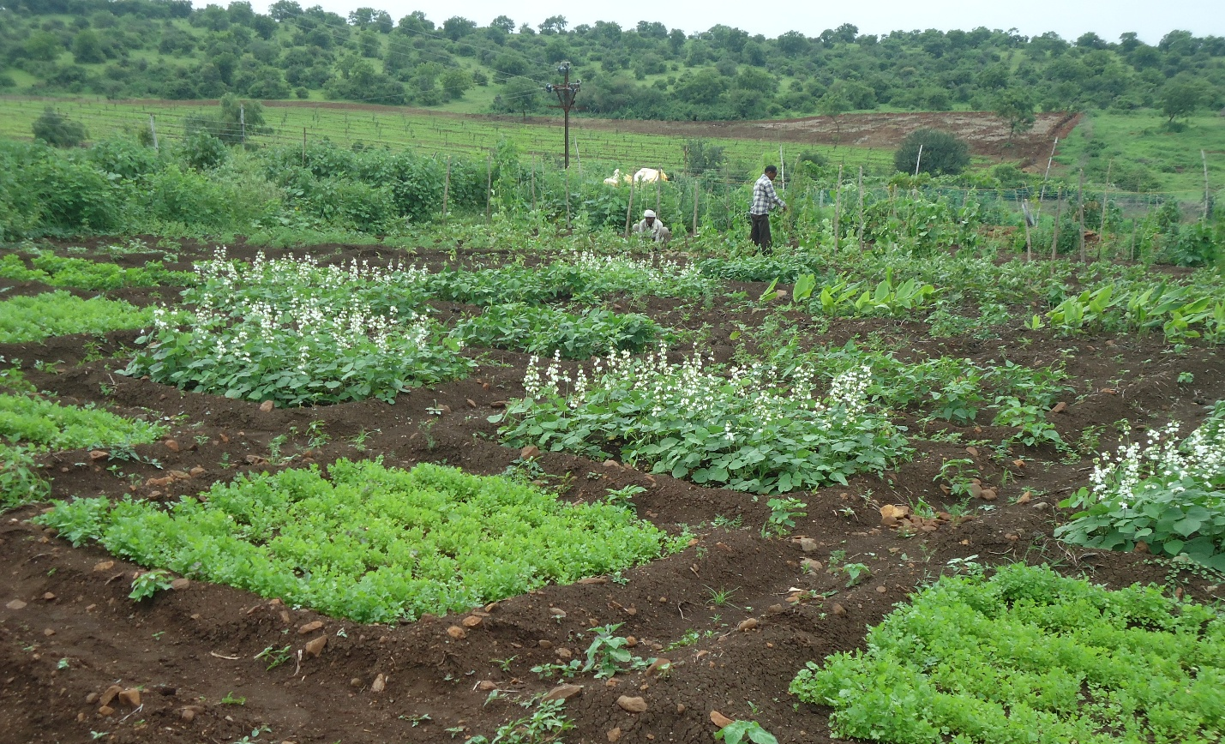

Fig.3 Nutritional Garden model established

4. Discussion
This five-year study provides compelling, longitudinal evidence for the transformative potential of nutritional gardens in addressing food and nutritional insecurity in rural India. The results unequivocally show that NGs are not a short-term fix but a sustainable strategy for significantly enhancing household-level vegetable availability and consumption. The observed 136% increase in consumption directly addresses the critical gap between recommended and actual vegetable intake, thereby mitigating micronutrient deficiencies as demonstrated in earlier studies (Choudhary et al., 2021; Kaur, S. 2023). The economic impact is equally profound. The 74% reduction in monthly expenditure on vegetables frees up scarce financial resources for other essential household needs, such as education, healthcare, and investment in income-generating activities, thereby strengthening overall economic resilience and reducing vulnerability to poverty (Chakraborty, S., & Basu, D. 2018).
The pivotal role of women, as highlighted in our qualitative findings, is a cornerstone of this intervention's success. By centralizing women in the management of NGs, the program facilitated not only improved nutrition but also advanced women's agency, skills, and status within the household and community. This aligns with the established understanding that empowering women in agriculture is one of the most effective strategies for improving household food security and nutritional outcomes (Swaminathan, 2010).
The strengths of this study include its long-term, field-based nature across diverse villages, the combination of robust quantitative data with rich qualitative insights, and the demonstration of the intervention's sustainability over a five-year period. The consistent positive trends across years, even amidst the pandemic, underscore the reliability and resilience of the NG model. A potential limitation is the use of a purposive sampling method, which may affect the generalizability of the findings. Future research could employ randomized control trials (RCTs) across broader geographical areas to strengthen the evidence base.

5. Conclusions and Recommendations
Nutritional gardens are a proven, sustainable strategy to improve household food security in rural areas, They:
1. Enhance daily vegetable consumption (+136% over five years).
2. Reduce household expenditure on vegetables (−74%).
3. Empower women and strengthen community resilience.
Expand NG promotion through KVKs, self-help groups, and schools. - Provide continuous technical support and seed kits to ensure sustainability. - Integrate NGs into government nutrition and livelihood programs. - Conduct broader impact evaluations at regional and state levels.

Disclaimer (Artificial intelligence)
Option 1:
Author(s) hereby declare that NO generative AI technologies such as Large Language Models (ChatGPT, COPILOT, etc.) and text-to-image generators have been used during the writing or editing of this manuscript.

References
AICRP–Home Science (FRM). (2020). Annual Report of All India Coordinated Research Project on Home Science: Family Resource Management. VNMKV Parbhani, Maharashtra, India.
Kaur, S. (2023). Barriers to consumption of fruits and vegetables and strategies to overcome them in low-and middle-income countries: a narrative review. Nutrition Research Reviews, 36(2), 420-447.Choudhary, M., Singh, S. P., & Patel, C. R. (2021). Nutritional Garden: A Nutrition Sensitive Promising Approach towards Improving Nutritional Security in Farm Households. International Journal of Current Microbiology and Applied Sciences, 10(02), 981-994.
Choudhary, M., Singh, S. P., & Patel, C. R. (2021). Nutritional Garden: A Nutrition Sensitive Promising Approach towards Improving Nutritional Security in Farm Households. International Journal of Current Microbiology and Applied Sciences, 10(02), 981-994.
FAO. (2016). Home gardens for improved food security and livelihoods. Food and Agriculture Organization of the United Nations, Rome.
Chakraborty, S., & Basu, D. (2018). Homestead gardening: an emerging venture towards achieving food security & nutritional security-a study of selected areas of West Bengal. International Journal of Applied and Natural Sciences (IJANS) ISSN (P), 2319-4014.KVK Akola. (2020–2024). Annual Reports of Frontline Demonstrations on Promotion of Nutritional Gardens for Food Security of Rural Families. Krishi Vigyan Kendra, Akola, Maharashtra, India. [Primary data source]
Yaregal, Y., & Sime, G. (2024). Traditional home garden agro‐biodiversity dynamics, agro‐ecosystem services, and management practices in smallholder farmers setting, South‐Central Ethiopia. Food and Energy Security, 13(4), e569.National Institute of Nutrition (NIN). (2011). Dietary Guidelines for Indians – A Manual. Hyderabad, India.
National Family Health Survey (NFHS-5). (2019-21). India Report. International Institute for Population Sciences.
Ghosh, S., Sen, L. C., Mali, S. K., Islam, M. M., & Bakchi, J. (2021). The role of rural women in household food security and nutrition management in Bangladesh. Asian Journal of Women's Studies, 27(3), 441-459.Sharma, R., & Singh, G. (2019). Kitchen gardens: A tool for food and nutrition security in rural households. International Journal of Agricultural Sciences, 11(2), 45–50.
Swaminathan, M. S. (2010). Science and sustainable food security: selected papers of MS Swaminathan (Vol. 3). World Scientific.
Du Toit, M. J., Rendón, O., Cologna, V., Cilliers, S. S., & Dallimer, M. (2022). Why home gardens fail in enhancing food security and dietary diversity. Frontiers in Ecology and evolution, 10, 804523
WHO. (2020). Healthy diet: Key facts. World Health Organization. Retrieved from https://www.who.int/news-room/fact-sheets/detail/healthy-diet

