Therapeutic wonders of Citrus: A narrative review

ABSTRACT
Fruits of Citrus sp. are reported to be packed with diverse essential nutrients have been valued in traditional medicine across numerous cultures for centuries due to their bioactive compounds, including flavonoids, polyphenols, coumarins, limonoids, carotenoids, tocopherols, and alkaloids. The secondary metabolites in citrus fruits exhibit diverse health-promoting properties, making them chemo-preventive, cardiovascular-protective, hepatoprotective, neuroprotective, antioxidant, anti-inflammatory, anti-obesity, anti-diabetic, antimicrobial, and anti-dyslipidaemic, while also aiding in improving blood profiles. While the nutritional benefits of whole citrus fruits and their juices are widely acknowledged, the potential of other parts, such as essential oils, peels, seeds, seed oils, and pomace, remains underappreciated. The methodology adopted was the sources available in Scopus, Google Scholar and Web of Science.
This review aims to provide a comprehensive summary of the bioactive compounds present in various parts of citrus fruits, along with their mechanisms of action and molecular targets. Citrus peels are rich in vitamins, minerals, essential oils, flavonoids, carotenoids, and carbohydrates, all of which contribute to mitigating oxidative stress and may play a role in the prevention or management of cancer, cardiovascular diseases, diabetes, infections, and neuropsychiatric disorders such as depression. Citrus juice is a significant source of flavonoids, phenolic compounds, and vitamins, which exhibit a wide range of pharmacological activities, including antihypertensive, anticoagulant, anti-inflammatory, anticancer, antimutagenic, antihyperglycemic, antibacterial, and neuroprotective effects. Additionally, citrus seed oil, characterized by its content of vitamins, carotenoids, and fatty acids, has demonstrated potential therapeutic benefits in the management of hypercholesterolemia, obesity, cancer, and other metabolic disorders. Researchers interested in the field of nutraceuticals will find the literature on successful in vivo studies on experimental animal models as well as human trial.
Keywords: Citrus, bioactive compounds, Secondary metabolites, antioxidants, health benefits.
1. INTRODUCTION
Citrus fruits belonging to the family Rutaceae are among the most widely cultivated fruit tree crops globally. The genus Citrus is indigenous to regions such as East Asia, Southeast Asia, South Asia, Australia, and Melanesia. Citrus sinensis (sweet orange) is the predominant citrus crop, accounting for approximately 70% of global citrus production. Citrus varieties can be classified into two groups: ancestral species and hybrids derived from those ancestors. Ancestral species include citron (Citrus medica), mandarin orange (Citrus reticulata), pomelo (Citrus maxima), papeda (Citrus micrantha), kaffir lime (Citrus hystrix), ichang papeda (Citrus cavaleriei), and kumquat (Citrus japonica). Hybrids of ancestral species encompass grapefruit (Citrus paradisi), lemon (Citrus limon), sweet orange (Citrus sinensis), rangpur (Citrus limonia), bitter orange (Citrus aurantium), Persian lime (Citrus latifolia), key lime (Citrus aurantifolia), and tangerine (Citrus tangerina), Fig.1.
Citrus fruits are highly versatile and consumed in various forms, including fresh fruit, juice (both fresh and canned), jelly, jam, and marmalade. Their by-products—such as peels, seeds, pomace, and essential oils—are widely utilized in the food and pharmaceutical industries as flavoring agents, and they also serve as key ingredients in the production of drugs, soaps, perfumes, and other cosmetic products. Moreover, citrus fruits hold significant medicinal value, particularly in several Asian countries, where they are traditionally used to treat ailments such as tuberculosis, bronchitis, cough, cold, menstrual disorders, hypertension, anxiety, and depression (Makni et al. 2018).
2. METHODOLOGY
This review was conducted to systematically synthesize existing scientific literature on the health benefits of citrus fruits. The methodology followed a structured approach to ensure comprehensive coverage, relevance, and academic rigor. A thorough literature search was conducted across multiple scientific databases, including PubMed, Scopus, Web of Science, Google Scholar. Search terms included combinations of the keywords such as citrus fruits, health benefits, role of citrus in various diseases, therapeutic potential of citrus, bioactive compounds of citrus etc. Filters were applied to

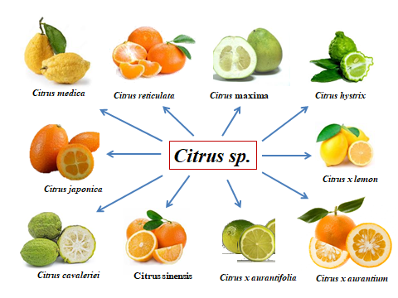
Fig.1 Some common species of Citrus fruits
include studies published in English between January 2015 and August 2025. Peer-reviewed articles, clinical trials, in vivo and in vitro studies, and meta-analyses as well as studies focusing on the nutritional composition, bioactive compounds, or health outcomes associated with citrus fruit consumption were included.
3. BIOACTIVE COMPOUNDS OF DIFFERENT PARTS OF CITRUS FRUITS AND THEIR PHARMACOLOGICAL PROPERTIES
To date, 115 carotenoids have been identified in various citrus fruit varieties, including α-carotene, β-carotene, lycopene, lutein, β-cryptoxanthin, xanthophylls, violaxanthin, and β-citraurin, etc. (IKoma et al. 2016). Additionally, citrus fruits are rich in numerous bioactive compounds, such as polyphenols, vitamins, minerals, soluble and insoluble fibers, essential oils, fatty acids, amino acids, coumarins, and phenolic acids.
Citrus fruits are considered superfoods due to their richness in bioactive compounds, such as vitamins, polyphenols, minerals, fibers, essential oils, amino acids, phenols, pectin, flavonoids, and carotenoids (Darband 2018). These compounds play a crucial role in combating degenerative diseases (Ramírez-Pelayo et al. 2019). Specifically, C. maxima exhibits inhibitory effects on α-amylase, α-glucosidase, acetylcholinesterase, tyrosinase, and β-glucuronidase (Abirami et al. 2014).
Adenaike and Abakpa (2021) concluded that phytochemicals in citrus fruits act as potent antioxidants, enhancing liver-protective enzymes, strengthening the immune system, and mitigating lipid oxidation. Wang et al. (2019) further observed that Citrus grandis demonstrates antioxidant and antiproliferative properties against leukemia cells while supporting cholesterol reduction and obesity prevention, attributed to its lycopene and β-carotene content. Flavonoids in orange peel offer a range of health benefits, including anti-inflammatory (Gosslau et al. 2014) and anti-cancer effects (de Luna et al. 2023), regulation of metabolic syndrome (Varshney et al. 2019) and prevention of Alzheimer’s disease progression (Yabuki et al. 2014). Both citrus peel and flesh are abundant in phenolic compounds, particularly flavanones such as hesperidin, neohesperidin, narirutin, and naringin. Widely utilized in pharmacy and the food industry, citrus essential oil serves as both a flavoring agent and a natural preservative. Bora et al. (2020) further emphasized its insecticidal, antimicrobial, and antifungal properties. Table 1 summarizes the bioactive compounds found in various citrus fruit components alongside their pharmacological activities.
Table 1: Bioactive compounds of different parts of citrus fruit and their pharmacological properties
Part of fruit | Constituents | Sub-constituents | Pharmacological effects | References
Peel | Carotenoids | Xanthophylls, lutein | Antioxidants | Saini et al. (2015)
Peel | Carotenoids | Xanthophylls, lutein | Respiratory health | Van Lent et al. (2016)
Peel | Carotenoids | Xanthophylls, lutein | Anticancer | Shin et al. (2020)
Peel | Flavonoids | Flavanones  (Hesperidin, naringin, narirutin, neohesperidin  eriocitrin) | Cancer | Koolaji et al. (2020)
Peel | Flavonoids |  | Oxidative stress and Inflammation | Huang et al. (2020)
Peel | Flavonoids |  | Periodontitis | de Souza Carvalho et al. (2021)
Peel | Flavonoids |  | Atherosclerosis and Cancer | Giammanco et al. (2022)
Peel | Vitamins | Folic acid | Neural tube defect | Zadarko-Domaradzka et al. (2021)
Peel | Vitamins | Vitamin C | CVD | Moser and Chun, (2016)
Peel | Vitamins | Vitamin C | Infection | Carr and Maggini, (2017)
Peel | Mineral | Potassium | Hypertension  Kidney stone and age-related bone loss | Stone et al. (2016)
Peel | Mineral | Potassium | Diabetes | Ekmekcioglu et al. (2016)
Peel | Carbohydrates | Pectin | Allergy | Blanco-Pérez et al. (2021)
Peel | Essential oil |  | Antioxidant, Anti-cholinesterase and neuroactive properties | Smeriglio et al. (2018)
Peel | Essential oil |  | Pancreatic cancer | Murthy et al. (2021)
Peel | Essential oil |  | Hypercholesterolemia and hepatic steatosis | Feng et al. (2020)
Peel | Essential oil |  | Neurotoxicity Neuropsychiatric | Piccialli et al. (2021)
Peel | Essential oil |  | Primary and dysmenorrhea | Bi et al. (2021)
Peel | Essential oil | α and β-pinene | Antidepressant | Zhang et al. (2019)
Peel | Essential oil | Geranial | Anticancer | Hadian et al. (2020)
Peel | Essential oil | Geranial | Antiradical, Anti-inflammatory and antimicrobial | Mączka et al. (2020)
Peel | Essential oil | Neral | Anti-inflammatory | Liao et al. (2015)
Peel | Essential oil | Linalool | Social depression | Caputo et al. (2018)
Juice | Phenolic acid | Ferulic acid | Anti-hyperlipidemic, anti-inflammatory | Bumrungpert et al. (2018)
Juice | Phenolic acid |  | Anti-hypertensive  coronary disease, | Alam (2019)
Juice | Phenolic acid | Sinapic acid | Antioxidant, Aging | Chen et al. (2016)
Juice | Phenolic acid | Coumarin | Anticoagulant, anti-inflammatory, anticancer, antimutagenic, antihyperglycemic, antibacterial, and neuroprotective | Bairagi et al. (2014)
Juice | Phenolic acid | Coumarin | Hepatoprotective | Tian et al., (2019)
Juice | Phenolic acid | Auraptene | Antihyperglycemic | Okuyama et al. (2018)
Juice | Phenolic acid | Auraptene | Cognitive function | Igase et al. (2018)
Juice | Vitamin | B₁, B₂, B₃, C | Gastric cancer | Wu et al. (2015a)
Juice | Vitamin | B₁, B₂, B₃, C | Obesity | Shabrova et al. (2016)
Juice | Vitamin | B₁, B₂, B₃, C | Type II diabetes | Iqbal and Naseem (2015)
Juice | Vitamin | B₁, B₂, B₃, C | Autism spectrum disorder (ASD) | Dhir et al. (2019)
Juice | Vitamin | B₁, B₂, B₃, C | Anti-nociceptive | Suwannasom et al. (2020)
Juice | Vitamin | B₁, B₂, B₃, C | Pellagra and hyperlipidemia | Peechakara and Gupta (2021)
Juice | Flavanoids | Flavonones  (hesperidin, naringin, hesperitin, naringenin) | Hyperlipidemia and hyperglycemia | Jayaraman et al. (2017)
Juice | Flavanoids | Flavonones  (hesperidin, naringin, hesperitin, naringenin) | Breast carcinoma | Ferreira et al. (2018)
Juice | Flavanoids | Flavonones  (hesperidin, naringin, hesperitin, naringenin) | Neurodegenerative diseases | Muhammad et al. (2019)
Juice | Flavanoids | Flavonones  (hesperidin, naringin, hesperitin, naringenin) | Antiviral and anti-inflammatory Bowel diseases | Tutunchi et al. (2020)
Juice | Flavanoids | Flavonones  (hesperidin, naringin, hesperitin, naringenin) | Oral cancer | Cirmi et al. (2021)
Juice | Flavanoids | Flavonones  (hesperidin, naringin, hesperitin, naringenin) | Parkinson’s disease | Denaro et al. (2024)
Juice | Flavanoids | Flavones (apigenin, chrysoeriol, diosmetin, luteolin, tangeretin, and gardenin A, nobiletin) | Alzheimer’s and Parkinson disease | Braidy et al. (2017)
Juice | Flavanoids |  | Anti-inflammatory | Rong et al. (2021)
Juice | Flavanoids |  | Obesity | Chen et al. (2022)
Juice | Flavanoids | Flavonol (sisoramnethin, quercetin, rutoside Dihydroxyflavonols) | Colon cancer | Alonso-Castro et al. (2013)
Juice | Flavanoids |  | Anti-Diabetes | Srinivasan et al. (2018)
Juice | Flavanoids |  | Antioxidant, | Sharma et al. (2018)
Juice | Flavanoids |  | Inflammation | Carullo et al. (2017)
Juice | Flavanoids |  | Anti-adipogenic | Shi et al. (2019)
Juice | Flavanoids | 5-demethylnobiletin | Colon cancer | Song et al. (2020)
Seed oil | Fatty acids | Palmitic acid, oleo palmitic acid, linolenic acid, linoleic acid, lignoceric acid, behenic acid, stearic acid, arachidonic acid | Lower cholesterol and Reduce obesity | Moreira et al. (2017)
Seed oil | Fatty acids |  | Immune responses | Jandacek et al. (2017)
Seed oil | Fatty acids |  | Inflammation | Tallima and Ridi (2018)
Seed oil | Fatty acids |  | CVD | Van Rooijen and Mensink et al. (2020)
Seed oil | Tocopherols | α-, β-, γ-, δ-tocopherol | Metabolic diseases | Aune et al. (2018)
Seed oil | Carotenoids | β-carotene  β-cryptoxanthin  lutein | Osteoporosis and non-alcoholic fatty liver | Burri et al. (2017)
Seed oil | Carotenoids | β-carotene  β-cryptoxanthin  lutein | Antidiabetic | Dhuique-Mayer et al. (2020)
Seed oil | Carotenoids | β-carotene  β-cryptoxanthin  lutein | Chemoprevention | Saini et al. (2020)
Seed oil | Carotenoids | β-carotene  β-cryptoxanthin  lutein | Prostate cancer | Dulińska-Litewka et al. (2021)

3. PHARMACOLOGICAL PROPERTIES OF CITRUS
Citrus fruits possess notable pharmacological properties, extensively studied due to their rich bioactive compounds, as depicted in Fig. 2.
3.1 Anti-inflammatory
Orange juice has been recognized for its role in preventing and regulating inflammation (Coelho et al. 2013). Numerous clinical trials have demonstrated a correlation between citrus flavonoids and the reduction of proinflammatory cytokines in humans (Bernabé et al. 2013). Polysaccharides found in Citrus grandis have also exhibited significant anti-inflammatory activity (Fang et al. 2020). Impellizzeri et al. (2015) observed that mice treated with bergamot juice extract showed greater resistance to colitis onset and a reduction in inflammatory mediators. Additionally, lemon essential oil has been found to exert anti-inflammatory effects in mice by inhibiting protein eruption, cell migration, and cytokine production (Amorim et al. 2016).

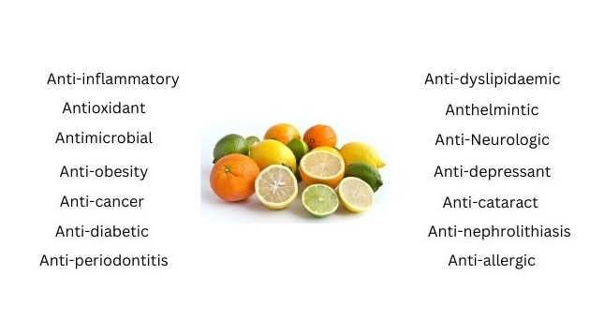
Fig.2 Pharmacological properties of Citrus
3,2 Antioxidant
Research conducted by Allam et al. (2020) demonstrated that increasing the administration of dried orange pulp enhances antioxidant levels in plasma. Mäkynen et al. (2013) highlighted the significant role of Citrus grandis as an antioxidant. Additionally, citrus peel is a rich source of antioxidant and flavonoid compounds (Azman et al. 2019), which possess free radical scavenging properties (Shanthi et al. 2019). These properties contribute to elevated serum antioxidant capacity, thereby protecting against lipid peroxidation (Assini et al.2013a) and reducing oxidative stress in the elderly. Huang et al. (2020) identified ponkan peel extract as a promising natural agent for free radical scavenging. Moreover, limonoids derived from Citrus grandis seeds have exhibited notable free radical-scavenging activity (Yu et al. 2015).
3.3 Antimicrobial
Citrus peel extract exhibits antibacterial activity against both Gram-positive and Gram-negative bacteria (Saleem and Saeed 2020) and has proven effective in eliminating bacteria responsible for dental caries (Pasaribu et al. 2018). Research conducted on albino mice indicates that Citrus reticulata peel extract possesses antimicrobial properties, suggesting its potential use in wound healing (Dahmani et al. 2020). Hamdan et al. (2013) identified antimicrobial activity in the peel oil of variegated pink-fleshed lemon against various microorganisms, including Gram-negative bacteria (Pseudomonas fluorescens), Gram-positive bacteria (Micrococcus luteus, Bacillus subtilis, and Staphylococcus capitis), as well as yeast species (Saccharomyces cerevisiae and Candida parapsilosis).
3.4 Anti-obesity
In vitro studies suggest that citrus polyphenols play a role in obesity management by reducing lipid content in cells, regulating adipocyte differentiation, and promoting adipocyte apoptosis. De Lima and De Paula Barbosa (2021) reported that citrus peel effectively reduces cholesterol levels and obesity. Kang et al. (2018) also highlighted the anti-obesity properties of Citrus unshiu peel’s aqueous extract. Additionally, Citrus tumida peel powder was found to decrease body weight by reducing epididymal, perirenal, and subcutaneous fat (Sato et al. 2019), likely due to the bioactive compounds in citrus peel influencing fatty acid and glucose metabolism. Furthermore, citrus peel oil has demonstrated lipolytic activity (Mohammed et al. 2016).
3.5 Anti-cancer
Citrus fruits are rich in secondary metabolites, including flavonoids, coumarins, and limonoids, which have been associated with a reduced risk of various cancers, such as gastric, breast, lung, hepatic, hematopoietic malignancies, and colon cancer (Arul and Subramanian, 2013). Tavsan and Kayali (2019) reviewed the anticancer effects of apigenin, luteolin, and myricetin, highlighting their influence on reactive oxygen species (ROS) signalling, as well as their role in apoptosis induction, cell cycle arrest, and inhibition of invasion, particularly in ovarian cancer treatment. Additionally, polymethoxyflavones impede carcinogenesis by disrupting the metastasis cascade, restricting cancer cell mobility in the circulatory system, and inhibiting angiogenesis (Wang et al. 2014). ALaqeel (2024) further reported that citrus-derived flavonoid antioxidants reduce cancer cell mobility in the bloodstream, enhance apoptosis, and suppress angiogenesis. Moreover, Citrus grandis seeds contain limonoids, primarily limonin and nobilin, which have demonstrated anticancer properties (Yu et al. 2015).
3.6 Anti-diabetic
Visvanathan and Williamson (2021) observed that prolonged citrus juice consumption enhances fasting glucose levels, fasting insulin, and insulin resistance. Additionally, flavonoids such as hesperidin, nobiletin, and naringin have been identified as anti-diabetic agents, improving insulin sensitivity. Due to the presence of flavone glycosides (naringin, hesperidin, and diosmin), citrus fruit is regarded as an excellent functional food for diabetes management (Srinivasan et al. 2018). Moreover, an in vivo study found that naringenin helps prevent alterations in vascular reactivity in rats through both NO-dependent and prostaglandin-independent pathways (Fallahi et al. 2012). Citrus reticulata and Citrus sudachi peel extracts have also demonstrated the ability to lower insulin levels and blood glucose concentrations (Kobayashi et al. 2017). Recent findings by Demir and Celik (2022) suggest that lemon seed extract may mitigate diabetic complications by activating antioxidant defense mechanisms and reducing blood glucose levels.
3.7 Anti-periodontitis
Graziani et al. (2018) reported that kiwifruit effectively reduces gingival inflammation in patients with periodontitis. Pribadi et al. (2018) concluded that vitamin C plays a crucial role in reducing gingival bleeding, while Amaliya et al. (2018) observed its preventive effects against periodontitis. Additionally, Citrus limon fruit has been recognized for its potential in treating debilitating diseases, gingivitis, and gingival bleeding (Hujoel et al. 2021).
3.8 Anti-dyslipidaemic
Citrus flavonoids are potent regulators of hepatic lipid metabolism (Assini et al. 2013b). Phenolic compounds extracted from Citrus grandis have demonstrated antihyperlipidemic properties by inhibiting cholesterol esterase and pancreatic lipase (Mäkynen et al. 2013). Additionally, these compounds bind with primary bile acids, preventing cholesterol solubility in micelles.
A study by Favela-Hernandez et al. (2016) found that juice from Citrus grandis and Citrus paradisi increased HDL cholesterol levels while lowering LDL cholesterol levels. Similarly, De Leo et al. (2020) observed that a daily oral dose of Citrus bergamia juice reduced triglycerides and cardiovascular risk in animals. Consumption of dried orange pulp has also been associated with a decrease in total lipid values (Allam et al.2020). Furthermore, aqueous and n-hexane extracts of mandarin peel have exhibited hypocholesterolemic effects, lowering cholesterol levels by 59.3% and 56.8%, respectively (Fayek et al. 2017).
3.9 Anti-Neurologic
Citrus maxima has been identified as a potential medicinal source for psychiatric and neurological disorders, demonstrating anxiolytic, depressant, hypnotic, muscle relaxant, and convulsant effects in experimental animals. Hesperetin plays a crucial role in neuroprotection by mitigating neuro-inflammatory and apoptotic pathways, earning recognition as a beneficial "brain food" (Li et al. 2023). Similarly, nobiletin and tangeretin have exhibited comparable neuroprotective properties (Braidy et al. 2017). Additionally, Pontifex et al. (2021) reviewed the neuroprotective potential of citrus polyphenols, highlighting their therapeutic significance in brain health.

3.10 Anti-depressant
Inhalation of lemon essential oil induced calming and anxiolytic effect in mice by stimulating the release of "happy hormones," specifically serotonin and dopamine (Lima et al. 2013). Similarly, ‘Citrus aurantium’ aqueous extract has demonstrated comparable anxiolytic properties (Wu et al. 2015b).
3.11 Anti-cataract
Ascorbic acid, a key antioxidant in the eye's lens, is abundantly present in citrus fruits. Studies have established a strong correlation between vitamin C and the prevention of cataracts, including age-related cataracts (Liu et al. 2018). By reducing oxidative damage, ascorbic acid plays a crucial role in minimizing cataract formation (Lim et al. 2020).
3.12 Anti-nephrolithiasis
Lime, lemon, and orange juices have been shown to aid in the prevention of kidney stone formation. Barghouthy and Somani (2021) reviewed evidence suggesting that orange juice offers protective benefits against kidney stones. Additionally, fresh lemon juice supplementation in a standard diet has been found to prevent stone recurrence in patients with calcium-oxalate nephrolithiasis (Ruggenenti et al. 2021), primarily due to the presence of citrates, which inhibit the formation of calcium oxalate crystals (Abd and Saeed 2023).
3.13 Anti-hypertensive
Grapefruit and lemon juice have been shown to lower blood pressure while also interfering with calcium channel blockers (Kato et al. 2014). Additionally, the consumption of orange juice has been found to reduce both blood pressure and pulse pressure (Valls et al. 2021), while also enhancing flow-mediated dilation (Li et al. 2020).
3.14 Anti-parasitic
Aboelhadid et al. (2016) demonstrated the efficacy of lemon essential oil against Sarcoptes scabiei, achieving 100% mite mortality following in vitro application of a 10% and 20% aqueous solution within 24 hours post-treatment. Anthelmintic properties of Citrus peel extracagainst Ascardiagalli has also been extablished (Garbin et al., 2021).
3.15 Blood profile
The study found that daily administration of 0.75% hydrogen peroxide along with 1 mL of lemon juice in drinking water led to an increase in haemoglobin concentration, RBC count, WBC count, and total protein levels (Ali et al. 2020).
3.16 Bone metabolic diseases
Neohesperidin, a citrus flavonoid, has been found to negatively correlate with osteoclast differentiation, suggesting its potential role in bone health (Tan et al. 2017). Ikeda et al. (2021) investigated the effects of calcium-supplemented lemon beverages, reporting their ability to suppress bone resorption. Additionally, Bergamottin, a natural citrus derivative, has demonstrated effectiveness in promoting osteoblast activity and bone formation, as observed by Wang et al. (2022).
A number of successful studies are reported after validation of in vivo experimental animal models (Table 2) and in vivo human trials (Table 3).
Table 2. Impact of citrus fruits on various diseases demonstrated using in vivo experimental animal models
S.r. N. | Citrus fruit | Disease | Type of sample | Time period | Result | References
4. | Orange peel extract (250mg/kg BW) | Inflammation | Rat induced with carrageenan |  | ↓Inflammation  comparable to the effects of ibuprofen | Gosslau et al. (2014)
7. | Sweet orange seed’s oil (1000 mg/kg BW) | Diabetes | 18 alloxan-induced diabetic rats | 28 days | ↓Blood glucose, ↓Triglycerides level,  ↓total cholesterol, ↑HDL cholesterol | Chilaka et al. (2015)
8. | C. reticulata extract (0.25% and 0.5%) | Obesity | Obese mice | 12 weeks | ↓21 % and 34% in body weight respectively | Guo et al. (2016)
9. | C. medica peel extract (600 mg/kg BW) | Diabetes | ZDF rats | 4 weeks | ↓ Blood glucose | Menichini et al. (2016)
10. | Citrus peel extract | Diabetes and cholesterol | Rat | 56 days | ↓ Total cholesterol (8.55%), LDL (11.39%), triglycerides (7.89%) and sera glucose level (8.96%) | Ashraf et al. (2017)
11. | C. sinensis methanol peels extract (50 and 100 mg/kg BW) | Diabetes | Diabetic rats | - | ↓Fasting blood glucose and plasma insulin levels | Sathiyabama et al. (2018)
12. | Orange peel hydroethanolic extract (50 mg/kg BW) | Liver injury | Male Wistar rats | 10-12 weeks | ↑antioxidant defense system and ↓inflammation and apoptosis. | Ahmed et al.  (2019)
13. | C. hytrix and C. maxima pulp’s extract (5, 50, 300, 1000 mg/kg BW) | Diabetes | Strepto-zotocin induced diabetic rat | 14 days | ↓Blood glucose, ↓Triglycerides level  ↓Total cholesterol, ↑HDL cholesterol | Abirami et al (2014)
14. | Methanolic extract of C. grandis  (1000 mg /day) | Dys-lipidemia | Long Evans rats | 21 days | ↓LDL cholesterol, ↓Total cholesterol,  ↑ HDL cholesterol | Ali et al. (2019)
15. | C. junos Tanaka peel extract  (200 mg/kg BW/day) | Pulmonary injuries | 8-week-old male C57BL / 6J mice | 10 days | ↓Pulmonary edema  ↓COPD | Kim et al. (2020)
16. | C. maxima peel’s methanol extract  (600 mg/kg BW/d) | Diabetes and cholesterol | 28 adult male rats | 14 days | ↓ Blood glucose (70.17%)  ↓Triglycerides (10.58%)  ↓LDL (10.20%) ↓HDL (4.43%) | Ani and Ochu (2020)
17. | Mandarin-peel extract | Rheumatoid arthritis | Thirty-six male albino rats | 2 weeks | ↓Disturbed ankle diameter, oxidative stress, anti-inflammatory mediators and ankle joint histopathology | Sakr et al. (2021)

Table 3. Impact of citrus fruits on various diseases demonstrated using in vivo human trial
S.r. | Citrus fruit | Diseases | Type of sample | Time period | Result | References
1. | Lemon juice | Blood pressure | 101 middle aged women | 5 months | ↓systolic blood pressure | Kato et al. (2014)
2. | Capsules containing lemon or sour orange powder | Obesity | Obese children | 1 month | ↑Flow-mediated dilatation (FMD) | Hashemi and co-worker (2015)
3. | Capsule of Lemon  (C. aurantifolia) peels powder | Cardio-metabolic risk factor  and obesity | 60 over  weight adolescents | 4 weeks | ↓Body mass index, LDL cholesterol and systolic blood pressure | Hashemipour et al. (2016)
4. | C. sinensis extract  (400 mg/day) | Obesity | Over  weight human | 12 weeks | ↓BMI,  Body weight and waist hip circumference | Cardile et al. (2015)
5. | Orange juice(500ml/day) | Obesity | 78 obese patients | 12 weeks | ↓Body weight, BMI, lean mass, fat mass, body fat, and waist-to-hip ratio. Insulin levels, ↓total cholesterol, LDL cholesterol and high-sensitivity C-reactive protein levels | Ribeiro et al. (2017)
6. | Red Orange juice (500ml/day) | Obesity | 11 obese women | 12 weeks | ↓Total cholesterol ↓LDL cholesterol | Azzini et al. (2017)
7. | Moro orange extract | Obesity | Over  weight adult | 6 months | ↓BMI,body mass, hip and waist circumference, ↓fat mass | Briskey et al. (2022)
8. | C. reticulata peel’s aqueous extract  (800 mg) | Obesity and cholesterol | obese adole-scents | 4-8 weeks | ↓ BMI, body fat percent ↓Waist circumference, ↓Total cholesterol,  ↓Triglycerides | Kamel et al. (2019)
9. | C. sinensis dried extract (0.5, 1 g/day) | Obesity | 106 people (BMI 25-35 kg /m²) | 3 months | ↓fat, ↑lean mass, ↓waist circumference | Kegele et al. (2019)

4. MECHANISTIC ASPECTS
The pharmacological action of any compound is known to be due to some specific structural properties. The interactions take place due to the inherent structural features present in the molecule. For example conjugated double bonds and that too in extension is most appropriate structural feature to absorb free radicals. Anti-oxidant compounds possess extended conjugation. If it is in conjunction with hydroxyl group then the antioxidant activity is enhanced. The bioactive ingredients of Citrus possessing antioxidant activities are decorated with these features. The pharmaco-active ingredient can also affect the receptors or enzymes through various physic-chemical interactions. Most common interactions happen to be ionic, hydrophobic, Hydrogen bond. The bioactive compounds present in citrus fruits exert their effect via modulating a number of targets as they contain highly nucleophilic groups which can interact via any one or more of these interactions. The cyclic flexible structure of terpenoids, xanthophylls, caroteinoids, vitamins can fit into the active site cavity of any enzyme target or the binding site of a receptor. The molecular targets of some selected bioactive ingredients are summarized in the Fig.3.
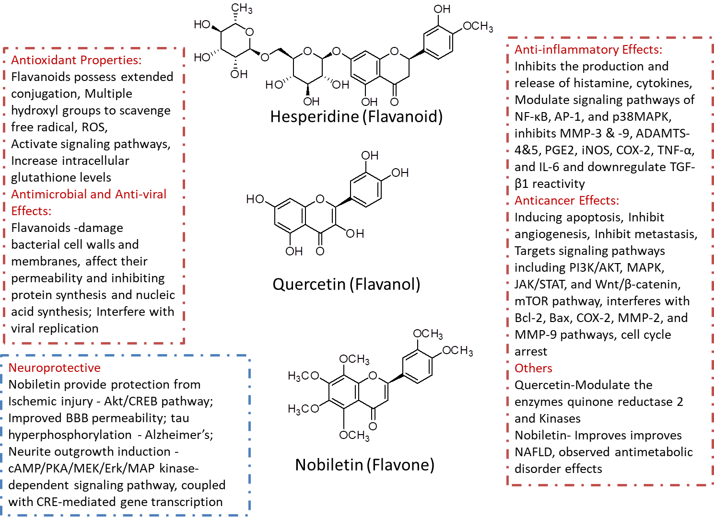
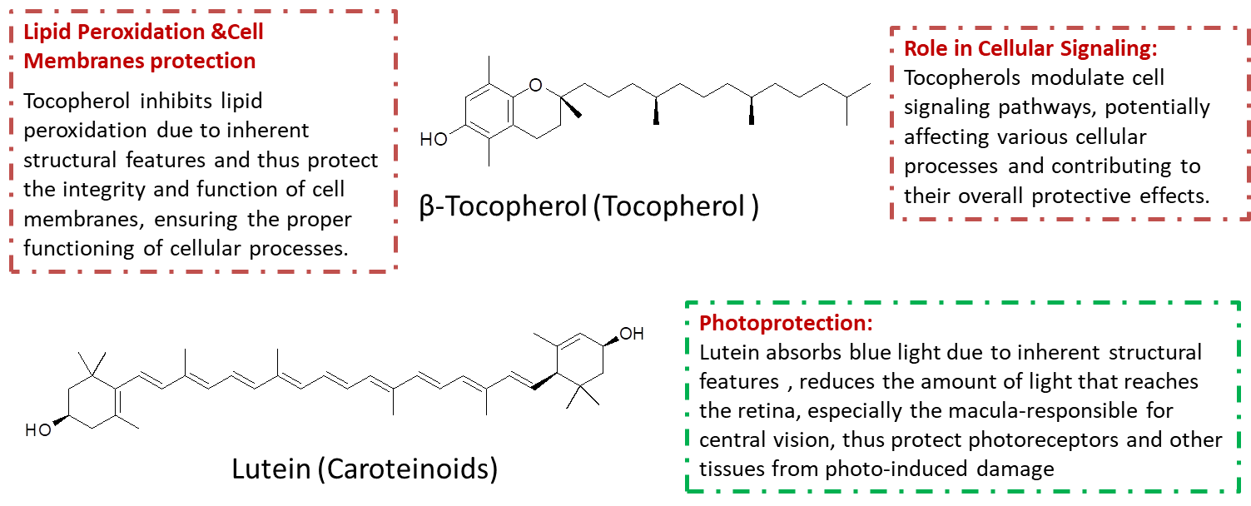
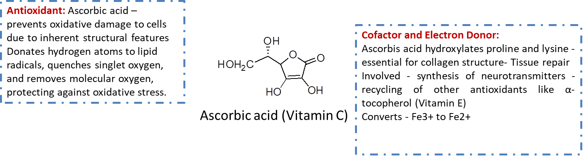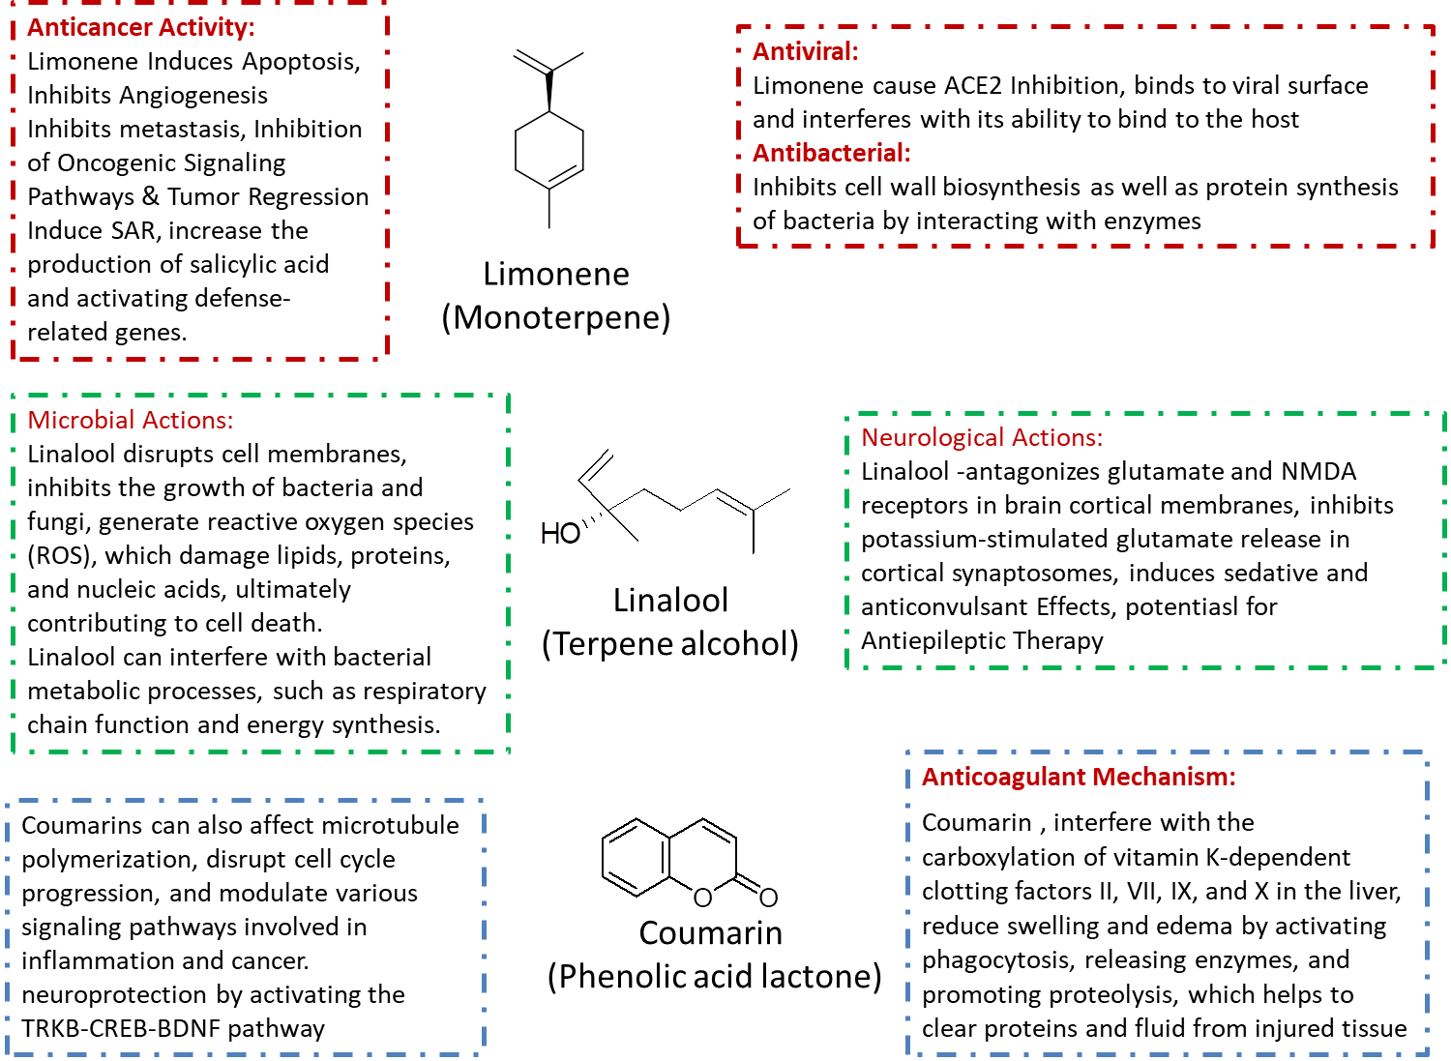
Fig 3 Molecular targets, mode of action of some flavonoids, antioxidant vitamins, terpenes and coumarin
In addition to overview of mechanism of actions of few bioactive ingredients (Fig.3), a more detailed Mechanism of action for Neral and ferulic acid is redrafted in Fig.4.a (Liao et al.,2015) and b (Dan Li et. Al. 2021) respectively.
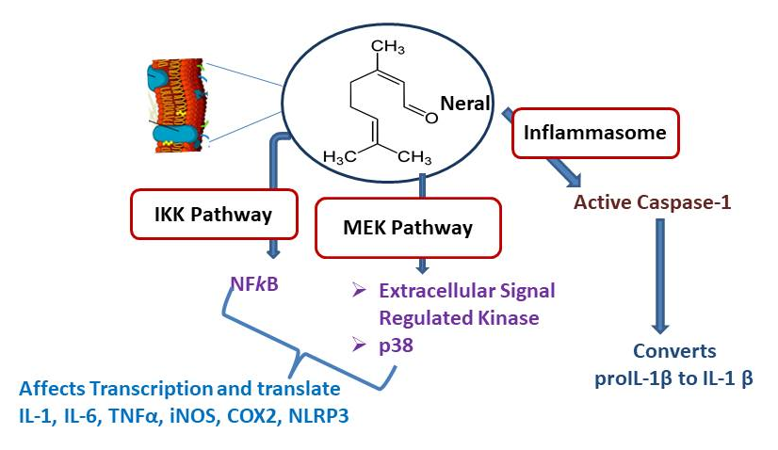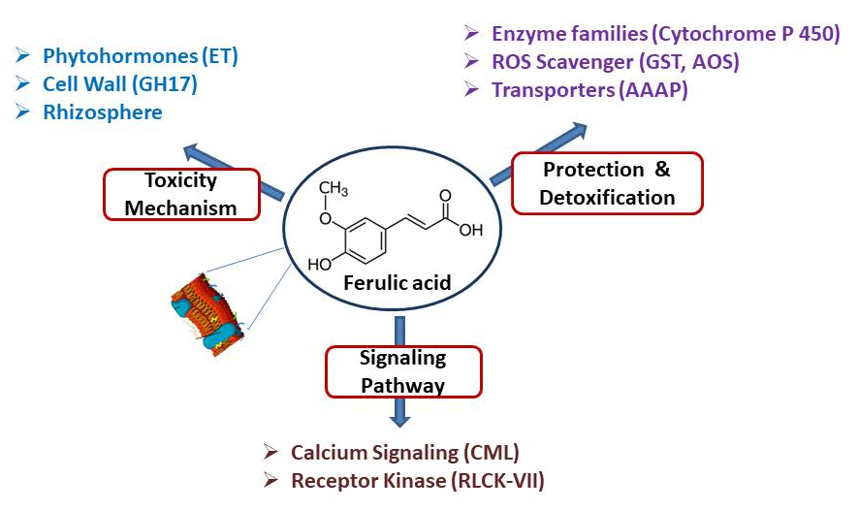

a b
Fig. 4 A detailed Mechanism of action of Neral (a) and Ferulic acid (b)

5. CONCLUDING REMARKS AND FUTURE PROSPECTS
Citrus fruits are a rich source of secondary metabolites, including flavonoids, carotenoids, essential oils, phenolic acids, and tocopherols, which contribute to various bioactivities in the body. These active compounds exhibit anti-inflammatory, anticancer, antimicrobial, and anti-allergic properties, along with chemo-preventive, neuroprotective, hepatoprotective, and hypotensive effects. Additionally, they offer antidiabetic, anti-dyslipidaemic, anti-obesity, anti-parasitic, anti-aging, antidepressant, and cardiovascular protective benefits. Given their diverse health advantages, incorporating citrus fruits into the daily diet is highly recommended.
Despite the pharmacological potential of citrus by-products such as peel, seeds, and pomace - rich in secondary metabolites - they remain underutilized. Further research and increased awareness are essential to maximize their applications.
In order to fully utilize the available knowledge, the individual compound can be further explored as a lead molecule for a number of mentioned conditions. This review aims to provide valuable insights for researchers across disciplines, including chemistry, biochemistry, and medicine, to further explores the immense pharmacological potential of this genus.

Disclaimer (Artificial intelligence)
Author(s) hereby declare that NO generative AI technologies such as Large Language Models (ChatGPT, COPILOT, etc.) and text-to-image generators have been used during the writing or editing of this manuscript.
REFERENCES
- Abd, N. M., & Saeed, S. K. (2023). The Effect of Dosing with Lemon Juice on the Renal Tissue of Laboratory Rats with Kidney Stones (Urolithiasis/Nephrolithiasis) Experimentally. IOP Conference Series: Earth and Environmental Science 1252(1), 012165. https://doi.org/10.1088/1755-1315/1252/1/012165.
- Abirami, G., Nagarani, P. & Siddhuraju, P. (2014). In Vitro Antioxidant, Anti-Diabetic, Cholinesterase and Tyrosinase Inhibitory Potential of Fresh Juice from Citrus hystrix and C. maxima Fruits. Food Science and Human Wellness 3(1), 16–25.
- Aboelhadid, S. M., L. N. Mahrous, S. A. Hashem, E. M. Abdel-Kafy, and R. J. Miller. (2016). "In Vitro and In Vivo Effect of Citrus limon Essential Oil Against Sarcoptic Mange in Rabbits." Parasitology Research 115(8): 3013–3020. https://doi.org/10.1007/s00436-016-5056-8.
- Adenaike, O., & Abakpa, G. O. (2021). Antioxidant compounds and health benefits of citrus fruits. European Journal of Nutrition & Food Safety, 13(2), 65–74. https://doi.org/10.9734/ejnfs/2021/v13i230376
- Ahmed, O. M., Fahim, H. I., Ahmed, H. Y., Al-Muzafar, H. M., Ahmed, R. R., Amin, K. A., et al. (2019). The preventive effects and the mechanisms of action of navel orange peel hydroethanolic extract, naringin, and naringenin in N-acetyl-p-aminophenol-induced liver injury in Wistar rats. Oxidative Medicine and Cellular Longevity, 2019, 2745352. https://doi.org/10.1155/2019/2745352
- Alam, M. A. (2019). Anti-hypertensive effect of cereal antioxidant ferulic acid and its mechanism of action. Frontiers in Nutrition, 6, 121. https://doi.org/10.3389/fnut.2019.00121
- ALaqeel, N. K. (2024). Antioxidants from different citrus peels provide protection against cancer. Brazilian Journal of Biology, 84, e271619. https://doi.org/10.1590/1519-6984.271619
- Ali, M. Y., Rumpa, N. N., Paul, S., Hossen, M. S., Tanvir, E. M., Hossan, T., et al. (2019). Antioxidant potential, subacute toxicity, and beneficiary effects of methanolic extract of pomelo (Citrus grandis L. Osbeck) in Long Evan rats. Journal of Toxicology, 2019, 2529569. https://doi.org/10.1155/2019/2529569
- Ali, S. (2020). Lemon juice antioxidant activity against oxidative stress. Baghdad Science Journal, 17(1 Suppl.), 0207. https://doi.org/10.21123/bsj.2020.17.1(suppl.).0207
- Allam, S. M., El-Bedawy, T., Bakr, M., & Mahmoud, A. (2020). Effect of feeding dried orange pulp to lactating dairy cows on nutrients digestibility, blood constituents, plasma antioxidant biomarker, and pathogenic fecal bacteria. Pakistan Journal of Zoology, 52(1), 79–86. https://doi.org/10.17582/journal.pjz/2020.52.1.79.86
- Alonso-Castro, A. J., Domínguez, F., & García-Carrancá, A. (2013). Rutin exerts antitumor effects on nude mice bearing SW480 tumor. Archives of Medical Research, 44(5), 346–351. https://doi.org/10.1016/j.arcmed.2013.06.002
- Amaliya, A., Risdiana, A. S., & Van Der Velden, U. (2018). Effect of guava and vitamin C supplementation on experimental gingivitis: A randomized clinical trial. Journal of Clinical Periodontology, 45(8), 959–967. https://doi.org/10.1111/jcpe.12922
- Amorim, J. L., Simas, D. L. R., Pinheiro, M. M. G., Moreno, D. S. A., Alviano, C. S., Da Silva, A. J. R., & Fernandes, P. D. (2016). Anti-inflammatory properties and chemical characterization of the essential oils of four citrus species. PLoS ONE, 11(4), e0153643. https://doi.org/10.1371/journal.pone.0153643
- Ani, P. N., & Ochu, K. E. (2020). Anti-diabetic, anti-hyperlipidemic, and hepatoprotective potential of shaddock (Citrus maxima) peel extract. Acta Scientiarum Polonorum Technologia Alimentaria, 19(3), 271–278. https://doi.org/10.17306/j.afs.0811
- Arul, D., & Subramanian, P. (2013). Inhibitory effect of naringenin (citrus flavanone) on N-nitrosodiethylamine-induced hepatocarcinogenesis in rats. Biochemical and Biophysical Research Communications, 434(2), 203–209. https://doi.org/10.1016/j.bbrc.2013.03.039
- Ashraf, H., Butt, M. S., Iqbal, M. J., & Suleria, H. A. R. (2017). Citrus peel extract and powder attenuate hypercholesterolemia and hyperglycemia using rodent experimental modeling. Asian Pacific Journal of Tropical Biomedicine, 7(10), 870–880. https://doi.org/10.1016/j.apjtb.2017.09.012
- Assini, J. M., Mulvihill, E. E., & Huff, M. W. (2013a). Citrus flavonoids and lipid metabolism. Current Opinion in Lipidology, 24(1), 34–40. https://doi.org/10.1097/mol.0b013e32835c07fd
- Assini, J. M., Mulvihill, E. E., Sutherland, B. G., Telford, D. E., Sawyez, C. G., Felder, S. L., Chhoker, S., Edwards, J. Y., Gros, R., & Huff, M. W. (2013b). Naringenin prevents cholesterol-induced systemic inflammation, metabolic dysregulation, and atherosclerosis in Ldlr mice. Journal of Lipid Research, 54(3), 711–724. https://doi.org/10.1194/jlr.m032631
- Aune, D., Keum, N., Giovannucci, E., Fadnes, L. T., Boffetta, P., Greenwood, D. C., Tonstad, S., Vatten, L. J., Riboli, E., & Norat, T. (2018). Dietary intake and blood concentrations of antioxidants and the risk of cardiovascular disease, total cancer, and all-cause mortality: A systematic review and dose-response meta-analysis of prospective studies. American Journal of Clinical Nutrition, 108(5), 1069–1091. https://doi.org/10.1093/ajcn/nqy097
- Azman, N. F. I. N., Azlan, A., Khoo, H. E., & Razman, M. R. (2019). Antioxidant properties of fresh and frozen peels of citrus species. Current Research in Nutrition and Food Science Journal, 7(2), 331–339. https://doi.org/10.12944/crnfsj.7.2.03
- Azzini, E., Venneria, E., Ciarapica, D., Foddai, M. S., Intorre, F., Zaccaria, M., et al. (2017). Effect of red orange juice consumption on body composition and nutritional status in overweight/obese female: A pilot study. Oxidative Medicine and Cellular Longevity, 2017, 1672567. https://doi.org/10.1155/2017/1672567
- Bairagi, S., Salaskar, P., Loke, S., Surve, N., Tandel, D., & Dusara, M. (2012). Medicinal significance of coumarins: A review. International Journal of Pharmaceutical Research, 4(2), 16–19.
- Barghouthy, Y., & Somani, B. K. (2021). Role of citrus fruit juices in prevention of kidney stone disease (KSD): A narrative review. Nutrients, 13(11), 4117. https://doi.org/10.3390/nu13114117
- Bernabé, J., Mulero, J., Cerdá, B., García-Viguera, C., Moreno, D. A., Parra, S., Avilés, F., Gil-Izquierdo, A., Abellán, J., & Zafrilla, P. (2013). Effects of a citrus-based juice on biomarkers of oxidative stress in metabolic syndrome patients. Journal of Functional Foods, 5(3), 1031–1038. https://doi.org/10.1016/j.jff.2013.02.003
- Bi, W., Zhou, J., Zhao, L., Wang, C., Wu, W., Zhang, L., Ji, B., Zhang, N., & Zhou, F. (2021). Preventive effect of different citrus essential oils on primary dysmenorrhea: In vivo and in vitro study. Food Bioscience, 42, 101135. https://doi.org/10.1016/j.fbio.2021.101135
- Blanco-Pérez, F., Steigerwald, H., Schülke, S., Vieths, S., Toda, M., & Scheurer, S. (2021). The dietary fiber pectin: Health benefits and potential for the treatment of allergies by modulation of gut microbiota. Current Allergy and Asthma Reports, 21(10), 43. https://doi.org/10.1007/s11882-021-01020-z
- Bora, H., Kamle, M., Mahato, D. K., Tiwari, P., & Kumar, P. (2020). Citrus essential oils (CEOs) and their applications in food: An overview. Plants, 9(3), 357. https://doi.org/10.3390/plants9030357
- Braidy, N., Behzad, S., Habtemariam, S., Ahmed, T., Daglia, M., Nabavi, S. M., Sobarzo-Sanchez, E., & Nabavi, S. F. (2017). Neuroprotective effects of citrus fruit-derived flavonoids, nobiletin and tangeretin in Alzheimer’s and Parkinson’s disease. CNS & Neurological Disorders - Drug Targets, 16(4). https://doi.org/10.2174/1871527316666170328113309
- Briskey, D., Malfa, G. A., & Rao, A. (2022). Effectiveness of ‘Moro’ blood orange Citrus sinensis Osbeck (Rutaceae) standardized extract on weight loss in overweight but otherwise healthy men and women—A randomized double-blind placebo-controlled study. Nutrients, 14(3), 427. https://doi.org/10.3390/nu14030427
- Bumrungpert, A., Lilitchan, S., Tuntipopipat, S., Tirawanchai, N., & Komindr, S. (2018). Ferulic acid supplementation improves lipid profiles, oxidative stress, and inflammatory status in hyperlipidemic subjects: A randomized, double-blind, placebo-controlled clinical trial. Nutrients, 10(6), 713. https://doi.org/10.3390/nu10060713
- Burri, B. J., La Frano, M. R., & Zhu, C. (2017). Absorption, metabolism, and functions of β-cryptoxanthin. Nutrition Reviews, 74(2), 69–82. https://doi.org/10.1093/nutrit/nuv064
- Caputo, L., Reguilon, M., Mińarro, J., De Feo, V., & Rodriguez-Arias, M. (2018). Lavandula angustifolia essential oil and linalool counteract social aversion induced by social defeat. Molecules, 23(10), 2694. https://doi.org/10.3390/molecules23102694
- Cardile, V., Graziano, A. C. E., & Venditti, A. (2015). Clinical evaluation of Moro (Citrus sinensis (L.) Osbeck) orange juice supplementation for weight management. Natural Product Research, 29(23), 2256–2260. https://doi.org/10.1080/14786419.2014.1000897
- Carr, A., & Maggini, S. (2017). Vitamin C and immune function. Nutrients, 9(11), 1211. https://doi.org/10.3390/nu9111211
- Carullo, G., Cappello, A. R., Frattaruolo, L., Badolato, M., Armentano, B., & Aiello, F. (2016). Quercetin and derivatives: Useful tools in inflammation and pain management. Future Medicinal Chemistry, 9(1), 79–93. https://doi.org/10.4155/fmc-2016-0186
- Chen, C. (2016). Sinapic acid and its derivatives as medicine in oxidative stress-induced diseases and aging. Oxidative Medicine and Cellular Longevity, 2016, 3571614. https://doi.org/10.1155/2016/3571614
- Chen, Q., Wang, D., Gu, Y., Jiang, Z., & Zhou, Z. (2022). Tangeretin prevents obesity by modulating systemic inflammation, fat browning, and gut microbiota in high-fat diet-induced obese C57BL/6 mice. Journal of Nutritional Biochemistry, 101, 108943. https://doi.org/10.1016/j.jnutbio.2022.108943
- Chilaka, K., Ifediba, E., & Ogamba, J. (2015). Evaluation of the effects of Citrus sinensis seed oil on blood glucose, lipid profile and liver enzymes in rats injected with alloxan monohydrate. Journal of Acute Disease, 4(2), 129–134. https://doi.org/10.1016/s2221-6189(15)30022-6
- Cirmi, S., Navarra, M., Woodside, J. V., & Cantwell, M. M. (2018). Citrus fruits intake and oral cancer risk: A systematic review and meta-analysis. Pharmacological Research, 133, 187–194. https://doi.org/10.1016/j.phrs.2018.05.008
- Coelho, R. C. L. A., Hermsdorff, H. H. M., & Bressan, J. (2013). Anti-inflammatory properties of orange juice: Possible favorable molecular and metabolic effects. Plant Foods for Human Nutrition, 68(1), 1–10. https://doi.org/10.1007/s11130-013-0343-3
- Dahmani, S., Chabir, R., Errachidi, F., Berrada, W., Lansari, H., Benidir, M., Ghadraoui, L. E., & Bour, A. (2020). Evaluation of in vivo wound healing activity of Moroccan Citrus reticulata peel extract. Clinical Phytoscience, 6(1), 22. https://doi.org/10.1186/s40816-020-00222-8
- Darband, S. G., Kaviani, M., Yousefi, B., Sadighparvar, S., Pakdel, F. G., Attari, J. A., Mohebbi, I., Naderi, S., & Majidinia, M. (2018). Quercetin: A functional dietary flavonoid with potential chemo-preventive properties in colorectal cancer. Journal of Cellular Physiology, 233(9), 6544–6560. https://doi.org/10.1002/jcp.26595
- De Leo, M., Piragine, E., Pirone, A., Braca, A., Pistelli, L., Calderone, V., Miragliotta, V., & Testai, L. (2020). Protective effects of bergamot (Citrus bergamia Risso & Poiteau) juice in rats fed with high-fat diet. Planta Medica, 86(3), 180–189. https://doi.org/10.1055/a-1070-9325
- De Lima, L. P., & De Paula Barbosa, A. (2021). A review of the lipolytic effects and the reduction of abdominal fat from bioactive compounds and Moro orange extracts. Heliyon, 7(8), e07695. https://doi.org/10.1016/j.heliyon.2021.e07695
- De Luna, F. C. F., Ferreira, W. A. S., Casseb, S. M. M., & De Oliveira, E. H. C. (2023). Anticancer potential of flavonoids: An overview with an emphasis on tangeretin. Pharmaceuticals, 16(9), 1229. https://doi.org/10.3390/ph16091229
- De Souza Carvalho, J., Ramadan, D., De Paiva Gonçalves, V., Maquera-Huacho, P. M., Assis, R. P., Lima, T. F. O., Brunetti, I. L., Spolidorio, D. M. P., Cesar, T., Manthey, J. A., & Spolidorio, L. C. (2021). Impact of citrus flavonoid supplementation on inflammation in lipopolysaccharide-induced periodontal disease in mice. Food & Function, 12(11), 5007–5017. https://doi.org/10.1039/d0fo03338c
- Demir, A., & Celik, I. (2022). Investigation of healing effects of lemon (Citrus limonum) seeds lyophilized extracts on experimental diabetic rats. Archives of Physiology and Biochemistry, 128(2), 539–546. https://doi.org/10.1080/13813455.2019.1702061
- Denaro, C., Stephenson, D., Müller, M. L. T. M., Piccoli, B., & Azer, K. (2024). Advancing precision medicine therapeutics for Parkinson’s utilizing a shared quantitative systems pharmacology model and framework. Frontiers in Systems Biology, 4, 1351555. https://doi.org/10.3389/fsysb.2024.1351555
- Dhir, S., Tarasenko, M., Napoli, E., & Giulivi, C. (2019). Neurological, psychiatric, and biochemical aspects of thiamine deficiency in children and adults. Frontiers in Psychiatry, 10, 207. https://doi.org/10.3389/fpsyt.2019.00207
- Dhuique-Mayer, C., Gence, L., Portet, K., Tousch, D., & Poucheret, P. (2020). Preventive action of retinoids in metabolic syndrome/type 2 diabetic rats fed with citrus functional food enriched in β-cryptoxanthin. Food & Function, 11(10), 9263–9271. https://doi.org/10.1039/d0fo02430a
- Dulińska-Litewka, J., Sharoni, Y., Hałubiec, P., Łazarczyk, A., Szafrański, O., McCubrey, J. A., Gąsiorkiewicz, B., Laidler, P., & Bohn, T. (2021). Recent progress in discovering the role of carotenoids and their metabolites in prostatic physiology and pathology with a focus on prostate cancer—A review—Part I: Molecular mechanisms of carotenoid action. Antioxidants, 10(4), 585. https://doi.org/10.3390/antiox10040585
- Ekmekcioglu, C., Elmadfa, I., Meyer, A. L., & Moeslinger, T. (2015). The role of dietary potassium in hypertension and diabetes. Journal of Physiology and Biochemistry, 72(1), 93–106. https://doi.org/10.1007/s13105-015-0449-1
- Fallahi, F., Roghani, M., & Moghadami, S. (2012). Citrus flavonoid naringenin improves aortic reactivity in streptozotocin-diabetic rats. Indian Journal of Pharmacology, 44(3), 382. https://doi.org/10.4103/0253-7613.96350
- Fang, J., Cao, Z., Song, X., Zhang, X., Mai, B., Wen, T., Lin, J., Chen, J., Chi, Y., Su, T., & Xiao, F. (2020). Rhoifolin alleviates inflammation of acute inflammation animal models and LPS-induced RAW264.7 cells via IKKβ/NF-κB signaling pathway. Inflammation, 43(6), 2191–2201. https://doi.org/10.1007/s10753-020-01286-x
- Favela-Hernández, J., González-Santiago, O., Ramírez-Cabrera, M., Esquivel-Ferriño, P., & Camacho-Corona, M. (2016). Chemistry and pharmacology of Citrus sinensis. Molecules, 21(2), 247. https://doi.org/10.3390/molecules21020247
- Fayek, N. M., El-Shazly, A. H., Abdel-Monem, A. R., Moussa, M. Y., Abd-Elwahab, S. M., & El-Tanbouly, N. D. (2017). Comparative study of the hypocholesterolemic, antidiabetic effects of four agro-waste citrus peels cultivars and their HPLC standardization. Revista Brasileira de Farmacognosia, 27(4), 488–494. https://doi.org/10.1016/j.bjp.2017.01.010
- Feng, K., Zhu, X., Liu, G., Kan, Q., Chen, T., Chen, Y., & Cao, Y. (2020). Dietary citrus peel essential oil ameliorates hypercholesterolemia and hepatic steatosis by modulating lipid and cholesterol homeostasis. Food & Function, 11(8), 7217–7230. https://doi.org/10.1039/d0fo00810a
- Ferreira, S. S., Silva, A. M., & Nunes, F. M. (2018). Citrus reticulata Blanco peels as a source of antioxidant and anti-proliferative phenolic compounds. Industrial Crops and Products, 111, 141–148. https://doi.org/10.1016/j.indcrop.2017.10.009
- Garbin, V. P., Munguía, B., Saldaña, J. C., Deschamps, C., Cipriano, R. R., & Molento, M. B. (2021). Chemical characterization and in vitro anthelmintic activity of Citrus bergamia Risso and Citrus × paradisii Macfad essential oil against Haemonchus contortus Kirby isolate. Acta Tropica, 217, 105869. https://doi.org/10.1016/j.actatropica.2021.105869
- Giammanco, M., Plescia, F., Giammanco, M. M., Leto, G., & Gentile, C. (2022). Bioactive effects of citrus flavonoids and role in the prevention of atherosclerosis and cancer. Journal of Biological Research, 95(1), 10313. https://doi.org/10.4081/jbr.2022.10313
- Gosslau, A., Chen, K. Y., Ho, C., & Li, S. (2014). Anti-inflammatory effects of characterized orange peel extracts enriched with bioactive polymethoxyflavones. Food Science and Human Wellness, 3(1), 26–35. https://doi.org/10.1016/j.fshw.2014.02.002
- Graziani, F., Discepoli, N., Gennai, S., Karapetsa, D., Nisi, M., Bianchi, L., Rosema, N. A. M., & Van Der Velden, U. (2018). The effect of twice daily kiwifruit consumption on periodontal and systemic conditions before and after treatment: A randomized clinical trial. Journal of Periodontology, 89(3), 285–293. https://doi.org/10.1002/jper.17-0148
- Guo, X., Yang, B., Tan, J., Jiang, J., & Li, D. (2016). Associations of dietary intakes of anthocyanins and berry fruits with risk of type 2 diabetes mellitus: A systematic review and meta-analysis of prospective cohort studies. European Journal of Clinical Nutrition, 70(12), 1360–1367. https://doi.org/10.1038/ejcn.2016.142
- Hadian, Z., Maleki, M., Feizollahi, E., Alibeyk, S., & Saryazdi, M. (2020). Health aspects of geraniol as a main bioactive compound of Rosa damascena Mill: A systematic review. Electronic Physician, 12(3), 7724–7735. https://doi.org/10.19082/7724
- Hamdan, D., Ashour, M. L., Mulyaningsih, S., El-Shazly, A., & Wink, M. (2013). Chemical composition of the essential oils of variegated pink-fleshed lemon (Citrus × limon L. Burm. f.) and their anti-inflammatory and antimicrobial activities. Zeitschrift für Naturforschung C, 68(7–8), 275–284. https://doi.org/10.1515/znc-2013-7-804
- Hashemi, M., Khosravi, E., Ghannadi, A., Hashemipour, M., & Kelishadi, R. (2015). Effect of the peels of two citrus fruits on endothelium function in adolescents with excess weight: A triple-masked randomized trial. Journal of Research in Medical Sciences, 20(8), 721–726. https://doi.org/10.4103/1735-1995.168273
- Hashemipour, M., Kargar, M., Ghannadi, A., & Kelishadi, R. (2017). The effect of Citrus aurantifolia (lemon) peels on cardiometabolic risk factors and markers of endothelial function in adolescents with excess weight: A triple-masked randomized controlled trial. Journal of Research in Medical Sciences, 30, 429. https://doi.org/10.28210594
- Huang, R., Zhang, Y., Shen, S., Zhi, Z., Cheng, H., Chen, S., & Ye, X. (2020). Antioxidant and pancreatic lipase inhibitory effects of flavonoids from different citrus peel extracts: An in vitro study. Food Chemistry, 326, 126785. https://doi.org/10.1016/j.foodchem.2020.126785
- Hujoel, P. P., Kato, T., Hujoel, I. A., & Hujoel, M. L. A. (2021). Bleeding tendency and ascorbic acid requirements: Systematic review and meta-analysis of clinical trials. Nutrition Reviews, 79(9), 964–975. https://doi.org/10.1093/nutrit/nuaa115
- Igase, M., Okada, Y., Ochi, M., Igase, K., Ochi, H., Okuyama, S., Furukawa, Y., & Ohyagi, Y. (2017). Auraptene in the peels of Citrus kawachiensis (Kawachibankan) contributes to the preservation of cognitive function: A randomized, placebo-controlled, double-blind study in healthy volunteers. Journal of Prevention of Alzheimer’s Disease, 1–5. https://doi.org/10.14283/jpad.2017.47
- Ikeda, H., Iida, T., Hiramitsu, M., Inoue, T., Aoi, S., Kanazashi, M., Ishizaki, F., & Harada, T. (2021). Effects of lemon beverage containing citric acid with calcium supplementation on bone metabolism and mineral density in postmenopausal women: Double-blind 11-month intervention study. Journal of Nutrition and Metabolism, 2021, 1–13. https://doi.org/10.1155/2021/8824753
- Ikoma, Y., Matsumoto, H., & Kato, M. (2016). Diversity in the carotenoid profiles and the expression of genes related to carotenoid accumulation among citrus genotypes. Breeding Science, 66(1), 139–147. https://doi.org/10.1270/jsbbs.66.139
- Impellizzeri, D., Bruschetta, G., Di Paola, R., Ahmad, A., Campolo, M., Cuzzocrea, S., Esposito, E., & Navarra, M. (2015). The anti-inflammatory and antioxidant effects of bergamot juice extract (BJe) in an experimental model of inflammatory bowel disease. Clinical Nutrition, 34(6), 1146–1154. https://doi.org/10.1016/j.clnu.2014.11.012
- Iqbal, S., & Naseem, I. (2015). Role of vitamin A in type 2 diabetes mellitus biology: Effects of intervention therapy in a deficient state. Nutrition, 31(7–8), 901–907. https://doi.org/10.1016/j.nut.2014.12.014
- Jandacek, R. J. (2017). Linoleic acid: A nutritional quandary. Healthcare, 5(2), 25. https://doi.org/10.3390/healthcare5020025
- Jayaraman, R., Subramani, S., Abdullah, S. H. S., & Udaiyar, M. (2017). Antihyperglycemic effect of hesperetin, a citrus flavonoid, extenuates hyperglycemia and exploring the potential role in antioxidant and antihyperlipidemic in streptozotocin-induced diabetic rats. Biomedicine & Pharmacotherapy, 97, 98–106. https://doi.org/10.1016/j.biopha.2017.10.102
- Kamel, I. H., Salib, J. Y., El-Toumy, S. A., Amina, H., Awad, & Elmenabbawy, M. K. (2019). Citrus reticulata peel extract: An anti-obesity therapy for adolescents. Middle East Journal of Applied Sciences, 9(1), 117–124.
- Kang, S., Song, S., Lee, J., Chang, H., & Lee, S. (2018). Clinical investigations of the effect of Citrus unshiu peel pellet on obesity and lipid profile. Evidence-Based Complementary and Alternative Medicine, 2018, 1–6. https://doi.org/10.1155/2018/4341961
- Kato, Y., Domoto, T., Hiramitsu, M., Katagiri, T., Sato, K., Miyake, Y., Aoi, S., Ishihara, K., Ikeda, H., Umei, N., et al. (2014). Effect on blood pressure of daily lemon ingestion and walking. Journal of Nutrition and Metabolism, 2014, 1–6. https://doi.org/10.1155/2014/912684
- Kegele, C. S., Oliveira, J., Magrani, T., Ferreira, A., De Souza Ferreira, R., et al. (2019). A randomized trial on the effects of CitrusiM® (Citrus sinensis (L.) Osbeck dried extract) on body composition. Clinical Nutrition Experimental, 27, 29–36. https://doi.org/10.1016/j.yclnex.2019.08.002
- Kim, J. W., Jo, E. H., Moon, J. E., Cha, H., Chang, M. H., Cho, H. T., et al. (2020). In vitro and in vivo inhibitory effect of Citrus junos Tanaka peel extract against oxidative stress-induced apoptotic death of lung cells. Antioxidants, 9(12), 1231. https://doi.org/10.3390/antiox9121231
- Kobayashi, A. K., Vieira, L. G. E., Filho, J. C. B., Leite, R. P., Pereira, L. F. P., Molinari, H. B. C., & Marques, V. V. (2017). Enhanced resistance to citrus canker in transgenic sweet orange expressing the sarcotoxin IA gene. European Journal of Plant Pathology, 149(4), 865–873. https://doi.org/10.1007/s10658-017-1234-5
- Koolaji, N., Shammugasamy, B., Schindeler, A., Dong, Q., Dehghani, F., & Valtchev, P. (2020). Citrus peel flavonoids as potential cancer prevention agents. Current Developments in Nutrition, 4(5), nzaa025. https://doi.org/10.1093/cdn/nzaa025
- Li, L., Lyall, G. K., Martinez-Blazquez, J. A., Vallejo, J. F., Tomas-Barberan, F. A., Birch, K. M., & Boesch, C. (2020). Blood orange juice consumption increases flow-mediated dilation in adults with overweight and obesity: A randomized controlled trial. Journal of Nutrition, 150(9), 2287–2294. https://doi.org/10.1093/jn/nxaa158
- Li, X., Huang, W., Tan, R., Xu, C., Chen, X., Li, S., Liu, Y., Qiu, H., Cao, H., & Cheng, Q. (2023). The benefits of hesperidin in central nervous system disorders, based on the neuroprotective effect. Biomedicine & Pharmacotherapy, 159, 114222. https://doi.org/10.1016/j.biopha.2023.114222
- Liao, P., Yang, T., Chou, J., Chen, J., Lee, S., Kuo, Y., Ho, C., & Chao, L. K. (2015). Anti-inflammatory activity of neral and geranial isolated from fruits of Litsea cubeba Lour. Journal of Functional Foods, 19, 248–258. https://doi.org/10.1016/j.jff.2015.09.034
- Lim, J. C., Arredondo, M. C., Braakhuis, A. J., & Donaldson, P. J. (2020). Vitamin C and the lens: New insights into delaying the onset of cataract. Nutrients, 12(10), 3142. https://doi.org/10.3390/nu12103142
- Lima, N. G., de Sousa, D. P., Pimenta, F. C. F., Alves, M. F., de Souza, F. S., Macedo, R. O., Cardoso, R. B., de Morais, L. C. S., Diniz, M. D. F. M., & de Almeida, R. N. (2013). Anxiolytic-like activity and GC–MS analysis of (R)-(+)-limonene fragrance, a natural compound found in foods and plants. Pharmacology Biochemistry and Behavior, 103(3), 450–454. https://doi.org/10.1016/j.pbb.2012.09.005
- Liu, F., Xiong, J., Hu, J., Ran, Z., Wang, J., Li, Z., Chen, M., & Wang, Y. (2018). Vitamin C and risk of age-related cataracts: A systematic review and meta-analysis. International Journal of Clinical and Experimental Medicine, 11(9), 8929–8940. https://www.ijcem.com
- Mączka, W., Wińska, K., & Grabarczyk, M. (2020). One hundred faces of geraniol. Molecules, 25(14), 3303. https://doi.org/10.3390/molecules25143303
- Makni, M., Jemai, R., Kriaa, W., Chtourou, Y., & Fetoui, H. (2018). Citrus limon from Tunisia: Phytochemical and physicochemical properties and biological activities. BioMed Research International, 2018, 1–10. https://doi.org/10.1155/2018/6251546
- Mäkynen, K., Jitsaardkul, S., Tachasamran, P., Sakai, N., Puranachoti, S., Nirojsinlapachai, N., Chattapat, V., Caengprasath, N., Ngamukote, S., & Adisakwattana, S. (2013). Cultivar variations in antioxidant and antihyperlipidemic properties of pomelo pulp (Citrus grandis [L.] Osbeck) in Thailand. Food Chemistry, 139(1–4), 735–743. https://doi.org/10.1016/j.foodchem.2013.02.017
- Menichini, F., Tundis, R., Loizzo, M. R., Bonesi, M., D’Angelo, D., Lombardi, P., & Mastellone, V. (2015). Citrus medica L. cv Diamante (Rutaceae) peel extract improves glycaemic status of Zucker diabetic fatty (ZDF) rats and protects against oxidative stress. Journal of Enzyme Inhibition and Medicinal Chemistry, 31(6), 1270–1276. https://doi.org/10.3109/14756366.2015.1115400
- Mohammed, K. H., Dayem, A. A., Yingfu, J. H., Kim, Y. K., Saha, S. K., Yang, G. M., Choi, H. Y., & Cho, S. G. (2016). Molecular mechanisms of the anti-obesity and anti-diabetic properties of flavonoids. International Journal of Molecular Sciences, 17(4), 569. https://doi.org/10.3390/ijms17040569
- Moreira, D. K. T., Santos, P. S., Gambero, A., & Macedo, G. A. (2017). Evaluation of structured lipids with behenic acid in the prevention of obesity. Food Research International, 95, 52–58. https://doi.org/10.1016/j.foodres.2017.03.005
- Moser, M. A., & Chun, O. K. (2016). Vitamin C and heart health: A review based on findings from epidemiologic studies. International Journal of Molecular Sciences, 17(8), 1328. https://doi.org/10.3390/ijms17081328
- Muhammad, T., Ikram, M., Ullah, R., Rehman, S., & Kim, M. (2019). Hesperetin, a citrus flavonoid, attenuates LPS-induced neuroinflammation, apoptosis, and memory impairments by modulating TLR4/NF-κB signaling. Nutrients, 11(3), 648. https://doi.org/10.3390/nu11030648
- Murthy, K. N. C., Jayaprakasha, G. K., Safe, S., & Patil, B. S. (2021). Citrus limonoids induce apoptosis and inhibit the proliferation of pancreatic cancer cells. Food & Function, 12(3), 1111–1120. https://doi.org/10.1039/d0fo02740e
- Okuyama, S., Nakashima, T., Nakamura, K., Shinoka, W., Kotani, M., Sawamoto, A., Nakajima, M., & Furukawa, Y. (2018). Inhibitory effects of auraptene and naringin on astroglial activation, tau hyperphosphorylation, and suppression of neurogenesis in the hippocampus of streptozotocin-induced hyperglycemic mice. Antioxidants, 7(8), 109. https://doi.org/10.3390/antiox7080109
- Pasaribu, F., Ervina, I., & Suryanto, D. (2018). The effectiveness antimicrobial activity test of citrus peel extract on some periodontal pathogenic bacteria (in vitro). International Journal of Applied Dental Sciences, 4(3), 146–150.
- Peechakara, B. V., & Gupta, M. (2024). Vitamin B3. In StatPearls. StatPearls Publishing.
- Piccialli, I., Tedeschi, V., Caputo, L., Amato, G., De Martino, L., De Feo, V., Secondo, A., & Pannaccione, A. (2021). The antioxidant activity of limonene counteracts neurotoxicity triggered by Aβ1–42 oligomers in primary cortical neurons. Antioxidants, 10(6), 937. https://doi.org/10.3390/antiox10060937
- Pontifex, M. G., Malik, M. M. A. H., Connell, E., Müller, M., & Vauzour, D. (2021). Citrus polyphenols in brain health and disease: Current perspectives. Frontiers in Neuroscience, 15, 640648. https://doi.org/10.3389/fnins.2021.640648
- Pribadi, I. M. S., Rusminah, N., Rusyanti, Y., & Suwargiani, A. A. (2018). Effect of vitamin C supplementation on gingival bleeding. Padjadjaran Journal of Dentistry, 30(3), 178. https://doi.org/10.24198/pjd.vol30no3.16237
- Ramírez-Pelayo, C., Martínez-Quiñones, J., Gil, J., & Durango, D. (2019). Coumarins from the peel of citrus grown in Colombia: Composition, elicitation and antifungal activity. Heliyon, 5(6), e01937. https://doi.org/10.1016/j.heliyon.2019.e01937
- Ribeiro, C., Dourado, G., & Cesar, T. (2017). Orange juice allied to a reduced-calorie diet results in weight loss and ameliorates obesity-related biomarkers: A randomized controlled trial. Nutrition, 38, 13–19. https://doi.org/10.1016/j.nut.2016.12.020
- Rong, S., Yang, C., Wang, F., Wu, Y., Sun, K., Sun, T., & Wu, Z. (2022). Amentoflavone exerts anti-neuroinflammatory effects by inhibiting TLR4/MYD88/NF-κB and activating NRF2/HO-1 pathway in lipopolysaccharide-induced BV2 microglia. Mediators of Inflammation, 2022, 1–12. https://doi.org/10.1155/2022/5184721
- Ruggenenti, P., Caruso, M. R., Cortinovis, M., Perna, A., Peracchi, T., Giuliano, G. A., et al. (2021). Fresh lemon juice supplementation for the prevention of recurrent stones in calcium oxalate nephrolithiasis: A pragmatic, prospective, randomised, open, blinded endpoint (PROBE) trial. EClinicalMedicine, 43, 101227. https://doi.org/10.1016/j.eclinm.2021.101227
- Saini, R. K., Nile, S. H., & Park, S. W. (2015). Carotenoids from fruits and vegetables: Chemistry, analysis, occurrence, bioavailability and biological activities. Food Research International, 76, 735–750. https://doi.org/10.1016/j.foodres.2015.07.047
- Saini, R. K., Keum, Y., Daglia, M., & Rengasamy, K. R. (2020). Dietary carotenoids in cancer chemoprevention and chemotherapy: A review of emerging evidence. Pharmacological Research, 157, 104830. https://doi.org/10.1016/j.phrs.2020.104830
- Sakr, H. I., Khowailed, A. A., Gaber, S. S., Ahmed, O. M., & Eesa, A. N. (2019). Effect of mandarin peel extract on experimentally induced arthritis in male rats. Archives of Physiology and Biochemistry, 127(2), 136–147. https://doi.org/10.1080/13813455.2019.1623263
- Saleem, M., & Saeed, M. T. (2020). Potential application of waste fruit peels (orange, yellow lemon and banana) as wide range natural antimicrobial agent. Journal of King Saud University - Science, 32(1), 805–810. https://doi.org/10.1016/j.jksus.2019.02.013
- 113. Sathiyabama, R. G., Gandhi, G. R., Denadai, M., Sridharan, G., Jothi, G., Sasikumar, P., et al. (2018). Evidence of insulin-dependent signaling mechanisms produced by Citrus sinensis (L.) Osbeck fruit peel in an insulin resistant diabetic animal model. Food and Chemical Toxicology, 116, 86–99. https://doi.org/10.1016/j.fct.2018.03.050
- 114. Sato, M., Goto, T., Inoue, E., Miyaguchi, Y., & Toyoda, A. (2019). Dietary intake of immature Citrus tumida Hort. ex Tanaka peels suppressed body weight gain and fat accumulation in a mouse model of acute obesity. Journal of Nutritional Science and Vitaminology, 65(1), 19–23. https://doi.org/10.3177/jnsv.65.19
- Shabrova, E., Hoyos, B., Vinogradov, V., Kim, Y., Wassef, L., Leitges, M., et al. (2015). Retinol as a cofactor for PKCδ‐mediated impairment of insulin sensitivity in a mouse model of diet‐induced obesity. The FASEB Journal, 30(3), 1339–1355. https://doi.org/10.1096/fj.15-281543
- Shanthi, P., Dhanalakshmi, B., Pugazhenthi, T., & Ronald, B. S. M. (2019). Characterization and antioxidant activity of orange peel extracts. International Journal of Scientific Engineering Technology. https://krishikosh.egranth.ac.in/handle/1/5810131296
- Sharma, G., Kumar, S., Sharma, M., Upadhyay, N., Kumar, S., Ahmed, Z., & Mahindroo, N. (2018). Anti-diabetic, anti-oxidant and anti-adipogenic potential of quercetin-rich ethyl acetate fraction of Prunus persica. Pharmacognosy Journal, 10(3), 463–469. https://doi.org/10.5530/pj.2018.3.76
- Shi, G., Li, Y., Cao, Q., et al. (2019). In vitro and in vivo evidence that quercetin protects against diabetes and its complications: A systematic review of the literature. Biomedicine & Pharmacotherapy, 109, 1085–1099. https://doi.org/10.1016/j.biopha.2018.10.130
- Shin, J., Song, M., Oh, J., Keum, Y., & Saini, R. K. (2020). Pro-oxidant actions of carotenoids in triggering apoptosis of cancer cells: A review of emerging evidence. Antioxidants, 9(6), 532. https://doi.org/10.3390/antiox9060532
- Smeriglio, A., Alloisio, S., Raimondo, F. M., Denaro, M., Xiao, J., Cornara, L., & Trombetta, D. (2018). Essential oil of Citrus lumia Risso: Phytochemical profile, antioxidant properties and activity on the central nervous system. Food and Chemical Toxicology, 119, 407–416. https://doi.org/10.1016/j.fct.2017.12.053
- Song, M., Lan, Y., Wu, X., et al. (2020). The chemopreventive effect of 5-demethylnobiletin, a unique citrus flavonoid, on colitis-driven colorectal carcinogenesis in mice is associated with its colonic metabolites. Food & Function, 11(6), 4940–4952. https://doi.org/10.1039/d0fo00616e
- Srinivasan, P., Vijayakumar, S., Kothandaraman, S., & Palani, M. (2018). Anti-diabetic activity of quercetin extracted from Phyllanthus emblica L. fruit: In silico and in vivo approaches. Journal of Pharmaceutical Analysis, 8(2), 109–118. https://doi.org/10.1016/j.jpha.2017.10.005
- Stone, M. S., Martyn, L., & Weaver, C. M. (2016). Potassium intake, bioavailability, hypertension, and glucose control. Nutrients, 8(7), 444. https://doi.org/10.3390/nu8070444
- Suwannasom, N., Kao, I., Pruß, A., Georgieva, R., & Bäumler, H. (2020). Riboflavin: The health benefits of a forgotten natural vitamin. International Journal of Molecular Sciences, 21(3), 950. https://doi.org/10.3390/ijms21030950
- Tallima, H., & Ridi, R. E. (2018). Arachidonic acid: Physiological roles and potential health benefits – A review. Journal of Advanced Research, 11, 33–41. https://doi.org/10.1016/j.jare.2017.11.004
- Tan, Z., Cheng, J., Liu, Q., et al. (2017). Neohesperidin suppresses osteoclast differentiation, bone resorption, and ovariectomized-induced osteoporosis in mice. Molecular and Cellular Endocrinology, 439, 369–378. https://doi.org/10.1016/j.mce.2016.09.026
- Tavsan, Z., & Kayali, H. A. (2019). Flavonoids showed anticancer effects on the ovarian cancer cells: Involvement of reactive oxygen species, apoptosis, cell cycle, and invasion. Biomedicine & Pharmacotherapy, 116, 109004. https://doi.org/10.1016/j.biopha.2019.109004
- Tian, D., Wang, F., Duan, M., et al. (2019). Coumarin analogues from the Citrus grandis (L.) Osbeck and their hepatoprotective activity. Journal of Agricultural and Food Chemistry, 67(7), 1937–1947. https://doi.org/10.1021/acs.jafc.8b06489
- Tutunchi, H., Naeini, F., Ostadrahimi, A., & Hosseinzadeh-Attar, M. J. (2020). Naringenin, a flavanone with antiviral and anti-inflammatory effects: A promising treatment strategy against COVID-19. Phytotherapy Research, 34(12), 3137–3147. https://doi.org/10.1002/ptr.6781
- Valls, R. M., Pedret, A., Calderón-Pérez, L., et al. (2021). Effects of hesperidin in orange juice on blood and pulse pressures in mildly hypertensive individuals: A randomized controlled trial (Citrus study). European Journal of Nutrition, 60(3), 1277–1288. https://doi.org/10.1007/s00394-020-02279-0
- Van Lent, D. M., Leermakers, E. T., Darweesh, S. K., et al. (2016). The effects of lutein on respiratory health across the life course: A systematic review. Clinical Nutrition ESPEN, 13, e1–e7. https://doi.org/10.1016/j.clnesp.2016.02.096
- Van Rooijen, M., & Mensink, R. (2020). Palmitic acid versus stearic acid: Effects of interesterification and intakes on cardiometabolic risk markers—A systematic review. Nutrients, 12(3), 615. https://doi.org/10.3390/nu12030615
- Varshney, R., Mishra, R., Das, N., Sircar, D., & Roy, P. (2019). A comparative analysis of various flavonoids in the regulation of obesity and diabetes: An in vitro and in vivo study. Journal of Functional Foods, 59, 194–205. https://doi.org/10.1016/j.jff.2019.05.004
- Visvanathan, R., & Williamson, G. (2021). Effect of citrus fruit and juice consumption on risk of developing type 2 diabetes: Evidence on polyphenols from epidemiological and intervention studies. Trends in Food Science & Technology, 115, 133–146. https://doi.org/10.1016/j.tifs.2021.06.038
- Wang, F., Lin, J., Xu, L., Peng, Q., Huang, H., Tong, L., Lu, Q., Wang, C., & Yang, L. (2019). On higher nutritional and medical properties of a carotenoid-rich mutant pomelo (Citrus maxima (L.) Osbeck). Industrial Crops and Products, 127, 142–147. https://doi.org/10.1016/j.indcrop.2018.10.065
- Wang, L., Wang, J., Fang, L., Zheng, Z., Zhi, D., Wang, S., Li, S., Ho, C. T., & Zhao, H. (2014). Anticancer activities of citrus peel polymethoxyflavones related to angiogenesis and others. BioMed Research International, 2014, 453972. https://doi.org/10.1155/2014/453972
- Wang, X., Tian, Y., Liang, X., Yin, C., Huai, Y., Zhao, Y., Huang, Q., et al. (2022). Bergamottin promotes osteoblast differentiation and bone formation via activating the Wnt/β-catenin signaling pathway. Food & Function, 13(5), 2913–2924. https://doi.org/10.1039/d1fo02755g
- Wu, M., Zhang, H., Zhou, C., Jia, H., Ma, Z., & Zou, Z. (2015b). Identification of the chemical constituents in aqueous extract of Zhi-Qiao and evaluation of its antidepressant effect. Molecules, 20(4), 6925–6940. https://doi.org/10.3390/molecules20046925
- Wu, Y., Ye, Y., Shi, Y., Li, P., Xu, J., Chen, K., Xu, E., & Yang, J. (2015a). Association between vitamin A, retinol intake and blood retinol level and gastric cancer risk: A meta-analysis. Clinical Nutrition, 34(4), 620–626. https://doi.org/10.1016/j.clnu.2014.06.007
- Yabuki, Y., Ohizumi, Y., Yokosuka, A., Mimaki, Y., & Fukunaga, K. (2014). Nobiletin treatment improves motor and cognitive deficits seen in MPTP-induced Parkinson model mice. Neuroscience, 259, 126–141. https://doi.org/10.1016/j.neuroscience.2013.11.051
- Yu, E. A., Kim, G., Lee, J. E., Park, S., Yi, S., Lee, S. J., Kim, J. H., Jin, J. S., El-Aty, A. M. A., Shim, J., & Shin, S. C. (2015). Flavonoid profiles of immature and mature fruit tissues of Citrus grandis Osbeck (Dangyuja) and overall contribution to the antioxidant effect. Biomedical Chromatography, 29(4), 590–594. https://doi.org/10.1002/bmc.3318
- Zadarko-Domaradzka, M., Kruszyńska, E., & Zadarko, E. (2021). Effectiveness of folic acid supplementation recommendations among Polish female students from the Podkarpackie region. Nutrients, 13(3), 1001. https://doi.org/10.3390/nu13031001
- Zhang, L., Yang, Z., Fan, G., Ren, J., Yin, K., & Pan, S. (2019). Antidepressant-like effect of Citrus sinensis (L.) Osbeck essential oil and its main component limonene on mice. Journal of Agricultural and Food Chemistry, 67(50), 13817–13828. https://doi.org/10.1021/acs.jafc.9b00650
- Dan Li, Yi-xin Rui, Shi-duo Guo, Fei Luan, Rong Liu, Nan Zeng (2021). Ferulic acid: A review of its pharmacology, pharmacokinetics and derivatives. Life Sciences, 284, 119921. https://doi.org/10.1016/j.lfs.2021.119921

