Evaluation of Biological Activity of Ethanolic and Petroleum Ether Extracts of Commercial Clove (Syzygium aromaticum (L.) Merr. & L. M. Perry)

.
ABSTRACT

In this study, ethanolic and petroleum ether extracts of commercial cloves were prepared and analyzed. Soxhlet extraction (SE) and ultrasonic extraction (UAE) were used to prepare the extracts. Phytochemicals from plant material were extracted for 2 hours, in the case of both extraction techniques. The content of total polyphenols and flavonoids, as well as their antioxidant and antibacterial activity, were analyzed in the extracts. The results show an extremely high content of total polyphenols, which was also confirmed by the high antioxidant capacity, confirmed by DPPH and FRAP methods. Antibacterial screening on reference bacterial strains from the WDCM collection shows high potency of clove extracts at the tested concentration. In terms of the efficiency of extraction of bioactive components, petroleum ether in combination with ultrasonic extraction is the most effective. These results may contribute to further research and optimization of the extraction of biologically active components from cloves and related plant materials.

Keywords: Clove; natural antioxidants; polyphenols; flavonoids; antibacterial activity.

1. INTRODUCTION

Traditional medicine, which relies on medicinal plants, plays an increasingly important role in the treatment of a wide range of acute and chronic diseases. It is believed that natural medicines derived from medicinal plants usually have fewer side effects and are more effective than synthetic drugs, which is why their use has gained importance in the last decade. “Today, traditional natural medicines are the primary source of health care for about 80% of the world's population” (Lone and Jain, 2022). The aromatic woody medicinal plant Syzygium aromaticum (L.) Merr. & L. M. Perry) (alternative names: Eugenia caryophyllata, Eugenia aromatica, Eugenia carophyllus), also known as clove, belongs to the family Myrtaceae. It belongs to the genus Syzygium, which is the largest genus within this family. “It originally came from the island of Maluku in eastern Indonesia, where it is an autochthonous species, and today it is cultivated all over the world, especially in Sri Lanka, India, Madagascar, Indonesia and southern China” (Boughendjioua, 2018; Pandey et al., 2023). S. aromaticum is a species that has been of extremely high economic importance since ancient times. It is originally known as a culinary spice with wide use in traditional medicine. The commercial part of this tree is the flower buds, the production of which begins only four years after planting. They are collected in the ripening stage before flowering (Filho et al., 2013). Due to the variety of bioactive components, it is often used in agriculture, cosmetics and gastronomy (Pandey et al., 2023). Three types of essential oils are obtained from this fragrant woody plant: clove flower stem oil, clove leaf oil and clove flower bud oil, with flower bud oil being the most used. Each clove essential oil, which is often denoted by the abbreviation CEO (Clove Essential Oil) in the literature, differs in its chemical composition, taste and color. The total amount of secondary metabolites depends on the quality and nature of the soil, climatic factors in which the plant grows, techniques of growing and treating the plant, and genetic factors (Liñán-Atero et al., 2024; Chaieb et al., 2007; Boughendjioua, 2018).
Current methods of extracting bioactive compounds from cloves are numerous, but the most commonly used methods include steam distillation, supercritical fluid extraction, and solvent extraction (Uwineza et al., 2020). Available research shows that solvents such as ethanol and petroleum ether efficiently extract bioactive compounds from cloves, but with different activity profiles. Ethanol and petroleum ether are solvents of different polarity, so they are expected to extract different groups of bioactive compounds from cloves, which may affect their biological activity (Akter et al., 2010). Petroleum ether is a non-polar solvent, and its use yields non-polar lipids, sesquiterpenes such as caryophyllene and humulene from cloves. Ethanol is a polar solvent used for the extraction of a wide range of compounds, and its use allows the isolation of flavonoids, phenolic compounds, tannins, saponins, alkaloids, and glycosides (Hemalatha et al., 2016; Cortés-Rojas et al., 2014; Mostafa et al., 2023). The efficacy of S. aromaticum in the treatment of various pathological conditions is attributed to the presence of chemical compounds, with eugenol being the main compound, and it constitutes at least 50% of the essential oil. The remaining 10–40% are eugenol acetate, β-caryophyllene, and α-humulene (Alanazi et al., 2022, Kim et al., 2023, El-Saber Batiha., 2020). Eugenol is a phenylpropanoid compound that previous research has shown to have diverse biological effects, including insecticidal, antimicrobial, anti-inflammatory, antiviral, antioxidant and anticancer activity (Haro-González et al., 2021; Didehdar et al., 2022; Ulanowska and Olas, 2021; El-Saber Batiha et al., 2020). It has an effective effect in the field of dentistry because it can penetrate the dental pulp, enter the bloodstream and inhibit the reproduction of oral pathogens. Thanks to the abundance of flavonoids, eugenol and gallic acid, cloves have proven to be particularly effective in the preparation of toothpastes and gum care products, as they have a strong anti-inflammatory effect (Liñán-Atero et al., 2024). Eugenol acetate is a phenylpropanoid derivative of eugenol which, like caryophyllene, shows strong antibacterial, anticancer, antimutagenic, antioxidant and antiviral activity. It has been found to have an inhibitory effect. It has been described as a powerful antioxidant and has also shown antifungal activity. In addition, it has high toxicity, so it can potentially be used as a larvicide (Pandey et al., 2023). Also, sesquiterpenes isolated from cloves have anticarcinogenic activity (Sarrami et al., 2002). The strong antioxidant capacity, derived from a variety of phenolic compounds, plays a key role in protecting cells from oxidative stress (Pandey et al., 2023). Pharmacological tests prove that it is effective against various parasites. Numerous studies have also proven analgesic, anticancer, antiseptic and anti-inflammatory effects (Lakshimi et al., 2022).
Petroleum ether and ethanol extracts of cloves show high activity against multidrug-resistant bacterial strains. Ethanol extracts of S. aromaticum show significant antibacterial activity, primarily due to the presence of polar bioactive compounds such as eugenol, which disrupts bacterial cell membranes and inhibits enzymes of gram-positive and gram-negative microorganisms (Chaieb et al., 2007; Shehu et al., 2023). Previous studies suggest that the synergistic action of eugenol, flavonoids and tannins in ethanol extracts enhances the antibacterial potential of S. aromaticum against a larger number of pathogenic strains (Cortés-Rojas et al., 2014). Non-polar extracts obtained with petroleum ether mainly contain sesquiterpenes such as β-caryophyllene, which contribute to moderate antibacterial effects against gram-positive and gram-negative bacteria and enhanced antifungal effects, especially against Candida strains (El-Saber Batiha et al., 2020; Yassin 2020). Phenolic compounds from clove essential oil can affect proteins and membrane phospholipids, thereby altering the permeability of bacterial and yeast cells (Matan et al., 2006). It has been recorded that S. aromaticum, thanks to the abundance of extracts, has the most effective effect on bacterial strains such as Salmonella typhi, Serratia marcescens, species of the genus Bacillus and Staphylococcus (Lopez et al., 2005; Pei et al., 2009). Research in recent years confirms these findings and extends them to strains such as E. coli, species of the genus Staphylococcus and species of the genus Pseudomonas (Freitas et al., 2025; Al-Tawalbeh et al., 2025; Wadi et al., 2025).
Given their broad spectrum of bioactive properties, clove extracts are attracting increasing scientific interest and show significant potential in the development of natural medicines and nutritional supplements. Their confirmed broad biological activity indicates significant potential in the development of natural medicines, pharmaceuticals, functional foods and cosmetic products. Continued research in this direction contributes to a better understanding of their mechanisms of action and possible application in clinical practice.
2. material and methods

All reagents used for extract preparation, spectrophotometric measurements and antibacterial activity testing were of p.a. purity and were used without additional purification. Demineralized water was used for the preparation of aqueous solutions in the process of polyphenol, flavonoid and antioxidant capacity analysis. Spectrophotometric measurements were performed on a Perkin Elmer Lambda 25 spectrophotometer.

2.1. Preparation of extracts

Commercial cloves were purchased at a local market and ground into a fine powder using an electric grinder. Ultrasonic (UAE) and Soxhlet extraction (SE) were used to prepare the extracts. For Soxhlet extraction, 20 grams of chopped cloves were transferred to a paper pestle and extracted separately with 150 mL of ethanol (EtOH) and 150 mL of petroleum ether (PE), each for 2 hours. The same amount of crushed cloves and solvent was used for ultrasonic extraction, with the same extraction time. The collected extracts were evaporated on a rotavapor and the residue after evaporation was used to test the antioxidant and antimicrobial activity.

2.2. Analysis of polyphenol and flavonoid content

Total phenolic compounds present in extracts were quantified spectrophotometrically through the Folin-Ciocalteu test following the protocol (Singleton et al., 1999). 200 μL of extracts was mixed with 2.54 mL of 10% Folin-Ciocalteu reagent. After 5 min 420 μL of 10% sodium carbonate was added. 910 μL distilled water was added to each sample prior to measuring. The absorbance of the resulting blue-coloured solution was measured at 765 nm.
Total flavonoid content was determined by the previously described method (Olajire and Azeez, 2011), with some modification. 1 mL of extract solution was mixed with 0.3 mL of 5% sodium nitrite. 0.3 mL of 10% aluminium chloride was added after 5 minutes. After 6 minutes of incubation at room temperature, 1 mL of 1 M sodium hydroxide was added to the reaction mixture. Immediately, the final volume was made up to 10 mL with distilled water. Absorbance of the sample was measured against the blank at 510 nm.

2.3. Analysis of antioxidant capacity

The antioxidant potential of extracts was tested by FRAP and DPPH methods. The FRAP (Ferric-reducing antioxidant power) test is based on testing the efficiency of extracts to reduce Fe³⁺ ions to Fe²⁺ ions, which is indicated by a change in color from yellow to purple. The reducing powers of the extracts were determined following the protocol (Benzie and Strain, 1999). 3 mL of prepared FRAP reagent is mixed with 100 μL of extracts. Absorbance at 593 nm is recorded after a 30 min incubation at 37°C.
The DPPH (2,2-diphenyl-1-picryl-hydrazyl) method was performed according to an earlier described method (Horozić et al., 2019). A series of dilutions was made by mixing different volumes of extracts with methanol to a volume of 2 mL. Then, 0.5 mL of 0.5 mM DPPH radical solution was added to the tube. The samples were incubated for 30 minutes in a dark space, after which their absorbance was measured at 517 nm.

2.4. Analysis of antibacterial activity

Antimicrobial activity was examined at the reference bacterial strains of the Collection from the Gram-positive and Gram-negative bacteria, as prescribed by the Clinical and Laboratory Institute, 2009. Reference bacterial strains were cultivated overnight in BHI broth at 37°C, aerobic. The suspension of the turbidity of 0.5 McFarland (density of 10⁷-10⁸ CFU/mL) in a sterile physiological solution was prepared. The strains were then applied to the surface of Mueller-Hinton agar, which was spilled into sterile Petri plates, with a thickness of 4 mm. In the agar, the recesses of the 10 mm diameter were made, and 100 μL of the extracts were added to each recess. Once the plates were left at room temperature for 15 minutes so that the substance diffuses into the agar, they were placed in incubation at 37°C/24 hours. After the incubation period, the size of the inhibitory zone was measured. The concentration of extracts in this analysis was 80 mg/mL. As controls, antibiotic discs of Amoxicillin (30 µg), Vancomycin (30 µg), Ampicillin (10 µg) and Imipenem (10 µg) were used.

3. results and discussion

The isolated extracts after evaporation are light brown in color. The yield varies from 7.54% for the petroleum ether extract obtained by ultrasonic extraction to 2.33% for the ethanol extract, also obtained by ultrasonic extraction.
Table 1 shows the results of the polyphenol and flavonoid content in ethanolic and petroleum ether extracts of commercial cloves. The content of total polyphenols ranges from 232.48 mg GEA/g for the ethanol extract obtained by ultrasonic extraction to 277.54 mg GEA/g for the petroleum ether extract obtained by ultrasonic extraction. Cloves are rich in more hydrophobic phenolic compounds, such as eugenol, which is one of the main compounds responsible for the biological activity of cloves. The results of the total flavonoid content range from 22.92 mg QE/g for the ethanol extract obtained by ultrasonic extraction to 33.12 mg QE/g for the petroleum ether extract, also obtained by ultrasonic extraction.

Table 1. Results of total polyphenols and flavonoids content
Extract | TPC [mg GEA/g] | TFC [mg QE/g]
UAE-EtOH | 232.48 | 22.92
UAE-PE | 277.54 | 33.12
SE-EtOH | 255.28 | 32.55
SE-PE | 250.50 | 30.56

The results vary depending on the solvent used and the extraction method. Petroleum ether as a non-polar solvent in this case proved to be more efficient in the extraction of bioactive components from cloves using ultrasonic extraction. Since ultrasonic extraction uses cavitation and petroleum ether has low viscosity and surface tension, cavitation is more intense than in ethanol, which allows for more efficient disruption of the cell membrane and the transfer of more lipophilic components into the solvent. Soxhlet extraction is less efficient in isolating polyphenolic compounds because it is carried out with heating, which can lead to evaporation or degradation of volatile components from the cloves.

Table 2 shows the results of the antioxidant capacity testing of ethanolic and petroleum ether extracts of cloves. The obtained results are correlated with the content of total polyphenols and flavonoids, which affect the antioxidant capacity of the extracts. FRAP values ​​range from 10577.06 to 16978.97 μmol/g, which indicates an extremely high reducing ability of the extracts. When it comes to the efficiency of neutralizing DPPH radicals, the results are expressed as IC₅₀ values, i.e., the concentration of extracts that neutralizes 50% of DPPH radicals. IC₅₀ values ​​range from 0.0062 mg/mL for petroleum ether extract obtained by ultrasonic extraction to 0.0109 mg/mL for ethanol extract obtained by the same extraction method. Compared to ascorbic acid, for which an IC₅₀ value of 0.03 mg/mL was obtained, all clove extracts show greater efficiency in neutralizing DPPH radicals.

Table 2. Results of antioxidant activity of clove extracts
Extract | FRAP value [μmol/g] | IC₅₀ value [mg/mL]
UAE-EtOH | 10577.06 | 0.0109
UAE-PE | 16978.97 | 0.0062
SE-EtOH | 12857.61 | 0,0075
SE-PE | 11334.77 | 0,0096

According to the available literature, the phenylpropanoid eugenol is the most abundant component in cloves, so its mechanism of action in neutralizing DPPH radicals will be explained below. Eugenol contains an aromatic nucleus in its structure to which a hydroxide group is attached. The phenolic moiety stabilizes the radical by donating H∙. Similarly, “the structures of the other aromatic compounds provide a chromophoric system, which leads to interference in DPPH·. It is well known that phenolic groups stabilize a radical formed on phenolic carbon with their resonance structure” (Gülçin, 2011).
Fig. 1. The proposed mechanism between eugenol and DPPH radicals (Gulcin, 2020)

Comparative graphical representations of the results of the content of total polyphenols, flavonoids and antioxidant activity are shown in Figure 2.

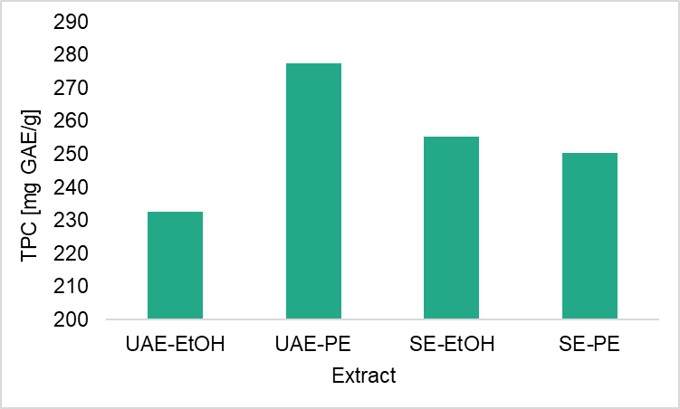 | 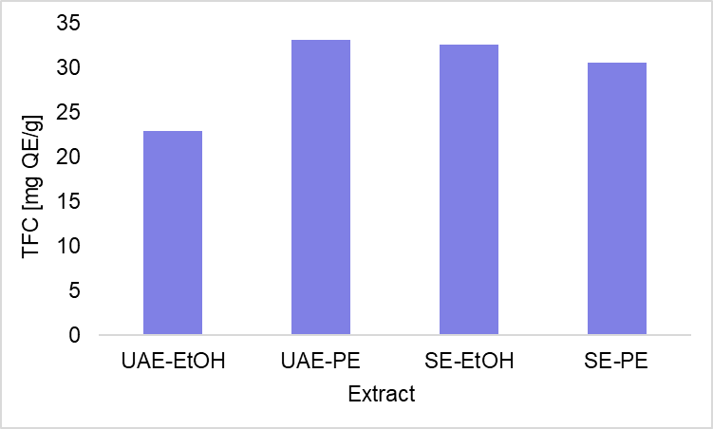
A | B
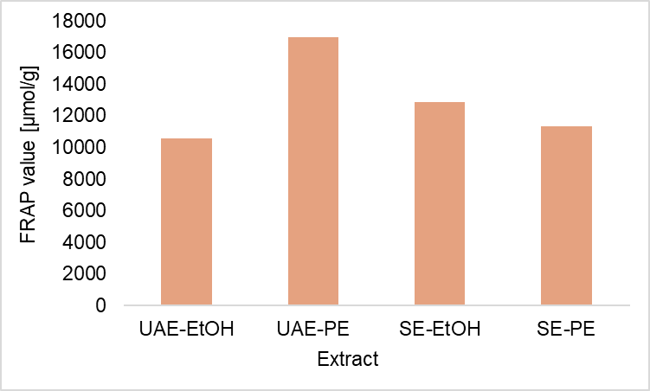 | 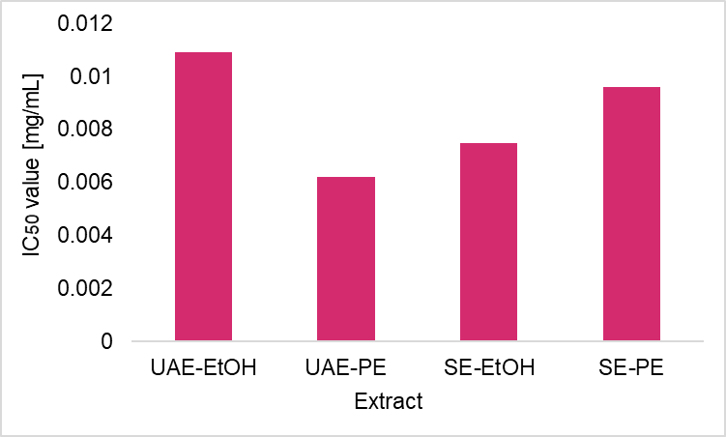
C | D
Fig. 2. Comparative graphical representations of: (A) total polyphenol content, (B) total flavonoids, (C) reducing ability and (D) DPPH radical neutralization efficiency (IC₅₀ value)

The antimicrobial activity of clove extracts was evaluated against six bacterial species, using standard antibiograms as the control to assess and compare their effectiveness.
Among Gram-negative bacteria (Table 3), the strongest inhibitory effect was observed against E. coli, with the largest inhibition zone for the UAE-PE extract (40 mm). In addition, significant values were noted for the SE-PE and UAE-EtOH extracts (30 mm). These results exceeded the inhibition of amoxyclav (20 mm) and were comparable to or higher than imipenem (33 mm). S. enterica exhibited moderate inhibition with values ranging between 20 and 25 mm, matching the inhibition zone of amoxiclav (21 mm). P. aeruginosa also showed inhibition in a similar range (16-25 mm), but UAE-PE extract was less effective (16 mm), with amoxyclav showing resistance and imipenem 20 mm.
Among Gram-positive bacteria (Table 4), S. aureus showed the highest susceptibility, with the UAE-EtOH extract producing a 29 mm inhibition zone, while all extracts exceeded the vancomycin activity (20 mm) but were slightly below amoxyclav (33 mm). B. subtilis and L. monocytogenes exhibited moderate inhibition, where UAE-PE was the most effective (27 mm and 25 mm, respectively). Among antibiotics, amoxyclav was most active against Listeria (32 mm) and showed moderate activity against B. subtilis (14 mm), while vancomycin was moderately active against Listeria (18 mm) but ineffective against B. subtilis. Ampicillin was ineffective against Listeria.
Table 3. Antibacterial activity of extracts against Gram-negative bacteria
Extract | Inhibition zone [mm]
Extract | E. coli | P. aeruginosa | S. enterica
UAE-EtOH | 30 | 25 | 20
UAE-PE | 40 | 16 | 25
SE-EtOH | 26 | 23 | 21
SE-PE | 30 | 20 | 21

Table 4. Antibacterial activity of extracts against Gram-positive bacteria
Extract | Inhibition zone [mm]
Extract | S. aureus | B. subtilis | L. monocytogenes
UAE-EtOH | 29 | 16 | 19
UAE-PE | 25 | 27 | 25
SE-EtOH | 25 | 23 | 20
SE-PE | 27 | 17 | 19

Overall, ultrasonic extraction generally yielded stronger antimicrobial effects than Soxhlet, while solvent choice influenced activity depending on bacterial species: petroleum ether favored Escherichia coli, Salmonella enterica, Listeria monocytogenes, and Bacillus subtilis, whereas ethanol was more effective against Pseudomonas aeruginosa and Staphylococcus aureus. In comparison to the antibiotic controls, clove extracts demonstrated comparable or even superior activity in several cases, highlighting their potential as natural antimicrobial agents.
The results of our research show that the antimicrobial activity of clove extracts depends on the extraction method and choice of solvent. Ultrasonic extraction in combination with petroleum ether gave the most pronounced inhibition zones in E. coli. Although eugenol is more often reported in the literature as more effective against Gram-positive bacteria, in our study it also showed a strong effect on Gram-negative strains. The study by Jeyakumar and Lawrence (2021) confirmed that eugenol acts on E. coli by increasing membrane permeability and leakage of intracellular contents, which leads to cell damage. A similar mechanism was observed in Salmonella typhi (Pandima et al., 2010), where eugenol primarily disrupts the integrity of the cytoplasmic membrane, causes leakage of intracellular proteins and causes morphological damage to the cell surface, which ultimately leads to cell death. In extracts obtained with ethanol, a polar solvent, flavonoids and phenolic acids were dominantly present, which had the most pronounced effect on P. aeruginosa and S. aureus. Their mechanism includes the generation of reactive oxygen species (ROS), DNA damage, inhibition of key enzymes, and disruption of bacterial signaling (Al-Tawalbeh et al., 2025). The results of Soxhlet extraction were weaker, probably due to the loss of thermolabile compounds during heating (Zhang et al., 2018).
“Other studies have highlighted that clove extracts, particularly those rich in eugenol, exhibit strong antibacterial activity against both Gram-positive and Gram-negative bacteria, including clinical multidrug-resistant (MDR) S. aureus strains” (Xu et al., 2016; Das et al., 2016; Yassin et al., 2020). Eugenol specifically exerts its antibacterial effects by inducing reactive oxygen species (ROS), causing DNA damage, and disrupting bacterial membranes, ultimately leading to cell death. These combined actions underscore the potential of eugenol and clove extracts as broad-spectrum natural antimicrobial agents. Liñán-Atero et al. (2024) demonstrated that clove essential oil (CEO), exhibits strong antibacterial as well as antifungal activity against foodborne pathogens and fungi, and due to its lipophilic nature and the presence of phenols, aldehydes, and ketones, it represents a promising natural food preservative. In the study by Kumari et al. (2013), clove bud extracts were prepared using Soxhlet extraction with various solvents, and petroleum ether extract had stronger antibacterial activity than ethanolic extracts. The higher efficacy of petroleum ether is likely due to better extraction of lipophilic compounds like eugenol, which aligns with our results, where ethanolic extracts were effective but slightly less potent.
“The ethanolic extract of Syzygium aromaticum demonstrated antimicrobial activity against both Gram-positive and Gram-negative bacteria” (Afanyibo et al., 2018), with Gram-positive strains such as S. aureus and L. monocytogenes generally being more susceptible, showing larger inhibition zones. Gram-negative bacteria (E. coli, P. aeruginosa, Salmonella, Shigella) were mostly affected bacteriostatically, with activity varying depending on the strain and extract concentration. These findings are consistent with previous studies (Hoque et al., 2008) reporting that “the ethanolic extract of clove exhibits strong activity against Gram-positive foodborne pathogens while being less effective against Gram-negative bacteria such as E. coli and Salmonella enteritidis, likely due to differences in cell wall structure”. Additionally, synergistic effects have been observed when clove extracts are combined with antibiotics such as imipenem or amoxicillin/clavulanic acid, enhancing efficacy against multidrug-resistant strains like P. aeruginosa (Al-Tawalbeh et al., 2025).
The review article by Marchese et al. (2017) confirmed that the primary target of eugenol is the bacterial membrane, while additional secondary mechanisms may vary depending on the microorganism. These findings show that the extraction method and solvent define the chemical profile and selective antimicrobial activity of clove extracts. Eugenol primarily disrupts the bacterial membrane, while flavonoids and phenolic acids act through oxidative and enzyme-mediated stress. This underlines their potential as natural antimicrobial agents, with extraction strategy and compound composition being key factors for efficacy.

4. Conclusion

The results of this study indicate that using ultrasonic extraction and a non-polar solvent (petroleum ether), most bioactive components are extracted from commercial cloves, which is reflected in the antioxidant activity of that extract. However, ethanol proved to be more efficient in the extraction of polyphenolic compounds using Soxhlet extraction. The lowest content of bioactive components was isolated by ultrasonic extraction, using ethanol as an extraction solvent. The results of the content of polyphenols and flavonoids are correlated with the results of antioxidant capacity. Regarding the antibacterial activity of the prepared extracts, a high sensitivity of the reference bacterial strains to all tested extracts was recorded.

DISCLAIMER (ARTIFICIAL INTELLIGENCE)

Author(s) hereby declare that NO generative AI technologies such as Large Language Models (ChatGPT, COPILOT, etc.) and text-to-image generators have been used during the writing or editing of this manuscript.

References

Afanyibo, Y. , Anani, K. , Esseh, K. , Sadji, Y. , Idoh, K. , Koudouvo, K. , Agbonon, A. , Améyapoh, Y. , Tozo, K. and Gbeassor, M. (2018) Antimicrobial Activities of Syzygium aromaticum (L.) Merr. & L.M. Perry (Myrtaceae) Fruit Extracts on Six Standard Microorganisms and Their Clinical Counterpart. Open Access Library Journal, 5, 1-13.
Akter, A., Neela, F. A., Khan, M. S. I., Islam, M. S., & Alam, M. F. (2010). Screening of ethanol, petroleum ether and chloroform extracts of medicinal plants, Lawsonia inermis L. and Mimosa pudica L. for antibacterial activity. Indian Journal of Pharmaceutical Sciences, 72(3), 388-392.
Alanazi, A.K., Alqasmi, M.H., Alrouji, M., Kuriri, F.A., Almuhanna, Y. Joseph, B. et al. (2022). Antibacterial activity of Syzygium aromaticum (Clove) bud oil and its interaction with imipenem in controlling wound infections in rats caused by methicillin-resistant Staphylococcus aureus. Molecules, 27, 8551.
Al-Tawalbeh, D.M., Saha, S.K., Hani, U., Paul, S.K., Sharmin, M., Basak, S. Begum, S.A. et al. (2025). Comparative antibacterial activity of clove extract against Pseudomonas aeruginosa. BMC Complementary Medicine and Therapies, 25(1), 7.
Benzie, IFF., Strain, JJ. (1999). Ferric reducing antioxidant power assay: Direct measure of total antioxidant activity of biological fluids and modified version for simultaneous measurement of total antioxidant power and ascorbic acid concentration. Methods in Enzymology, 299, 15-27.
Boughendjioua, H., 2018. Essential oil composition of Syzygium aromaticum (L.). International Research Journal of Pharmacy and Medical Sciences, 1(3), 26-28.
Chaieb, K., Zmantar, T., Ksouri, R., Hajlaoui, H., Mahdouani, K., Abdelly, C. & Bakhrouf, A. (2007). The chemical composition and biological activity of clove (Syzygium aromaticum) essential oil. Phytotherapy Research, 21(6), 501-506.
Cortés-Rojas, D.F., de Souza, C.R.F. & Oliveira, W.P. (2014). Clove (Syzygium aromaticum): A precious spice. Asian Pacific Journal of Tropical Biomedicine, 4(2), 90-96.
Das, B., Mandal, D., Dash, S. K., Chattopadhyay, S., Tripathy, S., Dolai, D. P., Dey, S. K., Roy, S., (2016). Eugenol provokes ROS-mediated membrane damage-associated antibacterial activity against clinically isolated multidrug-resistant Staphylococcus aureus strains. Infect Dis Res and Treat, 9, IDRT. S31741.
Didehdar, M., Chegini, Z. & Shariati, A. (2022). Eugenol: A novel therapeutic agent for the inhibition of Candida species infection. Frontiers in Pharmacology, 13, 872127.
El-Saber Batiha, G., Alkazmi, L.M., Wasef, L.G., Beshbishy, A.M., Nadwa, E.H., Rashwan, E.K. (2020). Syzygium aromaticum L. (Myrtaceae): Traditional uses, bioactive chemical constituents, pharmacological and toxicological activities. Biomolecules, 10(2), 202.
Filho, G.A., Cesar, J.O. & Ramos, J.V. (2013). Cravo from India. [Online] Available at: http://www.ceplac.gov.br/radar.htm
Freitas, V.D., Coelho, E.L.J., Moreira, J.M.A.R., Dutra, V., Sousa, V.R.F. & Almeida, A.d.B.P.F. (2025). Antibacterial activity of clove essential oil (Syzygium aromaticum) against oxacillin-resistant Staphylococcus pseudintermedius isolated from dogs with otitis externa. Pathogens, 14(7), 709.
Gulcin, I. (2011). Antioxidant Activity of Eugenol: A Structure–Activity Relationship Study. Journal of Medicinal Food, 14(9), 975-985.
Gulcin, I. (2020). Antioxidants and antioxidant methods: an updated overview. Archives of Toxicology, 94, 651-715.
Haro-González, J.N., Castillo-Herrera, G.A., Martínez-Velázquez, M. & Espinosa-Andrews, H. (2021). Clove essential oil (Syzygium aromaticum L. Myrtaceae): Extraction, chemical composition, food applications, and essential bioactivity for human health. Molecules, 26(21), 6387.
Hemalatha, R., Nivetha, P., Mohanapriya, C., Sharmila, G., Muthukumaran, C. & Gopinath, M. (2016). Phytochemical composition, GC-MS analysis, in vitro antioxidant and antibacterial potential of clove flower bud (Eugenia caryophyllus) methanolic extract. Journal of Food Science and Technology, 53, 1189-1198.
Hoque, M. M., Bari, M. L., Juneja, V. K., & Kawamoto, S. (2008). Antimicrobial activity of cloves and cinnamon extracts against foodborne pathogens and spoilage bacteria, and inactivation of Listeria monocytogenes in ground chicken meat with their essential oils. National Food Research Institute Report, No. 72, 9–21.
Horozić, E., Zukić, A., Kolarević, L., Bjelošević, D., Ademović, Z., Šarić-Kundalić, B., Husejnagić, D., Kudumović, A., Hamzić, S. (2019). Evaluation of antibacterial and antioxidant activity of methanol needle extracts of Larix Decidua Mill., Picea Abies (L.) H. Karst. and Pinus Nigra JF Arnold. TTEM, 14(1), 14-19.
Jeyakumar, G. E., & Lawrence, R. (2021). Mechanisms of bactericidal action of Eugenol against Escherichia coli. Journal of Herbal Medicine, 26, 100406.
Kim, K.H., Rateb, M., Hassan, H., Elbestawy, M.K.M., El-Sherbiny, G.M. & Moghannem, S.A. (2023). Antibacterial, antibiofilm and anti-inflammatory activities of eugenol clove essential oil against resistant Helicobacter pylori. Molecules, 28, 2448.
Kumari, S., Moorthi, S., & Kalpana, S. (2013). Antimicrobial activity of different extracts of Syzygium aromaticum (Linn.) against foodborne pathogens. International Journal of Current Microbiology and Applied Sciences, 2(11), 30–35
Lakshmi Praba, K., Jagan Mohan, R. & Loganathan, M. (2022). Optimization of concentration of clove (Syzygium aromaticum) extract on reduction of histamine content during fermentation of Idli batter. International Journal of Life Science and Pharma Research, 12, L53-L61.
Liñán-Atero, R., Aghababaei, F., Rodríguez García, S., Hasiri, Z., Ziogkas, D., Moreno, A. & Hadidi, M. (2024). Clove essential oil: Chemical profile, biological activities, encapsulation strategies, and food applications. Antioxidants, 13(4), 488.
Lone, Z.A. & Jain, N.K. (2022). Phytochemical analysis of clove (Syzygium aromaticum) dried flower buds extract and its therapeutic importance. Journal of Drug Delivery & Therapeutics, 12(4-S), 87-92.
Lopez, P., Sanchez, C., Batlle, R. & Nerín, C. (2005). Solid- and vapor-phase antimicrobial activities of six essential oils: Susceptibility of selected foodborne bacterial and fungal strains. Journal of Agricultural and Food Chemistry, 53, 6939-6946.
Marchese A, Barbieri R, Coppo E, Orhan IE, Daglia M, Nabavi SF, Izadi M, Abdollahi M, Nabavi SM, Ajami M. Antimicrobial activity of eugenol and essential oils containing eugenol: A mechanistic viewpoint. Crit Rev Microbiol. 2017 Nov;43(6):668-689. doi: 10.1080/1040841X.2017.1295225. Epub 2017 Mar 27. PMID: 28346030.
Matan, N., Rimkeeree, H., Mawson, A.J., Chompreeda, P., Haruthaithanasan, V. & Parker, M. (2006). Antimicrobial activity of cinnamon and clove oils under modified atmosphere conditions. International Journal of Food Microbiology, 107, 180-185.
Mostafa, A.A., Elden, S.S., Abdallah, H.M., El-Hawary, S.S. & Abdelwahab, S.I. (2023). Phytochemical analysis, antiproliferative and antifungal activities of different Syzygium aromaticum solvent extracts. Journal of King Saud University – Science, 35(1), 102362.
Olajire, AA., Azeez, L. (2011). Total antioxidant activity, phenolic, flavonoid and ascorbic acid contents of Nigerian vegetables. African Journal of Food Science and Technology, 2(2), 22-29.
Pandey, V.K., Srivastava, S., Verma, A., Dash, K.K., Singh, R., Dar, A.H., et al. (2024). Bioactive properties of clove (Syzygium aromaticum) essential oil nanoemulsion: A comprehensive review. Heliyon, 10(1), e22437.
Pandima Devi, K., Arif Nisha, S., Sakthivel, R., & Karutha Pandian, S. (2010). Eugenol (an essential oil of clove) acts as an antibacterial agent against Salmonella typhi by disrupting the cellular membrane. Journal of Ethnopharmacology, 130(1), 107–115.
Pei, R.S., Zhou, F., Ji, B.P. & Xu, J. (2009). Evaluation of combined antibacterial effects of eugenol, cinnamaldehyde, thymol, and carvacrol against E. coli with an improved method. Journal of Food Science, 74, M379-M383.
Sarrami, N., Pemberton, M., Thornhill, M. & Theaker, E.D. (2002). Adverse reactions associated with the use of eugenol in dentistry. British Dental Journal, 193, 253.
Shehu, I., Sanusi, S.B. i Saka, H.K. (2023). Study on antibacterial activity of clove (Syzygium aromaticum) crude extract against Staphylococcus aureus, Escherichia coli, Salmonella sp. and Pseudomonas sp. Science World Journal, 18(1), 97-100.
Singleton, VL., Orthofer, R., Lamuela-Raventós, RM. (1999). Analysis of total phenols and other oxidation substrates and antioxidants by means of Folin-Ciocalteu reagent. Methods in Enzymology, 299, 152-178.
Ulanowska, M. & Olas, B. (2021). Biological properties and prospects for the application of eugenol – A Review. International Journal of Molecular Sciences, 22(7), 3671.
Uwineza, P. A. & Waśkiewicz, A. (2020). Recent Advances in Supercritical Fluid Extraction of Natural Bioactive Compounds from Natural Plant Materials. Molecules, 25(17), 3847.
Wadi, M.A., Alwan, M.A., Abbas, M., Fidhe, M.A., Tauma, J.A. & Mlaghee, S.M. (2025). Evaluation of antibacterial activity and chemical analysis of clove aqueous extract (Syzygium aromaticum). BMC Complementary Medicine and Therapies, 25(1), 146.
Xu, J.-G., Liu, T., Hu, Q.-P., & Cao, X.-M. (2016). Chemical Composition, Antibacterial Properties and Mechanism of Action of Essential Oil from Clove Buds against Staphylococcus aureus. Molecules, 21(9), 1194.
Yassin, M.T., Mostafa, A.A.-F. & Al-Askar, A.A. (2020). In vitro anticandidal potency of Syzygium aromaticum (clove) extracts against vaginal candidiasis. BMC Complementary Medicine and Therapies, 20(1), 25.
Yassin, M. T., Al-Askar, A. A., Mostafa, A. A.-F., & El-Sheikh, M. A. (2020). Bioactivity of Syzygium aromaticum (L.) Merr. & L.M. Perry extracts as potential antimicrobial and anticancer agents. Journal of King Saud University - Science, 32(8), 3273–3278.
Zhang, Q. W., Lin, L. G., & Ye, W. C. (2018). Techniques for extraction and isolation of natural products: a comprehensive review. Chinese medicine, 13, 20.

