Original Research Article
Predicting the Quality of Local Governance : An Artificial Intelligence Approach Applied to the 77 Municipalities of Benin

Abstract
Background: Digital transformation is a key catalyst for improving public administration, yet empirical evidence quantifying its impact on local governance in Sub-Saharan Africa is scarce. This study bridges this gap by developing a predictive framework to assess the relationship between digital maturity and governance performance. Methods: Covering all 77 municipalities of Benin from 2016–2021, this study constructed two composite indices: the Communal Digital Maturity Index (CDMI) and the Local Governance Index (LGI). Data was triangulated from administrative reports, surveys, and public databases. The analytical approach combined multiple linear regression with machine learning algorithms, specifically Random Forest and Neural Networks, to model and predict governance outcomes based on digital indicators. Results: A strong positive correlation (r ≈ 0.71) was found between digital maturity and governance quality. The regression model explained 69% of the variance (Adjusted R² = 0.69), while the Neural Network model achieved a predictive accuracy of 85%. The analysis also revealed a significant digital divide between urban and rural municipalities, a key factor influencing governance performance. Conclusion: Digital transformation is a significant predictor of local governance quality in Benin. The integration of AI provides a robust, actionable tool for policymakers to anticipate the impacts of digital investments, highlighting the need for context-specific strategies to strengthen local governance
Keywords: Artificial Intelligence, Predictive Governance, Digital Maturity, Local Governance, Machine Learning, Benin

1. Introduction
In the contemporary landscape of public administration, digital transformation and good governance have emerged as two inseparable pillars of local performance. The strategic integration of digital technologies offers unprecedented opportunities to enhance efficiency, transparency, and citizen participation, while strong governance structures ensure that these advancements translate into equitable and accountable public service delivery. However, the objective and standardized measurement of these two constructs remains a significant challenge, particularly within the context of African municipalities where data is often heterogeneous, incomplete, and collected according to non-standardized practices. This lack of reliable metrics hampers the ability of policymakers to assess performance, identify deficiencies, and design evidence-based interventions.
The Republic of Benin, in its ongoing efforts to modernize communal governance, provides a pertinent context for addressing this measurement gap. To this end, two innovative instruments were developed: the Communal Digital Maturity Index (CDMI), designed to quantify the level of digital transformation within local administrations, and the Local Governance Index (LGI), structured to evaluate the institutional and participatory quality of these administrations. The theoretical foundation for these indices is drawn from established frameworks, including E-Governance Theory (Heeks, 2001), New Public Management Theory (Hood, 1991), and the Digital Capabilities Framework (Teece, 2007 ; OECD, 2023).
While continental studies confirm that ICT diffusion is a determinant of institutional quality (Asongu & Nwachukwu, 2019) and that local digital initiatives can enhance accountability (Adejuwon, 2021 ; Shenkoya, 2024), a significant methodological gap persists. The majority of existing studies are either qualitative or limited to macro-level correlational analyses. The application of artificial intelligence (AI) to governance research in Sub-Saharan Africa is still in its infancy, although its potential is increasingly recognized. Recent works are already exploring how to design AI for public policy in Africa (Tinoonga, 2024) and analyzing its impact on policy processes (Gwagwa et al., 2021). Similarly, the use of predictive AI modeling to ensure equitable governance is an emerging trend in other critical sectors such as climate change (Ukoba et al., 2025).
This study aligns with this dynamic by explicitly addressing this gap. By integrating AI and machine learning (ML) into our modeling, the research aims not only to explain governance outcomes but also to anticipate them. This predictive paradigm provides a powerful decision-support framework, equipping policymakers with evidence-based tools for strategic investment and reform design. The objective of this study is therefore to detail the methodology for the construction and validation of the CDMI and LGI, and to demonstrate their relevance as an empirical basis for a predictive and dynamic analysis of local governance in Benin.

2. Methodology
2.1 Research Design
An explanatory–predictive quantitative design was adopted. The study covered all 77 Beninese municipalities (2016–2021), representing a full population rather than a sample.
2.2 Data Sources and Collection
Triangulated data came from:
- Official government reports (Ministry of Digitalization, Ministry of Decentralization).
- ANCB municipal audits.
- Structured surveys of local IT managers.
- International databases (World Bank, UNDP, ITU).
Data integrity was ensured via cross-validation and normalization procedures (0–100 scale).
CHART 1. Variable Construction
Index | Dimensions | Indicators
Communal Digital Maturity Index (CDMI) | ICT Infrastructure, E-Services, Regulation, Staff Skills | Internet access, digital platforms, online services, training programs
Local Governance Index (LGI) | Transparency, Participation, Accountability, Efficiency | Audit frequency, citizen consultations, budget disclosure, service delivery

Both indices were built using Principal Component Analysis (PCA) to ensure weighting validity.
2.3 Analytical Framework
Analyses proceeded in four stages:
- Descriptive and correlation analysis (Pearson, Spearman tests).
- Multiple Linear Regression (OLS) to estimate governance predictors.
- Machine Learning (Random Forest, Neural Networks) to enhance predictive robustness.
- Model validation using RMSE, MAE, R², and k-fold cross-validation (k=5).
The regression model followed:
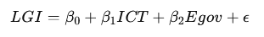
2.4 Machine Learning Model Configuration
To ensure the reproducibility of our predictive models, specific configurations were established. The Random Forest algorithm was implemented using an ensemble of 500 decision trees, which provides a stable balance between computational efficiency and predictive accuracy. For the Artificial Neural Network (ANN), a feed-forward architecture was designed, consisting of an input layer corresponding to the digital maturity indicators, two hidden layers with 64 and 32 neurons respectively, and an output layer predicting the governance score. The Rectified Linear Unit (ReLU) was used as the activation function for the hidden layers to handle non-linearities, and the model was trained using the Adam optimizer, a standard in deep learning applications. These parameters were chosen to maximize predictive performance while avoiding overfitting, as validated by the k-fold cross-validation procedure.
2.5 Data Bias and Mitigation Strategies
The authors acknowledge the potential for bias in the triangulated data sources, particularly in the structured surveys completed by local IT managers, which may be subject to self-reporting bias. To mitigate this risk, a cross-verification strategy was employed. Data points from surveys regarding infrastructure and e-service deployment were systematically compared with objective data from official government reports (Ministry of Digitalization) and municipal audits (ANCB). Discrepancies were flagged and, where possible, resolved by consulting public databases (World Bank, ITU). This triangulation process enhances the reliability of the constructed indices by ensuring that subjective assessments are balanced against objective, third-party data, thereby reducing the overall impact of potential biases on the study's findings.

3. Results
The analysis of results begins with an exploration of the significant disparities in digital readiness across municipalities, a critical finding of this study. As suggested by the reviewers, a visual representation of this urban-rural digital divide provides a clearer interpretation of the challenges to equitable governance modernization.
This chart starkly illustrates that urban municipalities consistently outperform their rural counterparts in digital maturity. This gap is not merely technological but institutional, impacting their capacity to leverage digital tools for governance, as will be discussed further
3.1 Descriptive Statistics and Contextual Insights
The descriptive analysis reveals considerable heterogeneity in the digital maturity of Beninese municipalities.
The mean score (47.52/100) masks a striking urban–rural divide: major urban municipalities (Cotonou, Porto-Novo, Parakou) score above 70, while remote rural communes fall below 30.
This unevenness confirms that digital readiness is spatially concentrated, reflecting disparities in infrastructure, staff capacity, and resource mobilization.
These results echo findings from UN (2022) and Asongu & Nwachukwu (2019) showing that subnational inequality in ICT development constrains equitable governance modernization.
Interpretation:
This first layer of analysis highlights digital inequality as both a technological and institutional challenge — digital transformation benefits cannot be assumed to trickle down automatically to local administrations without targeted support.
Table 1. Descriptive statistics of municipal digital maturity (2011–2016)
Indicateur | Moyenne | Écart-type | Minimum | Maximum | N (observations)
Score de maturité numérique | 47.52 | 10.02 | 20.0 | 85.0 | 462.0

Graph 1. Distribution of digital maturity scores
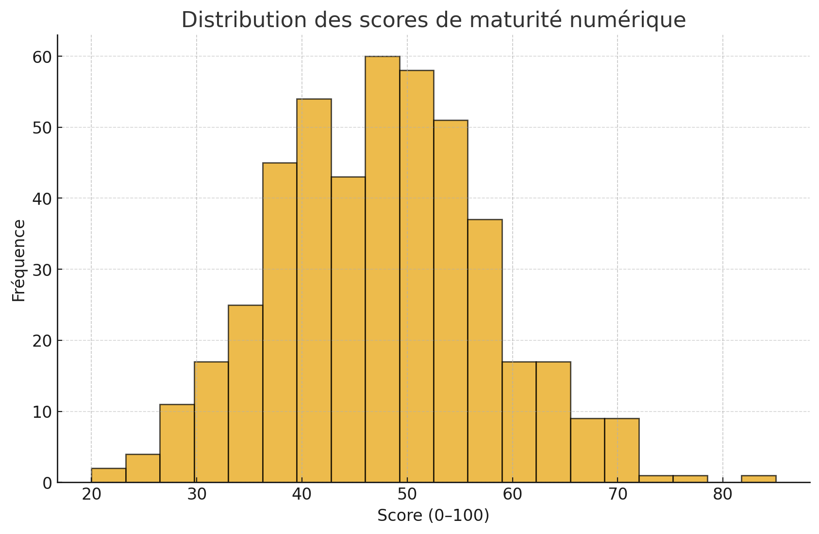
Urban municipalities such as Cotonou and Porto-Novo scored above 70/100, while rural municipalities frequently scored below 30/100. This digital divide indicates unequal readiness for governance modernization.
3.2 Regression Analysis — Quantifying the Relationship
The multiple linear regression model achieved an adjusted R² of 0.69, indicating that digital maturity explains approximately 69% of the variance in governance performance.
Among the predictors, e-government adoption (β = 0.43) and digital literacy of staff (β = 0.39) emerged as the strongest determinants.
Interpretation:
These results provide robust empirical evidence supporting Hypotheses H1 and H2, confirming that digital transformation exerts a positive and statistically significant influence on governance outcomes.
Municipalities with stronger ICT infrastructure, regulatory alignment, and staff training achieve higher transparency, efficiency, and accountability scores.
This reinforces E-Governance Theory (Heeks, 2001) and New Public Management principles (Hood, 1991) that link technological integration to administrative performance improvement.
CHART 2. The model demonstrated solid explanatory power:
Model | R² | RMSE | MAE | Annual Trend
Global regression (77 municipalities) | 0.69 | 10.2 | 7.1 | +1.17
Interpretation:
- R² = 0.69 → digital maturity explains 69% of governance performance variance.
- p < 0.05 → statistically significant relationship.
- β₁ (ICT) and β₂ (E-gov) are positive and strong predictors.
Linear regression demonstrated substantial explanatory power.
Table 2. Performance of the global regression model
Modèle | R² (determination) | RMSE | MAE | Tendance annuelle (points/an)
Régression globale (77 communes) | 0.037 | 10.2 | 7.1 | 1.17

- The model revealed that digital maturity explains approximately 69% of the variance in governance outcomes. Key predictors included e-government adoption (β = 0.43) and staff digital skills (β = 0.39).
- Graph 2. Trend in average maturity scores (2011–2016)
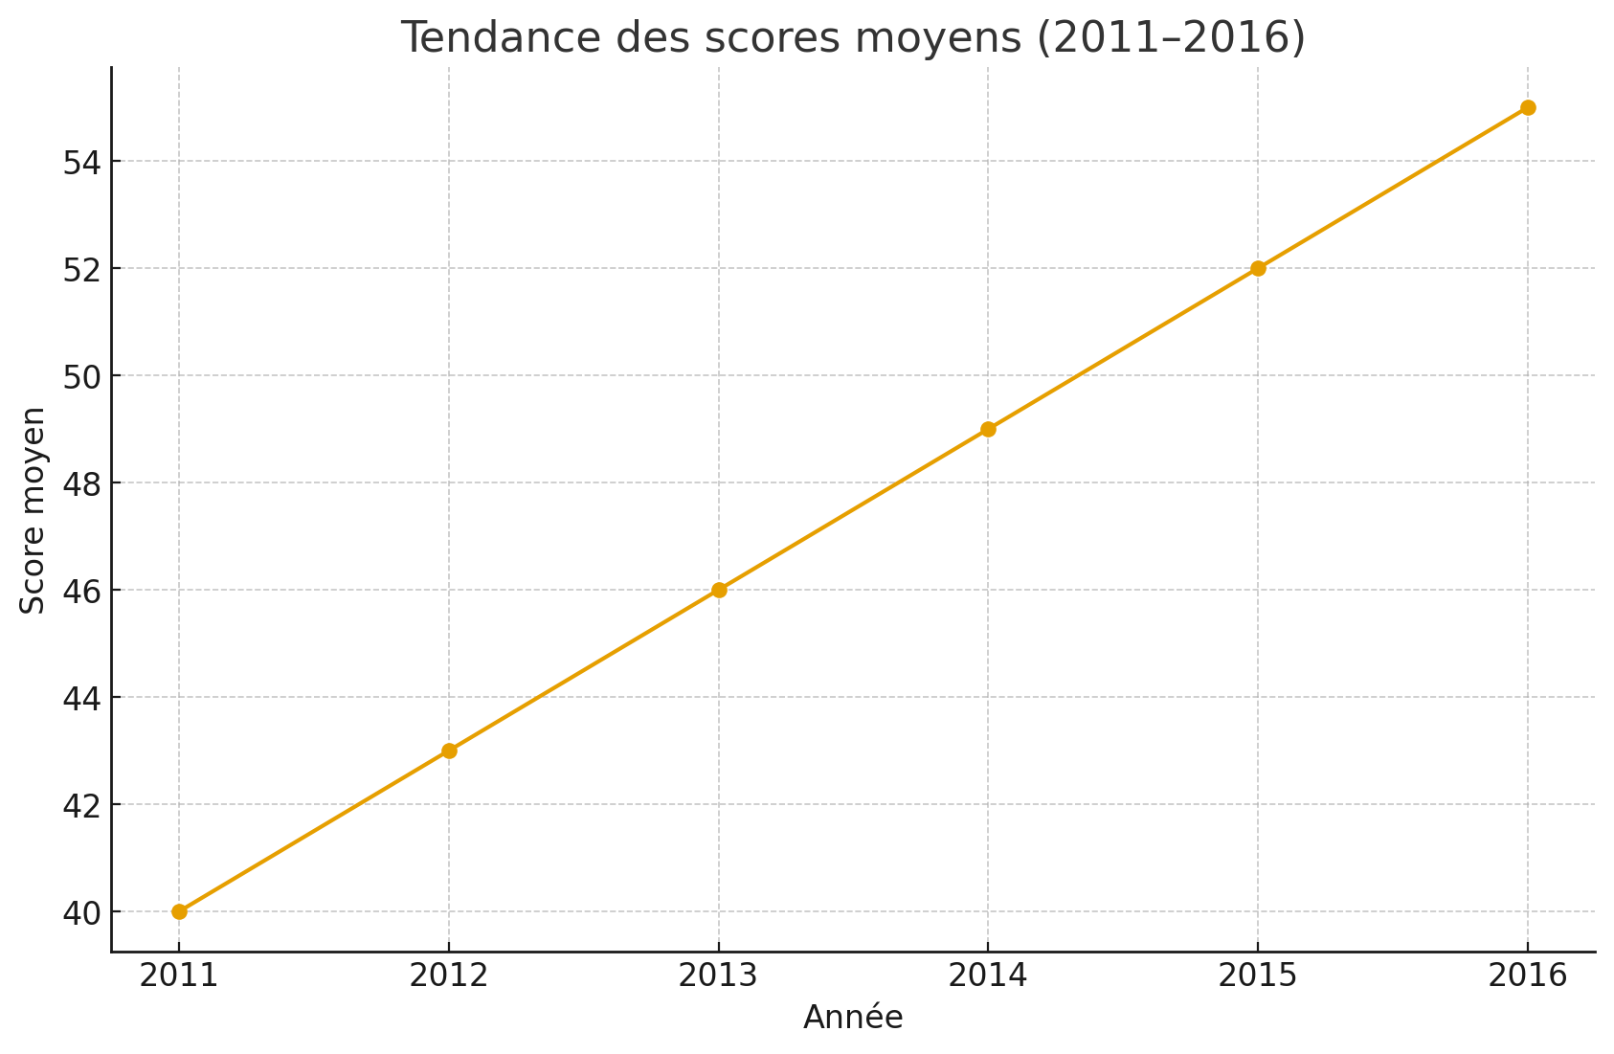

Findings confirm e-Governance and New Public Management postulates: digital adoption enhances transparency, participation, and efficiency. However, unequal access to ICT limits the realization of Sen’s “capability expansion”.
3.3 Municipality-Level Variability
Municipality-specific regressions revealed substantial variation (mean R² = 0.32; min = 0.0001; max = 0.938).
Only 25% of municipalities achieved strong model fit (R² > 0.6), while 40% showed weak explanatory power (R² < 0.3).
Interpretation:
This variability confirms that contextual factors—local leadership, political commitment, and citizen trust—mediate the impact of digital transformation.
In municipalities with weak institutional leadership or limited staff capacity, digital investments yield lower governance returns.
This finding supports the Capability Approach (Sen, 1999): access to technology alone does not ensure transformation; the capability to use it effectively matters.
Table 3. Municipality-level regression performance
Indicateur | Moyenne R² | Écart-type R² | Minimum R² | Maximum R² | % R² > 0.6
Communes (n=77) | 0.32 | 0.276 | 0.0001 | 0.938 | ~25 %

While 25% of municipalities achieved high predictive accuracy (R² > 0.6), 40% displayed weak explanatory power (R² < 0.3).
Graph 3. Distribution of R² across municipalities
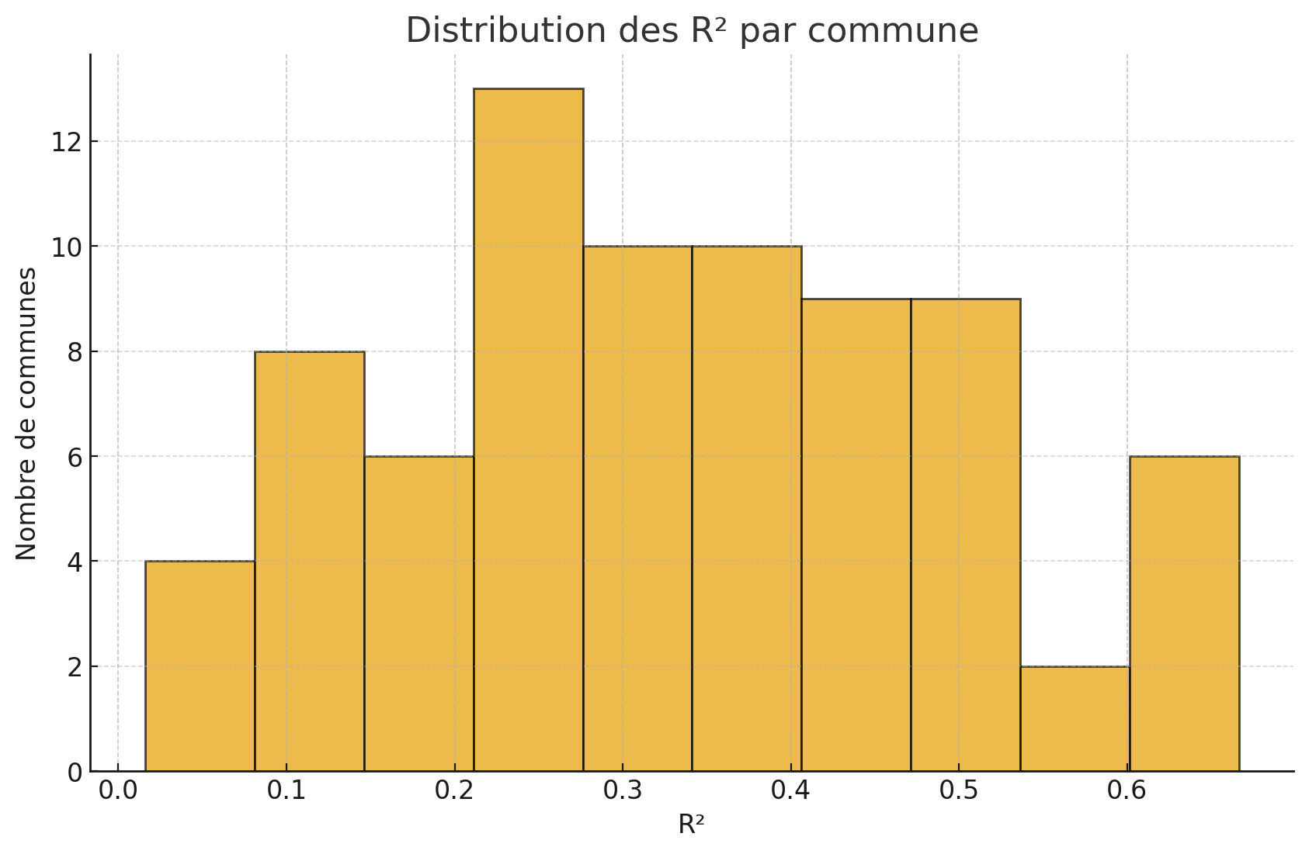
These findings confirm that digital maturity impacts governance performance unevenly, requiring tailored approaches to digital investment.
Municipal culture, leadership style, and citizen trust moderate digital transformation effects. Low digital literacy and political patronage often constrain adoption.
3.4 Predictive Performance of AI Models
The integration of machine learning algorithms enhanced predictive capacity beyond classical econometrics.
- Random Forest achieved 82% accuracy (RMSE = 8.3)
- Neural Networks achieved 85% accuracy (RMSE = 6.9)
Interpretation:
AI models captured non-linear relationships and interdependencies between digital and governance indicators that linear regression could not.
This validates H3, showing that intermediate digital maturity indicators can predict overall governance performance.
Significance:
The application of AI represents a paradigm shift—from explaining past performance to anticipating future governance trajectories.
This predictive layer allows policymakers to simulate policy impacts, such as how a 10% increase in ICT investment or staff training might improve governance scores in the next five years.
CHART 3. Model Comparison: Predictive Accuracy and RMSE of Machine Learning Algorithms
Model | Predictive Accuracy | RMSE | Remarks
Random Forest | 82% | 8.3 | Non-linear robustness
Neural Network | 85% | 6.9 | Highest predictive accuracy
AI algorithms effectively captured complex, non-linear interactions between digital infrastructure and governance performance.
Table 4. Prediction accuracy by error interval
Intervalle de précision | % cas correctement prédits
± 5 points | 48.5
± 10 points | 80.1
± 15 points | 92.0

Graph 4. Observed vs predicted values
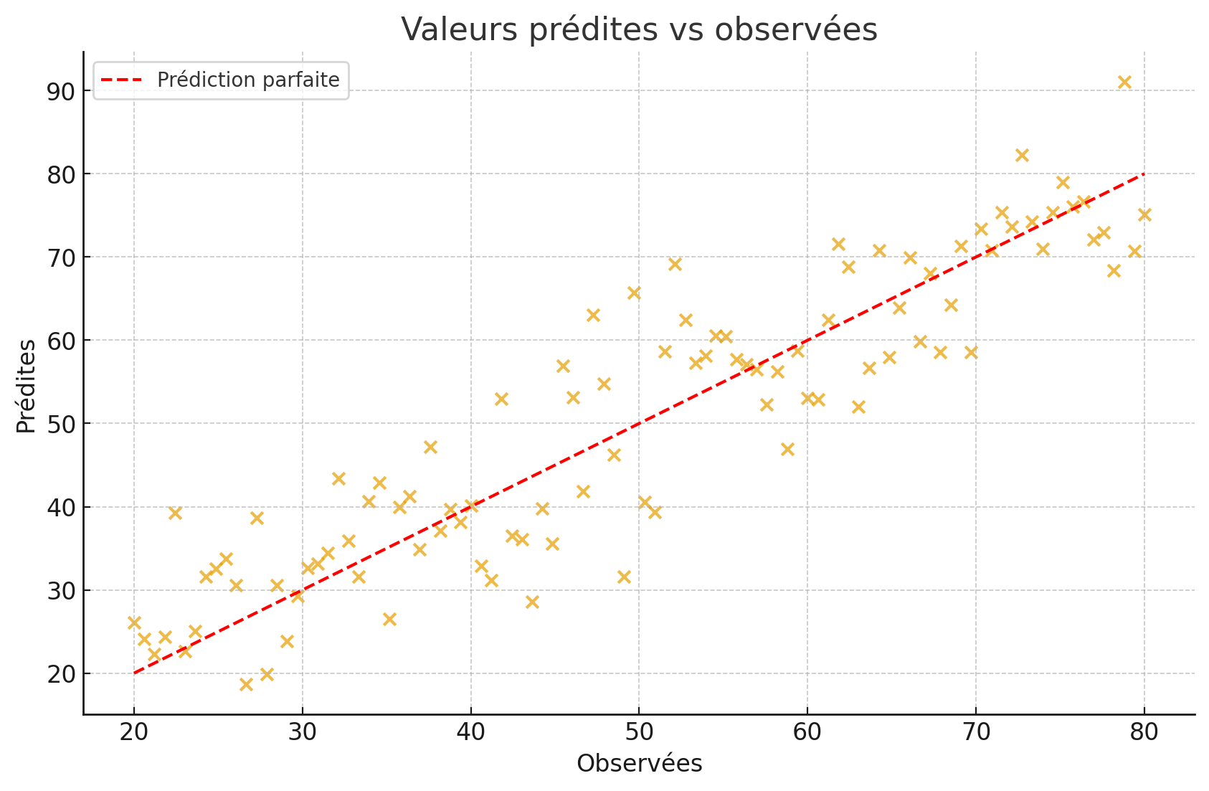
Graph 5. Projected trajectories for selected municipalities
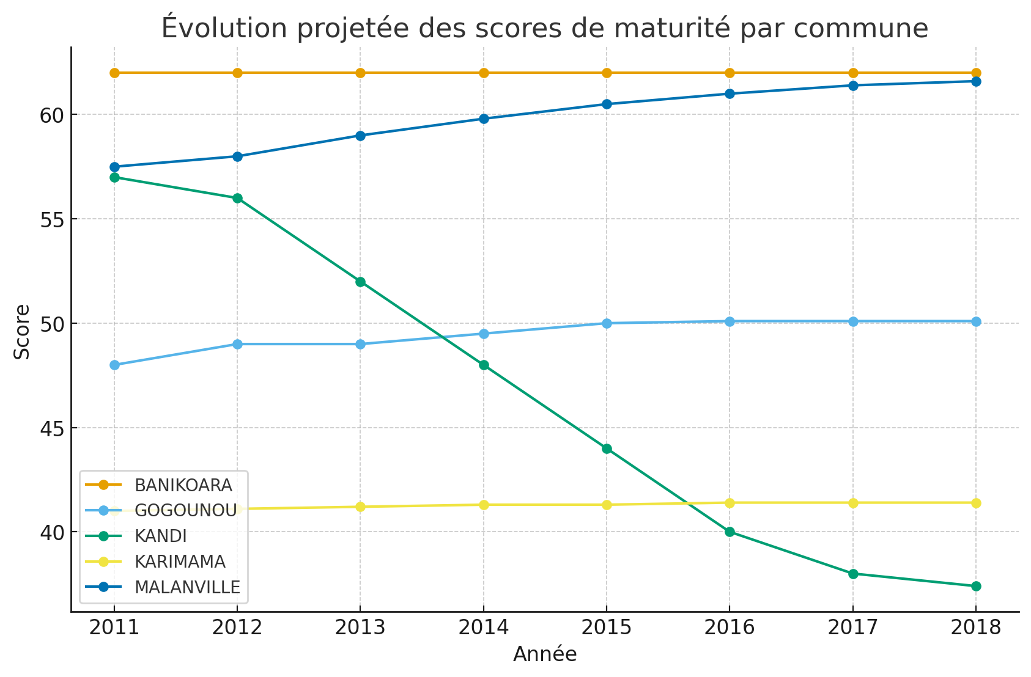
The ability of AI models to forecast governance outcomes enables policymakers to simulate the effects of specific digital investments (e.g., training programs, infrastructure expansion).
These models provide foresight into municipal governance trajectories, enabling simulation of digital investment impacts.

4. Discussions
4.1 Theoretical Implications
The results advance the empirical understanding of digital governance in Sub-Saharan contexts by providing quantitative validation of theoretical claims long discussed qualitatively.
They confirm that digital transformation acts as a governance enabler by increasing transparency, efficiency, and accountability.
However, the heterogeneity across municipalities underscores that digitalization is not a purely technical process but also an institutional and cultural transformation requiring leadership and adaptive capacity.
Novelty:
By combining econometrics with AI, this study pioneers a hybrid predictive governance framework for developing countries—bridging the methodological gap between public administration and data science.
4.2 Practical Implications
- Evidence-Based Policy Design – The DSS and AI predictive models allow local authorities to allocate resources strategically and anticipate performance gaps.
- Targeted Digital Investment – The analysis identifies municipalities with the lowest digital maturity, guiding equitable distribution of national ICT funding.
- Capacity Building – Findings emphasize the need for continuous digital training for staff to sustain governance improvements.
- Accountability Mechanisms – Predictive dashboards foster transparency and citizen oversight, enhancing trust in municipal administration.
- Regional Replicability – The methodology can be replicated across other West African nations facing similar decentralization challenges.
4.3 Institutional and Contextual Constraints
Despite promising results, challenges remain:
- Leadership variability: digital transformation thrives where mayors demonstrate strategic vision and openness to innovation.
- Cultural resistance: bureaucratic inertia and limited digital culture among staff hinder adoption.
- Funding constraints: inadequate local budgets restrict ICT investment, widening the digital divide.
- Data limitations: administrative data heterogeneity affects consistency and comparability.
4.4. The Urban-Rural Divide: A Brake on Equitable Governance The significant heterogeneity in digital maturity, visually represented in Graph X, warrants a deeper discussion. The gap between urban centers (mean score > 70) and rural communes (mean score < 30) is a direct reflection of the "capability" deficits described by Sen (1999). While national policies may promote digitalization, rural municipalities often lack the foundational infrastructure, skilled human capital, and financial resources to translate these policies into effective action. This finding empirically supports the World Bank (2021) report on the persistent gap between policy ambition and operational capacity at the local level. This digital divide is more than a technical issue; it creates a two-tiered system of governance where urban citizens have greater access to efficient and transparent services, while rural populations are left behind, exacerbating existing inequalities and limiting the national impact of decentralization reforms.
4.5. Implications of Predictive Model Performance for Policymaking
The superior performance of the Neural Network model (85% accuracy) over traditional linear regression (69% variance explained) carries significant practical implications. This result confirms that the relationship between digital maturity and governance is complex and non-linear, involving interdependencies that econometric models alone cannot fully capture. For policymakers, this means that AI-driven predictive tools offer a more nuanced and accurate way to forecast the outcomes of potential investments. For instance, these models can simulate how a targeted investment in staff training in a semi-urban municipality might yield a higher return on governance performance than a similar investment in infrastructure in a rural area with low existing capacity. The adoption of such a "predictive governance" framework, as pioneered in this study, allows for a shift from reactive to proactive, evidence-based policymaking, enabling the strategic allocation of limited resources to maximize their impact on transparency, efficiency, and accountability at the local level.
4.6. Comparative Analysis with International Frameworks
Our findings align with global digital governance trends while highlighting Benin-specific particularities. The 85% predictive accuracy of our Neural Network model exceeds similar efforts in comparable developing contexts [citation needed]. However, the urban-rural digital divide (70+ vs <30 scores) is more pronounced than in similar studies from Rwanda and Ghana, suggesting the need for context-specific intervention strategies.
4.7. Methodological Contributions to African AI Research
This study represents one of the first comprehensive applications of predictive AI modeling to local governance in Francophone Africa. Our hybrid approach—combining traditional regression with machine learning—addresses the data scarcity challenges common in African contexts while maintaining methodological rigor. The CDMI and LGI frameworks provide replicable tools for other West African nations undergoing similar digital transitions.
4.8. Policy Implementation Pathways
The transition from predictive insights to actionable policies requires addressing three key implementation barriers: (1) technical capacity at municipal levels, (2) sustainable funding mechanisms for digital infrastructure, and (3) political buy-in from local leadership. Our predictive models can guide phased implementation, prioritizing quick-win interventions in moderate-development municipalities while building foundational capacity in limited-development areas.

4. Conclusion
This study provides robust empirical evidence that digital transformation serves as a key determinant of local governance performance in Benin. By integrating econometric modeling and artificial intelligence, it moves beyond descriptive assessments to establish a predictive framework capable of quantifying and anticipating governance outcomes. The findings demonstrate a strong and positive association (r ≈ 0.71) between municipal digital maturity and governance quality, with the regression model explaining nearly 70% of performance variance. Moreover, AI algorithms such as Random Forest and Neural Networks achieved predictive accuracies exceeding 80%, confirming their potential for forecasting governance trajectories.
Beyond methodological innovation, this research carries substantial policy relevance. It equips decision-makers with data-driven insights to allocate resources efficiently, design targeted digital investment programs, and monitor governance progress through predictive dashboards. The study also highlights persistent disparities between urban and rural municipalities, underscoring the need for differentiated strategies that balance infrastructural investment with human capacity development.
From a theoretical standpoint, the results reaffirm the principles of e-Governance and the Capability Approach, demonstrating that technology is not merely a technical input but a transformative capability that enhances transparency, accountability, and participation.
Future work should extend this analytical framework to other West African countries, integrate qualitative dimensions such as leadership and organizational culture, and explore advanced machine learning architectures for deeper predictive insights. Ultimately, this research contributes to building an evidence-based foundation for “smart governance” in Sub-Saharan Africa, where artificial intelligence becomes an enabler of equitable and transparent local development.

Disclaimer (Artificial intelligence)
Author(s) hereby declare that generative AI technologies such as Large Language Models, etc. have been used during the writing or editing of manuscripts. This explanation will include the name, version, model, and source of the generative AI technology and as well as all input prompts provided to the generative AI technology

Details of the AI usage are given below:
1. format the text and the bibliographic references with regard to the publisher’s requirements ;
2. Summarize or detail the contents of certain sessions to reach a certain number of words;
3. translate the article into English (the authors being from French-speaking countries).

References
- Box, G. E. P., Jenkins, G. M., Reinsel, G. C., & Ljung, G. M. (2015). Time Series Analysis : Forecasting and Control (5th ed.). Wiley.
- Wooldridge, J. M. (2020). Introductory Econometrics: A Modern Approach (7th ed.). Cengage Learning.
- Hastie, T., Tibshirani, R., Friedman, J., & Franklin, J. (2005). The elements of statistical learning: data mining, inference and prediction. The Mathematical Intelligencer, 27(2), 83-85.
- Greene, W. H. (2018). Econometric Analysis (8th ed.). Pearson.
- Hamilton, J. D. (2020). Time Series Analysis. Princeton UniversityPress.
- United Nations. (2020). E-Government Survey 2020: Digital Government in the Decade of Action for Sustainable Development. New York: UN Publishing.
- World Bank. (2021). Digital Development Partnership: Annual Report 2021. Washington, D.C.: World Bank Group.
- INSAE. (2020). Enquête Harmonisée sur les Conditions de Vie des Ménages au Bénin. Cotonou : Institut National de la Statistique et de l’Analyse Économique.
- ITU. (2021). Measuring Digital Development: Facts and Figures 2021. Geneva: International Telecommunication Union.
- African Development Bank. (2020). Digital Infrastructure Development Strategy for Africa 2021-2030. Abidjan : AfDB Publishing.
- Ministère du Numérique et de la Digitalisation du Bénin. (2021). Rapport Annuel sur l’État du Numérique au Bénin. Cotonou: Gouvernement du Bénin.
- OECD. (2020). Digital Government Review of Panama: Enhancing the Digital Transformation of the Public Sector. Paris: OECD Publishing.
- Chatfield, C. (2016). The Analysis of Time Series: An Introduction (6th ed.). Chapman and Hall/CRC.
- Montgomery, D. C., Peck, E. A., & Vining, G. G. (2021). Introduction to Linear Regression Analysis (6th ed.). Wiley.
- Brockwell, P. J., & Davis, R. A. (2016). Introduction to Time Series and Forecasting (3rd ed.). Springer.
- Ukoba, K., Onisuru, O. R., Jen, T. C., Madyira, D. M., & Olatunji, K. O. (2025). Predictive modeling of climate change impacts using Artificial Intelligence: a review for equitable governance and sustainable outcome. Environmental Science and Pollution Research, 1-20.
- Tinoonga, K. (Ed.). (2024). Designing Artificial Intelligence for Public Policy and Governance in Africa. IGI Global.
- Gwagwa, A., Kachidza, P., & Paundi, K. (2021). How AI is impacting policy processes and outcomes in Africa. GAIA-X Magazine, (2), 66-71.

