Original Research Article

Isolation, characterization, and development of starter culture from traditional Djibna Baida cheese

.
ABSTRACT

Aims: To characterize the technological capabilities of lactic acid bacteria isolated from traditional cheeses coagulated by Jibben with a view to optimizing their use as starters in the manufacture of local cheeses.
Study design: Descriptive study based on analyses, property tests and interpretations of results.
Place and Duration of Study: The study was carried out in the city of N'Djamena at the food microbiology laboratory of the Institute for Research in Livestock for Development (IRED), between January, 2023 to June, 2024.
Methodology: Lactic acid bacteria were isolated from 9 samples of artisanal cheeses produced from cow's milk coagulated by Jibben (Solanum dubium). The identification of lactic acid bacteria isolates were carried out using classical microbiological techniques, such as evaluating their morphological, physiological and biochemical characteristics. Technological capabilities and interactions studies were carried out, followed by fermentation profiling.
Results: The results showed that the microbial population of selected cheese is dominated by Lactococcus (32.06%), mesophilic Lactobacillus (26.77%), and Leuconostoc (16.03%) bacteria. The study revealed the ability of some of the selected strains to rapidly produce lactic acid and cause a drop in pH. The interaction studies between the previously identified strains reflect to compose two mesophilic ferments FI and FII. The FI ferment is composed of four strains of the genus Lactococcus (Lc7, Lc8, Lc11 and Lc12) and one belonging to that of Leuconostoc (Leuc4). The second FII ferment contains two strains of Lactococcus (Lc15 and Lc16) and two others belonging respectively to the genus Leuconostoc (Leuc6) and mesophilic Lactobacillus (LbI1). The interaction between the strains was positive through the technological evaluation. The acidification and proteolysis rates as well as the lipolysis and texturizing power also gave interesting results.
Conclusion: The study highlighted the satisfactory technological characteristics of ferment I consisting of lactic acid bacteria isolates. These strains, after further characterization and investigation, could be used as starter cultures to improve the traditional cheese-making process.

Keywords: Traditional cheese, Lactic bacteria, Technological properties, ferments, starter, Jibben, Chad.

1. INTRODUCTION

Dairy products are known for their high nutritional value and contribute to the dietary balance of many populations (Boulefrek and Lakehal, 2020; Agbo et al., 2023). Milk contains essential nutrients with a high-water content recommended as a food or beverage for all age groups (Gondimo et al., 2024). In Chad, the dairy sector occupies an important place, bringing together the processing of fermented and powdered milk, butters and traditional cheese from local raw cow or goat milk (Beral et al., 2023; Niang et al., 2023). The high water content of milk favors the development of several germs including lactic acid bacteria. These lactic acid bacteria are a group of heterogeneous cells classified according to their ability to produce lactic acid as the end product of their fermentative metabolism. Their roles in the traditional fermentation of foods of plant and animal origin have been highlighted by several authors (Valence and Thierry, 2019; Fall et al., 2019). The use of these bacteria in the fermentation of foods, particularly dairy products, is closely linked to human history (Gasbarrini et al., 2016; Cherel, 2022). Their metabolic capacities not only contribute to the development of desirable sensory characteristics of food products, but also help to maintain or even improve the nutritional value of the raw material (Cao et al., 2022; Jade et al., 2024). In addition, certain species of lactic acid bacteria have probiotic properties that are very beneficial to consumers (Hussain et al., 2025). In Chad, local bacteria present in milk contribute to the acidification of milk and the production of a traditional fresh cheese called Djibna baida. This cheese is obtained using a traditional and empirical technology based on mixed coagulation obtained by the combined action of an extract of Jibben fruit (Solanum dibium) and lactic acid bacteria (Adnan and Tan, 2007). It is an activity that mainly employs women and micro-enterprises operating in a sector where the transformation process is almost traditional. The application of this technology, without specific precautions of good hygiene practices, increases the health risk and affects the quality of the processed milk, particularly the texture, taste and organoleptic qualities (Beral et al., 2023). The introduction of imported commercial ferments can contribute to the standardization of this product and the reduction of risks of development of pathogenic germs and alteration (Demeulenaere and Lagrola, 2021). But with its global uses, artisanal cheeses tend to lose their originality. In order to preserve the richness and typicality of the organoleptic profiles of artisanal cheeses, it seems wise to consider using sourdoughs directly from the local production environment. The objective of this study was to characterize the strains of lactic acid bacteria in traditional cheese (Djibna baida) coagulated by Jibben in order to optimize their reuse as starter cultures in the manufacturing process.

2. material and methods

2.1 Study Location and Sampling

2.1.1 Study Location

The study was carried out in the city of N'Djamena, between January 17, 2023 and June 13, 2024.

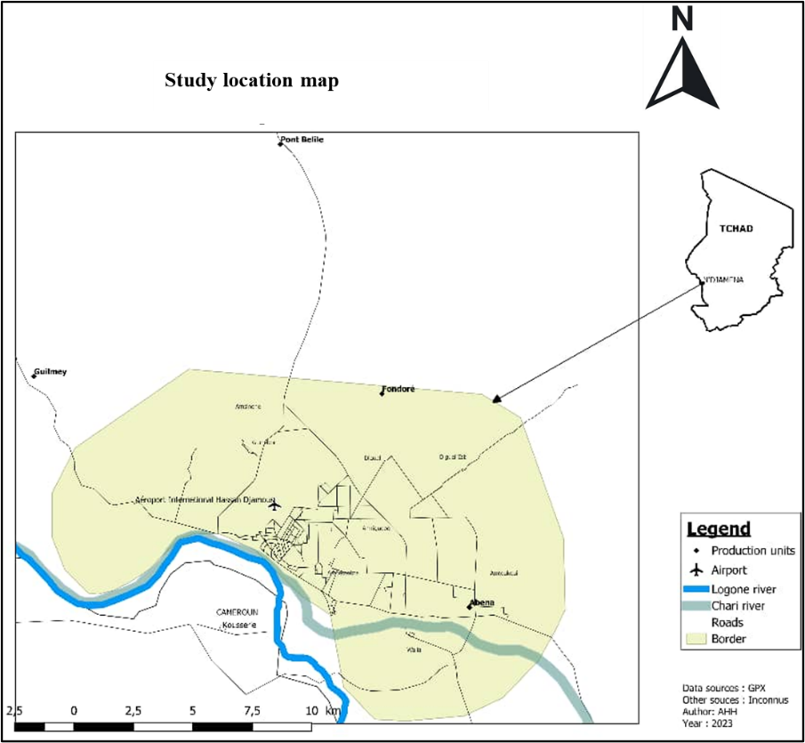

Fig. 1. Location of the study site

2.1.2 Sampling

Lactic acid bacteria were isolated from nine samples of artisanal cheeses produced from cow's milk coagulated by Jibben (Solanum dibium). These cheeses were collected from urban and peri-urban areas of the city of N'Djamena.

2.2 Isolation, Purification and Conservation

2.2.1 Isolation and Purification

Man-Rogosa-Sharpe (MRS) and M17 medium were used for isolation followed by successive subcultures to obtain pure (distinct and homogeneous) colonies. Table 1 summarizes the strain isolation conditions.

Table 1. Culture media for the isolation of lactic acid bacteria

Microorganisms | Culture media | T ºC | Duration (H) | Incubation
Entérococcus | M17 pH (6.5) | 45 | 72 | Aerobiosis
Lactococcus | M17 pH (6.5) | 30 | 72 | Aerobiosis
Leuconostoc | Hypersaline medium (6.5 %) ; pH (9.6) | 30 | 72 to 96 | Aerobiosis
Pediococcus | M17 pH (6.5) | 30 | 72 | Aerobiosis
Mesophilic Lactobacillus | MRS pH (6 and 5.5) | 30 | 72 | Aerobiosis to Anaerobiosis
Thermophilic Lactobacillus | MRS pH (6 and 5.5) | 45 | 72 | Anaerobiosis
Source: Dahou et al. (2015)

2.2.2 Strains Conservation

Short-term conservation of pure strains was carried out on solid slant media. After growth at optimal temperature, cultures were maintained at 4°C and strain renewal was performed by successive subcultures every four (4) weeks. Long-term conservation of purified isolates were carried out in a medium containing 70% skim milk (enriched with 0.05% yeast extract and 0.05% glucose) and 30% glycerol and stored at -20°C (El Ahmad et al., 2025).

2.3 Identification of Isolates

The identification of lactic acid bacteria isolates was carried out in two stages. The first consisted of testing all isolates using Gram staining (Antônioe et al., 2025), catalase production, and oxidase detection (Mercy et al., 2025). Gram-positive, oxidase-negative, and catalase-negative bacteria were selected for further analysis. The second stage was based on the morphological, physiological, and biochemical characteristics of the strains.

2.3.1 Determination of Morphological Characteristics

Macroscopic observation of pure and isolated colonies highlights the colony shape, size, color, and appearance. Microscopic study can confirm the cell shape, size, association mode, and the presence or absence of spores.

2.3.2 Determination of Biochemical and Physiological Characteristics

2.3.2.1 Thermoresistance

This test consisted of inoculating the bacterial strains into tubes containing MRS broth, then incubating them at 63.5°C for 30 minutes in a water bath to differentiate between mesophilic and thermophilic lactic acid strains (Bennani et al., 2017). The absence of turbidity indicates a negative result, which defines mesophilic strains, while turbidity results from the growth of thermoresistant strains (Badis et al., 2004; Joffin and Leyral, 2006).

2.3.2.2 Growth at pH 9.6

MRS medium at pH 9.6 was inoculated with fresh cultures and incubated at 30 and 37°C for 24 hours, which is generally hostile to lactic acid bacteria, which cannot grow in alkaline media (Mathara et al., 2004).

2.3.1.3 Growth in Hypersaline Broth

This study was conducted by inoculating MRS medium supplemented with 6.5% NaCl with a young culture. Incubation was carried out at 30 and 37°C for 24 to 48 hours. Unlike enterococci, lactic acid bacteria are sensitive to hypersaline media (Mathara et al., 2004).

2.3.2.4 Fermentation Type Test

This test determines the nature of sugar fermentation (homofermentative or heterofermentative). The test strain was incubated in liquid MRS medium containing the Durham bell jar at 30 and 37°C for 24 hours. The development of heterofermentative bacteria is manifested by the appearance of gas in the Durham bell jar, which is absent in homofermentative bacteria (Tigistu et al., 2022).

2.3.2.5 CO2 Production from Citrate

This test was performed using the method described by Leveau et al. (1991). The strain was inoculated into a tube containing 10.5 ml of sterile 10% skimmed milk, supplemented with 0.5 ml of sterile sodium citrate solution (10%) and 4 ml of sterilized white agar (1.5%), and then incubated at 30°C. Gas production in the bulk of the medium reflects the decomposition of the citrate.

2.3.3 Study of the Technological Aptitudes of Isolated Lactic Acid Bacteria

2.3.3.1 Acidifying and Coagulating Power

Acidifying activity was assessed using the Larpent method (1997). This involved monitoring the pH of the different cultures over time and simultaneously measuring total acidity using sodium hydroxide. To test the cultures, 100 ml of sterile skimmed milk was inoculated with 3 ml of culture. After incubation at 37°C for 24 hours, the volume of exuded whey was measured and the appearance of the resulting coagulum was noted. The pH change and lactic acid content were determined.

2.3.3.2 Proteolytic and Lipolytic Activities

The proteolytic activity of the strains was determined using the Veuillemard method (1986). Sterile Wattman paper discs were placed on the surface of MRS agar supplemented with 10% skimmed milk. Each disc received a 20 μL volume of a young culture. After incubation at 37°C for 24 hours, proteolysis was revealed by clear zones around the discs. Lipolytic activity was demonstrated on triglyceride agar. Sterile Wattman paper discs were placed on the surface of this agar, and then each disc received 10 μL of a young culture. After incubation at 37°C for two days, lipolysis was revealed by a clearing zone surrounded by a deposit around the discs (Guiraud, 2003).

2.3.3.3 Texturizing and Flavoring Power

The strains to be tested were streaked onto hypersucrose agar (supplemented with 10% sucrose). Dextran-producing strains are characterized by the formation of large, viscous, and sticky colonies (Zarour et al., 2017, Benhouna et al., 2019). The ability of mixed cultures to produce flavoring compounds during fermentation was demonstrated on skim milk. To do this, each tube containing sterile skim milk was inoculated with one of the cultures. After incubation for 24 hours and coagulation of the milk, the Vogues-Proskaeur reagents VPI and VPII were added and allowed to stand. The presence of flavor is revealed by the appearance of a red ring (Colombo et al., 2019).

2.3.3.4 Interaction Study

The selected strains were spot-inoculated onto the previously poured and solidified MRS agar. The mixture was allowed to dry at room temperature, and at the same time, 7 ml of the MRS agar, already melted and cooled to 39°C, was inoculated with 0.5 ml of the indicator strain. The mixture was then poured onto the surface of the spot-inoculated MRS agar. Symbiosis is revealed by the absence of inhibition zones, while antagonism is indicated by their presence after incubation at 37°C for 24 hours (Fleming et al., 1975; Moraes et al., 2010). Strains exhibiting symbiosis with each other were chosen for the reconstitution of our cultures.

2.4 Formation of a Mesophilic Starter

2.4.1 Selection of Strains

The selection of strains were based on the results of technological aptitudes and the study of strain interactions. Strains with technological power and that expressed no inhibition between them were selected to constitute our starter cultures.

2.4.2 Preparation of Starters

The starter cultures were prepared using 10% skimmed milk. The milk was pasteurized at a temperature of 72°C for 30 minutes, followed by cooling to 50°C and heating to 95°C for 15 seconds (Tyndallization technique). The milk was then cooled to room temperature and then inoculated at a rate of 3% with the selected strains, then incubated at 37°C for 16 hours.

2.5 Data Processing

Data entry was performed using Office Excel 2016 to create figures (graphs, histograms) and tables, enhanced with Paint Net software.

3. results and discussion

3.1 Results

3.1.1 Isolation and Identification of Lactic Acid Bacteria Strains

Macroscopic observation allowed us to identify whitish, sometimes transparent, round or lenticular colonies of varying size from one colony to another. Microscopic examination revealed 131 isolates that were Gram positive, oxidase-negative, and catalase-negative. 54 isolates in bacillary form and 77 isolates in cocci form. The results of biochemical and physiological characterization allowed to classify the isolates according to the type of fermentation (homofermentative or heterofermentative), the optimal growth temperature (mesophilic or thermophilic), the capacity to produce gas from citrate, the capacity to grow at different concentrations of NaCl (4% and 6.5%), growth in alkaline medium (pH 4.5, 6.5 and 9.5) and development on Sherman milk (0.1% and 0.3%). Thus, six (06) groups of lactic acid bacteria strains were identified: Lactococcus (42 isolates or 32.06%), mesophilic Lactobacillus (39 isolates corresponding to 26.77%), Leuconostoc (21 isolates representing 16.03%), thermophilic Lactobacillus (15 isolates or 11.45%), Pediococcus (9 isolates or 6.87%) and Enterococcus (5 isolates equivalent to 3.81%). The presumed Enterococcus isolates were all thermophilic homofermentative, capable of growing in the presence of 4% and 6.5% NaCl, of growing in alkaline medium pH 6.9 and 9.6 and reducing 0.1% methylene blue. The isolates identified as Lactococcus were all homofermentative, capable of growing in the presence of 4% NaCl, 0.1% and 0.3% methylene blue and at pH 4.6. The isolates identified as Leuconostoc were heterofermentative strains, capable of producing CO2, growing in an alkaline medium at pH 6.5, and 4.5% and at a concentration of 6.5% NaCl. The presumed Pediococcus isolates were all homofermentative, able to grow at pH 6.9 but not at 9.6 or 4.5 and did not tolerate the 6.5% NaCl concentration. The isolates identified as mesophilic Lactobacillus were all homofermentative, able to grow at pH 6.5. Some strains showed growth capacity at pH 4.5, unable to produce CO2 and they did not grow at 45° C. The presumed thermophilic Lactobacillus isolates were all homofermentative bacteria capable of growth at 45° C, at pH 4.5 and 6.5 but not at 9.6. Table 2 illustrates the biochemical and physiological characteristics of the isolated strains

Table 2. Morphology, biochemical and physiological characteristics of the strains
Characteristics | Group 1 | Group 2 | Group 3 | Group 4 | Group 5 | Group 6
Form | Cocci | Cocci | Cocci | Cocci | Bacilli | Bacilli
Coloration Gram | + | + | + | + | + | +
Catalase | - | - | - | - | - | -
Oxidase | - | - | - | - | - | -
Type of fermentation | Hom | Hom | Het | Hom | Hom | Hom
Growth at 30°C | + | + | + | + | + | +
Growth at 45°C | + | - | - | - | - | +
CO2 production |  | - | + |  | - | -
Growth in a salty medium (NaCl)
4% | + | + | +
6.5% | + | - | + | - | - | -
Growth in pH
4.5 | - | - | - | - | +/- | +
6.5 | + | + | + | + | + | +
9.6 | + | - | + | - | - | -
Sherman's Milk Test
0.1 | + | +
0.3 | - | +
Identification | Ec | Lc | Leuc | Pc | LbI | LbII
Number of isolates | 05 | 42 | 21 | 09 | 39 | 15
Percentages % | 3.81% | 32.06% | 16.03% | 6.87% | 26.77% | 11.45%

Ec: Enterococcus; Lc: Lactococcus; Leuc: Leuconostoc; Pc: Pediococcus; LbI: Mesophilic Lactobacillus; LbII: Thermophilic Lactobacillus; Hom: Homofermentative; Het: heterofermentative.

3.1.2 Technological Aptitudes of Isolated Lactic Acid Bacteria

3.1.2.1 Acidifying and/or Coagulating Activities

The majority of strains tested had the ability to lower pH values, with variability from one strain to another. We identified a total of 29 strains with the ability to lower pH to a unit ≥ 0.9 after 18 hours of incubation. Seventeen (17) strains of these isolates belong to the genus Lactococcus, seven isolates to the genus Leuconostoc, and five isolates to the mesophilic genus Lactobacillus. Table 3 illustrates the acidification kinetics of these strains. The fastest acidification recorded was 4.5, obtained by strain Leuc5 after 6 hours of incubation. Strains Lc8, Lc17, Leuc4, and LbI1 have the ability to lower pH to 5.3 after 6 hours of incubation. The pH value obtained during 18 hours of incubation by isolates belonging to the genus Lactococcus varies between 2.3 and 0.9. The highest value is obtained by strain Lc8 (2.3) and the lowest value was 0.9 obtained by strains Lc1, Lc2, Lc9 and Lc11 (Figure 2). The acidifying potential of strains of the genus Leuconostoc is very important, their ∆pH after 18 hours of incubation varies between 1.1 and 2.8. The strain Leuc5 showed the highest acidifying potential; the pH lowering caused by this strain during 18 hours of incubation reached 3.7 with a ∆pH of 2.8. (Figure 3). The mesophilic Lactobacillus strains LbI1, LbI2, LbI3, LbI4 and LbI5 have a ∆pH that varies between 0.9 and 1.69 (Figure 4). The most acidifying strain in this group was strain LbI1. It decreased the pH to 4.9 during the 18-hour incubation.

Table 3. Variation of pH and appearance of curd in the middle of skimmed milk in 18 hours of incubation

Strains | Incubation in skimmed milk
Strains | pH at 0H | pH after 2 H | pH after 6 H | pH after 18 H | Coagulation after 6 H
Lc1 | 6.5 | 6.1 | 6.1 | 5.6 | -
LbI1 | 6.5 | 5.7 | 5.3 | 4.9 | +++
LbI2 | 6.5 | 6.1 | 5.8 | 5.6 | -
Lc2 | 6.5 | 6.4 | 5.9 | 5.6 | -
Lc3 | 6.5 | 6.1 | 5.7 | 5.4 | -
LbI3 | 6.5 | 6.3 | 6.1 | 5.4 | -
Lc4 | 6.5 | 6.3 | 5.6 | 5.3 | -
Leuc1 | 6.5 | 6.4 | 5.8 | 5.4 | -
Lc5 | 6.5 | 6.3 | 5.6 | 5.4 | -
Lc6 | 6.5 | 6.2 | 5.5 | 5.1 | -
Lc7 | 6.5 | 6.1 | 5.7 | 4.9 | +++
Lc8 | 6.5 | 5.9 | 5.3 | 4.2 | +++
Lc11 | 6.5 | 6.3 | 5.9 | 5.6 | +/-
Lc9 | 6.5 | 6.3 | 5.8 | 5.6 | -
Lc12 | 6.5 | 6.1 | 5.6 | 5.3 | +++
Leuc2 | 6.5 | 6.1 | 5.5 | 5.1 | -
Lc10 | 6.5 | 6.3 | 5.6 | 5.1 | -
Leuc3 | 6.5 | 6.2 | 5.5 | 5.2 | -
Leuc4 | 6.5 | 6.1 | 5.3 | 4.6 | +++
LbI4 | 6.5 | 6.3 | 5.8 | 5.2 | -
LbI5 | 6.5 | 6.3 | 5.7 | 5.2 | -
Lb13 | 6.5 | 6.3 | 5.8 | 5.3 | -
Lc14 | 6.5 | 6.4 | 5.5 | 5.3 | -
Lc15 | 6.5 | 6.4 | 5.8 | 4.9 | +++
Lc16 | 6.5 | 5.8 | 5.7 | 4.8 | +++
Leuc5 | 6.5 | 5.8 | 4.5 | 3.7 | +++
Leuc6 | 6.5 | 6 | 5.9 | 5.1 | +/-
Leuc7 | 6.5 | 6.1 | 5.8 | 5.4 | -
Lc17 | 6.5 | 6.4 | 5.3 | 5.1 | -
Lc: Lactococcus; Leuc: Leuconostoc; LbI: Mesophilic Lactobacillus, -: Absence of coagulation, +/-: Partial coagulation; +++: Total coagulation; H: Hour.

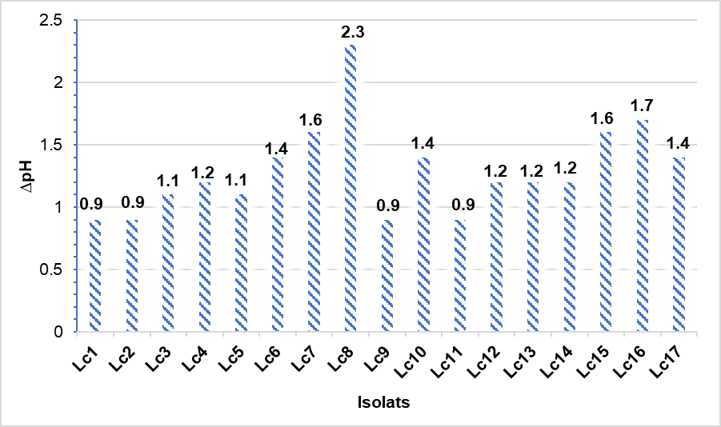

Fig. 2. Variation of pH with isolates of the genus Lactococcus
Lc: Lactococcus; ΔpH: Variation of pH

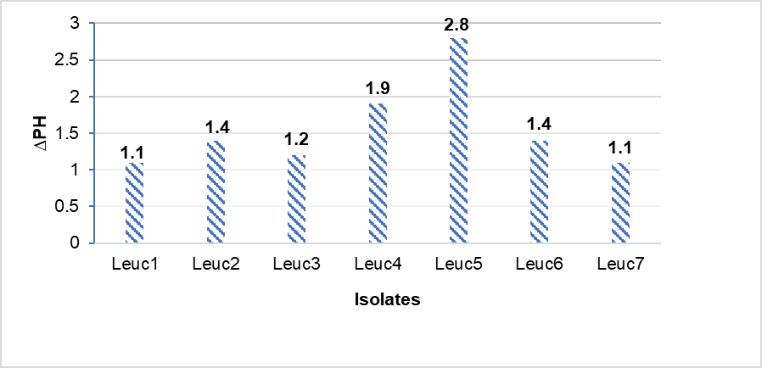

Fig. 3. Variation of pH with isolates of the genus Leuconostoc
Leuc: Leuconostoc; ΔpH: Variation of pH

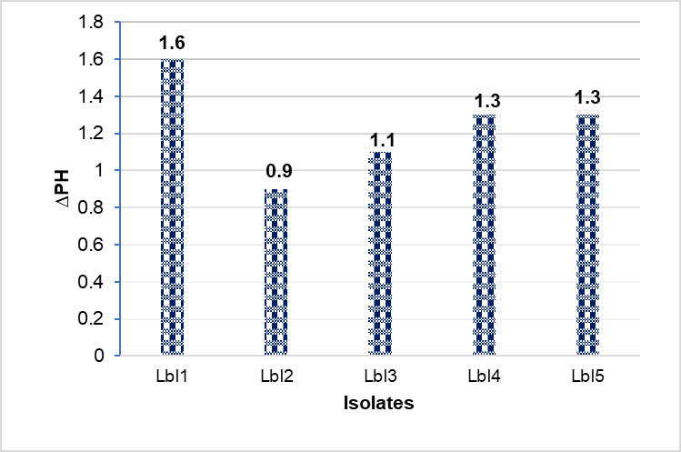

Fig. 4. Variation of pH with mesophilic Lactobacillus isolates
Lbl: Lactobacillus; ΔpH: Variation of pH

The results showed that 5 isolates of the genus Lactococcus (Lc7, Lc8, Lc12, Lc15 and Lc16) caused total coagulation during 18 hours of incubation, the same result was observed in two (02) strains of Leuconostoc (Leuc4 and Leuc5) and one strain of mesophilic Lactobacillus (LbI1). Strains Lc11 and Leuc6, which belong to the genus Lactococcus and Leuconostoc, respectively, caused partial coagulation at the bottom of the tube. Strains Lc8, Leuc4, Leuc5, and LbI1 showed good acidifying and coagulating power. All of these strains showed the ability to decrease the pH to a value ≤ 5.3 during the 6 hours of incubation with complete coagulation after 18 hours of incubation. Strain L17 showed good acidifying power without having the coagulating potential. Figure 5 presents the acidification kinetics of acidifying and/or coagulating strains during 24 hours of incubation. The acidity rate obtained by these strains during 24 hours of incubation varies between 52 and 78 D°. The highest acidity is obtained by the strain of the genus Leuconostoc Leuc5 with the production of 7.8 g/L of lactic acid after 24 hours of incubation (Figure 6).

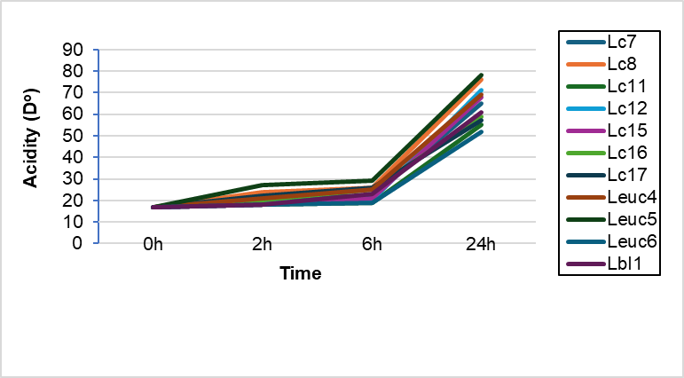

Fig. 5. Acidification kinetics of acidifying and/or coagulating strains
Lc: Lactococcus; Leuc: Leuconostoc; Lbl: Lactobacillus

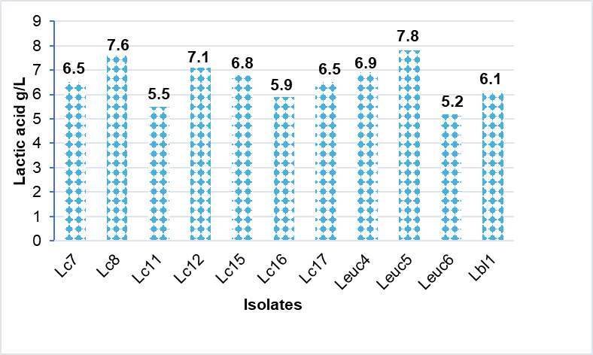

Fig. 6. Amounts of lactic acid produced by acidifying and/or coagulating strains
Lc: Lactococcus; Leuc: Leuconostoc; Lbl: Lactobacillus

3.1.2.2 Proteolytic, Lipolytic and Texturizing Activities

The proteolytic potential results for all strains tested showed lysis zone diameters ranging from 6 to 15 mm. Strains Lc11, Leuc4, and Lc15 exhibited the highest proteolytic activity with a diameter of 15 mm, followed by strain Lc7 with a lysis zone of 14 mm. Strains Lc3, Lc6, Leuc3, and Leuc7 recorded lower proteolytic activities (6 mm). Some of our strains exhibit lipolytic activity. This power is observed in four strains belonging to the genus Lactococcus (Lc7, Lc11 and Lc12), two strains of the mesophilic genus Lactobacillus (LbI1 and LbI5) and one strain of the genus Leuconostoc (Leuc6). The exopolysaccharide production test was positive for ten (10) strains of the genus Lactococcus (Lc2, Lc5, Lc6, Lc7, Lc8, Lc11, Lc12, Lc14, Lc15 and Lc16), three strains belonging to the genus Leuconostoc (Leuc1, Leuc4 and Leuc6) and two strains of mesophilic Lactobacillus (LbI1 and LbI3). Table 4 illustrates the proteolytic, lipolytic and texturizing power of isolated strains (table 4).

Table 4. Proteolytic, lipolytic and texturizing power of isolated strains
Strains | Proteolytic activity |  | Lipolytic activity | Texturizing power
 | Observation | Diameter (mm) | Lipolytic activity | Texturizing power
Lc1 | + | 12 | - | -
LbI1 | + | 13 | + | +
LbI2 | + | 7 | - | -
Lc2 | + | 9 | - | +
Lc3 | + | 6 | - | -
LbI3 | + | 9 | - | +
Lc4 | + | 8 | - | -
Leuc1 | + | 11 | - | +
Lc5 | + | 13 | - | +
Lc6 | + | 6 | - | +
Lc7 | + | 14 | + | +
Lc8 | + | 12 | - | +
Lc11 | + | 15 | + | +
Lc9 | + | 9 | - | -
Lc12 | + | 9 | + | +
Leuc2 | + | 13 | - | -
Lc10 | + | 10 | - | -
Leuc3 | + | 6 | - | -
Leuc4 | + | 15 | - | +
LbI4 | + | 12 | - | -
LbI5 | + | 10 | + | -
Lc13 | + | 11 | - | -
Lc14 | + | 12 | - | +
Lc15 | + | 15 | + | +
Lc16 | + | 13 | - | +
Leuc5 | + | 13 | - | -
Leuc6 | + | 13 | + | +
Leuc7 | + | 6 | - | -
Lc17 | + | 11 | - | -
Lc: Lactococcus; Leuc: Leuconostoc; LbI: Mesophilic Lactobacillus, -: Absence of activities, +: Presence of activities; mm: millimeter

3.1.3 Sourdough Composition

3.1.3.1 Interstrain Interactions

Most of the interactions between our strains appeared positive. However, all of our strains exhibited at least one antagonistic activity toward one of the strains studied. Strains LbI1 and Lc8 demonstrated remarkable antagonistic activity. The inhibition activity of LbI1 strain is observed against strains Leuc4, Lc12, Leuc5 e, Lc7 and Lc8 and that of Lc8 strain is observed against strains Lc15, Leuc6, Leuc5 and lbI1 (Table 5). Based on this result, two mesophilic ferments were reconstituted FI and FII. The FI ferment is composed of four strains of the genus Lactococcus (Lc7, Lc8, Lc11 and Lc12) and one strain of Leuconostoc (Leuc4). The second ferment FII contains two strains of Lactococcus (Lc15 and Lc16) and two other strains belonging respectively to the genus Leuconostoc (Leuc6) and mesophilic Lactobacillus (LbI1).

Table 5. Interaction between isolated strains

Strains | Leuc4 | Lc11 | Lc8 | Lc12 | Lc15 | Leuc6 | Lc16 | Leuc5 | Lbl1 | Lc7
Leuc4 |  | + | + | + | - | + | + | + | - | +
Lc11 | + |  | + | + | + | + | - | + | + | +
Lc8 | + | + |  | + | - | - | + | - | - | +
Lc12 | + | + | + |  | + | + | + | + | - | +
Lc15 | - | + | - | + |  | + | + | + | + | +
Leuc6 | + | + | - | + | + |  | + | + | + | +
Lc16 | + | - | + | + | + | + |  | + | + | +
Leuc5 | + | + | - | + | + | + | + |  | - | +
Lbl1 | - | + | - | - | + | + | + | - |  | -
Lc7 | + | + | + | + | + | + | + | + | -
Lc: Lactococcus; Leuc: Leuconostoc; LbI: Mesophilic Lactobacillus; -: Absence of Interaction, +: Presence of Interaction

3.1.3.2 Technological Capabilities of Reconstituted Mixed Ferments

Both reconstituted ferments FI and FII demonstrated significant acidifying potential, resulting in very rapid acidification. The pH values after 6 hours of fermentation were 4.2 and 4.3 for FI and FII, respectively (Figure 7). The pH variations after 18 hours of fermentation were 2.6 for FI and 2.4 for FII. Each of the two ferments induced complete coagulation during 18 hours of incubation.

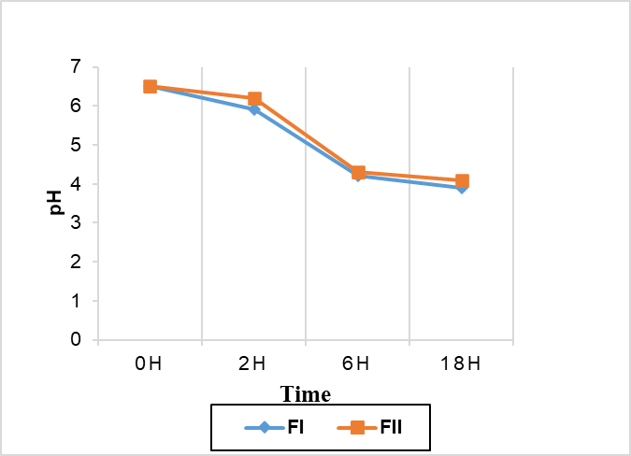

Fig. 7. Acidification kinetics of reconstituted ferments
FI: Ferment I; FII: Ferment II

The acidity obtained after 6 hours of fermentation was 51 °D for FI and 47 °D for FII. The acidity caused by the two ferments during 18 hours of incubation was respectively 81 o D and 77 °D with a production of 8.1 and 7.7 g/L of lactic acid. (Figure 8)

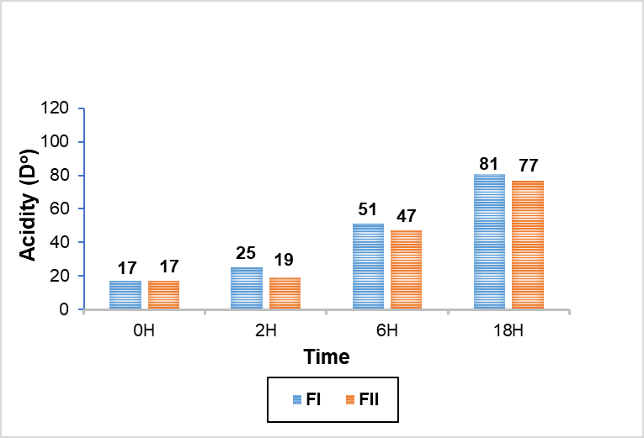

Fig. 8. Production of lactic acid by ferments I and II
FI: Ferment I; FII: Ferment II

The proteolytic power test was positive for both ferments with the presence of a lysis zone of 16 mm in diameter for FI and 21 mm for FII. Regarding the flavoring power, it appears that the two ferments did not have the same capacity to produce aromas. The FI ferment produced a significant quantity of aromas unlike the FII which was unable to produce these molecules (Table 6)

Table 6. Technological potential of FI and FII ferments

Ferments | Coagulation (18H) | Proteolytic activity |  | Lipolytic activity | Texturizing power
Ferments | Coagulation (18H) | Observation | Diameter (mm) | Lipolytic activity | Texturizing power
FI | +++ | + | 16 | + | +
FII | +++ | + | 21 | + | +
FI: Ferment I; FII: Ferment II

3.2 Discussion

According to the morphological and biochemical identification performed, the strains isolated from samples of traditional cheese coagulated by Jibben belong to the genera Lactococcus, Lactobacillus, Leuconostoc, Pediococcus, and Enterococcus. This microbial population is dominated by species of the genus Lactococcus, followed by mesophilic Lactobacillus and Leuconostoc. This result shows that species belonging to these genera are the main agents responsible for the transformation of milk and the production of fermented dairy products. The same result was reported by Lairini et al. (2014) in a study carried out on traditional Moroccan dairy products. Gonçalves et al. (2018) identified the microbial ecology of Portuguese Serpa cheese and the genera Lactococcus, Leuconostoc, Lactobacillus and Enterococcus were the main groups identified. The genus Enterococcus is particularly ubiquitous and survives in harsh conditions, such as those found in the digestive tract of humans and other animals. The probiotic properties of the latter are increasingly explored with reservations (Hussain et al., 2025). Doutoum et al. (2013) also demonstrated the dominance of species belonging to the genus Lactococcus in traditional Chadian curd.
Our study revealed the ability of some of the strains to rapidly produce lactic acid and cause a decrease in pH. According to Durango et al. (2023), lactic acid bacteria are said to be acidifying when they are able to reduce the pH of milk from its initial value of approximately 6.6 to 5.3 over a period of six (6) hours. We identified strains belonging to the genera Lactococcus, Leuconostoc and Lactobacillus that possess this characteristic. Acidity is the most important property of strains used as lactic ferments. In addition to its crucial role in milk curdling and triggering the desired change reactions in cheesemaking technology, such as whey expulsion, acidity contributes to the development of texture, aroma, flavor, and antimicrobial activity (Endo and Dicks, 2014). The selection criterion for our strains was essentially based on their acidifying potential. Coagulant activity was observed in all acidifying strains except strain Lc17 of the genus Lactococcus. Despite the rapid acidification achieved by this strain during the 6-hour incubation period, the pH remained at 5 after 18 hours of incubation and coagulation did not occur. Proteolytic activity was positive for all strains tested. This potential is essential for the growth of lactic acid bacteria (Hussain et al., 2025). These microorganisms have a high need for free amino acids to develop. Gómez de Cadiñanos et al. (2019) demonstrated that Lactococcus have a high requirement for glutamic acid, glycine, leucine, isoleucine, histidine, methionine and valine. This proteolysis also plays an important role due to its impact on the texture and flavors of cheeses (Frau et al., 2016; Araújo-Rodrigues et al., 2021). The study of lipolytic activity allowed us to identify strains with this property. They belong to the genera Lactococcus (Lc5, Lc11 and Lc12), Lactobacillus (LbI1 and LbI5) and Leuconostoc (Leuc6). This lipolysis is essential for the strengthening of proteolytic activity in cheese as well as for the improvement of desired technological characteristics such as the development of aromas and flavors by promoting the increase in the production of small peptides and free amines in cheese (Nicosia et al., 2023; Hulak et al., 2016). The exopolysaccharide production test was positive for the majority of tested strains 14/29. These strains belong to the genera Lactococcus, Leuconostoc and Lactobacillus. The production of exopolysaccharides is considered an important characteristic when selecting lactic acid bacteria as starter cultures for certain dairy products (Câmara et al., 2019).
The study of the interaction between the previously identified strains of interest allowed us to compose two ferments. Each of the two ferments contains several strains that do not exhibit any antagonistic activity. The symbiosis between the selected bacterial strains became clear during the technological evaluation of our ferments, which implies cell viability and coexistence between strains. The rate of acidification and proteolysis increased in both ferments tested. Lipolysis and texturizing power were positive. However, aroma production was observed only in the FI ferment. The study of Canon et al. (2022) highlighted the importance of the proteolytic system in the positive interactions between Lactobacillus bulgaricus species (involved in exopolysaccharide and aroma production) and Streptococcus thermophilus (involved in rapid acidification and aroma production). Similar studies have shown viability above 90% for Streptococcus thermophilus, Lactobacillus delbrueckii and Lactobacillus helveticus strains used as ambient starters in Comté cheese technology despite microbial diversity.
The selection of high-performance strains to make cheese cultures will improve the quality of the finished product and increase production at the industrial level (Adnan and Tan, 2007; Montel et al., 2012). This sector of cheese production in Chad is generally occupied by women from the collection of local raw milk to processing (Beral et al., 2023). An improvement in cheese production through the selection of appropriate cultures will promote scaled-up exploitation with the advantage of job creation for women and an increase in household income.

4. Conclusion

The study isolated and identified lactic acid bacteria strains from traditional cheeses. The selected strains produced two mesophilic starter cultures, FI and FII. These starter cultures consist of lactic acid bacteria strains belonging to the genera Lactococcus, Leuconostoc, and Lactobacillus. The combination of these bacteria has contributed to the improvement of several parameters sought in cheese technology. The inability of FII ferment to produce aromas will call into question its use and requires improvement. However, the FI ferment has satisfactory technological characteristics and can be used as a starter culture in the production of traditional cheeses. In order to be able to exploit this work, other studies must be carried out, namely the molecular characterization of the identified strains of technological interest, the study of their probiotic effects and then the development and evaluation of a test cheese.

Disclaimer (Artificial intelligence)

Author(s) hereby declares that NO generative AI technologies such as Large Language Models (ChatGPT, COPILOT, etc.) and text-to-image generators have been used during the writing or editing of this manuscript.

References

Albuquerque, A. P. D. C., Ferreira, H. D. S., Silva, Y. A. D., Silva, R. R. D., Lima C. V. D., Sarubbo L. A., & Luna, J. M. (2025). Biosurfactant Produced by Bacillus subtilis UCP 1533 Isolated from the Brazilian Semiarid Region: Characterization and Antimicrobial Potential. Microorganisms, 13(7), 1548. https://doi.org/10.3390/microorganisms13071548

Araújo-Rodrigues, H., Tavaria, F. K., dos Santos M. T. P. G., Alvarenga, N., & Pintado, M. M. A. (2020). Review on Microbiological and Technological Aspects of Serpa PDO Cheese: An Ovine Raw Milk Cheese. International. Dairy Journal.,100,104561, https://ciencia.ucp.pt/ws/portalfiles/portal/89385091/19589627.pdf

Badis, A., Guetarni, D., Moussa-Boudjemaa, B., Henni, D. E., Tornadijo, M. E & Kihal M. (2004). Identification of cultivable lactic acid bacteria isolated from Algerian raw goat’s milk and evaluation of their technological properties. Food Microbiology 21: 343-349. https://doi.org/10.1016/S0740-0020(03)00072-8

Benhouna, I. S., Heumann, A., Rieu, A., Guzzo, J., Kihal, M., Bettache, G., Champion, D., Coelho, C & Weidmann, S. (2019). Exopolysaccharide produced by Weissella confusa: Chemical characterisation, rheology and bioactivity. International Dairy Journal, 90 :88-94. https://doi.org/10.1016/j.idairyj.2018.11.006

Bennani, S., Mchiouer, K., Rokni, Y., & Meziane, M. (2017). Characterization and identification of lactic acid bacteria isolated from Moroccan raw cow’s milk. Greener Journal of Biological Science, 25, 4934-4944. https://www.jmaterenvironsci.com/Document/vol8/vol8_NS/524-JMES-2991-Bennani.pdf

Beral, V. M., Mayore, D. A., Hissein, A. O., Tarnagda, B., Bessimbaye, N., Mahamat, A., & Tidjani, A. T. A. (2023). Technological production processes and quality of dairy products consumed in the city of N'Djamena (Chad). International Journal of Biological and Chemical Sciences, 17(5), 1903-1916. DOI: https://dx.doi.org/10.4314/ijbcs.v17i5.10

Câmara, S. P., Dapkevicius, A., Riquelme, C., Elias, R. B., Silva, C. C. G., Malcata, F. X., & Dapkevicius, M. L. N. E. (2019). Potential of lactic acid bacteria from Pico cheese for starter culture development. Food Science and Technology International, 25(4), 303-317. https://doi.org/10.1177/1082013218823129

Canon, F., Maillard, M. B., Gwenaëlle, H., Jardin, J., Briard-Bion, V., Thierry, A., & Gagnaire, V. (2022). Nutritional dependencies in amino acids and peptides at the heart of positive interactions between lactic acid bacteria. In the 23rd edition of the Lactic Acid Bacteria Club conference. https://hal.science/hal-03697570/

Cao, W., Lecomte, M., Le Fur, S., Aubert, J. J., Maillard, M. B., Nicolas A., & Falentin H. (2022). Metatranscriptomics and metabolic model to identify the succession of bacterial metabolisms in interaction during the production of a model pressed cheese. In 23ème édition du colloque du Club des Bactéries Lactiques. 2022. https://hal.science/hal-03694338/

Cherel, A. F. (2022). Dairy Products in Brittany in Recent Protohistory: A History of Jars. Annals of Brittany and the Western Countries. Anjou. Maine. Poitou-Charente. Touraine, (129-3), 19-37. DOI: https://doi.org/10. 4000/abpo.7759

Cogan, T. M., Barbosa, M., Beuvier, E., Bianchi-Salvadori, B., Cocconcelli, P. S., Fernandes, I., & Rodríguez, E. (1997). Characterization of the lactic acid bacteria in artisanal dairy products. Journal of Dairy Research, 64(3) :409-421. https://doi.org/10.1017/S0022029997002185

Colombo, M., Todorov, S. D., Carvalho, A. F & Nero L. A. (2020). Technological properties of beneficial bacteria from the dairy environment and development of fermented milk with the beneficial strain Lactobacillus casei MRUV6. Journal of Dairy Research. 87(2): 259 - 262. https://doi.org/10.1017/S0022029920000308

Dahou, A., Homrani, A., Bensaleh, F & Medjahed, M. (2015). The lactic microflora of a traditional Algerian cheese “j’ben type”: knowledge of local dairy microbial ecosystems and their roles in cheese making. Afrique SCIENCE, 11(6) :1-13.

Doutoum, A. A., Tidjani, A., Abdelaziz, A., Tidjani, S. M. T., Balde, M., Sylla, K. S. B., Seydi, M. G., & Toguebaye, B. S. (2013). Identification of the lactic microorganisms responsible for milk coagulation in Abeche (Chad). African Journal of Food Science, 7(5) :103-106. https://academicjournals.org/journal/AJFS/article-full-text-pdf/550A0C412371.pdf

Durango Zuleta, M. M., Grisales Rojas, L. F., Sepúlveda, V. J. U., Valdés, D. B. E. & Moreno-Herrera, C. X. (2023). Growth Kinetics of Autochthonous Lactic Acid Bacteria Isolated from Double Cream Cheese as Potential Starter Culture. TecnoLógicas, 26(57), e2657. https://doi.org/10.22430/22565337.2657

El Ahmadi, L. K., Haboubi, K., El Allaoui, H., El Hammoudani, Y., Bouhrim M., Eto, B., Abdelaaty, A. S & Rashed, N. H. (2025). Isolation and preliminary screening of lactic acid bacteria for antimicrobial potential from raw milk. Frontiers in Microbiology, 16 :1565016. https://doi.org/10.3389/fmicb.2025.1565016

Elise, D., & Mathilde, L. (2021). Indicators to support “microbe breeders. Revue d’Anthropologie des Connaissances, 15 (3). https://hal.science/hal-03343740v1/file/rac-24953.pdf

Endo, A., & Dicks, L. M. T. (2014). The genus Fructobacillus. Lactic acid bacteria: biodiversity and taxonomy, 381-389. https://doi.org/10.1002/9781118655252.ch22

Fleming, H. P., Etchells, J.L. & Costilow, R.N. (1975). Microbial inhibition of isolates of Pediococcus from cucumber brines. Applied microbiology. (30): 1040-1042. https://journals.asm.org/doi/pdf/10.1128/am.30.6.1040-1042.1975

Frau, F., Nuñez, M., Gerez, L., Pece, N., & Font, G. (2016). Development of an Autochthonous Starter Culture for Spreadable Goat Cheese. Food Science and Technology (Campinas), (36) 622–630. http://dx.doi.org/10.1590/1678-457X.08616

Gasbarrini, G., Bonvicini, F., & Gramenzi, A. (2016). Probiotics history. Journal of clinical gastroenterology, 50 :116-S119. https://doi.org/10.1097/mcg.0000000000000697

Goa, T., Beyene, G., Mekonnen, M., & Gorems K. (2022). Isolation and characterization of lactic acid bacteria from fermented milk produced in Jimma Town, Southwest Ethiopia, and evaluation of their antimicrobial activity against selected pathogenic bacteria. International journal of food science, 2022(1), 2076021. https://doi.org/10.1155/2022/2076021

Gómez de Cadiñanos, L. P., García-Cayuela, T., Martínez-Cuesta, M. C., Peláez, C., & Requena, T. (2019). Expression of amino acid converting enzymes and production of volatile compounds by Lactococcus lactis IFPL953. International Dairy Journal, (96) 29 35. https://digital.csic.es/bitstream/10261/193559/3/expressIFPL.pdf

Gonçalves, M. T. P., Benito, M. J., Córdoba, M. G., Egas, C., Merchán A. V., Galván, A.I., Ruiz-Moyano, S. (2018). Bacterial Communities in Serpa Cheese by Culture Dependent Techniques, 16S r RNA Gene Sequencing and High-Throughput Sequencing Analysis. Journal of Food Sciences 83 :1333-1341. https://doi.org/10.1111/1750-3841.14141

Hulak, N., Žgomba Maksimović, A., Kaić A., Skelin, A., & Mrkonjić Fuka, M. (2016). Indigenous strains of Lactobacillus isolated from the Istrian cheese as potential starter cultures. Mljekarstvo: časopis za unaprjeđenje proizvodnje i prerade mlijeka, 66(4), 282-292. https://doi.org/10.15567/mljekarstvo.2016.0404

LairinI, S., Beqqali, N., Bouslamti, R., Belkhou, R & Zerrouq, Z. (2014). Isolation of lactic acid bacteria from traditional Moroccan dairy products and formulation of a fermented milk similar to Kefir. Afrique SCIENCE: International Journal of Science and Technology,10(4) 267-277. file:///C:/Users/User/Downloads/ajol-file-journals_258_articles_118408_submission_proof_118408-3073-327470-1-10-20150615%20(1).pdf

Larpent-Gourgaud, M., Michaux, O., Larpent, J.P., Desmasures, N., Desmazeaud, M., Mangin, I., Masson, F., Montel, M. C. & Tailliez, P. (1997). Lactic ferments and related bacteria In Food microbiology Laboratory techniques. Doc, Lavoisier, 199-255. https://hal.inrae.fr/hal-02839282

Lutin, J., Dufrene, F., Guyot, P., Palme, R., Achilleos, C., Bouton, Y., & Buchin, S. (2022). Microbial diversity and cell viability of ambient sourdoughs used in Comté cheese technology. In the 23rd conference of the Lactic Bacteria Club, June, 2022. https://hal.science/hal-04129709/

Mercy M. O., Taiwo S. A., & Bolanle A. A. (2025). Antimicrobial activity of lactic acid bacteria isolated from the gut of African catfish (Clarias gariepinus) against multi-drug-resistant resident pathogens. BMC Microbiology, 25(1) :410. https://doi.org/10.1186/s12866-025-04139-5

Montel, M. C., Bouton, Y., & Parguel, P. (2012). Ecosystems of raw milk and cheeses – challenges for their control. Renc. Recherches Ruminants, 19, 233-240.

Moraes, P. M., Perin, L. M., Maria, B. T., Anderson, K.Y., Gabriela, N. V & Nero, L. A. (2010). Protocols for the isolation and detection of lactic acid bacteria with bacteriocinogenic potential. Food Science and Technology 43(9) :1320-1324. https://doi.org/10.1016/j.lwt.2010.05.005

Niang, I., Ndiaye, M. A., & Ayessou, N. (2023). Goat milk production and cheese consumption in Sénégal. Moroccan Journal of Agronomic and Veterinary Sciences, 11(3), 335-339.

Nicosia, F.D., Pino, A., Maciel, G. L. R., Sanfilippo, R. R., Caggia. C., De Carvalho, A. F & Randazzo, C. L. (2023). Technological Characterization of Lactic Acid Bacteria Strains for Potential Use in Cheese Manufacture. Foods, 12(6) :1154. https://doi.org/10.3390/foods12061154

Pailin, T., Kang, D. H., Schmidt, K., & Fung, D. Y. C. (2001). Detection of extracellular bound proteinases In EPS-producing lactic acid bacteria cultures on skim milk agar. Letters in Applied Microbiology.33 :45-49. https://doi.org/10.1046/j.1472-765X.2001.00954.x

Zarour, K., Llamas, M. G., Prieto, A., Ruas-Madiedo, P., Dueñas, M. T., De Palencia, P. F., Aznar, R., Kihal, M. & Lopez, P. (2017). Rheology and bioactivity of high molecular weight dextrans synthesised by lactic acid bacteria. Carbohydrate polymers, (174) 646-657. http://dx.doi.org/doi:10.1016/j.carbpol.2017.06.113

