Experimental analysis of the thermal performance of a solar water heater storage unit

ABSTRACT
Solar thermal energy, particularly hot water production using solar water heaters, is one of the most promising solar energy applications in countries such as Burkina Faso. This study experimentally determined the efficiency of flat-plate solar collectors for solar water heaters. By selecting component materials and applying modeling and numerical methods, the parameters influencing system performance were identified and optimized. The results optimize system performance under the climatic conditions of Ouagadougou, particularly during the rainy season, when solar radiation is erratic and low in intensity, leading to increased hot water consumption. The experimental results demonstrate that while collector performance is affected by global radiation, it can be improved through the selection of component materials. Despite variable weather conditions, the flat-plate solar collector achieved an average yield of approximately 36% and a maximum instantaneous yield of 70% under conditions of maximum global solar radiation of 1101 W/m² and a maximum ambient temperature of 39.64°C. This study contributes to promoting the use of locally available materials; promoting local expertise in the field of hot water production; highlighting the effects of climate on the performance of solar water heaters; and responding to the challenges of electricity shortages and high costs in order to meet the need for domestic hot water in Burkina Faso.

Keywords: Thermal, energy; heater; solar, collector; optimization

- INTRODUCTION

Energy plays a vital role in accelerating development in the world's poorest countries. However, these countries mainly consume fossil fuels, the price of which continues to rise. On the other hand, reserves of oil, coal, natural gas and uranium diminish irretrievably when exploited(BOUALAMALLAH et al., 2021), and their impact on the environment and climate change has been clearly established since the Kyoto conference in 1997 (AlainLiébard, & NicolasGuichard, 2008). Optimizing energy consumption and reducing greenhouse gas emissions now requires the integration of the full range of renewable energies. (SAGNA, 2020). Fossil fuel usage for heating applications must be reduced considering the issues related to the environment and the restriction of their resources. In this regard, attention is devoted to renewable energy sources to supply the energy requirements of different sectors. In the building sector, solar energy is harnessed for heating and cooling. Solar energy is applicable both directly and indirectly for heating using different technologies (Li Peng et al., 2023).Their implementation could benefit countries such as Burkina Faso, which are richly endowed with a variety of renewable energy sources. Solar energy is currently one of the most promising sources for meeting the world's energy needs. It has the advantage of being clean and renewable, with 169,440 TWh of sunshine per year. (A.M. Shariah & G.O.G. Löf, 1997). Between 1973 and 1978, during the oil shocks, renewable energies underwent an initial phase of development, followed by a period of decline after the counter-shock of 1986, before regaining momentum in 1998, following the signing of the Kyoto Protocol, which provides for a 5.2 % reduction in greenhouse gas emissions from rich countries over the period 2002-2003 compared with 1990 (BOUALAMALLAH et al., 2021). Domestic hot water is an indispensable part of everyday life. However, obtaining it requires a great deal of energy. In Burkina Faso, households use both electrical and thermal energy (wood heating, etc.). However, these processes involve high electricity consumption, high greenhouse gas emissions and high costs. Moreover, most Burkinabè households have no access to electricity or are subject to frequent load shedding. (KAZADII & NGELEKA, 2019). The use of renewable energy sources and energy efficiency are the main strategies for achieving this goal. (M. BENBRIKA et al., 2015). To this end, UEMOA's Regional Program for the Development of Renewable Energies and Energy Efficiency (PRODERE) aims to promote the energy mix and energy management (TRAORE & KABORE, 2017). water heating accounts for substantial portions of total residential energy use reaching in average 18%. This vital service, powered by diverse technologies including electricity, gas, and oil. Water heating contribute 21% of the residential greenhouse gas emissions (GHGs) (Yasser Nassar & Mukhtar Irhouma, 2025).Today, optimizing energy consumption and reducing greenhouse gas emissions means integrating the full range of renewable energies. (SAGNA, 2020). Implementing these technologies can benefit countries such as Burkina Faso, which are richly endowed with a variety of renewable energy sources. The country's geographical location means that it has great potential in the field of solar energy. Average daily sunshine is estimated at 5.5 kWh/m2 for 3,000 to 3,500 hours a year (Rezki et al., 2018). The thermosiphon solar system, or natural circulation solar water heater, is the most interesting, simple and popular technological device used to harness solar energy(Kof et al., 2008).
The general aim of this work was to determine experimentally the performance of the flat-plate solar water collector. Specifically, we studied the daily evolution of :
- global radiation ;
- insulation, tube, absorber, heat transfer fluid and glazing temperatures
- the instantaneous yield of the flat-plate solar collector.
When determining the performance of a solar water heater installed on a site, the parameters used for calculation are generally averaged, but do not reflect the actual behaviour of performance on a daily scale, due to fluctuations in meteorological parameters (G.M. AbdullAzziz a & M.A. Mukbel, 1994). To this end, the results obtained will also be compared with those of numerical studies

- MATERIALS AND METHOD

The solar prototype studied was designed and built in Burkina Faso by a local company called Atelier Nikiema&frère. It was installed on the premises of the Ecole Normale Supérieure in 2020. The water heater is a separate unit comprising a solar collector and a storage tank.

  - Design
Determining individual consumption is the first step in sizing a solar water heater. However, this quantity depends on a number of parameters, and has different values depending on the author. Domestic hot water requirements can be expressed in terms of power. (BENALLOU & BOUGARD, 1996)
$C=0,001161×V×(T_{c}-T_{f})$ (Eq. 1)
The choice of materials plays a key role in the design process. In fact, it constitutes a reference stage in dimensioning and has an impact on realization. Table 1 summarizes all the parts of the water heater, but only the most essential. As the choice of materials is very important, all the components of our appliance have been subjected to a rigorous selection process.

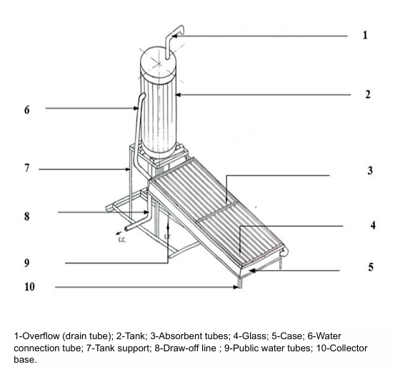

Figure 1: annotated diagram of the CESI design machete

  - Construction of the solar collector
    - The absorber
The absorber consists of twelve (12) rectangular tubes fixed to a black-painted galvanized sheet. It is manufactured in two phases: first, the exchanger is made up of tubes welded together, then it is attached to the sheet metal. This is done by welding or drilling, and fastening with soft iron. The duration of these operations varies according to the client.
    - The frame
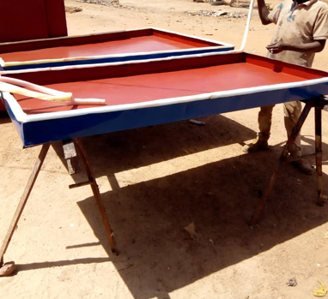
Easier to produce, the frame is made of iron and is rectangular in shape. It's made by cutting and welding materials according to defined dimensions. It is made in two parts: one for the glass and the other for the absorber.

Figure 2: frame

    - Sensor support
This stage consists of sawing and welding the angles
    - Heat exchanger
The heat exchanger has a serpentine shape placed within the storage tank at ¾ of the height.
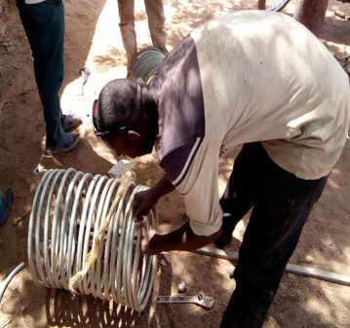

Serpentine heat exchanger

Figure3: Internal heat exchanger in the storage tank

    - Thermal insulation
Both the collector and the storage tank are insulated with glass wool. Glass wool is a thermal insulation material with a woolly consistency obtained by melting sand and recycled glass (calcin)(anonymous, 2024) .
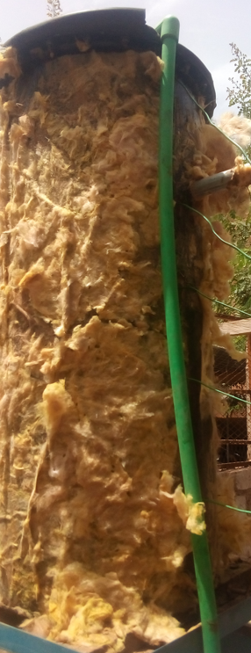

Glass wool around the storage tank

Figure 4: Balloon thermal insulation: glass wool

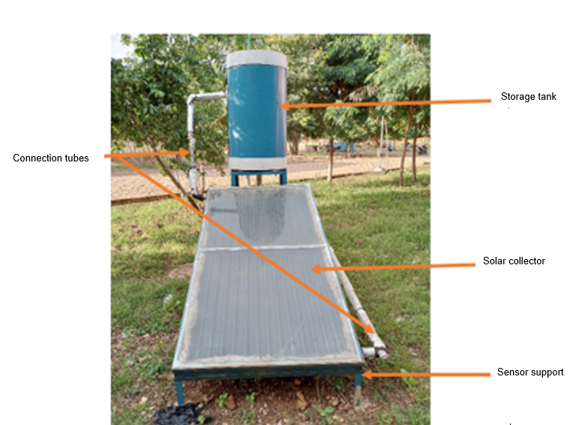
Figure 5 : thermosiphon solar water heater components

Table 1: Solar water heater components

Collector | Galvanized steel
Glazing  Clear glass | ransmissibility: $τ_{V}$= 83%  Reflexibility: 8 %  Absorptivity: $α_{V}$=9%  .
Tilt angle | 15°
Collector dimensions | Length: L=2 m  Width: l=1 m  Gross surface area:  S=2 m²
Pipe dimensions | Length: L_{t}=1.80 m  Diameter D_{H}:15 mm  Diameter: d_{t}=21 mm  Number: 12
Storage tank Steel | Acier
Length of connections | Hydraulic diameter  D_{H} :34mm
Exchanger dimensions | Length:3 m  Diameter D_{H}: 20 mm  External diameter:  d_{e}=27mm
Tank position | Vertical
Storage capacity | Thickness: 2 mm  Height:1000 mm
Maximum operating temperature | T_{max}=95 °C

  - How the separate-element thermosiphon solar water heater works
In this system, water from the public network (ONEA) enters the storage tank. Over the course of the day, the cold water stored in the tank above the solar collector descends into the collector, where it heats up. The water heated by the density gradient in the solar collector rises in the storage tank, while the colder water descends in a closed loop. The phenomenon stops when this gradient weakens, due to sufficient solar radiation to raise the temperature of the water in the collector via the absorber plate: this is the thermosiphon principle. The collector must be installed under the storage tank so that the hot water rises in the tank.(SEDKI & SI LARBI Amina, 2018).

- EXPERIMENTAL STUDY
  - Site
The water heater is installed in Burkina Faso at the Institute of Sciences in the city of Ouagadougou (latitude 12°21'45, North, longitude 1°29'21.8 West). The water heater is fixed to the ground next to an R+1 building used as a student residence.
  - Assumptions
- The ground temperature is taken to be equal to the ambient temperature;
- The flow regime is transient;
- The physical properties (mass per unit volume; density; thickness) of the materials are assumed to be constant and independent of temperature;
- The surfaces of the glass, the absorbing plate, and the insulation are isothermal.
- The surfaces where radiative exchanges occur are considered diffuse gray.
- The inner walls of the tubes are perfectly smooth so that losses due to roughness can be neglected.
- The side walls and rear face of the collector are insulated.
- The glass is opaque to infrared radiation emitted by the absorber.
- Exchanges between the ground and the device are negligible.
- The sky is considered a black body.
  - Limitations and uncertainties of the results
Thermocouple has a measurement error of plus or minus 1.5°C
The data logger used is a keithley type with an uncertainty of 1%.
The solarimeter has error committed by the device during a given measurement is estimated at 5 %

  - Measurement equipment
The solar prototype studied was designed and built in Burkina Faso by a local company called Atelier Nikiema&frère. It was installed on the premises of the Ecole Normale Supérieure in 2020. The water heater is a separate unit comprising a solar collector and a storage tank. The solar collector is a flat-plate glazed water collector. The system operates by thermosiphon effect, i.e. natural convection. The water is stored in a cylindrical tank placed vertically above the solar collector on a base. Three key criteria were used to select and use the materials: availability, acceptable cost and thermal properties.

    - Thermocouple
A thermocouple is a sensor used to measure temperature. Our thermocouple (photo2) is type K, its plus pole (+) is made of Chrome metal and its minus pole ( - ) is made of Aluminium metal (Anonymous, 1794) with a measurement error of plus or minus 1.5°C .
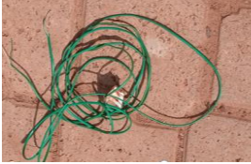
Figure 6: Type K thermocouples

    - Data logger
Thermocouples are connected to a data logger. The data logger used is a keithley type with an uncertainty of 1%. To power the data logger, we used the energy generated by Société Nationale Burkinabè d’Electricité (SONABEL).

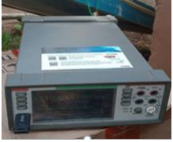
Figure 7 : Data loger type keithley

    - The Solarimeter
The solarimeter is the device used to measure global radiation. It is placed on the surface of our sensor with the same inclinations. The error committed by the device during a given measurement is estimated at 5 %

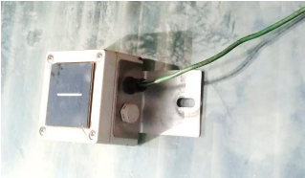
Figure 8°: The Solarimeter

  - Experimental protocol
In this work, we are mainly interested in global radiation and element temperatures at the collector. These data will enable us to study the actual performance of this system. Temperature measurements are made using K-type thermocouples held on the surface of the system where the temperature is to be measured. This is achieved by means of aluminum adhesive tape. The solarimeter, used to measure solar radiation, is placed on the system window at the same angle as the window. Finally, all the thermocouples and the pyranometer are connected to the data logger, which automatically saves the data on a USB medium for processing in a computer.

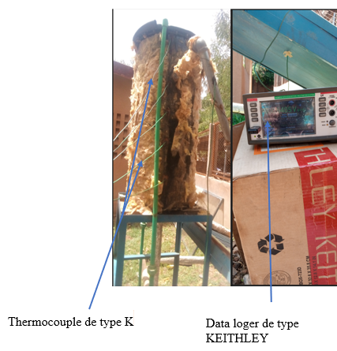

Figure 9.a.: Measuring equipment assembly diagram.

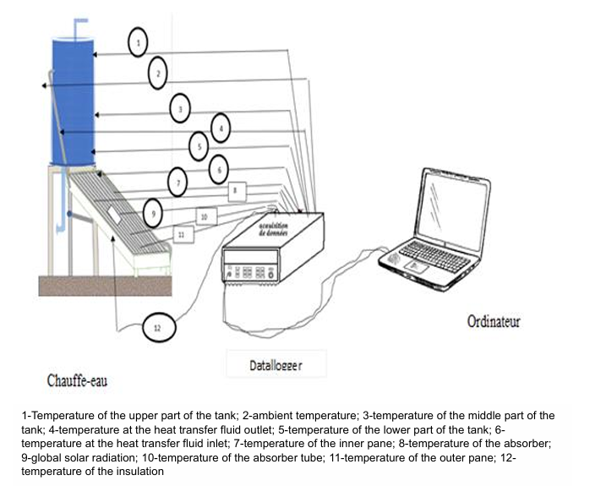
Figure 9.b.: Measuring equipment assembly diagram.
- Estimation of instantaneous efficiency (Anonymous, 2019)

Collector efficiency 𝜂𝑐𝑎𝑝 in (%):
$η_{cap}=β-κ.\left[T_{m}-T_{a}\right]÷I_{s}$ (Eq. 2)
$β=α×τ$ (Eq. 3)
$Heat loss=κ×\left[T_{m}-T_{a}\right]$ (Eq. 4)
$T_{m}=\left(T_{e}-T_{s}\right)÷2$ (Eq. 5)
The efficiency (𝜼𝒄𝒂𝒑) dépends on sunshine and the temperature difference between the ambient medium and the absorber. It is zero when the heat transfer fluid is stopped.
• Power received by the absorber P absorber in (W/𝑚²)
$P_{absorbeur}=β×I_{s}$ (Eq. 6)
• Absorber useful power (P_utile) per unit collector area (W/𝑚²): is the power returned to the brine
$P_{utile}=P_{absorber}- Heat losses$ (Eq. 7)
From equations (Eq. 4) and (Eq. 6) equation (Eq. 7) becomes :
$P_{utile}= β×I_{s} - κ×\left[T_{m}-T_{a}\right]$ (Eq. 8)
From equations (Eq. 1) and (Eq. 8) we obtain equation (Eq. 9)
$P_{utile}=η_{cap}×I_{s}$ (Eq. 9)
• Total useful power ($P_{U_{t}}$) of the collector in (W)
$P_{U_{t}}$ =Surface aperturedu capteur×$P_{utile}$
Equation (Eq. 10) is obtained from (Eq. 9)
$P_{U_{t}}=η_{cap}×I_{s}×S$
- RESULTS AND DISCUSSION
  - Solar radiation evolution and ambient temperature profile
The curves in figure 10.a ;10.b and 10.c below show the evolution of solar radiation and ambient temperature measured during the experimental days of 7-09-2023, 15-10-2023 and 16-10-2023. Solar radiation evolves progressively from sunrise, reaching its maximum value at true solar noon, then decreasing to zero at sunset. Figures 3.1, 3.2 and 3.3 show an oscillating phase, which differs from one figure to the next, around 9 a.m. to 3:30 p.m., 9 a.m. to 2:00 p.m. and 9 a.m. to 2:00 p.m. respectively. These trends can be explained by a cloudy passage over our sensor. The highest value of global solar radiation was reached on 07-09-2023 at 11:54 a.m, with a value of around 1101 W/m². For the days 10-15-23 and 10-16-2023, the maximum values are respectively 783.54 W/m²reached at 11 :52 a.m and 996.29 W/m² at 10 :56 a.m. This difference is due to weather conditions. The ambient temperature, given that the curves have phases of slight oscillation that vary from one day to the next from 11am to 4:15 pm, from 9am to 4pm and from 10am to 3 p.m respectively for the days of 7-09-2023, 15-10-2023 and 16-10-2023, rises and reaches its maximum value around 11a.m-3 p.m overall; then begins to have a slight downward slope until sunset. Its maximum value is 39.64 °C, reached on 10-15-2023 at 12:26 p.m. The results for the three days, although different in temperature, show the same pattern. The maximum and minimum ambient temperatures recorded were 39.64 °C and 25.14 °C respectively. These same trends were found by Kafando, in 2019 (Kafando, 2019) who conducted experimental studies on a flat solar dryer. The results of this study showed that the maximum ambient temperature was 40 °C and the maximum global solar radiation was 900 W/m²

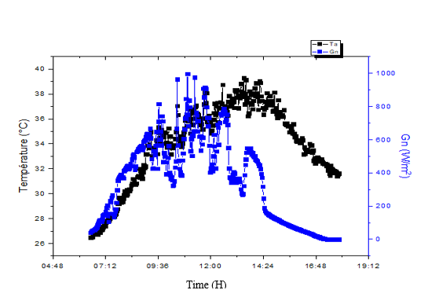

Figure 10.a. : Temporal evolution of solar radiation and ambient temperature (16/10/2023)

)
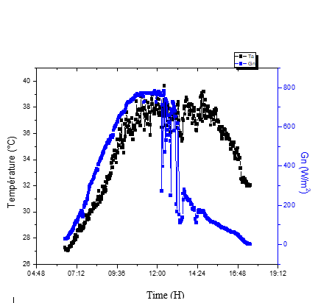
07/09/2023
15/10/2023
16/10/2023

Figure 10.b.: Temporal evolution of solar radiation and ambient temperature (15/10/2023)

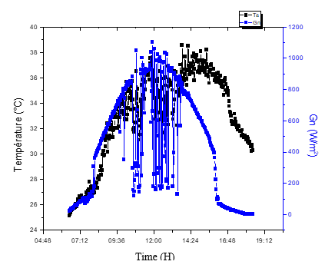
Figure 10.c.: Temporal evolution of solar radiation and ambient temperature (07/09/2023)

  - Experimental temperature profile for different parts of the storage unit
The curves in figure 11.a ;11.b and 11.c below show the evolution of heat transfer fluid temperatures at the collector inlet and outlet, as well as the temperature of the absorber tube through which the heat transfer fluid flows. The curves thus obtained have the same appearance. Based on these results, it can be seen that the temperature of the heat transfer fluid at the collector outlet reaches around 53 °C at midday. The absorber plate has a maximum temperature of 75 °C. What's more, the temperature difference between the collector inlet and outlet varies between 4 °C and 18 °C, despite the adverse climatic impacts (rainy season). We also observe that the difference between the temperature of the fluid entering the collector and that leaving it is very high at the start of our experiment, and this can be explained by a decrease in the temperature gradient infecting the thermosiphon effect of the system. The trends obtained are similar to those obtained by Madeleine Drame Sagna, (SAGNA, 2020) who conducted a study on the sizing and performance evaluation of a glazed flat plate solar water heater for domestic use in 2020 in Senegal. These results show that the difference between fluid inlet and outlet temperatures reaches a maximum ∆Tm value of 23.6 °C in the off-season for irradiation of 1053 W/m². Similarly, Sedki Lylia and Larbi Amina (SEDKI & SI LARBI Amina, 2018) studied and analyzed the performance of

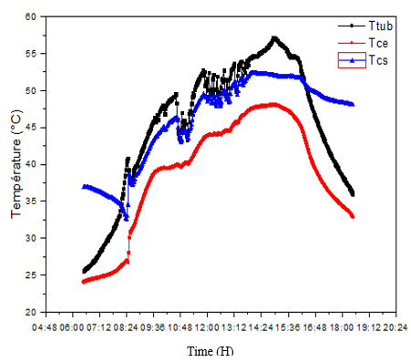

Figure 11.a. : Temporal evolution of experimental heat transfer fluid temperatures in the collector(07/09/2023)

)
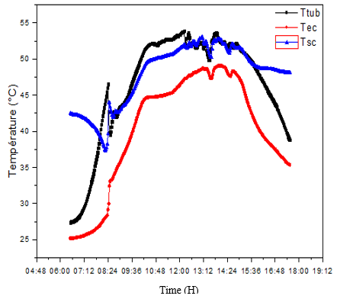

Figure 11.b. : Temporal evolution of experimental heat transfer fluid temperatures in the collector (15/10/2023

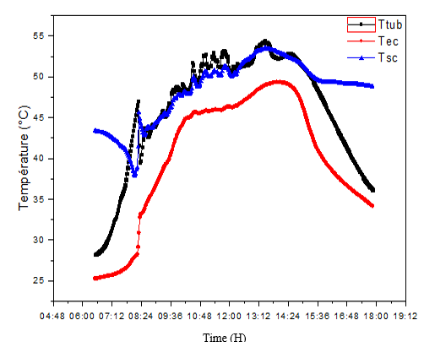

Figure 11.c. : Temporal evolution of experimental heat transfer fluid temperatures in the collector (16/10/2023)

Figure 12.a ;12.b. and 12.c shows that the temperature of the various components is closely linked to the overall solar irradiance received by the collector. The temperature of the various components rises to reach its maximum between 10:30 a.m. and 4:00 p.m., 10:00 a.m. and 4:15 p.m. and 10:00 a.m. and 3:00 p.m. respectively for the three days considered. In all three figures, it can be seen that the absorber plate has the highest temperature, and consequently absorbs the greatest amount of energy. There's a relatively large gap, between 10 °C and 20 °C, between the temperature of the working fluid at the collector outlet and that of the absorber plate, which is due to the poor contact (welding) of the tubes carrying the heat transfer fluid against the absorber plate (presence of a contact resistance). In descending order comes the temperature of the insulation, due to its direct contact with the absorber plate, its thinness and the presence of many unfilled parts, something we noticed during the experiment. This leads us to conclude that the collector has a lot of heat loss on its rear face. This is due to the fact that heat is lost between the absorber tube and the absorber plate. Finally comes the temperature at the collector outlet, followed by the temperature of the fluid at the collector inlet. The lowest of these temperatures is that of the outer pane (transparent cover), which is relatively low due to direct contact with the surrounding environment, giving rise to heat loss by convection with the surrounding environment, particularly in windy conditions. These same observations were made by Bentoumi Hadjer in 2017 on Numerical and experimental study of a solar thermal collector in Boussaâda(BERCHIDE, 2011).

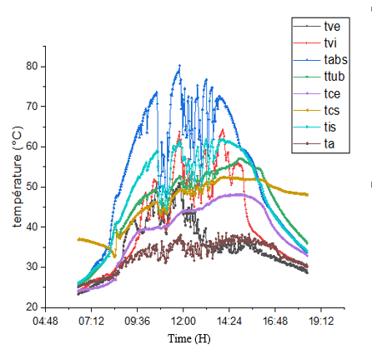

Figure 12.a.: Time trend in experimental temperatures for different parts of the sensor( 07/09/2023)

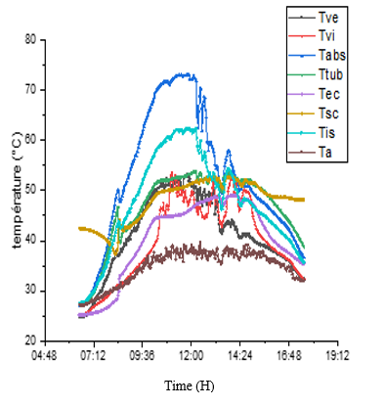

Figure 12.b.: Time trend in experimental temperatures for different parts of the sensor (15/10/2023)

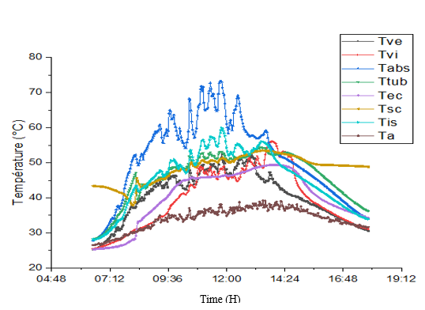

Figure 12.c.: Time trend in experimental temperatures for different parts of the sensor (16/10/2023)

  - Evolution of instantaneous yield over time
According to fig. 13.a ;13.b ;13.c Evolution over time of instantaneous yield increases progressively from sunrise to reach maximum levels between 9 am and 2 pm, even though sunlight begins to diminish from 1:30 pm.

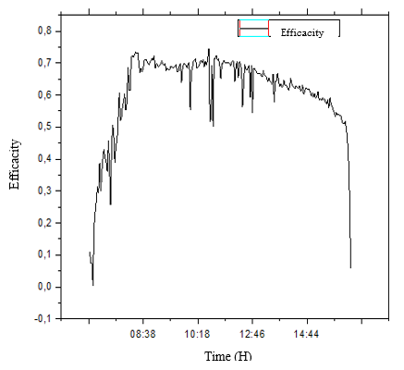

Figure 13.a. : Time trend in instantaneous yield ( 07/09/2023)

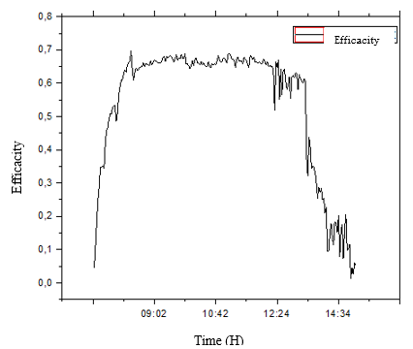
Figure 13.b. : Time trend in instantaneous yield (15/10/2023)

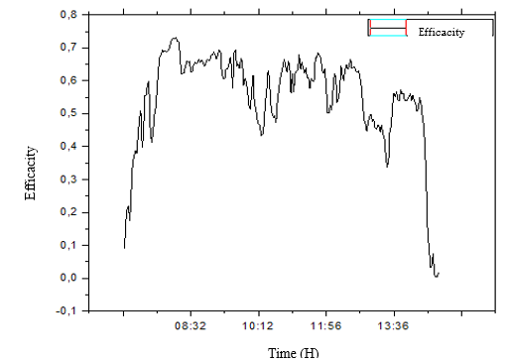

Figure 13.c. : Time trend in instantaneous yield (16/10/2023)

- COMPARISON WITH A CONVENTIONAL WATER HEATING SYSTEM
During the test period, the average efficiency of the flat-plate solar collector was around 36 %. This value can be considered acceptable given the constraints imposed by meteorological and climatic conditions and the choice of manufacturing materials.
The results obtained are compared with those of another conventional system (Table 2) on the market, consisting of a flat-plate collector and a vertically or horizontally positioned storage tank. This system operates on the principle of natural convection, by thermosiphon.
Table 2: Comparative results in the literature

Table 2 :

Theme | Authors | Performance
Thermal performance, economic and environmental life cycle analysis of thermosiphon solar water heaters | (Soteris Kalogirou, 2009) | 30 – 40 %
Year round performance and potential of a natural circulation type of solar water heater in India | (N.M Nahar, 2003) | 57 %
Thermal performance of a heating system working with a PCM plate heat exchanger and comparison with a water tank 2016 | (M.M. Prieto 1 et al., 2016) | 74 %
Modelling and Simulation of a Solar Water Heating System with Thermal Storage | (Ahmed Aisa & Tariq Iqbal, 2016) | 80 %
Thermal performance of a solar water heater with internal exchanger using thermosiphon system in Côte d'Ivoire | (koffi, 2013) | 50 %

- CONCLUSION
Thanks to the experimental study, we have been able to evaluate the temperature behavior of the solar water heater components. The operation of the various components of our solar water heater is linked to overall solar radiation. The solar collector is no exception in terms of efficiency. The maximum instantaneous efficiency is 70 % with a maximum global solar irradiation of 1101 W/m²and a maximum ambient temperature of 39.64 °C. This study has enabled us to evaluate the current performance of our solar collector, and to optimize it with a view to further enhancing this performance.

NOMENCLATURE
$$I_{s}:Solar irradiance (W/m²)$$
$$β :Optical factors(\%)$$
$$κ:Thermal transmittance (W /m².K)$$
$$T_{m} :Average collector temperature \left(K\right)$$
$$T_{a }\& t_{a }:ambient temperature \left(K\right)$$
$$T_{e}:collector input temperature\left(K\right)$$
$$T_{s}:collector output temperature\left(K\right)$$
$$α:taux d^{'}absorptionde l^{'}absorbeur\left(\%\right)$$
$$τ:glazing transmission rate (\%)$$
$$T_{ve}:external pane temperature\left(°C\right)$$
$$T_{vi}:Internal glass temperature\left(°C\right)$$
$$T_{tub}:Tube temperature\left(°C\right)$$
$$T_{abs}:Absorber plate temperature\left(°C\right)$$
$$T_{ec}:Temperature of water entering collector\left(°C\right)$$
$$T_{sc}:Temperature of water leaving collector\left(°C\right)$$
$$T_{f}:Temperature of cold water\left(°C\right)$$
$$V:le volume représente les besoins en L/j$$
$$C:Power represents requirements in kWh/j$$
$$T_{c}:Temperature of hot water \left(°C\right)$$
$$T_{is}:Temperature of insulation\left(°C\right)$$

ABBREVIATIONS :
ONEA : Office National de l’Eau et de l’Assainissement
SONABEL : Société Nationale Burkinabè d’Electricité
ARSE : Autorité de Régulation du Secteur de l’Energie
UEMOA : Union Economie et Monétaire Ouest-Africaine

Disclaimer (Artificial intelligence)

Option 1:

Author(s) hereby declare that NO generative AI technologies such as Large Language Models (ChatGPT, COPILOT, etc.) and text-to-image generators have been used during the writing or editing of this manuscript.

References

Ahmed Aisa, & Tariq Iqbal. (2016, octobre). Modelling and Simulation of a Solar Water Heating System with Thermal Storage. DOI:10.1109/IEMCON.2016.7746283
AlainLiébard, & NicolasGuichard,. (2008). Del’électricitévertepourcentmillerurauxauBurkinaFaso”? https://fondem.ong/wp-content/uploads/2021/03/De-le%CC%81lectricite%CC%81-verte-pour-100-000-ruraux-au-Burkina-Faso.pdf
A.M. Shariah, & G.O.G. Löf. (1997). ‘Effects of Auxiliary Heater on Annual Performance of Thermosyphon Solar Water Heater Simulated under Variable Operating Conditions. Solar Energy, Vol. 60, N°2, 119-126,.
Anonymous. (1794). Manuel Utilisateur,allen-Bradley-modules d’entrés thermocouples/millivolts (ref:1794-IT8) un livre de ROCKWELL Automation. https://literature.rockwellautomation.com/idc/groups/literature/documents/um/1794-um007_-fr-p.pdf
Anonymous. (2019). RENDEMENT DES CAPTEURS THERMIQUES - M2E-MarcSeguin. https://www.nouvenergie.fr/e-formation/solaire-1/rendement-capteurs/
anonymous. (2024). Laine de verre. In Wikipedia. https://fr.wikipedia.org/wiki/Laine_de_verre
BENALLOU, A., & BOUGARD, J. (1996). GUIDE: DE L’ENERGiE SOLAIRE : LE SOLAIRE THERMIQUEAU SERVICE DU DEVELOPPEMENT DURABLE».
BERCHIDE, A. (2011, juillet 6). Etude et expérimentation d’un chauffe-eau solaire de type capteur-stockeur. Université Abou Bekr Belkaid de Tlemcen/Algérie. http://dspace.univ-tlemcen.dz/bitstream/112/944/1/Etude-et-experimentation-dun-chauffe-eau-solaire-de-type-capteur-stockeur.pdf
BOUALAMALLAH, Hd., Merdji, A., ,GHAZI, A., & Miloudi, A. (2021). Optimisation d’un chauffe- eau solaire. Revue des Matériaux et Energies Renouvelable, Vol 6, N°1, 2022. Journal home : https://www.univ-relizane.dz
G.M. AbdullAzziz a, & M.A. Mukbel. (1994). Thermal Performance of Solar Water Heater System in Yemen. Vol. 4, N°2, 241-247,.
Kafando, G. J. (2019). Études expérimentales sur un séchoir solaire plan à air destiné au séchage des produits agro-alimentaires et halieutiques, mémoire de master soutenu le 31decembre 2019 à l’université Joseph Ki-Zerbo-Burkina Faso. Université Joseph Ki-Zerbo, Burkina Faso.
KAZADII, K. A., & NGELEKA, M. F. (2019, août 1). AVANT PROJET DE DIMENSIONNEMENT D’UN CHAUFFE-EAU SOLAIRE. International Journal of Innovation and Applied Studies, 71‑87.
Kof, P. M. E., Andoh, H. Y., Gbaha, T., Toure, S., & Ado, G. (2008). Theoretical and experimental study of solar water heater with internal exchanger using thermosiphon system. Energy Conversion and Management 49 (2008). www.sciencedirect.com
koffi, P. M. E. (2013, février 24). Thermal performance of a solar water heater with internal exchanger using thermosiphon system in Côte d’Ivoire. journal homepage: www.elsevier.com/locate/energy. . http://dx.doi.org/10.1016/j.energy.2013.09.059
Li Peng, Mohamed Salem, & Vojtech Blazek. (2023, juin). Thermal energy storage applications in solar water heaters : An updated review. https://doi.org/10.1016/j.seta.2023.103230
M. BENBRIKA, M. BENBELHOUT, & M. TEGGAR. (2015). Amélioration de l’efficacité thermique d’un chauffe-eau solaire par l’utilisation de matériaux à changement de phase (MCP). International Journal of Scientific Research & Engineering Technology (IJSET). benbelhoutmohammed@hotmail.com
M.M. Prieto 1, B. González 2, & E. Granado 2. (2016, juin 15). Thermal performance of a heating system working with a PCM plate heat exchanger and comparison with a water tank. https://doi.org/10.1016/j.enbuild.2016.03.078
N.M Nahar. (2003, mars). Year round performance and potential of a natural circulation type of solar water heater in India. https://doi.org/10.1016/S0378-7788(02)00091-9
Rezki, N., Arezki, S., & Hakim, D. (2018). Etude et conception d’un chauffe-eau solaire.
SAGNA, M. M. D. (2020, décembre 7). DIMENSIONNEMENT ET ETUDE DE PERFORMANCE D’UN CHAUFFE-EAU SOLAIRE À CAPTEUR PLAN VITRE POUR UN USAGE DOMESTIQUE.
SEDKI, L., & SI LARBI Amina. (2018, juillet 8). Etude et analyse des performances thermiques d’un chauffe-eau solaire individuel à circulation naturelle.
Soteris Kalogirou. (2009). Thermal performance, economic and environmental life cycle analysis of thermosiphon solar water heaters. https://doi.org/10.1016/j.solener.2008.06.005
TRAORE, M. Y., & KABORE, R. P. (2017, juin). ETUDE SUR L’ETAT DE LIEU DE L’OFFRE DE FORMATION EN ENERGIE RENOUVELABLE AU BURKINA FASO, RAPPORT FINAL de l’ Organisation Néerlandaise de Développement (SNV), de Association de Gestion des Ressources Naturelles et de la Faune de la Comoé- Léraba (AGEREF-CL),Organisation Catholique pour le Développement et la Solidarité (OCADES). https://a.storyblok.com/f/191310/be1dbe5c0b/evidence_sur_letat_des_lieux_de_loffre_de_formation_en_er_bf.pdf
Yasser Nassar, & Mukhtar Irhouma. (2025). Towards Green Economy : Case of Electricity Generation Sector in Libya. https://orcid.org/0000-0002-9675-8304

