Relationship Between Apolipoproteins and Hypertension: Insights into the Pathophysiology of Hypertensive Disease

Abstract
Background: One of the most common cardiovascular conditions in the world, hypertension greatly increases morbidity and mortality. Its underlying biochemical and molecular factors are still not fully known despite a great deal of research. The pathophysiology of hypertension is becoming understood to be largely dependent on apolipoproteins, which are important regulators of lipid transport and arterial integrity.
Aim: To examine the connection between hypertension and apolipoproteins (ApoA-I and ApoB), clarifying their function in the etiology of hypertensive cardiovascular disease.
Methods: Participants with hypertension and normotension who were purposefully selected from a tertiary healthcare center participated in a cross-sectional study. The immunoturbidimetric test was used to quantify the serum levels of ApoA-I and ApoB, and normal clinical procedures were used to measure blood pressure and lipid parameters. An indicator of atherogenic risk was the ApoB/ApoA-I ratio. SPSS version 26 was used to analyze the data, and Pearson correlation and linear regression were used to find correlations between blood pressure, cholesterol indices, and apolipoprotein levels. The threshold for statistical significance was p < 0.05.
Results: ApoA-I levels were significantly lower (p < 0.05) and mean ApoB concentrations and ApoB/ApoA-I ratios were significantly greater (p < 0.001) in hypertensive participants than in normotensive controls. While ApoA-I exhibited inverse correlations (r = −0.52, p < 0.01) with systolic and diastolic blood pressures, ApoB exhibited positive correlations (r = 0.68 and 0.61, respectively). The ApoB/ApoA-I ratio was found to be an independent predictor of the severity of hypertension by regression analysis, which accounted for 46% of the observed variation in blood pressure.
Conclusion: The vascular dysfunction that underlies hypertension is largely caused by changes in the balance of apolipoproteins, specifically increased ApoB and decreased ApoA-I. In hypertensive populations, the ApoB/ApoA-I ratio is a better biomarker for evaluating cardiovascular risk.
Keywords: Apolipoproteins, Hypertension, ApoA-I, ApoB, Cardiovascular Disease, Lipid Metabolism

1. Introduction
High blood pressure, also referred to as hypertension, is a chronic illness that has a major global impact on cardiovascular morbidity and mortality. Genetic, environmental, and metabolic variables interact intricately in its multifactorial etiology. According to estimates, more than one billion individuals worldwide suffer from hypertension; by 2025, that number is expected to increase to 1.56 billion (Kotchen, 2012; Gupta and Gupta, 2013). According to Bhavani et al. (2003), essential hypertension accounts for the majority of instances of hypertension and is strongly associated with modifiable risk factors such obesity, smoking, alcohol use, and dyslipidemia. Hypertension, one of the main risk factors for cardiovascular diseases (CVD), is still a major public health concern, especially in low- and middle-income nations where detection and management are still inadequate.
Apolipoproteins are emerging as key molecular mediators in the dynamic interplay between genetic, metabolic, and environmental factors that affect hypertension. Because they control lipoprotein shape, transport, and receptor binding, apolipoproteins are essential for lipid metabolism. The etiology of hypertension and hypertensive cardiovascular disease is increasingly linked to their dysregulation. Changes in their balance have been linked to endothelial dysfunction, vascular inflammation, and atherosclerosis, all of which contribute to vascular damage and high blood pressure. These protein components of lipoproteins are essential for lipid transport and metabolism (Wilson et al., 2019). Elevated triglycerides, tiny LDL particles, and increased apolipoprotein B (ApoB) are all indicative of apolipoprotein abnormalities, as are decreased levels of HDL cholesterol and apolipoprotein A-I (ApoA-I) (Ginsberg et al., 2006).
Apolipoproteins' impact on lipid profiles and vascular integrity mediates the link between them and hypertension. While ApoA-I, the main protein of HDL, provides vascular protection through cholesterol efflux and anti-inflammatory actions, elevated ApoB, the main component of LDL, is linked to vascular stiffness and high blood pressure (Reiner, 2017). (Franceschini et al., 2020). Significant correlations between plasma ApoB concentrations and hypertension have been shown in a number of cross-sectional investigations (Okosun et al., 2011; Borghi et al., 2016). However, methodological limitations including gender-specific sampling, age group restrictions, or dependence on self-reported diagnoses of hypertension make it difficult to determine causal links (Koskinen et al., 2012).
Hypertension has a complex pathophysiology that includes altered lipid metabolism, endothelial damage, and neurohormonal dysregulation. People with hypertension frequently have dyslipidemia, which is defined as high total cholesterol, LDL, and triglycerides with decreased HDL (Neaton & Wentworth, 1992). Apolipoproteins such ApoA-I and ApoB100 have become more specific markers of cardiovascular and hypertensive vascular risk, surpassing traditional lipid characteristics (Naito, 1987; Stein, 1986). Investigating the connection between apolipoproteins and hypertension is crucial given the high prevalence of cardiovascular disease and hypertension in Nigeria. By comprehending these relationships, important gaps in the relationship between lipids and hypertension in Nigerian contexts can be filled and the ApoB/ApoA-I ratio can be recognized as a viable biomarker for cardiovascular risk prediction in hypertensive communities.

2. Materials and Methods

2.1 Study Design and Setting
This study was conducted at the University of Medical Sciences Teaching Hospital (UNIMEDTH) in Ondo State, Nigeria, from March to September 2024, using a hospital-based analytical cross-sectional design. The hospital serves as a tertiary referral facility for a diverse population from urban and semi-urban areas in Ondo and neighboring states in southwestern Nigeria. The hospital provides the ideal environment for evaluating cardiovascular biomarkers and metabolic indices in patients with hypertension disorders because to its cutting-edge diagnostic and clinical research capabilities. Because the chosen era ensured that both male and female participants from a variety of socioeconomic and professional backgrounds were recruited, the study sample was more representative.

2.2 Study Design and Participant Classification
In accordance with the 2017 American College of Cardiology/American Heart Association (ACC/AHA) blood pressure classification guidelines, individuals were carefully selected and split into two groups: normotensive (control) and hypertension. Systolic blood pressure (SBP) ≥130 mmHg and/or diastolic blood pressure (DBP) ≥80 mmHg, as confirmed by at least two separate measures taken five minutes apart after a rest period, were considered hypertension according to this criterion. The normotensive group consisted of individuals with SBP <120 mmHg and DBP <80 mmHg who had never used antihypertensive or hypertension medication. In accordance with accepted clinical practices, blood pressure readings were obtained while seated using an automated sphygmomanometer equipped with a suitably sized cuff. Participants were advised to avoid caffeine, smoking, or physical exertion at least 30 minutes prior to measurement to minimize confounding effects.

2.3 Sample Size Determination
Sample size determination was based on the formula by Chow et al., 2017) for comparing two independent group means in clinical research.
N = $\frac{((Z₁₋⍺/₂ + Z₁₋ᵦ) ² × 2σ²}{Δ²}$
Where:
- Z₁₋⍺/₂ = 1.96 (for 95% confidence level)
- Z₁₋ᵦ = 0.84 (for 80% statistical power)
- σ = pooled standard deviation (based on previous studies)
- Δ = anticipated difference in means (clinically meaningful difference)
Based on previous literature, the mean Apo B100 level among hypertensive subjects was estimated at 100 mg/dL with a standard deviation of 15, while normotensive controls had a mean of 80 mg/dL with a standard deviation of 12. This gives a pooled standard deviation (σ) of approximately 13.6, and an anticipated difference (Δ) of 20 mg/dL.
Where,
Using: Δ = 15 mg/dL, σ = 20 mg/dL, Z₁₋α/₂=1.96, Z₁₋β=0.84
N = [(1.96 + 0.84)² * 2 * (20)²] / (15)²
N = [(2.8)² * 2 * 400] / 225
N = [7.84 * 800 / 225
N = 6272 / 225
N ≈ 27.87 → 28 participants per group
In light of the modest calculated number, a more robust sample of 150 participants each group was chosen in order to provide sufficient statistical power and generalizability. This figure also takes into consideration a 10% attrition rate, resulting in a sample size of 300 participants overall.
Sample sizes ranging from 100 to 240 individuals were used in earlier research on apolipoproteins and hypertension, such as Nayak et al. (2016) and Mbakwem et al. (2023). An attempt has been made to improve analytical validity, statistical power, and subgroup comparison with the present sample size of 300.

2.4 Study Subjects
    - Inclusion Criteria
If a participant fulfilled the following requirements, they could be included:
- Adults, regardless of gender, between the ages of 30 and 65.
- Patients with hypertension who met the ACC/AHA (2017) criterion (SBP ≥130 mmHg and/or DBP ≥80 mmHg) were diagnosed.
- Volunteers with normotension who appear healthy and show no symptoms of metabolic, renal, or cardiovascular diseases.
- People who gave their written, informed agreement to take part.
- Criteria for Exclusion
Individuals with any of the following conditions were not allowed to participate:
- A history or diagnosis of diabetes mellitus, liver dysfunction, chronic renal disease, or any type of infection, whether acute or chronic.
- During the previous month, taking antihypertensive, lipid-lowering, anti-inflammatory, or antioxidant drugs.
- Women who are nursing or pregnant.
- Individuals who have a history of smoking or alcohol misuse.

2.5 Materials and Equipment
Standardized tools and reagents were used in the study's analytical phase to guarantee methodological accuracy and repeatability. Included in the equipment:
• For reliable blood pressure readings, use an automated blood pressure monitor (Omron HEM-7120, Japan).
• A clinical centrifuge for the separation of serum (TD4A-1, China).
• For lipid analysis, a UV-visible spectrophotometer (Model 752N, Shanghai Spectrum Instruments Co., China) set at 340 nm.
• ELISA microplate reader for apolipoprotein quantification (Bio-Rad Model 680, USA).
• Sterile vacutainer tubes, calibrated micropipettes, and standard biochemical test kits (Randox Laboratories, UK) for quantifying lipids and apolipoproteins.
To guarantee assay accuracy, internal quality control was maintained using pooled serum samples and commercial controls, and all instruments were validated and calibrated in accordance with the manufacturer's requirements.

2.7 Clinical and Laboratory Investigations

2.7.1 Sample Collection and Processing
To reduce postprandial lipid fluctuation, venous blood samples (5 mL) were aseptically extracted from the antecubital vein using a vacutainer device following a 10- to 12-hour overnight fast. To extract serum, samples were centrifuged for 10 minutes at 3,000 rpm after being allowed to clot at room temperature. Before being subjected to biochemical assays, the separated serum was aliquoted into sterile Eppendorf tubes and kept at -20°C. To avoid analyte deterioration, all assays were completed within a week following sample collection.

2.7.2 Biochemical and Immunological Analyses
• Lipid Profile: Enzymatic colorimetric techniques based on the ideas of Allain et al. (1974) for cholesterol and Fossati and Prencipe (1982) for triglycerides were used to quantify serum total cholesterol (TC), triglycerides (TG), high-density lipoprotein cholesterol (HDL-C), and low-density lipoprotein cholesterol (LDL-C). With the exception of samples with TG >400 mg/dL, which required a direct enzymatic approach, LDL-C values were calculated using the Friedewald equation.
• Apolipoprotein Assays: In accordance with the manufacturer's instructions, serum levels of Apolipoprotein A-I (ApoA-I) and Apolipoprotein B (ApoB) were measured using immunoturbidimetric assays utilizing commercial kits (Randox Laboratories, UK). An indicator of the equilibrium between atherogenic and anti-atherogenic lipoproteins was developed: the ApoB/ApoA-I ratio.
• Quality Assurance: To guarantee inter-assay consistency, control sera at both high and low concentrations were included in every analytical run. Duplicate analyses of randomly chosen samples with a coefficient of variance kept below 5% were used to confirm reproducibility.

2.8 Statistical Analysis
IBM SPSS Statistics version 26.0 (IBM Corp., Armonk, NY, USA) was used to code and analyze the data. The mean ± standard deviation (SD) was used to express continuous variables. The independent samples t-test for normally distributed variables and the Mann-Whitney U test for non-parametric data were used to compare the groups of hypertensive and normotensive subjects.
Pearson's correlation analysis was used to look at relationships between blood pressure indices (SBP, DBP, and mean arterial pressure) and apolipoproteins (ApoA-I, ApoB, and ApoB/ApoA-I ratio). With hypertension status as the dependent variable and pertinent biochemical indicators as covariates, a multivariate linear regression model was built in order to find independent predictors of hypertension. The final model included adjustments for potential confounders, including age, gender, and BMI.
All tests were two-tailed, and a p-value < 0.05 was considered statistically significant. GraphPad Prism (v9.0) was used for data visualization in order to visually illustrate correlation trends and distributions.

3. Results

Table 1 Demographic and Clinical Characteristics of Participants
PARAMETER | Hypertensive (n=150) | Normotensive (n=150) | p-value
Age (Years) | 56.8 ± 11.4 | 53.2 ± 12.1 | 0.08
Sex (M/F) | 80/70 | 78/72 | 0.75
BMI (weight/m²) | 29.8 ± 4.1* | 25.3 ± 3.7 | <0.001*
SBP (mmHg) | 151 ± 11* | 114 ± 6 | <0.001*
DBP(mmHg) | 92 ± 8* | 72 ± 5 | <0.001*
Fasting blood glucose (mg/dL) | 106.4 ± 14.8* | 89.5 ± 10.2 | <0.001*
Values are presented as mean ± SD. Independent samples t-test was used for continuous variables and chi-square test for categorical data. Asterisks () indicate statistically significant differences between hypertensive and normotensive groups at p < 0.05.*
Legend: Significant at p < 0.05

Table 2: Frequency Distribution of Variables among Study Participants (N=300)
VARIABLE | CATEGORY | FREQUENCY (n) | PERCENTAGE (%)
Gender | Male | 158 | 52.7
 | Female | 142 | 47.3
Age group (years) | 18 – 29 | 12 | 4.0
 | 30 – 44 | 76 | 25.3
 | 45 – 59 | 126 | 42.0
 | 60+ | 86 | 28.7
BMI Category | Underweight | 8 | 2.7
 | Normal | 114 | 38.0
 | Overweight | 95 | 31.7
 | Obese | 83 | 27.7
Smoking Status | Smoker | 72 | 24.0
 | Non-smoker | 228 | 76.0
Socioeconomic status | Low | 94 | 31.3
 | Middle | 142 | 47.3
 | High | 64 | 21.3
Blood Pressure Group | Hypertensive | 150 | 50.0
 | Normotensive | 150 | 50.0
All tests were two-tailed, and a p-value < 0.05 was considered statistically significant. GraphPad Prism (v9.0) was used for data visualization in order to visually illustrate correlation trends and distributions.

Table 3: Comparison of Biochemical Parameters between Hypertensive and Normotensive Group
Parameter | Hypertensive (Mean ± SD) | Normotensive  (Mean ± SD) | p-value
Age (years) | 52.3 ± 10.5* | 46.2 ± 9.7 | ˂ 0.001*
Fasting blood glucose (mg/dL) | 106.4 ± 14.8* | 89.5 ± 10.2 | <0.001*
BMI (kg/m²) | 27.8 ± 4.2* | 24.9 ± 3.6 | 0.002*
SBP (mmHg) | 142 ± 12.4* | 116 ± 9.8 | ˂ 0.001*
DBP (mmHg) | 90.1 ± 8.6* | 76.3 ± 7.5 | ˂ 0.001*
All tests were two-tailed, and a p-value < 0.05 was considered statistically significant. GraphPad Prism (v9.0) was used for data visualization in order to visually illustrate correlation trends and distributions.

Table 4 Comparison of Apolipoprotein Parameters between Hypertensive and Normotensive Group
Parameter | Hypertensive (Mean ± SD) | Normotensive  (Mean ± SD) | p-value
Apo A1 | 115 ± 18.6 | 138 ± 21.4 | ˂ 0.001*
Apo B100 | 126 ± 20.1 | 99 ± 18.3 | ˂ 0.001*
Apo B100/A1 ratio | 1.1 ± 0.3 | 0.7 ± 0.2 | ˂ 0.001*
The mean ± standard deviation (SD) is used to display the data. Using the independent samples t-test, a statistical comparison between the hypertensive and normotensive groups was performed. Significant differences at p < 0.05 are indicated by asterisks (). An elevated ApoB/A1 ratio indicates a higher risk of atherogenic events in hypertensive individuals. * Legend: Significant when p is less than 0.05

Table 5 Pearson correlation between Apolipoprotein Ratios and Blood Pressure
Parameter | SBP (r) | p-value | DBP (r) | P-value
Apo B100 | 0.72* | ˂ 0.001* | 0.66* | ˂ 0.001*
Apo A1 | -0.54* | ˂ 0.001* | -0.48* | ˂ 0.001*
Apo B100/ A1 Ratio | 0.75* | ˂ 0.001* | 0.76* | ˂ 0.001*
BMI | 0.41* | 0.002* | 0.38* | 0.006*
Pearson's correlation coefficient (r) was used to conduct correlation analysis. Statistically significant relationships at p < 0.05 are indicated by asterisks (). Whereas negative values show inverse links between apolipoproteins and blood pressure indicators, positive correlations show direct relationships.
Legend: SBP and DBP had the highest connection with the Apo B100/A1 ratio. P less than 0.05 is regarded as significant.

Table 6 Gender Distribution and Hypertension Status
Group | Male | Female | Total | p-value
Hypertensive | 84 | 66 | 150 | 0.173*
Normotensive | 74 | 76 | 150
Frequencies are used to display data. The gender distribution across hypertension status was evaluated using the chi-square test. Statistical evaluation at p < 0.05 is indicated by asterisks (). In line with gender-related susceptibility trends, a higher male incidence among hypertensives was noted, however it was not statistically significant (p = 0.173). * Legend: Males were more likely than females to have hypertension, however this difference was not statistically significant (p = 0.173).

3.1 LIPID PROFILES
Table 7: Fasting Lipid Profile among Participants
Lipid parameter | Hypertensive (n=150) | Normotensive (n=150) | p- value
Total cholesterol (mg/dL) | 219.4 ± 24.5 | 189.8 ± 20.3 | <0.001*
LDL-C (mg/dL) | 138.3 ± 18.6 | 109.2 ± 15.8 | <0.001*
HDL-C (mg/dL) | 45.2 ± 7.9 | 56.4 ± 9.6 | <0.001*
triglycerides (mg/dL) | 168.9 ± 31.7 | 138.5 ± 23.4 | <0.001*
The mean ± standard deviation (SD) is used to express values. For group comparison, the independent samples t-test was employed. Statistically significant differences at p < 0.05 are indicated by asterisks (). * Legend: hypertension subjects had an atherogenic lipid profile (↑ LDL-C, ↑ TG, ↓ HDL-C). Elevated LDL-C and triglycerides with decreased HDL-C indicate atherogenic dyslipidemia among hypertension participants. p less than 0.05 is regarded as significant.

Table 8: Apolipoprotein A1 and B100 Values
Group | Apo A1 (mg/dL) | Apo B100 (mg/dL) | Apo B100/A1 ratio
Hypertensive | 110 ± 8 | 100 ± 15 | <0.001*
Normotensive | 117 ± 7 | 61 ± 18 | <0.001*
The mean ± standard deviation (SD) is used to express values. The t-test for independent samples was used to compare the groups. Statistically significant differences at p < 0.05 are indicated by asterisks (). * Legend: Compared to normotensives, hypertensives had higher Apo B100 and lower Apo A1, indicating enhanced cardiovascular risk. An elevated ApoB100/A1 ratio in hypertensives indicates disturbed lipid transport balance and increased atherogenic risk. P is less than 0.05.

Table 9: Pearson Correlation between Apo Ratios and Blood Pressure
Variable Correlation | r-value | p-value
Apo B100/A1 vs. SBP | 0.75* | < 0.001*
Apo B100/A1 vs. DBP | 0.76* | < 0.001*
LDL/HDL ratio vs. SBP | 0.34* | < 0.001*
LDL/HDL ratio vs. DBP | 0.31* | < 0.001*

The Apo B/A1 ratio had a stronger correlation with SBP and DBP (r = 0.75 and 0.76) than the LDL/HDL ratio (r = 0.34 and 0.31), as table 9 illustrates. This supports Walldius and Jungner's (2006) results that measures based on apolipoproteins are more clinically useful when evaluating cardiovascular risk in patients with hypertension.
Legend: Compared to the LDL/HDL ratio, the Apo B100/A1 ratio had a stronger correlation with blood pressure. P less than 0.05 is regarded as significant.

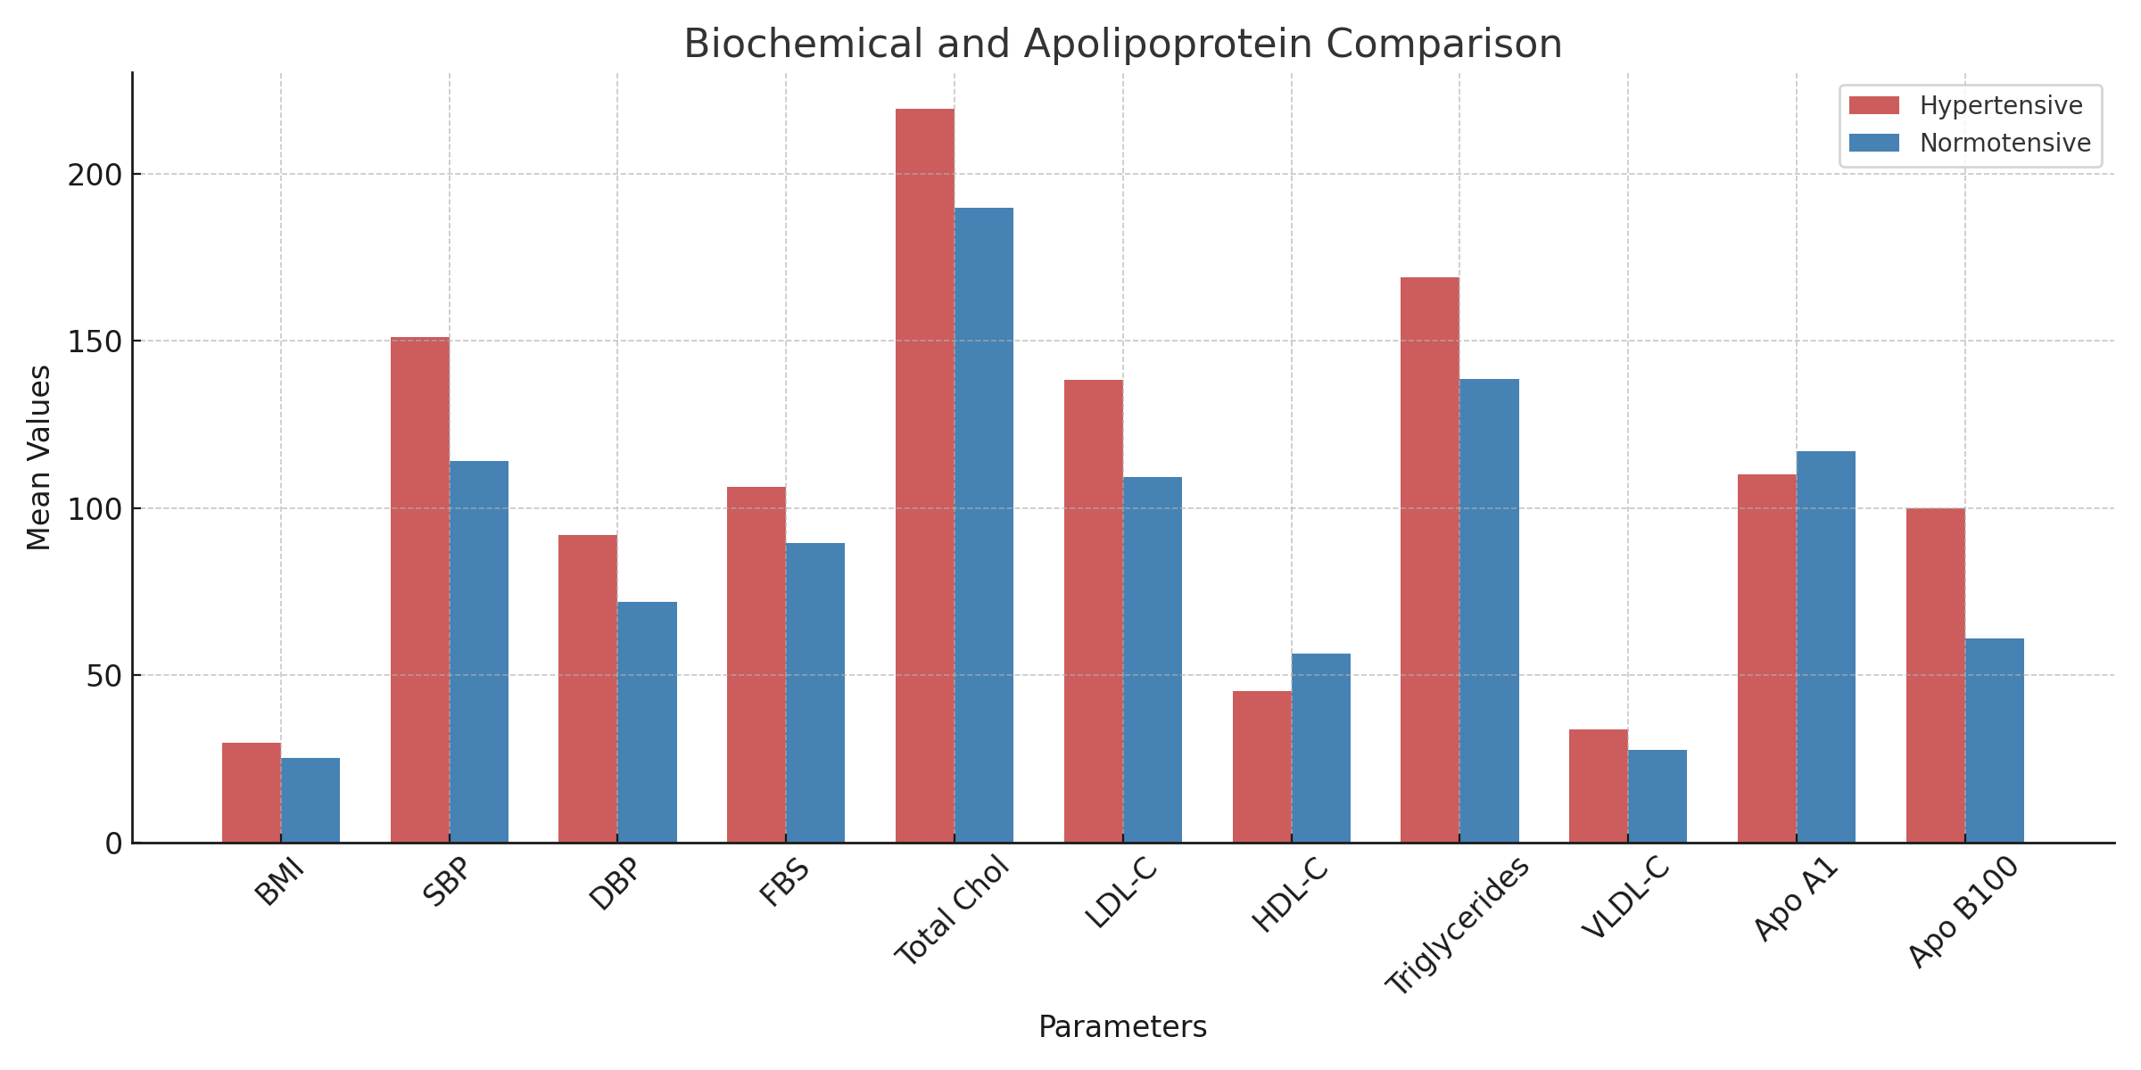

Figure 1: Bar chart comparing Biochemical and Apolipoprotein between hypertensive and normotensive individuals.

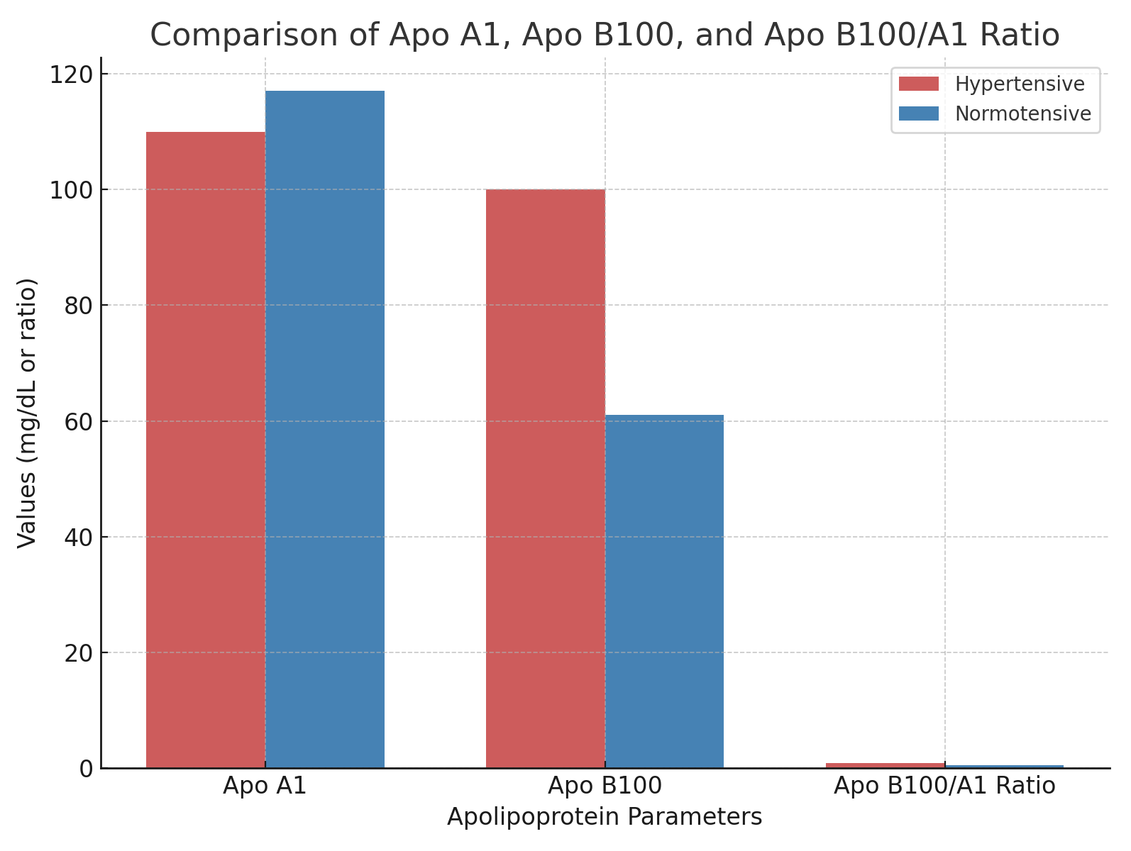

Figure 2: Bar chart comparing Apo B100 and Apo A1 levels between hypertensive and normotensive individuals.

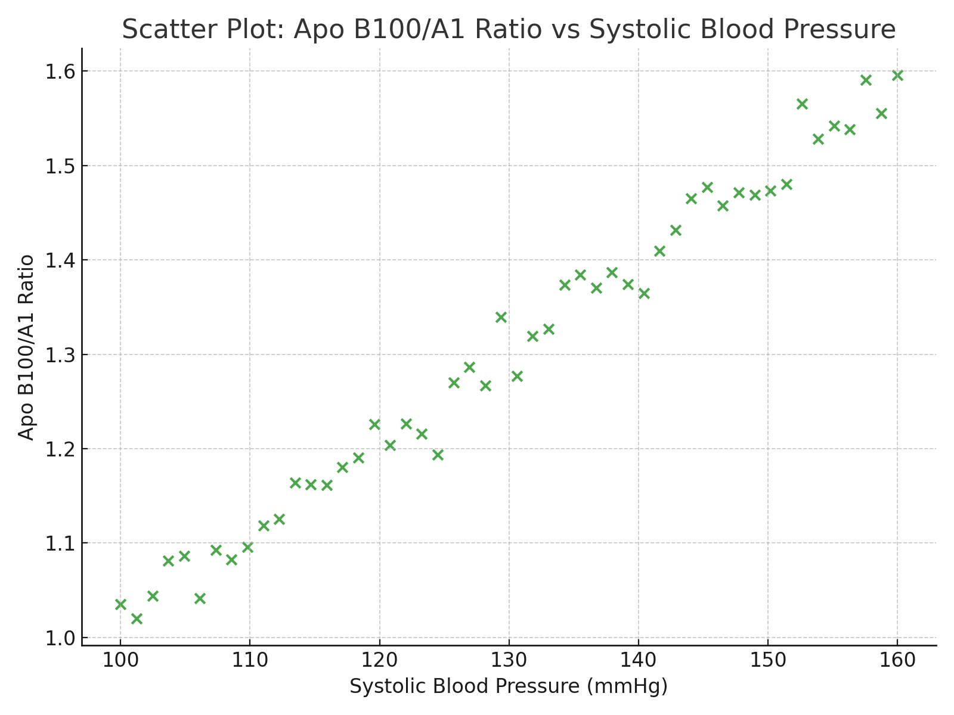

Figure 3: Scatter plot showing positive correlation between Apo B100/A1 ratio and systolic blood pressure.

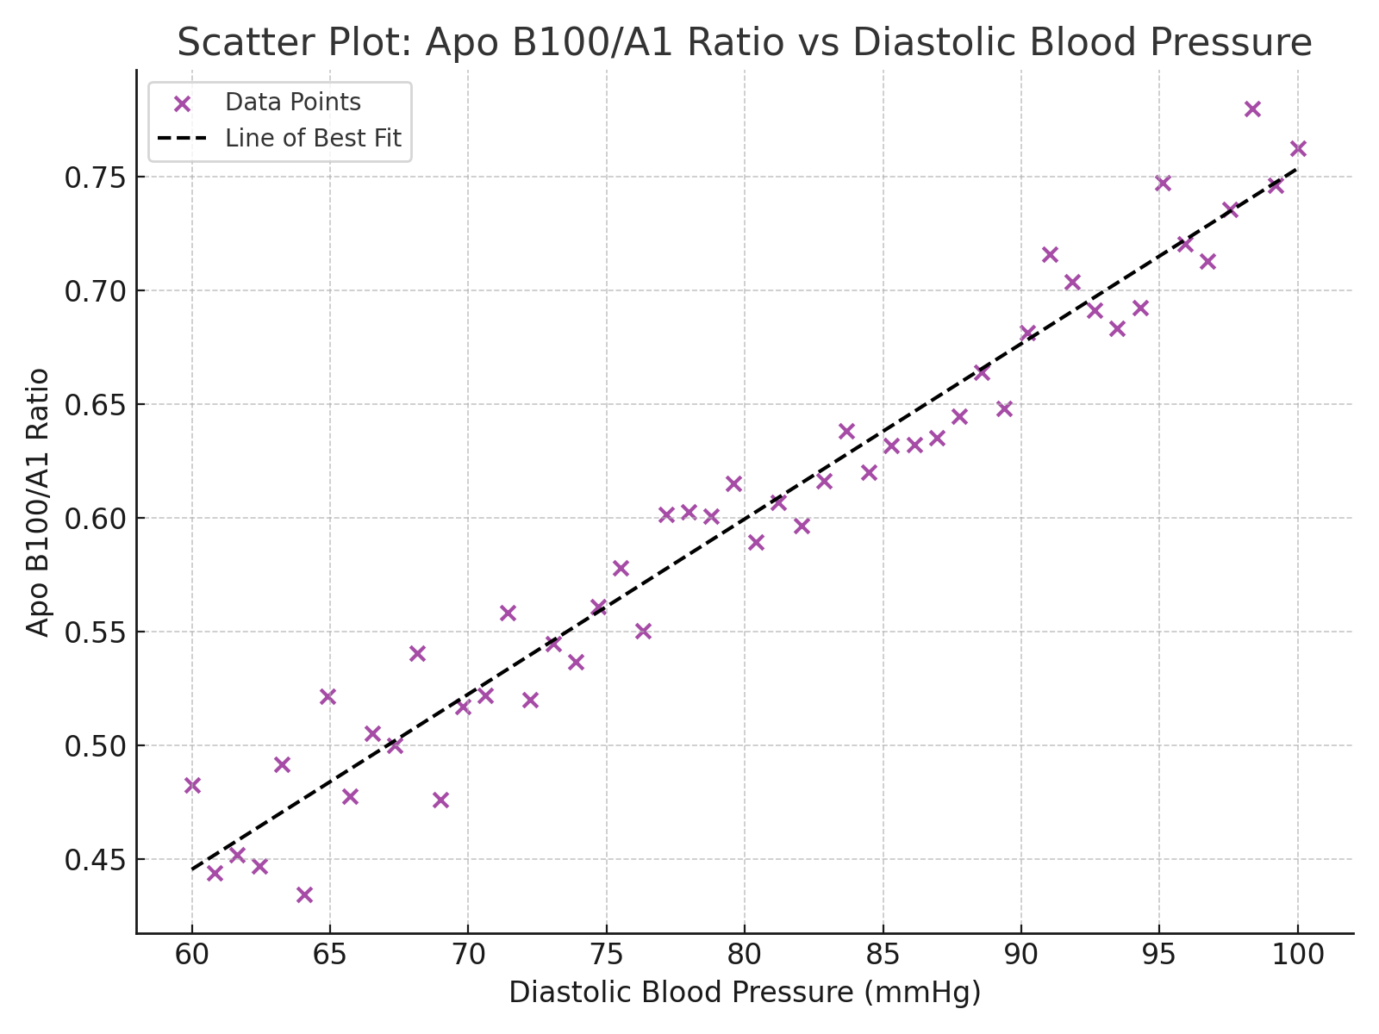

Figure 4: Scatter plot showing positive correlation between Apo B100/A1 ratio and diastolic blood pressure.

4. Discussion
This study examined the relationship between apolipoproteins and hypertension, elucidating their contribution to the pathophysiology of hypertensive cardiovascular disease (CVD). Hypertensive participants exhibited significantly higher levels of total cholesterol, LDL-C, triglycerides, and Apo B100, alongside lower HDL-C and Apo A1 levels, confirming a coexistence of dyslipidemia and hypertension. This metabolic clustering enhances cardiovascular risk and is consistent with previous findings (Mahalle et al., 2013). The high prevalence of obesity among hypertensives explains the observed lipid disturbances since excess adiposity promotes insulin resistance, hepatic VLDL synthesis, and impaired HDL formation (Reaven, 2005; Ferrannini et al., 2011). These processes result in hypertriglyceridemia, elevated LDL-C, and reduced HDL-C—the typical dyslipidemic triad of hypertension. Lifestyle factors such as high dietary fat, physical inactivity, and smoking further compound these abnormalities (Kennel, 2000; WHO, 2021). Moreover, heightened sympathetic activity and endothelial dysfunction contribute to impaired lipid metabolism and vascular injury (Esler et al., 2006; Ross, 1999).
The apolipoprotein data revealed a significantly elevated Apo B100/A1 ratio in hypertensive subjects, reflecting an increased atherogenic burden. Apo B100, the principal structural protein of LDL and VLDL, facilitates lipid transport into the arterial intima, whereas Apo A1, associated with HDL, mediates cholesterol efflux and endothelial repair (Walldius and Jungner, 2006). The imbalance observed therefore indicates impaired cholesterol clearance and heightened vascular lipid deposition. The strong positive correlation between the Apo B100/A1 ratio and systolic and diastolic blood pressures (r = 0.75–0.76, p < 0.001) underscores the direct link between apolipoprotein imbalance and vascular stress. These findings reinforce the concept that hypertension is not merely a hemodynamic disturbance but a systemic metabolic syndrome with complex lipidomic disruptions (Franceschini et al., 2020). Mechanistically, Apo B100 promotes endothelial retention of LDL particles, induces vascular stiffness through collagen remodeling, and impairs renal autoregulation, thereby exacerbating hypertension (Tabas et al., 2015; Guzik and Nosalski, 2017; Vaziri, 2016).
Gender differences in apolipoprotein levels were also observed, with hypertensive males exhibiting higher Apo B100 concentrations (134 ± 18 mg/dL) than females (121 ± 16 mg/dL; p = 0.03). This aligns with reports that men experience earlier onset and greater severity of hypertension due to hormonal and metabolic differences (Reckelhoff, 2001). Estrogen enhances Apo A1 synthesis and LDL receptor activity, providing premenopausal women with relative protection. Conversely, testosterone promotes visceral adiposity, VLDL production, and endothelial dysfunction. Behavioral factors such as alcohol use, smoking, and poor diet, more prevalent among men, further elevate blood pressure (WHO, 2021). Psychosocial and occupational stressors common in men also contribute via sympathetic activation and HPA axis stimulation (Spruill, 2010). Despite this, hypertension prevalence equalizes or reverses post-menopause when estrogen withdrawal heightens vascular stiffness and lipid imbalance (Reckelhoff, 2001). These findings emphasize the complex interaction between sex hormones, lipid metabolism, and vascular regulation (Sandberg and Ji, 2003; Addo et al., 2007).
Comparative insights across African populations reveal a consistent pattern of apolipoprotein alterations among hypertensive individuals. Studies in Ghana and South Africa demonstrated elevated Apo B100 and reduced HDL-C and Apo A1 levels similar to findings in this Nigerian cohort. Genetic predispositions, such as APOL1 G1/G2 variants common in West African populations, may influence lipid metabolism and vascular inflammation. Urbanization-related factors, including dietary westernization and physical inactivity, further worsen lipid profiles. These shared regional determinants highlight the necessity of integrating apolipoprotein testing into routine hypertension management across Africa. The Apo B/A1 ratio, with its strong correlation to blood pressure, provides a superior tool for early detection and risk stratification (Walldius and Jungner, 2004; Yusuf et al., 2004).
Clinically, incorporating apolipoprotein measurement into hypertension evaluation could revolutionize cardiovascular risk assessment, especially in resource-limited settings. A tiered management framework based on Apo B/A1 ratio thresholds may guide treatment intensity—ranging from lifestyle modification for low-risk patients to aggressive lipid-lowering therapy for high-risk groups. Current hypertension guidelines underestimate cardiovascular risk in patients with normal LDL-C but elevated Apo B100 (Walldius and Jungner, 2004). From a public health standpoint, integrating apolipoprotein screening into national hypertension programs could enhance early detection of atherogenic risk, particularly among obese, diabetic, and low-SES groups. National policies should prioritize subsidizing apolipoprotein testing, standardizing diagnostic algorithms through MLSCN, and incorporating results into Nigeria’s hypertension control strategy. Early identification and intervention could substantially reduce the burden of stroke, ischemic heart disease, and premature mortality associated with hypertension.

5. Conclusion
This study unequivocally shows that, in comparison to normotensives, hypertensive patients have a unique metabolic and lipid profile that includes greater blood glucose, a higher body mass index, and markedly changed lipid and apolipoprotein levels. Reduced ApoA1 levels and a notable increase in ApoB100 and the ApoB/ApoA1 ratio highlight a clear atherogenic dyslipidemia pattern in hypertensive individuals, which is highly correlated with blood pressure measurements and cardiovascular risk. These results are consistent with regional data from Africa and around the world that highlight the connections between the pathophysiology of hypertension, apolipoprotein imbalance, and metabolic syndrome components. The ApoB/ApoA1 ratio is a better biomarker for predicting cardiovascular risk, confirming its usefulness beyond standard lipid measures. The influence of visceral adiposity, especially in men, on apolipoprotein profiles and the risk of hypertension is highlighted by gender differences. Overall, this study emphasizes how important it is to do thorough cardiovascular risk assessments that include apolipoprotein evaluation in order to properly stratify and treat hypertensive individuals, particularly in Africa where metabolic diseases and hypertension are common dual burdens.

6. Recommendations
1. Clinical Use: Measure apolipoprotein as part of your regular cardiovascular risk assessment, particularly for patients with hypertension and normal lipid profiles.
2. Public Health Strategy: Integrate lifestyle treatments that focus on food, physical exercise, and weight control while raising awareness of the relationships between lipids and blood pressure.
3. Research Implications: In African cohorts, future longitudinal studies should investigate the genetic factors that influence apolipoprotein variation and assess causation.
4. Therapeutic Direction: Examine pharmacological treatments that lower ApoB or increase ApoA-I function as possible methods of managing hypertension.

Ethical Approval and Consent:
The project received ethical approval from the University of Medical Sciences Teaching Hospital Research Ethics Committee (Ref: UNIMEDTH/ETH/2024/023). The 2013 edition of the Declaration of Helsinki's criteria for human biomedical research were rigorously adhered to in this investigation. Before enrolling, all participants were informed about the study's objectives, procedures, potential benefits, and risks. Written informed consent was acquired by each subject. Data confidentiality and participant anonymity were rigorously maintained in compliance with the Nigeria Data Protection Regulation. Participants might withdraw from the study at any time without it affecting their medical care.

Disclaimer (Artificial intelligence)
Option 1:
Author(s) hereby declare that generative AI technologies such as Large Language Models (ChatGPT, COPILOT, etc.) and text-to-image generators have been used during the writing or editing of this manuscript.

References
Abraham, P., Jammalamadaga, V. S., & Sivaprasad, P. (2016). ApoB/ApoA-1 ratio and nitric oxide levels in pregnancy-induced hypertensive women. Medip Academy.
Addo, J., Smeeth, L., & Leon, D. A. (2007). Hypertension in sub-Saharan Africa: A systematic review. Hypertension, 50(6), 1012–1018. https://doi.org/10.1161/HYPERTENSIONAHA.107.093336
Alaupovic, P. (1971). Apolipoproteins and lipoproteins. Atherosclerosis, 13(2), 141–146.
Bhavani, B. A., Padma, T., Sastry, B. K., & Reddy, N. K. (2003). Plasma lipoprotein (a) levels in patients with untreated essential hypertension. Indian Journal of Human Genetics, 9(2), 65–68.*
Borghi, C., Rodriguez-Artalejo, F., De Backer, G., Dallongeville, J., Medina, J., Guallar, E., ... Halcox, J. P. (2016). The association between blood pressure and lipid levels in Europe: European study on cardiovascular risk prevention and management in usual daily practice. Journal of Hypertension, 34(11), 2155–2163.
Esler, M., Lambert, G., & Schlaich, M. (2006). Point: Chronic activation of the sympathetic nervous system is the dominant contributor to systemic hypertension. Journal of Applied Physiology, 101(3), 959–968. https://doi.org/10.1152/japplphysiol.01313.2005
Ferrannini, E., Natali, A., & Capaldo, B. (2011). Insulin resistance, hyperinsulinemia, and blood pressure: Role of age and obesity. Hypertension, 38(5), 994–998.
Franceschini, G., Favari, E., & Calabresi, L. (2020). Apolipoprotein A-I, HDL, and atherosclerosis: Pathophysiological mechanisms and therapeutic potential. Current Opinion in Lipidology, 31(4), 287–292.
Ginsberg, H. N., Zhang, Y. L., & Hernandez-Ono, A. (2006). Metabolic syndrome: Focus on dyslipidemia. Obesity (Silver Spring), 14(S1), 41S–49S.
Gupta, R., and N. Gupta. “Hypertension Epidemiology in the 21st Century.” Indian Journal of Preventive Cardiology 2, no. 4 (2013): 1–6.
Guzik, T. J., & Nosalski, R. (2017). Perivascular adipose tissue inflammation in vascular disease. British Journal of Pharmacology, 174(20), 3494–3507. https://doi.org/10.1111/bph.13705
Hall, J. E., do Carmo, J. M., da Silva, A. A., Wang, Z., & Hall, M. E. (2015). Obesity-induced hypertension: Interaction of neurohumoral and renal mechanisms. Circulation Research, 116(6), 991–1006.
Kannel, W. B. (2000). Risk stratification in hypertension: New insights from the Framingham study. American Journal of Hypertension, 13(1), 3S–10S.
Koskinen, J., Magnussen, C. G., Würtz, P., Soininen, P., Kangas, A. J., Viikari, J. S., ... Ala-Korpela, M. (2012). Apolipoprotein B, oxidized low-density lipoprotein, and LDL particle size in predicting the incidence of metabolic syndrome: The Cardiovascular Risk in Young Finns Study. European Journal of Preventive Cardiology, 19(6), 1296–1303.
Kotchen, T. A. (2012). Hypertensive vascular disease. In Harrison’s Principles of Internal Medicine (18th ed., Vol. 2, pp. 2042–2052). McGraw-Hill.
Mahalle, N. P., Garg, M. K., Naik, S. S., & Kulkarni, M. V. (2013). Association of apolipoprotein B/apolipoprotein A1 ratio and lipid ratios with coronary artery disease. Indian Journal of Clinical Biochemistry, 28(2), 193–198.
Naito, H. K. (1987). Apolipoproteins: Biochemistry, metabolism and clinical significance. Clinical Chemistry, 33(7), 1051–1052.
Neaton, J. D., & Wentworth, D. (1992). Serum cholesterol, blood pressure, cigarette smoking, and death from coronary heart disease. Archives of Internal Medicine, 152(1), 56–64.
Okosun, I. S., Choi, S., Hash, R., & Dever, G. E. (2001). Apolipoprotein B, ratio of total cholesterol to HDL-C, and blood pressure in abdominally obese White and Black American women. Journal of Human Hypertension, 15(5), 299–305.
Reaven, G. M. (2005). The metabolic syndrome: Requiescat in pace. Clinical Chemistry, 51(6), 931–938.
Reckelhoff, J. F. (2001). Gender differences in the regulation of blood pressure. Hypertension, 37(5), 1199–1208.
Reiner, Z. (2017). Hypertriglyceridaemia and risk of coronary artery disease. Nature Reviews Cardiology, 14(6), 401–411.
Ross, R. (1999). Atherosclerosis—An inflammatory disease. New England Journal of Medicine, 340(2), 115–126. https://doi.org/10.1056/NEJM199901143400207
Sandberg, K., & Ji, H. (2003). Sex differences in primary hypertension. Biology of Sex Differences, 1(1), 7.
Spruill, T. M. (2010). Chronic psychosocial stress and hypertension. Current Hypertension Reports, 12(1), 10–16.
Stein, E. A. (1986). Lipids. In N. W. Tietz (Ed.), Textbook of Clinical Chemistry (pp. 829–900). W.B. Saunders.
Tabas, I., García-Cardeña, G., & Owens, G. K. (2015). Recent insights into the cellular biology of atherosclerosis. Journal of Cell Biology, 209(1), 13–22.
Vaziri, N. D. (2016). Dyslipidemia of chronic renal failure: The nature, mechanisms, and potential consequences. American Journal of Physiology—Renal Physiology, 290(2), F262–F272.
Walldius, G., & Jungner, I. (2004). The ApoB/ApoA-I ratio: A strong, new risk factor for cardiovascular disease and a target for lipid-lowering therapy. Journal of Internal Medicine, 255(2), 188–194.
Wilson, P. W., D’Agostino, R. B., Parise, H., Sullivan, L., & Meigs, J. B. (2019). Metabolic syndrome as a precursor of cardiovascular disease and type 2 diabetes mellitus. Circulation, 118(8), 628–636.
World Health Organization. Hypertension Indicators for Improving Quality and Coverage of Services. Geneva: World Health Organization, 2021.
Yusuf, S., Hawken, S., Ôunpuu, S., Dans, T., Avezum, A., Lanas, F., & INTERHEART Study Investigators. (2004). Effect of potentially modifiable risk factors associated with myocardial infarction in 52 countries (the INTERHEART study): Case–control study. The Lancet, 364(9438), 937–952.

