Successful Percutaneous Device Closure of a Large Secundum Atrial Septal Defect in an Elderly Female with COPD and Atrial Fibrillation: A Case Report
Abstract
We describe a 72-year-old female with chronic obstructive pulmonary disease (COPD), atrial fibrillation, and a large ostium secundum atrial septal defect (ASD), who presented with progressive dyspnea, hypoxemia, and acute COPD exacerbation. Despite advanced age, lung disease, arrhythmia, and a high surgical risk score, the defect was successfully closed percutaneously using a 46 mm Lifetech CERA device. ASD and COPD both have synergistic effect on Right heart volume overload leading to Right heart failure. This case demonstrates that transcatheter ASD closure can be safely and effectively performed in carefully selected elderly patients with significant left-to-right shunting and without Eisenmenger physiology, even in the presence of multiple comorbidities (1–3). Transcatheter ASD closure has less adverse events and faster recovery rates with reduction in duration of Hospital stay as compared to surgical closure.
Keywords: Percutaneous Device closure, COPD , Atrial Fibrillation, Fluoroscopy, Pulmonary Hypertension, Right Heart Failure.

Introduction
“Atrial septal defect (ASD) represents about 5–10% of congenital heart disease in adults and is often undiagnosed until later life” (4). “Hemodynamically significant ASDs can lead to right-sided chamber enlargement, pulmonary hypertension (PH), tricuspid regurgitation (TR), and atrial arrhythmias” (5,6). In elderly patients, surgical closure carries increased perioperative risk, particularly when COPD and frailty coexist (7). For appropriately selected anatomies, transcatheter closure has become the preferred strategy and is feasible even in high-risk groups (8). Device Closure is indicated in Patients with evidence of right sided volume overload and a significant left to right shunt (Qp : Qs ≥1.5), with favourable anatomy for device closure and acceptable pulmonary pressures and resistances. Adverse events such as Device embolization, New onset arrhythmias, Cardiac Erosion/Perforation, Residual shunts, Pericardial Tamponade/Effusion, Vascular access related complications are rare as compared to surgical complications rates.

Case Presentation

A 72-year-old female, known case of COPD, presented with progressive dyspnea on exertion (NYHA II–III) for 3 months, and fever with dry cough for 5 days. On examination her Oxygen saturation was 88–90% on room air, she had Bilateral wheeze and Irregular pulse. ECG showed Atrial fibrillation with fast ventricular response (FVR) and right bundle branch block (RBBB).
2D Echocardiography (Figure 1)
Patient had Large Ostium secundum ASD (~40 mm) with left-to-right shunt , Severe TR, severe PAH . RA, RV Dilated with RA measuring 58 x 62mm and RV at base measuring 44mm , MPA measuring 29mm , Pulmonary Acceleration Time 82ms, LVEF: 60% , TAPSE: 15.2 mm, IVC 16mm dialted, with Hepatic diastolic flow reversal.
Pulmonary Function Test
s/o Restrictive ventilatory defect with small airway obstructive ventilatory Defect. (Table 1).
Patient managed medically with Non-invasive ventilation (NIV), antibiotics, nebulization, diuretics, and rate control with symptomatic improvement. Post Medical management Review 2D Echo done s/o decrease in PAH from severe to Moderate. After medical stabilization Patient underwent Cardiac catheterization study s/o Qp/Qs: 3.47, PVR: 3.07 Wood units , SVR: 41.17 Wood units and predominant L R shunt with no Eisenmengerization. Coronary angiography done in view of old age s/o Normal coronaries.
Given the large defect, Significant left to right shunt with reversible PH, normal coronaries, and high surgical risk device closure was performed.
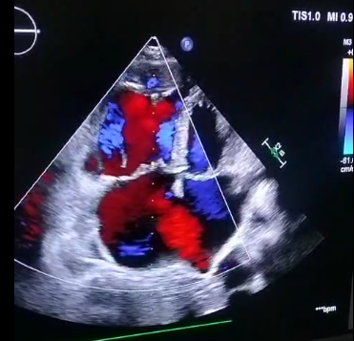
Figure 1. Transthorasic Echocardiography Apical 4 chamber view showing large ostium secondum Atrial Septal Defect.

Pulmonary Function Test :
Pulmonary Function Test present in table 1

 | PRE BRONCHODILATOR |  |  | POST BRONCHODILATOR
Lung Volumes | ACTUAL | PRED | % PRED | ACTUAL | PRED | % PRED
MVV | 18 | 75.5 | 24
FVC | 0.59 | 2.50 | 24 | 0.59 | 24 | 0
FEV1 | 0.59 | 2.00 | 30 | 0.59 | 30 | 0
FEV1/ FVC | 100 | 79.3 | 126 | 100 | 126 | 0
FEF 25-75 | 0.95 | 1.94 | 43 | 0.96 | 49 | + 1
PEF | 1.20 | 5.01 | 24 | 2.12 | 42 | + 51
SVC | 1.14 | 2.50 | 46

Table 1. Restrictive ventilatory defect with small airway obstructive ventilatory defect
(MVV – Maximal voluntary ventilation, FVC – Forced vital capacity , FEV1- Forced expiratory volume in 1 sec,
FEF – Forced expiratory flow, PEF – Peak expiratory flow, SVC – Slow vital capacity)

Intervention
Under fluoroscopic guidance Femoral Venous access obtained using 7F sheath, Guide catheter then passed into RA followed by crossing the Atrial septum then catheter positioned in left sided pulmonary vein. Balloon Interrogation of defect done and delivery sheath was placed. A Lifetech CERA ASD Occluder (46 mm) is then deployed under fluoroscopic guidance using Antero-Posterior (AP) view and Left Anterior Oblique (LAO) view(Figure 2). The procedure was uneventful with stable hemodynamics.
B
A

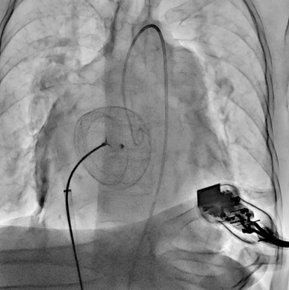

Figure 2. Fluoroscopic image showing Atrial Septal defect closure with a Lifetech CERA ASD Occluder (46 mm)

Outcome and follow up
Post-procedure, the patient improved symptomatically, with better oxygenation and exercise tolerance. No device embolization, arrhythmia exacerbation, residual shunt, or hemolysis was observed (Figure 3). She was discharged on anticoagulation, antiarrhythmic therapy, and standard COPD medications.
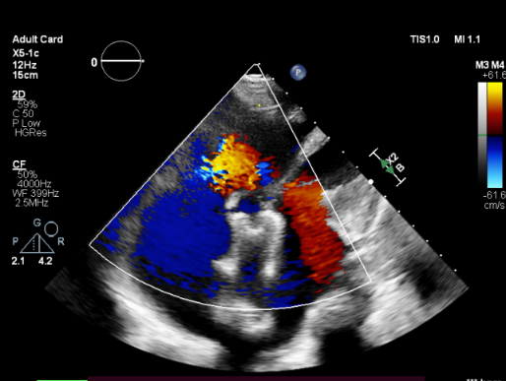
Figure 3. Transthorasic Echocardiography Apical 4 chamber view showing Atrial Septal Defect device in situ with no shunt across the device.

Discussion
This patient had several adverse factors such as advanced age, COPD, atrial fibrillation, severe TR, and pulmonary hypertension which markedly increased surgical risk. However, the large left-to-right shunt (Qp/Qs 3.47) with acceptable pulmonary vascular resistance made her a suitable candidate for transcatheter closure.
Elderly patients with ASD often present with atrial arrhythmias, right heart failure, and pulmonary vascular changes (6,9). If untreated, the condition predisposes to paradoxical embolism, arrhythmias, and progressive right ventricular dysfunction (4).
Both ASD and COPD contribute to right heart dilatation through different mechanisms. ASD produces chronic volume overload, while COPD causes hypoxia-induced pulmonary vasoconstriction leading to pressure overload. When coexistent, these mechanisms act synergistically, hastening right ventricular remodeling and increasing the risk of right heart failure or early pulmonary vascular disease (2,3).
If left uncorrected in older patients, ASD can progress to irreversible right ventricular dysfunction. Percutaneous closure eliminates abnormal shunting, relieves volume overload, and prevents further decline in right heart function. In those with moderate or reversible PH, closure may also reduce pulmonary pressures and improve exercise capacity (1,5,7).
Compared with surgery, device closure avoids sternotomy and cardiopulmonary bypass, and can be performed under local anesthesia with sedation, making it particularly suitable for elderly or comorbid patients. It is associated with lower complication rates, shorter hospitalization, and faster recovery (8,9).
Several studies have confirmed symptomatic improvement and favorable long-term outcomes after device closure in elderly patients (1,4,5). Pre-procedural cardiac catheterization remains crucial to assess pulmonary vascular resistance and exclude fixed pulmonary vascular disease (6).
This case highlights that even in elderly patients with COPD and arrhythmia, percutaneous closure of large ASDs is safe and effective when carefully selected. “The availability of large devices (up to 48 mm) enables closure of even very large defects with excellent outcomes” (10).

Conclusion
Percutaneous ASD closure provides a safe alternative to surgery in elderly patients with COPD, atrial fibrillation, and pulmonary hypertension. This case underscores that large-device closure can reduce surgical risk, improve functional capacity, and prevent progression of right heart dysfunction, supporting its role as the treatment of choice in suitable elderly patients (1–3,10). Hence, patients with multiple comorbidities and high surgical risk should undergo Percutaneous device closure if not contraindicated.

Consent
As per international standards or university standards, patient(s) written consent has been collected and preserved by the author(s).

Disclaimer (Artificial intelligence)
We hereby declare that NO generative AI technologies such as Large Language Models (ChatGPT, COPILOT, etc.) and text-to-image generators have been used during the writing or editing of this manuscript.

References
- Baroutidou A, Drakopoulou M, Tsioufis C, Toutouzas K. Transcatheter closure of atrial septal defect in the elderly. Heart. 2023;109(23):1741–1747. doi:10.1136/heartjnl-2023-322529. Available from: https://pubmed.ncbi.nlm.nih.gov/37380331
- Miranda-Segura R, Hernandez J, Rueda J, et al. Successful Evolution of Atrial Septal Defect Closure in an Elderly Patient. Cardiovasc Case Rep. 2024; [Epub ahead of print]. Available from: https://pmc.ncbi.nlm.nih.gov/articles/PMC11405808
- Honghiranrueng L, Kaewlai C, Chanthong S, et al. Long-term outcomes of transcatheter atrial septal defect closure: age is not a limiting factor. Front Cardiovasc Med. 2024;11:1448967. doi:10.3389/fcvm.2024.1448967. Available from: https://www.frontiersin.org/articles/10.3389/fcvm.2024.1448967/full
- Abrahamyan L, Kpodonu J, Guerrero M, et al. Long-Term Outcomes After Atrial Septal Defect Closure in Older Patients. JACC Cardiovasc Interv. 2021;14(7):764–773. doi:10.1016/j.jcin.2020.12.029. Available from: https://www.jacc.org/doi/10.1016/j.jcin.2020.12.029
- Lima MR, Freitas HC, Freitas ACV, et al. Long-term prognosis of elderly patients undergoing atrial septal defect closure. Int J Cardiol. 2025; [Epub ahead of print]. Available from: https://www.sciencedirect.com/science/article/pii/S0146280624005656
- Komar M, Hagendorff A, Thilén U, et al. The benefit of atrial septal defect closure in elderly patients. Clin Interv Aging. 2014;9:1887–1894. doi:10.2147/CIA.S62313. Available from: https://pmc.ncbi.nlm.nih.gov/articles/PMC4106953
- Thilén U, Nellgård B, Dellborg M, et al. Catheter closure of atrial septal defect in the elderly (≥ 60 years). Int J Cardiol. 2016;205:6–11. doi:10.1016/j.ijcard.2016.04.108. Available from: https://www.sciencedirect.com/science/article/abs/pii/S0167527316309184
- O’Neill L, Tomlinson R, Chen W, et al. Percutaneous secundum atrial septal defect closure: meta-analysis on effect on atrial arrhythmia. Int J Cardiol. 2020;310:77–83. doi:10.1016/j.ijcard.2020.02.020. Available from: https://www.sciencedirect.com/science/article/abs/pii/S0167527320334628
- Fujii Y, Kimura T, Hara K, et al. Clinical impact of transcatheter atrial septal defect closure. Int J Cardiol. 2020;306:8–15. doi:10.1016/j.ijcard.2020.01.091. Available from: https://www.sciencedirect.com/science/article/pii/S0914508720300277
- Singhi AK, Mahapatra SK, Kumar D, Dey S, Mishra A, De A. Large Fenestrated Atrial Septal Occluder to Treat an Elderly Patient with Multiple Comorbidities. JACC Case Rep. 2022;4(4):230–233. doi:10.1016/j.jaccas.2021.12.032. Available from: https://journals.lww.com/accd/fulltext/2022/04020/large_fenestrated_atrial_septal_occluder_to_treat.10.aspx

