T-Stenting Technique for Iatrogenic Left Main–LCX Dissection: A Case Report
Abstract
Iatrogenic left main (LM) dissection is a rare but life-threatening complication of PCI that can result in abrupt occlusion of both LAD and LCX, especially when the LCX is dominant, leading to hemodynamic collapse and conduction disturbances such as complete heart block (CHB). We present the case of a 58-year-old male with evolving anterior wall MI who developed LM–LCX dissection during PCI, causing TIMI 0 flow in both LAD and a dominant LCX. Because the LAD supplied the largest myocardial territory, LM–LAD stenting was performed first to restore perfusion to the majority of myocardium, followed by bailout T-and-Protrusion (TAP) stenting of the dominant LCX with final kissing balloon inflation (FKBI) and proximal optimization technique (POT), achieving TIMI 3 flow in both branches. The patient recovered fully and was discharged on guideline-directed therapy. T-stenting was one of the earliest bifurcation techniques, and its refinement, TAP, allows optimal side branch ostial coverage with minimal metal overlap (7). Contemporary studies confirm that TAP, when performed with second-generation DES, FKBI, and POT, offers excellent outcomes comparable to more complex techniques such as DK-crush. This case highlights TAP as a rapid, effective, and lifesaving bailout strategy in LM bifurcation PCI, particularly when both branches are occluded but priority must be given to revascularizing the main branch supplying the largest myocardium
Keywords: LM–LCX dissection, iatrogenic LM dissection, bailout TAP, bifurcation PCI, left main PCI

Introduction
Bifurcation lesions represent 15–20% of PCIs and are associated with increased risk of periprocedural MI, side branch occlusion, and restenosis (2). Provisional stenting of the main branch is the recommended default approach, with side branch stenting only if significant compromise occurs (3). However, in cases of dissection or flow-limiting occlusion of a dominant side branch, two-stent strategies become mandatory to preserve myocardial viability (4,5).
T-stenting was one of the first described bifurcation techniques, designed to cover the side branch ostium without excess overlap (6). The T-and-Protrusion (TAP) modification allows slight protrusion of the side branch stent into the main branch, followed by FKBI to optimize coverage and minimize geographic miss (7). TAP is technically simpler and faster than culotte or DK-crush and provides comparable outcomes with second-generation DES when performed with proper lesion preparation and optimization (8,9).

Case Presentation
A 58-year-old male presented with CCS class III anginal pain for two days. ECG showed ST-segment elevation in V1–V4, and echocardiography revealed hypokinesia in the LAD territory with LVEF 35%. Coronary angiography revealed diffuse proximal-to-mid LAD stenosis (80%) and a dominant LCX with 50% proximal plaque. SYNTAX score was <22, favoring PCI over CABG.
PCI was performed via right femoral access with a 7F EBU 3.5 guide. During LM engagement, an iatrogenic LM dissection occurred, resulting in TIMI 0 flow in both LAD and dominant LCX (Figure 1). The patient developed severe hypotension, chest pain, and complete heart block (CHB) due to ischemia of the AV nodal artery from the dominant LCX. A temporary pacemaker was placed, inotropes started, and a low-pressure angiogram confirmed dissection extending into both branches.
Given that the LAD supplied the majority of the myocardium at risk, LM–LAD stenting was performed first to restore perfusion quickly. A DES was deployed from LM to proximal LAD, followed by a second DES to mid-LAD, restoring TIMI 3 flow in LAD. LCX remained compromised (TIMI I flow), so bailout TAP stenting was performed by advancing a third wire through the LAD stent struts into LCX, deploying a DES with 1–2 mm protrusion into LM, followed by FKBI and POT. This achieved TIMI 3 flow in both LAD and LCX (Figure 2, 3).
Following revascularization, chest pain resolved, sinus rhythm was restored with resolution of CHB, and hemodynamics stabilized. The patient was discharged on dual antiplatelet therapy (aspirin, ticagrelor), high-intensity statin, and guideline-directed therapy. At follow-up, he remained asymptomatic, with elective angiography planned at 3 months.
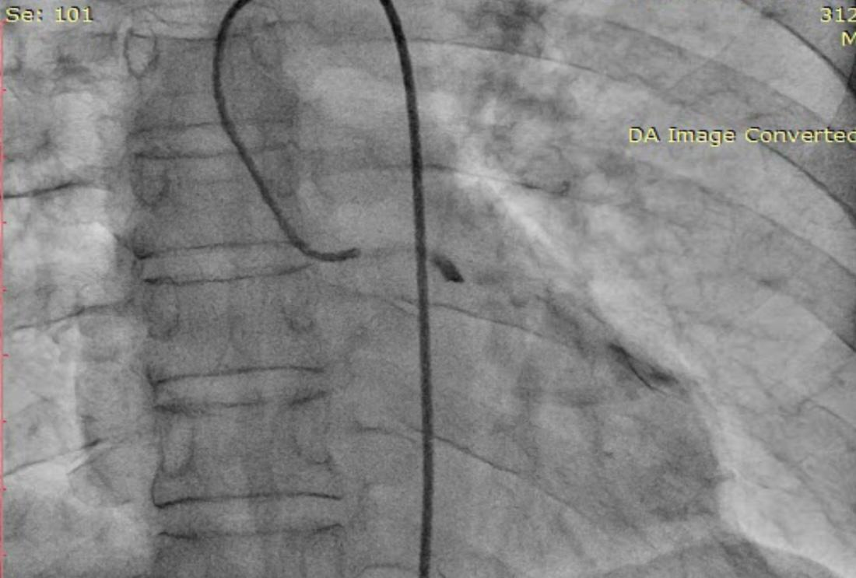
Figure 1. Coronary angiography showing LM-LCX dissection

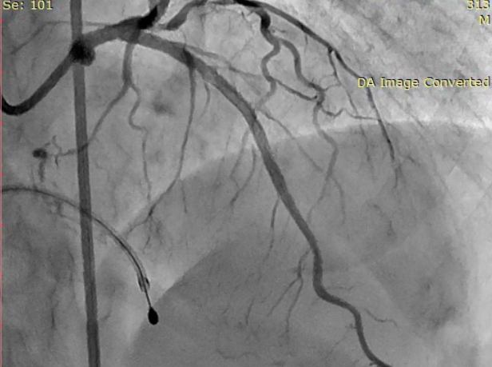
Figure 2. Coronary angiography showing final shoot after TAP stenting
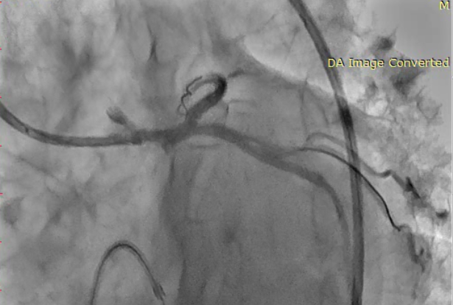
Figure 3. Coronary angiography showing final shoot after TAP stenting

Discussion
Iatrogenic LM dissection is rare but catastrophic, often resulting in occlusion of both LAD and LCX and hemodynamic instability (1). In cases with a dominant LCX, additional conduction disturbances such as CHB may occur due to AV nodal ischemia (5).
The immediate priority is re-establishing flow to the myocardial territory at highest risk. In this case, the decision to first stent LM–LAD was made because LAD supplied the majority of the myocardium, and rapid reperfusion was needed to prevent extensive infarction. Once LAD flow was secured, attention was turned to LCX, where TAP stenting allowed rapid restoration of perfusion to the side branch and resolution of CHB.
T-stenting, though simple, has the drawback of potential geographic miss at the side branch ostium (6). TAP improves this by allowing small protrusion and performing FKBI to ensure complete ostial coverage (7). Pan et al. demonstrated low long-term MACE with T-stenting with small protrusion (2). Ormiston et al. and randomized trials confirmed that provisional stenting with bailout TAP yields comparable outcomes to planned two-stent strategies, with lower metal burden and procedure time (3,4).
Compared with DK-crush, TAP is faster and technically less complex, making it highly suitable in unstable patients where time is critical (4,8). Proper wire recrossing, FKBI, and POT are essential to optimize results (7,9). Intravascular imaging is recommended to confirm true lumen wiring and ensure stent expansion, particularly in LM bifurcations (5,9).
This case illustrates the importance of prioritizing the branch supplying the largest myocardial territory in LM bifurcation dissections, followed by rapid side branch salvage using TAP — achieving full perfusion with minimal procedural delay.

Conclusion
TAP stenting is a technically straightforward and time-efficient bailout technique for LM bifurcation PCI complicated by iatrogenic dissection, particularly when both LAD and a dominant LCX are occluded. Prioritizing LM–LAD revascularization first stabilizes the majority of myocardium at risk, after which TAP can quickly restore LCX perfusion. When combined with FKBI, POT, and intravascular imaging, TAP achieves outcomes comparable to more complex bifurcation techniques, making it an ideal strategy for emergent scenarios.
Consent
As per international standards or university standards, patient(s) written consent has been collected and preserved by the author(s).
Disclaimer (Artificial intelligence)
Option 1:
Author(s) hereby declare that NO generative AI technologies such as Large Language Models (ChatGPT, COPILOT, etc.) and text-to-image generators have been used during the writing or editing of this manuscript.
Option 2:
Author(s) hereby declare that generative AI technologies such as Large Language Models, etc. have been used during the writing or editing of manuscripts. This explanation will include the name, version, model, and source of the generative AI technology and as well as all input prompts provided to the generative AI technology
Details of the AI usage are given below:
1.
2.
3.

References
1. Mehilli, J., Kastrati, A., Byrne, R. A., Bruskina, O., Iijima, R., Schulz, S., Pache, J., Seyfarth, M., Massberg, S., Laugwitz, K. L., Dirschinger, J., Schömig, A., & LEFT-MAIN Intracoronary Stenting and Angiographic Results: Drug-Eluting Stents for Unprotected Coronary Left Main Lesions Study Investigators (2009). Paclitaxel- versus sirolimus-eluting stents for unprotected left main coronary artery disease. Journal of the American College of Cardiology, 53(19), 1760–1768. https://doi.org/10.1016/j.jacc.2009.01.035
2. Naganuma, T, Latib, A, Basavarajaiah, S. et al. The Long-Term Clinical Outcome of T-Stenting and Small Protrusion Technique for Coronary Bifurcation Lesions. J Am Coll Cardiol Intv. 2013 Jun, 6 (6) 554–561. https://doi.org/10.1016/j.jcin.2013.01.137
3.Jabbour, R, Tanaka, A, Pagnesi, M. et al. T-Stenting With Small Protrusion: The Default Strategy for Bailout Provisional Stenting?. J Am Coll Cardiol Intv. 2016 Sep, 9 (17) 1853–1854. https://doi.org/10.1016/j.jcin.2016.06.034
4. Chen, S, Zhang, J, Han, Y. et al. Double Kissing Crush Versus Provisional Stenting for Left Main Distal Bifurcation Lesions: DKCRUSH-V Randomized Trial. JACC. 2017 Nov, 70 (21) 2605–2617. https://doi.org/10.1016/j.jacc.2017.09.1066
5. Stone GW, et al. Everolimus-Eluting Stents or Bypass Surgery for Left Main Coronary Artery Disease. N Engl J Med. 2016;375:2223-2235.
6. Burzotta, F., Džavík, V., Ferenc, M., Trani, C., & Stankovic, G. (2015). Technical aspects of the T And small Protrusion (TAP) technique. EuroIntervention, 11(suppl V), V91-V95.
7. Burzotta F, Džavík V, Ferenc M, Trani C, Stankovic G. Technical aspects of the T And small Protrusion (TAP) technique. EuroIntervention. 2015;11 Suppl V:V91-5. doi: 10.4244/EIJV11SVA20. PMID: 25983182.
8. Colombo A, Bramucci E, Saccà S, Violini R, Lettieri C, Zanini R, Sheiban I, Paloscia L, Grube E, Schofer J, Bolognese L, Orlandi M, Niccoli G, Latib A, Airoldi F. Randomized study of the crush technique versus provisional side-branch stenting in true coronary bifurcations: the CACTUS (Coronary Bifurcations: Application of the Crushing Technique Using Sirolimus-Eluting Stents) Study. Circulation. 2009 Jan 6;119(1):71-8. doi: 10.1161/CIRCULATIONAHA.108.808402. Epub 2008 Dec 22. PMID: 19103990.
9. Koo BK, Park KW, Kang HJ, Cho YS, Chung WY, Youn TJ, Chae IH, Choi DJ, Tahk SJ, Oh BH, Park YB, Kim HS. Physiological evaluation of the provisional side-branch intervention strategy for bifurcation lesions using fractional flow reserve. Eur Heart J. 2008 Mar;29(6):726-32. doi: 10.1093/eurheartj/ehn045. Epub 2008 Feb 28. PMID: 18308689.

