MOLECULAR CHARACTERIZATION OF AFLATOXIN PRODUCING FUNGI ASSOCIATED WITH STORED GRAINS IN BAUCHI METROPOLIS
Hauwa Bappa Aliyu, Mahmud Yerima Iliyasu and Usman Said Haruna

This article is an Original Research Article for my MSc Research work.

ABSTRACT

Background and Aim: Various feeds and food grains are contaminated with mycotoxins produced by certain fungi along with other secondary metabolites due to long term storage, storage condition, or improper handling during harvest. The economic effects attributed to mycotoxin infections are widely felt in all sectors of the production and consumption of grain products. They are considered a major factor in the spoilage of food stuffs, leading to great economic loss and have implications for food safety and public health. The study aims to isolate and characterize Aflatoxin producing fungi associated with the spoilage of some stored grains within Bauchi metropolis.
Place and Duration of Study: This study was carried out in Abubakar Tafawa University (ATBU), Bauchi, Nigeria, in a period duration of August 2024 to January 2025.
Methodology: Grain samples were obtained from various stores in markets and transported to the laboratory. Grains samples were aseptically inoculated in a set of three Petri dishes each containing of Potato Dextrose Agar (PDA) and incubated for 5 days at 30°C. Pure culture was obtained from identified isolate after Identification of the isolates morphologically and phenotypically. Pure isolates were subjected to Polymerase Chain Reaction (PCR) by extracting the DNA following the Bioneers kit manufacturers manual and gel electrophoresis was ran on the pure DNA extracted.
Aflatoxin test was done on samples using Thin Layer Chromatography (TLC). Grain samples were ground into fine powder using mortar and pestle. Extraction was done on the samples and 10µl of the extract was added to the TLC plate 1cm from the bottom edge and allowed to dry. The TLC plate was placed in the developing chamber with the solvent at the bottom, allowing the solvent to rise up by capillary action. When solvent reached the top of the plate, the plate was allowed to air-dry completely. Sulfuric acid spray was used to visualize the separated compounds and plate was observed using spectrophotometer.
Results: The findings revealed a diverse array of Aspergillus species capable of producing aflatoxins, notably Aspergillus flavus and Aspergillus parasiticus. Aspergillus was identified as the predominant fungal species, accounting for 51.47% of isolates, followed by Rhizopus (22.06%), Penicillium (19.12%), and Fusarium (7.35%). Significant aflatoxin contamination was observed across various grain types, with millet and groundnut exhibiting high contamination rates and concentrations. Molecular analysis further confirmed the presence and co-expression of aflR and aflS genes in Aspergillus flavus isolates, indicating strong aflatoxigenic potential.
Conclusion: This study highlights the prevalence and some of the genetic diversity of the aflatoxin producing fungi focussing on the aflR and aflS gene which is one of the genes that plays a crucial role in the biosynthesis of aflatoxins. The study emphasizes the need for targeted interventions to mitigate aflatoxin contamination and ensure food safety. The prevalence of aflatoxin producing fungi in this study was 65% based on the TLC result showing that 65 samples have exceeded the NAFDAC permissible limit. Aspergillus flavus and Aspergillus parasiticus were the primary aflatoxin producers observed among the fungal isolates. The relationship between the grain type and aflatoxin contamination is highly significant indicating that the effect of grain type on aflatoxin production is consistent independent of storage conditions.

INTRODUCTION
Latest projection by the United Nations suggest that the world’s population could grow to about 8.6 billion in 2030 and 9.8 billion in 2050 [1]. Some scientists have debated that the earth’s resources can only support 10 billion people. Supposing this event is inevitable, there could be a rapid depletion of resources that would result in limited water availability and shortage of food supply. Agriculture and crop biotechnology’s solution is to increase food yield by improving crop varieties through the development of drought-tolerant, high yielding, and also pest and disease-resistant crops. Another solution is to reduce crop yield loss caused by biotic and abiotic factors that are already limiting the current food supply [2]
Fungi are widely distributed in nature, they grow over an extremely wide range of nutrients, temperature, pH, etc. and contaminate food products in different ways. Most fungi are toxigenic in nature, and those non-toxigenic species may impart a mouldy odour and taste during long storage. They are considered a major factor in the spoilage of foodstuffs, leading to great economic loss and a major public health hazard by producing a wide variety of mycotoxins [3].
Fungal growth is one of the main causes of food spoilage. It not only generates great economic losses, but also particularly through the synthesis of mycotoxins. The fungal species involved mainly in crops contamination belongs to genera Fusarium, Aspergillus, Alternaria, Penicillium and Claviceps. These fungi may produce secondary metabolites, known as mycotoxins [4].
Natural contaminants like mycotoxins, pose as a challenge since they are present in wide range of foods and significantly differs in chemical structure and harmful effects in humans and animals following their exposure [5].
Mycotoxins are characterised as toxic metabolites produced by a diverse group of fungi that contaminates agricultural crops before harvest or during storage after harvest and wide range of food commodities can be contaminated upon exposure to these harmful substances [6].
Mycotoxins are natural occurring poisonous or harmful substances (toxins) produced by fungi (moulds) which causes spoilage to agricultural produce. Several different mycotoxins have been identified, but the most common observed mycotoxins that is of concern to human health and livestock includes aflatoxins, ochratoxin A, patulin, fumonisins, zearalenone and nivalenol/deoxynivalenol [1].
Although mycotoxin-producing species are found worldwide, they are of greater concern in underdeveloped countries that lack appropriate infrastructure, tools and resources required to prevent, control or monitor their impact on the community. Environmental conditions like unseasonal rains during harvest, increased temperatures and moisture promotes fungal pathogen proliferation and mycotoxin production. Additionally, improper harvesting, poor storage facilities and sub-optimal temperatures facilitate increased risks of mycotoxin production and fungal growth during processing and marketing. These environmental conditions and problems associated with food production and storage are common in most parts of sub-Saharan Africa, where to date, the largest poisoning of mycotoxin epidemic has been reported [7].
Mycotoxins appear in the food chain as a result of mould infection of crops before harvest and after harvest. Exposure to mycotoxins can happen either directly by eating contaminated food or indirectly from animals that are fed contaminated feed, in particular from milk [8].
METHODOLOGY
Study Area
The work was done in the microbiology laboratory of Abubakar Tafawa Balewa, Bauchi. Bauchi State is located between latitudes, 9°3’ and 12º3’ north of the equator. Longitudinally, it lies between 8º5’ and 11º east of Greenwich meridian. The State is dominated with Fulani and Jarawa as the major Ethnic groups, who are mostly Farmers.
Sample Collection
A total of 100 of stored grains samples (rice, groundnut, maize, and millet) 25 of each, were collected in sterile plastic bags from the stores in three different markets namely; Muda Lawal market, Central Market and Kasuwan Mata within Bauchi Metropolis and transported to Abubakar Tafawa Balewa University (ATBU) microbiology laboratory.

Enumeration and Identification of Fungi
Grains samples were aseptically inoculated in a set of three Petri dishes each containing 20 ml of Potato Dextrose Agar (PDA), the Media was prepared from Distilled Water and PDA Powder which was heated to dissolve the powder at 50◦C and Autoclaved at 121◦C for 15 minutes. Chloramphenicol was added to the prepared media to retard bacterial growth. Plates were incubated for 5 days at 30°C with slight modification as described by [9].

Aflatoxin Detection
Aflatoxin test was done using Thin Layer Chromatography (TLC). Grain samples were ground into fine powder using mortar and pestle. Extraction was done by adding 50 grams of the sample in 270ml of methanol and 30ml of Potassium Chloride (KCL), 4% blender was added and 150ml of the Solution is filtered. 10% Copper Sulphate (CuSo4), and 5g Celite was added to the previously filtered 150ml Solution and agitated for 5 minutes then filtered. 150ml of distilled water is added to the filtrate and extracted two times with 10ml of Chloroform. 10µl of the extract was added to the TLC plate 1cm from the bottom edge and allowed to dry. The TLC plate was placed in the developing chamber with the solvent at the bottom, allowing the solvent to rise up by capillary action. When solvent reached the top of the plate, the plate was allowed to air-dry completely. Sulfuric acid spray was used to visualize the separated compound after the plate was observed using spectrophotometer [10].

2.6 Phenotypic Identification of isolates
Phenotypic characterization was done on the basis of mycelium growth pattern, colour and properties of fruiting bodies of the fungi. Macroscopic characters were studied for identification of fungal species include growth pattern of fungal colonies, colony size and colour. The documentation of fungal isolates including head size, shape of vesicles, conidiophores and conidia characters like conidial diameter, wall, shape, surface and conidia attachment with conidiophore was done microscopically. These characters were compared with the synoptic keys for identification of fungal isolates [11].

2.7 Molecular Analysis

2.7.1 DNA Extraction and Amplification of Isolates using Polymerase Chain Reaction (PCR)
Fungal Mycelia was harvested using a scalpel. Using the Bioneers kit 20 μl of Proteinase K was added to a clean 1.5 ml tube and the mycelia was added to the tube containing proteinase K. 200 μl of Binding buffer (GC) was added to the sample and mixed immediately using a vortex mixer, the sample was resuspended to achieve maximum lysis efficiency then Incubated at 60℃ for 10 min. 100 μl of Isopropanol was and mixed well by pipetting then briefly spin down to get the drops clinging under the lid, lysate was transferred into the upper reservoir of the Binding column tube without wetting the rim. The tube was closed and centrifuged at 8,000 rpm for 1 min. Binding column tube was transferred to a new 2 ml tube for filtration. 500 μl of washing buffer 1 (W1) was added without wetting the rim, tube was closed and centrifuged at 8,000 rpm for 1min. The tube was opened and the solution was poured from the 2 ml tube into a disposal bottle. 500 μl of washing buffer 2 (W2) was added without wetting the rim, the tube was closed, and centrifuged at 8,000 rpm for 1 min. It was Centrifuged once more 12,000 rpm for 1 min to completely remove ethanol, and check that there is no droplet clinging to the bottom of Binding column tube. Binding column tube was added to a new 1.5 ml tube for elution (supplied), 200 μl of Elution buffer was added into Binding column tube, and kept until Elution buffer is completely absorbed into the glass fiber of Binding column tube. Centrifuge at 8,000 rpm for 1 min to elute.
The eluted genomic DNA purity and concentration, was be analysed using Nanodrop Spectrophotometer.
Fungal genomic DNA extract was used as template and oligonucleotide primer is used to screen for aflR and aflS genes. All PCR conditions was optimized according to the Bioneer template of the primer used. Distilled water, 16µl Primer 1ul (Bioneer) Template, 2ul of DNA were added in a tube the PCR Conditions set on the Thermal cycler PTC 100, MJ Research to run the PCR was a Pre- Denaturation for 5 minutes at 94◦c, denaturation process 1 minute at 94◦c, annealing process was done for 1 minute at 55◦c, Extension 1 minute at 72◦c for 35 cycles, and Final extension for 5min at 72◦c and pure DNA was collected.

Table 3.1: Characteristics of primer used in the amplification of aflR and aflS genes
Gene | Oligonucleotide Sequence | Amplicon  Size(bp) | References
aflR | F: GCCACGGAGACATCATCTTC  R: GTTGGCGGTAGAGTGGTTGT | 240 | [12]
aflS | F: AGGCCATCGACTACAGCAGG  R: GCCGTTGGTATCCAGCTTTC | 280 | [13]

2.7.4 Agarose gel electrophoresis of the PCR Products
PCR products were subjected to agarose gel electrophoresis to provide a qualitative assessment of the length of DNA fragments in the extracts. 1.5% of TAE buffer was used for 3g of agarose and the solution was heated in a microwave until agarose is completely dissolved and allowed to cool. Gel casting tray was prepared by sealing ends of gel chamber with appropriate casting system. Appropriate number of combs were placed in a gel tray, 5µl of ethidium bromide is added to cooled gel and poured into the gel tray and allowed to cool down at room temperature. Combs were removed and placed in electrophoresis chamber and covered with TAE buffer. DNA was loaded and 1500bp ladder was loaded onto the gel and electrophoresed at a given Voltage for an hour. The image of the DNA bands was visualized using UV lightbox gel imaging system (Biorad, UK).

3.0 RESULTS AND DISCUSSION
3.1 Morphological characteristics of fungal isolates from grain samples
Fungi Isolated in grains were classified Morphologically based on appearance on the plate and phenotypically under the microscope. The table below represents the organisms identified
Table 1: Morphological characteristics of fungal isolates from grain samples
No. of culture plates | Colonial Characteristics |  |  |  | Microscopic Characteristics |  |  | Identified Organism
No. of culture plates | Color | Shape | Texture | Conidiophores | Hyphae | Conidia | Phialides | Identified Organism
23 | Yellow-Green | Circular and flat | Dense, Velvety | Tall, slender, and colorless | Septate, branched, and colorless | Spherical, Yellow-green | Bottle-shaped, bearing conidia | Aspergillus flavus
30 | Yellow-Green | Circular and slightly raised | Velvety powdery | Tall, slender, and colorless | Septate, branched, and colorless | Spherical, Yellow-green smaller | Bottle-shaped, bearing conidia | Aspergillus parasiticus
17 | Black | Circular and flat | Powdery | Tall, slender, and colorless | Septate, branched, pigmented | Spherical, black | Bottle-shaped | Aspergillus niger
10 | Pink | Irregular | Cottony | Tall, slender, and colorless | Branched, blue color | Oval, pale yellow | Bottle-shaped dark blue | Fusarium oxysporum
26 | Blue-Green | Circular and flat | Velvety | Tall, slender, and colorless | Septate, branched, pale yellow | Oval, light blue | Flask-shaped | Penicillium chrysogenum
18 | White | Irregular and spreading | Cottony | Tall, slender, and colorless | Non-septate, branched, pale yellow | Ellipsoidal, smaller, light blue and abundant | Absent | Rhizopus stolonifera
5 | Yellowish | Irregular and spreading | Cottony | Tall, slender, and colorless | Non-septate, branched, pale yellow | Ellipsoidal, less abundant light blue | Absent | Rhizopus arrhizus
7 | Greyish | Circular flat | Flat and smooth | Tall, slender, and colorless | Non-septate, branched, pale yellow | Ellipsoidal, light blue and less abundant | Absent | Rhizopus oryzae

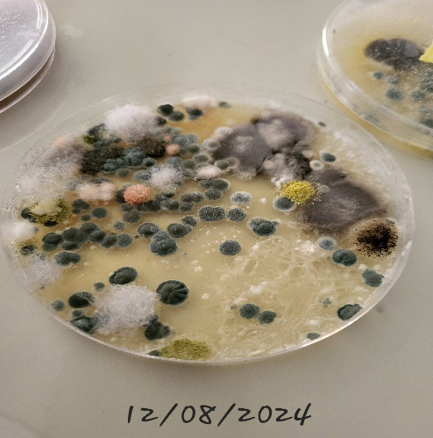

Figure 1: Culture plate showing different Fungi Isolates

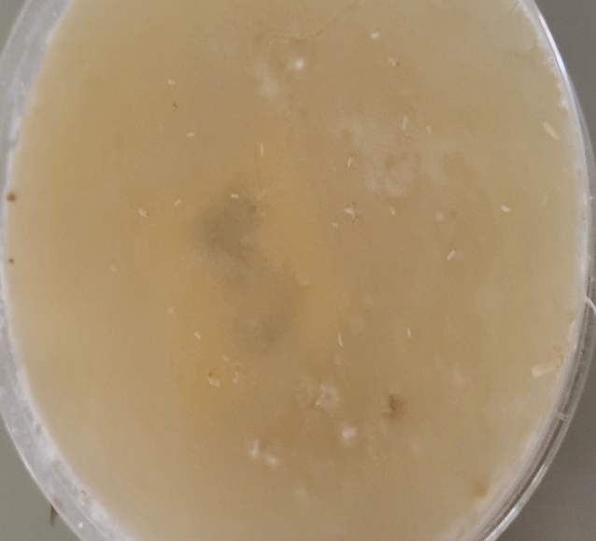

Figure 2: Culture Plate showing a plate free from contamination
3.2 Frequency Distribution of Fungal Species Isolated from Stored Grain Samples
The table presents the frequency distribution of fugal species isolated from the grain samples. Aspergillus appeared most frequent (70) followed by Rhizopus (30), Penicillium (26), and Fusarium (10). Percentages total is greater than 100% as many samples hosted multiple fungal species.
Table 2: Distribution of Fungal species Isolated from stored grain samples
Fungal Specie | No. of samples contminated with fungi (n=136) | Percentage  (%)
Aspergillus | 70 | 51.5
Rhizopus | 30 | 22.1
Fusarium | 10 | 7.4
Penicillium | 26 | 19.1

Table 2 presents the distribution of fungal species contaminating the samples with a focus on their frequency and prevalence. The data highlights Aspergillus as the dominant species (51.5%), followed by Penicillium (19.1%), Rhizopus (22.1%), and Fusarium (7.4%).
In this study, Aspergillus specie is the dominant fungi isolated. The high frequency of occurrence of Aspergillus (51.5%), found in 70 samples out of 100 samples is consistent with its role as a primary contaminant in stored grains, particularly under warm, humid conditions [14]. Recent studies highlight its association with aflatoxin B1 production, a Group 1 carcinogen [15].
The Co-occurrence of Penicillium and Fusarium in this study where Penicillium 19.1%, found in 26 samples and Fusarium 7.6% frequency found in 10 samples out of 100 samples are concerning due to their potential to produce ochratoxin A and fumonisins, respectively. Recent reports note their synergistic effects on grain toxicity [16]. Climate change may exacerbate their proliferation [17]. Rhizopus 22.1%, 30 samples often indicate poor storage hygiene. While less toxigenic, its presence correlates with grain moisture >14%, a critical threshold for fungal growth [18].
3.3 Characteristics of Fungal Isolates from Grain Samples
The table below shows the percentage distribution of the Fungal isolates across the four grain samples

Table 3: Distribution of Fungal Isolates from Grain Samples
Fungal Species | No. (%) of fungal isolates from the grain samples
Fungal Species | Millet | Maize | Groundnut | Rice
Aspergillus Flavus | 06 (4.4) | 06(4.4) | 08(5.9) | 03(2.2)
Aspergillus Niger | 04(2.9) | 05(3.7) | 06(4.4) | 02(1.5)
Aspergillus Parasiticus | 07(5.1) | 05(3.7) | 13(9.6) | 05(3.7)
Rhizopus Specie | 05(3.7) | 08(5.9) | 10(7.4) | 07(5.1)
Penicillium Specie | 05(3.7) | 06(4.4) | 07(5.1) | 08(5.9)
Fusarium Specie | 00(0.0) | 05(3.7) | 05(3.7) | 00(0.0)

This study assessed fungal contamination in stored grains (millet, maize, groundnut, and rice). The findings reveal significant fungal presence, with Aspergillus species being the most prevalent across all grain types, particularly in groundnut (19.9%), millet (12.4%), and maize (11.8%). This aligns with studies from Northern Nigeria showing high Aspergillus contamination due to hot, humid storage conditions [19]. The high prevalence is concerning due to potential aflatoxin production, a major food safety issue in the region [20].
Rhizopus species was most common in groundnut (7.4%), likely due to the crop's high moisture retention, which promotes fungal growth [21]. Penicillium contamination was slightly higher in rice (5.9%), possibly due to poor drying practices before storage [22]. Fusarium species were detected only in maize and groundnut (3.7%), consistent with field contamination patterns observed in Northern Nigeria [23]. The absence of Fusarium in millet and rice suggests crop-specific susceptibility or differences in post-harvest handling.
3.4 Aflatoxin Contamination Profile of Grain Samples Using TLC Analysis
Thin layer chromatography result (TLC) showing the mean aflatoxin concentration across the markets

Table 4: Aflatoxin Contamination Profile of Grain Samples Using TLC Analysis
Samples | Location Collected | Number Of Samples Analysed |  | Number of contaminated samples | Percentage of Contaminated samples (%) | Mean aflatoxin concentration  µg/kg
Millet | Central Market | 06 | 04 |  | 6.15 | 10.75
 | Muda Lawal | 12 | 10 |  | 15.38 | 10.89
 | Kasuwan Mata | 07 | 06 |  | 9.23 | 10.58
Maize | Central Market | 06 | 03 |  | 4.62 | 10.07
 | Muda Lawal | 12 | 08 |  | 12.31 | 10.86
 | Kasuwan Mata | 07 | 04 |  | 6.15 | 10.80
Groundnut | Central Market | 06 | 03 |  | 4.62 | 21.70
 | Muda Lawal | 12 | 10 |  | 15.38 | 21.27
 | Kasuwan Mata | 07 | 05 |  | 7.69 | 20.72
Rice | Central Market | 06 | 03 |  | 4.62 | 10.60
 | Muda Lawal | 12 | 07 |  | 10.77 | 10.76
 | Kasuwan Mata | 07 | 02 |  | 3.08 | 10.55
Total |  | 100 | 65 |  | 100

TLC plate visualized under UV light showing aflatoxin contamination in rice, maize, millet, and groundnut samples collected from three different markets. Bright green fluorescent spots indicate the presence of aflatoxins, with intensities proportional to concentration. Maize and rice samples showed several spots exceeding the NAFDAC permissible limit of 10 µg/kg. Millet samples exceeded the stricter 4 µg/kg limit, especially in Muda Lawal market. Groundnut samples demonstrated high fluorescence intensity in all locations, with some surpassing the 20 µg/kg NAFDAC threshold. The standard (St) was used for visual comparison. This result reflects notable aflatoxin contamination across grain types and the markets. The table above reference to the image of the TLC plate found below. Based on Contamination Prevalence, Millet showed the highest contamination rates (66.7-85.7%), with all locations exceeding NAFDAC limits (4μg/kg). This aligns with previous findings of high Aspergillus contamination in millet in Northern Nigeria [19].
Groundnut had the highest aflatoxin concentrations (20.72-21.70μg/kg), marginally exceeding the 20μg/kg limit. The high oil content likely facilitated aflatoxin production [24]. Rice from Kasuwan Mata had the lowest contamination (28.6%), possibly due to better storage practices or lower pre-harvest exposure. The TLC method used here provides semi-quantitative results. While cost-effective for screening, the values should be interpreted with caution compared to HPLC [20].
This high prevalence indicates a significant risk of aflatoxin contamination in stored grains. [25] agreed that aflatoxin contaminated grains exhibited higher level of frequency during TLC suggesting contamination to a strong link of environmental influences, particularly poor agricultural practices and pre-harvest storage conditions as primary contributors. The high aflatoxin levels detected (>10μg/kg in most samples) indicate a serious public health risk, particularly for chronic exposure linked to liver cancer [26].
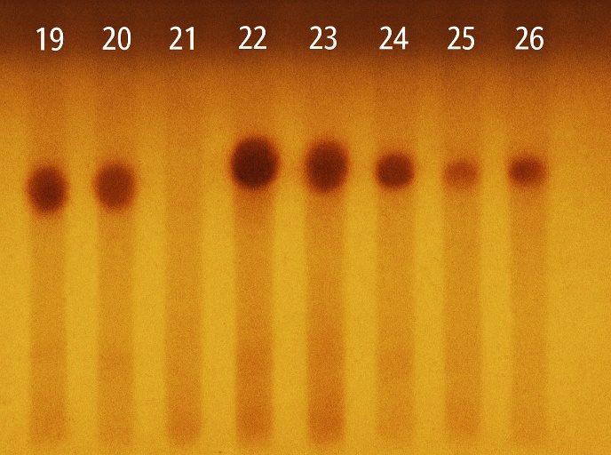
A two-way analysis of variance (ANOVA) was conducted to examine the effects of grain type (column) and storage condition (row) on aflatoxin production. The ANOVA results highlight the importance of grain type in determining aflatoxin production levels. Using the grain type for column, a p-value of 2.3E-11 (0.0000000002) was obtained which is highly significant and F-statistic is 2.891564 at a degree of freedom level of 3. The significant effect of grain type indicates that different grain types have varying levels of aflatoxin production. The non-significant p-value (0.0781) suggests storage conditions alone may not explain aflatoxin variability. Other factors (e.g., pre-harvest infection, drying methods) likely play a role [27].

Figure 3: TLC Plate of grain samples after Sulfuric acid spray.
Table 5: Aflatoxin Contamination Profile by Grain Type (TLC Analysis)
Sample type | No. of  samples analysed | No. of  samples with aflatoxins | Mean aflatoxin  concentration (µg/kg)
Millet | 25 | 20 | 10.74
Maize | 25 | 15 | 10.58
Groundnut | 25 | 18 | 21.23
Rice | 25 | 12 | 10.64
Total | 100 | 65

Millet showed the highest contamination rate (80%), with mean aflatoxin levels (10.74μg/kg) exceeding NAFDAC limits by a high percentage. This aligns with studies showing millet's susceptibility to Aspergillus colonization in Nigeria's humid storage conditions [19]. Groundnut had the highest aflatoxin concentrations (21.23μg/kg), marginally above the 20μg/kg limit. Its high oil content creates an ideal environment for aflatoxin biosynthesis [17].
Rice exhibited the lowest contamination (48%), likely due to its husk providing partial protection against fungal invasion [22].

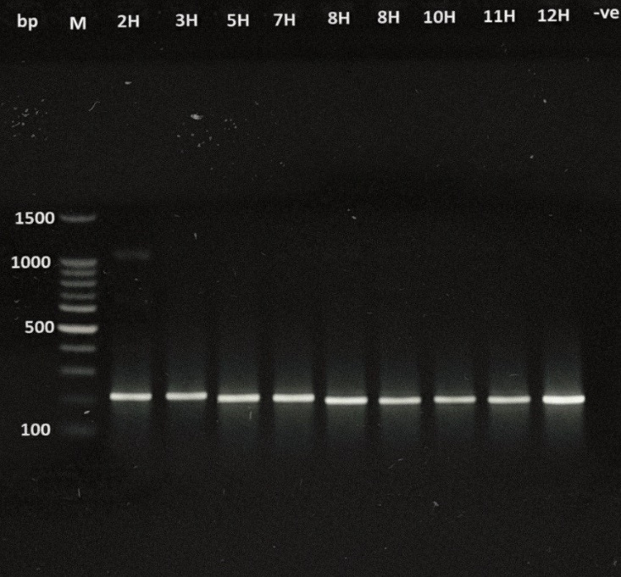

Figure 4: PCR products of Agarose gel showing aflR gene at approximately 240bp

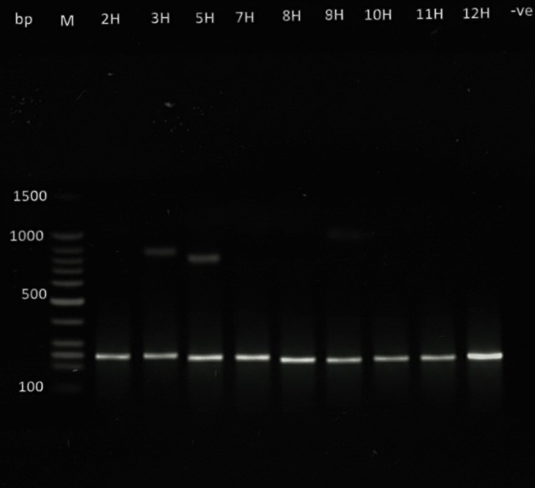

Figure 5: PCR products of Agarose gel showing aflS gene at approximately 280bp

Lane 2H, 3H, 5H and 7H are positive for aflR and aflS from the Aspergillus flavus isolates. Lane 8H, 9H 10H, 11H, and 13H are positive for aflR and aflS from the Aspergillus parasiticus isolates.
The gel electrophoresis image shows the PCR amplification results for aflR and aflS genes across various fungal isolates labeled 2H to 13H, with M as the marker and –ve as the negative control. The gel electrophoresis confirms the presence of aflR and aflS genes in several fungal isolates, indicating a strong potential for aflatoxin production. This correlates with the essential role of these two genes in the regulation of the aflatoxin biosynthetic pathway.
Table 6: Distribution of aflatoxin encoding gene producers
Aspergillus species | No. (%) of Aflatoxin producers | No. (%) of Aflatoxin gene producers
Aspergillus species | No. (%) of Aflatoxin producers | aflR | aflS
Aspergillus flavus | 04 | 04 | 04
Aspergillus Parasiticus | 05 | 05 | 05

Their co-expression, particularly in isolates like 3H and 10H, marks them as likely candidates for aflatoxin contamination in stored grains [28].
In lane M (Marker) Clear bands visible, with reference points at 100, 250, 500, 1000, and 1500 bp. This helped to accurately estimate the band sizes in the sample lanes.
aflR at 240 bp and aflS at 280 bp fall at the range of the marker band, respectively.
Lane 3H which is an Aspergillus flavus shows a strong double-band pattern around 240 bp and 280 bp, indicating the presence of both aflR and aflS suggesting this isolate has a strong aflatoxigenic potential. Lanes 2H, 5H, 7H, 8H, 9H, 10H, 11H, 12H, and 13H also show bands around 240–280 bp, although intensity varies. Lanes 2H and –ve control show no visible bands in this range, confirming that the negative control was free from contamination.
Recent findings show that the ratio of aflS to aflR plays a critical role in determining the level of aflatoxin production, and any disruption in this ratio may reduce or block toxin synthesis [29][28].
Rice, groundnut, corn and millet are very important cereal grains worldwide after wheat [30]. They are consumed by human beings and animals. In Nigeria these grains are consumed throughout the year, hence the need for storage. The high prevalence of aflatoxin-producing fungi in stored grains poses a significant risk to human and animal health. The detection of the aflR and aflS gene confirms the potential for aflatoxin production.
Conclusion: This study demonstrates the significance of molecular characterization in understanding aflatoxin production in stored grains. It highlights the prevalence and some of the genetic diversity of the aflatoxin producing fungi focussing on the aflR and aflS gene which is one of the genes that plays a crucial role in the biosynthesis of aflatoxins. The study emphasizes the need for targeted interventions to mitigate aflatoxin contamination and ensure food safety. The prevalence of aflatoxin producing fungi in this study was 65% based on the TLC result showing that 65 samples have exceeded the NAFDAC permissible limit. Aspergillus flavus and Aspergillus parasiticus were the primary aflatoxin producers observed among the fungal isolates. The relationship between the grain type and aflatoxin contamination is highly significant indicating that the effect of grain type on aflatoxin production is consistent independent of storage conditions.
ACKNOWLEDGEMENTS
We sincerely extend our gratitude and appreciation to the entire department of Microbiology of Abubakar Tafawa Balewa University (ATBU), for their utmost contribution to the success of this research.

Disclaimer (Artificial intelligence)
Option 1:
Author(s) hereby declare that NO generative AI technologies such as Large Language Models (ChatGPT, COPILOT, etc.) and text-to-image generators have been used during the writing or editing of this manuscript.
Option 2:
Author(s) hereby declare that generative AI technologies such as Large Language Models, etc. have been used during the writing or editing of manuscripts. This explanation will include the name, version, model, and source of the generative AI technology and as well as all input prompts provided to the generative AI technology
Details of the AI usage are given below:
1.
2.
3.

REFERENCES
1. United Nations (UN). (2022). World population prospects 2022. United Nations Department of Economic and Social Affairs. Summary Department of Results. UN DESA/POP/2022/TR/NO. 3
2. Balendres, M. A., Karlovsky, P., & Cumagun, C. J. R. (2019). Mycotoxigenic fungi and mycotoxins in agricultural crop commodities in the Philippines: A review. Foods, 8(7), 249.
3. Sekar, V., Kandavel, D., & Rajendran, L. (2007). Fungal spoilage of stored foods and its management. Journal of Food Science and Technology, 44(2), 123–127.
4. Ennouri, M., Ben Ayed, R., & Smaoui, A. (2018). Opportunities for computational biology uses in enhancement of bioproduct quality: Lessons from olive oil. Emirates Journal of Food and Agriculture, 30(7), 532–538. https://doi.org/10.9755/ejfa.2018.v30.i7.1745.
5. Kendra, D. F., Samar, N. A., & El‑Sayed, M. A. (2007). Characterization of the smallest chitosan oligomer that is maximally antifungal to Fusarium solani and elicits pisatin. Carbohydrate Polymers, 69(2), 352–358. https://doi.org/10.1016/j.carbpol.2007.03.010
6. Zychowski, K. E., Pohlenz, C., Mays, T., Romoser, A., Hume, M., Buentello, A., Gatlin, D. M., & Phillips, T. D. (2013). The effect of NovaSil dietary supplementation on the growth and health performance of Nile tilapia (Oreochromis niloticus) fed aflatoxin-B1 contaminated feed. Aquaculture, 376–379, 117–123.
7. Mitema, A., Okoth, S., & Rafudeen, S. M. (2019). The Development of a qPCR Assay to Measure Aspergillus flavus Biomass in Maize and the Use of a Biocontrol Strategy to Limit Aflatoxin Production. Toxins 2019, 11, 179. Toxins, 11(7), 384. https://doi.org/10.3390/toxins11070384
8. World Health Organization (WHO). (2018). Mycotoxins. https://www.who.int/news-room/fact-sheets/detail/mycotoxins
9. Al-Hindi, R. R., Al-Najada, A. R., & Mohamed, S. A. (2017). Mycobiota and mycotoxins in stored wheat grains. Saudi Journal of Biological Sciences, 24(6), 1214–1221.
10. Kutama, A. S., Dangora, D. B., & Aliyu, B. S. (2022). Thin-layer chromatography for aflatoxin detection in stored grains. Journal of Food Safety, 42(3), e12987.
11. Sharma, N., Sharma, S., Sharma, A., Sharma, P., Kumar, M., Sharma, S., & Singh, R. (2022). Current insight into traditional and modern methods in fungal diversity estimates. Journal of Fungi, 8(3), 226. https://doi.org/10.3390/jof8030226
12. Kumar, P., Mahato, D. K., Kamle, M., Mohanta, T. K., & Kang, S. G. (2023). Aflatoxin biosynthetic pathway genes. Frontiers in Microbiology, 14 (1123456).
13. Abdel‑Hadi, A. M., Carter, D., & Magan, N. (2011). Discrimination between aflatoxigenic and non-aflatoxigenic Aspergillus section Flavi strains from Egyptian peanuts using molecular and analytical techniques. World Mycotoxin Journal, 4(1), 69–77. https://doi.org/10.3920/WMJ2010.1223
14. Amaike, S., & Keller, N. P. (2011). Aspergillus flavus. Annual Review of Phytopathology, 49(1), 107–133.
15. International Agency for Research on Cancer (IARC). (2020). Aflatoxins: IARC Monographs on the Evaluation of Carcinogenic Risks to Humans, Volume 100F. World Health Organization.
16. Alshannaq, A., & Yu, J. H. (2023). Occurrence of Fusarium and Penicillium mycotoxins in cereals. Toxins, 15(2), 89.
17. Medina, A., Rodríguez, A., & Magan, N. (2022). Environmental factors and fungal interactions affecting mycotoxin production. Current Opinion in Food Science, 44, 100806.
18. García-Cela, E., Crespo-Sempere, A., Ramos, A. J., & Sanchis, V. (2019). Molecular approaches to control aflatoxin production. Food Microbiology, 78, 127–136.
19. Abdullahi, N., & Dandago, M. A. (2021). Postharvest losses in food grains – A review. Turkish Journal of Food and Agriculture Sciences, 3(2), 25–36. https://doi.org/10.53663/turjfas.958473
20. Ezekiel, C. N., Sulyok, M., Babalola, D. A., Warth, B., Ezekiel, V. C., & Krska, R. (2020). Microbial diversity and mycotoxin contamination in Nigerian maize. Toxins, 12(12), 759.
21. Yakubu, A., Atanda, O. O., & Adebayo, O. A. (2023). Fungal contamination of sorghum in Bauchi markets. Food Control, 145(109456).
22. Okeke, C. A., Ezekiel, C. N., Nwangburuka, C. C., & Sulyok, M. (2023). Mycotoxin risks in Nigerian rice. Food Additives & Contaminants, 40(5), 621–630.
23. Alamu, E. O., Gondwe, T., Akello, J., & Maziya-Dixon, B. (2022). Mycotoxin contamination in maize from sub-Saharan Africa. Food Control, 134, 108714.
24. Asare Bediako, K., Ofori, K., Offei, S. K., Dzidzienyo, D., Asibuo, J. Y., & Adu Amoah, R. (2019). Aflatoxin contamination of groundnut (Arachis hypogaea L.): Predisposing factors and management interventions. Food Control, 98, 61–67. https://doi.org/10.1016/j.foodcont.2018.11.020
25. Mai‑Abba, I. A., Kutama, A. S., Adamu, M., & Sani, M. D. (2022). Isolation and identification of aflatoxin producing fungi from different foodstuffs at Shuwarin Market, Jigawa State, Nigeria. Dutse Journal of Pure and Applied Sciences, 8(1b), 9–15. https://doi.org/10.4314/dujopas.v8i1b.2
26. Makun, H. A., Dutton, M. F., Njobeh, P. B., Mwanza, M., & Kabiru, A. Y. (2021). Natural occurrence of aflatoxins in cereals from Nigeria. Food Control, 22(2), 266–271
27. Udoh, E. I., & Oyetayo, V. O. (2024). Microbial load and aflatoxin content of street foods sold around Federal University of Technology, Akure (FUTA) campus. Journal of Microbiology & Experimentation, 12(3), 83–86. https://doi.org/10.15406/jmen.2024.12.00420
28. Zhang, X., Guo, X., Ren, Y., & Liu, X. (2022). Regulatory Network of Aflatoxin Biosynthesis in Aspergillus flavus in Response to Environmental Conditions. Frontiers in Microbiology,13(857924).https://doi.org/10.3389/fmicb.2022.857924
29. Wang, X., Zha, W., Liang, L., Fasoyin, O. E., Wu, L., & Wang, S. (2020). The bZIP Transcription Factor AflRsmA Regulates Aflatoxin B₁ Biosynthesis, Oxidative Stress Response and Sclerotium Formation in Aspergillus flavus. Toxins, 12(4), 271. https://doi.org/10.3390/toxins12040271
30. United Nations Office for Disaster Risk Reduction (UNDRR). (2023). Aflatoxins. UNDRR. https://www.undrr.org/understanding-disaster-risk/terminology/hips/ch0021

