Original Research Article
Comparative Ecology of Phytoplankton and Trophic Status of the Bandama (Côte d'Ivoire) and Volta (Ghana) Estuaries
ABSTRACT:
Background: Tropical estuaries are vital ecosystems that, despite being affected by human activities, remain under-researched.
Aims: This study evaluated the phytoplankton diversity and trophic pollution status of the Bandama Estuary in Côte d'Ivoire and the Volta Estuary in Ghana, both connected to significant rivers.
Methodology: A total of fifteen sampling sites were chosen, with six in the Bandama Estuary and nine in the Volta Estuary. Physico-chemical parameters were measured using a Hanna HI9829 portable multiparameter device, while microalgae were collected using a 20 μm mesh plankton net and a 1.5 L Niskin bottle. Phytoplankton identification and counting were performed with a Nikon Eclipse 0.90 Dry photonic microscope. The collection was carried out from February to July 2023 in the estuaries of the Volta and Bandama.
Results: In the Volta Estuary, 30 phytoplankton taxa were identified, primarily from three phyla: 20 Chlorophyta (67%), 7 Bacillariophyta (23%), and 3 Euglenophyta (10%). The Chlorophyceae class was the most abundant, with 2,400,000 cells/L (35%). Conversely, the Bandama Estuary revealed 52 phytoplankton taxa across five phyla, with Cyanophyta dominating at 92%. The Bandama Estuary showed hypoxic dissolved oxygen levels (0.72 mg/L), while the Volta Estuary was well-oxygenated (6.23 mg/L). The trophic index calculated for both estuaries indicates a eutrophic environment. In contrast, the Volta Estuary shows a score of 15, indicating moderate organic pollution, providing a foundation for future biomonitoring of anthropogenic pollution in the region.
Conclusion: This research highlights the ecological significance of these estuaries and the need for ongoing studies to understand their health and resilience.
Keywords: Bandama estuary, Volta estuary, phytoplankton diversity, water quality, trophic status, pollution indices.

1. INDRODUCTION
Phytoplankton plays a crucial role in estuarine ecosystems, serving as the basis of the food chain and influencing water quality. Estuaries, as transition zones between fresh and salt water, offer ideal conditions for phytoplankton blooms, which are an indicator of ecosystem health. According to Feldmann (1963), phytoplankton are all plants, generally microscopic, that live freely in water. Although less well known due to their essentially aquatic habitat, the role and importance of algae are well established (Gayral, 1975). As primary producers of trophic chains in aquatic environments, they are also sources of photosynthetic oxygen. Their use as biological indicators of water quality has become commonplace in environmental management (Iltis, 1980). According to Dufour & Durand (1982), these organisms occupy an important trophic position in the aquatic environment and are therefore a determining factor in its functioning. It is therefore essential to characterise the algal population of an aquatic biotope to identify potential disturbances. A good knowledge of the phytoplankton existing in an ecosystem enables us to assess its fertility and degree of productivity. The development of algal populations is governed by chemical, biological (predation, competition, etc.), and physical factors (Reynolds, 1984; Sommer, 1989). These different parameters play a more or less decisive role at different times of the year, leading to fluctuations in the composition and abundance of the algal flora. Numerous studies have been carried out on phytoplanktonic algae in estuarine environments in West Africa (e.g., in Côte d'Ivoire: Arfi et al., 1981; Lemasson et al., 1981; Dufour & Durand, 1982; Dufour, 1984 and 1994; Iltis, 1984; Couté & Iltis, 1985; Guiral et al., 1993; Adou, 1999; and in Ghana: Alhassan, 2015; Alhassan and Ofori-Danson, 2016). Most of these studies deal with quality, abundance, and spatio-seasonal variations. Studies concerning trophic status are rare. In the present study, we will characterise the trophic status of the waters of the Bandama and Volta river estuaries based on phytoplankton composition.

2. MATERIAL AND METHODS
2.1 Study environment
The study was conducted in the estuarine regions of the Volta River (8°39′43″N, 0°59′14″W) in Ghana's Volta Region and the Bandama River (5°08′47.9″N, 4°59′19.3″W) in the Grand-Lahou Department of southwestern Côte d’Ivoire (Figure 1). A total of 15 sampling stations were surveyed: 6 in the Bandama estuary and 9 in the Volta estuary. Grand-Lahou has an equatorial climate characterized by four distinct seasons: two rainy seasons (April–July and September–November) and two dry seasons (December–March and August). The area is influenced by both the Bandama River and the Atlantic Ocean. The Volta estuary experiences a similar climate. Coastal vegetation is dominated by swampy mangrove ecosystems, primarily composed of Rhizophora racemosa G.F.W. Mey (Rhizophoraceae), which are often degraded due to charcoal production and use as firewood for fish and shrimp smoking. At the mouth of the Bandama River and Tagba Lagoon, patches of Imperata cylindrica (L.) Raeuschel (Poaceae) savannah interspersed with Borassus aethiopum Mart. (Arecaceae) are present (Guillaumet & Adjanohoun, 1971; Girard et al., 1971; Guillaumet, 1979). Both estuaries lie within the Guinean forest zone. Inland areas contain remnants of primary and secondary forest, though much of it is degraded due to deforestation and logging activities.
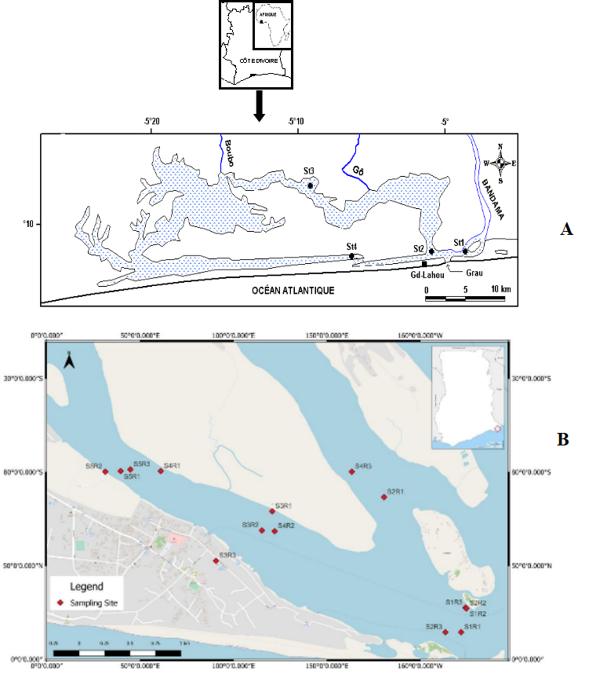

Fig. 1. Sampling stations in the Bandama Estuary (A) and Volta Estuary (B)

2.2 Sampling equipment
Parameters such as salinity ((‰), water temperature (°C), pH, dissolved oxygen level (mg L-1), and turbidity (in N.T.U.) were measured, respectively, using a portable multiparameter probe type 315i/SET (Figure 2a), a pH meter type HI 98158, an oximeter type YSI model 57, and a turbidimeter. A spectrophotometer (Figure 2b) and reagent kits were used to determine dissolved ions in water (mg/L). Phytoplankton samples were taken using a 20 µm mesh plankton net (Figure 2c), 40 ml pillboxes, a 1-litre Niskin hydrological bottle (Figure 2d), a 10-litre bucket, and commercial formalin, the acidity of which was neutralised by sodium borate for better fixation of the organisms. For the qualitative study, an Olympus CX 31 photonic microscope equipped with a digital camera, slides, and coverslips was used. Quantitative studies were carried out using a Zeiss inverted microscope and sedimentation tanks.
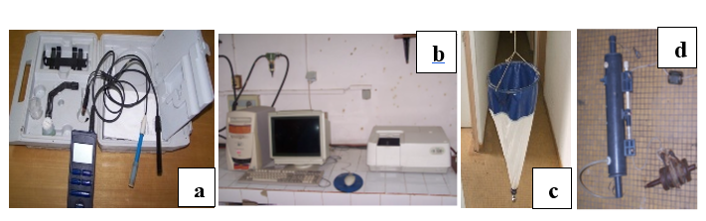

Fig. 2. : Matériel technique de mesure des paramètres physico-chimique et de prélèvement. a Multiprameter probe; b: Spectrophotometer UV JASCO; c: Plankton net; d: Niskin bottle

2.3 Trophy calculation methods
These are based on an examination of the phytoplankton population, for which the absence of a certain number of organisms is as significant as the presence, development, or regression of certain species. Nygaard (1949), following Thunmark (1945), proposed several indices, the most widely used of which is the composite index: this is the ratio of the sum of the number of species in four algal groups typical of eutrophic conditions (Cyanophyceae, Chlorococcales, Centrales, Euglenophyceae) to the number of species in a group typical of oligotrophic conditions (Desmidiaceae) :
$$A=\frac{Cyanophyceae + Chlorococcales + Centrales + Euglénophyceae}{Desmidiaceae}$$

A = composite index.
0,3 < A < 1 = oligotrophic environment ;
1 < A < 2,5 = mesotrophic environment ;
2,5 < A < 5 = eutrophic environment

A second index, B, derived from Diatoms, reflects the ratio of the number of species in the Centrales to those in the Pennales :
$$B=\frac{Centrales}{Pennales}$$
B : 0 - 0.2 = oligotrophic environment ;
B : 0.2 - 3 = eutrophic environment
- Palmer algal pollution index
The method used to assess water quality is that described by Palmer (1969), which is the Algal Pollution Index using 20 genera of microalgae most tolerant to organic pollution (table 1). This index is based on a relative number of total points scored by each algae present in a particular water body. According to Palmer's (1969) Algal Pollution Index, the score between 0 and 10 indicates a lack of organic pollution; 10-15 translates to moderate pollution. When the score fluctuates between 15-20, it indicates probable high organic pollution, and finally scores of 20 and above are considered high organic pollution.
Table 1. Algal pollution index of Palmer (1969)
Genre | Index | Genre | Index
Anacystis | 1 | Micractinium | 1
Ankistrodesmus | 2 | Navicula | 3
Chlamydomonas | 4 | Nitzschia | 3
Chlorella | 3 | Oscillatoria | 5
Closterium | 1 | Pandorina | 1
Cyclotella | 1 | Phacus | 2
Euglena | 5 | Phormidium | 1
Gomphonema | 1 | Scenedesmus | 4
Lepocinclis | 1 | Stigeoclonium | 2
Melosira | 1 | Syndra | 2

- Diversity index
The diversity index used to characterise phytoplankton populations at different stations is that of Shannon & Weaver (1963). It was calculated based on the number of species counted in each of the water samples collected with the Niskin bottle:
ni being the number of species i and the total number of individuals in the sample.

3. RESULTS
3.1 Physicochemical parameters
- Bandama estuary
The spatial variation of abiotic parameters was studied in the two estuaries. No significant differences were observed between the values of these parameters at any of the stations in this estuarine environment (Kruskal-Wallis test, p > 0.05).
Values for dissolved substances (TDS) range from 0.084 mg/L at the S4R1 station to 0.270 mg/L at the S5R1 station. The minimum salinity value recorded is 0.04 (‰) at the S5R2 station, while the maximum value of 0.17 (‰) was measured at the S1R3 station. The temperature in the estuary waters remains relatively constant, averaging 30.61°C. However, the lowest recorded temperature is 30.19°C at the S5R2 station. Overall, the waters are warm. With an average pH of 6.86, the recorded values range from 6 to 7.82. As for the dissolved oxygen levels in the river waters, they fluctuate between 5 and 9.08 mg/L, with an average of 6.23 mg/L.
- Bandama estuary
The environmental parameters studied in the waters of the Bandaman estuary did not vary significantly (Kruskal-Wallis test, p > 0.05) between the different stations. Some, notably dissolved oxygen, nitrite, phosphorus, and turbidity, are virtually constant, while others, such as salinity, pH, and temperature, show relative variations between stations. Dissolved oxygen (O2) levels fluctuate between 0.60 mg/L and 0.90 mg/L. The average value is 0.72 mg/L. Nitrite (NO₂) levels range from 0.02 mg/L to 0.70 mg/L, with an average value of 0.21 mg/L. As for phosphorus (PO), the average value obtained is 0.31 mg/L, ranging from a minimum of 0.1 mg/L to a maximum of 0.7 mg/L. Turbidity was highest (39.35 NTU) at ST6 and lowest (30.21 NTU) at ST1. The average value recorded is 34.53 NTU. Salinity values range from 20.10 ‰ to 31.20 ‰. The average salinity of the waters in this environment is 24.88 ‰. Temperature ranges from 27.65°C to 30.84°C. The average value obtained is 28.96°C. The pH ranges from 8.02 to 8.30, with an average of 8.14.
3.2 Qualitative characteristics of phytoplankton in the two estuaries
The identification of phytoplankton species presents in the two estuaries allowed for the cataloguing of a total of 82 taxa (Table 2), distributed across 5 phyla. Qualitatively speaking, 30 taxa were inventoried at the 15 stations in the Volta estuary. These taxa are divided into three phyla, with 20 species of Chlorophyta (67%), 7 of Bacillariophyta (23%), and 3 of Euglenophyta (10%) (Figure 3a).
In the Bandama estuary, samples taken at the 6 selected stations yielded 52 taxa in 5 phyla, distributed as follows (Figure 3b): 18 species of Chlorophyta (35%), 12 species of Euglenophyta (23%), 11 species of Bacillariophyta (21%), 6 species of Cyanophyta (11%) and 5 species of Dinophyta (10%).
Table 2. List of taxa recorded in the waters of the Volta estuary (Ghana) and Bandama estuary (Côte d'Ivoire)
Taxons | Volta | Bandama
Phylum Bacillariophyta
Class Bacillariophyceae
Order Centrales
Achnantes longipes |  | x
Achnanthes brevipes var. intermedia. |  | x
Aulacoseira grannulata | x | x
Aulacoseira grannulata var. angustissima | x | x
Chaetoceros curvisetus |  | x
Chaetoceros lorenzianus |  | x
Guinardia flacida |  | x
Guinardia striata |  | x
Order pennales
Campylodiscus clypeus |  | x
Diploneis smithii |  | x
Nitzschia cf. sigmoidea |  | x
Ploeurosigma sp. | x
Susrirella sp.1 | x
Surirella sp.2 | x
Ulnaria ulna | x
Class Chrisophyceae
Order Ochromonadales
Dinobryon sertularia | x
Phylum Chlorophyta
Class Conjugatophyceae
Order Desmidiales
Family Desmidiaceae
Closterium sp. | x
Cosmarium sp.1 | x
Cosmarium sp.2 | x
Cosmarium sp.3 | x
Micrasterias sp. | x
Spondylosium pulchrum | x
Staurastrum leptocladrum var. conutum | x
Staurastrum sp.1 | x
Staurastrum sp.2 | x
Staurastrum volans | x
Xanthidium sp. | x
Class Chlorophyceae
Order Chlorococcales
Coelastrum indicum |  | x
Crucigenia tetrapedia |  | x
Desmodesmus protuberans |  | x
Ankistrodesmus fusiformis | x
Ankistrodesmus spiralis | x
Coelastrum astroideum | x
Coelastrum cambricum | x | x
Coelastrum reticulatrum | x | x
Crucigenia quadrata |  | x
Crucigenia tetrapedia |  | x
Crucigeniella apiculata |  | x
Crucigeniella crucifera |  | x
Crucigeniella neglecta |  | x
Crucigeniella rectangularis |  | x
Desmodesmus intermedius |  | x
Desmodesmus intermedius |  | x
Desmodesmus armatus |  | x
Desmodesmus opoliensis var. mononensis |  | x
Pediastrum duplex | x
Pediastrum duplex var. gracillimum |  | x
Pediastrum simplex | x | x
Scenedesmus bernardii | x
Scenedesmus quadricauda | x
Sorastrum americanum |  | x
Phylum Euglenophyta
Euglenophyceae
Euglenales
Euglena proxima |  | x
Lepocinclis acus |  | x
Lepocinclis fusca |  | x
Lepocinclis spirogyra |  | x
Lepocinclis tripteris |  | x
Phacus ephippion |  | x
Phacus longicauda var. insecta |  | x
Phacus longicauda var. longicauda | x | x
Phacus sp. | x
Strombomonas fluviatilis |  | x
Strombomonas schauinslandii |  | x
Trachelomonas oblonga |  | x
Trachelomonas superba | x | x
Phylum Dinophyta
Ceratium furca |  | x
Ceratium fusus |  | x
Podolampas bipes |  | x
Prorocentrum micans |  | x
Protoperidinium divergens |  | x
Phylum Cyanophyta
Cyanophyceae
Aphanocapsa incerta |  | x
Chroococcus dispersus |  | x
Merismopedia elegans |  | x
Merismopedia glauca |  | x
Merismopedia punctata |  | x
Microcystis aeruginosa |  | x
TOTAL = 82 | 30 | 52
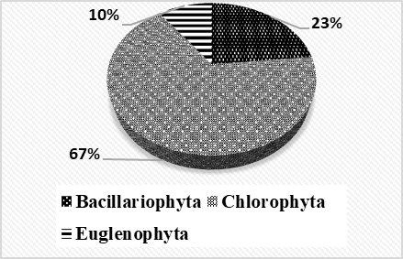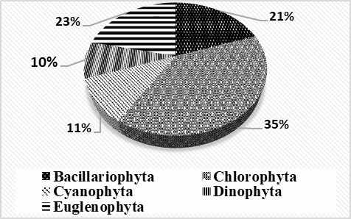
Fig. 3a: Proportions of major algal groups harvested from the waters of the Volta estuary
Fig. 3b: Proportions of major algal groups harvested from the waters of the Bandama estuary

3.3 Quantitative characteristics of phytoplankton in the two estuaries
In quantative terms, the data collected in the Volta estuary reveal a predominance of the Chlorophyceae class with 2,400,000 cells /L (35 %), followed by the Conjugatophyceae with 2,000,000 cells /L, (29 %), followed by the Bacillariophyceae with 1,700,000 cells /L, (25 %), the Euglenophyceae with 600,000 cells /L (9 %) and finally the Chrysophyceae with 100,000 cells /L, (1%) (Figure 4a). In the Bandama estuary (Figure 4b), the highest phytoplankton abundances are provided by species of the Cyanophyceae class (9200000 cells /L or 92 %). Taxa from other classes, notably Chlorophyceae (3000000 cells /L or 3%), Bacillariophyceae (2500000 cells /L or 2.5%), Conjugatophyceae (1000000 cells /L or 1%), Euglenophyceae (1000000 cells /L or 1%) and Dinophyceae (500000 cells /L or 0.5 1%) are not very abundant in the environment.
The Shannon-Weaver diversity indices calculated give values of H= 3.24 in the Volta estuary and H= 3.04 in the Bandama estuary.
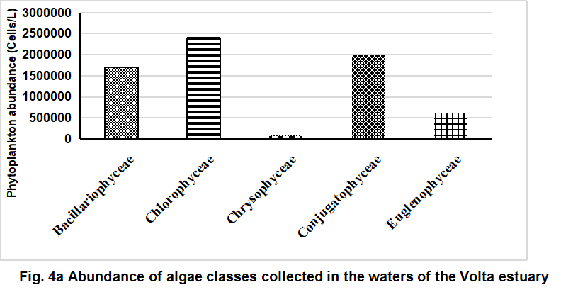

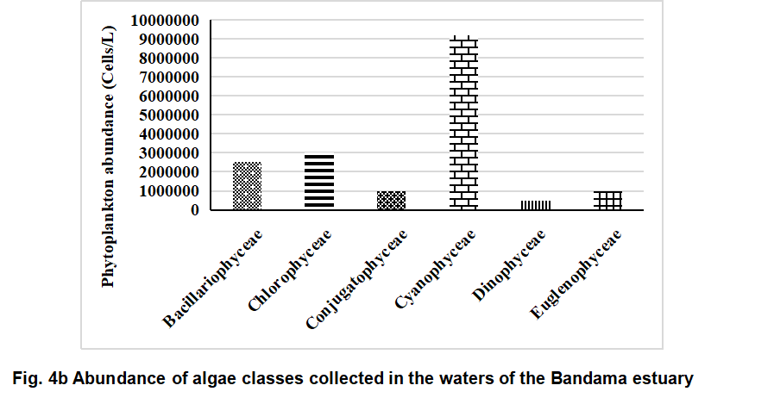

3.4 Trophic status of the waters of the two estuaries
Water trophic status indices (A and B) were calculated using the number of species belonging to the orders Chlorococcales, Centrales, Pennales, the family Cyanophyceae, and the family Desmidiaceae inventoried in the estuaries. The index calculated is 0.5 (B index) in the Volta estuary. In the Bandaman estuary, values of 3 (A index) and 0.83 (B index) were obtained. The Palmer algal pollution index calculated in the Bandama and Volta estuaries provided the results presented in Table 3. The waters of the Bandama estuary are characterised by an absence of organic pollution, with an index of 8 according to Palmer (1969). In contrast, the Black Volta shows a score of 15, indicating moderate pollution.
Table 3. Palmer Index Score in the Bandama and Volta estuaries
Genrera | index of Palmer (Palmer, 1969) | Volta | Bandama
Euglena | 5 | +5
Oscillatoria | 5 | - | -
Chlamydomonas | 4 | - | -
Scenedesmus | 4 | +4 | -
Chlorella | 3 | - | -
Navicula | 3 | - | -
Nitzschia | 3 | - | +3
Ankistrodesmus | 2 | +2 | -
Phacus | 2 | +2 | +2
Stigeoclonium | 2 | - | -
Synedra | 2 | - | -
Anacystis | 1 | - | -
Closterium | 1 | - | +1
Cyvlotella | 1 | - | -
Gomphonema | 1 | +1 | +1
Lepocinclis | 1 | +1 | +1
Melosira | 1 | - | -
Micractinium | 1 | - | -
Pandorina | 1 | - | -
Phormidium | 1 | - | -
Total | 20 | 15 | 08

4. DISCUSSION
Physicochemical analyses revealed spatiotemporal variability in both estuaries. The Volta estuary exhibited relatively high total dissolved solids (TDS) and salinity, closely linked to marine influence. Similarly, high salinity in the Bandama estuary was attributed to stronger marine intrusion and reduced freshwater input, likely due to upstream dams and high evaporation. Water temperatures were stable and warm in both systems (Volta: 30.61 °C; Bandama: 28.96 °C), consistent with tropical conditions and estuarine mixing (Anthony et al., 2020).
The Volta estuary showed slightly acidic waters (mean pH 6.84), likely due to humic acids from decomposing aquatic vegetation (Atanle et al., 2013) and possibly coastal upwelling and acid drainage (Ndong et al., 2021). In contrast, Bandama waters were alkaline (mean pH 8.14), influenced by urban/industrial effluents and phytoplankton photosynthesis (Koné et al., 2025). Dissolved oxygen (DO) levels were significantly different: well-oxygenated in the Volta estuary (6.23 mg/L), but hypoxic in Bandama (0.72 mg/L), suggesting high organic pollution and oxygen demand from bacterial decomposition (Kouassi et al., 2020).
Phytoplankton analysis revealed 30 taxa in the Volta and 56 in the Bandama estuary. In the Volta, species belonged to Chlorophyta, Bacillariophyta, and Euglenophyta, while Bandama also included Cyanophyta and Dinophyta, indicating higher diversity. Dominant classes were Cyanophyceae, Chlorophyceae, and Bacillariophyceae, all favored by warm, nutrient-rich, and turbid waters. Cyanophyceae tolerate harsh conditions, Chlorophyta are thermophilic and photophilic (Sheath & Wehr, 2003), and diatoms (Bacillariophyceae) thrive in turbid, mineralized environments (Ebang et al., 2012).
Trophic indices confirmed eutrophic conditions: Volta (B index = 0.5), Bandama (A index = 3; B index = 0.83). The Palmer index suggested probable organic pollution in the Volta, contrasting with its absence in Bandama. This may reflect higher microalgal abundance in Volta, supported by environmental conditions conducive to algal blooms (Skulberg et al., 1984).
5. CONCLUSION
This characterised water quality in two tropical estuaries (Bandama and Volta) using physico-chemical and phytoplanktonic indicators of trophic change. It has highlighted the relative stability of the values of the physicochemical parameters studied. It also revealed the floristic phytoplankton composition and trophic status of the two aquatic environments. A total of 86 phytoplankton taxa were inventoried, including 30 in the Volta estuary and 56 in the Bandama estuary, respectively. The trophic index calculated for the two aquatic ecosystems suggests a eutrophic estuarine environment. In contrast, the Black Volta estuary shows a score of 15, indicating moderate organic pollution.

Disclaimer (Artificial intelligence)
Author(s) hereby declare that NO generative AI technologies such as Large Language Models (ChatGPT, COPILOT, etc.) and text-to-image generators have been used during the writing or editing of this manuscript.

References
Adou A.R.E. (1999). Contribution to the knowledge of algae in the Tendo lagoon in N’Guiémé (Côte d’Ivoire). Memory of D.E.A., U.F.R. Biosciences, University of Cocody, Abidjan, 96 p.
Anthony, E. J., Almar, R., & Laïbi, R. A. (2024). Coastal lagoons of West Africa: A scoping study of environmental status and management challenges. Anthropocene Coasts, (7)7. https://doi.org/10.1007/s44218-024-00039-9
Alhassan, E.H. (2015). Seasonal variations in phytoplankton diversity in the Bui Dam area of ​​the Black Volta in Ghana during the pre- and post-impoundment periods. Tropical Biology Review, 63(1), 13–22.
Alhassan, E. H., & Ofori-Danson, P. K. (2017). Plankton abundance in relation to physicochemical factors in the Bui Reservoir of Ghana’s Black Volta River. African Journal of Ecology, 55(1), 12–20. https://doi.org/10.1111/aje.12303
Arfi R., Dufour P. & Maurer D. (1981). Phytoplankton and pollution: first studies in Biétri Bay (Côte d’Ivoire). Mathematical data processing. Oceanologica Acta, 4: 319–329.
Atanle K., Moctar L., Bawa, Kokou K., and Gbandi D. B. (2013). Physicochemical characterization and phytoplankton diversity of the waters of Lake Zowla (Lake Boko), Togo. J. Appl. BioSci., 64: 4847-4857.
Koné, T. S., Kouyaté, K., Soro, T. A., Kamelan, T. M., Etilé, R. N’doua, & Kouamélan E. P. (2025). Environmental characterization of the Bandama River estuary in Azagny National Park (Ivory Coast, West Africa). International Journal of Current Research, 12(03), 49307. https://doi.org/10.24941/ijcr.49307.08.2025
Couté A. & Iltis A. (1985). Scanning electron microscope study of some algae (Dinophyceae and Diatomophyceae) from the Ébrié lagoon (Côte d'Ivoire). Nova Hedwigia, 41: 69-79.
Dufour P. & Durand J.R., 1982. Plant production in the lagoons of Côte d’Ivoire. Tropical Hydrobiology Review, 15 (3): 209-230.
Dufour P., 1984. Plant biomass in coastal lagoons. Example of the Ébrié lagoon (Côte d’Ivoire). Tropical Hydrobiology Review, 17 (3): 207-233.
Dufour P., 1994. Microphytes. In Durand J.-R., Dufour P., Guiral D. & Zabi S.G.F. (Eds.), Environment and Aquatic Resources of Côte d’Ivoire. Volume II. Lagoon Environments, pp. 109-136.
Ébang Menye, D., Zébazé Togouet, S. H., Foto Menbohan, S., Kemka, N., Nola, M., Boutin, C. & Nguetsop, V. F. (2012). Bioecology of Epilithic Diatoms in the Mfoundi River (Yaoundé, Cameroon): Diversity, Spatial Distribution and Influence of Organic Pollution. Journal of Water Science, 25(3), 203–218.
Feldmann, J. (1963). Algae. In: P. P. Grassé: Botany. Masson et Cie, ed. Paris, pp. 83-249
Gayral, P. (1975). Algae: Morphology, Cytology, Reproduction, Ecology. Doin Éditeur, Paris, 166 p.
Girard, G., Sircoulon, J. & Toucheboeuf, P. (1971). Overview of Hydrological Regions. In Avenard J. M., Eldin E., Girard G., Sircoulon J., Touchebeuf P., Guillaumet J.L., Adjanohoun E. & Perraud A. (Eds.): The Natural Environment of Côte d’Ivoire. ORSTOM Memoir, Paris, 50: 109-156.
Guillaumet, J. L. & Adjanohoun, E. (1971). The Vegetation of Côte d’Ivoire. In Avenard J. M., Eldin E., Girard G., Sircoulon J., Touchebeuf P., Guillaumet J.L., Adjanohoun E. & Perraud A. (Eds.): The natural environment of Côte d’Ivoire. Éditions O.R.S.T.O.M., Paris, 50: 161-262.
Guillaumet, J.L. (1979). Vegetation in "Atlas of Côte d'Ivoire". Association of Atlases of Ivory Coast, Abidjan, 20p.
Guiral, D., Arfi, R., Da, K. P. & Konan-Brou, A. A. (1993). Communities, biomass and algal production within an artificial reef (acadja) in a tropical lagoon environment. Journal of Tropical Hydrobiology, 26 (3): 219-228.
Iltis, A. (1980). Algae. In: Durand J.R. & Lévêque C. (Eds). Aquatic Flora and Fauna of Sahel-Sudanese Africa. Volume I. Éditions O.R.S.T.O.M. Collection InitiationDocuments Techniques No. 44, Paris, pp. 9-61.
Iltis, A. (1984). Phytoplankton Biomass of the Ébrié Lagoon (Côte d’Ivoire). Tropical Hydrobiology Review, 118: 153-175.
Kouassi, A. M., Aka, M., & Pagano, L. (2020). Seasonal Hypoxia and Its Consequences in a Polluted Tropical Estuary (Côte d’Ivoire, West Africa). Environmental Monitoring and Assessment, *192*(12), 785. https://doi.org/10.1007/s10661-020-08751-y
Lemasson, L., Pagès, J., Dufour, P. & Cremou, J. L. (1981). Particulate organic matter and biomass in a tropical lagoon. Tropical Hydrobiology Review, 14 (3): 191-212.
Ndong, G. B., Diallo, M., & Diop, S. (2021). Coastal acidification in West Africa: Drivers and impacts on shellfish resources. African Journal of Marine Science, *43*(2), 145-158.
https://doi.org/10.2989/1814232X.2021.1929286
Nygaard, G. (1949). Hydrobiological studies in some ponds and lakes. Part II: The quotient hypothesis and some new or little-known phytoplankton organisms found in the videnskabernes selskab. Biology. Skrifter, 7 (1): 1 – 293.
Palmer, C.M. (1969). A composite rating of algae tolerating organic pollution. Journal of Phycology, 5 (1), 78-82.
Reynolds, C.S. (1984). Phytoplankton periodicity: the interactions of form, function, and environmental variability. Freshwater Biology, 14 (2): 111-142.
Shannon, C. E. & Weaver, W. (1963). The mathematical theory of communication. Urbana University Press, Illinois, 127 p.
Sommer, U. (1989). Plankton ecology. Succession in the plankton community. Springer-Verlag, Berlin, 360 p.
Skulberg, O.M, Codd. G.A. & Carmichael, W. (1984). Toxic blue-green algal blooms in Europe: a growing problem.Amibo. 13, pp. 244-246.
Thunmark, S. (1945). Zur Sociologic des Süsswasserplanktons. Eine methodologisch ökologische Study. Folia Limnologica Scandinavica, 3: 1 – 66
Wehr, J. D. & Sheath, R. G. (2003). Freshwater Algae of North America: Ecology and Classification. Academic Press. p 330.

