Short communication
Taxonomic Study of Eriovixia panigrahii (Araneae: Araneidae) from Kalahandi, Odisha, India

Abstract
Eriovixia Archer, 1951 is a genus of the spider family Araneidae Clerck, 1757, with 35 named species occurring three species in Africa and thirty two species in Asia.Four Eriovixia species were identified during our survey in the hilly area of Kalahandi, Odisha; three were identified as Eriovixia laglaizei , Eriovixia excelsa, and Eriovixia poonaensis and one was a new species. The new one was described as Eriovixia panigrahisis based on morphological characters and the COI mitochondrial gene sequence. But the species epithet was corrected from Eriovixia panigrahisis to Eriovixia panigrahii by the World Spider Catalog and treated as a “nomen nudum”, as the original description did not designate type specimens and lacked genitalia descriptions. This study presents the revised and complete taxonomic description of Eriovixia panigrahii, based on both male and female holotypes. The holotype and paratypes are clearly designated, and detailed observations of genital morphology are provided. Key diagnostic characters are described to support accurate identification of the species. It also registered in ZooBank.
Key Words: New species, Eriovixia panigrahii, morphology, orb-weaver spider, taxonomy, ZooBank;
Introduction
Eriovixia Archer, 1951 is a genus of the spider family Araneidae Clerck, 1757, with 35 named species occurring three species in Africa and thirty two species in Asia. In Japan, the species have been well studied by Tanikawa (1999, 2007, 2009) and species from China, India and Bangladesh have been considered by Han and Zhu (2010), Mi et al. (2010), Ahmed et al. (2016), Zhou et al. (2017), Biswas and Raychaudhuri (2018), Basumatary et al. (2019), Mi & Li (2021) and Panigrahi et al.(2025). Sudhir et al. (2019) reported three Eriovixia species reported from the Eastern Ghats of Odisha. While examining specimens from Kalahandi hilli areas, is part of the Eastern Ghats, an older, discontinuous mountain range, 04 Eriovixia species were identified, including three named species: Eriovixia laglaizei (Simon, 1877), Eriovixia excelsa (Simon, 1889), Eriovixia poonaensis (Tikader & Bal, 1981) and one new species.
In our earlier publication, Eriovixia panigrahii was proposed as a new species based on morphological characters and COI mitochondrial gene sequence (Panigrahi et al., 2025). But Species epithet corrected from Eriovixia panigrahisis to Eriovixia panigrahii and updated by World Spider Catalogon 10th February 2025 (World Spider Catalog, 2025). Further, the World Spider Catalog subsequently treated as a “nomen nudum”, as the original description did not designate type specimens and lacked genitalia descriptions, in accordance with ICZN Article 16.4.1 (Bento et al., 2022).
The present study provides the rectified and complete taxonomic description of Eriovixia panigrahii, including both male and female specimens. Holotype and paratypes are properly designated, and the detailed genital morphology, along with diagnostic characters is presented. This study, is the extension part of earlier publication (Panigrahi et al., 2025), validates the species as new to science in accordance with the ICZN Code, and also registered in ZooBank with LSID:zoobank.org:pub:7CE16E3F-5B89-43E2-A9A6-FD67DA737D5E.
Materials and Methods
Specimens were examined with an Olympus SZX16 stereomicroscope. Male palps were examined and illustrated after dissection from the spider body; whereas female epigyna were examined intact condition with spider body. Vulva was cleaned in boiling KOH solution to dissolve non-chitinous tissues, and the embolic division of male palps was excised by breaking the column. Photos were taken with a Nikon Z50 digital camera mounted on an Olympus SZX16 stereomicroscope and are given in micrometers. Eye diameter were not taken. The total body length excluded the length of the chelicerae or spinnerets. The leg measurements are given in the following sequence: total (femur,patella+tibia+metatarsus+tarsus) (Mi et al., 2010). Type material examined were preserved in 80% ethanol and deposited in the animal museum of the Department of Zoology, Maa Manikeshwari University, Bhawanipatna, Kalahandi, Odisha, India for future study.
Results and Discussion

Taxonomy
Family Araneidae Clerck, 1757
Subfamily Araneinae Clerck, 1757
Genus Eriovixia Archer, 1951
Eriovixia panigrahii sp. nov.

Eriovixia panigrahii (Panigrahi et al., 2025)
(Figures 1-2)
Type material:
Holotype (1♂, 1♀) Kushadangri Hill, Kalahandi District, Odisha, India, 19°54'43.7"N 83°11'27.3"E, August to December, 2024.
Paratype: Three females and two males, February 15 to march 15, 2025 from same location as above.
Etymology: The specific name after the surname of first author, noun (name) in genitive case.
Diagnosis.
The species Eriovixia panigrahii sp. nov. is very much similar with Eriovixia pooonaensis, having the body length of male from 2.60 to 3.90 mm. Carapace: pear-shaped (piriform), slightly longer than wide; narrower in the eye region. Covered with setae; cervical groove often more inconspicuous in males. Cephalic region may or may not have a protuberance beneath the anterior median eyes (Mi & Li, 2021)). Eyes: with standard araneid complement; eye region narrow; inter-ocular distances, MOA (median ocular area) measured; arrangement typical for orb-weavers. Chelicerae: yellowish; usually with 4 promarginal teeth, often 2–3 retromarginal. Legs: leg I longest; leg III usually shortest; coloration often yellowish with darker annuli/rings; some macrosetae on specific segments in certain species; male palp shows standard structures (paracymbium, median apophysis, conductor, embolus, terminal apophysis) (Mi & Li, 2021). Abdomen: shape triangular or somewhat tapering posteriorly; may extend beyond spinnerets; dorsal pattern (folium, patches, tubercles) variable by species (Tikader 1981; Mi &Wang, 2016). But it distinguished from its congeners by the male palp with a strongly hooked median apophysis, short robust conductor partially enclosing the slender curved embolus, and broad tegular apophysis projecting anterolaterally (Fig.1).
Similarly, the Eriovixia poonaensis (♀) has some common characters with Eriovixia panigrahii sp. nov. The body size somewhat larger than males (3.0 mm –5.7 mm). Carapace: same as male; the cephalic region slightly elevated; narrow eye region. Abdomen: tends to be triangular or tapering posteriorly; often the abdomen extends beyond spinnerets; dorsal folium, color patterns, possibly dorsal markings or patches; likely covered in setae (fine hairs) and maybe tubercles depending on species. Legs: yellowish with dark annuli; leg I usually the longest, leg formula typical for Eriovixia (leg I > II > IV > III in many species) (Han & Zhu, 2010). The epigyne of female Eriovixia panigrahiibears a subtriangular plate with a distinct projecting scape, narrow longitudinal median septum, and small rounded copulatory openings at the base of the scape, are distinguished characters. The vulva is also characterized by spherical spermathecae, moderately separated and posteriorly positioned, with short medially directed copulatory ducts and convoluted insemination ducts (Fig. 2).Both sexes have hairs and spines on their legs, and have common leg formula is 1243.

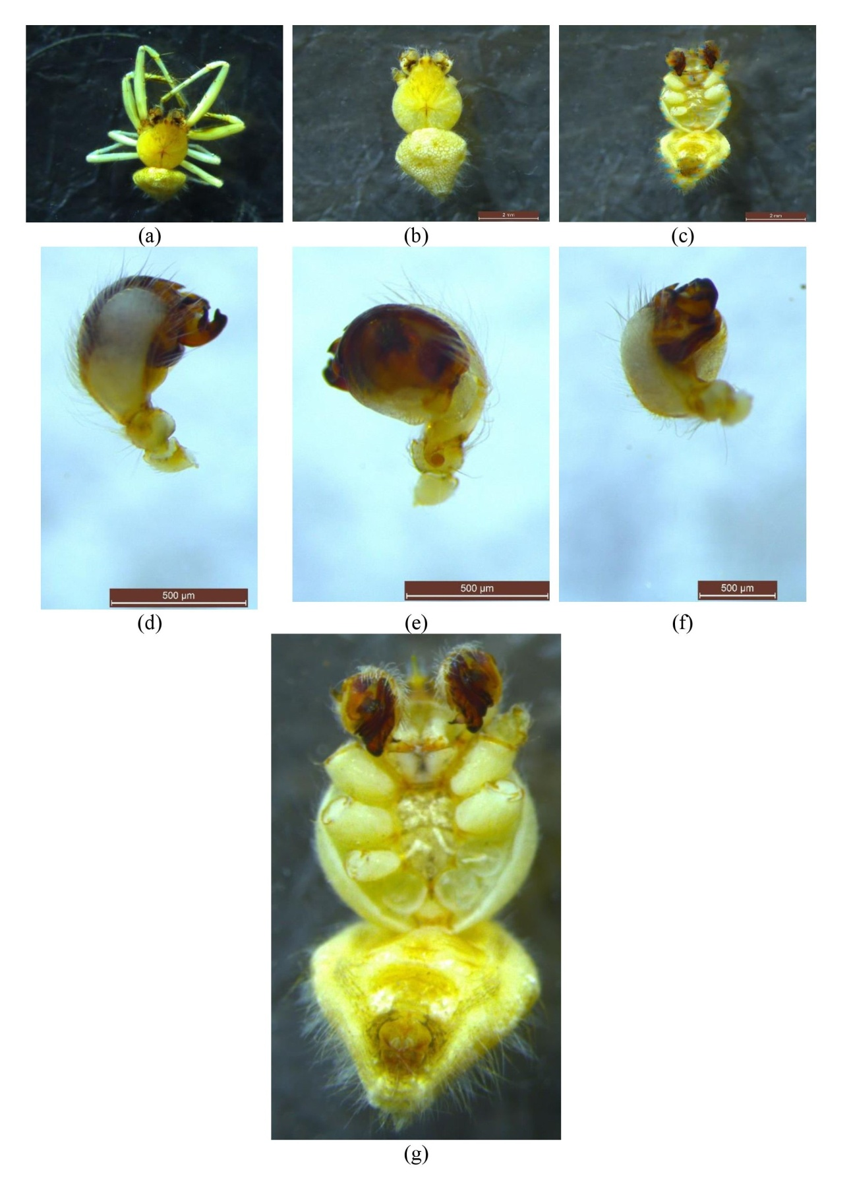
Figure1. Eriovixia panigrahii n. sp. photographs based on holotype and paratype. (a) Male specimen, preserved in ethanol; (b) Male habitus, dorsal view; (c) Same, ventral view; (d) Left palp, prolateral view; (e) Same, retrolateral view; (f) Same, ventral view; (g) Male habitus, ventral enlarged view.

Description
Male (holotype): Totallength: 6.40, Carapace: 2.31 long, 1.75 wide. Abdomen: 4.09 long, 4.16 wide. Palp with cymbium distally expanded, densely clothed with setae. Median apophysis well developed, strongly hooked apically; conductor short and robust, partly enclosing the embolus. Embolus slender, curved, arising from the prolateral margin of the tegulum, encircling the bulb. Tegular apophysis broad and curved, projecting anterolaterally. In dorsal aspect, cymbium broad, strongly covering bulb; tibial apophysis short and pointed; embolus mostly concealed beneath cymbial margin. Lengths of legs: I 10.80 (3.68+3.91+2.41+0.80), II 7.70 (2.72+2.49+1.81+0.68), III 5.64 (2.16+1.80+1.08+0.60), IV 7.44 (2.59+2.37+1.73+0.75) (Fig. 1). Males had a bulbous, strongly textured abdomen.
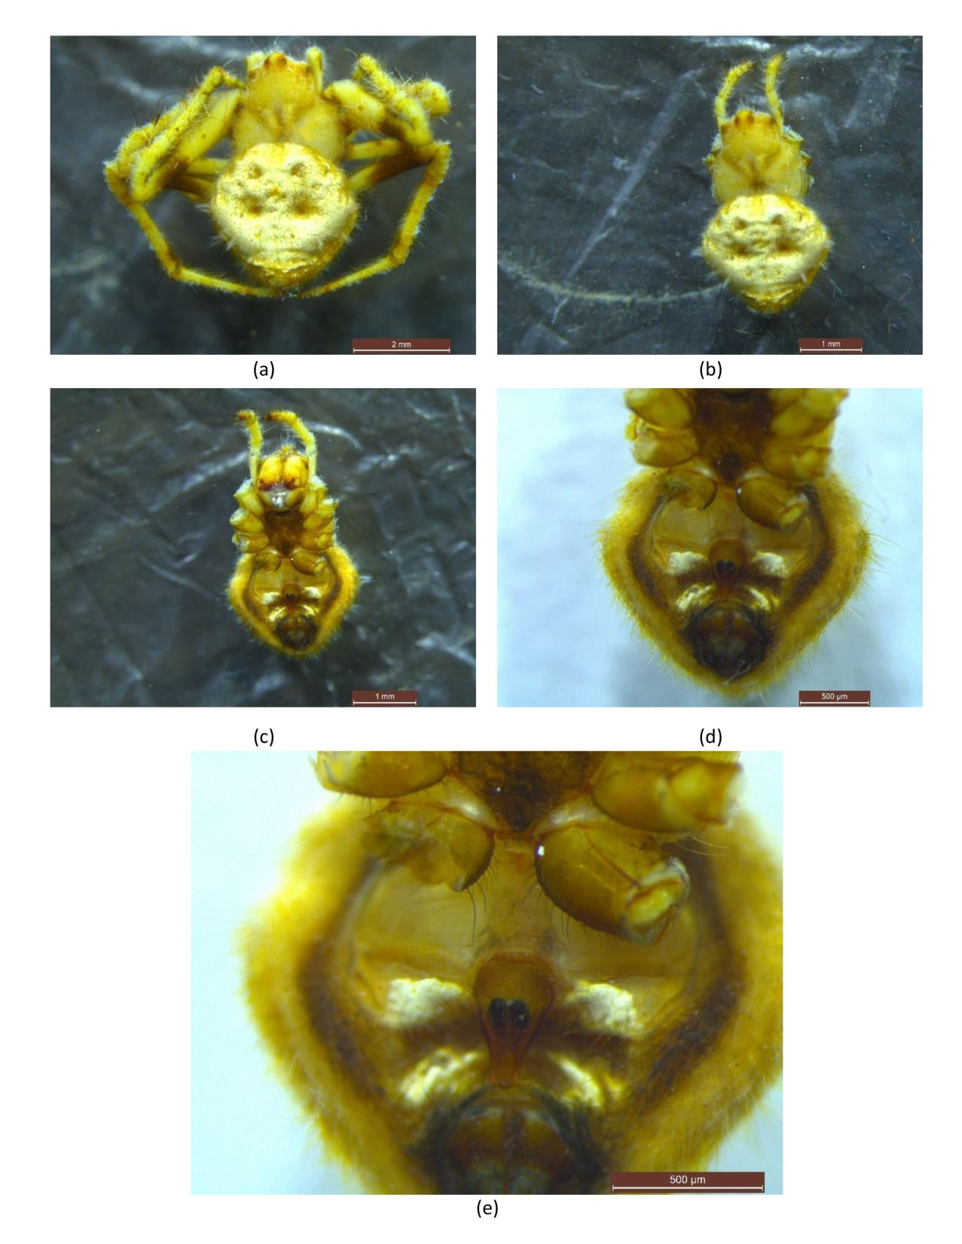
Figure 2. Eriovixia panigrahii n. sp., photographs based on holotype and paratype. (a) Female specimen, preserved in ethanol; (b) Female habitus, dorsal view; (c) Same, ventral view; (d) & (e) Enlarged, female genitalia (Epigynum).

Female (holotype): Total length: 7.39, Carapace: 1.98 long, 1.84 wide. Abdomen: 5.41 long, 5.46 wide. Epigynal plate subtriangular, moderately sclerotized, central, with distinct scape extending beyond posterior margin. Median septum narrow, longitudinal; copulatory openings small, rounded, positioned anterolaterally at base of scape. Plate surrounded by short setae; length < 1 mm. Vulva with copulatory ducts short, directed medially; insemination ducts convoluted, extending laterally before entering spermathecae. Spermathecae spherical, moderately separated, posteriorly positioned. Fertilization ducts arising posteriorly from spermathecae, directed laterally. Lengths of legs: I 11.66 (3.97+4.22+2.60+0.87), II 8.56 (2.98+2.73+1.98+0.87), III 5.78 (2.28+1.86+1.02+0.62), IV 8.43 (2.98+2.73+1.98+0.74).Surface of abdomen, rough with darker and moss-like appearance (Fig. 2).
Distribution. Presently known only from Kushadangri Hill, Kalahandi District, Odisha, India.
Conclusions:
The revised and comprehensive taxonomic description of Eriovixia panigrahii, based on both male and female holotypes, provides a detailed account of key diagnostic characters essential for accurate species identification. This enhanced characterization not only strengthens the taxonomic framework of the genus Eriovixia but also facilitates reliable differentiation from closely related species. The clear delineation of morphological traits will significantly aid arachnologists and the broader scientific community in recognizing and studying this newly described species, thereby contributing to the understanding of spider biodiversity and taxonomy.

Option 2:
Author(s) hereby declare that generativ AI technologies such as Large Language Models, etc. have been used during the writing or editing of manuscripts. This explanation will include the name, version, model, and source of the generative AI technology and as well as all input prompts provided to the generative AI technology
Details of the AI usage are given below:
1. Option 2, only for language editing

References

- Ahmed J, Khalap R, Sumukha JN (2016). A new species of dry foliage mimicking Eriovixia Archer, 1951 from central Western Ghats, India (Araneae: Araneidae). Indian Journal of Arachnology 5: 24–27.
- Archer, A. F., & Gertsch, W. J. (1951). Studies in the orbweaving spiders (Argiopidae). 1. American Museum novitates; no. 1487.
- Basumatary P, Chanda D, Das S, Kalita J, Brahma D, Basumatary T, Basumatary BK, Daimary S (2019). On a new species of the orb-weaving spider genus Eriovixia (Araneae: Araneidae) from India. Arachnology 18(1): 24–27. doi.org/10.13156/arac.2018.18.1.24
- Bento, M., Jameson, M. L., & Seidel, M. (2022). ﻿ New species and illustrated key of Macraspis (Scarabaeidae, Rutelinae, Rutelini) from the Amazon biome of Brazil. ZooKeys, 1124, 161. doi.org/10.3897/zookeys.1124.91156.
- Biswas V, Raychaudhuri D (2018). New species of the genus Eriovixia Archer, 1951 (Araneae: Araneidae) from Bangladesh. Bangladesh Journal of Zoology 46(1): 1–10. doi. org/10.3329/bjz.v46i1.37621
- Choudhury, S. R., Siliwal, M., & Das, S. K. (2019). Spiders of Odisha: a preliminary checklist. Journal of Threatened Taxa, 11(9), 14144-14157. doi.org/10.11609/jott.3786.11.9.14144-14157
- Choudhury, S. R., Siliwal, M., & Das, S. K. (2019). Spiders of Odisha: a preliminary checklist. Journal of Threatened Taxa, 11(9), 14144-14157. doi.org/10.11609/jott.3786.11.9.14144-14157
- Clerck, C. (1757). Aranei Svecici. Svenska spindlar, uti sina hufvud-slågter indelte samt under några och sextio särskildte arter beskrefne och med illuminerade figurer uplyste. Laurentius Salvius, Stockholmiae [= Stockholm], 154 pp. doi:10.5962/bhl.title.119890
- Han GX, Zhu MS (2010). Taxonomy and biogeography of the spider genus Eriovixia (Araneae: Araneidae) from Hainan Island, China. Journal of Natural History 44(43–44): 2609–2635. doi.org/10.1080/00222933.2010.507315.
- Mi, X. Q., & Wang, C. (2016). First description on the female of Eriovixia huwena and the male of E. poonaensis (Araneae, Araneidae). Sichuan Journal of Zoology, 35(5), 728-733.
- Mi, X. Q., Peng, X. J., & Yin, C. M. (2010). The orb-weaving spider genus Eriovixia (Araneae: Araneidae) in the Gaoligong mountains, China. Zootaxa, 2488(1), 39-51. doi.org/10.11646/ zootaxa.2488.1.3
- Mi, X., & Li, S. (2021). On nine species of the spider genus Eriovixia (Araneae, Araneidae) from Xishuangbanna, China. ZooKeys, 1034, 199. doi.org/10.3897/ zookeys.1034.60411
- Panigrahi, S. K., Bag, B., Haripal, D., Meher, M., Bariha, S. R., Parida, S. R., ... & Nayak, N. R. (2025). New Information about Spider Variety (Eriovixia panigrahisis) (Arachnidae: Araneidae) Emerged in India. Annual Research & Review in Biology, 40(2), 13-20. doi.org/10.9734/arrb/2025/v40i22195
- Simon, E. (1877). Etudes arachnologiques. 5e Mémoire. IX. Arachnides recueillis aux îles Philippines par MM. G.-A Baer et Laglaise. Annales de la Société Entomologique de France (5) 7: 53-96.
- Simon, E. (1889). Arachnides de l'Himalaya, recueillis par MM. Oldham et Wood-Mason, et faisant partie des collections de l'Indian Museum. Première partie. Journal of the Asiatic Society of Bengal, part II (Natural History) 58(4): 334-344.
- Tanikawa A (1999). Japanese spiders of the genus Eriovixia (Araneae: Araneidae). Acta Arachnologica 48: 41–48. doi.org/10.2476/asjaa.48.41.
- Tanikawa A (2007). An Identification Guide to the Japanese Spiders of the Families Araneidae, Nephilidae and Tetragnathidae. Arachnological Society of Japan, 121 pp.
- Tanikawa A (2009). Hersiliidae. Nephilidae, Tetragnathidae, Araneidae. In: Ono H (Ed.) The Spiders of Japan with keys to the families and genera and illustrations of the species. Tokai University Press, Kanagawa, 149: 403–463.
- Tikader, B. K. (1981). Studies on some orb-weaving spiders of the genera Neoscona Simon and AraneusClerck of the family Araneidae (= Argiopidae) from India.Rec. zool. Survey, India, Occ. Pap.,24, 1-60
- Tikader, B. K. & Bal, A. (1981). Studies on some orb-weaving spiders of the genera Neoscona Simon and Araneus Clerck of the family Araneidae (=Argiopidae) from India. Records of the Zoological Survey of India, Occasional Paper 24: 1-60.
- World Spider Catalog (2025). World Spider Catalog. Version 26. Natural History Museum Bern, online at http://wsc.nmbe.ch, accessed on 10/02/2025. doi: 10.24436/2.
- Zhou H, Zhu J, Zhang ZS (2017). Two new and four newly recorded species of orbweaver spiders from China (Araneae: Araneidae). Acta Arachnologica Sinica 26(1): 6–12.

