Original Research Article

Phytoplankton Diversity and Eutrophication Indicators under Anthropogenic Pressure in the Azagny Canal (Côte d'Ivoire)

ABSTRACT:
Background: The Azagny Canal is a major artificial waterway in southern Côte d'Ivoire, playing a crucial role in the region's water management and economy. It connects the Ebrié Lagoon to the Bandama River and, thus indirectly, to the Atlantic Ocean. However, this transitional ecosystem is under increasing anthropogenic pressure.
Aims: This study aims to characterize the phytoplankton communities in the Azagny Canal to assess the impact of human activities and environmental gradients, thereby providing biological indicators and essential scientific data for the sustainable management of this ecological corridor.
Methodology: Micro-algae were sampled using a 20 µm mesh plankton net from February to August 2022. The sampling combined physico-chemical and biological analyses across five stations.
Results: A total of 90 taxa were identified, revealing a dominance of Chlorophyta (43%) and Heterokontophyta (24%), with a heterogeneous spatial distribution. Station ST5 exhibited the highest taxonomic richness (45 taxa). Multivariate analyses demonstrated that water temperature, transparency, dissolved oxygen, conductivity, salinity, and nutrient levels (nitrite, nitrate, phosphate, and ammonium) significantly shaped the phytoplankton assemblages. The abundance of Chlorophyta and the presence of indicator species for nutrient enrichment confirm an ongoing process of eutrophication.
Conclusion: This study validates the use of phytoplankton as a diagnostic tool for water quality monitoring and highlights the urgent need for management measures to protect this vital ecological corridor
Keywords: Phytoplankton, physico-chemical parameters, eutrophication, Azagny Canal, Côte d’Ivoire.

1. INDRODUCTION
The Grand-Lahou lagoon system, which includes the Niouzounou, Tagba, Mackey, and Tadio water bodies, is connected to the Ebrié Lagoon through the 17 km-long Azagny Canal. This canal, of major ecological and socio-economic importance, is subject to intense anthropogenic pressures such as fishing, farming along its banks, transport, and domestic discharges (Egnankou et al., 2023). These pressures, combined with natural variations, may significantly alter the ecological balance of the system. Phytoplankton, defined as the assemblage of free-floating microscopic plants, plays a central role in aquatic food webs and is widely recognized as a reliable indicator of water quality (Hoang et al., 2024). In Côte d’Ivoire, several studies have demonstrated the usefulness of phytoplankton in assessing the ecological status of aquatic ecosystems (Seu-Anoï et al., 2011; Yéo et al., 2023). However, no study has yet investigated phytoplankton communities in the Azagny Canal, despite its strategic role in the connectivity and functioning of the Grand-Lahou lagoon system. This knowledge gap limits our understanding of the ecological condition of this critical waterway and hampers the development of appropriate management strategies. This study seeks to answer the following research question: To what extent do phytoplankton communities reflect the environmental conditions and anthropogenic pressures in the Azagny Canal? Based on current knowledge, we hypothesize that the structure and diversity of phytoplankton in the canal indicate a trend toward eutrophication, driven by nutrient inputs from agricultural runoff and domestic wastewater. By characterizing phytoplankton assemblages and linking them to physicochemical conditions, this study aims to provide new insights for the ecological monitoring and sustainable management of the Azagny Canal.
2. MATERIAL AND METHODS
2.1 Study environment
Located in the Grands Ponts region, more specifically in the sub-prefecture of Grand-Lahou, the Azagny Canal was dug in 1923 to facilitate hydraulic exchange and navigation between the various water bodies in the area. Situated at the western end of the Ebrié Lagoon (5°09'16" N and 4°57'00" W), it connects this lagoon to the Bandama River, the Grand-Lahou Lagoon, and, more broadly, to the Atlantic Ocean. Due to its strategic position, it forms a major hydraulic corridor that runs through the Azagny National Park, a 19,400-hectare protected area renowned for its ecological richness. Thus, the canal plays a major ecological, hydrological, and socio-economic role, but it is also subject to multiple pressures from human activities, including fishing, riverbank agriculture, transportation, and domestic waste discharge (N’dohou et al., 2023) The sampling stations are distributed as follows: station (ST1) Canal Entrance, station (ST2) N’guessan Amessandon, station (ST3) Djakétê, station (ST4) Noumouzou, and station (ST5) Canal End (Figure 1).

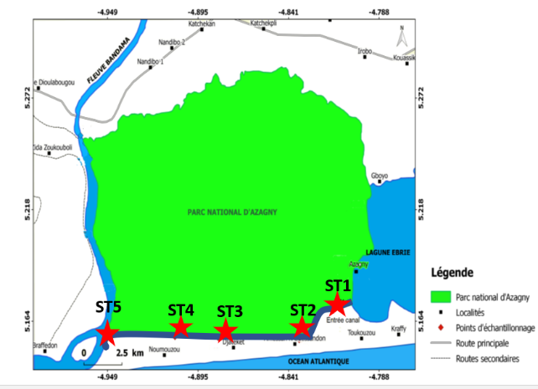
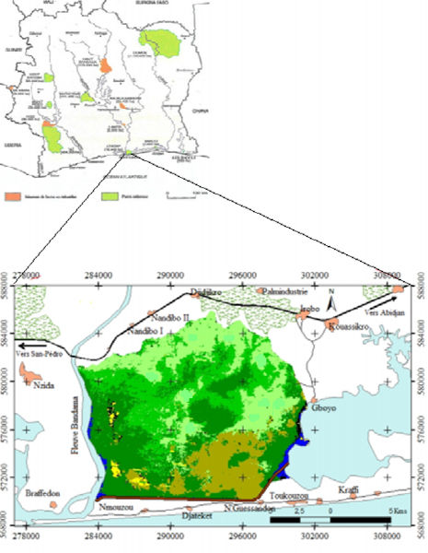

Map. 1. Map of the Azagny National Park showing the sampling stations
2.2 Physicochemical parameters
During our sampling, we used a GPS receiver to record the geographical coordinates of the sampling stations. Measurements of physicochemical parameters (temperature, pH, conductivity, dissolved oxygen, and salinity) were carried out in situ within the top fifty centimeters of the water column using a portable HANNA HI 9828 multi-parameter probe. A Secchi disk was used to measure water transparency. Portable HANNA mini-photometers were used to analyze the concentration of nutrient salts (nitrite, nitrate, phosphate, and ammonium) in the water.
2.3 Phytoplankton Sampling and Analysis Methodology
Samples intended for the study of phytoplankton communities were collected using a 20 µm mesh plankton net and 30 ml vials at the various stations in the canal. Surface water samples were collected with a 10-liter bucket and poured into the plankton net. The microalgae were concentrated by filtration through the net. The net's collector was then opened over a 30 ml vial to drain the contents. The samples were fixed with formaldehyde at a final concentration of 5%. Observations were carried out in the laboratory. A drop of the vial's content was collected using a pipette and mounted between a slide and a coverslip. The prepared sample was mounted on the stage of an Olympus CKX41 light microscope equipped with an integrated digital imaging system. Microorganism identification was supported by high-resolution photomicrographs captured directly through the microscope’s camera. Identification of the various phytoplankton species was based on taxonomic keys and various reference works: Ouattara (2000), Komoé (2010), Seu-Anoï (2012), Adon (2013), Kouassi (2013), Konan (2014), Salla (2015), Lozo (2016). Species descriptions followed the classification established by (Van den Hoek et al., 1995). The scale bar on each figure represents 10 μm.
3. RESULTS AND DISCUSSION
3.1 Physicochemical parameters
The study reveals a typically tropical aquatic environment, characterized by a consistently high and uniform temperature (30.85 °C) (Table 1). However, water quality is heterogeneous, showing signs of localized anthropogenic degradation and high hydrological variability.
Table 1. Physicochemical characteristics of the water from the Azagny Canal
Stations | Temp. (°C) | Oxygen (mg/L) | pH | Salinity (‰) | Conductivity (µS/cm) | Phosphate (mg/L) | Nitrate (mg/L) | Nitrite (mg/L) | Ammonium ( mg/L)
St1 | 30,67 | 4,12 | 6,83 | 1,76 | 3,39 | 0,9 | 0,42 | 0,14 | 0,5
St2 | 30,74 | 4,70 | 6,99 | 1,27 | 2,49 | 0,04 | 0 | 0,14 | 0,1
St3 | 30,83 | 4,80 | 6,84 | 3,53 | 6,528 | 0,41 | 1 | 0,8 | 0,1
St4 | 30,58 | 5,54 | 7,31 | 0,80 | 1,57 | 0,9 | 0 | 0,01 | 0,1
St5 | 31,44 | 12,4 | 7,02 | 0,11 | 0 ,24 | 0,36 | 2 | 1 | 0,4
Val mo | 30,85 | 6,31 | 7,02 | 1,49 | 2,84 | 0,52 | 0,68 | 0,42 | 0,24

The results reveal a physicochemical structure characteristic of West African tropical lagoon ecosystems, yet marked by significant spatial heterogeneity, reflecting the combined influence of natural and anthropogenic factors. The consistently high mean temperature (30.85 °C) across all sampling stations aligns with thermal regimes observed in surface waters of tropical environments, as documented in the Ebrié and Aby Lagoons (Adingra & Arfi, 1998). Such thermal conditions directly influence evaporation rates, the kinetics of biochemical reactions, and oxygen solubility, playing a fundamental role in structuring ecological processes. The pronounced variability in salinity (0.11 to 3.53 ‰) and conductivity highlights a well-defined estuarine gradient, characteristic of systems undergoing freshwater–saltwater transition. This gradient is controlled by the interplay of riverine inflows, marine intrusions, and seasonal rainfall. The very low salinity at station St5 suggests a dominant freshwater influence, likely from the Bandama River, whereas the elevated salinity at St3 indicates significant marine intrusion a phenomenon exacerbated by coastal erosion and altered hydrodynamic patterns along the Ivorian coast (Tano et al., 2016). Oxygen dynamics in the lagoon exhibit notable contrasts. The dissolved oxygen (DO) concentration at St1 (4.12 mg/L) falls below the critical threshold of 5 mg/L, indicating localized hypoxic conditions that could impair the survival of aquatic organisms. This depletion is likely driven by organic matter decomposition, hydrological confinement, or localized pollution inputs, consistent with findings from urbanized sections of the Ebrié Lagoon (Toulé et al., 2017). In contrast, the supersaturation observed at St5 (12.4 mg/L) may result from intense phytoplanktonic photosynthesis or water column turbulence promoting oxygenation. Elevated nutrient concentrations particularly phosphate (up to 0.9 mg/L) and nitrogen species (nitrites reaching 1 mg/L at St5) exceed baseline levels reported for less impacted Ivorian lagoons (Toulé et al., 2017). These values indicate anthropogenic inputs, notably from agricultural runoff (fertilizers) and domestic effluents (organic nitrogen). This nutrient enrichment represents an early signal of eutrophication, mirroring processes documented in Cocody Bay (Soro et al., 2021; Traoré et al., 2017). If sustained, this trend could trigger algal blooms, disrupt trophic balances, and lead to rapid degradation of water quality. Collectively, the measured parameters point to an increasingly vulnerable lagoon system: although subject to seasonal natural dynamics, the lagoon is significantly impacted by local anthropogenic pressures, including urban development, agricultural activity, and domestic discharges. These combined stressors are altering the lagoon’s physicochemical structure and threatening its ecological balance. The findings confirm the study's initial hypothesis of progressive water quality degradation and highlight the urgency of implementing integrated management strategies and enhanced ecological monitoring. A deeper understanding of the interactions between natural processes and human-induced disturbances is essential to guide future conservation and restoration efforts in these fragile environments.
3.2 Phytoplankton diversity
The algal flora of the Azagny Canal waters comprised 90 taxa distributed across 5 divisions, 9 classes, 15 orders, 22 families, and 45 genera (Table 2). The Chlorophyta division was the most diverse, with 39 taxa (43%), followed by Heterokontophyta with 20 taxa (24%), Euglenophyta with 14 taxa (16%), Cyanoprokaryota with 12 taxa (13%), and finally, the Dinophyta division, which was poorly represented with only 5 taxa (6%) (Figure 1).
Regarding the spatial distribution of taxa (Figure 2), the highest number was recorded at station ST5 with 45 taxa, followed by station ST3 with 34 taxa. Stations ST1 and ST2 each hosted 29 taxa, while station ST4 had the lowest count with 27 taxa.
Table 2. List of taxa recorded in the different stations of the Azagny Canal (Côte d'Ivoire)
Taxa | ST1 | ST2 | ST3 | ST4 | ST5
Cyanoprokaryota Anagnostidis et Komárek
Cyanophyceae Sachs
Chroococcales Wettstein et Westerheim
Chroococcaceae Nägeli
Aphanocapsa elachista G.S. West | X | X | X | X | X
Aphanocapsa incerta Lemmermann | X | X |  | X | X
Chroococcus dispersus (Keissler) Lemmermann |  | X | X | X
Chroococcus limneticus Lemmermann |  | X | X
Mycrocystis aeruginosa (Kützing) Kützing | X | X | X | X
Mycrocystis wesembergii Komárek |  | X
Merismopedia glauca (Ehrenberg) Nägeli |  |  |  |  | X
Nostocales (Borzi) Gétler
Nostocaceae Dumortier
anabaena affinis Lemmermann | X | X | X
Anabaena mucosa Komarkov-Legnerova et Eloranta |  |  |  |  | X
Oscillatoriales Elenkin
Phormidiaceae Anagnostidis et Komárek
Phormidium cf. simplicissimum (Gomont) Anagnostidis & Komárek |  |  |  |  | X
Spirulinales
Spirulinaceae
Spirulina okensis (C. Meyer) Geitler |  |  | X | X
Pseudanabaenaceae Anagnostidis et Komárek
Pseudanabaena papillaterminata (Kiselev) Kukk |  |  | X
Heterokontophyta Van Den Hoek et al.
Bacillariophyceae Haeckel
Centrales Schütt
Aulacoseiraceae Crawford
Aulacoseira granulata var. angustissima (O. Müller) Simonsen | X | X | X | X | X
Aulacoseira granulata (Ehrenberg) Simonsen | X | X | X | X | X
Aulacoseira italica (Ehrenberg) Simonsen |  |  |  |  | X
Melosira lineata (Dillwyn) Agard+A103 |  |  |  |  | X
Fragilariaceae Hustedt
Ulnaria biceps (Kützing) Compère | X | X | X | X
Ulnaria ulna (Nitzsch) Compère | X | X | X | X
Ulnaria sp | X | X | X | X | X
Naviculaceae Kützing
Diploneis smithii (Brébisson in W. Smith) Cleve | X
Diploneis weissflogi (Schmidt) Cleve |  | X
Caloneis crassa (Gregory) Ross in Hartley |  | X
Pinnulariaceae Mann in Round et al.
Pinnularia legumen Ehrenberg |  |  |  |  | X
Pinnularia sp. 1 |  | X
Cymbellales D.G. Mann
Cymbellaceae Greville
Encyonema silesiacum (Bleisch) D.G. Mann |  |  |  |  | X
Pleurosigmataceae Mereschkowsky
Pleurosigma angulatum (Quekett) Wm.Smith |  |  |  |  | X
Pleurosigma sp. |  |  |  |  | X
Surirellales Mann
Surirellaceae Kützing
Petrodictyon gemma (Ehrenberg) Mann | X | X | X
Surirella sp. 1 | X
Surirella sp. 2 | X
Surirella sp.3 | X
Xanthophyceae Allorge ex Fritsch
Mischococcales Fritsch
Sciadiaceae Borzi
Centritractus belonophorus Lemmermann | X | X | X | X | X
Chlorophyta Cavalier-Smith
Chlorophyceae Wille in Warming
Sphaeropleales Luerssen
Ankistrodesmaceae Korshikov
Ankistrodesmus nannoselene Skuyja |  |  | X
Chlorococcales Pascher
Hydrodictyaceae (Gray) Dumortier
Pediastrum duplex var. gracillimum West et G.S. West |  | X |  | X
Pediastrum simplex Meyen |  |  | X
Sorastrum americanum (Bohlin) Schmidle | X
Radiococcaceae Walton
Eutetramorus planctonica (Korshikov) Bourrelly |  |  |  |  | X
Scenedesmaceae Oltmanns
Coelastrum pulchrum Schmidle |  |  |  |  | X
Coelastrum astroideum De Notaris |  |  | X
Coelastrum indicum Terner |  |  | X |  | X
Actinastrum hantzschii Lagerheim | X |  |  |  | X
Actinastrum gracillimum G. M. Smith | X |  |  | X
Desmodesmus quadricaudatus (Turpin) Hegewald |  |  |  |  | X
Desmodesmus opoliensis (Richter) Hegewald |  |  |  |  | X
Scenedesmus acuminatus (Lagerheim) Chodat |  |  | X
Scenedesmus bernardii Chodat |  |  | X
Scenedesmus bicaudatus Dedussenko |  |  |  | X
Scenedesmus quadricauda var. longispina (Chodat) G.M. Smith | X
Scenedesmus tropicus Crow | X
Oocystis borgei J. Snow |  |  | X | X
Oocystis submarina Lagerheim |  |  | X | X | X
Treubaria triappendiculata Bernard | X
Volvocales Ehrenberg
Volvocaceae Ehrenberg
Pandorina morum (Müller) Bory |  |  | X |  | X
Conjugatophyceae Engler
Desmidiales Bessey
Closteriaceae Bessey
Closterium gracile Brébisson ex Ralfs |  |  |  | X
Closterium kuetzingii Brébisson | X |  | X
Closteririum limniticum Lemm | X | X | X
Closterium macilentum Brébisson |  |  | X
Desmidiaceae kützing ex Ralfs
Micrasterias foliacea Bailey |  |  |  |  | X
Cosmarium connatum Brébisson ex Ralfs |  |  |  |  | X
Cosmarium depressum var. achondrum (Boldt) West et G.S. West |  |  |  |  | X
Cosmarium contractum Kirchner var. minutum (delp.) West et West |  |  |  |  | X
Hyalotheca dissiliens Brébisson ex Ralfs |  |  |  | X
Staurastrum volans West & G.S.West |  | X | X | X | X
Staurastrum boreale W. & G.S. West |  |  | X | X | X
Staurastrum forficulatum Lundell var. minus Fritsch & Rich |  |  | X
Staurastrum polymorphum Brébisson ex Ralfs |  |  |  |  | X
Staurastrum subradians Rich |  |  |  | X
Staurastrum sp. |  | X
Staurodesmus convergens (Ralfs) Lillier |  |  |  | X
Staurodesmus triangularis (Lagerheim) Teiling |  |  |  |  | X
Euglenophyta Pascher
Euglenophyceae Schoenichen
Euglenales Engler
Euglenaceae Stein
Lepocinclis ovum Ehrenberg |  | X
Lepocinclis salina Fritsch |  | X | X
Phacus lefevrei Bourrelly |  |  | X
Phacus ephippion Pochm. |  |  |  |  | X
Phacus longicauda var. longicauda (Ehrenberg) Dujardin |  |  |  |  | X
Phacus onyx Pochmann |  | X |  |  | X
Phacus sp. | X
Strombomonas acuminata (Schmarda) Deflandre |  |  |  |  | X
Strombomonas fluviatilis (Lemmerm.) Deflandre |  |  |  |  | X
Strombomonas verrucosa (E.Daday) Deflandre |  |  |  |  | X
Trachelomonas hispida var. hispida (Perty) Stein |  |  |  |  | X
Trachelomonas oblonga Lemmermann |  |  |  | X | X
Trachelomonas volvocinopsis Swirenko |  |  |  |  | X
Trachelomonas sp. |  |  |  |  | X
Dinophyta Auct.
Dinophyceae Pascher
Peridiniales Haeckel
Peridiniaceae Ehrenberg
Peridinium cunninglonii (O. Müller) Ehrenberg |  |  |  |  | X
Karenia sp.1 | X | X | X | X | X
Karenia sp.2 | X | X | X | X | X
Desmophyceae Smith
Gonyaulacales F.J.R. Taylor
Goniodomataceae Lindemann
Pyrodinium sp. | X | X | X | X | X
Peridiniales Haeckel
Protoperidiniaceae F.J.R. Taylor
Protoperidinium conicoides (Paulsen) Balech |  |  |  | X
Total = 90 | 29 | 29 | 34 | 27 | 45

Fig. 1: Variation in taxa across the sampling stations on the Azagny Canal (Côte d'Ivoire)

Fig. 2 Variation in taxa across the sampling stations of the Azagny Canal (Côte d'Ivoire)
The phytoplankton survey revealed a high level of taxonomic richness in the Azagny Canal, with a total of 90 taxa identified. This elevated diversity is consistent with the canal's ecological positioning as a transitional zone at the confluence of multiple water masses namely, freshwater inflows from the Bandama River, brackish water from the Grand-Lahou lagoon complex, and saline incursions from the Atlantic Ocean. Such hydrological complexity fosters a mosaic of physicochemical conditions, generating diverse ecological niches that support phytoplankton taxa with varying ecological tolerances and functional traits. As emphasized by Gonzales and Descamps-Julien (2004), environmental heterogeneity and structural complexity are fundamental to the development and persistence of diverse biological communities. The presence of multiple nutrient sources, particularly nitrates and phosphates from upstream agricultural runoff, further promotes primary productivity. However, the observed phytoplankton richness may not exclusively reflect a stable and resilient ecosystem; rather, it may be symptomatic of a disturbed system undergoing nutrient enrichment. High nutrient loads particularly of anthropogenic origin can favor opportunistic and fast-growing taxa, leading to apparent richness that conceals ecological imbalance. This interpretation is supported by the co-dominance of Chlorophytes and Heterokontophyta, well-documented indicators of eutrophic conditions rich in nitrogen and phosphorus (Bellinger & Sigee, 2015; Reynolds, 2006). Station 5 exhibited the highest species richness (45 taxa), corresponding with elevated concentrations of nutrients and elevated water temperatures. In tropical systems, temperatures above 25 °C significantly accelerate microbial metabolism and the mineralization of organic matter (Paerl & Huisman, 2009), thereby increasing the bioavailability of nutrients that promote algal proliferation. The phytoplankton assemblage at this site, dominated by Chlorophytes and Heterokontophyta, strongly suggests sustained nutrient inputs, likely linked to untreated domestic discharges consistent with patterns observed in other eutrophic tropical water bodies (Smith et al., 1999). These findings support the hypothesis that the Azagny Canal functions as a biogeochemical and hydrological convergence zone, where environmental heterogeneity facilitates phytoplankton diversity. However, this richness is not unambiguously indicative of ecological integrity. Rather, the data suggest a dual dynamic: functional complexity driven by natural hydrological mixing, alongside increasing anthropogenic pressure contributing to nutrient loading and potential eutrophication. The dominance of taxa associated with nutrient-rich conditions reinforces the interpretation that organic and mineral enrichment primarily of anthropogenic origin is shaping community structure. In line with the study’s objectives, these results underscore the need to consider phytoplankton diversity not merely as a biodiversity metric, but as an indicator of broader ecological processes, including nutrient cycling and human-induced perturbations. Consequently, phytoplankton assemblages emerge as valuable bioindicators for monitoring environmental quality in transitional tropical aquatic systems.
4. CONCLUSION
The study of the phytoplankton communities in the Azagny canal highlights the importance of this transitional ecosystem for both hydraulic management and the local economy. The results reveal a notable phytoplankton diversity, dominated by Chlorophyta and Heterokontophyta, which reflects the specific environmental conditions of the canal. The impact of human activities, particularly through eutrophication, is clearly demonstrated by the proliferation of certain indicator species, as well as by the effect of the observed physicochemical gradients. These data confirm the usefulness of phytoplankton as an indicator of water quality, thus providing a valuable tool for the ecological monitoring of the Azagny canal. However, the study underscores the necessity to implement integrated and sustainable management actions, particularly to limit nutrient inputs and preserve this crucial space. Proactive management is essential to ensure the long-term viability of this ecological corridor in the face of increasing pressures from human activities.
5. Disclaimer (Artificial intelligence)
Author(s) hereby declare that NO generative AI technologies such as Large Language Models (ChatGPT, COPILOT, etc.) and text-to-image generators have been used during the writing or editing of this manuscript.
6. References
Adingra, A.A. and Arfi, R. (1998). Organic and bacterial pollution in the Ebrié Lagoon, Côte d’Ivoire. Marine Pollution Bulletin, 36, 689–695.
Adon M. P. (2013). Spatial and Seasonal Variations in Phytoplankton in the Adzopé Reservoir (Côte d'Ivoire): Composition, Structure, Biomass, and Primary Production. Doctoral Thesis, Nangui Abrogoua University, Abidjan, Côte d'Ivoire, 89 p.
Bellinger, E. G., & Sigee, D. C. (2015). Freshwater Algae: Identification, Enumeration and Use as Bioindicators. Wiley-Blackwell.
Egnankou M.W., Gnagbo A., Pagny J.P.F., Tiebre M-S. (2023). Sustainable management of mangroves in the Grand-Lahou lagoon complex (Côte d’Ivoire) under anthropogenic pressure. International Journal of Biological and Chemical Sciences, 17(2): 505–518.
Gonzalez, A., & Descamps-Julien, B. (2004). Population and community variability in randomly fluctuating environments. Oikos, *106*(1), 105–116.
Hoang TMH, Te MS, Duong VH, Luong QD, Stiers I, Triest L. (2024). Relationship between water quality and phytoplankton distribution of aquaculture areas in a tropical lagoon. Environmental Monitoring and Assessment, 196(11) :1099.
Konan E. S. (2014). Spatio-temporal distribution of phytoplankton populations in relation to abiotic factors in the Fresco lagoon (Ivory Coast), Doctoral thesis, Félix Houphouët-Boigny University of Cocody, Abidjan, Ivory Coast, 197p.
Kouassi B. A. (2013). Taxonomy, Floristic Composition, and Spatio-Seasonal Dynamics of Periphytic Algae in the Adzopé Reservoir (Côte d'Ivoire). Doctoral Thesis. Felix Houphouët-Boigny University of Cocody. Abidjan, Côte d'Ivoire, 177 p.
Komoé K. (2010). Phytoplankton Diversity in the Grand-Lahou Lagoon Complex in Côte d'Ivoire. Doctoral Thesis. Félix Houphouët-Boigny University of Cocody, Abidjan, Côte d'Ivoire, 305 p.
Lozo R. N. (2016). Floristic composition and distribution of the microalgal population in the Bandama River (Ivory Coast). Doctoral thesis, University of Cocody, Abidjan (Ivory Coast), 188p.
N’dohou, E. H. N., Gervais, N. K., Paul, G. U., Marius K.T., Marcellin Y.K. & Paul K.E (2023). Spatial and seasonal distribution of pesticides in the waters of Azagny area (Grand Lahou, Cote d’Ivoire). Environmental Monitoring and Assessment, 195, 626. https://doi.org/10.1007/s10661-023-11179-9
Ouattara A. (2000). First Systematic and Ecological Data on Phytoplankton in Lake Ayamé (Côte d’Ivoire). Doctoral Thesis, Faculty of Wetlands, Institute for Plant Sciences, Catholic University of Leuven, Belgium, 207 p.
Paerl, H. W., & Huisman, J. (2009). Climate change: a catalyst for global expansion of harmful Cyanobacterial blooms. Environmental Microbiology Reports, 1(1), 27-37.
Reynolds C.S. 2006, “The ecology of phytoplankton.” Cambridge University Press, p.524.
Salla M. (2015). Taxonomy, composition and spatio-seasonal distribution of phytoplankton in the tropical coastal rivers Boubo and Mé (Ivory Coast). Doctoral thesis. Felix Houphouët-Boigny University of Cocody. Abidjan, Ivory Coast, 215p.
Seu-anoï N.M., Ouattara A., Koné YJ-M. and Gourene G. (2011). Seasonal distribution of phytoplankton in the Aby Lagoon system, Ivory Coast. African Journal of Aquatic Science, 37(2), 217–225. https://www.ajol.info/index.php/ajas/article/view/73204
Seu-Anoï N. M. (2012). Spatial and Seasonal Structuring of Phytoplankton Communities and Variability of Abiotic Factors in Three Lagoon Complexes in Côte d'Ivoire (Aby, Ébrié, and Grand-Lahou). Doctoral Thesis, Nangui Abrogoua University (Côte d'Ivoire), 137 p.
Smith, V. H., Tilman, G. D., & Nekola, J. C. (1999). Eutrophication: impacts of excess nutrient inputs on freshwater, marine, and terrestrial ecosystems. Environmental Pollution, 100(1-3), 179-196.
Soro, M.-P., Ouattara, A., Koffi M. N’Goran, K. M., Yao, M., & Diaco, T. (2021). Eutrophication of a River Impacted by Agricultural Activities (N’zi River, Côte d’Ivoire). International Research Journal of Pure and Applied Chemistry, 22(10), 14-26. https://doi.org/10.9734/irjpac/2021/v22i1030436
Tano R. A., Angora A., Kouadio K. Y., Toualy E., Kouadio E. A., P. Assamoi, (2016). Assessment of the Ivorian Coastal Vulnerability, Journal of Coastal Research 32(6):1495-1503.
https://doi.org/10.2112/JCOASTRES-D-15-00228.1
Toule A.C., Adingra A.A., Kouadio-N’Gbesso N., Kambiré O., Koffi-Névr y R., & Koussemon M. (2017). Physicochemical and bacteriological characterization of water from aquaculture stations at Layo and Jacqueville (Ebrié Lagoon, Côte d’Ivoire). International Journal of Biological and Chemical Sciences, 11(6), 2842–2855. DOI:10.4314/ijbcs.v11i6.22
Traoré, A., Soro, G., Keuméon, N. K., Aka, N., Ahoussi, E., & Soro, N. (2017). Study of physical and chemical quality of waters of an anthropised tropical lagoon: Case of the Aghien lagoon (South-East of Côte d’Ivoire). Environmental and Water Sciences, Public Health and Territorial Intelligence Journal. 1(2), 13-24.
Yéo, K. M., Kouadio, A. N. B., Konan, E. S., Komoé, K., & Goné, D. L. (2023). Spatio-temporal distribution of phytoplankton in relation to some physicochemical parameters in the Adjin-Potou lagoon system (Côte d'Ivoire). European Scientific Journal, 19(30), 269p.
https://doi.org/10.19044/esj.2023.v19n30p269
Van den Hoek C., Mann D. G. & Jahns H. M. (1995). Algae. An introduction to phycology. Cambridge University Press, Cambridge, UK, 623 p.

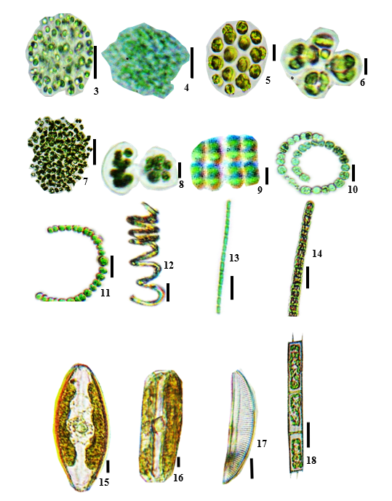
ANNEXE

(Fig. 3-18) 3: Aphanocapsa elachista, 4: Aphanocapsa incerta, 5: Chroococcus dispersus, 6: Chroococcus limneticus, 7: Microcystis aeruginosa, 8: Mycrocistis wesembergii, 9: Merismopedia glauca, 10: Anabaena spiroides, 11 : Anabaena mucosa, 12 : Spirulina okensis, 13 : Pseudanabaena papillaterminata, 14 : Phormidium cf. simplicissimum 15: Navicula cryptocephala, 16: Pinnularia sp, 17: Encyonema silesiacum, 18: Aulacoseira granulata

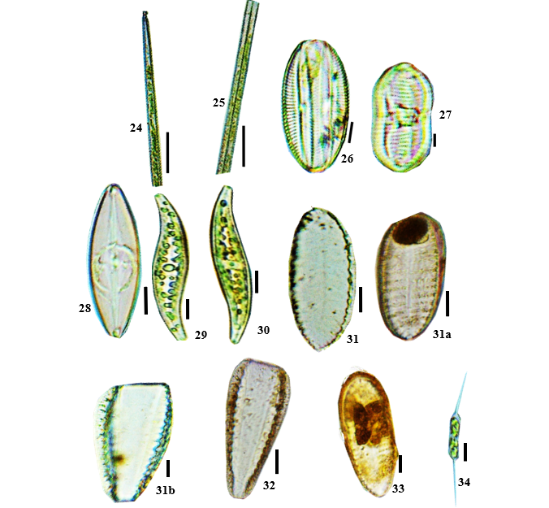
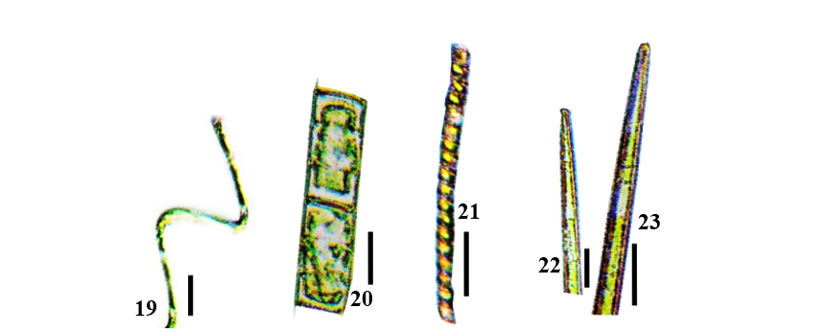

(Fig. 19-34) : 19: Aulacoseira granulata var. angustissima fo. Spiralis, 20 : Aulacoseira italica, 21 : Melosira lineata, 22: Ulnaria biceps, 23: Ulnaria ulna, 24: Ulnaria sp., 25 : Diploneis smithii, 26 : Diploneis weissflogi, 27: Caloneis crassa, 28: Pleurosigma angulatum, 29: Pleurosigma sp., 30: Petrodictyon gemma, 31a et b : Surirella sp.1, 32: Surirella sp.2, 33: Surirella sp.3, 34 : Centritractus belonophorus
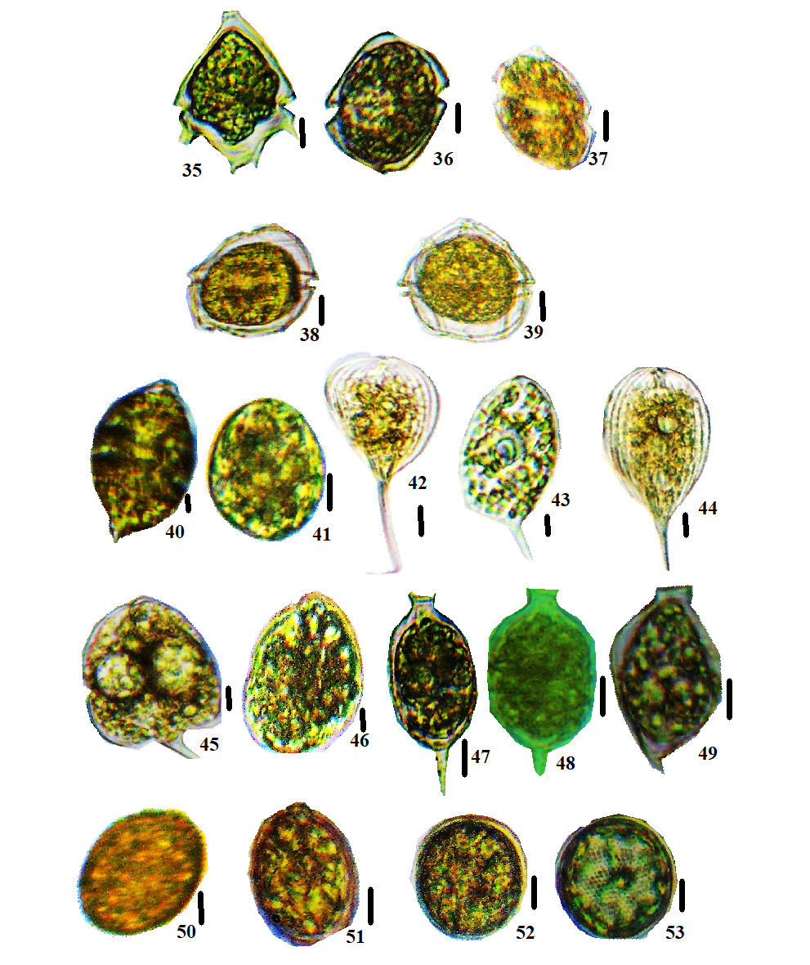

(Fig. 35-53) 35: Peridinium cunninglonii, 36: Karenia sp.1, 37: Karenia sp.2, 38: Pyrodinium sp., 39: Protoperidinium conicoides 40: Lepocinclis fusiformis 41: Lepocinclis salina, 42: Phacus ephippion 43: Phacus lefevrei, 44: Phacus longicauda, 45: Phacus onyx, 46: Phacus sp., 47: Strombomonas acuminata var. deflandreana, 48: Strombomonas fluviatilis, 49: Strombomonas verrucosa, 50: Trachelomonas hispida var. hispida, 51: Trachelomonas oblonga, 52 : Trachelomonas volvocinopsis, 53 : Trachelomonas sp.
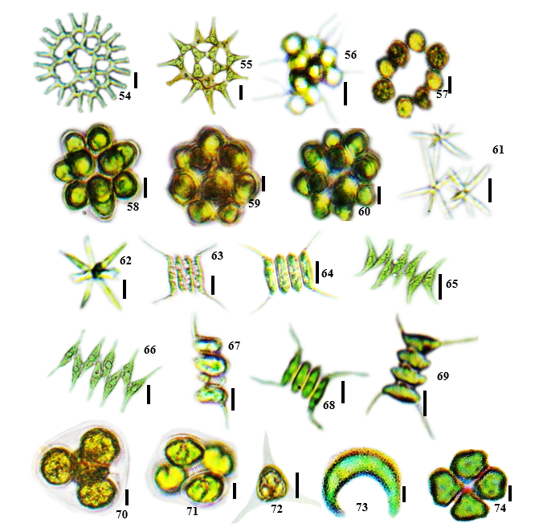

(Fig. 54-74) 54: Pediastrum duplex var. gracillimum, 55: Pediastrum simplex var. duodenarium, 56: Sorastrum americanum, 57: Eutetramorus planctonica 58: Coelastrum astroideum, 59: Coelastrum indicum 60: Coelastrum pulchrum, 61: Actinastrum gracillimum, 62: Actinastrum hantzschii, 63: Desmodesmus opoliensis, 64: Desmodesmus quadricaudata, 65: Scenedesmus acuminatus, 66: Scenedesmus bernardii, 67: Scenedesmus bicaudatus, 68: Scenedesmus quadricauda var. longispina, 69: Scenedesmus tropicus, 70: Oocystis borgei, 71: Oocystis submarina, 72: Treubaria triappendiculata, 73: Ankistrodesmus nannoselene, 74: Pandorina morum

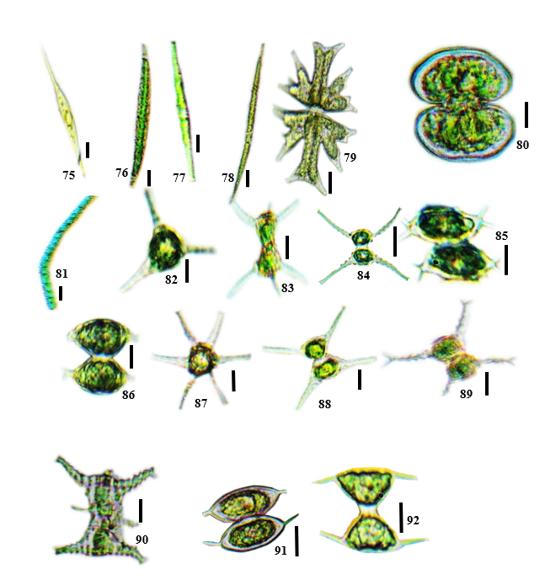

(Fig. 75-92) 75: Closterium gracile, 76: Closterium kuetzingii, 77: Closterium, 78: Closterium macilentum, 79: Micrasterias foliacea, 80: Cosmarium depressum var. achondrum, 81: Hyalotheca dissiliens, 82: Staurastrum asperatum, 83: Staurastrum boreale, 84: Staurastrum brachioprominens var. archerianum, 85: Staurastrum forficulatum var. minus 86: Staurastrum polymorphum, 87: Staurastrum subradians, 88: .Staurastrum tetracerum, 89: Staurastrum volans, 90: Staurastrum sp., 91: Staurodesmus convergens , 92: Staurodesmus triangularis

