On Variety of Signed Product Cordialness of Copper-Oxide and its Extended Networks

Abstract:
In current article, we have observed signed product cordial labeling on Copper Oxide ($CuO$) and its extended network. Also, we have defined balanced signed product cordial labeling on $CuO$ and related structures. We have concluded that $CuO(m,n)$,${CuO}_{EX}(m,n)$, ${CuO}_{EN}(m,n)$, ${CuO}_{OD}(m,n)$ and ${CuO}_{CuD}(m,n)$ admits signed product labeling and also admits balanced signed cordial labeling under some condition.
Keywords: Signed Product Cordial Labeling, Balanced Signed Product Cordial Labeling, Copper Oxide and its extended networks.
AMS Subject classification: 05C78, 05C15

Introduction
Around 1960, Graph Labeling was originated and later on plenty of labeling techniques is introduced which is continued till date. For this please refer [3]. Cahit [2] has initiated cordial labeling and Babujee et.al [1] has developed signed product cordial labeling. For a graph G, V(G) = set of vertices and E(G) = set of edges. Whereas |V(G)| = number of elements in the vertex set and |E(G)| = number of elements in the edge set. The concept of balanced cordial labeling was originated by Kaneria et.al [4], which inspired us to define the balanceness of signed product labeling. For terms not defined here, refer to [4]. In 2022, Yenoke et.al [5] explored copper oxide and its extended networks and applied L(2,1) labeling to it. These structures can be investigated for signed product cordial labeling and balanced signed product cordial labeling.
- Some Terminologies
Definition 2.1: Signed Product Cordial Labeling [1]
A vertex labeling of a graph G, $f∶V(G)⟶\left\{ -1,1 \right\}$ with edge labeling $f^{e}∶E(G)⟶\{ -1,1 \}$ defined by $f^{e}\left(uv\right)=f\left(u\right) f(v)$ is called a signed product cordial labeling if number of vertices labelled with $1$ and $-1$ are differed at most by $1$ and number of edges labelled with $1$ and $-1$ are differed at most by $1$. Its abbreviation is SPCL.
A Graph admits SPCL is called signed product cordial graph. Its abbreviation is SPCG.
Here, number of vertices labelled with $-1$ and $1$ is denoted by $v_{f}(-1)$ and $v_{f}(1)$ respectively. Also, number of edges labelled with $-1$ and $1$ is denoted by $e_{{f }^{e}}\left(-1\right) and e_{{f }^{e}}\left(1\right).$ respectively.

Definition 2.2: Balanced Signed Product Cordial Graph
A signed product cordial graph is called a balanced signed product cordial graph if $\left| v_{f}\left(-1\right)-v_{f}\left(1\right) \right|=\left| e_{{f }^{e}}\left(-1\right)-e_{{f }^{e}}\left(1\right) \right|=0$. Its abbreviation is B – SPCG.
Definition 2.3: Edge Balanced Signed Product Cordial Graph
A signed product cordial graph is called an edge balanced signed product cordial graph if $\left| v_{f}\left(-1\right)-v_{f}\left(1\right) \right|=1$ and $\left| e_{{f }^{e}}\left(-1\right)-e_{{f }^{e}}\left(1\right) \right|=0$. Its abbreviation is EB – SPCG.
Definition 2.4: Vertex Balanced Signed Product Cordial labeling
A signed product cordial graph is called a vertex balanced signed product cordial graph if $\left| v_{f}\left(-1\right)-v_{f}\left(1\right) \right|=0$and $\left| e_{{f }^{e}}\left(-1\right)-e_{{f }^{e}}\left(1\right) \right|=1$. Its abbreviation is VB – SPCG.
Definition 2.5: Unbalanced Signed Product Cordial Graph
A signed product cordial graph is called an unbalanced signed product cordial graph if $\left| v_{f}\left(-1\right)-v_{f}\left(1\right) \right|=\left| e_{f^{ e}}\left(-1\right)-e_{f^{ e}}\left(1\right) \right|=1$. Its abbreviation is UB – SPCG.
Definition 2.6: Copper (II) Oxide Structure [5]
The Copper (II) Oxide $( CuO )$ is an octagonal structure is joined to each other in rows and columns. Any two octagons are joined by Cu(4 bonds). Such networks with m octagons in row and n octagons in column is called Copper (II) Oxide Network, denoted by $CuO\left(m, n\right).$ Refer to Figure [1].
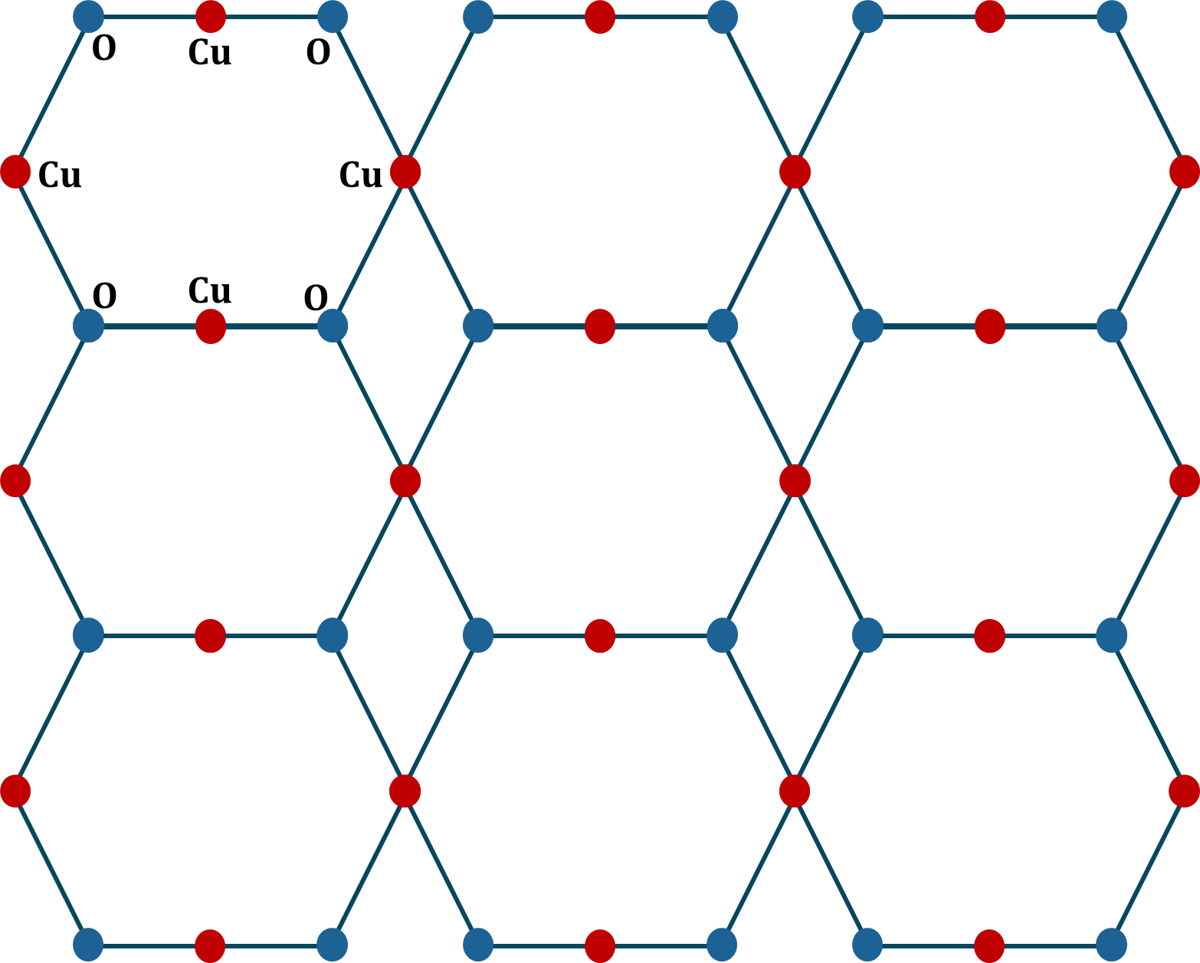
In this structure, there are $4mn+m+3n$ vertices and $6mn+2n$ edges.

Figure 1: $CuO\left(3,3\right)$Structure

Definition 2.7: Extended Copper (II) Oxide Structure [5]
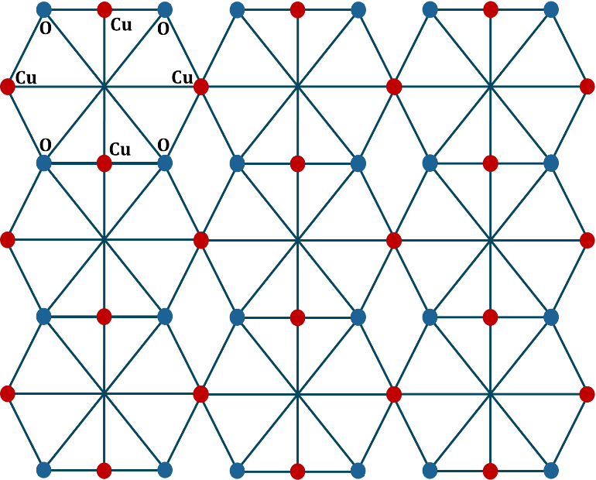
In Copper (II) Oxide Structure, both pair of Cu (Copper) and O (Oxygen) is joined by a bond, a resulting structure is called Extended Copper (II) Oxide Structure. It is denoted by ${CuO}_{EX}\left(m, n\right)$. Refer to Figure [2].In this structure, there are $4mn+m+3n$ vertices and $10mn+2n$ edges.

Figure 2: $CuO_{EX}\left(3,3\right)$ Structure
Definition 2.8: Enhanced Copper (II) Oxide Structure [5]
In Extended Copper (II) Oxide Structure, if we place a vertex in each face of an octagon (at apex) to form $W_{8+1}$, then the resulting structure is called Enhanced Copper (II) Oxide Structure. It is denoted by ${CuO}_{EN}\left(m, n\right)$. Refer to Figure [3].
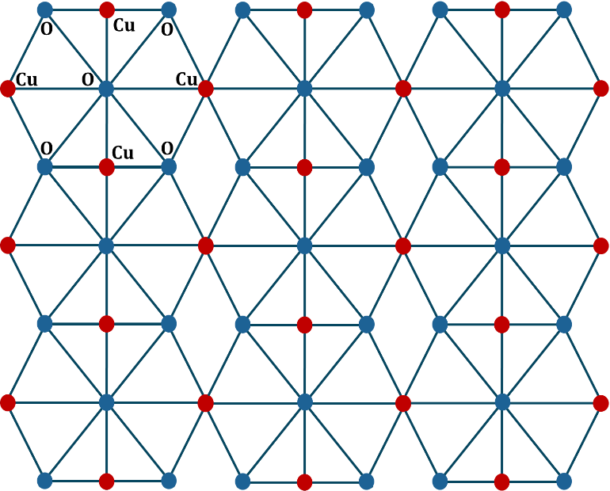
In this structure, there are $5mn+m+3n$ vertices and $14mn+2n$ edges.
Figure 3: $CuO_{EN}(3,3)$ Structure
Definition 2.9: O – Diagonal Copper (II) Oxide Structure [5]
In Copper (II) Oxide Structure, if both oxygen atoms are joined diagonally, then the generated structure is called O – Diagonal Copper (II) Oxide Structure It is denoted by ${CuO}_{OD}\left(m, n\right)$. Refer to Figure [4].
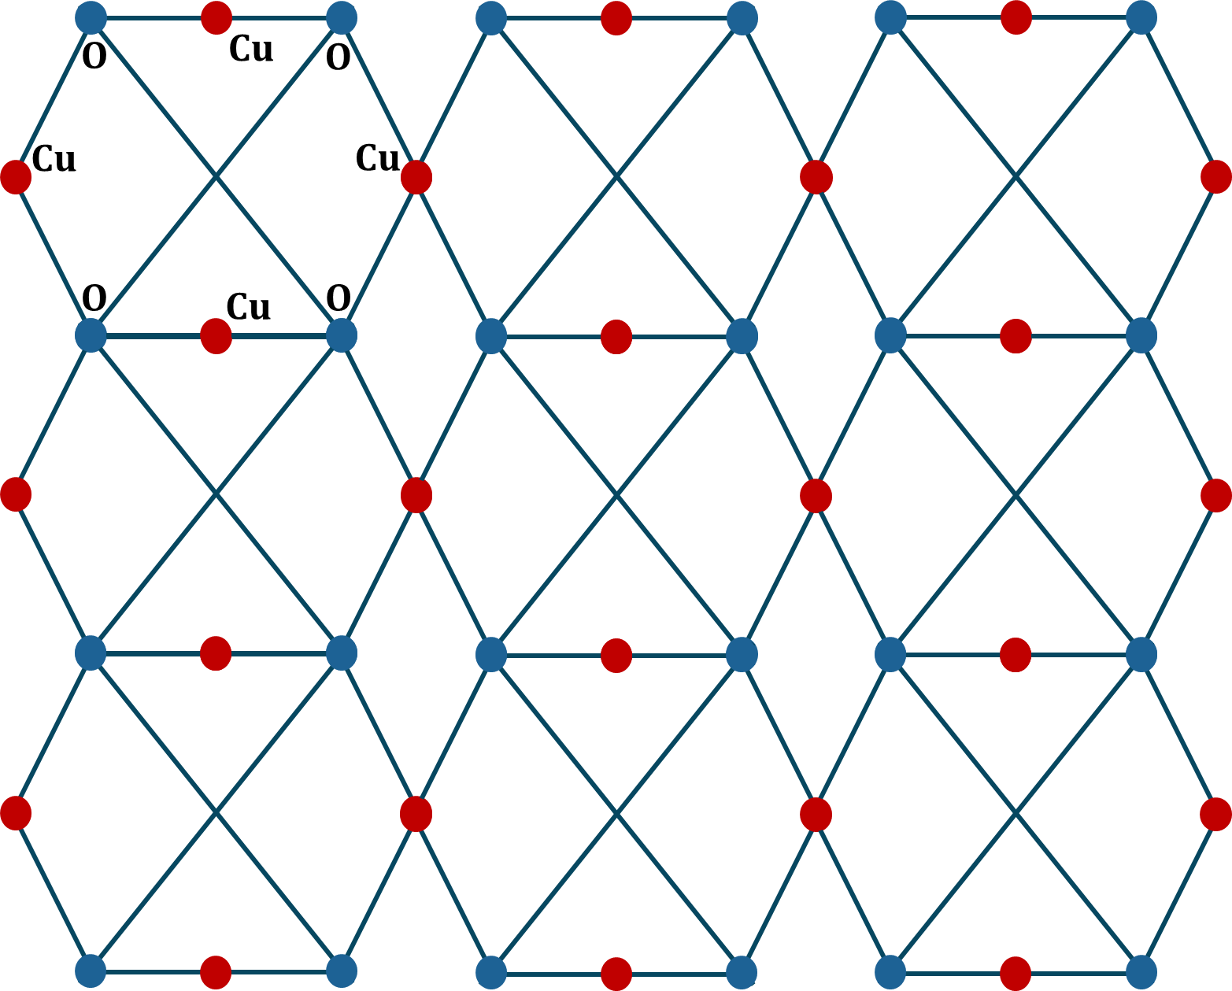
In this structure, there are $4mn+m+3n$ vertices and $8mn+2n$ edges.

Figure 4: $CuO_{OD}(3,3)$ Structure
Definition 2.10: Cu – Diagonal Copper (II) Oxide Structure
In Copper (II) Oxide Structure, if both copper atoms are joined diagonally, then the generated structure is called Cu – Diagonal Copper (II) Oxide Structure It is denoted by ${CuO}_{CuD}\left(m, n\right)$. Refer to Figure [5].
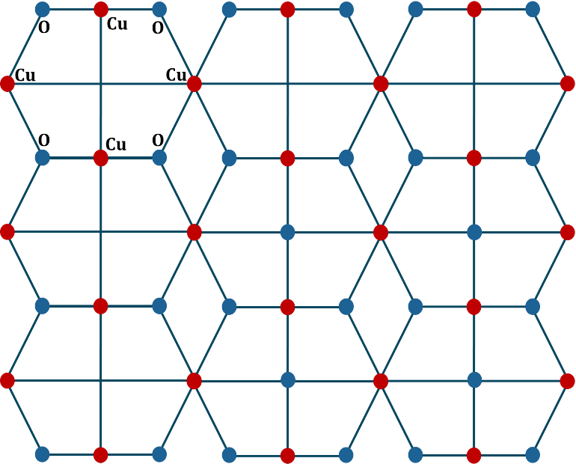
In this structure, there are $4mn+m+3n$ vertices and $8mn+2n$ edges.

Figure 5: $CuO_{CuD}(3,3)$ Structure

- Notation for Node of $CuO$ and its extended networks
The nodes in i^{th} row and j^{th} column are noted with
$$u_{ij} ;i=1, 2, 3, …, m+1, j=1,2,3,…, 3n$$
The nodes that appear between all consecutive rows are noted with
$$v_{ij} ;i=1, 2, 3, …, m, j=1,2,3,…, n+1$$
The nodes that appear at the apex of every octagon are noted with
$$w_{ij} ;i=1, 2, 3, …, m, j=1,2,3,…, n$$
Nodes noted with $w_{ij}$ appear only in ${CuO}_{EN}\left(m,n\right)$ structures, while nodes noted with $u_{ij}$ and $v_{ij}$ appear in $CuO\left(m,n\right), {CuO}_{EX}\left(m,n\right)$ and ${CuO}_{EN}\left(m,n\right)$. Refer to Figure [5].
In Figure [5], we have given notations for the ${CuO}_{EN}\left(3,3\right)$ structure; for the remaining structures, one can easily understand.
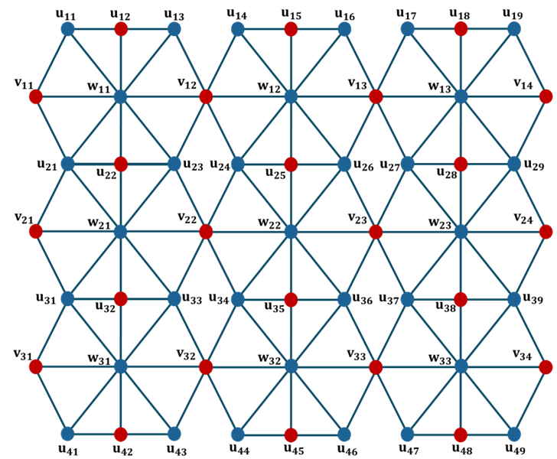
$$Figure 6: Node Notation for CuO_{EN}\left(3,3\right) Structure$$

- Results
Theorem 4.1: The $CuO\left(m,n\right)$ structure admits SPCL.
Proof: To prove $CuO\left(m,n\right)$structure admits SPCL, firstly, we prove that it admits V – SPCL, and then we will prove that it admits E – SPCL.
To Prove: $CuO\left(m,n\right)$ admits V – SPCL.
From Figure [1] and [3], the structure has 2 types of node notations $u_{ij}$ and $u_{ij}$.
Define an injective mapping $f :V\left(CuO\left(m,n\right)\right)⟶\left\{-1, 1\right\}$ as follows
Case – I: $i≡1\left(mod 2\right)$
$$f\left(u_{ij}\right)=\left\{ \begin{aligned}-1, j≡0, 1,5 \left(mod 6\right) \\ 1, j≡2, 3, 4 \left(mod 6\right)\end{aligned}\right.$$
$$f\left(v_{ij}\right)=\left\{ \begin{aligned}-1, j≡0 \left(mod 2\right) \\ 1, j≡1 \left(mod 2\right)\end{aligned}\right.$$
Case – II: $i≡0\left(mod 2\right)$
$$f\left(u_{ij}\right)=\left\{ \begin{aligned} 1, j≡0, 1, 5 \left(mod 6\right) \\ -1, j≡2, 3, 4 \left(mod 6\right)\end{aligned}\right.$$
$$f\left(v_{ij}\right)=\left\{ \begin{aligned} 1, j≡0 \left(mod 2\right) \\ -1, j≡1 \left(mod 2\right)\end{aligned}\right.$$
Now, we will show that, with this defined function $CuO\left(m,n\right)$ admits SPCL.
Consider the following table for the count of nodes with label $-1$ and $1$ in different cases.
Vertex Label | Notation | No. of Nodes, when
Vertex Label | Notation | $$m, n≡1\left(mod 2\right)$$ | $$m≡0\left(mod 2\right),$$  $$n∈N$$ | $m≡1\left(mod 2\right)$ & $n≡0\left(mod 2\right)$
$$-1$$ | $$u_{ij}$$ | $$\frac{ 3\left(m+1\right)n }{2}$$ | $$\left\lfloor \frac{ 3\left(m+1\right)n }{2} \right\rfloor$$ | $$\frac{ 3\left(m+1\right)n }{2}$$
$$-1$$ | $$v_{ij}$$ | $$\frac{ m\left(n+1\right) }{2}$$ | $$\frac{ m\left(n+1\right) }{2}$$ | $$\left\lfloor \frac{ m }{2}\right\rfloor +\frac{ mn }{2}$$
$$1$$ | $$u_{ij}$$ | $$\frac{ 3\left(m+1\right)n }{2}$$ | $$\left\lceil \frac{ 3\left(m+1\right)n }{2} \right\rceil$$ | $$\frac{ 3\left(m+1\right)n }{2}$$
$$1$$ | $$v_{ij}$$ | $$\frac{ m\left(n+1\right) }{2}$$ | $$\frac{ m\left(n+1\right) }{2}$$ | $$\left\lfloor \frac{ m }{2}\right\rfloor +\frac{ mn }{2}+1$$
$$| v_f (-1)-v_f (1) |$$ |  | $$0$$ | $$1$$ | $$1$$
Table 1: Counting of Nodes for $CuO(m,n)$structure

In each of the cases, $\left| v_{f}\left(-1\right)-v_{f}\left(1\right) \right|≤1$.
So, $CuO\left(m,n\right)$ admits V – SPCL.
To Prove: $CuO\left(m,n\right)$ admits E – SPCL.
Define a mapping $f^{e}:E\left(CuO\left(m,n\right)\right)⟶\left\{-1, 1\right\}$ as $f^{e}\left(pq\right)=f^{e}\left(p\right) f^{e}\left(q\right);$ $∀ pq∈\left(CuO\left(m,n\right)\right)$
Consider the following table for the count of nodes with label $-1$ and $1$ in different cases.

Edge Label | No. of Nodes, when
Edge Label | $$m, n≡1\left(mod 2\right)$$ | $$m≡0\left(mod 2\right),$$  $$n∈N$$ | $m≡1\left(mod 2\right)$ &  $$n≡0\left(mod 2\right)$$
$$-1$$ | $\left(3m+1\right)n$ | $\left(3m+1\right)n$ | $\left(3m+1\right)n$
$$1$$ | $$\left(3m+1\right)n$$ | $$\left(3m+1\right)n$$ | $$\left(3m+1\right)n$$
$$\left| e_{f^{ e}}\left(-1\right)-e_{f^{ e}}\left(1\right) \right|$$ | $$0$$ | $$0$$ | $$0$$
Table 2: Counting of Edges for $CuO(m,n)$ structure

So, $\left| e_{f^{ e}}\left(-1\right)-e_{f^{ e}}\left(1\right) \right|=0………\left(A\right)$
So, $CuO\left(m,n\right)$ admits E-SPCL.
Hence, $CuO\left(m,n\right)$ admits SPCL.
Corollary 4.1.1: The $CuO\left(m,n\right)$ structure is B – SPCG, If $m,n≡1\left(mod 2\right)$ otherwise EB – SPCG.
Proof: From Table [1] and Equation $(A)$, We can conclude that,
Condition | When
Condition | $$m, n≡1\left(mod 2\right)$$ | $$m≡0\left(mod 2\right),$$  $$n∈N$$ | $m≡1\left(mod 2\right)$ &  $$n≡0\left(mod 2\right)$$
$$\left| v_{f}\left(-1\right)-v_{f}\left(1\right) \right|$$ | $$0$$ | $$1$$ | $$1$$
$$\left| e_{f^{ e}}\left(-1\right)-e_{f^{ e}}\left(1\right) \right|$$ | $$0$$ | $$0$$ | $$0$$

Clearly, $CuO\left(m,n\right)$ structure is,
B – SPCG for $m, n≡1\left(mod 2\right)$
EB – SPCG for $m≡0\left(mod 2\right), n∈N$
EB – SPCG for $m≡1\left(mod 2\right)$ & $n≡0\left(mod 2\right)$.
Example: SPCL on $CuO\left(3,3\right)$ structure.
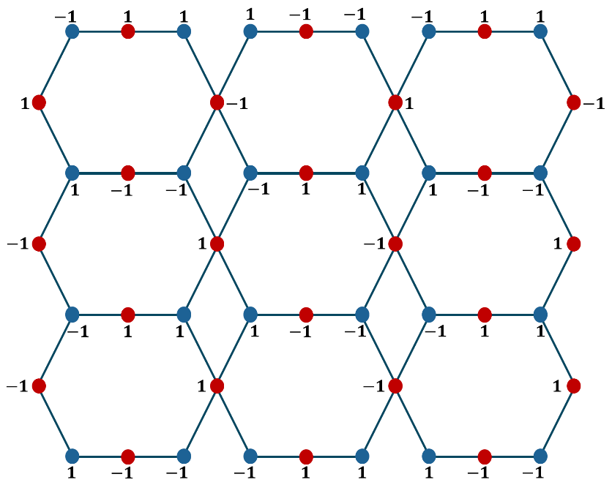
$Figure 7:$ Vertex Labeling on $CuO\left(3, 3\right)$
Theorem 4.2: The ${CuO}_{EX}\left(m,n\right)$ structure admits SPCL.
Proof: To prove $CuO_{EX}\left(m,n\right)$structure admits SPCL, Firstly, we prove that it admits V – SPCL and then we will prove that it admits E – SPCL.
To Prove: ${CuO}_{EX}\left(m,n\right)$ admits V – SPCL.
From Figure [2], there are same number of vertices in $CuO\left(m,n\right)$ and ${CuO}_{EX}\left(m,n\right)$ and hence with same function defined for $CuO\left(m,n\right)$ structure, ${CuO}_{EX}\left(m,n\right)$ admits V – SPCL.
To Prove: ${CuO}_{EX}\left(m,n\right)$ admits E – SPCL.
Consider the following table for the count of edges with label $-1$ and $1$ in different cases.
Edge Label | No. of Nodes, when
Edge Label | $$m, n≡1\left(mod 2\right)$$ | $$m≡0\left(mod 2\right),$$  $$n∈N$$ | $m≡1\left(mod 2\right)$ &  $$n≡0\left(mod 2\right)$$
$$-1$$ | $\left(5m+1\right)n$ | $\left(5m+1\right)n$ | $\left(5m+1\right)n$
$$1$$ | $$\left(5m+1\right)n$$ | $$\left(5m+1\right)n$$ | $$\left(5m+1\right)n$$
$$\left| e_{f^{ e}}\left(-1\right)-e_{f^{ e}}\left(1\right) \right|$$ | $$0$$ | $$0$$ | $$0$$

So, $\left| e_{f^{ e}}\left(-1\right)-e_{f^{ e}}\left(1\right) \right|=0………\left(B\right)$
So, ${CuO}_{EX}\left(m,n\right)$ admits E – SPCL.
Hence, ${CuO}_{EX}\left(m,n\right)$ admits SPCL.
Corollary 4.2.1: The $CuO_{EX}\left(m,n\right)$ structure is B – SPCG, If $m,n≡1\left(mod 2\right)$ otherwise EB – SPCG.
Proof: From Table [1] and Equation $(B)$, We can conclude that,
Condition | When
Condition | $$m, n≡1\left(mod 2\right)$$ | $$m≡0\left(mod 2\right),$$  $$n∈N$$ | $m≡1\left(mod 2\right)$ &  $$n≡0\left(mod 2\right)$$
$$\left| v_{f}\left(-1\right)-v_{f}\left(1\right) \right|$$ | 0 | 1 | 1
$$\left| e_{f^{ e}}\left(-1\right)-e_{f^{ e}}\left(1\right) \right|$$ | 0 | 0 | 0

Clearly, ${CuO}_{EX}\left(m,n\right)$ structure is,
B – SPCG for $m, n≡1\left(mod 2\right)$
EB – SPCG for $m≡0\left(mod 2\right), n∈N$
EB – SPCG for $m≡1\left(mod 2\right)$ & $n≡0\left(mod 2\right)$.
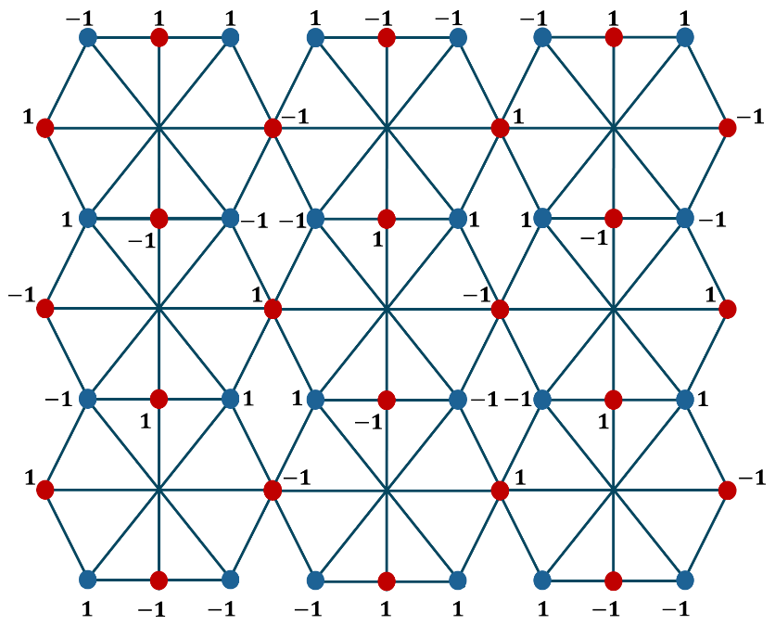
Example: SPCL on $CuO_{EX}\left(3,3\right)$ structure.

$Figure 8:$ Vertex Labeling on $CuO_{EX}\left(3, 3\right)$
Theorem 4.3: The ${CuO}_{EN}\left(m,n\right)$ structure admits SPCL.
Proof: To prove $CuO_{EN}\left(m,n\right)$structure admits SPCL, Firstly, we prove that it admits V – SPCL and then we will prove that it admits E – SPCL.
To Prove: ${CuO}_{EN}\left(m,n\right)$ admits V – SPCL.
From Figure [3], the structure has 3 types of node notations $u_{ij}, v_{ij}$ and $w_{ij}$. Here, Vertex Labeling for $u_{ij}$and $v_{ij}$ is same as defined for $CuO\left(m,n\right)$. Let us define $w_{ij}.$
Case – I: $i≡1\left(mod 2\right)$
$$f\left(w_{ij}\right)=\left\{ \begin{aligned} 1, j≡0 \left(mod 2\right) \\ -1, j≡1 \left(mod 2\right)\end{aligned}\right.$$
Case – II: $i≡0\left(mod 2\right)$
$$f\left(w_{ij}\right)=\left\{ \begin{aligned}-1, j≡0 \left(mod 2\right) \\ 1, j≡1 \left(mod 2\right)\end{aligned}\right.$$
Let us check cordiality in ${CuO}_{EN}\left(m,n\right)$ structure.
Consider the following table for the count in nodes with label $-1$ and $1$ in different cases.
Vertex Label | Notation | No. of Nodes, when
Vertex Label | Notation | $$m, n≡1\left(mod 2\right)$$ | $$m≡0\left(mod 2\right),$$  $$n∈N$$ | $m≡1\left(mod 2\right)$ &  $$n≡0\left(mod 2\right)$$
$$-1$$ | $$u_{ij}$$ | $$\frac{ 3\left(m+1\right)n }{2}$$ | $$\left\lfloor \frac{ 3\left(m+1\right)n }{2} \right\rfloor$$ | $$\frac{ 3\left(m+1\right)n }{2}$$
$$-1$$ | $$v_{ij}$$ | $$\frac{ m\left(n+1\right) }{2}$$ | $$\frac{ m\left(n+1\right) }{2}$$ | $$\left\lfloor \frac{ m }{2}\right\rfloor +\frac{ mn }{2}$$
$$-1$$ | $$w_{ij}$$ | $$\frac{ mn+1 }{2}$$ | $$\frac{ mn }{2}$$ | $$\frac{ mn }{2}$$
$$1$$ | $$u_{ij}$$ | $$\frac{ 3\left(m+1\right)n }{2}$$ | $$\left\lceil \frac{ 3\left(m+1\right)n }{2} \right\rceil$$ | $$\frac{ 3\left(m+1\right)n }{2}$$
$$1$$ | $$v_{ij}$$ | $$\frac{ m\left(n+1\right) }{2}$$ | $$\frac{ m\left(n+1\right) }{2}$$ | $$\left\lfloor \frac{ m }{2}\right\rfloor +\frac{ mn }{2}+1$$
$$1$$ | $$w_{ij}$$ | $$\frac{ mn-1 }{2}$$ | $$\frac{ mn }{2}$$ | $$\frac{ mn }{2}$$
$$\left| v_{f}\left(-1\right)-v_{f}\left(1\right) \right|$$ |  | $$1$$ | $$1$$ | $$1$$
Table 3: Counting of Nodes for $CuO_{EN} (m,n)$ structure

In each of the cases, $\left| v_{f}\left(-1\right)-v_{f}\left(1\right) \right|≤1$.
So, ${CuO}_{EN}\left(m,n\right)$ admits V-SPCL.
To Prove: ${CuO}_{EN}\left(m,n\right)$ admits E – SPCL.
Consider the following table for the count of edges with label $-1$ and $1$ in different cases.
Edge Label | No. of Nodes, when
Edge Label | $$m, n≡1\left(mod 2\right)$$ | $$m≡0\left(mod 2\right),$$  $$n∈N$$ | $m≡1\left(mod 2\right)$ &  $$n≡0\left(mod 2\right)$$
$$-1$$ | $\left(7m+1\right)n$ | $\left(7m+1\right)n$ | $\left(7m+1\right)n$
$$1$$ | $$\left(7m+1\right)n$$ | $$\left(7m+1\right)n$$ | $$\left(7m+1\right)n$$
$$\left| e_{f^{ e}}\left(-1\right)-e_{f^{ e}}\left(1\right) \right|$$ | 0 | 0 | 0

So, $\left| e_{f^{ e}}\left(-1\right)-e_{f^{ e}}\left(1\right) \right|=0………\left(C\right)$
So, ${CuO}_{EN}\left(m,n\right)$ admits E – SPCL. Hence, ${CuO}_{EN}\left(m,n\right)$ admits SPCL.
Corollary 4.3.1: The $CuO_{EN}\left(m,n\right)$ structure is EB – SPCG.
Proof: From Table [1] and Equation $(E)$, We can conclude that,
Condition | When
Condition | $$m, n≡1\left(mod 2\right)$$ | $$m≡0\left(mod 2\right),$$  $$n∈N$$ | $m≡1\left(mod 2\right)$ &  $$n≡0\left(mod 2\right)$$
$$\left| v_{f}\left(-1\right)-v_{f}\left(1\right) \right|$$ | $$1$$ | $$1$$ | $$1$$
$$\left| e_{f^{ e}}\left(-1\right)-e_{f^{ e}}\left(1\right) \right|$$ | $$0$$ | $$0$$ | $$0$$

Clearly, ${CuO}_{EN}\left(m,n\right)$ structure is EB – SPCG.
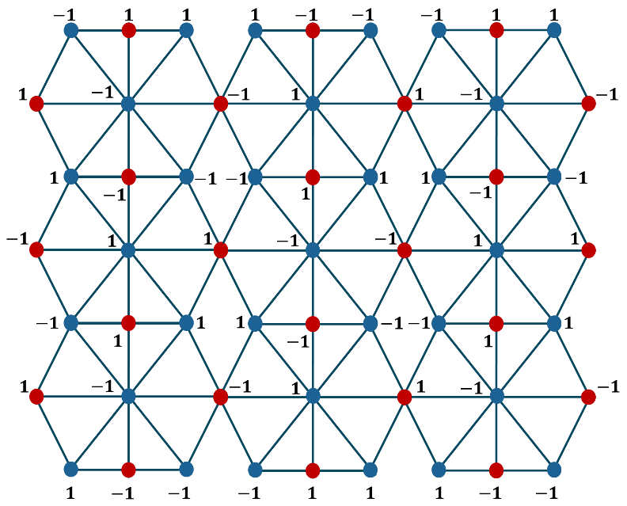
Example: SPCL on $CuO_{EN}\left(3,3\right)$ structure.

$Figure 9:$ Vertex Labeling on $CuO_{EN}\left(3, 3\right)$

Theorem 4.4: The ${CuO}_{OD}\left(m,n\right)$ structure admits SPCL.
Proof: To prove $CuO_{OD}\left(m,n\right)$structure admits SPCL, Firstly, we prove that it admits V – SPCL and then we will prove that it admits E – SPCL.
To Prove: ${CuO}_{OD}\left(m,n\right)$ admits V – SPCL.
Define an injective mapping $f :V\left({CuO}_{OD}\left(m,n\right)\right)⟶\left\{-1, 1\right\}$ as follows

Case – I: $i≡1\left(mod 2\right)$
$$f\left(u_{ij}\right)=\left\{ \begin{aligned}-1, j≡2, 3,5 \left(mod 6\right) \\ 1, j≡0, 1, 4 \left(mod 6\right)\end{aligned}\right.$$
$$f\left(v_{ij}\right)=\left\{ \begin{aligned}-1, j≡0 \left(mod 2\right) \\ 1, j≡1 \left(mod 2\right)\end{aligned}\right.$$
Case – II: $i≡0\left(mod 2\right)$
$$f\left(u_{ij}\right)=\left\{ \begin{aligned} 1, j≡0, 1, 3 \left(mod 6\right) \\ -1, j≡2, 4, 5 \left(mod 6\right)\end{aligned}\right.$$
$$f\left(v_{ij}\right)=\left\{ \begin{aligned} 1, j≡0 \left(mod 2\right) \\ -1, j≡1 \left(mod 2\right)\end{aligned}\right.$$
Now, we will show that, with this defined function ${CuO}_{OD}\left(m,n\right)$ admits SPCL.
Consider the following table for the count of nodes with label $-1$ and $1$ in different cases.
Vertex Label | Notation | No. of Nodes, when
Vertex Label | Notation | $$m, n≡1\left(mod 2\right)$$ | $$m≡0\left(mod 2\right),$$  $$n∈N$$ | $m≡1\left(mod 2\right)$ &  $$n≡0\left(mod 2\right)$$
$$-1$$ | $$u_{ij}$$ | $$\frac{ 3\left(m+1\right)n }{2}$$ | $$\left\lfloor \frac{ 3\left(m+1\right)n }{2} \right\rfloor$$ | $$\frac{ 3\left(m+1\right)n }{2}$$
$$-1$$ | $$v_{ij}$$ | $$\frac{ m\left(n+1\right) }{2}$$ | $$\frac{ m\left(n+1\right) }{2}$$ | $$\left\lfloor \frac{ m }{2}\right\rfloor +\frac{ mn }{2}$$
$$1$$ | $$u_{ij}$$ | $$\frac{ 3\left(m+1\right)n }{2}$$ | $$\left\lceil \frac{ 3\left(m+1\right)n }{2} \right\rceil$$ | $$\frac{ 3\left(m+1\right)n }{2}$$
$$1$$ | $$v_{ij}$$ | $$\frac{ m\left(n+1\right) }{2}$$ | $$\frac{ m\left(n+1\right) }{2}$$ | $$\left\lfloor \frac{ m }{2}\right\rfloor +\frac{ mn }{2}+1$$
$$\left| v_{f}\left(-1\right)-v_{f}\left(1\right) \right|$$ |  | $$0$$ | $$1$$ | $$1$$
Table 4: Counting of Nodes for $CuO_{OD}(m,n)$ structure

In each of the cases, $\left| v_{f}\left(-1\right)-v_{f}\left(1\right) \right|≤1$.
So, ${CuO}_{OD}\left(m,n\right)$ admits V – SPCL.
To Prove: ${CuO}_{OD}\left(m,n\right)$ admits E – SPCL.
Define a mapping $f^{e}:E\left({CuO}_{OD}\left(m,n\right)\right)⟶\left\{-1, 1\right\}$ as $f^{e}\left(pq\right)=f^{e}\left(p\right) f^{e}\left(q\right) ;$
$∀ pq∈E\left({CuO}_{OD}\left(m,n\right)\right)$.

Consider the following table for the count of nodes with label -1 and 1 in different cases.
Edge Label | No. of Nodes, when
Edge Label | $$m, n≡1\left(mod 2\right)$$ | $$m≡0\left(mod 2\right),$$  $$n∈N$$ | $m≡1\left(mod 2\right)$ &  $$n≡0\left(mod 2\right)$$
$$-1$$ | $\left(4m+1\right)n$ | $\left(4m+1\right)n$ | $\left(4m+1\right)n$
$$1$$ | $$\left(4m+1\right)n$$ | $$\left(4m+1\right)n$$ | $$\left(4m+1\right)n$$
$$\left| e_{f^{ e}}\left(-1\right)-e_{f^{ e}}\left(1\right) \right|$$ | $$0$$ | $$0$$ | $$0$$
Table 5: Counting of Edges for $CuO_{OD}(m,n)$ structure

So, $\left| e_{f^{ e}}\left(-1\right)-e_{f^{ e}}\left(1\right) \right|=0………\left(D\right)$
So, ${CuO}_{OD}\left(m,n\right)$ admits E-SPCL.
Hence, ${CuO}_{OD}\left(m,n\right)$ admits SPCL.
Corollary 4.4.1: The $CuO_{OD}\left(m,n\right)$ structure is B – SPCG, If $m,n≡1\left(mod 2\right)$ otherwise EB – SPCG.
Proof: From Table [4] and Equation $(D)$, We can conclude that,
Condition | When
Condition | $$m, n≡1\left(mod 2\right)$$ | $$m≡0\left(mod 2\right),$$  $$n∈N$$ | $m≡1\left(mod 2\right)$ &  $$n≡0\left(mod 2\right)$$
$$\left| v_{g}\left(-1\right)-v_{g}\left(1\right) \right|$$ | $$0$$ | $$1$$ | $$1$$
$$\left| e_{f^{ e}}\left(-1\right)-e_{f^{ e}}\left(1\right) \right|$$ | $$0$$ | $$0$$ | $$0$$

Clearly, ${CuO}_{OD}\left(m,n\right)$ structure is,
B – SPCG for $m, n≡1\left(mod 2\right)$
EB – SPCG for $m≡0\left(mod 2\right), n∈N$
EB – SPCG for $m≡1\left(mod 2\right)$ & $n≡0\left(mod 2\right)$.

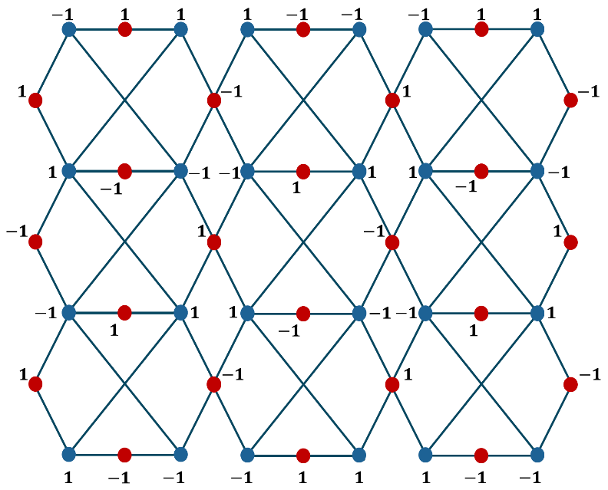
Example: SPCL on $CuO_{OD}\left(3,3\right)$ structure.

$Figure 10:$ Vertex Labeling on $CuO_{OD}\left(3, 3\right)$
Theorem 4.5: The ${CuO}_{CuD}\left(m,n\right)$ structure admits SPCL.
Proof: To prove $CuO_{CuD}\left(m,n\right)$structure admits SPCL, Firstly, we prove that it admits V – SPCL and then we will prove that it admits E – SPCL.
To Prove: ${CuO}_{CuD}\left(m,n\right)$ admits V – SPCL.
From Figure [5], there are same number of vertices in ${CuO}_{OD}\left(m,n\right)$ and ${CuO}_{CuD}\left(m,n\right)$ and hence with same function defined for ${CuO}_{OD}\left(m,n\right)$ structure, ${CuO}_{CuD}\left(m,n\right)$ admits V – SPCL.
To Prove: ${CuO}_{CuD}\left(m,n\right)$ admits E – SPCL.
Consider the following table for the count of nodes with label $-1$ and $1$ in different cases.
$$Edge Label$$ | No. of Nodes, when
$$Edge Label$$ | $$m, n≡1\left(mod 2\right)$$ | $$m≡0\left(mod 2\right),$$  $$n∈N$$ | $m≡1\left(mod 2\right)$ &  $$n≡0\left(mod 2\right)$$
$$-1$$ | $\left(4m+1\right)n$ | $\left(4m+1\right)n$ | $\left(4m+1\right)n$
$$1$$ | $$\left(4m+1\right)n$$ | $$\left(4m+1\right)n$$ | $$\left(4m+1\right)n$$
$$\left| e_{f^{ e}}\left(-1\right)-e_{f^{ e}}\left(1\right) \right|$$ | 0 | 0 | 0
Table 6: Counting of Edges for ${CuO}_{CuD}\left(m,n\right)$ structure

So, $\left| e_{f^{ e}}\left(-1\right)-e_{f^{ e}}\left(1\right) \right|=0………\left(E\right)$
So, ${CuO}_{CuD}\left(m,n\right)$ admits E-SPCL.
Hence, ${CuO}_{CuD}\left(m,n\right)$ admits SPCL.
Corollary 4.5.1: The $CuO_{CuD}\left(m,n\right)$ structure is B – SPCG, If $m,n≡1\left(mod 2\right)$ otherwise EB – SPCG.
Proof: From Table [4] and Equation $(E)$, We can conclude that,
Condition | When
Condition | $$m, n≡1\left(mod 2\right)$$ | $$m≡0\left(mod 2\right),$$  $$n∈N$$ | $m≡1\left(mod 2\right)$ &  $$n≡0\left(mod 2\right)$$
$$\left| v_{g}\left(-1\right)-v_{g}\left(1\right) \right|$$ | $$0$$ | $$1$$ | $$1$$
$$\left| e_{f^{ e}}\left(-1\right)-e_{f^{ e}}\left(1\right) \right|$$ | $$0$$ | $$0$$ | $$0$$

Clearly, ${CuO}_{CuD}\left(m,n\right)$ structure is,
B – SPCG for $m, n≡1\left(mod 2\right)$
EB – SPCG for $m≡0\left(mod 2\right), n∈N$
EB – SPCG for $m≡1\left(mod 2\right)$ & $n≡0\left(mod 2\right)$.
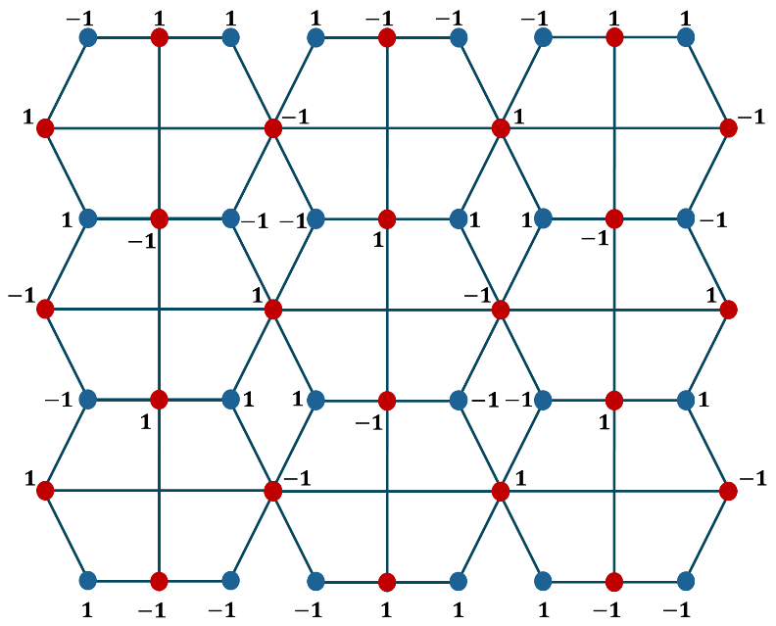
Example: SPCL on $CuO_{CuD}\left(3,3\right)$ structure.

$Figure 11:$ Vertex Labeling on$CuO_{CuD}\left(3, 3\right)$

Conclusion:
The $CuO\left(m,n\right)$, ${CuO}_{EX}\left(m,n\right),$ ${CuO}_{EN}\left(m,n\right)$, ${CuO}_{OD}\left(m,n\right),$ ${CuO}_{CuD}\left(m,n\right)$ structure admits SPCL. i.e. The extended networks of copper oxide ($CuO$) admits signed product cordial labeling (SPCL).

COMPETING INTERESTS DISCLAIMER:
Authors have declared that they have no known competing financial interests OR non-financial interests OR personal relationships that could have appeared to influence the work reported in this paper.

Disclaimer (Artificial intelligence)
Option 1:
Author(s) hereby declare that NO generative AI technologies such as Large Language Models (ChatGPT, COPILOT, etc.) and text-to-image generators have been used during the writing or editing of this manuscript.

References
- Babujee J. B. et.al, “On Signed Product Cordial Labeling”, Applied Mathematics, 2011, 2, 1525-1530. DOI:10.4236/am.2011.212216
doi: 10.4236/am.2011.212216.
- Cahit I., “On Cordial and 3-Equitable Labellings of Graphs”, Utilitas Mathematica 37(1990), pp. 189-190.
https://www.researchgate.net/publication/233792994
- Gallian J.A., “A Dynamic Survey of Graph Labeling,” The electronic journal of combinatorics, 27th Edition, Nov. 2024.
- Kaneria V. J. et.al, “Balanced Cordial Labeling and its Application to Produce new Cordial Families”, International Journal of Mathematics And its Applications, Volume 4, Issue 1C (2016), 65 – 68. ISSN: 2347-1557
https://www.researchgate.net/publication/306014877
- Kins Yenoke, T. Shiba Neenu, Charles Robert Kenneth, D. Francis Xavier, M. Peter and K. Leo Lawrence, “A Study on L(2,1) Labelling Problem for Copper-Oxide and its Extended Networks”, Advances and Applications in Mathematical Sciences, Vol.21(6361-6372), 2022.
https://www.researchgate.net/publication/364994928

