The role of Artistic Manuals in improving guidance and counselling services in Tamale Senior High School

Abstract
Senior High School Education is very important because it is one of the levels for progressing to tertiary institutions. The study assessed the guidance and counselling services offered in the Tamale Senior High School Tamale, within the Metropolis and investigated how students are accessing the services. The qualitative research approach was used with Action research design for the study. The sample beneficiary was about (100) hundred respondents which made up of two (2) guidance and counselling coordinators, (98) ninety-eight students, but after introducing them to additional information in Artistically designed manual as an intervention, the guidance and counselling coordinators revealed that this had marginally improved assessment of the service. The recommendations made pointed to the need for guidance and counselling coordinators making efforts to provide additional information to help their students to understand the types of guidance services available and to encourage the students to access them. There is also the need for the Ghana Education Service to train teachers to gain professional knowledge and skills in guidance and counselling so they can serve their students better.
Key Words: Guidance and counselling, Art, Intervention, Access, designed manual

Introduction
The assessment of Guidance and Counselling services is a necessary process for every school. It is required that after establishment of the Guidance and Counselling programme, its effectiveness should be periodically ascertained. This assessment, according to Nkala (2014), would help to evaluate how well the services are being administered, the extent to which students are benefiting, in the effective running of the service and the reasons for any ineffectiveness.
According to Getachew (2020), Guidance and Counselling plays a role in every individual’s life and it is essential in all aspects of human development. These roles were not refined, systematic and scientific as we have today. Even in our African traditional setting when the elders are finding it difficult to take a meaningful decision, they would say that “they are going to see the old lady”. This means that, they are going to seek counsel from an elderly person (Kokro et al., 2022).
Senior High School students are mostly adolescents. Psychologists describe the adolescent period as a major decision taking time for which reason the young people need guidance and counselling to enable them take meaningful decisions for achievement of their future goals. The Ghana Education Service (GES) has therefore mandated every Senior High School to have a Guidance and Counselling Unit to coordinate all guidance activities in the Senior High Schools (Anamuah-Mensah, 2007) as cited in Frempong, (2013). This, the GES envisages, would help promote the physical, mental, emotional and academic development of students. This necessitates the assessment of Guidance and Counselling in the schools.

Statement of the Problem
Interactions with students in the Tamale Senior High School in Sagnaregu Metropolis revealed that in spite of Government’s effort through Ministry of Education to appoint Guidance and Counselling Coordinators, students still have emotional and academic challenges. They also have problems relating to sexual harassment, absenteeism, lesbianism, occultism and masturbation. Students are known to depend on their ill-informed peers for solutions to personal problems instead of seeking help from their professional Guidance and Counselling coordinators. It is against this background that this study is done to help propound an intervention to rescue the menance.
Objectives of the Study
To propound an intervention programme for students in Tamale Senior High School to help improve access to Guidance and Counselling Services in the School.
Research Question
How can the intervention programme improve access to guidance and counselling?

Review of Related Literature

Global History of Guidance and Counselling
The global concept of guidance is associated with the early Greek and their communities. The Greek sought to train and develop their citizens so that they become useful to themselves. Roman parents served as role models to their children and encouraged occupational exploration. Early Egyptians were also concerned with guidance as early as 250 BC ( Osuoba, 2024).
From the perspective of Christensen and Larsen (2011), guidance and counselling and related theories may be roughly divided into three 50-year periods. The first period was the transformation from an agricultural to an industrial society (1820-1870s) where guidance and counselling of young people was on moral ethics of hard work and ethical conduct. Guidance and counselling in that period was inspired by religious aims. The second period was the 20th century (1900-1949) where the aim was to find a new job and the concept reflected technological development in relation to job and industry. The third period was from 1950 to1999 when the first theories of guidance and counselling emerged. At the same time there was a new development in individuals seeking jobs, that was when the concept of career development arose with the goal of helping a person develop his or her career.
According to, guidance and Uzunboylu et al (2021) counselling was relatively a new profession in the late 1890s and early 1900s. Its main purpose was to help people get a profession but before the 1900s most counselling was in the form of advice or information. Gladding points out that Counselling Services emerged during socially turbulent periods that straddled the ending of one century and the beginning of another period that was marked with great changes that caused major shifts in the way individuals viewed themselves and others.
The history of guidance and counselling in schools can be said to have started in America in the 1900s. The Romans and Greeks also gave guidance for reasons that are not known. Guidance and counselling in schools was introduced based on different reasons but these reasons were all directed toward the full development of the individual so they achieve their full potential and become productive to society as a whole (Osuoba, 2024).
According to, Uzunboylu et al (2021), America experienced a rapid industrial growth and social protest that led to the introduction of guidance. The focus was on assisting individuals to choose and to prepare for an occupation. The negative effect of industrial growth and related human conditions led to the introduction of guidance in U.S.A. Guidance has since been with man but when it is not done well, it can also lead to protests, social reform and utmost idealism.

Guidance and Counselling in Africa
According to, Alemu (2013), the history of Guidance and counselling in Africa can be traced to the early Egyptians as far back as 250 BC. The Egyptians sought to guide their citizens to develop their potentials. Although Africa has a history of guidance, it was more informal than formal. In the African setting, informal guidance comes in the form of advice given, which led to ethics in work, marriage and social values in society. Grandfathers taught their children music, dance, traditional medicine and religious beliefs. Guidance and counselling played a little role in this aspect; this may be termed as the informal way of guidance. Formal guidance has not much literature available in Africa since most of the countries such as South Africa, Nigeria, Ghana, Botswana, Tanzania, Kenya and Togo now practise formal guidance and counselling in school. Formal guidance and counselling started in Africa in Nigeria in 1959, where a Roman Catholic Sister at St. Theresa’s College, Ibadan, organised formal guidance services for their final year students shortly before their school certificate examination.

Guidance and Counselling in Ghana
Formal guidance and counselling in Ghana started as a kind of voluntary service administered in schools by headmasters, house masters or mistresses and teachers. Counselling also took place among colleagues and classmates.
They add that, the first attempt to establish formal guidance was by the Minister of Labour and Social Welfare Department and by 1961 youth employment centres had been established. Serious work however, began in the 1960s. In 1971 and 1973, six Ghanaian experts trained in United Kingdom, United States of America and Canada arrived to train other people. In 1975, some teachers were also trained to serve as Counsellors. The Ghana Education Service has now established a systematic guidance and counselling programme in all second cycle schools in the country.
Educational Guidance
Educational Guidance and Counselling, according to Arumugam et al (2021) is a process of helping students make the best possible decisions about their lives. Educational Guidance and Counselling helps students to understand themselves by focusing attention on their interests, abilities, potentials and needs to help them decide on what subjects to study or what curriculum to pursue. Educational Guidance and Counselling also helps students with decision-making abilities to enable them plan their education, choose an occupation and solve personal problems. They also add that Guidance and Counselling in education is the educative process that helps students choose and develop life purposes or goals based on their abilities and interests and personal traits. The secondary school system has changed over the years with diversification of the curriculum and an increase in the number of subjects, making more demands on the individual. Some students find it difficult to choose the right subjects because of the large variance between their interests and abilities. Assistance is therefore needed for such students to be able to comfortably adjust to their academic difficulties and recognise vocational life goals.

The Role of the School Guidance and Counselling Coordinator
Carme (2019) has described the educational Guidance and Counselling Coordinator as one who uses personal skills and understanding in relationships to help students solve practical and personal difficulties which arise as part of their developmental needs. The Institute of Adult Education report (2005) postulates that the guidance and counselling coordinator is the one who is trained to help those in difficulty.
According to the needs of the students with reference to Ghana Education Services Protocol, the guidance and counselling coordinator in Ghana is to help students to:
- Understand themselves in relation to the world in which they live.
- Develop personal decision-making competences.
- Solve social and personal problems.
Kumfo (2009) also states that it is anticipated that the guidance and counselling Coordinator will also work around these expectant areas:
- Assessment of students’ potential and other characteristics.
- Counselling of students.
- Group counselling and group guidance activity.
- Career development, guidance and intervention activities.
- Placement, follow-up and other accountability evaluation.
- Consultation with teachers and other school personnel, parents and students.
- Needs assessment for programme direction.
Kumfo (2009) notes as well that the practising school guidance and counselling coordinator is emerging as a consultant to teachers, parents and administrators. This means that the role and function of the school guidance and counselling coordinator is important to everybody.
Considering the role of the school guidance and counselling coordinator, it is clear that training and dedication to work is very important. The school Guidance and counselling coordinator must work diligently to help students achieve their goals. A Guidance and counselling coordinator is to assist students in solving their social, psychological, emotional and academic problems in the school setting. Although the position of the Guidance and Counselling Coordinator is not new, there are some schools which do not have qualified persons for these positions. In some schools’ house masters and mistresses are assigned the responsibility of acting as guidance and counselling coordinators because of their teaching experiences.

The Meaning of Art
“Art plays a large part in making our lives infinitely rich. Imagine, just for a minute, a world without art! Art gives a line of attack to be creative and communicate ourselves. For several people, art is the total sense they pick up out of the foundation in the morning. You could say Art is something that makes us extra helpful and well-rounded humans.” (Carkhuff, 2000).
“He continued to say that, art is such a large part of our everyday lives that we may hardly even stop to think about it. Look at the desk or table where we are, right this minute. Someone designed that. Even our shoes are art, your coffee cup is art, all functional design, well done is art. So, Art is something that is both functional and (hopefully) aesthetically pleasing to eyes. The definition of art has evolved and varies based on context; anything can be art, and the term continues to evolve. The nature of art has been described by philosopher Richard Wollheim as one of the most elusive of the traditional problems of human culture”(Band, 2015).

Brochure ( Manual )
“A brochure is a flyer, pamphlet or leaflet that is used to pass information about something. Brochures are advertisement pieces mainly used to introduce a company or organization and inform about product or service to a target audience. Brochures are distributed by radio, handed personally or placed in brochure racks. A brochure is a small printed paper piece, usually made from a single sheet. Brochures are typically 8.5" x 11" or 8.5" x 14" tri-fold, but they can have different dimensions and numbers of folds. Brochures are often also referred to as pamphlets or leaflets” (Semenenko, 2013).
The most common types of single-sheet brochures are the bi-fold (a single sheet printed on both sides and folded into halves) and the tri-fold (the same, but folded into thirds). A bi-fold brochure results in four panels (two panels on each side), while a tri-fold results in six panels (three panels on each side). Other folder arrangements are possible: they are "z-fold" method, the "c-fold" method. Larger sheets, such as those with detailed maps or expansive photo spreads, are folded into four, five, or six panels. When two card fascias are affixed to the outer panels of the z-folded brochure, it is commonly known as a "z-card".
Booklet brochures are made of multiple sheets most often saddle stitched, stapled on the creased edge, or perfect bound like a paperback book. Compared with a flyer or a handbill, a brochure usually uses higher-quality paper, more colours, and is folded.

1. What Purposes Can a Brochure Serve?
A brochure can explain an organization's purpose and services. During a presentation to a group that is not familiar with your organization, meeting with a potential funding agency or interviewing a group of potential volunteers, for any situation in which you need to introduce your group to someone new, a brochure can be useful. If one cannot tell someone the basic facts about an organization, what its mission is, what services are provided, who is in charge, how contacts can be made, and how group formed, a brochure that has this information can do this very effectively.
A brochure can answer frequently asked questions about an organization. If one is tired of answering questions like "How do I qualify to receive your services?" or "What do I do if I want to volunteer?" then consider making up a brochure. Of course, a brochure will never stop people from asking all of those questions, but it can give you a quick way to answer them.
A brochure can offer more specific instructional of information. If there is a specific, step-by-step process that you want to teach people about, a brochure is a very useful way to convey that information. For example, if you want to educate people on how to properly handle raw poultry to avoid salmonella, a brochure might be just the ticket. If you want to explain the various types of sleep disorders, you could do a brochure or, if you want to go into further detail, a series of brochures, and one on cholera, one on Ebola.
A brochure tells the reader how he or she can find out more about your organization. When you are trying to get people interested in doing something, for example, volunteering or making a contribution, a brochure can be used as a call to action and can give people more information on how exactly they can get involved. In a brochure, you can include information on the history of your group and how it was formed; you can also direct people to the specific committees or staff members that relate to their interest.
“A brochure can educate people about a specific programme or event. Are you planning a big annual fundraising event like concert? Does your group sponsor a speakers' bureau or peer counselling service? You can go into detail about these special programs or events in a brochure”(Edmonds, 2016).
2. Who Might a Brochure Target?
A brochure can be directed to a specific group or groups, or it can be made for a broad general audience. Think about the groups that typically are interested in information about your organization as well as groups you would like to generate more interest from, and consider whether you do like to have brochures that specifically target each of those groups. Some of the groups you might want to direct a brochure towards include:
- Potential members or volunteers
- Potential clients
- Potential funders
- Potential community partners
- The press
- The general public

Research Design

“Qualitative research uses naturalistic approach that seeks to understand phenomena in context of specific setting. The research does not attempt to manipulate the phenomenon of interest. Quantitative research on the other hand is broadly defined to mean any kind of research that produces findings arrived at by means of statistical procedure or order of quantification” (Aspers & Ugo 2019 ).
Ritchie and Lewis (2003) indicate that “most texts on qualitative research begin with some attempt to define what is meant by the term either theoretically or practically or both. However, providing a precise definition of qualitative research is not easy. This reflects the fact that the term is used as an overarching category, covering a wide range of approaches and methods found within different research disciplines. It consists of a set of interpretive material practice that makes the world visible. These practices turn the world into series of representations and include field notes, interviews, conversation, photographs, recording and memos. This means that qualitative research studies things in their natural setting, attempting to make sense of, or interpret, phenomena in terms of the meaning people bring to them”.

Action Research
Kusi (2012) explains that “action research may take two forms; Practical Action Research and Participatory Action Research. With regards to practical action research, the researcher investigates a problem within his or her own professional context to improve professional practices. It can also be conducted by a group of staff or stakeholders to solve a problem in their professional context. The purpose of the practical action research is to research a specific school situation with the view of improving practice. The participatory action research on the other hand, has a social and community orientation and an emphasis on research that contributes to changes in our society, and brings about improvement in the lives of people, families, organizations and communities”.
Considering the two types of action research the researchers adopted practical action research approach, by investigating the school guidance and counselling situation and improving practice.
1. How Do You Plan to Make a Brochure?
Gather ideas and samples, as with any type of printed material you plan to produce, it is good idea to start off by collecting samples of brochures you like. Become familiar with styles, graphics, and ways of wording things that you might like to use or model for your own brochure.
Brainstorm for your own project. First, consider what information the brochure should contain. Brochure is relatively short, you may want to limit the information you try to include; for example, you probably will not be able to include detailed descriptions of your organization's full history, mission, goals, fiscal status, five main annual projects, along with a staff directory and bios of the organization leadership! When considering what information to include, ask yourself:
- What in your project should be called upon for advance input, what you will need to make the brochure happen, and who you will get feedback from on drafts of the brochure
- Write an outline. This will give you the chance to decide how you want the brochure to be organized and what points you want to make. If you are working on a general informational brochure, make sure it contains your organization's goals and purpose.
- Arrange your topics in a logical sequence, fitting it to the general layout of the brochure. Think about what order you want the information to be presented in. It may help you to fold up a piece of paper in the way that your brochure will be folded and sketch it out.
2.Tips on Designing the Brochure
“On a typical brochure you will have six panels, but whatever the number of panels, consider carefully what should go. The front cover will at least need a title, your organization's name, and possibly a logo. Here is a typical brochure layout. Please keep in mind that you do not necessarily have to lay yours out the same way; for example, you can have more than three panels but you probably should include some of these elements”(Semenenko, 2013).

TABLE 1. Typical layout for a 3-panel brochure:
1  Contact Information  (Flap) | 2  Mailing Address  (back cover) | 3  Front Cover
- Contact information: This often ends up being the folded-in flap or the back of the brochure; should contain all the ways your organization can be contacted (names, addresses, phone and fax numbers, email, web site URL).
- Mailing addresses: One of the outside panels of your brochure should have a return address for your organization and a blank area where you can stick a mailing label or write an address. Saves you the cost of envelopes!
- Front cover: This should contain your name, logo, and slogan, but not much more. Keep it from getting too crowded and chaotic, but try to make the reader interested in opening the brochure up and reading on.
- Features/benefits: This is usually the inside of the brochure. This part of your brochure should tell a bit about what your program does and what the benefits are to those who become involved.
- Action: What can the reader do? This could focus on how the volunteer can pitch in and help your group or coalition, or it could focus on how the volunteer can benefit from the services him/herself. You can include both, if you like.
- Elsewhere, if desired: a brief history of the organization, directions on how to access or use services provided, how the organization is funded, or information on the staff.
- While standard 3-fold brochures are the most common, you can do just about any type of brochure you like. Remember brochure can be folded.
“Creating a brochure can be hard work, but a brochure can be a valuable tool for explaining what your organization is all about, answering questions, educating your audience, or promoting an event. By following the steps given here, your organization can produce professional-looking brochures that will greatly improve your ability to communicate efficiently with a wide variety of audiences” (www Smartdraw.com).

3.1 The Intervention Programme
This section gives account of intervention programme undertaken by the researchers to convince the students to access guidance and counselling services.
The scheme of work
FIG 1. 1Information in the Brochure
Teacher
Parent
Counsellor
Peer / Friend
A
B
C
D
Student

The intervention was to interact with students in the school to explain guidance services and their importance to their welfare. For this session the researchers planned a lesson of 10minutes to be taught during the students’ free periods as a means to enable the researchers to interact with as many of students as possible to learn of their concerns.
Lesson One
Lesson Title: Importance of Guidance and Counselling to students.
Lesson objectives:
- To explore the types of guidance and counselling services available.
- To induce students to access the guidance and counselling services.
Relevant Previous knowledge: Students have heard of guidance and counselling in their schools.

Classroom Resource: A brochure on guidance and counselling services
Activity in classroom:
Step 1: Researchers enter a classroom during the free period and exchange pleasantries with the students. Researchers introduce themselves, and appeals to the students to allow him 10 minutes of their time.
Step 2: Researchers then ask students what they know about guidance and counselling.
Step 3: Record of positive responses indicating that the students had heard about guidance and counselling was taken.
Step 4: Researchers pose the question “when you are faced with educational difficulties, who do you discuss it with?”
Step 5: Record responses were: Teacher, Parent, Friend, Brother, Senior, Uncle, Auntie and Boyfriend.
Step 6: Researchers explain the role the following Teachers, Parents, Friends and Guidance and Counselling Coordinators play in their development and success in school. The researchers support the explanations with the percentage designed brochures with the figures 90º, 180º, 270º and 360ºand admonishes the students to take advantage of them. The researchers also mention all the available guidance services, which include educational guidance and vocation or career guidance with emphasis on guidance services such as orientation, placement, follow-up, referral, consultation, counselling, information, evaluation and appraisal. The floor is then opened for students to ask questions.
Step 7: The researchers respond to questions the students ask.
Step 8: Researcher gives out the designed brochures to all students in the class. Plates 1 and 2 show the students’ reaction during the intervention sessions.
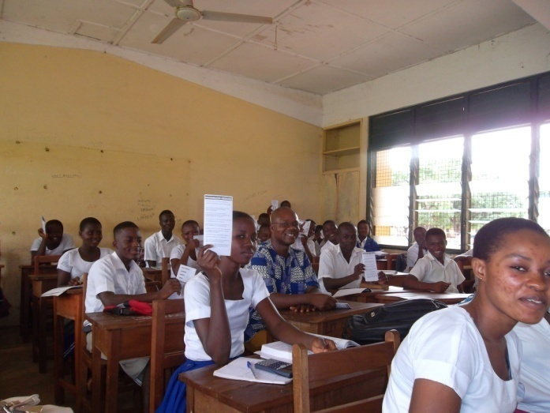
Plate 1 Students reading through the brochure after interaction
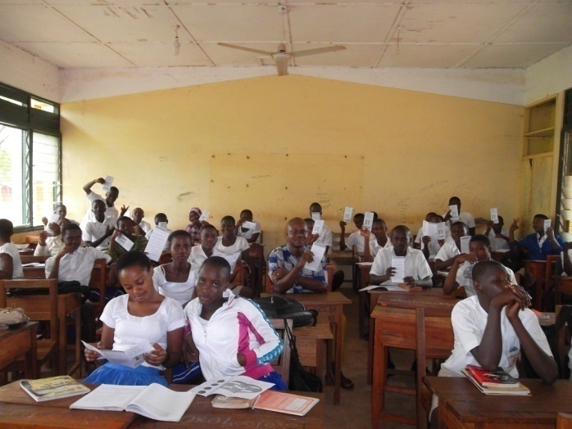
Plate 2 Students observing the brochure after interaction
After going through the lessons designed for the two (2) weeks for the students in the school, some improvements were reported. According to the guidance and counselling coordinators, the intervention of face-to-face interaction between the researchers and the students resulted in a remarkable improvement in the patronage of guidance and counselling services. As the guidance counselling coordinators reported after the intervention sessions, their students had begun accessing the services with at least ten students coming for the term, as compared to two students per a term previously as Figure 2 depicts.

Figure 2: Interventional Result
The result that was achieved through the implementation of the intervention programme which centred on interaction with the students, and giving them designed brochure which was easy to understand. This indicates that providing additional information probably by external resource persons could generate more interest for guidance and counselling services among Senior High Schools students. This also shows that bringing resource persons who have professional knowledge of guidance and counselling as was the case of the researchers. The intervention result was improved from two (2) students attending for counselling a term to ten (10) a term. This is why it is important that schools have professional counsellors whose duty would not include teaching.
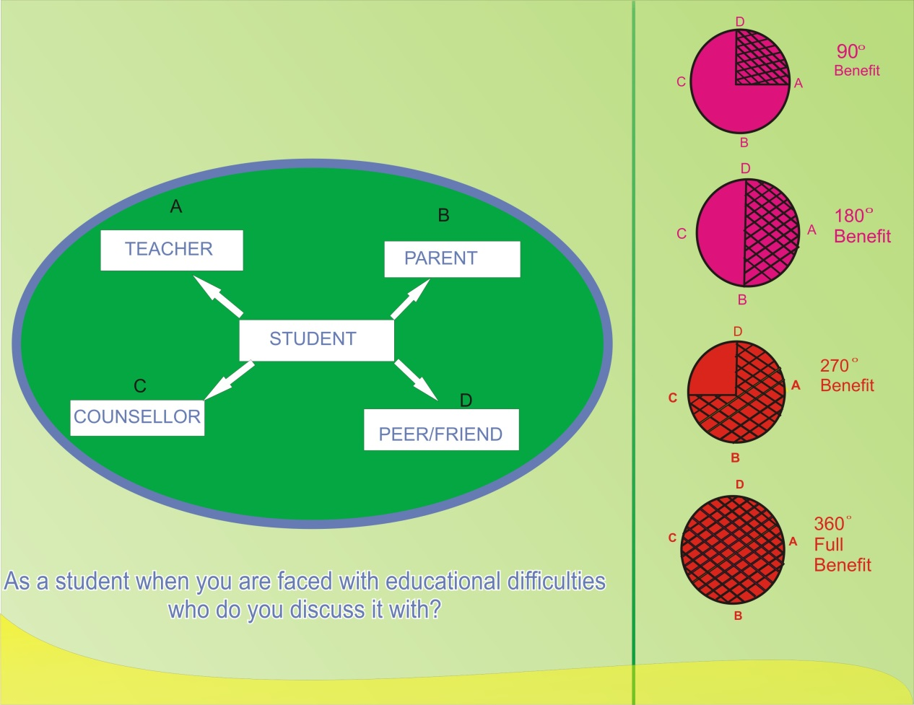
Plate 3 Brochures Designed for Students

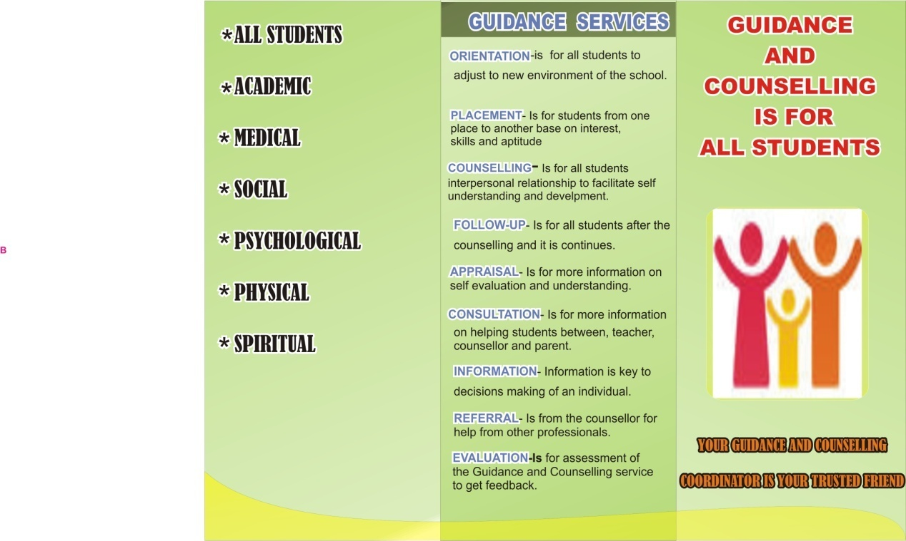
Plate 4 Brochures Designed for Students

Conclusions
Interactions with the students in the school helped the intervention programme which led to an improvement in students accessing of guidance and counselling services. The recommendations made pointed to the need for guidance and counselling coordinators making efforts to provide additional information to help their students to understand the types of guidance services available and to encourage the students to access them. There is also the need for the Ghana Education Service to train teachers to gain professional knowledge and skills in guidance and counselling so they can serve their students better.

Recommendations
- It is necessary for all stakeholder’s Headmasters/mistresses, Teachers and the Parent-Teacher Associations (PTA) to offer maximum support in whatever form necessary to help guidance and counselling coordinators perform their duties effectively.
- Students with deviant behaviour should not be dismissed but must be referred to guidance and counselling coordinators for assistance.
- Guidance and counselling programmes should be evaluated periodically by School Authorities to allow for recommendations and implementation of new ideas to improve the system.
- Counsellors should be helped to upgrade their knowledge and skill to get them committed in the performance of their duties.

COMPETING INTERESTS DISCLAIMER:
Authors have declared that they have no known competing financial interests OR non-financial interests OR personal relationships that could have appeared to influence the work reported in this paper.

Disclaimer (Artificial intelligence)
Option 1:
Author(s) hereby declare that NO generative AI technologies such as Large Language Models (ChatGPT, COPILOT, etc.) and text-to-image generators have been used during the writing or editing of this manuscript.
Option 2:
Author(s) hereby declare that generative AI technologies such as Large Language Models, etc. have been used during the writing or editing of manuscripts. This explanation will include the name, version, model, and source of the generative AI technology and as well as all input prompts provided to the generative AI technology
Details of the AI usage are given below:
1.
2.
3.

References
Alemu, Y. (2013). Assessment of the provisions of guidance and counseling services in
secondary schools of East Harerge Zone and Hareri Region, Ethiopia. Middle
Eastern & African Journal of Educational Research, (2).
Arumugam, A., & Shanmugavelu, G. (2021). Importance of guidance and counselling in the
school educational system: An overview. International Journal of
Multidisciplinary Research (IJMR), 7(8).
Aspers, P., & Ugo, C. (2019). What is qualitative in quantitative research? Qualitative Sociology,
42, 139–160. https://doi.org
Band, B. (2015). The Boundless. The School Librarian, 63(1), 56.
Bedu-Addo, P. K. A. (2006). Guidance and Counselling “Unmasked”. Accra-Ghana: Type
Company Limited.
Bell, J. (2010). Doing your research project: A guide for first time researchers in education,
health and social science. Singapore: Markona Print Media Pie Limited.
Brookhart, S. M. (2011). Educational assessment knowledge and skills for teachers. Education
Measurement and Practice, 30(1), 3–12.
Carme, R. (2019). Eucen Studies. EJournal of University Lifelong Learning. 3(1).
Carkhuff, R. R. (2000). The art of helping in the 21st century. Human Resource Development,
8.
Christensen, G., & Larsen, M. S. (2011). Evidence on guidance and counselling. Retrieved from http://www.dpu.dk/fileadmin/www.dpu.dk/aboutdpu/clearinghouse/UK_viden_om_vejledning.
Edmonds, S. W., Samantha, L. S., & Nicole, C. W. (2016). Understanding preferences for
osteoporosis information to develop an osteoporosis patient education brochure. The
Permanente Journal.
Frempong, F. E. (2013). Factors affecting the implementation of guidance and counselling
service in selected colleges of education in Ghana (Master’s thesis). University of
Cape Coast.
Getachew, A. (2020). Assessment of guidance and counselling service centre in higher education
institutions: A qualitative research. International Journal of School and Cognitive
Psychology.
Ghana Statistical Service. (2013). Ghana Living Standards Survey (Round 6). Retrieved from
www.statsghana.gov.gh/surveys.html
Kokro, F. K., Ahmoah, J. D., & Agyeman, E. P. (2022). Evaluation of the guidance and
counseling services in Tamale Technical University, Tamale in the Northern
Region, Ghana. Quest Journals Journal of Research in Humanities and Social
Science 10(4), 39–44.
Kumfo, N. K. (2009). The impact of guidance and counselling services on academic
performance on student (Master’s thesis). University of Cape Coast, Ghana.
http://ir.ucc.edu.gh/dspace.
Kusi, H. (2012). Doing qualitative research: A guide for research. Accra New Town: Emmpong
Press.
Nkala, P. P. (2014). An assessment of the guidance and counselling programme in secondary
schools at Mzilikazi District in Bulawayo Metropolitan Province. IOSR Journal of
Humanities and Social Science (IOSR-JHSS), 19(1), Ver. III.
Osuoha, J. (2024). Assessment of the impact of guidance and counselling on academic
performance and discipline among junior secondary school students (A study of
Federal Capital Territory in Abuja). Global Academic Journal of Humanities
and Social Sciences.
Ritichie, J., & Lewis, J. (2003). Qualitative research practice: A guide for social science students.
London: SAGE Publications.
Semenenko, V. (2013). Developing effective marketing brochure (Bachelor’s thesis). HAAGA–
HELIA University of Applied Science.
Uzunboylu, H., & Özmen, S. (2021). Research orientations related to guidance and counselling programmes: A content analysis study. Anales de Psicología / Annals of Psychology, 37, 88–100.

