Assessment of The Accuracy of Ultrasonography for Measuring Tumor Thickness in Patients with Oral Cancer

ABSTRACT
BACKGROUND: Oral squamous cell carcinoma is the most prevalent malignancy in the head and neck area, arising from various sites, including the lip, tongue, gingiva, cheek, and floor of the mouth. As the tumours grow, they invade the adjacent tissues and can spread to the cervical lymph nodes.
AIM
To assess the effectiveness of Ultrasonography (USG) in measuring Tumour Thickness (TT) in patients diagnosed with Oral Squamous Cell Carcinoma (OSCC).
METHODOLOGY
The study included eighteen cases of oral squamous cell carcinoma confirmed by biopsy. Tumour Thickness (TT) was measured for each patient using intra-oral Ultrasonography (USG) with a 4 -9 MHz conventional linear probe, from the tumour’s surface to the deepest point of invasion, prior to surgery. After the tumour specimen was sectioned, histopathological evaluation was conducted to measure tumour thickness postoperatively. A comparison was made between the preoperative and postoperative Tumour thickness measurements.
RESULTS
A statistically significant difference was observed between the tumour thickness values obtained preoperatively (USG) and postoperatively (HISTOPATHOLOGY), with a p value of 0.001. The average tumour thickness recorded preoperatively via USG was 1.12cm, while postoperatively via histopathology it was 1.62cm. This shows an average discrepancy of 0.5cm in tumour thickness between the two methods.
CONCLUSION
The findings of this study demonstrated that USG imaging accurately assesses Tumour thickness prior to surgery in cases of oral squamous cell carcinomas, suggesting a high potential for its use as a cost-effective and lower radiation alternative to other imaging modalities like MRI and CT in clinical settings. It is recommended to advocate for the use of ultrasonographic imaging as a standard diagnostic method for various maxillofacial conditions, which can help facilitate early diagnosis and treatment planning essential for improved patient care.
KEY WORDS: Oral squamous cell carcinoma, ultrasonography, histopathological findings, tumour thickness.

INTRODUCTION
Squamous cell carcinoma (SCC) of the oral and maxillofacial region is a potentially life-threatening malignancy due to its invasiveness into the orofacial and neck vital structures. Oral SCC is the most common carcinoma of the oral cavity and has been ranked the 12th most common cancer worldwide (Mujtaba et al., 2023; Mfutu Mana et al., 2022). Oral squamous cell carcinoma is the most prevalent malignancy in the head and neck area, arising from various sites, including the lip, tongue, gingiva, cheek, and floor of the mouth. As the tumours grow, they invade the adjacent tissues and can spread to the cervical lymph nodes¹⁻². This spread is attributed to the filtering function of the lymphatic system, which captures cancer cells and plays a crucial role in their dissemination to other organs³. Oral cancer is a growing problem, accounting for 377,713 new cases worldwide per year, and 177,757 deaths annually and representing a 5-year mortality rate close to 50%, which is a considerable mortality that has not decreased substantially in the last 40 years (González-Moles et al., 2022). Oral cancers are generally accessible for examination; however, they are often diagnosed at advanced stages, leading to increased mortality and morbidity rates. Advances in our understanding of cancer, along with the development of promising technologies that assist clinicians in detection, risk assessment, and management, have improved patient prognoses. Tumour Thickness (TT) has been identified as a contributing factor for nodal metastasis and is considered a potential prognostic indicator for overall patient survival. Various preoperative methods have been utilised to evaluate tumour thickness in oral cancers, such as CECT, MRI, Ultrasonography, and the gold standard histopathological examination⁴. Due to the radiation exposure and costs associated with CECT and MRI, Ultrasonography serves as a more economical and less invasive approach for determining the depth of invasion preoperatively⁵. Therefore, this newly designed study aims to evaluate the reliability of Ultrasonography in estimating tumour thickness prior to surgery and to compare it with histopathological tumour thickness.
AIM AND OBJECTIVES
AIM
Assess the effectiveness of Ultrasonography (USG) in evaluating Tumour Thickness (TT) in patients with oral cancer.
OBJECTIVES
I. To measure the tumour thickness using Ultrasonography (USG) prior to surgery.
II. To determine the tumour thickness based on postoperative histopathological analysis.
III. To evaluate the accuracy and dependability of tumour thickness measurements derived from ultrasonography preoperatively compared to postoperative histopathological results.

METHODOLOGY
ULTRASONOGRAPHY (USG):
Ultrasound measurements were conducted with a 4 -9 MHz conventional linear probe, utilising a sterile cover for patients diagnosed with oral cancer via biopsy. Tumour thickness (TT) was gauged from the surface of the tumour to the furthest point of invasion for protruding lesions; for ulcerative lesions, an imaginary line connecting the normal mucosa at both ends of the ulcerated area was drawn, and the deepest invasion point was measured.
HISTOPATHOLOGY:
Post resection, the specimen was preserved in formalin and promptly sent to the Pathology Department for sectioning. Specimen dimensions, tumour measurements (excluding thickness), and margins (other than deep clear margins) were recorded prior to sectioning. The cut sections were then assessed for tumour thickness, with the pathologist unaware of USG findings. The histopathological results were compared with those obtained via ultrasonography (USG).
PROCEDURE
Biopsy-confirmed instances of oral cancer were included in the study. Pre-operatively, Tumour Thickness (TT) was documented using intra-oral Ultrasonography (USG). After surgery, the specimen was sent for histopathological analysis to measure the tumour thickness with a Vernier Calliper. The preoperative and postoperative measurements were then compared.
STUDY SETTING
The research was conducted at Yenepoya Dental College and the Oncology department of Yenepoya Medical College and Hospital.
SAMPLE SIZE
The sample size was determined using G*Power software. Based on previous studies and an assumed correlation of 0.678 between Ultrasonography (USG) and Histopathology, a minimum of 18 patients was necessary to detect a clinically significant difference with a power of 95% and a significance level of 5%. Consequently, the study group will consist of 18 patients.
INCLUSION CRITERIA
I. Patients who provide informed consent for the study.
II. Primary oral carcinoma patients with soft tissue involvement only.
III. Primary oral carcinoma patients who are willing to undergo surgical treatment.
IV. Patients who are deemed fit for surgery.
EXCLUSION CRITERIA
I. Patients who have previously undergone surgery, radiotherapy, or chemotherapy.
II. Patients with oral carcinoma exhibiting hard tissue involvement.
III. Patients who do not provide consent.
RESULTS

Table 1. Patient characteristics and tumour thickness comparison
Patient No. | Sex | Age (yrs) | Tumour Stage | Tumour Thickness (USG, cm) | Tumour Thickness (Histopathology, cm) | Difference (HP – USG, cm)
1 | Male | 50 | T4a | 1.2 | 1.5 | 0.3
2 | Female | 66 | T2 | 1.0 | 1.2 | 0.2
3 | Male | 36 | T2 | 1.0 | 1.1 | 0.1
4 | Female | 68 | T2 | 0.6 | 1.0 | 0.4
5 | Male | 40 | T2 | 0.7 | 1.5 | 0.8
6 | Male | 33 | T2 | 1.4 | 1.5 | 0.1
7 | Male | 56 | T3 | 1.5 | 2.0 | 0.5
8 | Male | 48 | T3 | 1.6 | 3.0 | 1.4
9 | Male | 39 | T3 | 1.9 | 2.8 | 0.9
10 | Male | 55 | T4a | 3.7 | 3.6 | -0.1
11 | Male | 53 | T2 | 0.4 | 0.8 | 0.4
12 | Male | 36 | T3 | 0.6 | 1.0 | 0.4
13 | Male | 52 | T2 | 0.4 | 0.5 | 0.1
14 | Female | 58 | T3 | 1.0 | 1.0 | 0.0
15 | Male | 41 | T4a | 0.6 | 2.4 | 1.8
16 | Male | 59 | T2 | 1.1 | 0.9 | -0.2
17 | Male | 48 | T3 | 0.4 | 1.6 | 1.2
18 | Male | 40 | T3 | 1.1 | 1.8 | 0.7

Table 2. Comparison of tumour thickness (USG vs. Histopathology)
Parameter | USG (Preoperative) | Histopathology (Postoperative) | Test Statistics
Median (cm) | 1.0 | 1.5 | Z = –3.249
Interquartile Range (IQR) | 0.8 | 1.1 | p = 0.001 (significant)
Mean (cm) | 1.12 | 1.62 | —
Mean Difference (cm) | –0.50 | — | —

Table 3. Patient demographics and tumour stage distribution (n = 18)
Variable | Category | n | Percentage (%)
Sex | Male | 15 | 83.3
 | Female | 3 | 16.7
Age (years) | <40 | 4 | 22.2
 | 40–49 | 5 | 27.8
 | 50–59 | 6 | 33.3
 | ≥60 | 3 | 16.7
Tumour Stage | T2 | 7 | 38.9
 | T3 | 7 | 38.9
 | T4a | 4 | 22.2

Figure 1. Boxplot of tumour thickness (USG vs. Histopathology)
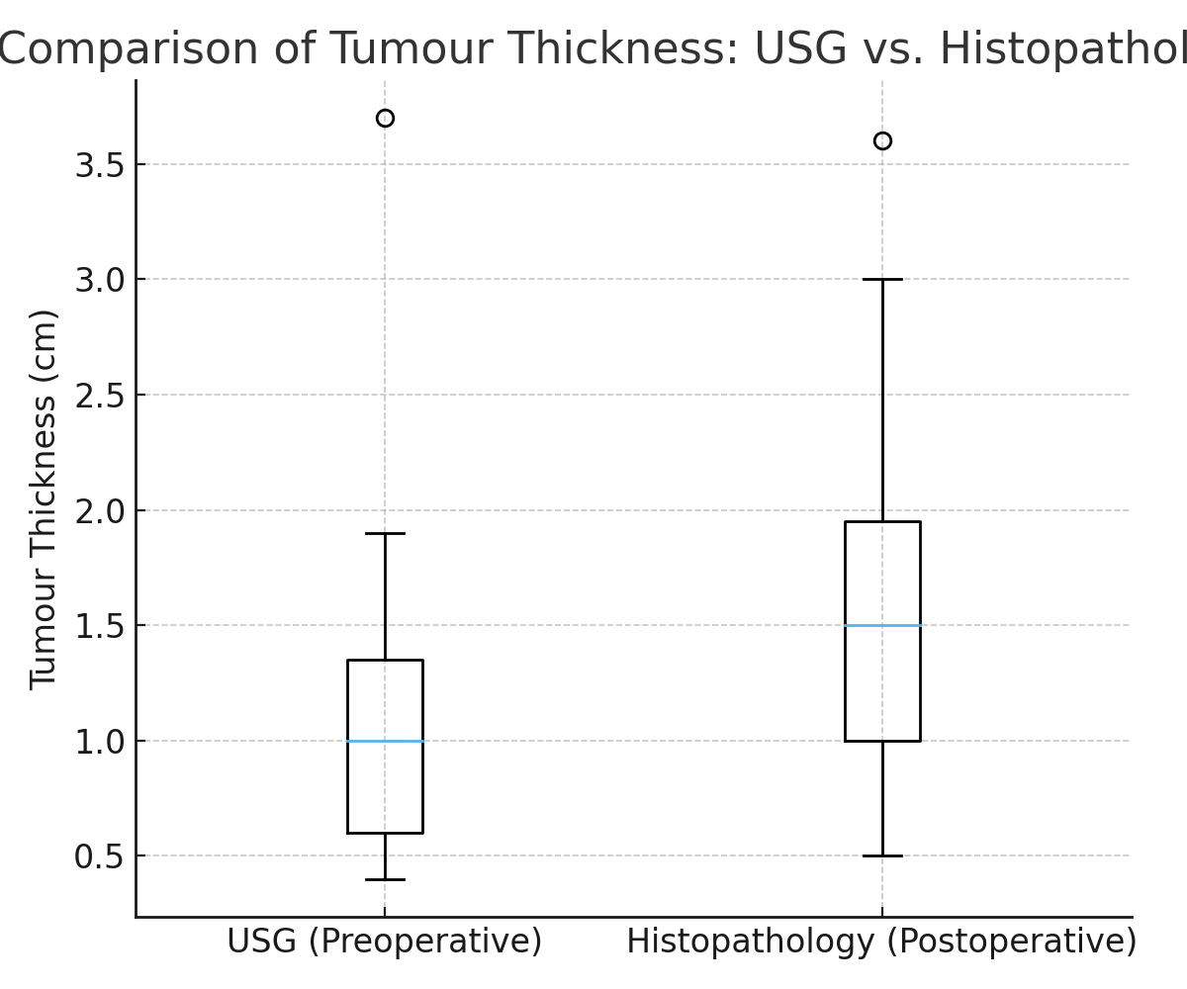

Figure 2. Scatter plot of tumour thickness (USG vs. Histopathology)
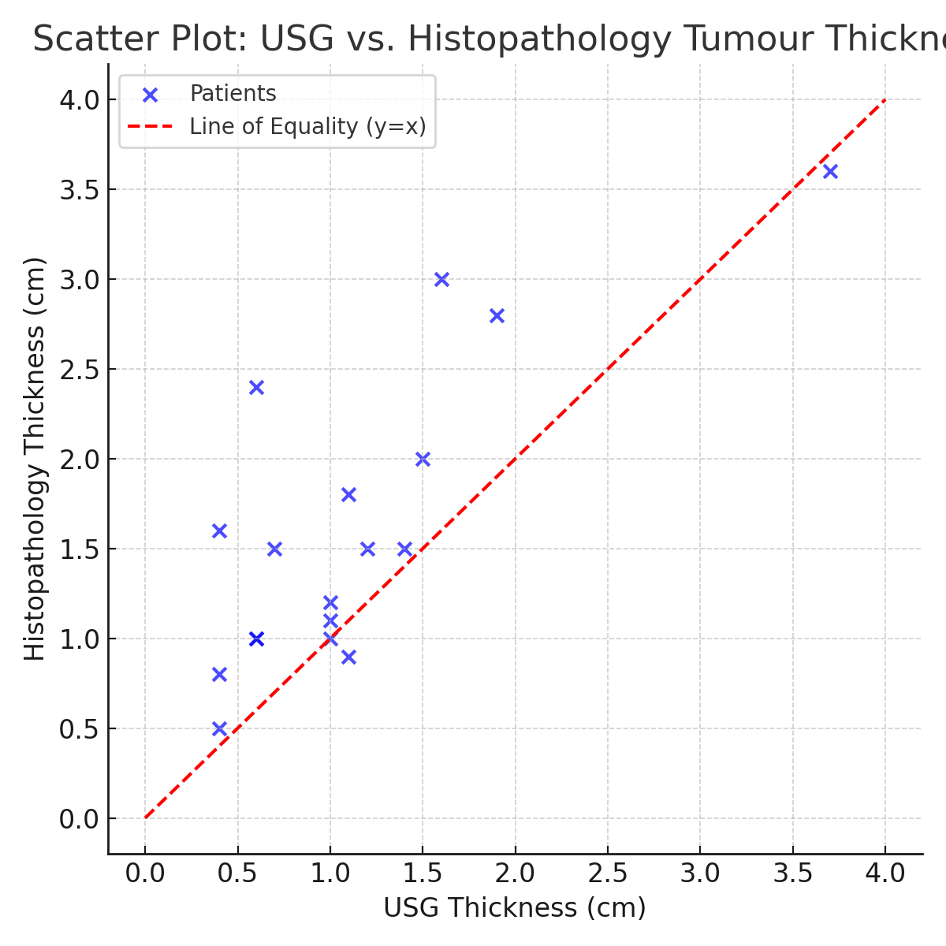
A total of 18 patients with histopathologically confirmed oral squamous cell carcinoma were included in the study. The cohort comprised 15 males (83.3%) and 3 females (16.7%), with a mean age of 49.9 years (range: 33–68 years). Tumour stage distribution revealed 7 cases each of T2 and T3 (38.9% each) and 4 cases of T4a (22.2%).
Preoperative ultrasonography (USG) measurements demonstrated a mean tumour thickness of 1.12 cm, compared to a mean of 1.62 cm measured on postoperative histopathology, with an average underestimation of 0.5 cm by USG. The median tumour thickness was 1.0 cm (IQR = 0.8) on USG and 1.5 cm (IQR = 1.1) on histopathology.
The Shapiro–Wilk test confirmed non-normal distribution of the data (p < 0.05); therefore, the Wilcoxon signed-rank test was applied. A statistically significant difference was found between USG and histopathology measurements (Z = –3.249, p = 0.001).
Boxplot analysis demonstrated consistently higher histopathological values compared to USG, while scatter plot analysis showed that most values lay above the line of equality, indicating a systematic underestimation by USG.
Overall, USG underestimated tumour thickness compared to the histopathological gold standard, but the difference remained consistent across cases, suggesting its reliability as a preoperative assessment tool.
Table 4: Summary of IOUS Studies in OSCC for Tumour Thickness and DOI Assessment
No. | Author(s) | Year | Journal | Sample Size / Tumour Type | Method | Key Findings on Tumour Thickness / DOI
1 | Shintani S, Yoshihama Y, Ueyama Y, et al. | 2001 | Int J Oral Maxillofac Surg | 26 OSCC | IOUS | IOUS useful in measuring tumour thickness; correlated with histopathology.
2 | Songra AK, Ng SY, Farthing P, et al. | 2006 | Int J Oral Maxillofac Surg | 30 OSCC | IOUS | Tumour thickness and margins assessed preoperatively; IOUS effective for surgical planning.
3 | Nulent TJ, Noorlag R, Van Cann EM, et al. | 2018 | Oral Oncol | Systematic review | IOUS | IOUS accurately measures tumour thickness; pooled correlation with histopathology is high.
4 | Nair AV, Meera M, Rajamma BM, et al. | 2018 | Indian J Radiol Imaging | 25 early tongue OSCC | IOUS | Preoperative IOUS guides management; strong correlation with histopathology.
5 | Yoon BC, Bulbul MD, Sadow PM, et al. | 2020 | AJNR Am J Neuroradiol | 20 tongue OSCC | Intraoperative US | IOUS correlates closely with histopathologic tumour thickness and DOI.
6 | Rocchetti F, Tenore G, Montori A, et al. | 2021 | Oral Surg Oral Med Oral Pathol Oral Radiol | 42 OSCC | IOUS | Retrospective study; IOUS accurately predicts DOI preoperatively.
7 | Filauro M, Missale F, Marchi F, et al. | 2021 | Eur Arch Otorhinolaryngol | 48 OSCC | IOUS vs MRI | IOUS comparable to MRI in DOI assessment; closer correlation with histopathology.
8 | Takamura M, Kobayashi T, Nikkuni Y, et al. | 2022 | Oral Radiol | 35 T1/T2 tongue OSCC | IOUS vs MRI/CT | IOUS provided the most accurate DOI measurement among imaging modalities.
9 | de Koning KJ, van Es RJ, Klijn RJ, et al. | 2022 | Oral Oncol | 30 tongue OSCC | IOUS-guided resection | IOUS-guided surgery improved margin control; accurate DOI assessment.
10 | Marcello Scotti F, Stuepp RT, Leonardi Dutra-Horstmann K, et al. | 2022 | Dentomaxillofac Radiol | Systematic review | IOUS vs MRI/CT | IOUS is highly accurate for thickness and DOI; superior to CT, comparable to MRI.

This table summarises key studies on the use of intraoral ultrasonography (IOUS) for evaluating tumour thickness and depth of invasion (DOI) in oral squamous cell carcinoma (OSCC). The studies span from 2001 to 2022 and include both prospective, retrospective, and systematic review designs. Sample sizes vary from 20 to over 40 patients, focusing primarily on early-stage tongue cancers. All studies report a strong correlation between IOUS measurements and histopathology, demonstrating IOUS as an accurate, non-invasive, and reliable tool for preoperative assessment, surgical planning, and margin control. Comparisons with MRI and CT in later studies highlight that IOUS is often superior or comparable, especially for measuring DOI in small tumours.
DISCUSSION
Assessing the precise measurement of tumour thickness serves as a guideline for the elective treatment of oral squamous cell carcinomas, helping to avoid failures in achieving local or regional disease control. Tumour thickness has emerged as a dependable prognostic indicator for predicting regional nodal metastasis, backed by a growing body of literature. Multivariate analyses indicate that tumour thickness is the most significant factor influencing patient survival in OSCC⁶.
This study aimed to compare the effectiveness of ultrasonography in determining tumour thickness before surgery and histopathological thickness afterwards in 18 confirmed cases of OSCC. The average preoperative tumour thickness measured by ultrasonography was 1.12 cm, while the postoperative thickness assessed through histopathology was 1.62 cm. The average discrepancy in tumour thickness between ultrasonography and histopathology was 0.5 cm, indicating a very small and clinically acceptable variation in measurements obtained via ultrasonography. Therefore, our study is statistically significant in supporting the notion that ultrasonography is a reliable technique for assessing tumour thickness in oral cancer patients, particularly when compared to histopathological examination, which is regarded as the gold standard⁷.
The American Joint Committee on Cancer (AJCC) introduced significant updates in the eighth edition of oral cancer staging. The previous seventh edition of staging and treatment planning focused solely on the anatomical extent of cancer. In contrast, the eighth edition incorporated substantial modifications to the staging of OSCC by including the depth of invasion (DOI) alongside tumour thickness, contributing to enhanced prognostication⁸⁻¹⁰.
In the context of oral cavity squamous cell carcinoma, both tumour thickness (TT) and depth of invasion (DOI) serve as independent prognostic factors. While these terms are occasionally used interchangeably, they possess distinct formal definitions. Specifically, TT measures the distance from the surface of the tumour to the deepest invasion point, whereas DOI assesses the tumour's invasiveness, defined from the nearby normal mucosal basement membrane to the lowest point of invasion. The eighth edition of the AJCC tumour node metastasis (TNM) classification has made a clear distinction between both terms and has included DOI in the OSCC T-classification to acknowledge its prognostic significance and clinical importance. Since histopathological evaluation is considered the gold standard due to its capability of ensuring clear surgical margins, it is essential for evaluating both TT and DOI¹¹.
Numerous studies report tumour thickness assessment via intraoral ultrasonography, specifically targeting tumours located on the tongue, floor of the mouth, buccal mucosa, and other accessible areas of the oral cavity. Alternative imaging techniques such as computed tomography (CT) and magnetic resonance imaging (MRI), along with palpation, are also advantageous for determining the extent of tumour metastasis in oral cancers¹². However, a comparative clinical study conducted by Shintani et al. in 2001 evaluated 39 oral cancer patients preoperatively using intraoral ultrasonography, CT, and MRI, revealing that tumours under 5.0 mm in thickness could not be detected with CT and MRI, highlighting ultrasonography's superiority in estimating tumour thickness¹³.
MRI and CT scans seem to be less effective in accurately measuring the thickness of thin tumours, whereas intraoral ultrasound offers precise tumour mapping. The prior limitations regarding the evaluation of oral carcinomas through extra-oral ultrasound measurements have been resolved by employing high-resolution intraoral probes. Recent studies utilising intraoral ultrasound imaging have proven to be particularly helpful in assessing tumour thickness in oral carcinoma. The ease of use of diagnostic ultrasound stems primarily from its non-invasive nature, which does not involve ionising radiation, is quick to carry out, and can often be repeated. The portability of the probes allows them to be taken into the operating room, enabling real-time imaging even during surgical interventions¹¹⁻¹⁴.
Our research aimed to propose a simple method for utilising ultrasonography to measure tumour thickness in 18 confirmed cases of OSCC affecting the tongue, floor of the mouth, and other regions accessible via the ultrasound probe, with a minor discrepancy of 0.5 cm compared to the gold standard histopathological assessment of tumour thickness. Additionally, the noted discrepancy might be attributed to the following factors:
1. The histopathological and ultrasonographic measurements were not taken at precisely the same location, with USG serving as a pre-operative prognostic tool while the histopathological measurement occurred postoperatively.
2. Variations in the marking of tumour margins in the specimens.
3. A minor compression often exerted on the surface by the ultrasound probe might contribute to an underestimation of tumour thickness.
In a comparative study conducted by Shintani et al. in 1997, the assessment of tumour thickness revealed that when ultrasound and MRI were correlated with histopathological measurements, ultrasound demonstrated a good correlation, whereas MRI failed to show a direct alignment with histopathological thickness. In a more recent meta-analysis by Marchi et al. in 2020, both MRI and intraoral US were found to be effective methods for determining depth of invasion/tumour thickness in oral squamous cell carcinoma prior to surgical intervention. Interestingly, it was found that intraoral US examinations had higher pooled r and r-to-z transformed values, suggesting that this method may be more closely related to histopathological findings. From this and other research, it is evident that ultrasonography is a more dependable technique for measuring tumour thickness and is sufficiently useful in clinical and surgical settings¹⁵.
In a comparative study conducted by Yoon et al. in 2021, preoperative tumour thickness assessment was performed using CT and USG and compared to histopathological tumour thickness postoperatively, particularly for OTSCC tumours smaller than 10 mm, which do not provide accurate results with CT in OTSCC evaluations. Specifically, for small tumours, USG serves as a valuable additional imaging tool with a unique role in primary tumour assessment, potentially aiding in preoperative planning¹⁶.
Despite our encouraging results, there are several limitations linked to ultrasonography that need to be addressed. Occasionally, false-positive or false-negative readings occur due to sudden alterations in the muscular layers surrounding the tumour or the presence of microscopic growths, such as perineural invasion near the tumour site. Proficiency and expertise are crucial to discerning between tumour thickness and depth of invasion during tumour staging, since the exophytic portion of the tumour can only be detected when the probe applies minimal pressure on the metastatic site¹⁷.

CONCLUSION
Oral squamous cell carcinoma (OSCC) is one of the most common types of malignant tumours found in the oral cavity, associated with lower survival rates. A variety of preoperative techniques, including ultrasonography, computed tomography (CT), and MRI, have been developed to evaluate tumour thickness, though they yield varying results compared to the histopathological evaluation, which is considered the gold standard. Most research indicates that ultrasound is more effective for measuring tumour thickness than CT and MRI, largely due to its lack of harmful ionising radiation effects.
The findings from our study suggest that ultrasound imaging could serve as the primary method for assessing oral tumour thickness, enhancing the feasibility of surgical procedures in early-stage cases and demonstrating broad applicability across various disease stages and tumor types, including vascular neoplasms, cancers, and nodal metastases, as well as salivary gland pathologies, in a safe, non-invasive, and cost-effective manner.
Furthermore, this study highlights the accuracy of USG imaging prior to surgery in oral squamous cell carcinomas classified as stages T2, T3, and T4a, and the strong potential for it to be a more economical alternative to MRI and CT in clinical settings. It is recommended to advocate for the use of ultrasonographic imaging as a standard diagnostic method for various maxillofacial conditions, which can help facilitate early diagnosis and treatment planning essential for improved patient care.
Consent
As per international standards or university standards, patient(s) written consent has been collected and preserved by the author(s).
Disclaimer (Artificial intelligence)
Option 1:
Author(s) hereby declare that NO generative AI technologies such as Large Language Models (ChatGPT, COPILOT, etc.) and text-to-image generators have been used during the writing or editing of this manuscript.
Option 2:
Author(s) hereby declare that generative AI technologies such as Large Language Models, etc. have been used during the writing or editing of manuscripts. This explanation will include the name, version, model, and source of the generative AI technology and as well as all input prompts provided to the generative AI technology
Details of the AI usage are given below:
1.
2.
3.

REFERENCES
- Shintani S, Yoshihama Y, Ueyama Y, Terakado N, Kamei S, Fijimoto Y, et al. The usefulness of intraoral ultrasonography in the evaluation of oral cancer. Int J Oral Maxillofac Surg. 2001 Apr;30(2):139–43.
- O-charoenrat P, Pillai G, Patel S, Fisher C, Archer D, Eccles S, et al. Tumour thickness predicts cervical nodal metastases and survival in early oral tongue cancer. Oral Oncol. 2003 Jun;39(4):386–90.
- O'Brien CJ, Lauer CS, Fredricks S, Clifford AR, McNeil EB, Bagia JS, et al. Tumor thickness influences prognosis of T1 and T2 oral cavity cancer—but what thickness? Head Neck. 2003 Nov;25(11):937–45.
- Haberal I, Çelik H, Göçmen H, Akmansu H, Yörük M. Which is important in the evaluation of metastatic lymph nodes in head and neck cancer: palpation, ultrasonography, or computed tomography? Otolaryngol Head Neck Surg. 2004 Feb;130(2):197–201.
- Sparano A, Weinstein G, Chalian A, Yodul M, Weber R. Multivariate predictors of occult neck metastasis in early oral tongue cancer. Otolaryngol Head Neck Surg. 2004 Oct;131(4):472–6.
- Pentenero M, Gandolfo S, Carrozzo M. Importance of tumor thickness and depth of invasion in nodal involvement and prognosis of oral squamous cell carcinoma: a review of the literature. Head Neck. 2005 Dec;27(12):1080–91.
- Songra AK, Ng SY, Farthing P, Hutchison IL, Bradley PF. Observation of tumour thickness and resection margin at surgical excision of primary oral squamous cell carcinoma—assessment by ultrasound. Int J Oral Maxillofac Surg. 2006 Apr;35(4):324–31.
- Blatt S, Ziebart T, Krüger M, Pabst AM. Diagnosing oral squamous cell carcinoma: how much imaging do we really need? A review of the current literature. J Craniomaxillofac Surg. 2016 May;44(5):538–49.
- Nulent TJ, Noorlag R, Van Cann EM, Pameijer FA, Willems SM, Yesuratnam A, et al. Intraoral ultrasonography to measure tumor thickness of oral cancer: a systematic review and meta-analysis. Oral Oncol. 2018 Feb;77:29–36.
- Nair AV, Meera M, Rajamma BM, Anirudh S, Nazer PK, Ramachandran PV. Preoperative ultrasonography for tumor thickness evaluation in guiding management in patients with early oral tongue squamous cell carcinoma. Indian J Radiol Imaging. 2018 Apr;28(2):140–5.
- Yoon BC, Bulbul MD, Sadow PM, Faquin WC, Curtin HD, Varvares MA, et al. Comparison of intraoperative sonography and histopathologic evaluation of tumor thickness and depth of invasion in oral tongue cancer: a pilot study. AJNR Am J Neuroradiol. 2020 Jul;41(7):1245–50.
- Rocchetti F, Tenore G, Montori A, et al. Preoperative evaluation of tumor depth of invasion in oral squamous cell carcinoma with intraoral ultrasonography: a retrospective study. Oral Surg Oral Med Oral Pathol Oral Radiol. 2021;131(1):130–8. doi:10.1016/j.oooo.2020.07.003
- Filauro M, Missale F, Marchi F, et al. Intraoral ultrasonography in the assessment of DOI in oral cavity squamous cell carcinoma: a comparison with magnetic resonance and histopathology. Eur Arch Otorhinolaryngol. 2021 Aug;278(8):2943–52.
- de Koning KJ, Koppes SA, de Bree R, et al. Feasibility study of ultrasound-guided resection of tongue cancer with immediate specimen examination to improve margin control–comparison with conventional treatment. Oral Oncol. 2021 May;116:105249.
- Takamura M, Kobayashi T, Nikkuni Y, et al. A comparative study between CT, MRI, and intraoral US for the evaluation of the depth of invasion in early stage (T1/T2) tongue squamous cell carcinoma. Oral Radiol. 2022 Jan;38(1):114–25.
- de Koning KJ, van Es RJ, Klijn RJ, et al. Application and accuracy of ultrasound-guided resections of tongue cancer. Oral Oncol. 2022 Oct;133:106023.
- Marcello Scotti F, Stuepp RT, Leonardi Dutra-Horstmann K, et al. Accuracy of MRI, CT, and ultrasound imaging on thickness and depth of oral primary carcinomas invasion: a systematic review. Dentomaxillofac Radiol. 2022 Jul;51(5):20210291. doi:10.1259/dmfr.20210291
18. Mujtaba, B., Braimah, R. O., Taiwo, A. O., Alyami, B., Aliyu, B. M., Kanmodi, K. K., Abubakar, S. F., Kaura, A. M., Yekini, L. A., & Yabo, S. U. (2023). Squamous cell carcinoma in the oral and maxillofacial region: A 12-year analysis at a tertiary healthcare facility from North-Western Nigeria. Journal of Cancer and Tumour International, 13(3), 19–27. 19. Mfutu Mana, C., Sekele, I. J.-P., Ngbolua, K.-T.-N., Situakibanza, N.-T. H., Kamangu, N. E., Alifi, P. B., Nzudjom, F. A., Monizi, M., Kitete, E. M., Nanou, T. M., Mpiana, P. T., & Pakasa, M. N. (2022). Review of the literature on oral cancer: Epidemiology, management and evidence-based traditional medicine treatment. Annual Research & Review in Biology, 37(6), 15–27.
González-Moles, M. Á., Aguilar-Ruiz, M., & Ramos-García, P. (2022). Challenges in the early diagnosis of oral cancer, evidence gaps and strategies for improvement: a scoping review of systematic reviews. Cancers, 14(19), 4967.

