Agro-Economic Evaluation of Lime and Tithonia diversifolia Biomass for Reducing Empty Pods in Groundnut on Acidic Ferralsols of Kenge, DRC.
Abstract
This study investigated the effects of lime and Tithonia diversifolia leaf biomass on the reduction of empty pods in groundnut (Arachis hypogaea L.) grown on acidic sandy soils in the grassland savanna of Kenge, Democratic Republic of Congo. A 2 × 3 factorial split-plot design with three replicates was used. Factor 1 consisted of two groundnut varieties (Local and G17), and factor 2 included soil amendments: lime, T. diversifolia leaves, and an untreated control. The experiment was conducted at the Faculty of Agronomic and Environmental Sciences, University of Kwango (4°50’10.4’’ S, 17°01’23.8’’ E; 532 m a.s.l.).
Results showed significant differences among treatments for dry pod yield, number of empty pods, 1000-seed weight, and dry seed yield. Dry pod yields were 4.0 t·ha⁻¹ with lime, 3.8 t·ha⁻¹ in the control, and 3.6 t·ha⁻¹ with Tithonia amendment (LSD₀.₀₅ = 0.66 t·ha⁻¹, P = 0.01, CV = 15.7%). Dry seed yields ranged from 2.4 t·ha⁻¹ to 2.5 t·ha⁻¹, with 2.5 t·ha⁻¹ for lime, and 2.4 t·ha⁻¹ for both control and Tithonia (LSD₀.₀₅ = 0.67 t·ha⁻¹, P = 0.05, CV = 23.9%). Empty pod formation averaged 5 pods per plant in the control, 0.5 with lime, and 3 with Tithonia (LSD₀.₀₅ = 0.33, P = 0.01, CV = 0.78).
Economic analysis based on the marginal rate of return (MRR) and cost–benefit ratio (CBR) confirmed the advantage of lime application, with MRR values of 2.31 for the Local variety and 0.61 for G17, both exceeding the conventional adoption threshold of 0.5. Likewise, the cost–benefit ratio was most favorable for agricultural lime application in the Local variety, with a CBR equal to or greater than 1, demonstrating its economic viability. These findings clearly indicate that lime application not only reduces empty pod formation and increases groundnut yield but also provides a profitable return on investment, thereby supporting its recommendation for farmers cultivating groundnuts on acidic sandy soils.
Key words: Lime, Tithonia diversifolia, acidic soil, calcium; peanut

Introduction
Groundnut (Arachis hypogaea L.) is an oil-protein crop that plays a major role in global food security, particularly in developing countries. It is among the five most important oilseeds produced worldwide (Fletcher and Shi, 2016). In 2020, the global shell production of groundnut averaged 53.6 million tons (FAO, 2022), with China being the largest producer, accounting for approximately 34% of the annual global output (Civil, 2022).
Groundnut is cultivated in over 100 countries across tropical, subtropical, and warm temperate regions (Sharma et al., 2006; Guchi et al., 2014). It is the fourth most important oilseed crop globally, both for domestic consumption and for trade (Christie et al., 2015). In addition, by-products such as meal and haulms are widely used as animal feed (Marloire, 2020). Groundnut also contributes to crop rotation systems due to its beneficial residual effects on soil fertility (Hamasselbe, 2008). Global production of unshelled groundnut is estimated at 48.75 million tonnes, with Africa and Asia accounting for 34.12% and 55.89%, respectively (FAOSTAT, 2022).
Groundnut production is limited by multiple constraints, both biotic and abiotic. Among the biotic factors, viral diseases such as peanut rosette can cause yield losses up to 100%. Several other viral and bacterial infections also affect productivity. Abiotic constraints are generally linked to tropical soil conditions and are responsible for significant yield losses. Soil acidity negatively affects nodulation, leading to a reduction in nodule number and an increase in non-functional nodules (Halidou, 2012). Tropical soils are often highly acidic due to aggressive climate conditions characterized by intense rainfall, which causes significant leaching of mineral elements from the rhizosphere. Also, high diurnal temperatures that accelerate organic matter mineralization (Ndonda, 2018) and calcium is one of the important soil nutrients required by groundnuts (Hamza et al., 2023) and is needed for both vegetative growth and normal healthy pod development. Besides the positive effects of calcium on plant growth and development, another important effect is its ability to reduce soil stress factors (Turhan and Kuscu, 2022). The effect of calcium should be emphasized more. Therefore, the reference should be added here.
In the DRC, groundnut seeds are mostly sold as dry pods, and quality is assessed based on seed size and the number of empty pods. The occurrence of empty pods becomes especially critical when groundnuts are shelled for sale as dry seeds. This study aims to establish a relationship between acidic tropical soils, as found in the Kenge region, and the prevalence of empty pods in groundnut. Lime was applied to correct soil pH and provide calcium, while organic amendment in the form of Tithonia diversifolia leaf biomass was used to improve soil organic matter content.

Materials, and Methods

Study Area,
The study was conducted in the experimental field of the Faculty of Agronomic and Environmental Sciences at the new site of the University of Kwango. The geographical coordinates of this site are 4°50’10.4’’ S latitude and 17°01’23.795’’ E longitude, at an altitude of 532 m above sea level.
According to the Köppen classification, Kenge is located in a tropical humid climate zone of type AW3, characterized by two main seasons: a dry season from mid-May to mid-September and a rainy season from mid-September to mid-May. The rainy season is interrupted by a short dry period between January and February. The average annual temperature ranges from 23 to 27 °C, with maximum temperatures around 30 °C and minimum temperatures of 19 °C. The average annual rainfall is approximately 1,600 mm (FAO New LocClim estimator). The prevailing winds are the constant trade winds blowing from east to west (Mitianga, 2022).
Soils in Kenge are predominantly sandy (ranging from sandy-loam to sandy-clay) with a clay content below 20%. They are light-textured soils, with a loose, poorly cohesive structure, unstable aggregates, and high susceptibility to erosion. These soils are highly porous and permeable, allowing good infiltration but with low water retention capacity. They are red to reddish-brown in color due to iron oxide accumulation (laterization) and are generally deep (several meters). However, the upper horizons are depleted due to leaching. The soils are acidic to very acidic, with pH values ranging from 4.5 to 5.5. They are typical Ferralsols with low cation exchange capacity (CEC =10 meq/100 g of soil) and are relatively nutrient-poor. Organic matter content is low (often =2% in the surface horizon) due to rapid mineralization under hot and humid conditions. These soils are deficient in nitrogen (N), phosphorus (P), and potassium (K), but rich in iron (Fe) and aluminum (Al), which can reach toxic concentrations. Calcium (Ca), magnesium (Mg), and exchangeable bases are low, and base saturation is below 30%.
The soil data collected prior to the experiment are presented in Table 1 below.
Table 1. Physico-chemical properties of the experimental site soil before the start of the trial.
Parameter | pH (H₂O) | Cation Exchange Capacity (CEC) cmol(+) kg⁻¹ | % Total Nitrogen (N) | Available Phosphorus (P) - ppm | Exchangeable Potassium (K) cmol(+) kg⁻¹ | Exchangeable Calcium (Ca) cmol(+) kg⁻¹ | Exchangeable Magnesium (Mg) cmol(+) kg⁻¹ | Exchangeable Sodium (Na) cmol(+) kg⁻¹ | Clay | Silt | Sand
Value | 5 | 15 | 0.1 | 3.5 | 0.17 | 3.2 | 1.5 | 0.05 | 20 | 20 | 60
The Kenge region is dominated by two main types of vegetation: grassland savanna and shrub savanna. The grassland savanna mainly consists of perennial grasses such as Panicum sp., Hyparrhenia sp. and Loudetia simplex, while the shrub savanna includes species like Hymenocardia acida and Annona senegalensis (Lunga, cited by Mitianga, 2022).
The city is bordered by two rivers, Wamba and Bakali, which flow along the north-south slope of the plateau. In addition to these main rivers, several tributaries flow through deep valleys, including Yete, Manioka, Mbangi, Biyembi, and Susa, which discharge their waters into the main rivers (Devred and Hardy, cited by Mitianga, 2022).
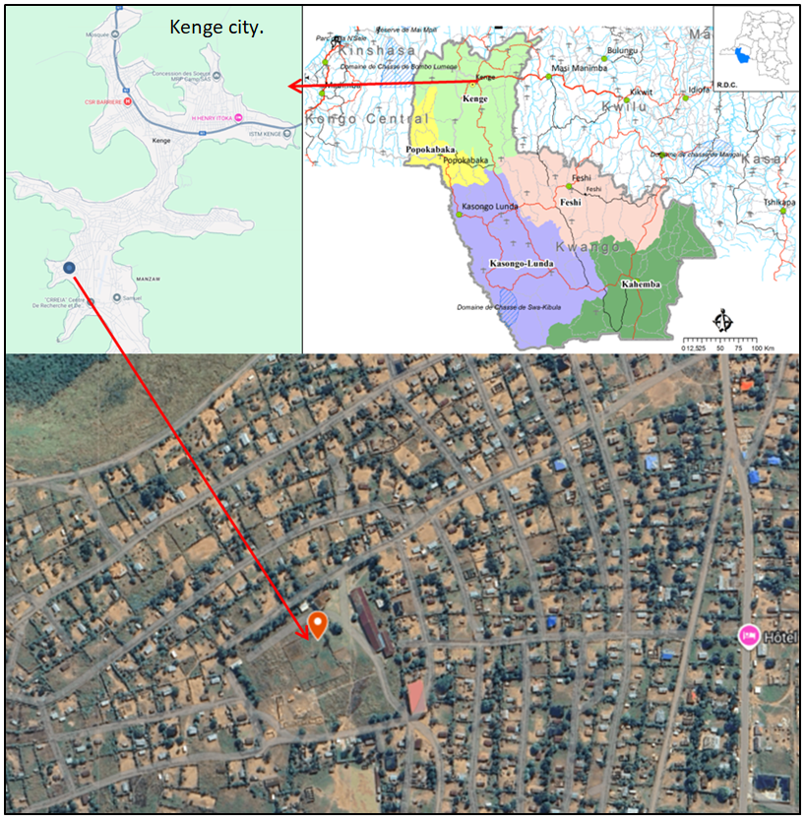
Figure 1. Map of the new experimental site of the University of Kwango in Kenge
Created with Google My Maps
Source: Kwango Province Monograph – Image Research
Climatic conditions during the trial
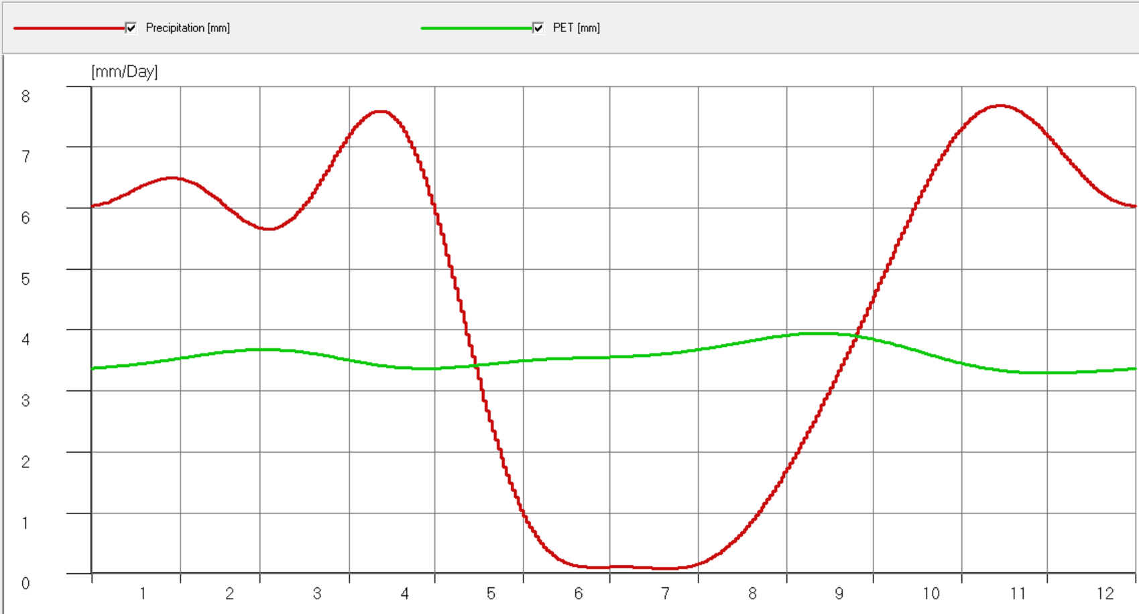
Figure 2: Ombrothermic curve of rainfall and potential evapotranspiration (mm) from January to December 2024
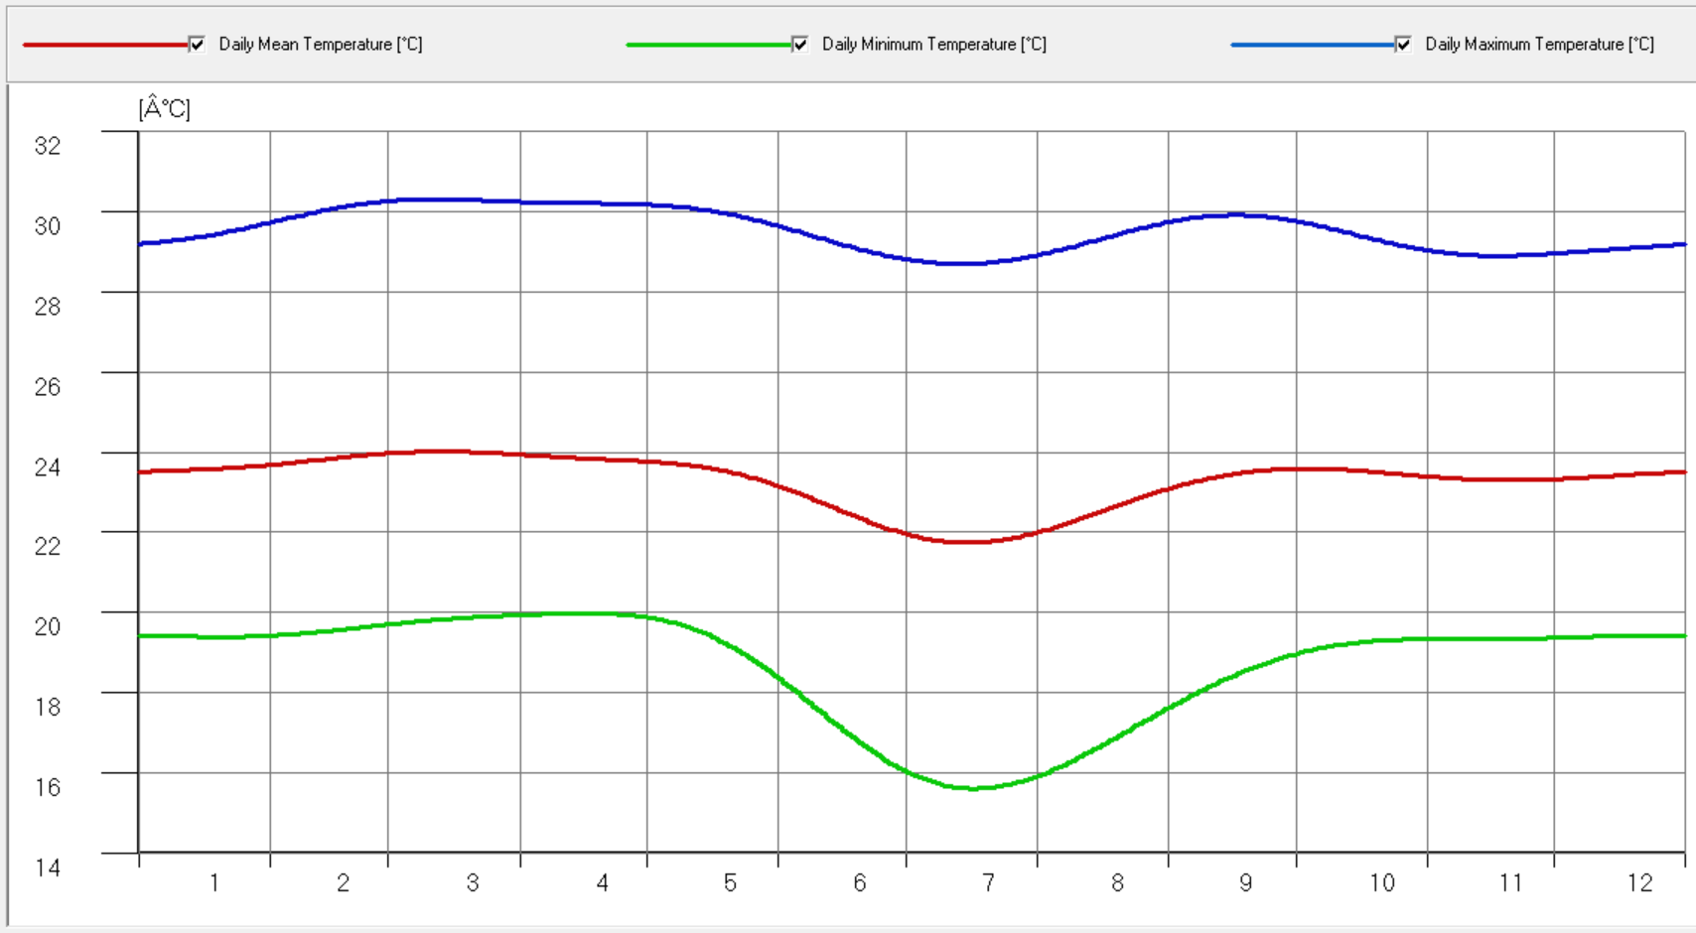

Figure 3: Ombrothermic curve of temperatures (°C) from January to December 2024 at the experimental site

Source: New LocClim estimator software (FAO)

Experimental Design and Treatments
The experimental design adopted was a 2 × 3 factorial arranged in a split-plot design with three replications. Factor 1 consisted of two groundnut varieties: the local variety and the improved variety G17, obtained from the National Legume Research Center. Factor 2 comprised soil amendments: application of agricultural lime at a rate of 10 t ha⁻¹ (T1), incorporation of Tithonia diversifolia leaf biomass at 20 t ha⁻¹ (T2), and an untreated control (T0). The elementary plot measured 4 m². Tithonia diversifolia leaf biomass was incorporated into the top 10 cm of soil as surface mulch one week before groundnut sowing.
Measurements were taken throughout the growth period and at harvest. The following software tools were used: FieldBook for in-field data collection, which helps minimize errors due to inattention; GenStat Discovery (latest edition) and PAST for statistical analyses; New Loc_Clim estimator for climatic data; and Google My Maps for mapping the experimental site.

Results and Discussion

Results
Data on groundnut growth, incidence of rosette disease, and harvest parameters were collected and analyzed using a two-way analysis of variance, comparing the two groundnut varieties subjected to three treatments: application of agricultural lime, incorporation of Tithonia diversifolia leaf biomass, and the untreated control. The summarized results are presented in Table 2 below.

Table 2. Agronomic performance of groundnut subjected to applications of agricultural lime and Tithonia diversifolia leaf biomass
Peanut Varieties | Soil Amendment | Emerged Plants (/30) | Plant Height Before Harvest (cm) | Rosette Incidence (infected plants/30 per plot) | Number of Pods per Plant | Number of Empty Pods per Plant | Dry Pod Yield (t·ha⁻¹) | 1000-Seed Weight (g) | Dry Seed Yield (t·ha⁻¹)
Local variety | No Amendment | 26^{b} | 52^{b} | 13 | 17^{b} | 4^{d} | 3.3ª | 260.7 | 2.2ª
Local variety | Agricultural Lime | 27^{bc} | 43ª | 12 | 18^{b} | 1^{b} | 4.9^{c} | 265.7 | 2.9^{b}
Local variety | Tithonia diversifolia Leaf Biomass | 25ª | 53^{b} | 2 | 16ª | 3^{c} | 3.5ª | 256.3 | 2.3ª
Improved variety (G17) | No Amendment | 23ª | 52^{b} | 13 | 17^{b} | 6e | 3.3ª | 253.0 | 2.1ª
Improved variety (G17) | Agricultural Lime | 29^{c} | 45ª | 11 | 14ª | 0ª | 4.2^{b} | 270.3 | 2.8^{b}
Improved variety (G17) | Tithonia diversifolia Leaf Biomass | 25ª | 46ª | 13 | 13ª | 3^{c} | 3.5ª | 258.3 | 2.3ª
 | Overall Mean | 26 | 48 | 10 | 16 | 3 | 3.8 | 260.7 | 2.4
 | Mean of the Local Variety | 26 | 49 | 9 | 17 | 3 | 3.9 | 260.9 | 2.5
 | Mean of the G17 Variety | 26 | 48 | 11 | 15 | 3 | 3.7 | 260.6 | 2.4
 | Mean of Varieties | 26 | 48 | 10 | 16 | 3 | 3.8 | 260.7 | 2.4
 | Mean of Controls | 25 | 50 | 10 | 17 | 5 | 3.8 | 258.9 | 2.4
 | Mean of Calcium Amendments | 26 | 48 | 9 | 16 | 0.5 | 4.0 | 261.3 | 2.5
 | Mean of Tithonia diversifolia Biomass Amendments | 25 | 49 | 8 | 15 | 3 | 3.6 | 259.5 | 2.4
 | Mean of Treatments | 25 | 49 | 9 | 16 | 3 | 3.8 | 259.9 | 2.4
 | LSD.05 varieties (Principal factor = A) | NS | NS | NS | 2.20 | 0.27 | NS | NS | NS
 | LSD.05 Treatments (Secondary factor = B) | 2.33 | 4.01 | NS | NS | 0.33 | 0.66 | NS | 0.67
 | LSD.05 A x B | 3.30 | 5.67 | NS | 3.81 | 0.47 | NS | NS | NS
 | CV% | 7.91 | 7.22 | 73.76 | 14.81 | 9.78 | 15.7 | 4.97 | 23.92

Elaborate analyses of the observed parameters indicated that groundnut emergence was significantly influenced by the application of agricultural lime. The average number of emerged plants was 29 and 27 per 30 for the local variety and G17, respectively. Emergence was relatively lower in the G17 control with 23 plants per 30 and in the Tithonia diversifolia treatment with 25 plants per 30, irrespective of the variety (LSD.05 = 2.33 plants, p= 0.05, CV% = 7.91).
Plant height was also significantly affected by the treatments. The tallest plants were recorded in the control, averaging 52 cm for both varieties. Heights under lime application averaged 43 cm for the local variety and 45 cm for G17. In the Tithonia treatment, plant height was higher in the local variety (53 cm) compared to G17 (46 cm). No statistically significant differences were observed among treatments for rosette disease incidence, although a high coefficient of variation was noted for this parameter (CV% = 73.76).
The number of empty pods per plant varied according to treatment. The control had the highest number of empty pods, averaging 5 per plant for both varieties. Lime application substantially reduced empty pods, with an average of 0.5 per plant across varieties. In the Tithonia treatment, empty pods averaged 3 per plant (LSD_{.05} = 0.33, p=0.05, CV% = 9.78). Total yield in pods and seeds was influenced by the prevalence of empty pods, suggesting a relationship between acidic soil conditions and pod filling. Dry pod yields were 4 t·ha⁻¹ with lime, 3.8 t·ha⁻¹ in the control, and 3.6 t·ha⁻¹ with Tithonia (LSD.05 = 0.66 t·ha⁻¹, p=0.05, CV% = 15.7). Seed size was not significantly affected by the treatments, with 1000-seed weight averaging around 260 g. Dry seed yields followed a similar pattern, averaging 2.5 t·ha⁻¹ for lime, and 2.4 t·ha⁻¹ for the control and Tithonia treatments (LSD.05 = 0.67 t·ha⁻¹, p=0.05, CV% = 23.9). Lime application significantly minimized the number of empty pods, effectively recovering up to 5 pods per plant.
Estimation of seed loss due to empty pods
Planted at 0.4 × 0.2 m spacing, groundnut density was 125,000 plants per hectare. Both the local variety and G17 averaged 2 seeds per pod. With 125,000 plants per hectare and 5 empty pods per plant, an estimated 625,000 pods per hectare were recovered through lime application. Assuming 2 seeds per pod, this corresponds to 1,250,000 seeds per hectare. With a 1000-seed weight of 260 g, approximately 325 kg of seeds per hectare were recovered by applying lime.

Figure 4. Number of Empty Pods as a Proportion of Total Pods According to Peanut Varieties and Applied Treatments
Partial Budget and Marginal Rate of Return
The partial budget analysis of the experimental treatments revealed that the application of agricultural lime resulted in the highest net benefit compared to the control and the Tithonia diversifolia treatment (table 3). The total variable costs included inputs such as lime, Tithonia biomass, labor for application, and land preparation.
Table 3. Partial budget for peanut production under agricultural lime and Tithonia diversifolia applications in Kenge conditions
 | Local groundnut variety |  |  | Improved groundnut variety
 | Control | Agricultural lime | Tithonia diversifolia | Control | Agricultural lime | Tithonia diversifolia
Mean yield (t ha⁻¹) | 3.3 | 4.9 | 3.5 | 3.3 | 4.2 | 3.5
Adjusted mean yield (t ha⁻¹) | 2.6 | 3.9 | 2.8 | 2.7 | 3.4 | 2.8
Gross field benefits (USD ha⁻¹) | 3960 | 5872 | 4200 | 4000 | 5040 | 4160
Seed cost (USD ha⁻¹) | 240 | 240 | 240 | 300 | 300 | 300
Cost of T. diversifolia leaf biomass (USD ha⁻¹) | 0 | 0 | 400 | 0 | 0 | 400
Cost of agricultural lime (USD ha⁻¹) | 0 | 510 | 0 | 0 | 510 | 0
Labor cost (USD ha⁻¹) | 2000 | 2000 | 2000 | 2000 | 2000 | 2000
Labor cost for lime application (USD ha⁻¹) | 0 | 100 | 0 | 0 | 100 | 0
Labor cost for T. diversifolia biomass application (USD ha⁻¹) | 0 | 0 | 125 | 0 | 0 | 125
Total variable costs (USD ha⁻¹) | 2240 | 2850 | 2765 | 2300 | 2910 | 2825
Net benefits (USD ha⁻¹) | 1720 | 3022 | 1435 | 1700 | 2130 | 1335
Selling price: 2 $ Kg⁻¹ of peanuts in dry pods for local variety and 2.5 $ Kg⁻¹ for improved variety (G17).
The gross benefit was calculated based on the market value of dry pods obtained per hectare. The net benefit (gross benefit minus variable costs) was highest for the lime treatment, followed by the control and the Tithonia sp. treatment.
The Marginal Rate of Return (MRR) was determined to evaluate the profitability of the treatments (table 4). Lime application recorded the highest MRR, indicating that each additional unit invested in lime returned a significantly higher benefit compared to other treatments. The MRR for lime exceeded 100%, demonstrating high economic efficiency, whereas the MRR for the Tithonia sp. treatment and the control were lower but still positive.
These results suggest that the application of agricultural lime is not only agronomical effective in reducing empty pods and increasing yield but also economically advantageous for groundnut production under the acidic soil conditions of Kenge.
Table 4. Calculation of the Marginal Rate of Return of Agricultural Lime and Tithonia diversifolia Applications on Groundnut.
 | Control |  |  | Agricultural lime
 | Control | Agricultural lime | Tithonia diversifolia | Control | Chaux agricole | Tithonia sp
Marginal cost (USD ha⁻¹) | 0 | 610 | 525 | 60 | 670 | 585
Marginal net benefit (USD ha⁻¹) | 0 | 1302 | -285 | -20 | 410 | -385
Marginal rate of return (MRR) | 0 | 2.13 | -0.54 | -0.33 | 0.61 | -0.66
Cost–benefit ratio (CBR) | 0.77 | 1.06 | 0.52 | 0.74 | 0.73 | 0.47
Formulas:
- Net benefit = Gross field benefit – Total variable costs
- Marginal cost = Total variable cost of the treatment – Total variable cost of the control (without input)
- Marginal net benefit = Net benefit of the treatment – Net benefit of the control (without input)
- Marginal rate of return (MRR) = Marginal net benefit ÷ Marginal cost
- Cost–benefit ratio (CBR) = Net benefit ÷ Total variable costs
Interpretation: An MRR ≥ 0.5 is considered economically significant and The Cost-Benefit Ratio (CBR) is considered profitable when it is greater than 1.
According to this economic analysis, the use of agricultural lime provides a clear advantage, with an MRR of 1.31 for the local variety and 0.63 for G17, both exceeding the standard MRR of 0.5 recommended by CIMMYT. A positive MRR is a favorable indicator for recommending the agricultural practice. Therefore, groundnut production under lime application allows (i) a substantial reduction in empty pod formation, (ii) increased productivity, and (iii) economically profitable cultivation.
Discussion
Groundnut is highly sensitive to soil salinity and acidity. Strongly acidic soils (pH ≈ 5) or soils deficient in CaO can induce aluminum or iron toxicities and suppress the development of nitrogen-fixing bacteria, as indicated by chlorotic foliage and the absence of the characteristic red coloration within nodules (Schilling, 2001). In the soils of Kenge, CaO deficiency further restricts pod filling and overall productivity.
Early work in Senegal by Mallouhi and Jutras (1987) reported that groundnut exhibits a relatively wide tolerance to soil pH. The application of horse manure substantially increased yield, reduced plant mortality, and exerted beneficial residual effects in the subsequent season. Peat, when combined with either manure or mineral fertilizers, also improved yield, although to a lesser extent than manure alone.
Phosphorus and calcium remain key limiting nutrients for groundnut production (Mupangwa and Tagwira, 2005). Field trials on sandy soils demonstrated that phosphorus application significantly enhanced yield, whereas the optimal calcium rates were 200 kg ha⁻¹ of calcitic lime (40% Ca, 4.5% Mg) and 100 kg ha⁻¹ of gypsum (22% Ca, 17% S), with no statistically significant difference between the two sources. Both phosphorus and calcium applications improved soil chemical properties.
More recent research by Razan et al. (2021) corroborated the critical role of calcium, showing that application at 165 kg ha⁻¹ increased mean pod yield by 24% relative to the control and reduced the proportion of empty pods from >13% to much lower levels. Similarly, Mandingaisa (2025) reported that the application of calcium ammonium nitrate (CAN) at 200 kg ha⁻¹ significantly improved groundnut growth and yield parameters.
Despite these findings, few studies have directly examined the physiological and agronomic causes of empty pod formation in groundnut, highlighting a critical gap that warrants further research.
Conclusion
This study effectively addressed the problem of empty pods in groundnut grown on acidic, low-organic-matter soils. It was observed that the number of unfilled pods increases as soil pH decreases. Lime amendment, which simultaneously provides additional calcium and reduces soil acidity, significantly reduces or eliminates empty pods in the sandy acidic soils of Kenge. On average, five empty pods per plant were recorded without lime application, whereas this number was reduced to zero when lime was applied. Agronomic and economic evaluations based on this performance demonstrate the advantage of using agricultural lime for groundnut production in nutrient-poor, degraded soils typical of many tropical regions.

Disclaimer (Artificial intelligence)

Option 1:

Author(s) hereby declare that NO generative AI technologies such as Large Language Models (ChatGPT, COPILOT, etc.) and text-to-image generators have been used during the writing or editing of this manuscript.

REFERENCES
Christie, M. E., Kyamureku, P., Kaaya, A., & Devenport, A. (2015). Farmers, peanuts, and aflatoxins in Uganda: A gendered approach. Development in Practice, 25(1), 4-18.
CIMMYT, 1989. From Agronomic Data to Farmer Recommendations: An Economics Training Manual. Fully revised edition. Mexico, D.F., Mexico: CIMMYT. ISBN 968-6127-04-6, 89 p.
Civil Jean Alain, End-Of-Studies Thesis 2022. Host Organization: Institute of Modeling the Growth and Yield of Peanut (Arachis hypogaea L.) in a Tropical Environment: Case of the Basin. Research for Development (IRD), CNRS IRD – UMR-242
FAO. 2022. Crops and animal products. Available at https://www.fao.org/faostat/fr/#data/QCL (Accessed 20 October 2022).
FAOSTAT, Agricultural production, crop primary database, Food and Agricultural Organization of the United Nations, ((2022) http://faostat.fao.org/faostat. Accessed on 14-07-2021
Fletcher S.M. and Shi Z. 2016. Chapter 10 - An Overview of World Peanut Markets. In: Stalker H.T., F. Wilson R. (eds.). Peanuts. AOCS Press, p. 267-287. Available at: https://www.sciencedirect.com/science/article/pii/B9781630670382000101 (Accessed August 11, 2022).
Guchi E., A. Ayalew, M. Dejene, M. Ketema, B. Asalf, C. Fininsa 2014. Occurrence of Aspergillus species in groundnut (Arachis hypogaea L.) along the value chain in different agro-ecological zones of Eastern Ethiopia. J. Appl. Environ. Microbiol., 2, 309-317. DOI: 10.12691/jaem-2-6-7
Halidou Oumarou Arabo. 2012. Peanut (Arachis hypogaea L.) nodulation and soil acidity in Northern Cameroon. Dschang: University of Dschang, 69 p. Engineering thesis: Agronomy. Plant Production: University of Dschang
Hamasselbe A., 2008. The revaluation of the peanut sector in the Sudano-Sahelian zone of Northern Cameroon, Tropicultura, 26 (4) (2008) 200-205
Hamza M, Abbas M, Sharaf S, Galal FH (2023). Response of Diverse Peanut Cultivars to Calcium Fertilization under Clay Soil Conditions. Agronomy 13(10):2656.
Mallouhi, N., & Jutras, P. (1987). Influence of lime and organic amendments on groundnut yield in degraded acidic soils in Senegal. Tropicultura, 4, 147–152.
Mandingaisa Maria, Marie Irakarama, Philbert Sindarihora, Jeannette Mukankurunziza, Vimbai Wedzerai Gumbeze, Samuel Nenhowe1 and Kudzaishe Christopher Mangadze, 2025. Exploring the influence of calcium sources (calcium ammonium nitrate [CAN] and lime) on groundnut (Arachis hypogaea L.) growth and yield in Rwanda. African Journal of Agricultural Research DOI: 10.5897/AJAR2024.16852 Article Number: 627917473034 ISSN: 1991-637X
Marloire M., Peanut, Encyclopædia Universalis [online]. URL: http://www.universalis.fr/encyclopedie/arachide/ (2019). Accessed December 29, 2020
Mitianga, C,Z 2022. Dissertation "Essay on the germination of the species Lippir multiflora in the ecological conditions of Kenge-Ville". UNIK (DRC) P. 15-16

Mupangwa W.T. and Tagwira F., 2005. Groundnut yield response to single superphosphate, calcitic lime and gypsum on acid granitic sandy soil. Nutrient Cycling in Agroecosystems (2005) 73:161–169 Springer 2005 DOI 10.1007/s10705-005-0075-3-1

Ndonda Malonda Adrien, 2018. Assessment of the agronomic effects of local mycorrhizal fungi on cassava (Manihot esculenta Crantz) productivity in degraded grassy fallow soils in Kisangani / DRC. Doctoral Thesis, University of Kisangani, Faculty of Renewable Natural Resource Management, http://hal.science/tel-02010741/document
Razan Malla, Saraswoti Kandel, Bisheswar Prasad Yadav, Santosh Rasaily and Pramod Wagle, 2021. Growth and Yield Responses to Calcium and Phosphorous Fertilization. International Journal of Advanced Research (IJAR) ISSN: 2320-5407 Int. J. Adv. Res. 9(04), 688-693 Journal Homepage: - www.journalijar.com Article DOI: 10.21474/IJAR01/12752 DOI URL: http://dx.doi.org/10.21474/IJAR01/12752
Schilling Robert, 2001. Basic agronomic data on the groundnut crop Groundnut; Oilseeds, Fats, Lipids. Volume 8, Issue 3, 230-6, May - June 2001, Special Report: Soybeans, peanuts, cotton: aspects of the conditions for the development of the value chains Author(s), CIRAD-CA, TA 70/01, 73, rue J.-F.-Breton, 34398 Montpellier Cedex 5, France. Article available on the site http://www.ocl-journal.org or http://dx.doi.org/10.1051/ocl.2001.0230
Sharma V., G. R. Purohit, R. S. Arya, M. Harsh, Evaluation of some complete rations in sheep incorporating unconventional feed resources of arid zones in India. Anim. Nutr. Feed Technol., 6 (2006) 135 – 141.
Turhan, A. and Kuscu, H. 2022. Improvement of Root Yield and Ion Content of Carrot with Exogenous Application Calcium Under Salinity. Gesunde Pflanzen, 75(4), 947-953.

