Rare Presentation of Aggressive B-Cell Lymphoma as Ileocolic Intussusception in a Young Adult: A Case Report

Abstract
Intussusception is defined as the telescoping of a segment of the gastrointestinal tract into an adjacent one. Adult intussusception, a rare yet critical gastrointestinal occurrence, accounts for 5% of all intussusceptions. Primary gastro-intestinal lymphoma accounts for 1–4% of all gastro-intestinal malignancies. 90% of them have B-cell non-Hodgkin lymphoma (NHL). The most prevalent lymphoma producing intussusception is diffuse large B-cell lymphoma.
We report a case of a 21-year-old male with acute ileocolic intussusception who was ultimately diagnosed with aggressive B-cell lymphoma. Computed tomography showed ileo-colic intussusception. A right hemicolectomy was performed, with ileotransverse anastomosis was done with post-operative chemotherapy.
This case illustrates the rare occurrence of intussusception secondary to lymphoma in adults. We emphasize the importance of including diffuse large B-cell lymphoma in the differential diagnosis of adult ileocolic intussusception to ensure accurate diagnosis and appropriate management.

Key words: Ileocolic intussusception, Large B-cell lymphoma, Primary gastro-intestinal lymphoma ,intestinal obstruction
Introduction
"Intussusception occurs when a more proximal portion of bowel invaginates into more distal bowel. Although intussusception is a common condition in children, it is a rare entity in the adult population. Adult intussusception represents 5% of all intussusceptions and 1% to 5% of all cases of intestinal obstruction in adults. Unlike pediatric population, an evident etiology is established in 70-90% of cases in adults and nearly 40% of them are caused by neoplasms" [1,2]
"The gastrointestinal tract is the most common extranodal site affected by lymphoma, accounting for 5% to 20% of all cases" [3]
"Primary gastro-intestinal lymphoma accounts for 1%-4% of all gastrointestinal malignancies. Most frequent primary sites are the stomach followed by the small intestine. Most common non-Hodgkin’s lymphoma is diffuse large B-cell lymphoma and The most common lymphoma causing intussusception" [4,5]. Here, we describe a rare instance of a male 21-year-old who had an ileocecal intussusception brought on by primary intestinal NHL.

Observation
A 21-year-old male presented to the Emergency Department of Ibn Sina University Hospital with a three-day history of generalized abdominal pain and persistent vomiting. He also reported a 48-hour history of complete cessation of flatus and bowel movements, consistent with signs of intestinal obstruction. Additionally, the patient had experienced an unintentional weight loss of approximately 5 kilograms over the past three months, without changes in appetite or known underlying conditions. His medical history was unremarkable, with no prior abdominal surgery or chronic illnesses.
On admission, the patient was stable in terms of hemodynamic and respiratory status, afebrile, and alert.
Physical examination revealed abdominal tenderness on palpation, associated with abdominal distension and decreased bowel sounds, with a palpable mass in the t right lower qudrant,Digital rectal examination revealed absence of stools.

Blood tests revealed a white blood cell count of 11,800 × 10⁹/L with 63% neutrophils, C-reactive protein (CRP) level of 50 mg/L, Liver and kidney function test results levels were all normal.
Abdominal radiograph revealed multiple dilated loops of small bowel with air-fluid levels.
Abdominal computed tomography (CT) scan revealed an ileocolic intussusception extending to the transverse colon, with notable thickening at the ileocecal junction. These findings raised suspicion for a pathological lead point, possibly a mass, at the intussusception site [Figure1].
Given the urgency of the situation, the patient was taken to the operating room. Intraoperative findings confirmed the presence of ileocolic intussusception with an extensive segment of intestine involved and thickening at the ileocecal junction [Figure 2,3].
Additionally, a small amount of clear peritoneal effusion was noted. A right hemicolectomy was performed, with ileotransverse anastomosis using a mechanical stapler to re-establish bowel continuity.
A Redon drain was placed at the anastomosis site for postoperative drainage.
Histological examination verified the tumor's identity as a DLBCL by identifying discohesive, massive, and pleomorphic tumor cells that had spread across the intestinal wall's thickness. Immunohistochemistry showed nuclear positivity for CD20, CD45 and Bcl-6 along with negativity for Bcl-2, MUM-1, and CD5. Ki-67 proliferation index value was > 90% .
The patient’s postoperative recovery was uneventful, with gradual clinical and biological improvement. the case was discussed multidisciplinary consultation meeting regarding initiating adjuvant chemotherapy. He was discharged on the sixth postoperative day with follow-up instructions.

Discussion
"Intussusception occurs when a segment of bowel and its associated mesentery (the intussusceptum) invaginates into the lumen of an adjacent bowel segment (the intussuscipiens)". [6]
"Adult intussusceptions are classified into three major types according to their site in the alimentary tract: entero-enteric which is limited to the small bowel, ileo-colic or ileo-cecal in which ileum invaginated through the ileo-cecal valve and colon-colic which is confined to the colon".[7]
"While intussusception is a frequent cause of intestinal obstruction in children, it accounts for only 1% to 5% of all cases in adults. In adults, it remains a rare condition and is typically associated with an underlying pathological cause. The lead point may be a benign lesion such as a polyp, lipoma, appendix, or Meckel’s diverticulum, or a malignant tumor including primary or metastatic adenocarcinoma, gastrointestinal stromal tumors (GISTs), lymphoma, or carcinoid tumors" [8,9].
"Primary gastrointestinal lymphoma is a rare entity, accounting for only 1% to 4% of all gastrointestinal malignancies. The most commonly involved sites are the stomach and, to a lesser extent, the small intestine. Among the various subtypes, diffuse large B-cell lymphoma (DLBCL) is the most frequent form of non-Hodgkin’s lymphoma and, although uncommon, is the subtype most often implicated in cases of intussusception" [10].

"The clinical presentation of adult intussusception varies considerably. The presenting symptoms are nonspecific, and the majority of cases in adults have been reported as chronic, consistent with partial obstruction. abdominal pain is the most common presenting symptom in patients with intussusception, followed by nausea, vomiting ,bleeding, and diarrhea and constipation" [11,12].
"Although intussusception is a rare condition in adults, when it does occur secondary to lymphoma, diffuse large B-cell lymphoma is the most commonly implicated subtype. Preoperative diagnosis remains challenging due to the non-specific nature of clinical symptoms and the overall rarity of the condition" [13].
The preoperative diagnosis of adult intussusception is difficult because the clinical presentation is often nonspecific and the condition is rare
"The radiological finding play a key role in the diagnosis Computed tomography is currently considered as the gold standard tool in confirming intussusception, Computed tomography showing Bowel-within-bowel configuration suggested by mesenteric vessels and fat compressed between the walls of the small bowel is pathognomonic of intussusception".[14,15]
"MRI is not applied routinely to diagnose intussusception in children or adults. This modality is reserved for evaluating select patients in whom an atypical sonographic appearance suggests a pathological lead point, such as lymphoma" [16].
"Colonoscopy is useful only in cases in which colonic involvement is strongly suspected and patient is not acute obstruction , and it allows the lesion to be diagnosed and biopsied" [17].
"However, a diagnosis made by colonoscopy is rare, and most of the time the diagnosis is performed during surgery" [18].

Intestinal intussusception in adults, particularly when caused by non-Hodgkin lymphoma (NHL), requires prompt and definitive management, typically involving surgical resection combined with chemotherapy.
Due to the high incidence of underlying malignancy in adult cases of intussusception, surgical intervention is considered essential, especially when complications such as obstruction or bowel ischemia are present.
The surgical strategy usually involves resecting the affected segment of the intestine without prior reduction, as the lead point is frequently a malignant tumor. This approach minimizes the risk of tumor dissemination and addresses[19,20]
"The potential for vascular compromise, which can result in ischemia and necrosis of the involved bowel. for right-sided colonic intussusceptions, resection and primary anastomosis can be carried out even in unprepared bowels" [21].

It has been demonstrated that treatment and surgical resection together independently increase overall survival for intestinal large B-cell lymphoma.
"Currently, up to 60% of DLBCL patients achieve cure with first‐line immunochemotherapy regimens such as R‐CHOP, which combines cyclophosphamide, doxorubicin, vincristine, prednisone, and rituximab" [22].

Our patient completed 6 cycles of R-CHOP regimen. After successful completion of chemotherapy, one month later whole body FDG-PET/CT was done. The scan found no indication of residual lymphoma or relapse, indicating total elimination of the malignancy.
The most effective treatment for localized malignancy that causes intussusception is surgical excision along with chemotherapy.
The prognosis for aggressive lymphomas depends largely on the timeliness of the diagnosis and the effectiveness of subsequent treatment.
A multidisciplinary approach involving radiologists, surgeons, and pathologists is essential for timely diagnosis and effective management.
Conclusion
Adult intussusception is a rare clinical entity and, when present, is often associated with an underlying pathological lead point, frequently of neoplastic origin. This case emphasizes the importance of including malignant lymphoma in the differential diagnosis of adult intussusception, especially when accompanied by systemic signs such as unexplained weight loss or features of bowel obstruction. Adjuvant chemotherapy is essential in the treatment of gastrointestinal NHL in order to eradicate the tumor, in addition to surgical therapy.

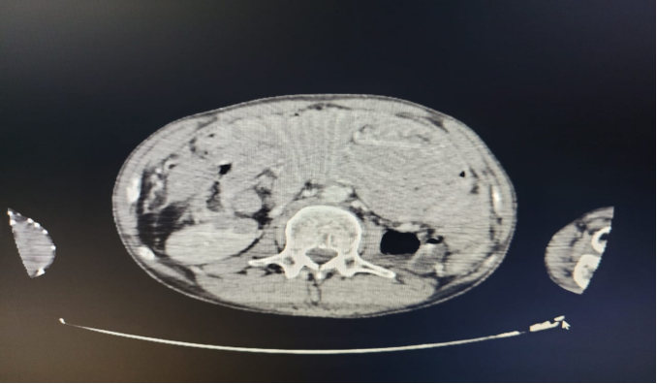
Figure 1 : CT SCAN shows ileocolic intussusception extending to the transverse colon, with notable thickening at the ileocecal junction

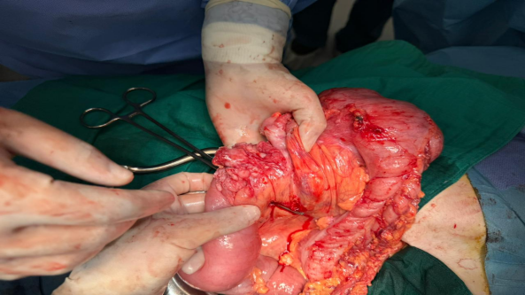

Figure 2 : operative specimen of ileocolic intussusception from our patient

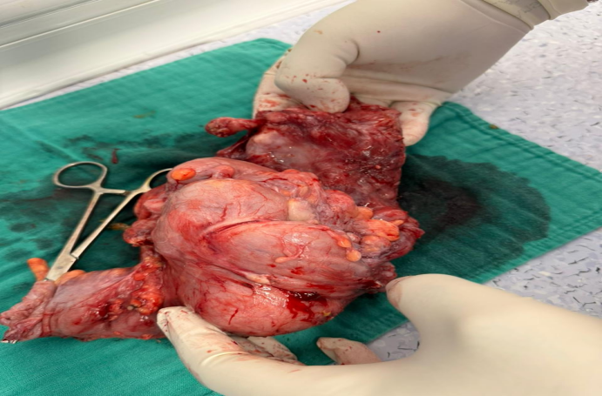

Figure 3 : operative specimen of ileocolic intussusception from our patient
Ethical Approval:
As per international standards or university standards written ethical approval has been collected and preserved by the author(s).
Consent
As per international standards or university standards, patient(s) written consent has been collected and preserved by the author(s).
Disclaimer (Artificial intelligence)
Option 1:
Author(s) hereby declare that NO generative AI technologies such as Large Language Models (ChatGPT, COPILOT, etc.) and text-to-image generators have been used during the writing or editing of this manuscript.
Option 2:
Author(s) hereby declare that generative AI technologies such as Large Language Models, etc. have been used during the writing or editing of manuscripts. This explanation will include the name, version, model, and source of the generative AI technology and as well as all input prompts provided to the generative AI technology
Details of the AI usage are given below:
1.
2.
3.

REFERENCES
1. Azar T, Berger DL. Adult intussusception. Ann Surg. 1997 Aug;226(2):134-8. doi: 10.1097/00000658-199708000-00003. PMID: 9296505; PMCID: PMC1190946.
2. Marinis A, Yiallourou A, Samanides L, Dafnios N, Anastasopoulos G, Vassiliou I, Theodosopoulos T. Intussusception of the bowel in adults: a review. World J Gastroenterol. 2009 Jan 28;15(4):407-11. doi: 10.3748/wjg.15.407. PMID: 19152443; PMCID: PMC2653360.
3. Luque-de-León E, Sánchez-Pérez MA, Muñoz-Juárez M, Cordera-González de Cosío F, Moreno-Paquentin E, Toledo-Valdovinos S. Ileocolic intussusception secondary to Hodgkin's lymphoma. Report of a case. Rev Gastroenterol Mex. 2011 Jan-Mar;76(1):64-7. PMID: 21592909.
4. Yin L, Chen CQ, Peng CH, Chen GM, Zhou HJ, Han BS, Li HW. Primary small-bowel non-Hodgkin's lymphoma: a study of clinical features, pathology, management and prognosis. J Int Med Res. 2007 May-Jun;35(3):406-15. doi: 10.1177/147323000703500316. PMID: 17593870.
5. Ghimire P, Wu GY, Zhu L. Primary gastrointestinal lymphoma. World J Gastroenterol. 2011 Feb 14;17(6):697-707. doi: 10.3748/wjg.v17.i6.697. PMID: 21390139; PMCID: PMC3042647.
6. Wagh AN, Ganesan B, Jawale HM, Mishra RA, Bhatt R. A rare case report of large B cell lymphoma in adult presentation as intussusception. Clin Pract. 2020 Oct 16;10(4):1292. doi: 10.4081/cp.2020.1292. PMID: 33123336; PMCID: PMC7586136.
7. Akbulut, Sami. “Unusual Cause of Adult Intussusception: Diffuse Large B-Cell Non-Hodgkin's Lymphoma: a Case Report and Review.” European Review for Medical and Pharmacological Sciences, 2012.

8. Chang HC, Kang JC, Pu TW, Su RY, Chen CY, Hu JM. Diffuse large B-cell lymphoma-induced intussusception: A case report and literature review. Clin Case Rep. 2024 Jun 18;12(6):e9046. doi: 10.1002/ccr3.9046. PMID: 38895050; PMCID: PMC11183938.
9. Zubaidi A, Al-Saif F, Silverman R. Adult intussusception: a retrospective review. Dis Colon Rectum. 2006 Oct;49(10):1546-51. doi: 10.1007/s10350-006-0664-5. PMID: 16990978.
10. Grin A, Chetty R, Bailey D. Mantle cell lymphoma as a rare cause of intussusception: a report of 2 cases. Ann Diagn Pathol. 2009 Dec;13(6):398-401. doi: 10.1016/j.anndiagpath.2009.03.003. Epub 2009 Apr 22. PMID: 19917477.
11. Li B, Shi YK, He XH, Zou SM, Zhou SY, Dong M, Yang JL, Liu P, Xue LY. Primary non-Hodgkin lymphomas in the small and large intestine: clinicopathological characteristics and management of 40 patients. Int J Hematol. 2008 May;87(4):375-381. doi: 10.1007/s12185-008-0068-5. PMID: 18409078.
12. Amer MH, el-Akkad S. Gastrointestinal lymphoma in adults: clinical features and management of 300 cases. Gastroenterology. 1994 Apr;106(4):846-58. doi: 10.1016/0016-5085(94)90742-0. PMID: 8143991.
13. Kashimura A, Murakami T. Malignant lymphoma of large intestine --15-year experience and review of literature. Gastroenterol Jpn. 1976;11(2):141-7. PMID: 789171.

14. Bar-Ziv J, Solomon A. Computed tomography in adult intussusception. Gastrointest Radiol. 1991 Summer;16(3):264-6. doi: 10.1007/BF01887362. PMID: 1879648.

15. Yakan S, Caliskan C, Makay O, Denecli AG, Korkut MA. Intussusception in adults: clinical characteristics, diagnosis and operative strategies. World J Gastroenterol. 2009 Apr 28;15(16):1985-9. doi: 10.3748/wjg.15.1985. PMID: 19399931; PMCID: PMC2675089.

16. Bar‐Ziv J, Solomon A. Computed tomography in adult intussusception. Gastrointest Radiol. 1991;16(3):264‐266. doi: 10.1007/bf01887362

17. LERNER A, SOTO J, ROSEN JE. Chemotherapy as treatment for colo-colonic intussusception associated with acquired immune deficiency syndrome- related lymphoma. Surgery 2011; 149: 726-727
18. Salemis NS, Tsiambas E, Liatsos C, Karameris A, Tsohataridis E. Small bowel intussusception due to a primary non-Hodgkin's lymphoma. An unusual presentation and clinical course. J Gastrointest Cancer. 2010 Dec;41(4):233-7. doi: 10.1007/s12029-010-9152-1. PMID: 20411355.

19. Wang LT, Wu CC, Yu JC, Hsiao CW, Hsu CC, Jao SW. Clinical entity and treatment strategies for adult intussusceptions: 20 years' experience. Dis Colon Rectum. 2007 Nov;50(11):1941-9. doi: 10.1007/s10350-007-9048-8. Epub 2007 Sep 11. PMID: 17846839.

20. Tan KY, Tan SM, Tan AG, Chen CY, Chng HC, Hoe MN. Adult intussusception: experience in Singapore. ANZ J Surg. 2003 Dec;73(12):1044-7. doi: 10.1046/j.1445-2197.2003.t01-22-.x. PMID: 14632903.
21. AHN JH, CHOI SC, L EE KJ, J UNG YS. A clinical overview of a retrospective study about adult intussusceptions: focusing on discrepancies among previous studies. Dig Dis Sci 2009; 54: 2643- 2649.
22. Kim SJ, Kang HJ, Kim JS, et al. Comparison of treatment strategies for patients with intestinal diffuse large Bcell lymphoma: Surgical resection followed by chemotherapy versus chemotherapy alone. Blood 2011;117:1958-65

