Review Article
Masquelet’s Induced Membrane Technique: a Narrative Review

Abstract:
In recent times, Masquelet’s two-stage, induced membrane technique is gaining popularity, and the technique is as simple as debridement and bone grafting, with induced membrane being a source of growth factors and osteo-inductive factors which prevent resorption of the cancellous bone graft, induce new bone formation, and help in consolidation. This review aims to explore Masquelet’s Induced Membrane Technique. The Masquelet technique is a two-stage surgical procedure. The first stage of the procedure involves extensive debridement of the necrotic and infected soft tissue as well as infected bone. The second stage of the technique involves the removal of the spacer and filling the defect with a bone graft. The ideal time for this is when the soft tissues have healed and the membrane is of sufficient strength that it does not disrupt while removing the spacer. At two weeks, the membrane produces abundant vascular endothelial growth factor (VEGF) and transforming growth factor beta (TGF-β). VGEF secreted by macrophages plays an important role in angiogenesis, and TGF-β aids matrix protein synthesis and bone metabolism. Though Masquelt’s technique has evolved over time with innovations and expansion of its indications, the basic principle of creation of an environment (the induced biological membrane) which favours the growth of blood vessels or neo-vascularisation of the graft material placed inside it is a key to success.

1. INTRODUCTION
Bone loss, infection and non-union is a well-known consequence of severe crush injuries and compound fractures. Iatrogenic infection after surgical fixation of simple fractures may also result in infected non-union. Debridement of infected avascular fracture ends in such a scenario will give rise to a bone defect. In a similar fashion a bone defect may be created by debridement and excision of avascular dead bone in case of chronic osteomyelitis. Management of these infected defect or gap non-unions has always been a challenge for an orthopedic surgeon. Eradication of infection, achieving union and restoration of length of the bone is of paramount importance to restore the function of the extremity. [1, 2] Different techniques have been used for management of these infected non-unions with a segmental bone loss. Simplest of all has been debridement and bone grafting the defect. However, bone grafting may only suite small defects as grafting in large defects is prone to resorption and failure. Besides, some complicated and technically demanding procedures like vascularized fibula or fibular osseo-cutaneous flaps have also been tried. They may get complicated by failure of vascular anastomosis, non-union of fibula with the parent bone at either end and even fracture of fibula if used in lower extremities. With the introduction of ilizarov and bone transport, the management of infected non-union with large defects has been simplified, however, every orthopedic surgeon is not well versed with this technique, bone transport may consume lot of time and the rings may be cumbersome to the patient. [3] In the recent times Masquelet’s two stage, induced membrane technique is gaining popularity and the technique is as simple as debridement and bone grafting with induced membrane being a source of growth factors and osteo-inductive factors which prevent resorption of the cancellous bone graft, induce new bone formation as well as help in consolidation. [4]
2. HISTORY
Alain Charles Masquelet is a French Orthopedic surgeon who was trained in general surgery for three years followed by residency in orthopedics for four years in Paris. He has been working at Avicenne Hospital in Bobigny since 1985 and has been chief of service since 1995. The concept of induced membrane technique by him was serendipity. He started using bone cement as a spacer in the dead space between the debrided bone fracture ends after thorough debridement in 1986. [5] He got this concept from the cement spacers used in arthroplasty with the aim to maintain length of bone and tension on surrounding soft tissue. Besides the bone cement being rigid is easy to remove as compared to muscle pedicle flaps that were used to fill the dead space, and at a later date space can filled with cancellous bone graft. With this technique A C Masquelet could reconstruct a defect as long as 20 cm when it was said cancellous bone graft will not work and get resorbed in defects of more than 5 cm. The mystery of this technique unfolded when Sir Masquelet presented his first five cases at Congress of the European Federation of Societies for Microsurgery at Rome in 1992 where surgeons from Munich Germany communicated about their graft resorption and failure using same technique. Sir AC Masquelet got the answer for his success when the surgeons from Munich mentioned about debridement of the membrane surrounding cement spacer. Masquelet used to preserve the membrane as it was vascular and bled a lot and there was risk of injury to surrounding nerves and vessels and additionally it looked like an enclosed chamber to be filled with cancellous graft without knowing its clinical significance and hence was serendipity. [6] It was Philippe Pelissier, a plastic surgeon, who after this European Congress of 1992 decided to take it as a postdoctoral thesis topic and discovered that the membrane secreted growth factors. [4]
3. SURGICAL TECHNIQUE
The Masquelet technique is a two stage surgical procedure. The first stage of the procedure involves extensive debridement of the necrotic and infected soft tissue as well as infected bone. Once debridement ends the bone needs to be stabilized. [7] Stabilization can be achieved with an external device like a simple external fixator, a rail fixator or an ilizarov ring fixator or internal fixation device like a plate or an intra-medullary nail can be used. The choice of stabilization depends on surgeon preference, status of the surrounding soft tissue, need for a plastic procedure like flap, and the bone involved. Besides stabilizing the bone, length, longitudinal alignment and rotational alignment of the two fragments should be restored. [8] After stabilization, the segmental bone defect is filled up with a bone cement spacer, preferably an antibiotic impregnated one (Figure 1). The choice of antibiotic impregnated in the bone cement can be worked out by pre-operative culture sensitivities of the pus obtained from the sinus or by needle aspiration from the abscess and at times a combination of antibiotics may need to be added. The antibiotic that will be eluted from the bone cement spacer in higher concentration at the site of infected non-union will eradicate the local infection. [9, 10] The spacer should be seated in the defect, avoiding pushing it inside the medullary canal which makes its retrieval difficult in the second stage and too much rough handling required for removal may damage the induced membrane. Some surgeons prefer to use cement cuffs at the two ends and put in spacer in between them (Figure 2). These cuffs aid in easy removal of the spacer at a later stage. Besides polymethy methacrylate (bone cement) other materials can be used as spacers for membrane induction which include silicon, titanium, polypropylene, calcium sulphate, polycaprolactone, and polyvinyl alcohol sponge. [11] Most of these have been used in experimental animal models. However, bone cement is being considered as a gold standard spacer in Masquelet technique. Polypropylene spacer made from disposable syringes is being used by Mozumder M et al in Bangladesh. [12] Once the dead space has been filled up with the spacer, the soft tissue covering it can be closed. However, in case of soft tissue defects, a plastic surgical intervention for coverage of defects should be performed at the same time (Figure 3and Figure 4).
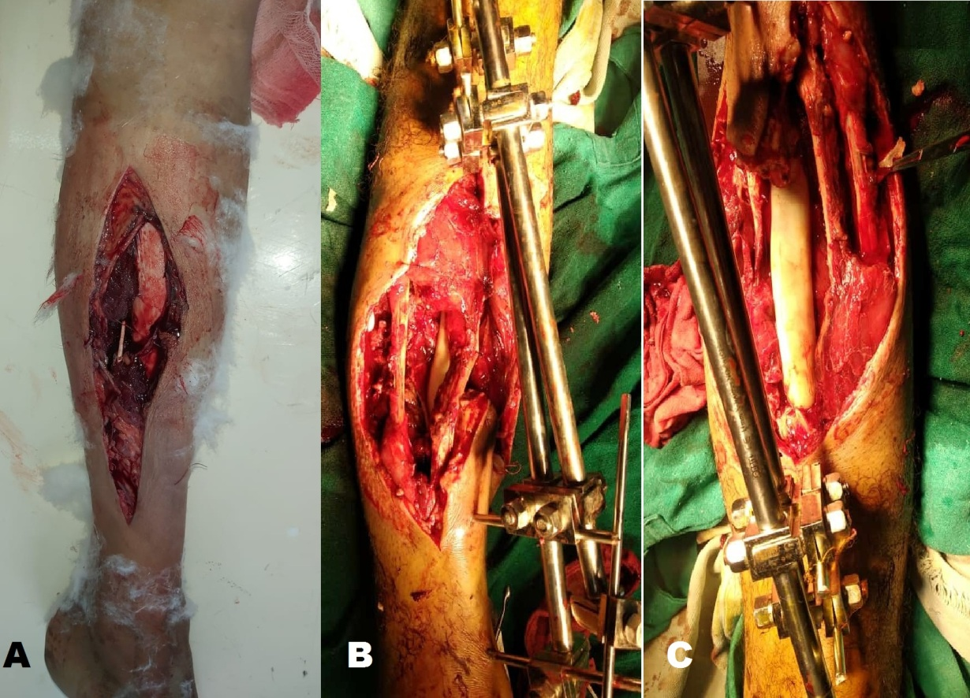
Figure 1: A. Open farmyard injury of leg with segmental bone loss was managed by debridement and external fixator. B, C. Second stage extensive debridement of dead tissue and dead infected bone and placement of a bone cement spacer at segmental bone defect.
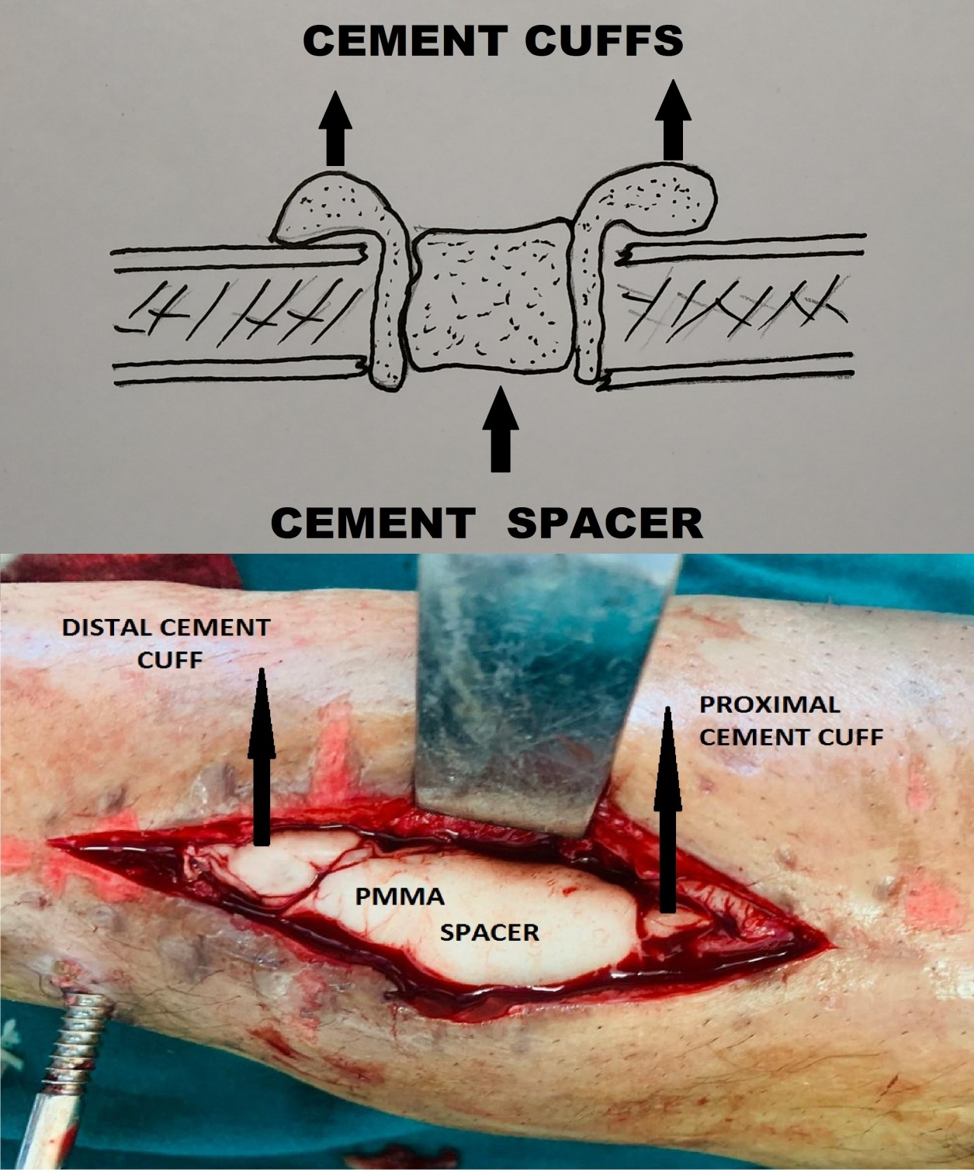
Figure 2: Diagrammatic and clinical picture showing cement spacer placed in between two cement cuffs for easy retrieval later in second stage.
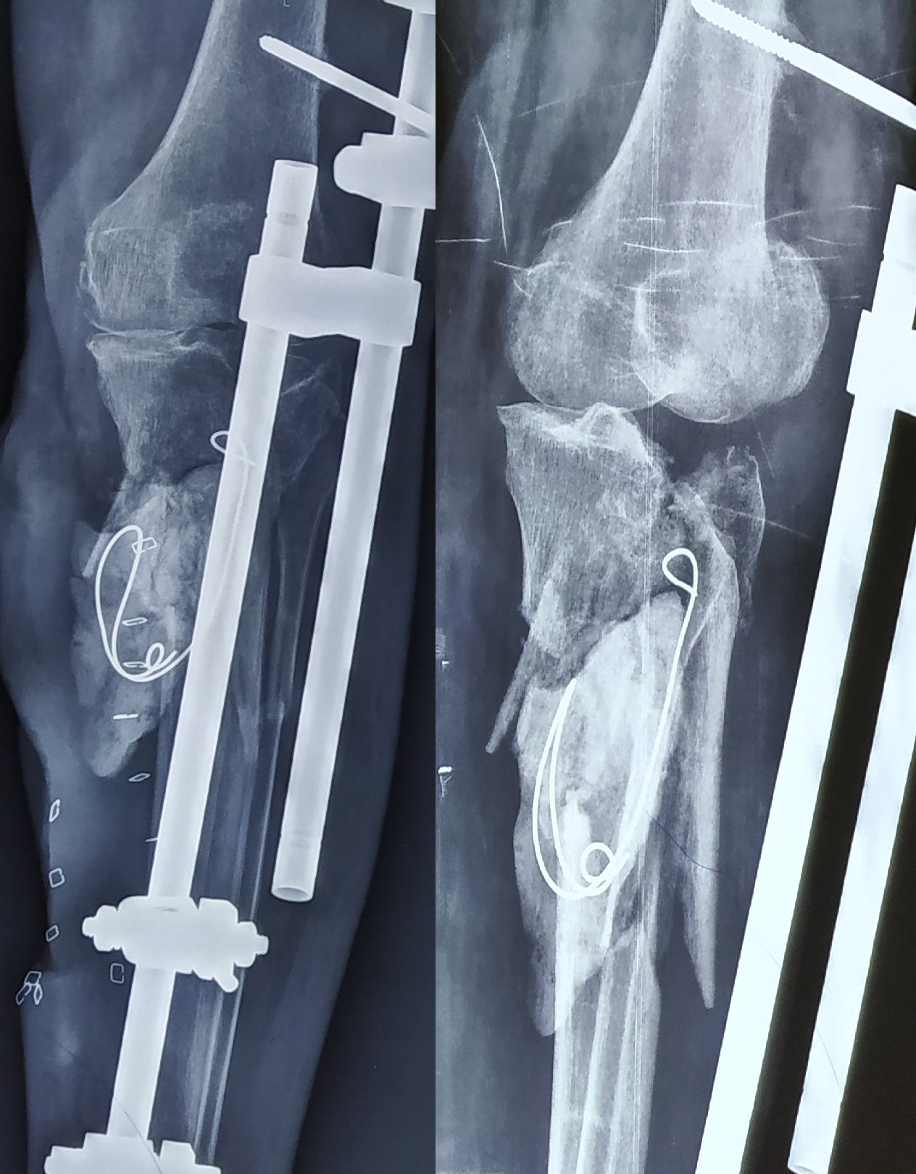
Figure 3: Radiograph of elderly diabetic female, who had compound fracture of proximal tibia, managed with repeated debridement and a spanning fixator. Infection settled only after incorporation of cement spacer in the dead space.
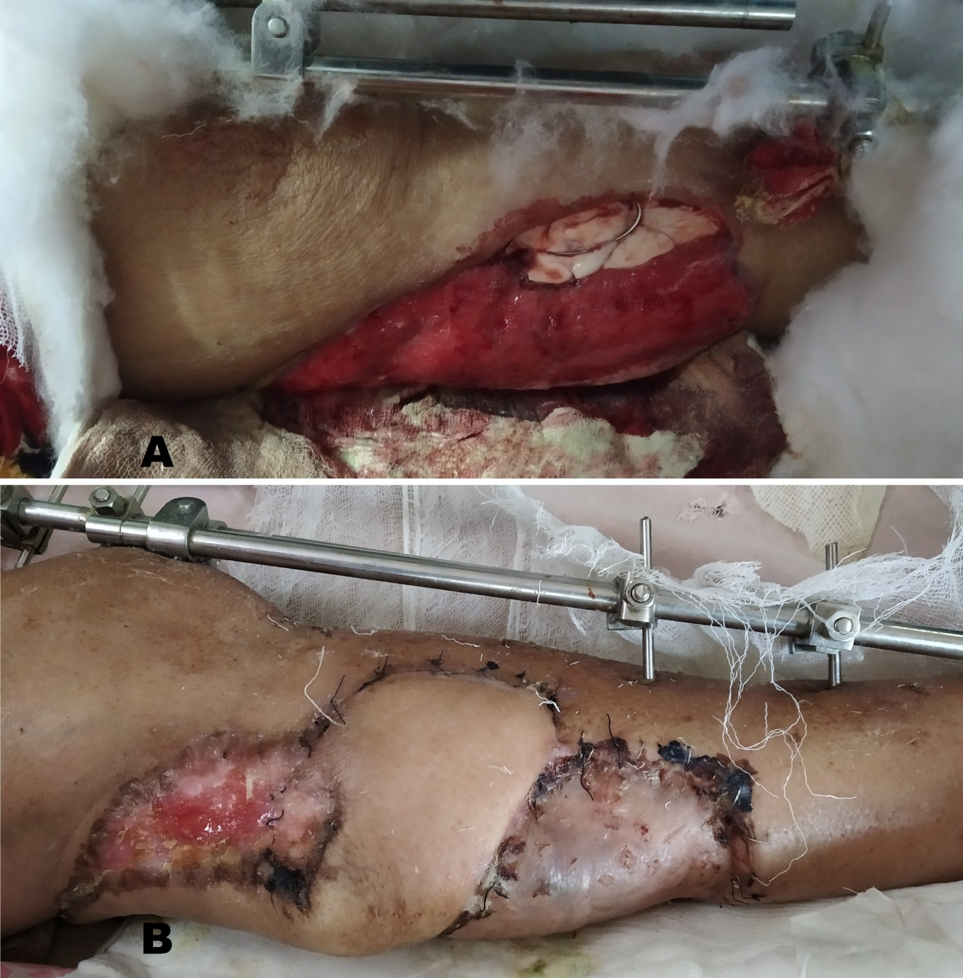
Figure 4: Clinical picture of the patient described in figure 3. A. Healthy wound with visible cement spacer. B. The raw area and visible spacer covered with a flap after blood sugars were well under control.
The second stage of the technique involves the removal of the spacer and filling the defect with bone graft. The ideal time for this is when the soft tissues have healed and the membrane is of sufficient strength that it does not disrupt while removing the spacer. It has been seen in animal models that the concentration of growth factors in the membrane is at peak at four weeks after implantation of the spacer but the membrane is weak and the soft tissues have not healed. Maximum membrane strength and ample soft tissue healing is achieved around eight weeks but the concentration of growth factors in the membrane diminishes so the ideal time for the second stage is around six weeks after the spacer implantation. [12, 13, 14] Before proceeding for grafting, one should be sure that infection is eliminated. In case of persistent infection and necrotic tissue and bone, the first stage of debridement should be repeated and a new spacer re-implanted. The spacer should be removed delicately, protecting the covering induced membrane. The bone ends should be gently freshened and the medullary canal re-opened. [13] Then a morcelised pure cancellous graft preferably harvested from iliac crest is placed in the defect. Care should be taken not to pack the graft tightly as it will hamper growth of vessels in between graft. Loosely placed cancellous graft is an important pre-requisite for re-vascularization and later consolidation; otherwise, the graft will be resorbed if packed tightly. [15] The soft tissue is closed in layers with membrane closed using bio-absorbable sutures. It is in this stage the type of fixation used can be changed if required (Figure 5, Figure 6 and Figure 7). Rigid stabilization is important to maintain the vascularity and integrity of the membrane and also to take up and consolidation of bone graft as well. [12]
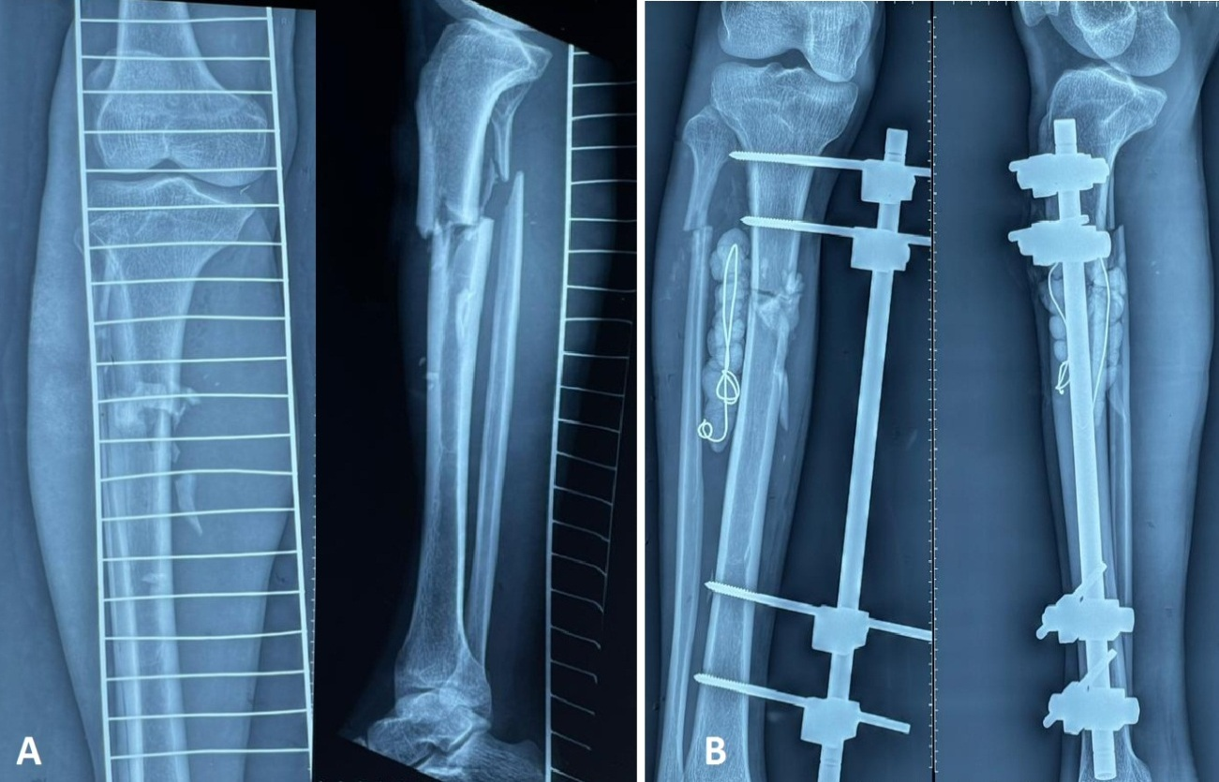
Figure 5: A. Preoperative radiographs of open tibia fracture. B. Post-operative radiographs after debridement, external fixation and placement of antibiotic beads in the dead space.
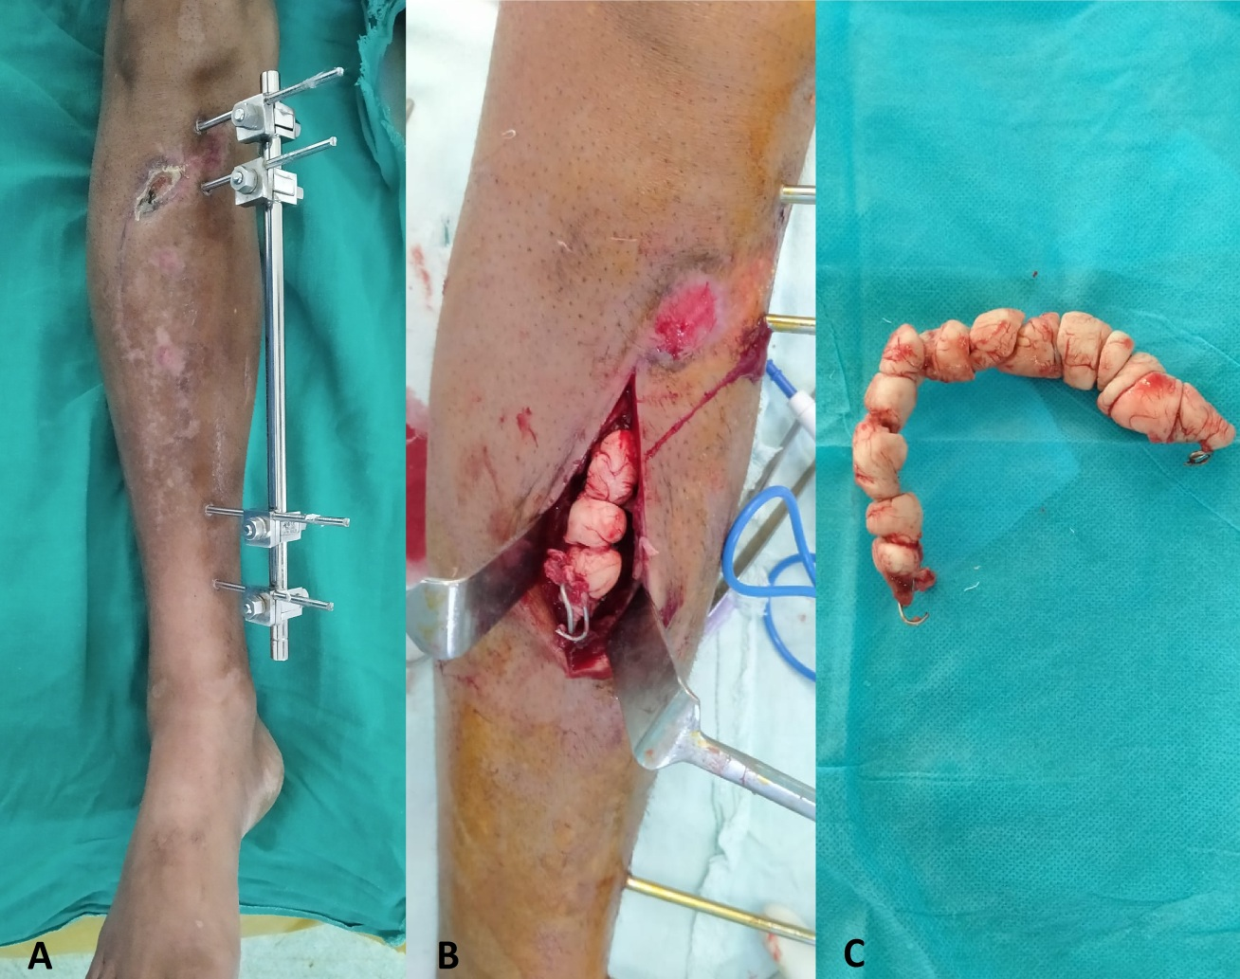
Figure 6: Same case as shown in figure 5 was planned for removal of beads conversion osteosynthesis to ring fixator and bone grafting. A. Clinical picture with external fixator and healed soft tissue. B, C. Removal of antibiotic beads.
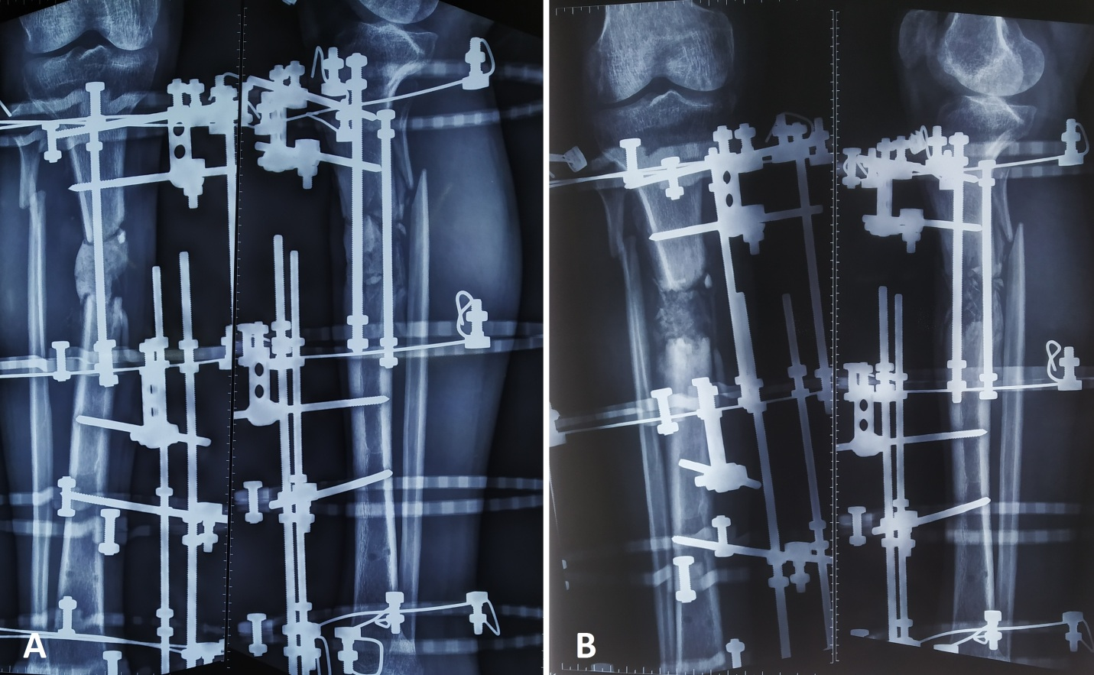
Figure 7: Post-operative radiographs of patient described in figure 5 and 6. After removal of beads and on inspection it was seen the bone ends were infected, necrotic and did not bleed so the plan was changed to Masquelet technique. A. Radiographs after stage 1 with spacer in situ. B. Radiographs after stage 2 showing bone graft filling the defect.

4. INDUCED BIOLOGICAL MEMBRANE
Any foreign body placed in the living tissues has a tendency to inflict a foreign body type of reaction. Similarly when a cement spacer is placed in the dead space for managing infected gap non-union, it will act as a foreign body and will induce an inflammatory and a foreign body response. (16) This foreign body response is a key to success that was seen in Masquelet technique. Sir Alain C Masquelet came to know about the importance of the membrane that surrounded the spacer, in 1992, six years after he started the technique, but it was the pioneering work of Pelissier P who studied the histology and biochemical features of these membranes in animal models. On microscopy the inner layers of the membrane will be lined by synovial like epithelium and the outer layers made of fibroblasts, myo-fibroblasts and collagen. Small capillaries are also seen in all the layers. Besides there will be mild inflammatory infiltrate, foreign body giant cells and edema (Figure 8). As the membrane gets older, the synovial lining shows villous hypertrophy, giant cells become less sparse, edema decreases and large vessels develop in outer layer. Besides, the membrane is a rich source of growth factors. At two weeks, the membrane produces abundant vascular endothelial growth factor (VEGF) and transforming growth factor beta (TGF-β). VGEF secreted by macrophages plays an important role in angiogenesis and TGF-β aids matrix protein synthesis and bone metabolism. Bone Morphogenetic protein-2 (BMP-2) has osteo-inductive properties is produced at peak level by membrane at 4 weeks. Beside these properties, Pelissier P also demonstrated the proliferation as well as differentiation of human bone marrow stromal cells to that of osteoblastic lineage. (4)
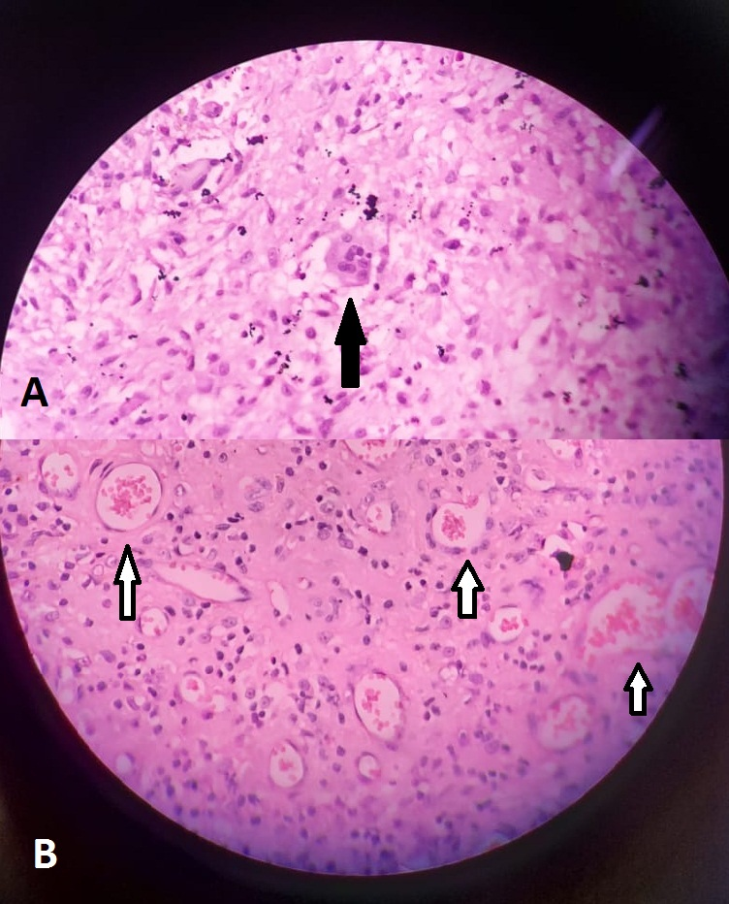
Figure 8: Microscopy of induced membrane. A. Multi-nucleate giant cell (black arrow) B. Capillaries (white arrows).
After this pioneering work, lot of animal as well as human studies have been conducted which studied histology, biochemistry and cellular dynamics of the induced membranes and lot of similarities have been noted between the induced membrane and periosteum. However, the induced membrane is thicker than periosteum with distinct two and occasionally three layers. The inner cellular layer is known as psudo-synovial layer and the outer fibrous layer with highly aligned fibers. The thickness of the membrane varies widely in the literature from 100 to 1000 µm. (17) Other growth factors that have been demonstrated include angiotensis II (ANG-II), fibroblast growth factor-2 (FGF-2) and prostaglandin E2 (PG-E2). (18) Inflammatory and anti-inflammatory factors like TNF-α, IL-6, IL-8 and IL-10 have also been seen. Progenitor cells which may differentiate along osteogenic, adipogenic or chondrogenic lineage have also been demonstrated. Varying concentration of mature osteoblasts has been demonstrated in different studies and it has been postulated maximum number are seen around interface of membrane and the cortical bone. (17) With control of infection and stable fixation of the bone, release of growth and angiogenic factors, neo-vascularization and differentiation of progenitor cells into osteoblastic lineage in the induced membrane makes it a biological chamber or a bioreactor that requires bone graft for osteo-conduction and new bone formation (Figure 9). A membrane without bone graft will be insufficient for new bone formation and bone graft without a membrane will be resorbed.
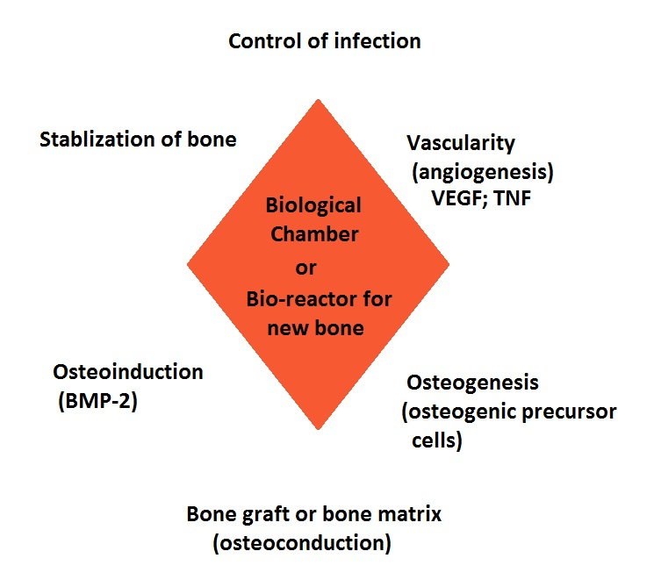
Figure 9: Diamond concept of bone healing. The chamber enclosed by the induced membrane acts as a bioreactor for new bone formation with bone graft acting as a fuel.

5. INNOVATIONS IN THE TECHNIQUE
5.1 Spacers
The conventional Masquelet technique utilized simple polymethy methacrylate (PMMA) as a spacer as the aim of Sir AC Masquelet was to use the spacer as a foreign body which will tell about the eradication or persistence of the infection. Later when its role in induction of a biological membrane became evident, surgeons started using antibiotic impregnated PMMA spacers with an aim to achieve higher concentrations of antibiotic at the debridement site to further control the infection. Schottle PB et al were first to use gentamycin impregnated cement spacer for management of infected non-union. (19) However, question arises if the eluted antibiotic has a negative impact on the properties of induced membrane. Nau C et al in their animal model study found the membranes formed around antibiotic impregnated PMMA were thinner than conventional PMMA. They also observed with use of clindamycin impregnated PMMA spacer, the membranes were thinnest and had least vascularity. (20) However, such studies have not been conducted on infected non-unions in humans. Most human clinical studies recommend use of antibiotic loaded cement spacers with favorable clinical and radiological results for induced membrane technique. (21, 22, 23)
Besides PMMA other material that have been used in animal models include silicon, titanium, polypropylene, calcium sulfate, polycaprolactone, and polyvinyl alcohol sponge. All can induce bioactive membrane except polyvinyl alcohol sponge. The rate of union has been better with PMMA than titanium spacers, which makes titanium unsuitable. Polypropylene spacers prepared from disposable syringes have bone synthesis comparable to that of PMMA at 10 weeks in rat models. (11, 24) Mozumder M, et al in their research presentation of a small series from Bangladesh comparing 5 cases of PMMA spacers with 7 cases of polypropylene disposable syringe spacers observed a comparable clinical and radiological results and recommended use of disposable syringes as spacers in under developed countries. (25)
5.2 Bone grafting
As Masquelet technique has been used for managing large segmental defects; abundant quantity of bone graft is required for the same. Iliac crests are the ideal site for harvesting of the cancellous grafts, other sites being proximal tibia and calcaneum. The graft can be harvested from multiple sites depending on the quantity of the graft required. However, harvesting large quantities of graft can give rise to donor site morbidity. To overcome it allografts like demineralized bone matrix (DBM) and bone graft substitutes like hydroxyapatite, coralline hydroxyapatite, tri-calcium phosphate, biphasic calcium phosphate, calcium sulfate and bioactive glass have been used. Since the artificial graft substitute have osteo-conductive properties and lack onteogenic and osteoinducing potential, their combination with autograft is recommended and they should not constitute more than 33 percent of the mixture volume. DBM is also osteo-conductive and has negligible osteoinducing potential and should also be used along with autologous cancellous bone graft. (12, 15, 26)
Cortical strut grafts have been tried but being compact have problems with revascularization. Maquelets experience with avascular fibular graft showed satisfying results but are prone to stress fractures suggestive of poor vascularization. Results of avascular fibular graft have been promising in induced membrane technique in pediatric age group. To solve this problem Masquelet drilled multiple holes in the fibular graft to permit blood vessel to grow in from the membrane. Multi-perforated fibula along with cancellous bone graft inside the induced membrane is a good alternative in large segmental bone defects. (27, 28, 29, 30) Capanna technique which is an allograft technique with an inlay of vascularized fibula has been combined with Masquelet technique and is known as Capasquelet technique. In this technique the vascular fibular autograft is embedded in freshly prepared femoral allograft. Results are promising as vascularity of graft prevents its fracture on weigh bearing, but is technically demanding procedure. (31, 32)
To reduce donor site morbidity that is associated with iliac crest grafting, cancellous bone graft has been harvested from the femoral canal by reamer irrigator aspirator (RIA) technique. Besides, complications like iatrogenic femoral fractures have been seen. The graft obtained by RIA has a gel like consistency and theoretically ingrowth of blood vessels may not be like that seen in loosely placed cancellous graft obtained from iliac crests. But the clinical results of its use in Masquelet have been encouraging. (33, 34)
Despite these innovations and alternatives, cancellous bone graft harvested from iliac crests is considered as gold standard for Masquelets induced membrane technique for reconstructions of long bone defects.
5.3 Biologicals (growth factors or cells)
With the advancements in recombinant DNA technology it has been possible to synthesize various growth factors involved in osteoinduction and bone grafts or their substitutes can be enriched with these factors to induce new bone synthesis. Promising results have been seen in experimental animal models. Epidermal growth factor, bone BMP-2, BMP-6, BMP 7, and platlet rich plasma have been used in animal models and have shown improvements in membrane histology, membrane biochemistry as well as radiological outcome. (35, 36) Use and their results in Masquelet technique in humans remain controversial. Piacentini F et al in their 16 cases of post-traumatic bone defects managed with induced membrane technique and autologous cancellous bone graft enriched with platlet rich plasma (PRP) and bone marrow concentrate aspirate (BMCA) showed poor healing rates as compared to other studies where simple cancellous graft was utilized. (37)
5.4 Three dimensional printing techniques
3-D printing is a novel technology which has proved its value in arthoplasty and orthopedic tumor surgeries. The technology has simplified reconstruction. 3-D printing has been recently being used for masquelet technique. With this, PMMA spacers of proper size and shape cane be pre-fashioned to avoid thermal damage to bone and the surrounding soft tissues and neuro-vascular elements. It also has a role for designing of scaffolds of titanium or graft substitutes to fill the membrane in the second stage of Masquelet. This technique will be promising in management of defects in periarticular regions as well as defects of small bones like calcaneum or talus where molds may be required to shape spacers and graft scaffolds. (38, 39, 40)
5.5 Intra-membranous bone transport
In the recent times the induced membrane has been combined with the illizarov technique of bone transport, with added advantage of non-requirement of voluminous bone graft. After removal of the spacer, a corticotomy is done at appropriate site and bone transport is started with the bone fragment advancing inside the membranous chamber till the bone ends dock. Bone grafting may or may not be required at a later date once ends dock. (41, 42, 43)
6. EXTENDED INDICATIONS OF MASQUELET TECHNIQUE
To begin with, Masquelet’s induced membrane technique was used for managing infected defect non-unions of long bones and open fractures with segmental bone loss. Over the two decade the indications for the technique have expanded. Cases of chronic osteomyelitis can be managed by debridement of sinus, infected soft tissue and resection of the diseased segment of the pathological bone and the defect created surgically can be addressed on the lines of induced membrane technique. (44) Defects created by resection of bone tumors can also be treated by the two stage Masquelet technique with added advantage of reduction of the time required for reconstruction and also avoiding need for the allografts and metallic implants used for reconstruction. (45) Chotel F et al in their series of 8 patients with long bone sarcomas were managed with two-stage induced membrane technique and all were free of the disease and bone union was achieved in 7 patients at a mean of 4.8 months. (46) Induced membrane technique has also been used with success in congenital pseud-arthrosis (CPT) and preliminary results have been promising. However, cases with severe dystrophic bone may need secondar tibio-fibular grafting to prevent re-fracture. (47)
To start with, the technique was reserved and used for long bones only but at present pathology of small bones of hand and feet can also be addressed with this technique. (48, 49) We at our institute commonly use the technique for crush injuries of hands and feet with bone loss (Figure 10).
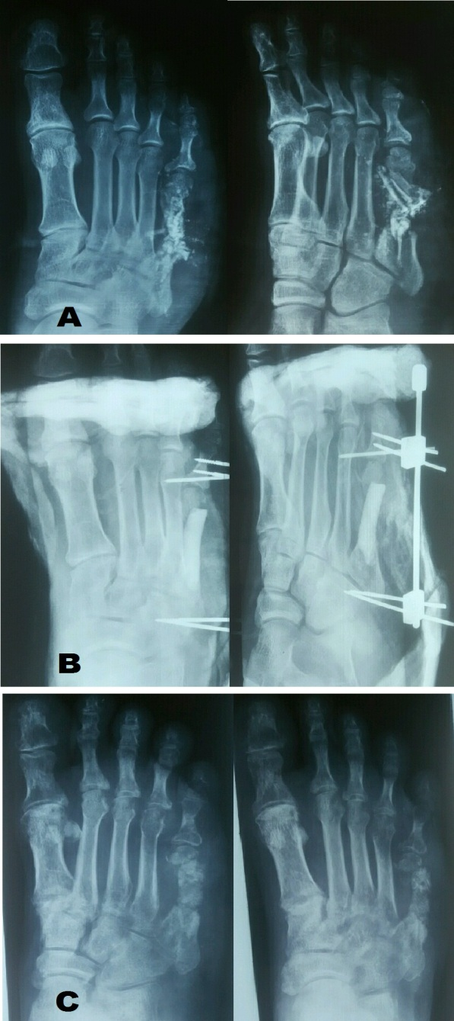
Figure 10: Crush injury of foot with crushing, bone loss and contamination of wound. A. Pre-operative radiograph showing contamination with foreign bodies (sand) seen as radio-opaque material along fifth metatarsal shaft. B. Post –operative radiograph showing cement spacer and stabilization with mini external fixator. C. Radiograph two months after second stage showing consolidation of bone graft.

7. CLINICAL RESULTS
Masquelet AC et al reported results of induced membrane technique on 35 cases of bone defects ranging from 5 to25cm in length. Normal weight bearing and walking was possible at 8.5months for long bones of lower extremity. [27] Karger C et al in their retrospective study of 84 post traumatic long bone reconstructions; using induced membrane technique had union in 90% cases at a mean of 14.4 months. In 57% cases the defect was more 5 cm in length. (50) Marais LC et al managed seven patients suffering from diaphyseal chronic osteomyelitis of tibia with a mean defect of 7cm (range 5-8cm) by intra-membranous bone transport. All cases had union with clinical eradication of infection with an average external fixation time of 77 weeks. However they also grafted the docking site after bone transport through membrane at an average of 17 weeks. (41) Obert L et al managed 20 cases of bone defects in long and short bones of upper extremity of induced membrane technique and all united except two in hand and one in long bone that had non- union. (51) Wong J et al in their 21 cases of infected segmental defects managed by masqulet technique had induced membrane injury during second stage in 6 cases but all of this united without any secondary interventions. Average time to healing was 5.5 months .All healed except one that required bone grafting for non-union at dorsal end of the defect. Adjacent joint function was good to excellent in 19 cases at the final follow up. (52) Dhar SA et al in 12 cases of infected non unions of forearm bone of average 10 to 25 months duration had a two stage Masquelet procedure. An average defect of 5 cm (range 3.5-7cm) was created at the first stage and all the defects united with cancellous bone grafting after removal of bone cement spacer in 6 to 12 months. (10) Hatashita S et al used acute Masquelet technique in seven acute open long limb fractures with bone loss. Two patients required additional procedure for delayed bone union .Eventually all fractured united. (53)
We at our institute prefer platting for stabilization in upper limbs. For long bones of lower extremity we prefer illizarov ring fixator. The ring fixators have an advantage of early weight bearing and in very long defects corticotomy can be added for bone transport besides adding cancellous graft in the membranous chamber at the second stage. This combination of grafting and bone transport has an advantage of reducing the time interval for healing of the bone defect. Occasionally we may remove the cement spacer and then acutely or gradually dock the defect if it does not give significant limb shortening and iit is actually a form of intra-membranous transport and we at our institute call it as “intra-membranous docking” (Figure 11, Figure 12 and Figure 13).
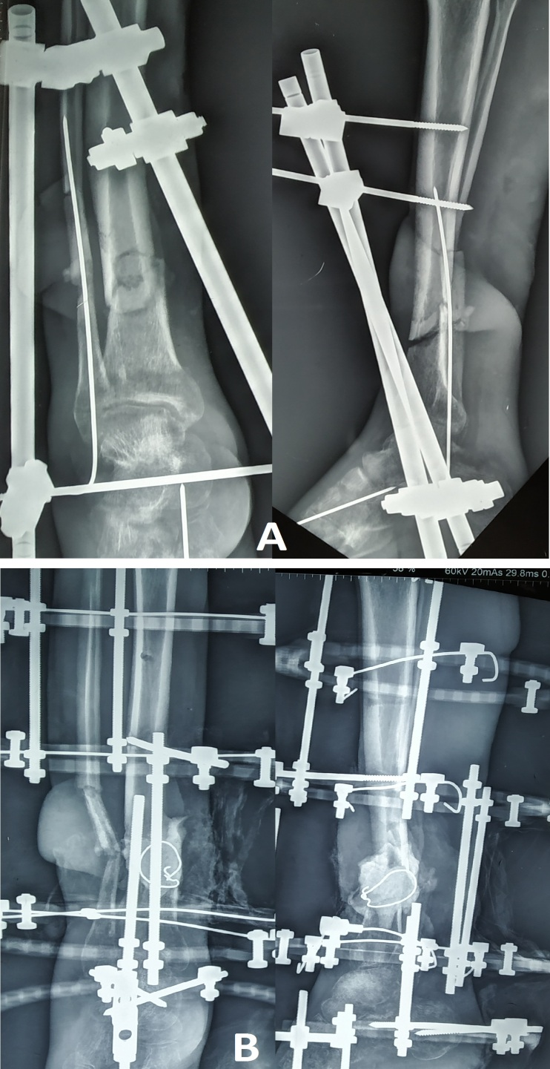
Figure 11: A. Postoperative radiograph of open type IIIB segmental tibia fracture with compound soft tissue defect managed by debridement, external fixator and flap coverage of the defect. B. Radiograph after second procedure of debridement of the necrotic bone segment and implantation of cement spacer in defect and conversion of fixation to circular ring fixator.
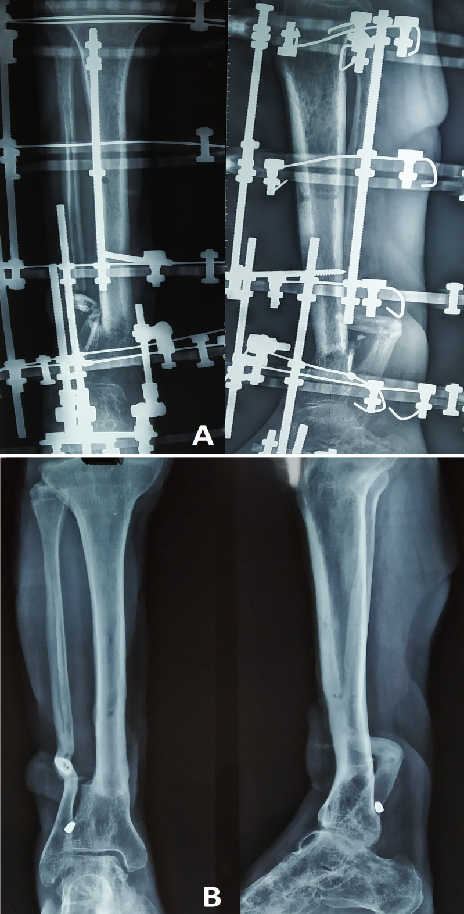
Figure 12: Radiographs of same patient described in Figure 11. A. Radiograph after removal of spacer and acute docking (intra-membranous docking) at the defect. B. Final radiograph showing union without any need for grafting.
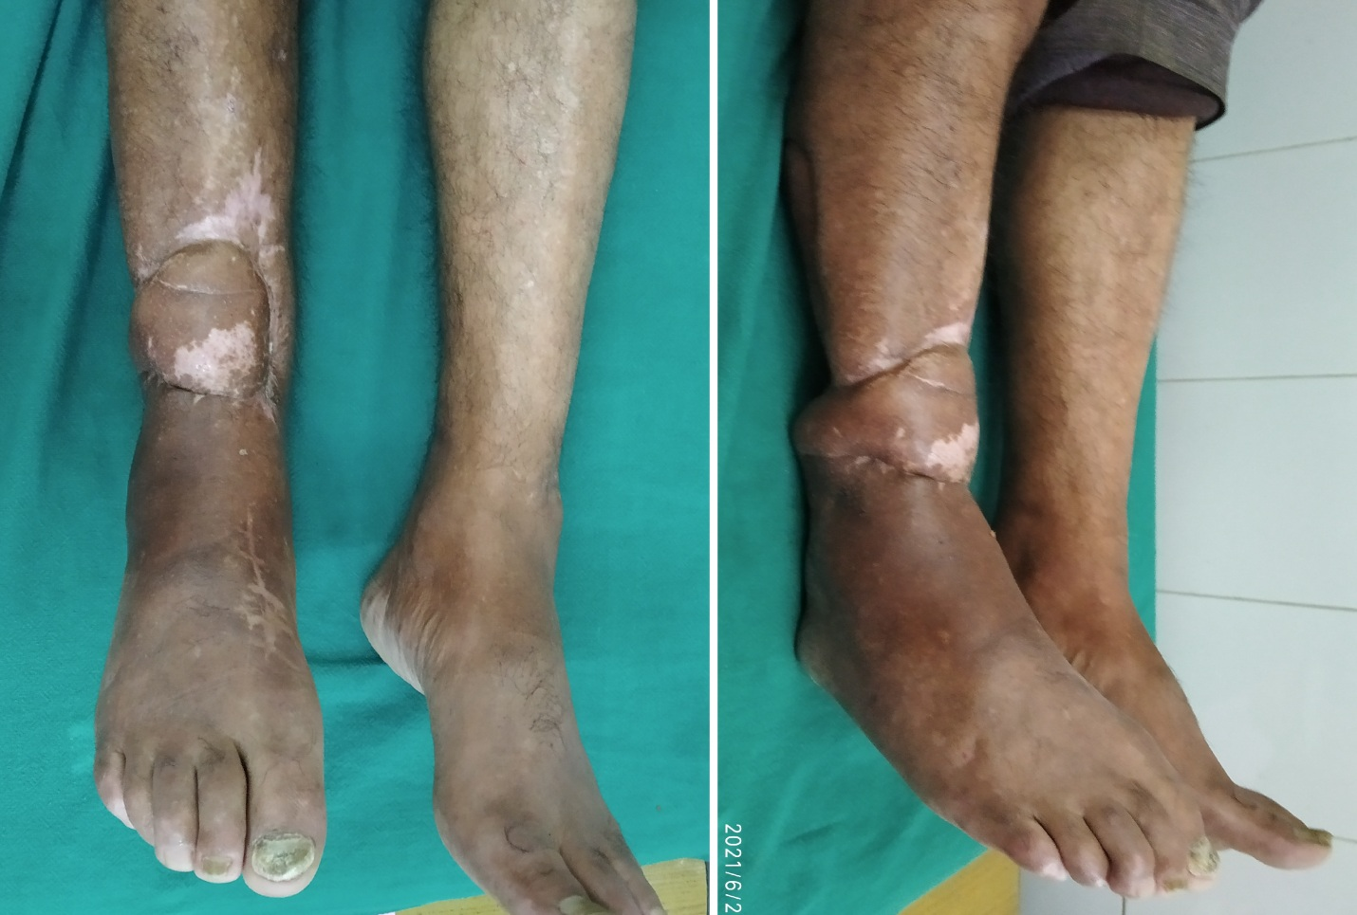
Figure 13: Final clinical picture of the patient described in Figure 12 and 13.
Despite excellent clinical and radiological results of this technique, the technique is still not adopted worldwide for management of infected non-unions and segmental bone loss. No guidelines have been framed for management of infected non-unions using Masquelet’s technique. There is a need for further studies and trials for framing these guidelines so that the technique will be accepted globally in future.
8. CONCLUSION
Though Masquelt’s technique has evolved over time with innovations and expansion of its indications, the basic principle of creation of an environment (the induced biological membrane) which favors growth of blood vessels or neo-vascularization of the graft material placed inside it is a key to success. In case of infection, debridement of infected necrotic tissue including bone and a stable rigid fixation of the bone fragments are the other two pillars without which the biological chamber or envelope of induced membrane will not be useful in generation of new bone from the graft substrate. Though an easy and a reproducible procedure, delicate handling of the induced membrane and its preservation in the second stage surgery is of utmost importance.

COMPETING INTERESTS
Authors have declared that they have no known competing financial interests or non-financial interests or personal relationships that could have appeared to influence the work reported in this paper.
DISCLAIMER (ARTIFICIAL INTELLIGENCE)
Authors hereby declare that no generative AI technologies such as large language models (ChatGPT, COPILOT, etc.) and text to image generators have been used during the writing or editing of this manuscript.
REFERENCES
- Meena, L.N., Galfat, D.R. (2017). Management of infected gap non-union of long bones by Masquelet technique. Nat J of Medical and Dental research, 6(1), 303-306.
- Apard, T., Bigorre, N., Cronier, P., Duteille, F., Bizot, P., Massin, P. (2010). Two stage reconstruction of post traumatic segmental tibia bone loss with nailing. Orthop Traumatol Surg Res, 96(5), 549-553. https://doi.org/10.1016/j.otsr.2010.02.010
- Keating, J.F., Simpson, A.H., Robinson, C.M. (2005). The management of fractures with bone loss. J Bone Joint Surg Br, 87(2), 142-150. https://doi.org/10.1302/0301-620X.87B2.15874
- Pelissier, P., Masquelet, A.C., Bareille, R., Pelissier, S.M., Amedee, J. (2004). Induced membranes secrete growth factors including vascular and osteoinductive factors and could stimulate bone regeneration. J Orthop Res, 22(1), 73-79. https://doi.org/10.1016/S0736-0266(03)00165-7
- Assal, M., Stern, R. (2014). The Masquelet procedure gone awry. Orthopedics, 37(11), e1045-e1048. https://doi.org/10.3928/01477447-20141023-93
- Masquelet, A., Kanakaris, N.K., Obert, L., Stafford, P., Giannoudis, P.V. (2019). Bone Repair Using the Masquelet Technique. J Bone Joint Surg Am, 101(11), 1024-1036. . https://doi.org/10.2106/JBJS.18.00842
- Mühlhäusser, J., Winkler, J., Babst, R., Beeres, F.J.P. (2017). Infected tibia defect fractures treated with the Masquelet technique. Medicine (Baltimore), 96(20), e6948. https://doi.org/10.1097/MD.0000000000006948
- Wong, T.M., Lau, T.W., Li, X., Fang, C., Yeung, K., Leung, F. (2014). Masquelet technique for treatment of posttraumatic bone defects. ScientificWorld Journal, 2014, 710302. https://doi.org/10.1155/2014/710302
- Kasha, S., Rathore, S.S., Kumar, H. (2019). Antibiotic Cement Spacer and Induced Membrane Bone Grafting in Open Fractures with Bone Loss: A Case Series. Indian J Orthop, 53(2), 237-245. https://doi.org/10.4103/ortho.IJOrtho_110_17
- Dhar, S.A., Dar, T.A., Mir, N.A. (2019). Management of Infected Nonunion of the Forearm by the Masquelet Technique. Strategies Trauma Limb Reconstr, 14(1), 1- 5. https://doi.org/10.5005/jp-journals-10080-1411
- Liodakis, E., Giannoudis, V.P., Sehmisch, S., Jha, A., Giannoudis, P.V. (2022). Bone defect treatment: does the type and properties of the spacer affect the induction of Masquelet membrane? Evidence today. Eur J Trauma Emerg Surg, 48(6), 4403-4424. https://doi.org/10.1007/s00068-022-02005-x
- Mathieu, L., Mourtialon, R., Durand, M., de Rousiers, A., de l'Escalopier, N., Collombet, J.M. (2022) Masquelet technique in military practice: specificities and future directions for combat-related bone defect reconstruction. Mil Med Res, 9(1), 48. https://doi.org/10.1186/s40779-022-00411-1
- Chadayammuri. V., Hake M., Mauffrey C. (2015). Innovative strategies for management of long bone infection; A review of Masquelet technique. Patient Saf Surg. 9, 32. https://doi.org/10.1186/s13037-015-0079-0
- Masquelet, A.C. (2016). The evolution of the induced membrane technique: Current status and future directions. Tech Orthop, 31(1), 3-8. https://doi.org/10.1097/BTO.0000000000000160
- Masquelet, A.C. (2017). Induced Membrane Technique: Pearls and Pitfalls. J Orthop Trauma, 31(Suppl 5), S36-S38. https://doi.org/10.1097/BOT.0000000000000979
- Anderson, J.M., Rodriguez, A., Chang, D.T. (2008). Foreign body reaction to biomaterials. Semin Immunol, 20(2), 86-100. https://doi.org/10.1016/j.smim.2007.11.004
- Alford, A.I., Nicolaou, D., Hake, M., McBride-Gagyi, S. (2021) Masquelet's induced membrane technique: Review of current concepts and future directions. J Orthop Res. 39(4), 707-718. https://doi.org/10.1002/jor.24978
- Wang, X., Wei, F., Luo, F., Huang, K., Xie, Z. (2015) Induction of granulation tissue for the secretion of growth factors and the promotion of bone defect repair. J Orthop Surg Res, 10, 147. https://doi.org/10.1186/s13018-015-0287-4
- Schöttle, P.B., Werner, C.M., Dumont, C.E. (2005) Two-stage reconstruction with free vascularized soft tissue transfer and conventional bone graft for infected nonunions of the tibia: 6 patients followed for 1.5 to 5 years. Acta Orthop, 76(6), 878-883. https://doi.org/10.1080/17453670510045534
- Nau, C., Seebach, C., Trumm, A., Schaible, A., Kontradowitz, K., Meier, S., et al. (2016) Alteration of Masquelet's induced membrane characteristics by different kinds of antibiotic enriched bone cement in a critical size defect model in the rat's femur. Injury, 47(2), 325-334. https://doi.org/10.1016/j.injury.2015.10.079
- Liu, X., Ding, G., Zhou, D., Xiang, L. (2018) Antibiotic-loaded bone cement spacer usage combined with membrane induction in infected gap non-unions: A case series. Pak J Med Sci, 34(5), 1088-1093. https://doi.org/10.12669/pjms.345.14569
- Siboni, R., Joseph, E., Blasco, L., Barbe, C., Bajolet, O., Diallo, S., et al. (2018). Management of septic non-union of the tibia by the induced membrane technique. What factors could improve results?. Orthop Traumatol Surg Res, 104(6), 911-915. https://doi.org/10.1016/j.otsr.2018.04.013
- Liu, X., Min, H.S., Chai, Y., Yu, X., Wen, G. (2022). Masquelet technique with radical debridement and alternative fixation in treatment of infected bone nonunion. Front Surg, 9,1000340. https://doi.org/10.3389/fsurg.2022.1000340
- Mathieu, L., Murison, J.C., de Rousiers, A., de Rousiers, A., de l’Escalopier, Lutomski, D., et al. (2021) The Masquelet Technique: Can Disposable Polypropylene Syringes be an Alternative to Standard PMMA Spacers? A Rat Bone Defect Model. Clin Orthop Relat Res, 479(12), 2737-2751. https://doi.org/10.1097/CORR.0000000000001939
- Mozumder, M., Chowdhury, A., Islam, M. Induced membrane technique (Masquelet technique) for the treatment of bone defect using piece of disposable syringe as a spacer in developing countries. 37th SICOT Orthopaedic World Congress, 2016, abstract no: 43308. Available at: http://www.sicot.org/sites/default/files/images/Rome/Abstract-Book-Free-Papers.pdf.
- Calori, G.M., Mazza, E., Colombo, M., Ripamonti, C. (2011) The use of bone-graft substitutes in large bone defects: any specific needs?. Injury, 42 (Suppl 2), S56-S63. https://doi.org/10.1016/j.injury.2011.06.011
- Masquelet, A.C., Fitoussi, F., Begue, T., Muller, G.P. (2000) Reconstruction des os longs par membrane induite et autogreffe spongieuse [Reconstruction of the long bones by the induced membrane and spongy autograft]. Ann Chir Plast Esthet, 45(3), 346-353.
- Fitoussi. F., Ilharreborde, B. (2015). Is the Induced-membrane Technique Successful for Limb Reconstruction After Resecting Large Bone Tumors in Children?. Clin Orthop Relat Res, 473(6), 2067-2075. https://doi.org/10.1007/s11999-015-4164-6
- Bhosale, A.H. (2021). Reconstruction of a post-traumatic tibial defect of 10 cm in a 6 month old induced membrane by non-vascularised fibula autograft - A case report. Trauma Case Rep, 37, 100576. https://doi.org/10.1016/j.tcr.2021.100576
- Yaokreh, J.B., Yapo Kouamé, G.S., Odéhouri-Koudou, T.H., Ouattara, O. (2022) Induced membrane technique for reconstruction of a 25 cm humerus diaphyseal defect secondary to chronic osteomyelitis in an adolescent. Afr J Paediatr Surg, 19(2), 112-114. https://doi.org/10.4103/ajps.AJPS_40_21
- Combal, A., Thuau, F., Fouasson-Chailloux, A., Arrigoni, P., Baud’huin, M., Duteille, F., et al. (2021) Preliminary Results of the "Capasquelet" Technique for Managing Femoral Bone Defects-Combining a Masquelet Induced Membrane and Capanna Vascularized Fibula with an Allograft. J Pers Med, 11(8), 774. https://doi.org/10.3390/jpm11080774
- Capanna, R., Campanacci, D.A., Belot, N., Beltrami, G., Manfrini, M., Innocenti, M., et al. A new reconstructive technique for intercalary defects of long bones: the association of massive allograft with vascularized fibular autograft long-term results and comparison with alternative techniques. Orthop Clin N Am. 38(1), 51-60. https://doi.org/10.1016/j.ocl.2006.10.008
- Dawson J, Kiner D, Gardner W, Swafford R, Nowotarski PJ. The reamer-irrigator-aspirator as a device for harvesting bone graft compared with iliac crest bone graft: union rates and complications. J Orthop Trauma 2014;28(10):584-590. https://doi.org/10.1097/BOT.0000000000000086
- Stafford, P.R., Norris, B.L. (2010). Reamer-irrigator-aspirator bone graft and bi Masquelet technique for segmental bone defect nonunions: a review of 25 cases. Injury, 41 Suppl 2, S72-S77. https://doi.org/10.1016/S0020-1383(10)70014-0
- Bilal, Ö., Topak, D., Kınaş, M., Kurutaş, E.B., Kızıldağ, B., Bahar, A.Y. (2020) Epidermal growth factor or platelet-rich plasma combined with induced membrane technique in the treatment of segmental femur defects: an experimental study. J Orthop Surg Res, 15(1), 601. https://doi.org/10.1186/s13018-020-02142-2
- Han, W., Shen, J., Wu, H., Yu, S., Fu, J., Xie, Z. Induced membrane technique: Advances in the management of bone defects. Int J Surg, 42,110-116. https://doi.org/10.1016/j.ijsu.2017.04.064
- Piacentini, F., Ceglia, M.J., Bettini, L., Bianco, S., Buzzi, R. (2019). Campanacci DA. Induced membrane technique using enriched bone grafts for treatment of posttraumatic segmental long bone defects. J Orthop Traumatol, 20(1), 13. https://doi.org/10.1186/s10195-019-0522-6
- Tetsworth, K., Woloszyk, A., Glatt, V. (2019) 3D printed titanium cages combined with the Masquelet technique for the reconstruction of segmental femoral defects: Preliminary clinical results and molecular analysis of the biological activity of human-induced membranes. OTA Int, 2(1), e016. https://doi.org/10.1097/OI9.0000000000000016
- Wei, C., Chen, J., Zheng, C. (2022) Application and advantages of three-dimensional printing in treatment of masquelet membrane induction for infectious tibial bone defects. Digit Med, 8, 18. https://doi.org/10.4103/digm.digm_41_21
- Zhang, L., Lu, C., Lv, Y., Wang, X., Guo, S., Zhang, H. (2021) Three-Dimensional Printing-Assisted Masquelet Technique in the Treatment of Calcaneal Defects. Orthop Surg, 13(3), 876-883. https://doi.org/10.1111/os.12873
- Marais, L.C., Ferreira, N. (2015) Bone transport through an induced membrane in the management of tibial bone defects resulting from chronic osteomyelitis. Strategies Trauma Limb Reconstr, 10(1), 27-33. https://doi.org/10.1007/s11751-015-0221-7
- Borzunov, D.Y., Kolchin, S.N., Mokhovikov, D.S., Malkova, T.A. (2022) Ilizarov bone transport combined with the Masquelet technique for bone defects of various etiologies (preliminary results). World J Orthop, 13(3), 278-288. https://doi.org/10.5312/wjo.v13.i3.278
- Khaled A., El-Gebaly, O., El-Rosasy, M. (2022) Masquelet-Ilizarov technique for the management of bone loss post debridement of infected tibial nonunion. Int Orthop, 46(9), 1937-1944. https://doi.org/10.1007/s00264-022-05494-y
- Wang, X., Wang, Z., Fu, J., Huang, K., Xie, Z. (2017) Induced membrane technique for the treatment of chronic hematogenous tibia osteomyelitis. BMC Musculoskelet Disord, 23;18(1):33. https://doi.org/10.1186/s12891-017-1395-6
- Fitoussi, F., Ilharreborde, B. (2015) Is the Induced-membrane Technique Successful for Limb Reconstruction After Resecting Large Bone Tumors in Children? Clin Orthop Relat Res, 473(6), 2067-75. https://doi.org/10.1007/s11999-015-4164-6
- Chotel, F., Nguiabanda, L., Braillon, P., Kohler, R., Bérard, J., Abelin-Genevois, K. (2012). Induced membrane technique for reconstruction after bone tumor resection in children: a preliminary study. Orthop Traumatol Surg Res, 98(3), 301-308. https://doi.org/10.1016/j.otsr.2011.11.008
- Pannier, S., Pejin, Z., Dana, C., Masquelet, A.C., Glorion, C. (2013) Induced membrane technique for the treatment of congenital pseudarthrosis of the tibia: preliminary results of five cases. J Child Orthop, 7(6), 477-85. https://doi.org/10.1007/s11832-013-0535-2
- Saito, T., Noda, T., Kondo, H., Demiya, K., Nezu, S., Yokoo, S. et al. (2019) The Masquelet technique for septic arthritis of the small joint in the hands: Case reports. Trauma Case Rep, 25, 100268. https://doi.org/10.1016/j.tcr.2019.100268
- Liu, Z.B., Li, Q., Liu, W.X., Li, X.H., Ma, K., Huo, Y.B., et al. (2022) Comparison of Clinical Effects of the Modified Masquelet Technique and Kirschner Wire External Fixation-Assisted Autogenous Bone Transplantation in the Treatment of Segmental Metacarpophalangeal Bone Defects. Int J Gen Med, 15, 1619-1635. https://doi.org/10.2147/IJGM.S343617
- Karger, C., Kishi, T., Schneider, L., Fitoussi, F., Masquelet, A.C. (2012) Treatment of posttraumatic bone defects by the induced membrane technique. Orthop Traumatol Surg Res, 98(1), 97-102. https://doi.org/10.1016/j.otsr.2011.11.001
- Obert, L., Loisel, F., Adam, A., Sergent, P., Gindraux, F., Garbuio, P. (2018) Induced membrane technique (Masquelet technique) to treat bone defects at upper limb prospective multicentre evaluation. Orthopedic Proceedings, 96B, 47-47. doi:10.1302/1358-992X.96BSUPP_19.SAOA2014-047
- Wang, J., Yin, Q., Sanjun, Gu., Wu, Y., Rui, Y. (2019) Induced membrane technique in treatment of infectious bone defect: A clinical analysis. Orthopedics and traumatology: Surgery and research, 105(3), 535-39. https://doi.org/10.1016/j.otsr.2019.01.007
- Hatashita, S., Kawakami, R., Ejiri, S., Sasaki, N., Toshiki, N., Ito, M., et al. (2021) Acute Masquelet technique' for reconstructing bone defects of an open lower limb fracture. Eur J Trauma Emerg Surg, 47(4), 1153-1162. https://doi.org/10.1007/s00068-019-01291-2

