Unexpected Discovery of An Unusually Long Appendix During Surgery : A case report

Abstract
Background: The vermiform appendix exhibits significant anatomical variability in terms of length, position, and relationships with surrounding structures. The incidental discovery of an exceptionally long appendix is rare and usually occurs during laparotomy or laparoscopy performed for other indications. Such variations can have important surgical implications, particularly during appendectomy or colonic procedures.
Case Presentation : We report the incidental intraoperative discovery of an appendix of extraordinary length in a patient who was the victim of a severe road traffic accident and in a state of shock refractory to resuscitation measures. The CT scan revealed a moderate hemoperitoneum associated with hepatic lacerations.
Discussion and conclusion: Although a long appendix is rare, surgeons must be aware of the anatomical variations of the appendix including length and position when considering diagnosis and surgical intervention. This is essential due to the increased risk of complication and morbidity associated with delayed or missed cases of appendicitis. Therefore, a high index of suspicion, combined with sound clinical judgment, is crucial for diagnosing acute appendicitis, particularly in atypical presentations.
Keywords: vermiform appendix, acute appendicitis, hepatic lacerations, long appendix, clinical implications

Introduction
The vermiform appendix is an anatomical structure known for its considerable variability in terms of position, shape, and size. Its average length, typically ranging between 6 and 9 cm[1], can vary significantly, from a few centimeters up to more than 20 cm according to anatomical pathology series[2,3]. These anatomical variations, often asymptomatic, can nevertheless have major clinical implications, particularly by altering the typical presentation of acute appendicitis. An unusual location or length of the appendix may complicate diagnosis, delay management, and increase the risk of complications[4].
Accurate recognition of these anatomical peculiarities is therefore crucial for the surgeon.We present a rare case of an exceptionally long vermiform appendix discovered intraoperatively, and discuss the clinical and surgical implications of the anatomical variation of appendix.
Case Presentation :
A 30-year-old man with no significant medical history was urgently taken to the operating room for an exploratory laparotomy following blunt abdominal trauma sustained in a road traffic accident. The patient was hemodynamically unstable and the computed tomography scan revealed a hemoperitoneum associated with hepatic lacerations. The rest of the body scan showed no other obvious intra-abdominal injuries.
During surgical exploration, the presence of hemoperitoneum was confirmed along with non-bleeding hepatic lacerations localized in segments II and VIII. Systematic examination of the digestive tract, pancreas, duodenum, stomach, esophagus, diaphragm, spleen, and mesentery revealed no abnormalities.
Incidentally, an atypical vermiform appendix was observed. Its origin at the base of the cecum was normal; however, its ascending course and exceptionally extended length reached the subhepatic region, in direct contact with the inferior surface of the left liver lobe. No signs of inflammation or appendiceal pathology were found. The appendix was left intact.
The abdominal cavity was irrigated and drained with a Delbet drain placed subhepatically and a Redon drain positioned in the pouch of Douglas. The abdominal wall was closed in layers. The patient was then transferred to the intensive care unit for further management.

Discussion
The vermiform appendix is a structure known for its significant anatomical variability in both position and length. Although these variations are often asymptomatic, they can alter the clinical presentation of appendiceal pathology and make diagnosis more challenging[5,6,7].
Typically located in the right iliac fossa, the appendix may assume several positions, including retrocecal, pelvic, paracolic, and more rarely pre-ileal, post-ileal, or subhepatic. Such atypical positions may mimic other abdominal or pelvic conditions. Differential diagnoses to consider in such cases include biliary colic, renal colic, urinary tract infection, testicular or ovarian torsion, ruptured ovarian cyst, ectopic pregnancy, pelvic inflammatory disease, endometriosis, and diverticulitis [8,9].
Appendiceal length is also subject to significant variation. While the average length is reported to range between 6 and 9 cm, it may vary from less than 2.5 cm to up to 26 cm, according to the literature [10,11]. The appendix tends to be longer during childhood and gradually shortens with age. The longest vermiform appendix ever documented measured 26 cm and was found during an autopsy in Croatia in 2006 [12,13].
In our case, the appendix was not inflamed, and no surgical procedure was performed on it. Rather, it was an incidental intraoperative finding during an exploratory laparotomy conducted in the context of polytrauma following a road traffic accident. The exploration revealed an unusually long appendix, originating from the cecum and extending upward to the subhepatic region, direct contact with the inferior surface of the left hepatic lobe ,the length was about 25 cm (Figures 1 and 2).
Although this variation was asymptomatic in our patient, it highlights the importance of recognizing anatomical variations of the appendix, particularly in cases presenting with atypical abdominal pain. An appendix with a subhepatic course, for instance, could potentially mimic hepatobiliary or gastric pathology, leading to misdiagnosis and delayed treatment in the event of appendicitis.
Finally, this case also illustrates the importance of surgeons recognizing the significant anatomical variability in both position and length. Documenting such a variation enhances our broader understanding of the anatomical differences and their implication in clinical practice. Although extremely long appendix is very rare awareness of this variation helps to prevent misdiagnosis ensure timely intervention and reduces risk of complications

Conclusion
The incidental intraoperative discovery of an exceptionally long appendix remains rare and illuminates the critical importance for clinicians to be aware of the possible anatomical variations of this structure. Such variations can alter the clinical presentation of appendicitis or make imaging interpretation more challenging,which can elevate the risk of misdiagnosis and delay surgical intervention.

FIGURE 1 Unexpected discovery of extremely long appendix

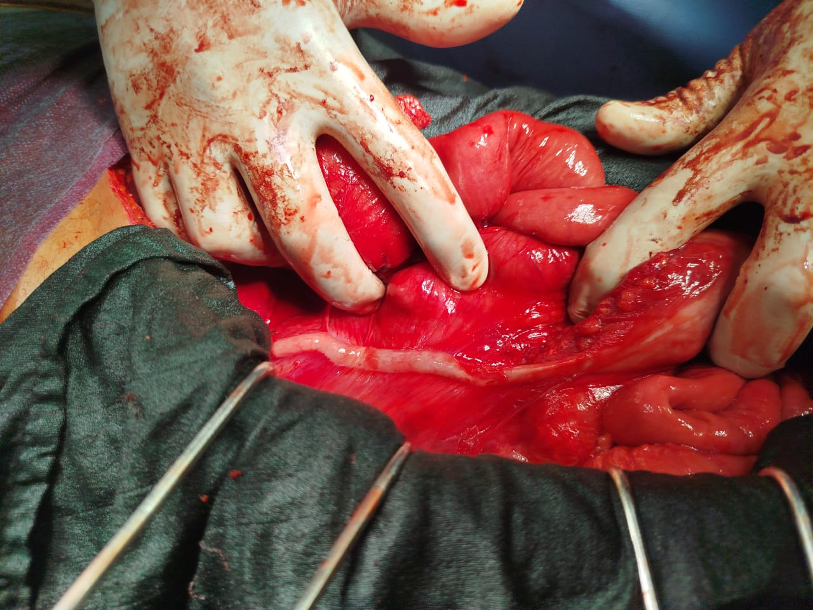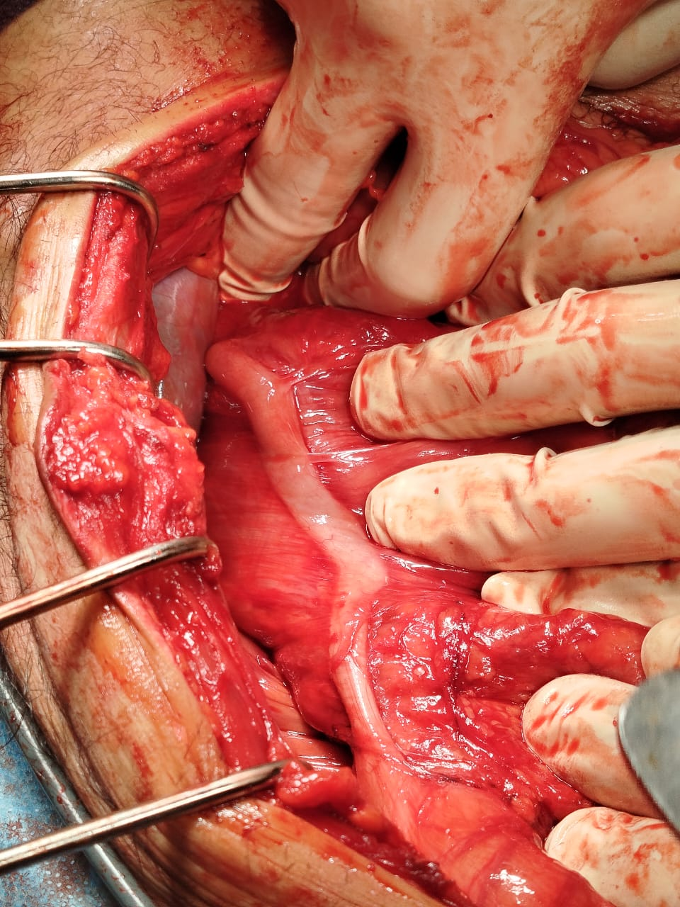

FIGURE 2 : long appendix in direct contact with the inferior surface of the left hepatic lobe

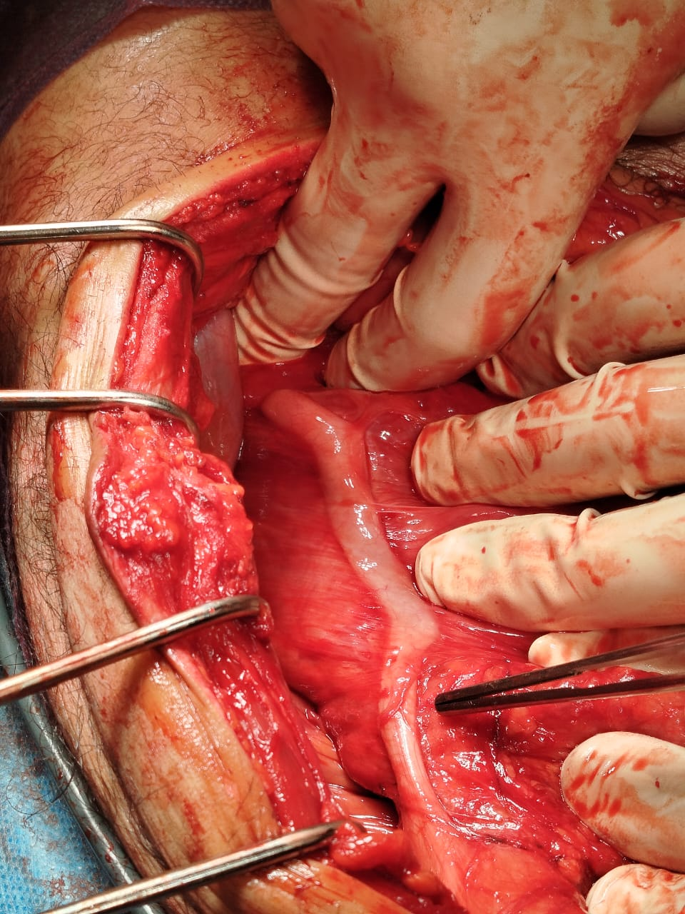

Consent
As per international standards or university standards, patient(s) written consent has been collected and preserved by the author(s).

Disclaimer (Artificial intelligence)
Option 1:
Author(s) hereby declare that NO generative AI technologies such as Large Language Models (ChatGPT, COPILOT, etc.) and text-to-image generators have been used during the writing or editing of this manuscript.
Option 2:
Author(s) hereby declare that generative AI technologies such as Large Language Models, etc. have been used during the writing or editing of manuscripts. This explanation will include the name, version, model, and source of the generative AI technology and as well as all input prompts provided to the generative AI technology
Details of the AI usage are given below:
1.
2.
3.

Référence

1.Rothrock S, Pagane J. Acute appendicitis in children: emergency department diagnosis and management. Annals of emergency medicine. 2000; 36(1): 39-51. PubMed | Google Scholar

2..Laraqui, Hicham, et al. "An unusual presentation of appendicitis: a 23 cm long appendix in Morocco." Pan African Medical Journal 32.1 (2019).

3.Ajmani ML, Ajmani K. The position, length and arterial supply of vermiform appendix. Anat Anz. 1983; 153(4): 369. PubMed | Google Scholar

4.Laraqui, Hicham, et al. "An unusual presentation of appendicitis: a 23 cm long appendix in Morocco." Pan African Medical Journal 32.1 (2019).

5. Vieira ED, Bonato LM, da Silva GG, Gurgel JL. Congenital abnormalities and anatomical variations of the vermiform appendix and mesoappendix. J Coloproctol. 2019;39(3):279-87. https://doi.org/10.1016/j.jcol.2019.04.003

6 Hafiz N, Greene KG, Crockett SD. An unusual cause of right upper quadrant pain. Gastroenterology. 2017;153(2):e10-1. https://doi.org/10.1053/j.gastro.2016.12.042 PMid:28672120

7.Mwachaka P, El-Busaidy H, Sinkeet S, Ogeng’o J. Variations in the position and length of the vermiform appendix in a black Kenyan population. ISRN Anat. 2014;2014:871048. https://doi. org/10.1155/2014/871048 PMid:25938112

8. De Souza SC, da Costa SR, de Souza IG. Vermiform appendix: Positions and length-a study of 377 cases and literature review. J Coloproctol. 2015;35(4):212-6. https://doi.org/10.1016/j. jcol.2015.08.003

9. Evola G, Ferrara F, Di Fede GF, Patanè M, Sarvà S, Piazza L. Leftsided acute appendicitis in a patient with situs viscerum inversus totalis: A case report. Int J Surg Case Rep. 2022;90:106658. https://doi.org/10.1016/j.ijscr.2021.106658 PMid:34915437

10.Yoshida Takuya, Morimoto Yoshikazu, Kurihara Yojiro, Nishikawa Kazuhiro, Tanaka Yasuhiro. A case report of torsion of an unusually large vermiform appendix, Journal of Japan Surgical Association, 2005, No. 6; Page 1376 – 1378.

11.Ajmani ML, Ajmani K. The position, length and arterial supply of vermiform appendix. Anat Anz. 1983;153(4):369-74. PMid:6881534

12.Boddeti, Ravindra Kumar, Roopa Kulkarni, and Pradeep Kumar H. Murudkar. "Unique 28 cm long vermiform appendix." Int J Anat Res 1.2 (2013): 111-14.

13.Collins DC. 71,000, Human appendix specimens: anal report summarizing forty years study. Am J Proctol. 1963; 14: 365- 81. PubMed | Google Scholar.

