Laparoscopic Resection of a Large Functioning Paraganglioma at the Organ of Zuckerkandl: A Rare Case Report and Review of the Literature

Abstract

Paragangliomas are rare neuroendocrine tumours that arise from extra-adrenal sympathetic or paratympanic ganglia. Intra-abdominal paragangliomas are particularly uncommon, with an estimated incidence of approximately 1 in 500,000. Paratympanic paragangliomas are typically located in the head and neck region, while sympathetic paragangliomas are more often found in the abdomen, followed by the chest and pelvis. A large paraganglioma of the organ of Zuckerkandl (POZ) is extremely rare. Notably, about 53% of paragangliomas occur in the organ of Zuckerkandl, which lies anterolateral to the distal abdominal aorta, between the origin of the inferior mesenteric or renal artery and the aortic bifurcation. The clinical presentation of abdominal paragangliomas can include the classical triad of headache, palpitations, and excessive sweating. Many paragangliomas remain asymptomatic and are detected incidentally during imaging studies. A rare case of a large abdominal functioning paraganglioma arising from the organ of Zuckerkandl in a 20-year-old female patient was reported and diagnosed through abdominal ultrasonography and CT imaging. Abdominal ultrasonography revealed a rounded, homogeneous, hypoechoic, vascular lesion measuring 6 × 4.5 cm, located just below the umbilicus on the right side of the abdomen. A laparoscopic excision was performed with the patient in the supine position and steep Trendelenburg. The patient remained in the ICU on inotropic support for 48 hours, after which her blood pressure stabilised at 120/80 mmHg. Findings were consistent with a benign extra-adrenal paraganglioma. In conclusion, abdominal paragangliomas of the organ of Zuckerkandl are rare endocrine tumours. Among surgical options, the laparoscopic approach is considered the gold standard treatment.

Keywords: Paraganglioma, Pheochromocytoma, organ at Zuckerkandl, Laparoscopic surgery, rare tumours

Introduction

Paragangliomas and pheochromocytomas are rare tumours that arise from chromaffin cells. About 53% of paragangliomas occur in the organs of Zuckerkandl, which are a collection of paraganglia located anterolaterally to the distal abdominal aorta between the origin of the inferior mesenteric artery or renal artery and the aortic bifurcation (Ren et al., 2020; Divya et al., 2025). Pheochromocytomas originate from the adrenal medulla, whereas paragangliomas develop outside the adrenal gland, typically along the sympathetic or parasympathetic ganglia. For this reason, paragangliomas are often referred to as extra-adrenal pheochromocytomas. [1,2,3]. The characteristic feature of the tumour is the presence of epitheloid, spindle and ganglion cells on routine staining. It is mostly benign, though it has a tendency for malignant transformation (Lambe & Yadav, 2025).

Classification

According to the World Health Organisation (WHO), paragangliomas are divided into two groups:

1. Parasympathetic paragangliomas (PGLs): Primarily located in the head and neck.
2. Sympathetic paragangliomas (PGLs): Usually located in the abdomen and chest, accounting for nearly 80% of all PGLs. [4,5,6]

Among sympathetic paragangliomas, about 85% occur below the diaphragm, most commonly along the abdominal aorta and inferior vena cava. The most frequent site of occurrence is the organ of Zuckerkandl. Genetic Associations: Approximately 25–35% of patients with paragangliomas have an associated hereditary condition, such as: [1,2,3]

• Multiple Endocrine Neoplasia type 2A and 2B (MEN2A and MEN2B)

• Von Hippel–Lindau (VHL) disease

• Neurofibromatosis type 1 (NF1)

• Hereditary paraganglioma syndrome

• Carney–Stratakis dyad (paraganglioma and gastrointestinal stromal tumour [GIST])

• Carney triad (paraganglioma, GIST, and pulmonary chondroma) [4,5,7]

Clinical Features

Symptoms are related to catecholamine hypersecretion. When the tumour releases excess adrenaline or noradrenaline, patients may present with: Episodic or sustained hypertension, Headache, Excessive sweating (diaphoresis/hyperhidrosis), Palpitations, Nausea and vomiting, Hyperglycemia, Syncope, often due to orthostatic hypotension. [1,2,4]

Diagnosis of Abdominal Paraganglioma

Biochemical Testing

• Plasma and urinary metanephrines: Gold standard test, measuring metanephrine and normetanephrine levels to detect catecholamine excess.

• 24-hour urinary catecholamines: Used to quantify total catecholamine output.

Imaging Studies

• CT abdomen: Tumours are highly vascular, typically showing homogeneous contrast enhancement when small. Larger lesions often appear heterogeneous, lobulated, and may contain necrosis, haemorrhage, or calcification.

• MRI: Demonstrates hypo- or isointense masses. Internal haemorrhage and cystic changes contribute to heterogeneous appearances.

• MIBG scintigraphy: A radiotracer study that helps localise catecholamine-secreting tumours.

• PET scan: Provides functional imaging using radiolabeled tracers to further characterise the tumour.

Genetic Testing
Genetic evaluation is recommended for all patients with paragangliomas, especially those with a
family history. It plays a crucial role in identifying hereditary syndromes and assessing the risk of recurrence after treatment. [1,2,3,4]

Case Report

A 20-year-old female was admitted to our centre on 17/08/2025 with complaints of headache, hypertension, palpitations, and hyperhidrosis. She also reported a history of vomiting, orthostatic hypotension, and syncopal episodes.

On physical examination, a firm, non-mobile lump was palpable in the right iliac fossa. Abdominal ultrasonography revealed a rounded, homogeneous, hypoechoic, vascular lesion measuring 6 × 4.5 cm, located just below the umbilicus on the right side of the abdomen. Contrast-enhanced CT abdomen demonstrated a vascular mass in the right para-aortic region, situated anterior to the lower abdominal aorta and inferior vena cava. The mass extended from below the right renal artery to the aortic bifurcation.

Two months earlier, the patient had been referred to an endocrinologist for evaluation and blood pressure management. At that time, her blood pressure was 230/130 mmHg, and plasma metanephrines were markedly elevated at 999.0 µg. She was started on alpha-blocker therapy for blood pressure
control prior to surgery. At the time of surgery, her blood pressure was well controlled at 130/74 mmHg.

Anaesthetic Management
On the day before surgery, oral anxiolytics were administered. On the day of surgery, the patient received all antihypertensive medications as scheduled. Two large-bore intravenous lines and a central venous catheter were placed. Anaesthesia was induced with high-dose thiopentone and succinylcholine, followed by endotracheal intubation and maintenance with O₂, N₂O, and isoflurane. During tumour mobilisation, blood pressure spiked to 230/140 mmHg, which was managed with beta-blockers and intravenous xylocard. Following vascular ligation, her blood pressure dropped to 76/36 mmHg and was stabilised using noradrenaline, dopamine, and phenylephrine infusions. She was shifted to the ICU on vasopressor support and managed for 48 hours, after which her blood pressure stabilised at 120/80 mmHg.

Surgical Procedure
A laparoscopic excision was performed with the patient in the supine position and steep Trendelenburg. Four ports were used: a 10 mm umbilical camera port, a 10 mm operating port in the left iliac fossa, and two 5 mm ports in the right iliac fossa and suprapubic region. The operating surgeon stood between the patient’s legs with assistants on either side.

The cecum and small bowel mesentery were mobilised, and the ascending colon was dissected up to the right renal artery and duodenum. The mass was exposed, and multiple feeding vessels from the abdominal aorta were clipped with titanium clips and divided. A well-encapsulated tumour was excised
en bloc. The specimen was placed in a retrieval bag and extracted through a 5 mm Pfannenstiel incision
in the suprapubic region.

The operative time was 240 minutes with an estimated blood loss of 50 ml. Intraoperatively, the patient experienced hypertensive crises up to 230/130 mmHg, which were effectively managed. Post-excision, hypotension occurred and was controlled with inotropes.
Postoperative Course
The patient remained in the ICU on inotropic support for 48 hours, after which her blood pressure stabilised at 120/80 mmHg. She was transferred back to our centre and discharged on the 8th postoperative day with normal blood pressure. At one-month follow-up, the patient remained normotensive and was off all antihypertensive medications.

Histopathology
Grossly, the specimen measured 7 × 6 × 3.4 cm and was well encapsulated. Microscopic examination showed a highly cellular tumour with an organoid (zellballen) pattern, composed of closely packed nests and alveolar structures. Mitoses were rare. Findings were consistent with a benign extra-adrenal paraganglioma. (Fig 1-11)
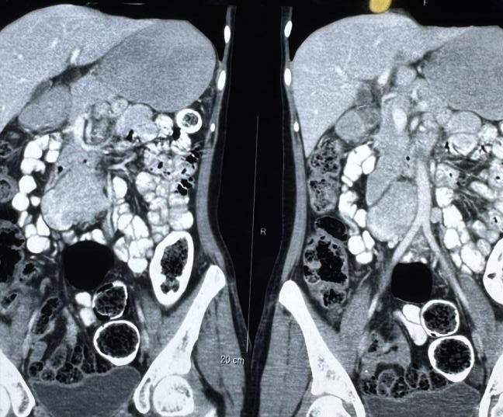

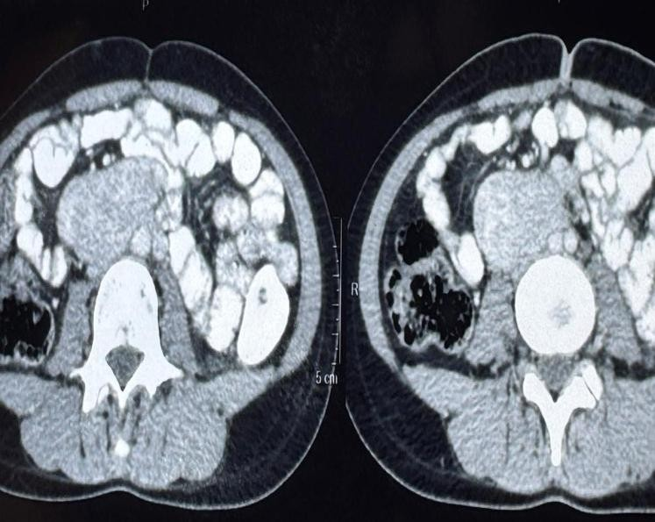

v
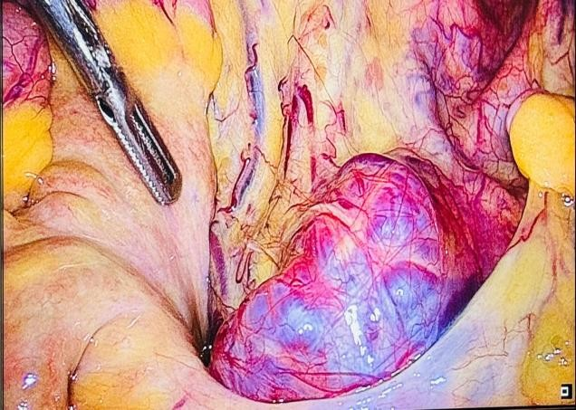Fig-1 CT abdomen shows 7x6x3.4 cm right para-aortic mass (Coronal plane)

Fig. 3 Laparoscopic Photographs showing a highly vascular tumour at the aortic bifurcation
Fig-2 CT abdomen shows 7x6x3.4 cm right para-aortic mass (Transverse plane)

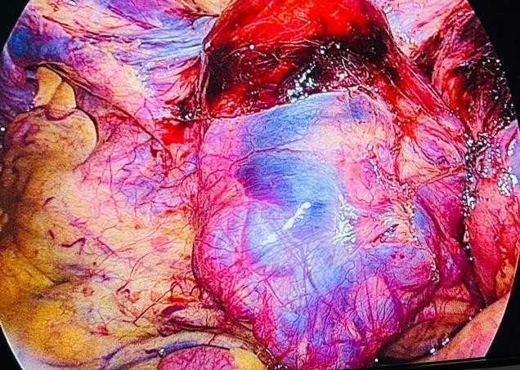Fig. 4 Laparoscopic Photographs showing a large vascular tumour of size 7x6x3.4 cm

aorta

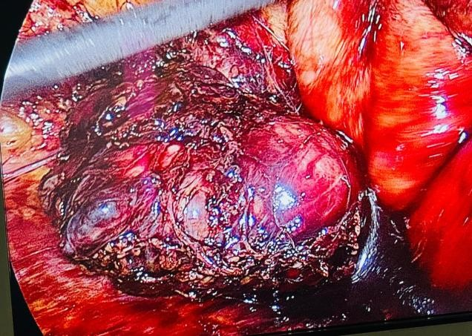Fig. 5 Laparoscopic Photographs showing dissection of the tumour from the lower part of the aorta

v
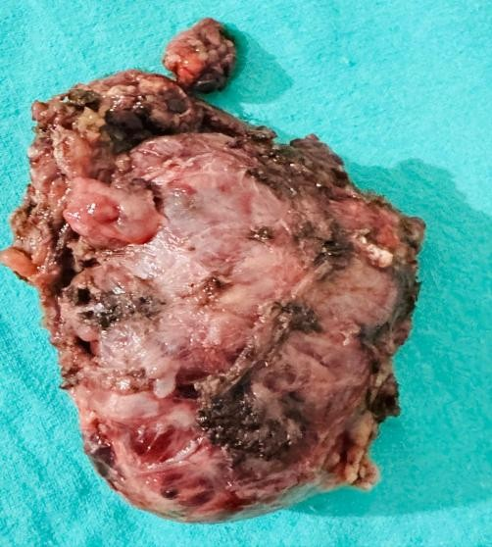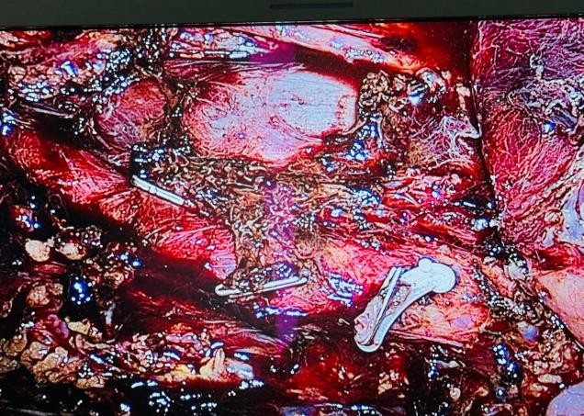
Fig. 6 Laparoscopic Photographs showing a clip applied to the feeder vessels of the tumor from aorta

Fig. 7 Laparoscopic Photographs showing clipped vessels and aortic bifurcation

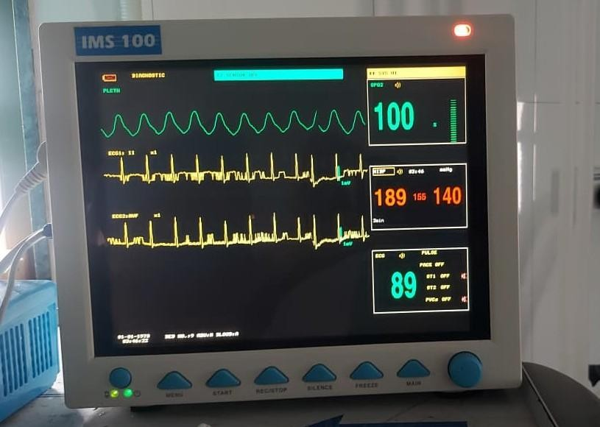Fig. 8 Laparoscopic Photographs showing complete excision of tumour

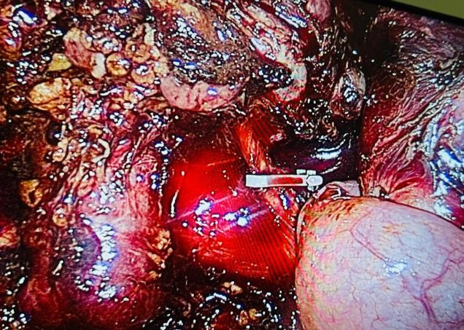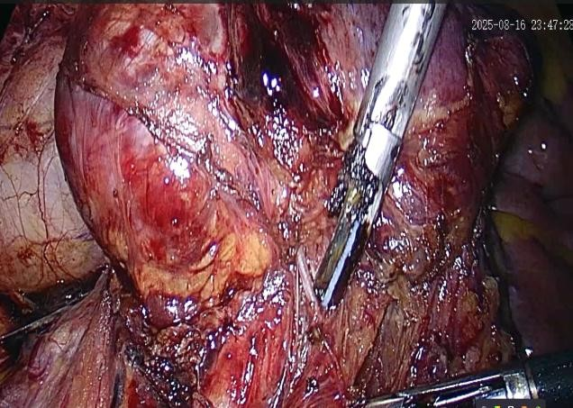Fig. 9 Gross specimen of right para-aortic mass at the organ of Zuckerkandl of size 7x6x3.4 cm
Fig. 10 Monitor shows hypertension during surgery
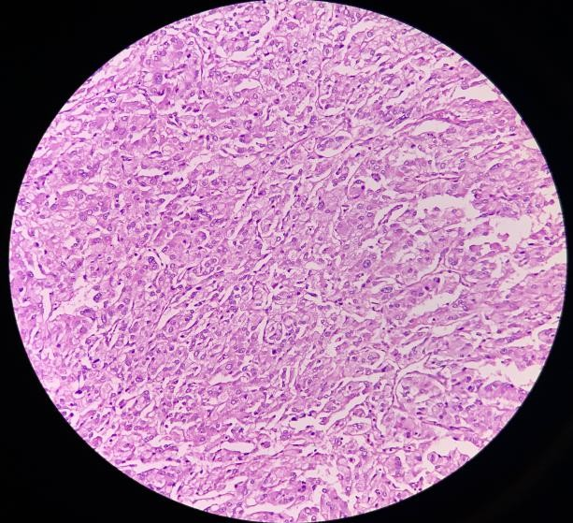

Fig. 11 Histopathology shows a highly cellular tumour organoid pattern with Zellballen pattern s/o Extra-adrenal paraganglioma

Discussion:

In 1901, Emile Zuckerkandl first described the abdominal para-aortic ganglia as a paired retroperitoneal organ located lateral to the abdominal aorta at the level of the inferior mesenteric artery. This paraganglionic complex, known as the organ of Zuckerkandl, is a rare site for paragangliomas. These tumours are typically found near the origin of the inferior mesenteric artery, below the renal arteries, or between the proximal common iliac arteries. [7,8,9]

Lesions may occur sporadically, and approximately 70% are associated with hereditary syndromes. To date, at least 150 cases of paragangliomas of the organ of Zuckerkandl have been reported in the literature. [2,3]

The majority of paragangliomas at this site are non-functional. Traditionally, large tumours were managed through open surgical resection, and only 12 laparoscopic resections had been reported up to
2020. A PubMed search revealed 12 cases of laparoscopic surgery for abdominal paragangliomas between 2010 and 2020, all performed using the transperitoneal approach. In contrast, our case was managed using a laparoscopic intraperitoneal approach for a paraganglioma of the organ of Zuckerkandl. [4,5,6]

Surgical Management

The treatment of paragangliomas requires a multidisciplinary approach, involving surgeons, endocrinologists, cardiologists, and anesthesiologists. This team-based strategy has reduced perioperative mortality from 40–60% to less than 1% (0.6%).

Because of the risk of life-threatening blood pressure fluctuations caused by catecholamine secretion, anaesthetic management is critical. Preoperative preparation with alpha- and beta-blockers is essential to achieve hemodynamic stability before surgery. Intraoperative monitoring and intensive postoperative care are also key to safe outcomes. [2,3,5]

1. Preoperative Management

Patients are optimised 14 days prior to surgery with alpha-blockers to control hypertension and prevent intraoperative hypertensive crises. Beta-blockers may be added after alpha-blockade to prevent reflex tachycardia. Pre-medication with anti-anxiety agents such as midazolam is recommended.

General anaesthesia with epidural analgesia is commonly used to provide intra- and postoperative pain control. Reliable IV access with at least two peripheral lines is necessary, along with central venous access for vasopressor and inotrope administration. Smooth induction of anaesthesia with agents such as propofol and careful intubation are critical to avoid hypertensive surges. [1,2,3]

2. Intraoperative Management

Tumour manipulation during laparoscopic or open resection may precipitate severe hypertensive crises and tachycardia, increasing the risk of myocardial ischemia or shock. Rapid-acting vasodilators such as nitroprusside, nitroglycerine, or calcium channel blockers (e.g., nifedipine) are used to control acute hypertension. Phentolamine can provide rapid blood pressure control, while beta-blockers are used to manage tachycardia.

Following tumour vessel ligation, sudden hypotension may occur. This is managed with fluid boluses and vasoconstrictors such as phenylephrine or norepinephrine. Vasopressin is particularly effective in refractory hypotension. Hemodynamically stable patients can be extubated at the end of surgery and transferred to the ICU for 24–48 hours of observation. [4,5,6]

3. Postoperative Care

Patients requiring vasopressors or those with unstable hemodynamics should remain in the ICU for continuous monitoring. Typically, systemic oedema resolves by postoperative day 2–3, and vasopressor support is no longer required after 48 hours. Once stable, patients are transferred to the ward for an additional 4–5 days of recovery. [7,8,9]

Open Surgery for Abdominal Paraganglioma

Indications for open surgery include:

• Tumours larger than 6 cm require complete and safe resection.

• Invasive or suspected malignant tumours, where complete resection is crucial.

• Complex vascular anatomy, particularly when tumours involve major vessels such as the aorta or inferior vena cava.

• Failure or conversion from laparoscopic to open surgery due to technical difficulty.

Surgical approaches include the transabdominal, posterior, or flank route. These allow meticulous identification and ligation of tumour-feeding arteries, often arising from the abdominal aorta or its branches. For tumours larger than 6 cm or suspected invasive lesions, open surgery is generally preferred to prevent tumour rupture and local recurrence. Retroperitoneal and transperitoneal approaches are both
offer access, with retroperitoneal surgery being effective in experienced hands, especially for paragangliomas of the organ of Zuckerkandl. [10,11,12]

Laparoscopic Surgery

Laparoscopy is a minimally invasive technique increasingly preferred due to its advantages: Reduced postoperative pain, Faster recovery and improved cosmetic outcomes. The transperitoneal approach provides a broad working space and excellent tumour exposure, while the retroperitoneal approach offers direct access with minimal manipulation of abdominal viscera and reduced operative time.

During laparoscopy, small vessels supplying the tumour are carefully dissected and controlled using ultrasonic scalpels, electrocoagulation, or hem-o-lok/titanium clips. Operative time and blood loss are key indicators of procedural safety and effectiveness. [2,4,5]

Robotic Surgery

Robotic-assisted surgery offers several advantages over conventional laparoscopy, including: Improved dexterity, Enhanced ergonomics and High-definition, three-dimensional visualisation

These benefits are particularly valuable in cases involving complex anatomy or large, highly vascular tumours. The da Vinci Robotic System has enabled complete tumour excision with minimal bleeding and without major complications, demonstrating its potential as a superior option in selected cases. [2,8]

Conclusion

Abdominal paragangliomas of the organ of Zuckerkandl are rare endocrine tumours. Their management requires a multidisciplinary team approach involving the surgeon, endocrinologist, cardiologist, and anesthesiologist to reduce perioperative mortality. Among surgical options, the laparoscopic approach is considered the gold standard treatment.

Diagnosis is established through biochemical testing, with tumour localisation confirmed by CT or MRI imaging. Laparoscopic surgery provides a safe and minimally invasive option, offering advantages such as faster recovery, reduced postoperative pain, and improved cosmetic outcomes compared with traditional open surgery.

Consent
As per international standards or university standards, patient(s) written consent has been collected and preserved by the author(s).

COMPETING INTERESTS DISCLAIMER:
Authors have declared that they have no known competing financial interests OR non-financial interests OR personal relationships that could have appeared to influence the work reported in this paper.

Disclaimer (Artificial intelligence)
Option 1:
Author(s) hereby declare that NO generative AI technologies such as Large Language Models (ChatGPT, COPILOT, etc.) and text-to-image generators have been used during the writing or editing of this manuscript.
Option 2:
Author(s) hereby declare that generative AI technologies such as Large Language Models, etc. have been used during the writing or editing of manuscripts. This explanation will include the name, version, model, and source of the generative AI technology and as well as all input prompts provided to the generative AI technology
Details of the AI usage are given below:
1.
2.
3.

References

1. Ren, X., Shang, J., Ren, R. et al. Laparoscopic resection of a large clinically silent paraganglioma at the organ of Zuckerkandl: a rare case report and review of the
literature. BMC Urol 20, 156 (2020). https:// doi.org / 10 .1186 /s128 94 - 020 -00 732 -

2. Salgaonkar H, Behera RR, Sharma PC, Chadha M, Katara AN, Bhandarkar DS.
Laparoscopic resection of a large paraganglioma arising in the organ of
Zuckerkandl: Report of a case and review of the literature. J Minim Access Surg.
2016 Oct-Dec;12(4):378-81. doi: 10.4103/0972-9941.169990. PMID: 27251804; PMCID: PMC5022524.

3. Kenichiro Yambe, Shingo Tsujinaka, Tomoya Miura, Yasuhiro Nakamura, Toru Nakano, Chikashi Shibata, Yu Katayose; Totally Laparoscopic Resection of a Large Retroperitoneal Paraganglioma in an Older Patient: A Case Report on Precise Diagnosis and Perioperative Management. Case Rep Gastroenterol 1 January
2025; 19 (1): 644–652.

4. Ares, J.Á & García, R. & Estellés, N. & Sospedra, R. & Lozano, A.. (2014).
Laparoscopic resection of a Zuckerkandl's paraganglioma. Gazzetta Medica
Italiana Archivio per le Scienze Mediche. 173. 155-160.

5. Yoshii H, Izumi H, Tajiri T, Mukai M, Nomura E, Makuuchi H. A patient with paraganglioma undergoing laparoscopic resection: A case report. Clin Case Rep.
2021 Jun 9;9(6):e04145. doi: 10.1002/ccr3.4145. PMID: 34136230; PMCID:
PMC8190555.

6. Badruddin, Basil1; Gupta, Samir2,*. Laparoscopic Resection of an Adrenaline
Secreting Para-aortic Paraganglioma. Journal of Cancer Research and Practice
8(4):p 163-165, Oct–Dec 2021. | DOI: 10.4103/JCRP.JCRP_18_21

7. Katsimantas A, Paparidis S, Filippou D, Bouropoulos K Sr, Ferakis N. Laparoscopic Resection of a Non-functional, Extra-adrenal Paraganglioma: A Case Report and Literature Review. Cureus. 2020 Apr 20;12(4):e7753. doi: 10.7759/cureus.7753. PMID: 32455070; PMCID: PMC7243083

8. Handa, A., Dash, S.C., Solanki, N. et al. Robotic excision of interaortocaval paraganglioma: a case report with the literature review. Afr J Urol 27, 162 (2021).
https:/ / d oi.org / 10 .118 6/s12 30 1 - 021 - 002 64 - 5

9. SARITAŞ AG, GÜL MO, YALAV O, TEKE Z, GÜNEY İB. Abdominal Paragangliomas: A Single Center Experience. Bezmialem Science. 2021 Apr 9;9(2):205-211. doi:
10.14235/bas.galenos.2020.4082.

10. FitzGerald SC, Gingell Littlejohn M, Parnaby CN, Abdominal Paragangliomas:
Analysis of Surgeon’s Experience, WJOES, 10.5005/jp-journals-10002-1057
11. Katherine Kramme, Robin Fountain, Michael Leinwand, Laparoscopic resection of pheochromocytoma (paraganglioma) of the organ of Zuckerkandl in a pediatric patient, Journal of Pediatric Surgery Case Reports, https://doi.org/10.1016/j.epsc.2021.102165.

12. Mithani SK, Marohn MR, Freischlag JA, Dackiw APB, Zeiger MA. Laparoscopic Resection of a Paraganglioma of the Organ of Zuckerkandl in a Patient with a Carotid Body Tumor. The American SurgeonTM. 2006;72(1):55-59.
doi: 10.1 177/ 000 313 48060 7200 113

13. Ren, X., Shang, J., Ren, R., Zhang, H., & Yao, X. (2020). Laparoscopic resection of a large clinically silent paraganglioma at the organ of Zuckerkandl: a rare case report and review of the literature. BMC urology, 20(1), 156.

14. Lambe, A., & Yadav, R. (2025). A common clinical presentation and an uncommon diagnosis of gangliocytic paraganglioma: A case report. Asian Journal of Case Reports in Surgery, 8(1), 173–177.

15. Divya, S., Dinesan, M., & Ajaya Kumar, T. (2025). Recurrent carotid body tumor treated with external beam radiotherapy: A case report and literature review. Asian Oncology Research Journal, 8(1), 27–32.

