T-cell lymphoblastic lymphoma presenting as bilateral cervical lymphadenopathy in a young adult: A case report

Abstract
Background: T-cell lymphoblastic lymphoma (T-LBL) is an uncommon, aggressive malignancy of immature T lymphocytes, predominantly affecting children and young adults. It typically presents with a mediastinal mass, but atypical presentations may delay diagnosis. Advances in treatment adapted from acute lymphoblastic leukemia protocols have significantly improved outcomes.
Case Presentation: We report a 20-year-old woman presenting with bilateral cervical lymphadenopathy and systemic B symptoms, including night sweats, fatigue, anorexia, and unquantified weight loss, without fever. Laboratory evaluation revealed microcytic hypochromic anemia and 17% circulating blasts. Cervical ultrasound suggested inflammatory lymphadenopathy. Excisional biopsy with immunohistochemistry confirmed T-LBL. The patient was referred promptly to hematology for further management.
Discussion: This case underscores an unusual presentation of T-LBL without mediastinal involvement. Persistent bilateral lymphadenopathy with B symptoms should prompt consideration of T-LBL. Early histopathological diagnosis and a multidisciplinary approach are crucial to initiate timely therapy and optimize prognosis.
Conclusion: Awareness of atypical presentations of T-LBL in young adults is essential for early detection and improved clinical outcomes.
Keywords:
T-cell lymphoblastic lymphoma; cervical lymphadenopathy; young adult; B symptoms; non-Hodgkin lymphoma

1. Introduction
Non-Hodgkin lymphoma (NHL) represents a heterogeneous group of lymphoid malignancies arising from the malignant transformation of lymphoid cells, and it is the fourth most common cancer in children and adolescents. Lymphoblastic lymphoma (LBL) is a high-grade neoplasm derived from precursor T- or B-lymphocytes and accounts for approximately 20–25% of pediatric NHL cases [‎1]. Of these, T-cell lymphoblastic lymphoma (T-LBL) represents the majority (70–80%), while precursor B-lymphoblastic lymphoma (B-LBL) accounts for the remainder [‎2].
T-LBL is considered biologically and clinically related to T-cell acute lymphoblastic leukemia (T-ALL); the distinction lies in the extent of bone marrow infiltration (<25% for T-LBL vs. ≥25% for T-ALL). Clinically, T-LBL typically presents with a mediastinal mass, often causing thoracic symptoms, while B-LBL more frequently involves the skin, lymph nodes, and bones [‎3,‎4]. Most patients with T-LBL are diagnosed at advanced stages, which contributes to its aggressive course and poor prognosis when untreated.
Advances in treatment strategies adapted from acute lymphoblastic leukemia protocols, such as the LSA2L2 and BFM regimens, have significantly improved outcomes, with event-free survival (EFS) rates reaching 75–90% in some studies [‎5]. Nevertheless, treatment-related complications, particularly infections, remain major challenges and continue to contribute to morbidity and mortality, especially in resource-limited settings [‎6,‎7].
Here, we report a rare case of T-LBL in a young adult woman presenting atypically with persistent bilateral cervical lymphadenopathy and systemic B symptoms, without mediastinal involvement. This case underscores the importance of early recognition, prompt histopathological confirmation, and a multidisciplinary approach to optimize patient outcomes.

2. Case Presentation
A 20-year-old woman with no significant medical history presented with a four-month history of a painful right submandibular mass that had progressively enlarged. A similar mass developed on the contralateral jugulo-carotid region. The patient reported night sweats, fatigue, anorexia, and unquantified weight loss, without fever.
Clinical Examination:
Bilateral lateral cervical lymphadenopathy was observed, more prominent on the right side, firm, fixed, and tender.
Investigations :
- Cervical ultrasound: Multiple bilateral lateral cervical lymph nodes measuring 3 cm on the right and 1.5 cm on the left, with features suggestive of inflammation.
- Laboratory tests: Microcytic hypochromic anemia, leukocytosis with 17% circulating blasts, and negative QuantiFERON test.
A right cervicotomy was performed to obtain an excisional lymph node biopsy. Histopathological and immunohistochemical analysis confirmed the diagnosis of T-cell lymphoblastic lymphoma. The patient was referred to the hematology department for further management and treatment.
Figure 1: Intraoperative photograph of excised cervical lymph nodes: one large node (~8 cm × 4 cm) and two smaller adjacent nodes.
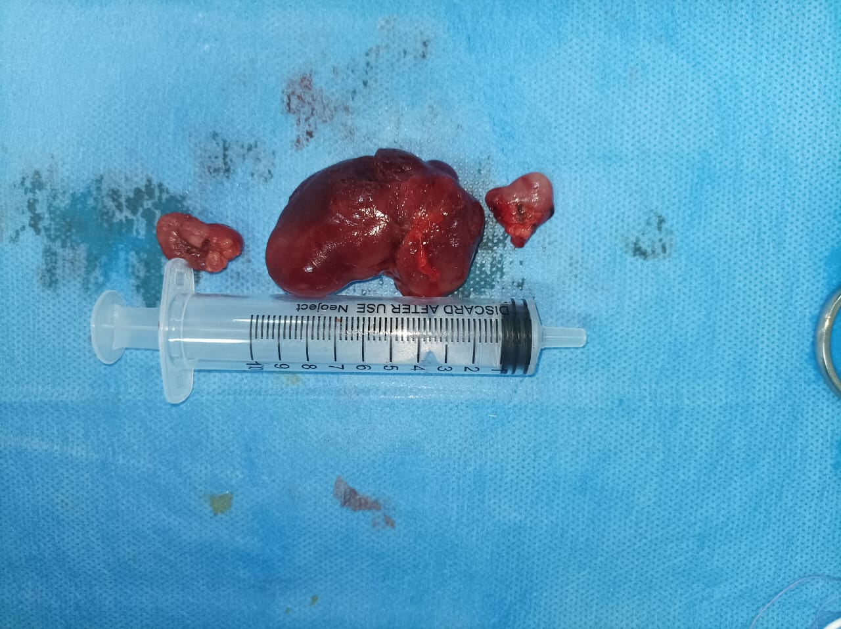

3. Discussion
Lymphoblastic lymphomas are aggressive malignancies of precursor lymphoid cells, most often of T-cell origin. In large cohorts, up to 70–80% of LBL cases are T-cell derived, and the majority present at advanced disease stages. Mediastinal involvement is the hallmark of T-LBL, reported in over 60% of cases, often associated with respiratory distress or superior vena cava syndrome [‎2]. In contrast, precursor B-LBL commonly involves the skin, bones, and peripheral lymph nodes [‎3,‎4]. The present case is unusual in that the patient presented with persistent bilateral cervical lymphadenopathy without mediastinal disease, which could delay diagnosis if lymphoma is not strongly suspected.
In addition, several reports worldwide have documented unusual presentations of T-cell lymphoblastic lymphoma in young adults. For example, a 24-year-old male presented with cutis verticis gyrata, ultimately revealing underlying T-LBL. Another case involved a pediatric patient with recurrent T-LBL presenting as bilateral breast masses, highlighting the diversity of clinical manifestations across age groups. Although these cases differ from our patient’s presentation with bilateral cervical lymphadenopathy, they emphasize the need for clinicians to consider T-LBL in the differential diagnosis of unusual masses and lymphadenopathy in young patients.‎ [15,‎16]
The presence of systemic B symptoms—night sweats, anorexia, fatigue, and weight loss—further raised concern for an underlying hematologic malignancy. Although fever was absent, the constellation of symptoms emphasized the importance of considering lymphoma in the differential diagnosis of persistent lymphadenopathy in young adults.
Historically, treatment outcomes for LBL were poor until Wollner and colleagues in 1975 demonstrated the efficacy of acute lymphoblastic leukemia–type protocols ‎[9]. Subsequent regimens, particularly the LSA2L2 and BFM protocols, incorporated high-dose methotrexate for CNS prophylaxis and minimized cranial radiotherapy, achieving survival rates up to 85–90% in some pediatric cohorts [‎10,‎11]. Modern strategies stratify patients by stage, with limited-stage disease achieving favorable survival of 73–100%, while advanced-stage disease remains more challenging [‎1,‎11,‎14].
Despite therapeutic advances, complications remain a significant concern. Patients with hematologic malignancies are highly susceptible to infections due to both disease-related immunosuppression and chemotherapy toxicity, with infection-related mortality rates reported at 2–4%. Effective supportive care, multidisciplinary coordination, and patient/family education are therefore essential components of management [‎13].
Emerging therapies, including immunotherapeutic approaches such as CAR-T cell therapy and immune checkpoint inhibitors, show promise in refractory or relapsed disease, though their use remains largely experimental.

4. Conclusion
This case emphasizes that, even in the absence of mediastinal disease, T-cell lymphoblastic lymphoma should be considered in young adults presenting with persistent bilateral lymphadenopathy and B symptoms. Early excisional biopsy and prompt referral to specialized hematology centers are crucial for timely diagnosis, initiation of therapy, and improved prognosis. Due to the lengthy and intense nature of therapy, close supportive care and education for patients and their families are crucial for enhancing patient outcomes and controlling toxicity during the course of treatment.
5. Consent
Written informed consent was obtained from the patient for publication of this case report and any accompanying images.
Ethical Approval:
As per international standards or university standards written ethical approval has been collected and preserved by the author(s).

Disclaimer (Artificial intelligence)
Option 1:
Author(s) hereby declare that NO generative AI technologies such as Large Language Models (ChatGPT, COPILOT, etc.) and text-to-image generators have been used during the writing or editing of this manuscript.
Option 2:
Author(s) hereby declare that generative AI technologies such as Large Language Models, etc. have been used during the writing or editing of manuscripts. This explanation will include the name, version, model, and source of the generative AI technology and as well as all input prompts provided to the generative AI technology
Details of the AI usage are given below:
1.
2.
3.

References
- Minard-Colin V, Brugières L, Reiter A, Cairo MS, Gross TG, Woessmann W, Burkhardt B, Sandlund JT, Williams D, Pillon M, Horibe K, Auperin A, Le Deley MC, Zimmerman M, Perkins SL, Raphael M, Lamant L, Klapper W, Mussolin L, Poirel HA, Macintyre E, Damm-Welk C, Rosolen A, Patte C. Non-Hodgkin Lymphoma in Children and Adolescents: Progress Through Effective Collaboration, Current Knowledge, and Challenges Ahead. J Clin Oncol. 2015 Sep 20;33(27):2963-74. doi: 10.1200/JCO.2014.59.5827. Epub 2015 Aug 24. PMID: 26304908; PMCID: PMC4979194. https://pubmed.ncbi.nlm.nih.gov/26304908/
- Temple WC, Mueller S, Hermiston ML, Burkhardt B. Diagnosis and management of lymphoblastic lymphoma in children, adolescents and young adults. Best Pract Res Clin Haematol. 2023 Mar;36(1):101449. doi: 10.1016/j.beha.2023.101449. Epub 2023 Feb 16. PMID : 36907639. https://pubmed.ncbi.nlm.nih.gov/36907639/
- Murphy SB, Fairclough DL, Hutchison RE, Berard CW. Non-Hodgkin's lymphomas of childhood: an analysis of the histology, staging, and response to treatment of 338 cases at a single institution. J Clin Oncol. 1989 Feb;7(2):186-93. doi: 10.1200/JCO.1989.7.2.186. PMID: 2915234. https://pubmed.ncbi.nlm.nih.gov/2915234/
- Kroeze E, Arias Padilla L, Bakker M, Boer JM, Hagleitner MM, Burkhardt B, Mori T, Attarbaschi A, Verdú-Amorós J, Pillon M, Anderzhanova L, Kabíčková E, Chiang AKS, Kebudi R, Mellgren K, Lazic J, Jazbec J, Meijerink JPP, Beishuizen A, Loeffen JLC; European Intergroup for Childhood Non-Hodgkin Lymphoma (EICNHL) and the International Berlin–Frankfurt–Münster (i-BFM) Study. Pediatric Precursor B-Cell Lymphoblastic Malignancies: From Extramedullary to Medullary Involvement. Cancers (Basel). 2022 Aug 12;14(16):3895. doi: 10.3390/cancers14163895. PMID: 36010889; PMCID: PMC9405801. https://pubmed.ncbi.nlm.nih.gov/36010889/
- Devine KJ, Fries C, Hermiston M, Wistinghausen B. How I approach B-lymphoblastic lymphoma in children. Pediatr Blood Cancer. 2023 Aug;70(8): e30401. doi: 10.1002/pbc.30401. Epub 2023 May 9. PMID: 37158503. https://pubmed.ncbi.nlm.nih.gov/37158503/
- Öztürk AP, Koç B, Zülfikar B. Acute Complications and Survival Analysis of Childhood Acute Lymphoblastic Leukemia: A 15-year Experience. Clin Lymphoma Myeloma Leuk. 2021 Jan;21(1): e39-e47. doi: 10.1016/j.clml.2020.08.025. Epub 2020 Sep 18. PMID : 33046422. https://pubmed.ncbi.nlm.nih.gov/33046422/
- Yildirim UM, Tekkesin F, Koc BS, Aydogdu S, Asarcikli F, Kilic SC. Acute complications observed during intensive chemotherapy in pediatric patients with acute lymphoblastic leukemia: Single-center experience. North Clin Istanb. 2023 Aug 10;10(4):458-469. doi: 10.14744/nci.2022.47600. PMID: 37719261; PMCID: PMC10500240. https://pubmed.ncbi.nlm.nih.gov/37719261/
- Susam-Sen H, Yalcin B, Orhan D, Aydin B, Kurucu N, Varan A, Uner A, Kutluk T. Precursor B-cell Lymphoblastic Lymphoma in Children: Hacettepe Experience. J Pediatr Hematol Oncol. 2023 Aug 1;45(6): e746-e749. doi: 10.1097/MPH.0000000000002656. Epub 2023 Mar 13. PMID : 36898054. https://pubmed.ncbi.nlm.nih.gov/36898054/
- Wollner N, Burchenal JH, Lieberman PH, Exelby P, D'Angio G, Murphy ML. Non-Hodgkin's lymphoma in children. A comparative study of two modalities of therapy. Cancer. 1976 Jan;37(1):123-34. doi: 10.1002/1097-0142(197601)37:1<123: aid-cncr2820370119>3.0.co;2-7. PMID: 1247950. https://pubmed.ncbi.nlm.nih.gov/1247950/
- Mora J, Filippa DA, Qin J, Wollner N. Lymphoblastic lymphoma of childhood and the LSA2-L2 protocol: the 30-year experience at Memorial-Sloan-Kettering Cancer Center. Cancer. 2003 Sep 15 ;98(6) :1283-91. Doi : 10.1002/cncr.11615. PMID : 12973853. https://pubmed.ncbi.nlm.nih.gov/12973853/
- Burkhardt B, Woessmann W, Zimmermann M, Kontny U, Vormoor J, Doerffel W, Mann G, Henze G, Niggli F, Ludwig WD, Janssen D, Riehm H, Schrappe M, Reiter A. Impact of cranial radiotherapy on central nervous system prophylaxis in children and adolescents with central nervous system-negative stage III or IV lymphoblastic lymphoma. J Clin Oncol. 2006 Jan 20;24(3):491-9. doi: 10.1200/JCO.2005.02.2707. PMID: 16421426. https://pubmed.ncbi.nlm.nih.gov/16421426/
- Neth O, Seidemann K, Jansen P, Mann G, Tiemann M, Ludwig WD, Riehm H, Reiter A. Precursor B-cell lymphoblastic lymphoma in childhood and adolescence: clinical features, treatment, and results in trials NHL-BFM 86 and 90. Med Pediatr Oncol. 2000 Jul;35(1):20-7. doi: 10.1002/1096-911x (200007)35:1<20: aid-mpo4>3.0.co;2-l. PMID: 10881003. https://pubmed.ncbi.nlm.nih.gov/10881003/
- Li MJ, Chang HH, Yang YL, Lu MY, Shao PL, Fu CM, Chou AK, Liu YL, Lin KH, Huang LM, Lin DT, Jou ST. Infectious complications in children with acute lymphoblastic leukemia treated with the Taiwan Pediatric Oncology Group protocol: A 16-year tertiary single-institution experience. Pediatr Blood Cancer. 2017 Oct;64(10). doi: 10.1002/pbc.26535. Epub 2017 Apr 1. PMID: 28371256. https://pubmed.ncbi.nlm.nih.gov/28371256/
- Reiter A, Schrappe M, Ludwig WD, Tiemann M, Parwaresch R, Zimmermann M, Schirg E, Henze G, Schellong G, Gadner H, Riehm H. Intensive ALL-type therapy without local radiotherapy provides a 90% event-free survival for children with T-cell lymphoblastic lymphoma: a BFM group report. Blood. 2000 Jan 15 ;95(2) :416-21. PMID : 10627444. https://pubmed.ncbi.nlm.nih.gov/10627444/
- Saad S, Fetoui NG, Rouatbi J, Mokni S, Ghariani N, Sriha B, Denguezli M. Cutis verticis gyrata in a 24-year-old young man revealing a T-cell lymphoblastic lymphoma. Clin Case Rep. 2022 Oct 6;10(10): e6403. doi: 10.1002/ccr3.6403. PMID: 36237939; PMCID: PMC9536495. https://pubmed.ncbi.nlm.nih.gov/36237939/
- Çalışkan Kamış Ş, Yağcı B. Recurrent T-lymphoblastic lymphoma in a pediatric patient with bilateral breast and skin involvement: A rare clinical presentation. Ann Med Surg (Lond). 2025 Jun 25;87(8):5209-5212. doi: 10.1097/MS9.0000000000003506. PMID: 40787532; PMCID: PMC12333807. https://pubmed.ncbi.nlm.nih.gov/40787532/

