Vogt–Koyanagi–Harada Syndrome: A Case Report and Updated Literature Review

Abstract
Vogt–Koyanagi–Harada (VKH) syndrome is a rare multisystemic autoimmune inflammatory disorder affecting melanocyte-containing tissues, including the eyes, meninges, skin, and inner ear. We report the case of a 19-year-old Afro-Caucasian female presenting with sudden unilateral vision loss that rapidly progressed to bilateral involvement. Ophthalmic imaging demonstrated serous retinal detachments with characteristic angiographic findings. Ancillary investigations revealed cerebrospinal fluid pleocytosis with no evidence of infection. A diagnosis of incomplete VKH syndrome was established, and the patient was treated with high-dose intravenous corticosteroids followed by oral tapering, leading to a favorable anatomical and functional outcome. This report highlights the importance of multimodal imaging and early aggressive corticosteroid therapy in improving visual prognosis. We also provide an updated review of current literature on the immunopathogenesis, diagnostic criteria, and management strategies for VKH syndrome.
Keywords: Vogt–Koyanagi–Harada syndrome, bilateral uveitis, serous retinal detachment, corticosteroid therapy, autoimmune inflammation.

Introduction
“Vogt–Koyanagi–Harada (VKH) syndrome is an uncommon, systemic, autoimmune inflammatory disease characterized by bilateral granulomatous panuveitis associated with neurological, dermatological, and auditory manifestations. The condition was initially described by Vogt in 1906, further detailed by Koyanagi in 1914, and later by Harada in 1929, leading to its eponymous designation. VKH primarily affects individuals with pigmented skin, notably among Asian, Hispanic, Middle Eastern, and Native American populations, though sporadic cases occur worldwide, including in Africa and Europe. Its incidence is estimated at 1–2 per million annually, with a clear female predominance and onset typically in the second to fourth decades of life” [1,2]. The exact etiology remains elusive but involves a complex interplay between genetic predisposition and autoimmune dysregulation. A strong association has been demonstrated with HLA-DR4 and HLA-DQ4 haplotypes, particularly among East Asian and Latin American populations [3,4]. “The immune response is primarily T-cell mediated, targeting melanocyte-associated antigens such as tyrosinase and gp100. This leads to choroidal inflammation and secondary exudative retinal detachment. Elevated levels of pro-inflammatory cytokines — IL-6, IL-17, IFN-γ, and TNF-α — have been found in aqueous humor and cerebrospinal fluid during the acute phase, confirming the systemic autoimmune nature of the disease” [5]. Clinically, VKH progresses through four overlapping stages: (1) the prodromal stage with flu-like or meningitic symptoms, (2) the acute uveitic stage characterized by bilateral exudative retinal detachments and optic disc hyperemia, (3) the convalescent stage with depigmentation phenomena such as sunset-glow fundus and vitiligo, and (4) the chronic recurrent stage, defined by recurrent anterior uveitis [6]. “Diagnosis relies on clinical presentation and multimodal imaging. Optical coherence tomography (OCT) demonstrates serous retinal detachment with subretinal septa, while fluorescein angiography (FA) and indocyanine green angiography (ICGA) identify multiple pinpoint leaks and choroidal hypofluorescent dark dots. More recently, OCT angiography (OCT-A) has provided a non-invasive assessment of choriocapillaris flow impairment” [7]. Given its potential for irreversible visual loss, early recognition and prompt initiation of systemic corticosteroid therapy remain crucial. The present report describes a case of incomplete VKH syndrome in a young woman and provides an updated review of current understanding and therapeutic strategies.

Case Report
A 19-year-old Afro-Caucasian female with no significant medical history presented with sudden, painless vision loss in the left eye (LE) for three days, accompanied by mild intermittent headaches. She reported exposure to tuberculosis six months prior but had not received treatment. There was no history of ocular trauma, infection, or systemic autoimmune disease. Ophthalmic examination revealed a best-corrected visual acuity (BCVA) of 10/10 in the right eye (RE) and 1/10 in the LE. The anterior segment examination was unremarkable bilaterally. Fundus examination of the LE demonstrated serous retinal elevation and paramacular folds (Figure 1). Optical coherence tomography (OCT) confirmed a serous retinal detachment involving the macula (Figure 2). Fluorescein angiography (FA) showed multiple pinpoint hyperfluorescent leaks with progressive pooling of dye (Figure 3). Systemic evaluation was normal. Laboratory investigations showed leukocytosis (13,000/mm³), negative autoimmune and infectious serologies, and a positive Quantiferon-TB Gold test, though chest X-ray was unremarkable. The patient was admitted for observation and hypotensive therapy. After five days, partial improvement was noted with reduced subretinal fluid (Figure 4). Seven days later, she developed sudden visual loss in the right eye with severe headaches. Slit-lamp examination revealed fine keratic precipitates and a 3+ aqueous flare bilaterally. Fundus examination showed bilateral serous detachments and optic disc edema. OCT revealed a large macular detachment in the RE with residual atrophy in the LE (Figure 5–6). Fluorescein angiography confirmed multiple leakage points and optic disc hyperfluorescence. MRI was normal. Lumbar puncture revealed pleocytosis (130 cells/mm³) with sterile culture. A diagnosis of incomplete VKH syndrome was made. The patient received intravenous methylprednisolone (1 g/day for five days) followed by oral prednisone taper (1 mg/kg/day), topical corticosteroids (Maxidrol®), and antiviral prophylaxis (Valex®). Within one week, headaches resolved and OCT showed near-complete resorption of subretinal fluid (Figure 7). One month later, BCVA improved to 9/10 bilaterally.

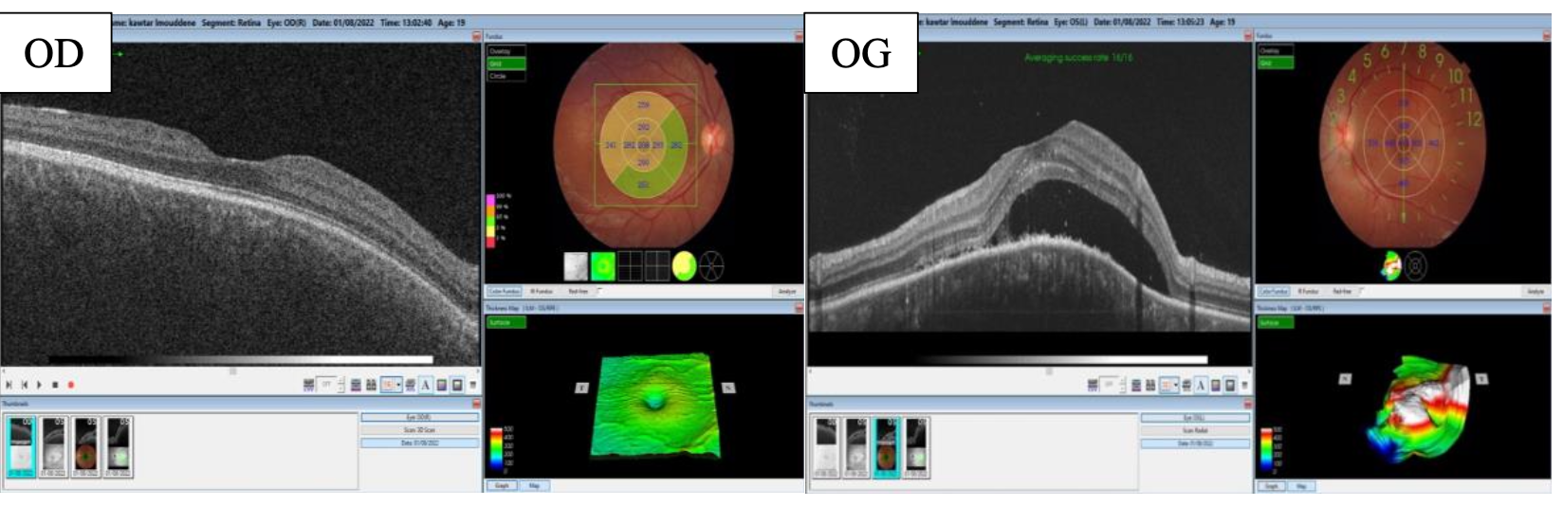
Figure 1: Initial macular OCT showing serous retinal detachment in the left eye.

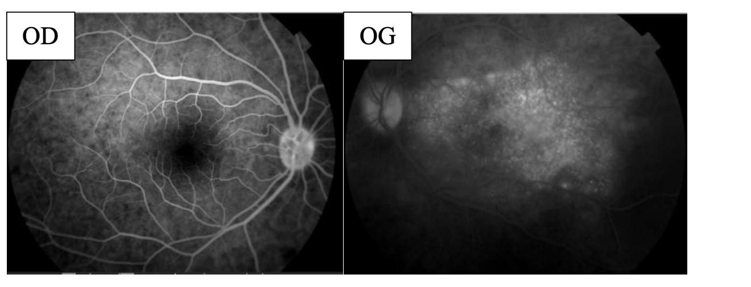
Figure 2: Early fluorescein angiography showing multiple leakage points and a bilobed pattern of serous detachment

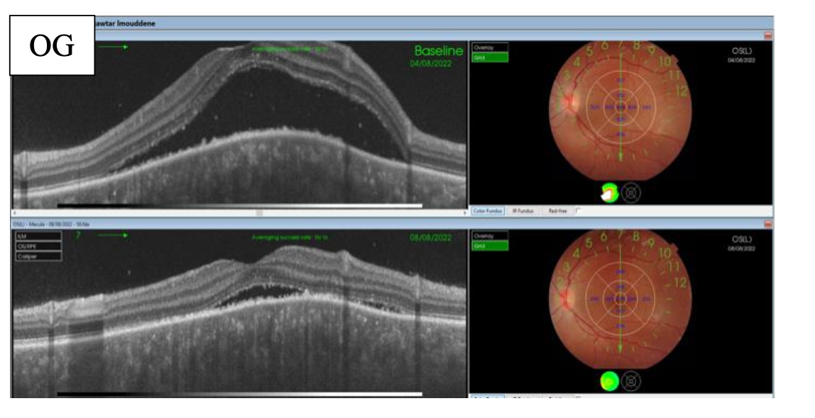Figure 3: OCT under Diamox® showing regression of subretinal fluid

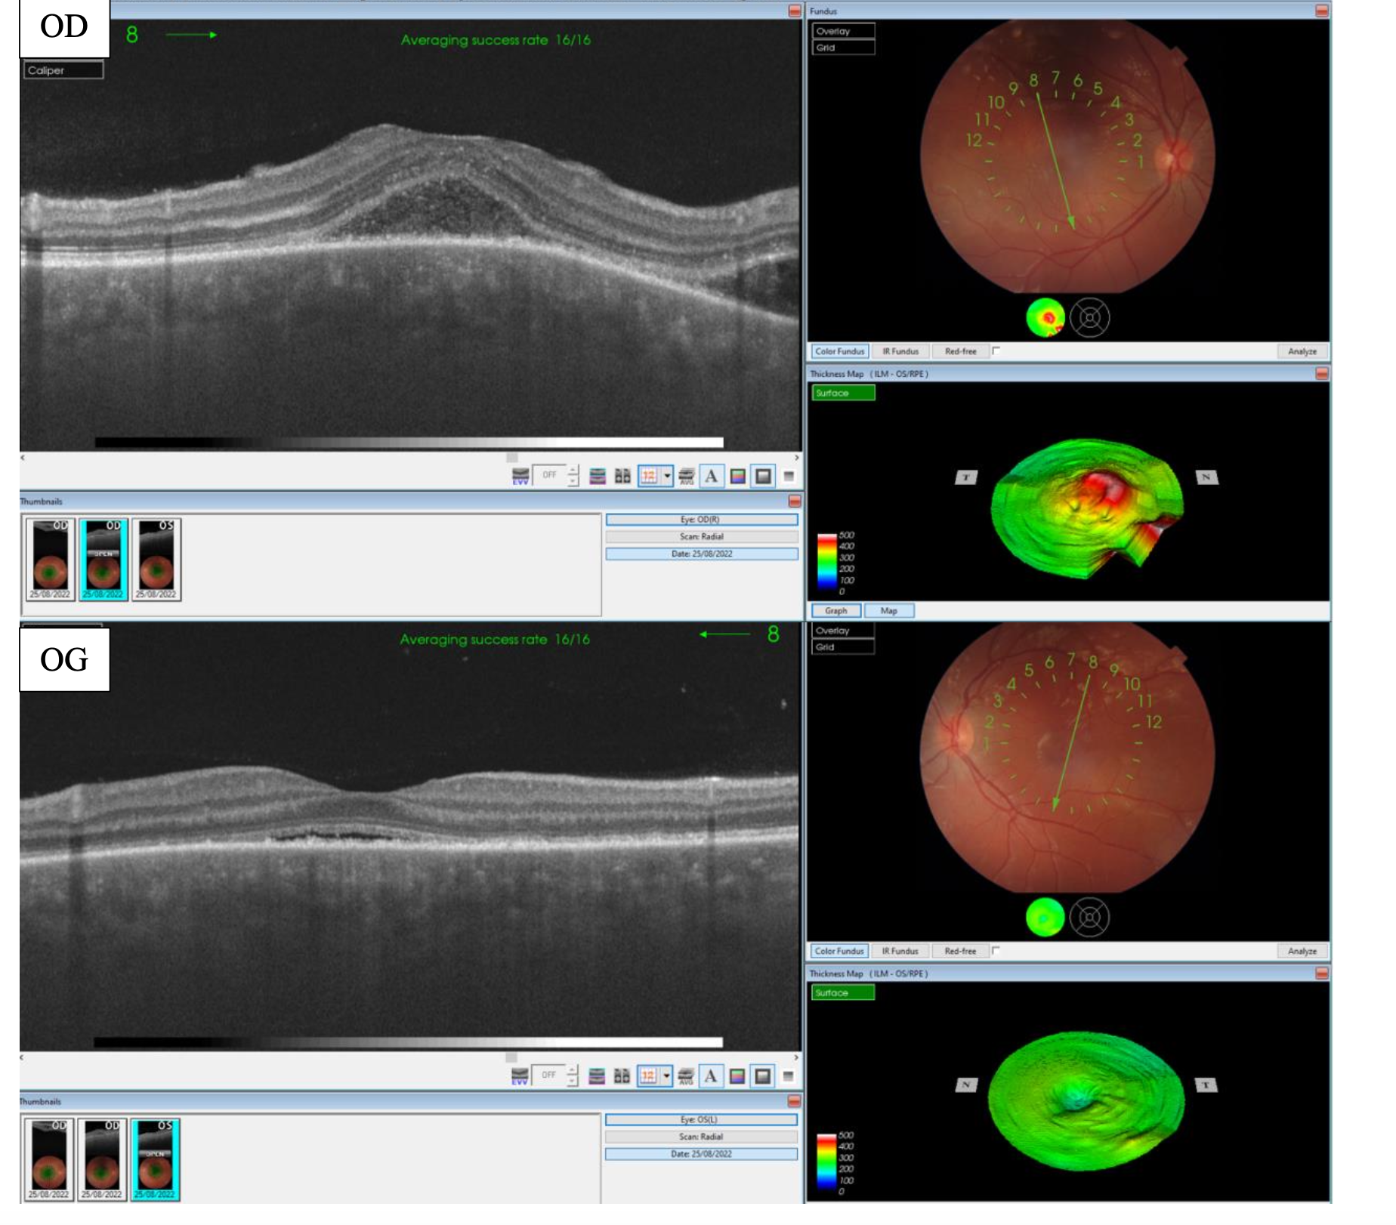
Figure 4: Late-phase angiography showing confluence of leakage points and optic disc hyperfluorescence.
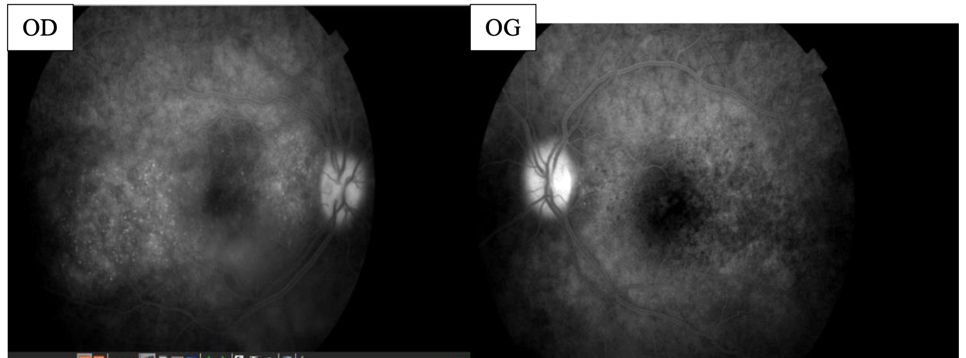
Figure 5: Bilateral OCT showing persistent serous detachment before corticosteroid therapy.

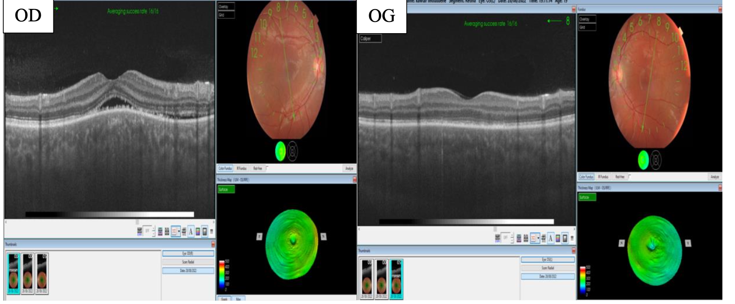
Figure 6: OCT at day 3 after intravenous methylprednisolone showing regression of serous detachment.

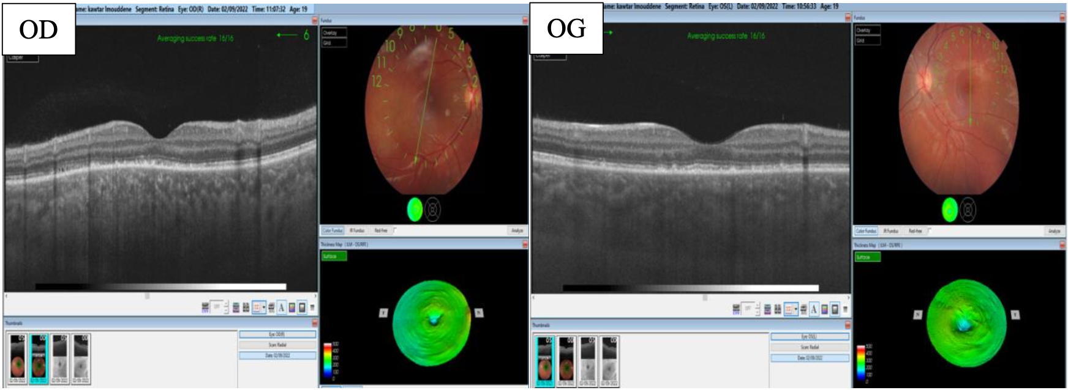
Figure 7: OCT at day 6 showing near-complete resolution of serous retinal detachment.

Discussion

“VKH syndrome represents a prototype of organ-specific autoimmune disease mediated by autoreactive T cells against melanocyte antigens. The pathogenesis involves CD4+ helper T cells (Th1 and Th17 subsets), CD8+ cytotoxic T cells, and pro-inflammatory cytokines, leading to diffuse choroidal inflammation and secondary serous retinal detachment” [5]. The association with HLA-DR4 and HLA-DQw3 alleles supports a genetic predisposition [3]. Recent studies suggest that infections such as Epstein–Barr virus or influenza may act as environmental triggers via molecular mimicry [8,9].
Diagnosis remains primarily clinical, supported by the Revised Diagnostic Criteria by Read et al. (2001), which classify VKH into complete, incomplete, and probable forms based on ocular, neurologic, and integumentary involvement [1]. Imaging modalities play an essential role. OCT demonstrates multilobular serous retinal detachments and hyperreflective septa. FA shows early pinpoint leaks with late pooling (“starry-sky” appearance), while ICGA reveals hypofluorescent dark dots indicating choroidal granulomas [10,11]. OCT-A has emerged as a promising non-invasive tool to detect choriocapillaris hypoperfusion and monitor therapeutic response [12]. These observations are consistent with recent findings reported by Chaabani et al. (2025), who emphasized the diagnostic value of multimodal ocular imaging in confirming VKH disease even in atypical presentations [13]. In our patient, FA and OCT findings were sufficient to establish the diagnosis despite limited access to ICGA.
“The mainstay of treatment remains systemic corticosteroids, initiated promptly to suppress inflammation and prevent chronicity. High-dose intravenous methylprednisolone followed by a slow taper of oral prednisone over 6–12 months yields the best visual outcomes” [14]. Early treatment within the first two weeks of symptom onset significantly reduces recurrence and the risk of developing depigmentation (sunset-glow fundus) [6].
In corticosteroid-resistant or recurrent cases, immunosuppressive agents such as azathioprine, cyclosporine, and mycophenolate mofetil are recommended as steroid-sparing agents [15]. More recently, biologic therapies—especially anti-TNF agents (adalimumab, infliximab)—have shown remarkable efficacy in refractory VKH [16]. Studie by Lai et al. demonstrated sustained remission and preservation of visual function with these agents [5].
“The visual prognosis in VKH is generally favorable when treatment is initiated early and maintained adequately. Long-term complications include recurrent anterior uveitis, choroidal thickening, and subretinal fibrosis. Optical coherence tomography (OCT) and fundus autofluorescence are now integral tools for long-term follow-up, enabling detection of subclinical inflammation” [11]. Predictors of poor outcomes include delayed therapy, inadequate corticosteroid tapering, and recurrent relapses [6].
VKH must be distinguished from sympathetic ophthalmia, posterior scleritis, sarcoidosis, and tuberculous choroiditis. Sympathetic ophthalmia can mimic VKH but occurs after penetrating ocular trauma. Sarcoidosis often presents with granulomatous uveitis and systemic signs, whereas tuberculosis must be excluded in endemic regions using imaging and Quantiferon testing, as in our patient.
Our case highlights a rare incomplete VKH form in a young patient, with sequential bilateral involvement and favorable response to corticosteroid therapy. The absence of cutaneous signs does not preclude the diagnosis when clinical and imaging findings are typical. This case underscores the importance of early recognition, especially in resource-limited settings where ICGA may be unavailable.

Conclusion
Vogt–Koyanagi–Harada syndrome is a rare, sight-threatening autoimmune disease. Early recognition based on multimodal imaging and prompt corticosteroid therapy are crucial to preserve vision. Long-term monitoring and appropriate immunosuppression reduce recurrence and chronic complications. Advances in OCT-A and biologic therapies offer promising avenues for improved management.

Patient Consent
The patient provided informed consent for the publication of this case report and accompanying images.

Disclaimer (Artificial intelligence)
Option 1:
Author(s) hereby declare that NO generative AI technologies such as Large Language Models (ChatGPT, COPILOT, etc.) and text-to-image generators have been used during the writing or editing of this manuscript.
Option 2:
Author(s) hereby declare that generative AI technologies such as Large Language Models, etc. have been used during the writing or editing of manuscripts. This explanation will include the name, version, model, and source of the generative AI technology and as well as all input prompts provided to the generative AI technology
Details of the AI usage are given below:
1.
2.
3.

References
- Read RW, Holland GN, Rao NA, et al. Revised diagnostic criteria for Vogt–Koyanagi–Harada disease. Am J Ophthalmol. 2001;131(5):647–652.
- Moorthy RS, Inomata H, Rao NA. Vogt–Koyanagi–Harada syndrome. Surv Ophthalmol. 1995;39(4):265–292.
- Rao NA, Inomata H, Moorthy RS. Vogt-Koyanagi-Harada syndrome. In: Pepose J, Holland GN, Wilhelmus K, editors. Ocular infection and immunity. St. Louis, MO: Mosby-Year Book, 1996:734–753.
- Kondo I, Yamagata K, Yamaki K, Sakuragi S. [Analysis of the candidate antigen for Harada’s disease]. Nippon Ganka Gakkai Zasshi—Acta Societatis Ophthalmologicae Japonicae 1994;98:596–603.
- Lai T, Chan R, Chan C, Lam D. Effects of the duration of initial oral corticosteroid treatment on the recurrence of inflammation in Vogt-Koyanagi-Harada disease. Eye (Lond). 2009; 23(3):543-548
- Rubsamen, P. E. and J. D. M. Gass. Arch Ophthalmol 1991;109:682–687.
- Read RW, Rechodouni A, Butani N, Johnston R, et al. Complications and prognostic factors in Vogt-Koyanagi-Harada disease. Am J Ophthalmo 2001;131:599-606.
- V. Touitou, C. Escande, B. Bodaghi, N. Cassoux, B. Wechsler, C. Lemaitre, T.H.C. Tran, C. Fardeau, J.-C. Piette, P. LeHoang. Diagnostic and therapeutic management of Vogt-Koyanagi-Harada syndrome. J. Fr. Ophtalmol., 2005; 28, 1: 9-16.
- Lai TY, et al. Advances in the management of uveitis: biologics and targeted therapies. Eye (Lond). 2021;35(9):2342–2354.
- Goto H, et al. Update on the clinical features and management of VKH disease. Int Ophthalmol Clin. 2020;60(2):61–72.
- Soon-Phaik C, Aliza J, Chui Ming GC. The Prognostic Value of Angiography in Vogt-Koyanagi-Harada Disease. Am J Ophthalmol 2010;150:888-893
- Zhang X, et al. Optical coherence tomography angiography findings in acute VKH. Retina. 2019;39(7):1389–1396.
- Chaabani L, Doulemi Y, Ksouri S. Vogt–Koyanagi–Harada disease diagnosis by means of ocular multimodal imaging: a case report. Ophthalmol Res Int J. 2025;20(5):6–10.
- Autoimmunity reviews. 2013; 12: 1033–1038
- Kim S, Yu H. The use of low-dose Azathioprine in patients with Vogt-Koyanagi-Harada disease. Ocul Immunol Inflamm. 2007; 15(5):381-387
- B.J. Flores , C. Fernández , J. Blanco , N. Palmou Fontana , R. Blanco. ANTI-TNFα THERAPY AND SWITCHING IN SEVERE UVEITIS OF VOGT-KOYANAGI-HARADA SYNDROME. REPORT OF TWO CASES AND LITERATURE REVIEW. Annals of the Rheumatic Diseases Volume 75, Supplement 2, June 2016, Page 613

