Case Report
Plummer-Vinson Syndrome Associated with Celiac Disease: A Case Report

Abstract
Plummer-Vinson Syndrome (PVS), also known as Paterson-Kelly syndrome, is a rare condition characterized by cervical dysphagia associated with iron-deficiency anemia and the presence of a web in the upper esophagus. The association of this syndrome with celiac disease is not well known.
Aim : We report a case of a patient with PVS associated with celiac disease.
Case report : A 48-year-old woman was hospitalized for the management of high dysphagia accompanied by an anemic syndrome. The diagnosis of PVS associated with celiac disease was established. The patient was treated with iron supplementation and endoscopic dilation of the esophageal web, along with a gluten-free diet.
Conclusion : Celiac disease is a classic cause of iron-deficiency anemia and should be considered an etiological factor in sideropenic dysphagia. Since both Plummer-Vinson syndrome (PVS) and celiac disease are each associated with an increased risk of pharyngeal and esophageal cancer, regular follow-up of these patients is essential.
Keywords : Plummer-Vinson syndrome, Celiac disease, Endoscopic dilation, Iron supplementation, Gluten-free diet

Introduction
Plummer-Vinson syndrome (PVS), also known as Paterson-Kelly syndrome, is a rare condition characterized by cervical dysphagia associated with iron deficiency anemia and the presence of an upper esophageal web. The association between this syndrome and celiac disease is not well known and was first reported by Dickey and McConnell in 1999. The aim of our report is to highlight the importance of considering a diagnosis of celiac disease whenever we encounter a case of iron deficiency anemia, especially when it is associated with Plummer-Vinson syndrome.

Case Presentation
We report the case of a 48-year-old woman, followed for unexplored iron deficiency anemia, who was admitted for progressive, selective high dysphagia to solids evolving over a period of two years, without other associated symptoms. Clinical examination revealed cutaneous-mucosal pallor with koilonychia. Laboratory tests showed hypochromic microcytic anemia, with a hemoglobin level of 7.3 g/dL hypoferritinemia at 3.85 ng/l and low serum iron at 20 mcg/dl without other signs of malabsorption. Esophagogastroduodenoscopy (EGD) revealed a regular, stenotic narrowing located 15 cm from the dental arches, which was impassable by the endoscope. A complementary barium swallow (esophagogastroduodenal transit) showed a constant, short, and regular stenosis of the cervical esophagus, suggestive of Plummer-Vinson syndrome. The patient subsequently underwent endoscopic dilation using Savary-Gilliard bougies. Endoscopic examination downstream of the stenosis revealed a serrated duodenal mucosa with a normal-looking gastric mucosa, in particular the fundic folds were preserved. Celiac serology, specifically anti-tissue transglutaminase antibodies (IgA and IgG), was positive at 110.70 IU/mL and 25.90 IU/mL, respectively. Anti-intrinsic factor and anti-parietal cell antibodies were negative. Duodenal biopsies showed subtotal villous atrophy classified as grade IIIb according to the Marsh classification and gastric biopsies were normal with absence of Helicobacter pylori. Thus, the diagnosis of PVS associated with celiac disease was confirmed. The patient was started on a gluten-free diet combined with iron supplementation. The 6-month follow-up showed resolution of the deficiency syndrome, weight gain, and no recurrence of dysphagia.

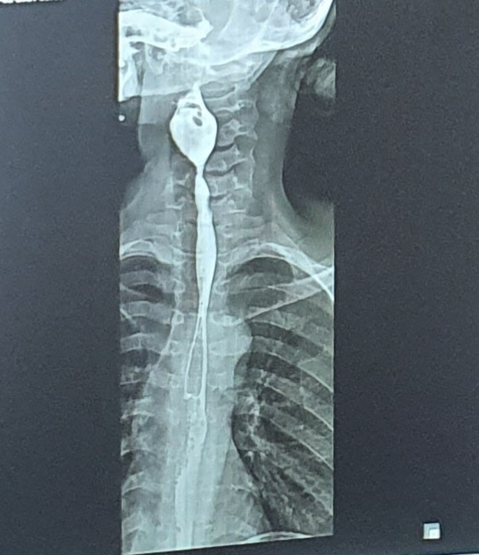
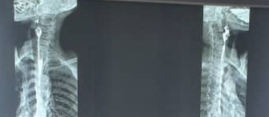
Figure 1: A consistent, short, and regular stenosis of the cervical esophagus, seen on frontal and lateral viewsTOGD
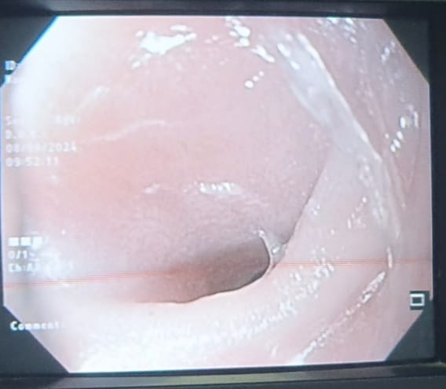

Figure 2: Endoscopic view of a thin, stenosing semi-lunar membrane in the cervical esophagus
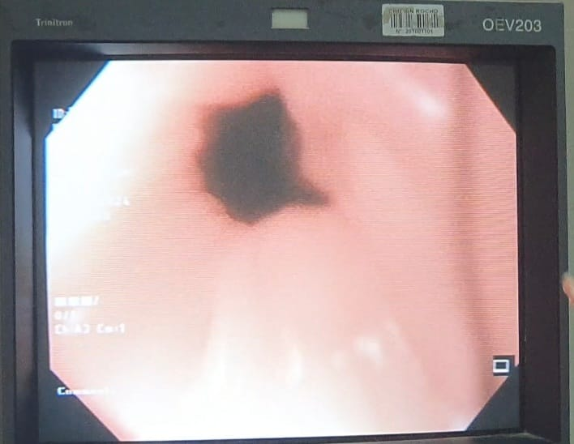
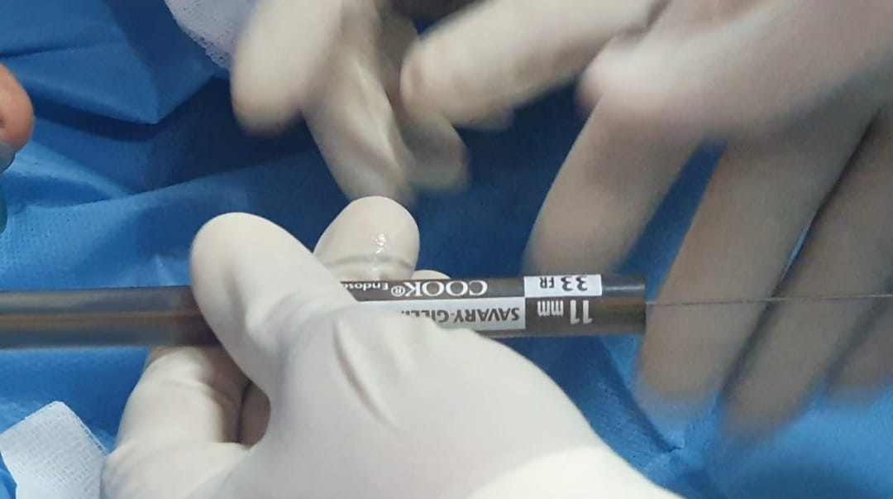
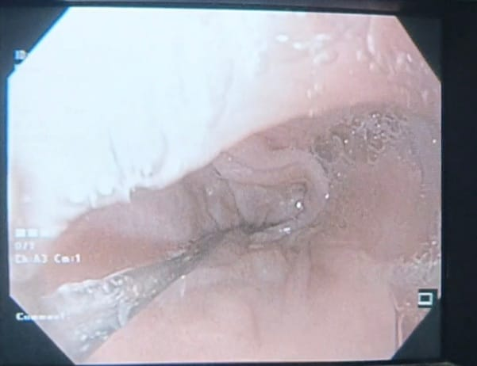
Figure 4: Appearance of the stenosis after dilation with bougies
Figure 3: Endoscopic dilation using Savary-Gilliard bougies

Discussion
« Plummer Vinson (PVS) or Paterson-Kelly syndrome is a rare entity characterized by the association of cervical dysphagia with iron-deficiency anemia and a membrane in the upper esophagus » [1]. « Dysphagia is the main presenting symptom. However, some unusual presentations without dysphagia may lead to delayed diagnosis » [2]. « This syndrome was first described by Henry Plummer in 1912, then by Vinson in 1919 » [3,4]. « Its incidence is declining, which may be attributed to improved nutrition and/or iron intake. It predominantly affects women (85%), between the third and seventh decades of life, which is consistent with our patient's case » [5]. « Cases of VPS have also been reported in men, children and adolescents [6]. This entity is described in northern European countries, particularly in rural Sweden » [7]. « In Africa, PVS remains rarely reported despite widespread malnutrition and iron deficiency » [1,8–10].
« The pathogenesis of the syndrome remains uncertain, but among the most cited etiopathogenic mechanisms is iron deficiency » [1,11]. « Several studies suggest an important etiological role for anemia in the formation of the esophageal diaphragm » [12,13]. « It has been described that iron deficiency induces dysfunction of iron-dependent enzymes, leading to oxidative stress and DNA damage. This dysfunction is responsible for mucosal atrophy and pharyngeal muscle degradation, leading to the development of esophageal membranes » [7, 14].
The relationship between Plummer-Vinson syndrome (PV) and celiac disease (CD) remains uncertain [2]. « Some believe that it is not a causal association, while others suggest common etiopathogenic mechanisms » [15,16]. « CD is an autoimmune enteropathy triggered by gluten consumption. Gliadin activates the immune system via the key enzyme tissue transglutaminase, leading to mucosal damage and atrophy, as well as antibody production » [15,17]. « Similar mechanisms could be involved in membrane formation in PV, but the most plausible hypothesis to date is that CD could be an etiological factor in the iron-deficiency anemia observed in Plummer-Vinson syndrome. Other genetic, environmental and immunological mechanisms (Biermer's disease, etc.) could also play a role in this condition » [5,9,10].
Some studies have even shown that correction of this anemia alone in certain patients can lead to an improvement in dysphagia [7]. « For example, a study by Lee et al reported that the patient's swallowing difficulties were resolved after 8 months of CD management using a gluten-free diet » [18,].
« Clinically, SPV is characterized by high cervical dysphagia, painless, intermittent or slowly progressive, predominating in solids, associated with an anemic syndrome of mucocutaneous pallor, asthenia, palpitations, disorders of the phanera, cheilitis and glossitis. These clinical manifestations correspond to those of our patient. Endoscopically, the presence of a thin semi-lunar membrane in the cervical oesophagus may be overlooked or accidentally ruptured during rapid introduction of the endoscope » [1,3,11]. « Oesogastroduodenal transit reveals a short, hanging, diaphragmatic or ring-shaped stenosis opposite the cervical vertebrae » (C5-C6) [13].
« Management of a patient with VPS begins with the search for a possible cause of the iron-deficiency anemia. This investigation begins by ruling out intake deficiency, haemorrhage (including digestive), neoplasia or celiac disease or gluten intolerance » [1]. Indeed, although the association of VPS and celiac disease is uncommon, the latter is a common cause of iron-deficiency or sideropenic anemia in VPS patients such as our patient; hence the need for a systematic duodenal biopsy, as recommended in several studies.
« The association between SPV and celiac disease is little known and was first described by Dickey and McConnell in 1999 »[19]. « CD diagnosis relies on clinical, biological, and histological criteria. Though traditionally seen in children and young adults, recent years have seen increasing recognition of CD in older adults » [20].
« The clinical spectrum of CD is broad ranging from typical forms (malodorous steatorrhea, malabsorption, weight loss) to atypical forms (abdominal pain, growth delay, bone pain, etc.). Biologically, iron-deficiency anemia, with or without other signs of malabsorption, is one of the most frequent extra-intestinal manifestations » [21,22], as seen in our patient. Serology often reveals positive anti-transglutaminase IgA antibodies, and duodenal biopsies confirm the diagnosis by showing villous atrophy with increased intraepithelial lymphocytes.
In patients with PVS and associated CD, treatment involves both iron supplementation and a gluten-free diet. In many cases, mild dysphagia improves with iron therapy alone, even before full correction of anemia, despite the persistence of the esophageal web [7,23].
However, when the oesophageal ring is tight, treatment relies mainly on endoscopic dilatation, most often performed with a balloon or Savary-Gilliard dilators [24,25,26]. Other techniques, such as laser sectioning or electro-incision, have also shown good efficacy [27,28]. Recourse to surgery remains rare, and is reserved for cases where endoscopic methods have failed.
In our case, the patient benefited from additional treatment with iron (route) and a dilatation session, with good clinical and biological improvement.
Plummer-Vinson syndrome is considered a precancerous lesion, with an estimated risk of malignant transformation of between 3% and 30%, depending on the study. In a cohort of 132 patients followed over 10 years, Patil et al. reported an esophageal squamous cell carcinoma rate of 4.5% [29,30]. Therefore, regular endoscopic and histological surveillance is recommended, although no standardized guidelines have yet been defined [5,31].

Conclusion
PVS is a rare condition with an underestimated prevalence. Its association with celiac disease is uncommon but increasingly reported. In any patient with PVS, celiac disease should be considered and investigated, especially in women and when the cause of anemia is not obvious. Management involves correcting the iron deficiency, performing esophageal dilatation in symptomatic cases, and adhering strictly to a gluten-free diet. In patients with PVS and celiac disease, the increased risk of malignant transformation justifies close endoscopic monitoring.

Consent

As per international standards or university standards, patient(s) written consent has been collected and preserved by the author(s).

Ethical approval
As per international standards or university standards written ethical approval has been collected and preserved by the author(s).

COMPETING INTERESTS DISCLAIMER:
Authors have declared that they have no known competing financial interests OR non-financial interests OR personal relationships that could have appeared to influence the work reported in this paper.

Reference
- Novacek G (2006) Plummer-Vinson syndrome. Orphanet J Rare Dis 1:36
- Elwood PC, Jacobs A, Pitmann RG, et al. Epidemiology of the Patterson KeIIy syndrome. Lancet. 1964 Oct 3;2(7362):716–20.
- Plummer S (1912) Diffuse dilatation of the esophagus without anatomic stenosis (cardiospasm). A report of ninety-one cases. J Am Med Assoc 58:2013–5
- Vinson PP (1919) A case of cardiospasm with dilatation and angulation of the esophagus. Med Clinics North Am 3:623–7
- Chisholm M. The association between webs, iron, and post-cricoids carcinoma. Postgrad Med J 1974;50:215–9.
- Lopez Rodrigez MJ, Robledo Andres P, Amarilla Jimenez A, et al. Sideropenic dysphagia in an adolescent. J Pediatr Gastroenterol Nutr 2002;34:87–90
- Hofmann RM, Jaffe PE (1995) Plummer-Vinson Syndrome: a case report and literature review. Arch Inter Med 155:2008–11
- Dia D, Diouf ML, Mbengue M, et al (2010) Plummer-Vinson syndrome: clinical, paraclinical, and therapeutic aspects of 19 cases in Dakar. Med Afr Noire 57:189–92
- Berthé A, Diop MM, Touré PS, et al (2014) Unusual presentations of Plummer-Vinson syndrome in Black African: report of two cases. Pan Afr Med J 19:145
- Fall F, Gning SB, N’diaye AR, et al (2011) Plummer-Vinson syndrome: retrospective study of 50 cases. J Afr Hepatol Gastroenterol 5:259–63
- Park JM, Kim KO, Park CS, Jang BI (2014) A case of Plummer Vinson syndrome associated with Crohn’s disease. Korean J Gastroenterol 63:244–7
- . Chisholm M, Ardran GM, Callender ST, et al. A followup study of patients with postcricoid webs. Q J Med 1971;159:409–20
- Jacobs A, Kilpatrick GS. The Paterson-Kelly syndrome. Br Med J 1964;2:79–82.
- Changela K, Haeri NS, Krishnaiah M, Reddy M. Plummer-Vinson Syndrome with Proximal Esophageal Web. J Gastrointest Surg. 2016 May;20(5):1074-5. [PubMed]
- Soltesz, K.; Mosebach, J.; Paruch, E.; Covino, J. Updates on the diagnosis and management of celiac disease. J. Am. Acad. Physician Assist. 2022, 35, 39–44.
- Ben Gamra, O.; Mbarek, C.; Mouna, C.; Zribi, S.; Zainine, R.; Hariga, I.; El Khedim, A. Plummer Vinson syndrome. Tunis. Med.2007, 85, 402–404.
- Rubio-Tapia, A.; Hill, I.; Semrad, C.; Kelly, C.; Greer, K.; Limketkai, B.N.; Lebwohl, B. American College of Gastroenterology Guidelines Update: Diagnosis and Management of Celiac Disease. Am. J. Gastroenterol. 2023, 118, 59–76
- Lee A, Tobin M, Cherian J, Chawla A. Dysphagia as a presentation of celiac disease. ACG Case Reports J. 2020;7(4):e00359. doi: 10.14309/.
- Dickey W, McConnell B (1999) Celiac disease presenting as the Paterson-Brown Kelly (Plummer-Vinson) syndrome. Am J Gastroenterol 94:527–9
- Freeman H, Lemoyne M, Pare P. Coeliac disease. Best Pract Res Clin Gastroenterol 2002;16:37–49.
- Bottaro G, Cataldo F, Rotolo N, et al. The clinical pattern of sub clinical/silent celiac disease: an analysis on 1026 consecutives cases. Am J Gastroenterol 1999;94:691–6.
- Halfdanarson TR, Litzow MR, Murray JA. Hematologic manifestations of celiac disease. Blood 2007;109:412–21
- Bakshi SS (2015) Plummer Vinson syndrome: is it common in males? Arq Gastroenterol 52:250–2
- Goel A, Lakshmi CP, Bakshi SS, Soni N, Koshy S. Single-center prospective study of Plummer-vinson syndrome. Dis Esophagus.2016;29(7):837–841.Neil Floch R. Syndrome de Plummer-Vinson. Netter Gastroenterologia. 2006:42–43
- Bakari G, Benelbarhdadi I, Bahije L, El Feydi Essaid A. Endoscopic treatment of 135 cases of plummer-vinson web: a pilot experience. Gastrointest Endosc. 2014;80(4):738–741
- Yasawy MI. Treatment of plummer-vinson syndrome with savary- gilliard dilatation. Saudi Med J. 2004;25(4):524–526
- Ohtaka M, Kobayashi S, Yoshida T, et al. Use of sato’s curved laryngo-scope and an insulated-tip knife for endoscopic incisional therapy of esophageal web. Dig Endosc. 2015;27(4):522–526.
- Nishitani M, Matsuda M, Arihara F, Sakai A, Noda Y. Electroincision for hypopharyngoesophageal stricture caused by plummer-vinson syndrome. Gastrointest Endosc. 2016;84(5):849–850.
- Rhonda, K.Y.; Odze, R.O. Neoplasic precursor lesions of the upper gastrointestinal tract. Diagn. Histopathol. 2008, 14, 437–452.
- Patil, M.; Malipatel, R.; Devarbhavi, H. Plummer-Vinson syndrome: A decade’s experience of 132 cases from a single center. J. Gastroenterol. Hepatol. 2021, 36, 181–185
- Messmann H (2001) Squamous cell cancer of the oesophagus. Best Pract Res Clin Gastroenterol 15:249–65

