Immunomodulatory Potential of Vernonia amygdalina L.In Silico Screening and In Vitro Validation of Bioactive Compounds for Gastrointestinal Immune Regulation
ABSTRACT
Background: The gastrointestinal (GI) tract is a complex and dynamic system that plays a crucial role in maintaining overall health and homeostasis. The increasing prevalence of gastrointestinal disorders globally has prompted a significant interest in exploring natural remedies that can offer therapeutic benefits. Among these remedies is Vernonia amygdalina L., commonly known as bitter leaf. It has been widely recognised for its traditional medicinal properties.
Aim: This study investigates the immunomodulatory potential of V. amygdalina, focusing on its bioactive compounds and their interactions with key proteins involved in gastrointestinal immune regulation.
Methods: Leaves of V. amygdalina were collected from a farm in Ado-Ekiti, Nigeria, and authenticated. The 10 g of V. amygdalina were subjected to successive solvent extraction with 95% ethanol (1:7, m/V) for 48 h by maceration at room temperature and filtered through Whatman No. 4 filter paper. The residues were re-extracted with 95% ethanol. The following procedures were carried out: Anti-Lipoxygenase Activity Analysis, Protein Denaturation Activity Analysis, Membrane Stabilising Activity Analysis, and Protein-Ligand Docking using standard methodologies. Ex-vivo biochemical assays were carried out, gas chromatography-mass spectrometry (GC-MS) for compound identification, and in silico docking studies to assess molecular interactions. GraphPad Prism software (version 9.0, GraphPad Software, Inc., was used for data analysis. All data are reported as mean values with standard deviation (mean ± SD). Significant difference was set at P < 0.05.
Results: The biochemical analysis revealed significant anti-inflammatory activities, including anti-lipoxygenase and protein denaturation inhibition. In silico molecular docking demonstrated strong binding affinities of selected compounds against target proteins FABP4, COX-1, FFAR1, and PPARα/ PPARA involved in regulating gastrointestinal immune function, with binding energies ranging from -8.704 to -2.979 kcal/mol.
Conclusion: These findings suggest that V. amygdalina has substantial potential as a therapeutic agent for gastrointestinal disorders, warranting further exploration through further experimental validation.
Keywords: Vernonia amygdalina, immunomodulation, in-silico docking, traditional medicine, gastrointestinal tract.
Introduction
The gastrointestinal tract (GI) is a complex and dynamic system that plays a crucial role in maintaining overall health and homeostasis [1]. At the core of this system lies the GI immune system, which is responsible for regulating immune responses and protecting the host against harmful pathogens, while also maintaining tolerance towards commensal microbiota and dietary antigens [1]. Dysregulation of the GI immune system has been implicated in the pathogenesis of various gastrointestinal disorders, such as inflammatory bowel diseases (IBD), irritable bowel syndrome (IBS), and even metabolic disorders [2,3]. In regulating the GI immune function, key molecular targets involved include fatty acid-binding protein 4 (FABP4) [4], cyclooxygenase-1 (COX-1) [5], free fatty acid receptor 1 (FFAR1) [6], and peroxisome proliferator-activated receptor alpha (PPARα/ PPARA) [7].
Fatty acid binding proteins (FABPs) is a cytoplasmic protein that plays a crucial role in lipid metabolism by binding and transporting fatty acids within cells [4]. It is involved in regulating lipid storage and metabolism, as well as inflammation and insulin sensitivity [4]. COX-1 is an enzyme that is responsible for the production of prostaglandins, which are important mediators of inflammation, pain, and fever [5]. It is constitutively expressed in many tissues and is involved in maintaining normal physiological functions, such as protecting the stomach lining and regulating blood flow to the kidneys [8]. FFAR1, also known as GPR40, is a G-protein-coupled receptor that is activated by free fatty acids [6]. It plays a role in regulating glucose and lipid metabolism, insulin secretion, and inflammation. Activation of FFAR1 can affect various physiological processes related to metabolic homeostasis [9,10].
PPARα is a nuclear receptor that regulates the expression of genes involved in lipid metabolism, energy homeostasis, and inflammation [7]. It plays a key role in the transcriptional control of genes related to fatty acid oxidation, ketogenesis, and anti-inflammatory responses in various tissues, particularly in the liver and muscle [11]. These target proteins play crucial roles in the modulation of inflammatory pathways, immune cell function, and intestinal barrier integrity. Aberrant or excessive activity of them has been associated with the development and progression of various GI-related disorders.
Inhibiting the activity of these key target proteins holds great promise for the management of GI-associated immune dysfunction and related diseases. Previous studies have demonstrated the therapeutic potential of targeting these proteins in the context of gastrointestinal disorders. Notably, a recent study by Wu et al. (2020) investigated the role of FABP4 in the pathogenesis of asthma, a respiratory condition characterised by airway inflammation and epithelial barrier dysfunction [12]. The researchers found that the inhibition of FABP4 effectively alleviated airway inflammation and improved epithelial barrier function, suggesting that the inhibition of FABP4 could be a promising therapeutic approach not only for respiratory disorders but also for gastrointestinal conditions. Complementing these findings, the research by Costa-Filho et al. (2023) specifically focused on the role of COX-1 in maintaining intestinal barrier integrity [13]. The study found that the inhibition of COX-1, but not COX-2, led to a decrease in transepithelial electrical resistance (TER) and an increase in mucosal permeability in an experimental colitis model. Bartoszek et al. (2020) provided a comprehensive review on the development and characterisation of FFAR1 ligands, focusing on the liver toxicity observed with the clinical candidate TAK875 and the importance of developing selective FFAR1 ligands [14]. Recent research by Decara et al. (2020) underscores the significance of PPARα in the GI tract, highlighting its expression in peripheral tissues and its role in crucial metabolic pathways [15]. PPARα is involved in the catabolism of fatty acids, glucose homeostasis, and insulin resistance, linking it to the pathogenesis of prevalent diseases such as diabetes, hypertension, and inflammation [15]. The therapeutic potential of PPARα agonists in treating dyslipidemia and metabolic syndromes further emphasises the relevance of this receptor in GI health. Moreover, Decara et al. discuss the anti-inflammatory properties of endogenous PPARα ligands, such as oleoylethanolamide (OEA) and palmitylethanolamide (PEA). This suggests that modulation of PPARα could be a viable strategy for addressing GI immune dysregulation [15].
Pharmacological interventions available today may have limitations, resulting in researchers exploring alternative approaches. Vernonia amygdalina, a widely grown shrubby plant in Africa, is consumed as a vegetable and has high medicinal value. It has gained wide application in the treatment and management of various diseases. The leaves are useful components for herbal medicine constitution. The plant’s activities are a result of diverse bioactive compounds isolated from the different parts of the plant (Oyeyemi et al., 2018). One such approach is the potential role of Vernonia amygdalina L. in regulating GI immune function. Vernonia amygdalina L. (Bitter leaf) is a medicinal plant widely utilised in traditional African medicine, known for its diverse therapeutic properties [16]. It has been reported to exhibit anti-inflammatory, antioxidant, and immunomodulatory effects. In traditional medicine, V. amygdalina L. is highly esteemed for its medicinal benefits and is employed in the treatment of various ailments [17]. It is believed to possess anti-inflammatory, antimicrobial, and antioxidant characteristics, making it a popular remedy for conditions such as malaria, diabetes, gastrointestinal issues, and skin infections [17,18]. The bioactive compounds present in V. amygdalina L. have the potential to target the aforementioned key proteins involved in the regulation of GI immune function, making it a promising candidate for the development of novel therapeutic strategies. This study aims to explore the immunomodulatory potential of V. amygdalina L. through in silico screening and in vivo validation, conducting a detailed phytochemical analysis to identify bioactive compounds capable of inhibiting FABP4, COX-1, FFAR1, and PPARα activities.
Materials And Methods
Plant Collection and Authentication
Bitter leaves (Vernonia amygdalina) were sourced locally in Ikere-Ekiti, Nigeria. It was identified and authenticated at the Department of Veterinary Physiology and Biochemistry, Faculty of Veterinary Medicine, University of Ibadan, Oyo State, Nigeria and assigned the voucher specimen number 2022011. The leaves of the bitter leaf were detached from the stem of the plant. They were rinsed thoroughly with clean water and later were spread on a sack and placed under room temperature for drying. The drying process took ten (10) days, and we ensured that they were thoroughly dried by turning them regularly for the duration of ten days.
Preparation of Plant Sample
After drying, the leaves were ground using a pestle and mortar into smaller particles and then blended into powder using an electric blender. The powdered sample was then stored in containers and kept at a normal room temperature for further analysis.
Solvent Extraction
The V. amygdalina L. (10 g) were subjected to successive solvent extraction with 95% ethanol (1:7, m/V) for 48 h by maceration at room temperature and filtered through Whatman No. 4 filter paper. The residues were re-extracted with 95% ethanol (1:5, m/V), as described above, for 24 h. The solvent combined extract was evaporated at 40 °C and stored at 4 °C for further analysis.
Anti-Lipoxygenase Activity Analysis
Anti-Lipoxygenase Activity Anti-LOX assay was carried out using linoleic acid as substrate and lipoxygenase as enzyme. V. amygdalina L extract sample (200-800 µg/ml) was dissolved in 0.25 ml of 2 M borate buffer, pH 9.0 and 0.25 ml of soybean lipoxidase enzyme solution (final concentration 20,000 U/ml) was added. This mixture was incubated at 25 °C for 5 minutes. Then, 1.0 ml of linoleic acid solution (0.6 mM) was added, mixed well, and the absorbance was measured at 234 nm. Indomethacin (60 µg/ml) was used as a reference standard. Per cent inhibition was calculated using the following equation: (% inhibition = [(AC – AT)/AC] x 100), where AC is the absorbance of the control; AT is the absorbance of the test sample. All tests and analyses were performed in triplicate and averaged.
Protein Denaturation Activity Analysis
The protein denaturation assay was carried out according to the method described by Gambhire et al. (2009) with some modifications as in Gunathilake et al [19]. The reaction mixture (5 mL) consisted of 0.2 mL of 1% bovine albumin, 4.78 mL of phosphate-buffered saline (PBS, pH 6.4), and 0.02 mL of extract. The mixture was mixed and incubated in a water bath (The reaction mixture was first heated to 37 °C for 15 minutes and then heated to 70 °C for 5 minutes. After cooling, the turbidity was measured at 660 nm using a UV/VIS spectrometer (Spectrumlab 752S). Aspirin was used as a standard. The per cent inhibition of protein denaturation was calculated using the following formula: (% inhibition of denaturation = 100 × (1 − A2/A1)), where A1 = absorption of the control sample, and A2 = absorption of the test sample.
Membrane Stabilising Activity Analysis
The membrane stabilising activity of the V. amygdalina L. extracts was determined according to the method of Akhtar [20]. Whole blood from a rat was collected under ether anaesthesia. An erythrocyte suspension was prepared and tested for hemolysis using V. amygdalina L. extracts at concentrations ranging from 1000 µg/ml to 3000 µg/ml for locust bean and V. amygdalina L., respectively. Acetyl salicylic acid (Aspirin) was used as a reference standard at concentrations of 1000 µg/ml, 1500 µg/ml, and 2000 µg/ml. Hemolysis was quantified by measuring the absorbance at 560 nm after incubation and centrifugation of the mixtures. The percentage of inhibition or acceleration was calculated according to the formula: % acceleration or inhibition of hemolysis = 100(OD1 – OD2)/OD1, where OD1 represents the optical density of the control sample and OD2 represents the optical density of the test sample.
In Vitro Urease Inhibition Activity Analysis
The modified Berthelot method was used. Each sample (0.01g) was dissolved in 10ml ethanol to make a 1mg/mL test solution. A thiourea reference solution was prepared by dissolving 0.1g of thiourea in 10ml ethanol to create a 10mg/mL stock solution. A 1ml aliquot of the stock solution was diluted to 10ml with ethanol to obtain a 1mg/mL working solution for comparison. The BUN enzyme vial was reconstituted in 10ml deionised water as per the kit instructions. The assay involved mixing V. amygdalina L. extracts, thiourea solution, and ethanol in labelled test tubes. To each tube, 1ml of reconstituted BUN enzyme solution and 10µl of urea were added, followed by a 10-minute incubation at room temperature. Urease inhibition was calculated using the formula: % inhibition = 100(A control - A sample) / A control, where A control is the absorbance of the control solution and A sample is the absorbance of the extracts or thiourea solution. Thiourea served as the standard urease inhibitor. Both ureases were 99.9% pure from Mon Scientific (Lagos, Nigeria).
Gas Chromatography-Mass Spectrometry (GC-MS) Analysis
The V. amygdalina L. powder underwent chromatographic analysis using a Varian 3800/4000 gas chromatograph with a VF-5MS fused silica capillary column. Operating conditions included electron impact mode at 70ev, nitrogen as the carrier gas, and specific temperature settings. Mass spectra were compared with NIST Library data and literature for identification. Only components with 90% or higher spectral matching accuracy were reported, without calculating response factors.
Computational Drug Designing and Screening
In-silico Pharmacokinetics Analysis
The in silico ADME (absorption, distribution, metabolism, and excretion) screening of the compounds was done on the SwissADME server (www.swissadme.ch), which was performed at default parameters using the SMILES format [21], by following Lipinski’s rule of five.
Clustering Analysis
The SMILES of the bioactive compounds in V. amygdalina L. identified through GC-MS were obtained from the NCBI PubChem Compound database (https://pubchem.ncbi.nlm.nih.gov/) and used to generate clustering analysis of the compounds. The clustering of the chemical compounds was done on the ChemMine R webserver (https://chemminetools.ucr.edu/). The fingerprint of similarity of the compounds based on their physicochemical properties was obtained.
Ligand Preparation
The main phytochemical components of V. amygdalina L. were determined through GC-MS analysis, and their structures were sourced from the NCBI PubChem Compound database (https://pubchem.ncbi.nlm.nih.gov/) in SDF format. The LigPrep tool within the Maestro Schrodinger panel (v. 12.8) was employed for ligand preparation. This involved energy minimisation using the OPLS4 force field, applying the standard energy function of molecular mechanics and limiting the generation of stereoisomers to one per ligand.
Target Preparation
The three-dimensional crystallographic structure of receptors/enzymes were obtained from the Protein Data Bank RCSB PDB: Fatty acid-binding protein 4 receptor (PDB ID: 3P6H), Cyclooxygenase 1 (PDB ID: 3N8Z), Free fatty acid receptor 1 (PDB ID: 4PHU), and Peroxisome proliferator-activated receptor alpha receptor (PDB ID: 3KDU). Subsequently, the protein receptor targets underwent preprocessing, optimisation, minimisation, and refinement using the Protein Preparation Wizard. Charges and protonation states were assigned, followed by energy minimisation utilising the OPLS-4 force field in Maestro 12.8. The x, y, and z coordinates of the active sites of their respective centroid co-crystallised ligands were employed to generate docking grid boxes saved in gridbox.zip files.
Protein-Ligand Docking
Protein-ligand docking was conducted using the Glide tool within the Schrodinger Maestro package. The molecular docking process utilised a generated receptor grid file for synthesis and screening, with ligand sampling set to both rigid and flexible modes under Highthroughput Virtual Screening (HTVS), Standard Precision (SP), and Extra Precision (XP) settings. Docking scores were recorded post-screening. The XP method aimed to eliminate false positives, improve the correlation between favourable poses and scores, predict the theoretical interaction of ligands with proteins, and evaluate interactions between the ligands and amino acids.
Statistical Analysis
GraphPad Prism software (version 9.0, GraphPad Software, Inc.) was used for data analysis. All data are reported as mean values with standard deviation (mean ± SD). Significant difference was set at P < 0.05.
Results
Anti-Lipoxygenase Activity Analysis
The anti-lipoxygenase (ALOX) activity and its minimum inhibitory concentrations (MIC) of V. amygdalina L. extract as well as that of reference standard (indomethacin) were as shown in Figure 1. It was observed that the V. amygdalina L. extract showed a concentration-dependent increase in anti-lipoxygenase activity, but less when compared with the standard reference used, although the MIC of the V. amygdalina L. extract revealed a significant (p<0.05) decrease when compared with reference standard.
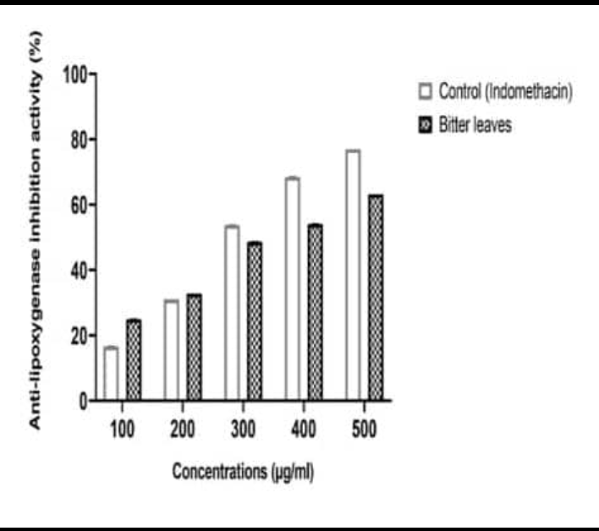
Figure 1: Anti-lipoxygenase inhibitory activity of V. amygdalina L (Bitter leaf).
Protein Denaturation Inhibition Activity Analysis
Figure 2 depicts the result for V. amygdalina L. extract as well as that of the reference standard (aspirin) of protein denaturation (PD) inhibitory activity and its minimum inhibitory concentration (MIC). The V. amygdalina L. extract showed high PD inhibitory activity at 300, 400, and 500 µg/ml concentrations when compared with the reference standard used, although the MIC of V. amygdalina L. extract revealed a decrease (p<0.05) when compared with the reference standard used.

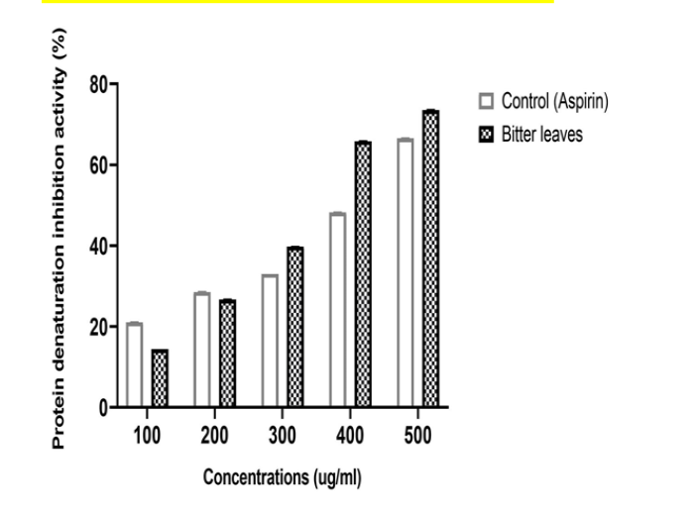
Figure 2: Protein denaturation inhibitory activity of V. amygdalina L (Bitter leaf).

Membrane Stabilising Activity Analysis
The membrane stabilising activity and its minimum inhibitory concentration (MIC) of V. amygdalina L. extract, as well as that of the reference standard (aspirin), were as shown in Figure 3. It was observed that V. amygdalina L. extract showed a concentration-dependent increase in membrane stabilising activity, but less when compared with the standard reference used, although the MIC of V. amygdalina L. extract revealed a significant (p<0.05) decrease when compared with the reference standard.
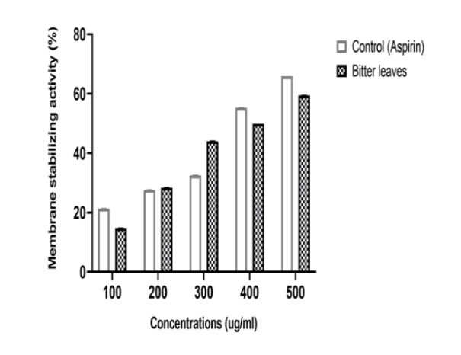
Figure 3: Membrane stabilising inhibitory activity of V. amygdalina L (Bitter leaf).
Urease Inhibition Activity Analysis
The Urease inhibition activity and its minimum inhibitory concentration (MIC) of V. amygdalina L. extract, as well as that of the reference standard (thiourea), were as shown in Figure 4. It was observed that V. amygdalina L. extract showed a concentration-dependent increase in urease inhibitory activity, but less when compared with the standard reference used, while the MIC of V. amygdalina L. revealed a significant (p<0.05) increase when compared with the reference standard.
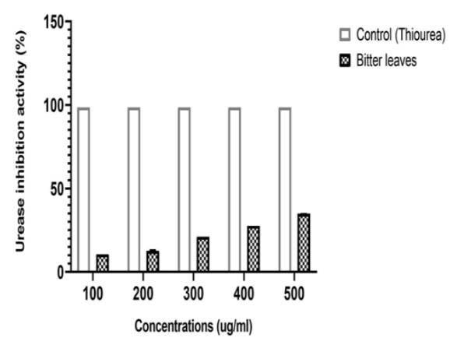
Figure 4: Urease inhibitory activity of V. amygdalina L (Bitter leaf).
Gas Chromatography-Mass Spectrometry (GC-MS) Analysis
The GC-MS analysis revealed the chemical composition of V. amygdalina L., which is presented in Table 1 with 90% or greater spectral matching accuracy compared to those of NIST Library mass Spectra database and mass spectra. The result shows 17 bioactive compounds from V. amygdalina L. extract.
Table 1: Gas Chromatography-Mass Spectrometry GC-MS Analysis result of bioactive compounds present in V. amygdalina L.
Peak | RT | Compound Detected | Molecular Formula | Molecular Weight | Peak Area % | Composition by weight % | Mass fragmentation
1 | 8.02 | Benzene  Acetaldehyde | C₈H₈O | 120 | 5.23 | 1.20 | 41, 93, 136
2 | 10.50 | 1,2-Benzenedicarboxylic acid | C₈H₆O₄ | 166 | 5.66 | 5.73 | 50, 104, 166
3 | 11.43 | Caryophyllene oxide | C₁₅H₂₄O | 220 | 1.79 | 2.31 | 41, 79, 220
4 | 13.25 | n-Hexadecanoic acid | C₁₀H₁₆ | 256 | 8.15 | 6.05 | 43, 73, 256
5 | 16.50 | Phenol, 3,5-bis(1,1-dimethylethyl)- | C₁₄H₂₂O | 206 | 5.41 | 6.26 | 41, 57, 206
6 | 20.81 | Tetradecanoic acid | C₁₄H₂₈O₂ | 228 | 2.08 | 3.61 | 41, 73, 228
7 | 23.03 | 1, 2-epoxy hexadecane | C₁₆H₃₂O | 240 | 1.66 | 2.93 | 41, 82, 240
8 | 26.02 | Hexadecanoic acid, methyl ester | C₁₇H₃₄O₂ | 270 | 18.30 | 17.54 | 43, 74, 270
9 | 28.50 | 2-Pentade canone,6,10,14-trimethyl | C₁₈H₃₆O | 268 | 2.91 | 3.99
10 | 32.50 | Oleic acid | C₁₈H₃₄O₂ | 282 | 20.80 | 21.96 | 41, 55, 282
11 | 35.71 | 9,12-Octadecadienoic acid (Z,Z)- | C₁₈H₃₂O₂ | 280 | 2.83 | 3.88 | 65, 67, 280
12 | 37.20 | Phytol | C₂₀H₄₀O | 296 | 2.00 | 1.63 | 43, 71, 296
13 | 37.80 | Eicosanoic acid | C₂₀H₄₀O₂ | 312 | 12.06 | 12.45 | 43, 73, 312
14 | 39.75 | 6-Octadecenoic acid, (Z)- | C₁₈H₃₄O₂ | 282 | 2.29 | 2.56 | 41, 55, 282
15 | 40.75 | Octadecanoic acid | C₁₈H₃₆O₂ | 284 | 2.91 | 3.04 | 43, 73, 284
16 | 43.52 | Cholestane | C₂₇H₄₈ | 382 | 3.33 | 3.27 | 43, 217, 382
17 | 48.21 | Campesterol | C₂₈H₄₈O | 400 | 1.66 | 1.18 | 43, 55, 400

Clustering Analysis
The results of the clustering analysis are presented in Figure 5, which shows the various compounds and their weights. Canonical smiles and compound identifier (CID) numbers were generated from the NCBI PubChem database for each compound, as shown in Table 2. These identifiers were then used in clustering analysis to group the compounds according to their molecular weights. The colour-coded legend (Figure 5) depicts the range of molecular weights for each compound, with each colour representing a different weight range as shown in Figure 5.

Table 2: Compound CID and canonical smiles of V. amygdalina L. bioactive compounds.
S/N | COMPOUND NAME | COMPOUND CID | CANONICAL SMILES
1 | Benzeneacetaldehyde | 998 | C1=CC=C(C(=C1)C(=O)O)C(=O)O
2 | 1,2-Benzenedicarboxylic acid | 1017 | C1=CC=C(C(=C1)C(=O)O)C(=O)O
3 | Caryophyllene oxide | 1742210 | C[C@@]12CC[C@@H]3[C@H](CC3(C)C)C(=C)CC[C@H]1O2
4 | n-Hexadecanoic acid | 985 | CCCCCCCCCCCCCCCC(=O)O
5 | Phenol, 3,5-bis(1,1-dimethylethyl)- | 70825 | CC(C)(C)C1=CC(=CC(=C1)O)C(C)(C)C
6 | Tetradecanoic acid | 11005 | CCCCCCCCCCCCCC(=O)O
7 | 1, 2-epoxyhexadecane | 23741 | CCCCCCCCCCCCCCC1CO1
8 | Hexadecanoic acid, methyl ester | 8181 | CCCCCCCCCCCCCCCC(=O)OC
9 | 2-Pentadecanone, 6,10,14-trimethyl | 10408 | CC(C)CCCC(C)CCCC(C)CCCC(=O)C
10 | Oleic acid | 445639 | CCCCCCCC/C=C\CCCCCCCC(=O)O
11 | 9,12-Octadecadienoic acid (Z,Z)- | 5280450 | CCCCC/C=C\C/C=C\CCCCCCCC(=O)O
12 | Phytol | 5280435 | C[C@@H](CCC[C@@H](C)CCC/C(=C/CO)/C)CCCC(C)C
13 | Eicosanoic acid | 10467 | CCCCCCCCCCCCCCCCCCCC(=O)O
14 | 6-Octadecenoic acid, (Z)- | 5281125 | CCCCCCCCCCC/C=C\CCCCC(=O)O
15 | Octadecanoic acid | 5281 | CCCCCCCCCCCCCCCCCC(=O)O
16 | Cholestane | 6857534 | C[C@H](CCCC(C)C)[C@H]1CC[C@@H]2[C@@]1(CC[C@H]3[C@H]2CCC4[C@@]3(CCCC4)C)C
17 | Campesterol | 173183 | C[C@H](CC[C@@H](C)C(C)C)[C@H]1CC[C@@H]2[C@@]1(CC[C@H]3[C@H]2CC=C4[C@@]3(CC[C@@H](C4)O)C)C
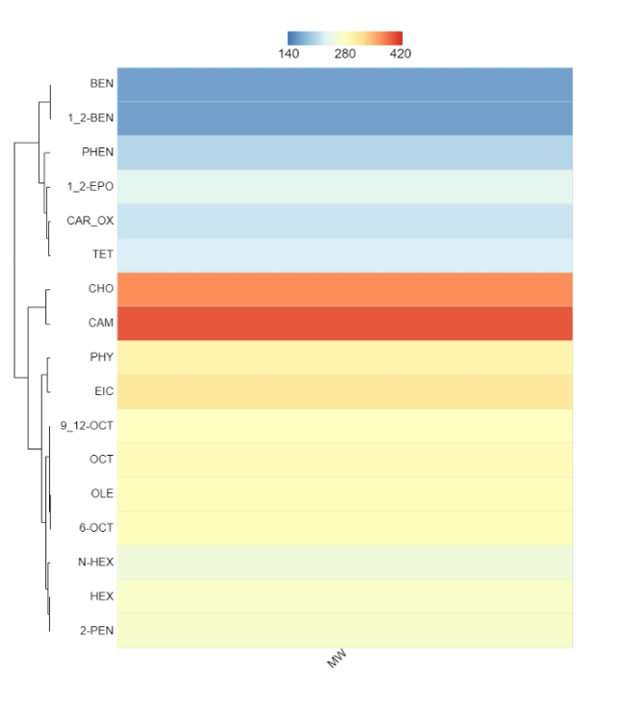
Figure 5: Clustering analysis of V. amygdalina L. bioactive compounds

In-silico Pharmacokinetics Analysis
The In-silico pharmacokinetics analysis of the chemical compounds identified through GC-MS was conducted, using the SwissADME online tool and following Lipinski’s rule of five to evaluate the pharmacokinetic properties of these compounds. Lipinski criteria suggest that for a compound to be considered orally bioavailable, it must have no more than one violation of the following criteria: a molecular weight of less than 500 daltons, no more than 10 hydrogen bond acceptor sites, no more than 5 hydrogen bond donor sites, and the mlogP (the logarithm of the partition coefficient) value of less than or equal to 4.15. Our analysis revealed that all the compounds adhered to these guidelines as detailed in Table 3.
Table 3: In-silico pharmacokinetics analysis of V. amygdalina L. bioactive compounds
COMPOUND NAME | MW | HBA | HBD | MLOGP | ROF
Benzeneacetaldehyde | 120.15 | 1 | 0 | 1.78 | 0
1,2-Benzenedicarboxylic acid | 166.13 | 4 | 2 | 1.20 | 0
Caryophyllene oxide | 220.35 | 1 | 0 | 3.67 | 0
n-Hexadecanoic acid | 256.42 | 2 | 1 | 4.19 | 1
Phenol, 3,5-bis(1,1-dimethylethyl)- | 206.32 | 1 | 1 | 3.87 | 0
Tetradecanoic acid | 228.37 | 2 | 1 | 3.69 | 0
1, 2-epoxyhexadecane | 240.42 | 1 | 0 | 4.06 | 0
Hexadecanoic acid, methyl ester | 270.45 | 2 | 0 | 4.44 | 1
2-Pentadecanone, 6,10,14-trimethyl | 268.48 | 1 | 0 | 4.79 | 1
Oleic acid | 282.46 | 2 | 1 | 4.57 | 1
9,12-Octadecadienoic acid (Z,Z)- | 280.45 | 2 | 1 | 4.57 | 1
Phytol | 296.53 | 1 | 1 | 5.25 | 1
Eicosanoic acid | 312.53 | 2 | 1 | 5.13 | 1
6-Octadecenoic acid, (Z)- | 282.46 | 2 | 1 | 4.57 | 1
Octadecanoic acid | 284.48 | 2 | 1 | 4.67 | 1
Cholestane | 372.67 | 0 | 0 | 8.47 | 1
Campesterol | 400.68 | 1 | 1 | 6.54 | 1

Protein-Ligand Docking
Schrodinger Maestro 12.8 was utilised to dock the ligands identified with GC-MS against the target proteins. The docking result shows that a minimum of nine (9) of the bioactive compounds were able to bind well to the active site of the target proteins (Table 4). A stronger or more potent interaction between molecules is typically associated with more negative binding energies. Against the target FABP4, fifteen (15) compounds were seen to bind against the target with binding affinities ranging from -6.220kcal/mol to -2.979kcal/mol. 1,2-Benzenedicarboxylic acid; Phenol, 3,5-bis(1,1-dimethylethyl)-; 9,12-Octadecadienoic acid (Z,Z)-; Caryophyllene oxide; 2-Pentadecanone, 6,10,14-trimethyl-; and Oleic acid among the others had the highest binding affinity against the target with docking score of -6.220kcal/mol, -5.298kcal/mol, -4.712kcal/mol, -4.687kcal/mol, -4.677kcal/mol, and -4.646kcal/mol respectively (Table 4). The 2-dimensional structure of these lead compounds docked against the FABP4 active site is illustrated in Figure 6a. From the docking result, nine (9) compounds were able to exhibit binding affinity against the target COX-1 among the bioactive compounds present in V. amygdalina, ranging from -7.784kcal/mol to -5.647kcal/mol. Among the nine compounds, 9,12-Octadecadienoic acid (Z, Z)-; 1,2-Benzenedicarboxylic acid; 6-Octadecenoic acid, (Z)-; Benzene acetaldehyde; Caryophyllene oxide; and n-Hexadecanoic acid exhibited the best binding compounds against the COX-1 with binding affinities of -7.784kcal/mol, -6.945kcal/mol, -6.799kcal/mol, -6.434kcal/mol, -6.123kcal/mol, and -6.083kcal/mol respectively (Table 4). The 2-dimensional structure of these lead compounds docked against the COX-1 active site is illustrated in Figure 6b. Against the target FFAR1, fifteen (15) compounds were seen to bind at the active site of this target with binding affinities ranging from -8.704kcal/mol to -2.952kcal/mol. Eicosanoic acid; Phytol; 6-Octadecenoic acid, (Z)-; 9,12-Octadecadienoic acid (Z, Z); 2-Pentadecanone, 6,10,14-trimethyl-; and Octadecanoic acid had the highest binding affinity against the target FFAR1 with docking score of -8.704kcal/mol, -7.581kcal/mol, -7.560kcal/mol, -7.535kcal/mol, -7.220kcal/mol, and -7.173kcal/mol respectively (Table 4). The 2-dimensional structure of these lead compounds docked against the FFAR1 active site is illustrated in Figure 6c. Among V. amygdalina L. bioactive compounds, nine (9) compounds exhibited binding affinity against the target PPARA, with binding affinity values ranging from -7.312kcal/mol to -4.813kcal/mol. 6-Octadecenoic acid, (Z)-; 9,12-Octadecadienoic acid (Z, Z)-; 1,2-Benzenedicarboxylic acid; Phytol; Hexadecanoic acid, methyl ester; and n-Hexadecanoic acid with docking score -7.312kcal/mol, -6.479kcal/mol, -6.109kcal/mol, -5.847kcal/mol, -5.737kcal/mol, and -5.484kcal/mol respectively (Table 4) had the highest binding affinity against the active site of the target PPARA. The 2-dimensional structure of these lead compounds docked against the PPARA active site is illustrated in Figure 6d
Table 4: Docking scores of the lead compounds of V. amygdalina L. docked against the target proteins: FFAR1 (PDB ID: 4PHU), FABP4 (PDB ID: 3P6H), PPARD (PDB ID: 1Y0S), and PPARA (PDB ID: 3KDU) receptors.
COMPOUND NAME | DOCKING SCORE (Kcal/mol)
COMPOUND NAME | FABP4 | COX-1 | FFAR1 | PPARA
Benzeneacetaldehyde | -4.424 | -6.434 | -6.297 | -5.045
1,2-Benzenedicarboxylic acid | -6.220 | -6.945 | -6.880 | -6.109
Caryophyllene oxide | -4.687 | -6.123 | -2.952 | -
n-Hexadecanoic acid | -3.411 | -6.083 | -6.886 | -5.484
Phenol, 3,5-bis(1,1-dimethylethyl)- | -5.298 | - | -3.997 | -4.813
Tetradecanoic acid | -2.979 | - | -6.190 | -4.897
1, 2-epoxyhexadecane | -3.697 | -5.893 | -5.633 | -
Hexadecanoic acid, methyl ester | -3.571 | -5.837 | -5.210 | -5.737
2-Pentadecanone, 6,10,14-trimethyl | -4.677 | -5.647 | -7.220 | -
Oleic acid | -4.646 | - | -6.278 | -
9,12-Octadecadienoic acid (Z,Z)- | -4.712 | -7.784 | -7.535 | -6.479
Phytol | -4.404 | - | -7.581 | -5.847
Eicosanoic acid | -4.404 | - | -8.704 | -
6-Octadecenoic acid, (Z)- | -4.474 | -6.799 | -7.560 | -7.312
Octadecanoic acid | -3.510 | - | -7.173 | -
Cholestane | - | - | - | -
Campesterol | - | - | - | -

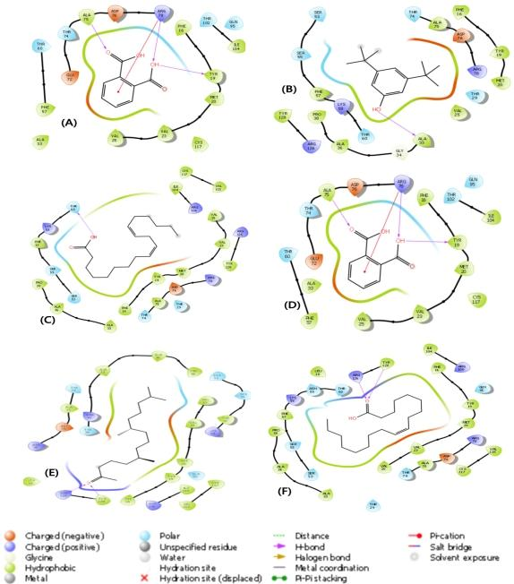
Figure 6a: 2D-molecular interactions of V. amygdalina L. lead compounds docked against FABP4 active site: (A) 1,2-Benzenedicarboxylic acid (B) Phenol, 3,5-bis(1,1-dimethylethyl) (C) 9,12-Octadecadienoic acid (Z,Z)- (D) Caryophyllene oxide (E) 2-Pentadecanone, 6,10,14-trimethyl- (F) Oleic acid

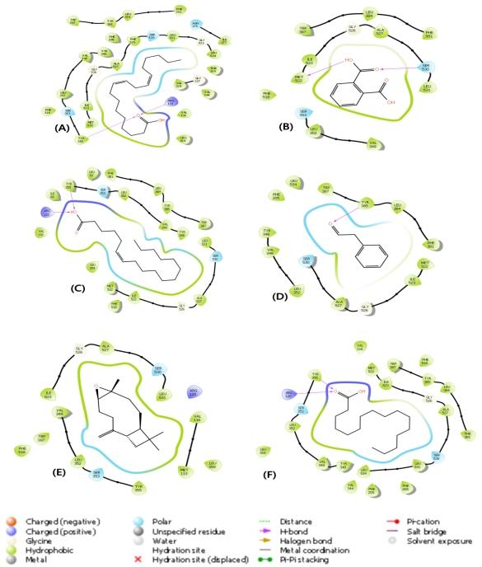
Figure 6b: 2D-molecular interactions of V. amygdalina L. lead compounds docked against COX-1 active site: (A) 9,12-Octadecadienoic acid (Z,Z)- (B) 1,2-Benzenedicarboxylic acid (C) 6-Octadecenoic acid, (Z)- (D) Benzene acetaldehyde (E) Caryophyllene oxide (F) n-Hexadecanoic acid

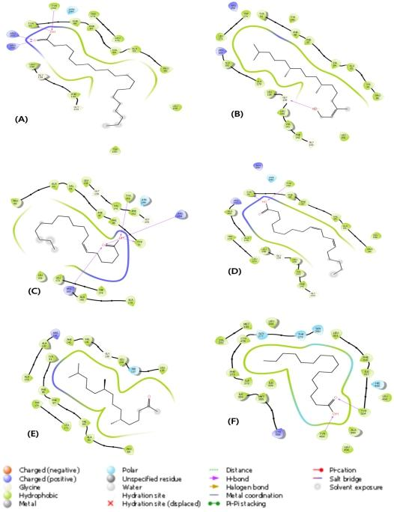
Figure 6c: 2D-molecular interactions of V. amygdalina L. lead compounds docked against FFAR1 active site: (A) Eicosanoic acid (B) Phytol (C) 6-Octadecenoic acid, (Z)- (D) 9,12-Octadecadienoic acid (Z,Z) (E) 2-Pentadecanone, 6,10,14-trimethyl- (F) Octadecanoic acid

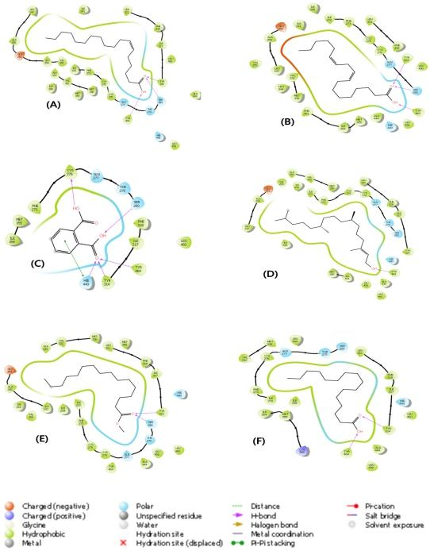
Figure 6d: 2D-molecular interactions of V. amygdalina L. lead compounds docked against PPARA active site: (A) 6-Octadecenoic acid, (Z)- (B) 9,12-Octadecadienoic acid (Z,Z)- (C) 1,2-Benzenedicarboxylic acid (D) Phytol (E) Hexadecanoic acid, methyl ester (F) n-Hexadecanoic acid

Discussion
The rising incidence of gastrointestinal disorders has sparked interest in natural remedies with therapeutic potential [22]. Vernonia amygdalina L., or bitter leaf, is recognised for its traditional medicinal uses, particularly in African cultures, where it has been employed to treat digestive issues, inflammation, and infections [23]. Its therapeutic effects are attributed to a rich phytochemical profile, including flavonoids, terpenoids, and polyphenols, known for their antioxidant and anti-inflammatory properties. Recent studies have begun to substantiate these traditional applications, highlighting their potential benefits for gastrointestinal health [23]. Given the role of inflammation in conditions like inflammatory bowel disease, peptic ulcers, and gastritis, exploring natural compounds that can modulate immune responses may offer promising therapeutic options [24].
The biochemical analysis of V. amygdalina L. extracts revealed significant anti-inflammatory properties that support its traditional use in managing gastrointestinal disorders. One of the primary assays performed was the anti-lipoxygenase activity test. Lipoxygenases are enzymes that play a critical role in the inflammatory response by converting arachidonic acid into leukotrienes, which are potent mediators of inflammation [25,26]. The results indicated that V. amygdalina L. extracts exhibited a concentration-dependent increase in anti-lipoxygenase activity. Although the extract's potency was lower than that of the reference standard, indomethacin, the significant decrease in the minimum inhibitory concentration (MIC) suggests that V. amygdalina L. can effectively inhibit lipoxygenase activity. This inhibition is crucial for mitigating inflammatory responses, particularly in conditions such as asthma and inflammatory bowel disease, where leukotrienes are implicated [27-29]. Another important aspect of the biochemical analysis was the evaluation of protein denaturation inhibitory activity. Protein denaturation is a process that can lead to the loss of structural integrity and function of proteins, often exacerbated during inflammatory conditions [30,31]. The results showed that V. amygdalina L. extracts demonstrated high inhibitory activity at concentrations of 300µg/ml and above. This finding indicates that the extract may possess compounds that stabilise proteins and cellular membranes, thereby protecting them from denaturation. Such protective effects are particularly relevant in the gastrointestinal tract, where maintaining protein integrity is essential for proper digestive and immune functions [32,33]. The membrane stabilising activity of V. amygdalina L. was also assessed, revealing its potential to protect cellular integrity during inflammatory responses. The extract exhibited a concentration-dependent increase in membrane stabilisation, with significant decreases in MIC compared to aspirin, a known anti-inflammatory agent. This activity suggests that V. amygdalina L. may help preserve the integrity of cell membranes during inflammatory processes, thereby preventing cell lysis and subsequent tissue damage. This protective mechanism could be particularly beneficial in conditions characterised by increased membrane permeability and inflammation, such as ulcerative colitis [34]. Furthermore, the analysis included the evaluation of urease inhibition activity. Urease is an enzyme produced by certain bacteria in the gastrointestinal tract, and its activity can lead to the production of ammonia, which is toxic to intestinal cells [35]. The results indicated that V. amygdalina L. extracts possess urease inhibitory properties, suggesting that they may help reduce ammonia production and its associated toxic effects. This activity is particularly relevant in the context of gastric disorders, where elevated urease activity can contribute to mucosal injury and exacerbate inflammation [36].
The phytochemical composition of V. amygdalina L. is a critical aspect of its therapeutic potential, as it is rich in various bioactive compounds that contribute to its medicinal properties. Through gas chromatography-mass spectrometry (GC-MS) analysis, a diverse array of phytochemicals was identified, including flavonoids, terpenoids, alkaloids, and fatty acids. Among the notable compounds identified are Benzeneacetaldehyde, Caryophyllene oxide, and several fatty acids, including Oleic acid and 9,12-Octadecadienoic acid (Z, Z). These compounds play significant roles in modulating biological processes, particularly those related to inflammation and oxidative stress. For instance, oleic acid, a monounsaturated fatty acid, is known for its anti-inflammatory properties. It can influence the expression of pro-inflammatory cytokines and promote the resolution of inflammation, making it a valuable component in the management of inflammatory conditions [37,38]. The presence of flavonoids and terpenoids in V. amygdalina L. further enhances its pharmacological profile. Flavonoids are well-documented for their antioxidant activities, which help combat oxidative stress, an important factor in the pathogenesis of many gastrointestinal diseases [39-41]. By scavenging free radicals and reducing oxidative damage, flavonoids can protect intestinal cells and maintain mucosal integrity [39-41]. Similarly, terpenoids have been shown to possess anti-inflammatory and antimicrobial properties [42], contributing to the overall health benefits of the plant. The implications of these phytochemical findings extend beyond traditional uses. The identification of specific bioactive compounds allows for targeted research into their mechanisms of action and potential therapeutic applications. For instance, understanding how caryophyllene oxide interacts with inflammatory pathways could lead to the development of novel anti-inflammatory agents derived from V. amygdalina L.. Additionally, the potential synergistic effects of multiple compounds working in concert should not be overlooked. The complex interplay between different phytochemicals may enhance their individual effects, resulting in a more potent overall therapeutic impact [43]. Moreover, the rich phytochemical profile of V. amygdalina L. suggests its potential for use in functional foods and nutraceuticals. As consumers increasingly seek natural alternatives to synthetic pharmaceuticals, products derived from V. amygdalina L. could meet the demand for safe and effective dietary supplements aimed at promoting gastrointestinal health and preventing inflammation. This shift towards natural remedies aligns with broader trends in health and wellness, emphasising the importance of preventive care and holistic approaches to health management [44].
In silico drug design and screening represent a crucial component of modern pharmacological research, allowing for the efficient identification and optimisation of potential therapeutic compounds [45-47]. Clustering Analysis was performed to categorise the bioactive compounds based on their molecular weights and structural characteristics. This analysis facilitated a deeper understanding of how these compounds might interact with biological systems [48]. Following clustering, we conducted a pharmacokinetics assessment using the SwissADME online tool, which evaluates the pharmacokinetic properties of compounds based on Lipinski’s rule of five. This rule serves as a guideline to predict the oral bioavailability of compounds, suggesting that an ideal drug should have a molecular weight of less than 500 daltons, no more than 5 hydrogen bond donors, no more than 10 hydrogen bond acceptors, and a logP value of less than or equal to 4.15 [49-52]. Our analysis revealed that all identified compounds from V. amygdalina L. adhered to these criteria, indicating their potential for effective oral absorption and systemic distribution. This finding is pivotal, as it suggests that the bioactive compounds could be viable candidates for further development as therapeutic agents for gastrointestinal disorders.
Molecular docking is an essential computational approach in drug discovery that enables the prediction of interactions between small molecules and target proteins [53]. In this study of V. amygdalina, docking analyses were performed to assess the binding affinities of the bioactive compounds against key target proteins involved in gastrointestinal immune regulation: Fatty Acid-Binding Protein 4 (FABP4), Cyclooxygenase-1 (COX-1), Free Fatty Acid Receptor 1 (FFAR1), and Peroxisome Proliferator-Activated Receptor Alpha (PPARα). Fifteen compounds were identified as capable of binding to the FABP4 target, exhibiting binding affinities that ranged from -6.220 kcal/mol to -2.979 kcal/mol. Among these, six compounds stood out with the highest binding affinities: 1,2-Benzenedicarboxylic acid (-6.220 kcal/mol), Phenol, 3,5-bis(1,1-dimethylethyl)- (-5.298 kcal/mol), 9,12-Octadecadienoic acid (Z, Z) (-4.712 kcal/mol), Caryophyllene oxide (-4.687 kcal/mol), 2-Pentadecanone, 6,10,14-trimethyl- (-4.677 kcal/mol), and Oleic acid (-4.646 kcal/mol). The strong binding of 1,2-Benzenedicarboxylic acid, in particular, suggests its potential role in modulating fatty acid transport and metabolism, which are critical processes in inflammatory responses [54]. The 2-dimensional structure of these lead compounds docked against the FABP4 active site is illustrated in Figure 6a, showcasing their spatial orientation and interaction with the protein. The docking results also revealed that nine compounds exhibited significant binding affinities against the COX-1 target, with values ranging from -7.784 kcal/mol to -5.647 kcal/mol. Notably, 9,12-Octadecadienoic acid (Z, Z) demonstrated the highest affinity at -7.784 kcal/mol, followed by 1,2-Benzenedicarboxylic acid (-6.945 kcal/mol), 6-Octadecenoic acid (Z) (-6.799 kcal/mol), Benzene acetaldehyde (-6.434 kcal/mol), Caryophyllene oxide (-6.123 kcal/mol), and n-Hexadecanoic acid (-6.083 kcal/mol). The strong binding of 9,12-Octadecadienoic acid suggests its potential as an anti-inflammatory agent by inhibiting COX-1, a key enzyme in the biosynthesis of pro-inflammatory prostaglandins [55]. The 2-dimensional structures of these lead compounds docked against the COX-1 active site are depicted in Figure 6b, illustrating their interactions and potential inhibitory effects. Fifteen compounds were also found to bind effectively at the active site of FFAR1, with binding affinities ranging from -8.704 kcal/mol to -2.952 kcal/mol. The compounds with the highest binding affinities included Eicosanoic acid (-8.704 kcal/mol), Phytol (-7.581 kcal/mol), 6-Octadecenoic acid (Z) (-7.560 kcal/mol), 9,12-Octadecadienoic acid (Z, Z) (-7.535 kcal/mol), 2-Pentadecanone, 6,10,14-trimethyl- (-7.220 kcal/mol), and Octadecanoic acid (-7.173 kcal/mol). The exceptional binding affinity of Eicosanoic acid highlights its potential role in mediating gut inflammation and metabolic regulation through its interaction with FFAR1, a receptor involved in fatty acid sensing and signaling [56]. The 2-dimensional structure of these lead compounds docked against the FFAR1 active site is illustrated in Figure 6c, providing a visual representation of their binding modes. Also, nine compounds exhibited binding affinities against the PPARA target, with values ranging from -7.312 kcal/mol to -4.813 kcal/mol. The compounds with the highest binding affinities included 6-Octadecenoic acid (Z) (-7.312 kcal/mol), 9,12-Octadecadienoic acid (Z, Z) (-6.479 kcal/mol), 1,2-Benzenedicarboxylic acid (-6.109 kcal/mol), Phytol (-5.847 kcal/mol), Hexadecanoic acid, methyl ester (-5.737 kcal/mol), and n-Hexadecanoic acid (-5.484 kcal/mol). The 2-dimensional structures of these lead compounds docked against the PPARα active site are shown in Figure 6d, illustrating their spatial orientation and interactions with the protein. The strong binding of 6-Octadecenoic acid suggests its potential role in regulating lipid metabolism and inflammation, as PPARα is a key transcription factor involved in fatty acid oxidation and inflammatory responses.
Conclusion
This study highlights the promising immunomodulatory properties of Vernonia amygdalina leaf and its bioactive compounds. The comprehensive biochemical analysis demonstrated significant anti-inflammatory effects, while in silico docking studies identified key interactions with target proteins critical for gastrointestinal health. The strong binding affinities observed for compounds such as 9,12-Octadecadienoic acid and 1,2-Benzenedicarboxylic acid suggest their potential roles as therapeutic agents for managing GI disorders. These results not only provide a foundation for future experimental studies but also underscore the importance of traditional medicinal plants in contemporary drug discovery. Further research, such as exploring the clinical efficacy of the identified compounds and conducting trials, is essential to validate these findings and explore the clinical applications of V. amygdalina L. in the treatment of inflammatory gastrointestinal conditions
List of Abbreviations
FABP4: Fatty Acid-Binding Protein 4
COX-1: Cyclooxygenase-1
FFAR1: Free Fatty Acid Receptor 1
PPARα/ PPARA: Peroxisome Proliferator-Activated Receptor Alpha
PDB: Protein Data Bank
ANOVA: Analysis of Variance
HTVS: High Throughput Virtual Screening
SP: Standard Precision
XP: Extra Precision
GC-MS: Gas Chromatography-Mass Spectrometry

Disclaimer (Artificial intelligence)
Author(s) hereby declare that NO generative AI technologies such as Large Language Models (ChatGPT, COPILOT, etc.) and text-to-image generators have been used during the writing or editing of this manuscript.
References
- Ahluwalia, B., Magnusson, M. K., & Öhman, L. (2017). Mucosal immune system of the gastrointestinal tract: maintaining balance between the good and the bad. Scandinavian journal of gastroenterology, 52(11), 1185-1193.
- Singh, R., Zogg, H., Wei, L., Bartlett, A., Ghoshal, U. C., Rajender, S., & Ro, S. (2021). Gut microbial dysbiosis in the pathogenesis of gastrointestinal dysmotility and metabolic disorders. Journal of neurogastroenterology and motility, 27(1), 19.
- Santana, P. T., Rosas, S. L. B., Ribeiro, B. E., Marinho, Y., & de Souza, H. S. (2022). Dysbiosis in inflammatory bowel disease: pathogenic role and potential therapeutic targets. International journal of molecular sciences, 23(7), 3464.
- Huang, X., Zhou, Y., Sun, Y., & Wang, Q. (2022). Intestinal fatty acid binding protein: A rising therapeutic target in lipid metabolism. Progress in Lipid Research, 87, 101178.
- Wang, D., Cabalag, C. S., Clemons, N. J., & DuBois, R. N. (2021). Cyclooxygenases and prostaglandins in tumor immunology and microenvironment of gastrointestinal cancer. Gastroenterology, 161(6), 1813-1829.
- Kimura, I., Ichimura, A., Ohue-Kitano, R., & Igarashi, M. (2019). Free fatty acid receptors in health and disease. Physiological reviews.
- Guo, Y. X., Wang, B. Y., Gao, H., Hua, R. X., Gao, L., He, C. W., ... & Xu, J. D. (2022). Peroxisome Proliferator–Activated Receptor-α: A Pivotal Regulator of the Gastrointestinal Tract. Frontiers in Molecular Biosciences, 9, 864039.
- Fuertes Agudo, M. (2023). Role of cyclooxygenase-2 in ischemia-reperfusion injury in the liver (Doctoral dissertation, Universitat Politècnica de València).
- Hara, T., Hirasawa, A., Ichimura, A., Kimura, I., & Tsujimoto, G. (2011). Free fatty acid receptors FFAR1 and GPR120 as novel therapeutic targets for metabolic disorders. Journal of pharmaceutical sciences, 100(9), 3594-3601.
- Kumari, P., Inoue, A., Chapman, K., Lian, P., & Rosenbaum, D. M. (2023). Molecular mechanism of fatty acid activation of FFAR1. Proceedings of the National Academy of Sciences, 120(22), e2219569120.
- Todisco, S., Santarsiero, A., Convertini, P., De Stefano, G., Gilio, M., Iacobazzi, V., & Infantino, V. (2022). PPAR alpha as a metabolic modulator of the liver: role in the pathogenesis of nonalcoholic steatohepatitis (NASH). Biology, 11(5), 792.
- Wu, G., Yang, L., Xu, Y., Jiang, X., Jiang, X., Huang, L., ... & Cai, S. (2018). FABP4 induces asthmatic airway epithelial barrier dysfunction via ROS-activated FoxM1. Biochemical and biophysical research communications, 495(1), 1432-1439.
- Costa-Filho, H. B., Sales, T. M. A. L., Paula, S. M., Nicolau, L. A. D., Queiroga, M. L., Havt, A., ... & Souza, M. H. L. P. (2023). Role of cyclooxygenases 1 and 2 in the maintenance of colonic mucosal integrity in an experimental colitis model. Brazilian Journal of Medical and Biological Research, 56, e12946.
- Bartoszek, A., Von Moo, E., Binienda, A., Fabisiak, A., Krajewska, J. B., Mosińska, P., ... & Fichna, J. (2020). Free fatty acid receptors as new potential therapeutic target in inflammatory bowel diseases. Pharmacological Research, 152, 104604.
- Decara, J., Rivera, P., López-Gambero, A. J., Serrano, A., Pavón, F. J., Baixeras, E., ... & Suárez, J. (2020). Peroxisome proliferator-activated receptors: Experimental targeting for the treatment of inflammatory bowel diseases. Frontiers in pharmacology, 11, 730.
- Ugbogu, E. A., Emmanuel, O., Dike, E. D., Agi, G. O., Ugbogu, O. C., Ibe, C., & Iweala, E. J. (2021). The phytochemistry, ethnobotanical, and pharmacological potentials of the medicinal plant-Vernonia amygdalina L.(bitter Leaf). Clinical Complementary Medicine and Pharmacology, 1(1), 100006.
- Ogwu, M. C., & Ikhajiagbe, B. (2023). Vernonia amygdalina Delile (Asteraceae): An Overview of the Phytochemical Constituents, Nutritional Characteristics, and Ethnomedicinal Values for Sustainability. Herbal Medicine Phytochemistry: Applications and Trends, 1-29.
- Atolani, O., Banerjee, P., Ayenı, A. E., Usman, M. A., Adejumo, O. J., Erukaınure, O. L., ... & Adedotun, I. Phytochemical, Pharmacological, Phyto-cosmeceutical, Toxicity, and In silico Toxicological Evaluations of Vernonia amygdalina Delile–A Review. Journal of the Turkish Chemical Society Section A: Chemistry, 11(2), 775-802.
- Gunathilake, K. D. P. P., Ranaweera, K. K. D. S., & Rupasinghe, H. V. (2018). In vitro anti-inflammatory properties of selected green leafy vegetables. Biomedicines, 6(4), 107.
- Akhtar, M. A. (2022). Anti-inflammatory medicinal plants of Bangladesh—a pharmacological evaluation. Frontiers in pharmacology, 13, 809324.
- Daina A, Michielin O, Zoete V (2017) SwissADME: a free web tool to evaluate pharmacokinetics, drug-likeness and medicinal chemistry friendliness of small molecules. Scientific Report 7(1): 42717.
- Krupavaram, B., Babu, A. K., Santhiya, M. P., Tan, C. S., Bama, V. V., Ganesh, S. P., ... & Chooi, W. H. (2023). A Review of Herbal Treatment for Functional Gastrointestinal Disorders and Infection. Progress in Microbes & Molecular Biology, 6(1).
- Ojimelukwe, P. C., & Amaechi, N. (2019). Composition of Vernonia amygdalina and its potential health benefits. International Journal of Environment, Agriculture and Biotechnology, 4(6), 1836-1848.
- Ouahed, J., Spencer, E., Kotlarz, D., Shouval, D. S., Kowalik, M., Peng, K., ... & Snapper, S. B. (2020). Very early onset inflammatory bowel disease: a clinical approach with a focus on the role of genetics and underlying immune deficiencies. Inflammatory bowel diseases, 26(6), 820-842.
- Smith, W. L., & Murphy, R. C. (2016). The eicosanoids: cyclooxygenase, lipoxygenase and epoxygenase pathways. In Biochemistry of lipids, lipoproteins and membranes (pp. 259-296). Elsevier.
- Bennett, M., & Gilroy, D. W. (2017). Lipid mediators in inflammation. Myeloid cells in health and disease: a synthesis, 343-366.
- Powell, W. S. (2021). Eicosanoid receptors as therapeutic targets for asthma. Clinical Science, 135(16), 1945-1980.
- Bennett, M., & Gilroy, D. W. (2017). Lipid mediators in inflammation. Myeloid cells in health and disease: a synthesis, 343-366.
- Kotlyarov, S., & Kotlyarova, A. (2021). Anti-inflammatory function of fatty acids and involvement of their metabolites in the resolution of inflammation in chronic obstructive pulmonary disease. International Journal of Molecular Sciences, 22(23), 12803.
- Akhter, S., Irfan, H. M., Ullah, A., Jahan, S., Roman, M., Latif, M. B., ... & Althobaiti, Y. S. (2022). Noscapine hydrochloride (benzyl-isoquinoline alkaloid) effectively prevents protein denaturation through reduction of IL-6, NF-kB, COX-2, Prostaglandin-E2 in rheumatic rats. Saudi Pharmaceutical Journal, 30(12), 1791-1801.
- Amaya-Farfan, J. (2021). Denaturation of proteins, generation of bioactive peptides, and alterations of amino acids. In Chemical Changes During Processing and Storage of Foods (pp. 21-84). Academic Press.
- Wang, B., Timilsena, Y. P., Blanch, E., & Adhikari, B. (2019). Lactoferrin: Structure, function, denaturation and digestion. Critical reviews in food science and nutrition, 59(4), 580-596.
- Navis, M., Muncan, V., Sangild, P. T., Møller Willumsen, L., Koelink, P. J., Wildenberg, M. E., ... & Renes, I. B. (2020). Beneficial effect of mildly pasteurized whey protein on intestinal integrity and innate defense in preterm and near-term piglets. Nutrients, 12(4), 1125.
- Ahmad, R., Sorrell, M. F., Batra, S. K., Dhawan, P., & Singh, A. B. (2017). Gut permeability and mucosal inflammation: bad, good or context dependent. Mucosal immunology, 10(2), 307-317.
- Patra, A. K., & Aschenbach, J. R. (2018). Ureases in the gastrointestinal tracts of ruminant and monogastric animals and their implication in urea-N/ammonia metabolism: A review. Journal of advanced research, 13, 39-50.
- Wu, H., Xie, X., Tang, Q., Huang, T., Tang, X., Jiao, B., ... & Li, X. (2024). Epiberberine inhibits Helicobacter pylori and reduces host apoptosis and inflammatory damage by down-regulating urease expression. Journal of Ethnopharmacology, 318, 117046.
- Rodriguez-Pacheco, F., Gutierrez-Repiso, C., Garcia-Serrano, S., Alaminos-Castillo, M. A., Ho-Plagaro, A., Valdes, S., ... & Garcia-Fuentes, E. (2017). The pro-/anti-inflammatory effects of different fatty acids on visceral adipocytes are partially mediated by GPR120. European journal of nutrition, 56, 1743-1752.
- Coniglio, S., Shumskaya, M., & Vassiliou, E. (2023). Unsaturated fatty acids and their immunomodulatory properties. Biology, 12(2), 279.
- Ribeiro, D., Proenca, C., Rocha, S., Lima, J. L., Carvalho, F., Fernandes, E., & Freitas, M. (2018). Immunomodulatory effects of flavonoids in the prophylaxis and treatment of inflammatory bowel diseases: a comprehensive review. Current medicinal chemistry, 25(28), 3374-3412.
- CF Bodewes, T., Luttikhold, J., FM van Stijn, M., Visser, M., van Norren, K., AR Vermeulen, M., & AM van Leeuwen, P. (2011). Antioxidative properties of flavonoids. Current Organic Chemistry, 15(15), 2616-2626.
- Sanjay, S. S., & Shukla, A. K. (2021). Potential therapeutic applications of nano-antioxidants. Berlin/Heidelberg, Germany: Springer.
- Onifade, A. K., Akinyemi, D. D., & Ogundare, A. O. (2023). Antibacterial activities of Vernonia amygdalina (Del.) stem bark extracts on multiple antibiotic-resistant bacteria isolated from wound samples. Microbes and Infectious Diseases.
- Zhang, L., Virgous, C., & Si, H. (2019). Synergistic anti-inflammatory effects and mechanisms of combined phytochemicals. The Journal of nutritional biochemistry, 69, 19-30.
- Ali, A., & Katz, D. L. (2015). Disease prevention and health promotion: how integrative medicine fits. American journal of preventive medicine, 49(5), S230-S240.
- Ekins, S., Mestres, J., & Testa, B. (2007). In silico pharmacology for drug discovery: methods for virtual ligand screening and profiling. British journal of pharmacology, 152(1), 9-20.
- Prada-Gracia, D., Huerta-Yépez, S., & Moreno-Vargas, L. M. (2016). Application of computational methods for anticancer drug discovery, design, and optimization. Boletín Médico Del Hospital Infantil de México (English Edition), 73(6), 411-423.
- Rognan, D. (2017). The impact of in silico screening in the discovery of novel and safer drug candidates. Pharmacology & therapeutics, 175, 47-66.
- Perez De Souza, L., Alseekh, S., Brotman, Y., & Fernie, A. R. (2020). Network-based strategies in metabolomics data analysis and interpretation: from molecular networking to biological interpretation. Expert Review of Proteomics, 17(4), 243-255.
- Ivanović, V., Rančić, M., Arsić, B., & Pavlović, A. (2020). Lipinski’s rule of five, famous extensions and famous exceptions. Popular Scientific Article, 3(1), 171-177.
- Davis, A. M., & Leeson, P. D. (2023). Physicochemical Properties.
- Shetty, C. R., Chandana, C. S., Rao, D. H., & Manasa, V. (2022). In-silico Studies, Synthesis and Antioxidant Studies of Different Substituted 7-Phenyl-5-(Thiophen-2-Yl)-2-Thioxo-2, 3-Dihydropyrido [2, 3-D] Pyrimidine-4 (1h)-Ones. Indian Journal Of Pharmaceutical Education And Research, 56(3), S535-S546.
- Karami, T. K., Hailu, S., Feng, S., Graham, R., & Gukasyan, H. J. (2022). Eyes on Lipinski's rule of five: A New “rule of thumb” for physicochemical design space of ophthalmic drugs. Journal of ocular pharmacology and therapeutics, 38(1), 43-55.
- Stanzione, F., Giangreco, I., & Cole, J. C. (2021). Use of molecular docking computational tools in drug discovery. Progress in medicinal chemistry, 60, 273-343.
- Fritsche, K. L. (2015). The science of fatty acids and inflammation. Advances in Nutrition, 6(3), 293S-301S.
- Vishwakarma, R. K., & Negi, D. S. (2020). The development of COX-1 and COX-2 inhibitors: a review. Int J Pharm Sci Res, 11(8), 3544.
- Falomir-Lockhart, L. J., Cavazzutti, G. F., Giménez, E., & Toscani, A. M. (2019). Fatty acid signaling mechanisms in neural cells: fatty acid receptors. Frontiers in cellular neuroscience, 13, 162.

