Malignant Hypertension-Induced Microangiopathic Hemolytic Anemia and Acute Kidney Injury: A Case Report

Abstract
Malignant hypertension (MH) is a medical emergency characterized by severe blood pressure elevation and end-organ damage. We present the case of a 34-year-old male with MH leading to microangiopathic hemolytic anemia (MAHA) and acute kidney injury (AKI), a rare and life-threatening combination. The patient exhibited severe hypertensive retinopathy, thrombocytopenia, and hemolysis, complicated by renal dysfunction. Diagnosis was confirmed through clinical, laboratory, and imaging findings. Multidisciplinary management, including antihypertensive therapy and supportive care, was crucial in stabilizing the patient. While features of MAHA are seen in malignant hypertension patients the full triad of malignant hypertension with clinically significant MAHA and AKI / biopsy-proven TMA is quite rare, with only a few cases reported in the literature to date. This case highlights the rarity and severity of MH with MAHA and AKI and emphasizes that rapid blood pressure control and early, coordinated multidisciplinary care are essential to prevent irreversible organ damage and improve outcomes.
Keywords: hemolytic anemia, hypertension, acute kidney injury, microangiopathic hemolytic anemia
Introduction
Malignant hypertension can cause thrombotic microangiopathy (TMA) and the overall presentation may mimic thrombotic thrombocytopenic purpura (TTP). This presents a dilemma of whether or not to initiate plasma exchange. Hypertensive urgencies may affect as many as 1% of all hypertensive patients and account for 3% of all emergency room visits, and a quarter of all medical emergencies. Given its high incidence, malignant hypertension, although uncommonly associated with TMA, is an important etiology. In malignant hypertension, the autoregulatory mechanism fails, resulting in damage to the vascular wall. Disruption of the vascular endothelium causes plasma constituents (Allinovi et al., 2025; Ikeda et al., 2024). In clinical practice, it is often a diagnostic challenge to differentiate hypertension-associated TMA from complement-mediated disease. This is particularly the case in patients presenting without profound hemolysis and/or thrombocytopenia. If one refrains from a complete diagnostic work-up, including a comprehensive search for complement abnormalities, a subset of patients may progress to end-stage renal disease without receiving optimal treatment. Moreover, the correct diagnosis is of utmost importance to adopt suitable prophylactic measures prior to kidney transplantation (Timmermans et al., 2017).

Case Presentation
A 34-year-old male with known hypertension, non-compliant with medications for one year, presented to the emergency department with a two-day history of worsening dyspnea, cough, hemoptysis, severe headache, chest pain, and blurred vision.
Vital signs: BP 230/162 mmHg, HR 91 bpm, RR 21/min, SpO₂ 92% on room air.
Initial workup revealed evidence of end-organ damage, including an elevated troponin T (183 ng/L). The patient was admitted to the intensive care unit and started on intravenous urapidil (12.5 mg stat) followed by continuous infusion.

Clinical Findings
- Cardiac evaluation: ECG showed severe left ventricular hypertrophy with ST changes. Echocardiography revealed LVH (21 mm), left atrial dilation, diastolic dysfunction, mild pericardial effusion, and an ejection fraction of 50%.
- Ophthalmologic findings: Grade IV hypertensive retinopathy with macular edema, cotton wool spots, flame-shaped hemorrhages, and macular star formation. Topical bromfenac was initiated and BP control was emphasized. (Figure 1)
- Nephrology evaluation:
  - Urinalysis: 2+ blood, 3+ urobilinogen, 20–25 RBCs, microalbumin 2768.9 mg/dL, protein-creatinine ratio 4259.8 mg/g.
  - ANA: speckled positive, C3/C4 normal.
  - Renal ultrasound: bilaterally reduced kidney size, increased echogenicity, and loss of cortico-medullary differentiation.
  - Diagnosis: AKI secondary to MH.
- Hematology workup: Peripheral smear showed schistocytes (>1%), microspherocytes, and polychromasia. Platelet count was 80 × 10³/μL. (Figure 2)
  - Diagnosis: MAHA secondary to malignant hypertension.

Laboratory Investigations:
Test | Value | Reference Range
Creatinine (mg/dL) | 6.21↑ | 0.6–1.2
Urea (mg/dL) | 131.5↑ | 7–20
eGFR (mL/min/1.73m²) | 10.4↓ | >90
Sodium (mmol/L) | 128.9↓ | 135–145
Potassium (mmol/L) | 3.1↓ | 3.5–5.0
Chloride (mmol/L) | 93↓ | 98–107
LDH (U/L) | 715↑ | 140–280
Platelets (×10³/μL) | 72↓ | 150–450
Hemoglobin (g/dL) | 11↓ | 13.8–17.2
Ferritin (ng/mL) | 1001↑ | 24–336
Reticulocyte (%) | 4.21↑ | 0.5–2.5
D-Dimer (ng/mL) | 2451↑ | <500
Troponin-T (ng/L) | 183↑ | <14
proBNP (pg/mL) | >9000↑ | <125

Management
- Intravenous urapidil infusion followed by oral antihypertensives (moxonidine, amlodipine, doxazosin).
- ICU admission with fluid restriction and renal-friendly diet.
- Multidisciplinary involvement (nephrology, cardiology, ophthalmology, hematology).
- No plasma exchange was initiated, as the presentation was consistent with hypertensive TMA rather than TTP.

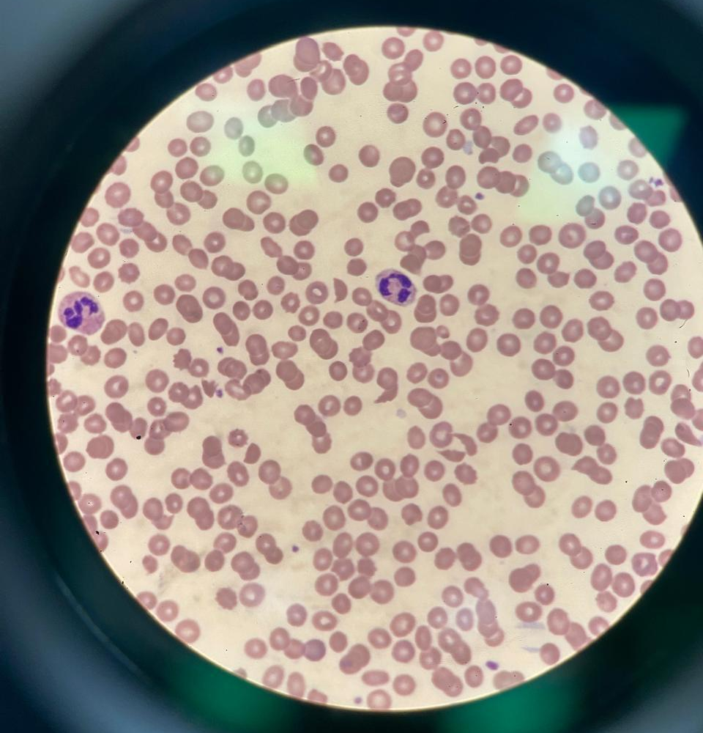
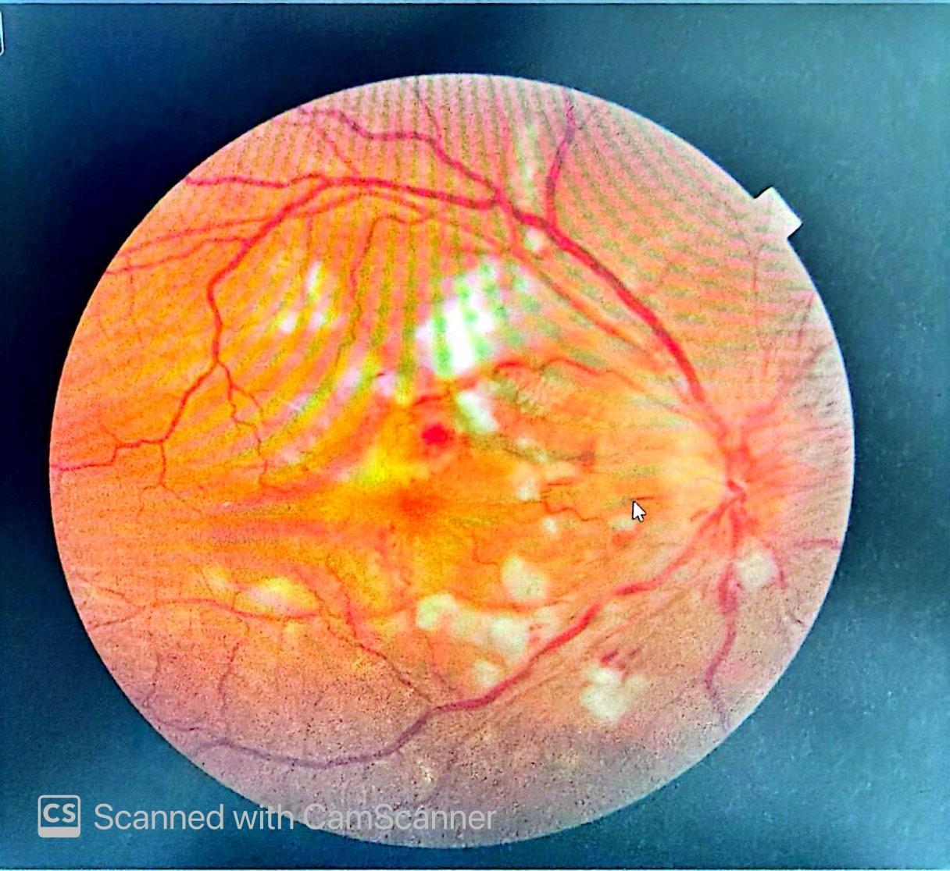

Figure 1. Grade IV hypertensive retinopathy with macular edema

Figure 2. Normocytic normochromic RBCs

Outcome

After 7 days, blood pressure stabilized at 151/99 mmHg. Serum creatinine was 6.94 mg/dL with an eGFR of 9.1 mL/min/1.73 m². Platelet count normalized (163 × 10³/μL) and LDH decreased to 594 U/L. The patient’s symptoms improved, and he was discharged on oral antihypertensives with scheduled follow-up.

Discussion
This case highlights a classic presentation of thrombotic microangiopathy (TMA) secondary to MH, defined by systolic BP ≥180 mmHg and diastolic ≥120 mmHg.¹ TMA is characterized by thrombocytopenia, MAHA, and organ injury, commonly involving the kidneys.² Severe hypertension can precipitate endothelial damage, leading to mechanical stress on red blood cells and platelet aggregation.³
Malignant hypertension often presents with hypertensive retinopathy, including flame-shaped retinal hemorrhages, cotton wool spots, and papilledema.⁴ Grade IV retinopathy, as seen in our patient, correlates with high-risk vascular complications.⁵ MAHA in MH results from fibrinoid necrosis of arterioles and capillaries, causing red cell fragmentation and microvascular thrombosis.⁶ Activation of the renin-angiotensin-aldosterone system (RAAS) and endothelial dysfunction play central roles in this process.⁷
Differentiating hypertensive TMA from thrombotic thrombocytopenic purpura (TTP) is critical, as management strategies differ.⁸ TTP typically requires urgent plasma exchange, whereas hypertensive TMA responds to aggressive blood pressure control.⁹ Our patient’s hematologic parameters improved with antihypertensives alone, without plasma exchange, confirming hypertensive TMA.^{4,10}
Renal involvement is a key determinant of prognosis.² Elevated creatinine, proteinuria, and reduced eGFR indicate significant microvascular injury. MAHA may exacerbate renal dysfunction through arteriolar occlusion and endothelial injury.¹¹ Early recognition of MAHA using LDH, schistocytes, and platelet trends helps predict AKI progression.¹² Recent studies show that high BNP/NT-proBNP levels correlate with thrombotic risk and adverse cardiovascular outcomes in hypertensive crises.¹³
Multidisciplinary management—including nephrology, cardiology, and ophthalmology—was crucial in stabilizing this patient.^{14,15} Timely fundoscopic evaluation facilitated early detection of severe retinopathy.⁵ The choice of antihypertensives (urapidil, amlodipine, doxazosin, moxonidine) aligns with current hypertensive emergency guidelines.^{16,17} Nutrition and fluid management also contributed to renal protection.¹⁸
Literature supports that long-term outcomes in malignant hypertension improve with early diagnosis, blood pressure control, and monitoring for TMA-related complications.^{19,20} This case emphasizes vigilance for MAHA and renal impairment in patients presenting with extreme BP elevations.

Conclusion
In conclusion, malignant hypertension can induce TMA and MAHA, complicating AKI and end-organ injury. Early recognition through clinical examination, laboratory findings, and fundoscopic evaluation is crucial. Effective multidisciplinary management, focused on blood pressure control and supportive care, can prevent irreversible organ damage. This case underscores the importance of differentiating hypertensive TMA from TTP, guiding appropriate therapy, and monitoring for renal and retinal complications.

Disclaimer (Artificial intelligence)

Option 1:

Author(s) hereby declare that NO generative AI technologies such as Large Language Models (ChatGPT, COPILOT, etc.) and text-to-image generators have been used during the writing or editing of this manuscript.

Option 2:

Author(s) hereby declare that generative AI technologies such as Large Language Models, etc. have been used during the writing or editing of manuscripts. This explanation will include the name, version, model, and source of the generative AI technology and as well as all input prompts provided to the generative AI technology

Details of the AI usage are given below:
1.
2.
3.

References
- National Institute for Health and Care Excellence. Recommendations: Measuring blood pressure. NICE guidance NG136. Available at: https://www.nice.org.uk/guidance/ng136/chapter/Recommendations#measuring-blood-pressure. Accessed February 11, 2025.
- Brocklebank V, Wood KM, Kavanagh D. Thrombotic microangiopathy and the kidney. Clin J Am Soc Nephrol. 2018;13(2):300–317. doi:10.2215/CJN.00620117
- Asano T, Mori H. Thrombotic microangiopathy due to malignant hypertension treated exclusively with antihypertensive therapy. Cureus. 2022;14(2):e21835. doi:10.7759/cureus.21835
- Bandaru SS, Anaji SC, Stowe IT. A case of thrombotic microangiopathy secondary to hypertensive emergency. Cureus. 2022;14(4):e24237. doi:10.7759/cureus.24237
- Wong TY, Mitchell P. Hypertensive retinopathy. N Engl J Med. 2004;351:2310–2317. doi:10.1056/NEJMra041234
- van den Born BJ, Honnebier UP, Koopmans RP, van Montfrans GA. Microangiopathic hemolysis and renal failure in malignant hypertension. Hypertension. 2005;45(2):246–251. doi:10.1161/01.HYP.0000151620.17905.ee
- Vaziri ND. Mechanisms of endothelial dysfunction in hypertension. Circ Res. 2001;88:608–616. doi:10.1161/01.RES.88.6.608
- George JN. Clinical practice. Thrombotic thrombocytopenic purpura. N Engl J Med. 2006;354:1927–1935. doi:10.1056/NEJMcp055912
- Aydin S, Aydin C, et al. Hypertensive emergencies: Etiology, treatment, and outcomes. Am J Emerg Med. 2018;36:833–838. doi:10.1016/j.ajem.2017.12.063
- Coppo P, Froissart A, Veyradier A. Thrombotic microangiopathies: Diagnosis and management. Haematologica. 2014;99:177–188. doi:10.3324/haematol.2013.088848
- Timmermans S, et al. Kidney outcomes in patients with TMA: A systematic review. Kidney Int Rep. 2021;6:204–216. doi:10.1016/j.ekir.2020.10.009
- Aoudia H, et al. MAHA as a marker of renal prognosis in malignant hypertension. Clin Nephrol. 2020;93:107–115. doi:10.5414/CN109735
- Rossi R, Jabrah D, Douglas A, et al. Investigating the role of BNP and NT-proBNP in thrombosis and acute ischemic stroke etiology. Int J Mol Sci. 2024;25(5):2999. doi:10.3390/ijms25052999
- KDIGO Clinical Practice Guideline for Acute Kidney Injury. Kidney Int Suppl. 2012;2:1–138. doi:10.1038/kisup.2012.1
- AHA Scientific Statement. Management of hypertensive emergencies. Circulation. 2022;145:e123–e139. doi:10.1161/CIR.0000000000001082
- ESC Council on Hypertension. 2023 ESC/ESH Guidelines for the management of arterial hypertension. Eur Heart J. 2023;44:3222–3320. doi:10.1093/eurheartj/ehad075
- Legendre C, Licht C, et al. Thrombotic microangiopathy: Pathophysiology, diagnosis, and management. Nephrol Dial Transplant. 2019;34:2020–2032. doi:10.1093/ndt/gfz148
- Wijnsma KL, et al. Nutritional management in patients with malignant hypertension and AKI. Clin Kidney J. 2019;12:505–514. doi:10.1093/ckj/sfz056
- Pavlakis M, et al. Long-term outcomes of malignant hypertension: A systematic review. Hypertension. 2020;76:109–118. doi:10.1161/HYPERTENSIONAHA.120.15065
- Bendapudi PK, et al. Guidelines for thrombotic microangiopathies: Diagnosis and management. Haematologica. 2021;106:1019–1031. doi:10.3324/haematol.2020.260003
- Allinovi, M., Menale, S., Querin, V., Caroti, L., Antognoli, G., Cirami, C. L., ... & Scheggi, V. (2025). Potentially reversible severe cardiac involvement in thrombotic microangiopathies with malignant hypertension. Journal of Nephrology, 38(6), 1655-1661.
- Ikeda, S., Inoue, Y., Suzuyama, K., Ide, T., & Eriguchi, M. (2024). Haemorrhagic and ischemic stroke following posterior reversible encephalopathy syndrome and thrombotic microangiopathy in a patient with malignant hypertension. Acta Neurologica Belgica, 124(1), 339-341.
- Timmermans, S. A., Abdul-Hamid, M. A., Vanderlocht, J., Damoiseaux, J. G., Reutelingsperger, C. P., van Paassen, P., ... & van Duijnhoven, E. (2017). Patients with hypertension-associated thrombotic microangiopathy may present with complement abnormalities. Kidney international, 91(6), 1420-1425.

