Recurrent Nosocomial Infections and Multi-Organ Dysfunction in a Pediatric Patient with Complex Congenital Disorders: A Case Report

ABSTRACT
AIM:
Pediatric patients with multiple congenital and chronic conditions are particularly vulnerable to critical illness as they are predisposed to severe infections and multi-organ dysfunction. This case report details the clinical course of a 13-year-old female with a complex medical history who developed life-threatening nosocomial infections leading to a fatal outcome.
PRESENTATION OF CASE:
The patient, with a history of mitochondrial disorder, microcephaly, neurodevelopmental delay, cerebral palsy, left eye evisceration, epilepsy, type 1 diabetes mellitus, and chronic respiratory failure requiring long-term mechanical ventilation, was admitted emergently to the Intensive Care Unit (ICU). On admission, the patient had a Glasgow Coma Scale of 3/15 presented with fever, purulent secretions and multiple skin lesions along with signs of systemic infection. Microbiological cultures revealed Burkholderia cepacia complex and Candida species in tracheostomy secretions, significant pyuria suggestive of urinary tract infection, and evidence of central line-associated bloodstream infection (CLABSI) as well as a PEG tube infection. This presentation was likely to be consistent with a mitochondrial disorder-related multi-organ dysfunction syndrome.
DISCUSSION:
This case highlights the combined effects on pediatric patients of invasive procedures, chronic comorbidities, and antibiotic resistance. Frequent isolation of Klebsiella that produce ESBLs highlighted to the challenges in antibiotic selection and contributed to the fatal outcome.
CONCLUSION:
This case underscores the challenges inherent in managing critically ill pediatric patients with complex congenital disorders. The interplay of multiple comorbidities, invasive procedures, and nosocomial infections can lead to a rapid decline in clinical status. Enhanced infection control measures and individualized management strategies are critical for improving outcomes in this vulnerable population.
Keywords: Pediatric critical care, congenital disorders, nosocomial infections, multi-organ dysfunction, case report

INTRODUCTION
Pediatric patients with multiple congenital anomalies and chronic illnesses develop a unique challenge to critical care medicine by becoming susceptible to severe infections, multi-organ dysfunction and other life threatening complications (1). In addition to this, there is an increased risk of recurrent nosocomial infections since their would be a continuous association of invasive medical procedures, medical devices and exposure to infectious agents in the hospital surroundings which can remarkably impact their morbidity and mortality (2,3). This report describes the clinical course of a long term hospitalized, 13-year-old female patient with an extensive medical history who presented with severe respiratory failure and multi-organ dysfunction secondary to nosocomial infections. The case highlights the complexities of managing such high-risk patients in an intensive care setting (1,4).

PRESENTATION OF CASE
Patient Medical History:
The patient’s past medical history was significant for the following conditions:
- Mitochondrial Disorder: A genetic defect impairing cellular energy production.
- Microcephaly: Marked by a significantly reduced head size.
- Neurodevelopmental Disorder: Characterized by delayed and impaired developmental milestones.
- Cerebral Palsy: A neurological disorder affecting motor function and coordination.
- Left Eye Evisceration: Surgical removal of the left eye.
- Epilepsy: A seizure disorder requiring ongoing management.
- Type 1 Diabetes Mellitus: An autoimmune condition necessitating regular insulin administration.
- Chronic Respiratory Failure: Requiring long-term ventilatory support via tracheostomy.
Procedural History Prior to Admission:
- PEG Tube Change: Performed on May 22, 2024.
- Tracheostomy Change: Performed on April 23, 2024.
- Central Line Insertion: Performed on May 12, 2024.
The patient was admitted to Thumbay University Hospital on May 24, 2024, in a critical state.

Physical Examination:
General Appearance and Neurological Status:
- Consciousness: Glasgow Coma Scale (GCS) of 3/15, indicative of severe impairment.
- Dependency: Bedridden and ventilator-dependent via tracheostomy.
- Response: No response to painful stimuli.
Ophthalmologic Findings:
- Left Eye: Eviscerated.
- Right Eye: Minimal spontaneous closure, absence of eye contact.
Musculoskeletal and Dermatologic Findings:
- Multiple limb deformities involving bilateral hands and feet.
- Darkened skin with shortened fingers.
- Numerous skin lesions were present.
Additional Findings:
- Infection Sites: Approximately 50 mL of purulent material was noted from the Foley catheter, with additional pus observed around the PEG tube.
- Metabolic Instability: Notable fluctuations in blood glucose levels consistent with type 1 diabetes.

Investigations and Testing:
Microbiological Studies
A series of cultures and sensitivity tests were conducted from various sites:
- Tracheostomy Secretions:
  - Cultures revealed Burkholderia cepacia complex and Candida species.
- Urine Analysis:
  - WBC count of 30–40/HPF, RBC count of 20–24/HPF, moderate mucus, positive leukocyte esterase, and the presence of pus in the Foley catheter sample confirmed a urinary tract infection.
- Central Line and PEG Tube Infections:
  - Gram stain of the PEG tube aspirate showed abundant pus cells (+++), consistent with bacterial infection.
- Antibiotic Sensitivity:
  - Sensitivity testing done by Microscan equipment guided the adjustment of the antibiotic regimen.
Table 1:- Laboratory results of Culture and Sensitivity test including CBC and CRP results from 27 May 2024 to 19 October 2024
DATE | CBC | CRP (mg/L) | CULTURE & SENSITIVITY - BODY FLUID | RESPONSE | Susceptible Antibiotics
27/5/24 | WBC = 16.3 * 10 ^ 3/uL  N = 71.0 %  NLR = 4.5 | 42.3 | Tracheal | 1. Burkholderia cepacia complex (Moderate growth)  2. Candida species | 1.Meropenem  2.Trimethoprim-sulphamethoxazole
30/5/24 | WBC = 19.4 * 10 ^ 3/uL  N = 61.0 %  NLR = 2.5 | 236.2 | Blood | Pseudomonas aeruginosa | Cefepime, Ceftazidime, Piperacillin-Tazobactum, Ciprofloxacin, Levofloxacin, Imipenem, Meropenem, Tobramycin, Trimethoprim-sulphamethoxazole.
1/6/24 | WBC = 11.3 * 10 ^ 3/uL  N = 54.8 %  NLR = 1.5 | 64.3 | Urine | Candida species
26/6/24 | WBC = 9.7 * 10 ^ 3/uL  N = 31.4 %  NLR = 0.6 | 136.3 | Urine | Candida species
15/7/24 | WBC = 13.3 * 10 ^ 3/uL  N = 46.9 %  NLR = 1.3 | 82.9 | Sputum | Pseudomonas aeruginosa  (Moderate growth) | Amikacin, Cefepime, Ceftazidime, Piperacillin-Tazobactum, Ciprofloxacin, Levofloxacin, Imipenem, Meropenem, Tobramycin, Trimethoprim-sulphamethoxazole.
6/8/24 | WBC = 6.6 * 10 ^ 3/uL  N = 39.6 %  NLR = 0.8 | 52.4 | Body fluid | Klebsiella pneumoniae ESBL | Amoxycillin + Clavulanate, Amikacin, Cefoxitin, Ertapenem, Gentamicin, Imipenem, Meropenem, Piperacillin-Tazobactum.
20/8/24 | WBC = 8.6 * 10 ^ 3/uL  N = 48.0 %  NLR = 1.3 | 100.7 | Blood, Site:- Peripheral line | Klebsiella pneumoniae ESBL | Amoxycillin + Clavulanate, Amikacin, Cefoxitin, Ertapenem, Gentamicin, Imipenem Meropenem, Piperacillin-Tazobactum.
20/8/24 |  |  | Blood, Site:- Central line | Klebsiella pneumoniae ESBL | Amikacin, Amoxycillin + Clavulanate, Cefoxitin, Ertapenem, Gentamicin, Imipenem, Meropenem, Piperacillin-Tazobactum.
28/8/24 | WBC = 10.5 * 10 ^ 3/uL  N = 60.4 %  NLR = 2.2 | 97.4 | Urine | Candida species
30/8/24 | WBC = 6.9 * 10 ^ 3/uL  N = 34.2 %  NLR = 0.7 | 72.7 | Sputum | Pseudomonas fluorescens/putida (Heavy growth) | Amikacin, Cefepime, Ceftazidime, Piperacillin-Tazobactum, Ciprofloxacin, Levofloxacin, Imipenem, Meropenem, Tobramycin, Trimethoprim-sulphamethoxazole.
4/9/24 | WBC = 8.9 * 10 ^ 3/uL  N = 31.6 %  NLR = 0.6 | 127.4 | Urine | Candida species
22/9/24 | WBC = 15.3 * 10 ^ 3/uL  N = 71.0 %  NLR = 3.4 | 194 | Blood | No bacterial growth in culture after 24 hours of incubation
27/9/24 | WBC = 7.3 * 10 ^ 3/uL  N = 36.5 %  NLR = 0.8 | 57 | Blood | No bacterial growth in culture after 5 days of incubation
24/9/24 | WBC = 7.3 * 10 ^ 3/uL  N = 56.1 %  NLR = 2.1 | 221.6 | Sputum | Pseudomonas fluorescens/putida (Heavy growth)
24/9/24 |  |  | Urine | Klebsiella pneumoniae ESBL | Amikacin, Amoxycillin + Clavulanate, Cefoxitin, Ertapenem, Gentamicin, Imipenem, Meropenem, Piperacillin-Tazobactum.
19/10/24 | WBC = 6.8 * 10 ^ 3/uL  N = 39.0 %  NLR = 1.0 | 111.9 | Blood | 1. Staphylococcus epidermidis MRS  2. Candida species (Moderate growth) | Daptomycin, Vancomycin, Linezolid, Synercid, Teicoplanin, Trimethoprim.
19/10/24 |  |  | Urine | Klebsiella pneumoniae ESBL | Amoxycillin + Clavulanate, Amikacin. Cefoxitin, Ertapenem, Gentamicin, Imipenem, Meropenem, Piperacillin-Tazobactum.
19/10/24 |  |  | Blood | Candida species grown in culture after 48 hours of aerobic incubation
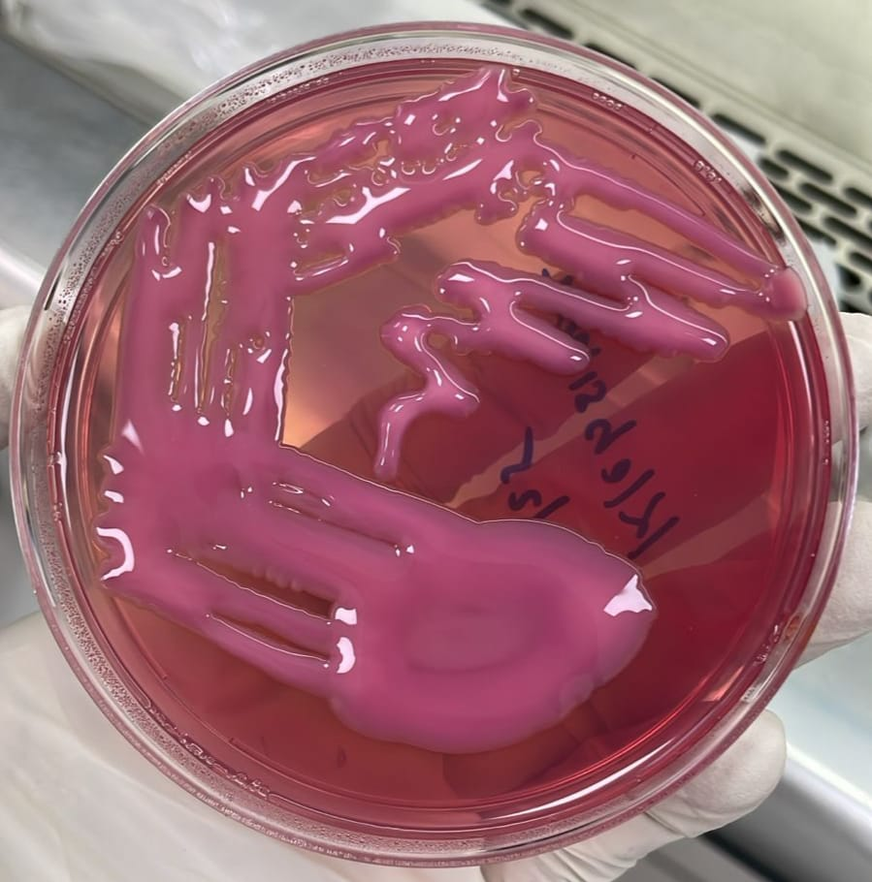 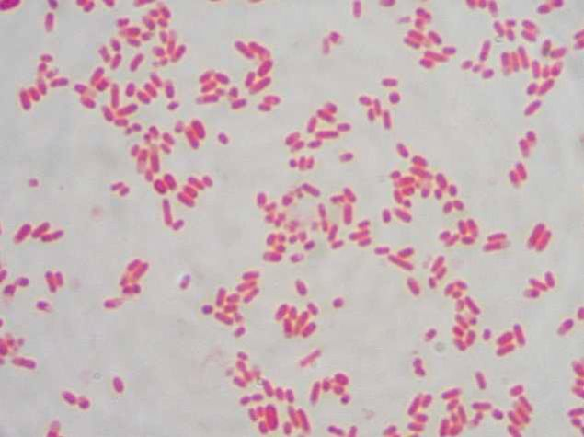 (A) (B)
Figure 1: (A) Mucoid lactose fermenting colonies of klebsiella pneumoniae on MacConkey agar after 24 hrs of incubation.
Figure 2: (B) Microscopic appearance showing cell morphology of Klebsiella pneumoniae: shorter gram negative rods.

Clinical Course and Report:
Upon admission, the patient was in critical condition with signs of systemic infection and multi-organ dysfunction. The interplay between her pre-existing chronic conditions and recent invasive procedures increased her susceptibility to nosocomial infections. Despite aggressive management in the ICU, including respiratory support and targeted antimicrobial therapy, the patient’s clinical status progressively deteriorated. The presence of persistent fever, reduced urine output, and multiple infection sites necessitated transfer to the Nephrology Department for further management.

Treatment and Management:
A multidisciplinary approach was adopted in managing this critically ill patient:
- Antibiotic Therapy:
  - Empiric broad-spectrum antibiotics were initiated and later refined based on culture and sensitivity results.
  - Meropenem (10/5/2024 to 21/5/2024) , Vancomycin (14/5/2024 to 21/5/2024).
  - Moxifloxacin eye drops, and Tobramycin eye drops were administered.
- Respiratory Support:
  - Continuous mechanical ventilation was maintained via the tracheostomy.
- Glycemic Control:
  - Intensive insulin therapy was administered to manage type 1 diabetes, with frequent monitoring.
- Infection and Wound Management:
  - Rigorous wound care was applied to address skin lesions and local infections at the PEG tube and Foley catheter sites.
- Nutritional Support:
  - Nutritional requirements were met via the PEG tube.
Despite these interventions, the patient’s overall condition continued to worsen, ultimately resulting in multi-organ failure and death.
Outcome:
The patient expired following a prolonged and complicated clinical course characterized by overwhelming nosocomial infections and multi-organ dysfunction.

DISCUSSION
This case illustrates the considerable challenges encountered in the management of pediatric patients with complex congenital and chronic conditions.The patient's medical history characterized by multi organ dysfunction and the prolonged hospital stay increased her exposure to different sources of infection like medical equipments and hospital environment making her highly susceptible to nosocomial infections (5,6). The laboratory results as illustrated in the table provides significant information about the patients clinical trajectory into the course. The white blood cell (WBC) count, a potential marker of infection and inflammation was found to be consistently elevated throughout the patients treatment and management with a maximum value of 19.4 x 10^3/uL along with an increased neutrophil count indicating a strong inflammatory reaction to the underlying infections (7,8). Along with this, another sensitive indicator of infection and inflammation, C-reactive protein (CRP) levels were also noticeably higher, peaking at 236.2 mg/L. Given the patient's clinical presentation of sepsis and multi-organ dysfunction, this abnormally high CRP level points to a severe inflammatory response (9).
In addition to this, the use of medical devices like tracheostomy tube, Foley's catheter, PEG tube and central line insertion provided a trench for nosocomial bacteria to enter the body and cause severe infections (10,11). The cultural studies revealed multiple bacterial infections from various bodily fluids with the isolation of Klebsiella pneumoniae, Pseudomonas aeruginosa, Burkholderia cepacia complex, Staphylococcus epidermidis MRS and Candida species. But the pathogens role in nosocomial infection might be highlighted by the frequent isolation of ESBL producing klebsiella pneumoniae (12) from a variety of body fluids such as blood, central and peripheral lines, sputum and urine which is already a well known cause of hospital acquired infections mainly in patients with compromised immune systems and those that require invasive medical devices (13,14). The production of ESBL (Extended-Spectrum Beta-Lactamase) enzyme by klebsiella pneumoniae limits the treatment for infection caused by this bacteria as the enzyme develops resistance to most of the beta-lactum antibiotics (15). The resistance pattern of the bacteria to many antibiotics was identified through the cultural sensitivity test performed through microscan equipment there by making it challenging to select effective antibiotics for treatment and hence leading to a fatal outcome of the patient (14,16). Furthermore, the case report emphasizes the significance of strict infection control measures including medical equipment sterilization, hand hygiene, antimicrobial management to prevent the spread of nosocomial infections in high-risk patients (17). In conclusion, it highlights the need for continuously observing and monitoring the patterns of antibiotic resistance in order to build efficient treatment plans for the patient (18,19) .
CONCLUSION
Invasive procedures, while often necessary for supportive care, further increased the risk for severe infections. The high morbidity associated with such infections, combined with multiple comorbities, prolonged hospitalization and repeated exposure to multidrug resistant organisms underscores the need for stringent infection control measures and early intervention strategies of resistant organisms in similar high risk patients.
Ethical Approval:
As per international standards or university standards written ethical approval has been collected and preserved by the author(s).

Consent
As per international standards, parental written consent has been collected and preserved by the author(s).
Disclaimer (Artificial intelligence)

Author(s) hereby declare that NO generative AI technologies such as Large Language Models (ChatGPT, COPILOT, etc.) and text-to-image generators have been used during the writing or editing of this manuscript.

REFERENCES
- Pastura PSVC, Land MGP. Children with multiple congenital defects: What are the limits between therapeutic obstinacy and the treatment of uncertain benefit? Revista Paulista de Pediatria. 2017 Feb 20;35(1):110–4.

- Julije Meštrovi, Goran Kardum, Poli B, Marija Meštrovi, Marki J, Šusti A, et al. The influence of chronic health conditions on susceptibility to severe acute illness of children treated in PICU. European Journal of Pediatrics. 2006 Mar 24;165(8):526–9.

- Bruno Russo Porchera, Moraes C, Rayssa Pinheiro Miranda, Quadros R, Henrique P, Oliveira G, et al. Linezolid and vancomycin for nosocomial infections in pediatric patients: a systematic review. Jornal de Pediatria. 2023 Dec 22;100(3).

- Maki DG, Crnich CJ, Safdar N. Nosocomial Infection in the Intensive Care Unit. Critical Care Medicine. 2008;1003–69.
Available from: https://pmc.ncbi.nlm.nih.gov/articles/PMC7170205/

- Nasir A, Nasir L, Tarrell A, Finken D, Lacroix A, Pinninti S, et al. Complexity in pediatric primary care. Primary Health Care Research & Development. 2018 May 22;20.

- Cavalcante SS, Mota E, Silva LR, Teixeira LF, Cavalcante LB. Risk Factors for Developing Nosocomial Infections Among Pediatric Patients. The Pediatric Infectious Disease Journal. 2006 May;25(5):438–45.

- Chmielewski PP, Strzelec B. Elevated leukocyte count as a harbinger of systemic inflammation, disease progression, and poor prognosis: a review. Folia Morphologica [Internet]. 2018;77(2):171–8. Available from: https://journals.viamedica.pl/folia_morphologica/article/view/54054

- Leukocytosis (High White Blood Cell Count): Causes & Symptoms [Internet]. Cleveland Clinic. 2023 [cited 2025 Aug 16]. Available from: https://my.clevelandclinic.org/health/diseases/17704-high-white-blood-cell-count?utm

- Pradhan S, Ghimire A, Bhattarai B, Khanal B, Pokharel K, Lamsal M, et al. The role of C-reactive protein as a diagnostic predictor of sepsis in a multidisciplinary Intensive Care Unit of a tertiary care center in Nepal. Indian Journal of Critical Care Medicine : Peer-reviewed, Official Publication of Indian Society of Critical Care Medicine [Internet]. 2016 Jul 1;20(7):417–20. Available from: https://www.ncbi.nlm.nih.gov/pmc/articles/PMC4968065/

- Ssekitoleko RT, Oshabaheebwa S, Munabi IG, Tusabe MS, Namayega C, Ngabirano BA, et al. The role of medical equipment in the spread of nosocomial infections: a cross-sectional study in four tertiary public health facilities in Uganda. BMC public health [Internet]. 2020 Oct 16;20(1):1561. Available from: https://pubmed.ncbi.nlm.nih.gov/33066745/

- Nandini Raveendra, Subhodha Hosagadde Rathnakara, Neha Haswani, Subramaniam V. Bacterial Biofilms on Tracheostomy Tubes. 2021 May 6;74(S3):4995–9.

- Demir S, Soysal A, Bakir M, Kaufmann ME, Yagci A. Extended-spectrum β-lactamase-producingKlebsiella pneumoniaein paediatric wards: A nested case-control study. Journal of Paediatrics and Child Health. 2008 Oct;44(10):548–53.

- Parveen R, Khan M, Menezes G, Harish B, SC Parija, Hays J. Extended-spectrum β-lactamase producing Klebsiella pneumoniae from blood cultures in Puducherry, India. The Indian Journal of Medical Research [Internet]. 2011 Sep;134(3):392. Available from: https://pmc.ncbi.nlm.nih.gov/articles/PMC3193723/

- SUHARTONO S, HAYATI Z, MAHDANI W, ANDINI F. Distribution of ESBL-producing and non-ESBL-producing Klebsiella pneumoniae isolated from sputum specimens in the Zainoel Abidin General Hospital, Banda Aceh, Indonesia. Biodiversitas Journal of Biological Diversity. 2024 Jul 30;25(7)

- Singh A, Jain S, Kumar D, Singh R, Bhatt H. Antimicrobial susceptibility pattern of extended-spectrum beta- lactamase producing Klebsiella pneumoniae clinical isolates in an Indian tertiary hospital. Journal of Research in Pharmacy Practice. 2015;4(3):153.

- Kumar D, Chaudhary M, Naresh Kumar Midha, Gopal Krishana Bohra, Meena DS, Tak V, et al. Pathogenic Burden, Antimicrobial Resistance Pattern and Clinical Outcome of Nosocomial Bloodstream Infections in Intensive Care Unit. Journal of Intensive Care Medicine. 2024 Dec 22;

- Kubde D, Badge AK, Ugemuge S, Shahu S. Importance of Hospital Infection Control. Cureus [Internet]. 2023 Dec 22;15(12):e50931. Available from: https://pmc.ncbi.nlm.nih.gov/articles/PMC10801286/

- Garvey M. Medical Device-Associated Healthcare Infections: Sterilization and the Potential of Novel Biological Approaches to Ensure Patient Safety. International Journal of Molecular Sciences [Internet]. 2024 Jan 1;25(1):201. Available from: https://www.mdpi.com/1422-0067/25/1/201

- Johnson AP. Surveillance of antibiotic resistance. Philosophical Transactions of the Royal Society B: Biological Sciences [Internet]. 2015 Jun 5 [cited 2019 Oct 22];370(1670):20140080. Available from: https://www.ncbi.nlm.nih.gov/pmc/articles/PMC4424431/

- Costa AL, Privitera GP, Tulli G, Toccafondi G. Infection Prevention and Control. Textbook of Patient Safety and Clinical Risk Management. 2020 Dec 15;99–116.

