THE ASSESSMENT OF DIET ON MENSTRUAL IRREGULARITIES IN WOMEN WITH CHRONIC KIDNEY DISEASE STAGES 3-5: A CROSS- SECTIONAL STUDY

ABSTRACT
AIM: The Aim of the research is to study Assessment of Diet on Menstrual Irregularities in Women with Chronic Kidney Disease stage 3- 5
STUDY DESIGN: This study is a cross-sectional study aimed at assessing the relationship between dietary patterns and menstrual irregularities in women diagnosed with chronic kidney disease (CKD) stage 3 – 5. The designs enable the collection of data at a single point in time from a defined population, allowing the identification of association between dietary habits, nutritional status and menstrual cycle.
STUDY SETTING: The research was conducted at a tertiary care hospital – Shanmukhananda Charitable Hospital, Mallika hospital, Mumbai, Maharashtra. Over a specified study period.
METHODOLOGY: A cross-sectional study was conducted among 50 women aged 18-50 years with CKD stage 3-5 at a tertiary care hospital in Mumbai. Data were collected using a structured self-designed questionnaire, a semi-quantitative food frequency questionnaire (FFQ), and 24-hour dietary recall. Anthropometric and biochemical parameters were also analysed. Statistical tools included descriptive statistics, Chi-square test, and correlation analysis.

RESULTS: 40% of participants reported irregular menstrual cycle, 34% had prolonged cycles, and 64% noticed changes in their cycles over the past year. Nutritionally, the mean energy intake was 1002 kcal/day, with inadequate protein and fiber intake. Biochemical findings revealed low haemoglobin (mean 9.42g/d L) and elevated creatinine and potassium levels. Significant association were observed between daily fenugreek consumption and menstrual regularity (p=0.024), while buckwheat consumption patterns revealed a possible self-modification trend among women with irregular cycles (p=0.017). The dietary profile indicated low intake of whole grains and legumes, with high consumption of processed food and refined carbohydrates
CONCLUSION: Inadequate nutritional intake is seen in women with CKD stages 3–5, which may be a factor in irregular menstruation. Reproductive health results in this population may be enhanced by the inclusion of particular foods and suitable nutritional interventions.
Keywords: Chronic Kidney Disease, Menstrual Irregularities, Nutritional Assessment, Dietary Intake, Fenugreek, Buckwheat.

INTRODUCTION

Chronic Kidney Disease (CKD) is a chronic condition that causes slow loss of kidney function and has serious systemic effects, particularly in women of reproductive age. Globally, CKD affects almost 10% of the population, and its impact on women’s reproductive health is becoming more widely recognized in clinical literature. In women, CKD can cause menstrual irregularities such as amenorrhea, Oligomenorrhea, and irregular cycles, owing to hormonal disruptions, metabolic abnormalities and uraemia-related effects on the hypothalamic-pituitary-ovarian (HPO) axis [1] [2]
As kidney function diminishes, changes in gonadotropin-releasing hormone (GnRH) secretion, higher prolactin levels, and decreased oestrogen metabolism contribute to ovulation and menstrual pattern dysregulation [3]. Lin et al 2016 found that over 40% of premenopausal women with end stage renal disease (ESRD) had monthly abnormalities. These alterations have an impact not only on fertility, but also on the overall quality of life for women with CKD.
Despite the well-established endocrine consequences of CKD, little study has looked at impact of nutritional status and food consumption on menstrual health in these patients. Nutrient shortages, notably in calories, protein, and micronutrient such as iron and calcium are common in severe CKD and can impair menstruation function. Furthermore, certain foods such as fenugreek and buckwheat, which contain phytoestrogenic and anti-inflammatory qualities, may provide therapeutic benefits in regulating menstrual periods, while research in this area is limited.
Dietary advice in CKD usually focuses on renal parameters such as sodium, potassium, phosphorus, and fluid intake. However, there is a rising need to incorporate reproductive outcomes into comprehensive care for premenopausal women with CKD [4]. This study intends to fill that gap by examining the relationship between dietary intake and monthly abnormalities in women with CKD stages 3-5 as well as if include functional foods like fenugreek and buckwheat is related with better menstrual health outcomes.

- METHODOLOGY

A cross-sectional observational study was undertaken on 50 women aged 18-50 years diagnosed with CKD stages 3-5 who visited the nephrology OPD of a tertiary care hospital in Mumbai. The Inter System Biomedical Ethics Committee (ISBEC) provided ethical approval for the study.

FLOW CHART OF PARTICIPANT SELECTION PROCESS
Exclusion Criteria
Postmenopausal women
Participants with various gynaecological disease
Pregnant or breastfeeding ladies
Recruited CKD female stage 3-5, aged 18-50 years
┌────────────┴─────────────┐
Inclusion Criteria
Female aged 18 to 50 years
Diagnosed with CKD stages 3-5

DATA COLLECTING TOOLS

A Structured questionnaire was used to gather demographic information (age, education background, marital status) and clinical history (stage of chronic kidney disease, menstrual history, and comorbid conditions).
A 24- hour dietary recall method was employed to evaluate the specific intake of foods and beverage consumed on the previous day
A Food Frequency Questionnaire (FFQ) was utilized to record regular consumption patterns of various food items over the past month.
Standard procedures were followed to take anthropometric measurements, including height and weight. The Body Mass Index (BMI) was calculated using the formula: weight (kg)/ height (m2)
Key clinical parameters such as haemoglobin (Hb), serum creatinine, serum potassium, and sodium levels were collected from the most recent laboratory reports of the participants.

STATISTICAL ANALYSIS

The data were analysed using SPSS version 20. Descriptive statistics, the Chi- square test, and Pearson correlation were utilized. A p – value of <0.05 was considered statistically significant.

RESULTS

The cross-sectional study was designed to analyse the dietary patterns and nutrient intake of women with Chronic Kidney Disease (CKD) stage 3-5 and their relationship with menstrual abnormalities. The data were gathered using a variety of dietary assessment techniques (24-hour recall and Food Frequency Questionnaire), anthropometric measurements, menstrual health questionnaire, and biochemical indicators. The findings shed light on the nutritional quality, frequency of menstrual disturbance, and potential involvement of certain foods like fenugreek and buckwheat in menstrual control.

Menstrual Cycle Irregularities Among Participants

40% participants reported irregular menstrual cycles 64% reported noticeable alteration in their menstrual pattern in the previous year 30% were diagnosed with oligomenorrhea, while 10% had amenorrhea. Others reported polymenorrhagia, lengthy cycles, or irregular menstruation. These findings confirm pervious research indicating that the hormonal and metabolic abnormalities seen in CKD have a major impact on menstrual regularity.

Demographic Characteristics of Study Participants
Figure 1: Demographic Characteristics of Study Participants
94
0 20 40 60 80 100 120
Percentage (%) Frequency
16
Family Type
32
35
47
70
26
Occupation
Age (in years)
52
49
46
56
98
23
28
Family History of Renal Disease
82
41
100
96
50
48
Comorbid Conditions
88
44
Dietary Habit
100
100
50
50
Physical Activity
Demographic Characteristics of Study Participants
(Bar chart showing age distribution, education, occupation, and socioeconomic background of CKD women (n=50).

Figure 1 shows the frequency distribution of demographic, socioeconomic, and health related characteristics of the study population (n=50). The Majority of participants (56%) were in the 35–44- year age group indicating a predominance of early middle-aged individual in the sample

In terms of educational attainment, nearly half of the participants (46%) had completed primary education, while 24% had attained secondary school education. This reflects limited access to higher education among the participants
Occupationally, the vast majority (98%) were homemakers, suggested minimal participants in the formal workforce. Regarding socioeconomic status, over half (53.1%) of the participants had a monthly income less than ₹15000, indicating a financially vulnerable population.
Family structure analysis revealed that 70% belonged to joint families and the most common household size was five member (32%). A significant 94% of participants reported no family history of renal disease and 82% had no known past medical history suggesting a relatively health medical background in terms of personal and family history.
However, 96% of participants reported comorbid condition, primarily including hypertension and diabetes mellitus. This high prevalence highlights the need for early screening and management programs for non-communicable disease in this group
Lifestyle analysis showed that all participants reported no allergies, no smoking and notably, no physical activity. The lack of physical activity, despite a relatively low self-reported history of smoking or allergies, may contribute to the high prevalence of comorbid conditions.
Dietary habits indicated that 88% of participants were non vegetarian which could influence dietary related health risk depending on quality and pattern of intake.

Anthropometric and Biochemical Profile

Parameter | Mean ± SD
BMI (kg/m²) | 22.6 ± 3.5
Haemoglobin (g/dL) | 9.42 ± 1.33
Serum Creatinine (mg/dL) | 6.03 ± 2.21
Serum Potassium (mEq/L) | 5.2 ± 1.2
*Data represented as Mean ± Standard Deviation (SD)
Table 1: Biochemical Profile of Participants

Table 1 show out of 50 participants,40% experienced irregular menstrual cycles. A significant 64% also reported alteration in their menstrual cycle in the previous year. These changes included delayed in their menstruation, missing cycles longer bleeding, and shorter intervals. This shows a high frequency of menstruation abnormalities among women with CKD stages 3-5. Such patterns indicate hormonal imbalances induced by uraemia, anaemia, and low nutritional status, which are all typical in late renal disease. The findings are consistent with prior research indicating the menstruation irregularities affect up to 60% of CKD women [1].

Nutrient Intake Profile

Nutrient | Mean ± SD
Energy (kcal) | 1002 ± 273.47
Protein (g) | 30.14 ± 11.76
Carbohydrates (g) | 155.43 ± 51.22
Fat (g) | 28.32 ± 9.04
Fiber (g) | 10.26 ± 4.12
*Data represented as Mean ± Standard Deviation (SD)

Table 2 : Nutrient Intake Profile of Participants

Table 2 Energy intake is significantly lower than recommended range of 1600-1800 kcal/day for adult women with CKD. Protein consumption is below the recommended range of 0.6-0.8g/kg body weight. Carbohydrate and lipid intake was sufficient but ideal. Fiber intake is significantly lower than the recommended daily intake of 20-25g.Low calorie intake can cause hypothalamic suppression, which reduced GnRH release and inhibits the menstrual cycle. Chronic low-calorie diets are known to cause hypothalamic amenorrhea, especially in diseases such as CKD. Low protein intake inhibits the synthesis of critical reproductive hormones, enzymes and carrier protein, reducing ovarian function. Inadequate fiber consumption indicates a lack of fruits, vegetables, legumes, resulting in vitamin (B6, folate), mineral (iron, calcium, magnesium), and phytonutrient deficits necessary for oestrogen detoxification and metabolism. These deficits reflect the cumulative dietary problems that CKD patient encounter, such as combining potassium, phosphorus, and protein limits with optimal caloric and micronutrient consumption.

Distribution of Menstrual Health Characteristics Among Participants (n = 50)

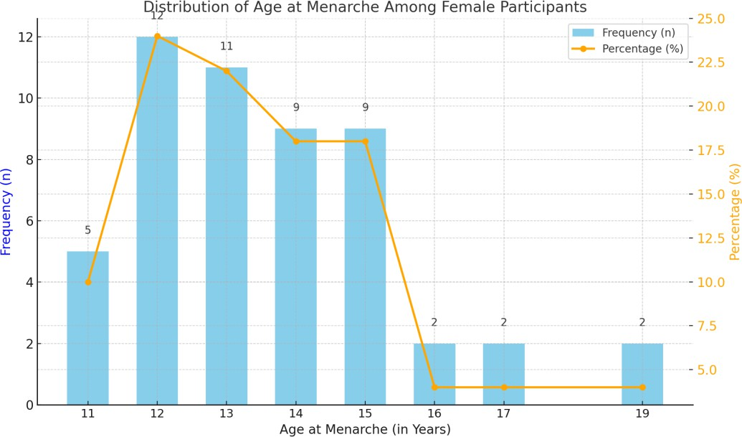
(Most attained menarche at 12–14 years, with fewer reporting early (<12) or late (>15) menarche.)

Figure 2 Distribution of Age at Menarche Among Female Participants
Most participants attained menarche between the ages of 12 and 14 years, with 24% reporting age 12, 22% age 13, and 18% age 14, while early (< 12 years) and late (>15 years) menarche were less common. The average timings of menarche are influenced by nutritional status body fat, endocrine signals like leptin and insulin, and overall health. Early menarche is increasingly observed with rising obesity and has been associated with future risk of PCOS, metabolic syndrome, and cardiovascular disease. Conversely, delayed menarche may indicate hypothalamic suppression, undernutrition, chronic illnesses such as CKD. According to Ibanez et al 2017, early menarche is linked with hyperinsulinemia and hyperandrogenism, setting a foundation for endocrine and metabolic disturbances in late adolescence
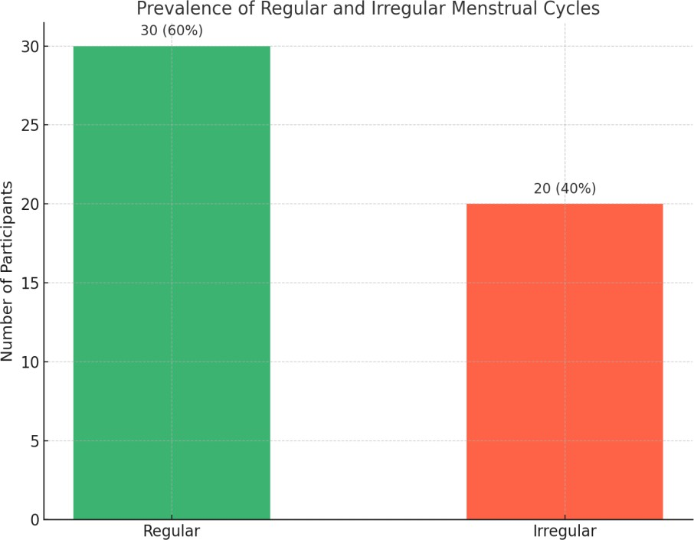

(60% had regular cycles, while 40% reported irregular menstruation.)

Figure 3 Prevalence of Regular and Irregular Menstrual Cycles
Among participants, 60% reported regular menstrual cycle while 40% experienced irregular menstruation. Regular menstrual pattern suggests appropriate hypothalamic-pituitary-ovarian (HPO) axis function, while irregularity is frequently seen in conditions such as PCOS, thyroid disorder, and CKD. In CKD, disruption in oestrogen metabolism and uremic toxin accumulation can disturb gonadotropin release, leading to menstrual irregularities. Carrero et al 2018 found that regular cycles are prevalent in women with CKD, reflecting impaired hormonal signalling and ovulatory dysfunction

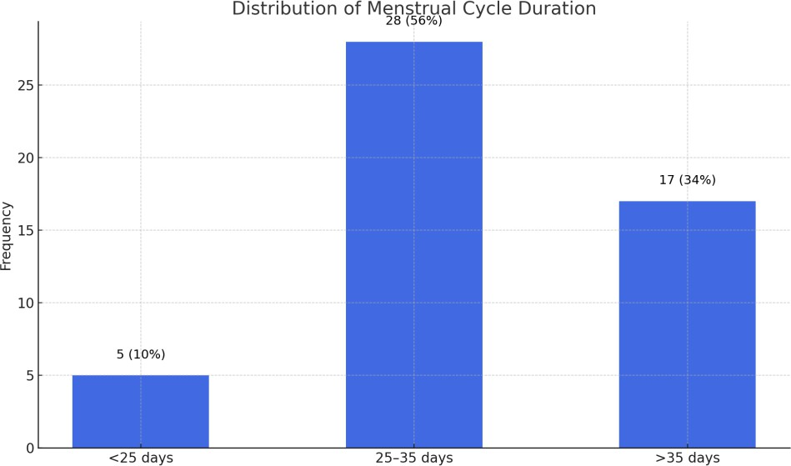
(56% had normal cycle length (25–35 days), 34% prolonged (>35 days), and 10% short (<25 days).

Figure 4 Variation in Average Menstrual Cycle Length
The data show that 56% of participants had a normal cycle length of 25-35 days, while 34% had prolonged cycles (>35 days) and 10% had shorter cycles (<25 days). Menstrual cycle length reflects the hormonal rhythm involving oestrogen, LH, FSH, and progesterone. Prolonged cycles are often due to anovulation, typical in PCOS, while short cycle suggest luteal phase defects or ovarian insufficiency.

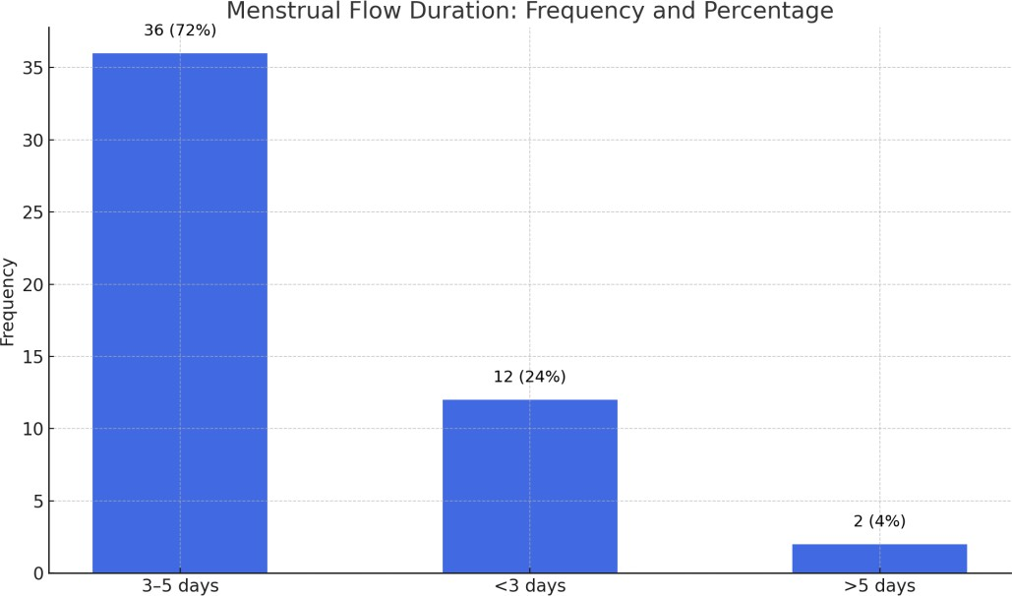
(Majority (72%) reported 3–5 days of flow, 24% <3 days, and 4% >5 days.)

Figure 5 Duration of Menstrual Flow Among Participants
A majority (72%) reported a flow duration of 3-5 days, considered normal, while 24% had hypomenorrhea (<3 days) and 4% had hypermenorrhoea (>5 days). These variations are often hormone driven shorter flows may result from inadequate endometrial buildup due to oestrogen deficiency or chronic stress, while longer flows may stem from endometrial hyperplasia, unopposed oestrogen, or fibroids. In CKD, abnormal bleeding can occur due to platelet dysfunction and oestrogen imbalance. Fraser et al 2011 emphasized that heavy or irregular floe must be evaluated in the context of both hormonal and structural causes.

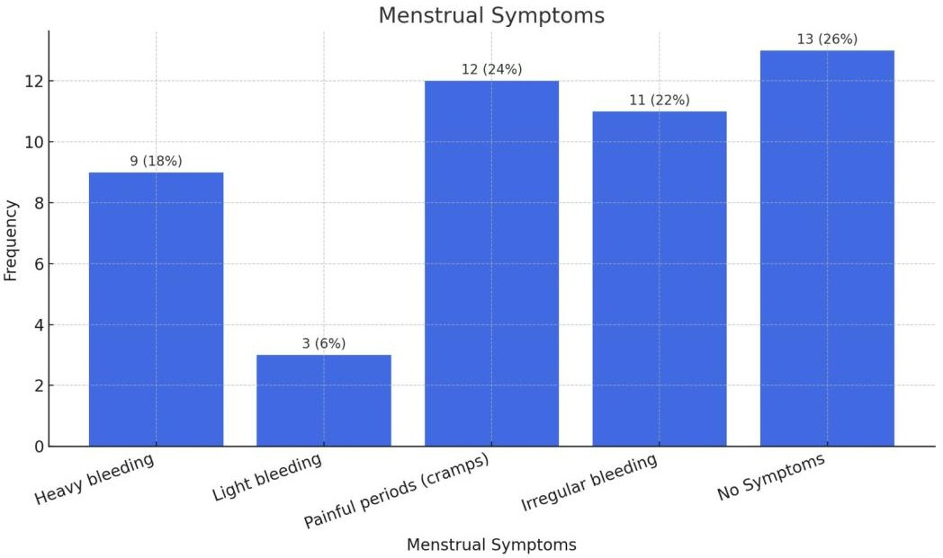
(Common symptoms included dysmenorrhea (24%), irregular bleeding (22%), and heavy flow (18%)

Figure 6 Distribution of Menstrual-Related Symptoms
Painful periods (dysmenorrhea) were reported by 24% of participants, 22% experienced irregular bleeding 18% heavy floe, and 6% light bleeding, while 26% had no symptoms. Dysmenorrhea is commonly attributed to excessive prostaglandin release, especially in adolescent and women with endometriosis or PCOS. Irregular or heavy bleeding often points to anovulatory cycle and unopposed oestrogen, a hallmark of PCOS and thyroids dysfunction. CKD-related hormonal disturbance and anaemia may exacerbate these symptoms. Ju et al 2014 confirmed that menstrual pain significantly impacts productivity and quality of life emphasizing the importance of addressing underlying causes.

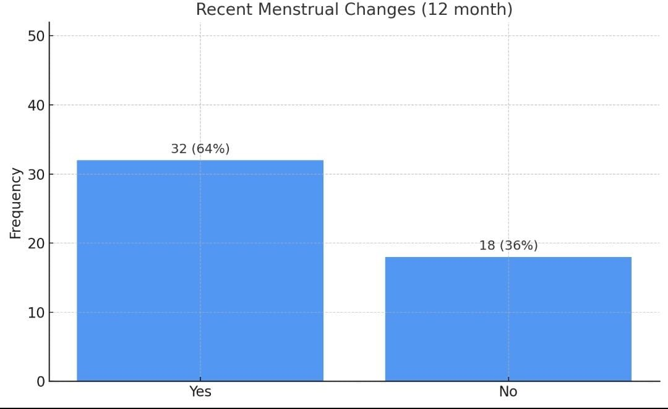
(64% experienced changes in cycle regularity, duration, or flow; 36% reported no change.) Figure 7 Reported Changes in Menstrual Patterns Over the Past 12 Months In the past year, 64% of participant reported noticeable changes in their menstrual cycles,
including irregularity, altered duration, or flow, while 36% did not observe any changes. Such changes can result from lifestyle factors like stress, rapid weight gain or loss, or the progression of systemic disease like CKD. Chronic condition affects the HPO axis and often leads to irregular ovulation or amenorrhea. Carrero et al 2018 reported that menstrual irregularity in CKD patients worsens as renal function declines due to impaired feedback regulation of gonadotropins and sex steroids.
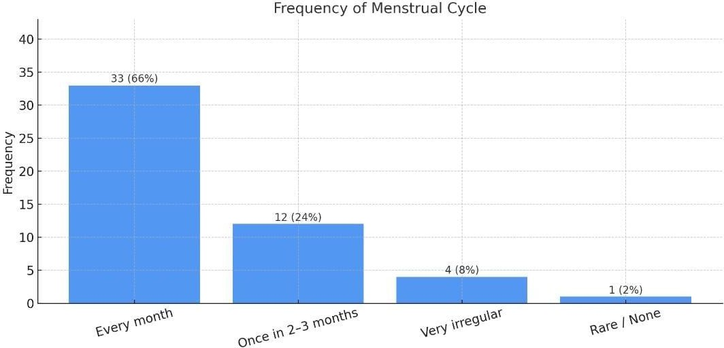
(66% reported monthly cycles, 24% oligomenorrhea (2–3 monthly), and 10% highly irregular/rare menstruation.)

Figure 8 Frequency of Menstrual Cycles Among Participants
Two-thirds (66%) of participant experienced monthly menstrual, while 24% had cycles every 2-3 months (oligomenorrhea), 8% had very irregular cycles, and 2% rarely menstruated. Monthly cycles generally indicate ovulatory cycles and balanced hormonal levels, where areas infrequent cycles often reflect anovulation. Oligomenorrhea and amenorrhea are classic symptoms of PCOS, and are seen in CKD due to hormonal dysregulation and metabolic disturbance. Azziz et al 2016 pointed out that menstrual infrequency is one of the defining criteria of PCOS and is strongly linked with metabolic and reproductive dysfunction

3.4 Dietary Association with Menstrual Regularity

Factor | χ² | p-value
Fenugreek consumption | 9.393 | 0.024
Buckwheat consumption | 10.230 | 0.017
Adherence to dietary restrictions | 4.30 | 0.038
Menstrual frequency | 8.44 | 0.037
*p-Value ≤ 0.05 is considered statistically significant
Table 3 : Dietary and Menstrual Regularity

Table 3 shows a statistically significant link was observed between regular consumption of fenugreek (p=0.024) and buckwheat (p=0.017) and existence of regular menstrual cycles. Participant adhere to CKD dietary restrictions (p=0.038) reported fewer menstruation abnormalities. Menstrual frequency is linked substantially with menstrual pattern regularity (p=0.037). Fenugreek is well-known for its phytoestrogen concentration, which mimics natural oestrogen activity and can help in cycle regulation, especially in hormonally suppressed circumstances[5]. Buckwheat includes D-chiro-inositol, which is known to improve insulin sensitivity and ovarian function, making it especially good for women suffering from reproductive hormone imbalances. The positive relationship between dietary compliance and monthly regularity shows that stabilizing metabolic parameters such as urea, electrolyte, and acid-base balance via diet may indirectly restore endocrine function. Furthermore, women with more constant menstruation were more likely to have stable hormonal and nutritional profiles. These findings indicate inclusion of safe functional foods and increased diet adherence to address reproductive difficulties in CKD women.

DISCUSSION

The findings of this study highlight the complex link between nutritional status and menstrual abnormalities in women with CKD stages 3-5. Menstrual health is becoming recognized as an important predictor of women’s overall well-being, and disruptions in CKD patients is caused by a combination of hormonal, metabolic and nutritional derangements [1]. The study found that 40% of participants had irregular menstrual cycles and 64% reported changes in their menstrual patterns in past 12 months. These numbers are consistent with prior research, including a meta-analysis by [1], which found a high prevalence of menstruation abnormalities in premenopausal CKD women, particularly in advanced stages. The underlying pathophysiology includes abnormalities in hypothalamic- pituitary- ovarian (HPO) axis increased prolactin levels, decreased gonadotropin output, and altered oestrogen metabolism [3]. All of these hormonal disturbances are exacerbated by chronic inflammation, anaemia and uremic environment of CKD.
The study also revealed a low average intake of energy (1002 ± 273.47) and protein (30.14 ± 11.76g), as well as fiber and micronutrient consumption. These findings are consistent with previous research demonstrating nutritional deficiencies in CKD patients due to complex dietary limitation, decreased appetite, altered taste, gastrointestinal problems, and socioeconomic constraints. These nutritional deficits may have a impact on reproductive hormones. Energy and protein deficiency, in particular, can cause functional hypothalamic amenorrhea, where areas inadequate fiber and micronutrients consumptions can affect oestrogen metabolism and clearance.
Biochemically, participants had low haemoglobin levels (mean 9.42g/dL), elevated serum creatinine, and borderline high potassium levels, all of which are characteristic of stage 3-5 CKD. Anaemia in CKD is caused mostly by erythropoietin insufficiency and contributes to fatigue and hormonal imbalance, thereby altering menstrual periods (Lin et al 2016). Furthermore, hyperkalaemia and metabolic acidosis have been shown to alter adrenal and pituitary hormone pathways, affecting reproductive function.
One of the study’s main findings is the discovery of statistically significant link between menstrual regularity and consumption of functional foods notably fenugreek and buckwheat. Fenugreek (Trigonella foenumgraecum) is well known for its phytoestrogen content, which mimics estrogenic activity and promotes menstrual regularity. Similarly, buckwheat (fagopyrum esculentum) included D- chiro-inositol, which possesses insulin- sensitizing characteristics and has demonstrated benefits for enhancing ovarian function in women with hormonal abnormalities. These findings are novel in context of CKD research and may pave the way for future dietary therapies that target hormonal support within renal dietary frameworks. Another notable conclusion was the link between following dietary restriction and better menstrual outcomes (p = 0.038). Patients who followed renal dietary guidelines more closely, particularly in terms of phosphorus, sodium, and potassium control, reported more consistent cycles. This shows that dietary compliance can help to stabilize metabolic parameters and indirectly boost hormonal function. Low intake of fiber and iron-rich foods, such as green leafy vegetables whole grains, and legumes, may further contribute to the cohort’s

menstruation difficulties. Inadequate iron intake combined with chronic blood loss caused by irregular or delayed menstruation exacerbates anaemia in CKD, resulting in vicious cycle. This necessitates the inclusion of bioavailable, renal safe iron sources in dietary regimens, especially in menstruation CKD patients
Interestingly, the study also found that menstrual frequency was substantially connected with menstrual regularity (p= 0.037) implying that longer gaps between periods or fewer cycles per year could indicate deeper hormonal imbalance. This data highlights the importance of periodically monitoring reproductive health as part of nephrology follow up in premenopausal women. Overall, the results of this study accord with growing view that menstrual abnormalities in CKD are not only a result of renal failure but also impacted by modifiable factor such as food intake. Although the small sample size and cross- sectional design present some limitations, the results offer valuable insights into how diet may influence reproductive dysfunction in chronic kidney disease (CKD). To determine causal relationships and investigate the possibility of incorporating hormone- supportive dietary strategies into renal nutrition care plans, future longitudinal studies and larger participant groups are essential. This study had a small small sample size and can be expanded in the future research.

CONCLUSION

The study concluded that menstrual irregularities are a significant yet underdiagnosed problem among women with CKD, and that dietary factors play a measurable role in modulating reproductive health in this population. Despite receiving nephrology care, the participants in the study had inadequate energy, protein, and micronutrient intakes, which may be contributing to hormonal imbalances and menstrual disruptions. The findings highlight the dual burden of chronic kidney disease and reproductive dysfunction, revealing the need for more integrated, patient-centred approach in CKD management that includes regular menstrual health assessment and nutritional interventions.
Importantly, the association between dietary intake of functional food like fenugreek and improved menstrual regularity opens up new avenues for therapeutic dietary strategies in CKD care. At the same time, the low intake of pulses, whole grains, and micronutrients-rich foods observed among participants indicates that there is significant scope for improvement in dietary planning. Given the role of inflammation, oxidative stress, and metabolic derangement in both CKD and menstrual disorder, anti- inflammatory dietary patterns rich in fiber, plant-based protein, and healthy fats should be emphasized in this population.
Furthermore, the study underscores the importance of addressing broader social and healthcare access barriers that affect women with CKD. Limited awareness about menstrual health, Stigma around reproductive issues, and lack of tailored nutritional advice hinder early diagnosis and intervention. Therefore, healthcare provider must adopt a multidisciplinary model that includes dietitian, gynecologist, and mental health professional in the management of women with CKD. Nutritional counselling in such cases should not only aim to meet renal dietary guidelines but also support hormonal balance and menstrual well-being.
In conclusion, this research has contributed to the growing evidence that diet has a crucial role in managing menstrual health in CKD. It advocates for a more holistic, gender-sensitive approach in the dietary management of female CKD patients. Although limited by its cross-sectional nature and small sample size, the study provides valuable insights and a strong foundation for future longitudinal and interventional research. Addressing these gaps in clinical practice and public health will not only improve kidney outcomes but also enhance the reproductive and overall quality of life for women living with CKD.

FUTURE RECOMMENDATION

Future efforts should focus on integrating menstrual health assessment into routine CKD care, along with gender-sensitive dietary counselling that supports both renal and reproductive health.
Longitudinal studies and dietary intervention, especially involving functional foods like fenugreek and anti-inflammatory diets, are needed to confirm and expand current findings.
Multidisciplinary care involving nephrologist, dietitians and gynaecologist, along with improved awareness, reduced stigma, and better access to nutrient-rich food, will enhance the quality of like for women with CKD. Tailored nutritional guidelines and public health initiatives should also address social and healthcare barriers to ensure holistic and equitable management.
ETHICAL APPROVAL

The study protocol has been submitted and approved by the Inter System Biomedical Ethics Committee (ISBEC). Ethical conduct was maintained throughout the study, adhering to the principles of confidentiality, voluntary participation, and the right to withdraw at any time without consequence.

Consent
As per international standards or university standards, Participants’ written consent has been collected and preserved by the author(s).
Disclaimer (Artificial intelligence)
Option 1:
Author(s) hereby declare that NO generative AI technologies such as Large Language Models (ChatGPT, COPILOT, etc.) and text-to-image generators have been used during the writing or editing of this manuscript.
Option 2:
Author(s) hereby declare that generative AI technologies such as Large Language Models, etc. have been used during the writing or editing of manuscripts. This explanation will include the name, version, model, and source of the generative AI technology and as well as all input prompts provided to the generative AI technology
Details of the AI usage are given below:
1.
2.
3.

ACKNOWLEDGEMENTS

The author would like to thank Sir Vithaldas Thackersey College of Home Science (Autonomous), SNDT Women’s University, Mumbai, for providing institutional support for this research. Special thanks to the nephrology department and OPD staff of the tertiary care hospital in Mumbai for their cooperation in participant recruitment and data collection. The authors are also grateful to all the women who voluntarily participated in this study.

COMPETING INTERESTS

The authors have declared that no competing interests exist.

AUTHORS’ CONTRIBUTIONS

- Anam Ansari: Conceptualized the study, performed data collection, statistical analysis, and prepared the first draft of the manuscript.
- Dr. Anuradha Ramesh: Provided guidance in study design, supervised data interpretation, and critically reviewed the manuscript.
- Dr. Keshnath K. Chauhan: Assisted with clinical aspects, participant recruitment, and provided critical input in discussion and final editing.
All authors read and approved the final manuscript.

REFERENCE

- Rytz, C. L., Kochaksaraei, G. S., Skeith, L., Ronksley, P. E., Dumanski, S. M., Robert, M., & Ahmed,
S. B. (2022). Menstrual Abnormalities and Reproductive Lifespan in Females with CKD: A Systematic Review and Meta-Analysis. Clinical Journal of the American Society of Nephrology, 17(12), 1742– 1753. https://doi.org/10.2215/CJN.07100622.
- Jabin, M., Chowdhury, M. N., Islam, M. N., & Uddin Khan, M. E. (2022). Menstrual Abnormalities and Associated Hormone Profile in Chronic Kidney Disease Stage 5 Patients. Journal of Bangladesh College of Physicians and Surgeons, 40(1), 45–51. https://doi.org/10.3329/jbcps.v40i1.57057 .
- Chang, D. H., Dumanski, S. M., & Ahmed, S. B. (2021). Female Reproductive and Gynaecologic Considerations in Chronic Kidney Disease: Adolescence and Young Adulthood. Kidney International Reports, 7(2), 152–164. https://doi.org/10.1016/j.ekir.2021.11.003.
- Chang, D. H., Dumanski, S. M., Brennand, E. A., Ruzycki, S. M., Ramage, K., Gantar, T., Shah, S., & Ahmed, S. B. (2023). Female Reproductive Health and Contraception Use in CKD: An International Mixed-Methods Study. Kidney Medicine, 5(10), 100713. https://doi.org/10.1016/j.xkme.2023.100713.
- Lin, C. T., Liu, X. N., Xu, H. L., & Sui, H. Y. (2016). Menstrual Disturbances in Premenopausal Women with End-Stage Renal Disease: A Cross-Sectional Study. Medical Principles and Practice, 25(3), 260–265. https://doi.org/10.1159/000444323
- Carrero, J. J., Qureshi, A. R., Parini, P., Arver, S., & Bárány, P. (2018). Low testosterone is associated with poor prognosis in men with CKD stages 3–5. Nephrology Dialysis Transplantation, 27(2), 592–598. https://doi.org/10.1093/ndt/gfr313
- Ibáñez, L., et al. (2017). Frontiers in Endocrinology, 8, 298. https://doi.org/10.3389/fendo.2017.00298
- Ju, H., et al. (2014). BJOG, 121(6), 674–683. https://doi.org/10.1111/1471-0528.12439

- Azziz, R., et al. (2016). Nature Reviews Disease Primers, 2, 16057. https://doi.org/10.1038/nrdp.2016.57
- Fraser, I. S., Römer, T., Parke, S., Zeun, S., Mellinger, U., Machlitt, A., & Jensen, J. T. (2011). Effective treatment of heavy and/or prolonged menstrual bleeding with an oral contraceptive containing estradiol valerate and dienogest: a randomized, double-blind Phase III trial. Human reproduction (Oxford, England), 26(10), 2698–2708. https://doi.org/10.1093/humrep/der224
- Attini R, Cabiddu G, Ciabatti F, Montersino B, Carosso AR, Gernone G, Gammaro L, Moroni G, Torreggiani M, Masturz B, Santoro D, Revelli A, Piccoli GB; Italian Society of Nephrology’s Project Group on Kidney and Pregnancy. Chronic kidney disease, female infertility, and medically assisted reproduction: a best practice position statement by the Kidney and Pregnancy Group of the Italian Society of Nephrology. J Nephrol. 2023 Jun;36(5):1239-1255. doi: 10.1007/s40620-023-01670-4. Epub

2023 Jun 24. Erratum in: J Nephrol. 2024 Apr;37(3):837-838. doi: 10.1007/s40620-024-01980-1. PMID:
37354277; PMCID: PMC11081994

- Hojjati Kermani, M.A., Awlqadr, F.H., Talebi, S. et al. Ultra-processed foods and risk of declined renal function: a dose–response meta-analysis of 786,216 participants. J Health Popul Nutr 44, 79 (2025). https://doi.org/10.1186/s41043-025-00799-1
- Swaroop, A., Jaipurian, A. S., Gupta, S. K., Bagchi, M., Kumar, P., Preuss, H. G., & Bagchi, D. (2015). Efficacy of a novel fenugreek seed extract (Furocyst™) in polycystic ovary syndrome (PCOS). International Journal of Medical Sciences, 12(10), 825–831. https://doi.org/10.7150/ijms.13024 pubmed.ncbi.nlm.nih.gov+9medsci.org+9pmc.ncbi.nlm.nih.gov+9
- Singh, A., Gainder, S., Banerjee, P., Goel, A., Kumar, P., Mondal, B., & Bagchi, D. (2023). Efficacy of a proprietary fenugreek seed extract (Trigonella foenum-graecum, Furocyst®) in women with polycystic ovary syndrome (PCOS): A randomized, double-blind, placebo-controlled study. Journal of the American Nutrition Association, 42(7), 651–659. (Open access via DietFactor) pdfs.semanticscholar.org+15dietfactor.com.pk+15mdpi.com+15

LIST OF ABBREVIATIONS

Abbreviation | Full Form
CKD | Chronic Kidney Disease
ESRD | End-Stage Renal Disease
HPO | Hypothalamic-Pituitary-Ovarian Axis
FFQ | Food Frequency Questionnaire
BMI | Body Mass Index
HB | Haemoglobin
BUN | Blood Urea Nitrogen
FSH | Follicle Stimulating Hormones
LH | Luteinizing Hormone
GnRH | Gonadotropin-Releasing Hormone
PCOS | Polycystic Ovary Syndrome
HD | Haemodialysis
PD | Peritoneal Dialysis
GFR | Glomerular Filtration Rate
eGFR | Estimated Glomerular Filtration Rate
ACR | Albumin-Creatinine Ratio
PMS | Premenstrual Syndrome
CR | Caloric Restriction
HFD | High-Fat Diet
VLCD | Very-Low-Calorie Diet
IR | Insulin Resistance
TSH | Thyroid Stimulating Hormone
SHBG | Sex Hormone Binding Globulin
IL-6 | Interleukin- 6
CRP | C-Reactive Protein
DEXA | Dual-Energy X-ray Absorptiometry
HPA Axis | Hypothalamic-Pituitary-Adrenal Axis
OS | Oxidative Stress
SPSS | Statistical Package for the Social Science
ISBEC | Inter System Biomedical Ethics Committee

APPENDICES

A. ETHICS COMMITTEE APPROVAL LETTER

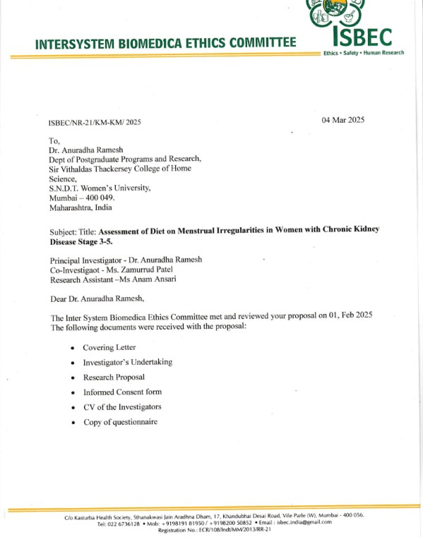

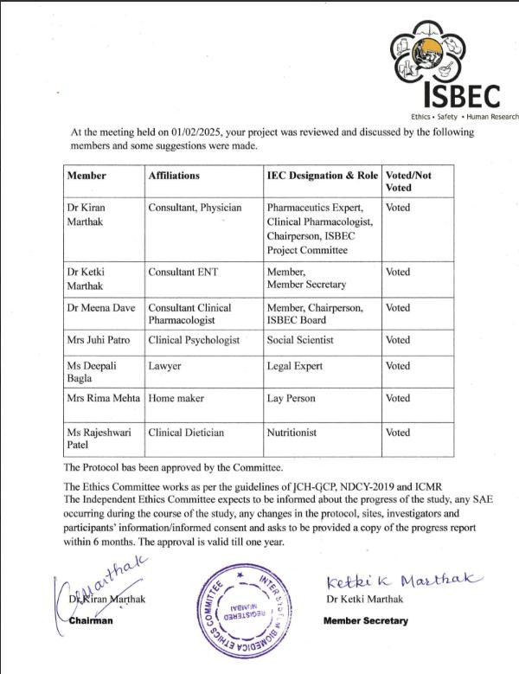

B PARTICIPANT INFORMATION SHEET

M.Sc. Dissertation of MS. Anam Ansari from Sir Vithaldas Thackersey College of Home Science (Empowered Autonomous Status), SNDT Women's University]
Title of Research: The Assessment of Diet on Menstrual Irregularities in Women with Chronic Kidney Disease (CKD) Stage 3-5
It is essential to evaluate and enhance the knowledge, education, and awareness of chronic kidney disease (CKD) and its impact on menstrual irregularities in women to better understand and address these interconnected health issues. Therefore, the study aims to assess The Influence of Diet on Menstrual Irregularities in Women with Chronic Kidney Disease Stage 3-5
If you consent to be a part of this study, you will be required to fill out a questionnaire that will take nearly 10 - 15 minutes. The questionnaire will include sections to record demographic information, (age, education, and socioeconomic status), medical history (including CKD stage and treatment), self-reported anthropometric indices like height, weight, and BMI, and nutritional status evaluated through biochemical markers. It will also assess dietary habits and patterns using 24- hours dietary recall and semi- quantitative food frequency questionnaire tailored to renal specific food, as well as menstrual history, including details of cycle regularity, duration, and associated, symptoms. Your participation will contribute to understand the relationship between diet and menstrual health in women with CKD
All the information that you provide, will be kept confidential and will be only for research purposes.

The information provided by the participants would be useful data for the enhancement of research in the field of non-communicable diseases and may lead to the planning of better treatment and prevention strategies in the future. This study does not involve any medicine or invasive blood investigation.
Please note that no incidental expenses will be paid for participation in the study. Your participation in this study is completely voluntary.
If you have any questions, concerns, or complaints about the study at any stage, you can contact:
Dr. Anuradha Ramesh (Principal Investigator)

S.V.T. College of Home Science (Empowered Autonomous Status), S.N.D.T Women’s
University Contact: 02226602504 Ms. Anam Ansari

Email ID:
N0232@svt.edu.i

If you have concerns or complaints about the study and the ethical conduct of the project, you may contact the INTER SYSTEM BIOMEDICA ETHICS COMMITTEE (ISBEC).
Secretary, INTER SYSTEM BIOMEDICA ETHICS COMMITTEE (ISBEC)

C/o Kasturba Health Society, Sthanakwasi Jain Aradhna Dham, 17, K.D. Road, Vile Parle (West), Mumbai - 400056
Tel: 26246119 / 26715147, Email ID: isbec.india@gmail.com

C. INFORMED CONSENT FORM

Title of Research: The Influence of Diet on Menstrual Irregularities in Women with Chronic Kidney Disease Stage 3-5
By signing below, I show that,

- I confirm that I have read and understood the information mentioned in the Participant Information Sheet. I have received an explanation of the nature, purpose, duration, and foreseeable effects and risks of the study and what I will be expected to do.
- I understand that my participation in the study is voluntary and that I am free to withdraw at any time, without giving any reason, without my medical care or legal rights being affected.
- I understand that my identity will not be revealed in any information released to third parties or published.
- I agree not to restrict the use of data or results that arise from this study provided such a use is only for scientific purposes.

- I have had time to make my decision whether or not to take part in this research. I agree to take part in the research study described in this form.

I agree/ disagree to participate:

Participant Name and Signature

Person who is seeking consent (Name, Signature, and Date)

D. SELF DESIGN QUESTIONNAIRE

Demographic information Age:
  - 18-24
  - 25-34
  - 35-44
  - 45-54
  - 55 and above

Educational level:

  - No formal education
  - Primary school
  - Secondary school
  - Diploma/certificate
  - Undergraduate degree
  - Postgraduate degree

Occupation:
  - Employed
  - Business
  - Homemaker

Socioeconomic status (estimated monthly income)

  - Less than Rs 15,000
  - Rs15,000-30,000
  - Rs30,000-45,000
  - Rs45,000-60,000
  - More than Rs60,000

Family type

  - Nuclear Family
  - Joint Family

- No. of Family members:

- Family History of Renal Disease:

- Past Medical History:

- Comorbid Conditions:

- Allergies:

- Dietary Habit

  - Vegetarian
  - Non-vegetarian
  - Ovo vegetarian
  - Lacto vegetarian
  - Lacto Ovo vegetarian

- Medications:
  - Name:
  - Dosage:

- Smoking:
  - Yes
  - No 14.Physical Activity:

Section 2 Nutritional Status Evaluation

- Height (in cm):
- Weight (in kg):
- Body max index (bmi)(optional):

- Have you undergone any recent biochemical test (e.g./. blood test for haemoglobin, serum, creatinine etc):
  - Yes
  - No

If yes list the values available:

SR NO | TEST | PATIENT’S  VALUE | NORMAL VALUE
1 | Fasting Blood Sugar (mg/dL) |  | <95 (normal in pregnancy)
2 | Postprandial Blood Sugar (mg/dL) |  | <120 (normal in pregnancy)
3 | HbA1c (%) |  | ≤6.0 (normal for  GDM)
4 | Blood Pressure (mmHg) |  | <120/80 (normal)
5 | Thyroid Profile
6 | - T4 (µg/dL) |  | 4.5–12.5
7 | - TSH (µIU/mL) |  | 0.27–4.2
8 | - FT3 (pg/mL) |  | 2.0–4.4
9 | - FT4 (ng/dL) |  | 0.8–1.7
10 | Creatinine |  | 0.6–1.1 mg/dL
11 | HB |  | 11-14mg/dl
12 | Iron |  | 60-170mg/dl
13 | BUN |  | 7–20 mg/dL
14 | Uric acid (mg/dl) |  | 3.5-7.5
15 | Sodium- (mEq/L) |  | 137-145

16 | Potassium- (mEq/L) |  | 3.5-5.6
17 | Chloride- (mEq/L) |  | 95-105
18 | Total protein-(g/dl) |  | 6-8
19 | Albumin-(g/dl) |  | 3.5-5.5
20 | Calcium (mg/dl) |  | 8.5-10.5
21 | Phosphorus (mg/dl) |  | 2.5-4.5

- Do you follow any specific dietary restrictions (e.g. low sodium, low potassium, low phosphorus)

  - Yes
  - No
  - If yes please specify:

- How many glasses of water or other fluids did you consume in the last 24 hour?

  - Less than 4
  - 4-6
  - Mor than 6

- Do you take any dietary supplements?

  - Yes
  - No
  - If yes please specify

Section 3 Clinical Assessment

- What stage of CKD are you in?

  - Stage3
  - Stage4
  - Stage5(end stage renal disease)

- When were you diagnosed with CKD?

  - Less than 1 year
  - 1-5 years ago
  - More than 5 years ago

- Are you currently receiving treatment for CKD (select all that apply)?

  - Dialysis
  - Medication(specify)
  - Dietary modification
  - Other treatment specifies

- How long have you been receiving Haemodialysis treatment?

- Frequency of Dialysis:

  - Once week
  - Twice week
  - Thrice a week

- Duration of Dialysis

- Do you have any other chromic medical condition (e.g. diabetes, hypertension)

  - Yes
  - No
  - If yes please specify
- Have you noticed any changes in your menstrual cycle since starting hemodialysis
  - Yes my cycle has become regular
  - Yes my cycle has become shorter
  - Yes my cycle has become longer
  - Yes, I have missed my periods since starting hemodialysis
  - No. my menstrual cycle has not changed
  - I am not sure if my cycle has changed

- Are you taking any medications that affect your menstrual cycle (e.g. hormonal therapies, both control pills etc)
  - Yes
  - No
  - If yes please specify:

Section 4: Menstrual history

- Age at menarche (first period):

- Do you have a regular menstrual cycle?

  - Yes
  - No
  - Sometimes

- Average duration of your menstrual cycle (in days)

  - Less than 21 days
  - 21 to 35 days(normal)
  - More than 35 days

- Duration of menstrual flow (in days)

  - 1-3 days
  - 4-7 days
  - More than 7 days

- Symtoms during menstruations (select all that apply)

  - Heavy bleeding
  - Light bleeding
  - Painful period(cramps)
  - Irregular bleeding
  - No symptoms

- Have you experienced any recent changes in your menstrual cycle (last 12 months)

  - Yes
  - No
  - If yes please specify

- At what frequency menstrual cycle comes

  - Once in a month
  - Once in 3 months
  - Once in 6 months
  - Twice in a month

24 Hour Dietary Recall

Meals | Time | Food or Beverage Consumed | Amounts consumed in  Household  Measures | Method of Preparation
Early Morning
Breakfast
Mid-morning
Lunch
Snacks
Dinner
Bedtime

E. FOOD FREQUENCY QUESTIONNAIRE

FOOD GROUP | Amount (gms) | Twice Daily | Once Daily | 3-5  Times a week | 1-2  Times a week | 3-5  Times in a month | 1-2  Times in a month | Rarely | Never

Cereals
Jowar
Bajra
Ragi
Wheat flour (whole)
Maida
Rice, parboiled,
milled
Puffed rice
Buckwheat
Daliya
Sago
Oats
Wheat

vermicelli
Semolina
White bread
Brown bread

Multigrain bread
Pulses
Red gram dal
Green gram

whole
Green gram dal
Bengal gram dal
Bengal gram whole
Lentil, whole, yellowish
Lentil, whole, brown
Rajma
Cowpea white
Soya bean
Black gram dal
Black gram whole
Moth beans

Field beans brown
Field beans black
Nuts & Oilseeds
Almond
Cashew
Pistachio

Groundnuts
Makhana
Flaxseeds
Gingelly seeds, black
Gingelly seeds, white
Chia seeds
Coconut kernel, fresh
Coconut kernel, dry
Sunflower seeds
Pumpkin seeds
Fenugreek seeds

Fruits
Apple
Pear
Pineapple
Papaya
Banana, ripe robusta
Chikoo
Strawberries

Oranges
Mosambi
Watermelon
Custard apple
Dates, dry, dark
brown Dates, dry, pale
Dates processed
Pomegranate
Litchi
Guava, pink flesh
Guava, white

flesh
Mango, green, raw
Mango,
ripe,

tot Apari
Peach

Plum
Raisins, dried black
Raisins, dried golden
Vegetables
Lady's finger
Tinda
Cabbage
Tomato
Cucumber
Capsicum
Cauliflower
Bottle gourd
Bitter gourd
Ridge gourd
Drumstick

Pumpkin
French beans
Cluster beans
Broad beans
Field beans, tender, lean
Brinjal (all varieties)

Green leafy

Vegetables
Amaranth
Fenugreek leaves
Spinach
Roots & Tubers
Potato
Sweet potato
Onion
Beetroot
Carrot
Radish, elongate,

Tapioca
Water chestnut
Yam elephant
Condiments
Coriander leaves
Mint leaves
Garlic

Ginger
Egg
Egg Poultry,
Whole
Egg Poultry, White Boiled
Egg Poultry, White Raw
Egg Poultry, Yolk Boiled
Egg Poultry, Yolk Raw
Poultry
Chicken Leg

Chicken Breast,
Skinless
Chicken Thigh,
Skinless
Chicken Wing,
Skinless
Chicken Liver Mutton, muscle
Pork
Fish &

Seafood

Salmon (Ravas)
Surami
Mackerel
Pomfret white
Bombil (fresh)
Bombil (dry)
Prawns (big)
Milk & Milk products

Milk (c)
Milk (b)
Curd (c)
Paneer (c)
Cheese
Skimmed milk, liquid
Animal Fat
Butter, salted
Ghee
Miscellanea us

Wafers/

Khari/ Khakhra/ Other Savouries
Vada pav/samosa pav/ Vada/ Masala vada/
Bhajiyas/Pak oras / Aloo bonda/
Gujiyas

Pizza/Burger
/Pas ta/Pav bhaji/
French Fries/ Instant
Noodles
Soft drinks/ sugary
drinks/juices (Tetra pack)
Pastries/ cakes
Chocolates/ biscuits Cookies Good day
Sweets (Ladoo,
Halwa/Kaj u
katli,

Shrikhand/B arfi / Mysore pak)
Packaged food

(Peppy/Kur mura/ Aloo bhujiya/Lays/

Balaji wafers/

Kurkure/Ka chori / Bhakarvadi etc)

