Recent Advances in the Development of New Antibiotics and Alternative Anti-Infective Therapies

ABSTRACT
The growing problem of antibiotic resistance has become one of the most serious global health challenges of the 21st century. Many disease-causing bacteria have developed resistance to existing antibiotics, making common infections harder to treat and increasing the risk of severe illness and death. To address this, researchers are focusing on developing new antibiotics and exploring alternative therapies. The development of new antibiotics involves finding novel compounds, modifying existing drugs, and identifying new bacterial targets to overcome resistance mechanisms. However, antibiotic discovery is slow, expensive, and often faces regulatory and economic challenges. As a result, alternative therapies are gaining attention. These include bacteriophage therapy, which uses viruses to attack specific bacteria; antimicrobial peptides that destroy bacterial cell membranes; probiotics that restore healthy microbiota; and immune-based treatments that boost the body’s natural defenses. Advances in nanotechnology and gene-editing tools like CRISPR-Cas systems also offer new ways to precisely target and eliminate resistant bacteria. Combating antibiotic resistance requires a combined approach—developing new antibiotics, promoting responsible antibiotic use, and encouraging research into innovative alternatives. Global cooperation among scientists, governments, and health organizations is essential to ensure sustainable progress. By investing in both new and alternative treatments, we can protect public health and maintain effective infection control for future generations.
Key words: CRISPR-Cas System, Bacteriophage Therapy, Immune Based Treatments, Antibiotic Resistance.

INTRODUCTION:
Antibiotics:
Antibiotics are the powerful medicines which are used to treat bacterial infections caused by any type of bacteria either by inhibiting the growth of bacteria or by killing the bacteria. Selman A. Waksman, described antibiotics as ”substances produced by microorganisms that are capable of inhibiting the growth, or destroying, the other microorganisms”¹. The discovery of penicillin by Sir Alexander Fleming in 1928 marked a transformative milestone in the treatment of infectious diseases and paved the way for the development of numerous antibacterial agents in the years that followed ². Today, while the rate of antibiotic innovation has declined, resistance continues to expand globally . As a result, antimicrobial resistance has become one of the most serious health threats of the twenty-first century. The World Health Organization warns that if this trend persists, resistant infections could cause up to ten million deaths per year and decrease the global gross domestic product by approximately 2–3.5% annually by 2050 ³. The discovery of the antibiotics are considered as the one of the greatest milestones in the history of the human medical.
Classification of antibiotics :

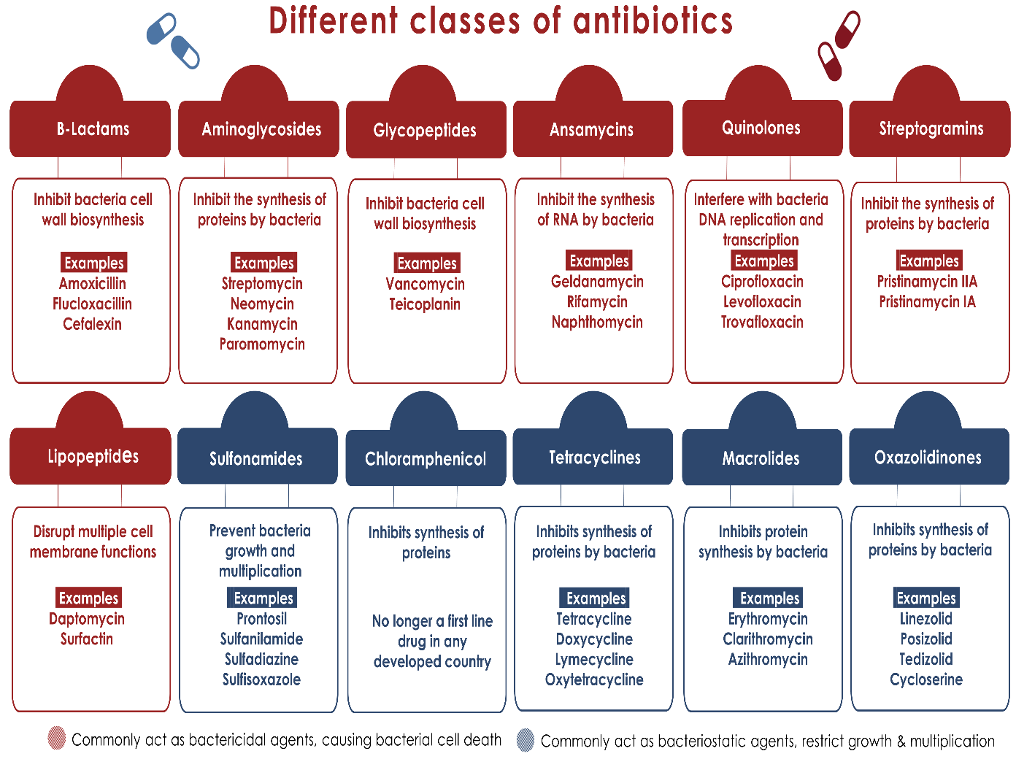
Fig 1 : Classification of Antibiotics
Alternative Therapies of Antibiotics :
Alternative therapies for antibiotics are non-traditional treatment strategies designed to treat or prevent the antibiotic resistance or to treat the bacterial infections without using the conventional antibiotics. The main aim of these alternative therapies are to overcame the antibiotic resistance by either eliminating the pathogens directly or by inhibiting their growth. As antibiotic resistance increases and continues to threaten the treatment of various infections, researchers are looking for the new ways And one of them include the alternative therapies of the antibiotics⁴. Meanwhile to reduce the usage and dependence of the antibiotics other medical terms are introduced , and one of them are the alternative therapies of the antibiotics. Alternative therapies like the vaccines, antibodies, probiotics, bacteriophages, peptides, phytochemicals, pattern recognition, metals and antimicrobial enzymes are being used in place of antibiotics ⁵.
Golden Era :
After the invention of the penicillin the golden age of the antibiotics was started .After these following 20 years became the “Golden Age” of antibiotic discovery . In these golden era a surge of the new antibiotics classes were discovered and developed , transforming medicine and increasing the human lifespan. In the time of golden age in 1953 vancomycin was discovered by Edmund kornfeld and was came into the market in the year of the 1954. Methicillin was developed in the year of 1959 by Beecham as the first penicillinase – resistant B- lactam antibiotic. The period between the 1940s and 1960s was considered as the golden age of antibiotic discovery. The timeline below is now arranged by the year of clinical introduction for each antibiotic drug class. It shows that almost two- thirds of all antibiotics drug classes were developed in the golden age and most of them are still used toady⁶.
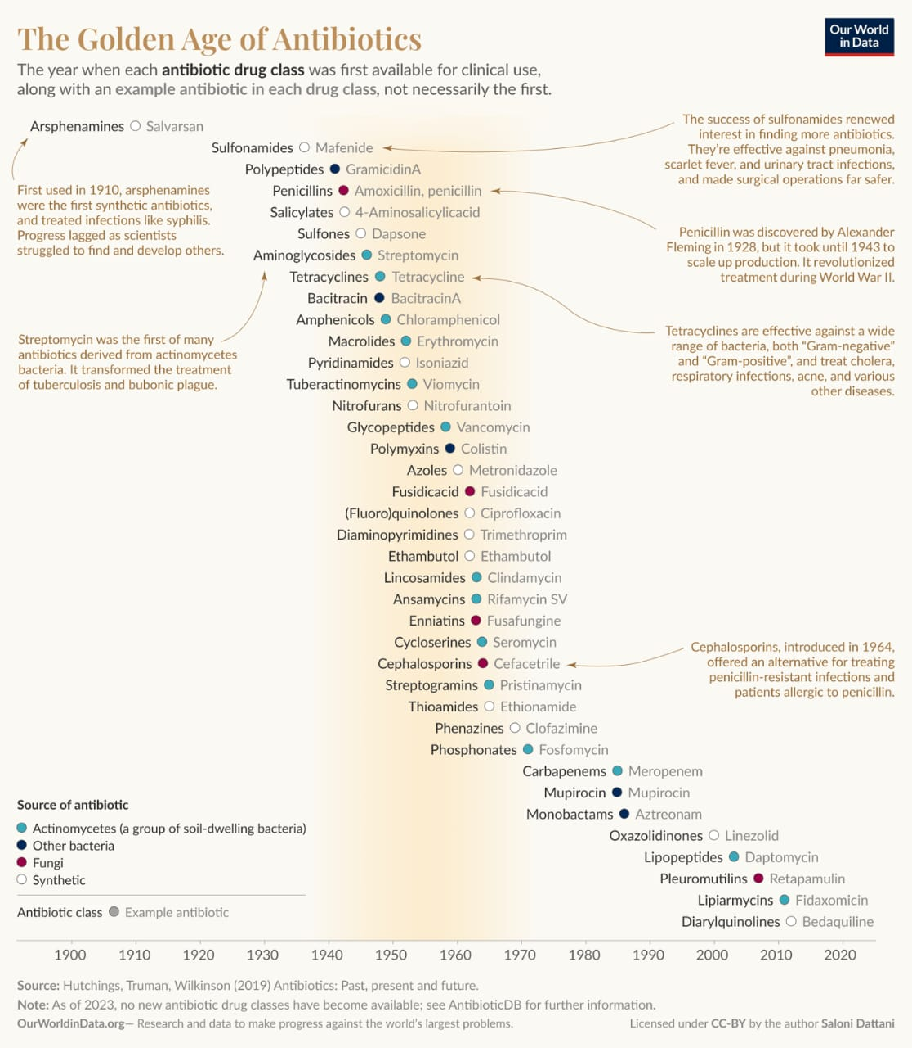
Fig 2: Time Line of Antibiotics
Alternative therapies :
Theres isn’t a single discoverer of these alternative therapies of antibiotics. Instead various researchers in the 20th and 21 centuries identified and developed different alternative therapies of antibiotics. There were many persons who were discovered these alternative therapies. To generate suitable alternatives, at first we have understood better about why antibiotics are being overused and to define the unintended consequences. Antibiotics have multiple purposes which suggest the alternatives. Most of the antibiotics are used to treat different specific diseases , suggesting the bacteriophages , bacteriocins, and more alternatives therapies are used in similarly ⁷.
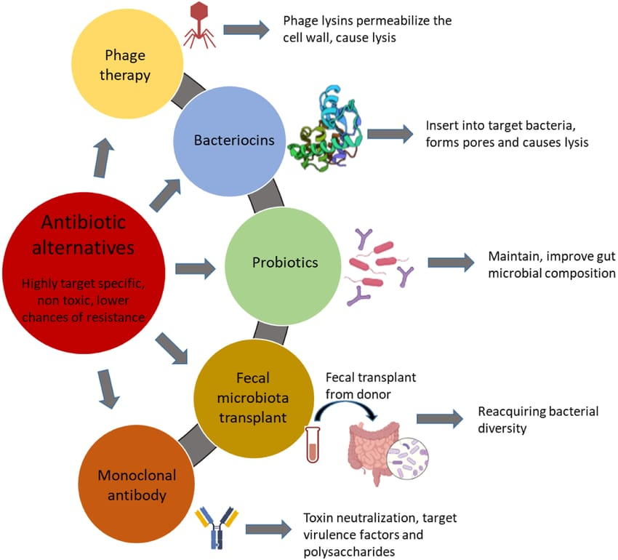
Fig 3: Alternative therapies
Bacteriophage Therapy :
Phages are the simple, incredible and non living biological creatures consisting of DNA or RNA enclosed with a protein capsule. Phages are incapable of reproducing independently and are dependent to survive on the bacteria host, where as the naturally – occurring phage’s they are capable of reproducing independently. Phage is also called as the bacteriophages, which was discovered a century ago. In these phage therapy bacterial viruses are used to the bacterial infections. These phage therapy is widely being used as an alternative therapy of the antibiotics. The naturally -occurring phages which are used to treat the bacterial infections has an continuous history in the western medicine ⁸. When compared to the traditional antibiotic treatment these phage therapy is much more safest way of treatment. Phages will infect the bacteria by reprogramming the cell to become a phage factory by producing more phages inside the bacteria cell. These phage treatment came into the use from the year of 1919⁹.
Antibodies :
Historically serum antibodies are used to treat the infectious diseases, before the usage of antibiotics. Antibodies are the therapeutic agents, which will use our immune system to provide therapeutic benefit . Human monoclonal antibodies are the specialized antibodies, which will target pathogens without disrupting the body ‘s normal bacteria flora. Recent clinical trails, have evaluated the suvratoxumab, a monoclonal antibody designed to treat the ventilator- associated pneumonia caused by S aureus in patient intensive Care settings.
Bacteriocins :
Different types of the bacteriocins are originated from the lactic acid bacteria. Lactic acid bacteria which are mainly related to the food groups could produce the bacteriocins. These bacteriocins were identified at 100 years ago as , cationic, ribosomally synthesised , antibacterial peptides. These shows their action by forming pore and disrupting target cell membrane integrity, eventually which leads to the cell death ¹⁰.
Mechanism of Action:
Membrane Disruption: Bacteriocins, often possessing a positive charge, bind to negatively charged receptors on the target bacterium's cell surface.
Pore Formation: Upon binding, they induce the formation of pores or channels in the bacterial cell membrane, which dissipates the cell's internal electrical potential.
Cell Lysis: The increased ion permeability caused by these pores leads to cell death through direct lysis.
Interference with Cellular Processes: Some bacteriocins also interfere with essential cellular functions like cell division or inhibit critical enzymes, further contributing to their antimicrobial effect.
Probiotics :
Probiotics are the living microorganisms that will provide many health benefits when they are introduced into a human body in an adequate amount. Most of these probiotics are the gram – positive bacteria. The main function of these probiotics related to the modulation and maintenance of the intestinal tract health. Under the clinical trails these probiotics have shown that these are effective against a wide range of the pathological conditions like , such as the constipation, diarrhoea, polycystic ovary syndrome, ulcerative colitis, stress and anxiety, inflammatory bowel disease, breast cancer and diabetes ¹¹.
mechanism of Action:
Probiotics are live, non-pathogenic microorganisms that provide health benefits when consumed. Their therapeutic effects are achieved through several mechanisms:
Competitive Exclusion: Probiotics compete with harmful bacteria for limited space and nutrients in the gut, preventing pathogens from adhering to the intestinal lining.
Antimicrobial Compound Production: Some probiotics can produce substances like short-chain fatty acids, enzymes, and other antimicrobial compounds that directly inhibit the growth of pathogens.
Immune System Modulation: Probiotics interact with the immune system to improve both innate and adaptive immune responses, helping to strengthen the body's defence against disease.
Gut Barrier Improvement: They can strengthen the gut mucosal barrier, reducing the leakage of harmful substances from the gut into the bloodstream.
Toxin Neutralization: Certain "designer probiotics" can be engineered to bind to neutralize toxins produced by pathogens, preventing damage to the host cells.
Fecal Microbiota Transplant :
The human microbiome. Mainly the gut microbiome has emerged as the central determination of the health and diseases. Fecal microbiota transplantation has received considerable attention as a promising therapy to modulate the gut microbiome and restore microbial homeostasis ¹².
Fecal microbiota transplantation will helps to cure the recurrent clostridium difficile infections. Fecal microbiota transplantation therapy will also helps to cure the gastrointestinal diseases like the inflammatory bowel diseases , irritable bowel syndrome, and as well as non- gastrointestinal related diseases. Fecal microbiota transplantation is a process of suspension of the fecal from a healthy donor into the intestines of a diseased patient.
Monoclonal Antibodies :
Monoclonal antibodies are the protein molecules which are made from the hybridoma cells by recombinant DNA technology in the laboratory. These protein molecules are used in the various fields but they are mainly used to cure the diseases like breast cancer, leukemia, arthritis, asthma, crohn’s diseases, macular degeneration , and transplantations and etc. When these are applied as a therapeutic these are referred as the Mabs. The Mabs are defined as the “monospecific antibodies that are made by the identical immune cells that are all clones of a unique parent cell These monoclonal antibodies are used via intravenous infusion or subcutaneous injection to help the body fight diseases by binding to specific targets on the viruses , pathogens or diseased cells ¹³.
Table 1 : FDA- APPROVED NEW ANTIBIOTICS
SL.no | ANTIBIOTIC | Year of Approval | Route  Of administration | Main indication
1 | GEPOTIDACIN | 2025 | Oral | Uncomplicated urinary-  Tract infections
2 | EMBLAVEO | 2025 | IV | Complicated intra-  Abdominal infections  Caused by gram  Negative bacteria.
3 | ZAYNICH | 2025 | IV | Complicated urinary tract infections and acute pyelonephritis.
4 | ORLYNVAH | 2024 | ORAL | Oral treatment  For Uncomplicated  UTIS.
5 | NAFITHROMYCIN | 2024 | ORAL | Treates both typical  And atypical drug  Resistance.
6 | XACDURO | 2023 | IV infusion | Used to treat pneumonia infections in hospitalized adults.
7 | REZZAYO | 2023 | IV infusion | Used to treat invasive candidiasis.
8 | DALBAVANCIN INJECTION | 2023 | IV infusion | Used to trat acute bacterial skin.
9 | EXBLIFEB | 2024 | IV infusion | Used to treat the complicated urinary disease and hospitalized acquired pneumonia, ventilator associated pneumonia and Bacteremia.
10 | ZEVTERA | 2024 | IV infusion | Used to treat bacterial infections.
DEVELOPMENT OF NEW ANTIBIOTICS
The development of new antibiotics is a critical area of biomedical research aimed at combating the growing threat of antimicrobial resistance (AMR). Traditional antibiotic discovery, which relied heavily on natural products from soil microorganisms, has slowed significantly since the 1980s. Modern strategies now combine genomic, bioinformatic, and synthetic biology approaches to identify novel drug targets and molecules.
Recent advances include:
- Genome mining to discover previously silent biosynthetic gene clusters in microbes.
- Structure-based drug design using computational modelling to optimize activity and reduce toxicity.
- Synthetic and semi-synthetic modifications of existing antibiotic scaffolds to overcome resistance.
- Phage therapy and antimicrobial peptides as alternative strategies.
- AI-driven drug discovery, which accelerates identification of promising antibiotic candidates Eg : Halicin ^{14,15}.

CURRENT STATUS OF ANTIBIOTICS AND ALTERNATIVE THERAPIES
A new report from the world health organization (WHO) stated that the antibiotics currently in clinical development are not sufficient to rising AMR , especially against those pathogens which are greatest threat to the human life . As for the current status , only few molecules in clinical trails can potentially counter the multidrug- resistance mainly in gram-negative bacteria¹⁶.
1.GEPOTIDACIN :
Gepotidacin is also known as Blujepa. It is an triazaacenapthylene bacteria type II topoisomerase inhibitor. it is the first new oral antibiotic which is approved by the FDA in decades, represents a major advancement in the treatment of the uncomplicated urinary tract infections ¹⁷.
Mechanism Of Action:
It involves the disruption of bacterial DNA replication through the selective inhibition of two essential bacterial enzymes: DNA gyrase (also known as topoisomerase II) and topoisomerase IV. These enzymes are crucial for bacteria as they manage the topological state of DNA during replication, transcription, and cell division. Gepotidacin exerts its inhibitory effect by binding to these enzymes in a manner that is distinct from other antibiotic classes, including fluoroquinolones - specifically, gepotidacin interacts with the GyrA subunit of bacterial DNA gyrase and the ParC subunit of bacterial topoisomerase IV. Structural studies have revealed that gepotidacin binds midway between the two scissile DNA bonds, within a pocket formed by these subunits ¹⁸.
Adverse Effects :Diarrhoea, soft stools, Nausea, Stomach pain, Gassiness, Yeast infections, headache, Dizziness, Heart rhythm, Difficulty speaking or trouble saying words, Heart rhythm changes ¹⁹.
Medicinal uses: used in the treatment of uncomplicated urinary disease.
2. EMBLAVEO:
Emblaveo is an intravenous (IV) antibiotic that is used for certain infections in the abdomen or stomach area caused by bacteria. monobactam antibiotic/beta-lactamase inhibitor.
Mechanism Of Action :
Emblaveo contains two different medicines, aztreonam and avibactam. Aztreonam, an antibiotic, kills certain bacteria by preventing them from being able to create their cell wall. Some bacteria can produce substances, called beta-lactamases, that reduce how well aztreonam works. Avibactam is a beta-lactamase inhibitor, which means it blocks these substances so that aztreonam can keep working ²⁰.
Adverse Effects :
Anaemia ,diarrhoea ,Hypokalemia ,Pyrexia , Phlebitis, flushing, hypotension, dermatitis, erythema, abdominal pain, constipation, Mental status change, dizziness, headache, sleep disorder, Coagulopathy, leucocytosis, thrombocytopenia , thrombocytosis, eosinophilia, Bronchospasm ²¹.
Medicinal Uses :
- Complicated intra-abdominal infections
- Hospital-acquired pneumonia, including ventilator-associated pneumonia ²².
3. ZAYNICH:
It is a combination of cefepime + zidebactam . The strategy is that cefepime acts as the antibacterial agent (a known cephalosporin), while zidebactam acts as a β-lactamase inhibitor / enhancer to block bacterial resistance mechanisms and in some cases enhance binding to targets ²³ .
Mechanism Of Action:
Zidebactam comes in and inhibits or blocks those enzymes and also interacts with bacterial penicillin-binding proteins to boost efficacy .Because the drug both protects cefepime from degradation and strengthens its binding, the combination can overcome bacterial defences better than single antibiotics. News reports claim Zaynich yields about 20% higher treatment success compared to existing antibiotic treatments²⁴.
Adverse Effects :diarrhoea, Nausea, vomiting, stomach pain, headache, fever, body aches, dehydration, bleeding disorders, anaphylaxis.
Medicinal Uses :
The drug targets Gram-negative bacteria such as E. coli, Klebsiella pneumoniae, Pseudomonas aeruginosa, and Acinetobacter baumannii — some of the toughest pathogens known for causing hospital infections that resist almost all current antibiotics²⁵.
4. ORLYNVAH :
Orlynvah contains sulopenem etzadroxil, a penem antibiotic, and probenecid which increases blood concentrations of sulopenem. Sulopenem belongs to the penem class of antibacterials which works against bacteria infections resistant to specific antibiotics.
Mechanism Of Action :
Orlynvah has two medicines in it, probenecid and sulopenem. Probenecid helps to keep sulopenem in body longer. Sulopenem kills the bacteria causing the infection by binding to a specific protein in the bacteria ²⁶.
Adverse Effects :
Nausea, Diarrhoea, Headache , vomiting, severe allergic, reactions , tachycardia, constipation, confusion, urine odour abnormal, cough, dyspnea, rashes, flushing, hypertension, dizziness .
Medicinal uses : It is used as UTIs caused by the following microorganisms Escherichia coli, Klebsiella pneumoniae, proteus mirabilis.
5. NAFITHROMYCIN :
It is a novel antibiotic derived from Streptomyces species. India's, first indigenous macrolide antibiotic ²⁷.
Mechanism of action :
Mechanism of action: Nafithromycin is a newer antibiotic in the ketolide class.
Step 1: Drug Entry :Nafithromycin enters bacterial cells via passive diffusion or specific transport mechanisms.
Step 2: Target Binding :The bacterial Binds to the 50S ribosomal subunit of ribosome.
Step 3: Inhibition of Protein Synthesis :Prevents proper functioning of the ribosome by blocking the translocation step, where the growing peptide chain moves from the A-site to the P-site during translation.
Step 4: Disruption of Bacterial Function :Inhibits bacterial protein synthesis, affecting vital proteins required for growth and replication²⁸.
Adverse Effects :
Gastrointestinal disturbances , liver enzyme elevation, QT prolongation, Allergic reactions .
Medicinal uses :
- Respiratory Infections.
- Skin and Soft Tissue Infections .
- Urinary Tract Infections.
- Gastrointestinal Infections.
- Prevention of Bacterial Endocarditis.
6. XACDURO :
it is a combination medication that works to treat certain types of pneumonia that's caused by bacteria called Acinetobacter baumanii-calcoaceticus complex. It's typically used for adults. Xacduro (Sulbactam/Durlobactam) Is Usually Given As A 3-Hour Infusion Into The Veins Every 6 hours for 1 to 2 weeks.
Side effects: diarrhoea and changes to liver enzyme levels in the blood ²⁹.
Mechanism Of Action :
Sulbactam: Beta-lactam antibiotic and A serine beta-lactamase inhibitor; elicits bactericidal activity due to its inhibition of Acinetobacter baumannii-calcoaceticus complex penicillin-binding proteins PBP1 and PBP3, which are essential enzymes required for bacterial cell wall synthesis.
Durlobactam: Diazabicyclooctane non–beta lactam beta-lactamase inhibitor that protects sulbactam from degradation by certain serine beta lactamases; durlobactam alone does not have antibacterial activity against ABC isolates³⁰.
Adverse Effects :
Hypersensitivity, Anaphylaxis, diarrhoea, Anaemia, Hypokalemia, Thromocytopeina, constipation.
Medicinal uses : Hospital – acquired bacterial pneumonia and ventilator – associated bacterial pneumonia³¹ .
7.REZZAYO :
Rezzayo is an antifungal medicine used to treat adults with invasive candidiasis. Invasive candidiasis is a fungal infection caused by a yeast called Candida that has spread widely in the body and may also be present in the blood ³².
Mechanism Of Action :
Rezzayo works by inhibiting the synthesis of 1,3-(beta)-D-glucan, a critical component of the fungal cell wall. This action weakens the fungal cells, causing them to die.
Adverse effects : pyrexia, diarrhoea, anaemia, vomiting, nausea, hypomagnesemia, abdominal pain, constipation, hypophosphatemia; infusion-related reactions, photosensitivity, hepatic adverse reactions .
Medicinal Uses : To treat candidemia and invasive candidiasis in patients who have limited or no alternative options ³³ .
ALTERNATIVE THERAPIES :
1.CRISPR- CAS SYSTEM :
The CRISPR-Cas system is a revolutionary genetic tool that has reshaped the landscape of molecular biology and genetic engineering. Originally discovered in bacteria and archaea as an
adaptive immune mechanism, CRISPR (Clustered Regularly Interspaced Short Palindromic Repeats) and its associated protein, Cas (CRISPR-associated proteins), have been repurposed for genome editing in diverse organisms. The CRISPR/ Cas system roles in microbial defense involve storing segments of viral DNA in the form of CRISPR sequences and using these sequences to guide the Cas proteins to target and cleave foreign DNA during subsequent infections³⁴.
Mechanism Of Action :
- Finding the target: The guide RNA is engineered to match a specific DNA sequence. It forms a complex with the Cas9 protein, which then acts like a GPS to search for that exact sequence in the genome.
- Making the cut: Once the guide RNA finds and binds to its matching DNA sequence, it activates the Cas9 protein. The Cas9 protein then acts as a pair of scissors to make a double-stranded cut in the DNA.
- Repairing the break: The cell's natural DNA repair machinery takes over to fix the cut.
- Disabling a gene: The cell's "error-prone" repair system can often introduce small insertions or deletions, which can disable the gene at that location.
- Editing the gene: Scientists can also provide a new piece of DNA with the desired sequence. The cell's "precise" repair system can use this new DNA as a template to replace the original sequence, allowing for specific edits to be made.
2.NANOTECHNOLOGY :
The nanotechnology and nanoparticles were developed in recent years to reduce and combat bacterial resistance, multidrug resistance (MDR) and even bacterial biofilm. Nanoparticles are engineered structures with sizes ranging from 1 to 100 nm (nm) . Nanomaterials are used in a variety of medical applications, ranging from medical equipment to therapeutic agents, drug delivery systems, and diagnostic imaging system. The NPs provide the most effective method of addressing MDR bacteria since they not only act as transporters for natural antibiotics and antimicrobials, but also actively combat bacteria. Nanoparticles can act as inherent therapies .Due to the ability of the NPs to carry medications to the target location in the ideal dosage range, protect them against deactivation, and boost their therapeutic effectiveness with fewer adverse effects, nanoparticles are considered a targeted therapy approach ³⁵.
Mechanism Of Action :
Nanoparticles (NPs) offer unique mechanisms to combat bacterial infections, especially antibiotic-resistant strains:
1. Membrane Disruption – NPs, such as silver or zinc oxide nanoparticles, attach to bacterial cell walls, increasing permeability and causing leakage of cellular contents, leading to bacterial death.
2. Generation Of Reactive Oxygen Species (ROS) – Some NPs generate ROS that damage bacterial DNA, proteins, and lipids, causing oxidative stress and cell death.
3. Biofilm Disruption – NPs can penetrate and break down biofilms, which are protective structures formed by bacteria, enhancing the effectiveness of antimicrobial agents.
4. Inhibition of Enzymatic Activity – NPs can bind to bacterial enzymes, disrupting essential metabolic processes and weakening the bacteria .
3. MICRO ROBOTS :
Tiny powerful micro-/nanorobots are gaining a great deal of attention in the field of medical applications. These autonomous devices can be precisely programmed to perform a specific task in a desired bioenvironment; they can be applied to visualize in imaging techniques, as sensors, to transport cargo, or to manipulate microorganisms and objects. Depending on the requirements, micro-/nanorobots can be designed using different types of materials to achieve biocompatibility, biodegradability, and scalability alongside the desired functionality ³⁶.
Misuse of Antibiotics
The misuse of antibiotics refers to inappropriate or excessive use of antibacterial drugs, which can lead to antimicrobial resistance (AMR), treatment failure, and increased healthcare costs. Common forms of misuse include:
1. Overprescription: Prescribing antibiotics for viral infections such as colds and influenza.
2. Incomplete courses: Patients stopping antibiotics early once symptoms improve.
3. Self-medication: Using leftover antibiotics or obtaining them without a prescription.
4. Incorrect dosing: Using the wrong dose, frequency, or duration.
5. Use in agriculture: Excessive use of antibiotics in livestock and poultry to promote growth³⁷.
Applications and Challenges of Antibiotics
Applications Of Antibiotics:
Treatment of Bacterial Infections: Antibiotics are used to treat a wide range of bacterial infections including respiratory tract infections, urinary tract infections, skin infections, and sepsis.
Prophylaxis: Used to prevent infections in surgical procedures, in immune deficiency patients, and in certain high-risk medical conditions.
Combination Therapy: Often combined to broaden the spectrum of activity, prevent resistance, or achieve synergistic effects in severe infections.
Agricultural Use: Some antibiotics are used in livestock to prevent disease and promote growth, though this practice is increasingly discouraged due to resistance concerns.
Research and Biotechnology: Serve as selective agents in molecular biology for selecting genetically modified organisms³⁸.
Challenges Of Antibiotics:
Antimicrobial Resistance (AMR): Overuse, misuse, and suboptimal dosing of antibiotics lead to the development of resistant bacteria such as MRSA, VRE, and multidrug-resistant Gram-negative organisms.
Side Effects and Toxicity: Can cause adverse reactions including gastrointestinal disturbances, allergic reactions, nephrotoxicity, and hepatotoxicity.
Limited Discovery of Novel Classes: Few new antibiotic classes have been discovered in recent decades; most new drugs are modifications of existing classes.
Environmental Impact: Improper disposal of antibiotics contaminates water systems, contributing to environmental resistance.
Global Health Challenges: Resistance patterns vary worldwide, making empirical therapy difficult and increasing treatment costs and mortality.
Regulatory and Economic Hurdles: High cost of R&D and limited financial incentives have reduced pharmaceutical investment in novel antibiotic development ^{39,40}.
Future Aspects of Antibiotics
Nearly more than 140 antibiotics was developed for the use of humans over the past 80 years. In these year 2025, numerous antimicrobial agents, including novel classes like bacteriophages, and anti virulence factors, as well as traditional agents like new Beta-lactamase inhibitor combinations, were in various stages of clinical development ,with many targeting WHO priority pathogens.
LARIOCIDIN:
These is the antibiotic which is under the development stage. The lariocidin antibiotic is till under the phase 3 clinical trails..
FUNOBACTAM :
A combination antibiotic which is under the development that consists of the beta-lactamase, which has reached the phase 3 clinical trail in china.
CONCLUSION
The rise of antimicrobial resistance (AMR) poses one of the most serious global health threats of the 21st century, demanding urgent innovation in the development of new antibiotics and alternative therapeutic strategies. While traditional antibiotic discovery has slowed due to scientific, regulatory, and economic challenges, recent advances in genomics, bioinformatics, and synthetic biology are revitalizing the search for novel antimicrobial agents. At the same time, alternative approaches—such as bacteriophage therapy, antimicrobial peptides, microbiome modulation, immunotherapies, and anti-virulence strategies—offer promising routes to complement or replace conventional antibiotics.
To effectively combat AMR, a multifaceted approach is essential—one that combines scientific innovation with global collaboration, and sustainable funding models. Continued investment in research, coupled with responsible antibiotic use and improved infection control, will be critical in preserving the effectiveness of existing drugs and ensuring that new therapies can meet the evolving challenges of resistant pathogens. The future of effectively treating bacterial infections depends on a fundamental and urgent shift in how the world develops, uses, and protects these life-saving medicines, moving away from a traditional antibiotic-centric model toward an integrated strategy of stewardship, prevention, and innovation.

COMPETING INTERESTS DISCLAIMER:
Authors have declared that they have no known competing financial interests OR non-financial interests OR personal relationships that could have appeared to influence the work reported in this paper.

Disclaimer (Artificial intelligence)
Author(s) hereby declare that NO generative AI technologies such as Large Language Models (ChatGPT, COPILOT, etc.) and text-to-image generators have been used during the writing or editing of this manuscript.

REFERENCES
1. Matthew j. chessman, Aishwarya Ilanko, Baxter Blonk. Developing new therapies : Are synergistic combinations of plant extracts /compounds with conventional Antibiotics the solution. A multifaceted peer reviewed journal in the field of pharmacognosy and natural products. 2017; vol: 11(22): 57-72.
2. Brunel Anne-Sophie, Guery Benoit. Multidrug resistant (or antimicrobial-resistance) pathogens-alternatives to new antibiotics . Frontiers in drug discovery 2017.
3 Chih – Hung Wangs, Yi Hsien Hsien, Zachary M powers. Defeating Antibiotic – Resistance Bacteria : Exploring Alternative therapies for a post antibiotic Era. International journal of molecular sciences .2020 ;vol :21 (1601) .
4. Brain Owens. New approaches to overcoming antimicrobial resistance. Antibiotic resistance. 2016.
5. Renu Gupta, Sangeeta Sharma. Role of alternatives to antibiotics in mitigating the antimicrobial resistance crisis. Indian journal of medical research. 2022; 156(3):464-477.
6. Saloni Dattani. what was the golden age of antibiotics , and how can we spark a new one . Our worlds in data, antibiotic and antibiotic resistance.2024 .
7. Heather K. Allen, Julian Trachsel .Finding alternatives to antibiotics. Animals of the new York academy of sciences. 2014; 91-100.
8.Derek M Lin , Britt Koskella. phage therapy: An alternative to antibiotics in the age of multi drug resistance. World journal of Gastrointestinal pharmacology and therapeutics.2017, vol: 8( 3) 162- 173.
9. Vaishnavi Mishra , Nandkishor Bankar. How phage therapy works, its advantages and disadvantages : mini review”. Journal of pure and applied microbiology. 2024; 18 (1):177- 184.
10. Atieh Darbandi, Arezoo Asadi. Bacteriocins : Properties and potential use as antimicrobials. Journal of Clinical laboratory analysis. 2021; 36 (1).
11. Diego Romario Silva , Janaina de cassia Orlandi. Probiotics as alternative antimicrobial therapy: current reality and future directions. Journal of functional foods. 2020;73.
12. Anam Latif, Aamir Shehzad. Probiotics: mechanism of action , health benefits and their applications in food industries. Frontiers in microbiology. 2023.
13. Zenawork Sahle, Getabalew Engidaye. Fecal microbiota transplantation and next generation therapies: A review on are getting dysbiosis in metabolic disorders and beyond. Sage open medicine, 2024; 12 :1-12.
14. Daniela A Quinteros, Jose M Bermudez. Therapeutic use of monoclonal antibodies : general aspects and challenges for drug delivery. Nanostructure of drug delivery , 2017: 807-833.
15. Lewis, K. The science of antibiotic discovery. Cell. 2020 ;vol : 181(1):29–45.
16. Wright, G. D. Unlocking the potential of natural products in antibiotic discovery. Microbial Biotechnology. 2019; 12(1): 55–57.
17. Ghazala Muteeb, Md Tabish Rehman , Moayad Shahwan. Origin of Antibiotics and Antibiotic Resistance , and Their Impacts on Drug Development : A Narrative Review. Pharmaceuticals. 2023; 16(11):1615.
18.Miguel Garcia, - Castro , Francisco Sarabia. Approved antibacterial drugs in the last 10 years: from the bench to the clinic . Exploration of drug science. 1: 180-209.
19. Arwa Mohamed Amer Ibrahim. Gepotidacin (Blujepa)FDA approval – A pivotal moment in antibiotic development . preprints .org. 2025.
20. Source: DrugBank
https://share.google/sXX8HSmJJLBdTbj7O .
21. Mandeep Sohal. 7 Blujepa side effects : how to manage diarrhea , stomach pain, and more .https://share.google/KP7rEAJhDfsaq7Pvq .
22. Beth Johnston. Emblaveo (aztreonam/avibactum) uses , side effects , and more. WebMD https://share.google/t8mrmmVmgDJ1E7QGx . 2025.
23 . 217906Orig1s000lbl Pdf https://share.google/IJO2SSVSzXISKzVQ.
24. Zaynich (zidebactam/ cefepime, WCK5222 ) achieves over 97 % effeicay, in clinical study for serious infections caused by meropenem – resistant gram- negative pathogens. Press release, 2025 .https://www.wockhardt.com/wp-content/uploads/2025/01/zaynich-pr-13-jan-2025.pdf.
25. Shreya Goswani. India Develops Homegrown Antibiotic ZaynichTo Fight Multi-Drug ResistantInfection.2025, https://share.google/07wf8S3bSdVvwhcMM.
26. Dr. Nikitha Narayanan. india's New Antibiotic 'Zaynich' Targets Deadly Superbugs: A Breakthrough After 30 Years. Med india, 2025. https://share.google/501RGlZvZ1K8OLAWs.
27. Kelli Garrison, BethJohnston.“ Orlynvah(sulopenem\ probenecid)-uses , side effects, and more”. WebMD https://share.google/ZvnPYk4oxGHQOniP0. 2025.
28. Chennupati V. suresh, N. Renuka Lakshmi. Nafithromycin : A generation macrolide antibiotic with enhanced efficacy against gram positive bacteria .International journal of research in pharmacy and chemistry. 2025; 15 (1):11-15.
29. Robert chadhakim ,kristiannehannemann. Xacduro (sulbactam/durlobactam): Uses, Side Effects, Dosage &Reviews. 2023.
30. Xacduro (sulbactam/durlobactam) dosing, indications, interactions, adverse effects, and more . https://share.google/Hc7jFcvaeFnzcTilQ.
31. 216974s000lbl.pdf https://share.google/RVU8cThTQXXg6sSZ1.
32. https://www.ema.europa.eu/en/medicines/human/EPAR/rezzayo.
33. Rezzayo(rezafungin): Uses, Side Effects, Interactions, Pictures, Warnings & Dosing - WebMD https://www.webmd.com/drugs/2/drug-186425/rezafungin-intravenous/details#uses.
34. Abolfazl Saffari Natanzi, Mohsen Poudineh. innovative approaches to combat antibiotic resistance :integrating CRISPR/Cas9 and nanoparticles against biofilm- driven infections. Saffari Natanzi et al. BMC Medicine. (2025) 23:486, https://doi.org/10.1186/s12916-025-04323-4.
35. Helal F Hetta, Yasmin N Ramadan. Nanotechnology as a promising approach to combat multidrug resistance bacteria : a comprehensive review and future perspectives. Biomedicines.2023;vol : 11 (2) .
36. Anna Jancik-Prochazkova, Hana Michalkova. microrobots for antibiotic resistant staphylococcus aureus skin colony eradication . ACS applied materials & interfaces. 2025;17: 39340-39348.
37. Ventola, C. L. The antibiotic resistance crisis . Pharmacy and Therapeutics.2015; 40(4): 277–283.
38. O’Neill, J. Tackling drug-resistant infections globally: Final report and recommendations. Review on Antimicrobial Resistance. 2016.
39. Wright, G. D. Opportunities for natural products in antibiotic discovery. Microbial Biotechnology. 2019 ;12(1): 55–57.
40. Hancock, R. E., & Sahl, H. G. Antimicrobial and host-defense peptides as new anti-infective therapeutic strategies. Nature Biotechnology. 2006 ; 24: 1551–155.

