Original Research Article
In Silico Evaluation of Synergistic Phytochemical Interactions for Wound Repair

.
ABSTRACT

The integration of complementary medicine with modern computational and in silico approaches enables the scientific re-evaluation of traditional knowledge, particularly highlighting the role of terpenes in herbal remedies. This paradigm facilitates biomolecular-level assessment of efficacy and safety, strengthening the evidence-based use of plant-derived compounds in wound healing. Through such approaches, natural remedies can be optimized and safely delivered to wider populations, supporting both biomedical innovation and the sustainability of traditional therapeutic knowledge. The present study aims to investigate, at the molecular level, the combined use and potential synergistic effects of Calendula officinalis, Plantago major, and Aloe vera, which have been traditionally employed in wound treatment. In this context, molecular docking interactions, synergy scores, ADMET properties, and molecular dynamics simulations were evaluated for three major terpenes from C. officinalis essential oil and three major alkaloids reported in the ethanolic extracts of P. major and A. vera. The results revealed that, in addition to the high inhibitory activity of alkaloid constituents against inflammatory and microbial targets, the combination of aloe-emodin, plantamajoside, and τ-muurolol exhibited a pronounced molecular synergy against the T204D inflammation-related protein target. These synergistic interactions among the phytochemicals indicate enhanced wound healing potential, providing a scientific basis for future plant-based therapeutic strategies in clinical wound care.

Keywords: wound, medicinal plants, synergistic interaction, in-silico

1. INTRODUCTION

Humans have used plants for medicinal purposes for thousands of years (Napagoda & Wijesundara, 2022). Beyond their traditional applications, plant-derived compounds are now essential sources for developing new therapeutic agents (Jamshidi-Kia et al., 2017). Advances in analytical techniques have accelerated the structural characterization of plant secondary metabolites and the investigation of their bioactivities, supporting the scientific validation and integration of many phytopharmaceutical products, especially in complementary and integrative medicine (Elshafie et al., 2023). Polyherbal formulations, composed of mixtures of multiple plants or plant extracts, have demonstrated promising therapeutic efficacy in a wide range of applications, including anti-cancer, cardioprotective, neuroprotective, anti-inflammatory, antimicrobial, wound healing, and antioxidant activities (Aslam et al., 2016; Karole et al., 2019). Globally, there remains a substantial clinical and economic burden concerning the management of acute and chronic wounds (Guest et al., 2020). It is estimated that over 13 million individuals suffer from chronic wounds worldwide each year, a figure projected to rise due to the aging population (Chakraborty et al., 2014). In India alone, the epidemiological prevalence of chronic wounds is reported as 4.5 per 1,000 individuals, while acute wounds are observed at a rate of 10.5 per 1,000 (Gupta et al., 2004). Cutaneous wound healing is a complex physiological process involving the restoration of skin integrity through four overlapping and coordinated phases: hemostasis, inflammation, proliferation, and remodeling (Al-Warhi et al., 2022). During the natural course of healing, keratinocytes actively participate in wound closure by re-epithelialization, thereby re-establishing tissue homeostasis (Shedoeva et al., 2019). However, disruptions in any of these phases—resulting from trauma, underlying diseases, or autoimmune conditions—can delay healing, potentially leading to non-healing wounds or chronic ulceration. Traditional and indigenous medicinal systems widely incorporate natural products and their derivatives, which currently constitute more than half of all pharmaceuticals consumed globally (Tümen et al., 2006). Therefore, during the development and standardization of medicinal plants and polyherbal formulations, it is of paramount importance to ensure quality control by identifying their phytochemical compositions, elucidating their biological activities, and uncovering their underlying molecular mechanisms of action (Dubey & Dixit, 2023). In recent years, with the progress of bioinformatics and computer-aided analytical tools, in silico approaches have become increasingly vital in the evaluation of the pharmacological potential of natural products (Roney & Aluwi, 2024). Techniques such as molecular docking, which predicts ligand-target interactions; ADMET modeling, which forecasts pharmacokinetic and toxicological profiles; and systems biology analyses, which map biological pathways, serve as powerful complements to conventional laboratory methods (Chang et al., 2023). These strategies offer a rapid, cost-effective, and ethically sustainable alternative for identifying active compounds in complex herbal mixtures, assessing their potential interactions, and predicting binding affinities with high precision. Particularly in multicomponent systems such as polyherbal formulations, in silico analyses conducted prior to experimental validation provide valuable insights into molecular mechanisms, facilitate rational target selection, and enhance the overall efficiency of experimental design (Zhang et al., 2022). Integrating such approaches into the investigation of traditional herbal agents helps bridge the gap between empirical knowledge and scientific understanding, thereby contributing meaningfully to modern drug discovery and development. In this context, the present study investigates, through in silico methods, the potential synergistic interactions of three medicinal plants—Calendula officinalis L., Plantago major, and Aloe vera—frequently used in wound healing processes (Albahri et al., 2023; Quave, 2018).
2. material and methods

2.1. Plant constituents and ligand molecules
In the present study, three representative bioactive compounds were selected from each plant species to ensure both chemical diversity and pharmacological relevance to wound healing. For C. officinalis, compounds such as sesquiterpenes (α-cadinol, γ-himachalene, and τ-muurolol) were chosen due to their well-documented anti-inflammatory and antimicrobial effects, which are critical for the initial phases of wound repair (Ak et al., 2021). From P. major, phenylethanoid glycosides (plantamajoside and acteoside) and the iridoid glycoside asperuloside were included, as these molecules are reported to exhibit antioxidant, anti-inflammatory, and tissue-regenerative properties, thereby supporting granulation and re-epithelialization (Adom et al., 2017). Similarly, in A. vera, anthraquinone derivatives (aloin A, aloin B, and aloe-emodin) were incorporated based on their multifunctional activities, including modulation of oxidative stress, promotion of fibroblast proliferation, and antimicrobial action, all of which accelerate wound closure (Dong et al., 2020). Selecting three compounds from each plant allowed for the inclusion of structurally and functionally distinct molecules, providing a more comprehensive in silico evaluation of their potential synergistic contributions to wound healing mechanisms. So, selected bioactive compounds from C. officinalis, P. major, and A. vera—plants previously demonstrated to exert synergistic effects in combination through in vitro biological activity (Baca Delgao et al., 2018) and utilized in polyherbal formulations—were employed as ligands (Table 1 and Figure 1).

Table 1. Plants and bioactive compounds as ligands
Plant | Formulation | Bioactive Compounds | Chromatographic Analyses and References
Calendula officinalis | Essential oil | α-cadinol (1)  γ-himachalene (2)  τ -muurolol (3) | GC/MS Analysis  (Ak et al., 2021; Okoh et al., 2008)
Plantago major | Ethanolic extract | Plantamajoside (4)  Acteoside (5)  Asperuloside (6) | LC/MS-MS Analysis  (Adom et al., 2017)
Aloe vera | Ethanolic extract | Aloin A (7)  Aloin B (8)  Aloe-emodin (9) | HPLC Analysis  (Kahramanoğlu et al., 2019)

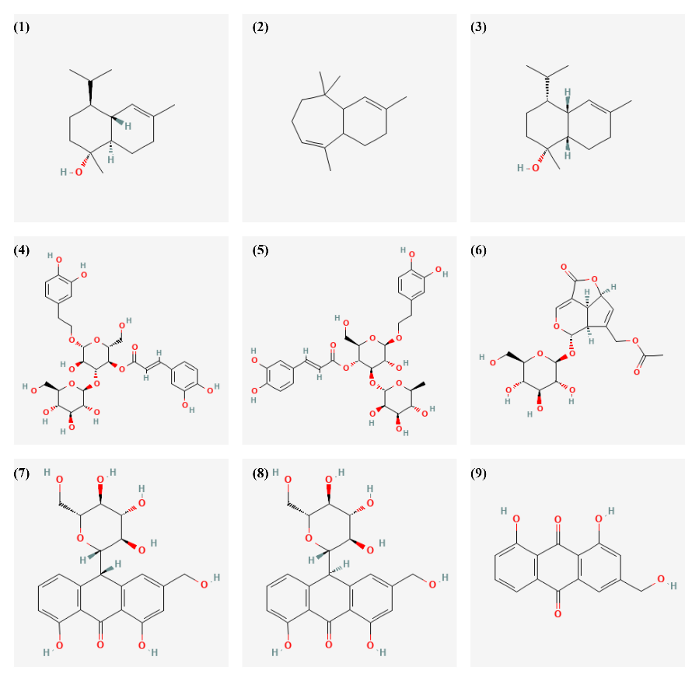
Fig. 1. 2D chemical structures of plant-derived ligands

2.2. Molecular docking analysis
Molecular docking is a target-based, in silico approach in computational biology that evaluates the spatial orientation and binding affinity of small molecules at the active sites of protein targets. It serves as a critical preliminary step in predicting the potential interactions and pharmacological behavior of candidate compounds toward their biological targets (Paggi et al., 2024). In this study, AutoDock Vina v.12.5, embedded within the UCSF Chimera platform, was employed to perform molecular docking simulations (Pettersen et al., 2004; Trott & Olson, 2010). The three-dimensional structures of the target proteins were retrieved in .pdb format from the Protein Data Bank (PDB). To identify the active binding pockets of these proteins, the CASTp 3.0 web server was utilized. Two protein targets associated with wound site inflammation were selected for docking: TGF-Beta Receptor Type 1 Kinase Domain (T204D, PDB ID: 5E8W) and Glycogen Synthase Kinase-3 Beta (GSK-3β, PDB ID: 5OY4) (McCallum et al., 2021). Additionally, to investigate potential inhibition of antimicrobial activity at the wound site, the transcriptional regulator MvfR from Pseudomonas aeruginosa (PDB ID: 4JVI) was used as a microbial protein target (Xiao et al., 2006). The ligand structures were obtained in .sdf format from the PubChem database and subsequently prepared and introduced into the docking workflow (Kim et al., 2023). Energy minimization was carried out for all protein and ligand structures. The AMBER ff14SB force field was applied for protein residues, with AM1-BCC charge assignments for proteins and Gasteiger charges for ligands (Kaymak et al., 2025). For docking simulations, the Lamarckian Genetic Algorithm was employed. Binding poses with Root Mean Square Deviation (RMSD) values less than 2.0 Å were considered for further analysis. The resulting protein–ligand complexes were visualized and analyzed using Discovery Studio Visualizer (Visualizer, 2005).

2.3. Molecular dynamic (MD) simulations
MD simulations were performed on the phytochemicals that exhibited the strongest binding affinities. The simulations were conducted using the AMBER99SB force field in combination with the BioBB-Wfs workflow-based MD protocol (Andrio et al., 2019). Initially, the protein–ligand complexes obtained from molecular docking were solvated using the TIP3P water model within an octahedral simulation box. To achieve electrostatic neutrality, counter-ions were added to the system at a concentration of 0.05 M. The entire system was then subjected to equilibration under both NVT (constant volume and temperature) and NPT (constant pressure and temperature) ensembles for 1 nanosecond. During the NVT phase, the temperature was maintained at 300 K, while in the NPT phase, the pressure was kept constant at 1.0 bar. Following equilibration, a production molecular dynamics (MD) simulation was carried out for 500 picoseconds. The simulation trajectory was subsequently analyzed to assess the structural stability and dynamic behavior of the complexes over time. For this purpose, parameters such as Root Mean Square Deviation (RMSD), Radius of Gyration (Rg), and total system energy (calculated via GROMACS) were evaluated (Lai et al., 2025).
2.4. ADMET properties
ADMET (Absorption, Distribution, Metabolism, Excretion, and Toxicity) profiling was conducted using the SwissADME and pkCSM web-based prediction tools (Daina et al., 2017; Pires et al., 2015). Additionally, relevant data from the literature were incorporated to support and validate computational predictions. For this analysis, the chemical structures of the selected bioactive compounds were obtained in SMILES format from the PubChem database and subsequently submitted to the respective platforms. The integrated use of these computational tools allowed for a comprehensive assessment of pharmacokinetic properties and potential toxicological effects, thereby providing critical insights into the drug-likeness and safety profiles of the investigated compounds.

2.5. Docking-derived synergy scoring method
Synergistic effects refer to the phenomenon where the combined action of two or more compounds produces a biological effect greater than the sum of their individual effects (Gilbert & Alves, 2003). In drug discovery and natural product research, understanding and quantifying synergy is crucial as it can lead to enhanced therapeutic efficacy, reduced dosage requirements, and minimized side effects. Computational approaches, such as molecular docking, provide valuable insights into the potential synergistic interactions at the molecular level by evaluating how compounds bind and inhibit target proteins simultaneously (Chaachouay, 2025). This method introduces a novel method to quantify synergy based on inhibition constants derived from docking simulations, facilitating a more precise assessment of combined compound effects before experimental validation. First, the relationship between the binding free energy (ΔG, in kcal/mol) obtained from molecular docking and the inhibition constant (𝐾𝑖):

$$∆G=RT.ln⁡(Ki)$$  $$Ki=e^{∆G/RT}$$ | (1)

Where, ΔG: binding free energy (kcal/mol), R: gas constant ≈ 1.987 cal/(mol·K), T: absolute temperature (298 K), Ki: inhibitor constant (M).
The expressions required for synergy to be achieved are as follows; the binding energies of the compound from plants A and B are ΔGA and ΔGB, respectively. For the synergistic effect to be observed, the following equation must be obtained (Eq. 2),
$$ΔG_{AB} < ∆G_{A}+ ∆G_{B}$$ | (2)

So, when they bind together the total energy is lower, which describes the synergistic effect with more stable binding. If we develop a score that describes this mathematically (Eq.3),

$$S=\left(∆G_{A}+ ∆G_{B}\right)- ΔG_{AB}$$ | (3)

According to the Chou–Talalay method (Wang et al., 2003), a value of S > 0 indicates a synergistic effect, S = 0 indicates an additive effect, and S < 0 suggests an antagonistic interaction. If we reconstruct the same model over Ki, assuming theoretical inhibition rates (Eq. 4),

$$S= \left(\frac{1}{K_{i,A}}+ \frac{1}{K_{i,B}}\right)- \frac{1}{K_{i,AB}}$$ | (4)

Synergy calculations were derived based on an equimolar two or three-component formulation of the selected plants, and all mathematical operations were carried out using Mathematica v.13.0 software.

2.6. Statistical analysis
All experimental data were expressed as mean ± standard deviation (SD) of at least three independent replicates. Statistical analyses were performed using one-way analysis of variance (ANOVA) followed by Tukey’s post hoc test to evaluate significant differences between groups. A P-value of less than 0.05 was considered statistically significant.

3. results and discussion

3.1. Molecular Docking and Synergy Scoring
The binding scores obtained from docking analyses, which evaluated the inhibitory effects of bioactive compounds selected from three different plants on specific wound-related markers, are presented in Figure 2. To enable a comparative assessment of inhibitory effects on the target proteins, site-specific docking analyses were also performed using control ligands. The obtained binding affinities were −11.3 kcal/mol for T204D–staurosporine, −8.8 kcal/mol for GSK-3β–{N}-[6-[3,4-bis(oxidanyl)phenyl]-1{H}-pyrazolo[3,4-b]pyridin-3-yl]ethanamide, and −7.8 kcal/mol for 4JVI–3-amino-7-chloro-2-nonyl-4(3H)-quinazolinone. These results demonstrate that, compared to their respective control groups, the binding scores for GSK-3β and 4JVI were significantly higher (P < 0.05), whereas the score for T204D exhibited an inhibition level statistically comparable to that of the control ligand (P > 0.05).

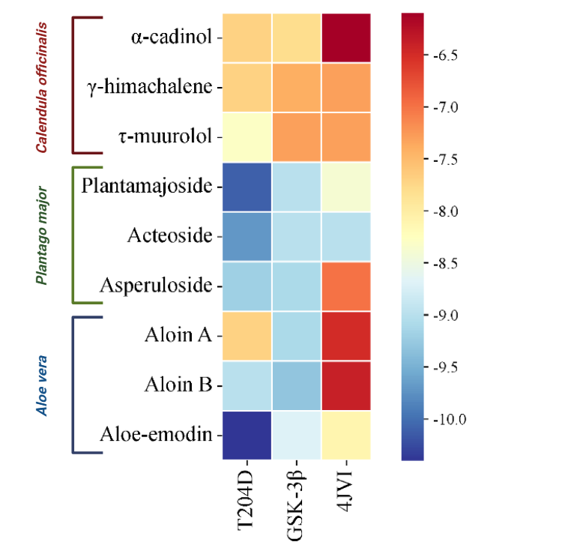

Fig. 2. Binding affinities heatmap from molecular docking analysis

According to the two-dimensional interaction diagrams obtained from molecular docking analyses, all three ligands exhibited multiple strong interactions with the active sites of their respective target proteins (Figure 3). Aloe-emodin interacted with T204D by forming conventional hydrogen bonds through its carbonyl and hydroxyl groups with residues ARG372, ASN370, and ASP400. It also engaged in Pi–sulfur and Pi–alkyl interactions with hydrophobic residues MET390 and ILE388. Previous studies have reported that aloe-emodin inhibits various kinases and can modulate PI3K/Akt signaling pathways, inducing apoptosis (Li et al., 2019; Liu et al., 2020). In the case of aloin B interacting with GSK-3β, the ligand established multiple conventional hydrogen bonds, particularly with residues ILE376, THR375, ARG344, and ASP341, thereby ensuring a strong attachment to the target protein. Furthermore, a Pi–anion interaction with GLU333 was observed, contributing to electrostatic stability within the binding site. GSK-3β is a serine/threonine kinase critically involved in the pathogenesis of various diseases, including Alzheimer’s disease, cancer, and diabetes (Beurel et al., 2015). Aloin, a bioactive compound derived from A. vera, has demonstrated anti-inflammatory and cell cycle–modulating properties, and literature suggests a possible link between these effects and GSK-3β inhibition (Huang et al., 2022). For acteoside binding to the PqsR active site, the ligand formed multiple hydrogen bonds, particularly with ARG209, ASP264, LEU208, and GLU259 residues. In addition, its extensive conjugated structure facilitated Pi–Pi stacking and Pi–alkyl interactions, providing stability within the binding site. PqsR is a key transcriptional regulator in the quorum sensing (QS) system of Pseudomonas aeruginosa, and inhibition of QS pathways has been proposed as a strategic approach to attenuate bacterial virulence (Lee & Zhang, 2015; Papenfort & Bassler, 2016). Acteoside has been documented to possess antioxidant, antimicrobial, and antibiofilm activities (Zhao et al., 2021), and its interaction with PqsR may underlie its antibacterial activity through quorum sensing inhibition.
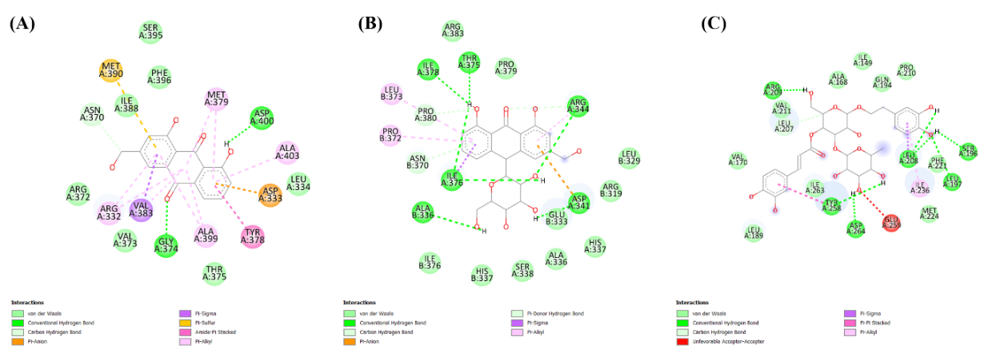

Fig. 3. 2D ligand–protein interaction maps and bond types of the top-scoring compounds

On the other hand, analysis of synergy scores revealed that the calculated values between the two most potent compounds for each target were consistent with expectations (Table 2).

Table 2. Synergistic interactions of high-affinity ligands with their protein targets

Target Protein | Compound 1  (A. vera) | Compound 2  (P. major) | Compound 3  (C. officinalis) | S-Score
T204D | Aloe-emodin | Plantamajoside | τ -muurolol | 19.93
GSK-3β | Aloin B | Asperuloside | γ-himachalene | 17.28
4JVI | Aloe-emodin | Acteoside | γ-himachalene | 17.31

For the T204D protein target, the combination of aloe-emodin from A. vera, plantamajoside from P. major, and τ-muurolol from C. officinalis exhibited the highest synergistic effect, with a score of S = 19.93. Aloe-emodin has been reported to suppress inflammation and accelerate re-epithelialization by enhancing keratinocyte migration (Dong et al., 2020). Plantamajoside promotes cellular migration, activates fibroblasts, and regulates matrix remodeling, directly contributing to the healing of chronic wounds (Yu et al., 2022). Meanwhile, sesquiterpenes such as τ-muurolol possess antimicrobial and antioxidant activities, which can reduce microbial burden at the wound site, limit the risk of infection, and support re-epithelialization (Kamli et al., 2024). The simultaneous targeting of cell proliferation, inflammation, and oxidative stress through distinct mechanisms by these compounds provides molecular-level support for the observed high synergy score (Figure 4). Regarding the GSK-3β protein target, this kinase acts as a negative regulator of the Wnt/β-catenin signaling pathways, which control cellular proliferation and migration during wound healing (Wang et al., 2021). The inhibitory effect of Aloin B on GSK-3β is proposed to enhance fibroblast migration and collagen synthesis, thereby potentially accelerating tissue repair (Roney et al., 2024). The anti-inflammatory and wound-healing properties of asperuloside, demonstrated in both in vitro and in vivo models (Lu et al., 2022), combined with the antimicrobial and antioxidant effects of γ-himachalene (Tavakkoli et al., 2023), offer a holistic approach to addressing the multifactorial pathology of chronic wounds. On the other hand, regarding the synergistic score determined for the PqsR target protein, selected from wound-associated pathogens, the effects of aloe-emodin and acteoside have been extensively reported in the literature for their bacterial quorum sensing inhibition, antibiofilm, and antimicrobial activities (Zhao et al., 2024; Chen et al., 2017). Furthermore, the strong antimicrobial properties of γ-himachalene enhance the potential of this combination to reduce the microbial burden in chronic wounds (Tavakkoli et al., 2023).
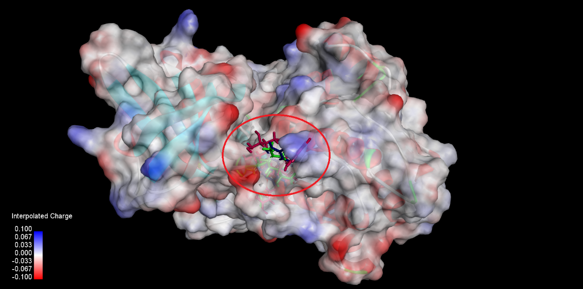

Fig. 4. Synergistic interactions of ligands with the T204D protein target

3.2. MD Simulation Results
The molecular dynamics simulation of the T204D protein in complex with aloe-emodin, plantamajoside, and τ-muurolol was performed for 500 ps to assess the structural stability and compactness of the complex. Examination of the RMSD plot revealed an initial rapid increase (~0.15 nm), followed by a quick equilibration of the system, after which it remained stable with low-amplitude fluctuations throughout the remainder of the simulation (Figure 5). This indicates that the ligand–protein complex adopts a conformationally stable structure post-binding (Hollingsworth & Dror, 2018; Shukla et al., 2020).

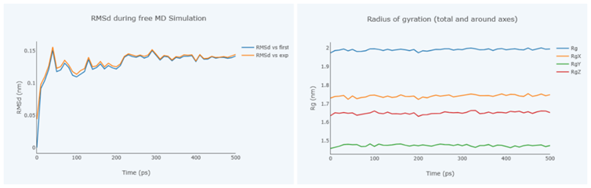

Fig. 5. MD analysis results

Moreover, the total radius of gyration (Rg) remained stable within the range of ~1.98–2.00 nm, indicating that the protein maintained its global compactness without significant structural relaxation post-binding. The stable RgX, RgY, and RgZ values along the respective axes further support the homogeneous preservation of the three-dimensional structure of the complex throughout the simulation. These findings suggest that the combination of aloe-emodin, plantamajoside, and τ-muurolol achieves high structural complementarity and conformational stability with the T204D target protein. One of the key molecular-level features of the observed synergistic effect is the maximal preservation of inhibitor activity and stabilization of biochemical structures throughout the reaction. The stable RMSD and Rg profiles indicate that the complex is likely to maintain functional integrity under biological conditions (Karplus & McCammon, 2002; Hospital et al., 2015).

3.3. ADMET Properties

The ADMET evaluation of the investigated phytochemicals highlighted critical pharmacokinetic and safety parameters pertinent to the design of a polyherbal formulation for wound healing, with the results summarized in Table 3.

Table 3. ADMET properties of phytochemicals

Bioactive Compounds | Mw (g/mol) | LogP | Skin Permeability (logKp) | BBB permeability | CYP3A4 substrate | Total Clearance  (log ml/min/kg) | Skin Sensitisation
α-cadinol | 222.37 | 3.77 | -1.92 | 0.59 | No | 1.08 | Yes
γ-himachalene | 204.35 | 4.72 | -1.64 | 0.73 | No | 1.09 | Yes
τ -muurolol | 222.37 | 3.77 | -1.92 | 0.59 | No | 1.08 | Yes
Plantamajoside | 640.59 | -2.04 | -2.73 | -2.09 | No | 0.47 | No
Acteoside | 624.59 | -1.01 | -2.73 | -1.86 | No | 0.47 | No
Asperuloside | 414.36 | -2.29 | -2.79 | -1.43 | No | 1.21 | No
Aloin A | 418.39 | -0.89 | -2.73 | -1.07 | No | 0.35 | No
Aloin B | 418.39 | -0.88 | -2.73 | -1.07 | No | 0.35 | No
Aloe-emodin | 270.24 | 1.36 | -2.74 | -0.72 | No | 0.008 | No

The lipophilic terpenoids α-cadinol (Mw: 222.37 g/mol), γ-himachalene (Mw: 204.35 g/mol), and τ-muurolol (Mw: 222.37 g/mol) are well below the 500 Dalton threshold in terms of molecular weight, indicating a potentially high dermal penetration capability. In contrast, glycoside derivatives such as plantamajoside (Mw: 640.59 g/mol) and acteoside (Mw: 624.59 g/mol) exceed the 500 Dalton limit, reducing their potential for systemic absorption; however, they are considered suitable candidates for providing local antioxidant and anti-inflammatory effects at the wound surface (O’Donovan et al., 2023). Examination of skin permeability parameters (log Kp) indicates that terpenoids possess higher dermal penetration potential compared to glycosides and polyphenolic compounds (approximately −2.73). Literature reports that logKp values in the range of −1 to −2 correspond to moderate to good skin penetration (Mortazavi et al., 2022). These characteristics suggest that terpenoids can penetrate the wound site more rapidly and effectively, while polyphenolic compounds are likely to remain on the surface to exert antioxidant effects. Regarding dermal sensitization, α-cadinol, γ-himachalene, and τ-muurolol are predicted to have “positive” skin sensitization potential, representing a safety consideration in formulation development. Various studies have reported that oxidative derivatives of essential oil components can increase the risk of allergic contact dermatitis (DeGroot & Schmidt 2021; Barbaud et al., 2023). Therefore, in polyherbal topical formulations containing terpenoids, the selection of appropriate carrier systems and minimization of oxidation are critically important. Total clearance data indicate that terpenoids (1.08–1.09 log ml/min/kg) undergo relatively rapid elimination, whereas aloe-emodin exhibits a very low clearance value (0.008), allowing it to remain at the application site for a longer duration. Low-clearance compounds may exert sustained effects at the wound site, thereby supporting epithelialization and re-epithelialization processes (Guo & DiPietro, 2010).

4. Conclusion

The findings of this study support a dual strategy for polyherbal wound healing: (i) the use of lipophilic terpenoids capable of penetrating deep tissues to exert anti-inflammatory and antimicrobial effects, and (ii) the inclusion of polyphenolic and glycoside compounds that remain at the surface to provide sustained antioxidant and re-epithelialization activity. This approach enables simultaneous support of both deep and superficial wound-healing processes. Importantly, formulation development should consider the skin sensitization potential and oxidative susceptibility of terpenoids, with stability and safety evaluations incorporated to ensure therapeutic efficacy. The observed synergistic combinations demonstrate that phytochemicals from different plants can collectively target multiple pathological stages of wound healing, including inflammation, oxidative stress, fibroblast activation, cell migration, and microbial infection. While the individual contributions of A. vera, P. major, and C. officinalis to wound repair have been reported previously, this study is the first to computationally evaluate the molecular synergy of their bioactive compounds, proposing a holistic mechanism for wound healing. These results strongly support the potential of multi-component phytotherapeutic agents derived from these plants as a novel approach for chronic wound treatment.

Consent

It is not applicable.

Ethical approval

It is not applicable.

COMPETING INTERESTS DISCLAIMER:
Authors have declared that they have no known competing financial interests OR non-financial interests OR personal relationships that could have appeared to influence the work reported in this paper.

DISCLAIMER (ARTIFICIAL INTELLIGENCE)

Author(s) hereby declares that NO generative AI technologies such as Large Language Models (ChatGPT, COPILOT, etc.) and text-to-image generators have been used during the writing or editing of this manuscript.

References

Adom, M. B., Taher, M., Mutalabisin, M. F., Amri, M. S., Abdul Kudos, M. B., Wan Sulaiman, M. W. A., Sengupta, P., & Susanti, D. (2017). Chemical constituents and medical benefits of Plantago major. Biomedicine & Pharmacotherapy, 96, 348-360.
Ak, G., Zengin, G., Ceylan, R., Fawzi Mahomoodally, M., Jugreet, S., Mollica, A., & Stefanucci, A. (2021). Chemical composition and biological activities of essential oils from Calendula officinalis L. flowers and leaves. Flavour and Fragrance Journal, 36(5), 554-563.
Albahri, G., Badran, A., Hijazi, A., Daou, A., Baydoun, E., Nasser, M., & Merah, O. (2023). The therapeutic wound healing bioactivities of various medicinal plants. Life, 13(2), 317.
Al-Warhi, T., Elmaidomy, A. H., Maher, S. A., Abu-Baih, D. H., Selim, S., Albqmi, M., Al-Sanea, M. M., Alnusaire, T. S., Ghoneim, M. M., & Mostafa, E. M. (2022). The wound-healing potential of Olea europaea L. cv. Arbequina leaves extract: an integrated in vitro, in silico, and in vivo investigation. Metabolites, 12(9), 791.
Andrio, P., Hospital, A., Conejero, J., Jordá, L., Del Pino, M., Codo, L., Soiland-Reyes, S., Goble, C., Lezzi, D., & Badia, R. M. (2019). BioExcel Building Blocks, a software library for interoperable biomolecular simulation workflows. Scientific data, 6(1), 169.
Aslam, M. S., Ahmad, M. S., Mamat, A. S., Ahmad, M. Z., & Salam, F. (2016). An update review on polyherbal formulation: A global perspective. Systematic Reviews in Pharmacy, 7(1), 35-41.
Baca Delgao, W. U., Carmona, S. V., & Chévez Arbizú, L. Y. (2018). Diseño y formulación de gel cicatrizante conteniendo extracto fluido de aloe vera, plantago major y calendula officinalis, marzo-diciembre 2017
Barbaud, A., Kurihara, F., Raison‐Peyron, N., Milpied, B., Valois, A., Assier, H., ... & Dermato‐Allergology Group of the French Society of Dermatology (DAG). (2023). Allergic contact dermatitis from essential oil in consumer products: Mode of uses and value of patch tests with an essential oil series. Results of a French study of the DAG (Dermato‐Allergology group of the French Society of Dermatology). Contact Dermatitis, 89(3), 190-197.
Beurel, E., Grieco, S. F., & Jope, R. S. (2015). Glycogen synthase kinase-3 (GSK3): regulation, actions, and diseases. Pharmacology & Therapeutics, 148, 114–131.
Chaachouay, N. (2025). Synergy, additive effects, and antagonism of drugs with plant bioactive compounds. Drugs and Drug Candidates, 4(1), 4.
Chakraborty, C., Gupta, B., & Ghosh, S. K. (2014). Mobile metadata assisted community database of chronic wound images. Wound Medicine, 6, 34-42.
Chang, Y., Hawkins, B. A., Du, J. J., Groundwater, P. W., Hibbs, D. E., & Lai, F. (2023). A guide to in silico drug design. Pharmaceutics, 15(1), 49.
Chen, F., Xie, F., Yang, B., Wang, C., Liu, S., & Zhang, Y. (2017). Streptococcus suis sortase A is Ca2+ independent and is inhibited by acteoside, isoquercitrin and baicalin. PLoS One, 12(3), e0173767.
Daina, A., Michielin, O., & Zoete, V. (2017). SwissADME: a free web tool to evaluate pharmacokinetics, drug-likeness and medicinal chemistry friendliness of small molecules. Scientific reports, 7(1), 42717.
DeGroot, A., & Schmidt, E. (2021). Essential oils: contact allergy and chemical composition. Routledge.
Dong, X., Zeng, Y., Liu, Y., You, L., Yin, X., Fu, J., & Ni, J. (2020). Aloe‐emodin: a review of its pharmacology, toxicity, and pharmacokinetics. Phytotherapy Research, 34(2), 270-281
Dubey, S., & Dixit, A. K. (2023). Preclinical evidence of polyherbal formulations on wound healing: A systematic review on research trends and perspectives. Journal of Ayurveda and integrative Medicine, 14(2), 100688.
Elshafie, H. S., Camele, I., & Mohamed, A. A. (2023). A comprehensive review on the biological, agricultural and pharmaceutical properties of secondary metabolites based-plant origin. International journal of molecular sciences, 24(4), 3266.
Gilbert, B., & Alves, L. (2003). Synergy in plant medicines. Current medicinal chemistry, 10(1), 13-20.
Guest, J. F., Fuller, G. W., & Vowden, P. (2020). Cohort study evaluating the burden of wounds to the UK’s National Health Service in 2017/2018: update from 2012/2013. BMJ open, 10(12), e045253.
Guo, S., & DiPietro, L. A. (2010). Factors affecting wound healing. Journal of Dental Research, 89(3), 219–229.
Gupta, N., Gupta, S., Shukla, V., & Singh, S. (2004). An Indian community-based epidemiological study of wounds. Journal of wound care, 13(8), 323-325.
Hollingsworth, S. A., & Dror, R. O. (2018). Molecular dynamics simulation for all. Neuron, 99(6), 1129–1143.
Hospital, A., et al. (2015). Molecular dynamics simulations: advances and applications. Advances and Applications in Bioinformatics and Chemistry, 8, 37–47.
Huang, Q., Wang, Y., Liu, L., Wang, L., & Wang, Z. (2022). Aloin: A natural anthraquinone glycoside with multiple pharmacological activities. Frontiers in Pharmacology, 13, 923350.
Jamshidi-Kia, F., Lorigooini, Z., & Amini-Khoei, H. (2017). Medicinal plants: Past history and future perspective. Journal of herbmed pharmacology, 7(1), 1-7.
Kahramanoğlu, İ., Chen, C., Chen, J., & Wan, C. (2019). Chemical constituents, antimicrobial activity, and food preservative characteristics of Aloe vera gel. Agronomy, 9(12), 831.
Kamli, H., Ali, A. A. M., Salem, Y. H., Shaikh, A., & El‐Nashar, H. A. (2024). Chemical Profiling and Enzyme Inhibitory Activities of Essential Oil Isolated From Pistacia Khinjuk Leaves: Insights on GC‐MS Analysis and Skin Aging‐Relevant Enzymes. Chemistry & Biodiversity, 21(5), e202302096.
Karole, S., Shrivastava, S., Thomas, S., Soni, B., Khan, S., Dubey, J., Dubey, S. P., Khan, N., & Jain, D. K. (2019). Polyherbal Formulation Concept for Synergic Action: A Review. Journal of Drug Delivery & Therapeutics.
Karplus, M., & McCammon, J. A. (2002). Molecular dynamics simulations of biomolecules. Nature Structural Biology, 9(9), 646–652.
Kaymak, S., Vural, N., & Çelik, H. T. (2025). In Silico Analysis of Ergosterol as Antiviral Agents Targeting Monkeypox Methyltransferase, Phosphatase and A42R Profilin-like Protein Receptors.
Kim, S., Chen, J., Cheng, T., Gindulyte, A., He, J., He, S., Li, Q., Shoemaker, B. A., Thiessen, P. A., & Yu, B. (2023). PubChem 2023 update. Nucleic acids research, 51(D1), D1373-D1380.
Lai, A. C.-Y., González-Cuesta, M., Ho, C.-H., Chi, P.-Y., Wu, K.-C., Rocha, G., Muñoz-García, J. C., Angulo, J., Fernández, J. M. G., & Chang, Y.-J. (2025). α-GalCer sp2-iminoglycolipid analogs as CD1d-dependent iNKT modulators: Evaluation of their immunotherapeutic potential in murine models of asthma and autoimmune hepatitis. European Journal of Medicinal Chemistry, 282, 117060.
Lee, J., & Zhang, L. (2015). The hierarchy quorum sensing network in Pseudomonas aeruginosa. Protein & Cell, 6(1), 26–41.
Li, C., Li, Z., Zhang, Y., & Li, H. (2019). Aloe-emodin induces apoptosis in human breast cancer cells through PI3K/Akt pathway. Journal of Huazhong University of Science and Technology Medical Sciences, 39(3), 361–365.
Liu, J., Zhang, C., Wang, X., et al. (2020). Anticancer potential of aloe-emodin: Mechanistic perspectives. Phytotherapy Research, 34(7), 1488–1507.
Lu, Y., Guan, T., Xu, S., Chen, Y. E., Shen, Q., Zhu, S., ... & Hou, S. (2022). Asperuloside inhibited epithelial-mesenchymal transition in colitis associated cancer via activation of vitamin D receptor. Phytomedicine, 101, 154070.
McCallum, R. T., & Perreault, M. L. (2021). Glycogen synthase kinase-3: a focal point for advancing pathogenic inflammation in depression. Cells, 10(9), 2270.
Mortazavi, S. M., & Moghimi, H. R. (2022). Skin permeability, a dismissed necessity for anti‐wrinkle peptide performance. International journal of cosmetic science, 44(2), 232-248.
Napagoda, M., & Wijesundara, D. (2022). Medicinal plants as sources of novel therapeutics: The history, present, and future. Chem. Nat. Prod. Phytochem. Pharm. Med. Plants, 3, 4-18.
O’Donovan, D. H., De Fusco, C., Kuhnke, L., & Reichel, A. (2023). Trends in molecular properties, bioavailability, and permeability across the bayer compound collection: miniperspective. Journal of medicinal chemistry, 66(4), 2347-2360.
Okoh, O., Sadimenko, A., Asekun, O., & Afolayan, A. (2008). The effects of drying on the chemical components of essential oils of Calendula officinalis L. African journal of biotechnology, 7(10).
Paggi, J. M., Pandit, A., & Dror, R. O. (2024). The art and science of molecular docking. Annual review of biochemistry, 93(1), 389-410.
Papenfort, K., & Bassler, B. L. (2016). Quorum sensing signal–response systems in Gram-negative bacteria. Nature Reviews Microbiology, 14(9), 576–588.
Pettersen, E. F., Goddard, T. D., Huang, C. C., Couch, G. S., Greenblatt, D. M., Meng, E. C., & Ferrin, T. E. (2004). UCSF Chimera—a visualization system for exploratory research and analysis. Journal of computational chemistry, 25(13), 1605-1612.
Pires, D. E., Blundell, T. L., & Ascher, D. B. (2015). pkCSM: predicting small-molecule pharmacokinetic and toxicity properties using graph-based signatures. Journal of medicinal chemistry, 58(9), 4066-4072.
Quave, C. L. (2018). Wound healing with botanicals: a review and future perspectives. Current dermatology reports, 7(4), 287-295.
Roney, M., & Aluwi, M. F. F. M. (2024). The importance of in-silico studies in drug discovery. Intelligent Pharmacy, 2(4), 578-579.
Roney, M., Aluwi, M. F. F. M., & Zamri, N. B. (2024). An In-Silico Approach to Evaluate Bioactive Molecules of Aloe Vera Leaf Extracts in Inhibiting the Glycogen Synthase Kinase-3β (GSK3-β) Protein for Faster Diabetic Wound Healing Potential. Biointerface Res. Appl. Chem, 14, 115.
Shedoeva, A., Leavesley, D., Upton, Z., & Fan, C. (2019). Wound healing and the use of medicinal plants. Evidence‐Based Complementary and Alternative Medicine, 2019(1), 2684108.
Shukla, R., & Tripathi, T. (2020). Molecular dynamics simulation of protein and protein–ligand complexes. In Computer-aided drug design (pp. 133-161). Singapore: Springer Singapore.
Tavakkoli, A., Asili, J., Soheili, V., Iranshahy, M., Saiar, M., Najafzadeh, M. J., & Iranshahi, M. (2023). GC/MS profiling of the essential oils from Ferula xylorhachis Rech. f. roots and aerial parts and assaying their antimicrobial activity against human skin pathogens. Journal of Essential Oil Bearing Plants, 26(5), 1236-1244.
Trott, O., & Olson, A. J. (2010). AutoDock Vina: improving the speed and accuracy of docking with a new scoring function, efficient optimization, and multithreading. Journal of computational chemistry, 31(2), 455-461.
Tümen, G., Malyer, H., Başer, K., & Öz Aydın, S. (2006). Plants used in Anatolia for wound healing. Proceedings of the IVth international congress of ethnobotany (ICEB 2005).
Visualizer, D. (2005). Discovery studio visualizer. 2. Accelrys software inc.
Wang, R., Lu, Y., & Wang, S. (2003). Comparative evaluation of 11 scoring functions for molecular docking. Journal of medicinal chemistry, 46(12), 2287-2303.
Wang, X., Li, W., Lu, S., & Ma, Z. (2021). Modulation of the Wound Healing through Noncoding RNA Interplay and GSK‐3β/NF‐κB Signaling Interaction. International journal of genomics, 2021(1), 9709290.
Xiao, G., Déziel, E., He, J., Lépine, F., Lesic, B., Castonguay, M.-H., Milot, S., Tampakaki, A. P., Stachel, S. E., & Rahme, L. G. (2006). MvfR, a key Pseudomonas aeruginosa pathogenicity LTTR-class regulatory protein, has dual ligands. Molecular Microbiology, 62(6), 1689-1699.
Yu, N., Li, Y., Wang, Y., Xu, H., Ye, F., & Fu, Q. (2022). Healing effect of carboxymethyl chitosan-plantamajoside hydrogel on burn wound skin. Burns, 48(4), 902-914.
Zhang, X., Wu, F., Yang, N., Zhan, X., Liao, J., Mai, S., & Huang, Z. (2022). In silico methods for identification of potential therapeutic targets. Interdisciplinary Sciences: Computational Life Sciences, 14(2), 285-310.
Zhao, Y., Wu, J., Chen, X., et al. (2021). Biological activities of acteoside: Recent updates. Journal of Ethnopharmacology, 281, 114530.
Zhao, Y., Zhang, T., Liang, Y., Xie, X., Pan, H., Cao, M., ... & Hu, W. (2024). Combination of aloe emodin, emodin, and rhein from Aloe with EDTA sensitizes the resistant Acinetobacter baumannii to polymyxins. Frontiers in Cellular and Infection Microbiology, 14, 1467607.

