Effective Biopesticides analysis for Blast disease of Rice in Ranchi district of Jharkhand State.

ABSTRACT

Blast disease in Rice was first reported in China in1637, in India it was first reported in 1918 Pyricularia oryzae, a fungus of Ascomycota release septate pear form conidia attack host’s leaves, node, internode area. In 1919-1920 Japan was affected by blast of rice create 40-90% yield losses, Rice blast disease was outbreak,1943 at the time of second world war in Bengal, Bangladesh, 800,000-3.8 million people died due to starvation, malaria, malnutrition known as Bengal Famine.1980-1990 Brazil was suffering continuously from rice blast, causes 100% crop loss in humid wet condition.In past 2021-2022 blast of rice disease incidence(DI) increase by 17.13 in Malda district of West Bengal. Chemical pesticide Carbendazim (0.2%) then Propiconazole (0.1%) application reduced blast DI 3.12%. Lots of Blast disease resistance varieties were developed, like Phalguna (CR Dhan 801) from ICAR-NRRI of Cuttack, Odisha in 2011. Swarna Mukhi, Jaya, Kotha, Apoorva by the Agricultural Research Station (ARS), Maruteru, Andhra Pradesh. IR-36, IR-64 were released from IRRI, CO-50 from Tamil Nadu Agriculture University, ADT-36 and ADT-37 selected from Aduthurai Rice Research Station in Tamil Nadu many more but problems were not solved completely. NRRI demonstrated an effective botanical plant extraction made up of leaves of Aegle marmelos (Bael) and Ocimum sanctum (Tulsi) against rice blast. In this experiment, Invasive Plants were chosen as biopesticides for their high quality of resistance capacity against any pathogen. Lantana camera, Ipomoea carnea, and Parthenium heterosporous were collected and used for their extraction as biopesticide tagging with T1-Lantana camera extract, T2-Ipomoea carnea extract, T3 for the extraction of Parthenium heterosporous and T4 used mixture of all. Chemical Pesticide (T5), Only Infection (T6) and Control (T7) were used for comparison purposes. All over the experimental plot T2 Ipomoea extracted solution worked very effectively as compared to others, T1, T3, T4, and T5 were more or less similar impact against Blast disease.

Keywords: Rice Blast, Biopesticides, Bengal famine, Invasive Plant.
Introduction
China was the first inventor of rice then it spread Korea, Japan, South Asia, and India. Rice farming took at peak position during late neolithic period. Oryzae rufipogon was the most popular variety at that time. It had amazing adaptability towards the climatic changes, high calorific value provides extra energy to a large population, nutritional benefits, easy growing plant took as an important precious crop in agriculture world. In India rice production increase by 11 % over the last five years. The leading states are West Bengal, Uttar-Pradesh, Punjab, Odisha, and Andra Pradesh for Rice Production.
In spite of all India cannot cultivate rice with it is full potential for climate change, water scarcity, soil degradation, labour shortage, pest and disease attacks. Brown plant hopper, yellow stem borer, Rice stem borer, Rice leaf fodder, Rice water weevil, Rice Hispa, Thrips are causing damage for rice growing. Blast due to Magnaportthe oryzae or Pyricularia oryzae a filamentous, colonial creamy colour mycelium contain pyriform conidia are causes major yield losses of rice. Pests like stem borers, plant hopper are control by imidacloprid, chlorpyrifos, thiamethoxam, organophosphate type insecticides, Fungicides are Tricyclazole, Mancozeb and Azoxystrobin used for rice. Penoxsulum, Butachlor, Prelilachlor, Bispyribae sodium help to weed remove on the field. According to Rao.et.al 2003 and Singh et.al,2008 in India total eight microbial pesticides were registered of them five bacterial (four Bacillus and one Pseudomonus fluorescences), Three fungal (Two Trichoderma, one Beauveria brassiana) and 1 viral (Nuclear Polyhedrosis Virus). Neem seed contain 0.2 to 0.6% azadiractin are collected from cold pressing and seeds residues act as a very good Plant based pesticides. R. Rai, R. Singh and S. Suthar reported compost prepared by Lantana extracted with cow dung suppressed the growth of E. coli and Salmonella spp.
Instruments
Inside laboratories: Laminar Airflow, Microscope, Autoclave, pH Meter, Analytical Balance, Test tubes, Petri Plates, Inoculation Niddle, Incubator, Measuring cylinders, Lamp, Parafilm, Marker.
Field Area: Hoe, Sickle, Measuring tape, Water Sprinkling Bucket, Water Pipe, Knief, Axe, Sprayer, Gloves, Garden Shear, Trowel.
Methodology: Media Preparation: PDA media preparation: 39 grams of PDA powder of Hi- Media dissolved in 1 liter of distilled water through boiling then sterilized in an autoclave for 15 mins at 121⁰C (15 psi). Maintain pH 5.6, then slants were prepared for inoculation.
Pathogen Collection and Replica preparation: Blast pathogen of rice sample as well as raw material was collected from Plant Pathology Department of Birsa Agriculture University’s Rice Field and inoculated it in DSPMU Botanical Laboratory, followed by the saline dilution method for isolation. 1 ml Pathogen was taken from sample through micro pipet and transferred it into 2% saline water containing test tube (A), again 1 ml sample from test tube (A) to transferred another 2% saline water containing test tube (B)10⁻¹, similarly sample kept in test tube (B)10⁻² to test tube (C)10⁻³, and its repeat up to 5 times ,(D)10⁻⁴ and (E)10⁻⁵(Nair.S, Baranwal.S, et.al,2021).1 ml sample from each test tubes poured within individual agar petri plates through micro pipet. After 6 days pure blast pathogen culture slants were prepared, keeping them at normal room temperature. After one week creamy coloured mycelium grew all over the slants.
Seedling Preparation: Lalat variety of Rice was purchased from the Plant breeding and Genetics Department of Birsa Agriculture University, Ranchi, Jharkhand. Seeds were grown on a small area with proper water supply for 25 days before planting into proper field at that time seedlings heights were 15 to 20 cm.
Field Preparation: A 35 ×40 feet agriculture land was prepared in Kanke Block Area of Ranchi District of Jharkhand State. Main Field was properly ploughed puddled and surface levelling with proper water suppling channel, also added NPK for proper Growth.
Transplanting: Seedlings were uprooted carefully from first land and transplanting to the another field one by one 2-3 seedlings together into the muddy area kept spacing 20×20 cm in between two hill. Total seven experiment area was prepared and each area contains four replicas.
Pathogen Inoculation: A week after transplanting, seedlings had adapted perfectly on the new field. Blast pathogen Inoculation procedure had started on early stage at 32th day. Two methods were followed 1- Took 28 numbers of infected test tubes, with a cotton swab infection were transfer from test tube to plant body through rubbing method. 2- Infection were collected from the sample slants, mixed it properly with water then sprayed the solution all over the field. Swabbed areas were cover through polyethylene bags (Kumar.J and Doshi,2018). Except the Control, it was planted very far from the other treatments. This inoculation methos was applied in two times, two days for two weeks during the morning before sunrises and in the afternoon after sunset.
Appearing of Infection: Initially water soaked like small spots were notified on leaves gradually its enlarged with dark brown boarder while pale white more or less greyish center. Leaf blade and sheath started to rotting and drying, nodal part become very soft and break it easily on the later stage. Panicles affected with dark brown colours without grains or some time incomplete grains. High humidity, cloudy weather is a favourable for Blast pathogen.
Biopesticides Preparation- Three invasive plants were selected for treated against this fungal infection, Lantana camera, Ipomoea carnea, Parthenium heterosporous and the fourth was mixture of all those extractions. All invasive plant’s leaves, twigs and soft stem parts were collected from the roadside in adequate amount, washing them properly to removed dust, then deep them into water for 24 hrs into the different containers, then all containers were boiled for 3 hr separately. A dark green strong unpleasant smell solution were ready for used as plant-based pesticide.
Applying of Biopesticides: Total seven treatments was designed in RBD style, one of then Control (without any infection inoculation and spraying any solution) named T7. Rest T1 toT6 tagged field were inoculated with infection. T1 field treated with Lantana camera extracted biopesticide, T2 with Ipomoea carnea extraction, T3 with Parthenium heterosporous extracted biopesticides, T4- field treated with mixture of all four invasive plants extracted biopesticides, T5- fields crops were protected by chemical pesticide solution and lastly T6 field treated with only infection without spraying any disease preventing solution.
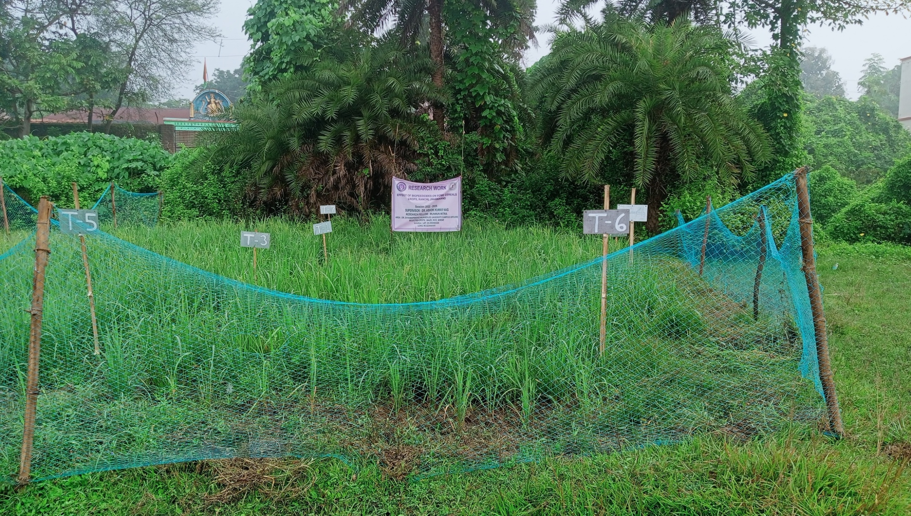
Fig. 1: Rice Experimental Plot.
Result

Percentage of Disease Plant:
FORMULA: (Number of Diseased Plants/Total no. of Plants) ×100 Yadav. P et al (2022)
Treatment | Percentage of disease (R1) | Percentage of disease (R2) | Percentage of disease (R3) | Percentage of disease (R4) | Mean ± SD
T1 | 53.99 | 53.98 | 54 | 53.99 | 53.99±0.07
T2 | 16.11 | 16.11 | 16.09 | 16.12 | 16.10±0.01
T3 | 58.56 | 59.48 | 59.65 | 58.27 | 58.99±0.58
T4 | 49.12 | 48.99 | 48.15 | 48.25 | 48.62±0.43
T5 | 56.99 | 56.12 | 56.48 | 56.12 | 56.42±0.35
T6 | 82.18 | 82.19 | 82.12 | 82.18 | 82.16±0.03
T7 | 12.92 | 12.91 | 12.89 | 12.86 | 12.89±0.02
Table 1a: Percentage and Mean ± SD of Disease Plant

Source | D.F. | S.S. | M.S. | Cal F | Tab F | S. Em. |  | C.D.
Replication | 3 | 0.40 | 0.13 | 1.08 | 3.16 | 0.13 |  | N.S.
Treatment | 6 | 14553.57 | 2425.59 | 19519.39 | 2.66 | 0.18 |  | 0.52
Error | 18 | 2.24 | 0.12
Total | 27 | 14556.20 |  |  |  | C.V. % |  | 0.75
Table 1b: ANOVA outcomes of the Percentage of Disease Plant
Table 1: Percentage of infection
FORMULA: (Total Area- uninfected area) = Infected Area.
Treatments | Average Infected Area (R1) | Average Infected Area (R2) | Average Infected Area (R3) | Average Infected Area (R4) | Mean
T1 | 49.125 | 49.146 | 49.178 | 48.199 | 48.91±0.41
T2 | 21.936 | 21.976 | 21.952 | 21.964 | 21.95±0.01
T3 | 52.976 | 52.956 | 52.982 | 52.845 | 52.93±0.06
T4 | 48.976 | 48.967 | 48.956 | 48.972 | 48.96±0.01
T5 | 51.985 | 51.925 | 51.997 | 51.956 | 51.96±0.03
T6 | 79.995 | 80.023 | 79.923 | 79.985 | 79.98±0.04
T7 | 9.845 | 9.875 | 9.826 | 9.715 | 9.815±0.06
Table 2a. Area of Plant Infections (cm) and Mean

Source | D.F. | S.S. | M.S. | Cal F | Tab F | S. Em. |  | C.D.
Replication | 3 | 0.16 | 0.05 | 1.67 | 3.16 | 0.07 |  | N.S.
Treatment | 6 | 12540.92 | 2090.15 | 67156.05 | 2.66 | 0.09 |  | 0.26
Error | 18 | 0.56 | 0.03
Total | 27 | 12541.63 |  |  |  | C.V. % |  | 0.39
Table 2b. ANOVA outcomes of the Area of Plant infections (cm)
Table 2: Area of plant infection
FORMULA: (Total leaves area – uninfected area) = infected area.
Treatments | Average of Leaves Infections area (R1) | Average of Leaves Infections area (R2) | Average of Leaves Infections area (R3) | Average of Leaves Infections area (R4) | Mean
T1 | 14.156 | 13.998 | 14.132 | 14.169 | 14.11±0.07
T2 | 8.954 | 9.236 | 9.235 | 9.198 | 9.155±0.12
T3 | 19.187 | 18.967 | 18.981 | 19.152 | 19.07±0.10
T4 | 12.985 | 12.892 | 12.954 | 12.898 | 12.93±0.04
T5 | 17.156 | 17.121 | 17.108 | 17.182 | 17.14±0.03
T6 | 27.982 | 27.966 | 28.116 | 27.983 | 28.01±0.06
T7 | 5.965 | 6.128 | 5.924 | 6.158 | 6.043±0.10
Table 3a. Average Area of Leaves Infections (cm) and Mean

Source | D.F. | S.S. | M.S. | Cal F | Tab F | S. Em. |  | C.D.
Replication | 3 | 0.02 | 0.01 | 0.56 | 3.16 | 0.04 |  | N.S.
Treatment | 6 | 1238.37 | 206.40 | 22895.71 | 2.66 | 0.05 |  | 0.14
Error | 18 | 0.16 | 0.01
Total | 27 | 1238.55 |  |  |  | C.V. % |  | 0.62
Table 3b: ANOVA outcomes of Average Area of Leaves Infections (cm)
Table 3: Leave area infection
FORMULA: Add all good grains per branch/Total no of branches
Treatments | Good Grains (R1) | Good Grains (R2) | Good  Grains (R3) | Good Grains (R4) | Mean
T1 | 122.86 | 123.15 | 122.94 | 123.19 | 123.03±0.14
T2 | 138.95 | 138.92 | 137.12 | 138.92 | 138.47±0.78
T3 | 102.95 | 103.96 | 103.11 | 102.86 | 103.22±0.44
T4 | 128.96 | 128.87 | 128.93 | 129.16 | 128.98±0.11
T5 | 116.12 | 115.99 | 115.98 | 116.11 | 116.05±0.07
T6 | 29.19 | 30.12 | 29.87 | 28.97 | 29.54±0.47
T7 | 148.92 | 149.1 | 148.99 | 148.98 | 148.99±0.06
Table 4a. Numbers of Good Grains (per branch) and Mean

Source | D.F. | S.S. | M.S. | Cal F | Tab F | S. Em. |  | C.D.
Replication | 3 | 0.75 | 0.25 | 1.28 | 3.16 | 0.17 |  | N.S.
Treatment | 6 | 37483.52 | 6247.25 | 31952.93 | 2.66 | 0.22 |  | 0.66
Error | 18 | 3.52 | 0.20
Total | 27 | 37487.80 |  |  |  | C.V. % |  | 0.39
Table 4b: ANOVA outcomes of Numbers of Good Grains (per branch)
Table 4: Numbers of Good Grains
FORMULA: Add all infected grains per branch/ Total no of branches.
Treatments | Infected Grains (R1) | Infected Grains (R2) | Infected Grains (R3) | Infected Grains (R4) | Mean
T1 | 39.998 | 40.132 | 39.982 | 40.185 | 40.07±0.09
T2 | 20.658 | 20.175 | 20.765 | 20.124 | 20.43±0.28
T3 | 54.856 | 53.845 | 53.846 | 54.193 | 54.18±0.41
T4 | 36.124 | 36.268 | 36.561 | 35.952 | 36.22±0.22
T5 | 43.925 | 44.121 | 43.895 | 44.135 | 44.01±0.11
T6 | 93.476 | 94.103 | 93.872 | 93.398 | 93.71±0.29
T7 | 17.986 | 17.895 | 18.102 | 17.962 | 17.98±0.07
Table 5a. Numbers of Infected Grains (per branches) and Mean

Source | D.F. | S.S. | M.S. | Cal F | Tab F | S. Em. |  | C.D.
Replication | 3 | 0.11 | 0.04 | 0.44 | 3.16 | 0.11 |  | N.S.
Treatment | 6 | 15531.42 | 2588.57 | 30559.82 | 2.66 | 0.15 |  | 0.43
Error | 18 | 1.52 | 0.08
Total | 27 | 15533.06 |  |  |  | C.V. % |  | 0.66
Table 5b. ANOVA outcomes of the Number of Infected Grains (per branches)
Table 5: Infected grains
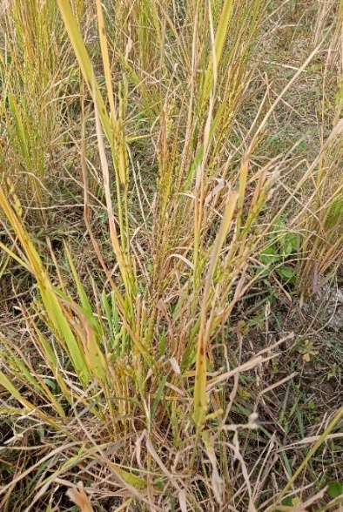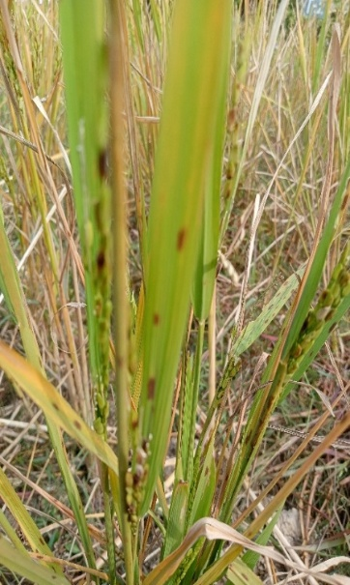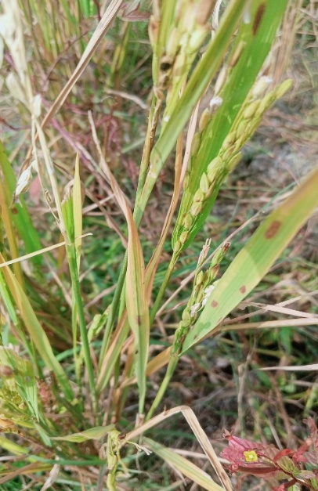
T-4
T-2
T-7
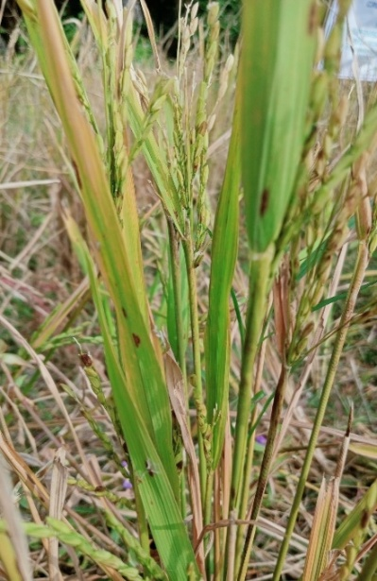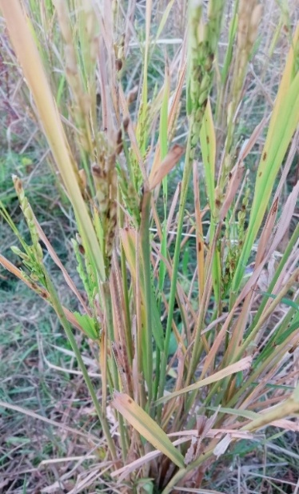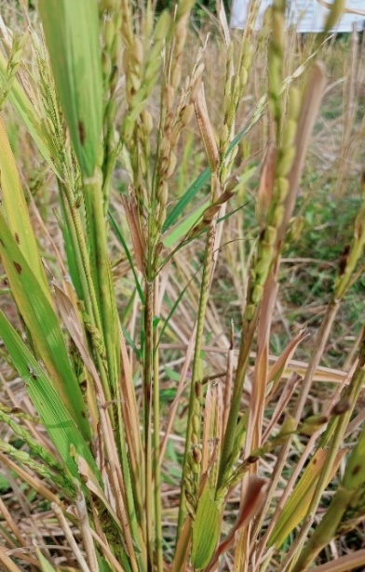
T-5

T-3
T-1
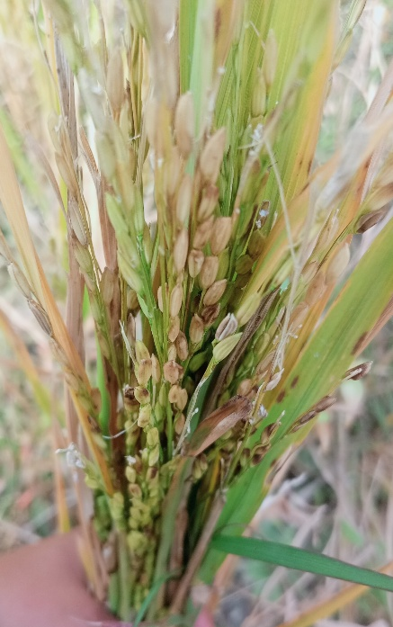
T-6
Fig 2: Blast infection in rice (T-1 to T-6)

Graph 1: Percentage of Disease

Graph 2: Area of Infection

Graph 3: Leaves infection area

Graph 4: Good Grains

Graph 5: Infected Grains

Graph 6: Bar Graph indicating the percentage of infection

Graph 7: Bar Graph indicating the area of infection

Graph 8: Bar Graph indicating the leaf infection area

Graph 9: Bar Graph indicating good grains

Graph 10: Bar Graph indicating infected grains

Discussion
Table no. 1, Percentage of infection: The highest percentage of infection was acquired in T6 (82.16%), which failed to protect crops effectively. T2 was inoculated with an infection, but its infection (16.10%) was nearly the same as that of control T7 (12.86%). Intermediate-level protection capacity was noted in T4 (48.62%), T1(53.99%), T5(56.42%), and T3 (58.99%).
The analysis of variance (ANOVA) revealed a highly significant effect of treatments. The calculated F-value 19519.39 > F-value (2.66) at the 5% level of significance, indicating that the treatments differed significantly from each other. and replication effect, F = 1.08 < 3.16 non-significant described the uniform environment.
Table no. 2, Area of plant infection: T7 recorded the lowest infected area (9.815 ± 0.06), indicating the highest level of effectiveness in reducing disease severity. This was followed by T2 (21.95 ± 0.01), which also showed a considerable reduction compared to other treatments. In contrast, T6 exhibited the highest infected area (79.98± 0.04), suggesting poor control efficiency.
Anova result: Calculated F value 670156.05> F-value (2.66) at 5%.CD value 0.26 and CV value-0.39%, replication effect -1.67, describe experiment was statistically significant with a uniform environment.
Table no. 3, Leave area infection: like the plant area infection, T7 control plants leaves infected by 6.043± 0.10, and T2 leaves infected by 9.15± 0.02, which was much better than the other treatments, T1 (14.11 ± 0.07) and T4 (12.93 ± 0.04). T3 (19.07 ± 0.10) and T5 (17.14 ± 0.03) report a high level of infection, followed by T6 (28.01 ± 0.06).
Anova Table:
F-value (22895.71) was much greater than the tabulated F-value (2.66), indicating treatments differed significantly from each other. CV Value-0.62% and CD- Value-0.14 at 5% level denote that the experiment was reliable.
Table no. 4, Number of good grains: T7 contains an average of 148.99 seeds, while T2 contains 138.47. Intermediate values were moderately well in T1-123.03 and T4-128.98, comparatively in T5-116.05 and T3-103.22 and T6 contains the average least number of good grains was 29.54.
Anova Analysis-
CF-value 31952.93> Table F-value 2.66, highly significantly different, C.V value= 0.39% was a reliable experiment with CD Value-0.66 and replication effect (F)= 1.28 < 3.16 was non-significant.
Table no. 5, Infected grains: the lowest number of infected grains was observed in T7 -17.98 ± 0.07, followed closely by T2 -20.43 ± 0.28, indicating superior efficacy in reducing grain infection. In contrast, T6 recorded the highest infection 93.71 ± 0.29. Intermediate levels of infection were noted in T1-40.07 ± 0.09, T4-36.22 ± 0.22, and T5-44.01 ± 0.11, while T3 showed a comparatively high variability in replication data with a mean value of 54.18 ± 0.41.
Anova Result-
CF-value 30559.82 > Tabulated F-value 2.66 was significant at 5% level, C.V =0.66% and CD=0.43 showed reliable data.
The analysis of variance (ANOVA) revealed a highly significant difference (p < 0.01) among treatments with respect to disease incidence. Further comparison of treatment means using the Least Significant Difference (LSD) test at 5% probability level indicated that T7 and T2 were statistically superior to all other treatments, recording significantly lower disease percentages. Treatments T1, T3, T4, and T5 formed a homogeneous group, were significantly less effective than T2. The highest disease incidence was observed in T6 treated with only infection.
Conclusion
Biopesticides regulation very strict in Europian Countries, only four type biopesticide are approved by EU legislation Barros-Rodríguez A et al (2020).These countries now using digital technologies, AI, robotics for optimal resource utilization, promoting sustainable crop production known as the green deal.⁸ China uses the Rice-crayfish integrated farming system (RCIS), mixed chemical pesticide with biopesticides to enhance the crop’s nutritional value, soil fertility, and reduce the toxicity level, as well as total cost. Chemical pesticides adversely affect aquatic life, hamper the pH value of soil, cause cancer, kidney disease, neuro problems. Union Carbide Plant used MIC methyl iso cyanide to make chemical pesticides, took more than 15000 lives, more than 500000 were injured, babies born with chronic respiratory diseases, cancers, birth defects, and blindness still now in Bhopal. Major component of chemical pesticides neonicotinoids acts on nicotinic acetylcholine receptors in insects responsible for colony collapse disorder of bees. Carbamates highly toxic substance, Organochlorine are responsible for bioaccumulation. Chemical pesticides protect crops simultaneously causes harmful affect to environments. Plants also contain identical chemical substance but their adverse effects are minimum or not life threatening. Invasive plants such a powerful group which never destroy by any pathogen or external forces. Their chemical constitute can be act as a protector for other crops to enhance defense power against pathogens.
Disclaimer (Artificial intelligence)
Option 1:
Author(s) hereby declare that NO generative AI technologies such as Large Language Models (ChatGPT, COPILOT, etc.) and text-to-image generators have been used during the writing or editing of this manuscript.
Option 2:
Author(s) hereby declare that generative AI technologies such as Large Language Models, etc. have been used during the writing or editing of manuscripts. This explanation will include the name, version, model, and source of the generative AI technology and as well as all input prompts provided to the generative AI technology
Details of the AI usage are given below:
1.
2.
3.
References
- Pasrija, R., & Kumari, D. (2025). Protocols for studying pathogenic fungi. Springer Nature.
- Debnath, D., Rayanoothala, P., Mahapatra, S., (2025) Evolutionary of Rice Blast disease in key cultivation regions of the Indo-Gangetic plains. Discover Plants.2(118)
- Johnson, E. (2025). Rice farming life. Publifye AS.
- 1.Avinash, G., Namasivayam, S. K. R., Bharani, R. A., Samrat, K., & Tamilselvi, M. (2024). Eco-friendly formulation preparation of fungal biopesticide Metarhizium anisopliae and its impact on the viability, insecticidal activity and pesticidal compatibility. Journal of Environmental Biology, 45(6), 686–694. https://doi.org/10.22438/jeb/45/6/mrn-5476
- Praneetvatakul, S., Schreinemachers, P., Vijitsrikamol, K., & Potchanasin, C. (2024). Policy options for promoting wider use of biopesticides in Thai agriculture. Heliyon, 10(2), e24486. https://doi.org/10.1016/j.heliyon.2024.e24486
- Srivastava, D., Shamim, M., Ahmad, M. M., & Upadhyay, R. S. (2024). Fungal diseases of rice and their management. CRC Press.
- Shi, L., Zhou, X., & Qi, P. (2024). Resin acid copper salt, an interesting chemical pesticide, controls rice bacterial leaf blight by regulating bacterial biofilm, motility, and extracellular enzymes. Molecules, 29(18), 4297. https://doi.org/10.3390/molecules29184297
- Balaska, V., Adamidou, Z., Vryzas, Z., & Gasteratos, A. (2023). Sustainable crop protection via robotics and artificial intelligence solutions. Machines, 11(8), 774. https://doi.org/10.3390/machines11080774
- Chakraborty, B., Banerjee, S., Samanta, S., Debangshi, U., Yadav, S. V., Khaire, P. B., Shelar, V. B., Bansode, G. D., & Landage, K. B. (2023). Detection of Rice Blast Disease (Magnaporthe grisea) Using Different Machine Learning Techniques. International Journal of Environment and Climate Change, 13(8), 2256–2264. https://doi.org/10.9734/ijecc/2023/v13i82190
- Mohanty, S. S., & Mohanty, K. (2023). Valorization of Chlorella thermophila biomass cultivated in dairy wastewater for biopesticide production against bacterial rice blight: a circular biorefinery approach. BMC Plant Biology, 23(1). https://doi.org/10.1186/s12870-023-04579-z
- Singh, N., Jiwani, G., Rocha, L. S., & Mazaheri, R. (2023). Bioagents and Volatile organic compounds: an emerging control measure for rice bacterial diseases. In Apple Academic Press eBooks (pp. 255–274). https://doi.org/10.1201/9781003331629-16
- Gill.K. P, Cherekar.N.M. (2023). Antimicrobial Activity of Ipomoea Carnea Leaves .Asian Journal of Microbial.Biotech. Env.Sc .25 (4) 803-805.
- Ayilara.S.M., Adeleke.S.B., Akinola.A.S., Fayose.A.C., Adeyemi.T.U., Gbadegesin.A.L., Omole.K.R., Johnson.M.R., Uthman.O.Q., Babalola.O.O (2023) Biopesticides as a promising alternative to synthetic pesticides: A case for Microbial pesticides,phytopesticides,and nanobiopesticides. Frontiers Microbiology. (14). https://doi.org/10.3389/fmicb.2023.1040901.
- Zheng, Y., Liu, Y., Zhang, J., Liu, X., Ju, Z., Shi, H., Mendoza‐Mendoza, A., & Zhou, W. (2023). Dual role of endophytic entomopathogenic fungi: induce plant growth and control tomato leafminer Phthorimaea absoluta. Pest Management Science, 79(11), 4557–4568. https://doi.org/10.1002/ps.7657
- Liu, K., Qi, Z., Tan, L., Yang, C., & Hu, C. (2023). Mixed Use of Chemical Pesticides and Biopesticides among Rice–Crayfish Integrated System Farmers in China: A Multivariate Probit Approach. Agriculture, 13(8), 1590. https://doi.org/10.3390/agriculture13081590
- Vocaturo, E., Rani, G., Dhaka, V. S., & Zumpano, E. (2023a). AI-Driven agriculture: Opportunities and challenges. 2021 IEEE International Conference on Big Data (Big Data), 3530–3537. https://doi.org/10.1109/bigdata59044.2023.10386314
- Tavenner, K., Crane, T. A., Bullock, R., & Galiè, A. (2022). Intersectionality in gender and agriculture: toward an applied research design. Gender Technology and Development, 26(3), 385–403. https://doi.org/10.1080/09718524.2022.2140383
- Huang, Y., Luo, X., & Li, Z. (2022). Substitution or complementarity: why do rice farmers use a mix of biopesticides and chemical pesticides in China? Pest Management Science, 78(4), 1630–1639. https://doi.org/10.1002/ps.6781
- Yadav, P., Sharma, S.S., Kumari, P., Kumar.A (2022).Host Plant Resistance for Effective Management of Blended Leaf and Sheath Blight in Maize caused by Rhizoctonia solani f. sp sasakii.Biological forum, 14(2):555-559.
- Singh, T., Bhadwaj, H., Verma, L., Navadia, N. R., Singh, D., Sakalle, A., & Bhardwaj, A. (2022). Applications of AI in agriculture. In BENTHAM SCIENCE PUBLISHERS eBooks (pp. 181–203). https://doi.org/10.2174/9789815036060122010011
- Abd-ElGawad, A. M., Elshamy, A. I., Elgorban, A. M., Hassan, E. M., Zaghloul, N. S., Alamery, S. F., Gendy, A. E. G. E., Elhindi, K. M., & Ei-Amier, Y. A. (2022). Essential Oil of Ipomoea carnea: Chemical Profile, Chemometric Analysis, Free Radical Scavenging, and Antibacterial Activities. Sustainability, 14(15), 9504. https://doi.org/10.3390/su14159504
- Hernandez-Tenorio, F., Miranda, A. M., Rodríguez, C. A., Giraldo-Estrada, C., & Sáez, A. A. (2022). Potential Strategies in the Biopesticide Formulations: A Bibliometric analysis. Agronomy, 12(11), 2665. https://doi.org/10.3390/agronomy12112665
- Samal, S., & Parida, S. (2021). Major fungal diseases of rice: a case study. Asian Journal of Biological and Life Sciences, 10(2), 469–475. https://doi.org/10.5530/ajbls.2021.10.62
- Vazquez, J. P. G., Torres, R. S., & Perez, D. B. P. (2021). Scientometric analysis of the application of artificial intelligence in agriculture. Journal of Scientometric Research, 10(1), 55–62. https://doi.org/10.5530/jscires.10.1.7
- Nair.S., Baranwal.S., Srivasta.A.,Abraham.J (2021) Isolation and optimazation of Laccase producing Marine Fungi Neurospora Crassa AJAS1. Research.J.Pharma and Tech.14(12),6592-6600. doi-10.52711/0974-360x2021:1140

- Sharma, R., Kukreja, V., & Kadyan, V. (2021). Rice diseases detection using Convolutional Neural Networks: A Survey. 2021 International Conference on Advance Computing and Innovative Technologies in Engineering (ICACITE), 995–1001. https://doi.org/10.1109/icacite51222.2021.9404620
- Steinke, J., Ortiz-Crespo, B., Van Etten, J., & Müller, A. (2021). Participatory design of digital innovation in agricultural research-for-development: insights from practice. Agricultural Systems, 195, 103313. https://doi.org/10.1016/j.agsy.2021.103313
- Reddy, D. S., & Chowdary, N. M. (2021). Botanical biopesticide combination concept—a viable option for pest management in organic farming. Egyptian Journal of Biological Pest Control, 31(1). https://doi.org/10.1186/s41938-021-00366-w
- Ganeshkumar, C., Jena, S. K., Sivakumar, A., & Nambirajan, T. (2021). Artificialintelligence in agricultural value chain: review and future directions. Journal of Agribusiness in Developing and Emerging Economies, 13(3), 379–398. https://doi.org/10.1108/jadee-07-2020-0140
- Naik, R. H., Pallavi, M. S., Kumar, K. P., Vanitha, B., Reddy, V. C. S., Shwetha, A., S, N., P, N., Nidoni, R. U., & Bheemanna, M. (2021). Determination of 72 chemical pesticides and estimation of measurement of uncertainty in rice using LC-MS/MS and GC-MS/MS. Food Analytical Methods, 14(9), 1788–1805. https://doi.org/10.1007/s12161-021-02000-9
- Sok, S., Chhinh, N., Hor, S., & Nguonphan, P. (2021). Climate change impacts on rice cultivation: A comparative study of the Tonle SAP and Mekong River. Sustainability, 13(16), 8979. https://doi.org/10.3390/su13168979
- Barros-Rodríguez A, Rangseekaew P, Lasudee K, Pathom-Aree W, Manzanera M. Regulatory (2020) risks associated with bacteria as biostimulants and biofertilizers in the frame of the European Regulation (EU) 2019/1009. Sci Total Environ. 20;740: 140239. doi: 10.1016/j.scitotenv.2020.140239. Epub 2020 Jun 15. PMID: 32563889.
- Hale, E. H., Jadallah, C. C., & Ballard, H. L. (2021). Collaborative research as boundary work: learning between rice growers and conservation professionals to support habitat conservation on private lands. Agriculture and Human Values, 39(2), 715–731. https://doi.org/10.1007/s10460-021-10283-1
- Patel, S. (2011). Harmful and beneficial aspects of Parthenium hysterophorus: an update. 3 Biotech, 1(1), 1–9. https://doi.org/10.1007/s13205-011-0007-7
- Ameen, F., & Al-Homaidan, A. A. (2020). Compost Inoculated with Fungi from a Mangrove Habitat Improved the Growth and Disease Defense of Vegetable Plants. Sustainability, 13(1), 124. https://doi.org/10.3390/su13010124
- Srivastava, P. K., Singh, V. P., Singh, A., Tripathi, D. K., Singh, S., Prasad, S. M., & Chauhan, D. K. (2020). Pesticides in crop production: Physiological and Biochemical Action. John Wiley & Sons.
- Kumar Rajiv (2020) Management of Sheath Blight and Blast Disease of Rice. International Journal of Current Microbiology and Applied Sciences.19(9),1659-1665
- Rai, R., Singh,R., Suthar, S., (2020) Production of compost with biopesticide properly from toxic weed Lantana: Quantification of alkaloids in composting and bacterial pathogen suppression. Journal of Hazardous Materials,401
https:// doi.org/10.1016/J.hazmat.2020.123332
- Zhang, Y., Liu, B., Huang, K., Wang, S., Quirino, R. L., Zhang, Z., & Zhang, C. (2020). Eco-Friendly Castor Oil-Based Delivery System with Sustained Pesticide Release and Enhanced Retention. ACS Applied Materials & Interfaces, 12(33), 37607–37618. https://doi.org/10.1021/acsami.0c10620
- Dang, A. T. N., Kumar, L., & Reid, M. (2020). Modelling the potential impacts of climate change on rice cultivation in Mekong Delta, Vietnam. Sustainability, 12(22), 9608. https://doi.org/10.3390/su12229608
- Marichelvam, M. K., Jawaid, M., & Asim, M. (2019). Corn and rice Starch-Based Bio-Plastics as alternative packaging materials. Fibers, 7(4), 32. https://doi.org/10.3390/fib7040032
- Parkes, B., Higginbottom, T. P., Hufkens, K., Ceballos, F., Kramer, B., & Foster, T. (2019). Weather dataset choice introduces uncertainty to estimates of crop yield responses to climate variability and change. Environmental Research Letters, 14(12), 124089. https://doi.org/10.1088/1748-9326/ab5ebb
- Suárez-Moreno, Z. R., Vinchira-Villarraga, D. M., Vergara-Morales, D. I., Castellanos, L., Ramos, F. A., Guarnaccia, C., Degrassi, G., Venturi, V., & Moreno-Sarmiento, N. (2019). Plant-Growth Promotion and Biocontrol Properties of Three Streptomyces spp. Isolates to Control Bacterial Rice Pathogens. Frontiers in Microbiology, 10. https://doi.org/10.3389/fmicb.2019.00290
- Lengai, G. M., Muthomi, J. W., & Mbega, E. R. (2019). Phytochemical activity and role of botanical pesticides in pest management for sustainable agricultural crop production. Scientific African, 7, e00239. https://doi.org/10.1016/j.sciaf.2019.e00239
- Mane, R. S., Nagarkar, R. D., Sonawane, P. P., & Vedamurthy, A. B. (2019). Brief Review on Lantana camera. International Journal of Secondary Metabolite, 6(2), 205–210. https://doi.org/10.21448/ijsm.577172
- Kumar,J and Doshi,A (2018) Pathogenicity Test and convenient inoculation Method of Xanthomus axonopodis pv. vignaeradiatae causes leaf spot of green gram. International Journal of current Microbiology and Applied Sciences 7(4):152-166.
- Ribot C, Hirsch J, Balzergue S, Tharreau D, Nottéghem JL, Lebrun MH, Morel JB. (2008) Susceptibility of rice to the blast fungus, Magnaporthe grisea. J Plant Physiol. 2008 Jan;165(1):114-24. doi: 10.1016/j.jplph.2007.06.013. Epub 2007 Oct 1. PMID: 17905473.

