Simulation and Construction of Radio Frequency Identification (RFID) Based Door Locking System Using Smart Card

ABSTRACT

Doors are meant for security and safety to prevent intrusions from unwanted persons. However, traditional locking mechanisms, reliant on physical keys, present significant challenges, including loss, theft, and unauthorised duplication, which compromise the safety of individuals and properties. This research focuses on the simulation and construction of a Radio Frequency Identification (RFID) based door locking system utilising smart card authentication. Simulation was performed using Proteus 8.0 to design and verify the RFID-based circuit before implementation. Embedded C was used to program the microcontroller, ensuring logical control of the door locking mechanism based on RFID authentication. Printed Circuit Board (PCB) files were created using Proteus software. The design stuff was carried out using these software’s layout explorer features. The physical construction was done on a Vero board using an LGT8F328P microcontroller, RC522 RFID reader, 12V solenoid lock, and relay. The system was powered using a 12V DC adapter. Testing involved scanning 4 RFID cards and 1 RFID tag—only 1 card and 1 tag were registered in memory. Simulation results showed reliable activation of lock/unlock functions, with the system responding in under 1 second per card authentication. LED indicators displayed a clear lock and unlock status throughout the process. The system, when tested, granted access only to the registered RFID cards and tags to unlock the door, while the unregistered ones were denied access. Unlike traditional locks that can be forced open or bypassed with duplicated keys, the RFID system ensures that only authorised users can gain access. This demonstrates that even a focused system like an RFID door lock can significantly increase the security of an enclosure, complementing a larger smart home system, demonstrating reliability, efficiency, ease of installation and low power consumption. The findings indicate that the RFID system provides a robust alternative to traditional locking mechanisms, mitigating issues related to lost or stolen keys while enhancing user convenience. This work contributes to the field of access control systems by demonstrating the feasibility of RFID technology in improving security measures for individuals and organisations.
Keywords: Radio frequency identification, microcontroller, smart card, embedded C, computer numerical control, Proteus
1.0 INTRODUCTION
“Security and safety of human life and property are common concerns for individuals and one of the paramount challenges facing nations and corporate organisations. Home security and possessions are one of the most essential challenges” (Alsaadi, 2015). “Human lifestyle, behaviour and thinking in modern society are changing radically with the advancement in technology, and the simple home is changing into a smart home” (Alnabhi, 2020). Due to busy lives, many people sometimes forget about home security issues. Theft that often occurs as a polemic in the midst of life creates anxiety about house doors being broken into, which results in the loss of valuables (Syarifuddin et al., 2024). “Doors are entrances to homes, offices and many other kinds of enclosures, providing access to homeowners, visitors, lawbreakers and criminals” (Ekejiuba & Folayan, 2016). “Doors are meant to be secured and to prevent intrusions from unwanted persons, and are controlled mainly by locks and keys (Chasani et al., 2024). From time past until present, security locks usually include mechanical devices made of forged metal, such as simple locks and bolts, the door chain, pin tumbler lock, the jam lock and padlock” (Ekejiuba & Folayan, 2016).
“The common way everyone is familiar with is using physical keys to lock or unlock a door, but this tested and known method comes with its challenges. There can only be one unique key for a lock. For different locks, you have different keys. Furthermore, carrying a large number of keys is a burden and increases the chance of keys getting stolen, misplaced or lost” (Anaza & Haruna, 2020). “People always remain busy in their day-to-day work and also want to ensure the safety of their belongings. Sometimes they forget to look after their necessary things like keys, wallets, etc. Without these, they are unable to access their home or any place they access using keys” (Anushri & Barkha, 2015). “In this modern world with already more than 7 billion human population, expected to exceed 11billion by 2100, crime has become ultra-modern in nature, with theft and home abduction on the rise by day” (Park et al., 2009). “This has raised questions about doors and the safety of homes. Individuals and corporate bodies are becoming more aware of the dangers associated with relying on keys and parameter fencing to provide security to exclusive areas of their apartments and organisation, because criminals and fraudsters can forge keys or make master keys that can be used to break into such rooms or offices” (Harshitha et al., 2025). So, “security does matter in daily life. The disadvantage of a traditional lock is that when homeowners lose a key and have no alternative key, they have to wait for long hours for a technician to come; otherwise, they will have to break the door or lock” (Park et al., 2009).
Gupte and Shelar (2013) mentioned another challenge that “the key may be locked away or may be misplaced inside the house; in this case, even authorised persons won’t have access to his/her property or belongings”. “The function of a padlock and a jam lock is to prevent an unauthorised person from gaining access to a place. The simple jam lock and pad lock can be forced open or the keys duplicated by unauthorised persons, which is, however, classified as a loophole that gives an unauthorised individual access to where they are excluded” (Park et al., 2009). But Agbo et al. (2017) described the use of Radio Frequency Identification (RFID) technology, as it has gained significant attention in various applications, including access control systems. “RFID technology uses electromagnetic fields to automatically identify and track tags attached to objects. These tags contain electronically stored information that can be read from a distance. RFID technology operation is similar to the bar code identification system operation, but the major difference between the two is that RFID does not rely on the line-of-sight reading needed by bar code. It can be done from any angle. RFID technology depends on the communication between RFID tags and RFID readers” (Okafor et al., 2022; Makanjuola et al., 2022). One common application of RFID technology is in door lock systems, where RFID tags are used for authentication purposes (Anaza & Haruna, 2020). It is hence vital to provide a smart security door, one which is also efficient and reliable; with high discriminative capability, non-reliance on the physical quality of the individual concerned and does not have key access or any physical locking interface and which is by far less expensive than its counterparts. This research focuses on the simulation and construction of an RFID-based door locking system utilising smart card authentication.
2.0 METHODOLOGY
2.1 Methods
The study was carried out in three (3) parts, which include the Software design method, which involves the simulation of the circuit, the hardware design method, which is the construction of the prototype and testing of the system to ensure proper functionality. The simulation of the circuit is done according to the block diagram shown in Figure 1.
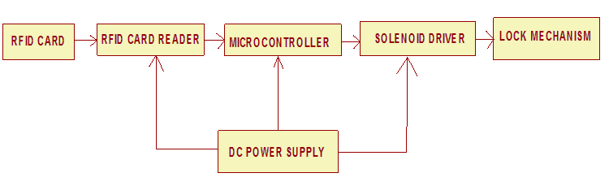
Figure 1: Block diagram of the system

2.2 Simulation Method
The simulation method uses Proteus 8.0 to verify the design before implementation. The simulation tests circuit behaviour, component interaction, and control logic accuracy. To develop an algorithm for the simulation method, a step-by-step process to simulate and verify the system design using Proteus 8.0 was carried out as follows.
- Start: Launch Proteus 8.0 simulation software.
- Set Requirements: Define system requirements and components such as the RFID reader, solenoid lock, and microcontroller.
- Design Circuit: Use the software to draw the schematic.
- Configure Components: Assign parameters to each component (e.g., RFID frequency, voltage levels).
- Program Control Logic: Develop and upload control logic to the microcontroller (using Embedded C).
- Simulate and Test:
  - Run the simulation.
  - Test with multiple RFID card inputs (authorised/unauthorised).
- Debug and Modify: Refine circuit design or code based on observed behaviour.
- Analyse Results: Validate the output to ensure functionality.
- Optimise: Finalise the design for hardware implementation.
- End.

2.3 The Algorithm

The algorithm follows the steps outlined below:
- Start
- Initialise the system variables, Microcontrollers, Card Reader, etc.
- Insert the RFID card into the Card Reader for authentication
- Match the data with the pre-loaded data for authorisation
- If no match, deny the access. May decide to buzz or alarm and give no output
- If yes, allow access to close or open the door by pressing BOT1 or BOT2, respectively
- Stop.

2.4 Flowchart
The flow chart for the RFID Door Locking System is shown in Figure 2.

2.4 Choice of Programming Language
“The programming language that must be available on a wide set of platforms, exists free implementations of the chosen language, widely accepted, and the availability of compilers producing highly optimised code is needed. These may be Java, C, C++, Embedded C, etc.” (Hirzel et al., 2013). For this work implementation, “Embedded C was used because it is a microcontroller programming language and it is the most widely used programming language for embedded processors/controllers. Assembly is also used, but mainly to implement those portions of the code where very high timing accuracy, code size efficiency, etc., are prime requirements. Embedded C is perhaps the most popular language among Embedded Programmers due to its efficiency, less development time and portability” (Fok, 2017).
2.5 PCB Files Creation
PCB files were created using Proteus software. “The design stuff was carried out using these software’s layout explorer features. The second step was creating CNC-readable files. The file format generated by the earlier software is usually not understandable by the CNC machine’s software. Hence, intermediary software (CopperCam) that converts these file formats into the ones readable by the CNC machine’s software was used. The copper layer file and the drill layer files were separately generated by the software. Once the CNC-readable files are generated, they will then be uploaded to the CNC software (CNC software comes with the machine itself and is recommended by its manufacturer)” (Sathyakumar et al., 2018).
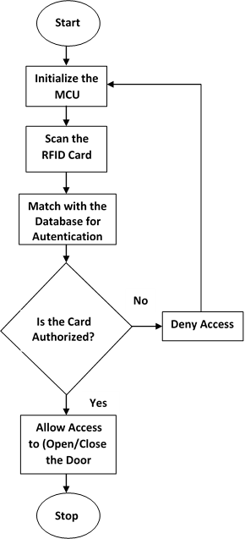
Figure 2: Flowchart of an RFID-based door locking system using a smart card
2.6 CNC Software
The CNC software only requires the CNC files as input, and when these files are loaded, the machine is ready to go. Using the CNC software, the milling reference points and the speed at which the work was done were adjusted and configured for the creation of tracks. Isolation milling was carried out using a milling bit. After milling has been done, the bit is changed from a milling bit to a drill bit. Then the other file was loaded in the CNC software to carry out the drilling of holes for mounting components on the PCB (Hägele et al., 2016).
2.7 Construction Method
The construction of this work was carried out in two parts.
- Component temporary assembly and placement on a breadboard, and
- Soldering of components on a Vero board on a permanent basis.

2.8 Testing and Analysis Method

Firstly, the constructed system was tested by placing Radio Frequency Identification (RFID) cards near the RFID reader. Several tests were performed by taking the card readings as registered on the Arduino microcontroller memory. The test was done using 4 RFID cards and 1 RFID tag. In that, 1 RFID card and 1 RFID tag were registered in the microcontroller memory; the remaining 3 RFID cards were unregistered.
3.0 Results
The simulation results are presented in Figures 3 to 6. The power supply adaptor comprises a step-down transformer, a filtering capacitor, a rectifier and a variable resistor as in Figure 3. As indicated, the transformer steps down the voltage from +230V AC to 5V AC. The 5V AC generated by the transformer (TR1) is then fed to the rectifier (BR1) circuit. This was prior to the rectification and filtering processes of the signal. The actual voltage coming out of the power outlet is +5Vdc. The same power feeds all other parts of the system.
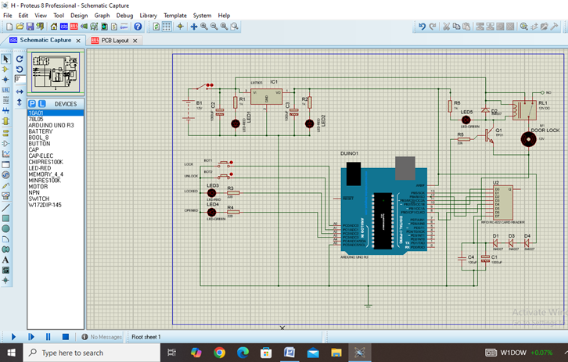
Figure 3: Simulated general circuit of an RFID-based door locking system using a smart card

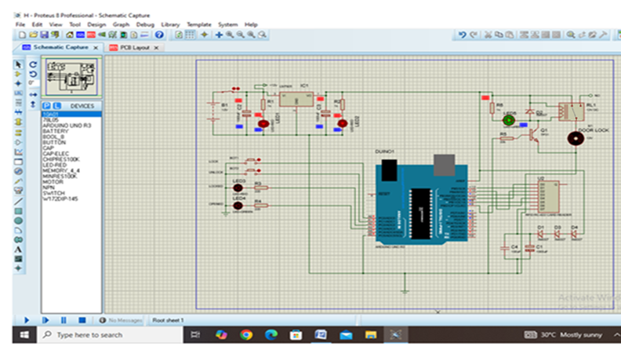

Figure 4: Simulation result when powered ON and circuit initialised

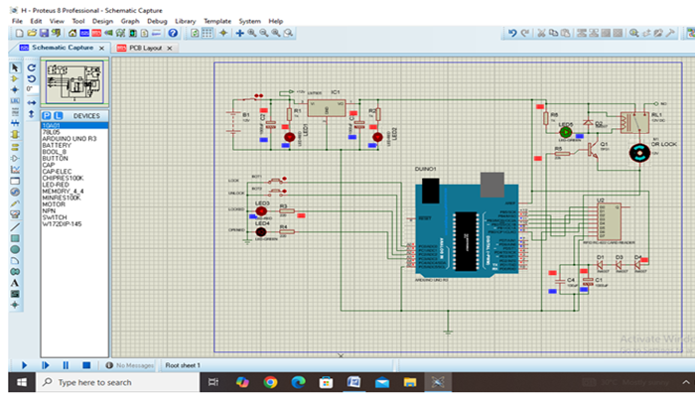
Figure 5: Simulation result showing the door locked

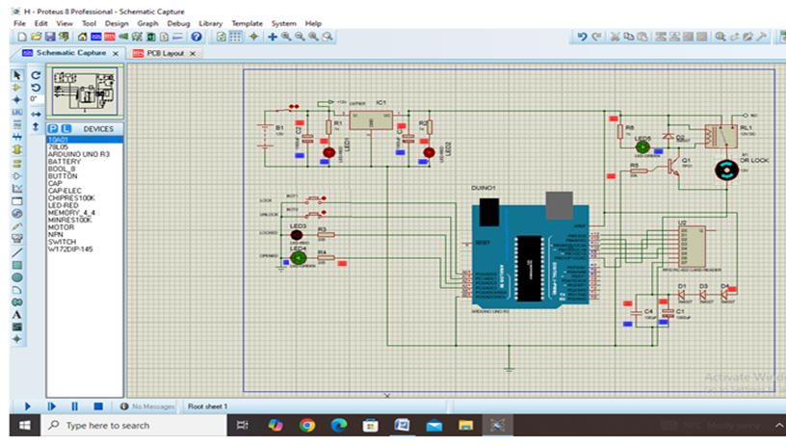
Figure 6: Simulation result showing the door opened
Figure 4 presents the simulated RFID-based door locking system using a smart card. When it is powered, the power supply unit, as can be seen from the simulation result when the switch is triggered “ON”, RED LEDs glow, an indication that the battery supply voltage of 12Vdc has been passed, then regulated to 5Vdc. The two voltages (12V and 5V) reached different circuit units according to each unit's specification. Signals present to the unit components can be seen in red, blue and grey colours. Figure 5 presents a simulation of the system when the door is locked, after the BOT1 was pressed and the relay was triggered. It can be seen that the Red LED of the switching unit glows and the door motor moved clockwise, while Figure 6 is the system’s simulation when the door opened, after the BOT2 was pressed and the relay triggered. It can also be seen that the Green LED of the switching unit glows and the door (motor) moved anticlockwise. However, the program for the system written in Micro C was simulated using Proteus in parts and as a whole. In the simulation of an RFID system, a slave microcontroller (representing RFID) was created to transfer data to the main microcontroller using the Wiegand protocol. This was because the version of Proteus used has no RFID tool in its library. The Wiegand protocol is a special sequence of data exchange between the microcontroller and the RFID scanner. For simulation of the Tag named “D337929” to ascertain tag identification as in Figures 5 and 6, raw data was sent with a command to display any Tag identified.
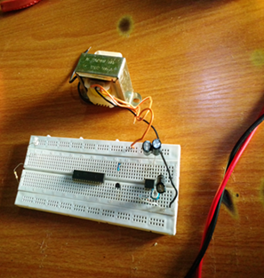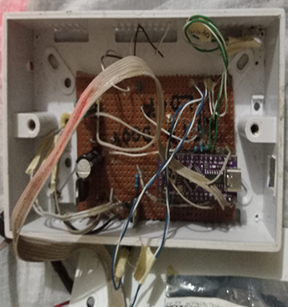
Plate 1: Bread board with some components Plate 2: Components inside casing on Vero board
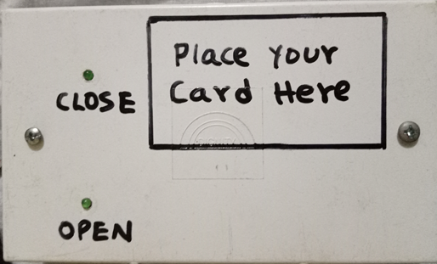
Plate 3: Physical casing of the system
Plate 1 represents the temporal construction made on the breadboard with some circuit components. The components are connected in the circuit with jump wires. Jumper wires were used to allow connection between individual components and to complete the circuit. Plate 2 shows the permanently constructed circuit soldered onto the Vero board. The Vero board allows construction of a permanent circuit, which has more reliable connections than with breadboard. A 40 Watt soldering iron was used because it minimises damage to electrical components caused by the excessive heat from a higher-wattage iron. In addition to preventing heat from damaging the microcontroller and other components, they were plugged into sockets, which were then placed directly on the Vero board and soldered. After the soldering and integration of all components involved, the circuit was supplied with the required source voltage, and it worked satisfactorily according to the output of the simulated results. Plate 3 shows that the device was tested for the expected outcomes, focusing on its core functionality and security features. The system is centrally controlled by the Arduino Uno microcontroller, which detects and responds to input from the Radio Frequency Identification (RFID) reader. Upon detecting valid input, the microcontroller triggers the solenoid lock to either grant or deny access.
Additionally, sensors are used to automate lighting based on motion detection, with the number of sensors varying depending on the need to activate lights in different rooms. The door will open only when the RFID card data or password matches the stored information. Without the registered RFID card, access is denied, ensuring that the RFID card functions as the sole key to unlocking the door, making the system highly secure.
To test the system’s functionality, several trials were conducted using four RFID cards and one RFID tag. Out of these, two RFID cards and one RFID tag were registered in the microcontroller’s memory, while the remaining two RFID cards were left unregistered. The test results showed that only the registered RFID cards and tags successfully unlocked the door, while the unregistered ones were denied access.
4.0 Discussion

The constructed RFID door lock system was tested using four RFID cards and one RFID tag. Among them, only one RFID card and one RFID tag were registered in the system’s microcontroller memory, while the remaining three RFID cards were unregistered. The system, when tested, granted access only to the registered RFID cards and tags to unlock the door, while the unregistered ones were denied access. Unlike traditional locks that can be forced open or bypassed with duplicated keys, the RFID system ensures that only authorised users can gain access. This demonstrates that even a focused system like an RFID door lock can significantly increase the security of an enclosure, complementing a larger smart home system, demonstrating reliability, efficiency, ease of installation and low power consumption. The study is in line with that of Agbo, Madukwe and Odinya (2017), who applied RFID technology for access control systems for preventing unauthorised access. The study is similar to that of Murugan and Vignech (2016), highlighting the convenience and security of RFID technology in door lock systems and digital authentication. Also in line with Alnabhi (2020) and Gupte and Shelar (2013), who integrated RFID with other smart home technologies for increased security and convenience, highlighting the importance of advanced technological solutions in enhancing home security.

5.0 Conclusion

A Radio Frequency Identification (RFID) door lock system using a smart card offers an effective solution for enhancing both security and convenience in access control. By addressing key challenges associated with traditional locks, such as key duplication and the inconvenience of carrying physical keys, the Radio Frequency Identification (RFID) system provides a more alternative. The integration of Radio Frequency Identification (RFID) technology with a solenoid lock mechanism ensures that access is restricted to authorised individuals, thereby improving the security of homes, offices, and other secure spaces. The construction and testing of the system demonstrated its reliability and efficiency. Not only does it present a contemporary solution to home and office security, but it also reduces the risks inherent in traditional locks while offering a user-friendly interface. The simplicity of its design allows for easy scalability, making it suitable for larger applications, such as commercial or industrial settings. These findings contribute to the growing body of research on Radio Frequency Identification (RFID) technology and access control systems, laying a strong foundation for future research and development in this field.
Disclaimer (Artificial intelligence)
Option 1:
Author(s) hereby declare that NO generative AI technologies such as Large Language Models (ChatGPT, COPILOT, etc.) and text-to-image generators have been used during the writing or editing of this manuscript.
Option 2:
Author(s) hereby declare that generative AI technologies such as Large Language Models, etc. have been used during the writing or editing of manuscripts. This explanation will include the name, version, model, and source of the generative AI technology and as well as all input prompts provided to the generative AI technology
Details of the AI usage are given below:
1.
2.
3.

REFERENCES
Agbo, D. O., Madukwe, C. & Odinya, J. O. (2017). Design and Implementation of a Door Locking System Using Android App. International Journal of Scientific and Technology Research, 6(8), 198-203.
Alnabhi, H., Al-naamani, Y., Al-madhehagi, M. & Alhamzi, M. (2020). Enhanced Security Methods of Door Locking Based Fingerprint. International Journal of Innovative Technology and Exploring Engineering, 9(3), 1173-1178.
Alsaadi, I. M. (2015). Physiological Biometric Authentication Systems Advantages, Disadvantages and Future Development A Review. International Journal of Scientific and Technology Research, 4(12), 285-289.
Anaza, S. O., Jiya, J. D. & Haruna, Y. S. (2020). Development of a prototype RFID-GSM based lock system. International Journal of Engineering Applied Sciences and Technology, 4(12), 77-84
Anushri, J., Vijay, L. K. & Barkha, N. (2015). RFID and GSM Based Attendance Monitoring System using door locking/unlocking system and Its Hardware Implementation. Journal of Management Engineering and Information Technology, 2(3), 5-10
Ekejiuba, C. O. & Folayan, G. B. (2016). Remote Controlled Security Door. Journal of Electrical and Electronic Systems, 5(2), 1-4. DOI: 10.4172/2332-0796.1000184.
Gupte, N. N. & Shelar, M. R. (2013). Smart Door Locking System. International Journal of Engineering Research and Technology. 2(11), 2214- 2217.
Park, Y. T., Sthapit, P. & Pyun, J. (2009). Smart Digital Door Lock for the Home Automation. TENCON 2009 – 2009. IEEE Region 10 Conference, pp. 1-6, doi: 10.1109/TENCON. 2009.5396038
Okafor, C. S., Nnebe, S. U., Alumona, T. L., Onuzuluike, V. C., & Jideofor, U. C. (2022). Door access control using RFID and voice recognition system. International Journal for Research in Applied Science and Engineering Technology, 10(3), 157-163.
Syarifuddin, S., Syam, H., & Syafar, F. (2024). IoT-based facial recognition door lock with push button combination. Asian Journal of Advanced Research and Reports, 18(8), 111–129.
Makanjuola, P. O., Shokenu, E. S., Araromi, H. O., Idowu, P. O., & Babatunde, J. D. (2022). An RFID-based access control system using electromagnetic door lock and an intruder alert system. Journal of Engineering Research and Reports, 22(11), 7–17.
Chasani, A., Irawan, D., & Fauza, N. (2024). RFID (Radio Frequency Identification) Application for Door Security Systems. Journal of Frontier Research in Science and Engineering, 2(1), 7-11.
Harshitha, G., Gopika, S. N., Gourinandan, B., Goutham, P., Gowrinath, L., & Nalinakshan, S. (2025, February). RFID based Access Control System. In 2025 International Conference on Electronics and Renewable Systems (ICEARS) (pp. 182-186). IEEE.

