A Cloud Implementation Assessment System for Smes
Abstract
The emerging impact of cloud computing in businesses has become a great driving force for business success and cannot be understated. The lack of a tailored functional application software, even though a framework exists, poses a significant challenge to SMEs. Without a digital corresponding software solution, SMES struggle to conduct a practical assessment since the framework offers only theoretical guidance. A well-developed cloud implementation assessment tool is essential for SMEs to thrive.

The main aim of the study was to develop a robust cloud implementation assessment system for SMEs to evaluate their cloud implementation readiness. Design Science Research Methodology (DSRM)
, is a kind of research methodology which aims at developing and evaluating innovative artefacts, in the form of models, frameworks, designs, or prototypes, to solve complex and practical problems. Framework Usability Validation used. On the Clarity of the framework, none of the respondents strongly disagreed, representing 0%. 8 respondents, representing 15.4% disagreed, and 3 respondents, representing 5.8% were unsure. The system was developed using the Django Python web framework. Out of 43 respondents, 18 participants (42%) found the Learn Cloud Phase helpful, 3 participants (7%) found the Assessment and Cloud Choice Phase helpful, and 15 participants (35%) found the Migration Phase helpful. Additionally, 4 participants (9%) reported that all phases were helpful, 2 participants (5%) indicated that none of the phases were helpful, and 1 participant (2%) was uncertain about the helpfulness of any phase.
In this paper, the design science Research (DSR) method was utilised to develop and evaluate the cloud implementation assessment system for SMEs. Key features of the developed system include learn cloud, assessment, cloud choice and migration phase. The developed system was said to be very useful and suitable, solidifying its value as a helpful resource for small businesses aiming to utilise cloud technology. A cloud assessment system was developed to aid in assessing SMEs' cloud readiness and implementation. Generally, SMEs responded positively to the cloud computing implementation framework.
Keywords: Cloud Computing, Cloud Implementation Assessment System (CIAS), Small and Medium Enterprise (SMEs), service-oriented architecture (SOA), cloud technology
- INTRODUCTION
Cloud computing has emerged as a transformative technological paradigm, reshaping how organisations leverage computing resources and information technology capabilities. At its core, cloud computing enables ubiquitous, convenient, and on-demand network access to a shared pool of configurable computing resources like networks, servers, storage, applications, and services that can be rapidly provisioned and released with minimal management effort or service provider interaction (Omagbemi et al., 2024; Igwenagu et al., 2024). It has seen a meteoric rise in the domain of IT in recent years. Although the term "Cloud Computing" has become popular, the concept of multiple users sharing computer resources is nothing new. According to Ahmed (2020), the numerous advantages of cloud-based solutions for businesses indicate the significance of cloud determinants in cloud computing. According to Dahiru et al. (2014), Cloud computing has the ability to influence a wide range of social and economic activities. Cloud computing has proven to be advantageous for SMEs. However, despite the numerous benefits associated with cloud technology, Boateng et al. (2024), highlight that SMEs in developing countries are yet to fully realise the potential of Cloud computing. A successful cloud implementation rate clearly relies on relative advantage, compatibility, top management support and others in the cloud implementation process (Atuah et al., 2023).
Despite the clear advantages, the uptake of cloud computing by SMEs, especially in developing regions, has been slower than expected. This hesitation can be attributed to a mix of technological, organisational, and environmental challenges. Key obstacles include security and data privacy concerns, perceived complexity, insufficient top management support, and lack of prior experience with IT systems (Mkhize et al., 2025). Even though SMEs are beginning to appreciate the use of technology to optimise their operations in the global market, and despite the availability of tailored frameworks to support this effort, Atuah et al. (2023), the framework lacks the practical tools required for execution. Without a corresponding software solution, SMEs struggle to translate the framework into operational practice, resulting in implementation gaps, inefficiencies, and missed opportunities for technological optimisation. The advantages cloud computing offers are still underutilised, compared to the speed at which developed countries are running with it. (Balobaid and Debnath, 2020; Rastogi, 2010; Chemjor and Lagat, 2017; Senarathna, 2018). The low patronage can be likened to the lack of a tailored-made cloud implementation assessment tool (Malik et al., 2019). A firm or business's success largely relies on the implementation of technological systems (Yang et al.,2025). The significant obstacle is highlighted by the absence of a well-defined standard or system and essential knowledge for SMEs to implement cloud technology (Asiaei and Rahim, 2016)
2. LITERATURE REVIEW
2.1 Meaning of Cloud Computing
According to (Vaquero et al., 2008; Yang & Tate, 2012) Cloud computing has been a public discourse for some period now. However, there is no universally accepted definition of this concept. Nevertheless, it can be described as a shared IT infrastructure that connects various computing resources across the Internet and creates a great pool of resources (cite). Large organisations are making use of cloud technology to manage their company data efficiently and effectively while offering their customers appealing services Satria et al., 2017. This infrastructure dynamically allocates computing resources in response to changing service demands, improving utilisation and productivity (IBM, 2011; Rimal et al.,2009).
Cloud computing uses a service-oriented architecture (SOA) and offers opportunities to reduce operating costs (Vouk, 2008). It allows companies to allocate resources quickly within a controlled environment, ensures efficient management, prevents system overload, and enhances flexibility and scalability (Conway et al., 2014).
According to Yang and Tate (2012), the popular gained definition provided by the National Institute of Standards and Technology (NIST), defines cloud computing as "a model for enabling ubiquitous, convenient, on-demand network access to a shared pool of configurable computing resources (e.g., networks, servers, storage, applications, and services) that can be rapidly provisioned and released with minimal management effort or service provider interaction

2.2 Types of Cloud Computing Service Models
The cloud computing service model consists of three types according to the NIST, they include Service (SaaS), Platform as a Service (PaaS), and Infrastructure as a Service (IaaS). These services provide different levels of abstraction and functionality to users according to Mell and Grance (2011)
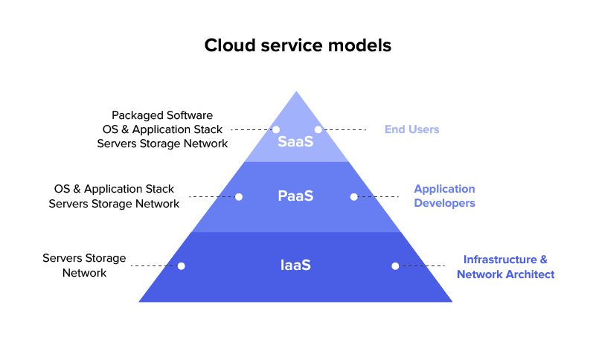
Figure 1 Cloud Computing Service Models
2.3 Types of Cloud Computing Deployment Models
According to Mell and Grance (2011), cloud computing has four main implementation models these models include Public, Private, Hybrid and Community cloud
Public cloud: This involves the provision of cloud infrastructure to the general public on a free or paid basis. The physical location of the infrastructure is typically within the premises of the cloud service provider
Private Cloud: This entails the provision of dedicated cloud infrastructure to an individual organisation, mostly a company which has several departments within itself. The infrastructure can be internally or externally managed or owned by another entity
Hybrid Cloud: This is the combination of two or more cloud infrastructures which linked through a standardised technology to aid the transferability of data and applications.
Community Cloud: The cloud infrastructure is exclusively dedicated to a specific consumer communities that share the same concerns, such as security requirements, compliance considerations and policies
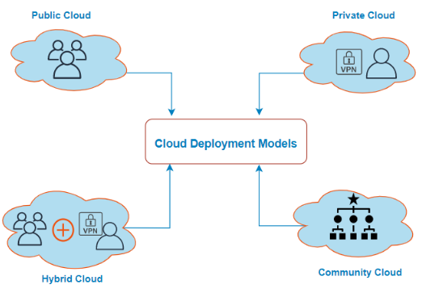
Figure 2 Cloud Computing Deployment Models
2.4 Small and Medium-sized Enterprises in Ghana
The SME sector includes three different business classifications: micro, small and medium enterprises. The official European Commission definition of SMEs takes into account three key factors: Employment levels, turnover, and balance sheet size Muller et al., 2016. This comprehensive definition enables a comprehensive classification and understanding of SMEs based on multiple aspects of SME operations and financial metrics. SMEs are noticeably becoming predominant in countries across the globe with an impact on gross domestic product and employment (Olayemi and Folajimi 2021). While Rahayu and Day (2017), describe that SME (i) is a firm that does not separate the position of both owner and managerial structure, (ii) uses its own labour, (iii) is unbackable and uses its own capital, (iv) has a low level of entrepreneurship, and mostly does not have legal status
According to Daniel (2022), business that obtains certain turnovers, assets and number of employees are classified as SMEs. In Ghana, for example, the Ghana Bureau of Statistics identifies enterprises with employees less than 10 and more than 10 are considered small enterprises as medium or large enterprises, respectively (Arthur-Aidoo et al., 2018).
2.5 The Theory of TOE in Cloud Computing
Cloud computing has gained an influential trend in the modern computing industry. By making computing resources available on demand over the Internet. The existence of cloud computing offers significant benefits and potential impacts in many areas of economic and social activity around the world. Its inherent properties, such as flexibility and extensibility, have the potential to bring about significant changes in various fields (Ahmed, 2020).
Wan and Mokhtar (2016), employed the TOE framework to demonstrate that technology adoption issues have increased due to rapid technological progress across all fields. Organisations and governments alike have invested heavily in new technologies that promise to enhance their users' lives.
A TOE framework was employed to test a query that examined electronic commerce factors in nine hundred and twenty-six mid-to-small-scale companies in Vietnam (Gonzalez et. al., 2017). This framework can also be utilised for analysing hierarchical dynamics that encourage cloud computing within industries.
3. METHODOLOGY
3.1 Research Design
The study of the design science to develop and assess the cloud implementation assessment system for SMEs

3.2 Design Science Research Methodology (DSRM)
DSRM is a kind of research methodology which aims at developing and evaluating innovative artefacts, in the form of models, frameworks, designs, or prototypes, in order to solve complex and practical problems
3.3. Use Case Diagram of Cloud Implementation Assessment System for SMEs
A use case diagram showcases the interactions between actors (users or systems). It visualises the different functionalities such as Registration, logging in, registering, Homepage, learn cloud tutorials, conducting assessments, making cloud choices, managing profiles, and more. This helps to understand the system's behaviour and the roles of different users within the system. Figure 3 is the use case diagram for CIAS
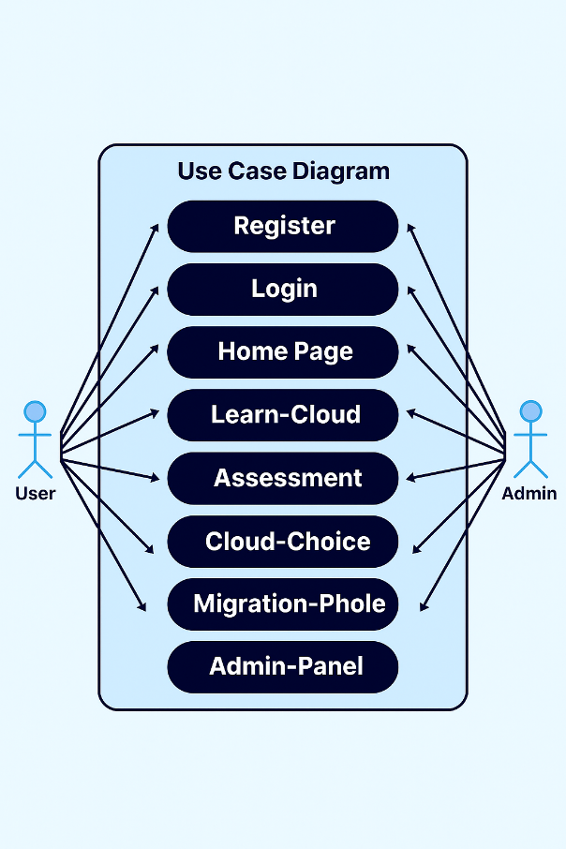

Figure 3: Use Case Diagram for CIAS

3.4 Class Diagram of CIAS
Below is a class diagram showing the system’s entities, attributes, and relationships in Figure 4
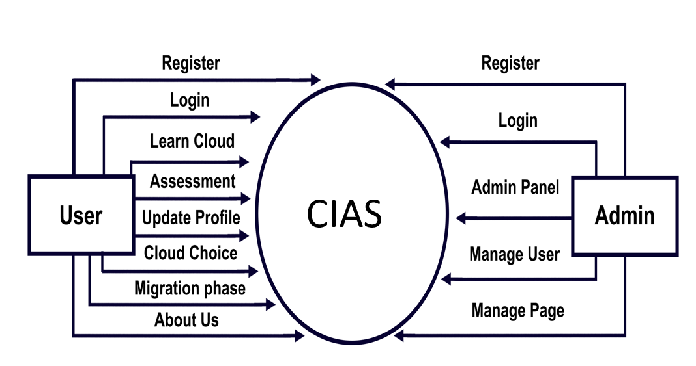

Figure 4: Class Diagram of CIAS

3.5 ER diagram for CIAS
This is the data structure and relationship within the system. The modules and units are integrated and interconnected in the system design. The ER diagram of CIAs is shown in Figure 5
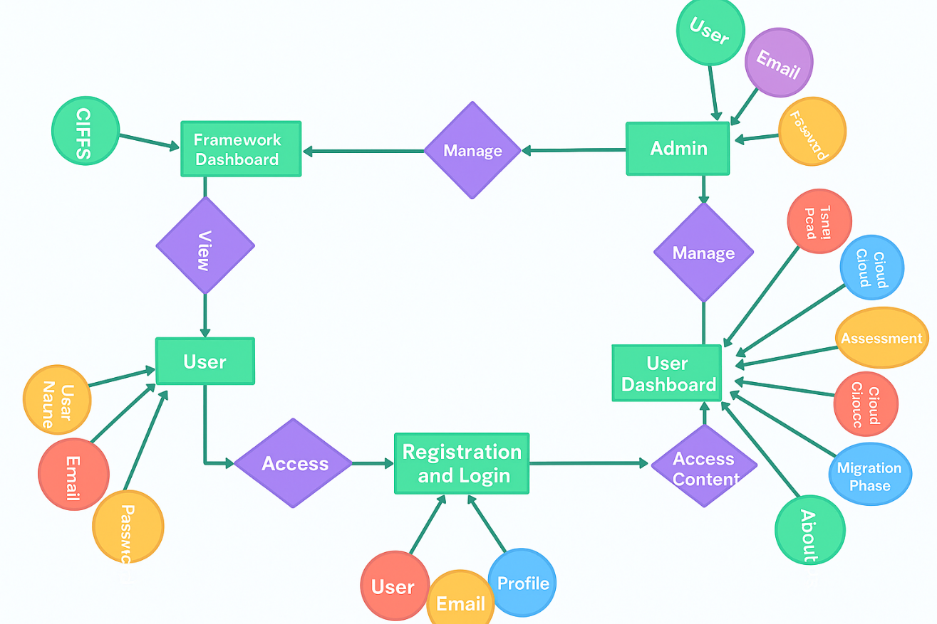

Figure 5: ER Diagram for CIAS
3.6 The System Development Tools and Specification
The system was developed using the Django Python web framework. Django framework is said to be the most efficient platform for developing flexible, user-friendly and robust web applications, specifically a tailored-made system like CIAS for SMEs' specific needs. The primary programming language used to develop the system was Python because of its extensive libraries.
4. RESULTS AND FINDINGS
CIAS Home page
Home: The Home page is the visitor index page, which serves as the starting point for users accessing the system. It provides an overview and introduction to the system's features and functionalities. Other taps in the home page are “About tap; Login tap, Register tap as found in figure 6.
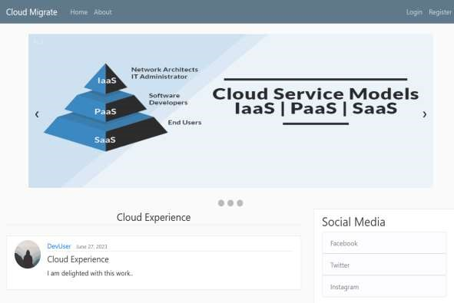

Figure 6: CIAS Home Page

About tab of home page: The About tab of the home page contains a summary of the functional use of the system. Providing information about the purpose, goals, and key features of the system, as seen in Figure 7
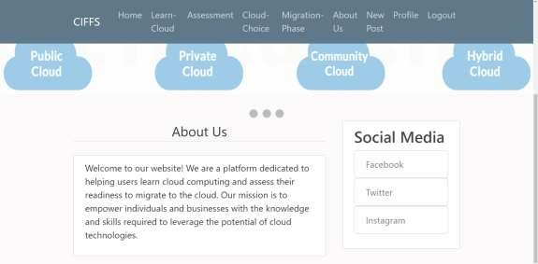

Figure 7: CIAS About Page

Login: The Login tab, presented in Figure 8 of the home page, allows registered users to log into the system to access specific functionalities within the system that are not available to unregistered users.
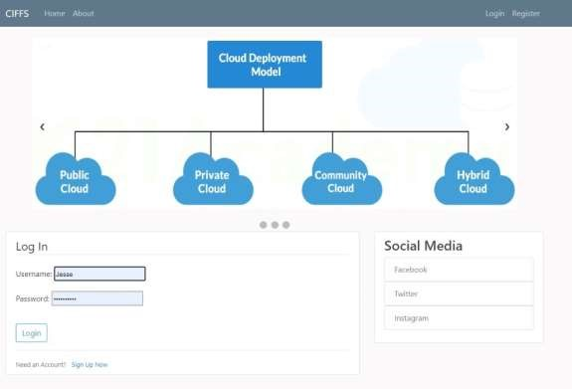

Figure 8: CIAS login

Sign Up: The register link, as shown in figure 9 provides new potential users to register their information into the system in order to gain full access to the system, specified user privileges and features and functionalities.
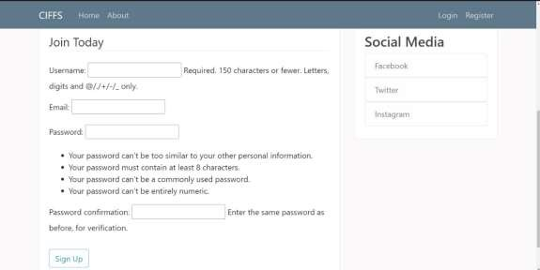

Figure 9 CIAS Registration

Logged in User Dashboard
The logged user dashboard shows all system features, functionalities and modules such as the Learn-Cloud, Assessment, Cloud Choice, Migration Phase, About us, among others, as shown in figure 10

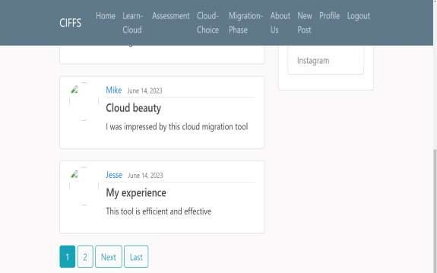

Figure 10 Logged in User Dashboard

Learn Cloud: The learn cloud provides and comprehensive training video of cloud computing, such as the meaning, benefits, types and implications of cloud computing on business
Assessment: The assessment module allows users to assess factors such as technology readiness, organisational readiness, and environmental factors. The assessment result helps users make informed decisions or proceed to the next stage based on their assessment score.
Cloud Choice: The Cloud Choice tab educates users about the characteristics, advantages, and considerations associated with each deployment model. It provides information about different cloud deployment models that businesses can adopt, such as public, private, hybrid, and community cloud.
Migration Strategy: This offers clear directions for migration based on the specific needs of the business. It may include options such as rehosting, repurchasing, refactoring, and re-platforming, which describe different approaches to migrating applications and infrastructure to the cloud.
New Post: This allows users of the system to post their opinions, comments, or any related content.
Logged in Admin Dashboard
The Logged in Admin Dashboard shown in Figure 11 is a specialised interface accessible to administrators or system administrators after logging into the system. The Admin Dashboard provides additional functionalities and controls for managing the system and its users. Some components of the admin dashboard are “Authentication and Authorisation;
Edu; and Users”
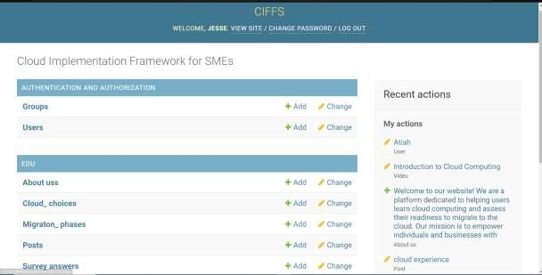

Figure 11: Admin Dashboard

Table 1 Framework Usability Validation

Framework Phases Validation
The learn Cloud Phase is crucial to support important  processes in understanding cloud implementation requirements for SMEs Response | Frequency | Per cent (%)
Strongly Disagree | 0 | 0.0
Disagree | 2 | 3.8
Not Sure | 2 | 3.8
Agree | 15 | 28.8
Strongly Agree | 33 | 63.5
Total | 52 | 100.0
The Assessment and Cloud Choice Phase of the framework is crucial to support important processes in understanding  Cloud Implementation Requirements for SMEs Response | Frequency | Per cent (%)
Strongly Disagree | 1 | 1.9
Disagree | 3 | 5.8
Not Sure | 7 | 13.5
Agree | 15 | 28.8
Strongly Agree | 26 | 50.0
Total | 52 | 100.0
The Migration Phase is crucial to support important processes in understanding cloud implementation requirements for SMEs' Response | Frequency | Per cent (%)
Strongly Disagree | 3 | 5.8
Disagree | 2 | 3.8
Not Sure | 4 | 7.7
Agree | 17 | 32.7
Strongly Disagree | 26 | 50.0
Total | 52 | 100.0
Table 1 presents the evaluation of the framework phases in supporting important processes related to understanding cloud implementation requirements for SMEs
Learn Cloud Phase: No respondents strongly disagreed. 2 respondents representing 3.8% each disagreed or were unsure about its significance. Additionally, 15 respondents representing 28.8% agreed with the importance of this phase. Finally,33 respondents representing 63.5% strongly agreed with the statement.
Assessment and Cloud Choice Phase: 1 respondent representing 1.9% strongly disagreed, and 3 respondents representing 5.8% disagreed to some extent, while 7 respondents representing 13.5% were unsure. Additionally,15 respondents representing 28.8% agreed with the statement and 26 respondents representing 50.0% strongly agreed with its importance.
Migration Phase: The Migration Phase, which involves the process of migrating to the cloud, no respondents strongly disagreed, but 2 respondents representing 3.8% disagreed to some extent. 4 respondents representing 7.7% were unsure, while 17 respondents representing 32.7% agreed. 26 respondents, constituting 50.0% strongly agreed with its significance.
Table 2 Framework Usability Validation
The Framework is Clear
Response | Frequency | Per cent (%)
Strongly Disagree | 0 | 0.0
Disagree | 8 | 15.4
Not Sure | 3 | 5.8
Agree | 12 | 23.1
Strongly Agree | 29 | 58.8
Total | 52 | 100.0
The Framework is easy to learn  Response | Frequency | Per cent (%)
Strongly Disagree | 0 | 0.0
Disagree | 0 | 0.0
Not Sure | 5 | 9.6
Agree | 26 | 50.0
Strongly Agree | 21 | 40.4
Total | 52 | 100.0
The framework provides a comprehensive coverage of processes involved in implementing cloud for your business. Response | Frequency | Per cent (%)
Strongly Disagree | 6 | 11.5
Disagree | 2 | 3.8
Not Sure | 4 | 7.7
Agree | 21 | 40.4
Strongly Agree | 19 | 36.5
Total | 52 | 100.0

Table 2, shows the Framework Usability Validation. On the Clarity of the framework, none of the respondents strongly disagreed, representing 0%. 8 respondents, representing 15.4% disagreed, and 3 respondents, representing 5.8% were unsure. On the other hand, 12 respondents representing 23.1% agreed, while 29 respondents representing 58.8%, strongly agreed that the framework was clear.
In terms of the ease of learning the framework, no respondents strongly disagreed or disagreed representing 0%. 5 respondents representing 9.6% were unsure, while 26 respondents, representing 50.0% agreed that the framework was easy to learn. Additionally, 21 respondents representing 40.4% strongly agreed with the statement.
Regarding the comprehensive coverage of the processes involved in implementing cloud for a business, 6 respondents representing 11.5% strongly disagreed, and 2 respondents representing 3.8% disagreed. 4 respondents representing 7.7% were unsure, while 21 respondents representing 40.4% agreed with the statement. Furthermore, 19 respondents representing 36.5% strongly agreed that the framework provided a comprehensive coverage.

Table 3 Framework Usability Validation
The framework is useful
Response | Frequency | Percent (%)
Strongly Disagree | 4 | 7.7
Disagree | 5 | 9.6
Not Sure | 6 | 11.5
Agree | 18 | 34.6
Strongly Agree | 19 | 36.5
Total | 52 | 100.0
The Framework can be practically used Response | Frequency | Percent (%)
Strongly Disagree | 10 | 19.2
Disagree | 5 | 9.6
Not Sure | 4 | 7.7
Agree | 12 | 23.1
Strongly Agree | 21 | 40.4
Total | 52 | 100.0
The framework is flexible and efficient Response | Frequency | Percent (%)
Strongly Disagree | 3 | 5.8
Disagree | 3 | 5.8
Not Sure | 6 | 11.5
Agree | 9 | 17.3
Strongly Agree | 31 | 59.6
Total | 52 | 100.0
Table 3 evaluates the usability of the framework in terms of its usefulness, practicality, flexibility and efficiency. For usefulness, 4 respondents (7.7%) strongly disagreed, 5 respondents (9.6%) disagreed, and 6 respondents (11.5%) were unsure. However, 18 respondents (34.6%) agreed, and 19 respondents (36.5%) strongly agreed that the framework was useful. Regarding practicality, 10 respondents (19.2%) strongly disagreed, 5 respondents (9.6%) disagreed, and 4 respondents (7.7%) were unsure. In contrast, 12 respondents (23.1%) agreed, and 21 respondents (40.4%) strongly agreed on the framework's practicality. For flexibility and efficiency, 3 respondents (5.8%) strongly disagreed, 3 respondents (5.8%) disagreed, and 6 respondents (11.5%) were unsure. Meanwhile, 9 respondents (17.3%) agreed, and 31 respondents (59.6%) strongly agreed that the framework was flexible and efficient.
Table 4. Framework Usability Validation
The framework provides a systematic approach to implementing a cloud service for your enterprise
Response | Frequency | Percent (%)
Strongly Disagree | 3 | 5.8
Disagree | 4 | 7.7
Not Sure | 4 | 7.7
Agree | 13 | 25.0
Strongly Agree | 28 | 53.8
Total | 52 | 100.0
The framework for implementing cloud computing is easy to use.  Response | Frequency | Percent (%)
Strongly Disagree | 0 | 0.0
Disagree | 1 | 1.9
Not Sure | 3 | 5.8
Agree | 15 | 28.8
Strongly Agree | 33 | 63.5
Total | 52 | 100.0

Table 4 evaluates the usability of a framework for implementing cloud services, focusing on its systematic approach and ease of use. For the systematic approach, 3 respondents (5.8%) strongly disagreed, 4 respondents (7.7%) disagreed, and 4 respondents (7.7%) were unsure. However, 13 respondents (25.0%) agreed, and 28 respondents (53.8%) strongly agreed that the framework provided a systematic approach. Regarding ease of use, none of the respondents strongly disagreed, 1 respondent (1.9%) disagreed, and 3 respondents (5.8%) were unsure. Meanwhile, 15 respondents (28.8%) agreed, and 33 respondents (63.5%) strongly agreed that the framework was easy to use.

Table 5: Helpfulness of the phases in the framework
Which Phase in the framework would you feel is very helpful
Response | Frequency | Percent (%)
Learn Cloud | 18 | 42
Assessment Phase | 3 | 7
Migration | 15 | 35
All Phases | 4 | 9
None | 2 | 5
Not Sure | 1 | 2
Total | 43 | 100
The summary of the data in Table 5 reveals participants' views on the helpfulness of different phases in cloud implementation. Out of 43 respondents, 18 participants (42%) found the Learn Cloud Phase helpful, 3 participants (7%) found the Assessment and Cloud Choice Phase helpful, and 15 participants (35%) found the Migration Phase helpful. Additionally, 4 participants (9%) reported that all phases were helpful, 2 participants (5%) indicated that none of the phases were helpful, and 1 participant (2%) was uncertain about the helpfulness of any phase.

5. CONCLUSION AND RECOMMENDATIONS

A cloud assessment system was developed to aid in assessing SMEs' cloud readiness and implementation. Generally, SMEs responded positively to the cloud computing implementation framework. Respondents found the framework user-friendly, clear, and comprehensive, aligning well with their needs. The "Learn Cloud" phase was particularly appreciated for aiding SMEs in understanding cloud requirements. Positive feedback highlighted the framework's practicality, usefulness, and flexibility. Despite the overwhelming support for the developed system, indicating that the system effectively served its intended purpose, the were a few concerns for the improvement of the learn cloud and migration phase, specifically requesting additional video content. In addition, providing comprehensive training and resources to SMEs on effectively utilising the system can empower the implementation process more efficiently.
6. FUTURE WORK
Future efforts should be directed towards assessing the implementation challenges and ways to mitigate them in enhancing cloud usage.
CONSENT
As per international standards or university standards, respondents’ written consent has been collected and preserved by the author(s).
ETHICAL APPROVAL
As per international standards or university standards written ethical approval has been collected and preserved by the author(s).

Disclaimer (Artificial intelligence)
Option 1:
Author(s) hereby declare that NO generative AI technologies such as Large Language Models (ChatGPT, COPILOT, etc.) and text-to-image generators have been used during the writing or editing of this manuscript.
Option 2:
Author(s) hereby declare that generativ AI technologies such as Large Language Models, etc. have been used during the writing or editing of manuscripts. This explanation will include the name, version, model, and source of the generative AI technology and as well as all input prompts provided to the generative AI technology
Details of the AI usage are given below:
1.
2.
3.

REFERENCES
- Adjei, J. K., Adams, S., & Mamattah, L. (2021). Cloud computing adoption in Ghana; accounting for institutional factors. Technology in Society, 65, 101583.
- Ahmed, I. (2020). Technology organization environment framework in cloud computing. TELKOMNIKA (Telecommunication Computing Electronics and Control), 18(2), 716-725.
- Ahmed, M., & Singh, N. (2019, April). A framework for strategic cloud migration. In Proceedings of the 2019 5th International Conference on Computing and Artificial Intelligence (pp. 160-163).
- Alshamaila, Y., Papagiannidis, S., & Li, F. (2013). Cloud computing adoption by SMEs in the north east of England: A multi‐perspective framework. Journal of enterprise information management, 26(3), 250-275.
- Asiaei, A., & Rahim, N.Z. (2016). CONCEPTUALIZING A MODEL FOR CLOUD COMPUTING ADOPTION BY SMEs.
- Atuah, J., Akobre, S., Laar, D. S., & Agbedemnab, P. A. (2023) An Investigation of Factors Influencing the Implementation of Cloud Computing by SMEs, International Journal for Multidisciplinary Research, 5 (5)
- Atuah, J., Laar, D. S., Akobre, S., & Agbedemnab, P. A. (2023). Optimizing Business Potential: A Framework for the Implementation of Cloud Computing by SMEs in the Bolgatanga Municipality, Ghana. Asian J. Res. Com. Sci, 16(4), 389-395.
- Boateng, F. O., Awudu, F., Shardey, K., & Owusu, A. O. (2024). Cloud computing practices among small and medium-sized enterprises (SMEs); Contemporary trends, possibilities, and challenges. International Journal of Innovative Science and Research Technology, 9(10), 2123–2132. https://doi.org/10.38124/ijisrt/IJISRT24OCT1437
- Conway, G., Carcary, M., & Doherty, E. (2015). A conceptual framework to implement and manage a cloud computing environment. Cloud computing, 122-126.
- Dahiru, A. A., Bass, J. M., & Allison, I. K. (2014). Cloud computing: A comparison of adoption issues between UK and sub-Saharan Africa SMEs. In European, Mediterranean & Middle Eastern Conference on Information Systems
- González-Benito, Ó., Venturini, W. T., & González-Benito, J. (2017). CRM technology: Implementation project and consulting services as determinants of success. International Journal of Information Technology and Decision Making, 16(2). https://doi.org/10.1142/S0219622017500067
- Khan, N., & Al-Yasiri, A. (2016). Framework for cloud computing adoption: A road map for Smes to cloud migration. arXiv preprint arXiv:1601.01608.
- Lian, J., Si, T., Nair, N. U., & Zhao, H. (2014). Design and construction of acetyl-CoA overproducing Saccharomyces cerevisiae strains. Metabolic engineering, 24, 139-149.
- Malik, B. H., Asad, J., Kousar, S., Nawaz, F., Hayder, F., Bibi, S., ... & Raza, A. (2019). Cloud Computing Adoption in Small and medium-sized enterprises (SMEs) of Asia and Africa. (IJACSA) International Journal of Advanced Computer Science and Applications, 10(5).
- Oliveira, T., Thomas, M., & Espadanal, M. (2014). Assessing the determinants of cloud computing adoption: An analysis of the manufacturing and services sectors. Information & management, 51(5), 497-510.
- Peffers, K., Tuunanen, T., Rothenberger, M. A., & Chatterjee, S. (2008). A design science research methodology for information systems research. Journal of management information systems, 24(3), 45-77
- Rastogi, A. (2010). A model-based approach to implement cloud computing in e-Governance. International Journal of Computer Applications, 9(7), 15-18.
- Wan Ismail, W. N., & Mokhtar, M. Z. (2016). Application of TOE framework in examining the factors influencing pre- and post-adoption of CAS in Malaysian SMEs. International Journal of Information Technology and Business Management …, 49(2).
- Yang, X., Tu, H., Li, Y., & Wang, Q. (2025). The impact of IT system implementation and upgrade on firm operational and financial performance. Journal of Digital Management, 1(1), 1-18.
- Omagbemi, T. E., Igwe, C. P., Ntow, R. Y., & Igwe, E. P. (2024). Determinants of cloud computing adoption amongst SMEs in the UK technology sector. Asian Journal of Economics, Business and Accounting, 24(11), 514–531.
- Igwenagu, U. T. I., Salami, A. A., Arigbabu, A. S., Mesode, C. E., Oladoyinbo, T. O., & Olaniyi, O. O. (2024). Securing the digital frontier: Strategies for cloud computing security, database protection, and comprehensive penetration testing. Journal of Engineering Research and Reports, 26(6), 60–75.
- Mkhize, A., Mokhothu, K. D., Tshikhotho, M., & Thango, B. A. (2025). Evaluating the Impact of Cloud Computing on SME Performance: A Systematic Review. Businesses, 5(2), 23.

