Enhancing Quality Assurance Practices in Software Development: Application of Agile Methodology

Abstract
In the fast-paced and ever-evolving landscape of the software industry, delivering high-quality software has become paramount. The shift from traditional software development models to agile methodologies has been driven by the need to accommodate complex software requirements and dynamic user expectations efficiently. However, integrating quality assurance (QA) practices within agile frameworks presents significant challenges. This study aimed to assess the effectiveness of various QA practices within agile methodologies. The study employed a quantitative research approach, utilising surveys targeting fifty software developers and QA professionals. The results underscored the critical role of continuous integration and testing in maintaining software quality, while also highlighting the need for enhanced QA visibility and influence, optimisation of documentation, and fostering collaboration between developers and QA professionals. Based on the findings, a comprehensive framework for effectively incorporating QA practices into agile development processes was proposed. To address the challenges identified in integrating Quality Assurance (QA) practices within agile development processes, a framework or strategies are proposed. These include embedding QA early and throughout the agile cycle, enhancing QA visibility and influence, enhancing QA visibility and influence, promoting continuous integration and testing, adopting a holistic approach to automated testing and similar other strategies. By implementing these strategies, organisations can enhance the quality of their software products while retaining the agility and efficiency offered by agile methodologies, thus ensuring that software products meet the highest standards of quality and exceed user expectations.

Keywords: agile methodologies, continuous integration and testing, quantitative research, quality assurance, software development
1. Introduction
In the modern software industry, the primary focus for software developers is the delivery of software of the highest quality. An unplanned, unsystematic approach to software development, especially with complex requirements, leads to poor-quality, high-cost products. To fulfil global user needs for storing, retrieving and processing information, knowledge and wisdom, those systems have to be supported by quality software, which should function correctly and reliably, be easy, safe and fit to use, test, reuse and maintain, and finally to conform to stakeholders’ requirements. Software quality is not only one of the most important but also a multidimensional attribute of computer software (Kotol, 2022). Thus, the methodology in software development is vital for delivering high-calibre software. This realisation among practitioners led to the creation and adoption of various software development life cycle models, ensuring better planning, execution, and quality control throughout the software development process. In a rapidly evolving software landscape, quality assurance is an integral part of delivering software that meets the highest standards of functionality, reliability, and security. Quality assurance refers to a systematic process that ensures the excellence of products and services. It should be involved throughout the entire agile process, in line with the new agile paradigm. Agile software development quality assurance provides a firm grasp of the key concepts, trends, and technologies (Kaur et al., 2023).
By ensuring user satisfaction, reducing costs, maintaining a competitive edge, mitigating risks, and facilitating scalability, QA practices are fundamental to the success of software development projects [1]. Organisations that prioritise and invest in QA can deliver software that not only meets but often exceeds user expectations, ultimately leading to long-term success and growth (Lee, 2014).
The Software Development Life Cycle (SDLC) offers a structured framework for effectively planning and managing software development or modification. It incorporates various methodologies and models used throughout the process [2]. The industry has moved from traditional models to agile-based development due to increasing software complexity and evolving user needs. Agile methods, unlike traditional ones, feature shorter development cycles, improved customer interaction, incremental delivery, and frequent redesigns to accommodate changing requirements [2][3]. This shift ensures more responsive and adaptive software development. This approach better addresses the dynamic nature of modern software development. Software development is a dynamic and ever-evolving field where delivering high-quality software products on time and within budget is crucial for the success of businesses. Traditional software development methodologies, such as the Waterfall model, have been the norm for many years. However, these methodologies often struggle to cope with rapidly changing requirements, customer feedback, and the need for continuous improvement [4].
Agile methodologies have gained prominence in software development for their flexibility, adaptability, and emphasis on rapid delivery. The iterative nature and emphasis on continuous feedback allow for greater alignment with customer needs and the ability to adapt to changing requirements. However, integrating quality assurance (QA) practices within agile frameworks remains a challenge, necessitating innovative approaches to maintain high-quality standards without compromising the agile ethos.
1.1 Statement of Problem
Despite the agility and flexibility offered by agile methodologies, ensuring consistent software quality poses significant challenges. Traditional QA practices often conflict with the dynamic and fast-paced environment of agile development, leading to potential compromises in product quality, reliability, and user satisfaction
1.2 Aim and Objectives
To enhance quality assurance practices in software development projects employing agile methodologies, ensuring high-quality outcomes without sacrificing the agility and efficiency that characterise agile approaches. The objectives are to:
- identify the challenges and limitations faced in integrating quality assurance practices within agile software development methodologies.
- propose a framework or strategies for effectively incorporating QA practices into agile development processes, ensuring both agility and quality.
2.0 Literature Review.
2.1 Agile Methodology: Principles and Practices

Agile Practices
Agile methodologies include practices like Extreme Programming, Scrum, Kanban, Lean, FDD (Feature-Driven Development), Crystal, and DSDM (Dynamic Systems Development Method) [2]. Each practice focuses on iterative development, regular feedback, and continuous improvement. Agile is a project management approach widely used in software development. According to [5], teams can effectively tackle software development challenges by adopting an incremental and iterative work strategy known as sprints. This approach enhances flexibility and responsiveness to changing requirements and feedback.

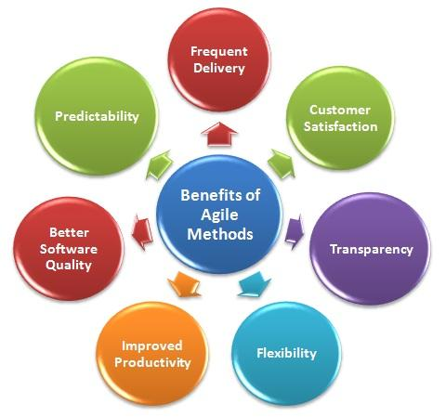
Figure 1. Benefits of Agile Methods [2]

Agile methodology encompasses several models. Some of the most popular ones include
Extreme Programming Model: Developers are expected to thoroughly test their own code as part of their responsibilities. Extreme Programming (XP) is tailored for development teams of 3 to 10 engineers [6]. Customer representatives and managers enhance the team by providing architectural guidance and acting as coding mentors or coaches. XP is a rigorous software development approach emphasising simplicity, effective communication, continuous feedback, and the courage to tackle challenges. This methodology ensures high-quality code and adaptive responses to changing requirements. XP unites the entire team through straightforward methodologies and extensive feedback, allowing the team to assess progress and adjust methods to their specific circumstances [7]. This cohesive approach fosters a collaborative environment conducive to addressing evolving project demands effectively.
The life cycle of Extreme Programming (XP) consists of five phases [8]. During the Exploration phase, the customer provides detailed story cards, outlining the specific features required for the initial release. In the Planning phase, the team prioritises user stories and estimates the effort and schedule for each story [7]. In the Iterations to Release phase, the planned schedule is divided into multiple iterations, each lasting one to four weeks. By the end of the final iteration, the system is fully prepared for production.

In the Production phase, any new changes are carefully evaluated to determine if they should be incorporated into the current release, ensuring system stability and readiness for deployment. Finally, in the Death phase, system documentation is meticulously prepared once all modifications to the architecture, design, and code are completed. If the system fails to produce the intended results or if continued development becomes financially unfeasible, it may be terminated [7]. This structured approach ensures that the XP methodology remains adaptive and responsive to customer needs and technical challenges, promoting a high-quality software development process. XP's emphasis on iterative development and continuous feedback supports effective project management and successful outcomes.

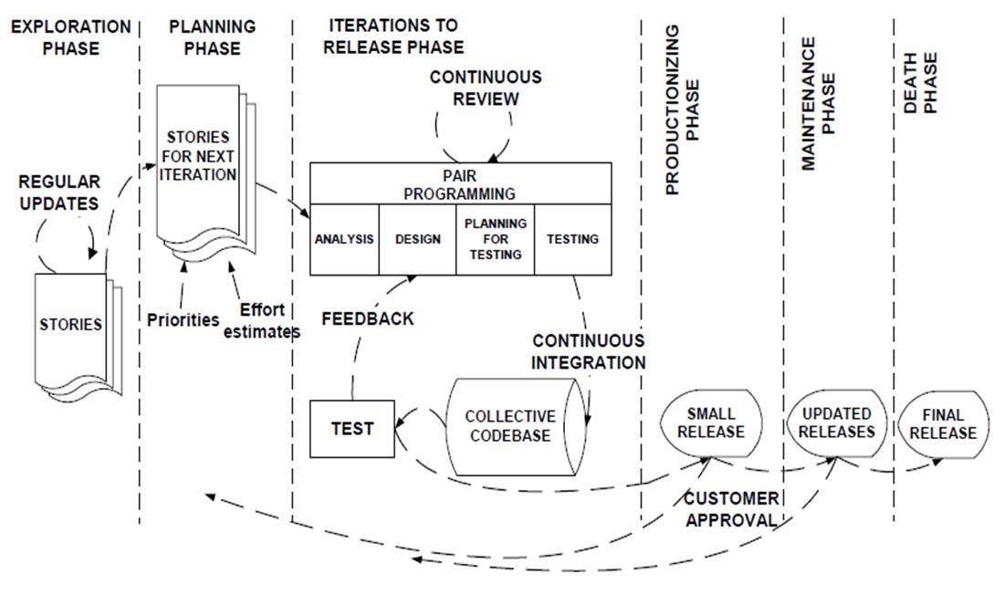
Figure 2: Extreme Programming model [7]
SCRUM Model: This includes a daily check-in meeting to assess progress and develop solutions [9]. Scrum, shown in Figure 2, is a flexible project management framework ideal for projects with tight deadlines, complex requirements, and unique characteristics [7].
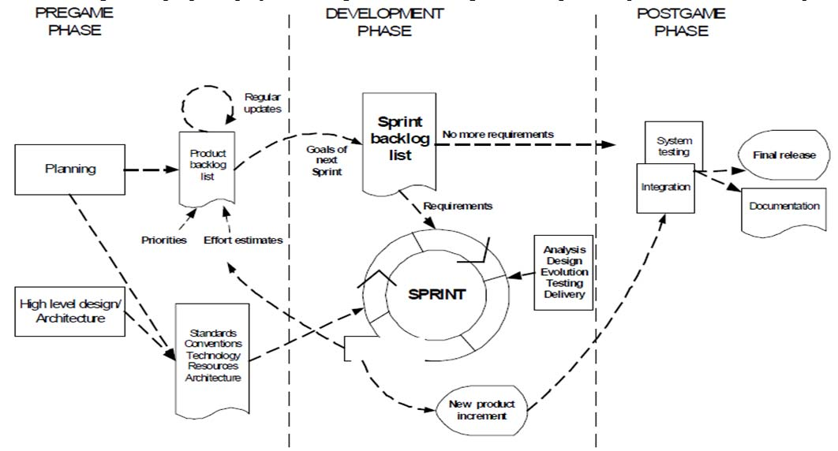
Figure 3: SCRUM model [7]

The term "Scrum" originates from rugby, where it refers to the collaborative effort to get the ball back into play [10]. Scrum is based on principles of self-commitment, self-organisation, and emergence, rather than authoritarian measures. It is ideal for small teams of fewer than 10 engineers. The Scrum process consists of three distinct phases: pre-game, development, and post-game [7]. The pre-game phase is further divided into two sub-phases, ensuring effective teamwork and adaptability in managing complex projects:
- Planning involves clearly defining the system being developed. A comprehensive product backlog list is generated, encompassing all currently identified requirements.
- In the architecture phase, meticulous planning is undertaken to design the system's high-level structure, considering the current items in the Product Backlog.
This approach supports efficient project management and successful outcomes. During the Development phase, the system is created in Sprints, which are iterative cycles focused on developing or enhancing functionality to produce new increments. Every Sprint consists of several phases, including requirements, analysis, design, evolution, and delivery [7]. The Post-game phase encompasses the finalisation of the release, which involves tasks like integration, system testing, and documentation [11].
Crystal Clear Model: Crystal Clear is a streamlined software development methodology that prioritises individuals, collaboration, community, abilities, talents, and effective communication over tools or procedures. This approach is ideal for teams of up to 6 developers and is suitable for smaller-scale projects that do not have life-or-death implications [12]. Organisations using Crystal Clear adapt their methodology to meet specific business demands, ensuring flexibility and adaptability. For moderate-scale projects, Crystal Orange is recommended, catering to teams of 10 to 40 members with project durations ranging from one to two years [11]. This methodology upholds the core principles of Crystal Clear while scaling to manage more complex and extended projects, promoting effective project management and successful outcomes across various team sizes and project scopes.
Feature Driven Development (FDD) Model: Feature-Driven Development (FDD) is a software process that prioritises client needs, focusing on architecture and practicality. According to [7], FDD comprises five primary activities, executed iteratively, as shown in Figure 4.

- Develop an Overall Model: A comprehensive model is created, producing a high-level object model and detailed notes. Initially, the goal is to identify and understand the core principles of the domain that the system addresses. As the project progresses, this model is continuously refined to accurately represent the system being built, ensuring clarity and precision.

2. Create a Comprehensive List of Features: Features are organized into related sets.

3. Plan by Feature: This involves the development process, identifying the owners of each class and the feature set.

4. Design by Feature: This phase includes detailed modelling.

5. Build by Feature: This phase includes programming, testing, and packaging the system.

This structured approach ensures the development process remains client-focused and methodically organised.
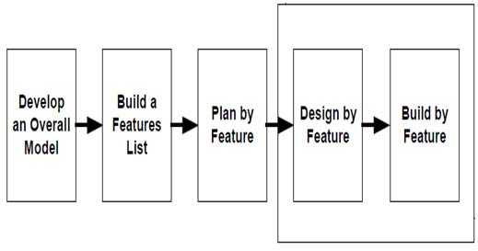
Figure 4: Feature Driven Development model [7]
2.2 Quality Assurance in Agile
Quality Assurance (QA) in Agile is a critical aspect of software development that emphasises preventing defects, delivering high-quality software, and continuously improving processes.
2.1 Test-Driven Development (TDD)
Test-Driven Development (TDD), as illustrated in Figure 5, is a software development method where tests are written before actual development begins. This iterative approach relies on test results [13]. Each iteration produces code necessary to pass its respective tests. Subsequently, the programmer or team adjusts the code to incorporate any changes [7]. This ensures the code meets predefined requirements and maintains high quality.

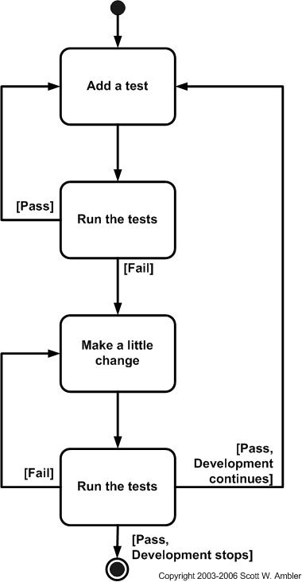
Figure 5: Test Driven Development model [13]

TDD encourages the creation of modular, flexible, and extensible code. It removes the necessity for using a debugger and enables incremental progress. However, overemphasis on Unit Testing can be time-consuming, requiring a large number of tests and necessitating their rewrite when requirements change. This balance is crucial for maintaining efficient development practices [7].

Related Studies
[14] discussed the issues and challenges in adopting software quality assurance within agile development, emphasising the need for measures to ensure quality adherence in iterative development cycles. [15] shared their experience in organising an agile team into two cells with distinct responsibilities for development and testing, noting improvements in test efficiency and potential reductions in time-to-market. [16] assessed the quality practices used in agile development methodology, revealing a lack of adherence to specific quality standards and identifying major obstacles affecting quality practices. [17] developed a quality assurance system using the agile development methodology with Scrum, highlighting the effectiveness of agile methods in achieving higher education accreditation standards quickly and precisely. This study demonstrates the applicability of agile methodologies in developing systems that meet stringent quality assurance requirements. [18] explored the elevation of software quality roles using agile methodology, addressing the critical factors affecting the success of agile methodology implementation and its impact on software quality. The paper suggests that employee behaviour, mutual relations, and motivation are significant factors in the successful implementation of agile methodologies. [19] Explored the impact of agile practices on software quality, using the ISO/IEC 25010 standard as a basis for evaluation. The study revealed that the implementation of agile engineering and project management practices has a noteworthy impact on the quality of functionality. This emphasises the advantages of adopting agile practices in improving particular aspects of software quality.
A study conducted by researchers [20] examined the utilisation of software development metrics to assist small and medium enterprises (SMEs) in implementing Agile methodologies for software development. The study presented a comprehensive list of metrics for Agile development processes that were rigorously tested in the setting of a small software development company. It shed light on how Agile projects can effectively meet quality standards.
The study, therefore, aims to synthesise the diverse approaches and insights from the existing literature into a comprehensive, actionable framework for integrating quality assurance within agile methodologies, something that is fragmented or only partially addressed in the reviewed literature. Additionally, it seeks to empirically validate this framework through a quantitative approach, providing quantifiable evidence of its effectiveness in enhancing software quality without compromising the agility and efficiency of the agile development process.
3.0 Methodology
To identify the challenges and limitations faced in integrating quality assurance practices within agile software development methodologies, a quantitative research approach was employed. Quantitative data was collected via surveys targeting software developers and QA professionals to assess the effectiveness of various QA practices within agile methodologies. A total of fifty (50) software developers and QA professionals were purposively sampled.
4. 0 Results and Discussion
Table 1: Challenges and Limitations Faced in Integrating Quality Assurance Practices Within Agile Software Development Methodologies
 | Items | Mean | SD (%) | D  (%) | N  (%) | A  (%) | SA  (%)
1 | Agile methodologies allow for effective integration of QA practices throughout the development cycle. | 3.98 | 0.0 | 0.0 | 12.0 | 78.0 | 10.0
2 | Continuous integration and testing are critical for maintaining software quality in Agile projects. | 4.9 | 0.0 | 0.0 | 0.0 | 10.0 | 90.0
3 | QA professionals have sufficient visibility and influence in Agile teams. | 2.92 | 2.0 | 20.0 | 62.0 | 16.0 | 0.0
4 | The fast-paced nature of Agile projects compromises the thoroughness of QA practices. | 2.0 | 18.0 | 64.0 | 18.0 | 0.0 | 0.0
5 | User stories and acceptance criteria are effectively used to guide QA efforts in Agile projects. | 4.02 | 0.0 | 0.0 | 16.0 | 66.0 | 18.0
6 | Automated testing tools are adequately utilized in Agile methodologies to ensure software quality. | 3.96 | 0.0 | 0.0 | 14.0 | 76.0 | 10.0
7 | There is often a lack of documentation in Agile projects, which negatively impacts QA activities. | 3.02 | 0.0 | 16.0 | 66.0 | 18.0 | 0.0
8 | Agile methodologies facilitate early detection and correction of defects, improving overall software quality. | 4.82 | 0.0 | 0.0 | 0.0 | 18.0 | 82.0
9 | Collaboration between software developers and QA professionals in Agile teams is effective in identifying quality issues early. | 4.08 | 0.0 | 0.0 | 6.0 | 80.0 | 14.0
10 | The iterative nature of Agile methodologies makes it challenging to maintain a consistent focus on quality assurance. | 1.9 | 20.0 | 72.0 | 6.0 | 2.0 | 0.0
Key: SD= Strongly Agree, A= Agree, D= Disagree, SD= Strongly Disagree
From Table 1, with a mean score of 4.9 and 90% of respondents strongly agreeing, there is overwhelming support for the critical role of continuous integration and testing in maintaining software quality within Agile projects. This suggests a widespread recognition of these practices as foundational to effective QA in Agile. A mean score of 2.92, with 62% neutral responses, indicates a significant challenge in ensuring QA professionals have sufficient visibility and influence in Agile teams. This points to a potential gap in how QA roles are integrated and valued within Agile methodologies. The concern that the fast-paced nature of Agile projects compromises the thoroughness of QA practices is highlighted by a mean score of 2.0, with 64% disagreeing and 18% strongly disagreeing. This indicates a perception that Agile's speed may be at odds with the depth and rigour required for comprehensive QA. With a mean score of 4.02, there is strong agreement that user stories and acceptance criteria are effectively used to guide QA efforts. This suggests that these Agile practices are well-regarded as tools for ensuring quality, but may not address all aspects of QA integration challenges. The utilisation of automated testing tools, indicated by a mean score of 3.96, shows general agreement on their adequacy in Agile methodologies. However, 14% neutrality suggests room for improvement in fully leveraging automation for QA.
The mean score of 3.02 reflects concern over the lack of documentation in Agile projects negatively impacting QA activities. With 66% neutral and 18% agreeing, this suggests ambivalence about the role of documentation, pointing to a challenge in balancing Agile's preference for minimal documentation with QA requirements. A high mean score of 4.82 indicates strong agreement that Agile methodologies facilitate early detection and correction of defects. This is a positive aspect of Agile for QA, but it may not mitigate other challenges, such as the depth of testing or documentation. With a mean score of 4.08, there's acknowledgement of effective collaboration between software developers and QA professionals. While this is encouraging, the 6% neutral response indicates potential areas for improvement in collaboration practices. The lowest mean score of 1.9 concerning the challenge of maintaining a consistent focus on QA highlights a significant concern. With 72% disagreeing that Agile methodologies make it challenging to maintain QA focus, this suggests a fundamental tension within Agile projects between iterative development and sustained QA attention.
3.2 Strategies for Incorporating QA Practices into Agile Development Processes
To address the challenges identified in integrating Quality Assurance (QA) practices within Agile development processes, the following framework or strategies are proposed. These strategies aim to ensure both agility and quality, reconciling the speed and flexibility of Agile methodologies with the thoroughness and rigour required for effective QA.
Embed QA Early and Throughout the Agile Cycle: Integrate QA professionals from the very start of the product development cycle, ensuring they are involved in planning, review sessions, and daily stand-ups. This early integration helps in understanding requirements clearly, setting quality benchmarks early, and planning tests well in advance.
Enhance QA Visibility and Influence: Establish clear roles and responsibilities for QA professionals that emphasise their importance in the Agile team. This could include leadership roles such as QA Lead or Test Manager within Agile teams, who would have the authority to influence decisions related to product quality.
Promote Continuous Integration and Testing: Implement continuous integration (CI) and continuous testing (CT) practices rigorously. Automate the deployment and testing processes to ensure that every code commit is tested, and issues are identified and addressed promptly.
Leverage User Stories for Quality: Utilise user stories and acceptance criteria as a foundation for test case development. Ensure that acceptance criteria are detailed and comprehensive, providing a solid basis for testing activities and quality benchmarks.
Optimise Documentation for Agile: Develop a balanced approach to documentation that satisfies the need for essential information without overwhelming the Agile process. Adopt tools and practices like living documents that evolve with the project and are easily accessible to all team members.
Enhance Collaboration Between Developers and QA: Foster a culture of collaboration and open communication between developers and QA professionals. Implement practices like pair programming and buddy testing, where developers and testers work closely together, blending development with quality assurance activities.
Adopt a Holistic Approach to Automated Testing: Broaden the use of automated testing to cover unit, integration, system, and acceptance testing. Invest in robust automated testing frameworks and tools that integrate seamlessly with the Agile development environment.
Implement Feedback Loops for Continuous Improvement: Establish feedback loops through regular retrospectives and reviews, focusing specifically on quality assurance practices. Use these sessions to identify what is working well and what needs improvement, fostering a culture of continuous learning and quality enhancement.
Implementing this framework requires commitment from all stakeholders, including management, development teams, and QA professionals. It begins with education and training on the importance of integrating QA into the Agile process and evolves through continuous improvement and adaptation based on feedback and results. By following these strategies, organisations can enhance the quality of their software products while retaining the agility and efficiency offered by Agile methodologies.
5.0 Conclusion

The analysis of survey responses highlights both the strengths and challenges of integrating Quality Assurance (QA) practices within Agile development processes. The strong support for continuous integration and testing underscores the recognition of these practices as essential for maintaining software quality in Agile environments. However, the survey also uncovers significant challenges, including the need for enhanced visibility and influence of QA professionals, concerns about the impact of Agile's fast pace on the thoroughness of QA practices, and the balancing act between minimal documentation and the requirements of effective QA.
By embedding QA early and throughout the Agile cycle, enhancing the visibility and influence of QA professionals, and promoting practices such as continuous integration and testing, the framework aims to weave quality assurance more tightly into the fabric of Agile methodologies. Strategies such as leveraging user stories for quality, optimising documentation for Agile, enhancing collaboration between developers and QA, and adopting a holistic approach to automated testing are designed to overcome the identified challenges, ensuring that quality is not compromised for speed or flexibility. The successful integration of QA practices into Agile development processes requires a deliberate and strategic approach that recognises and addresses the unique challenges posed by Agile methodologies. The proposed framework offers a comprehensive strategy for achieving this integration, ensuring that software products are not only developed with agility and efficiency but also meet the highest standards of quality. By committing to this framework and continuously adapting based on feedback and results, organisations can fully harness the benefits of Agile methodologies while ensuring that quality remains at the forefront of software development efforts.

COMPETING INTERESTS DISCLAIMER:
Authors have declared that they have no known competing financial interests OR non-financial interests OR personal relationships that could have appeared to influence the work reported in this paper.

Disclaimer (Artificial intelligence)
Option 1:
Author(s) hereby declare that NO generative AI technologies such as Large Language Models (ChatGPT, COPILOT, etc.) and text-to-image generators have been used during the writing or editing of this manuscript.
Option 2:
Author(s) hereby declare that generativ AI technologies such as Large Language Models, etc. have been used during the writing or editing of manuscripts. This explanation will include the name, version, model, and source of the generative AI technology and as well as all input prompts provided to the generative AI technology
Details of the AI usage are given below:
1.
2.
3.

References

- Kayed, A. (2023). Improving Quality Assurance by Providing Robust Tools.
- Matharu, G. S., Mishra, A., Singh, H., & Upadhyay, P. (2015). Empirical study of agile software development methodologies: A comparative analysis. ACM SIGSOFT Software Engineering Notes, 40(1), 1-6.
- Varl, M., Duhovnik, J., & Tavčar, J. (2020). Agile product development process transformation to support advanced one-of-a-kind manufacturing. International Journal of Computer Integrated Manufacturing, 33(6), 590-608.
- Al-Saqqa, S., Sawalha, S., & AbdelNabi, H. (2020). Agile software development: Methodologies and trends. International Journal of Interactive Mobile Technologies, 14(11)
- Gheorghe, A. M., Gheorghe, I. D., & Iatan, I. L. (2020). Agile Software Development. Informatica Economica, 24(2).
- Akhtar, A., Bakhtawar, B., & Akhtar, S. (2022). Extreme Programming Vs Scrum: A Comparison Of Agile Models. International Journal of Technology, Innovation and Management (IJTIM), 2(2), 80-96.
- Kumar, G., & Bhatia, P. K. (2014, February). Comparative analysis of software engineering models from traditional to modern methodologies. In 2014 Fourth International Conference on Advanced Computing & Communication Technologies (pp. 189-196). IEEE.
- Abrahamsson, P., Salo, O., Ronkainen, J., & Warsta, J. (2017). Agile software development methods: Review and analysis. arXiv preprint arXiv:1709.08439.
- Kikitamara, S., & Noviyanti, A. A. (2018, July). A conceptual model of user experience in scrum practice. In 2018 10th International Conference on Information Technology and Electrical Engineering (ICITEE) (pp. 581-586). IEEE.
- Crisan, E., Beleiu, I., & Ilies, L. (2015). The place of Agile in management science-A literature review. Managerial Challenges of the Contemporary Society. Proceedings, 8(1), 62.
- Aitken, A., & Ilango, V. (2013, January). A comparative analysis of traditional software engineering and agile software development. In 2013 46th Hawaii International Conference on System Sciences (pp. 4751-4760). IEEE.
- Bharathi, M. V., & Spurthi, V. (2013). A survey on efficient agile development methods. International Journal of Engineering Research and Technology, 2(9).Qiu, J. (2023). A Brief History of Test-Driven Development. In Test-Driven Development with React and TypeScript: Building Maintainable React Applications (pp. 1-13). Berkeley, CA: Apress.
- https://agilemodeling.com/essays/executablespecifications.html
- Shuib, R. (2021). Towards adopting software quality assurance in agile development methodology. Turkish Journal of Computer and Mathematics Education (TURCOMAT), 12(3), 2152-2157.
- Dóra, P. M., Oliveira, A. C., & Moura, J. A. B. (2013). Improving Quality in Agile Development Processes. In ICSOFT (pp. 411-416).
- Nyandongo, K., & Madonsela, T. (2021). ASSESSMENT OF SOFTWARE QUALITY IN AGILE PRACTICES. 30th Annual Conference of the International Association for Management of Technology (IAMOT 2021). https://doi.org/10.52202/060557-0077.
- Legowo, M., Indiarto, B., & Prayitno, D. (2019). Agile Software Methodology with Scrum for Developing Quality Assurance System. 2019 2nd International Conference of Computer and Informatics Engineering (IC2IE), 104-109. https://doi.org/10.1109/ic2ie47452.2019.8940831.
- Lochan, M. (2021). Elevating Software Quality Role Using Angle Methodology. 2021 International Conference on Technological Advancements and Innovations (ICTAI), 576-581. https://doi.org/10.1109/ICTAI53825.2021.9673334.
- Arcos-Medina, G., & Mauricio, D. (2020). The influence of the application of agile practices in software quality based on ISO/IEC 25010 standard. International Journal of Information Technologies and Systems Approach (IJITSA), 13(2), 27-53.
- Choraś, M., Springer, T., Kozik, R., López, L., Martínez-Fernández, S., Ram, P., ... & Franch, X. (2020). Measuring and improving agile processes in a small-size software development company. IEEE access, 8, 78452-78466.
- Kaur, G., Kaur, I., Harnal, S., & Malik, S. (2023). Factors and techniques for software quality assurance in agile software development. Agile Software Development: Trends, Challenges and Applications, 257-272.
- Kokol, P. (2022). Software Quality: How Much Does It Matter? Electronics, 11(16), 2485.
- Lee, M. (2014). Software Quality Factors and Software Quality Metrics to Enhance Software Quality Assurance. Current Journal of Applied Science and Technology, 4(21), 3069–3095.

