Original Research Article
Phytochemical, Antioxidant and Free Radical Scavenging Activities of Ethanol Extract of Costus afer, Sida acuta and Irvingia gabonensis

ABSTRACT

Background: Scientific investigation supporting the use of various African plant species for the management of diseases, including neurological disease is currently ongoing. Plant-based antioxidants have recently received a lot of attention because of their purported positive impact on human health. Medicinal plants selected for this study are widely used in traditional medicine for the treatment of neurological disorders.
Aims: This study investigated the phytochemical, antioxidant and free radical scavenging activities of ethanol leaf extracts of Costus afer, Irvingia gabonensis and Sida acuta.
Materials and Methods: Fresh leaves of Costus afer, Irvingia gabonensis and Sida acuta were collected from a farm at Egbu in Owerri North LGA of Imo state. They were washed and spread to air dry at room temperature and ground into fine powder. Phytochemistry was carried out through gas chromatography coupled with mass spectrometry (GC-MS) analysis. Fourier transform infrared (FTIR) spectroscopy was used to determine the functional groups in the plant extracts. The in vitro antioxidant activity was determined for total flavonoid content (TFC) and total phenol content (TPC). Free radical scavenging potential was evaluated by measuring 2, 2-diphenyl-2-picrylhydrazyl (DPPH), ferric reducing antioxidant potential (FRAP), nitric oxide (NO), and hydroxyl (OH) radicals.
Results: A total of thirty-seven (37) phytocompounds were revealed in Costus afer, while Irvingia gabonensis and Sida acuta exhibited sixty-seven (67) and ninety-four (94) phytocompounds respectively. Bioactive compounds such as flavonoids, alkaloids, phenols, carboxylic acids, fatty acids, alkenes, glycosides, steroids, alcohol, and aldehydes were present in the plant extracts. The functional groups present in the extracts included disubstituted aromatic compounds, phenols, alkenes, aromatic amines, isothiocyanates, phosphonic acids, amine salts, secondary amines, phosphines, carboxylic acids, aldehydes, intramolecular bonded alcohols, aromatic esters and free alcohols. Sida acuta extract exhibited the highest levels of total flavonoid (9.29 ± 0.23 mg/ml) and phenolic content (6.15 ± 0.15 mg/ml). All three samples exhibited statistically significant (p<0.05) values for DPPH, FRAP and OH scavenging activities.
Conclusion: The results suggested that the ethanol leaf extracts of Costus afer, Sida acuta and Irvingia gabonensis had considerable number of phytochemicals, antioxidant and free radicals scavenging properties, hence supporting the traditional use of the plants in the management and treatment of neurological disorders.

Keywords: Costus afer, Irvingia gabonensis, Sida acuta, Phytochemical, Antioxidant.

1. INTRODUCTION

“Currently, medicinal plants and extracts have found increased use as an alternative treatment for a variety of diseases. The increasing occurrence of diseases, the advent of drug resistance, and the demand for drugs with few side effects have led researchers to explore the best plant-based sources of medicine utilizing revolutionary scientific and technical methodologies” (Osuagwu et al., 2023). “Primary and secondary metabolites in plants are thought to be responsible for their medicinal properties which include antioxidant effects, free radicals scavenging activities, enzyme induction, and activation of important biochemical pathways. These compounds also have the ability to protect against pathogens and provide significant physiological advantages that can help avert certain diseases” (Asiwe et al., 2021). “The chemical components found in plants are called phytochemicals. Both phytochemicals and other nutrients present in plants, such as vitamins, minerals, proteins, amino acids, and carbohydrates, are biologically active in nature and effective against disease-causing organisms. Therefore, these plants with biologically active components are referred to as medicinal plants” (Ezekwe et al., 2020). “Medicinal plants are rich sources of secondary metabolites, such as phenolics, alkaloids, flavonoids, resins, cyanogenic glycosides, oxalates, and many more components that have a wide range of potential uses in the treatment, prevention and management of diseases. As such, these plants are now being used as useful resources for the development of novel drugs, nutritional supplements, pharmaceutical intermediates, dietary supplements and chemical models for synthetic medications” (Dike et al., 2023; Rafiqkhan et al., 2013). “Plants are utilized extensively for medicinal purposes in many traditional systems of healthcare and are becoming more prevalent in contemporary culture as substitutes to synthetic medications. Herbal remedies are typically less expensive, more accessible, and more socially acceptable due to the notion that they have fewer negative effects compared to some synthetic medications” (Chikezie et al., 2015).

“Free radicals play a crucial role in phagocytosis, respiration, and mitochondrial energy generation and they are implicated in the pathogenesis of several disorders such as diabetes mellitus, gastric ulcer, Alzheimer's disease, rheumatoid arthritis, and respiratory diseases. However, researchers are currently focused on utilizing raw or refined plant materials and plant-derived products as potential remedies in the management of oxidative stress” (Asiwe et al, 2021). “The efficacy of plants has been attributed to their capacity to reduce some biomolecules that trigger oxidative stress in living organisms. Oxidative stress in living organisms has been defined as a state that arises when reactive oxygen species (ROS) are produced in excess against the defense mechanisms. The defensive mechanisms include a number of complex antioxidant systems that counteract the actions of reactive oxygen species. They consist of the major cellular redox buffers ascorbate and glutathione, in addition to tocopherol, carotenoids, and phenolic compounds, as well as enzymatic components like superoxide dismutase, catalase, guaiacol peroxidase, ascorbate peroxidase, enzymes of ascorbate-glutathione, monodehydroascorbate reductase, dehydroascorbate reductase, and glutathione reductase. Antioxidants of plant origin with properties against free radicals could have enormous importance as therapeutic agents in numerous disorders associated to oxidative stress, since these compounds are effective as radical scavengers and regulators of lipid peroxidation. As a result, the use of these natural substances has demonstrated to be clinically efficient and relatively less toxic than the existing medications” (Alisi, et al., 2014; Ezekwe et al., 2021).

“Costus afer (C. afer), a member of the Zingiberaceae family, is a tall, herbaceous, and unbranched tropical plant with a creeping rhizome which is typically found in damp or shaded forest in West and Tropical Africa. It is a perennial plant with spirally arranged leaves. The sheath is tubular, green with purple markings, while the ligule and petiole are leathery and glabrous. The blade is elliptical to obovate, measuring 15-35cm by 3.5-9.5cm, with a rounded base and tip. The inflorescence is a short, terminal spike with densely inbricate bracts and boat-shaped bracteoles. The flowers are bisexual and zygomorphic. C. afer, is commonly called “Okpete” or “Okpoto” in the Eastern part of Nigeria, while it is called “Ireke omode” or “Ireke ogun” in the Western part of Nigeria. It is also called “Kakizawa” in Hausa and “Mbritem” in Efik. C. afer is a valuable medicinal plant in South-East and South-West Nigeria known for its numerous medicinal properties” (Omokhua, 2011). Stem extract from Costus afer inhibited ethanol-induced neuronal degeneration in mice through an antioxidant-inflammatory pathway (Odey et al., 2024).

“Irvingia gabonensis (I. gabonensis) which belongs to the family Irvingiaceae is a large evergreen tree commonly found in West and Central Africa. In Nigeria, it is identified by various names such as Ugiri in Igbo, Goron or Biri in Hausa Apon in Yoruba, and Mbukpabuyo by the Efik and Ibibio” (Emejulu et al., 2016; Unaeze et al., 2017). “The fruits are greenish yellow with fleshy fibrous pulp surrounding a huge hard stone. The kernel is used in making sauces. The fruit pulp is edible and the kernel is often utilized for medicinal purposes and as a source of oil for making soap. The leaves, bark and roots are used in ethnomedicine for the treatment of a variety of ailments” (Etta et al., 2013). Other studies have also investigated the neuroprotective effect of I. gabonensis (Ojo et al., 2014; Uchewa et al., 2023)

“Sida acuta (S. acuta) an ethnomedicinally important genus of about 200 species of herbaceous plants, belongs to the Malvaceae family. It is sometimes referred to as tenacious weed. It is an upright, branching, tiny perennial shrub with hairy branches that can reach heights of one metre (1 m) with a woody tap root. S. acuta is predominantly found in abandoned cropland, waste areas, grazing land, and roadside ditches. Plants of this genus are widely distributed as weeds in pasture and waste lands of tropical and subtropical regions of the world” (Senthilkumar et al., 2018). The study conducted by Benjumea et al. (2016), on the neuropharmacological properties of S. acuta leaves and stems, including sedative, anticonvulsant and anxiolytic activities showed that the leaves and stems of S. acuta exhibited sedative properties.

This study was designed to investigate the phytochemical, antioxidant and free radical scavenging activities of ethanol leaf extracts of Costus afer, Irvingia gabonensis and Sida acuta. The aim was to explore the potential therapeutic benefits of these plants in the treatment of neurological disorders, given their wide traditional use for this purpose.

2. MATERIALS AND METHODS

2.1. Chemicals/Reagents

Ethanol (Sigma, St. Louis, USA), Trichloroacetic acid (Labosi, Paris, France), Thiobarbituric acid (Sigma-Aldrich, MO USA), 2,2-Diphenyl-2-Picryl Hydrazyl Hydrate (0.3mm in Methanol), Sodium Nitroprusside, Griess Reagent (1% Sulphanilamide, 2% H₃PO₄ and 0.1% Naphthylethylene diamine dihydrochloride), Potassium ferrocyanide, Butylated hydroxytoluene. Other chemicals were of analytical grades.

2.2. plant materials

Fresh leaves of Costus afer, Irvingia gabonensis and Sida acuta used for this research work were collected from a farm at Egbu in Owerri North LGA of Imo state. Samples were identified by a plant taxonomist. The leaves were washed with tap water and spread to air dry at room temperature for two (2) weeks. The samples were ground into fine powder using an industrial-grade grinding machine, weighed and placed in clearly labelled containers to facilitate identification and subsequently stored for extraction.

2.3. Extraction

Exactly 200g of each pulverized sample was macerated in 400 ml of 96% ethanol and was vigorously shaken every two hours for 48 hours. Thereafter, they were filtered, first with clean handkerchief, then with filter paper to obtain a filtrate which was concentrated at 40ºC in a hot-air oven to obtain the extract which were all pasty in consistency (Stéphane et al., 2021). The extracts were appropriately labelled and stored in airtight container and refrigerated at 4 °C until required for analysis.

2.4. Gas chromatography- mass spectrometry (GC-MS)

The GC-MS analysis of bioactive compounds from the different leaf extracts was done using Agilent Technologies GC systems equipped with HP-5MS column (30 m in length × 250 μm in diameter × 0.25 μm in thickness of film). The spectroscopic detection by GC-MS employed an electron ionization system that utilized high-energy electrons with an energy level of 70 electron volts (eV). Pure helium gas was used as the carrier gas with flow rate of 1 mL/min. The temperature was initially set within the range of 50 to 150 °C, with increasing rate of 3 °C/min and holding time of 10 min. The temperature was finally increased to 300 °C at 10 °C/min. One microliter of the prepared 1.0 % of the extracts diluted with appropriate solvents, was injected into the system using a splitless mode. Relative quantity of the chemical compounds present in each of the extracts was expressed as percentage based on peak area produced in the chromatogram (Buss et al., 2010).

2.5. Identification of unknown compounds present in the extract

To identify the unknown components in the extract, their individual mass spectral peak values were compared with the database of National Institute of Science and Technology 2014 (NIST, 2014). Then, the phytochemicals were identified after comparing the unknown peak value and chromatogram from the GC-MS against the known chromatogram, peak value from the NIST library database. Subsequently, the details about the molecular formula, molecular weight, retention time and percentage content were also obtained (Buss et al., 2010).

2.6. Fourier transform infrared (FTIR) spectroscopy

Buck scientific M530 USA FTIR was used for the analysis. This instrument was equipped with a detector of deuterated triglycine sulphate and beam splitter of potassium bromide. The software of the Gram A1 was used to obtain the spectra and to manipulate them. Then, 0.5ml of nujol was added to an approximately 1.0 g of sample, mixed properly and placed on the salt pellet. During measurement, FTIR spectra was obtained at frequency regions of 4,000 – 6000 cm⁻¹ and co-added at 32 scans and at 4 cm⁻¹ resolutions. The FTIR spectra were displayed as transmitter values (VanderWeerd et al., 2004).

2.7. Total flavonoid content (TFC)

A volume of 0.5 ml of the sample was pipetted out and evaporated to dryness. Four millilitres (4.0ml) of Vanillin reagent was added and the tubes were heated in a boiling water bath for 15 minutes. Varying concentrations of the standard were also treated in the same manner. The optical densities were read in a spectrophotometer at 340 nm. A standard curve was constructed and the concentration of flavonoids in each sample was extrapolated. The values of flavonoids were expressed as mg/g sample (Cameron et al., 1943).

2.8. Total phenolic content (TPC)

A sample volume of 1.0 ml was mixed with 5.0 ml of distilled water and supplemented with an extra 1.0 ml of Folin-Denis reagent. After a 5-minute period of incubation, a solution of 10% Na₂CO₃ was added, and the resulting mixture was incubated for one hour at ambient temperature under conditions of low light. The process of determining the absorbance was carried out using a UV spectrophotometer, with a wavelength of 725 nm. The total phenol content (TPC) was determined from extrapolation of calibration curve which was made by preparing gallic acid solution (Attard et al., 2013).

2.9. DPPH radical scavenging assay

Twenty microliters (20 μl) of the leaf samples were added to 0.5 ml of 0.1 mM methanol solution of DPPH and 0.48 ml of methanol. The mixture was allowed to react at room temperature for 30 minutes. Methanol served as the blank and DPPH in methanol, without the leaf samples, served as the positive control while butylated hydroxytoluene (BHT) served as reference. After 30 minutes of incubation, the discolouration of the purple colour was measured at 518 nm with a spectrophotometer (Mensor et al., 2001). The radical scavenging activity was calculated as follows:
% DPPH scavenging activity = Abs control˗Abs sample × 100%
Abs control
Where; Abs control = Absorbance of control
Abs sample = Absorbance of sample

2.10. Ferric reducing antioxidant potential (FRAP)

A volume of 0.25 ml of the extracts was mixed with 0.25 ml of 200 mM sodium phosphate buffer pH 6.6 and 0.25 ml of 1% potassium ferrocyanide. The mixture was incubated at 50 ºC for 20 min. Thereafter, 0.25 ml of 10% trichloroacetic acid was added and centrifuged at 2000 rpm for 10 min. A volume of 1.0 ml of the supernatant was mixed with 1 ml of distilled water and 0.2 ml of ferric chloride and the absorbance was measured at 700 nm after allowing the solution to stand for 30 min. The ferric reducing antioxidant power of the extract was quantified in terms of gallic acid equivalent per gramme (GAE/g) (Pulido et al., 2000).
FRAP = A/Ao ×Mo/M
Where A= sample absorbance
Ao= mean absorbance of the standard
Mo= mass of standard
M= mass of sample

2.11. Nitric oxide radical scavenging activity

A volume of 2 mL of 10 mM sodium nitroprusside was dissolved in a 0.5 ml phosphate buffered saline (pH 7.4) and mixed with 0.5 ml of the sample at various concentrations. The mixture was then incubated at 25 ºC. After 150 min of incubation, the incubated mixtures were mixed with 0.5 ml of Griess reagent containing one percent (1%) sulphanilamide, two percent (2%) H₃PO₄ and zero-point one percent (0.1%) N-(1-naphthyl) ethylenediamine dihydrochloride and incubated again for 30 minutes. Control tubes were prepared without the samples. The absorbance was read at 546 nm against the reagent blank, in a spectrophotometer (Shukla et al., 2012). The amount of nitric oxide radical inhibition was calculated following this equation:
% Nitric oxide scavenging activity = Abs control˗Abs sample × 100%
Abs control
Where; Abs control = Absorbance of control
Abs sample = Absorbance of sample

2.12. Hydroxyl radical scavenging activity

The reaction mixture contained 0.1 ml of deoxyribose, 0.1 ml of FeCl₃, 0.1 ml of EDTA, 0.1 ml of H₂O₂, 0.1 ml of ascorbate, 0.1 ml of KH₂PO₄-KOH buffer and 20 µl of samples in a final volume of 1.0 ml. The mixture was incubated at 37 ºC for 1 hour. At the end of the incubation period, 1.0 ml of TBA was added and heated at 95 ºC for 20 minutes to develop the colour. After cooling, the TBARS formation was measured spectrophotometrically at 532 nm against an appropriate blank. The hydroxyl radical scavenging activity was determined by comparing the absorbance of the control with that of the samples. The percent TBARS production for positive control (H₂O₂) was fixed at 100 % and the relative percent TBARS was calculated for the sample treated groups (Jayasundara et al., 2018).
% inhibition of OH• radical = Abs control˗Abs sample × 100%
Abs control
Where; Abs control = Absorbance of control
Abs sample = Absorbance of sample

2.13. Statistical analysis

Data obtained from this study was analyzed statistically using Graph Pad Prism. The data are presented as the mean values of three replicates ± standard deviation (SD). Statistical significance was considered at p<0.05 using one-way analysis of variance (ANOVA).

3. RESULTS

3.1. GC-MS analysis of Costus afer

A total of thirty-seven (37) compounds were isolated from the ethanolic extract of Costus afer. The bioactive compounds with their peak values, retention time (RT), structural formula and percentage composition are shown in Table 1. Based on the results, the most predominant phytochemicals identified in C. afer ethanol extract included 2,4-di-tert-butylphenol (9.67%), carbonic acid, decyl prop-1-en-2-yl ester (9.26%), 9,12-octadecadienal (9.20%), carbonic acid, nonyl prop-1-en-2-yl ester (8.64%), undecane, 5-methyl- (8.00%), 17-pentatriacontene (3.48%) and undecane, 1-bromo- (3.25%). Conversely, benzene, 1,4-dichloro- (0.15%), 1-decanol, 2-hexyl- (0.93%) and 9-octadecenoic acid (Z)-, 2,3-dihydropropyl ester (0.97%) were found to be the least abundant bioactive phytocompounds present in C. afer extract.

Table 1. Phytocompounds present in ethanol extract of Costus afer

Peak | RT | Compound name | Structure | % Composition
1 | 5.238 | 9,12-Octadecadienal | 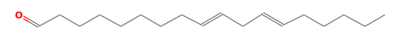 | 9.10
2 | 6.884 | Hexadecane 1- Chloro- | 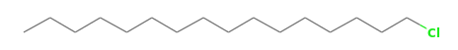 | 1.23
3 | 7.426 | Benzene, 1,4-dichloro- | 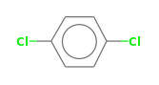 | 0.45
4 | 8.522 | Carbonic acid, decyl tetradecyl | 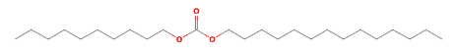 | 1.45
5 | 8.878 | 17-pentatriacontene |  | 3.58
6 | 8.985 | Undecane, 1-bromo- | 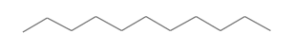 | 3.35
7 | 9.138 | Tetracosane | 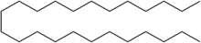 | 1.18
8 | 9.430 | Carbonic acid, decyl prop-1-en-2-yl ester | 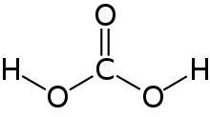 | 9.06
9 | 9.558 | 17-Pentatriacontene |  | 1.37
10 | 9.621 | Heptane , 2,6-dimethyl- | 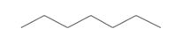 | 3.22
11 | 9.815 | Carbonic acid, nonyl prop-1-en-2-yl ester | 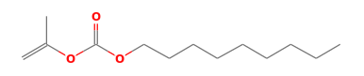 | 8.64
12 | 10.159 | Undecane , 5-methyl- | 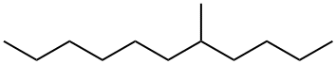 | 8.30
13 | 10.579 | Hydroxylamine, o-decyl- | 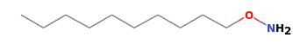 | 2.09
14 | 12.804 | Hexadecane, 1-chloro- |  | 1.71
15 | 15.708 | Hexadecane, 1-chloro- |  | 1.72
16 | 18.284 | Cyclohexadecane,1,2-diethyl- | 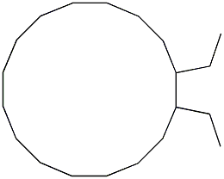 | 1.78
17 | 18.478 | Palmitic acid vinyl ester | 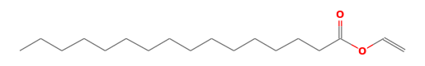 | 1.94
18 | 21.107 | 1-Decanol, 2-hexyl- | 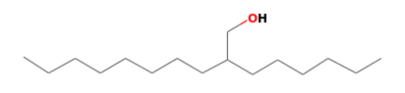 | 0.93
19 | 22.130 | 2,4-Di-tert-butylphenol | 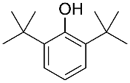 | 9.67
20 | 23.442 | Erucic acid | 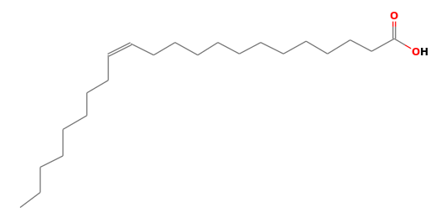 | 2.24
21 | 28.091 | 1-Nonadecene |  | 2.97
22 | 30.529 | Dibutyl phthalate | 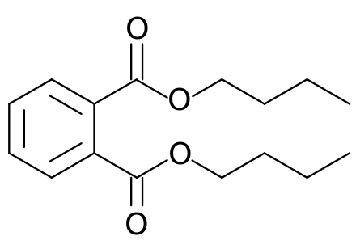 | 1.60
23 | 30.704 | 3-Eicosene |  | 2.54
24 | 30.886 | - Ethanone, 1-[4-acetyl-2,5-dimethyl-1-(8-quinolinyl)- 1H-pyrrol-3-yl]- |  | 0.64
25 | 32.036 | Oleic acid | 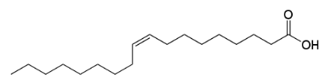 | 0.57
26 | 32.181 | 1-Docosene |  | 1.27
27 | 32.591 | 9-Octadecenal | 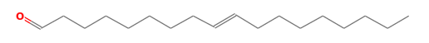 | 2.05
28 | 32.934 | 9-Octadecenal |  | 3.41
29 | 33.106 | Oleic acid | 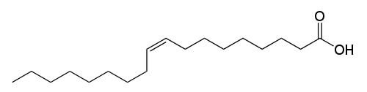 | 2.36
30 | 33.225 | Oleic acid |  | 0.64
31 | 33.375 | Oleic acid |  | 2.11
32 | 33.679 | 9-Octadecenoic acid (Z)- tetradecyl ester | 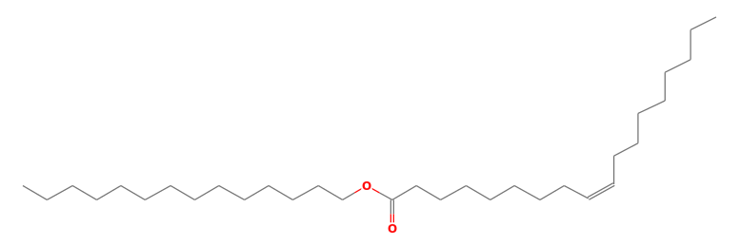 | 1.61
33 | 33.875 | 9-Octadecenoic acid (z), 2,3 -dihydroxypropyl ester | 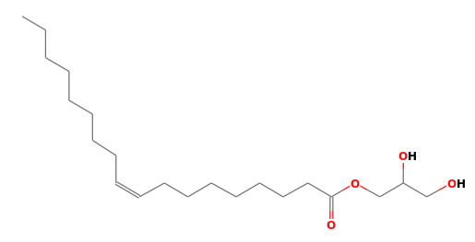 | 0.97
34 | 34.000 | Oleic acid |  | 0.95
35 | 34.116 | Oleic acid |  | 1.42
36 | 34.544 | Oleic acid |  | 1.45
37 | 37.065 | 13-Octdecenal | 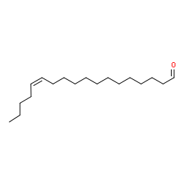 | -0.25
RT: retention time

3.2. GC-MS analysis of Irvingia gabonensis

A total of sixty-seven (67) compounds were isolated form Irvingia gabonensis. The bioactive compounds with their peak values, retention time (RT), structural formula and percentage composition are shown in Table 2. The prevailing bioactive phytocompounds identified in the ethanol extract of I. gabonensis based on the results included docosane, 2,21-dimethyl- (8.19%), 2,4-di-tert-butylphenol (7.74%), octadecane, 1-(ethenyloxy)- (3.03%), 1-decanol, 2-hexyl- (5.09%) and undecane (4.88%) while the least abundant compounds were benzocycloheptatriene (0.15%), undecane, 5-methyl- (0.20%), oxirane, tetradecyl- (0.22%), 2-chloro-4-fluorophenol, TBDMS derivative (0.23 %) and 2-methyl-Z, Z-3,13-octadecadienol (0.29%).

Table 2. Phytocompounds present in ethanol extract of Irvingia gabonensis

Peak | RT | Compound | Structure | % Composition
1 | 5.253 | Butyl 9-octadecenoate | 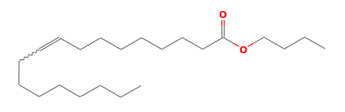 | 0.99
2 | 6.884 | Trifluoroacetoxy hexadecane | 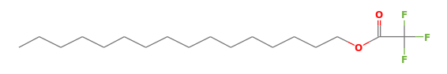 | 1.44
3 | 7.425 | Benzene, 1,4-dichloro- | 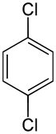 | 1.22
4 | 8.359 | Butyl 9-octadecenoate |  | 0.69
5 | 8.521 | Tricosane, 2-methyl- | 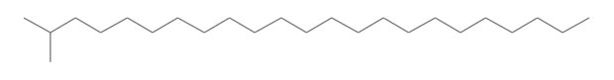 | 1.45
6 | 8.613 | 1-Hexadecanol, 2-methyl- | 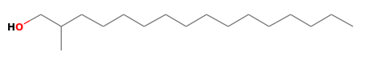 | 0.98
7 | 8.669 | Oxalic acid, cyclobutyl tetradecyl ester | 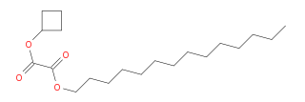 | 1.13
8 | 8.875 | Octadecane, 1-(ethenyloxy)- |  | 3.80
9 | 8.976 | Octadecane, 1-(ethenyloxy)- |  | 3.03
10 | 9.138 | Tricosane, 2-methyl- |  | 1.80
11 | 9.428 | Docosane, 2,21-dimethyl- | 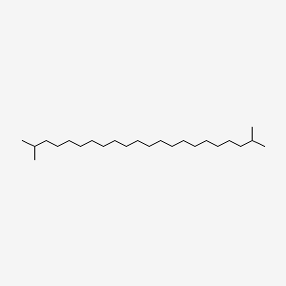 | 8.19
12 | 9.553 | Decane | 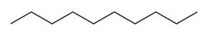 | 2.11
13 | 9.619 | Hydroxylamine, O-decyl- |  | 2.96
14 | 9.734 | Undecane |  | 2.88
15 | 9.815 | Undecane |  | 4.89
16 | 9.937 | Tetracosane, 3-ethyl- | 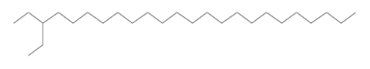 | 1.24
17 | 10.158 | 1-Decanol, 2-hexyl- |  | 5.09
18 | 10.268 | Allyl n-octyl ether | 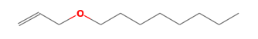 | 2.61
19 | 10.505 | Benzene, 1,2,4,5-tetramethyl- | 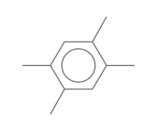 | 2.67
20 | 10.578 | 2,6-Dimethyldecane | 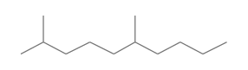 | 1.14
21 | 10.638 | Benzene, 1-ethyl-2,4-dimethyl- | 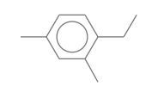 | 2.67
22 | 11.123 | Oxirane, tetradecyl- | 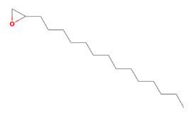 | 0.32
23 | 11.329 | Stearic acid hydrazide | 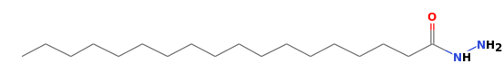 | 0.36
24 | 11.464 | Undecane, 5-methyl- | 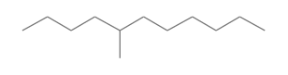 | 0.20
25 | 11.571 | Benzene, 1-ethyl-2,3-dimethyl- | 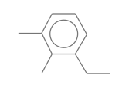 | 0.33
26 | 12.595 | Azulene | 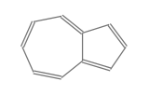 | 1.21
27 | 12.803 | Dodecane | 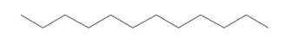 | 1.22
28 | 14.889 | 9-Octadecenal, (Z)- | 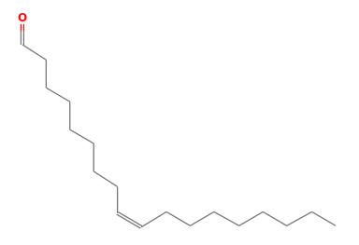 | 0.56
29 | 15.705 | Tridecane | 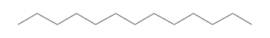 | 1.56
30 | 15.872 | Naphthalene, 1-methyl- | 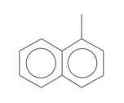 | 0.77
31 | 16.352 | Benzocycloheptatriene | 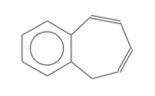 | 0.15
32 | 17.804 | Oxirane, tetradecyl- | 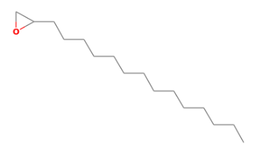 | 0.22
33 | 18.282 | 4-Tetradecene, (Z)- | 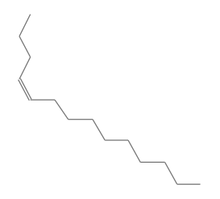 | 1.18
34 | 18.476 | Tetradecane | 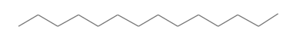 | 1.24
35 | 21.104 | Tricosane, 2-methyl- |  | 0.84
36 | 22.133 | 2,4-Di-tert-butylphenol | 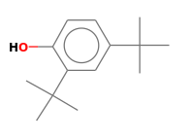 | 7.74
37 | 23.441 | Z-8-Hexadecene | 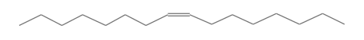 | 2.07
38 | 23.597 | Carbonic acid, eicosyl vinyl ester | 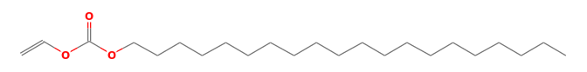 | 0.32
39 | 25.514 | 2-Chloro-4-fluorophenol | 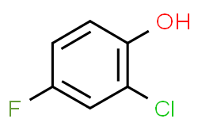 | 0.23
40 | 26.072 | Cyclohexene, 6-butyl-1-nitro- | 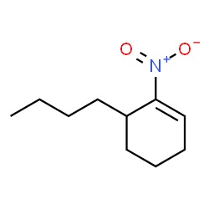 | 4.36
41 | 26.626 | 2-Methyl-Z,Z-3,13-octadecadienol | 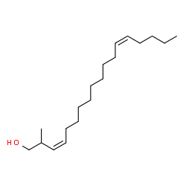 | 0.29
42 | 28.090 | 1-Octadecene | 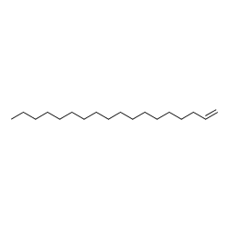 | 2.40
43 | 28.327 | E-15-Heptadecenal | 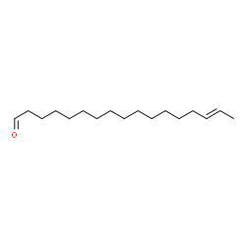 | 0.32
44 | 29.790 | Oleic Acid |  | 0.48
45 | 30.068 | Hexadecanoic acid, methyl ester | 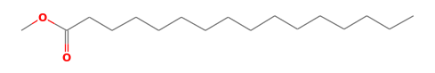 | 2.35
46 | 30.527 | Dibutyl phthalate | 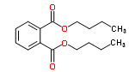 | 0.88
47 | 30.704 | Cyclohexadecane, 1,2-diethyl- | 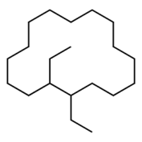 | 1.79
48 | 30.796 | Cycloeicosane | 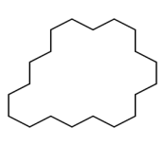 | 0.25
49 | 30.887 | Indazol-4-one, 3,6,6-trimethyl-1-phthalazin-1-yl-1,5,6,7-tetrahydro- | 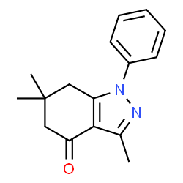 | 0.62
50 | 31.022 | 9-Methyl-10,12-hexadecadien-1-ol acetate | 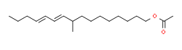 | 0.34
51 | 31.550 | 8,11-Octadecadienoic acid, methyl ester | 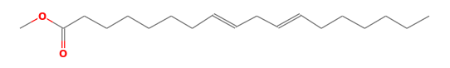 | 1.57
52 | 31.588 | trans-13-Octadecenoic acid, methyl ester | 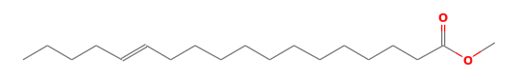 | 1.70
53 | 31.764 | Methyl stearate | 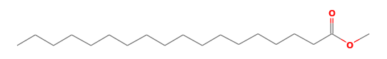 | 0.72
54 | 32.035 | Oleic acid |  | 0.53
55 | 32.181 | 1-Docosene |  | 1.02
56 | 32.340 | Oleic acid |  | 0.19
57 | 32.601 | Oleic Acid |  | 0.86
58 | 32.847 | Oleic Acid |  | 0.74
59 | 32.993 | Oleic Acid | 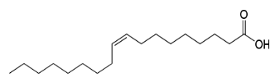 | 0.59
60 | 33.112 | Oleic acid |  | 0.44
61 | 33.375 | 2- Chloropropionic acid, hexadecyl ester | 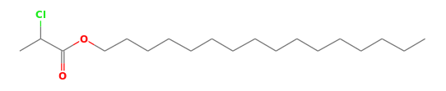 | 1.25
62 | 33.671 | Oleic acid |  | 0.78
63 | 33.999 | 3-(Prop-2-enoyloxy)dodecane | 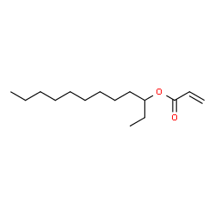 | 0.32
64 | 34.110 | Eicosanoic acid, isobutyl ester | 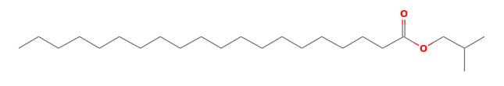 | 0.38
65 | 34.544 | Bis(2-ethylhexyl) phthalate | 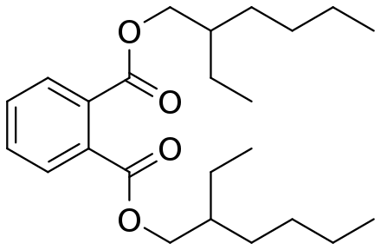 | 1.33
66 | 34.796 | cycloeicosane | 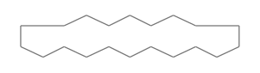 | 0.36
67 | 37.258 | 13-Octadecenal, (z) | 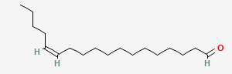 | 0.60
RT: retention time

3.3. GC-MS analysis of Sida acuta

A total of ninety-four (94) compounds were isolated form Sida acuta. The bioactive compounds with their peak values, retention time (RT), structural formula and percentage composition are shown in Table 3. Based on the results, the most abundant phytocompounds identified in the ethanol extract of Sida acuta were 2,4-di-tert-butylphenol (8.08%), decane, 3,8-dimethyl- (7.72%), heptadecane, 2,6,10,14-tetramethyl (4.71%), heptadecane, 2,6-dimethyl- (4.51%) and hexadecane, 3-methyl- (3.38%) whereas compounds such as hexadecanoic acid, 4-nitrophenyl ester (0.12%), oxirane, tetradecyl- (0.15%), 1-hexacosanol (0.15%), 3-eicosene, (E)- (0.15%), dodecane, 1,1'-oxybis- (0.16%), erucic acid (0.17%) and 9-octadecenal, (Z)- (0.17%) were identified at low levels.

Table 3. Phytocompounds present in ethanol extract of Sida acuta

Peak | RT | Compound name | Structure | % Composition
1 | 5.250 | Butyl 9-octadecenoate |  | 1.49
2 | 5.455 | 2-Thiopheneacetic acid, 3-tridecyl ester | 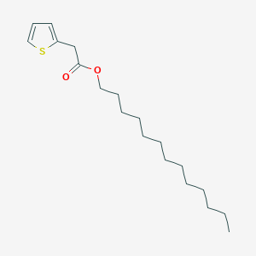 | 0.17
3 | 6.885 | 9-Octadecenal |  | 1.05
4 | 7.137 | Hexadecanoic acid, 4-nitrophenyl ester | 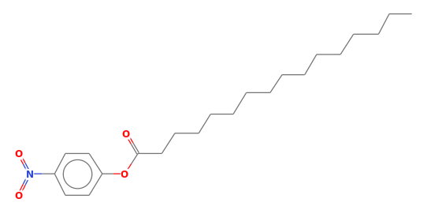 | 0.12
5 | 7.225 | 13-Octadecenal |  | 0.12
6 | 7.425 | Benzene 1,3- dichloro- | 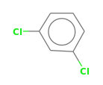 | 1.33
7 | 7.788 | Octadecane, 1-(ethenyloxy)- |  | 0.59
8 | 8.362 | Butyl 9-octadecenoate |  | 0.64
9 | 8.521 | 2-Ethyl-1-dodecanol | 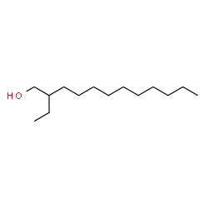 | 1.41
10 | 8.612 | 1-Hexadecanesulfonic acid | 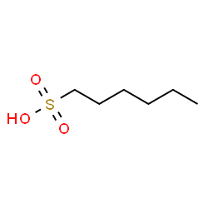 | 2.07
11 | 8.876 | Hexadecane, 3-methyl- 3,5--dichloro-2-6-dimethyl-4-pyridyl ester | 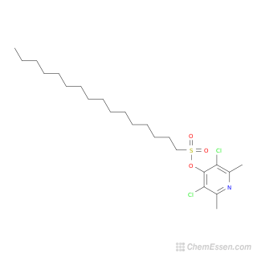 | 3.36
12 | 8.980 | Nonane | 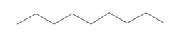 | 1.84
13 | 9.059 | Decane | 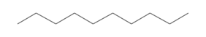 | 1.19
14 | 9.138 | 2,6-Dimethyldecane |  | 1.69
15 | 9.217 | Tricosane, 2-methyl- |  | 0.96
16 | 9.430 | Decane, 3,8-dimethyl | 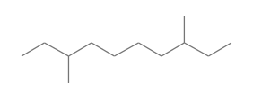 | 7.72
17 | 9.558 | Decane, 3,8-dimethyl |  | 1.66
18 | 9.622 | Undecane |  | 2.93
19 | 9.737 | Dodecane |  | 3.16
20 | 9.816 | Heptadecane, 2,6,10,14-tetramethyl | 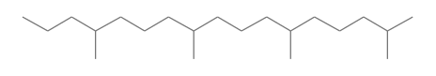 | 4.71
21 | 9.938 | Carbonic acid, nonyl prop-1-en-2-yl ester |  | 1.24
22 | 9.938 | Carbonic acid nonyl prop-1-en-2-yl ester |  | `1.24
23 | 10.159 | Carbonic acid nonyl prop-1-en-2-yl ester |  | 3.73
24 | 10.268 | Heptadecane, 2,6- dimethyl- | 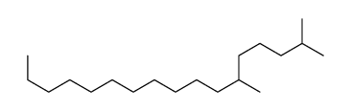 | 4.51
25 | 10.506 | Undecane, 5- methyl- |  | 1.70
26 | 10.579 | Tricosane, 2-methyl- |  | 1.30
27 | 10.635 | Octane, 3-ethyl- | 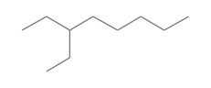 | 1.52
28 | 10.992 | Stearic acid hydrazide |  | 0.26
29 | 11.119 | Undecane |  | 0.26
30 | 11.336 | Undecane, 5-methyl- |  | 0.35
31 | 11.468 | Oxirane, tetradecyl- | 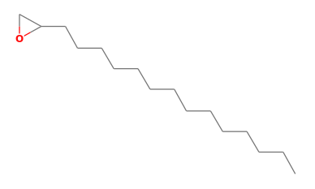 | 0.15
32 | 11.563 | 1-Octadecanesulphonyl chlorid | 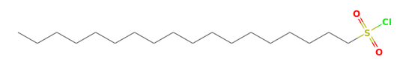 | 0.19
33 | 11.710 | Stearic acid hydrazide |  | 0.07
34 | 12.584 | E-14-Hexadecenal | 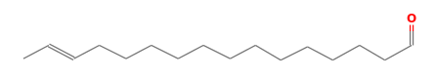 | 0.95
35 | 12.803 | Dodecane |  | 1.73
36 | 13.191 | Trifluoroacetoxy hexadecane |  | 0.24
37 | 14.651 | Stearic acid hydrazide |  | 0.33
38 | 14.888 | Decyl octyl ether |  | 0.57
39 | 15.706 | Tridecane |  | 1.82
40 | 15.873 | 1,4-Methanonaphthalene, 1,4-dihydro- | 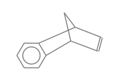 | 0.84
41 | 16.361 | 9-Oxabicyclo[6.1.0]nonane | 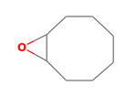 | 0.53
42 | 17.108 | 9-Octadecenal, (Z)- |  | 0.17
43 | 17.473 | Hexadecane, 1-chloro- |  | 0.26
44 | 17.662 | 13-Octadecenal, (Z)- |  | 0.19
45 | 17.804 | Oxirane, decyl- | 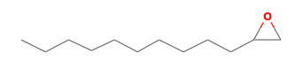 | 0.23
46 | 18.283 | 4-Tetradecene, (Z)- |  | 1.31
47 | 18.476 | Tridecane |  | 1.33
48 | 18.963 | Naphthalene, 2,7-dimethyl- | 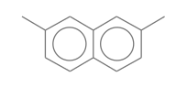 | 0.33
49 | 19.354 | Citronellol | 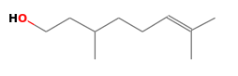 | 0.23
50 | 19.437 | Naphthalene, 2,7-dimethyl- |  | 0.34
51 | 19.743 | 1-Hexacosanol |  | 0.15
52 | 20.087 | 9-Octadecenal |  | 0.46
53 | 20.899 | Dodecane, 1,1'-oxybis- |  | 0.16
54 | 21.104 | Undecane, 2-methyl- | 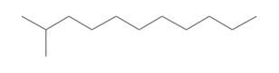 | 0.88
55 | 22.130 | 2,4-Di-tert-butylphenol |  | 8.08
56 | 23.440 | Z-8-Hexadecene |  | 2.35
57 | 23.597 | Hexadecane | 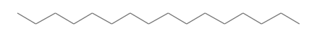 | 0.57
58 | 23.743 | Cetene | 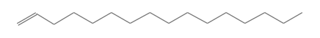 | 0.31
59 | 23.978 | Cyclohexadecane | 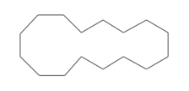 | 0.30
60 | 25.513 | Benzoic acid, 4-(3-hydoxy-3-methyl-1-butynyl)-, methyl ester | 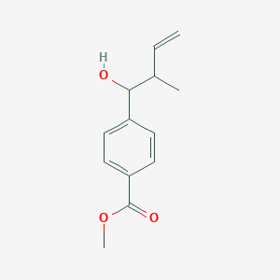 | 0.32
61 | 25.958 | Cyclopentadecanone, 2-hydroxy- | 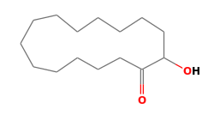 | 0.26
62 | 26.072 | Heptane, 2,6-dimethyl- | 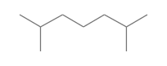 | 0.41
63 | 28.090 | 1-Octadecene | 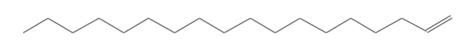 | 2.66
64 | 28.325 | 1-Octadecene |  | 0.35
65 | 28.553 | 3-Eicosene, (E)- |  | 0.15
66 | 29.799 | Anthracene, 1,2,3,4,5,6,7,8-octahydro-1,1,4,4,5,5,8,8-0ctamethyl- | 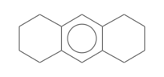 | 0.47
67 | 29.928 | cis-Vaccenic acid | 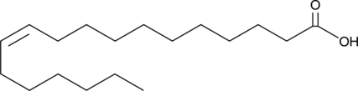 | 0.20
68 | 30.069 | Hexadecanoic acid, methyl ester |  | 1.02
69 | 30.415 | 13-Octadecenal, (Z)- |  | 0.16
70 | 30.527 | Dibutyl phthalate | 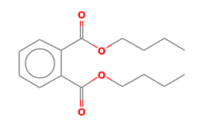 | 1.31
71 | 30.703 | 1-Octadecene |  | 2.05
72 | 30.886 | Indazol-4-one, 3,6,6-trimethyl-1-phthalazin-1-yl-1,5,6,7-tetrahydro- |  | 0.60
73 | 31.033 | Oleic Acid |  | 0.22
74 | 31.185 | 13-Octadecenal, (Z)- |  | 0.10
75 | 31.551 | 9,12-Octadecadienoic acid, methyl ester | 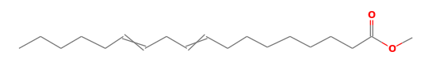 | 1.43
76 | 31.762 | cis-Vaccenic acid |  | 0.30
77 | 31.849 | Oleic acid |  | 0.05
78 | 32.035 | Oleic acid |  | 0.51
79 | 32.181 | 1-Docosene |  | 1.03
80 | 32.340 | Oleic Acid |  | 0.09
81 | 32.605 | Oleic Acid |  | 0.53
82 | 32.843 | Oleic Acid |  | 0.61
83 | 32.929 | Oleic Acid |  | 0.31
84 | 33.103 | Oleic Acid |  | 0.53
85 | 33.229 | Oleic Acid |  | 0.40
86 | 33.375 | 9-Tricosene, (Z)- | 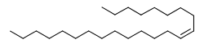 | 1.08
87 | 33.550 | Hexacosanoic acid | 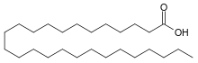 | 0.20
88 | 33.678 | Oleic Acid |  | 0.24
89 | 34.001 | Oleic Acid |  | 0.25
90 | 34.116 | Tetradecanoic acid, dodecyl ester | 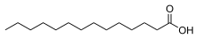 | 0.36
91 | 34.543 | Bis(2-ethylhexyl) phthalate |  | 1.70
92 | 34.796 | 1-Hexacosene |  | 0.91
93 | 36.839 | Oleic acid |  | 0.20
94 | 37.248 | - Octadecenal, (z)- |  | 0.33
RT: retention time

3.4. FTIR analysis of Costus afer

From the result of FTIR analysis displayed in Table 4, peaks contained single bond area in C. afer. A broad absorption band was found, informing there was hydrogen bond in the material. There was a sharp bond between 3400-3800cm⁻¹, which implied the existence of oxygen-related bonding that could be O-H or N-H. Peaks between 3000 and 3200 cm⁻¹ were found, informing there was aromatic structure in the compound. Strong bond at less than 3000 cm⁻¹ corresponded to the C-C bond. The presence of absorption in the 3000 to 2850 cm⁻¹ region indicated that there were hydrogens bonded to sp3-hybridized carbons in the compound. This further indicated the presence of alkane in the compound. Specific peak for aldehyde were not found at between 2700 and 2800 cm⁻¹. Triple bond region (2000-2500 cm⁻¹) were not detected, informing the absence of C≡C bond in the material. Regarding the double bond region (1500-2000 cm⁻¹), absorption at 1885 cm⁻¹ indicated the presence of an alkene group in the fingerprint region (600-1500 cm⁻¹). A strong signal was found at about 1275 cm⁻¹, which indicated the presence of an amine.

Table 4. Functional groups present in ethanol extract of Costus afer

S/N | Wave number (cm-1) | Bond
  Compound
1 | 758.98 | Sp2 C-H out of plane bending | 1,2 disubstituted aromatic compound
2 | 877.5813 | C-H bending | Alkene
3 | 1275.847 | C-O stretching | Aromatic amine
4 | 1434.306 | O-H bending | Alcohol
5 | 1620.917 | N-H stretching | Aromatic amine
6 | 1885.264 | C=C asymmetric stretch | Alkene
7 | 2022.106 | C-H bending | Aromatic amine
8 | 2117.113 | N=C=S stretching | Isothiocyanate
9 | 2620.168 | (O=)PO-H | Phosphonic acid
10 | 2951.199 | N-H stretching | Amine salt
11 | 3230.72 | O-H stretching | Alcohol
12 | 3331.469 | N-H stretching | Secondary amine
13 | 3424.231 | O-H stretching | Alcohol
14 | 3541.062 | N-H stretching | Aliphatic primary amine
15 | 3826.027 | O-H stretching | Free alcohol

3.5. FTIR analysis of Irvingia gabonensis

The different functional groups found in the ethanol extract of I. gabonensis, is presented in Table 5. Several peaks were detected in the single bond area. Broad absorption band in the range of 38230 and 33400 cm⁻¹, which indicated hydrogen bond (O–H) group due to the vibration of water molecules were found in the compound. Peaks at between 3000 and 3200 cm⁻¹, were related to the aromatic ring. Peaks at below 3000 cm⁻¹, responded to the single bond of carbon. The absorption in the region of 3000 to 2850 cm⁻1 was attributed to presence of aliphatic C–H stretch of CH, CH₂ and CH₃ groups. Aldehyde peak was not detected at between 2700 and 2800 cm⁻¹. Regarding the triple bond region (2000-2500 cm⁻¹), no peak was observed due to the absence of C≡C groups. In the double bond region (1500-2000 cm⁻¹), the peak which was presented at 1620 cm⁻¹ could also be corresponded to C = C stretching in the fingerprint region (600-1500 cm⁻¹). The band found at 1388 cm⁻1 was related to the stretching vibrations of alcohol with overtones at 3077 cm⁻¹and 3676 cm⁻¹.

Table 5. Functional groups present in ethanol extract of Irvingia gabonensis

S/N | Wave number (cm-1) | Bond
  Compound
1 | 816.2805 | C-H out of plane bending | 1,4-disubstituted aromatic compound
2 | 1272.558 | C-N stretching | Aromatic amine
3 | 1384.755 | O-H stretching | Phenol
4 | 1619.72 | C=C stretching | Cyclic alkene
5 | 1842.576 | C-H bending | Aromatic compound
6 | 2046.772 | N=C=S stretching | Isothiocyanate
7 | 2454.886 | P-H stretching | Phosphine
8 | 2592.56 | O-H stretching | Carboxylic acid
9 | 2718.376 | C-H stretching | Aldehyde
10 | 2824.56 | N-H stretching | Amine salt
11 | 3077.869 | O-H stretching | Intra molecular bonded Alcohol
12 | 3186.518 | C-H stretching | alkene
13 | 3372.517 | N-H stretching | Aliphatic primary amine
14 | 3676.808 | O-H stretching | Intermolecular bonded alcohol
15 | 3829.963 | O-H stretching | Free alcohol

3.6. FTIR analysis of Sida acuta

Table 6 shows the findings of the FTIR investigation of the ethanol extract of Sida acuta. The presence of absorption in the 3800 to 3100 cm⁻¹ region indicated that S. acuta contained O-H or N-H groups, which indicated hydrogen bond (O–H) group due to the vibration of water molecules. The presence of absorption in the 3000 to 2850 cm⁻¹ region indicated that there were hydrogens bonded to sp3-hybridized carbons in the compound, which indicated the presence of alkenes. Examination of the triple-bond region showed no indications of the presence of triple bonded functional group. Continuing to the double-bond region, the strong absorption at 1947 cm⁻¹ indicated the presence of an alkene group. Furthermore, the absorption band at 1618 cm⁻¹ showed the presence of N-H bond (amine) in the sample with overtones at 3394 cm⁻¹ and 2886 cm⁻¹. The strong absorption at 1372 cm⁻¹suggested that the compound contained an alcohol with overtones at about 3669 cm⁻¹ and 2713 cm⁻¹.

Table 6. Functional groups present in ethanol extract of Sida acuta

S/N | Wave number (cm-1) | Bond
  Compound
1 | 1266.607 | C-O stretching | Aromatic ester
2 | 1372.413 | O-H stretching | Alcohol, phenol
3 | 1618.268 | N-H stretching | Amine
4 | 1947.389 | C=C=C stretching | Allene
5 | 2057.87 | N=C=S stretching | Isothiocyanate
6 | 2450.898 | P-H stretching | Phosphine
7 | 2713.724 | O-H stretching | Intramolecular bonded alcohol
8 | 2886.179 | N-H stretching | Amine salt
9 | 3109.682 | C-H stretching | Alkene
10 | 3394.782 | N-H stretching | Aliphatic primary amine
11 | 3669.282 | O-H stretching | Intermolecular bonded alcohol
12 | 3828.417 | O-H stretching | Free alcohol

3.7. Total flavonoid content

Total flavonoid content illustrated in Table 7 shows that Sida acuta extract had significantly higher (p < 0.05) concentration of flavonoid content at varying concentrations (10, 20, 40 and 80 mg/ml) than C. afer and I. gabonensis extracts. However, the total flavonoid content of the three plant extracts was significantly lower than that of the standard (gallic acid).

Table 7. Total flavonoid content

Concentration (mg/ml) | Sida acuta | Irvingia gabonensis | Costus afer | Standard (Gallic acid)
10 | 6.99 ± 0.27 ª | 4.64 ± 0.09 ª | 4.36 ± 0.05 ^{b} | 13.28 ± 0.11 ^{c}
20 | 8.58 ± 0.25 ª | 6.94 ± 0.12 ^{b} | 5.67 ± 0.11 ^{c} | 15.58 ± 0.13 ^{d}
40 | 9.29 ± 0.23 ª | 4.36 ± 0.10 ^{b} | 6.56 ± 0.13 ^{c} | 18.16 ± 0.16 ^{d}
80 | 7.46 ± 0.37 ª | 4.78 ± 0.09 ^{b} | 4.64 ± 0.08 ^{b} | 18.91 ± 0.12 ^{c}
Values are mean ± standard deviation of triplicate determinations. Different letters indicate statistically significant differences (p<0.05).

3.8. Total phenol content

The total phenol content displayed in Table 8 was slightly higher in the ethanol extract of I. gabonensis (at concentration of 10 and 40 mg/ml) compared to the extracts of C. afer, S. acuta and the standard whereas at concentration of 20 and 80 mg/ml, S. acuta had slightly higher phenolic content among the selected plants. The measured values of the three plant extracts however, exhibited a moderate decrease in comparison to the standard of gallic acid at 80 mg/ml.

Table 8. Total phenol content

Concentration (mg/ml) | Sida acuta | Irvingia gabonensis | Costus afer | Standard (Gallic acid)
10 | 2.58 ± 0.05 ª | 2.74 ± 0.07 ^{b} | 2.60 ± 0.04 ª | 2.02 ± 0.02 ^{c}
20 | 3.75 ± 0.06 ª | 3.71 ± 0.09 ª | 2.90 ± 0.05 ^{b} | 3.69 ± 0.08 ª
40 | 4.82 ± 0.10 ª | 5.42 ± 0.13 ^{b} | 3.61 ± 0.09 ^{c} | 5.42 ± 0.12 ^{b}
80 | 6.15 ± 0.15 ª | 6.01 ± 0.14 ª | 2.96 ± 0.06 ^{b} | 7.44 ± 0.15 ^{c}
Values are mean ± standard deviation of triplicate determinations. Different letters indicate statistically significant differences (p<0.05).

3.9. Free radical scavenging activity

3.9.1. DPPH radical scavenging assay

Analysis of the in vitro antioxidant activity showed that the plant extracts possessed significant 2,2-diphenyl-1-picrylhydrazyl (DPPH) radical scavenging activity as seen in Table 9 in comparison to the standard (BHT). Sida acuta extract had the highest DPPH radical scavenging activity among the plant extracts in a concentration-dependent manner from 93.94 ± 1.55 mg/ml to 98.47 ± 1.65 mg/ml compared with that of the standard BHT (98.99 ± 1.14 mg/ml).

Table 9. DPPH scavenging activity

Concentration (mg/ml) | Sida acuta | Irvingia gabonensis | Costus afer | Standard (BHT)
10 | 93.94 ± 1.55 ^{ac} | 93.42 ± 1.42 ^{ab} | 89.75 ± 1.45 ^{b} | 98.99 ± 1.14 ^{c}
20 | 95.95 ± 1.29 ^{ab} | 94.00 ± 1.84 ª | 92.36 ± 1.77 ª | 98.99 ± 1.14 ^{b}
40 | 93.84 ± 1.52 ª | 92.15 ± 2.03 ª | 94.79 ± 1.94 ª | 98.99 ± 1.14 ^{b}
80 | 98.47 ± 1.65 ª | 97.31 ± 1.94 ª | 95.95 ± 1.82 ª | 98.99 ± 1.14 ª
Values are mean ± standard deviation of triplicate determinations. Different letters indicate statistically significant differences (p<0.05).

3.9.2. Ferric reducing antioxidant potential (FRAP)

Table 10 presents the results of the Ferric reducing antioxidant potential (FRAP) assay. Sida acuta extract showed significantly (p <0.05) highest ferric reducing antioxidant potential (80.79 ± 1.28 mg/ml) when compared with the C. afer (70.79 ± 1.37 mg/ml) and I. gabonensis (69.74 ± 1.67 mg/ml) counterparts. However, the standard reference compound gallic acid, gave a little higher ferric reducing antioxidant potential (87.45 ± 1.12 mg/ml) than the three extracts.

Table 10: Ferric reducing antioxidant potential (FRAP)

Concentration (mg/ml) | Sida acuta | Irvingia gabonensis | Costus afer | Standard (Gallic acid)
10 | 68.69 ± 1.27 ª | 50.27 ± 1.97 ^{b} | 64.74 ± 1.59 ª | 78.42 ± 1.51 ^{c}
20 | 75.00 ± 3.15 ª | 54.21 ± 2.03 ^{b} | 67.11 ± 1.45 ^{c} | 81.32 ± 1.72 ^{d}
40 | 80.79 ± 1.28 ª | 68.69 ± 1.31 ^{b} | 70.79 ± 1.37 ^{b} | 84.74 ± 1.46 ^{c}
80 | 79.74 ± 1.73 ª | 69.74 ± 1.67 ^{b} | 68.69 ± 1.44 ^{b} | 87.45 ± 1.12 ^{c}
Values are mean ± standard deviation of triplicate determinations. Different letters indicate statistically significant differences (p<0.05).

3.9.3. Nitric oxide radical scavenging activity

Table 11 showed that the nitric oxide (NO) scavenging activity of I. gabonensis (4.85 ± 0.19 mg/ml) at concentration of 10 mg/ml was higher than that of C. afer and S. acuta including that of the standard (gallic acid), but at concentrations of 20, 40 and 80 (mg/ml), the NO scavenging activity of the extracts were lower than that of the standard.

Table 11: Nitric oxide scavenging activity

Concentration (mg/ml) | Sida acuta | Irvingia gabonensis | Costus afer | Standard (Gallic acid)
10 | 2.47 ± 0.07 ª | 4.85 ± 0.19 ^{b} | 2.34 ± 0.20 ª | 3.52 ± 0.14 ^{c}
20 | 2.09 ± 0.10 ª | 4.47 ± 0.04 ^{b} | 3.10 ± 0.11 ^{c} | 6.20 ± 0.22 ^{d}
40 | 2.02 ± 0.06 ª | 3.54 ± 0.07 ^{b} | 3.05 ± 0.04 ^{c} | 8.90 ± 0.21 ^{d}
80 | 2.20 ± 0.09 ª | 3.10 ± 0.11 ª | 2.66 ± 0.11 ª | 14.48 ± 0.76 ^{b}
Values are mean ± standard deviation of triplicate determinations. Different letters indicate statistically significant differences (p<0.05).

3.9.4. Hydroxyl radical scavenging activity

The hydroxyl (OH) scavenging radical activity of ethanol extract of C. afer (74.91 ± 0.91 mg/ml) and I. gabonensis (74.16 ± 0.97 mg/ml) were significantly higher (p < 0.05) than that of S. acuta (66.67 ± 0.89 mg/ml). However, the OH scavenging radical values of the three extracts were lower than that recorded for the standard gallic acid as shown in Table 12.

Table 12: Hydroxyl radical scavenging activity

Concentration (mg/ml) | Sida acuta | Irvingia gabonensis | Costus afer | Standard (Gallic acid)
10 | 64.98 ± 0.61ª | 58.24 ± 0.84 ^{b} | 68.73 ± 0.89 ^{c} | 63.05 ± 0.21 ^{d}
20 | 63.48 ± 0.58 ª | 59.18 ± 0.87 ^{b} | 70.04 ± 0.84 ^{c} | 70.77 ± 0.59 ^{d}
40 | 64.98 ± 1.06 ª | 56.55 ± 0.96 ^{b} | 74.91 ± 0.91 ^{c} | 73.35 ± 0.45 ^{d}
80 | 74.16 ± 0.97 ª | 66.67 ± 0.89 ^{b} | 72.85 ± 0.95 ª | 79.41 ± 0.32 ^{c}
Values are mean ± standard deviation of triplicate determinations. Different letters indicate statistically significant differences (p<0.05).

4. DISCUSSION

Medicinal plants have been pharmacologically beneficial to human health for centuries. In traditional practices, numerous plants have been used to treat cognitive disorders, including neurodegenerative diseases and different neuropharmacological disorders. A wide array of secondary and primary metabolites (phytochemicals) found in these plants accounts for their highly significant pharmacological effects. The history of drug discovery has shown that plants contain active compounds that have become new sources to investigate for the pharmaceutical industry (Adewusi et al., 2010). The utilization of gas chromatography-mass spectrometry (GC-MS) and Fourier transform infrared (FTIR) spectroscopy for the determination of the various phytocomponents and target identification of functional groups that are present in medicinal plants even in minute concentrations has expanded considerably in recent time (Saranya et al., 2016). In this study, the GC-MS profile of C. afer, I. gabonensis and S. acuta as shown in Tables 1-3 demonstrated the presence of a vast number of secondary metabolites, which included tetradecane, hexadecane, heptadecane, and octadecane which had earlier been reported to have antioxidant, antibacterial, antiepileptic, and therapeutic properties (Mbongue et al., 2005). The phenolic compound 2, 4-Di-tert-butylphenol which was present in the extracts have been reported to possess antioxidative properties (Yoon, et al., 2006; Choi et al., 2011; Choi et al., 2019). Phenolic compounds, contained in plants, have been found to have potential protective roles against oxidative damage-induced diseases. Consumption of fruits, vegetables, and herbs can provide these compounds, which have been shown to exert potent antioxidant effects. Some phenolic compounds have also been found to inhibit neurotoxicity as a result of their antioxidant properties. Consequently, several phenolic acids have been suggested in the management of oxidative stress-induced disorders such as Alzheimer’s Disease (Heo et al., 2006; Alothman et al., 2009; Nayaka et al., 2010; Jeong et al., 2010). Hexadecanoic acid has been reported to have anti-inflammatory, antioxidant, antimicrobial, antibacterial, anti-fibrinolytic, hemolytic, anti-androgenic, nematicide, anti-cancerous as well as anti-hyperlipidemic activities (Abubakar et al., 2016; Olivia et al., 2021). The plant extracts also contained several alkene compounds, including 1-docosene, cetene, 9-Tricosene, (Z), 1-Hexacosene and 1-octadecene which have been reported to possess antifungal and antibacterial properties (Dégbé et al., 2018; Asif et al., 2023). Furthermore, 9,12- Octadecadienoic acid (Z,Z)-, methyl ester has been documented to have antioxidant, anti- inflammatory, anti-arthritic, anti-tumor, antifungal and anticancer activities against prostate cancer cell lines (Bharath et al., 2021). Dodecane possesses antibacterial activity (Ramalingam et al., 2015), whereas 9,12-Octadecadienal was reported to exhibit antioxidant and antimicrobial activities (Hyde et al., 2019). Fatty acids including 3-eicosene, (E)-, hexadecanoic acid, methyl ester, cis-vaccenic acid and oleic acid which were identified in the plant extracts have been reported to exhibit antioxidant, antimicrobial, antihyperglycemic, cytotoxic and insecticidal activities (Yogeswari et al., 2012; Banakar et al., 2018). Trans-13-Octadecenoic acid present in I. gabonensis has been shown to exhibit anti-inflammatory, antiandrogenic, dermatitigenic, anaemiagenic and insecticidal properties (Awonyemi et al., 2020). Additionally, Octadecanoic acid has been demonstrated to possess substantial antioxidant capacity and strong neuroprotective effects (Wang et al., 2007). Hexadecanoic acid, methyl ester which has antioxidant, immunostimulant, anticholesteremic, antibacterial, antitumor and anti-inflammatory properties was also observed in the plants (Gavamukulya et al., 2015; Dalal et al., 2021).

The Fourier Transform Infrared (FTIR) vibration spectroscopy technique is widely recognized for its ability to identify important functional groups present in plant extracts, biological substances, and manufactured chemicals. This spectroscopic technique remains unmatched in its capability to identify and distinguish various kinds of chemical bonds (functional groups) within molecules. (Movasaghi et al., 2008; Ashokkumar et al., 2014). In this study, the FTIR spectra of ethanol leaf extracts of Costus afer, Irvingia gabonensis and Sida acuta depicted in Tables 4, 5 and 6 revealed 15, 15 and 12 peaks respectively, which corresponded to important functional groups. The functional groups found in C. afer extract included 1,2 disubstituted aromatic compounds, alkenes, aromatic amines, alcohols, isothiocyanates, phosphonic acids, amine salts, secondary amines and aliphatic primary amines (Table 4). Aromatic amines, 1,4 disubstituted aromatic compounds, phenols, cyclic alkenes, isothiocyanates, phosphines, carboxylic acids, aldehydes, amine salts, intra molecular bonded alcohols, alkenes, aliphatic primary amines and free alcohols were the functional groups found in I. gabonensis extract (Table 5) whereas aromatic esters, alcohols/phenols, amines, allenes, isothiocyanates, phosphines, intramolecular bonded alcohols, amine salts, alkenes, aliphatic primary amines and free alcohols were identified in S. acuta extract (Table 6).

Flavonoids and phenolics are important secondary metabolites that are abundant in plants and have important biological functions. They are referred to as natural antioxidants because of their ability to scavenge free radicals through the donation of an electron or hydrogen (Islam et al., 2021). Flavonoids have also been reported to inhibit lipid peroxidation and protect against oxidative damage. As a result of these mechanisms, they are able to neutralize free radicals (Zahra et al., 2024). Quantitative analysis of the flavonoid and phenolic contents of the extracts revealed the presence of flavonoids and phenolic compounds in the various plant extracts. From the results of the study presented in Table 7 and table 8, the total flavonoid content (TFC) was highest in Sida acuta extract. The total phenolic content (TPC) was highest in the ethanol extract of S. acuta compared to the extracts of C. afer and I. gabonensis. The high flavonoid and phenolic content of S. acuta is consistent with the results of a study conducted by Subramanya et al., (2015) which analyzed the total flavonoid and phenolic content of root organs in various sidaguri plants, including S. acuta, S. cordata, S. rhombifolia, S. cordifolia, S. retusa, S. indica, S. mysorensis, and S. spinosa and showed that some species of Sida plants had relatively higher levels of total flavonoid and phenolic content compared to the others.

The excessive buildup of reactive oxygen species can disrupt intracellular macromolecules such as lipids, proteins, and nucleic acids, which have been associated with various diseases including chronic inflammation, cancer, diabetes mellitus and neurodegenerative disorders, among others. (Ho et al., 2019; Gracia et al., 2017). Antioxidants can delay or prevent oxidation by scavenging free radicals thereby reducing oxidative stress. Numerous chemicals with antioxidant properties can be found in plants, particularly plant polyphenols, which have been studied in an effort to identify molecules that can protect against a variety of pathologies associated with oxidative stress and damage caused by free radicals (Vladimir-Kneevi et al., 2012).

In this study, the radical scavenging activity of ethanol extract of C. afer, I. gabonensis and S. acuta leaves presented in Table 9 using 2, 2-Diphenyl-1-picryl-hydraxyl (DPPH) radical assay showed that the ethanol extracts of the plants were capable of scavenging the DPPH free radical to great extents. The DPPH• is a persistent free radical molecule that, following its interaction with antioxidants, either transfers an electron or a hydrogen atom to DPPH•, thus neutralizing its free radical nature (Vladimir-Kneevi et al., 2012). The DPPH• scavenging effects produced by the extracts were in the following order: S. acuta > I. gabonensis > C. afer. This was consistent with the report of Sari et al., (2023) on the antioxidant potential of different extracts from S. acuta utilizing various methods. Also, Siddiqui et al., (2016) utilized the DPPH and superoxide anion radical (O₂•-) methods to analyze the antioxidant activity of various plants including a Sida specie which exhibited a potent anti-oxidant activity in DPPH assay. Furthermore, Muneeswari et al., (2016) utilized 2,2-Diphenyl-1-picrylhydrazyl (DPPH•) to confirm the antioxidant capacity of various extracts of the aerial parts of S. acuta. These results can be attributed to the presence of bioactive antioxidant phytochemical components in these extracts, which work synergistically to scavenge the DPPH radicals.

The FRAP method assesses the ability of experimental samples to reduce ferric ion to ferrous ion at low pH, resulting in a blue complex. An increase in absorbance at 700 nm indicates the ferric-reducing antioxidant power of the examined material (Moriasi et al., 2020). In this study, the iron reducing capacity of the ethanolic extracts of Costus afer, Irvingia gabonensis and Sida acuta was estimated from their ability to reduce the Fe3+-ferricyanide complex to the ferrous form by the donation of an electron.There was a significant difference in the ferric reducing antioxidant potential (FRAP) among the ethanolic plant extracts at various concentrations as shown in Table 10. Sida acuta extract revealed the highest FRAP activity (from 68.69 ± 1.27 mg/ml to 80.79 ± 1.28 mg/ml) in comparison to Costus afer and Irvingia gabonensis extracts. This obtained outcome was consistent with the result of the study done by Muneeswari et al., (2019). This study demonstrates that the antioxidant activities of the studied plant extracts may be due to the active phytocompounds with phenolic components such as flavonoids, catechins, coumarins, tannins, carotenoids, and phenols present in their structures. These phytocompounds reduce oxidative stress either solely or synergistically with other phenolic-containing compounds (Nemudzivhadi et al., 2014).

The assays for evaluating the capacity of free radical scavenging, as presented in Tables 11 and 12, typically rely on the deactivation of radicals, including nitric oxide (NO) and hydroxyl (OH) radicals. Nitric oxide (NO) is a vital chemical mediator produced by endothelial cells, macrophages, and neurons, and plays a significant role in the control of several physiological processes, including inflammation. NO is formed in biological tissues by specialized nitric oxide synthase (NOSs), which metabolizes arginine to citrulline, resulting to the formation of NO via a five-electron oxidative process (Adebayo et al., 2019). The extracts of C. afer, I. gabonensis and S. acuta as well as the standard showed little inhibition towards nitric oxide free radical in comparison to the standard as indicated in Table 11.

The hydroxyl radical is the most reactive oxygen-centered species, which causes significant damage to surrounding biomolecules (Halliwell et al., 2021). The interaction of H₂O₂ and ferrous produces hydroxyl radicals. These hydroxyl radicals reacted with 2-deoxyribose and generated a malonaldehyde-like product, giving the red color with TBA (Jayasundara et al., 2018). The addition of the ethanolic plant extracts to the reaction mixture removed hydroxyl radicals, consequently preventing further damage. According to the data presented in Table 12, the hydroxyl scavenging radical effects of the ethanol extract of C. afer at concentrations of 10 and 40 mg/ml were higher than those of I. gabonensis, S. acuta and gallic acid. This indicated an increased scavenging potential of the leaf extract of C. afer when compared to the other extracts which could be attributed to the number of phytochemicals present in the extract. The findings were comparable with the in vitro study by Guchu et al. (2020) who demonstrated the antioxidant capacity of the leaves extracts of Caesalpinia volkensii, Vernonia lasiopus, and Acacia hockii.

5. CONCLUSION

The results from this study showed that Costus afer, Irvingia gabonensis and Sida acuta extracts possessed diverse bioactive compounds in appreciable concentrations which could be responsible for their potential biological and pharmacological applicability. The plant extracts also demonstrated substantial antioxidant and free radical scavenging properties, suggesting that these plants could be potential sources of natural antioxidant which could have great importance as therapeutic agents in drug production, and in preventing or slowing the ageing process or age associated oxidative stress related degenerative diseases. However, further research is needed to identify, isolate, and purify the bioactive constituents responsible for the pharmacological activities exhibited by the plant extracts. Furthermore, research aimed at investigating the in vivo antioxidant efficacy of the studied plant extracts is encouraged, in order to ascertain if the in vitro antioxidant results reported in this study can be replicated in the in vivo settings. Also, further studies on combination therapy for the three plant extracts, assessment of pharmacokinetic properties, bioavailability and investigation of associated metabolic pathways is required to draw definite conclusions on the effectiveness of the extracts for the pharmacological activities exhibited.

DISCLAIMER (ARTIFICIAL INTELLIGENCE)
Author(s) hereby declare that NO generative AI technologies such as Large Language Models (ChatGPT, COPILOT, etc.) and text-to-image generators have been used during the writing or editing of this manuscript.

REFERENCES

Osuagwu, O. L., Igwe, C. U., Nzebude, C. P., Njoku, O. C., & Ejiofor, J. C. (2023). Phenolic Profile and Antioxidant Potential of Aqueous Extracts of Selected Traditional Anti-cough Plants, Journal of Drug Delivery and Therapeutics. 13(7):22-29.

Asiwe E. S., Igwe, C. U., Iheanacho, K. M. E., Onyeocha, I. O., & Onwuliri, V. A. (2021). Antioxidative and Free Radical Scavenging Properties of Ethyl Acetate Fractions of Persea americana Seed and Bryophyllum pinnatum Leaf. Tropical Journal of Natural Product Resources. 5(8):1486-1492.

Ezekwe, A. S., Ordu, K. S., & Oruamabo, R. S. (2020). Phytochemical Screening, GC-MS Analysis and Antioxidant Activity of Three Medicinal Plants from Nigeria. Asian Journal of Applied Chemistry Research, 6(3), 14–26.

Dike, C. S., Emejulu, A. A., Chukwudoruo, C. S., Akpaki, M. A., Nsofor, W. N., & Edom, C. V. (2023). GC-MS and FTIR analyses of bioactive compounds present in ethanol leaf extract of Sida acuta from Imo State, Nigeri. GSC Biological and Pharmaceutical Sciences, 25(2), 394–404.

Rafiqkhan M., & Saranya. (2013). “Pharmacognostic profile and phytochemical investigation on the leaves of Achyranthes aspera,” International Journal of Pharmacy and Pharmaceutical Sciences, vol. 5, no. 3, pp. 368–370.

Chikezie, P. C., Ibegbulem, C. O., & Mbagwu, F. N. (2015) Medicinal Potentials and Toxicity Concerns of Bioactive Principles. Medicinal Aromatic Plants 4:202.

Alisi, C. S., Asiwe, E. S., Emejulu A. A., Ene, A. C., & Nwoguikpe, R. N. (2014). Neuroprotective and free radicals scavenging potentials of some common leafy vegetables consumed in south - eastern Nigeria. Annual Research & Review in Biology, 4(22), 3345–3358.

Ezekwe, A. S., Nwadike, C. N., Wokocha, G. P., & Orlando, G. B. (2021). Phytochemistry and Antioxidant Activity of Irvingia gabonensis (Bush mango) Seed Sample. Asian Journal of Biochemistry, Genetics and Molecular Biology. 25-34.

Omokhua, G. (2011). Medicinal and Socio-Cultural Importance of Costus afer (Ker Grawl) in Nigeria. African Research Review, 5(5).

Odey, A. I., Bisong, S. A., Ezekiel, I., Eze, E. D., Nachamada, S. E., Atoki, A. V., . . . Aja, P. M. (2024). Stem extract from Costus afer (Bush cane) prevents ethanol-induced neuronal degeneration in mice via an antioxidant-inflammatory pathway. Phytomedicine Plus, 4(4), 100653.

Emejulu, A. A., Alisi, C. S., Asiwe, E. S., Igwe, C. U., Nwogu, L. A., & Onwuliri, V. A. (2016). Renal and Hepato-Protective Effects of Irvingia gabonensis Juice on Sodium Fluoride-Induced Toxicity in Wistar Rats. Journal of Clinical Toxicology, 6: 296.

Unaeze, B. C., Ilo, C. E., Egwuatu, C., Orabueze, I., & Obi, E. (2017). Anti-diarrhoeal effects of three Nigerian medicinal plant extracts on E. coli-induced diarrhea. International Journal of Biological and Chemical Sciences, 11(1), 414.

Etta, H. E., Olisaeke, C. C., & Iboh, C. I. (2013). Effect of Irvingia gabonensis (Aubry-Lecomte ex O’Rorke) Seeds on the Liver and Gonads of Male Albino Rats. Journal of Biology, Agriculture and Healthcare, 2(1), 10–15.

Ojo, O., Oyinloye, B., Ajiboye, B., & Onikanni, S. (2014). Neuroprotective Mechanism of Ethanolic Extract of Irvingia gabonensis Stem Bark against Cadmium-induced Neurotoxicity in Rats. British Journal of Medicine and Medical Research, 4(36), 5793–5805.

Uchewa, O. O., Okpara, F. C., Abraham, J. C., & Ibegbu, O. A. (2023). Role of Irvingia gabonensis Seed Extract in Streptozotocin- Induced Hyperglycemia Memory Deficit in Rodents. Neurology & Neurotherapy Open Access Journal, 8(1).

Senthilkumar, R. P., Bhuvaneshwari, V., Malayaman, V., Ranjithkumar, R., & Sathiyavimal, S. (2018). Phytochemical screening of Aqueous leaf extract of Sida acuta Burm. f. and its antibacterial activity. Journal of Emerging Technology and Innovation Research. Vol. 5(8):474-478.

Benjumea, D. M., Gómez-Betancur, I. C., Vásquez, J., Alzate, F., García-Silva, A., & Fontenla, J. A. (2016). Neuropharmacological effects of the ethanolic extract of Sida acuta. Revista Brasileira De Farmacognosia, 26(2), 209–215.

Stéphane, F. F. Y., Jules, B. K. J., Batiha, G. E., Ali, I., & Bruno, L. N. (2021). Extraction of Bioactive Compounds from Medicinal Plants and Herbs. In IntechOpen eBooks.

Buss, A. D., & Butler, M. S. (2010). Natural product chemistry for drug discovery. The Royal Society of Chemistry, Cambridge, p. 153.

VanderWeerd, J., Heeren, R. M. A., & Boon, J. J. (2004). Preparation methods and accessories for the infrared spectroscopic analysis of multi-layer paint. Studies in Conservation. 49:193 – 210.

Cameron, G. R., Milton, R. F. & Allen, J. W. (1943). Measurement of flavonoids in plant samples. Lancet, p. 179.

Attard, E. (2013). A rapid microtitre plate Folin-Ciocalteu method for the assessment of polyphenols. Open Life Sciences, 8(1):48-53.

Mensor, L. L., Meneze, F. S., Leitao, G. G., Reis, A. S., Dos santor, J. C., Coube, C. S., & Leitao, S. G. (2001). Screening of Brazilian plant extracts for antioxidant activity by the use of DPPH free radical method. Phytotherapy Research. 15: 127-130.

Pulido, R., Bravo, L., & Saura-Calixto, F. (2000). Antioxidant Activity of Dietary Polyphenols as Determined by a Modified Ferric Reducing/Antioxidant Power Assay. Journal of Agricultural and Food Chemistry, 48(8), 3396–3402.

Shukla, S., Mehta, A., Mehta, P., & Bajpai, V. K. (2012). Antioxidant ability and total phenolic content of aqueous leaf extract of Stevia rebaudiana Bert. Experimental and Toxicologic Pathology, 64(7–8), 807–811.

Jayasundara, C. W., Deraniyagala, S. A., Hettiarachchi, C. M., & Thiripuranathar, G. (2018). Antioxidant and Antibacterial Activities of Leaves, Skin, Flesh and Seeds of Sri Lankan Variety of Cucurbita moschata, International Journal of Ayurveda and Pharma Research. 6(3).

Adewusi, E. A., Moodley, N. & Steenkamp, V. (2010). Medicinal plants with cholinesterase inhibitory activity: A Review. African Journal of Biotechnology, 9(49), 8257-8276.

Saranya, D., & Sekar, J. (2016). GC-MS and FT-IR Analyses of Ethylacetate Leaf extract of Abutilon indicum (L.) Sweet. International Journal of Advanced Research in Biological Sciences. 3(2):193-197.

Mbongue, F. G., Kamtchouing, P., Essame, O. J., Yewah, P. M., Dimo, T. & Lontsi, D. (2005). Effect of the aqueous extract of dry fruits of Piper guineense on the reproductive function of adult male rats. Indian Journal of Pharmacology. 7: 3032.

Yoon, M. A., Jeong, T. S., Park, D. S., Xu, M. Z., Oh, H. W., Song, K. B., ... & Park, H. Y. (2006). Antioxidant effects of quinoline alkaloids and 2, 4-di-tert-butylphenol isolated from Scolopendra subspinipes. Biological and Pharmaceutical Bulletin, 29(4), 735-739.

Choi, S. J., Lee, J. H., Heo, H. J., Cho, H. Y., Kim, H. K., Kim, C. J., . . . & Shin, D. H. (2011). Punica granatum Protects Against Oxidative Stress in PC12 Cells and Oxidative Stress-Induced Alzheimer’s Symptoms in Mice. Journal of Medicinal Food, 14(7–8), 695–701.

Choi, S. J., Kim, J. K., Kim, H. K., Harris, K., Kim, C. J., Park, G. G., Park, C. S., & Shin, D. H. (2013). 2,4-Di-tert-butylphenol from sweet potato protects against oxidative stress in PC12 cells and in mice. Journal of Medicinal Food, 16(11), 977–983.

Heo, H. J., & Lee, C. Y. (2006). Phenolic phytochemicals in cabbage inhibit amyloid β protein-induced neurotoxicity. LWT-Food Science and Technology, 39(4), 331-337.

Alothman, M., Bhat, R., & Karim, A. A. (2009). Effects of radiation processing on phytochemicals and antioxidants in plant produce. Trends in Food Science & Technology, 20(5), 201-212.

Nayaka, M. H., Sathisha, U. V., & Dharmesh, S. M. (2010). Cytoprotective and antioxidant activity of free, conjugated and insoluble-bound phenolic acids from swallow root (Decalepis hamiltonii). Food Chemistry, 119(4), 1307-1312.

Jeong, C., Kwak, J. H., Kim, J. H., Choi, G. N., Kim, D., & Heo, H. J. (2010). Neuronal cell protective and antioxidant effects of phenolics obtained from Zanthoxylum piperitum leaf using in vitro model system. Food Chemistry, 125(2), 417–422.

Abubakar, M. N., & Majinda, R. R. T. (2016). GC-MS Analysis and Preliminary Antimicrobial Activity of Albizia adianthifolia (Schumach) and Pterocarpus angolensis (DC). Medicines, 3(1), 3.

Olivia, N. U., Goodness, U. C., & Obinna, O. M. (2021). Phytochemical profiling and GC-MS analysis of aqueous methanol fraction of Hibiscus asper leaves. Future Journal of Pharmaceutical Sciences, 7(1).

Dégbé, M., Debierre-Grockiego, F., Tété-Bénissan, A., Débare, H., Aklikokou, K., Dimier-Poisson, I., & Gbeassor, M. (2018). Extracts of Tectona grandis and Vernonia amygdalina have anti-Toxoplasma and pro-inflammatory properties in vitro. Parasite, 25, 11.

Asif, R., Ali, M., Mazhar, M., Mustafa, M., & Yasmin, R. (2023). Evaluation of Phytochemical Contents, Antimicrobial, and antioxidant Potential of Haloxylon griffithii Collected from Northern Region of Balochistan, Pakistan. Dose-response, 21(1), 155932582311633.

Bharath, B., Perinbam, K., Devanesan, S., AlSalhi, M. S., & Saravanan, M. (2021). Evaluation of the anticancer potential of Hexadecanoic acid from brown algae Turbinaria ornata on HT–29 colon cancer cells. Journal of Molecular Structure, 1235, 130229.

Ramalingam, V., & Rajangam, U. (2015). Gas Chromatography-Mass Spectrometry (GC-MS) Analysis of Ethanolic Extracts of Aerva lanata (L.). International Journal of Biochemistry Research & Review. 7(4):192-203.

Hyde, K. D., Xu, J., Rapior, S., Jeewon, R., Lumyong, S., Niego, A. G. T., . . . & Stadler, M. (2019). The amazing potential of fungi: 50 ways we can exploit fungi industrially. Fungal Diversity, 97(1), 1–136.

Yogeswari, S., Ramalakshmi, S., Neelavathy, R., & Muthumary, J. (2012). Identification and Comparative Studies of Different Volatile Fractions from Monochaetia kansensis by GCMS. Global Journal of Pharmacology, 6(2):65-71.

Banakar, P., & Jayaraj, M. (2018). Gc-Ms Analysis of Bioactive Compounds from Ethanolic Leaf Extract of Waltheria indica Linn. And Their Pharmacological Activities. International Journal of Pharmaceutical Science and Research, 9(5).

Awonyemi, I., Abegunde, M. S., & Olabiran, T. E. (2020). Analysis of bioactive compounds from Raphia taedigera using gas chromatography–mass spectrometry, Eurasian Chemical Communications, 2(8), 938–944.

Wang, Z. J., Liang, C. L., Li, G. M., Yu, C. Y., & Yin, M. (2007). Stearic acid protects primary cultured cortical neurons against oxidative stress. Acta Pharmacologica Sinica, 28(3), 315–326.

Gavamukulya, Y., Abou-Elella, F., Wamunyokoli, F., & El-Shemy, H. A. (2015). GC-MS Analysis of Bioactive Phytochemicals Present in Ethanolic Extracts of Leaves of Annona muricata: A Further Evidence for Its Medicinal Diversity. Pharmacognosy Journal, 7(5), 300–304.

Dalal, S. R., Hussein, M. H., El-Naggar, N. E. A., Mostafa, S. I., & Shaaban-Dessuuki, S. A. (2021). Characterization of alginate extracted from Sargassum latifolium and its use in Chlorella vulgaris growth promotion and riboflavin drug delivery. Scientific Reports, 11(1).

Movasaghi, Z., Rehman, S., & urRehman, D. I. (2008). Fourier transform infrared (FTIR) spectroscopy of biological tissues. Applied Spectroscopic Review. 43(2):134-79.

Ashokkumar, R., & Ramaswamy, M. (2014). Phytochemical screening by FTIR spectroscopic analysis of leaf extracts of selected Indian medicinal plants. International Journal of Current Microbiological and Applied Sciences. 3(1):395 – 406.

Islam, M. A., Zaman, S., Biswas, K., Al-Amin, M. Y., Hasan, M. K., Alam, A. H. M. K., . . . & Sadik, G. (2021). Evaluation of cholinesterase inhibitory and antioxidant activity of Wedelia chinensis and isolation of apigenin as an active compound. BMC Complementary Medicine and Therapies, 21(1).

Zahra, M., Abrahamse, H., & George, B. P. (2024). Flavonoids: antioxidant powerhouses and their role in nanomedicine. Antioxidants, 13(8), 922.

Subramanya, M. D., Pai, S. R., Upadhya, V., Ankad, G. M., Bhagwat, S. S., & Hegde, H. V. (2015). Total polyphenolic contents and in vitro antioxidant properties of eight Sida species from Western Ghats, India Journal Ayurveda Integrated Medicine 6(1):24–28.

Ho, Y., Wu, J., & Chang, C. (2019). A New Natural Antioxidant Biomaterial from Cinnamomum osmophloeum Kanehira Leaves Represses Melanogenesis and Protects against DNA Damage. Antioxidants, 8(10), 474.

Gracia, K. C., Llanas-Cornejo, D., & Husi, H. (2017). CVD and Oxidative Stress. Journal of Clinical Medicine, 6(2), 22.

Vladimir-Kneevi, S., Blaekovi, B., Bival, M., & Babac, M. (2012). Plant polyphenols as antioxidants influencing the human health. In InTech eBooks.

Sari, E. R., Suharti, N., Ismed, F., & Putra, D. P. (2023). Metabolite profiling, in vitro antioxidant and xanthine oxidase inhibitory properties of six Sumatran sidaguri (Sida L.). Journal of Pharmacy & Pharmacognosy Research, 11(3), 401–413.

Siddiqui, M. A., Rasheed, S., Saquib, Q., Al-Khedhairy, A. A., Al-Said, M. S., Musarrat, J., & Choudhary, M. I. (2016). In-Vitro dual inhibition of protein glycation, and oxidation by some Arabian plants. BMC Complementary and Alternative Medicine, 16(1).

Muneeswari, P., Deepika, S., Perumal, P. C., Gopalakrishnan, V. K., & Poornima, K. (2016). Phytochemical screening and free radical scavenging activity of chloroform extract of Sida acuta Burm. F. International Journal of Pharmacognosy & Phytochemical Research. 8, 663-7.

Moriasi, G., Ireri, A., & Ngugi, M. P. (2020). In Vitro Antioxidant Activities of the Aqueous and Methanolic Stem Bark Extracts of Piliostigma thonningii (Schum.). Journal of Evidence-Based Integrative Medicine, 25, 2515690X2093798.

Muneeswari, P., Kunnathupara, B., & Poornima, K. (2019). Identification of active pharmaceuticals of Sida acuta Burm. f. leaves using GC-MS and HPTLC fingerprinting. International Journal of Pharmaceutical Science. 10(3):1194–1207.

Nemudzivhadi, V., & Masoko, P. (2014). In Vitro Assessment of Cytotoxicity, Antioxidant, and Anti‐Inflammatory Activities of Ricinus communis (Euphorbiaceae) Leaf Extracts. Evidence-based Complementary and Alternative Medicine, 2014(1).

Adebayo, S., Ondua, M., Shai, L., & Lebelo, S. (2019). Inhibition of nitric oxide production and free radical scavenging activities of four South African medicinal plants</p> Journal of Inflammation Research, Volume 12, 195–203.

Halliwell, B., Adhikary, A., Dingfelder, M., & Dizdaroglu, M. (2021). Hydroxyl radical is a significant player in oxidative DNA damage in vivo. Chemical Society Reviews, 50(15), 8355–8360.

Guchu, B. M., Machocho, A. K., Mwihia, S. K., & Ngugi, M. P. (2020). In Vitro Antioxidant Activities of Methanolic Extracts of Caesalpinia volkensii Harms., Vernonia lasiopus O. Hoffm., and Acacia hockii De Wild. Evidence-based Complementary and Alternative Medicine, 2020(1).

