Behavioral and Histopathological Responses of African Catfish (Clarias gariepinus) to Turmeric (Curcuma longa) Leaf Extract: Risks for Aquaculture and Food Safety

Abstract
This study investigated the toxicological effects of ethanolic leaf extract of turmeric (Curcuma longa) on the mortality and organ morphology of African catfish (Clarias gariepinus) fingerlings. Two hundred healthy specimens (mean length 3.40 ± 1.2 cm; mean weight 2.26 ± 1.25 g) were exposed to graded concentrations of the extract (0, 20, 22, 24, 26, 28 mg/L) for 96 h. The 96 hours LC₅₀ was given at 22 mg/L representing a log transformed concentration of 1.34 mg/L a point where 50 % of the test organisms would be killed at the end of the experiment. No mortality or abnormal behavior was observed in the control group, whereas exposed fish exhibited concentration-dependent mortalities and behavioral changes, including erratic swimming, air gulping, loss of reflex, hyperactivity, and skin discoloration. Water quality parameters (pH and dissolved oxygen) significantly (P < 0.05) declined with increasing extract concentration. The significant decline in DO affect the survival of the fingerlings, hence the mortality recorded during the study. Histopathological examination revealed progressive damage in the gills, including epithelial disintegration, lamellar fusion, and structural collapse, as well as hepatic alterations such as hepatocellular necrosis, vacuolation, and blood cell rupture. These changes indicate severe impairment of respiratory and metabolic functions at higher exposure levels. Although turmeric is globally recognized for its nutraceutical, antimicrobial, and immunostimulatory properties, this study demonstrates that excessive concentrations can compromise fish health, nutrient assimilation, and survival. Safe inclusion limits are therefore necessary if turmeric is to be applied in aquaculture as a feed additive. Future studies incorporating biochemical and molecular biomarkers are recommended to better define its risk–benefit profile in fish culture.
Keywords: Curcuma longa, Clarias gariepinus, histopathology, phytochemicals, aquaculture toxicology, food safety

- Introduction
Turmeric (Curcuma longa), a perennial herbaceous plant of the Zingiberaceae family, is renowned for its rhizome, which harbors bioactive compounds like curcumin, demethoxycurcumin, and bisdemethoxycurcumin. These compounds exhibit a spectrum of biological activities, including antioxidant, anti-inflammatory, and antimicrobial properties (Prasad and Aggarwal, 2011; Arulkumar, et al., 2017). While the rhizome has been extensively studied, the leaves of turmeric also contain significant phytochemicals such as flavonoids, tannins, and alkaloids, which may possess potent biological effects.
Aqueous as well as ethanolic components of turmeric has proven to be active in the treatment of bacterial diseases in aquaculture production (Sahu, et. al., 2005). Supplementation of turmeric in diet of Oreochromis niloticus demonstrated evidence of improved growth performance, protected the fish against Pseudomonas fluorescens infection (Mahmoud, et al., 2014). Apart from fish, Daneshyar, et al. (2011) reported that inclusion of turmeric powder in broiler chickens feed could improve the quality of the meat by reducing its saturated fatty acids and triglycerides concentration.
In aquaculture, particularly concerning the African catfish (Clarias gariepinus), there is a growing interest in utilizing plant-based additives to enhance growth, immunity, and overall health of the fish. Studies have explored various herbal additives and their impacts on fish health. For instance, research has evaluated histopathological changes in African catfish fed diets containing herbal plants like Allium sativum, Chromolaena odorata and Talinum triangulare, noting effects on visceral organs at varying inclusion rates (Adebisi, et. al., 2024). Additionally, the use of ethanolic leaf extracts from plants such as Senna occidentalis has been investigated for their impact on water quality parameters and histopathological changes in gills and liver of C. gariepinus juveniles (Adesanya, et. al., 2024).
Several studies have been documented on the use of turmeric extract as an additive in the formulation of fish feed for different species of fishes to assess growth indices. Nurizku, et. al., (2022) reported on the effectiveness of turmeric extract on the growth performance and viability of Eel seeds (Anguilla spp); effects of turmeric on the growth and survival of fresh water pomfret (Colossoma macropomum); Prihandini and Umami, (2022), assess the effects of turmeric extract on the growth of O. niloticus; Putri, et. al., (2016), digestive enzymes and growth performance of goldfish (Cyprinus carpio) fed turmeric flour.
Despite these studies, there remains a paucity of information regarding the toxicological effects of ethanol-extracted turmeric leaves on C. gariepinus fingerlings. Understanding the potential toxicity is crucial, as certain plant extracts can induce histopathological alterations in fish tissues. For example, exposure to sub-lethal doses of Melaleuca cajuputi leaf extract in African catfish has been shown to cause degenerative changes in gill, liver, and kidney tissues. Therefore, assessing the safety and potential adverse effects of turmeric leaf extracts is essential before recommending their use in aquaculture.
Clarias gariepinus, commonly known as African catfish, is an economically significant species in aquaculture due to its rapid growth, adaptability, and resilience to environmental stress (Otoh et al., 2022; 2023; 2024a–d). Studying the effects of turmeric leaf extract on this species will provide valuable insights into its applicability in aquaculture practices, particularly for safeguarding the health of cultured fish during vulnerable life stages such as fingerlings. From a nutrition and toxicology perspective, turmeric’s phytochemicals including curcumin, flavonoids, and tannins may act as antioxidants and immunostimulants at low doses but become hepatotoxic and disruptive to gill function at higher exposures (Akpakpan et al., 2014; Su et al., 2019). Such dual effects underscore the importance of defining safe inclusion limits, as excessive concentrations could impair fish nutrient utilization, compromise product quality, and raise consumer food safety concerns (FAO, 2022). Therefore, assessing the toxicity of ethanolic turmeric leaf extract on C. gariepinus fingerlings is essential for evidence-based recommendations in aquaculture.
2.0 Materials and Methods
2.1 Collection of Plant Sample
Fresh leaves of turmeric (Curcuma longa) were collected from Obio Akpa in Oruk Anam Local Government Area, Akwa Ibom State. The date of Collection was 15th October, 2024. The plants material was transported to University of Uyo, Uyo, Akwa Ibom State for identification and authentication of the plants. This was done at the Herbarium in the Department of Botany and ecological studies, University of Uyo, Uyo with herbarium No: (Ben, UUH 4418 (Uyo).

2.2 Preparation of Plant Material
After the identification, the leaves were washed, shredded and spread on cellophane and allowed to dry for 72 hours under room temperature. The dried leaves were then pulverized (grinded) into fine powder using wooden pestle and mortar.

2.3 Preparation of Ethanolic Extract (Maceration and Extraction)
Cold extraction method (Maceration) was employed in this study following the procedure described by Hidayat and Wulandari (2021). In this process 240g plant materials were macerated in 1000 mL of 99% concentrated ethanol in an airtight container and kept at room temperature for 72 hours (3 days). The ethanolic suspension was filtered using a filter net and filter paper and the extract was evaporated in a water bath at 40° C for 48 hours and stored in a beaker covered with aluminum foil for bioassay immediately after the evaporation was complete.

2.4 Collection of Test Organism
Fingerling of Clarias gariepinus were collected from Akwa Ibom State University fish farm, Obio Akpa Akwa Ibom State, Nigeria and were acclimated in a re-circulatory plastic aquarium measuring 25 ×13 × 8.3 Cm³ containing hatchery water for 24hours in the Fisheries and Aquaculture laboratory of Akwa Ibom State fish farm. This acclimation period helped stabilize the fish and minimize stress resulting from collection and transportation (George, et. al., 2024 a, b, c, d).

2.5 Preliminary Test
Prior to commencement of actual experiment, a preliminary test (range finding test) was conducted using varying concentration (0, 10, 12, 14, 16 mg/L) to determine appropriate concentrations levels for the bioassay. Each of the aquarium had a replicate to ensure reliability of results. Each of the Ten (10) plastic aquaria was filled with two liters of hatchery water and 10 Clarias gariepinus fingerlings was stocked in each aquarium. The ethanolic extract of Curcuma longa was added at varying concentrations (0, 20, 22, 24, 26 mg/L) and the setup was maintained for 96 hours for mortality examination (George, et. al., 2013 a; b; 2014 a; b).
2.6 Monitoring of Water Quality
Water Quality Parameters was monitored prior to commencement of the experiment and periodically thereafter, following the Standard Method (APHA, 2005). Parameters investigated include dissolve Oxygen (DO), pH, and Temperature (⁰C). Temperature and pH were measured using portable pH /Ec/ TDs/ Temperature HANNA, H1 991301 Model instrument while dissolve oxygen was measured using digital portable analyser (JPB - 607A "Search Tech Instrument).

2.7 Determination of Mortality and Survival Rates of Fingerlings
The percentage mortality and survival rates of the fingerlings exposed to different concentrations of the ethanolic extract of Curcuma longa during the study period were determine using the following formula;
% mortality =n/N × 100 (Chan, 1977).
Where;
n = number of dead fish per aquarium per concentration
N = Total Individual Stocked
The difference between dead fish and survivors will give the percentage survival of the fingerlings at the end of the experiment (96 hours) (George et.al., 2023 a, b, c, d).

2.7.1 Determination of Mortality Lethal Median Concentration (96 Hours Lc₅₀)
The effects of the various concentrations of the ethanolic extract of C. longa on the fingerlings of C. gariepinus was determined by graphical method (Probit Level Determination as recommended by Finney (1971). The Lethal Median Concentration (LC₅₀) at 96 hours was estimated from the graph, representing the concentration expected to cause mortality in 50% of the fingerlings. Similarly, the concentration corresponding to 50% mortality at the end of the 96-hour test was determined at the probit level.

2.7.2 Behavioral and Morphological Measurement
Behavioral cum morphological responses of C. gariepinus fingerling exposed to C. longa were monitored and measured daily according to OECD (2014). In addition to the acute doses, the controls without toxicant exposure were observed as a guide for the assessment of any behavioral and morphological changes. The responses monitored included irregular swimming, excessive mucus secretion, increased air gulping, vertical erection, respiratory distress and change in skin color. Each experimental tank was observed for the exposure durations.
2.7.3 Collection of Samples for Histopathological Examinations
The gills and liver tissues were isolated from the test animal and fixed in formalin -saline for 48 hours. The fixed tissue was processed manually through graded ethanol, cleared in xylene impregnated and embedded in paraffin wax, sections of the tissue sample were cut with a rotary microtome, stained by hematoxylin and eosin technique. Prepared tissues were finally observed using a microscope for pathological changes at x100 and x400 magnification.

2.8 Data Analysis
The results of the respective concentration effects of the ethanolic extract of C. longa were presented in tables. One-way analysis of variance (ANOVA) was used to test for significant difference between the varying concentrations in both batches (batch A and batch B) at the probability level of (P<0.05). Probit analysis was done using SPSS version 20.0.

3.0 Results
3.1 Initial Water Quality Parameters
Water quality parameters were monitored and recorded prior to commencement of the toxicity studies as shown in Table 1. The values of dissolved oxygen (5.2 mg/L), temperature (29.8 ⁰C) and pH (6.77) observed were within the acceptable range for aquaculture operations.

Table 1: Initial Physico-chemical parameters of the test water prior to stocking of test organism
Fish Species | Initial physico-chemical parameters prior to stocking
Fish Species | DO (mg/L) | Temp (ºC) | pH
Clarias gariepinus | 5.2 | 29.8 | 6.77

3.2 Variation in Physico-chemical parameters of the test media with Clarias gariepinus as test organism during the experimental period (96 Hours)
Figure 1-3 shows variation in the water quality parameters (DO, temperature, pH) of the test media at the different concentrations and exposure time. As shown in Figure 1, dissolved oxygen (DO) levels at 24 hours decreased progressively with increasing concentrations of the toxicant, in contrast to the highest DO values recorded in the control group. A similar pattern persisted at 72 and 96 hours, indicating a sustained decline in oxygen availability with toxicant exposure. However, at 48 hours, only slight differences in DO levels were observed across the treatment groups, and these were not statistically significant compared to the control. Correspondingly, as illustrated in Figure 2, water temperature exhibited a concentration-dependent decrease throughout the entire exposure period (24, 48, 72, and 96 hours), whereas the control group maintained relatively higher and stable temperature values. Notably, this trend mirrors the decline in DO, reinforcing the interrelationship between temperature and oxygen solubility in aquatic systems under toxic stress. These results were consistent with those observed in pH levels (Figure 3), where a similar concentration-dependent shift was detected during the exposure period.
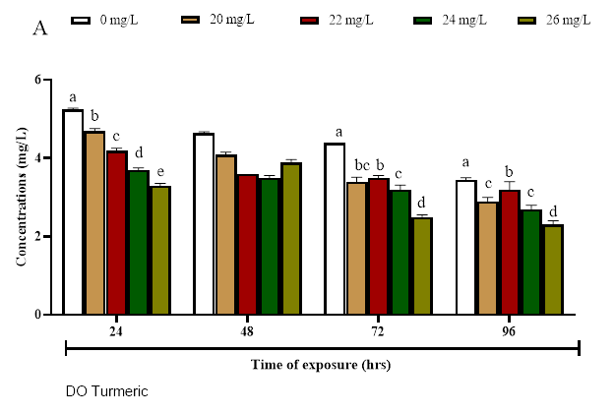
Fig 1. Dissolved Oxygen Variations in the Experimental Media During the 96th Hours of Test

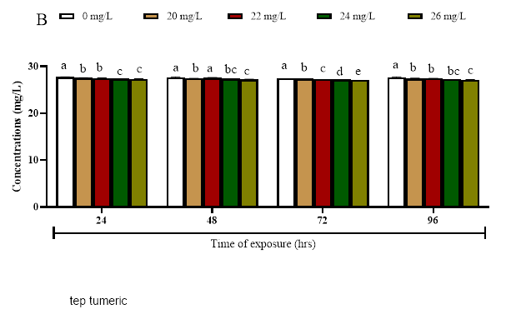
Fig 2. Temperature Variations Experimental in the Media During the 96th Hours of Test
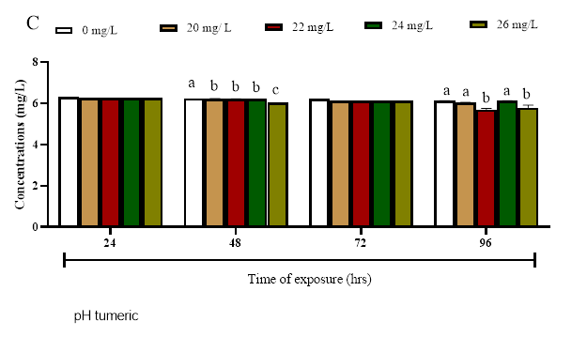
Fig 3. pH Variations in the Experimental Media During the 96th Hours of Test

3.3 Percentage Mortality and survivors of C. gariepinus Fingerlings in the different concentrations of the ethanoic extract of Curcuma longa at the end of the experiment (96 hrs) (Preliminary Test).
A range finding test was conducted prior to the commencement of the toxicity experiment to determine the actual concentrations to be used for the bioassay. Ethanoic extract of Curcuma muricata leaf was administered on the test organism, no mortality was recorded in the control (0 mg/L) of the extract used resulting in 100 % survival of the test organisms in both batches A and B respectively during the 96th hour exposure period. 100 % survivor were recorded in the 8, 12, 16 mg/L concentration of the extract during the 96th hours of test in both batches. In the 20 mg/L concentration of the extract, 40 % mortality was recorded during the 24th hour of test and 10% mortality recorded during the 48th hour of test leaving behind 50 percent survivor at the end of the 96th hour bioassay.

3.4 Summary of the Percentage Mortality and survivors of C. gariepinus Fingerlings in the different concentrations of the ethanoic extract of Curcuma longa at the end of the experiment (96 hrs.).
The percentage mortality and survivors of C. gariepinus fingerlings at the end of the test period in each of the concentrations are shown in Table 2 for the two batches of the experiment.
In the 0 mg/L concentration of the extract, no mortality was recorded throughout the test period in both batches A and B. At the end of the 96-hour bioassay 50 % and 40% mortalities was observed in the 22 mg/L concentration of the extract leaving behind 50% and 60% test organisms in the test media for both batches. In the 22 mg/L 60% and 50% mortalities was recorded leaving behind 40% and 50% survivors at the end of 96th hours. 70% and 60% mortalities were recorded in the 24 mg/L concentration of the extract leaving behind 30% and 40% survivors at the end of 96th hours. In the 26 mg/L concentration of the extract 80% and 70% mortalities were recorded leaving behind 20% and 30% survivors at the end of 96 hours of test (Table 2). Statistical Analysis using one-way Anova (SPSS 20.0) showed that there was no significant difference (p<0.05) in mortality between the two batches.

Table 2: Summary of the Percentage Mortality and survivors of C. gariepinus in the different concentrations of the ethanoic extract of Curcuma longa at the end of the experiment (96 hrs.).
Conc. of extract (mg/L) | BATCH A |  |  |  | BATCH B
 | Mortality  (M) | %  M | Survivors  (S) | %  S | Mortality  (M) | %  M | Survivors  (S) | %  S
0 | 0 | 0 | 10 | 100 | 0 | 0 | 10 | 100
20 | 5 | 50 | 5 | 50 | 4 | 40 | 6 | 60
22 | 6 | 60 | 4 | 40 | 5 | 50 | 5 | 50
24 | 7 | 70 | 3 | 30 | 6 | 60 | 4 | 40
26 | 8 | 80 | 2 | 20 | 6 | 70 | 3 | 30

3.5 96 Hours LC₅₀ Determination
The 96 hours LC₅₀ for C. gariepinus fingerlings exposed to the different concentrations of the ethanolic extract of Curcuma longa was determine using probit analysis. The concentrations were first transformed into log for the probit analysis (Table 3). The 96 hours LC₅₀ was given at 22 mg/L representing a log transformed concentration of 1.34 mg/L a point where 50 % of the test organisms would be killed at the end of the experiment (Fig. 4).

Table 3: LC₅₀ determination for C. gariepinus Fingerlings at the end of the 96-hours bioassay.
Concentration (mg/L) | Log Transformation | Mortality (M) | % Mortality | Survivors  (S) | % Survivor
0 | 0 | 0 | 0 | 10 | 100
20 | 1.30 | 5 | 50 | 5 | 50
22 | 1.34 | 6 | 60 | 4 | 40
24 | 1.38 | 7 | 70 | 3 | 30
26 | 1.41 | 8 | 80 | 2 | 20

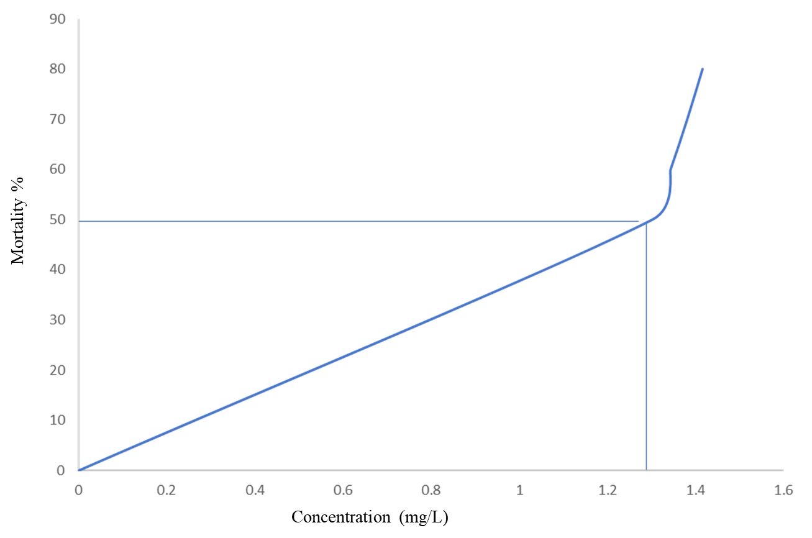
Fig. 4: Probit Graph of mortality (%) against concentration

3.6. Behavioral Responses
Exposure of the test organisms to varying concentrations of C. longa triggered abnormal behavioral response in a concentration dependent manner and also exposure time. Semi-quantitative measurement was used in assessing Behavioural abnormalities (Table 4). After 24 h exposure, the treated groups exposed to varying concentrations of the plant extract displayed slight to moderate behavioral changes such as erratic swimming, respiratory distress, air gulping, excessive mucus secretion, and vertical erection, while the control (0 mg/L) concentration exhibited none of these behavioral changes. Further exposure at 48–96 hours of the plant leaf extract promoted moderate to severe behavioral abnormalities in the treated groups, in a concentration-dependent pattern.

Table 4: Effect of Curcuma longa leaf extract on Behavior of Clarias gariepinus fingerling at exposure to Varying Concentrations at different Time intervals
Time in hours | Conc. (mg/L) | Gulping of air | Vertical erection | Respiratory distress | Erratic swimming | Abnormal mucus secretion
24 | control | - | - | - | - | -
 | 20 | + | + | + | + | +
 | 22 | + | + | + | + | +
 | 24 | ++ | ++ | ++ | ++ | +
 | 26 | ++ | ++ | ++ | ++ | ++
48 | control | - | - | - | - | -
 | 20 | + | + | + | + | +
 | 22 | + | + | + | + | +
 | 24 | + | + | + | + | +
 | 26 | + | + | + | + | +
72 | control | - | - | - | - | -
 | 20 | + | + | + | + | +
 | 22 | + | + | + | + | +
 | 24 | + | + | + | + | +
 | 26 | + | + | + | + | +
96 | control | - | - | - | - | -
 | 20 | + | + | + | + | +
 | 22 | + | + | + | + | +
 | 24 | + | + | + | + | +
 | 26 | + | + | + | + | +

Where;
- = Normal
+ = Mild
++ = Moderate
+++ = Severe

3.7 Histopathology of the gill of C. gariepinus Exposed to the different concentrations of the Ethanolic extract of Curcuma longa
3.7.1 Gills Histopathology
The histopathological analyses of the gills of the test organisms exposed to the different concentrations of the extract is shown in Figure 5 (I-V). Histopathological analysis of the gill tissues revealed distinct structural responses among the experimental groups exposed to ethanolic extract of Curcuma longa. The control group exhibited normal gill morphology with well-organized primary filaments, clearly defined secondary lamellae, intact cartilaginous support, and abundant red blood cells within the vascular lacunae. No evidence of epithelial degeneration or other pathological alterations was observed.
In contrast, varying degrees of epithelial damage and cellular disruption were noted in the treated groups. Group 2 showed diffuse epithelial degeneration along the filaments with reduced or absent epithelial lining on the secondary lamellae. Group 3 presented partial disorganization of the filaments and decreased epithelial cell density, although cartilage epithelium remained preserved. Group 4 demonstrated preservation of epithelial integrity and filament cellularity, though a reduction in red blood cell distribution was noted. Group 5 exhibited the most pronounced damage, characterized by extensive epithelial degeneration of the secondary lamellae, with retention of filament cartilage structure and a few remaining lamellar projections.

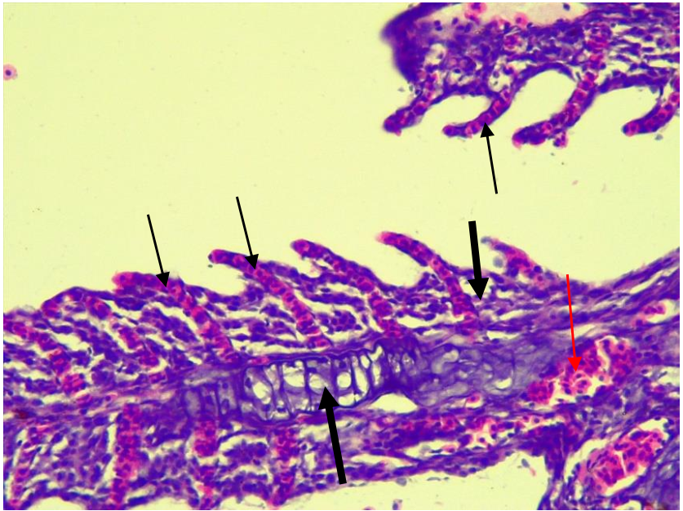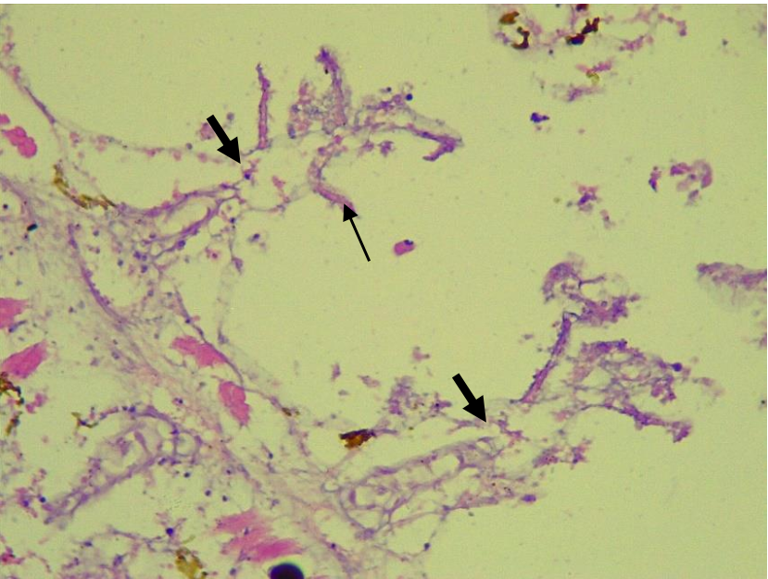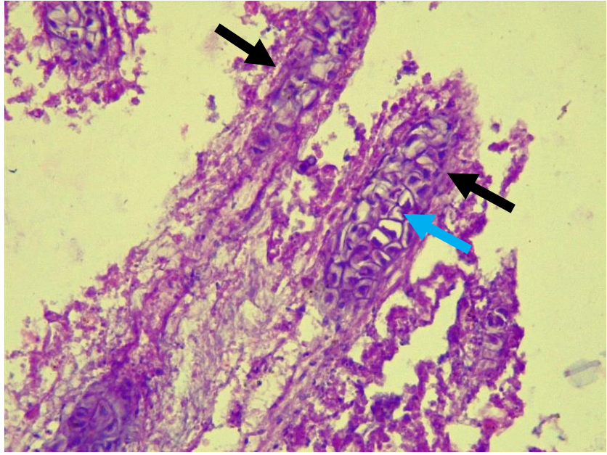
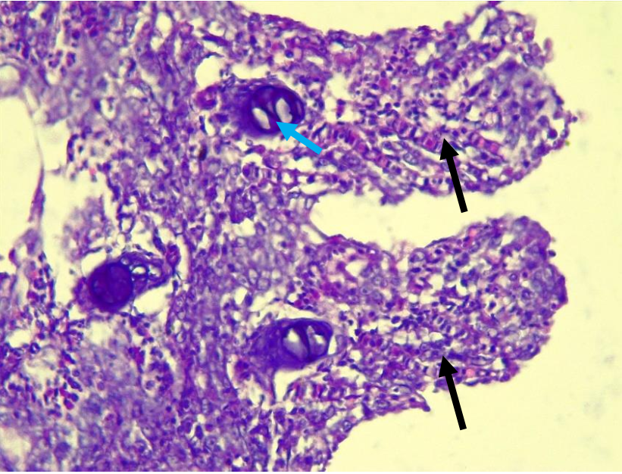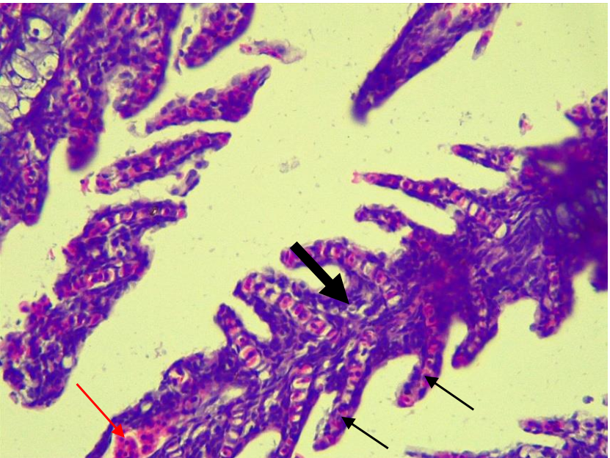
II
III
V
IV
III

Figure 5. Histopathological Changes in Gill Tissues of Fingerlings Exposed to Ethanolic Extract of Curcuma longa
Photomicrographs of gill tissues from fingerlings. Group 1, figure 5 (I) shows a highly cellular primary filament (thick arrow), secondary lamellae (thin arrow), supporting cartilaginous filaments (blue arrow), and blood lacunae filled with red blood cells (thin red arrow), with no pathological changes. Group 2, figure 5 (II) shows diffused epithelial degeneration of the filament (thick arrow) and retained secondary lamellae (thin arrow) with few or no epithelial cells. Group 3 shows disorganized and partially degenerated filament (thick arrow), decreased epithelial cells, and preserved cartilage epithelium (blue arrow). Group 4 shows a highly cellular filament (thick arrow), visible central cartilaginous support (blue arrow), and reduced red blood cell distribution. Group 5 shows diffuse epithelial degeneration of the secondary lamellae (thick black arrow), preserved filament cartilage, and few retained secondary lamellae (green arrow). Hematoxylin and eosin stain; magnification ×400.

3.7.1 Liver Histopathology
Histopathological analysis of the liver tissues in fingerlings exposed to ethanolic extract of Curcuma longa revealed dose-dependent alterations in hepatic architecture as shown in Figure 6 (I-V). Group 1 (control) displayed normal hepatic organization, with well-defined cords of hepatocytes and sporadic fatty changes presenting as uniformly sized lipid droplets.
Treated groups exhibited varying degrees of hepatic injury. Group 2 showed parenchymal distortion with degenerated connective tissue and mild inflammatory infiltrates. Group 3 exhibited signs of hepatocellular ballooning degeneration within the parenchyma. Group 4 demonstrated similar features to Group 2, including distorted hepatic parenchyma, degenerated connective tissue, and mild inflammatory cell infiltration. Group 5 displayed the most severe hepatic pathology, including extensive epithelial loss, hepatocyte vacuolation, hydropic degeneration, diffuse mononuclear inflammatory infiltration, and presence of bile pigments, indicating severe hepatic toxicity.

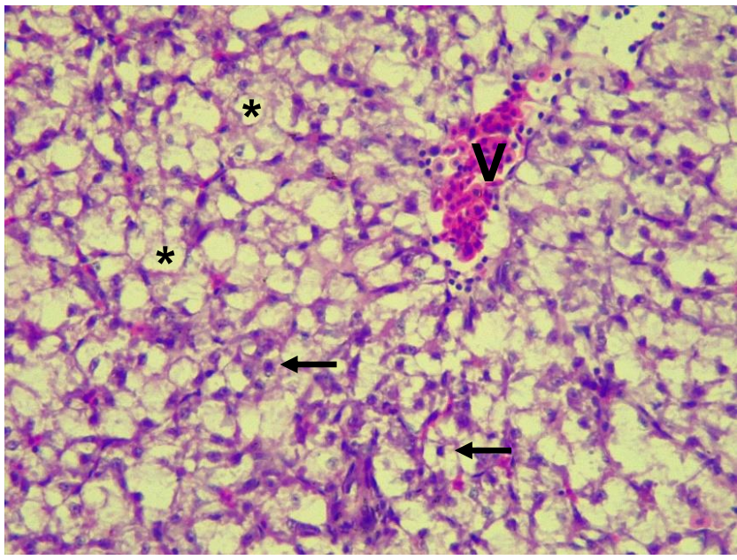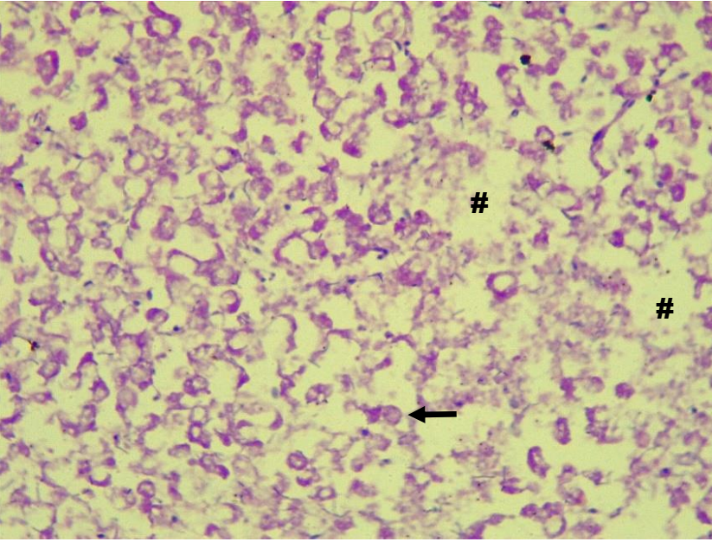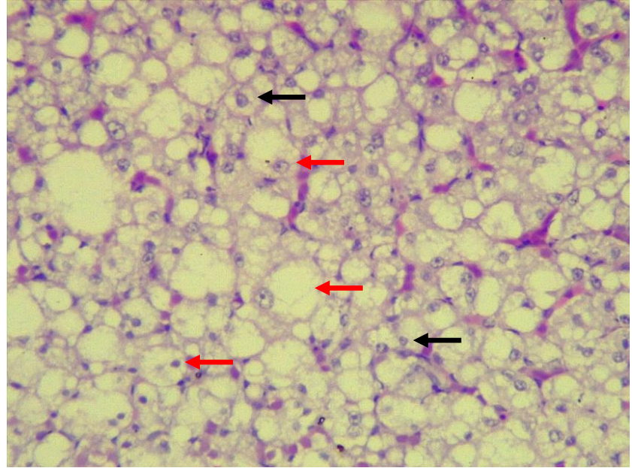
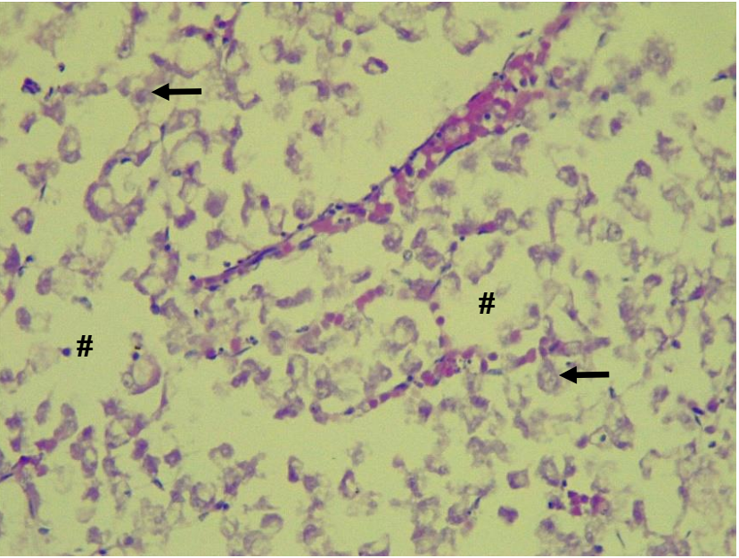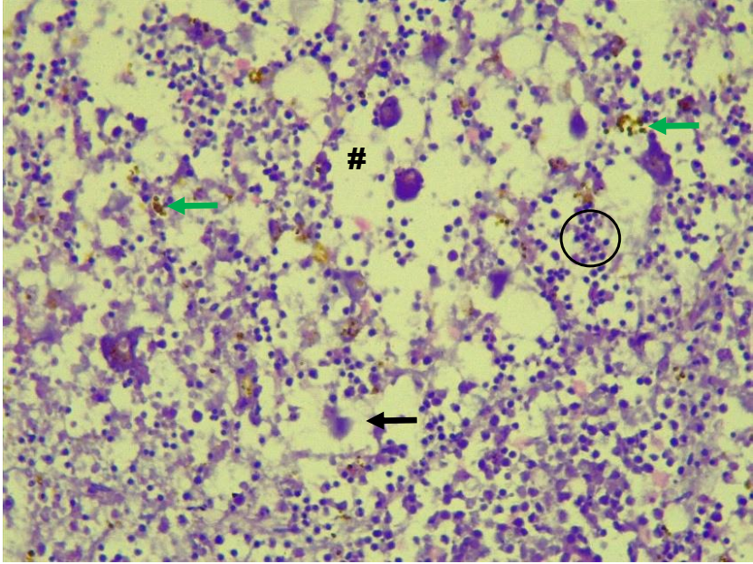
I
IV
II
V
III

Figure 6 (I-V). Histopathological Changes in Liver Tissues of Fingerlings Exposed to Ethanolic Extract of Curcuma longa,
Photomicrographs of liver tissues from fingerlings. Group 1 (I) shows cords of hepatocytes (arrows) and sporadic fatty changes with uniform fatty lobules. II shows cords of hepatocytes (arrows), distorted parenchyma with degenerated connective tissue (#), and mild inflammatory infiltrates. III, shows hepatocyte cords (arrows) with ballooning degeneration (red arrow). IV, shows cords of hepatocytes (arrows), parenchymal distortion with degenerated connective tissue (#), and mild inflammatory infiltrates (arrowhead). V shows severe epithelial loss, hepatocyte vacuolation (thin black arrow), hydropic degeneration (#), degenerated connective tissue (#), diffused mononuclear inflammatory infiltrates (circle), and bile pigment deposits (green arrow). Hematoxylin and eosin stain; magnification ×400.
4.0 Discussion
The use of medicinal plants, including their leaves, bark, and roots for both feed formulation and therapeutic applications in aquaculture has been widely documented, primarily due to their broad-spectrum bioactivities such as antimicrobial, antiparasitic, antioxidant, and growth-promoting properties. However, their potential toxicological effects remain significantly underreported and poorly understood, as highlighted by George et al. (2023a).
No mortality was recorded at 0 mg/L (control), confirming that fish deaths were directly associated with exposure to the extract. Mortality increased with concentration, establishing a dose-dependent relationship. The highest mortality occurred at 26 mg/L, where fish exhibited rapid toxicity symptoms which agrees favourably with the findings of (George, et. al., 2013 a; b; 2015 a; b; 2024 d) who observed a similar mortality trend. The present study provides critical evidence confirming the acute toxicity of Curcuma longa leaf extract on Clarias gariepinus fingerlings, with a 96-hour median lethal concentration (LC₅₀) of 22 mg/L, corresponding to a log-transformed value of 1.34 mg/L. This LC₅₀ value classifies the extract as mildly toxic based on standard toxicological benchmarks. Comparative analysis with other plant-derived extracts reveals substantial variability in toxicity levels. For instance, George et al. (2023b) reported an LC₅₀ of 2.983 mg/L for Lantana camara leaf extract in C. gariepinus fingerlings, suggesting higher toxicity, whereas Phragmanthera capitata ethanolic leaf extract produced median lethality at 22.124 mg/L in Oreochromis niloticus juveniles (George et al., 2023c), a value closely aligning with the present findings. Additionally, L. camara exhibited an LC₅₀ of 7.346 mg/L in O. niloticus after 96 hours (George et al., 2023d), underscoring the influence of species sensitivity. These variations in toxicological profiles can be scientifically attributed to several factors, including the specific plant species, the bioactive compounds present in different plant parts, the method of extraction (aqueous vs. ethanolic), the developmental stage or age of the test organisms, and inherent interspecies physiological differences. Therefore, while plant extracts offer promising benefits in aquaculture, a cautious, evidence-based approach is essential to evaluate both their therapeutic potential and associated risks, especially in the context of environmental safety and fish health.
Stable water quality is critical to the growth and physiological processes of aquatic organisms (Jonah and George, 2019; Jonah, et.al., 2020; George, et. al., 2020 a; b). Alterations in the physical and chemical properties of water can alter physiological and metabolic processes of aquatic species. A higher dosage of toxicant induced a series of physicochemical changes in the aquatic environment, likely driven by underlying scientific mechanisms associated with stress responses and chemical interactions (Banaee et. al., 2025). The progressive decline in dissolved oxygen (DO) levels at 24, 72, and 96 hours with increasing toxicant concentration in this study may be attributed to reduced photosynthetic activity due to toxicity-induced inhibition of autotrophic organisms, increased oxygen consumption from heightened metabolic stress in aquatic fauna, and potential chemical oxygen demand imposed by the toxicant itself. The lack of significant DO variation at 48 hours may reflect a transient equilibrium or delayed physiological response before the onset of more pronounced toxic effects. Simultaneously, the observed decrease in water temperature across toxicant concentrations could stem from reduced biological heat generation or altered heat exchange properties of the contaminated water, which in turn impacts oxygen solubility (Hutchings et. al., 2024). The parallel trends in decreasing pH suggest increased CO₂ accumulation from respiration and decomposition, or the formation of acidic byproducts, further stressing the system. Overall, the interdependence of DO, temperature, and pH underlines the systemic impact of toxicant exposure on aquatic environments, with each parameter influencing the others through a network of chemical and biological feedback mechanisms.
The harmful effects of several range of extract / toxicants can be measured via the behavioral abnormalities of the intoxicated test organism (George, et. al., 2024 a). In bioassay studies, animal behavioral measurements are effective to assess the toxic effects of the toxicant. The present study showed that the test organism was highly sensitive to the toxic effect of C. longa leaf extract, following the behavioral aberrations exhibited, particularly in a concentration and duration-dependent pattern. Toxicant-induced stress such as excessive mucus secretion, air gulping, erratic swimming, respiratory distress and vertical erection, were evident in the treated groups and could further impair physiological processes and subsequent mortality (George, et. al., 2024 b; c). Plant piscicides have been reported to induce behavioral abnormalities in aquatic species such as hyperactivity, reduced swimming in Launaea taraxocifolia exposed catfish (C. gariepinus) (George, et. al., 2024 c), loss of equilibrium, air gulping, incessant jumping in C. indica exposed C. gariepinus fingerling (George, et. al., 2024 b), excessive mucus accumulation and jerky movement in both D. innoxia (Ayuba, et. al., 2012) and C. odorata (Okoro, et. al., 2019) exposed C. gariepinus.
Histopathological analysis is a critical biomarker for assessing tissue-level changes in animals resulting from dietary, environmental, or toxicant-related exposure events (Essien-Ibok et al., 2024a, b; George et al., 2014a, b). In the present study, Clarias gariepinus fingerlings exhibited concentration-dependent histopathological alterations in both gill and liver tissues following a 96-hour acute exposure to ethanolic leaf extract of Curcuma longa. Gills, which are integral to vital physiological functions such as osmoregulation, ion balance, gas exchange, and excretion of nitrogenous waste (Arman, 2021), are particularly sensitive to aquatic pollutants due to their constant and direct contact with the external environment (Mallatt, 1985). In this study, gill tissues from exposed groups demonstrated varying degrees of lesion development, including cellular degeneration, desquamation, hyperplasia, erosion and fusion of secondary lamellae, and extensive epithelial damage. These lesions suggest impaired respiratory function, likely due to disrupted gaseous exchange across the lamellar epithelium (George, 2024a). Similar oxidative stress–mediated gill alterations have been reported in biomarker studies, where elevated SOD, GPx, and MDA levels coincided with lamellar degeneration in catfish exposed to pollutants (Akpakpan et al., 2014). Also, patterns of gill pathology have been reported in C. gariepinus exposed to Euphorbia hirta and Vernonia amygdalina extracts, further supporting the sensitivity of gill tissues to phytochemical stressors (Idowu et al., 2019; Audu et al., 2017).
Notably, the severity of the observed gill lesions increased with concentration. Groups 2, 3, and 5 showed marked epithelial degeneration, structural disintegration of secondary lamellae, and reduced epithelial cellularity, indicating cytotoxic effects of specific bioactive compounds in the extract at elevated concentrations. Group 4, while lacking epithelial degeneration, showed reduced red blood cell distribution, potentially indicating a sublethal circulatory impairment or an adaptive physiological response. Interestingly, the consistent preservation of the cartilaginous support structure in Groups 3 and 5 suggests that deeper gill architecture may possess greater resistance to short-term chemical insult.
These findings are consistent with previous research documenting plant extract-induced gill damage, including epithelial lifting, lamellar fusion, and necrosis (Fanta et al., 2003). Although C. longa is renowned for its antioxidant and anti-inflammatory activities (Chainani-Wu, 2003), certain phytoconstituents may become harmful at high concentrations, potentially exerting oxidative, pro-inflammatory, or membrane-disruptive effects that contribute to the epithelial and vascular lesions observed in this study.
Liver histopathology also revealed a dose-dependent toxicological response. The control group (Group 1) exhibited normal hepatic architecture with only minor fatty changes, likely representing normal lipid metabolism in fish hepatocytes (Wolf and Wolfe, 2005). In contrast, treated groups demonstrated progressively severe hepatic alterations. Group 2 and Group 4 showed signs of early hepatic stress, including parenchymal disorganization, degenerated connective tissue, and mild inflammatory infiltrates. Group 3 displayed ballooning degeneration—an early indicator of hepatocyte injury characterized by cytoplasmic swelling and potential necrosis. Group 5 exhibited the most profound hepatic pathology, including vacuolation, hydropic degeneration, bile pigment accumulation, mononuclear infiltration, and widespread epithelial cell loss. These pathological changes suggest compromised hepatocellular function, impaired bile metabolism, and possible oxidative damage, supporting findings from previous studies that curcumin, despite its hepatoprotective reputation, may elicit toxic responses at high concentrations or with prolonged exposure (Meghana et al., 2007 a; Rai et al., 2008). Comparable results were demonstrated by Akpakpan et al. (2014), who reported that increased oxidative stress biomarkers were closely associated with hepatocellular necrosis and vacuolation in wild catfish from polluted Nigerian rivers.
From a biochemical perspective, the hepatic necrosis and vacuolation observed suggest disruption of hepatocellular metabolism, possibly mediated by curcumin’s paradoxical pro-oxidant activity at high concentrations (Meghana et al., 2007 b; Su et al., 2019). While turmeric is widely regarded as an antioxidant and immunostimulant, excessive exposure may overwhelm antioxidant defenses, leading to lipid peroxidation, bile pigment accumulation, and impaired detoxification pathways. For aquaculture, such toxic stress diverts metabolic energy away from growth and reproduction toward stress response and detoxification, ultimately reducing feed efficiency and productivity (Chakraborty and Hancz, 2011). From a nutritional standpoint, gill and liver damage may also compromise protein and lipid metabolism, lowering nutrient assimilation and affecting the quality of fish flesh destined for human consumption. These findings highlight the importance of dose regulation, since turmeric’s nutraceutical benefits at low inclusion levels can turn toxic at higher exposures, with implications for aquaculture sustainability and food safety.
In summary, the histopathological alterations observed in both gill and liver tissues confirm that ethanolic extracts of Curcuma longa can induce concentration-dependent cellular and structural damage in C. gariepinus fingerlings. While the plant is widely recognized for its therapeutic properties, these findings underscore the importance of dose regulation and comprehensive toxicity assessment before application in aquaculture or phytotherapeutic contexts.

4.1 Conclusion
Following the findings of this study, we infer that C. longa leaf extract induced behavioral abnormalities and prominent histopathological lesions in the liver and gill tissues of C. gariepinus fingerlings at higher concentrations. While turmeric may be less toxic at lower concentrations, excessive exposure produces marked tissue damage and mortality, reflecting a clear dose-dependent toxicological profile. From a nutritional and toxicology perspective, this dual effect underscores the importance of defining safe inclusion limits if turmeric is to be used as a feed additive in aquaculture. Furthermore, processing and indiscriminate disposal into aquatic environments should be discouraged to preserve aquatic biodiversity, particularly in sensitive freshwater species. Future research should incorporate biochemical and oxidative stress biomarkers to clarify mechanistic pathways and strengthen risk assessment. Such approaches will provide evidence-based guidance for balancing turmeric’s nutraceutical potential with its toxicological risks in aquaculture and food safety contexts.

Disclaimer (Artificial intelligence)
Option 1:
Author(s) hereby declares that NO generative AI technologies such as Large Language Models (ChatGPT, COPILOT, etc.) and text-to-image generators have been used during the writing or editing of this manuscript.

5.0 References
Adebisi, M. T., Theophilus, A. J., Magnus, M. C. A. and Benjamin, O. E. (2024). Changes in the Histopathology of the Visceral organ of African catfish (Clarias gariepinus, Burchell 1822) fed various herbal plant additives. Proceedings of the Nigerian Academy of Science; 17(1):38-50.
Adesanya, O. E., Idowu, Adekunle, A., Alegbeleye, W. O., Adekola, M. B., Towolawi, A. T. and Ibrahim, F. O. (2024). Water Quality Parameters and Histopathological Changes in Gills and Liver of Clarias gariepinus Juveniles Exposed to Ethanol Leaf Extract of Senna occidentalis. Journal of Stress Physiology and Biochemistry; 20(4):44-51.
Akpakpan, E. I., Ekanemesang, U. M., Akpanyung, E. O. and Anazodo, N. O. (2014). Biomarkers of oxidative stress and histopathological studies in fish from Ibaka and Ifiayong Rivers, Akwa Ibom State, Nigeria. World Appl Sci J.; 32(7):1209–1218.
American Public Health Association (APHA) (2005). Standards Methods for Examination of Water and Waste Water. 21st ed., Washinton DC, USA. 1498Pp.
Arman, S. (2021). Effects of Acute Triclosan exposure on gill and liver tissues of zebrafish (Danio rerio), Int. J. Limnol. 57 (6):1–9.
Arulkumar, A., Miranda, J. M., Ramanchandran, K., Paramasivam, S. and Palanive R. (2017) Effects of turmeric (Curcuma longa) on shelf-life extension and biogenic amine control of cuttlefish (Sepia brevimana) during chilled storage. Cyta – Journal of Food 15 (3), 441–447.
Audu, B. S., Omirinde, J. O., Gosomji, I. J. and Wazhi, P. E. (2017). Histopathological changes in the gill and liver of Clarias gariepinus exposed to acute concentrations of Vernonia amygdalina, Animal Res. Int; 14 (1):2576–2587.
Ayuba, V. O., Ofojekwu, P. C. and Musa, S. O. (2012). Acute toxicity of Clarias gariepinus exposed to Datura innoxia leaf extract, J. Med. Plants Res. 6 (12):2453–2457.
Banaee, M., Multisanti, C. R., Impellitteri, F., Piccione, G., and Faggio, C. (2025). Environmental toxicology of microplastic particles on fish: A review. Comparative Biochemistry and Physiology Part C: Toxicology & Pharmacology, 287, 110042. https://doi.org/https://doi.org/10.1016/j.cbpc.2024.110042
Chainani-Wu, N. (2003). Safety and anti-inflammatory activity of curcumin: A component of turmeric (Curcuma longa). Journal of Alternative and Complementary Medicine, 9(1), 161–168. https://doi.org/10.1089/107555303321223035
Chakraborty, S. B. and Hancz, C. (2011). Application of phytochemicals as immunostimulant, antipathogenic, and antistress agents in finfish culture. Rev Aquac.; 3(3):103–19
Chan, E. I. (1977). Oil pollution and tropical littoral communities. Biological effects of the 1975 Floride key oil spills. In: Procedures of oil spill Conference. Api publication, Washington DC; Pp:187-192.
Daneshyar, M., Alizadeh Ghandkanlo, M., Sabzi Bayeghra, F., Farhangpajhoh, F. and Aghaei, M. (2011). Effects of dietary turmeric supplementation on plasma lipoproteins, meat quality and fatty acid composition in broilers. South African Journal of Animal Science, 41, 420-428.
Essien-Ibok, M. A., George, U. U., Abiaobo, N. O. and Mbong, E. O. (2024 a). Evaluation of the Toxic Potentials and Histopathological Variations in Clarias gariepinus Fingerlings Exposed to Ethanolic Extract of Costus afer. Mathews Journal of Cytology and Histology; 8(1):1-12.
Essien-Ibok, M. A., George, U. U., Ajayi, O. O. and Okokon, P. (2024 b). Investigating the Impact of Senna alata Extract on Hematology and Histopathology of Juvenile of Clarias gariepinus. Asian Journal of Environment & Ecology; 23(8):74-85.
Fanta, E., Rios, F. S., Romão, S., Vianna, A. C. C. and Freiberger, S. (2003). Histopathology of the fish Corydoras paleatus contaminated with sublethal levels of organophosphorus in water. Environmental Research, 93(2), 169–178. https://doi.org/10.1016/S0013-9351(03)00076-3
Finney, D. J. (1971). Probit Analysis, a Statistical Treatment of Sigmoid Response Curve. 7th Edition, Cambridge University Press, Cambridge.
Food and Agriculture Organization (FAO). (2022). The State of World Fisheries and Aquaculture 2022. Towards Blue Transformation. Rome: FAO.
George U. U., Etim, I. N., Ekanim, M. P. and Akpan, M. K. (2015 a). Toxic Effect of Crude Oil on Hatchery Reared Oreochromis niloticus Fingerlings. Journal of Academia and Industrial Research, 3 (11): 573-576.
George U. U., Etim, I. N., Ekanim, M. P. and Akpan, M. K. (2015 b). Acute Toxic Effects of Hevea brasiliensis on the Gills of Hatchery Reared Oreochromis niloticus Fingerlings. Journal of Academia and Industrial Research, 3 (11): 562-566.
George, U. U and Essien-Ibok, M. A. (2024 d). Investigating the Acute Toxic Effects of Urea Fertilizer on Juvenile Nile Tilapia (Oreochromis niloticus). Asian Journal of Fisheries and Aquatic Research, 26(6):68-75.
George, U. U., Ajayi, O. O., Essien-Ibok, M. A., Abiaobo, N. O. and Mbong, E. O. (2024 c). Assessment of the Toxicity and Histopathological Effects of Launaea taraxocifolia Extract on Fingerlings of Clarias gariepinus. Mathews Journal of Cytology and Histology; 8(1):1-10.
George, U. U., Ajayi, O. O., George, I. E. and Vincent, U. E. (2023 a). Establishing a Dose-Response Toxicity for Clarias gariepinus Fingerlings Exposed to Ethanolic Extract of Latana camara. Asia Journal of Fisheries and Aquatic Research; 24(1):1-10.
George, U. U., Akpan, E. R. and Akpan, M. M. (2020 a). Assessing the Impacts of Coastal Activities on the Water Quality of Qua Iboe River Estuary, South-South, Nigeria. New York Science Journal; 13(3):1-15.
George, U. U., Asuquo, F. E., Idung, J. U. and Andem, A. B. (2013 a). Effects of Lethal Concentration of Rubber Extract (Hevea brasiliensis) on the survival on fingerlings of Clarias gariepinus Under Laboratory Conditions. Journal of Natural Sciences Research, 3 (9): 56-60.
George, U. U., Asuquo, F. E., Idung, J. U. and Andem, A. B. (2013 b). A Laboratory Bioassay of the Potential Effects of Rubber Extract (Hevea brasiliensis) on the survival of fingerlings of Oreochromis niloticus. Journal of Biology, Agriculture and Health Care, 3 (11): 70-74.
George, U. U., Essien-Ibok, M. A. Ajayi, O. O., Abiaobo, N. O. and Mbong, E. O. (2024 a). Assessment of the Toxicity and Histo-Morphological Effects of Clint Car Wash Liquid Soap on African Catfish (Clarias gariepinus) Fingerlings. Journal of Aquatic Science and Marine Biology; 5(1):1-10.
George, U. U., Essien-Ibok, M. A. Ajayi, O. O., Abiaobo, N. O. and Mbong, E. O. (2024 b). Investigating the Toxicity and Histopatho-Morphological Alterations Induced by Cana indica Extract on Clarias gariepinus Fingerlings. Annals of Ecology and Environmental Science; 6(1): 46-57.
George, U. U., Etim, I. N., Ekanim, M. P and Otu, U. (2015 c). Acute Toxicity of Ariel Detergent on the Survival of Fingerlings of Nile Tilapia (Oreochromis niloticus). International Journal of Current Research. 7 (4): 14825-14828.
George, U. U., Jonah, U. E., Nkpondion, N. N. and Akpan, M. M. (2020 b). Assessment of Water Quality and Benthic Macroinvertebrates Assemblage of Etim Ekpo River, Niger Delta, Nigeria. World Rural Observation;12(1):16 – 24.
George, U. U., Joseph A. and Andy, J. A. (2014 a). Histopathological Alterations in Gills of Fingerlings of Clarias gariepinus (Burchell, 1822) Following Sublethal Acute Exposure to Hevea brasiliensis. International Journal of Scientific & Technology Research, 3(9):252- 255.
George, U. U., Mbong, E. O., Abiaobo, N. O. and Akpan, I. I. (2023 b). In Vivo Studies on Mortality and Histopathological Indices of Phragmenthera capitata (Mistletoes) on Clarias gariepinus Fingerlings in Aquarium. Mathews Journal of Cytology and Histology; 7(2):1-10.
George, U. U., Otoh, A. J., Ajayi, O. O and George, I. E. (2023 c). Studies on mortality and Histopathological Alteration on the Gills of Oreochromis niloticus Juveniles Following Exposure to Ethanolic Extract of Phramenthera capitata Under Laboratory Conditions. Asian Journal of Fisheries and Aquatic Research, 24(3):23-34.
George, U. U., Otoh, A. J., Ajayi, O. O and George, I. E. (2023 d). Dose-Response Relationship and Histo-Morphological Alterations on Oreochromis niloticus Juveniles following Exposure to Ethanolic Extract of Latana camara. Asian Journal of Research in Zoology;6(4):71-83.
George, U. U., Urom, S. E. and Etanketuk, N. (2014 b). Acute Toxic Effect of Qua Iboe Light Crude Oil on the Gills of Clarias gariepinus Juveniles. International Journal of Environment and Pollution Research, 2(2):16-30.
Hidayat, R. and Wulandari, P. (2021). Methods of Extraction: Maceration, percolation and Decoction. Eureka Herba Indonesia; 2(1):68-74.
Hutchings, A. M., de Vries, C. S., Hayes, N. R., and Orr, H. G. (2024). Temperature and dissolved oxygen trends in English estuaries over the past 30 years. Estuarine, Coastal and Shelf Science, 306, 108892. https://doi.org/https://doi.org/10.1016/j.ecss.2024.108892
Idowu, A. A., Soetan, M. O. Akinde, A. and. Popoola, O. C. (2019). Effect of Euphorbia hirta leaf extracts on histopathology of juvenile Clarias gariepinus, Nigerian Journal of Animal Science; 21(1):96–109.
Jonah, U. E. and George, U. U. (2019). Influence of Water Quality on Zooplankton Community Structure of Etim Ekpo River, Akwa Ibom State, South-South, Nigeria. World Rural Observation; 11(3):49-57.
Jonah, U. E., George, U. U. and Avoaja, D. A. (2020). Impacts of Agrochemical on Water Quality and Macroinvertebrates Abundance and Distribution in Ikpe Ikot Nkon River, South-South, Nigeria. Researcher; 12(1):36-43.
Mahmoud, M. M. A., El-Lamie M. M., Dessouki A. A. and Yusuf M.S. (2014). Effect of Turmeric (Curcuma longa) supplementation on growth performance, feed utilization, and resistance of Nile tilapia (Oreochromis niloticus) to Pseudomonas fluorescens Challenge. Global Research Journal of Fishery Science and Aquaculture, 1(12):26-33.
Mallatt, J. (1985). Fish gill structural changes induced by toxicants and other irritants: A statistical review. Canadian Journal of Fisheries and Aquatic Sciences, 42(4), 630–648. https://doi.org/10.1139/f85-083.
Meghana, K., Sanjeev, G. and Ramesh, B. M. (2007 a). Curcumin prevents streptozotocin-induced islet damage by scavenging free radicals: A study in Wistar rats. Phytotherapy Research, 21(4), 278–283.
Meghana, S., Sanjeev, G., Ramesh, G. T. (2007 b). Curcumin prevents streptozotocin-induced islet damage by scavenging free radicals: a biochemical and histopathological study. Toxicol Mech Methods; 17(4):189–96.
Nurizku, M., Nainggolan, A., and Rahmatia, F. (2022). The Effectiveness of Giving Turmeric Extract (Curcuma domestica) in Feed on Growth Performance and Viability of Eel Seeds (Anguilla spp). Scientific Journal of Satya Minabahari, 08(01), 22-35.
Okoro, N., Iheanacho, S. C., Nwakpa, J. and Eze, K. (2019). Effects of Chromolaena odorata leaf extract on behaviour and haematology of Clarias gariepinus juveniles (Burchell, 1822), Afr. J. Aquat. Sci. 44:421–427.
Organisation of Economic Cooperation and Development (OECD) (2014). Guidelines for the Testing of Chemicals. Test Guidelines No.301, OECD, Paris, France.
Otoh, A. J., Ekanem, I. E., Okoko, A. C., Asangusung, P. S. and George, U. U. (2024 a). Comparative Study of Inducing Broodstock with Natural and Artificial Hormones on Reproductive Performances of Clarias gariepinus. Asian Journal of Fisheries and Aquatic Research; 26(3): 31-38.
Otoh, A. J., George, U. U., Asangusung, P. S., Okoko, A. C., Ekanem, I. E. and Umaha, M. N. (2024 b). Investigation into the Impacts of Varied Batches of Stripped Eggs on the Reproductive Success of Clarias gariepinus. Asian Journal of Research in Zoology; 7(2): 28-35.
Otoh, A. J., Okoko, A. C., Asangusung, P. S., Ekanem, I. E., George, U. U. and Idiong, T. E. (2024 c). Effect of Different Ages of African catfish (Clarias gariepinus) Broodstock on Reproductive Performance and Fries Production. Asian Journal of Fisheries and Aquatic Research; 26(3): 39-47.
Otoh, A. J., Okoko, A. C., Ekanem, I. E., George, U. U. and Asangusung, P. S. (2024 d). Effects of Multiple Batches of Stripped Eggs on the Reproductive Performances of Heterobranchus longifilis. Asian Journal of Research in Zoology; 7(2): 9-16.
Otoh, A. J., Udo, M. T. and George, U. U. (2023). Comparative Growth Performance and Sex Ratio of Heterobranchus longifilis and its Offspring Induces with Synthetic Hormone and Pituitary gland of Heterobranchus longifilis. Journal of Wetlands and Waste Management; 5(1):106-111.
Otoh, A. J., Udo, M. T., and George, U. U. (2022). Comparative Effects of Inducing Brood stock with Natural and Artificial Hormones on Reproductive Performances of Heterobranchus longifilis. Tropical Freshwater Biology, 31:95-102.
Prasad, S. and Aggarwal, B. B. (2011). Turmeric the golden spice from traditional medicine to modern medicine. Pages 263-288 in I.F.F Benzie and S. Wachtel-Galor, editors. Herbal medicine: Bimolecular and clinical aspects. 2nd edition CRC press Taylor and Francis Group, Boca Raton, Florida USA.
Prihandini, A. and Umami, M. (2022). The Effect of Addition of Turmeric Extract (Curcuma domestica Val.) on the Growth of Tilapia (Oreochromis niloticus). Scientific Journal of Basic and Environmental Sciences, 22(1), 37-43.
Putri, I. W., Setiawati, M., and Jusadi, D. (2016). Digestive Enzymes and Growth Performance of Goldfish (Cyprinus carpio Linnaeus, 1758) fed Curcuma longa Linn Turmeric Flour. Indonesian Journal of Ichthyology, 17(1), 11-20.
Rai, D., Singh, J. K., Roy, N. and Panda, D. (2008). Curcumin inhibits FtsZ assembly: An attractive mechanism for its antibacterial activity. Biochemical Journal, 429(2), 195–204. https://doi.org/10.1042/BJ20100443
Sahu, S., Mishra, B.K., Pradhan, J., and Das, B.K. (2005). Antibacterial activity of Curcuma longa on fish microbial pathogens. Journal of Aquaculture, 13, 9-16.
Su, L. J., Zhang, J. H., Gomez, H., Murugan, R., Hong, X., Xu, D., Jiang, F. and Peng, Z. Y. (2019). Reactive oxygen species–induced lipid peroxidation in apoptosis, autophagy, and ferroptosis. Oxid Med Cell Longev; 2019:5080843.
Wolf, J. C. and Wolfe, M. J. (2005). A brief overview of nonneoplastic hepatic toxicity in fish. Toxicologic Pathology, 33(1), 75–85.

