Prevalence of Gastrointestinal Parasites in Cattle at Keraniganj Upazila, Dhaka, Bangladesh

.
ABSTRACT

Background: Cattle play a crucial role in the agricultural economy of Bangladesh, serving as a primary source of livestock for both farming and dairy production. Gastrointestinal parasitism is a world-wide concern in cattle. The objective of this study was to investigate the gastrointestinal parasite of cattle at Kerani Ganj upazila in Dhaka.
Methods: A total of 184 samples were collected by simple random processing from the household’s farm of Kerani Ganj Upazila and examined through simple sedimentation technique.
Results: Faecal sedimentation revealed 141 positive samples out of 184 (76.63%) were infected, where seven species of helminths, namely Fasciola spp. (6.52%), Paramphistomum spp. (16.30%), Nematodirus spp. (1.63%), Trichuris spp. (11.41%), Strongyloides spp. (26.63%), Dictyocaulus spp. (3.80%), Moniezia spp. (2.72%) and three species of protozoa Eimeria spp. (8.69%), Balantidium spp. (19.02%), Cryptosporidium spp. (23.91%) were identified, respectively. In case of gender-wise prevalence, a little difference was observed where females (84.47%) were infected more than males (64.19%). Moreover, the highest prevalence (86.27%) was seen in the younger groups of age, followed by 72.93% in adult of more than 6 months. In addition to this, the prevalence of gastrointestinal parasites in non-deworming animals was found 97.29% which was higher than deworming animals (44.59%).
Conclusions: The increased prevalence observed in the study area can be linked to geo-climatic factors and the presence of water-logged regions. Additionally, inadequate management practices, poor nutrition, limited awareness, and infrequent de-worming contributed to the higher occurrence of gastrointestinal parasites.

Keywords: Cattle, Parasites, Risk factors, Prevalence

Introduction
Bangladesh has the largest livestock population in Asia, with an estimated population of 23.4 million cattle. With 43% of the population being employed and 13.31% of the country's GDP being generated by agriculture, it continues to be the most significant sector of the Bangladeshi economy. (BBS, 2024). “The contribution of livestock in GDP is 2.5% and GDP growth rate of livestock is 3.23%” (DLS, 2024). The livestock sector, particularly in low- and middle-income countries, is critical to a country's social and economic progress. In the poor world, it directly enables 600 million impoverished small-scale farmers make a living (Thornton et al., 2018). Both rural and urban households rely on livestock as a direct and indirect source of food. Animal-source foods (ASF), or foods sourced from cattle, are thought to account for 34% of the world's protein consumption and 18% of its food energy consumption (FAOSTAT, 2024). In Bangladesh, cattle are a significant domestic animal. Zebu cattle make up the majority of Bangladesh's native cattle population. Red Chittagong Cattle (RCC), Munshinganj cattle, Pabna cattle, Manikganj cattle, and North Bengal Grey cattle are among the improved cattle varieties that have the ability to provide both meat and milk (Hamid et al., 2017). Gastrointestinal parasitism (GP) is a world-wide concern in cattle. It is regarded to be one of the key restrictions that hinder the expansion of cattle population (Khan et al., 2022) and also has a negative impact on animals' productivity and health (Radostits et al., 1994). The losses brought on by parasitic infections include poorer overall health, slower growth, reduced productivity, less production of milk and meat, abortion, the expense of preventive care, and a diminished capacity to withstand disease, all of which can eventually result in increased mortality. (Silvestre et al., 2000; Radostits et al., 1994). “Approximately 50% of calves die from GP before they turn one year old. However, their impacts are typically characterized by decreased livestock productivity as seen by a slower growth rate, low milk output, low body condition score (BCS), and increased therapy costs” (Charlier et al., 2015). Productivity losses due to reduced feed intake and poor feed utilization efficiency caused by subclinical or chronic illnesses are also impeding the profitability of the livestock business (Akanda et al., 2014). Unfortunately, the animals in Bangladesh exhibit little to no clinical symptoms after contracting parasites, these issues are occasionally disregarded or ignored. (Alim et al., 2012). “The farmers usually rear their cattle under traditional husbandry practices. Nutritional status of the animals in general is not satisfactory as they are over-worked but under-fed or huffed, which makes the animal susceptible to diseases including different parasitic diseases” (Karim et al., 2019). “The development of gastrointestinal parasitic diseases is influenced by several risk factors, including the host, species, sex of the animal, age, bodily condition, breed/genotype, parasite species, and worm population frequency” (Tariq et al., 2010).
Despite significant changes throughout the years, livestock has always been an essential component of Kerani Ganj Upazila's agricultural system. The environmental conditions such as humidity, environmental temperature of Kerani Ganj Upazila is suitable for growth and survivable of parasites and their intermediate hosts. Therefore, the present study was conducted to investigate the prevalence of gastrointestinal parasite in cattle at Kerani Ganj Upazila of Dhaka district as well as to identify the associated factors such as age, breed, feeding and rearing system, health condition, vaccination and nutritional condition
Materials and Methods
Study Area
The study was carried out in Kerani Ganj Upazila, which is situated in the southern region of the country's capital, Dhaka (Figure 1). This upazila is located at latitude 23°41′N and longitude 90°20′E. There are hectares of grazing lands, with rivers of various sizes crossing them. Although the Buriganga and its intertwining tributaries and offshoots make up the river system, the climatic conditions of the chosen research regions were largely comparable to the county's average. The coldest recorded temperature is 12.7°C in December and the highest is 36°C in April. The average humidity is 44%, and the average precipitation is 101.7 mm.
Figure 1: The map of the Study area, Kerani Ganj (left) which is under Dhaka district (middle), Bangladesh (right).

Study period
The study was conducted between 10 October, 2024 to 7 November, 2024 which covers late autumn seasons of Bangladesh. The samples were collected randomly from the household’s farm of Kerani Ganj upazila. During the collection, the data on age, sex, breed and deworming history were gathered from the owners through a structured interview.
Fecal sample collection and Preservation
The feces of 184 cattle were by simple random process, and each sample was taken directly from the rectum. Feces weighing 10–15 grams were collected from each animal and placed in a zipper bag. After being transferred to the lab using a cool chain, the fecal samples were stored at 4°C until they were prepared for further analysis.
Sedimentation Technique
Fecal samples weighing 5–10 grams were placed in a beaker with 50 milliliters of water. A tea strainer was used to filter the sample after it had been thoroughly combined. After filtering, the sample was transferred to a plastic test tube and allowed to settle for five minutes. The supernatant was removed, and a dropper was used for extracting the sediments. After placing a drop of the sediment onto the slide, it was observed with a 10x or 40x microscope.
Statistical Analysis
The data on individual cattle were entered into Microsoft Excel spread sheet program to create a database. Then the data were transferred to SPSS version 20 for further analysis. Prevalence of the gastrointestinal parasites in relation to sex, age, breed, and deworming status were analyzed using Chi-square statistical test, where P<0.05 was considered to be lest limit of significance. Comparative prevalence of various gastrointestinal (GI) parasites group or species was calculated by following formula:
Prevalence (%) = (Number of positive samples / Total number of samples examined) x 100

Results and discussion
Morphological observation

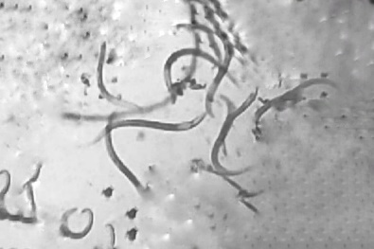 |  | 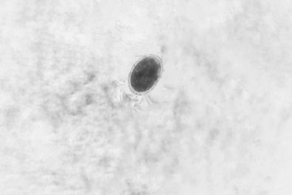 |  | 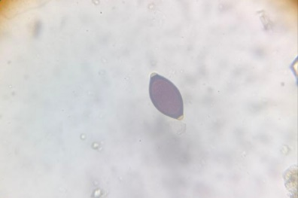
A |  | B |  | C
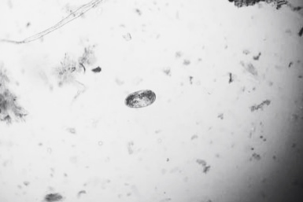 |  | 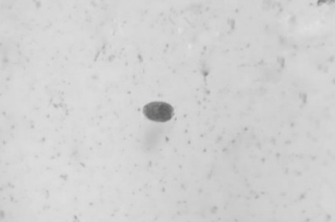 |  | 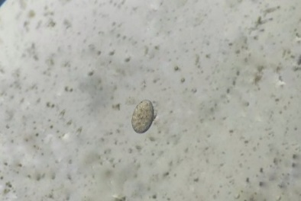
D |  | E |  | F
 |  | 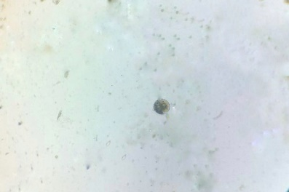 |  | 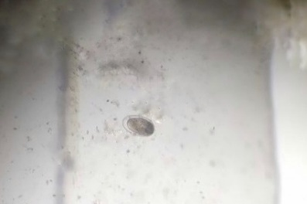
G |  | H |  | I
 |  | A: Dictyocaulus spp. (larval stage), B: Strongyloides spp., C: Trichuris spp., D: Nematodirus spp., E: Fasciola spp., F: Paramphistomum spp., G: Moniezia spp., H: Balantidium spp., I: Eimeria spp., and J: Cryptosporidium spp.
J
Figure 2: Identified gastrointestinal parasites in cattle

Through the examination of all 184 samples, ten parasites were confirmed by observing them under microscope (Figure 2). These include 2 species of trematode (Fasciola spp. and Paramphistomum spp.), 4 species of nematode (Nematodirus spp., Trichuris spp., Strongyloides spp. and Dictyocaulus spp.), 1 species of cestode (Moniezia spp.) and 3 species of protozoa (Eimeria spp., Balantidium spp. and Cryptosporidium spp). All the parasite was identified according to the keys and descriptions of various authors (Soulsby 1982, Taylor et al., 2016, Hendrix & Robinson, 2020, Bowman, 2021).
Overall prevalence of gastrointestinal parasites
The study was conducted between 10 October, 2024 to 7 November, 2024, where faecal sedimentation revealed 141 positive samples out of 184 (76.63%) were infected with any of those ten species of helminth. These findings complement those of other authors who previously found a prevalence range of 50.50% to 63.41%. (Mamun et al.,2020; Das et al.2017). However, other countries also recorded comparatively higher prevalence, with 81% reporting in Bangladesh (Nath et al., 2016), 96.09 % in Thailand (Thanasuwan et al., 2022), 86.1% in Romania (Sirbu et al. 2020). However, other parts of Bangladesh have reported lower rates of gastrointestinal parasite infection than our study (Akther et al., 2017). The ecology and host-parasite interaction, sample size, experimental design variation, and diagnostic methods are some of the variables that may have contributed to the discrepancies in the results of various researchers. Furthermore, “the true prevalence may be higher than the rate determined by copro-microscopic inspection of this study because of the high likelihood of missing larval stages or low-grade infections during such diagnostic procedures” (Chakrabortty et al., 2023).
Species wise prevalence of gastrointestinal parasites
Table 1: Species-wise prevalence of gastrointestinal parasites
Types of Parasites | Species | No of infected  (N=184) | Prevalence (%) | P-value
Helminths | Fasciola spp. | 12 | 6.52 | <0.0001*
Helminths | Paramphistomum spp. | 30 | 16.30 | <0.0001*
Helminths | Trichuris spp. | 21 | 11.41 | <0.0001*
Helminths | Strongyloides spp. | 49 | 26.63 | <0.0001*
Helminths | Dictyocaulus spp. | 7 | 3.80 | <0.0001*
Helminths | Nematodirus spp. | 3 | 1.63 | <0.0001*
Helminths | Moniezia spp. | 5 | 2.72 | <0.0001*
Protozoa | Eimeria spp. | 16 | 8.69 | <0.0001*
Protozoa | Balantidium spp. | 35 | 19.02 | <0.0001*
Protozoa | Cryptosporidium spp. | 44 | 23.91 | <0.0001*

*-indicates significant at p<0.05

A total of the ten species of parasites, where seven species of helminths, namely, Fasciola spp., Paramphistomum spp., Nematodirus spp., Trichuris spp., Strongyloides spp., Dictyocaulus spp. Moniezia spp. and three species of protozoa, namely, Eimeria spp., Balantidium spp., and Cryptosporidium spp. were detected at a prevalence of 6.52%, 16.30%, 1.63%, 11.41%, 26.63%, 3.80%, 2.72%, and 8.69%, 19.02% and 23.91%, respectively. The species-wise prevalence of gastrointestinal parasites is illustrated in Table 1. In our study, nematodes may be more common than other helminths because of their direct life cycle and extended environmental survival period. Compared to other helminths, some nematodes can infect hosts more readily and last in the environment for up to ten years. (Kabaka et al., 2013). Furthermore, for trematodes to finish their life cycle, they require an intermediary host, which makes comparable lower prevalence during our study (Andrade et al., 2023). In addition to this, the research population's shared housing with other domestic animals, inadequate bedding materials, and excessive stocking density were all clearly indicated by protozoan infection (Chartier et al., 2012).
Single and Mixed infections of gastrointestinal parasites
Table 2: Single and Mixed infections of gastrointestinal parasites
Types of infection | No of infected  (n=141) | Prevalence  (%) | P-value
Single infection | 94 | 66.66 | <0.0001*
Two species | 28 | 19.86
More than 2 species | 19 | 13.47

*-indicates significant at p<0.05

Among the 141 positive samples, the single parasitic infection was calculated at 66.67%, and the rest 33.33% of the studied samples were infected with more than one species. In case of the mixed infection, 28 were infected with two species of parasites (19.86%) and 19 samples were contaminated with more than two species of parasites (13.47%). These co-infections of gastrointestinal parasites are exhibited in Table 2.
Gender-wise prevalence of gastrointestinal parasites
Table 3: Gender-wise prevalence of gastrointestinal parasites
Variables | No. of examined | No. of infected | Prevalence  (%) | P-value
Male | 81 | 52 | 64.19 | < 0.001*
Female | 103 | 87 | 84.47 | < 0.001*

*-indicates significant at p<0.05

The proportion of gender was mentioned before where 103 were females and the rest 81 were males. In case of gender-wise prevalence, a little difference was observed where females (84.47%) were infected more than males (64.19%). The gender-wise prevalence is given in Table 3. Females had a higher parasitic abundance than males in our study which is supported by Kabir et al. (2019). Stress and weakened immune systems during pregnancy, cyclic parturition, and healthcare may be the cause of this increased occurrence in females, which lowers the body's inherent defenses against parasites (Verma et al., 2018).
Age-wise prevalence of gastrointestinal parasites
Table 4: Age-wise prevalence of gastrointestinal parasite
Variables | No. of examined | No. of infected | Prevalence  (%) | P-value
Young (<6 months) | 51 | 44 | 86.27 | 0.057
Adult (>6 months) | 133 | 97 | 72.93 | 0.057

During sampling, all cattle were categorized into two groups, i.e., young (<6 months) and adult (>6 months). The highest prevalence (86.27%) was seen in the younger groups of age, followed by 72.93% in adult of more than 6 months. These results indicated more helminth infections in calf than in adults. Age-wise prevalence is shown in Table 4. According to earlier research, young calves in our study population had more parasite infections than adults (Zvinorova et al., 2016). Through repeated challenges, adult animals can develop parasite immunity, which allows them to eliminate the parasite before infection happens. Furthermore, “young animals are susceptible to infections because of immunological immaturity and unresponsiveness, overgrazing of infected pastures, and failure to remove young animals from adult stock during pre-weaning age”. (Sutherst et al.,2001).
Breed wise prevalence of Gastrointestinal Parasite
Table 5: Breed related prevalence of gastrointestinal parasites
Name of the  breeds | No. of examined | No. of infected | Prevalence  (%) | P value
Local | 53 | 44 | 83.02 | 0.204
Cross (LxHF) | 131 | 97 | 74.05 | 0.204

A total of 184 cattle were analyzed in this study under two breed categories: 53 were local cattle from the Pabna, Munshiganj, and RCC breeds, which produce less milk, and the remaining 131 were crossbred (LocalxHF) cattle, whose produce more milk. Following a comprehensive analysis, the local breed had the highest incidence rate (83.02%), followed by the HF crossbreed (74.05%). However, in addition to irregular or sometimes strategic anthelmintic medication, improved management practices resulted in fewer parasite infections in crossbred cattle (Alim et al.2012 and Rahman et al.2009).
Prevalence of gastrointestinal parasites depending on their deworming status
Table 6: Prevalence of gastrointestinal parasites on their deworming status
Variables | No. of examined | No. of infected | Prevalence  (%) | P-value
Dewormed | 74 | 33 | 44.59 | <0.0001*
Non-dewormed | 111 | 108 | 97.29 | <0.0001*

*-indicates significant at p<0.05

We had a history of deworming in 74 cattle among the study samples, where the rest 111 cattle were not dewormed recently. On the basis of deworming status, better results were observed in the group of dewormed animals (44.59%), which indicates a good anthelmintic management among the study area. However, the prevalence of gastrointestinal parasites in non-deworming animals was found 97.29%. This prevalence of gastrointestinal parasites depending on deworming status is shown in Table 6. In order to effectively control gastrointestinal parasites and reduce the development of anthelmintic resistance, frequent anthelmintic deworming is commonly used as endoparasite control in study areas (Gunathilaka et al., 2018).

Conclusions
One of the main factors influencing the production and well-being of cattle is parasitism. According to this study, 76.63% of the cattle in Kerani Ganj Upazila had gastrointestinal parasitic infections. In this investigation, only the prevalence rate and severity of parasite infections in cattle were examined. However, it would be more beneficial for farmers to research the impact of parasites on cattle production performance. Furthermore, the study's examined data will provide a broad understanding of the spread of gastrointestinal parasitic contaminations across the study areas.

Disclaimer (Artificial intelligence)

We confirm that no generative AI technologies (such as ChatGPT, Copilot, or similar tools) were used in the writing, editing, or preparation of this manuscript. All contents were prepared entirely by the authors.

REFERENCES

Akanda, M. R., Hasan, M. M. I., Belal, S. A., & Roy, A. C. (2014). A survey on prevalence of gastrointestinal parasitic infection in cattle of Sylhet division in Bangladesh. American Journal of Phytomedicine and Clinical Therapeutics, 2(7), 855–860.
Akther S, Hossain MA, Karim MR, Begum N. (2017). Prevalence of gastrointestinal parasitism of cattle in Banskhali Upazila, Chittagong. Journal of Bangladesh Agricultural University.; 15(1): 79-86.
Alim MA, Das S, Roy K, Sikder S, Mohiuddin MM, Hossain MA. (2012). Prevalence of gastrointestinal parasites in cattle of Chittagong division, Bangladesh. Wayamba Journal of Animal Science. 4: 1-8.
Andrade RB, Forero J, Ospina JD. (2020). Prevalence of trematodes and host risk factors associated with dairy cattle in Colombia. Revista Veterinaria. Jul 1;31(2).

Bangladesh Bureau of Statistics (2024) http://nsds.bbs.gov.bd/
Bowman DD. Georgis' parasitology for veterinarians. 11th edition. Elsevier; 2021.
Chartier C, Paraud C. (2012). Coccidiosis due to Eimeria in sheep and goats, a review. Small Ruminant Research. 103(1): 84-92.
Das AK, Das S, Roy PS. (2017). A study on gastrointestinal parasitism in dairy cattle in West Bengal, India. Veterinary Research Communications.; 41(5): 443-450.
Department of livestock services. (2024). Livestock economy at a glance 2023-2024. Government of Bangladesh. https://file-rajshahi.portal.gov.bd/uploads/0f236d9d-0a28-4fbd-b4d5

FAOSTAT (2024). FAO Statistics, Crops and Livestock Products.
https://www.fao.org/faostat/en/#data/QCL
Gunathilaka N, Niroshana D, Amarasinghe D, Udayanga L. (2018). Prevalence of gastrointestinal parasitic infections and assessment of deworming program among cattle and buffaloes in Gampaha District, Sri Lanka. BioMed research international. (1):3048373.
Hamid, M., Rahman, A., Zaman, M. A., & Hossain, K. (2017). Cattle genetic resources and their conservation in Bangladesh. Asian Journal of Animal Sciences, 11(2), 54–64
Hendrix CM, Robinson E. Diagnostic parasitology for veterinary technicians. 5th edition. Elsevier; 2020.
Kabaka WM, Gitau GK, Kitala PM, Maingi N, Van Leeuwen JA. (2013) The prevalence of gastrointestinal nematode infection and their impact on cattle in Nakuru and Mukurweini districts of Kenya. Ethiopian Veterinary Journal.17(1):95-104.
Kabir MHB, Islam KBMS, Islam K, Islam M, Karim SJ, Abdullah SM, Mahmud MS. (2019) Epidemiological survey on gastrointestinal parasitic zoonosis in cattle of Sirajganj District, Bangladesh. International Journal of Pathogen Research.; 2(2): 1-10.
Khan, T., Khan, W., Iqbal, R., Maqbool, A., Fadladdin, Y. A. J., & Sabtain, T. (2022). Prevalence of gastrointestinal parasitic infection in cows and buffaloes in Lower Dir, Khyber Pakhtunkhwa, Pakistan. Brazilian Journal of Biology, 83, e242677.
Karim, M. R., Sumon, S. M. M. R., Soad, S. H., Siddiki, S. H. M. F., Dey, A. R., & Ehsan, M. A. (2019). Prevalence and factors affecting the parasitic infections in calves at selected areas of Bangladesh. Annals of Bangladesh Agriculture, 23(2), 1–13.
Mamun MA, Hossen MA, Bhowmik M, Nizami TA, Hasib FM, Hasan T, Hossain MA, Alim MA. (2020). Prevalence of gastrointestinal parasitic infections in cattle and buffalo of Sandwip Island, Chattogram, Bangladesh. Bangladesh Journal of Veterinary and Animal Sciences. Jul;8(2):84-90.
Nath, T., Bhuiyan, J., Islam, K., & Ilyus, N. (2016). Assessment of the prevalence of gastrointestinal parasitic infections of cattle in hilly areas of Bangladesh. World Scientific News, 59, 74–84.
Radostits, O. M., Blood, D. C., & Gay, C. C. (1994). Veterinary medicine: A textbook of the diseases of cattle, sheep, pigs, goats and horses (8th ed.). Baillière Tindall.
Rahman AKMA, Begum N, Nooruddin M, Rahman MS, Hossain MA, Song HJ. (2009). Prevalence and risk factors of helminth infections in cattle of Bangladesh. Korean Journal of Veterinary Service. 32(3): 265-273.
Silvestre A, Mandonnet N, Le Gal P. (2000). Impact of gastrointestinal parasitism on cattle productivity: A review. Veterinary Parasitology. 91(1): 1-14.
Sîrbu, C. B., Imre, K., Dărăbuș, G., Suici, T., Mateș, B., & Morariu, S. (2020). Prevalence of gastrointestinal parasitic infections in cattle and sheep in two regions of Romania. Turkish Journal of Veterinary and Animal Sciences, 44(3).
Soulsby EJL. Helminths, arthropods and protozoa of domesticated animals. 7th edition. Baillière Tindall; 1982.
Sutherst RW. The vulnerability of animal and human health to parasites under global change. International journal for parasitology. 2001 Jul 1;31(9):933-48.
Tariq KA, Chishti MZ, Ahmad F, Shawl AS. (2010). Epidemiology of gastrointestinal nematodes of sheep managed under traditional husbandry system in Kashmir valley. Veterinary Parasitology. 170(1-2): 138-143.
Taylor MA, Coop RL, Wall RL. Veterinary parasitology. (2016). 4th edition. Wiley-Blackwell.
Thanasuwan S, Piratae S, Tankrathok A. (2021). Prevalence of gastrointestinal parasites in cattle in Kalasin Province, Thailand. Veterinary World. Aug 13;14(8):2091.
Thornton, P., Kristjanson, P., Kruska, R., & Reid, R. (2018). Mapping livestock and poverty: A tool for targeting research and development. BSAP Occasional Publication, 33, 25–36.
Verma T, Wei X, Lau SK, Bianchini A, Eskridge KM, Subbiah J. (2018) Evaluation of Enterococcus faecium NRRL B‐2354 as a surrogate for Salmonella during extrusion of low‐moisture food. Journal of food science. Apr;83(4):1063-72.
Zvinorova PI, Halimani TE, Muchadeyi FC, Matika O, Riggio V, Dzama K. (2016). Prevalence and risk factors of gastrointestinal parasitic infections in goats in low-input farming systems in Zimbabwe. Small Ruminant Research. 143: 75-83.
Chakrabortty, M., Shohana, N. N., Begum, N., Dey, A. R., Rony, S. A., Akter, S., & Alam, M. Z. (2023). Diversity and prevalence of gastrointestinal parasites of Black Bengal goats in Natore, Bangladesh. Journal of Advanced Veterinary and Animal Research, 10(1), 80.

