Original Research Article
STUDY OF BIOPESTICIDE EFFECTS ON GROWTH AND YIELD OF COWPEA (VIGNA UNGUICULATA (L.) WALP) IN SUBSAHARAN AFRICA : CASE OF FAR-NORTH CAMEROON

ABSTRACT
Sub-Saharan Africa has a large population from malnutrition. With a growth rate of ≈ 2.7% per year, this number is constantly increasing. Added to this challenge are the effects of climate change, which are impacting the yield of crops that are part of our dietary habits. One of these crops is cowpea, which requires increasing use of chemical inputs (synthetic pesticides) due to pest attacks. The aim of this study is to test the effectiveness of a biopesticide on cowpea (Vigna Unguiculata (L.) Walp) growth and yield. To do this, a complete block with three replications was set up in two localities (Moudawa and Guidiguis) for two successive years (2021 and 2022), using the Fekem and Lori varieties respectively. The control was the plots treated with PACHA. Growth parameters (emergence rate, number of nodes/plant, pod yield, number of seeds/pod, 1000-seed weight) and yield were recorded. The results show that there is no significant difference between the parameters studied at each site for the two varieties. Consequently, the chemical treatment can be replaced by the biopesticide.
Keywords: Climate change, sub-Saharan Africa, cowpea, biopesticide.

INTRODUCTION
Sub-Saharan Africa is home to over 950 million people, i.e around 13% of the world's population. With a growth rate of ≈ 2.7% per year, by 2050 this share is expected to rise to almost 22%, or 2.1 billion people (OCDE/FAO, 2016). Achieving food security remains a major challenge in this region, where approximately 218 million people are undernourished (OCDE/FAO, 2016). In order to improve crop yields, producers resort to the use of large quantities of chemical inputs (herbicides, fertilisers, pesticides) which have a negative impact not only on the environment (Kattwinkel et al., 2015 ; Santás-Miguel et al., 2020 ; Thomas et al., 2020 ; Fernández-Calviño et al., 2021) but also on human health (Hoppin et al., 2017 ; Andreotti et al., 2018 ; Woźniak et al., 2018 ; Peillex and Pelletier, 2020).
The effects of climate change, particularly pockets of drought in the rainy season, have led to a proliferation of pests, which require increased use of pesticides for their control. However, given the precarious conditions in which producers in sub-Saharan Africa live (over the period 2005-2015, average annual agricultural productivity per worker in sub-Saharan Africa was US$1,109.30, Odusola, 2016), it is difficult, if not impossible, for them to have access to sufficient quantities of pesticides. This results in huge losses, exacerbating food insecurity.
During the 1970s, WHO (World Health Organization) and other international organizations have initiated studies to identify new biological control agents and optimize the existing ones (Gay, 2012). Biopesticides constitute one alternative solution to the use of chemical insecticides and have the advantage of being biodegradable (Martinez, 2002) with low, or no, toxicity to humans and animals (Valle Pinheiro and Dias Quintela, 2010). Biopesticides include pesticides produced from living organisms such as plants, animals, and microorganisms (viruses, bacteria, and fungi) to control and provide crops with protection against dangerous plant-damaging pathogens. Biopesticides are effective even in low quantities and have no residual effects, which is a major concern for consumers, specifically for vegetables and fruits (Thakore, 2006; Essiedu et al., 2020).
Cowpea, Vigna unguiculata L. (Walp.) is one of the most important food and nutritional security crops, providing the main source of protein to millions of people in developing countries (Lonardi et al., 2019). In sub-Saharan Africa, farmers with small land holding are the major producers and consumers of cowpea, which is grown for its grains, tender leaves and pods as food for human consumption, with the crop residues being used for fodder or added back to the soil to improve fertility (Singh, 2014). The cowpea yield in the field is often lowered by several insect pests whose populations attain damaging levels (Ba et al., 2009). However, the manufacture of biopesticides to combat these insects does not require large investments and the materials (plants) are available locally. This is the background to the present study, which was carried out in the Far North region of Cameroon with the aim of testing the effectiveness of a biopesticide on cowpea growth and yield.

STUDY AREA
The study area is located in the Far North region of Cameroon, specifically in the localities of Moudawa and Guidiguis (figure 1). These localities are in the arrondissements of Moutourwa and Guidiguis respectively. The coordinates of the plot centres are N 10° 23' 45.7'', E 14° 12' 00.3'' and N 10° 08' 41'', E 14° 42' 10.4'' respectively for Moudawa and Guidiguis.
The Far North region is characterised by a Sudano-Sahelian climate. Rainfall over a period of five months ranges from 1,200 mm in the south to 500 mm on the shores of Lake Chad. Average temperatures are around 28°C, with maximums reaching 34°C in April.
In the Moudawa locality, the soils are leached tropical ferruginous soils developed on gneiss with the presence of concretions and cuirasse in places. The texture is generally sandy or sandy-clay on the surface, then the clay content increases sharply with depth (30 to 37% clay). Silt content does not exceed 8% and there is always more amount of fine than coarse sand. Exchange capacity is never very high: 5 to 10 meq/100g at the surface and 14 meq/100g at depth. Kaolinite is clearly dominant among the clay minerals. The sum of exchangeable bases varies between 3 and 10 meq/100g. The pH is acidic and generally decreases with depth. The degree of saturation is between 50% and 90%. Organic matter content is average (1 to 1.6%) with C/N ratios of between 11 and 14 (Martin, 1963).
In Guidiguis, the soils are advanced hydromorphic mineral soils developed on alluvium. The texture is sandy-clay throughout the profile, silt content does not exceed 8% and there is always more fine than coarse sand. The exchange capacity is relatively homogeneous, at around 17 meq/100g. Clay minerals include kaolinite, montmorillonite and iron hydroxides. The surface pH averages 5.8; at depth it rises slightly to 5.9. The absorbent complex is on average 46% saturated at the surface and 57% saturated at depth. Organic matter content is not very high (0.5% on average), with C/N ratios of 10 (Sieffermann, 1963).
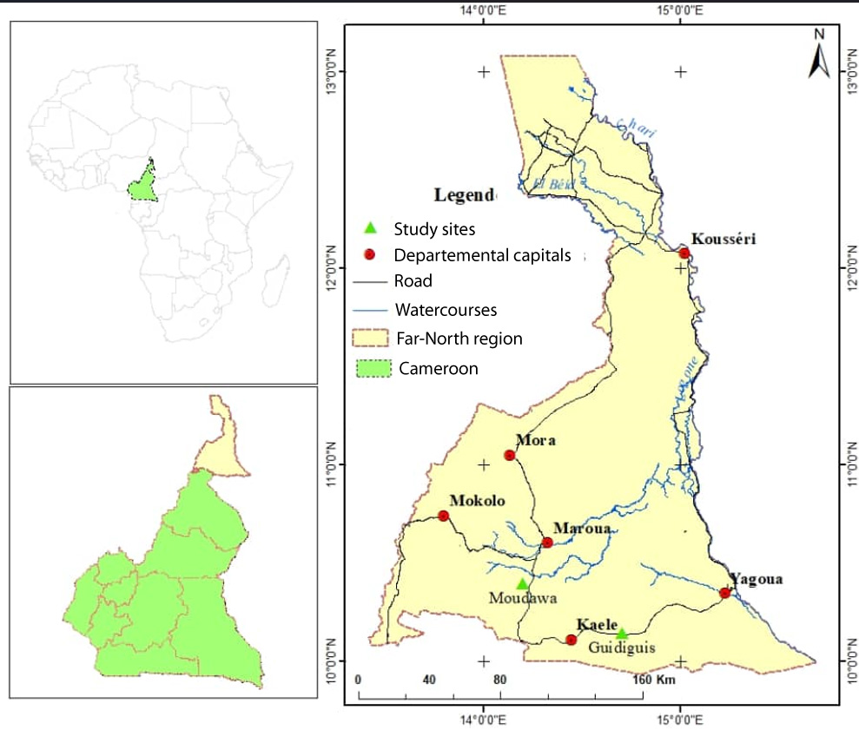
Figure 1 : Study area

METHODOLOGY
The study was conducted during the 2021 and 2022 cropping seasons in the localities of Moudawa and Guidiguis. To carry out the work, materials and equipment had to be assembled and a test protocol established.

Vegetal material
The plant material used consists of two varieties of cowpea and biopesticide.

Cowpea varieties
The two cowpea varieties used are : Fekem and Lori. The varieties were obtained from certified seed producers who are partners of African Institute for Economic and Social Development (INADES - Formation).
The 'Fekem' cowpea is selected by the local population and originates in Cameroon. Under normal conditions, yields are in the region of 2 t/ha to 2.5 t/ha and the weight of 100 seeds varies between 180 and 190 g, or even 200 g. The sowing-flowering cycle varies between 40 and 50 days. The sowing-maturity cycle is between 80 and 90 days. This variety is susceptible to viruses. It is tolerant to Striga gesnerioides and bruchids (FAO, 2012).
Cowpea 'Lori' is a pure line crop originating in Cameroon. Under normal conditions, its yield is around 1.5 t/ha to 2 t/ha and the weight of 1000 seeds varies between 170 and 190 g. The sowing-flowering cycle varies between 40 and 45 days. The sowing-maturity cycle is between 80 and 85 days. This variety is resistant to leaf diseases (with the exception of anthracnose) and to Cowpea aphid-borne mosaic virus (CAbMV). It is tolerant to Striga gesnerioides and bruchids (FAO, 2012).
Varieties were put in the field by farmers at the two experimental sites.

Biopesticide
The products considered as biopesticides by European and global regulatory agencies come from a variety of sources. They can be classified into three broad categories, depending on their nature: microbial biopesticides, plant biopesticides and animal biopesticides (Chandler et al., 2011 ; Leng et al., 2011). In this study, the plant biopesticide used was an aqueous mixture of neem kernel, garlic, onion and pepper.
These plants were chosen for their various properties, but also because of their availability in the area. Neem has an insecticidal effect on caterpillars, mealybugs, aphids and whiteflies. It also has a nematicidal effect. Garlic, on the other hand, has an insect repellent effect (on caterpillars, mealybugs, aphids and mites) and destroys fungi (fungicidal effect). Onions have an insect repellent effect on caterpillars and aphids. Finally, pepper has an insecticidal effect on caterpillars, aphids, white flies and trips (ESSOR, 2018).

Agricultural equipment
The following equipment was needed to carry out this work: machetes for clearing land; a decameter for measuring distances; string to mark the boundaries of the experimental units; stakes to mark the edges and corners of the experimental units; signs to identify the plots; a sensitive electronic scale for weighing; a hand-held GPS for taking coordinates; sprayers for administering treatments; barbed wire to protect the plot; a camera for taking photographs; boots for working in the field; gloves and nose covers for handling inputs and crop protection products.

Experimental device
The aim of the study was to investigate the effect of a biopesticide on cowpea growth and yield at two locations mentioned above. In each case, only the biopesticide was studied, leading to the choice of a complete block design with three replications.
The experimental set-up (Figure 2) consisted of three experimental units treated with biopesticide and one experimental unit treated with PACHA 25 EC (control).
The seedlings were sown on 07 and 15 August 2021 (Fekem variety) and 18 July and 11 August 2022 (Lori variety) respectively in the localities of Moutourwa and Guidiguis with 2 seeds per plot and a sowing density of 0.80m x 0.40m.
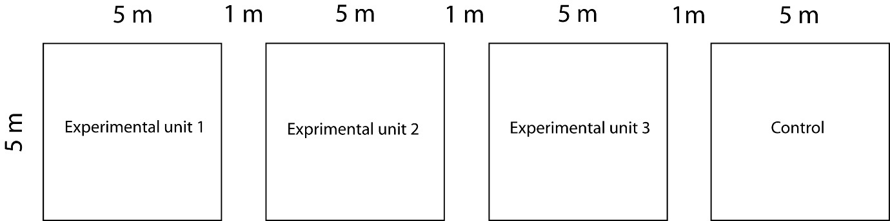
Figure 2 : Experimental set-up

Biopesticide preparation
The biopesticide was prepared locally with the help of local people. The ingredients are onion (1 Kg), garlic (1 Kg), chilli pepper (1 Kg), neem kernels (1 Kg) and 200 g of wood ash. All the ingredients were crushed in turn, mixed and homogenised. 5 liters of water were added to the resulting mixture and the solution, contained in a container with a lid, macerated for 5 hours. The filtrate was then filtered and 2 liters of water was added to the filtrate, which was filtered again. The final mixture obtained was stored in 0.5 liter bottles in a cool place.

Treatment application
For field treatment with biopesticide (T1), 1 part of product was mixed with 9 parts of water, giving a dilution rate of 10%. The treatment was carried out in the late afternoon to reduce evaporation losses, as the product's constituents are highly volatile. Treatment can be preventive or curative, but for this study, the choice was made for curative treatment (once the first attacks had been observed), i.e., one treatment per week.
The field treatment solution using the synthetic pesticide PACHA 25 EC (T2) was obtained by mixing 5 ml of the synthetic pesticide with 5 liters of water. This practice, which was repeated, is used by people in the study area.
The two treatments were applied simultaneously to prevent the pests from migrating from one experimental unit to another.

Data collection and analysis
Parameters and data are recorded on 05 central lines of each experimental unit (elementary plot). The data collected were (1) emergence rate, (2) number of nodules/plant, (3) pod yield, (4) number of seeds/pod, (5) 1000-seed weight, and (6) total seed weight/elemental plot.
The data collected was processed using Microsoft Excel and then analysed by ANOVA using XLSTAT software version 2023.3.1.(1416).

RESULTS
The results obtained from the two localities are shown in Tables 1a and b.
Table 1a : Field data of Moudawa
Repetitions | Treatments | Varieties | ERP | Nod | PY | SP | W1000 | SW
2021
R1 | T1 | V1 | 71.79 | 15.80 | 29.60 | 11.48 | 150.00 | 1.25
R2 | T1 | V1 | 71.17 | 15.20 | 56.00 | 12.04 | 200.00 | 2.50
R3 | T1 | V1 | 79.63 | 15.40 | 59.20 | 12.76 | 200.00 | 2.60
RC | T2 | V1 | 84.62 | 15.80 | 76.00 | 12.84 | 200.00 | 3.30
2022
R1 | T1 | V2 | 82.38 | 3.60 | 41.33 | 12.20 | 200.00 | 2.20
R2 | T1 | V2 | 75.82 | 3.80 | 40.00 | 14.70 | 200.00 | 2.60
R3 | T1 | V2 | 76.54 | 4.00 | 40.00 | 13.10 | 250.00 | 2.05
RC | T2 | V2 | 73.08 | 3.40 | 27.33 | 13.90 | 200.00 | 1.40
ERP : Emergence Rate of plants (%); Nod: Number of nodes; PY: Pods yield/m²; SP: Seeds per pods; W1000: Weight of 1000 seeds (g); SW: Seed weight (Kg).
Table 1b : Field data of Guidiguis
Repetitions | Treatments | Varieties | ERP | Nod | PY | SP | W1000 | SW
2022
R1 | T1 | V2 | 97.00 | 10.0 | 14.80 | 12.6 | 200 | 2.6
R2 | T1 | V2 | 96.00 | 9.4 | 11.66 | 12.1 | 200 | 2.8
R3 | T1 | V2 | 96.00 | 9.2 | 11.27 | 12.9 | 200 | 2.1
RC | T2 | V2 | 98.86 | 9.0 | 15.60 | 12.7 | 200 | 2.2
ERP : Emergence Rate of plants (%); Nod: Number of nodes; PY: Pods yield/m²; SP: Seeds per pods; W1000: Weight of 1000 seeds (g); SW: Seed weight (Kg).

Moudawa
The different results obtained for each parameter studied were compared with those of the control plot. The values obtained are shown in tables 2a and 2b for the years 2021 and 2022 respectively.
Table 2a : Summary of variance analyses for Moudawa in 2021
 | ERP | Nod | PY | SP | W1000 | SW
R² | 0.647 | 0.309 | 0.522 | 0.337 | 0.111 | 0.481
F | 3.664 | 0.893 | 2.186 | 1.016 | 0.250 | 1.856
Pr > F | 0.196 | 0.444 | 0.277 | 0.420 | 0.667 | 0.306
Table 2b : Summary of variance analyses for Moudawa in 2022
 | ERP | Nod | PY | SP | W1000 | SW
R² | 0.436 | 0.600 | 0.991 | 0.070 | 0.111 | 0.784
F | 1.547 | 3.000 | 218.729 | 0.150 | 0.250 | 7.240
Pr > F | 0.340 | 0.225 | 0.005 | 0.736 | 0.667 | 0.115

Emergence Rate of Plants and number of nodes
Plant emergence rates ranged from 71.17 to 84.62%, with an average of 76.80 ± 6.48% in the first year. It varied between 73.08 and 82.38 % with an average of 76.96 ± 3.91 % for the second year.
Comparison of the averages for each respective year shows that there is no significant difference between the results obtained in the two treatments (p > 0.05).
The number of nodes varied between 15.20 and 15.80, with an average of 15.55 ± 0.30 in the first year (Fekem). The highest value was obtained with the chemical treatment (Figure 3a). On the other hand, for Lori, in the second year, the number of nodes ranged from 3.40 to 4.00, with an average of 3.70 ± 0.26. The highest value was obtained with the chemical treatment (Figure 3a). The highest value was obtained with the organic treatment (Figure 3b).
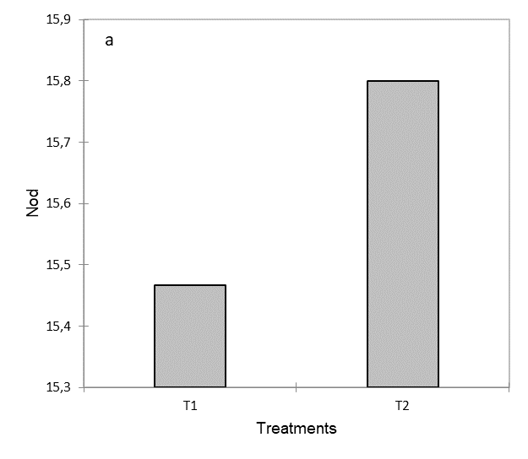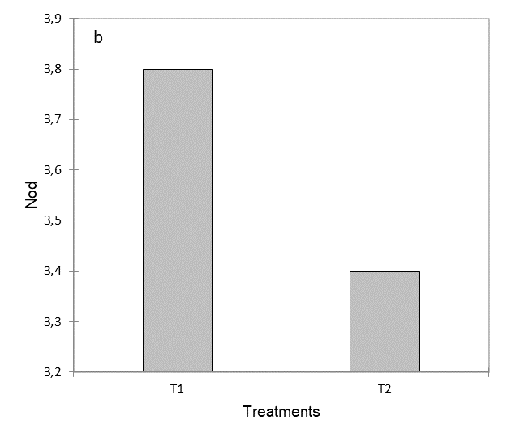
Figure 3 : Number of nodes of a) Fekem, 2021, b) Lori, 2022
Comparing the averages for each respective year shows that there is no significant difference between the results obtained with treatments T1 and T2 (p > 0.05).

Pods yield and seeds per pods
Pod yield varied from 29.60 to 76.00 with an average of 55.20 ± 19.19 for Fekem. The highest value was obtained with chemical treatment T2 (Figure 4a). With Lori, the pod yield ranged from 27.33 to 41.33 with an average of 37.17 ± 6.59. The highest yield was obtained with biological treatment T1 (Figure 4b).
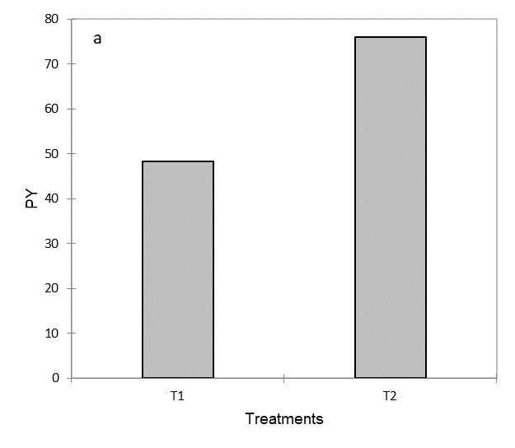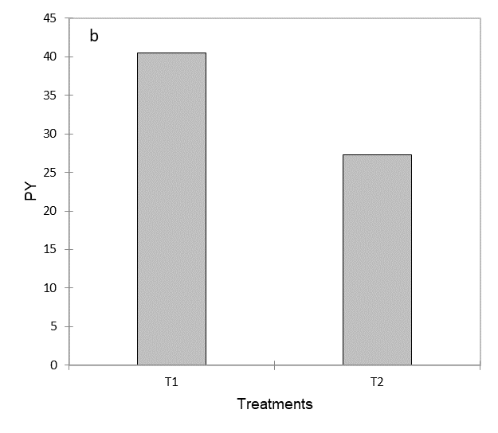
Figure 4 : Pods yield of a) Fekem, 2021, b) Lori, 2022
The average values obtained for Fekem shows that there is no significant difference between the results obtained with the two treatments. On the other hand, for Lori, the comparison of the averages between the biological treatment and the chemical treatment shows that there is a significant difference (p ˂ 0.05). In fact, the values obtained with the organic treatment are much higher than those obtained with the chemical treatment.
For Fekem, the number of seeds per pod varied between 11.48 and 12.84, with an average of 12.28 ± 0.64. The highest value was obtained with chemical treatment T2 (Figure 5a). For Lori, the number of seeds per pod ranged from 12.20 to 14.70. The average was 13.48 ± 1.07. The highest value is obtained with the T1 biological treatment, but the chemical treatment has the highest average (Figure 5b).
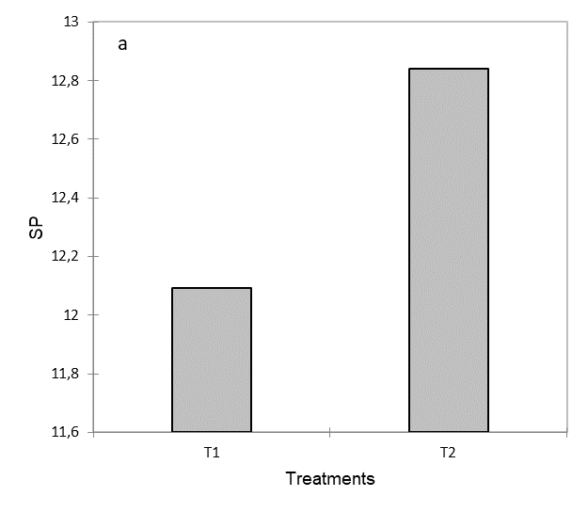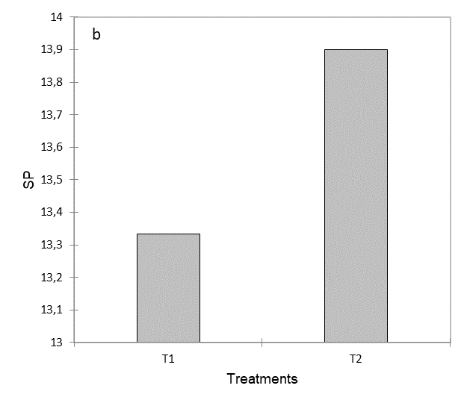
Figure 5 : Seeds per pods of a) Fekem, 2021, b) Lori, 2022
When comparing the averages for each year respectively shows that there is no significant difference between the results obtained by the two treatments (p > 0.05).

Weight of 1000 seeds and seed weight
The weight of 1000 seeds was between 150 and 200 g, with an average of 187.50 ± 25.00 for Fekem. The highest weight was obtained with chemical treatment T2 (Figure 6a). For Lori, it varies between 200 and 250 g with an average of 212.50 ± 25 g. The highest weight was obtained with biological treatment T1 (Figure 6b).
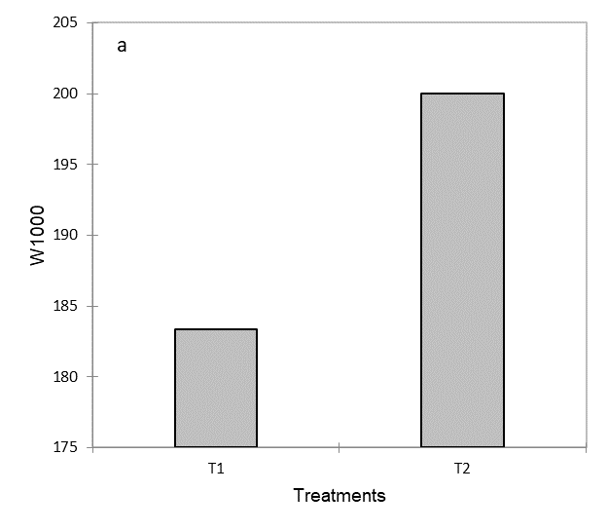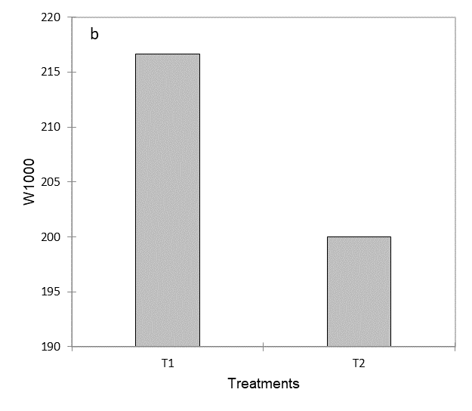
Figure 6 : Weight of 1000 seeds a) Fekem, 2021, b) Lori, 2022
Yearly average comparison between the two treatments shows that there is no significant difference between them (p > 0.05).
Seed weight varied between 1.25 and 3.30 kg, with an average of 2.41 ± 0.85 kg for Fekem. The highest value was obtained with chemical treatment T2 (Figure 7a). For Lori, the weight of the seeds ranged from 1.40 to 2.60, with an average of 2.06 ± 0.5 kg. The highest value was obtained with biological treatment T1 (Figure 7b).
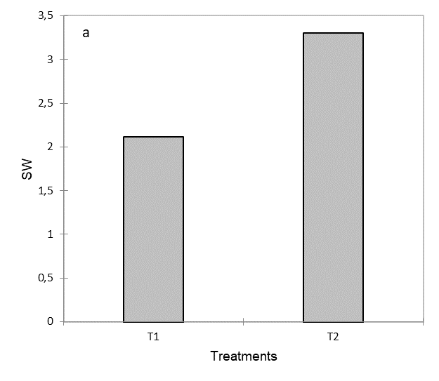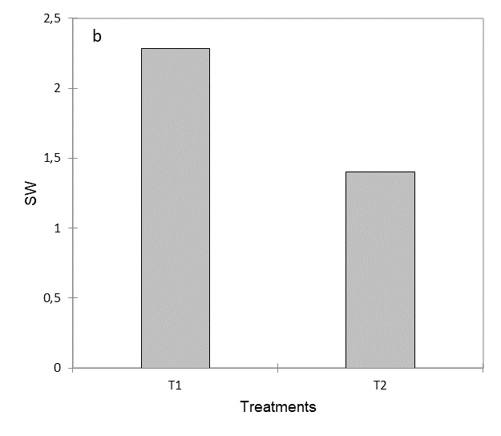
Figure 7 : Seeds weight of a) Fekem, 2021, b) Lori, 2022
Comparison of the averages for each respective year shows that there is no significant difference between the results obtained with treatments T1 and T2.

Guidiguis
The different results obtained for each parameter studied were compared with those of the control plot. The values obtained in 2022 are shown in Table 3. The results for 2021 are not available because the experimental plot was intruded by animals.
Table 3 : Summary of variance analyses for Guidiguis in 2022
 | ERP | Nod | PY | SP | SW
R² | 0.878 | 0.381 | 0.478 | 0.060 | 0.206
F | 14.364 | 1.231 | 1.830 | 0.128 | 0.519
Pr > F | 0.063 | 0.383 | 0.309 | 0.755 | 0.546

Emergence Rate of Plants and Number of nodes
Plant emergence rates ranged from 96.00 to 98.86%, with an average of 96.97 ± 1.35% for Lori. Comparison of the averages obtained shows that there is no significant difference between the two treatments (p > 0.05).
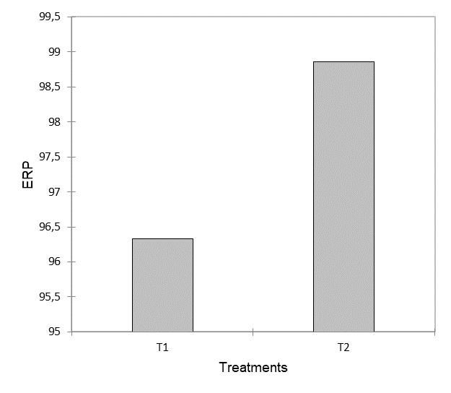
Figure 8: Emergence Rate of plants at Guidiguis
The number of nodes varied between 09.00 and 10.00, with an average of 09.40 ± 0.43 in the second year. The highest value was obtained with the organic treatment. Comparison of the averages obtained shows that there is no significant difference between the two treatments (p > 0.05).
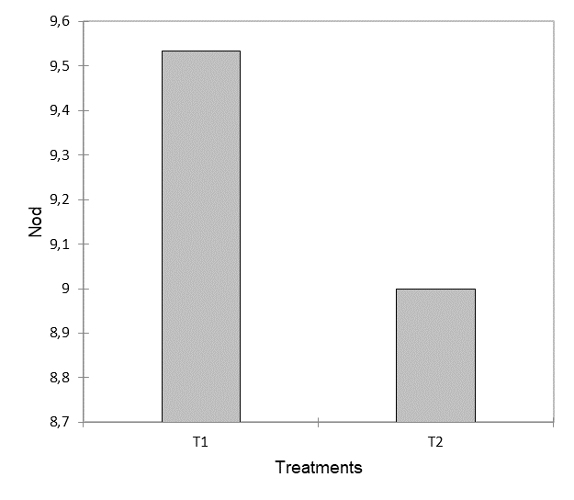
Figure 9: Number of nodes at Guidiguis

Pods yield and seeds per pods
Pod yields ranged from 11.27 to 15.60, with an average of 13.33 ± 2.19 for Lori. The highest value was obtained with the chemical treatment (T2). Comparison of the averages obtained shows that there is no significant difference between the results obtained with the two treatments (p > 0.05).
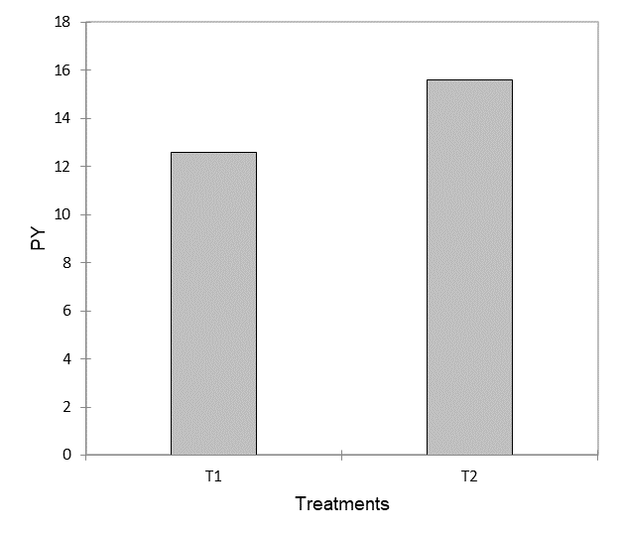
Figure 10: Pods yield at Guidiguis
The number of seeds per pod for Lori varied between 12.10 and 12.90 with an average of 12.58 ± 0.34. The highest value was obtained with the organic treatment (T1). Comparison of the averages shows that there is no significant difference between the results obtained with the two treatments (p > 0.05).
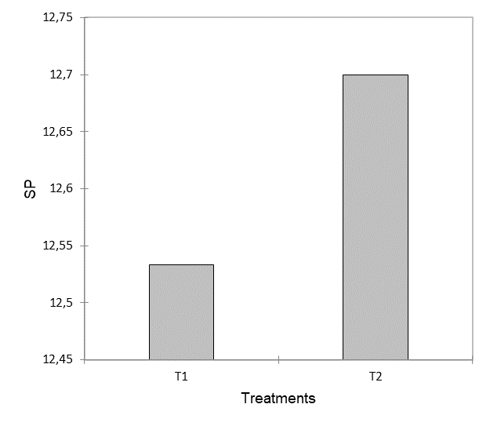
Figure 11: Seeds per pod at Guidiguis

Seed weight
Seed weight varied between 2.10 and 2.80 kg, with an average of 2.43 ± 0.33 kg for Lori. The highest value was obtained with the organic treatment (T1). Comparison of the averages shows that there is no significant difference between the results obtained with treatments T1 and T2 (p > 0.05).
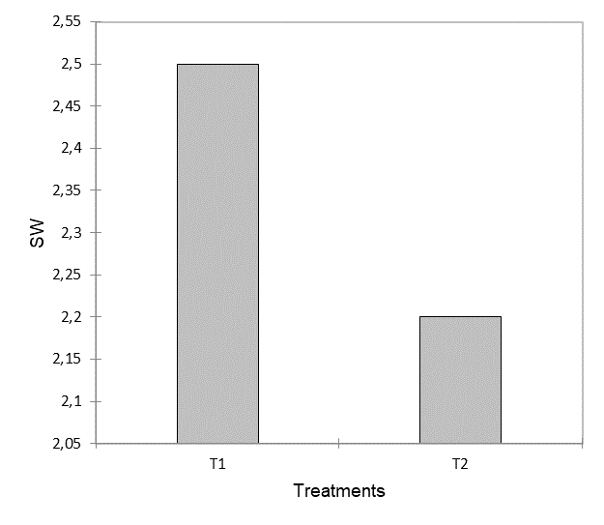
Figure 12: Seeds Weight at Guidiguis

DISCUSSION
The emergence rate of the plants depends on the germination capacity of the seed and therefore on its conservation. The rates obtained are all above 70%. This means that the seed is of good quality. Furthermore, the absence of any significant difference between the rates obtained on the different microplots demonstrates the homogeneity of the experimental plot. Similar results were reported by Waga Mana et al. (2023).
There was no significant difference in the number of nodes between different treatments, regardless of location or variety. However, a significant difference (p = 0.005) was observed at Moudawa in the second year between the organic treatment and the chemical treatment. This difference could be due to the presence of pests. According to Singh and Jackai (1985, 1990), the major insect pests of cowpea in the field are flower thrips, pod borers and brown bugs. Thrips attack cowpea flowers to feed. The cowpea is deprived of its reproductive system, the flowers, and is therefore unable to produce fruit (Bambra and Tiemtoré, 2008; Barry et al., 2022).
Although there was no significant difference between the seed weights for all the treatments and for each variety, the low pod production in Moudawa in the second year had an impact on the seed weight, which was much lower than that obtained with the organic treatment. According to Singh and Allen (1980), Rusoke and Rubaihayo (1994), Edema and Adipala (1996), thrips cause yield losses of 20 to 70%. Pod borers and bugs attack the pods where the seeds are formed and mature. The larvae of pod borers pierce the pod and eat away at its contents, resulting in yield losses. According to Dugje et al. (2009), although borer larvae also feed on the tender parts of the plant, they are more likely to attack the pods. As for bugs, they bite green pods to suck out the sap, drying them out and causing yield losses. The effectiveness of aqueous extracts of neem seeds against insects has been demonstrated by several authors, including Lowery et al. (1993), Mordue (2004), Islam et al. (2007) and Gnago et al. (2010). The same is true of aqueous extracts of garlic and onion, which significantly reduced the density of aphids per plant (Hori, 1996; Trematerra and Lanzotti, 1999; Auger et al., 2002; Auger et al., 2013; Kulimushi et al., 2014).

CONCLUSION
Cowpeas are highly prized in sub-Saharan Africa, not only for their seeds but also for their pods and stalks. But yields are falling due to pest attacks. The aim of this study is to test the effectiveness of a biopesticide, made from local plants, on cowpea growth and yield. The results showed that there was no significant difference between the biological treatment and the chemical treatment in terms of growth and yield. As a result, biological treatment can be substituted for chemical treatment for the well-being of both the population and the environment.

DECLARATION OF INTERESTS
The authors declare that they have no known competing financial interests or personal relationships that could have appeared to influence the work reported in this paper.
DISCLAIMER (ARTIFICIAL INTELLIGENCE)
Authors hereby declare that NO generative AI technologies such as Large Language Models (ChatGPT, COPILOT, etc.) and text-to-image generators have been used during the writing or editing of this manuscript.

REFERENCES
Andreotti G, Koutros S, Hofmann JN, Sandler DP, Lubin JH, Lynch CF, Lerro CC, De Roos AJ, Parks CG, Alavanja MC, et al. (2018). Glyphosate use and cancer incidence in the Agricultural Health Study. Journal of the National Cancer Institute 110(5) : 509–516.
Auger J., Dugravot S., Naudin A., Abo-Ghalia A., Pierre D., Thibout E. (2002). Utilisation des composés allélochimiques des Allium en tant qu’insecticides. International Organisation for Biological and Integreted Bulletin 259: 295- 308.
Auger J., Lecomte C., Thibout E. (2013). Les composés soufrés des Allium : leurs activités biologiques chez les insectes et leur production. Acta Botanica Gallica 140 : 157– 168.
Ba M. N., Margam V. M., Binso-Dabire C. L., Sanon A., McNeil J. N., Murdock L. L., Pittendrigh BR (2009) Seasonal and regional distribution of the cowpea pod borer Maruca vitrata (Lepidoptera: Crambidae) in Burkina Faso. International Journal of Tropical Insect Science 29(3):109–113. https://doi.org/10.1017/s174275840999021x
Bambara D., Tiemtoré J. (2008). Efficacité biopesticide de Hyptis spicigera Lam., Azadirachta indica A. Juss. Et Euphorbia balsamifera Ait. Sur le niébé Vigna unguiculata L. Walp. Tropicultura 26 (1) : 53-55.
Barry Borkeum R., Dikongue H.P., Nchare Ngapout M., Kandem Bemmo U.L., Mewounko A., Ngakou A., Nukenine Nchiwan E. (2022). Efficacité de deux extraits de plantes dans le contrôle des insectes ravageurs de Vigna unguiculata L. (Walp) à Bertoua (Cameroun). Journal of Experimental and Applied Tropical Biology 2(1) : 11-18
Chandler D, Bailey A.S, Tatchell G.M, Davidson G, Greaves J, Grant W.P. (2011). The development, regulation and use of biopesticides for integrated pest management. Philosophical Transactions of the Royal Society B: Biological Sciences 366 (1573), 1987-1998.
Dugje I. Y., Omoigui L. O., Ekeleme F., Kamara A. Y., Ajeigbe H. (2009). Production du niébé en Afrique de l’Ouest. Guide du paysan IITA, 26p.
Edema R., Adipala E. (1996). Effect of crop protection management practice on yield of seven cowpea varieties in Uganda. International Journal of Pest Management, 42 : 317-320.
Essiedu J. A., Adepoju F. O. and Ivantsova M. N. (2020). Benefits and limitations in using biopesticides: a review. AIP Conference Proceedings 2313, 080002. https://doi.org/10.1063/5.0032223
ESSOR (2018). Guide pratique du maraîcher agroécologique de Brazzaville. 40 p.
FAO (2012). Catalogue des espèces et variétés de cultures vivrières d’intérêt communautaire dans l’espace CEMAC. ISBN 978-92-5-207193-8
Fernández-Calviño D., Rousk J., Bååth E., Bollmann U.E., Bester K., Brandt K.K. (2021). Short-term toxicity assessment of a triazine herbicide (terbutryn) underestimates the sensitivity of soil microorganisms. Soil Biology and Biochemistry 154, 108130 https://doi.org/10.1016/j.soilbio.2021.108130
Gay H. (2012) Before and after silent spring: from chemical pesticides to biological control and integrated pest management—Britain, 1945-1980. Ambix 59(2) : 88–108
Gnago JA, Danho M, Agneroh TA, Fofana IK, Kohou AG (2010). Efficacité des extraits de neem (Azadirachta indica) et de papayer (Carica papaya) dans la lutte contre les insectes ravageurs du gombo (Abelmoschus esculentus) et du chou (Brassica oleracea) en Côte d’Ivoire. International Journal of Biological and Chemical Sciences 4: 953-966.
Hoppin J, Umbach D, Long S, London S, Henneberger P, Blair A, Alavanja M, Freeman L, Sandler D. (2017). Pesticides are associated with allergic and non-allergic wheeze among male farmers. Environmental Health Perspectives 125(4) : 535–543.
Hori M. (1996). Settling inhibition and insecticidal activity of garlic and onion against Myzus persicae (Sulzer) (Homoptera: Aphididae). Applied Entomology and Zoology 31: 605- 612.
Islam MD, Latif MA, Begum R, Razzaque MA, Akhtar Akhy A (2007). Effect of neem oil on food consumption, growth and development of Jute hairy caterpillar, Spilarctia obliqua (Walker). International Journal of Sustainable Agriculture. Technology 3: 1–5.
Kattwinkel M., Liess M., Arena M., Bopp S., Streissl F., Rombke J. (2015). Recovery of aquatic and terrestrial populations in the context of European pesticide risk assessment. Environmental Reviews 23, 382–394
Kulimushi E. (2014). Evaluation des effets d'insecticides botaniques sur les pucerons noirs du haricot (Aphis fabae) à Goma en république démocratique du Congo. Cahiers Africains des Droits de l’Homme et de la Démocratie 1 : 365-380.
Leng J, Lan X, Liu Y, Du S. (2011). Shape –memory polymers and their composites: stimulus methods and applications. Progress in Materials Science 56 (7), 1077-1135.
Lonardi S., Muñoz-Amatriaín M., Liang Q., Shu S., Wanamaker S. I., Lo S., Tanskanen J., Schulman A. H., Zhu T., Luo M-C, et al. (2019). The genome of cowpea (Vigna unguiculata [L.] Walp.). The Plant Journal 98, 767–782. https://doi.org/10.1111/tpj.14349
Lowery DT, Isman MB, Brard NL (1993). Laboratory and field evaluation of neem for the control of aphids (Homoptera: Aphididae). Journal of Economic Entomology 86: 864-870.
Martin D. (1963). Carte pédologique du Nord-Cameroun 1/100 000 feuille de Kaélé. Office de la Recherche Scientifique et Technique d’Outre-Mer, Institut de Recherches Scientifiques au Cameroun, 137p.
Martinez S. S. (2002) Composiçào do nim. In: Martinez SS (ed) O nim (Azadirachta indica) natureza, usos multiplos, produçào. Instituto agronômico do Paraná (IAPAR), Londrina, pp 23–30
Mordue AJ (2004). Present concepts of the mode of action of azadirachtin from neem, in: Neem: Today and in the New Millennium. (Koul O. and Wahab S. eds.), Kluwar Academy Publishers, Dordresch, Boston, London, pp 229-242.
OCDE/FAO (2016). L'agriculture en Afrique subsaharienne : Perspectives et enjeux de la décennie à venir. In Perspectives agricoles de l'OCDE et de la FAO 2016-2025, Éditions OCDE, Paris, pp : 63-104. https://dx.doi.org/10.1787/agr_outlook-2016-5-fr
Odusola A. (2016). Agriculture, pauvreté rurale et inégalités de revenus en Afrique subsaharienne. Pp : 85-109 In UNDP/RBA : Income inequality in Sub-Saharan Africa. Chapter 4.
Peillex C., Pelletier M. (2020) The impact and toxicity of glyphosate and glyphosate-based herbicides on health and immunity. Journal of Immunotoxicology, 17:1, 163-174. https://doi.org/10.1080/1547691X.2020.180449
Rusoke D. G., Rubaihayo P. R. (1994). The influence of some crop protection management practices on yield stability of cowpeas. African Crop Science Journal, 2 : 43-48.
Santás-Miguel V., Arias-Estévez M., Díaz-Raviña M., Fernández-Sanjurjo M.J., Álvarez-Rodríguez E., Núñez-Delgado A., Fernández-Calviño D. (2020). Interactions between soil properties and tetracycline toxicity affecting to bacterial community growth in agricultural soil. Applied Soil Ecology 147, 103437.
Sieffermann G. (1963). Carte pédologique du Nord-Cameroun 1/100 000 feuille de Kalfou. Office de la Recherche Scientifique et Technique d’Outre-Mer, Institut de Recherches Scientifiques au Cameroun, 75p.
Singh B. (2014) Cowpea: The Food Legume of the 21st Century. Madison, WI, USA: Crop Science Society of America.
Singh S. R., Allen D. J. (1980). Pests, diseases, resistance and protection of (Vigna unguiculata (L.) Walp. In: Summerfield, R.J., Bunting, A.H.K. (Eds.), Advances in Legume Science, Royal Botanic Gardens, London, and Ministry of Agriculture, Fish and Food, MAFF, pp. 419-443.
Singh S. R., Jackai L. E. N., Dos Santos J. H. R., Adalla C. B. (1990). Insect pests of cowpea. In: Singh, S. R. (Ed.), Insect Pests of Tropical Food Legumes. Wiley, Chichester, UK, pp. 43-89.
Singh S. R., Jackai L.E.N. (1985). Insect pests of cowpea in Africa: their life cycle, economic importance and potential for control. In: Singh, S.R., Rachie, K.O. (Eds.), Cowpea Research, Production and Utilization. Wiley, Chichester, UK, pp. 217-231.
Thakore Y. (2006). The biopesticide market for global agricultural use. Industrial biotechnology 2(3), 194-208.
Thomas M.C., Flores F., Kaserzon S., Fisher R., Negri A.P. (2020). Toxicity of ten herbicides to the tropical marine microalgae Rhodomonas salina. Scientific Reports 10, 7612.
Trematerra P., Lanzotti V. (1999). The activity of some compounds extracts by Allium on stored-product insects Oryzaephilus surinamensis (L.), Sitophilus oryzae (L.) and Tribolium castaneum (Herbst). Journal of Pest Science 72: 122-125.
Valle Pinheiro P., Dias Quintela E. (2010) Neem oil antifeedant and insecticidal effects on Oebalus poecilus (Hemiptera: Pentatomidae) males and females. Pesquisa Agropecuária Tropical 40(4):394–400
Waga Mana P.B, Wang-Bara B., Mvondo V.Y.E, Bourou S., Palaï O. (2023). Evaluation of the Agronomic and Technological Performance of Three New Cotton Varieties in the Cotton Zone of Cameroon. Acta Botanica Plantae. V02i01, 28-39. http://dx.doi.org/10.5281/zenodo.7715249
Woźniak E, Sicińska P, Michałowicz J, Woźniak K, Reszka E, Huras B, Zakrzewski J, Bukowska B. (2018). The mechanism of DNA damage induced by Roundup 360 PLUS, glyphosate and AMPA in human peripheral blood mononuclear cells – genotoxic risk assessment. Food and Chemical Toxicology 120 : 510–522

