Machine Learning Algorithm for Modelling and Analysis of Faults in Secondary Power Distribution Networks

.
ABSTRACT

Power transmission networks are inherently susceptible to faults arising from uncontrollable environmental factors such as lightning and storms. Rapid identification and localisation of these faults are critical to maintaining system reliability and enabling protective actions. While conventional methods rely on measurements from current and voltage transformers, this study proposes an artificial intelligence-driven approach for enhanced fault detection and classification in secondary power distribution networks. A custom-designed sensing prototype captured voltage and current data under simulated fault conditions, including short-circuit and open-circuit faults. Fundamental variables, such as fault type, sensor placement topology, and line distance, were rigorously controlled during data acquisition. The acquired dataset was analysed using two machine learning classifiers: an Artificial Neural Network (ANN) and an Adaptive Neuro-Fuzzy Inference System (ANFIS). Performance was validated under variable load conditions across line distances of 200–800 meters. Simulation results demonstrate that the ANFIS classifier achieved superior accuracy in fault classification (99.7%) and minimal distance estimation error (0.5%). Both ANN and ANFIS delivered high precision in fault detection, localisation, and classification, with ANFIS exhibiting significantly faster training convergence (1 ms). The framework presents a robust, computationally efficient solution for real-time fault management, recommending the integration of dedicated sensors by distribution utilities to enable targeted grid interventions.

Keywords: Fault detection, fault classification, power distribution networks, Adaptive Neuro-Fuzzy Inference System (ANFIS), machine learning

1. INTRODUCTION

Modern society fundamentally depends on reliable electric grids for essential healthcare, transportation, and industrial services. As energy infrastructure ages and faces increasing threats from natural disasters and human-induced disruptions, the vulnerability of these interconnected networks—especially low-voltage distribution systems—has become a pressing national concern. The electrical grid, comprising generation, high-voltage transmission, and lower-voltage distribution components, delivers power from producers to end users.

Secondary distribution networks (operating around 0.4 kV to 11 kV) are particularly susceptible to disturbances due to proximity to environmental hazards, wildlife interactions, human activities, and variable loads. Protecting these geographically dispersed and complex systems requires rapid fault detection, isolation, and restoration to minimize damage and service interruptions (Vidya, 2018). However, prompt and accurate fault location remains challenging due to complex network topologies and operational uncertainties (Voziki et al., 2022).

Traditional fault-location methods such as patrols or impedance-based techniques are now considered too slow for modern reliability standards. Conventional protection schemes, though essential, can be undermined by maintenance issues like incorrect fuse replacement or poor grounding (De La Cruz et al., 2023). A robust protection framework must maintain dependability and security across all fault scenarios (Alayande et al., 2021). Thus, fast, precise fault detection, location, and classification (FDLC) methods have become indispensable for reducing outage frequency and duration (Özdemir et al., 2025).

The advent of “smart distribution networks” has introduced integrated sensors, advanced communication protocols, and real-time data analytics, enabling distributed voltage and current monitoring, automated fault mitigation, and accelerated restoration workflows (Almasoudi, 2023). Research reviews emphasize the substantial gains in outage reduction and enhanced fault resilience through intelligent grid automation (Liang et al., 2024; Chanda & Soltani, 2023).

Machine learning (ML) has become a significant tool for improving the functionality and efficiency of distribution systems, especially regarding FDLC. Recent advancements in AI-driven FDLC methods have utilised deep learning models, such as deep neural networks (DNNs), convolutional neural networks (CNNs), and recurrent neural networks (RNNs), including long short-term memory (LSTM) models, to tackle complex challenges in smart grids (Hong et al., 2022; Khalaf, 2024). These models demonstrate considerable efficacy in detecting faults in distribution systems with high precision, even across diverse operational conditions. Nguyen et al. (2022) opined that successful deployment requires high-quality training datasets, which are challenging to obtain due to the diverse and dynamic characteristics of power distribution networks. Ngo et al. (2024) however noted that these advanced models necessitate significant computational resources, resulting in high implementation costs at scale, especially for utilities with limited budgets.
Graph-based models, including Graph Neural Networks (GNNs), represent a viable alternative to traditional methods, particularly in their ability to capture the topological complexities present in distribution systems. Recent studies have investigated multi-head attention mechanisms in Graph Neural Networks (GNNs), specifically Graph Attention Networks (GAT), which are effective in modelling non-linear dependencies and topological variations (Baskar & Selvam, 2020; Mansourlakouraj et al., 2021; Ngo et al., 2024). These models have the capacity to precisely represent the complex interconnections among different elements in a distribution network, including transformers, substations, and feeders, through the application of the network's graph structure.
This study presents an artificial intelligence-based framework for real-time fault detection, classification, and localization in secondary power distribution networks operating between 0.4 kV and 11 kV. The proposed system integrates a custom-built sensing module with machine learning models, specifically Artificial Neural Networks (ANN) and Adaptive Neuro-Fuzzy Inference Systems (ANFIS), to enhance diagnostic precision and response time. Fundamental operational variables including fault type (short-circuit and open-circuit), sensor placement topology, and feeder lengths from 200 m to 800 m were systematically incorporated to ensure robustness and applicability. This design addresses several limitations in existing studies, such as reliance on substation-level data, inadequate performance validation under varying load and spatial conditions, and limited applicability to distribution-level fault scenarios.

Model performance was assessed via MATLAB/Simulink simulations on a 415 V network modeled after a real-world feeder. Synthetic fault data were used for training and testing. ANFIS achieved superior results, with 99.7% classification accuracy, a localization error of 0.5%, and a convergence time of 1 ms under dynamic load profiles. These results highlight the framework’s potential for precise, low-latency fault management in modern distribution grids.

2. LITERATURE SURVEY

Traditional fault detection, location, and classification (FDLC) methods in power systems rely heavily on impedance-based calculations, wavelet transforms, and manual patrols, which exhibit limitations in speed, adaptability to dynamic grid conditions, and scalability for complex distribution networks (Voziki et al., 2022; De La Cruz et al., 2023). Artificial intelligence (AI) techniques, particularly ANNs, have emerged as robust alternatives; for instance, Thukaram (2004) demonstrated ANN-based fault identification using substation data, though it ignored field-level sensor integration, while Alayande et al. (2020) achieved 100% test accuracy for unsymmetrical faults but lacked validation across variable loads and distances. To enhance interpretability and handle uncertainty, ANFIS-hybridized ANN’s learning capability with fuzzy logic reasoning, as validated by Zhang et al. (2013) for distribution fault classification and Mohamed et al. (2021) for motor diagnostics, yet these studies overlooked real-time deployment constraints. Recent advancements include GNNs for topology-aware fault section identification (98.3% accuracy, Ngo et al., 2021), CNN-SVM hybrids for noise resilience (97.6% accuracy, Thomas et al., 2023), and federated learning for privacy preservation (Wu et al., 2023); however, these methods suffer from computational intensity, latency (>45 ms), or high hardware costs (Dana et al., 2022). Despite progress, gaps persist in cost-effective, real-time FDLC for secondary distribution networks under dynamic operating conditions. This gap is addressed by this study’s integrated ANN-ANFIS framework, which uses edge-compatible sensors and variable-load validation.

3. RESEARCH METHODOLOGY

This research developed an AI-driven fault management framework for three-phase distribution networks. A 415 V distribution system (line-to-line, 0.24 kV phase-to-neutral) was modelled in MATLAB/Simulink, supplied through step-down transformers from 11/33 kV sources. The network incorporated three balanced loads and employed circuit breakers for fault isolation to prevent cascading failures. Voltage and current signals were captured during normal operations and simulated three-phase faults. These datasets trained two artificial intelligence models, including an ANN and an ANFIS, for real-time fault detection, classification, and localization. Model validation confirmed their predictive capability in identifying fault occurrences and categorizing fault types within the distribution network. Fig. 1 presents a flow diagram summarizing the research procedure.
Two sets of data were utilized in this study. The first dataset comprised power system network information obtained from the Ayobo feeder of Ikeja Electric Distribution Company. The second dataset was employed to develop the ANN and Adaptive Neuro-Fuzzy Inference System (ANFIS) models. This dataset was derived from the power system network simulations conducted in MATLAB/Simulink. Current and voltage signals were generated during simulation for each fault class and subsequently used as input features for training and validating the ANN and ANFIS models. The simulation procedure is illustrated in Fig. 2.

Fig. 1. Research procedure
Fig. 2. Modelling procedure in MATLAB/Simulink

The procedure depicted in Fig. 2. is explained with snapshots from MATLAB/Simulink interface the succeeding subsections.

3.1 Development of Case Study Distribution Network in MATLAB/Simulink

The system components included a three-phase voltage source (representing the power supply from the library’s electrical source), a three-phase load, a distributed line, a three-phase transformer, and a three-phase breaker (also functioning as a switch). A three-phase fault block was also incorporated to simulate fault conditions; these components were selected from the Simscape Electrical elements library. Voltage and current measurements were obtained using a three-phase voltage-current measurement block from the measurement section of the library. The simulation model, consisting of all required electrical components, is illustrated in Fig. 3.

Fig. 3. Model of distribution power system network in MATLAB/Simulink

3.2 Artificial Intelligent Model Development for Fault Detection and Classification

Two artificial intelligence models were utilized to detect and classify the fault. The models were the ANN model ANN and the ANFIS system. Three of the models were developed to be inserted as sensors in each of the load stations. The current signal data and the voltage signal data exported from the Simulink model of the power system network to the MATLAB environment were used to generate the models. The data shown in Table 1 is the current signal data used for analysis.

Table 1. Current signal data used for the generation of the AI models

Load station | Phases | Current signal for each fault class (A)
Load station | Phases | Normal condition | Single-phase fault |  | Double phase fault | Double phase fault (line-to-line)
Load station | Phases | Normal condition | Ag | Bg | Double phase fault | Double phase fault (line-to-line)
Load station 1 | - g  - g | 59.3  58.2 | 204.6  60.1 | 56.6  206.1 | 55.5  58.7 | 54.5  60.3
Load station 1 | AB-g | 57.6 | 58.7 | 60.3 | 211.1 | 57.9
Load station 1 | AB | 58.4 | 56.4 | 61.1 | 51.6 | 212.8
Load station 1 | Classification Code | 0 | 1 | 2 | 3 | 4
Load station 2 | - g  - g | 55.92  58.23 | 211.31  58.88 | 60.09  202.1 | 57.77  59.21 | 61.32  60.41
Load station 2 | AB-g | 59.12 | 62.07 | 55.67 | 211.31 | 59.77
Load station 2 | AB | 61.04 | 54.33 | 58.24 | 56.11 | 231.44
Load station 2 | Classification Code | 0 | 1 | 2 | 3 | 4
Load station 3 | - g  - g | 61.31  56.72 | 203.31  62.41 | 59.97  227.97 | 62.92  58.90 | 55.98  62.19
Load station 3 | AB-g | 60.11 | 58.81 | 57.75 | 212.31 | 59.50
Load station 3 | AB | 55.79 | 61.19 | 60.88 | 62.21 | 204.47
Load station 3 | Classification Code | 0 | 1 | 2 | 3 | 4
Source station | A-g  B-g | 57.13  51.33 | 220.1164.3 | 56.14  232.15 | 59.31  65.51 | 55.59  60.33
Source station | AB-g | 54.31 | 59.41 | 56.41 | 226.41 | 61.31
Source station | AB | 61.33 | 58.13 | 61.33 | 62.14 | 0
Source station | Classification Code | 0 | 1 | 2 | 3 | 4

The voltage signal used for the data is presented in Table 2.

Table 2. Voltage signal values

Load station | Phases | Voltage signal for each fault class (V)
Load station | Phases | Normal condition | Single-phase fault |  | Double phase fault | Double phase fault (line-to-line)
Load station | Phases | Normal condition | A-g | B-g | Double phase fault | Double phase fault (line-to-line)
Load station 1 | - g  - g | 218.81  219.37 | 434.28  222.31 | 214.33  421.47 | 224.49  219.97 | 226.54  220.01
Load station 1 | AB-g | 220.41 | 218.17 | 220.97 | 424.32 | 223.32
Load station 1 | AB | 221.31 | 227.39 | 217.01 | 216.98 | 431.97
Load station 1 | Classification Code | 0 | 1 | 2 | 3 | 4
Load station 2 | - g  - g | 223.98  214.99 | 434.19  219.21 | 222.21  431.76 | 215.09  220.56 | 220.01  219,25
Load station 2 | AB-g | 221.81 | 225.65 | 218.73 | 413,43 | 221.38
Load station 2 | AB | 220.33 | 219.92 | 223.33 | 224.09 | 217.90
Load station 2 | Classification Code | 0 | 1 | 2 | 3 | 4
Load station 3 | - g  - g | 223.98  220.11 | 410.32  221,90 | 216.17  442.34 | 220.22  217.31 | 222.61  216.33
Load station 3 | AB-g | 218.33 | 219.01 | 221.24 | 443.39 | 228.31
Load station 3 | AB | 220.18 | 220.88 | 216.99 | 225.34 | 221.67
Load station 3 | Classification Code | 0 | 1 | 2 | 3 | 4
Source station | A-G  B-G | 221  217 | 421.16  203.44 | 216.3  433.10 | 217.31  221.33 | 221.19  212.65
Source station | AB-g | 215 | 213.17 | 215.66 | 212.47 | 214.31
Source station | AB | 417 | 415.22 | 413.45 | 412.37 | 0
Source station | Classification Code | 0 | 1 | 2 | 3 | 4

Based on the classification codes in Tables 1 and 2, 0 represents normal system operation (fault-free). In contrast, values of 1 and 2 correspond to single-phase faults in the Red and Yellow phases, respectively. A value of 3 denotes a double-phase fault, and 4 indicates a line-to-line fault. In developing the AI models, the fault classifications were used as input variables, while the corresponding classification codes served as the output variables.

3.3 Development of ANN model

Two artificial intelligence models were utilized to detect and classify the fault. The models were the ANN model ANN and the ANFIS system. Three of the models were developed to be inserted as sensors in each of the load stations. The current signal data and the voltage signal data exported from the Simulink model of the power system network to the MATLAB environment were used to generate the models. The data shown in Table 1 is the current signal data used for analysis.

The steps used to generate the ANN model are described in this section.
Step 1: call up the ANN Graphical User Interface (GUI) and select input and output data
This was done by entering and executing ‘nftool’ in the MATLAB command window. The snapshot of the ANN interface.
The input data consisted of current signal values for one model and voltage signal values for a separate model, each corresponding to different fault classes. Common to both models, the output data comprised the classification codes representing the fault conditions.

Step 2: Dataset Partitioning and Hidden Neuron Selection

The dataset used in this study was divided into 70% for training, 15% for validation, and 15% for testing. This partitioning strategy was applied uniformly across both current and voltage signal datasets, ensuring the Artificial Neural Network (ANN) had sufficient data for generalization and performance optimization. The model architecture included four hidden neurons, which were selected after empirical evaluation for balancing complexity and accuracy. The ANN configuration consisted of three input features (corresponding to fault classes) and a single output node representing the classification label.

Step 3: Network Training

The ANN model was trained using the Levenberg-Marquardt backpropagation algorithm, chosen for its fast convergence properties and suitability for function approximation problems. Training was carried out within a standard supervised learning environment, where the model adjusted weights iteratively based on the minimization of the mean squared error (MSE) between predicted and actual outputs.

Step 4: Simulink Integration

Following training, the ANN model was exported and integrated into Simulink as a block for real-time simulation compatibility. This enabled seamless incorporation of the trained ANN into the system-level model of the power distribution network.

Step 5: Model Implementation in the Distribution Network

The trained ANN Simulink block was embedded within the simulation model of the secondary power distribution network. This implementation allowed the trained ANN to classify faults in real-time using incoming voltage and current signal inputs from the system. The framework facilitated rapid fault detection and classification during simulation, aligning with real-world operational requirements is depicted in Fig. 4.

Fig. 4. Power system model with the ANN block

The essence of the ANN block is to detect and classify the fault according to Tables 1 and 2 classification code and send the outcome to the display block.
3.4 Generation of ANFIS model

The steps used to generate the ANFIS model with the current and voltage signal data are described in this section.

Step 1: call up the ANFIS Graphical User Interface (GUI) and select input and output data

This was done by entering and executing ‘anfisedit’ in the MATLAB command window. The snapshot of the ANN interface is shown in Fig. 5. The input data is imported via the ‘worksp’ icon and the outcome is also shown.

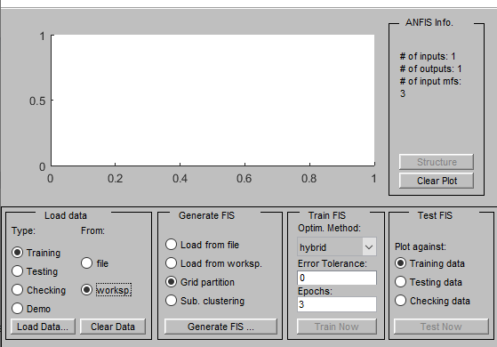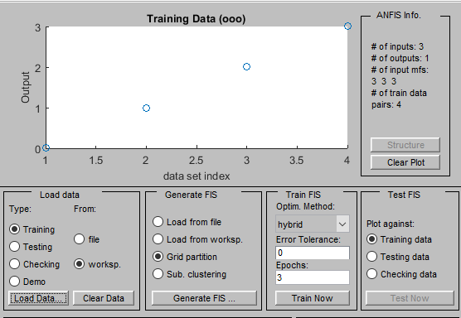

Fig. 5. ANFIS model interface (a) Input (b) Output

From the report in Fig. 5, the number of inputs was 3 (fault class of the current signal), and the output was one (classification code).

Step 2: Generate the Fuzzy inference system (FIS)

The snapshot for the FIS in the ANFIS model is shown in Fig. 6.

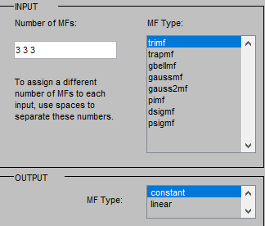

Fig. 6. FIS selection environment

Fig. 6 shows that the membership function (MF) type selected for the input variables was the triangular membership function (trimf). The membership function chosen for the output variable was linear MF.

Step 3: Train the model

The ANFIS model was trained from the ‘train now’ button shown in Fig. 5. The ANFIS structure resulting from the training is shown in Fig. 7.

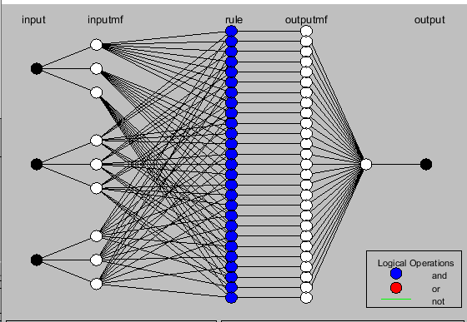

Fig. 7. Outcome of training ANFIS model

The ANFIS structure in Fig. 7 implies that there were three inputs, each with three MFs, and each MF generated nine inference rules linked to eighty-one MF of the output variable.

Step 4: Implement the ANFIS model in the distribution power system network

To achieve this, the first process was to save the ANFIS model (the model was saved as ‘Load1’). Load2 and load3 ANFIS models were generated with the outlined procedures, the three ANFIS models were imported to the fuzzy Simulink block, and the model block was inserted in the power system model. The Simulink model of the power system with the ANFIS model is shown in Fig. 8.
Fig. 8. Power system distribution model with ANFIS model
3.5 Fault Location with AI Models

The location of the fault with both ANN and ANFIS models was done on the distribution lines to generate separate AI models for the fault locations. The steps for generating the models for the fault locations were outlined in the following steps:

Step 1: obtain the distance of the distribution lines from the source to the load and split the distance into four equal points cumulatively.

Step 2: Generate the current signal by entering each distance at a single-phase fault.
The distance of the distribution line and the splitting is shown in Table 3.

Table 3. Distance of the distribution line

Distribution line distance | Load 1 (m) | Load 2 (m) | Load 3 (m)
Point 1  Point 2  Point 3  Point 4 | 200  400  600  800 | 180  360  540  720 | 220  440  660  880
Cumulative sum (actual distance of the distribution line) | 800 | 720 | 880

The outcome of the current signal obtained for each cumulative distance at a single-phase fault is shown in Table 4.

Table 4. Fault location distance and currents at single-phase fault

Class of single-phase fault | Load 1 |  | Load 2 |  | Load 3
Ag | Distance (m) | Current signal (amps) | Distance (m) | Current signal (amps) | Distance (m) | Current signal (amps)
Ag | 200 | 401.09 | 180 | 449.15 | 220 | 390.87
Ag | 400 | 389.77 | 360 | 440.13 | 440 | 383.93
Ag | 600 | 385.22 | 540 | 433.32 | 660 | 381.29
Ag | 800 | 380.17 | 720 | 431.56 | 880 | 380.97
Bg | 200 | 450.19 | 180 | 399.61 | 220 | 420.32
Bg | 400 | 430.33 | 360 | 397.19 | 440 | 412.19
Bg | 600 | 428.28 | 540 | 392.17 | 660 | 441.90
Bg | 800 | 423.32 | 720 | 420.23 | 880 | 440.17
Cg | 200 | 410.33 | 180 | 421.37 | 220 | 398.71
Cg | 400 | 398.819 | 360 | 403.4 | 440 | 389.43
Cg | 600 | 400.12 | 540 | 400.31 | 660 | 387.33
Cg | 800 | 387.19 | 720 | 420.23 | 880 | 381.41

The single-phase was 1, 2 and 3 for Ag, Bg and Cg respectively.

Step 3: Enter the input and target data for the AI models and train the network

The inputs to the AI models were the current signals, while the target variable was the distance values. The same conditions were selected for the fault classification at the location, and the system was trained. The generated AI models were inserted in the power system Simulink network as it was done for the fault classification shown in Fig. 4 for ANN and Fig. 8 for ANFIS.

4. results and discussion

This section presents simulation results evaluating the performance of proposed models (ANN and ANFIS) under various operating conditions and fault scenarios within a power distribution network. Results are visualized through plots and charts depicting key system behaviors, including voltage/current signal patterns, fault classification accuracy, and comparative fault responses. These visualizations demonstrate the models' effectiveness in identifying and classifying faults, while interpretations highlight their practical strengths and limitations for power system monitoring and fault diagnosis applications.

4.1 Result of the power system in normal condition

Fig. 9 and Fig. 10 illustrate the current and voltage signal of the power system network under normal (fault-free) operating conditions. This waveform is a reference baseline for evaluating system behaviour and detecting abnormalities when introducing faults. Analyzing the current signal’s characteristics during steady-state operation makes identifying deviations caused by various fault scenarios in subsequent simulations easier.

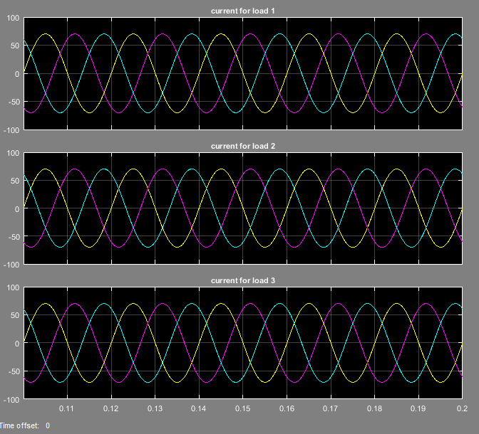
Fig. 9. Current waveform for loads 1, 2, and 3 at normal condition
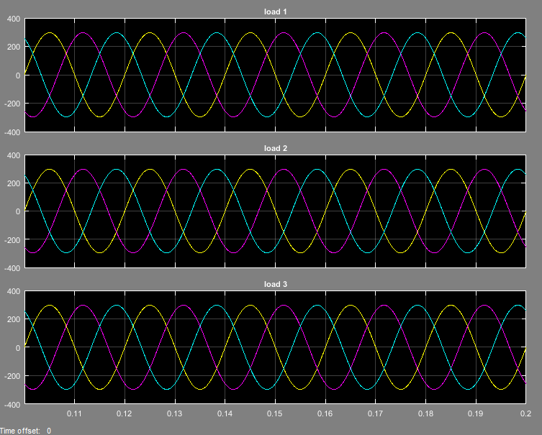
Fig. 10. Voltage waveform of the power system network at normal condition

The current and voltage signals at normal conditions exported to MATLAB are presented in the bar chart shown in Fig. 11.

(a) (b)
Fig. 11. Power system operating waveform in normal condition (a) Current (b) Voltage

The current signal for each load was measured between 23 A and 32 A, while the voltage levels at each load were measured between 210 V and 230 V.

4.2 Results of the power system at various fault classes

Fig. 12 and Fig. 13 present the current and voltage signals of the power system network during a single-phase fault condition. This waveform highlights the disturbance introduced by the fault, making it distinguishable from the normal operating signal. The observed deviations in the current pattern serve as critical input features for training and validating the artificial intelligence models developed for fault detection and classification.

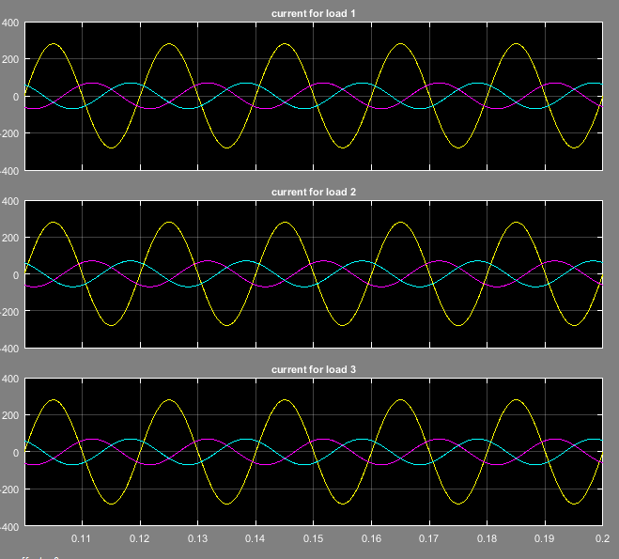
Fig. 12. Current waveform indicating single-phase fault (Ag)

It is observed from Fig. 13 that a single-phase fault occurred in the distribution system as a rise in the voltage level above the normal 220 V was captured in the simulation.

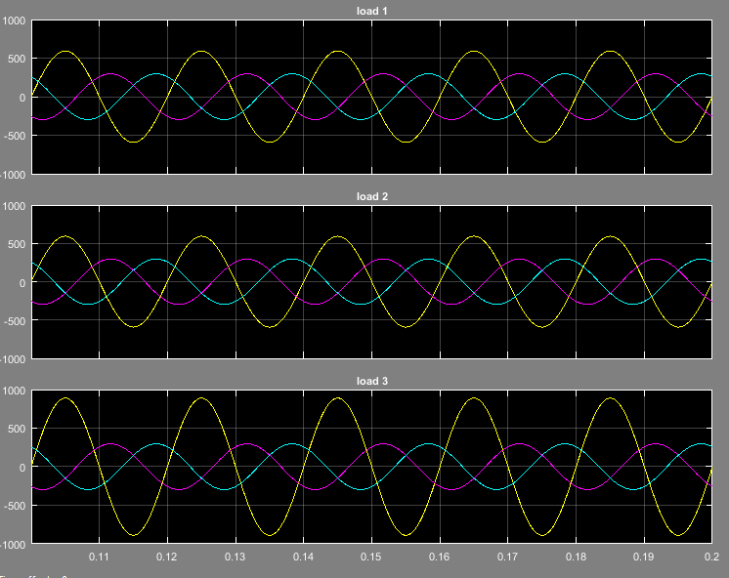
Fig. 13. Voltage waveform indicating single-phase fault (Ag)
The current signal at single-phase fault Ag was exported to MATLAB and plotted, as presented in Fig. 14 as a bar chart.
Fig. 14. Current signal showing single-phase fault (Ag)

Fig. 15 and Fig. 16 show the current and voltage signal obtained from the power system network during a double-phase fault condition. The waveform reflects the disturbance caused by simultaneous faults in two phases, with notable deviations from the normal signal pattern. This type of fault introduces a more complex distortion in the current profile, which is crucial for training and evaluating the AI-based fault classification models in accurately distinguishing multi-phase fault scenarios.

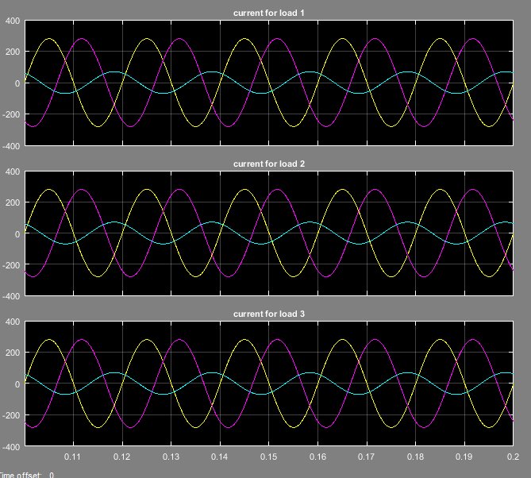
Fig. 15. Current waveform of the double-phase fault

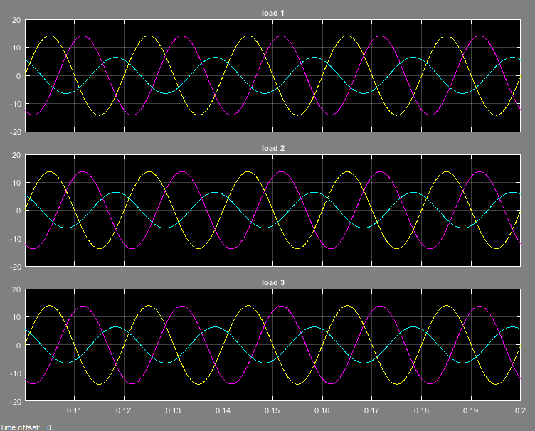

Fig. 16. Voltage waveform of double-phase fault

The bar chart for the current signal indicating the occurrence of double phase fault is shown in Fig. 17.
Fig. 17. Voltage signal of the double phase fault to ground

Fig. 18 and Fig. 19 illustrate the current and voltage signal of the power system network during a line-to-line fault condition. This type of fault, involving direct contact between two phases, results in a pronounced disturbance in the current waveform. The changes observed in the signal are distinct from those of single or double-phase faults, providing valuable features for fault classification. This waveform is instrumental in training the AI models to identify and differentiate line-to-line faults from other fault types accurately.
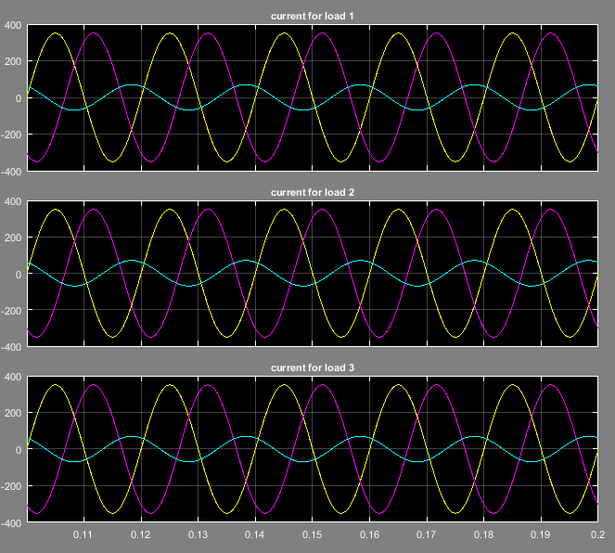
Fig. 18. Current waveform for line-to-line fault

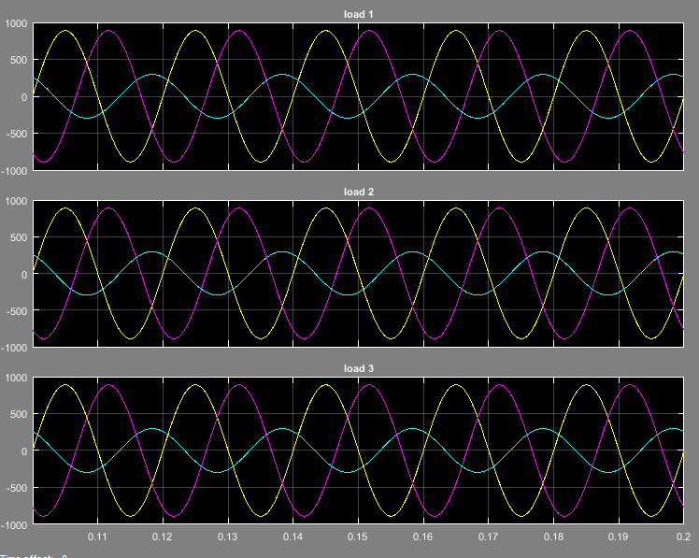
Fig. 19. Voltage waveform for line-to-line fault

The voltage signal in Fig. 14 shows a higher magnitude than the double phase to ground fault in Fig. 17.

The occurrence of a fault within the power system network results in a sudden surge in the signal magnitude, typically reflected as a sharp spike in the current waveform. This abnormal condition persists until the circuit breaker operates, at which point the signal drops to zero, indicating the isolation of the faulted section. Artificial intelligence models were developed to mimic the behaviour of protective relays to automate the fault detection and isolation process. In this study, two intelligent models, ANN and ANFIS, were employed for the real-time detection, classification, and response to various fault conditions. These models were trained to recognize fault signatures and initiate appropriate control actions, such as opening or closing breakers, thereby enhancing system reliability and reducing response time.

4.3 Implementation of Artificial Intelligent Models in the Power System Network

Table 5 presents the set detection and classification values alongside the predictions generated by the ANN and ANFIS models. The table illustrates how each model responds to various fault scenarios by accurately identifying the fault type and assigning the appropriate classification value. This comparison highlights the effectiveness and accuracy of both AI models in automated fault diagnosis within the power system network.

Table 5. Fault detection and classification demonstration with AI models

Fault class | Fault class code | ANN predicted code | ANFIS predicted code
Normal condition  Single-phase fault  Double phase fault  Triple phase fault | 0  1  2  3 | 0.014  0.9923  2  3.001 | 0  1  2  3

Table 5 shows that the ANFIS model had a perfect prediction, implying that ANFIS effectively detected and classified fault occurrence.

4.4 Results for the Fault Location

Table 6 presents the comparative predicted fault locations obtained after simulating the power system under a single-phase fault condition. The results show the estimated fault positions as identified by the ANN and ANFIS models, allowing for an assessment of each model’s accuracy and reliability in pinpointing the exact location of the fault. This comparison is essential for evaluating the effectiveness of the proposed intelligent techniques in facilitating prompt and precise fault localization within the distribution network.

Table 6. Fault location prediction with AI models

Loads | Standard | ANN | ANFIS
Load 1 | 200  400  600  800 | 155  384  647  735 | 201  400  602  803
Load 2 | 180  360  540  720 | 153  348  588  703 | 201  400  602  803
Load 3 | 220  440  660  880 | 207  422  631  888 | 220  442  658  880

The plots for the fault location in loads 1, 2 and 3 are shown in Fig. 20.

Fig. 20. Predicted fault location comparison

Based on the fault location prediction results illustrated in Fig. 20 and summarized in Table 6, the ANFIS model demonstrated superior prediction accuracy compared to the ANN model. The ANFIS model consistently provided fault location estimates with lower error margins and closer proximity to the actual fault points. Given its improved precision and robustness in handling non-linear data patterns, the ANFIS model is recommended as the preferred intelligent sensor for fault location detection in the power system.

Table 7 presents the percentage deviation values associated with the fault localization results. These values quantify the difference between the predicted fault locations and the actual fault points within the power distribution network. The percentage deviation serves as a key performance metric in evaluating the accuracy and reliability of the AI-based fault location models, allowing for a clear comparison of how closely each model approximates the true fault location.

Table 7. Location deviation percentage

Load 1 (%) |  | Load 2 (%) |  | Load 3 (%)
ANN | ANFIS | ANN | ANFIS | ANN | ANFIS
22.5000  4.0000  7.8333  8.1250 | 0.5000  0  0.3333  0.3750 | 15.0000  3.3333  8.8889  2.3611 | 0.5556  0.5556  0.5556  0 | 5.9091  4.0909  4.3939  0.9091 | 0  0.4545  0.3030  0

The distribution network on the load lines was improved in this study, enabling the learning classifiers and locators to precisely categorise the fault type and find the location where the fault occurred. ANFIS’ accuracy was 99.7 %, and compared to ANN, it performed significantly better with its analysis. Table 8 gives a tabulated comparison of the proposed study with existed related works

Table 8. Comparison of proposed study with existing related works

Author(s) & Year | Methodology/Approach | Key Results | Research Gap Addressed by Current Study
Thukaram (2004) | Feed-forward ANN using substation measurements | Feasibility of fault identification/classification | Limited to substation data; ignores field sensor inputs
Muhammad et al. (2018) | ANN + fuzzy clustering for oil/gas ring networks | Reduced fault location time; estimated $R_{f}$ | Specialized for ring networks; not tested in radial topologies
Avagaddi & Edward (2016) | Wavelet transform (DWT) + MRA for transmission lines | High fault classification accuracy (500Ω) - $R_{f}$ | Transmission-line focus; inapplicable to distribution systems
Alayande et al. (2020) | ANN (MLP) for unsymmetrical faults in 11kV campus network | 90% training accuracy; 100% test accuracy | Small-scale validation; lacks variable load/distance testing
Ngo et al. (2021 | Graph Neural Networks (GNNs) for fault section identification | 98.3% accuracy in mesh networks | Requires full network topology data; computationally intensive
Thomas et al. (2023) | CNN-based feature extraction + SVM classification | 97.6% accuracy under noisy measurements | High latency (45 ms); unsuitable for real-time use
Wu et al. (2023) | Federated learning for privacy-preserving fault diagnosis | 96.8% accuracy across decentralized grids | Compromised accuracy vs. centralized methods
Dana et al. (2022) | IoT-enabled ensemble learning (RF + XGBoost) | 98.9% accuracy; 0.8% distance error | High hardware cost; limited to high-voltage networks
Djaballah et al. (2024) | Transfer learning with ResNet-50 for multi-fault detection | 99.1% accuracy in hybrid grids | Requires massive pre-training data; overkill for simple faults
Kanwal & Jiriwibhakorn (2024) | ANFIS/NN/hybrid comparative study | High accuracy in transmission lines | Not adapted for distribution systems
Current Study (2025) | ANFIS + ANN with custom sensing prototype  • Controlled variables: fault type, topology, distance (200-800m)  • Validated under variable loads | ANFIS: 99.7% classification accuracy, 0.5% distance error, 1ms training  ANN: High precision detection/localization | Addressed:  • Real-time operation (low-latency ANFIS)  • Secondary distribution focus  • Field sensor integration  • Variable load/distance validation  • Cost-effective hardware

4. Conclusion

Artificial Intelligence Trending Methods (AITMs) have proven to be more accurate, faster, and cost-effective for power system analysis. Among these, the ANN algorithm has gained widespread adoption due to its demonstrated success in recent years. Although fuzzy clustering techniques have shown effectiveness in diagnosing various power system issues, their application remains limited, likely due to challenges in data correlation. This study found that the Adaptive Neuro-Fuzzy Inference System (ANFIS) model delivered the most accurate fault classification and location results, achieving a 99.7% accuracy rate. These findings suggest that the proposed approach can support system operators by significantly improving the speed and precision of fault detection during major disturbances, thereby reducing downtime and mitigating the risk of prolonged outages. Future research should explore the integration of three-phase (3φ) and three-phase-to-ground (3φ-G) fault data for training AI models, enhancing the model's ability to address a broader range of fault scenarios. This integration could significantly expand the applicability of the proposed model, enabling it to effectively handle diverse fault types encountered in real-world distribution systems. A notable limitation of the current model is its focus on symmetrical faults, which restricts its performance in situations involving asymmetrical faults. By using both symmetrical and unsymmetrical fault data, the model's robustness and fault detection accuracy can be further improved, ensuring more reliable and comprehensive performance across different grid configurations.

Disclaimer (Artificial intelligence)
Option 1:
Author(s) hereby declare that NO generative AI technologies such as Large Language Models (ChatGPT, COPILOT, etc.) and text-to-image generators have been used during the writing or editing of this manuscript.

References

- Vidya Venkatesh (2018). Fault Classification and Location Identification on Electrical Transmission Network Based on Machine Learning Methods. Virginia Commonwealth University
- Stefanidou Voziki, Paschalia & Sapountzoglou, Nikolaos & Raison, Bertrand & Dominguez-Garcia, José Luis. (2022). A review of fault location and classification methods in distribution grids. Electric Power Systems Research. 209. 108031.
- De La Cruz, J., Gómez-Luna, E., Ali, M., Vasquez, J. C., & Guerrero, J. M. (2023). Fault Location for Distribution Smart Grids: Literature Overview, Challenges, Solutions, and Future Trends. Energies, 16(5), 2280.
- Alayande, Akintunde. S., Okakwu, I. K., Olabode, O. E. and Nwankwoh, O. K. (2021). Analysis of unsymmetrical faults based on artificial neural network using 11 kV distribution network of University of Lagos as case study. Journal of Advances in Science and Engineering. 4(1); 53-64
- Özdemir, Ö., Köker, R., & Pamuk, N. (2025). Fault Classification and Precise Fault Location Detection in 400 kV High-Voltage Power Transmission Lines Using Machine Learning Algorithms. Processes, 13(2), 527.
- Almasoudi, F. M. (2023). Enhancing Power Grid Resilience through Real-Time Fault Detection and Remediation Using Advanced Hybrid Machine Learning Models. Sustainability, 15(10), 8348.
- Liang, Lingyu & Zhang, Huanming & Cao, Shang & Zhao, Xiangyu & Li, Hanju & Chen, Zhiwei. (2024). Fault location method for distribution networks based on multi-head graph attention networks. Frontiers in Energy Research. 12.
- Hong, J., Kim, Y.-H., Nhung-Nguyen, H., Kwon, J., & Lee, H. (2022). Deep-Learning Based Fault Events Analysis in Power Systems. Energies, 15(15), 5539. https://doi.org/10.3390/en15155539
- Khalaf, Muna. (2024). Fault Location and Detection in Power Distribution Systems with Presence of Distributed Generations using Improved CNNs. Journal of Electrical Systems. 20. 7840-7865. 10.52783/jes.6999.
- Nguyen, B. L. H., Vu, T. V., Nguyen, T.-T., Panwar, M., & Hovsapian, R. (2023). Spatial-temporal recurrent graph neural networks for fault diagnostics in power distribution systems. IEEE Access, 11, 46039-46050.
- Ngo, Q.-H., Nguyen, B., Zhang, J., Schoder, K., Ginn, H., & Vu, T. (2024). Deep graph neural network for fault detection and identification in distribution systems. TechRxiv.
- Baskar. D. and Dr. Selvam. (2020). Machine Learning Framework for Power System Fault Detection and Classification. International Journal of Scientific & Technology Research. 9(2);277-8616.
- Mansourlakouraj, M., Hossain, R., Livani, H., & Benidris, M. (2021). Application of graph neural network for fault location in PV penetrated distribution grids. Proceedings of the North American Power Symposium (NAPS), 1-6.
- Thukaram (2004). Detection of fault in Distribution systems using artificial neural network. National power system conference (NPSC), IEEE, 9p
- Muhammad M.A.S. Mahmoud (2013). 3-Phase Fault Finding in Oil Field MV Distribution Network Using Fuzzy Clustering Techniques. Journal of Energy and Power Engineering, 7: 155-161.
- Avagaddi Prasad and J. Belwin Edward (2016). Application of Wavelet Technique for Fault Classification in Transmission Systems. School of Electrical Engineering, VIT University, Vellore, Tamil Nadu, 632014, India
- Q. Wu, C. Dong, F. Guo, L. Wang, X. Wu and C. Wen, "Privacy-Preserving Federated Learning for Power Transformer Fault Diagnosis With Unbalanced Data," in IEEE Transactions on Industrial Informatics, vol. 20, no. 4, pp. 5383-5394, April 2024,
- Dana F. Doghramachi, Siddeeq Y. Ameen. (2023). Internet of Things (IoT) Security Enhancement Using XGboost Machine Learning Techniques. Computers, Materials and Continua, 77(1): 717-732.
- Djaballah, Said & Meftah, Kamel & Khelil, Khaled & Sayadi, Mounir. (2023). Deep Transfer Learning for Bearing Fault Diagnosis using CWT Time–Frequency Images and Convolutional Neural Networks. Journal of Failure Analysis and Prevention.
- Liang, Lingyu & Zhang, Huanming & Cao, Shang & Zhao, Xiangyu & Li, Hanju & Chen, Zhiwei. (2024). Fault location method for distribution networks based on multi-head graph attention networks. Frontiers in Energy Research. 12.
- B Thomas, Jibin & Chaudhari, Saurabh & Shihabudheen, K. & Verma, Nishchal. (2023). CNN-Based Transformer Model for Fault Detection in Power System Networks. IEEE Transactions on Instrumentation and Measurement. PP. 1-1.
- Zhang, J. & He, Zhengyou & Lin, Sheng & Zhang, Y.B. & Qian, Q.Q. (2013). An ANFIS-based fault classification approach in power distribution system. International Journal of Electrical Power & Energy Systems. 49. 243–252.
- Kanwal, S, and Jiriwibhakorn, S. (2024). Advanced Fault Detection, Classification, and Localization in Transmission Lines: A Comparative Study of ANFIS, Neural Networks, and Hybrid Methods. IEEE Access. 12. 49017-49033.
- Goutam Kumar Yadav, Mukesh Kumar Kirar, S.C. Gupta and Jatoth Rajender. Integrating ANN and ANFIS for effective fault detection and location in modern power grid.Science and Technology for Energy Transition 80, 34.
- Mohamed, M. A., Hassan, M. A. M., Albalawi, F., Ghoneim, S. S. M., Ali, Z. M., & Dardeer, M. (2021). Diagnostic Modelling for Induction Motor Faults via ANFIS Algorithm and DWT-Based Feature Extraction. Applied Sciences, 11(19), 9115.

