Case report

Osteogenesis imperfecta: A case report

.
ABSTRACT

Background: Osteogenesis imperfecta is a heterogeneous group of inherited connective tissue disorders that share similar skeletal abnormalities that cause fragility, bone deformity, and fracture risk, leading to the name brittle bones. It has an incidence of approximately 1 in every 15,000 to 20,000 newborns and is considered a rare disease. Presentation of case: A woman who was unaware of her pregnancy and without prenatal care delivered a 2.2 kg male infant at home; he was admitted with head trauma, cranial crepitation, occipital fracture, and neonatal sepsis. Radiological evaluation revealed fractures in various bones, and osteogenesis imperfecta was suspected. The mother said that father and paternal grandfather had osteogenesis imperfecta. The patient was referred to for genetic sequencing (pending). The mother said that The patient's progress was good, with adequate fracture healing. Conclusion: the control prenatal is fundamental to detect osteogenesis imperfecta and avoid a late diagnosis with poor prognostic of the newborn.

Keywords: Bone metabolism, Bone defects, Fractures; Newborns

1. INTRODUCTION

Osteogenesis imperfecta (OI) is a heterogeneous group of inherited connective tissue disorders that share similar skeletal abnormalities that cause fragility, bone deformity, and fracture risk, leading to the name brittle bones (Forlino & Marini, 2016) (Torrent, 2020).
OI has an incidence of approximately 1 in every 15,000 to 20,000 newborns and is considered a rare disease (Torrent, 2020). Osteogenesis imperfecta is a disease with an estimated worldwide prevalence of 1/15,000 to 1/20,000 newborns, and an estimated prevalence in the United States of between 25,000 and 50,000 affected individuals (Marini & Dang Do, 2020).

It presents with a wide spectrum of clinical manifestations, and five clinical forms of OI have been identified: non-deforming type I with persistently blue sclera; perinatally lethal type II; progressively deforming type III; moderate type IV; and type V with calcification of the interosseous membranes and/or hypertrophic callus (Sillence, Senn, & Danks, 1979).
Differential diagnoses for this disease include child abuse, thanatophoric dysplasia, achondrogenesis type I, campomelic dysplasia, hypophosphatasia, and osteoporosis (Martin & Shapiro, 2007). Given the patient's clinical characteristics, the patient could be classified as type I, as she has had several fractures and has thus far reported good healing. She also has blue sclera and autosomal dominant inheritance. This means that one copy of a mutated (changed) gene from one of the parents can cause the genetic condition, and the child has a 50% chance of inheriting that mutated gene. Daughters and sons have the same chance of inheriting the condition. In this case, there is a family history; in the case described, the father and grandfather had the condition, and the mother appears healthy.
Treatment should be multifactorial, including orthopedic management, nutritional rehabilitation, dental care, and other subspecialties, as well as emotional support for the parents, since the survival of these patients depends significantly on the care provided.

2. CASE DESCRIPTION

This is a 20-year-old mother who came to Hospital General Guanajuato (HGG). She was unaware she was pregnant, so she did not take any supplements or receive prenatal care during the pregnancy. She reported having had whitish vaginal discharge for the previous 3 days. The baby, male sex, was born in the toilet bowl at her home on March 9, 2023. The cord tore, and the father provided immediate care. He tied the cord with non-sterile tape, dried it, and reported crying and spontaneous breathing. He was taken to HGG by paramedics. Upon admission, the patient was pale and hypothermic (35.4°C). He was placed in a warming crib, dried, and showed adequate respiratory effort with an arterial oxygen saturation of 92%. The patient was evaluated and found abundant cranial crepitation with a 2x2 anterior fontanelle, facial symmetry, an intact oral cavity, a chest with good air entry and exit in the lung fields, a precordium with rhythmic heart sounds and no murmurs, an abdominal cord with an artery/vein ratio of 2/1, adequate peristalsis without megalia, intact extremities with good capillary refill, no edema, and no mobility limitations.
Thermoregulation was performed. Due to the maternal history of infection and the place of birth, ampicillin (50 mg/kg every 12 hours) and amikacin (15 mg/kg every 24 hours) were started. Blood gases were taken (pH 7.29, pCO2: 35, pO2: 31, HCO3: 17.5, with BE: -9.2 sat 61%) with no signs of asphyxia, so oral administration was started.
The patient was admitted with a diagnosis of a newborn of 40 gestation weeks with a low birth weight for gestational age (2.200 kg), head trauma, occipital fracture, perinatal sepsis, and accidental delivery. A head x-ray was taken, showing loss of bone continuity at the occipital level (Figure 1).
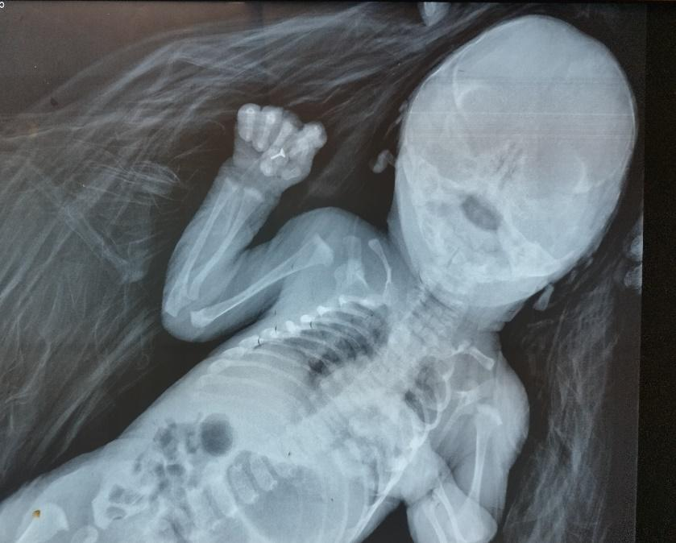
Source: Medical file of the patient
Figure 1 X-ray showing loss of bone continuity in the occipital region.
A soft chest x-ray was obtained, with limited clinical significance (Figure 2).
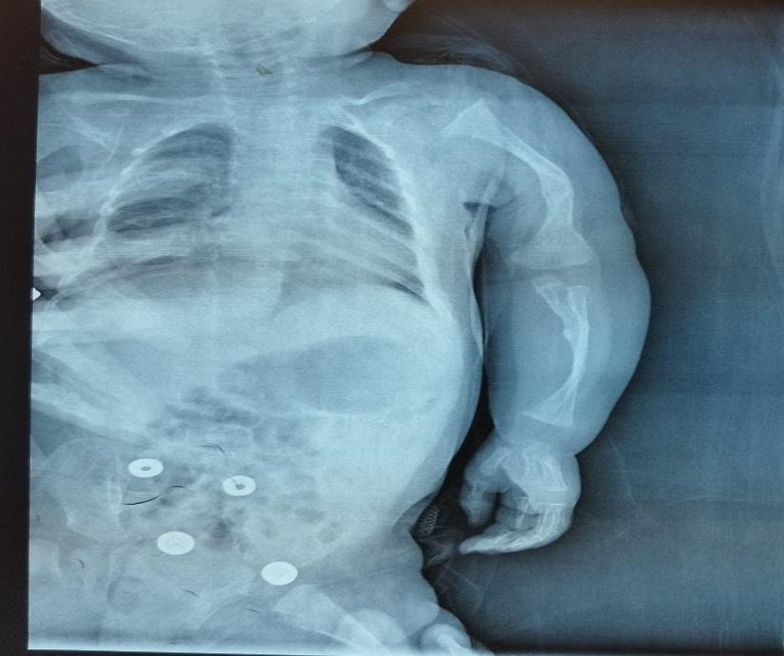
Source: Medical file of the patient
Figure 2 Chest X-ray showing no significant data, and humerus deformed.
Laboratory results included a complete blood count with a tendency toward thrombocytopenia, with no other infectious signs, and no significative C-reactive protein (CRP). A transfontanellar ultrasound was requested, which was reported as unremarkable.
On March 10, 2023, the newborns had stable neurological evolution, without deterioration or complications. The patient was observed with no mobility of the left thoracic limb, left clavicle deformity, evaluated by traumatology where a diaphyseal clavicle fracture was confirmed (Figure 1 and 2). Conservative treatment was given. Control laboratory results showed a complete blood count with hemoglobin (HB) 16.4 gr/dL, hematocrit (HCT): 46%, platelets of 183,000/uL, leukocytes of 17,760/uL, 72% segmented, glucose of 75 mg/dL, indirect bilirubin (IB): 7.3 mg/dL, with total bilirubin (TB): 7.7 mg/dL, creatine phosphokinase 2785 u/L, mb fraction 90u/L, antibiotics continued. On March 11, 2023, the patient presented with no seizures or abnormal movements. Irritability decreased with analgesics: paracetamol (15 mg/kg every 6 hours) and metamizole 10 mg/kg every 8 hours, ampicillin and amikacin on day 2. Blood cultures were unreactive. He tolerated oral administration and was euglycemic. On March 12, 2023, the patient presented with edema and pain in the lower left extremity. Barlow and Ortolani scores were not evaluable. Range of motion was limited. He continued to show signs of an inflammatory response. HB; 16.2 mg/dl HCT: 47.3%, platelets: 141,000/uL, leukocytes: 15,930/uL, 71% segmented, and CRP: 39.9 mg/L. The antibiotic was changed to cefepime (30 mg/kg/day every 12 hours) and amikacin (15 mg/kg/day every 24 hours). TB: 10.2mg/dL, with IB: 9.8mg/dL. He was reassessed due to trauma with a distal femur fracture (Figure 3). Osteogenesis imperfecta was suspected. Peripheral blood culture was reported at 68 hours without development.

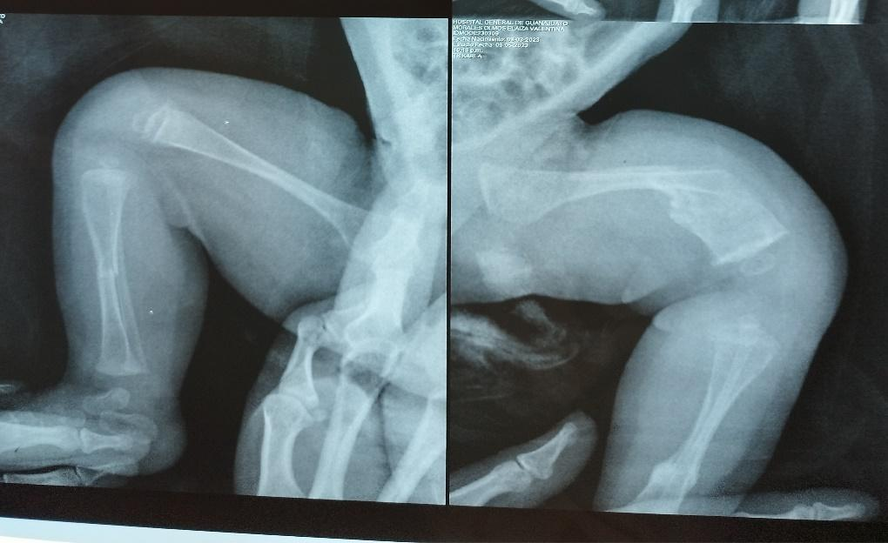
A B

Source: Medical file of the patient
Figure 3 Right tibia fracture (A), left distal femur fracture (B)
On March 13, 2023, the patient's progress was stable, with no deterioration or complications. There was no evidence of systemic inflammatory response syndrome (SIRS). Laboratory tests showed glucose 84 mg/dL, urea 27.8 mg/dL, Cr 1.04 mg/dL, TB 3.4mg/dL, IB 2.9 mg/dL, HB 15.4 g/dL, HCT 44.6%, platelets 184,000/uL, leukocytes 12,240/uL with 62% neutrophils, and CRP 37.1 mg/L. Antibiotic treatment was continued. The patient was re-evaluated for a distal fracture of the left femur. A shin splint was placed for 4 weeks.
On March 14, 2023, the patient was progressing toward improvement and well-tolerated oral administration. Amikacin, cefepime, and analgesics were continued. The management continued as discussed by the traumatology service.
On March 15, 2023, the patient was hemodynamically stable. The infectious disease status was decreased: 7,930/uL leukocytes, 40% segmented, platelets, 283,000/uL, and CRP 17.1mg/L. The patient continues with the same management. Ventilation was monitored with no signs of respiratory distress, pain control was maintained, and close monitoring was maintained.
On March 16, 2023, the mother was re-examined and informed that her father and paternal grandfather had osteogenesis imperfecta.
On March 18, 2023, the patient's respiratory status was adequate, with no supplemental oxygen support. The patient was infected with no signs of SIRS. Cefepime and amikacin were continued. Gastrometabolic status was adequate: oral intake was adequate, suction was present, and the patient was euglycemic.
03/20/23 Control labs with PCR: 4.2 mg/L, with HB: 13.5gr/dL, HCT: 39%, platelets of 531,000/uL, leukocytes of 11,340/uL, 40% segmented, 10 days of amikacin and 8 days of cefepime are completed, antibiotics are discontinued.
On March 21, 2023, a consultation with the Orthopedic Department was requested due to a functional limitation in the left thoracic limb. Physical examination revealed abduction and internal rotation of the arm and forearm in the left thoracic limb, preserved range of motion in the wrist and fingers, and severe pain when palpating the surface of the proximal humerus. An x-ray showed loss of bone continuity in the left proximal humerus in the metaphyseal area, a simple, non-angulated line, and mild displacement. A diagnosis was made of a fracture of the left humerus in the proximal metaphyseal area, and Duchenne Erb's palsy in the left thoracic limb. Conservative management was provided, without the use of a splint on the left humerus.
On March 22, 2023, the patient was discharged with information to parents about alarming symptoms and an open appointment to the Emergency Department. The mother was trained in special care for probable osteogenesis imperfecta, and a continuous splint was prescribed. A referral was made to pediatric genetics and traumatology. On May 3, 2023, the patient attended a pediatric consultation and was reported to be stable, with a reserved prognosis.
On April 14, 2023, the patient attended a trauma consultation for a subsequent fracture of the clavicle, femur, and humerus. The patient was asymptomatic. An X-ray was requested and an appointment was scheduled for two months.
The trauma consultation showed adequate healing on June 16, 2023.
The pediatric consultation revealed delayed psychomotor development in the motor area on July 24,2023. An appointment was scheduled for a neurodevelopmental consultation.

3. discussion

The disease primarily affects the skeletal system. Skeletal manifestations include bone fragility resulting from primary bone fragility and secondary fragility resulting from osteoporosis (Van Dijk, & Sillence, 2014), which lead to recurrent fractures, fractures in atypical sites, and low-trauma fractures (including in utero fractures in severe forms of OI) (Forlino & Marini, 2016) (Torrent, 2020). At least in the most common and mildest type I OI, the incidence of fractures is higher in the pediatric population and decreases with age (Forlino & Marini, 2016).
In 1979, Sillence, Senn & Danks (1979), proposed a classification based on clinical/radiological features and mode of inheritance: OI type I, autosomal dominant (AD) with blue, non-deforming sclera; OI type II, with multiple fractures and severe deformities leading to death in the perinatal period; OI type III, a severe, progressively deforming form with scoliosis and white sclera; OI type IV is the most heterogeneous group, with moderate deformities, variable sclera coloration, and dentinogenesis imperfecta.
Subsequently, several classifications have been made, until the most recent, in which an alternative functional classification based on the metabolic mechanism was proposed: Group A, defects in collagen synthesis, structure, or processing; Group B, defects in collagen modification; Group C, defects in collagen folding and cross-linking; Group D, compromised bone mineralization; and Group E, defects in osteoblast development with collagen insufficiency (Forlino & Marini, 2016) (Marini, Reich, & Smith, 2014).
The classification of OI has been debated in recent years due to the discovery of several genes, including non-collagen genes (Marini, Forlino, Bächinger, Bishop, Byers, Paepe, Fassier, Fratzl-Zelman, Kozloff, Krakow, Montpetit, & Semler, 2017). Although a strictly genetic classification is used, it has been expanded due to the growing number of different types of OI (Marini, et al., 2017). Therefore, the most recent recommendations are to continue using the Sillence type (I-IV) classification for osteogenesis imperfecta. This recommendation is based on the phenotypic characteristics of the disease and not on its molecular genetics, but an OI type V is added since this type is radiologically distinguishable from the others, type V is associated with additional distinctive features, such as hyperplastic callus formation (seen in approximately 66% of patients) and ossification of the interosseous membrane of the forearms (Bonafe, Cormier-Daire, Hall, Lachman, Mortier, Mundlos, Nishimura, Sangiorgi, Savarirayan, Sillence, Spranger, Superti-Furga, Warman, & Unger, 2015).
The most common spinal deformities are scoliosis, spondylosis, and spondylolisthesis; abnormalities of the craniocervical junction, such as basilar invagination, are reported in up to 37% of patients and can cause serious complications (Arponen, Makitie, Haukka, Ranta, Ekholm, Mayranpaa, Kaitila, & Waltimo-Sired, 2012) (Reznikov, Dagdeviren, Tamimi, Glorieux, Rauch, & Retrouvey, 2019). As a consequence of structural and functional skeletal abnormalities, bone pain is common.
Craniofacial disorders include abnormal development of craniofacial structures, such as a hypoplastic face with maxillary retrusion and mandibular prognathism, as well as an abnormal skull base (Van Dijk, & Sillence, 2014).
In the hip, the condition is characterized by coxa vara and sometimes coxa valga (Torrent, 2020).
Short stature is a common feature, especially in severe forms of OI, and to a lesser extent in milder type I OI (Forlino & Marini, 2016). In addition to skeletal findings, multiple systems can be affected.
Ocular disorders include bluish or grayish discoloration of the sclera, corneal abnormalities, refractive errors, and glaucoma (Torrent, 2020).
Oral: dentinogenesis imperfecta (yellowing and brittle teeth), tooth eruption abnormalities, malposition, malocclusion (Marom, Rabenhorst, & Morello, 2020) (Morello, 2018).
Auditory: progressive conductive hearing loss, sensorineural or mixed hearing loss, even deafness (Marini, et al., 2017).
Muscle weakness and reduced muscle mass may also result from the patient's limited mobility (Veilleux,Trejo, & Rauch, 2017).
Cardiovascular manifestations include aortic root dilation, valvular dysfunction, and rarely, aortic aneurysm and dissection (Balasubramanian, Verschueren, Kleevens, Luyckx, Perik, Schirwani, Mortier, Morisaki, Rodrigus, Van Laer, Verstraeten, & Loeys, 2019) (Marom, Rabenhorst, & Morello, 2020).
Lung function: Loss of lung function is associated with scoliosis greater than 60° (Widmann, Bitan, Laplaza, Burke, DiMaio, & Schneider, 1999), skeletal abnormalities affecting the rib cage and pectoral deformity, which impair the action of the respiratory muscles and chest wall, contributing to respiratory infections and respiratory failure (Forlino & Marini, 2016) (LoMauro, Pochintesta, Romei, D'Angelo, Pedotti, Turconi, & Aliverti, 2012) (Torrent, 2020) (Veilleux, Trejo, & Rauch, 2017).
Impaired lung function is the main cause of morbidity and mortality in osteogenesis imperfecta (Singer, Ogston, & Paterson, 2001).
The diagnosis is based on clinical and radiological findings. The main features are fractures due to mild trauma, accompanied by deformities in the long bones and thorax, scoliosis, kyphosis, and growth retardation (Forlino & Marini, 2016).
Prenatal diagnosis is possible but not always. In some patients with OI, it cannot be predicted as it is mentioned by Edelu, Ndu, Asinobi, Obu, & Adimora (2014), in their case report. The case in Guanajuato, the pregnant mother did not receive any prenatal care.
The management for OI is multidisciplinary and tailored to the patient based on their age, type, and severity of OI (Forlino & Marini, 2016) (Timila, Mousa, & Gundamraj, 2025).
It is based on four main pillars:
1) Physical rehabilitation is possibly the most important contribution to the function of this pathology, helping patients recover from fractures and achieving maximum functional independence in basic activities of daily living (Barnes, Chang, Morello, Cabral, Weis, Eyre, Leikin, Makareeva, Kuznetsova, Uveges, Ashok, Flor, Mulvihill, Wilson, Sundaram, Lee, & Marini, 2006). (Torrent, 2020).
2) Orthopedic surgery with intramedullary nailing, and in pediatric patients, telescopic intramedullary nails that enlarge as the bone grows, correcting bone deformities with osteotomies (Torrent, 2020).
3) The most commonly used medical treatment is oral or intravenous bisphosphonates, which improve bone mass and architecture (Marini, et al., 2017) (Reznikov et al., 2019). Bisphosphonates act by inhibiting osteoclastic activity and bone resorption, which improves bone mineral density and reduces the incidence of fractures (Reznikov, et al.,2019).
Teriparatide (PTH) is associated with an anabolic bone response, with increased bone mineral formation and density (Neer, Arnaud, Zanchetta, Prince, Gaich, Reginster, Hodsman, Eriksen, Ish-Shalom, Genant, Wang, & Mitlak, 2001).
Other therapies used are under investigation, such as denosumab (an anti-RANKL monoclonal antibody), anti-sclerostin antibody, and TGFB inhibitor antibody, as well as stem cell therapy (Forlino & Marini, 2016) (Reznikov, et al., 2019). (Hoyer-Kuhn, Franklin, Allo, Kron, Netzer, Eysel, Hero, Schoenau, & Semler, 2016) (Tauer, Robinson, & Rauch, 2019).
4) Psychological treatment.
Patients with mild OI will likely only require monitoring for complications, but patients with moderate and severe OI will require multidisciplinary management with medications, physical therapy, occupational therapy, orthopedic interventions, and follow-up by other subspecialists (Forlino & Marini, 2016).
Orthopedic treatment has been conservative so far, as the patient reportedly had several fractures with adequate healing. The newborn's progress was satisfactory, and the fracture healing was as expected.
The complication associated with the highest mortality is respiratory failure (Singer, Ogston, & Paterson, 2001).
Prenatal care is very important, as early diagnosis of this condition allows for a successful delivery and management of the newborn with the necessary care, minimizing mobilization, which increases the chances of survival. However, in our case, this was not performed because the mother stated that she was unaware she was pregnant, and the birth conditions were inadequate, thus increasing the risk of fractures. The case reported did not receive any prenatal care.
Although the definitive diagnosis is made by genetic sequencing, as this service is not available in the unit, the patient was referred to a tertiary hospital for further evaluation. The patient is still awaiting evaluation.
The newborn had background of family members with osteogenesis imperfecta; If the mother had had prenatal care and with the family history, it was a possibility of a better prognosis for the newborn (Zhytnik, Simm, Salumets, Peters, Märtson, & Maasalu, 2020).
4. CONCLUSION
Prenatal control is fundamental for the care of mother and outcome. In this case, that absence of it, caused more problems on health for the newborns.
The evolution of the case was satisfactory.
CONSENT
The mother of the newborn signed a consent form to publish clinical and image data, and the patients cannot be identified.
A copy of the written consent is available for review by the Editorial office/Chief Editor/Editorial Board members of this journal.
ETHICAL APPROVAL
Not applicable
Disclaimer (Artificial intelligence)

Authors hereby declare that NO generative AI technologies such as Large Language Models (ChatGPT, COPILOT, etc.) and text-to-image generators have been used during the writing or editing of this manuscript.

REFERENCES
Arponen, H., Makitie, O., Haukka, J., Ranta, H., Ekholm, M., Mayranpaa, M.K., Kaitila, I., & Waltimo-Sired, J. (2012). Prevalence and natural course of craniocervical junction anomalies during growth in patients with osteogenesis imperfecta. J Bone Miner Res. 27(5),1142–1149. DOI: https://doi.org/10.1002/jbmr.1555.
Balasubramanian, M., Verschueren, A., Kleevens, S., Luyckx, I., Perik, M., Schirwani, S., Mortier, G., Morisaki, H., Rodrigus, I., Van Laer, L., Verstraeten, A., & Loeys, B. (2019). Aortic aneurysm/dissection and osteogenesis imperfecta: Four new families and review of the literature. Bone, 121, 191-195. https://doi.org/10.1016/j.bone.2019.01.022
Barnes, A.M., Chang, W., Morello, R., Cabral, W.A., Weis, M., Eyre, D.R., Leikin, S., Makareeva, E., Kuznetsova, N., Uveges, T.E., Ashok, A., Flor, A.W., Mulvihill, J.J., Wilson, P.L., Sundaram, U.T., Lee, B., & Marini, J.C. (2006). Deficiency of cartilage-associated protein in recessive lethal osteogenesis imperfecta. N Engl J Med, 355(26), 2757-2764. DOI: https://doi.org/10.1056/NEJMoa063804.
Bonafe, L., Cormier-Daire, V., Hall, C., Lachman, R., Mortier, G., Mundlos, S., Nishimura, G., Sangiorgi, L., Savarirayan, R., Sillence, D., Spranger, J., Superti-Furga, A., Warman, M., & Unger, S. (2015). Nosology and classification of genetic skeletal disorders: 2015 revision. Am J Med Genet, 167(12), 2869-2892. DOI: https://doi.org/10.1002/ajmg.a.37365.
Edelu, B.O., Ndu, I.K., Asinobi, I.N., Obu, H.A., & Adimora, G.N. (2014). Osteogenesis imperfecta. Annals of Medical and Health Sciences Research, 4 (Suppl 1), S1–S5. PMID: 25031897.
Forlino, A. & Marini, J.C. (2016). Osteogenesis imperfecta. Lancet, 387(10028), 1657-1671. DOI: https://doi.org/10.1016/S0140-6736(15)00728-X.
Hoyer-Kuhn, H., Franklin, J., Allo, G., Kron, M., Netzer, C., Eysel, P., Hero, B., Schoenau, E., & Semler, O. (2016). Safety and efficacy of denosumab in children with osteogenesis imperfect a first prospective trial. J Musculoskelet Neuronal Interact, 16(1),24-32. Available in: PMID: 26944820
LoMauro, A., Pochintesta, S., Romei, M., D'Angelo, M.G., Pedotti, A., Turconi, A.C., & Aliverti, A. (2012). Rib cage deformities alter respiratory muscle action and chest wall function in patients with severe osteogenesis imperfecta. PLoS One, 7(4), e35965. DOI: https://doi.org/10.1371/journal.pone.0035965. .
Marini, J.C. & Dang Do, A.N. (2020). Osteogenesis Imperfecta. Endotext. Available in: https://endotext.org/wp-content/uploads/pdfs/osteogenesis-imperfecta.pdf

Marini, J.C., Forlino, A., Bächinger, H.P., Bishop, N.J., Byers, P.H., Paepe, A., Fassier, F., Fratzl-Zelman, N., Kozloff, K.M., Krakow, D., Montpetit, K. & Semler, O. (2017). Osteogenesis imperfecta. Nat Rev Dis Primers, 18 (3),17052. DOI: https://doi.org/10.1038/nrdp.2017.52.

Marini, J.C., Reich, A. & Smith, S,M. (2014). Osteogenesis imperfecta due to mutations in non-collagenous genes: lessons in the biology of bone formation. Curr Opin Pediatr, 26, 500–507. DOI: https://doi.org/10.1097/MOP.0000000000000117.
Marom, R., Rabenhorst, B., & Morello, R. (2020). Osteogenesis Imperfecta: An Update on Clinical Features and Therapies Eur J Endocrinol, 183(4). R95–106. DOI: https://doi.org/10.1530/EJE-20-0299.
Martin, E., & Shapiro, J.R. (2007). Osteogenesis imperfecta: epidemiology and pathophysiology. Curr Osteoporos Rep, 5(3), 91-97. DOI: https://doi.org/10.1007/s11914-007-0023-z.
Morello, R. (2018). Osteogenesis imperfecta y terapeutics Matrix Biol, 71-72, 294–312. DOI: https://doi.org/10.1016/j.matbio.2018.03.010
Neer, R.M., Arnaud, C.D., Zanchetta, J.R., Prince, R., Gaich, G.A., Reginster, J.Y., Hodsman, A.B., Eriksen, E.F., Ish-Shalom, S., Genant, H.K., Wang, O., & Mitlak, B.H. (2001). Effect of parathyroid hormone (1-34) on fractures and bone mineral density in postmenopausal women with osteoporosis. N Engl J Med, 344(19), 1434-1441. DOI: https://doi.org/10.1056/NEJM200105103441904.
Reznikov, N., Dagdeviren, D., Tamimi, F., Glorieux, F., Rauch, F., & Retrouvey, J.M. (2019). Cone-Beam Computed Tomography of Osteogenesis Imperfecta Types III and IV: Three-Dimensional Evaluation of Craniofacial Features and Upper Airways. JBMR Plus, 3(6), e10124. DOI: https://doi.org/10.1002/jbm4.10124.
Sillence, D.O., Senn, A. & Danks, D. (1979). Genetic heterogeneity in osteogenesis imperfecta. J. Med.Genet, 16(2), 101-116 .DOI: https://doi.org/10.1136/jmg.16.2.101.
Singer, R.B., Ogston, S.A., & Paterson, C.R. (2001). Mortality in various types of osteogenesis imperfecta. J Insur Med, 33(3), 216-220. PMID: 11558400.
Tauer, J.T., Robinson, M.E., Rauch F. (2019). Osteogenesis Imperfecta: New Perspectives From Clinical and Translational Research. JBMR Plus, 3(8), e10174. DOI: https://doi.org/10.1002/jbm4.10174.
Timila, D., Mousa, A., & Gundamraj, L. (2025). Case Report: Holistic approach to management of an infant with severe osteogenesis imperfecta in the neonatal intensive care unit. Front. Pediatr, 13: 1475545. DOI: https://doi.org/10.3389/fped.2025.1475545
Torrent, R. B. (2020). Osteogénesis imperfecta. Protocolos diagnósticos y terapéuticos en Pediatría, 2, 349-359. Available in: https://www.aeped.es/sites/default/files/documentos/30_osteogenesis_imp.pdf
Van Dijk, F.S., & Sillence, D.O. (2014). Osteogenesis imperfecta: clinical diagnosis, nomenclature and severity assessment. Am J Med Genet, 164(6), 1470–1481. DOI: https://doi.org/10.1002/ajmg.a.36545,
Veilleux, L.N., Trejo, P., & Rauch, F. (2017). Muscle abnormalities in osteogenesis imperfecta. J Musculoskelet Neuronal Interact, 17(2): 1-7. Available in: https://pmc.ncbi.nlm.nih.gov/articles/PMC5492314/
Widmann, R.F., Bitan, F.D., Laplaza, F.J., Burke, S.W., DiMaio, M.F., & Schneider, R. (1999). Spinal deformity, pulmonary compromise, and quality of life in osteogenesis imperfecta, Spine, 24: 1673–1678. DOI: https://doi.org/10.1097/00007632-199908150-00008.
Zhytnik, L., Simm, K., Salumets, A., Peters, M., Märtson, A., & Maasalu, K. (2020). Reproductive options for families at risk of Osteogenesis Imperfecta: a review. Orphanet J Rare Dis 15, 128. DOI: https://doi.org/10.1186/s13023-020-01404-w

