Original Research Article

DETERMINE THE RISK FACTORS ASSOCIATED WITH NEONATAL SEPSIS AMONG NEONATES IN THE NEWBORN UNIT AT MANDERA COUNTY REFERRAL HOSPITAL, MANDERA COUNTY

.
ABSTRACT

Aims: Identified neonate-related factors associated with neonatal sepsis and determined knowledge gaps among healthcare providers on neonatal sepsis at Mandera County Referral Hospital.

Study design: In light of the information presented above, a retrospective study that is both descriptive and analytic in nature was employed.
Place and Duration of Study: The study was carried out in the Newborn Unit of the Mandera County Referral Hospital in Mandera County between May 2022 and May 2023 with the goal of identifying risk variables associated with newborn sepsis.

Methodology: Purposive sampling was used to select 199 infants aged 0 to 28 days old for inclusion in the study. These infants had been referred to the neonatal intensive care unit (NICU) with a suspicion of sepsis and/or had been discharged through the same ward following delivery. The single formula for population proportion was utilized where a sample size of 50 for the medical staff working in the pediatric unit was used in the study.

Results: A total of 199 neonates were included (100% response rate); 71.9% were <7 days old, 56.8% were male, and 60% were breastfed. Overall, 79.4% (95% CI: 75.2–83.6%) of neonates had sepsis. Low birth weight (<2.5 kg, 60.8%), prematurity (<37 weeks, 54.3%), male sex (56.8%), and birth asphyxia (41.2%) were common among septic neonates, though not significantly associated with sepsis severity (all P > 0.05). Of the 50 nurses surveyed, most were aged 21–30 (72%), female (74%), held a BSc in Nursing (52%), had 2–4 years of experience (66%), and the majority (82%) had not taken specialized neonatology courses. Among healthcare providers, neonates managed by nurses knowledgeable in essential care had higher odds of sepsis (AOR = 2.69; 95% CI: 1.526–7.672). Multivariate analysis identified neonatal age <3 days (aOR = 2.77; 95% CI: 1.31–5.84; P = 0.008) and preterm birth (<37 weeks) (aOR = 4.15; 95% CI: 1.19–9.17; P ≤ 0.001) as significant predictors.

Conclusion: Neonatal sepsis was highly prevalent at Mandera County Referral Hospital, affecting 79.4% of admitted neonates. Early neonatal age (<3 days) and preterm birth (<37 weeks) were significant predictors of sepsis, while other factors such as low birth weight, male sex, and birth asphyxia were common but not independently associated with severity. Targeted surveillance, early diagnosis, and improved healthcare provider knowledge are essential to reduce the burden of neonatal sepsis in this setting.

Keywords: Hospital, Mandera County, Mandera County Referral Hospital, Neonates, Newborn unit,Risk Factors, Sepsis

1. INTRODUCTION

Neonatal mortality is referred to as the death of a child within the 1st 28th days of life as defined by the World Health Organization (WHO) and it happens to be a critical factor in the health of a child (WHO, 2019). The global death rate of children is at 18 in every 1000 live births, within the firth month of birth, making this time in a child's life the most vulnerable. Newborn sepsis, which causes 30% to 50% of all newborn fatalities in Africa, is the most frequent cause of neonatal mortality. Up to 20% of newborns are predicted to develop sepsis, and only around 1% of them will pass away from sepsis-related reasons. Due to sociodemographic, neonatal, and maternal factors, neonatal sepsis has emerged as a major cause of hospitalization and mortality in neonatal hospitals, particularly in developing nations, despite advancements in diagnosis and treatment (Adedokun,.Onosakponome & Nyenke. 2020; Roble, Ayehubizu & Olad, 2022). Moreover, despite the high prevalence of neonatal sepsis among African nations and other underdeveloped countries, little data was available on the potential risk factors for the disease (Vergnano et al., 2018).
A variety of neonatal risk factors, do play a major role when it comes to the early as well as the late start of neonatal sepsis and they include but not limited to; gestational age, sex, low birth weight 2.5kg, less than 7 APGAR score in the 1st minute, prolonged membrane rupture and mechanical ventilation (Yelda et al., 2020; Stephanie et al., 2018; Chiabi et al., 2017). Several study findings have listed a number of obstetric risk factors that lead to the neonatal sepsis and they include but not limited to; meconium-stained amniotic fluid, one having had urinary tract infection, presence of foul-smelling alcohol, age of mothers, presence of group B Streptococcus in the genital tract colonization, having long membrane rupture (Yelda et al., 2020, Stephanie et al., 2018). If a mother has had more than 3 vaginal exams, more than 9 hours of labour and prolonged rapture of the membrane (18 hours and more) the newborn is likely to have neonatal sepsis this is as per research done on Sri Lanka (Perera et al., 2018).
As per findings of a study conducted by Knoema in Kenya revealed neonatal deaths related to neonatal sepsis between 2000 and 2010 remained stable at 7%. UNICEF in their studies found 15.6% and 16.9% in the years 2007 and 2016 respectively to be deaths caused by neonatal sepsis in Kenya (UNICEF 2007 and 2016).
In Mandera County Referral Hospital the period between September 2020 and August 2021 shows 35.2% of 528 neonates admitted having neonatal sepsis (Mandera County Referral Hospital Records, 2021). However, there is little or no published data on neonatal sepsis and its risk factors specific to Mandera County Referral Hospital or the broader North Eastern region of Kenya. Moreover, most studies are from urban or better-resourced hospitals, making it unclear if the same risk factors apply in Mandera. This study was justified because neonatal sepsis remains a leading cause of morbidity and mortality among newborns, yet there is limited evidence on its risk factors in Mandera County, where unique socio-cultural and healthcare challenges may influence outcomes. Thus, the investigation intended to clarify the risk factors and the prevalence of sepsis in neonates in Mandera County Referral Hospital. Identifying these risk factors will provide context-specific data to guide preventive measures, improve clinical management, and strengthen neonatal survival strategies at Mandera County Referral Hospital.The proposed solution is to generate evidence-based data on the maternal, neonatal, and health-system risk factors contributing to neonatal sepsis at Mandera County Referral Hospital. By identifying these factors, the study will guide the development of targeted interventions such as strengthening infection prevention and control measures, enhancing maternal and newborn care practices, improving diagnostic capacity, and informing policy decisions to reduce neonatal sepsis and improve survival outcomes in Mandera County.

2. RESEARCH methodology

2.1 Research design
A retrospective descriptive study design was used in this study, mainly because it incorporates human experience and uses various data forms.

2.2 Study Site
The study location was Mandera County, which is located in the North-eastern part of the County.The study was in a primary care hospital run by the Ministry of Health, Mandera County Referral Hospital, which is situated in Neboi, Mandera East, in the county of Mandera. The facility attended to majority of the neonates. Moreover, it was the only healthcare facility in the surrounding region with NICUs and provided services in this field, thus the hospital was purposively chosen.

2.3 Targeted Population
The targeted population was the neonates who were clinically diagnosed with neonatal sepsis at Mandera County Referral Hospital and admitted in the pediatric general ward and those discharged through the same ward after delivery over the period of May 2022 to May 2023. The study also targeted healthcare providers at the pediatric unit who took care of the babies.

2.4 Sampling technique and size determination
Because only sepsis files were sampled (case series), the investigator did not estimate incidence nor causal effects. 199 files pertaining to neonates who were diagnosed with neonatal sepsis between May 2022 and May 2023 were purposively reviewed. The Keish and Leslie (1965) formula determined the sample size calculation of this study: 199 neonates. Using a single formula for population proportion, with the following assumption serving as the foundation, allowed for the determination of the sample size for the medical staff working in the pediatric unit. It has been determined that 75% of HCWs are capable of carrying out medical duties for neonates, that the target accuracy degree will be 5%, and that a confidence interval of 95% will be utilized. In light of these findings, the size of the sample is 47; however, when a contingency rate of 5% for non-respondents is taken into account, the overall sample size will be 50.

2.5 Data collection process/instruments
Based on a study of relevant literature on the risk factors of newborn sepsis, a semi structured pre-tested data collection checklist and administered-interviewer questionnaire instrument were created as per the study objectives. An expert evaluation of the checklist's components and questionaire test items revealed the genuine measure of the notion being examined, so establishing the face and content validity of the instruments.

2.6 Data analysis
Data analysis wias done first through conducting data error correction and to check for accuracy and completeness. In order to correct data entry errors, the retrieved data was double-entered using Epidata software version 3.1. After that, STATA 14.0 was used to export the data and do data analysis and cleaning. Descriptive analysis summarized the data so as to have a meaningful description. The analysis utilized figures, percentages, frequencies distribution tables, mean and standard deviation of neonatal characteristics to explain the variables of the study. Analysis was done using Statistical Package for Social Sciences version 27.

3. results and discussion

3.1 Demographic Characteristics of the Study Subjects

Understanding the sample's characteristics, spotting potential biases, and interpreting results in light of various groups are the reasons why sociodemographic characteristics determination in the study was essential. The study evaluated the sociodemographic traits of the participants, such as their age, gender, and maternal age. The results shown in Table 1 were based on the data analysis, 199 neonates in all were included in the study with a 100% response rate, overall, 103 (71.9%) were less than seven days, 56 (28.1%) were older than seven days, 88 (44.2%) were male, and 111 (55.7%) were female.
The majority of the mothers/guardian respondents (76.4%) are between the ages of 18 and 35, followed by those under the age of 18 (7.5%) and those over 35 (16.1%). 60% of the neonates in the sample are breastfed, while 40% are not, indicating a lopsided distribution of nutrients. Most finished elementary school (33%), then secondary school (44%). 192 (96.60%) of the moms were married. Additionally, a sizable percentage of respondents (23%) had a college or university degree, suggesting that the general public is well-informed. This suggests that the study participants were intelligent enough to understand and analyze the inquiries. These results were consistent with those of Amare et al. (2022), who found that lower levels of education, particularly no formal education, are related with higher odds of newborn sepsis, and that maternal age (less than 20 or more than 35) can be linked to an increased risk. According to a related study by Tisho et al. (2025) at Kenyatta National Hospital, unmarried moms may be more susceptible to newborn sepsis.
Table 1: Socio Demographic Characteristics of Neonates and Mothers at Mandera County Referral Hospital.

Variable |  | Frequency | (%)
Age | < 7 days  >7 day | 143  56 | 71.9%  28.1%
 | Total | 199 | 100.0%
Gender | Male | 88 | 44.2%

 | Female | 111 | 55.8%
 | Total | 199 | 100.0%
Maternal Age | <18 years | 15 | 7.5%
 | 18–35 years | 152 | 76.4%
 | >35 years | 32 | 16.1%
 | Total | 199 | 100.0%
Mother’s level of | Primary | 66 | 33%
education | Secondary | 87 | 44%
 | College/Uni | 46 | 23%
 | Total | 199 | 100%
 | Breastfed | 119 | 60%
Nutrition | Not breastfed | 80 | 40%
 | Total | 199 | 100%
Mother’s marital | Married | 192 | 96.5%
status | Unmarried | 7 | 3.5%
 | Total | 199 | 100%
Source: (Researcher, 2025)
3.1 The neonate-related factors causing neonatal sepsis in Mandera County Referral Hospital.
3.1.1 Proportion of Children with Neonatal Sepsis in Mandera County Referral Hospital
The study sought to investigate the proportion of children with neonatal sepsis in Mandera County Referral Hospital as shown in Figure 1 below where Overall, 79.4% (95% CI: 75.2–83.6%) of babies in this research had neonatal sepsis. Neonatal sepsis was diagnosed using biological blood tests and/or clinical symptoms. If a newborn exhibits at least two of the following clinical symptoms, they are diagnosed with sepsis: Temperatures above 37.5°C, below 35.5°C, convulsions, rapid breathing (>60 breaths per minute), tightness in the chest, swollen nose, lethargy, grunting, bulging fontanel, purulent discharge from ear canal, skin-like umbilical redness, feeling cold (from past history), having many or severe skin pustules, having trouble waking up, not being able to be soothed in an hour, having less regular movements, not being able to feed, and not being able to attach to the breast or suckle (Tisho et al., 2025; Thaver & Zaidi, 2019). The denominator used to determine the proportion of neonates with sepsis was: The total number of neonates admitted to the Newborn Unit during the study period (regardless of whether they developed sepsis or not). This was expressed mathematically:
Proportion of neonates with sepsis=Total number of neonates admitted to the NBU (from June 1 to December 31, 2024) /Number of neonates diagnosed with sepsis​×100
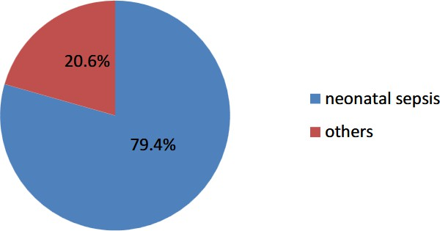
Figure 1 Proportion of children with neonatal sepsis among neonates in Mandera County Referral Hospital, from June 1 to December 31, 2024

3.1.2 The neonate-related factors causing neonatal sepsis in Mandera County Referral Hospital.
With regard to the first study objective the investigator sought to assess the neonate-related factors causing neonatal sepsis in Mandera County Referral Hospital. The findings are summarized in table 2:
Table 2 Neonate-Related Risk Factors, Proportion, and Association with Sepsis Severity at Mandera County Referral Hospital (n = 199)
Factor | Category | Frequency (n) | Percentage (%) | Mild (n) | Severe (n) | P-value
Birth Weight | Low (<2.5 kg) | 121 | 60.8 | 62 | 62 | 0.391
 | Normal (≥2.5 kg) | 78 | 39.2 | 43 | 32
Gestational Age | Preterm (<37 wks) | 108 | 54.3 | 51 | 50 | 0.611
 | Term (≥37 wks) | 91 | 45.7 | 54 | 44
Birth Asphyxia | Present | 82 | 41.2 | 39 | 35 | 1.000
 | Absent | 117 | 58.8 | 66 | 59
Sex | Male | 113 | 56.8 | 61 | 61 | 0.402
 | Female | 86 | 43.2 | 44 | 33
Congenital Anomalies | Present | 21 | 10.6 | 12 | 11 | 1.000
 | Absent | 178 | 89.4 | 93 | 83
Multiple Births | Yes | 29 | 14.6 | 18 | 9 | 0.177
 | No | 170 | 85.4 | 87 | 85
Invasive Procedures | Performed | 92 | 46.2 | 49 | 45 | 0.978
 | Not Performed | 107 | 53.8 | 56 | 49
Source : (Researcher, 2025)

Based on the cross-tabulation findings as shown in table 2, none of the neonate-related factors examined showed a statistically significant association with sepsis severity among the 199 neonates admitted to the Newborn Unit at Mandera County Referral Hospital (P > 0.05 for all factors). However, low birth weight and male sex were more frequently observed among neonates with severe sepsis, although these differences did not reach statistical significance. Preterm birth and birth asphyxia were also common among septic neonates, reflecting the vulnerability of these groups due to immature immune systems and potential perinatal complications. A considerable proportion of neonates had undergone invasive procedures, which may have increased their exposure to hospital-acquired infections. Congenital anomalies and multiple births, though less prevalent, were still present and may contribute to higher clinical complexity and infection risk. These results suggest that while certain neonatal characteristics—particularly low birth weight, prematurity, and male sex—are prevalent among septic neonates, they may not independently determine the severity of the condition. Nevertheless, the trends observed reinforce the need for heightened surveillance, prompt diagnosis, and targeted preventive measures for neonates exhibiting these risk factors to reduce the burden and potential complications of neonatal sepsis in this setting (Adedokun,.Onosakponome & Nyenke. 2020).
This findings concurs to those by Tisho et al. (2025) at Kenyatta National Hospital, which discovered that while low birth weight and male sex were observed to have a higher proportion of cases in the severe sepsis category, these differences did not reach statistical significance. The findings of our study are similar to a study that was carried out in Northern Ethiopia (Destaaleem, HaftuBerche, & Kashu, 2021), that suggested that although certain neonatal characteristics—such as low birth weight, male sex, prematurity, and birth asphyxia—are common among neonates with sepsis, they may not independently predict the severity of the condition within this study population.
These outcomes aligned with the qualitative data, which demonstrated that;

"According to one of the KII, the early onset of sepsis (EOS) in this study were more frequently observed in male sex, multiple births, and congenital anomalies….”

3.2 Knowledge Gaps Among Health Care Providers on Neonatal Sepsis in Mandera County Referral Hospital.
In order to comprehend the makeup of the nurse sample and evaluate the potential effects of variables like age, gender, educational attainment, years of experience, and employment status on the nurses' perspectives, professional practices, and overall contribution to the healthcare environment, the study aimed to ascertain the demographic characteristics of the participating nurses. According to data analysis in Table 3, 36 (72.0%) of the 50 nurses who took part in the study were between the ages of 21 and 30. Furthermore, 37 (74%) of them were female, 26 (52%) had earned a B Sc in nursing, 33 (66%) had two to four years of experience, and 41 (82%) had not taken any specific neonatology courses.

Table 3. Nurses Socio-demographic characteristics
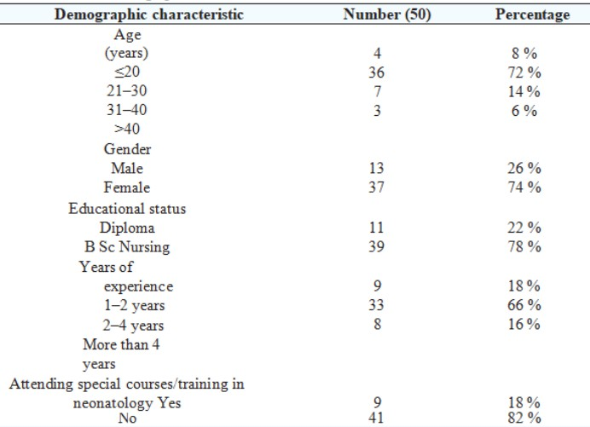

According to Table 4, the majority of the nurses knew a lot about ENC. Every nurse is aware of being vaccinated on time. Hand washing (96%), equipment sterilization (96.0%), frequent bed sheet changes (92%), umbilical cord care (94.0%), maternal health education (90%), minimizing invasive procedures (92%), starting breastfeeding (98%), and nail cutting (76%) were the most commonly used neonatal sepsis prevention strategies among the respondents.
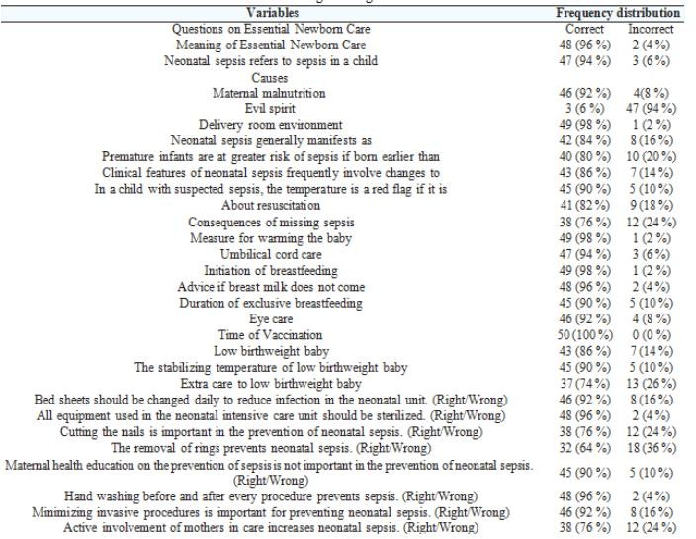
Table 4 Distribution of Nurse’s knowledge level about Essential Newborn Care
The study sought to determine the existing knowledge gaps among health care providers on neonatal sepsis in Mandera County Referral Hospital. All variables with a P value less than 0.20 were adjusted for using logistic regression as shown in table 5. When all other factors were taken into account, neonates treated by health care providers with a diploma were twice as likely to develop neonatal sepsis as those treated by nurses with graduate degrees (AOR=2.320, 95% CI 0.456 to 11.802). AOR=2.690, 95% CI 1.526 to 7.672 showed that neonates treated by nurses who were knowledgeable about neonatal essential care had a 2.69-fold higher risk of developing sepsis than those treated by nurses who were not. These outcomes aligned with the qualitative data, which demonstrated that;

"Although all nurses knew enough about the ENC, groups with BScs showed a greater level of understanding, suggesting that they had learned more through case exposure and likely better coursework….”Compared to nurses with fewer than two years of experience, neonates attended by nurses with two to four years of experience had a 0.721 (AOR= 0.721, 95% CI 0.389–1.337) higher risk of developing sepsis. Neonatals treated by nurses who were highly skilled in identifying the signs and symptoms of neonatal sepsis had a one-fold higher risk of developing sepsis than those treated by nurses who were less skilled in this area (AOR=1.138, 95% CI 0.134–9.642). These results were in contrast to those of Maisaba et al. (2024), who came to the conclusion that there was a knowledge gap between the practical and theoretical identification of newborn sepsis signs and symptoms; Tisho et al. (2025) found comparable results in KNH.
These outcomes aligned with the qualitative data, which demonstrated that;
"Although all nurses knew enough about the ENC, groups with BScs showed a greater level of understanding, suggesting that they had learned more through case exposure and likely better coursework….”

Table 5 Bivariate and Multivariate Analyses of Knowledge Gaps Among Healthcare Providers Risk Factors for Neonatal Sepsis in the Hospital in 2024 (n = 50).
Variables | Nurses where Sepsis |  |  | cOR (95% CI) | p value
 | developed
 | N = 50 | Yes | No
 |  | Percent | Percent
Age of nurses | 5% |  | 3% | 1.726 (0.645–4.613) | 0.277
<21years
21-40 years | 42& |  | 44% | 1
Above 40 years | 3% 3% |  |  | 1.084 (0.557–2.108) | 0.811
Educational status  Diploma | 10% |  | 12% | 1
BSC Nursing | 30% |  | 48% | 0.413 (0.457–1.284) | 0.352
Years of experience  1-2 years | 9% |  | 9% | 1
2-4 years | 35% |  | 31% | 0.721 (0.389–1.337) | 0.300
More than 4 years | 9% |  | 7% | 0.627 (0.240–1.640) | 0.342
Special course on neonates  Yes | 12% |  | 6% | 1
No | 45% |  | 37% | 1.133 (0.328–3.910) | 0.843
Knowledge of neonate essential care  Right | 48% |  | 26% | 1
Wrong | 18% |  | 16 | 0.971 (0.326–2.886) | 0.958
Knowledge on SNCU equipments  Poor | 4% |  | 1% | 1
Right | 9% |  | 86% | 2.690 (1.526–7.672) | 0.310
Identification of signs and symptoms of neonate sepsis  Right | 12% |  | 67% | 1
Wrong | 9% |  | 12% | 1.138 (0.134–9.642) | 0.905

Source : (Researcher, 2025)

Only the neonatal factors (neonate age and gestational weeks) that indicated a correlation that was significant with sepsis of the neonates in bivariate analysis were subjected to multivariable analysis. Neonatal age <3 days (aOR: 2.769; 95% CI 1.312–5.843; P = 0.008) and gestational weeks <37 weeks (aOR: 4.149; CI 1.1878–9.167; P ≤ 0.001) were strongly associated with sepsis .

4. Conclusion

This study established that neonatal sepsis remains a significant public health concern at Mandera County Referral Hospital, with a high prevalence rate of 79.4% among neonates admitted to the Newborn Unit. The findings revealed that although several neonatal characteristics such as low birth weight, prematurity, male sex, birth asphyxia, congenital anomalies, multiple births, and invasive procedures were frequently observed among septic neonates, none independently predicted the severity of sepsis. However, trends indicated that preterm neonates, low birth weight infants, and male neonates were more vulnerable to severe forms of sepsis, underscoring the need for heightened surveillance and early interventions in these groups.

Additionally, multivariate analysis identified neonatal age below three days and preterm gestation (<37 weeks) as significant predictors of sepsis, highlighting the critical vulnerability of newborns in the early days of life and those with immature immune systems. Importantly, the study also revealed knowledge gaps among healthcare providers, particularly related to essential newborn care and equipment use, which may contribute to suboptimal diagnosis and management of neonatal sepsis.

These findings suggest that while demographic and neonatal factors increase susceptibility, effective prevention and management will require strengthening healthcare providers’ skills, improving infection control practices, and enhancing early detection strategies. Focused interventions on high-risk groups—especially preterm and early-age neonates—along with capacity building of healthcare staff, are essential to reduce the burden and adverse outcomes of neonatal sepsis at Mandera County Referral Hospital.This should briefly state the major findings of the study. If you are using copy-paste option then select ‘match destination formatting’ in paste option OR use ‘paste special’ option and select ‘unformatted Unicode text’ option]

Consent

All authors declare that written informed consent was obtained from the parents/guardians of the neonates for participation in this study. A copy of the written consent is available for review by the Editorial Office, Chief Editor, or Editorial Board members of this journal upon request.

Ethical approval

The authors confirm that all necessary ethical approvals were obtained prior to the commencement of this study. Approval was granted by the Kenyatta University Graduate School and subsequently by the Kenyatta University Ethics Review Committee. Following this, a research permit was obtained from the National Council for Science, Technology and Innovation (NACOSTI) and permission was granted by the Mandera County Department of Health.

Informed consent was obtained from all eligible mothers prior to data collection, after clearly explaining the objectives, potential benefits, risks, and the voluntary nature of participation. Confidentiality and privacy were strictly maintained by anonymizing the data, safeguarding respondent identities with coded questionnaires, and securely storing collected data accessible only to the researcher.

This confirms that the study complied with all relevant ethical guidelines, is not contrary to the public interest, and that the release of information is permitted under applicable legislation.

Disclaimer (Artificial intelligence)
Author(s) hereby declare that NO generative AI technologies such as Large Language Models (ChatGPT, COPILOT, etc.) and text-to-image generators have been used during the writing or editing of this manuscript.

References

World health report (WHO). (2019). Make every mother and child count. Geneva: WHO; 2019.

A. A. Adedokun, E. O. Onosakponome & C. U. Nyenke. (2020). Early Onset and Late Onset of Neonatal Sepsis in a Tertiary Hospital, South-South, Nigeria. Journal of Advances in Microbiology, 20(6), 19–29. https://doi.org/10.9734/jamb/2020/v20i630249

Roble, A. K., Ayehubizu, L. M., & Olad, H. M. (2022). Neonatal sepsis and associated factors
among neonates admitted to neonatal intensive care unit in general hospitals, eastern Ethiopia 2020. Clinical Medicine Insights: Pediatrics, 16, 11795565221098346.

Vergnano S, Sharland M, kazembe P, Mwansambo C, (2018). Heath PT-Neonatal sepsis an international Perspective. Arch Dis Child Fetal Neonatal Ed,: 90 F220-4.

Yelda, A. Leal, N., Juan, R. V., Ulises, R.Q., Nidia, D.R., Dávila, V. (2020). Risk factors and prognosis for neonatal sepsis in southeastern Mexico: analysis of a four-year historic cohort follow-up. BMC Pregnancy and Childbirth, 2020:12:48.

Stephanie, J., Schrag, D., Clare, L., Cutland, M.D., Elizabeth, R., & Zell, M.S. (2018). Risk Factors for Neonatal Sepsis and Perinatal Death Among Infants Enrolled in the
Prevention of Perinatal Sepsis Trial, Soweto, South Africa. The Pediatric Infectious Disease Journal 2018;31(8).

Chiabi, A.D.M., Mah, E., Nguefack, S., Mbuagbaw, L., & Zafack, J. (2017). Recent epidemiology of neonatal sepsis in Iran. Iran J Pediatr. 2017;21(4):441-8.

Polin, R. A. Palazzi, D., Klein, J. & Gene, J. W. (2018). Neonatal Sepsis. Advanced Pediatric Infectious Disease Journal 7: 25-61.

UNICEF.org/files/UNICEF. Levels and trends in child mortality. Child mortality_for_web(http://apromiserenewed. 2018

UNICEF. (2020). Every newborn: An action Plan to end preventable deaths: Executive summary Geneva.

Amare, G.W.L., Felek, M., Beyene, M.B., Anagaw, C., & Unakal, A.K. (2022). Predictors of positive blood culture and death among neonates with suspected neonatal sepsis in Gondar University Hospital, Northwest Ethiopia. European Journal of Experimental Biology;2(6): 2212-8.

Tisho, A. K., Mbugua, P. M., Bosire, R., & Karanja, S. M. (2025). Predictors of Length of Hospitalization for Neonatal Sepsis at Kenyatta Nation Hospital, Kenya: A Prospective Cross‐Sectional Study. Health Science Reports, 8(1), e70344.

Thaver D, and Zaidi AK. (2019). Burden of neonatal infections in developing countries: a review of evidence from community-based studies. Pediatr Infect Dis J, 28(1 Suppl):S3–S9.
Destaaleem, G., HaftuBerche, T., & Kashu, G. (2021). Risk factors for neonatal Sepsis in public hospitals, North Ethiopia 2021.

Maisaba, J. M., Migisha, R., Owaraganise, A., Tibaijuka, L., Agaba, D. C., Muhumuza, J., ... & Kayondo, M. (2024). Maternal factors associated with early-onset neonatal sepsis among caesarean-delivered babies at Mbarara Regional Referral Hospital, Uganda: a case- control study. BMC Pregnancy and Childbirth, 24(1), 707.

