Comparing the power of correlation measures under different relationships: A simulation study

Abstract

Aims: The association between two variables is a fundamental aspect of data analysis across various research fields. Among the many measures of association, Pearson’s, Spearman’s, Kendall’s, Hoeffding’s, Distance Correlation, and Bergsma and Dassios' tau are commonly used in practice. The aim of this study is to compare the statistical power of these six correlation coefficients in detecting various types of relationships, including linear, non-linear, and non-monotonic associations, under different levels of noise and sample sizes.
Study design and Methodology: We evaluate these methods through simulations involving nine specific relationship types (linear, parabolic, cubic, power, sine, exponential, circle, and step function), following the work of Simon and Tibshirani (2011) in their commentary on Reshef et al. (2011).
Results: The results demonstrate that Bergsma and Dassios' tau consistently outperforms all other methods for non-linear and non-monotonic relationships, particularly for small sample sizes and complex dependencies. Distance Correlation and Hoeffding’s D also show competitive power, especially for larger sample sizes, but remain generally less powerful than Bergsma and Dassios' tau in small-sample scenarios. For linear relationships, Pearson and Spearman correlations remain the most powerful.
Conclusion: These findings highlight the robustness and versatility of Bergsma and Dassios' tau, making it a preferred measure for studies in fields such as social sciences and biology, where small sample sizes and complex relationships are common. Distance Correlation remains a strong alternative for larger datasets, while Pearson and Spearman correlations continue to be effective choices for linear relationships.

Keywords: Correlation coefficients; statistical power; monotonic relationships; non-monotonic relationships; linear relationships; non-linear relationships; Bergsma and Dassios' tau

1 Introduction

Understanding the relationship between two variables is a fundamental objective in statistical analysis across various research fields, including social sciences, biology, finance, and more. Numerous correlation coefficients have been developed to measure different types of associations, each with its own strengths, limitations, and assumptions about the data.
The aim of this study is to compare the statistical power of six widely used correlation coefficients —Pearson, Spearman, Kendall, Hoeffding, Distance Correlation, and Bergsma and Dassios' tau — in detecting various types of relationships, including linear, non-linear, and non-monotonic associations, under different levels of noise and sample sizes.

1.1 Why is this aim important for researchers?
The choice of correlation method can have significant implications for research outcomes, particularly in fields where the nature of the relationship between variables is not known a priori. For example:
- In social sciences, researchers often deal with ordinal or non-normally distributed data, making rank-based methods like Spearman and Kendall more appropriate. However, if the relationship is non-linear or complex, traditional methods like Pearson’s correlation may fail to detect it, leading to incorrect conclusions. Bergsma and Dassios' tau offers a robust alternative for detecting general dependencies in small datasets.
- In biology, relationships between variables can be highly non-linear, necessitating the use of methods like Distance Correlation or Hoeffding’s D. Bergsma and Dassios' tau provides an additional tool for detecting complex dependencies, particularly in small-sample studies common in molecular biology or ecology.
- In finance, detecting complex dependencies between assets is crucial for risk management and portfolio optimization. Distance Correlation has shown promise in capturing these dependencies, but Bergsma and Dassios' tau may offer complementary insights, especially in datasets with outliers or influential observations.
By comparing the power of these six methods across a range of relationship types, noise levels, and sample sizes, this study provides practical guidance for researchers, helping them choose the most appropriate correlation method based on the nature of their data and the relationships they aim to detect. This is particularly important in exploratory data analysis, where the underlying relationship is unknown, and the choice of method can significantly impact the results.

1.2 Why these six coefficients?
A wide variety of dependence measures have been proposed in the literature, yet these six coefficients - Pearson, Spearman, Kendall, Hoeffding’s D, distance correlation, and Bergsma and Dassios’ tau - collectively represent the major methodological families of association measures. Pearson’s correlation quantifies linear dependence; Spearman’s and Kendall’s statistics capture monotonic but potentially nonlinear trends through ranks; Hoeffding’s D and distance correlation are designed for general, possibly non-monotonic relationships; and Bergsma and Dassios’ tau, a recent rank-based development, has the unique property of equaling zero if and only if two variables are independent. This property makes tau a conceptually appealing and robust benchmark for assessing general dependence, extending the interpretability of Kendall’s statistic while remaining non-parametric and consistent against all alternatives. Recent theoretical work by Weihs, Drton, and Meinshausen (2016) unified several rank-based dependence measures under the framework of symmetric rank covariances, further highlighting the distinct role of Bergsma and Dassios’ tau among rank-based statistics. Likewise, Székely and Rizzo (2017) extended the framework of distance covariance and correlation to high-dimensional settings, reinforcing the importance of distance-based approaches for general dependence detection.
Together, these six measures span the full spectrum of linear, monotonic, and general nonlinear associations encountered in applied research. Their inclusion therefore enables a comprehensive and balanced comparison of statistical power across dependence types, providing insights into which methods are most effective under varying sample sizes and noise levels.
In practical terms, each coefficient offers distinct advantages in applied contexts:
- Pearson’s correlation: measures linear association and serves as the benchmark for comparison.
- Spearman and Kendall: rank-based measures for monotonic relationships; robust to outliers and non-normality.
- Hoeffding’s D: designed to detect general, possibly non-monotonic dependence.
- Distance correlation: detects both linear and nonlinear associations and is consistent against all dependence alternatives.
- Bergsma and Dassios’ tau: a generalized rank-based statistic that equals zero only under independence, extending Kendall.
Together, these six methods provide a comprehensive foundation for comparing statistical power across a wide range of dependence structures.

2 The six correlation coefficients: An overview

Pearson’s correlation has been the workhorse for understanding dependence between two variables for over a century of statistical practice. Unfortunately, Pearson’s correlation is not a useful measure of dependency in general because it works well only when data are linearly associated. It will misrepresent any relationship that isn’t linear, which occurs very often in real-world applications. For other types of associations, such as non-linear or non-monotonic relationships, alternative methods have been developed. These include rank-based measures (e.g., Spearman, Kendall, Hoeffding) and information-theoretic measures (e.g., Mutual Information, Maximal Information Coefficient (MIC)). Additionally, there are measures based on the distance between observations, such as Distance Correlation (Székely et al., 2007; Székely and Rizzo, 2009), and a lesser-known but powerful measure in social sciences research: Bergsma and Dassios' tau. This chapter provides an overview of these six correlation coefficients, highlighting their strengths, limitations, and applicability to different types of relationships.

2.1 Pearson’s product-moment correlation coefficient
Pearson’s correlation measures the linear relationship between two variables. It is defined as the standardized covariance. The formula is as follows: $Cor\left(X,Y\right)=\frac{Cov(X,Y)}{\sqrt{Var\left(X\right)}\sqrt{Var\left(Y\right)}}$
where cov is the covariance.

A value of zero indicates no linear association, but it does not imply independence between the variables.

Assumptions:
1. Linearity: The relationship between the variables is linear.
2. Normality: The variables should be normally distributed, especially for small sample sizes.
3. Homoscedasticity: The variance of the residuals should be constant across all levels of the independent variable.
4. Continuous Data: Pearson’s correlation is designed for continuous variables.

2.2 Spearman’s rank correlation coefficient
Spearman’s correlation assesses monotonic relationships by applying Pearson’s formula to the ranked values of the variables. The formula is given by:
$$ρ=1-\frac{6\sum{d_{i}^{2}}}{n(n^{2}-1)}$$
where : di is the difference between the ranks of corresponding values of X and Y and n is the number of observations.

Assumptions:
1. Monotonicity: The relationship between the variables is monotonic (either consistently increasing or decreasing, but not necessarily linear).
2. Ordinal or Continuous Data: Spearman’s correlation can be used with ordinal or continuous data.
3. No Normality Assumption: Spearman’s correlation does not require the variables to be normally distributed.

2.3 Kendall rank correlation coefficient
Kendall’s correlation measures the strength of association based on the concordance and discordance of pairs:

The formula is as follows:
Kendall’s tau = $(C-D/C+D)$ where C is the number of concordant pairs and D is the number of discordant pairs.

Assumptions:
1. Monotonicity: The relationship between the variables is monotonic.
2. Ordinal or Continuous Data: Kendall’s correlation can be used with ordinal or continuous data.
3. No Normality Assumption: Kendall’s correlation does not require the variables to be normally distributed.

2.4 Distance correlation coefficient
Distance Correlation has been widely studied as a measure that captures both linear and non-linear dependencies (Székely et al., 2007). Recent developments have extended its use in high-dimensional applications, with novel approaches integrating kernel-based independence measures (Deb & Sen, 2021) and distribution-free dependency tests (Heller et al., 2016). These studies highlight the growing interest in dependence measures beyond classical correlation techniques.

The formula is as follows:
$$dCor\left(X,Y\right)=\frac{dCov(X,Y)}{\sqrt[2]{dVar\left(X\right)*dVar(Y)}}$$

where $dCov(X,Y)$ is the distance covariance, and $dVar\left(X\right) and dVar\left(Y\right)$ are the distance variances of X and Y, respectively.

Assumptions:
1. General Dependence: Distance Correlation can detect both linear and non-linear relationships.
2. No Specific Distributional Assumptions: Distance Correlation does not assume any specific distribution for the variables.
3. Continuous Data: Distance Correlation is typically used with continuous data.
4. Independence Characterization: Distance Correlation is zero if and only if the variables are independent.

2.5 Hoeffding’s D correlation coefficient
Hoeffding’s D measures the difference between the joint ranks of (X,Y) and the product of their marginal ranks. It is defined as:
$$D=\int{\left(F-GH\right)df}$$
A measure of the distance between $F(X,Y)$ and $G\left(X\right)H(Y)$, where $F\left(X,Y\right)$ is the joint cumulative distribution function (CDF) of X and Y, and G and H are the marginal CDFs of X and Y, respectively.

Assumptions:
1. General Dependence: Hoeffding’s D is designed to detect general forms of dependence, including non-linear and non-monotonic relationships.
2. No Specific Distributional Assumptions: Hoeffding’s D does not assume any specific distribution for the variables.
3. Continuous Data: Hoeffding’s D is typically used with continuous data.

2.6 Bergsma and Dassios' tau
Bergsma and Dassios' tau, often referred to as tau-star $τ^{*}$,is a non-parametric measure of association that generalizes Kendall’s tau. Unlike traditional measures like Pearson, Spearman, and Kendall, which are primarily focused on linear or monotonic relationships, Bergsma and Dassios' tau is based on the concept of sign covariance and is capable of detecting both monotonic and non-monotonic dependencies, making it a versatile tool for analyzing complex relationships. It is defined as:

$τ^{*}:=$ $\frac{1}{(\begin{matrix}n \\ 4\end{matrix})}\sum_{1≤i<j<k<l≤n}{a(x_{i},}x_{j},x_{k},x_{l}).a(y_{i},y_{j},y_{k},y_{l})$

where:
- n is the number of observations.
- $(\begin{matrix}n \\ 4\end{matrix})$ is the number of combinations of 4 observations from n.
- $a$ is a kernel function that captures the concordance and discordance of quadruples of observations. The kernel function $a$ is defined as :
$a\left(z_{1},z_{2},z_{3},z_{4}\right)≔sign(\left|z_{1}-z_{2}\right|+\left|z_{3}-z_{4}\right|-\left|z_{1}-z_{3}\right|-\left|z_{2}-z_{4}\right|)$

The kernel function $a$ assigns a value of +1, -1, or 0 based on whether the quadruple is concordant, discordant, or tied. The summation runs over all combinations of 4 observations, and the result is normalized by $(\begin{matrix}n \\ 4\end{matrix})$. In practice, the measure is calculated over all quadruples in a larger dataset to assess the dependence between X and Y.

Key Properties:
1. Non-parametric: Bergsma and Dassios' tau does not assume any specific distribution for the variables.
2. Robustness: It is robust to outliers and influential observations, similar to Kendall’s tau.
3. General Dependence: It can detect both monotonic and non-monotonic relationships, including complex non-linear dependencies.
4. Independence Characterization: $τ^{*}$ = 0 if and only if X and Y are independent, making it a consistent measure of dependence.

Assumptions:
1. Continuous or Ordinal Data: Bergsma and Dassios' tau is typically used with continuous or ordinal data.
2. No Specific Distributional Assumptions: It does not require the variables to follow any specific distribution.
3. Sample Size: Due to its reliance on quadruples of observations, \( \tau^* \) may require larger sample sizes to achieve reliable estimates compared to simpler measures like Pearson or Spearman.

3 Simulations

To illustrate the power of each of the six correlation tests, we perform simulations that analyze the effects of the number of observations, the type of dependence (linear, non-linear monotonic, non-linear non-monotonic, and non-functional), and different levels of noise. Linear association is represented by a line, non-linear monotonic associations are represented by cubic, power, exponential, and step functions, non-linear non-monotonic associations are represented by parabolic and sine functions, and non-functional association is represented by a circle. As a reminder, power is defined as the probability of correctly rejecting the null hypothesis when it is false. Therefore, the higher the power, the better the test is at detecting a true relationship.

3.1 Sample Sizes
The number of data points per simulation ranges from n = 10 to n = 1000. More precisely, we vary the sample size across the following values: 10, 20, 50, 100, 200, 300, 500, and 1000. This range of sample sizes is chosen to reflect the diversity of real-world research scenarios:

1. Small Sample Sizes (10–50):
- Social Sciences: Studies in psychology, sociology, and education often involve small sample sizes due to practical constraints (e.g., difficulty recruiting participants, limited funding).
- Biology: Experiments in molecular biology, genetics, or ecology may involve small sample sizes due to the high cost of data collection or ethical considerations (e.g., animal studies).
- Importance: Evaluating the performance of correlation measures at these sample sizes is critical because small samples are more prone to variability, and the choice of method can significantly impact the results.

2. Medium Sample Sizes (50–200):
- These sample sizes are common in many applied research settings, including clinical trials, behavioral studies, and field experiments.
- They provide a balance between practical feasibility and statistical power, making them a key focus for evaluating correlation measures.

3. Large Sample Sizes (200–1000):
- While less common in some fields, large sample sizes are increasingly encountered in genomics, finance, and large-scale surveys.
- Including these sample sizes allows us to assess how the performance of correlation measures scales with increasing data availability.

By covering this wide range, the study provides insights into the performance of correlation measures across the full spectrum of sample sizes encountered in practice.

3.2 Hypothesis Testing
We test the following hypotheses:
- H_0: X and Y are independent.
- H_1: X and Y are not independent.

Following the work of Simon and Tibshirani (2011) in their commentary on Reshef et al. (2011), we simulate data with nine specific functional relationships: linear, quadratic, cubic, sine, circle, exponential, power function, step function, and parabolic. These relationships were selected to represent a diverse range of dependency structures, from simple linear associations to complex non-linear and non-monotonic patterns.
Recent studies (Reshef et al., 2018) have further examined the empirical performance of dependence measures, highlighting how different metrics excel under varying conditions. The study builds on this work by providing a more detailed comparison of correlation measures across a broader range of sample sizes and noise levels, offering additional insights into their relative effectiveness.

3.3 Simulation Setup
1. Data Generation:
- The independent variable X is uniformly distributed in the range [0, 1].
- The dependent variable Y is generated from the nine functional forms mentioned above, with added Gaussian noise. The noise level scales the standard deviation of the Gaussian noise, allowing us to test the performance of the correlation methods under different levels of noise.
- For example, a noise level of 0.5 corresponds to a Gaussian variance of 0.0025, while a noise level of 2 corresponds to a Gaussian variance of 0.04.

2. Noise Levels:
- We use 30 different noise levels, ranging from very low (e.g., noise level = 0.1) to relatively high (e.g., noise level = 3). This allows us to evaluate the robustness of each correlation measure to varying degrees of noise.

3. Null and Alternative Datasets:
- We use 500 null datasets to estimate the rejection regions for a significance level of 0.05.
- We use 500 alternative datasets to estimate the power of each correlation measure.

4. Correlation Calculation:
- For each dataset, we calculate the six correlation coefficients: Pearson, Spearman, Kendall, Hoeffding, Distance Correlation, and Bergsma and Dassios' tau.
- Under the null hypothesis, we estimate the rejection cutoffs for each correlation measure.
- Under the alternative hypothesis, we estimate the power as the proportion of alternative statistics exceeding the estimated cutoffs.

5. Simulation Loop:
- We loop through each noise level and functional form. For each combination:
- Simulate data under the null hypothesis (with uniform X and Y as a function of X with Gaussian noise).
- Calculate the six correlation coefficients under the null hypothesis and determine the rejection cutoffs.
- Simulate data under the alternative hypothesis (with the specified functional relationship and noise).
- Calculate the six correlation coefficients under the alternative hypothesis.
- Estimate the power as the proportion of alternative statistics exceeding the rejection cutoffs.

3.3.1 Key Parameters
- Number of Null Datasets: 500 (to estimate rejection regions).
- Number of Alternative Datasets: 500 (to estimate power).
- Noise Levels: 30 (ranging from 0.1 to 3).
- Sample Sizes: 10, 20, 50, 100, 200, 300, 500, 1000.
- Functional Relationships: Linear, quadratic, cubic, sine, circle, exponential, power function, step function, parabolic.

3.3.2 Summary of Simulation Steps
1. Define the independent variable X as uniformly distributed in [0, 1].
2. Generate the dependent variable Y using the nine functional forms, with added Gaussian noise scaled by the noise level.
3. Simulate 500 null datasets to estimate rejection cutoffs for each correlation measure.
4. Simulate 500 alternative datasets to estimate the power of each correlation measure.
5. Loop through noise levels and functional forms, calculating correlations and estimating power at each step.

Figure 1 is an illustration of the nine types of relationships studied here.

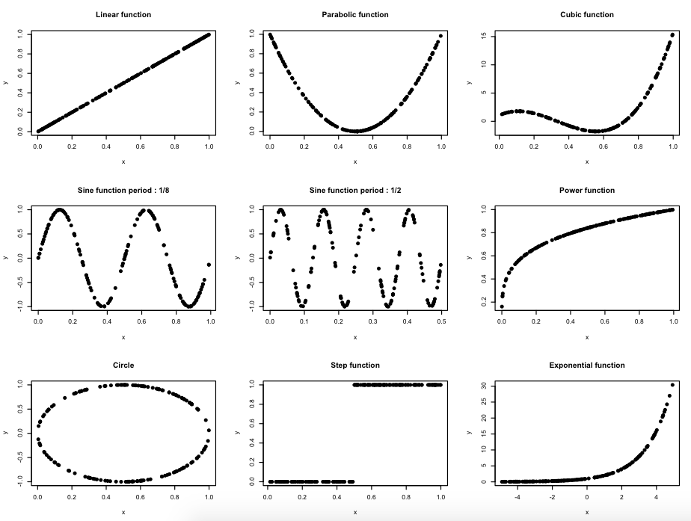
Figure 1: Illustration of the 9 types of relationships without noise.

We first present the results showing eight graphs, each of them referring to a sample size (n=10, 20, 50, 100, 200, 300, 500 and 1000).
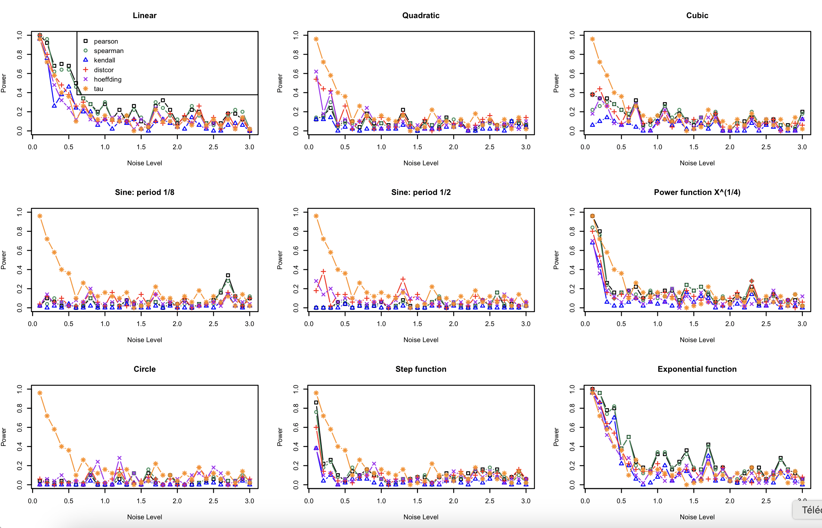
Figure 2: Results of the simulation with n=10

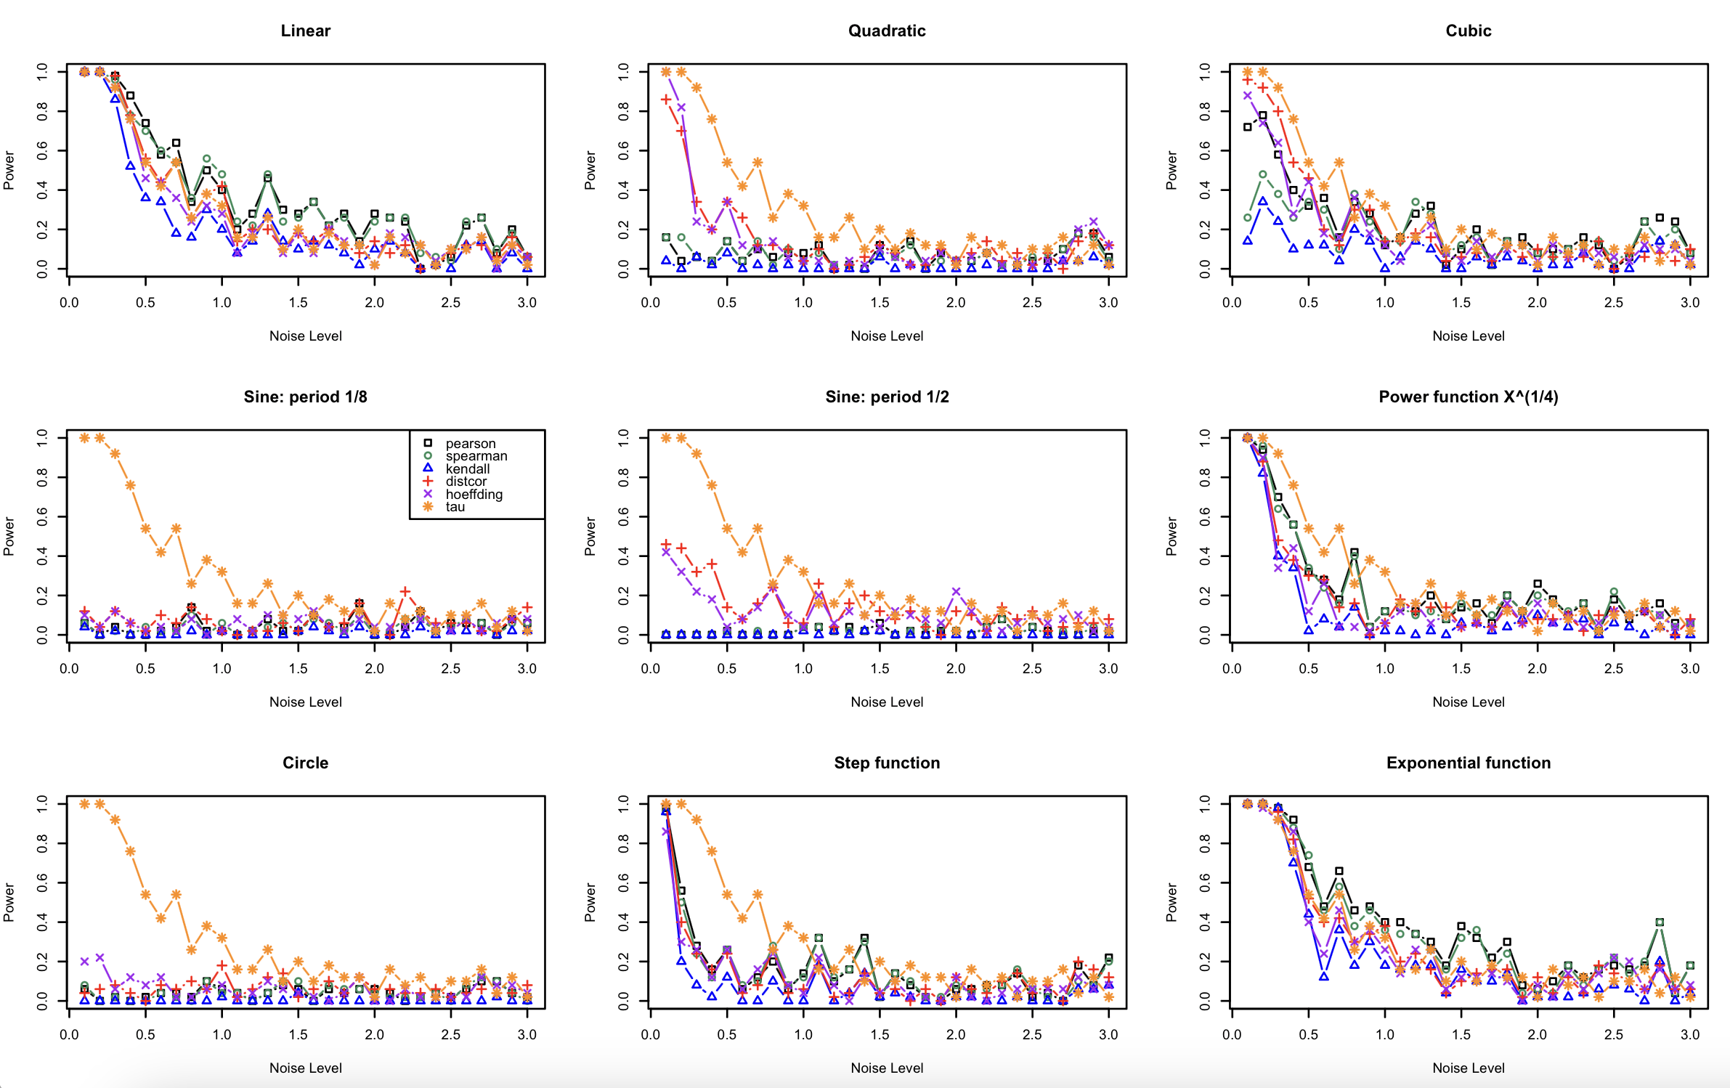
Figure 3: Results of the simulation with n=20

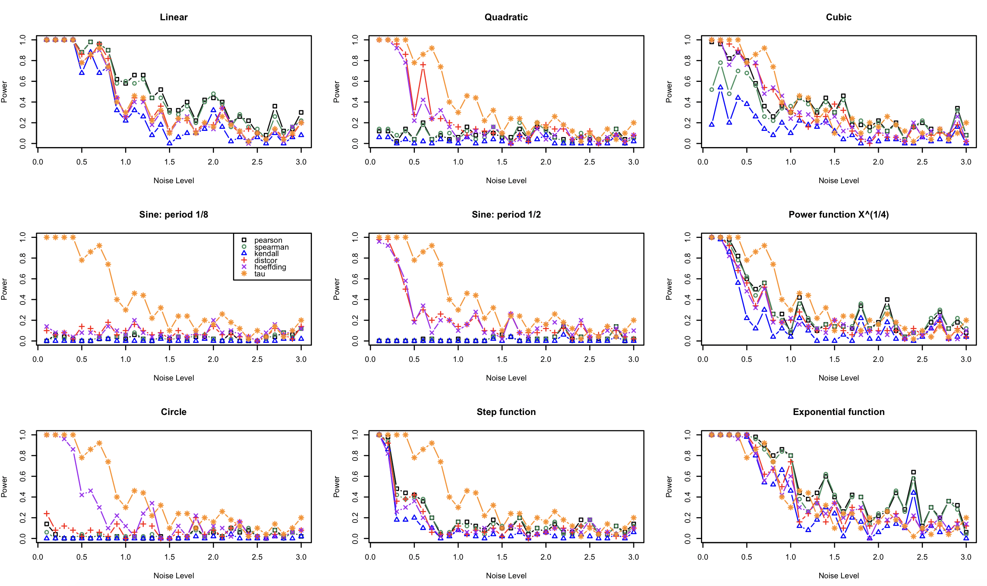
Figure 4: Results of the simulation with n=50

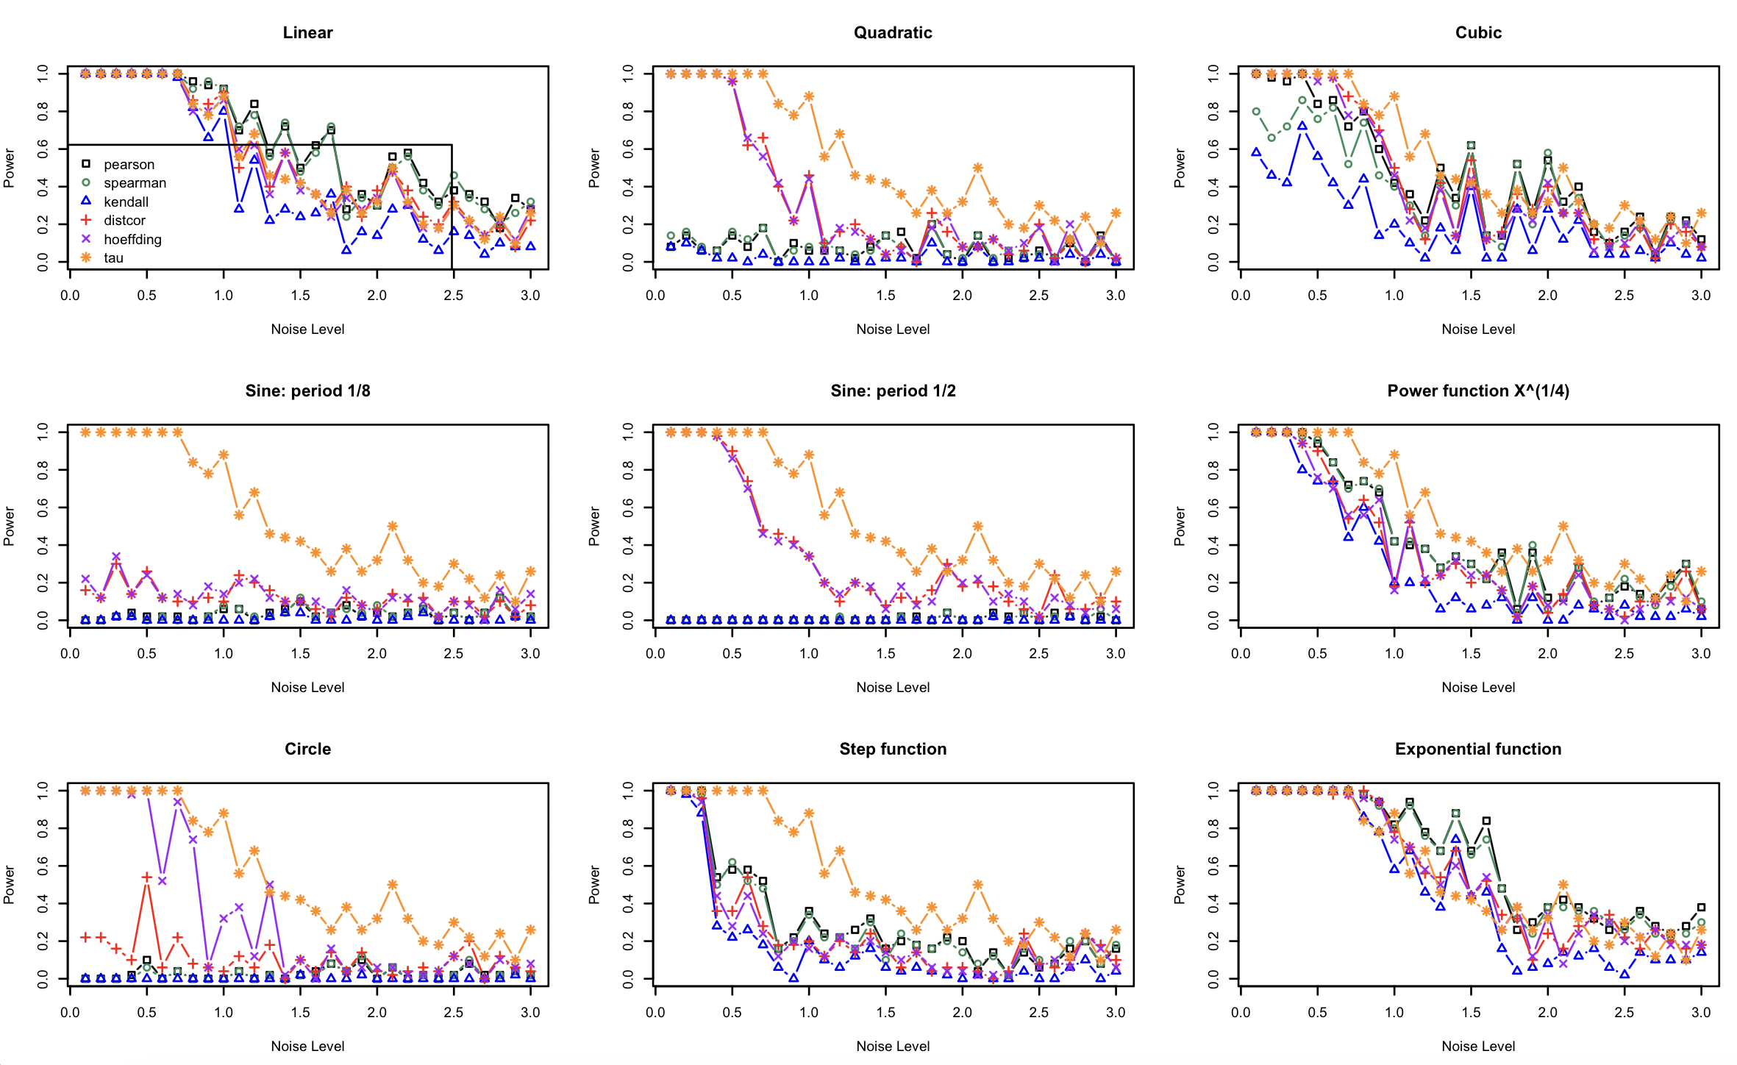
Figure 5: Results of the simulation with n=100

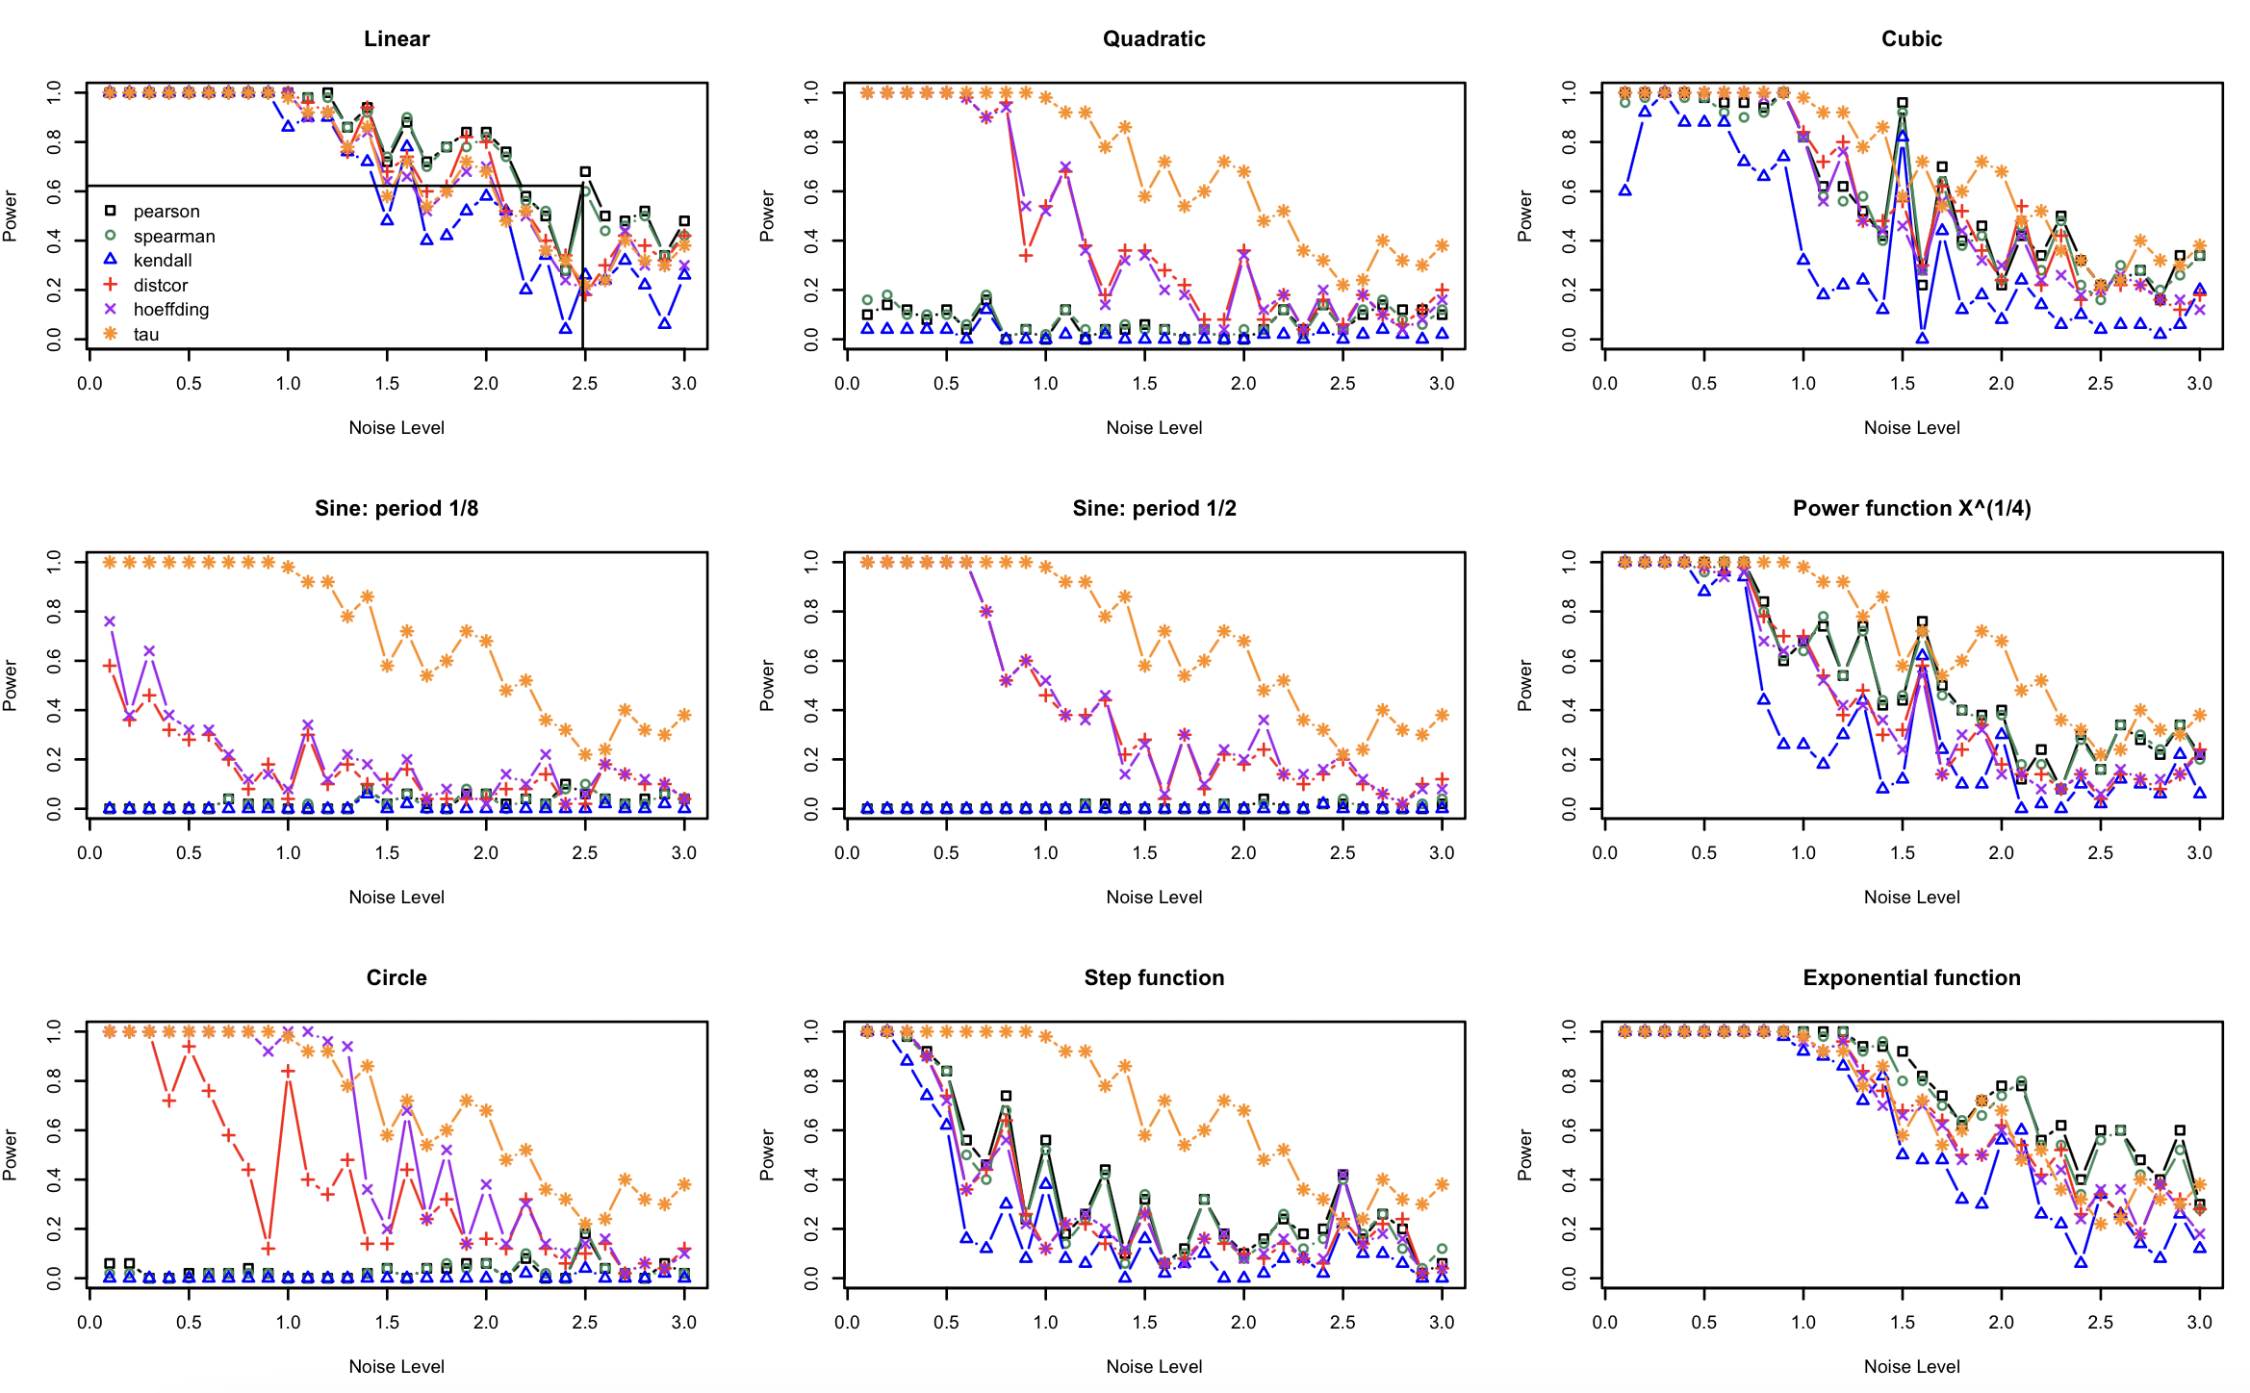
Figure 6: Results of the simulation with n=200

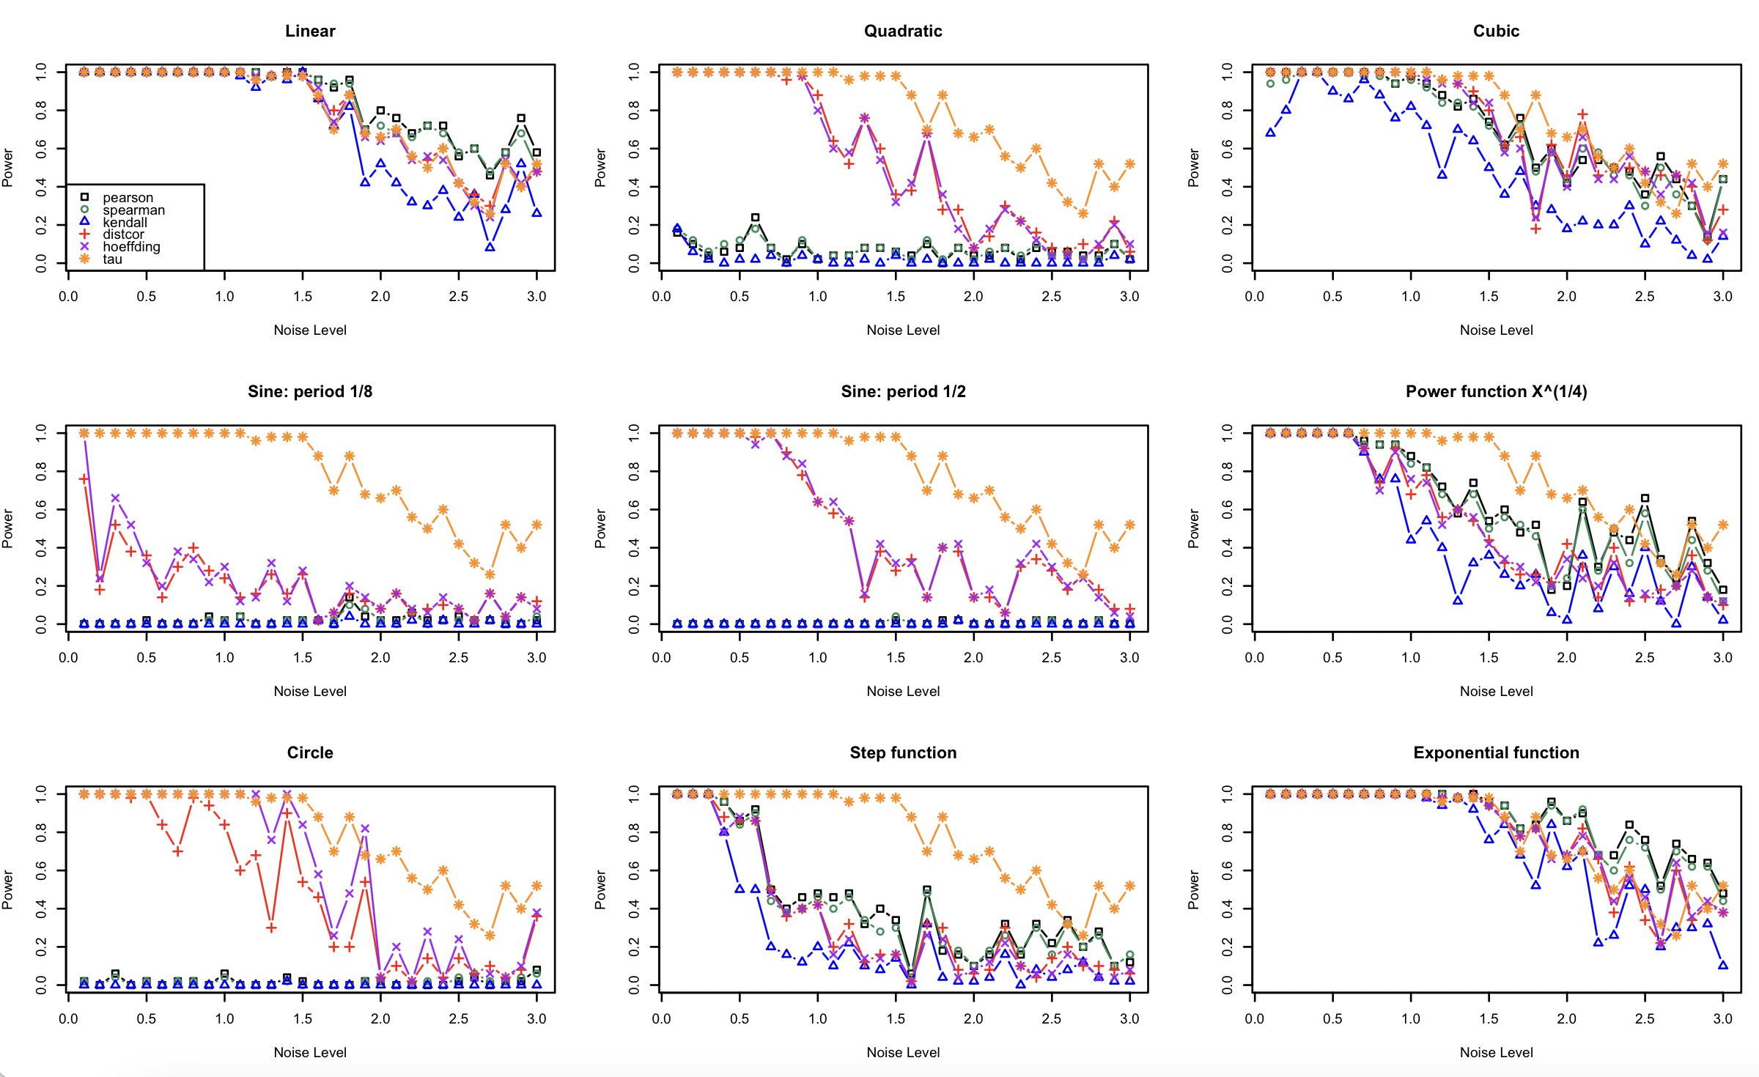
Figure 7: Results of the simulation with n=300

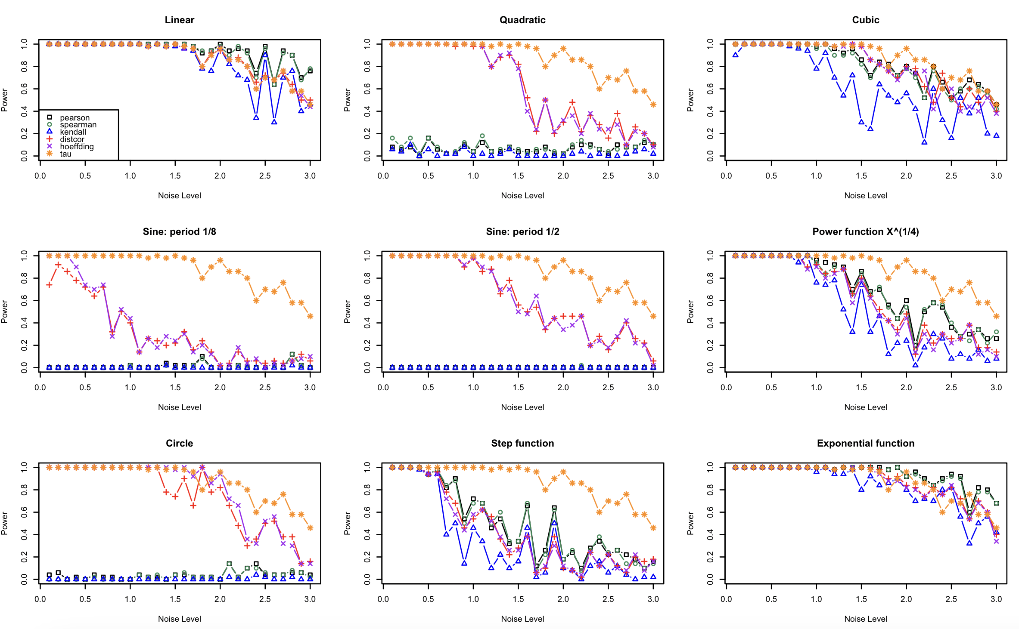
Figure 8: Results of the simulation with n=500

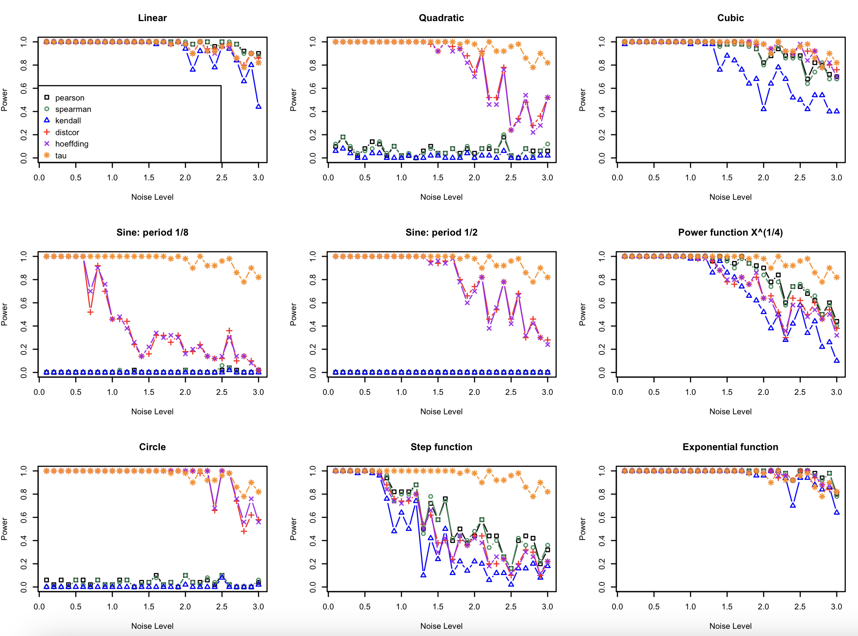
Figure 9: Results of the simulation with n=1000

4 Results and discussion

4.1 Overview of Results
The simulations evaluated the power of six correlation measures—Pearson, Spearman, Kendall, Hoeffding, Distance Correlation, and Bergsma and Dassios' tau—across nine types of relationships (linear, parabolic, cubic, sine, circle, exponential, power function, step function, and parabolic) and varying sample sizes (from n = 10 to n = 1000). The results are presented in Figures 2 through 9, which show the power of each correlation measure for different sample sizes and relationship types. Below, we summarize the key findings and discuss their implications..

4.1.1 Key Findings
1. Performance Across Sample Sizes

- Small Sample Sizes (n = 10 to n = 50)
Figures 2-4 indicate that Bergsma and Dassios’ tau is the most powerful measure across most noise levels, except in the linear, cubic, power, and exponential cases, where other methods perform similarly.
- Linear Relationships: Pearson and Spearman correlations consistently outperform the other measures, particularly for small sample sizes. This is expected, as these measures are specifically designed for linear and monotonic relationships.
- Non-linear and Non-monotonic Relationships: Bergsma and Dassios' tau outperforms Distance Correlation and Hoeffding’s D for small sample sizes, particularly for complex dependencies like the circle and sine functions. This makes it a robust choice for small-sample studies in fields like social sciences and biology.
- Step Function and Power Function x^{1/4}: Pearson and Spearman correlations are more powerful than Distance Correlation for these relationships at small sample sizes, but Bergsma and Dassios' tau also performs competitively.

- Medium Sample Sizes (n = 100 to n = 200)
Figures 5-6 demonstrate that Bergsma and Dassios’ tau is the most powerful measure across most noise levels, except in the linear, cubic, and exponential cases, where other methods perform similarly.

- Linear Relationships: Pearson and Spearman correlations remain the most powerful, but Distance Correlation begins to catch up, showing nearly equivalent power for n = 100 and above.
- Non-linear and Non-monotonic Relationships: Bergsma and Dassios' tau continues to outperform Distance Correlation and Hoeffding’s D for many relationship types, particularly for non-monotonic relationships like the sine and circle functions. Its power is consistently high, making it a reliable choice for medium sample sizes.

- Large Sample Sizes (n = 300 to n = 1000)
Figures 7-9 show that Bergsma and Dassios’ tau is the most powerful measure across most noise levels, except in the linear, cubic, and exponential cases, where other methods perform similarly.

- Linear Relationships: Distance Correlation becomes nearly as powerful as Pearson and Spearman correlations, even for linear relationships.
- Non-linear and Non-monotonic Relationships: Bergsma and Dassios' tau remains competitive with Distance Correlation and Hoeffding’s D, particularly for complex dependencies like the circle and sine functions. While Distance Correlation and Hoeffding’s D dominate for larger sample sizes, Bergsma and Dassios' tau still performs well, especially for non-monotonic relationships.

2. Performance Across Relationship Types
- Linear Relationships: Pearson and Spearman correlations are the most powerful, especially for small sample sizes. Distance Correlation becomes competitive as the sample size increases.
- Non-linear Monotonic Relationships (Cubic, Power, Exponential, Step Function):
- Bergsma and Dassios' tau performs well, particularly for small to medium sample sizes, outperforming Distance Correlation and Hoeffding’s D in some cases.
- Distance Correlation and Hoeffding’s D are also powerful, particularly for larger sample sizes.
- Non-linear Non-monotonic Relationships (Parabolic, Sine, Circle):
- Bergsma and Dassios' tau is the clear winner for these relationships, particularly for small to medium sample sizes. It consistently outperforms Distance Correlation and Hoeffding’s D for the circle and sine functions.
- Pearson, Spearman, and Kendall correlations show near-zero power for these relationships, as they are not designed to detect non-monotonic dependencies.

3. Comparison of Correlation Measures
- Bergsma and Dassios' tau: Outperforms Distance Correlation and Hoeffding’s D for small to medium sample sizes, particularly for non-monotonic relationships like the circle and sine functions. Its robustness to noise and outliers makes it a reliable choice for real-world data, especially in fields with small sample sizes.
- Distance Correlation: Consistently performs well for non-linear and non-monotonic relationships, particularly for larger sample sizes. It is robust to noise and outliers, making it a reliable choice for real-world data.
- Hoeffding’s D: Shows similar performance to Distance Correlation, particularly for non-linear relationships. However, it is slightly less powerful for linear relationships at small sample sizes.
- Pearson and Spearman Correlations: Excel at detecting linear and monotonic relationships, especially for small sample sizes. However, they fail to detect non-linear and non-monotonic relationships, as expected.
- Kendall’s Correlation: Consistently shows lower power compared to Pearson and Spearman correlations across all scenarios. It is not recommended for detecting non-linear or non-monotonic relationships.

4.2 Discussion
The results provide key insights into the performance of six widely used correlation measures across a variety of functional relationships, sample sizes, and noise levels. Notably, we find that Bergsma and Dassios’ tau consistently outperforms all other methods for detecting complex, non-monotonic dependencies, particularly in small-sample settings. This makes it an excellent choice for exploratory analysis in disciplines such as social sciences, biology, and psychology, where datasets are often limited in size but may exhibit intricate relationships. However, given its computational complexity, further optimizations may be needed for large datasets, as discussed in the limitations section.
Distance Correlation and Hoeffding’s D also prove to be powerful alternatives, particularly for larger sample sizes. These measures are effective in capturing both linear and non-linear dependencies, making them suitable for finance, genomics, and other large-scale data applications. Although the power differences are visually clear, future work should statistically confirm these differences using hypothesis tests (e.g., paired t-tests, ANOVA), as noted in the limitations section.
For linear relationships, Pearson’s and Spearman’s correlations remain the most efficient methods, particularly for small sample sizes. Their simplicity and interpretability continue to make them the preferred choice in situations where the assumption of monotonicity holds. However, as sample sizes increase, Distance Correlation becomes equally powerful and provides a more versatile alternative.
Why Bergsma and Dassios’ tau Stands Out?
Bergsma and Dassios’ tau exhibits strong performance across various dependency structures due to the following properties:
1. Detection of Non-Monotonic Relationships – Unlike traditional rank-based measures (Spearman, Kendall), it captures complex dependencies such as circular or oscillatory patterns.
2. Robustness to Outliers – Similar to Kendall’s tau, it remains resistant to extreme values, making it particularly useful for real-world datasets that may contain anomalies.
3. Theoretical Independence Property – Like Distance Correlation, it equals zero if and only if two variables are truly independent, reinforcing its reliability in assessing dependency.
4.3 Practical Implications for Researchers
Based on the findings, we offer the following recommendations:
• Social Sciences & Psychology: Bergsma and Dassios’ tau is the preferred measure for small sample sizes (n < 100), where relationships may be non-monotonic or difficult to detect with traditional methods.
• Biology & Genomics: Distance Correlation is highly effective for larger datasets (n $≥$ 100) but can be complemented by Bergsma and Dassios’ tau in smaller-scale studies.
• Finance & Economics: Distance Correlation is recommended for modeling asset dependencies, but Bergsma and Dassios’ tau provides additional insights when dealing with non-monotonic financial relationships.
While these insights are valuable, several open questions remain, particularly regarding the computational feasibility of Bergsma and Dassios’ tau for large datasets. Future work should focus on optimizing its computation or developing approximations that maintain accuracy while reducing complexity. Moreover, researchers working with high-dimensional or real-world datasets should also consider robustness to non-Gaussian noise and missing values, as future studies will explore.
4.4 Limitations and future work
While this study provides valuable insights into the performance of various correlation measures, several limitations warrant further investigation. Addressing these limitations could enhance the applicability and robustness of these methods in real-world scenarios.

1. Computational Complexity
The computational cost of each method is an important consideration, especially for researchers working with large datasets:
- Bergsma and Dassios' tau:
Complexity: $O\left(n^{4}\right)$ (quadruple observations) limits scalability.
- Distance Correlation and Hoeffding’s D:
Both require $O\left(n^{2}\right)$operations.
Hoeffding’s D evaluates pairwise ranks (benefits from sparse data optimizations).
- Pearson, Spearman, and Kendall:
Most efficient $(O(n)$ or $O(nlogn))$ for linear/monotonic relationships.

2. Handling of Noise and Real-World Data
Simulations assume Gaussian noise, but real-world data often exhibit heavy-tailed (e.g., Cauchy), or skewed noise. Several recent studies have examined robustness properties of distance covariance (and, by extension, distance correlation) and proposed robustified estimators for heavy-tailed data (Ma et al., 2022) and (Leyder et al., 2025). Future work should test these methods with missing data or outliers.

3. High-Dimensional Extensions
This study focuses on bivariate relationships, but many real-world applications involve high-dimensional data (e.g., genomics, finance). Extending these correlation measures to multivariate settings is an important area for future research. Recent advances, such as kernel-based dependence measures (Deb & Sen, 2021) demonstrate extensions to high-dimensional data. Combining these with PCA or t-SNE could broaden applicability.

4. Statistical Significance of Differences in Power
While the results highlight differences in power across methods, we do not perform statistical significance tests to determine whether these differences are meaningful. Future work could include:
- Hypothesis tests (e.g., paired t-tests or ANOVA) to compare the power of different methods.
- Confidence intervals or effect size measures to quantify the magnitude of differences in power.

Practical Implications
Addressing these limitations would enhance the applicability of these methods in fields like social sciences, biology, and finance, where real-world data often exhibit complex noise structures, high dimensionality, and missing values. By improving computational efficiency, robustness to noise, and scalability to high-dimensional settings, these methods could become even more valuable tools for researchers.

5 Conclusion

This study provides a comprehensive comparison of six correlation measures in detecting linear, non-linear, and non-monotonic relationships across varying sample sizes and noise conditions. Through extensive simulations, we demonstrate that:
• Bergsma and Dassios’ tau is the most powerful measure for small sample sizes and complex relationships, making it a strong candidate for exploratory research.
• Distance Correlation and Hoeffding’s D perform exceptionally well for large datasets, making them ideal for high-dimensional applications.
• Pearson and Spearman correlations remain optimal for strictly linear dependencies, particularly in small samples.
These findings provide practical guidance for researchers selecting correlation methods based on sample size, data structure, and research objectives. While simulations provide valuable insights, applying these methods to real-world datasets remains an important next step, particularly in fields like genomics, finance, and psychology, where data distributions may deviate from idealized assumptions.
6 Final Remarks - Recommendations for researchers from different research fields

6.1 Social Sciences
- Typical Data Characteristics: Social science research often involves small sample sizes, ordinal or non-normally distributed data, and relationships that may be non-linear or non-monotonic.
- Recommended Measures:
- Bergsma and Dassios' tau: This measure is particularly well-suited for small sample sizes and complex dependencies, which are common in social sciences. It is robust to outliers and can detect both monotonic and non-monotonic relationships, making it ideal for exploratory data analysis where the nature of the relationship is unknown.
- Distance Correlation: For larger datasets or when the relationship is suspected to be non-linear, Distance Correlation is a powerful and versatile tool. It can detect a wide range of dependencies and is robust to noise.

- When to Use:
- Use Bergsma and Dassios' tau for small-sample studies or when the relationship is complex and non-monotonic.
- Use Distance Correlation for larger datasets or when the relationship is suspected to be non-linear but the sample size is sufficient.

6.2 Biology
- Typical Data Characteristics: Biological data often involves non-linear relationships, small sample sizes (e.g., due to high costs or ethical constraints), and noisy measurements.
- Recommended Measures:
- Bergsma and Dassios' tau: This measure is highly effective for detecting complex dependencies in small-sample studies, such as gene expression data or ecological studies. Its robustness to outliers and ability to detect non-monotonic relationships make it a strong choice for biological research.
- Distance Correlation: For larger datasets, such as genomic or proteomic studies, Distance Correlation is a powerful tool for detecting both linear and non-linear associations. It is particularly useful when the relationship between variables is unknown or complex.
- When to Use:
- Use Bergsma and Dassios' tau for small-sample studies or when the relationship is non-monotonic (e.g., oscillating patterns like sine or circular relationships).
- Use Distance Correlation for larger datasets or when the relationship is suspected to be non-linear.

6.3 Finance
- Typical Data Characteristics: Financial data often involves complex dependencies, non-linear relationships, and large datasets. Detecting these dependencies is crucial for risk management, portfolio optimization, and asset pricing.
- Recommended Measures:
- Distance Correlation: This measure is highly effective for detecting complex dependencies in large datasets, such as those encountered in finance. It can capture both linear and non-linear relationships, making it a versatile tool for financial analysis.
- Bergsma and Dassios' tau: While Distance Correlation is generally preferred for large datasets, Bergsma and Dassios' tau can be useful for smaller datasets or when the relationship is highly non-monotonic.
- When to Use:
- Use Distance Correlation for large datasets or when the relationship is suspected to be non-linear (e.g., detecting dependencies between asset returns).
- Use Bergsma and Dassios' tau for smaller datasets or when the relationship is highly complex and non-monotonic.

6.4 Why Bergsma and Dassios' tau and Distance Correlation?
6.4.1 Bergsma and Dassios' tau:
- Strengths:
- Detects both monotonic and non-monotonic relationships.
- Robust to outliers and influential observations.
- Performs well for small sample sizes, making it ideal for social sciences and biology.
- Limitations:
- Computationally intensive for very large datasets.
- Slightly less powerful than Distance Correlation for large sample sizes.

6.4.2 Distance Correlation:
- Strengths:
- Detects both linear and non-linear relationships.
- Robust to noise and outliers.
- Highly effective for large datasets, making it ideal for finance and genomics.
- Limitations:
- Requires larger sample sizes to achieve high power compared to Bergsma and Dassios' tau.

6.5 Practical Guidance for future work
While this study provides important insights, several avenues remain open for further exploration:
1. Computational Efficiency – Recent studies (Weihs et al., 2016) have proposed more efficient rank-based dependency measures, which may provide inspiration for optimizing Bergsma and Dassios’ tau.
2. Real-World Applications – Reshef et al. (2018) demonstrated the importance of validating dependence measures on diverse empirical datasets.
3. Handling of Non-Gaussian Noise – Deb & Sen (2021) introduced topological approaches that may complement existing correlation measures in complex data environments.
By addressing these challenges, future research can refine our understanding of dependence structures and improve statistical methodologies for real-world data analysis.
For small-sample studies and complex dependencies, Bergsma and Dassios’ tau is the preferred choice, particularly in social sciences, biology, and finance. For larger datasets and non-linear relationships, Distance Correlation offers a powerful alternative. Both measures provide robust tools for detecting diverse dependency structures, making them valuable for exploratory data analysis and real-world applications.

Competing interests
The author declares that there are no competing interests.

Disclaimer (Artificial intelligence)
Author hereby declares that no generative AI technologies such as Large Language Models (ChatGPT, COPILOT, etc.) and text-to-image generators have been used during the writing or editing of this manuscript.

References

Bergsma, W., & Dassios, A. (2014). A consistent test of independence based on a sign covariance related to Kendall’s tau. Bernoulli, 20(2), 1006–1028.

Deb, N., & Sen, B. (2021). Measuring association on topological spaces using kernels and geometric graphs. Annals of Statistics, 49(2), 667-690.
Heller, R., Heller, Y., Kaufman, S., Brill, B., & Gorfine, M. (2016). Consistent distribution-free K-sample and independence tests. Journal of the American Statistical Association, 111(515), 1369-1379.
Hoeffding, W. (1948). A non-parametric test of independence. The Annals of Mathematical Statistics, 19(4), 546–557.

Kendall, M. G. (1938). A new measure of rank correlation. Biometrika, 30(1–2), 81–93.

Leyder, S., Raymaekers, J., & Rousseeuw, P.J. (2025). Robust distance covariance. International Statistical Review. https://doi.org/10.1111/insr.70005.

Ma, T., Ke, H., & Ren, Z. (2022). Robust distance correlation for variable screening [Preprint]. ArXiv. https://doi.org/10.48550/arXiv.2212.13292.
(Note: This paper has since been accepted/in press for Stat with https://doi.org/10.1002/sta4.70094.

Pearson, K. (1895). Notes on regression and inheritance in the case of two parents. Proceedings of the Royal Society of London, 58, 240–242.

Reshef, D. N., Reshef, Y. A., Finucane, H. K., Grossman, S. R., McVean, G., Turnbaugh, P. J., ... & Sabeti, P. C. (2011). Detecting novel associations in large data sets. Science, 334(6062), 1518–1524.

Reshef, D. N., Reshef, Y. A., & Sabeti, P. C. (2018). An empirical study of leading measures of dependence. Journal of Machine Learning Research, 19, 1-63.
Simon, N., & Tibshirani, R. (2011). Comment on “Detecting novel associations in large data sets” by Reshef et al. Science, 334(6062), 1518–1524.

Székely, G. J., Rizzo, M. L., & Bakirov, N. K. (2007). Measuring and testing dependence by correlation of distances. The Annals of Statistics, 35(6), 2769–2794.

Székely, G. J., & Rizzo, M. L. (2009). Brownian distance covariance. The Annals of Applied Statistics, 3(4), 1236–1265.

Székely, G. J., & Rizzo, M. L. (2017). The energy of data. Annual Review of Statistics and Its Application, 4, 447-479.
Spearman, C. (1904). The proof and measurement of association between two things. The American Journal of Psychology, 15(1), 72–101.

Weihs, C., Drton, M., & Meinshausen, N. (2016). Symmetric rank covariances: A generalized framework for nonparametric measures of dependence. Biometrika, 103(3), 577-587.

