Original Research Article

Comparison of Robust Methods for Multiple Linear Regression Models

Abstract: The linear regression model is one of the most important basic statistical models widely used in data analysis in many fields, such as economics, social sciences, and medicine. This model used to illustrate the relationship between a dependent variable and several independent variables. Although the ordinary least squares (OLS) method is effective for estimation under appropriate conditions, the presence of outliers or extreme values ​​may reduce the effectiveness and accuracy of these estimates. Therefore, the need has emerged to use alternative and more robust estimation methods to address these observations, known as robust estimation methods. This study compares the classical ordinary least squares method with several robust methods, such as the S-estimation, M-estimation, MM-estimation, and Huber methods, to evaluate their performance in the presence of data contamination. The analysis results showed that the Huber method outperformed the other methods when contamination levels reached 7% or more, making it an effective choice for obtaining more accurate and reliable estimates in environments containing imperfect or contaminated data.
Keywords: Robust Regression, Multiple Linear Regression, Outliers Detection, M-estimator, S-estimator, MM-estimator, Huber’s Method, Ordinary Least Squares (OLS), Mean Squared Error (MSE), Statistical Modeling.
- Introduction:
Linear regression is one of the most widely used methods in statistical modeling to estimate relationships between variables. However, the presence of outliers and extreme values can significantly distort the accuracy of the model and lead to biased estimates. Traditional approaches, such as ordinary least squares (OLS), are highly sensitive to these anomalies, which reduces their reliability in practical applications. This limitation has motivated the development of robust methods that minimize the influence of outliers and provide more accurate and stable estimates.
Among the most prominent robust methods are M-estimation, S-estimation, and MM-estimation. M-estimation, based on the principle of maximum likelihood, uses efficient loss functions to down-weight the effect of extreme values but may be less robust against high-leverage points. S-estimation improves robustness by focusing on scale estimation of the error term, though it is generally less efficient than M-estimation. To address these limitations, MM-estimation was introduced, combining the robustness of S-estimation with the efficiency of M-estimation, thereby achieving both a high breakdown point and satisfactory efficiency.
Recent developments in robust regression have further highlighted the trade-off between efficiency and robustness. Maronna et al. (2019) [1] provide a modern synthesis of robust methods and influence functions; Koller and Stahel (2017) [2] refine inference in small samples; while Copt and Victoria-Feser (2015) [3] extend robust techniques to generalized linear models. Despite these advances, few empirical studies have directly compared the performance of robust estimators on real-world datasets, particularly in developing economies.
This study addresses that gap by applying robust regression methods to Iraqi agricultural data. Specifically, it compares the effectiveness of M-estimation, S-estimation, and MM-estimation in the presence of outliers, evaluating their relative efficiency and robustness. The study tests the following hypotheses:
H₁: MM-estimation provides more accurate estimates than M-estimation and S-estimation.
H₂: MM-estimation demonstrates greater resistance to outliers than M- and S-estimation.
By evaluating these methods on real data, this research contributes to the literature on robust regression and provides practical guidance for researchers and practitioners in selecting the most appropriate estimation technique when analyzing contaminated datasets.
  - Research Problem: The research problem is summarized as estimating the coefficients of a multiple linear regression model in the presence of outliers and extreme values that are far removed from the data. This is considered one of the most common problems faced by researchers. In such cases, relying on the ordinary least squares (OLS) method is ineffective and leads to misleading and inaccurate results. Therefore, robust estimation methods must be employed to obtain highly efficient estimates with the desired statistical properties.
  - Research Objective: The objective of this study is to compare several robust estimation methods for estimating the parameters of a multiple linear regression model in the presence of outliers and extreme values. Comparisons were conducted using the standard error and mean square error (MSE) criteria, based on real data through practical application using the statistical software SPSS (version 23) and EViews (version 12).
- Methodology:
The theoretical aspect includes some concepts related to the multiple linear regression model, the ordinary least squares method, the problem of outliers, and how to detect them, in addition to some robust estimation methods.
  - Multiple Linear Regression model [4]
The multiple linear regression model is used to predict future values ​​by estimating the model's coefficients, which form the basis of the predictions in the estimation models. Its goal is to study the effect of explanatory variables on the response variable, known as the correlation. The multiple linear regression model is expressed as follows:
$$Y_{i}=β_{0}+β_{1}X_{1i}+β_{2}X_{2i}+…+ β_{k}X_{ki}+ui (1)$$
  - Classic Methods of Estimation [6][5][4]
To obtain the best estimate of the parameters of a multiple linear regression model using the ordinary least squares (OLS) method, all assumptions on which the model depends must be met, and we then obtain the best estimates of the model parameters. However, if one of these assumptions is violated or there are outliers, these methods lose their advantages and negatively affect the estimation results. The classical methods worth mentioning are as follows:
    - Ordinary Least Squares (OLS)
Before we discuss the standard least-squares method, we explain the assumptions of this method because the problem of determining a straight line for a number of observations depends on determining the random error ($ui$ ).
$$Y_{i}=β_{0}+β_{1}X_{i}+ui (2)$$
$ui$ : It is sometimes called the disturbance term and is called by this name because it causes a disturbance in the linear relationship between the dependent variable and the independent variable. Then, we divide the relationship into two parts, the first part) ($β_{0}+β_{1}X_{i}$ ) , which is called the explanatory variable, while the second part is the random variable ($ui$ ), which is called the unexplained variable, which is the result of the deviation of the estimated value from its true value for the dependent variable, due to some factors, which are: -
Delete some variables from the function under study randomness of Human Behaviors, Incomplete Model, Aggregation Errors, Measurement Errors.
The first four factors give us an incorrect form of the equation, and are called errors in the equation, whereas the last factor is called the measurement error of the observation itself. Considering these factors, we must address the assumptions of random error ($ui$) in the linear relationship under study.
The first assumption: The values ​​of the residuals ($ui$) are normally distributed around their mean, which equals zero, and are identical for all values ​​of the independent variable ($X_{i}$) and with a variance equal to${{(σ}_{u}}^{2})$, that is:
$$u_{i}\sim N(0,{σ_{u}}^{2})$$
The second assumption: The value of the common variance $u_{i}, u_{j}$ is equal to zero, meaning that:
$$cov\left(u_{i}, u_{j}\right)=E\left(u_{i}, u_{j}\right)=0 i,j=1,2,….,n$$
Different values ​​of the random variable are independent of each other.
The third assumption: The value of the covariance between the random error and the value of the independent variable is zero.
$$cov\left(u_{i}, x_{j}\right)=0$$
This means that the values ​​of ($u_{i}$) are not correlated with any independent variables. In the applied field, this assumption is achieved by the stability of the values ​​of the independent variables from one sample to another.
The traditional least squares method can be used to obtain the unknown β estimators according to the following formula:
$$\underline{\hat{β}}={\left(X'X\right)}^{-1}X^{'\underline{Y}} (3)$$
Where:
$\underline{Y} :$ vector for observations of the dependent variable
$X :$ Matrix of observations of independent variables.
$\underline{\hat{β}} :$ vector of parameters to be estimated.
The above formula was used to estimate the sample variance of the actual and estimated values ​​of the dependent variable. However, in practical applications, it is preferable to use the following formula without accounting for errors resulting from the difference between the actual and estimated values ​​of the dependent variable: This was done based on a previous formula for sample variance.
$$∴{S_{e}}^{2}=\frac{{\underline{Y}}^{'}\underline{Y}-b'X'\underline{Y}}{n-k-1} (4)$$
Where:
(n); represents the sample size and, (k) is: the number of independent variables.
2.3 Outliers Value [7]
Outliers occur naturally in the studied data and deviate from the rest of the observations. These values ​​may arise from several factors including measurement errors, implementation errors, and weighted variability. The factor "weighted variability" indicates that the data were exposed to natural conditions that were not controlled. "Measurement errors" relate to the inaccurate use of standard instruments, while "implementation errors" relate to a deficiency in the data collection method. Outliers can affect the mean, covariance matrix, and the correlation matrix. To check for these values, we tested them using the following ordinary squared Muhlenberg distances:
$${d_{i}}^{2}={\left(\underline{X_{i}}-\overline{X}\right)}^{'}S^{-1}(\underline{X_{i}}-\overline{X} ) (5)$$
$\underline{X_{i}}$: Vector of independent variables
$\overline{X}$: Mean of independent variables.
$S^{-1}$: Standard deviation
After identifying outliers, we removed them to avoid their influence on the results when using classical estimation methods and applying them to well-characterized observations. To obtain accurate results in the presence of outliers, we used the following robust squared Muhlenberg distances:
$${{RD}_{i}}^{2}={\left(\underline{X_{i}}-μ_{n}\right)}^{'}Σ^{-1}\left(\underline{X_{i}}-μ_{n}\right) (6)$$
$μ_{n}$: represents the vector of the average of the straight variables when an outlier exists.
$Σ^{-1}$: Standard deviation when an outlier
It is completely suitable for discovering outliers because it depends on robust estimates, as we calculate the robust squared Muhlenberg distances for each observation then compare its value with the following table value of $x^{2}$ ${x^{2}}_{\left(p, 0.975\right)}$If the robust squared Mehlenberg distances for the observation are greater than the value of ${x^{2}}_{\left(p, 0.975\right)}$ then that observation is considered an outlier.
2.3.1 Methods for Detecting Outliers
Visual Examination
Box Plot: Outliers appear as extreme values located beyond the whiskers.
Scatter Plot: Highlights observations that deviate markedly from the overall data pattern.
Statistical Methods
Z-test: Identifies outliers as values lying several standard deviations away from the mean.
Interquartile Range (IQR) Test: Observations falling outside the interval [Q1−1.5×IQR, Q3+1.5×IQR] [Q1 - 1.5 \times IQR, \; Q3 + 1.5 \times IQR] [Q1−1.5×IQR, Q3+1.5×IQR] are considered outliers.
Grubbs’ Test: A formal statistical procedure to detect a single outlier in normally distributed data. First introduced by Grubbs (1950), this test remains widely used.
Extended Procedures
Rosner’s ESD Test: An extension proposed by Rosner (2011) [8], to detect multiple outliers simultaneously.
Barnett and Lewis (1994): Provided a comprehensive review of classical and modern techniques for outlier detection, covering a broad range of graphical and statistical methods.
Dealing with Outliers After Their Discovery
After identifying outliers in a dataset, it is necessary to make a thoughtful decision about how to handle them. Most statistical researchers agree on the importance of first verifying the validity of these values, particularly regarding the possibility of data-entry errors. If the outlier is real and not the result of technical or human error, the appropriate course of action requires examining its impact on the analytical results. Many experts recommend using analytical methods capable of handling outliers, such as robust or nonparametric methods, which are less affected by outliers than traditional methods. A common analytical practice is to compare the results of statistical analyses when including and excluding outliers to assess their impact on the final conclusions.
2.3.2. Grubbs’ Test for a Single Outlier
The assumption that the value furthest from the sample mean was an outlier was tested using Grubbs' (1950) method. Assume that we have a sample size n from X₁ to X_{n}, which we believe is normally distributed. The Grubbs test, which uses the ESD quantile, was suggested as a way to evaluate the null hypothesis—that there is no outlier—against the alternative hypothesis—that there is only one outlier. Where:
$$ESD=MAX_{i=1,2.....n}\frac{\left|x_{i}-\bar{x}\right|}{s}$$
The level of ESD significance can be determined using:
$$ESD=\frac{n-1}{\sqrt{n}}\sqrt{\frac{t^{2}}{n-2+t^{2}}}$$
where t denotes $t_{n-2,p}$ and $p=1-α/2n$ . Grubbs tabulated this result; however, we factored it so that the p-value could be calculated. The above is for the two-sided tests. For one-sided tests, replace (𝛼/𝑛) with 𝛼/ (2𝑛).
2.3.3. Rosner’s ESD Many-Outlier Procedure
It might be tempting to apply the Grubbs test to the maximum ESD, then take it out and recalculate the Grubbs test on the smaller sample, and so on, until the outcome is not significant. Nevertheless, this method does not identify all outliers owing to the characteristics of outlier multiplication, which is known as engulfment and masking. However, assuming that n is more than 20, Rosner (2011) provided a method for spotting a cluster of outliers. His method is as follows:
- Choose a value of k that is slightly higher than the anticipated number of outliers. This could be a percentage of the sample size or number.
- Determine the average, standard deviation, and ${ESD}_{(n)}$for a sample of n.
- Determine the significance level of ${ESD}_{(n)}$Name it $P_{ESD(n)}$.
- Delete the value from the matching ${ESD}_{(n)}$.
- After removing the matching ESD value in each step, Stages 2, 3, and 4 were repeated for each subsequent sample.
- Think about the k values $P_{ESD\left(n\right)}, P_{ESD\left(n-1\right)},P_{ESD\left(n-2\right)}, …,P_{ESD\left(n-K+1\right)}$
- Beginning with $P_{ESD(n-K+1)}$, the first value that falls below a specific significance threshold such as 0. 05.
- Consider this number as an outlier, along with all prior numbers, regardless of whether their respective $P_{ESD}$ values are significant.
2.3.4. Mahalanobis Distance Test:
It is utilized for identifying outliers in multi-dimensional datasets.
Dealing with outliers:
• Removal or exclusion: Deleting outliers from the dataset is contingent on the number of outliers and significance of the data.
• Modification: Modifying outliers to fit the overall pattern of the data and is only used in cases of clear errors in data collection.
• Robust modelling: Robust models (such as M-estimation, MM-estimation, or S-estimation) that are less sensitive to outliers.
Outlier detection. We combined visual and formal diagnostics: box plots, Grubbs’ test for single outliers, and Mahalanobis distance for multivariate leverage. This ensured consistent identification of extreme observations prior to estimator comparison.
  - Robust Estimator Method: [9][10]
Any interpretation or analysis of the data is based on specific assumptions and rules that must be adhered to. However, researchers may sometimes encounter problems with the data, such as deviations from the normal distribution or the presence of outliers (data contamination). These issues cause departures from the fundamental assumptions upon which classical methods such as the ordinary least squares method for calculating the parameters of the linear model are predicated. As a result, it is essential to create other approaches that are not greatly impacted by these assumption deviations, referred to as sturdy techniques. These approaches were less affected when the data did not meet the criteria necessary for the analysis. Three reliable approaches were selected to estimate the parameters of the multiple linear regression model.

2.4.1. M-estimator Method: [11][12][14]
Implementation details. We used standard tuning constants: Huber’s ψ with k = 1.345, Tukey’s biweight with c = 4.685, and Andrews’ sine with c = 1.339. These values are widely recommended to balance efficiency and robustness.
Outlier detection. We combined visual and formal diagnostics: box plots, Grubbs’ test for single outliers, and Mahalanobis distance for multivariate leverage. This ensured consistent identification of extreme observations prior to estimator comparison.
this is one of the most common regression estimation methods proposed by Huber (1973) [13], The symbol (M) means the maximum likelihood estimation method. This method was used if the dependent variable contained outliers. The estimator using the M method is equal to
$$\hat{β}=\left[β_{n}\left(X_{1},X_{2},…,X_{n}\right)\right]=β (7)$$
Taking the expectation, we will have:$E\left[β_{n}\left(X_{1},X_{2},…,X_{n}\right)\right]=β$
From equation (7), we can see that the estimated
$$\hat{β}=\left[β_{n}\left(X_{1},X_{2},…,X_{n}\right)\right]$$
This is an unbiased estimate, and the variance is as low as possible. In addition, the variance of the M estimator is very small and as low as possible compared to the variance of the rest of the estimators.
$$var\hat{\left(\hat{β}\right)}≥\frac{{\left[\hat{β}.^{'}\right]}^{2}}{nE{\left[\left(\frac{∂}{∂β}\ln{f \left(x_{i};β\right)}\right)\right]}^{2}} (8)$$
Where: $\hat{\left(\hat{β}\right)}$is an unbiased linear estimate of β.
The principle of the M method of estimation is to minimize the residual function P as follows:
$${\hat{β}}_{m}=\min_{β}P(y_{i}-\sum_{j=0}^{k}{x_{ij}β_{j}} (9)$$
$$\min_{β}\sum_{i=1}^{n}{P(u_{i})}=\min_{β}\sum_{i=0}^{n}{P\left(\frac{e_{i}}{σ}\right)} (10)$$
$$Equals=\min_{β}\sum_{i=0}^{n}{P\left(\frac{y_{i}-\sum_{j=0}^{k}{x_{ij}β_{j}}}{σ}\right) (11)}$$
To obtain equation (9), we set an estimator for σ.
$$\hat{σ}=\frac{MAD}{0.6745}=\frac{median\left|e_{i}-median (e_{i})\right|}{0.6745} (12)$$
For the function ρ, use Tukey's Bia square as the objective function.
$$ρ\left(u_{i}\right)=\left\{\begin{aligned}\frac{{u_{i}}^{2}}{2}-\frac{{u_{i}}^{4}}{2c^{4}}+\frac{{u_{i}}^{6}}{6c^{4}}, \left|u_{i}\right|≤c \\ \frac{c^{2}}{6},\left|u_{i}\right|>c\end{aligned} \right.$$
In addition, we are looking for the first partial derivative${\hat{β}}_{m}$ of $β$ so
$$\sum_{i=1}^{n}{X_{ij}Ψ\left(\frac{y_{i}-\sum_{j=0}^{k}{X_{ij}β}}{\hat{σ}}\right)}=0 , j=0,1,2,3,…,k (13)$$
Since $Ψ=ρ$ , $X_{ij}$: is the first observation on the independent variable$\sum_{i=1}^{n}{X_{i0}=0}$
$$\left(e_{i}\right)=\frac{Ψ\left(\frac{y_{i}-\sum_{j=0}^{k}{X_{ij}β}}{\hat{σ}}\right)}{\left(\frac{y_{i}-\sum_{j=0}^{k}{X_{ij}β}}{\hat{σ}}\right)} (14)$$
$$W_{i}=\left\{\begin{aligned}{[1-{\left(\frac{u_{i}}{c}\right)}^{2}]}^{2} ,\left|u_{i}\right|≤c \\ 0 ,\left|u_{i}\right|>c\end{aligned} \right.$$
By taking c = 4.685 for the weighted Tukey's biasquare function, Equation 13 becomes
$$\sum_{i=1}^{n}{X_{ij}W_{i}\left(y_{i}-\sum_{j=0}^{k}{X_{ij}β}\right)=0 ,j=0,1,…,k (15)}$$
In this method, an initial estimator is assumed, where $β and {\hat{ σ}}_{i}$ are the numbers and parameters, respectively:
$$\sum_{i=1}^{n}{X_{ij}{W_{i}}^{0}\left(y_{i}-\sum_{j=0}^{k}{X_{ij}β^{0}}\right)=0 ,j=0,1,…,k} (16)$$
The above equation can be written as follows: -
$$X^{'}W_{i}β=X^{'}W_{i}Y (17)$$
Because $W_{i}$ is a matrix of degree n*n and the weight has the elements of the main diagonal, equation (17) is known as weighted least squares WLS, and the solution to this equation gives an estimate of $β$, that is:
$$\hat{β}={(X^{'}W_{i}Y)}^{-1}(X^{'}W_{i}Y) (18)$$
The robust M method is based on the following functions: Therefore, we have three estimation methods.
Clarification. Huber’s Method can be viewed as a specific M-estimator using Huber’s ψ-function; our separate reporting of “Huber’s Method” highlights its empirical performance relative to other robust ψ-functions.
1- The Huber function is as follows:
$$Ψ\left(u\right)=\left\{\begin{aligned}u ;\left|u\right|<h \\ h Sin \left(u\right) ;\left|u\right|≥h \end{aligned} \right.$$
Since:
$$Sin\left(u\right)=\left\{\begin{aligned}+1 u>0 \\ 0 u=0 \\ -1 u<0\end{aligned}\right.$$
h: Constant taking values: ​​1.5, 1.70, 2.08
- Andrews' function is sometimes called the sin function
.$Ψ\left(u\right)=\left\{\begin{aligned}Sin\left(u/c\right) ;\left|u\right|<cπ \\ o ;\left|u\right|≥cπ\end{aligned}\right.$
c: constant that takes the values ​​1.339, 1.5, 1.339
- Tukey function, sometimes called double weight (Tukey Biweight). It is as follows:
$$2Ψ\left(u\right)=\left\{\begin{aligned}u{\left(1-u^{2}\right)}^{2} ;\left|u\right|<c \\ o ;\left|u\right|≥c\end{aligned}\right.$$
c: Constant that takes the values ​​4.685, 6.0.
2.4.2. S-estimator Method: [7] [ 9]
This approach is employed when independent variables contain outliers The residual measure of the M method was used for estimation in this approach. The M method's reliance solely on the median as a weighting factor results in the loss of both the data's probability function and its distribution. To address the limitations of the median, this approach employs the standard deviation of residuals. The following formula determines the estimator:
$${\hat{β}}_{s}=\min_{β}{\hat{σ}}_{s}\left(e_{1},e_{2},…,e_{n}\right) (19)$$
By specifying (${\hat{σ}}_{s}$) minimum robust scale estimation, the following is achieved:
$$\min_{β}\sum_{i=1}^{n}{P\left(\frac{y_{i}-\sum_{i=0}^{k}{X_{ij}β_{j}}}{{\hat{σ}}_{s}}\right) (20)}$$
$${\hat{σ}}_{s}=\sqrt{\frac{1}{nk}\sum_{i=1}^{n}{w_{i}}{e_{i}}^{2}} (21)$$
K=0.199, $w_{i}=w_{σ}=\frac{p(u_{i})}{{u_{i}}^{2}}$
The initial estimate is:
$${\hat{σ}}_{s}=\frac{median\left|e_{i}-median(e_{i})\right|}{0.6745} (22)$$
The solution is obtained by substituting for β so that $\sum_{i=1}^{n}{X_{ij}Ψ\left(\frac{y_{i}-\sum_{j=0}^{k}{X_{ij}β}}{{\hat{σ}}_{s}}\right)=0 j=0,1,,…,k (23)}$
Since Ψ is a function derived from P:
$$Ψ\left(u_{i}\right)=\acute{P (}u_{i})\left\{\begin{aligned}{[1-{\left(\frac{u_{i}}{c}\right)}^{2}]}^{2} ,\left|u_{i}\right|≤c \\ 0 ,\left|u_{i}\right|>c\end{aligned}\right.$$
Where $Ψ_{i}$ is the weighted IRLS function?
$$W_{i}\left(u_{i}\right)=\left\{\begin{aligned}{[1-{\left(\frac{u_{i}}{c}\right)}^{2}]}^{2} ,\left|u_{i}\right|≤c \\ 0 ,\left|u_{i}\right|>c\end{aligned}\right.$$
Since: c=1.547, $u_{i}=\frac{e_{i}}{σ_{s}}$
2.4.3. MM-estimator Method [10][14]
This approach is employed when outliers exist in both the dependent and independent variables; in other words, it merges the M and S methods. The MM estimator is one of the most common methods in the field of regression, and was proposed by Yohai in 1987. The estimator has many desirable properties, including high efficiency in the case of a normal distribution of errors with a high breaking point. The MM estimator refers to multiple operations using the M estimator, and the MM regression estimator can be obtained according to the following steps:

- An initial estimator with a high point of collapse was determined; however, it was not necessarily efficient. We symbolize this with the symbol (${\hat{β}}_{s}$), and using it, the initial residuals are calculated according to the following formula:

$$r_{i}\left({\hat{β}}_{s}\right)=y_{i}-{\acute{x}}_{i}{\hat{β}}_{s} ، 1<i<n (24)$$

- The M estimator ($S_{n}$) is calculated for the initial residual $r_{i}\left({\hat{β}}_{s}\right)$according to the M estimating equation for the measurement parameters and, as follows:

$$\frac{1}{n}\sum_{i=1}^{n}{\left(\frac{r_{i}\left({\hat{β}}_{s}\right)}{s}\right)=0.5 (25)}$$
$$S_{n}=S {(r}_{1}\left({\hat{β}}_{s}\right), …,r_{n}\left({\hat{β}}_{s}\right))$$
3. The MM estimator is defined as an estimator of M using the (re-descending score) function:
$$Ψ_{1}\left(u\right)=\frac{∂p_{1}(u)}{∂u} (26)$$
Therefore, the estimator (MM), denoted by the symbol ${\hat{β}}_{MM}$, is the solution to the following equation:
$$\sum_{i=1}^{n}{X_{ij}Ψ_{1}\left(\frac{y_{i}-{\acute{X}}_{i}β}{S_{n}}\right)=0 , j=1,2,…, n (27)}$$
The measurement estimate is found in step (2).
Since:$r_{1}\left(β\right)=y_{i}-{\acute{X}}_{i}β$
2.4.4. Huber’s estimator Method
All its assumptions must be satisfied for multiple regressions to be optimal. Least-squares regression can perform poorly when some of these assumptions are not true. These assumption breakdowns can be highlighted by a thorough residual analysis, which enables us to overcome these restrictions. However, conducting this residual analysis is labor intensive and requires extensive training. Hippocampal regression offers a less constrained alternative to least-squares regression. More specifically, it provides considerably more accurate estimates of the regression coefficients when outliers are present in the data. The assumption of normally distributed residuals in least-squares regression is broken by outliers. By influencing the least-squares coefficients more than they should be affected, they typically skew them. In a dataset with N observations, it is generally anticipated that each observation will weigh approximately 1/N. Outliers, on the other hand, may be weighted at 10, 20, or even 50%.
This resulted in significant distortions in the estimated coefficients. These outliers are difficult to detect owing to this distortion because their residuals are far smaller than they ought to be. These outliers can be seen visually in several scatterplots when only one or two independent variables are used. Nevertheless, outliers are frequently obscured in scatterplots because of the increased complexity of the additional independent variables. The impact of outliers was mitigated by robust regression. This causes the residuals from the extreme cases to become larger and more noticeable. Robust regression is an iterative process that aims to detect outliers and reduce their impact on coefficient estimates. In robust regression, the proportion of the weight given to each observation is regulated by a specific curve. where is referred to as the effect function.
NCSS provides two effective functions. Despite its usefulness to inexperienced users, the findings of the robust regression should be examined with care. Robust regression analyses the residuals and either lowers the weights or eliminates various observations. You should examine the weights assigned to each observation, determine which are primarily omitted, and decide if you want them in your study. To initiate the iteration process, the ordinary least squares technique was used in the first iteration to derive regression coefficients. The iterations proceed until the regression coefficients change very little or no at all between successive iterations. It is advisable to conduct at least five iterations to allow outliers to be discovered, because of the way outliers are hidden.
Two functions are available in NCSS. These are Huber’s Method and Tukey’s biweight method. Huber’s method is the most commonly used regression method. The details of Huber’s function are as follows:
Huber’s Method
$$P\left(U\right)=\left\{\begin{aligned}U^{2}>c if ∣u∣<c \\ ∣2U∣C-C^{2} if ∣u∣≥c\end{aligned}\right.$$
$$φ\left(U\right)=\left\{\begin{aligned}u if ∣u∣<c \\ C Sign\left(u\right) if ∣u∣≥c \end{aligned}\right.$$
$$W\left(U\right)=\left\{\begin{aligned}1 if ∣u∣<c \\ \frac{C}{∣U∣} if ∣u∣≥c \end{aligned}\right.$$
- Empirical Aspect.
3.1 Data Description
The research sample represents the study of agricultural investment in Iraq in million dinars (Y), total area in thousand dunums (X₁), agricultural production (in million dinars) (X₂), loans (in million dinars) (X₃), number of workers (X₄), and capital accumulation (in million dinars) (X₅) for the period (1990-2016) for a sample size of (27) observations. The following table presents the descriptive statistics.
Table 1: Descriptive Statistics.
 | N | Minimum | Maximum | Mean | Std. Deviation | Skewness |  | Kurtosis
 | Statistic | Statistic | Statistic | Statistic | Statistic | Statistic | Std. Error | Statistic | Std. Error
Y | 27 | 116.00 | 9627.00 | 3926.7037 | 3303.86131 | .323 | .448 | -1.292- | .872
X1 | 27 | 10531.00 | 21862.00 | 13854.7407 | 1862.22827 | 3.039 | .448 | 13.786 | .872
X2 | 27 | 2877.20 | 6195.90 | 4604.6556 | 864.48546 | .339 | .448 | -.223- | .872
X3 | 27 | 10901.00 | 67263.00 | 36449.7037 | 17766.20929 | -.034- | .448 | -1.259- | .872
X4 | 27 | 100319.00 | 1880351.00 | 1202731.6296 | 489790.72264 | -.385- | .448 | -.219- | .872
X5 | 27 | 247.00 | 499.00 | 354.8889 | 101.20707 | .252 | .448 | -1.620- | .872

3.2 Detecting Outliers
Detecting anomalous observations using the Box plot method using SPSS to detect outliers using box plots and normal distribution tests.
A- Detecting outliers for the dependent variable (Y). Figure 1 shows that there are no outliers.
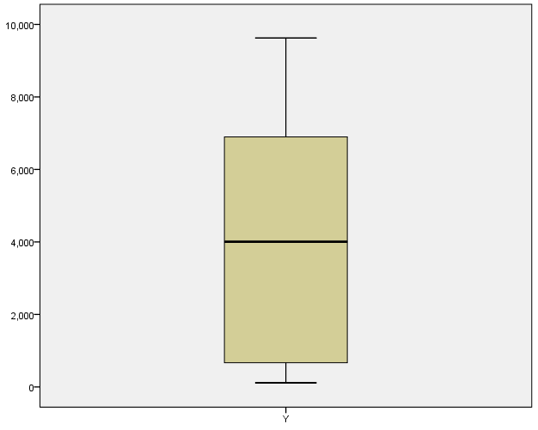
Figure 1: Box Plot of Dependent Variable (Y).

The dataset was right-skewed, with a skewness coefficient above zero and no outliers.
b- Detecting outliers of the independent variable X₁
Figure 2 illustrates that the data are right-skewed, with a skewness coefficient higher than zero, and that there are no outliers, whereas there are outliers in sequences 20, 2, and 1.
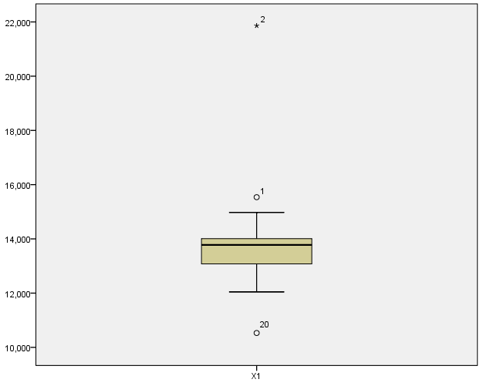
Figure 2: Box Plot of Independent Variable (X₁).
C. Detecting outliers for the independent variable X₂
Figure 3 shows the absence of outliers. The data were slightly skewed to the right, and the skewness coefficient was less than 3.
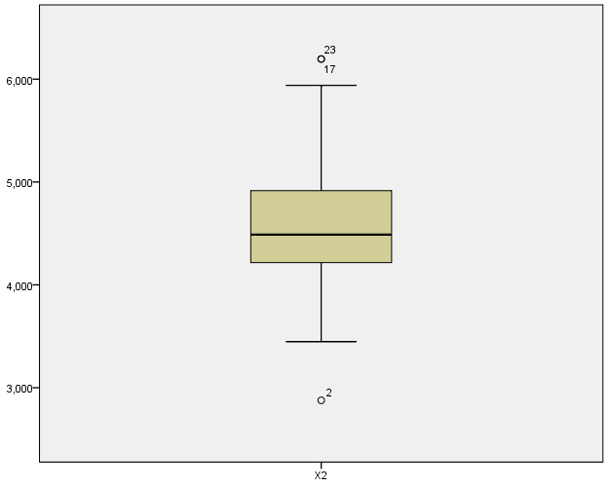
Figure 3: Box Plot of Independent Variable (X₂).

D. Detecting outliers for the independent variable X₃
Figure 4 shows the presence of abnormal values ​​in Sequences 2, 17, and 23. The data were skewed to the right because the mean was greater than the median, the skewness coefficient was less than zero, and there were no outliers.
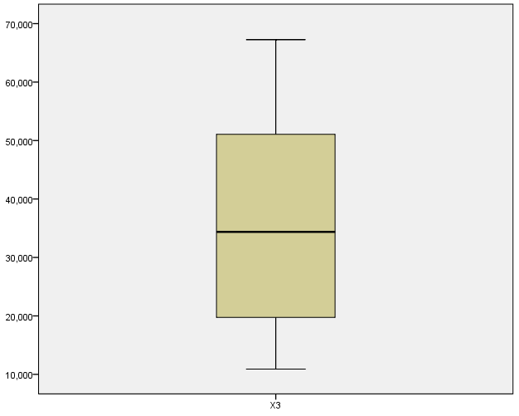
Figure 4: Box Plot of Independent Variable (X₃).

E. Detecting outliers for the independent variable X₄
Figure 5 shows the presence of outliers for independent variable X₄. The data are skewed towards, the skewness coefficient is less than zero, and there are no outliers.

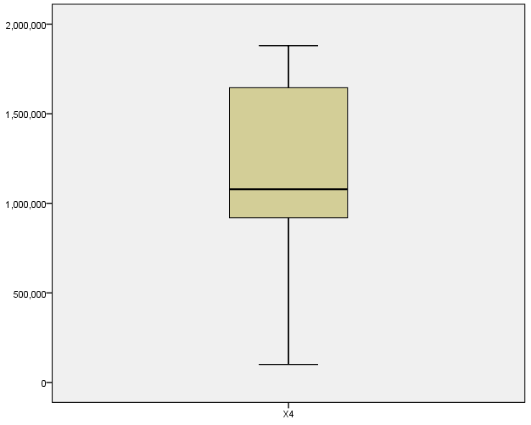
Figure 5: Box Plot of Independent Variable (X₄).
F. Detecting outliers of the independent variable X₅
Figure 6 shows that there are no outliers in which the data are skewed to the right, and the skewness coefficient is greater than zero.

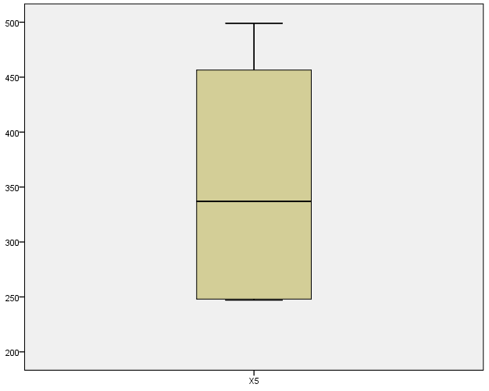
Figure 6: Box Plot of Independent Variable (X₅).
3.2.1. Grubbs' Outlier Test
The NCSS (12) program was used to test for outliers using the Grubbs' outlier test, as shown in the table below.
Table 2: Grubbs’ Outlier Test.
 | N | Result | Outlier
Y | 27 | No | 0
X1 | 27 | YES | 2 , 20
X2 | 27 | No | 0
X3 | 27 | No | 0
X4 | 27 | No | 0
X5 | 27 | No | 0
3.2.2. Tests of Normality
Statistical tests were performed using SPSS (version 23), to examine the extent to which the data conformed to a normal distribution using the Kolmogorov-Smirnov and Shapiro-Wilk tests. These tests aim to verify the null hypothesis, which states that the data follows a normal distribution, against the alternative hypothesis, which assumes that the data do not. The Shapiro-Wilk test was more appropriate for small samples (n < 50), while the Kolmogorov-Smirnov test was used for larger samples. The results of both tests were interpreted on the basis of the probability value (Sig.), where a value less than the accepted significance level 0.05 indicates that the null hypothesis is rejected, indicating that the data do not follow a normal distribution.
Table 3: Results of Normality Tests (Kolmogorov–Smirnov and Shapiro–Wilk.
Tests of Normality
 | Kolmogorov-Smirnova |  |  | Shapiro-Wilk
 | Statistic | Df | Sig. | Statistic | df | Sig. | Normality
Y | .177 | 27 | .029 | .888 | 27 | .007 | No
X1 | .270 | 27 | .000 | .671 | 27 | .000 | No
X2 | .223 | 27 | .001 | .921 | 27 | .041 | No
X3 | .134 | 27 | .200* | .935 | 27 | .092 | Yes
X4 | .131 | 27 | .200* | .924 | 27 | .051 | No
X5 | .223 | 27 | .001 | .834 | 27 | .001 | Yes

The table shows the distribution of variables as follows:
Y: does not follow the normal distribution because 0.05>sig
X1: does not follow the normal distribution because 0.05>sig
X2: does not follow the normal distribution because 0.05>sig
X3: follows the normal distribution because 0.05<sig
X4: does not follow the normal distribution because 0.05>sig
X5: follows the normal distribution because 0.05<sig

3.3 Estimation methods
3.3.1. Least Squares Method (OLS)
The OLS method is important and commonly used method when conditions are met to test the following statistical hypotheses:
$$H_{0}=β_{0}=β_{1}=β_{2}=β_{3}=β_{4}=β_{5}=0$$
$$H_{1}=At least one of them not equal zero$$
Using the REVIEWS program (12), the results of estimating the parameters of the multiple linear regression model using the (OLS) method are as follows:
Table 4: OLS Estimation Results.
Prob. | t-Statistic | Std. Error | Coefficient | Variable
0.6840 | -0.412774 | 6273.187 | -2589.411 | C
0.1113 | 1.662366 | 0.288133 | 0.478983 | X1
0.0492 | 2.088127 | 0.585344 | 1.222273 | X2
0.0708 | 1.902940 | 0.025164 | 0.047885 | X3
0.0644 | 1.952198 | 0.001143 | 0.002232 | X4
0.0000 | -5.254546 | 5.457831 | -28.67842 | X5
3926.704 | Mean dependent var |  | 0.691587 | R²
3303.861 | S.D. dependent var |  | 0.618156 | Adjusted R²
18.27396 | Akaike info criterion |  | 2041.574 | S.E. of regression
18.56192 | Schwarz criterion |  | 87528491 | Sum squared resid
18.35959 | Hannan-Quinn criter. |  | -240.6985 | Log likelihood
2.603814 | Durbin-Watson stat |  | 9.418109 | F-statistic
 |  |  | 0.000080 | Prob(F-statistic)
From the SPSS program (version 23), OLS results can be obtained using the following tables. We conclude from the table below that there is no influential multicollinearity, because the VIF is less than 10.
Table 5: Regression Coefficients.
Coefficients
Model |  | Unstandardised Coefficients |  |  | Standardised Coefficients | t | Sig. | Collinearity Statistics
 |  | B | Std. Error | Beta |  |  |  | Tolerance | VIF
1 | (Constant) | -2589.411- | 6273.187 |  |  | -.413- | .684
1 | X1 | .479 | .288 | .270 |  | 1.662 | .111 | .557 | 1.796
1 | X2 | 1.222 | .585 | .320 |  | 2.088 | .049 | .626 | 1.597
1 | X3 | .048 | .025 | .257 |  | 1.903 | .071 | .802 | 1.247
1 | X4 | .002 | .001 | .331 |  | 1.952 | .064 | .511 | 1.955
1 | X5 | -28.678- | 5.458 | -.879- |  | -5.255- | .000 | .525 | 1.903
- Dependent Variable: Y

Table 6: OLS Model Summary.
Model Summary
Model | R | R Square | Adjusted R Square | Std. Error of the Estimate | Durbin-Watson
1 | .832a | .692 | .618 | 2041.57375 | 2.604
a. Predictors: (Constant), X5, X3, X2, X1, X4
- Dependent Variable: Y

Interpretation. X₂ and X₅ are statistically significant; other coefficients are not. The R² (~0.69) indicates moderate fit, yet sensitivity to outliers remains visible.
Table 7: ANOVA Results (OLS Model).
Model | Sum of Squares | df | Mean Square | F | Sig.
Regression | 196,274,496.888 | 5 | 39,254,899.378 | 9.418 | .000ᵇ
Residual | 87,528,490.741 | 21 | 4,168,023.369
Total | 283,802,987.630 | 26
The formula estimated using the OLS method in the presence of outliers is as follows:
Y=-2589.411 + 0.47898 * X1 + 1.2223 * X2 + 0.0478853 * X3 + 0.002232 * X4 - 28.67842 * X5
From the above tables you can conclude the following:
1. The coefficients are not significant except for the coefficient of the independent variable X5, X2
2. The coefficient of determination R2 = 0.692
3. The significance of F and the validity of the model for regression
4. MSE = Mean square error equals 4168023.369.

3.3.2. Robust Estimation: M-Estimator
Using the EVIEWS (12) program, the results of estimating the parameters of the multiple linear regression model using the M-method (weight=Bi square), Huber’s Method function, and a distance of 0.5 are obtained to test the statistical hypotheses.
H0: B0=B1=B2=B3=B4=B5 =0
H1: At Least one of them not equal to zero
Using the Huber’s Method function, the results were obtained in the following table:
Table 8: M-Estimation Results (Tukey’s Biweight).
Variable | Coefficient | Std. Error | z-Statistic |  | Prob.
C | 913.2237 | 5817.965 | 0.156966 |  | 0.8753
X1 | 0.410901 | 0.267224 | 1.537662 |  | 0.1241
X2 | 0.831661 | 0.542868 | 1.531977 |  | 0.1255
X3 | 0.029859 | 0.023338 | 1.279437 |  | 0.2007
X4 | 0.002233 | 0.001060 | 2.106659 |  | 0.0351
X5 | -30.36402 | 5.061776 | -5.998688 |  | 0.0000
 | Robust Statistics
R² | 0.598913 | Adjusted R² |  |  | 0.503416
Rw-squared | 0.827048 | Adjust Rw-squared |  |  | 0.827048
Akaike info criterion | 50.97072 | Schwarz criterion |  |  | 60.15749
Deviance | 59398162 | Scale |  |  | 1212.802
Rn-squared statistic | 51.80716 | Prob (Rn-squared stat.) |  |  | 0.000000
 | Non-robust Statistics
Mean dependent var | 3926.704 | S.D. dependent var |  |  | 3303.861
S.E. of regression | 2171.799 | Sum squared resid |  |  | 99050936
Interpretation. M-estimation identifies X4 and X5 as significant, but overall fit is lower than OLS, consistent with robustness–efficiency trade-offs.
    - Robust Estimation: S-Estimator
Using the EVIEWS (12) program, the results of estimating the parameters of the multiple linear regression model using the S-method and convergence of 0.5 are used to test the statistical hypotheses.
H0: B0=B1=B2=B3=B4=B5 =0
H1: At Least one of them not equal zero
Using the Huber’s Method function, the results were obtained in the following table:

Table 9: S-Estimation Results.
Variable | Coefficient | Std. Error | z-Statistic | Prob.
C | 3616.988 | 3615.134 | 1.000513 | 0.3171
X1 | 0.374266 | 0.166046 | 2.253981 | 0.0242
X2 | 0.240306 | 0.337324 | 0.712389 | 0.4762
X3 | 0.034551 | 0.014502 | 2.382596 | 0.0172
X4 | 0.002230 | 0.000659 | 3.385633 | 0.0007
X5 | -30.21938 | 3.145257 | -9.607920 | 0.0000
 | Robust Statistics
R² | 0.713148 | Adjusted R² |  | 0.644849
Scale | 1416.666 | Deviance |  | 2006942.
Rn-squared statistic | 118.0324 | Prob (Rn-squared stat.) |  | 0.000000
 | Non-robust Statistics
Mean dependent var | 3926.704 | S.D. dependent var |  | 3303.861
S.E. of regression | 2404.415 | Sum squared resid |  | 1.21E+08
Interpretation. S-estimation flags X₁, X₃, X₄, and X₅ as significant; efficiency is slightly reduced relative to M-estimation.
Robust Estimation: MM-Estimator
The EVIEWS (12) program was used to, estimate the parameters of the multiple linear regression model using the -MM method and convergence 0.5, to test the following statistical hypotheses:
H0: B0=B1=B2=B3=B4=B5 =0
H1: At Least one of them not equal zero
Using the Huber’s Method function, the results were obtained in the following table
Table 10: MM-Estimation Results.
Variable | Coefficient | Std. Error | z-Statistic | Prob.
C | 768.9495 | 6269.357 | 0.122652 | 0.9024
X1 | 0.407696 | 0.287957 | 1.415821 | 0.1568
X2 | 0.913550 | 0.584987 | 1.561658 | 0.1184
X3 | 0.031298 | 0.025148 | 1.244535 | 0.2133
X4 | 0.002037 | 0.001142 | 1.782988 | 0.0746
X5 | -29.99152 | 5.454499 | -5.498493 | 0.0000
 | Robust Statistics
R² | 0.626314 | Adjusted R² |  | 0.537341
Rw-squared | 0.794720 | Adjust Rw-squared |  | 0.794720
Akaike info criterion | 43.63007 | Schwarz criterion |  | 53.02312
Deviance | 66727022 | Scale |  | 1416.666
Rn-squared statistic | 46.12346 | Prob (Rn-squared stat.) |  | 0.000000
 | Non-robust Statistics
Mean dependent var | 3926.704 | S.D. dependent var |  | 3303.861
S.E. of regression | 2123.653 | Sum squared resid |  | 94707955

From the above table, we conclude that:
- The coefficient of determination is R2=0.626314
- The standard error of the regression was 2123.653.
- Significance of regression coefficient X₅.
3.3.4. Robust Estimation: Huber's-Estimator
The NCSS (12) program was used to estimate the parameters of the multiple linear regression model using the Huber's method to test the following statistical hypotheses:
H0: B0=B1=B2=B3=B4=B5=0
H1: At Least one of them does not equal zero.

Table 11. Huber’s Method Results.
Item | Value | Item | Value
Dependent Variable | Y | Number Processed | 27
Number of Independent Variables | 5 | Number Used in Estimation | 27
Weight Variable | None | Number Filtered Out | 0
Robust Method | Huber’s Method | Number with X’s Missing | 0
Tuning Constant | 1.345 | Number with Weight Missing | 0
MAD Scale Factor | 0.6745 | Number with Y Missing | 0
 |  | Sum of Robust Weights | 24.001
Iterations | 20
Max % Change in any Coefficient | 0.001
R² after Robust Weighting | 0.7755
S using MAD | 1204.712
S using MSE | 1533.838
Completion Status | Normal Completion

Table 12: Regression Coefficients (Fixed Weights).
Regression Standard Standard- T-Statistic Reject
Independent Coefficient Error ized to Test Prob H0 at
Variable b(i) Sb(i) Coefficient H0: β(i)=0 Level 5%?
Intercept -1637.25 5162.525 0.0000 -0.317 0.7543 No
X1 0.4592683 0.2247395 0.2888 2.044 0.0537 No
X2 1.068331 0.4886983 0.2925 2.186 0.0403 Yes
X3 0.03954342 0.01991889 0.2294 1.985 0.0603 No
X4 0.002384397 0.000931958 0.3671 2.558 0.0183 Yes
X5 -29.2425 4.415265 -0.9571 -6.623 0.0000 Yes

The same decision is made assuming random weights, and the estimated equation is as follows:
Y =-1637.24993 + 0.4593* X1 + 1.068331 * X2 + 0.039543 * X3 + 0.0023843972 * X4 - 29.2425 * X5.

3.4. Comparison of results of robust methods
Comparison of results of robust methods
Table 13 Summary of Robust Methods.
R² | S.E. REG | MSE | Method | NO
.6920 | 2041.574 | 4.17× 10³ | OLS | 1
0.598913 | 2171.799 | 4.72 × 10³ | M | 2
0.713148 | 2404.415 | 5.76 × 10³ | S | 3
0.626314 | 2123.653 | 4.51 × 10³ | MM | 4
0.7755 | 1533.421 | 2.35 × 10³ | HUBER’S METHOD | 5
Summary. Aggregate metrics confirm the ranking led by Huber’s Method, followed by MM and M; S shows robustness with some efficiency loss, and OLS is most affected by contamination.

3.5. OLS Method after Removing Outliers
Outliers were identified using the Grubbs Outlier Test (2, 20), representing a 7% contamination rate. After removing these outliers and applying the OLS method using EVIEWS (12), the following results were obtained.
Table 14: OLS Results After Outlier Removal.
Dependent Variable: Y
Method: Least Squares
Sample: 1 25
Included observations: 25
Variable | Coefficient | Std. Error | t-Statistic | Prob.
C | 2114.350 | 11432.92 | 0.184935 | 0.8552
X1 | 0.221109 | 0.657726 | 0.336172 | 0.7404
X2 | 1.024510 | 0.666734 | 1.536609 | 0.1409
X3 | 0.052133 | 0.027061 | 1.926517 | 0.0691
X4 | 0.002056 | 0.001209 | 1.700516 | 0.1053
X5 | -29.08677 | 5.690520 | -5.111443 | 0.0001
R² | 0.682312 | Mean dependent var |  | 4031.360
Adjusted R² | 0.598709 | S.D. dependent var |  | 3341.277
S.E. of regression | 2116.616 | Akaike info criterion |  | 18.35859
Sum squared resid | 85121173 | Schwarz criterion |  | 18.65112
Log likelihood | -223.4823 | Hannan-Quinn criter. |  | 18.43972
F-statistic | 8.161403 | Durbin-Watson stat |  | 2.627983
Prob(F-statistic) | 0.000296
From the table above, we conclude that:
The coefficient of determination is (R2=0.682312), the standard error of the regression was 2116.616, the mean squared error is (MSE=4053389.19), and the significance of the regression coefficient was X5.
However, a drawback of this method is the loss of values ​​or observations, which may have affected the sample size.
This shows an improvement in the coefficient of determination compared with the robust M, S, and MM methods, as it approaches the OLS method before deleting outliers, with a slight improvement.
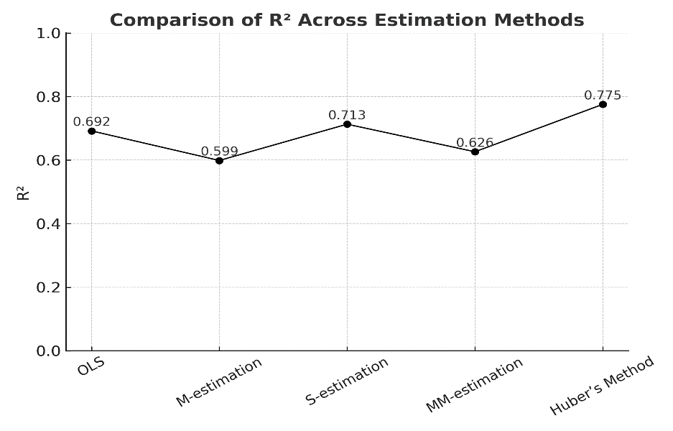

Figure 7. Comparison of R² across estimation methods.
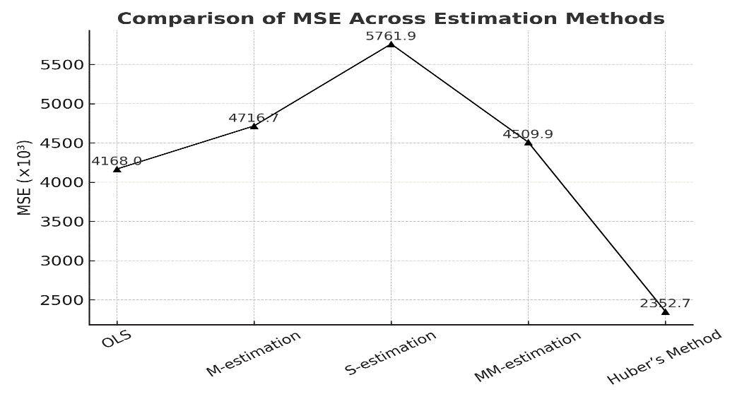

Figure 8. Comparison of MSE across estimation methods.
- Discussion and Conclusions
  - Discussion of Results
This study compared multiple robust estimators against OLS under contamination. While OLS is efficient under classical assumptions, it is highly sensitive to outliers. Robust methods, particularly Huber’s Method, achieved superior performance once contamination exceeded ~7%, aligning with theory that balances efficiency and resistance via bounded influence. In contrast, S- and MM-estimators reflect different robustness–efficiency trade-offs.
From a theoretical standpoint, breakdown points and influence functions explain the observed ranking: Huber’s ψ limits the effect of large residuals without overly sacrificing efficiency, whereas MM elevates resistance at some cost in precision. These properties are consistent with modern robust-statistics literature and with our empirical results.
4.2 Limitations of the Study
Limitations. The sample is relatively small (n = 27) and specific to agricultural investment data in Iraq, potentially limiting generalizability. Estimators were run with standard defaults without sensitivity analysis for tuning constants. No Monte-Carlo simulations, bootstrap intervals, or formal forecast-accuracy tests (e.g., Diebold–Mariano) were conducted; these are important avenues for future validation.
4.3 Conclusions
.1 The presence of outliers (2.20) in the data and other extreme values, ​​according to the Grubbs outlier tests and box plots.
2. The variables Y, X1, X2, and X4 deviate from the assumption of a normal distribution of the data owing to the presence of outliers or extreme values.
3. The robust (Huber's method) is superior to other robust methods in cases where outliers of 7% or more are present, such as the OLS method.
4. The OLS method, after removing outliers that do not significantly affect the sample data, is considered a method comparable to robust methods.
Overall, robust regression provides clear advantages in contaminated datasets. Among the estimators considered, Huber’s Method consistently yielded the most reliable results at contamination levels ≥ 7%. In contrast, OLS performed poorly under contamination and should not be regarded as robust, even if it appears competitive after manual outlier removal.

4.4 Recommendations and Future Work
- Other statistical methods were used in cases in which outliers or extreme values ​​ were present in the analysis.
- The robust (Huber's method) was adopted in cases where outliers or extreme values ​​ were present, as it has proven to be superior in the analysis.
- Comparing robust methods using simulation.
- Using other robust methods in analysis.

AI Declaration Statement
The authors acknowledge that they did not use generative AI techniques such as (e.g., ChatGPT, Copilot, etc.) or text-to-image conversion while writing or editing the article.

References:
[1] Maronna, R. A., Martin, R. D., Yohai, V. J., & Salibián-Barrera, M. (2019). Robust Statistics: Theory and Methods (with R). Wiley.
[2] Koller, M., & Stahel, W. A. (2017). Sharpening Wald-type inference in robust regression for small samples. Computational Statistics & Data Analysis, 113, 38–55.
[3] Copt, S., & Victoria-Feser, M. P. (2015). High-breakdown inference for generalized linear models. Journal of the American Statistical Association, 110(510), 1071–1081.
[4] Draper, N. R., & Smith, H. (1981). Applied regression analysis. John Wiley & Sons.
[5] Kazem, A. H., & Musal, B. S. (2002). Advanced econometrics: Theory and application. Dunya Al Amal Library.
[6] Bickel, D. R. (2002). Robust and efficient estimation of the mode of continuous data. Retrieved from http://www.mcg.edu/research/biostat/bickel.html
[7] Ali, F. A. (2000). Rigid estimation in simultaneous equation models (Unpublished doctoral dissertation). University of Baghdad.
[8] Nancy, N. G. (2001). Evaluating the efficiency of outlier estimation methods for regression models (Unpublished doctoral dissertation). College of Administration and Economics, University of Baghdad.
[9] Chatterjee, S., & Hadi, A. S. (1990). Sensitivity analysis in linear regression. Journal of the Royal Statistical Society: Series A (Statistics in Society), 153(1). https://doi.org/10.2307/2983106.
[10] Rocke, D. M. (1996). Robustness properties of S estimators of multivariate location and shape in high dimension. The Annals of Statistics, 24(3), 1327–1345.
[11] Yuliana, S., Hasih, P., Sri Sulistijowati, H., & Twenty, L. (2014). M estimation, S estimation, and MM estimation in robust regression. International Journal of Pure and Applied Mathematics, 91(3), 349–360.
[12] Willis, A. J., Brich, J. B., & Woodall, W. H. (2007). High breakdown estimation methods for Phase I multivariate control charts. Department of Statistics, Virginia Polytechnic Institute and State University, 23(5), 615–629.
[13] Chen, C. (2002). Robust regression and outlier detection with the Robust reg procedure. In Proceedings of the Twenty-Seventh Annual SAS Users Group International Conference. Cary, NC: SAS Institute.
[14] Ismail, M. I., & Rasheed, H. A. (2021). Robust regression methods/a comparison study. Turkish Journal of Computer and Mathematics Education, 12(14), 2939-2949.‏

Source: Ministry of Planning - Central Statistical Agency for the period 1990-2016 https://mop.gov.iq/en/central-statistical-organization .

X₅ | X₄ | X₃ | X₂ | X₁ | Y | YEAR
337 | 992510 | 12309 | 3447.8 | 15538 | 739 | 1990
499 | 1195300 | 10901 | 2877.2 | 21862 | 152 | 1991
468 | 1425006 | 11143 | 3531.9 | 14976 | 116 | 1992
432 | 1443675 | 41141 | 3492.4 | 13799 | 116 | 1993
490 | 1610201 | 51143 | 3741 | 13779 | 1185 | 1994
415 | 1630560 | 12959 | 4188.2 | 12907 | 599 | 1995
445 | 1660345 | 16000 | 4498.3 | 12780 | 341 | 1996
489 | 1710310 | 54207 | 4133.8 | 12958 | 345 | 1997
496 | 1770511 | 45000 | 4475.1 | 14131 | 341 | 1998
489 | 1810305 | 59800 | 5188.3 | 13778 | 7631 | 1999
496 | 1850561 | 54379 | 4589 | 13622 | 1012 | 2000
331 | 1878000 | 27914 | 4644 | 13130 | 6791 | 2001
320 | 1880351 | 14682 | 5432.6 | 13545 | 4841 | 2002
300 | 170150 | 13495 | 5850.3 | 13545 | 2131 | 2003
389 | 1078112 | 32319 | 4521 | 13137 | 1489 | 2004
359 | 100319 | 23500 | 5939.6 | 13964 | 4811 | 2005
349 | 910256 | 62475 | 6195.9 | 13448 | 3329 | 2006
249 | 902781 | 33836 | 4479.7 | 13843 | 4007 | 2007
247 | 870613 | 33077 | 4244 | 14239 | 5166 | 2008
248 | 982674 | 67263 | 4488.2 | 10531 | 5085 | 2009
248 | 809169 | 50549 | 4510 | 12043 | 9551 | 2010
248 | 710123 | 56512 | 5939.6 | 13023 | 6025 | 2011
247 | 928314 | 28981 | 6195.9 | 12743 | 9556 | 2012
247 | 1180570 | 39765 | 4479.7 | 14055 | 7011 | 2013
247 | 939669 | 34373 | 4244 | 14902 | 9627 | 2014
249 | 1016184 | 45442 | 4488.2 | 13900 | 7017 | 2015
248 | 1017185 | 50977 | 4510 | 13900 | 7007 | 2016
354.89 | 1202732 | 36449.7 | 4604.65 | 13854.7 | 3926.7 | MEAN
499 | 1880351 | 67263 | 6195.9 | 21862 | 9627 | MAX
247 | 100319 | 10901 | 2877.2 | 10531 | 116 | MIN
Appendix 1, Table 1. Agricultural Investment Data (1990–2016).

