Modeling Risk Factors Associated with Snakebite Morbidity Using a
Logit Binary Model in
Chemalingot, Baringo County, Kenya

Abstract
The public health problem of snake envenomation affects Chemalingot within Baringo County due to regular human-snake encounters. The area maintains high snakebite rates with major medical consequences which strain healthcare institutions. A logit binary model from this study evaluated snakebite morbidity risk factors in Chemalingot to determine major contributing elements in severe health results. The study employed a retrospective design, where past medical records from Chemalingot district hospital was selected using purposive sampling scheme. A total of 266 snakebite cases were analyzed. The findings reveal an overall morbidity prevalence of 30.0% due to snakebites. The average age of the study participants was 19.26 years, with a standard deviation of 15.30 and the length of hospital stay was 4 days. Morbidity rates varied significantly based on the timing of the bite, with the highest rates occurring in the evening 38.2% and night 26.3%. At the multivariate level, both the duration and timing of hospital visits were identified as strong significant factors affecting morbidity.Helps in designing appropriate intervention measures to optimize treatment outcomes in the county and get the required health policies that tailored to lower snake morbidity incidence in the region.
KEYWORDS: Snakebite, Risk Factors, Morbidity, Optimize Outcomes, Global health security,

Introduction
Snakebite is a neglected tropical disease that affects 4.4 to 5.3 million people globally, with 2.5 million people having documented clinical cases and mortality cases ranging from 81,000 to 138,000 yearly. It is a major problem in many parts of the world, especially affecting those living in country sides and villages. Snakebite incidence has not been seriously considered as an agent of human disease, causing humanitarian and therapeutic challenges. Diagnosis, treatment, and prevention of snakebite incidence are needed, especially in rural areas like Chemalingot.

According to WHO, each year, about 5 million snakebites occur, with 1.5% of these being envenomings, which lead to death if not treated earlier. In Africa, up to 32,000 deaths occur annually due to snakebite incidents, but the actual number of deaths remains unknown. To reduce morbidity and mortality due to snakebite envenoming by 50% by 2030, the WHO launched a global snakebite strategy for prevention and control in 2019.

Snakebite poses a significant threat in developing countries due to delayed access to healthcare, inadequate antivenom availability, and limited awareness. Strategies include prevention, education, and improved healthcare. Research has shown that locals seek medication from hospitals, and there are hundreds of thousands of bites every year. To reduce the extent of snakebite incidence in Chemalingot, much work is needs to be done.

SNAKEBITE MORBIDITY
Snakebite morbidity is the extend of which snakebite incidence have been observed within a region or a place. In this it has come to our concern that snakebite incidence in Chemalingot has gone far and it needs an immediate solution to reduce. An important area of emphasis in snakebite research over the past several decades has been the issue of effect of venom to the patient bitten by snake and also the dangerous snakes that exist. Millions of snakebite incidence are reported every year, leading to over 1.8 million envenoming with up to 94,000 deaths Larson, P. S et al .,2022. Many snakebite patience has been seeking medication at Chemalingot health center and others luckily were treated well. It is these kind of questions that have increased understanding of the processes and problems of snakebite extend of distribution and have led to the development of strategies designed to minimize the rate of morbidity due to snakebite within Chemalingot and Baringo County At Large. At the same time awareness among the locals have not been emphasized as expected on how to take care of themselves against the dangerous snakes in the terrains.

HIGH MORTALITY RATE
Mortality rate is when the number of patients dying is high due to snakebite incidence. Most people are dying due to many risk factors associated with snakebite incidence for example time taken to seek medication in hospitals, lack of ante venom in the health center, distance to the hospital and also the landscape of the community and many other factors. All this as contributed to the rate of innocent people dying due to lack of care and medication within the hospitals. As we expect in our research to know the causes and how to reduce or take precaution to lower the rate of morbidity and avoid mortality at all in Chemalingot.In Baringo County there has been a study done and it has shown that many people were highly reported ,this study was done on the snakebite reports in the inpatient files at the sub county hospital in Chemalingot.Also most of the cases are not reported in the hospital .Male victims are accounting to 57.7% between January and October this year and the age of those affected is around 17 years.This gives us an overview of the snakebite challenge in Chemalingot.

Materials and Methods
This section outlines the research methodology, detailing the study site, study design, data collection processes, sampling techniques, and approaches for data management and analysis.
These methods are utilized to meet the specific objectives established in Chapter One.

Study Site and sampling
The study focuses on Chemalingot in Baringo County, Kenya. Located in Western Pokot, Chemalingot is one of six areas within Baringo County, situated in the northwest region of Kenya. The population exceeds 130,000, spread over an area of 4,500 square kilometers. According to county statistics, an estimated 85% of the residents live below the poverty line. Healthcare provision in this area is limited, leading many individuals to rely on traditional remedies rather than seeking medical treatment. Chemalingot is particularly prone to snakebites, with most cases occurring here, making it a representative location for the study. I selected this area randomly for data collection, as the local population has experienced snakebites for an extended period. This choice will facilitate accurate data gathering for analysis, especially since the area shares borders with other affected regions. Common venomous snakes in Chemalingot include the black mamba, eastern green mamba, red spitting cobra, James Ashe spitting cobra, puff adder, and boom slang.

STUDY DESIGN
A logit binary model from this study evaluated snakebite morbidity risk factors in Chemalingot to determine major contributing elements in severe health results .The study also employ a retrospective design, retrieving past medical records from selected health facilities in Chemalingot health center, Baringo County. This design is appropriate because the target population consists of individuals who have experienced snake bites in the study area, drawn from various environmental strata. Additionally, the study population specifically comprises those affected by snake bites in Chemalingot, Baringo County.

DATA COLLECTION
After identifying the area of study as mentioned above, our data sources are limited to two that which has provided reliable variables for our study. Our targeted period spans from 2018 to 2024, covering the last six years to gather the necessary data. We collected relevant information on the socio-demographic factors of the study subjects, environmental variables, healthcare variables and other clinical parameters of interest in Chemalingot, Baringo County. Additionally, all risk factors associated with snakebites will be compiled for analysis. In this data collection, we will focus on different age groups among individuals who have experienced snakebite incidents. Data will be gathered from Chemalingot Health Center and confirmed at the County Referral Hospital (CRH) by specialized medical practitioners. The data to be collected will include;

Socio-demographic Factors: individuals
- Age - Occupation of snakebite victims
- Gender - Location of snakebite incidents
- Education levels and awareness of affected - Distance to healthcare facilities

Environmental Variables

- Climate and seasonal variations
- Presence of venomous snake species
Healthcare Access - Availability of antivenom and other medical resources - Time taken to reach healthcare

facilities

Conduct Geospatial Analyses
With the availability of data sources, we can conduct geospatial analyses to identify hotspots of snakebite incidents in the county. We will source the data from our hospital records, allowing us to save time and efficiently achieve our objectives.

Data Management
Data collected was managed with use of excel and R studio statistical packages. Data cleaning was performed by running descriptive statistics and checking for outliers.

Statistical Analysis
Data was analyzed using descriptive statistics, a logit binary model from this study used to evaluate snakebite morbidity risk factors in Chemalingot to determine major contributing elements in severe health results, including data exploration techniques such as graphical methods and the chi-square test. Means and standard deviations was computed under descriptive statistics. For skewed observations, nonparametric measures was also calculated. Additionally, frequency tables and bar graphs will be created for categorical variables to compare different grouping variables. To test for associations between categorical variables, the chi-square test was employed. The primary outcome of interest is morbidity status among the subjects. Subjects who developed physical disabilities after treatment for snake bites was classified as having morbidity and assigned a score of 1. Conversely, those who were similarly bitten but fully recovered was classified as non-morbid and assigned a score of 0.To model the outcome variable of interest, which is morbidity due to snake bites, a multivariate logistic regression model was conducted, using a significance level of 5%.

Additionally, to assess the model's performance based on the logit multivariate model of predicted factors, both ROC and cross-validation techniques was utilized, with a threshold of at least 60% considered indicative of a good model fit.

Model Development to Determine the Risk Factors Associated with Snakebite Morbidity in Chemalingot Baringo County
The study explored the use of multivariate logistic regression since it is a powerful tool when multiple independent variables are believed to influence a binary outcome. It also provides a more precise and thorough knowledge of how different factors contribute to the likelihood of an event, such as morbidity, and enables the modeling of complex relationships, adjustment for confounders.
The model was developed as shown in equation 3.1 based on the binary outcome morbidity subject the following explanatory variable: 𝑋₁ = Age in years, 𝑋₂ = Gender, 𝑋₃ = Duration of hospital stay, 𝑋₄ = Distance to hospital (> 10 𝑘𝑚), 𝑋₅ =Time to Hospital (> 12 hours), 𝑋₆ =Premedication (yes or no), 𝑋₇ = Snakebite activities (leisure) and 𝑋₈ = Snakebite activities (house chores. In this study, morbidity refers to the existence or occurrence of illness or problems brought on by the snake bite. It shows if the snake bite and subsequent treatment had a detrimental effect on the patient's health, such as a disease, ailment, or circumstance.
Let Morbidity be denoted with 𝑦 such that:
1 patient experienced morbidity
𝑦 = {
0 did not experienced morbidity Therefore, the model is given as
𝑝(𝑦 = 1) log (1 − 𝑝(𝑦 = 1))
= 𝛽0 + 𝛽1𝑋1 + 𝛽2𝑋2 + 𝛽3𝑋3 + 𝛽4𝑋4 + 𝛽5𝑋5 + 𝛽6𝑋6 + 𝛽7𝑋7 + 𝛽8𝑋8
where
i. 𝑝(𝑦 = 1) is the probability of morbidity (dependent variable) ii. 𝛽₀ is the intercept which represents the baseline log-odds of morbidity when all predictor variables are set to their reference categories or zero (for continuous variables).
iii. 𝛽₁, 𝛽₂, 𝛽₃, … , 𝛽₈ are the independent variable's corresponding coefficients.

Parameter Estimation in the Model
The parameters in model 3.1 was estimated using maximum likelihood method as follows:
- Define logistic model based on model 3.1
1

𝑝(𝑦 = 1|𝑿) = 1 + e−(𝛽₀+𝛽₁𝑋₁+𝛽₂𝑋₂+𝛽₃𝑋₃+𝛽₄𝑋₄+𝛽₅𝑋₅+𝛽₆𝑋₆+𝛽₇𝑋₇+𝛽₈𝑋₈)
which can be simplified as
1
𝑝(𝑦 = 1|𝑿) = 1 + 𝒆−𝑿𝜷, 3.2
where 𝑿 is the vector of independent variables (including an intercept), 𝜷 = (𝛽₁,𝛽₂,𝛽₃,… , 𝛽₈ )^{𝑇} is the vector of parameters to be estimated.
- Obtain likelihood function that represents the probability of observing the data given the parameter estimates. For 𝑛 independent observations (𝑦_{𝑖}, 𝑋_{𝑖}) where 𝑦_{𝑖} ∈ {1,0}, the likelihood of the entire dataset is:
𝑛 ^{𝑦𝑖} (1 − 𝑝(𝑦_{𝑖} = 1|𝑋_{𝑖}))1−𝑦_{𝑖}
𝐿(𝜷) = ∏ 𝑝(𝑦_{𝑖} = 1|𝑋_{𝑖})
𝑖=1
Substituting the logistic model for 𝑝(𝑦_{𝑖} = 1|𝑋_{𝑖}), the likelihood becomes:
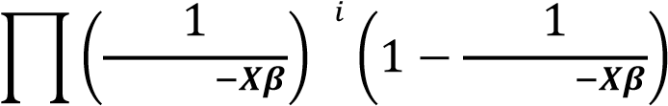
^{𝑛} 𝑦 1−𝑦_{𝑖}
𝐿(𝜷) =
𝑖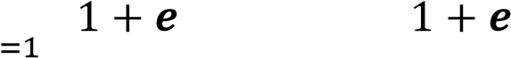
This likelihood function combines the probabilities for each observation 𝑖.
- Compute the log-likelihood function by taking the natural logarithm of the likelihood function since the likelihood function involves products, it can become numerically unstable for large datasets:
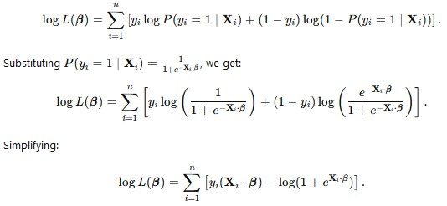
This is the log-likelihood function to maximize in order to estimate the parameters 𝛽.
- Determine the values 𝛽 that maximize the log-likelihood function. This was typically done by solving the following system of equations, which was derived by taking the partial derivatives of the log-likelihood function with respect to each parameter:

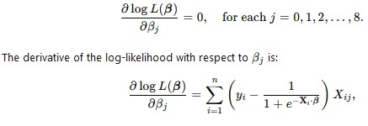 where 𝑋_{𝑖𝑗} is the 𝑗-th independent variable for the 𝑖-th observation.
The system of equations was solved using numerical optimization (Newton-Raphson) method

Results

Descriptive summaries of the snake bite thesis
The study analyzed the prevalence of snake bites among respondents, with a mean age of 19.26 years and a median age of 15.0 years. The gender distribution was slightly higher, with 137 males (51.5%) and 129 females (48.5%). The total number of patients was 266, with a higher prevalence of males in the field. The mean duration of hospital stay was 4.16 days, with a median duration of 3 days. The mean distance traveled to the hospital was 12.43 kilometers, with a standard deviation of 9.94 kilometers. The most common times for snake bites were evening to night (40.9% compared to 30.3%), while morning and afternoon bites were less frequent (40 cases (15.7%) and 33 cases (13.0%). The data suggests that males are likely doing more jobs in the field due to the higher number of male bitten patients.
Furthermore, the mean duration of hospital stay was 4.16 days, with the median duration also being 3 days. The mean distance traveled by the study respondents to the hospital was 12.43 kilometers, with a standard deviation of 9.94 kilometers. Similarly, the median distance to the nearest hospital was 10.0 kilometers, with the distance range spanning from 1 to 40 kilometers.
The most common times for snake bites were from evening to night (40.9% compared to 30.3%), while bites occurring in the morning and afternoon were less frequent, at 40 cases (15.7%) and 33 cases (13.0%), respectively.

Table 1: Descriptive summaries of socio-demographic factors and clinical measures of the study subjects
Factors of interest | N (%)
Mean age in years (SD) | 19.26 (SD=15.30)
Median age (IQR) | 15.00 (IQR=16.00)
Age range in years | 1-84
Gender
Male | 137 (51.5%)
Female | 129 (48.5%)
Mean duration of hospital stay | 4 days
Median duration of hospital stay | 3 days
Mean distance to the hospital in Kilometres  (SD) | 13.17 (SD=12.25)
Median distance to the hospital in Kilometres  (Range) | 10.00 (Range=1 - 70)
Time of snake bite
Morning | 40 (15.7%)
Afternoon | 33 (13.0%)
Evening | 104 (40.9%)
Night | 77 (30.3%)

Prevalence rate of morbidity due to snake bites among study subjects
Figure 1 ;below shows that the overall prevalence rate of morbidity from snake bites was 30%, while the proportion of those who fully recovered was 70%.
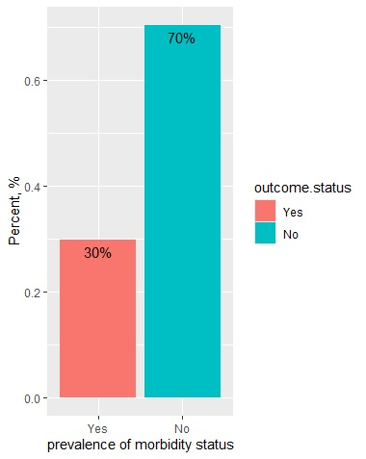

Figure 2: shows the overall prevalence rate of morbidity from snake bites stratified by gender. It is evident that morbidity rates varied between genders, with male subjects experiencing a morbidity rate of 14.7% and female subjects having a morbidity rate of 15.0%.
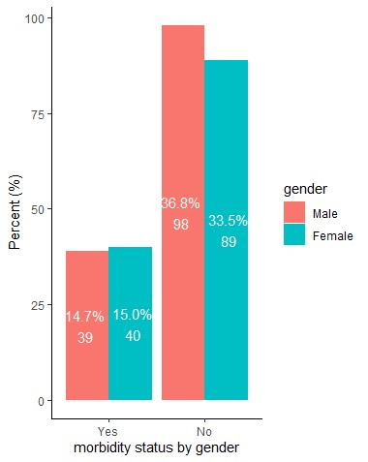
Figure 2: Figure showing morbidity status due to snake bites by gender of the study subjects
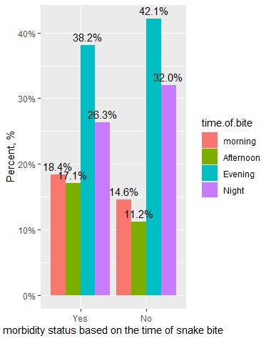
Figure 3 shows the prevalence rate of morbidity from snake bites stratified by the time of the bite. The data indicate that morbidity varied significantly based on the time of the bite, with the highest rates occurring in the evening and night (38.2% vs.26.3%). The prevalence rates for morning and afternoon bites were 18.4% and 17.1%, respectively.In addition to this a lot of activities took place during the morning ,afternoon and evening as shown below.Others were sleeping and even doing other activities. TABLE 2. Summary of activity during bite table(data$activity.during.bite

cooking | farming | Fetching firewood | herding | In house | Not record | playing | sleeping | Toilet visit | walking | Toilet visit | walking
1 | 1 | 8 | 57 | 30 | 6 | 11 | 88 | 6 | 58 | 6 | 58

This shows that only 1 person was bitten while cooking,meaning snakes don’t appear during active time when people are seeing.Also during farming one individual was bitten,suggesting that snakes don’t appear in areas were people sees them.Around 8 people were bitten while Fetching Firewood.The increase in number indicate the availability of snakes in bushy areas and also it indicate that peole fetching wood are not safe and need to have boots and be vigilant while fetching firewood.
The most affected people are those Herding animals 57 occurrences is a large number.This is an indication that young people are more active and enter into rocky areas bushy areas ,long grasses were snakes have habitation.Also the social life of this individuals is still low since the can enter bushy areas without shoes According to the study its clear that around 30 people were bitten In the House which is the worst ever and it indicate a lot .Snakes are seeking for resources to eat for example water.This as lead the animal to compete and find its habitation in peoples house.Also the environmental conditions can be hash making the snake to find a place to shelter in peoples houses 6 people did not record the place they were bitten .11 childern were bitten while Playing in the field which is a vibrant activity ,but it suggest that the place they were playing was not safe at all,maybe it was a bushy arear or rocky place were snakes exist.This has indicated vulnerability of children during recreational activities.The incidence that took place when sleeping is high totaling 88 which is wanting .It suggest that there is high risk of snakebite at night.Snakes like warm places and places were people dont see.Accoding to the data the number of those bitten while visiting toilet are 6 in number.This indicates that it is not safe to be out and people should be keen when working around toilets. 58 occurrences were bitten while walking which has made this also as an activity associated with snakebite. Sleeping (88 cases), Herding (57 cases), and Walking (58 cases) these are now the activities which has led to the rise of the snakebite incidences within Chemalingot .
Bites can occur in various contexts, home domestic activities (like cooking and being in the house) to outdoor activities (like herding and fetching firewood).

This information can be used to the targeted public health interventions and educational campaigns, particularly for those involved in high-risk activities like herding and sleeping outdoors.
As indicated and shown above we need to Increase the level of awareness about the risk of snakebites within chemalingot and also people should be informed to be keen when doing all risk activities.We need to explore preventive measures for individuals in agricultural or outdoor professions.

TABLE 3. IDENTIFICATION OF THE SUSPECTED SNAKES THAT HAS CAUSE THE BITE table(data$suspected.snake)
not identified | not seen | puff  adder | red spitting cobra | seen
2 | 124 | 76 | 32 | 32

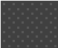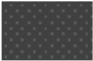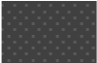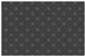

1
%
%
47
28
%
12
%
12
%
Distribution of suspected snake species
not identified
not seen
puff adder
red spitting cobra
seen

Interpretation:It is clear that 2 (1%)patients were bitten by the snake and the snake was not identified at all,this could be because of the environmental they were during the bite and they could have killed the snake beyond identification.
A large number of patients totaling, 122 (47%)individuals were bitten by the snake and the snakes were not seen by the victims. This shows a lot of uncertainty which indicate that the snakes were not seen even before the bite.
Puff Adder: there were 76 (28%) people who were bitten by what was suspected to be a puff adder, this shows that the most common snake species in this area of chemalingot is the puff adder.
32 (12%)patients were found to be bitten by the Red Spitting Cobra which was suspected because of the signs and others seen during the bite. 32 cases reported in our data shows that,they were able to see the snake that bit them,this shows high level of certainty in the identification of the snake species.
To explain more on this it is seen that most cases fall under the"not seen" which indicate that many patients are not aware of the kind of the snake which has bitten them and even lack the knowledge on how to handle the situation like this.Puff adder is the most frequent identified snake species in the dataset which may have raise the prevalences in the region.
According to the data The high number of "not seen" and "not identified" cases are totaling to 126 ,meaning we need to make a better snakebite awareness and education among the locals on how to identify and to prevent snakebite in the region.

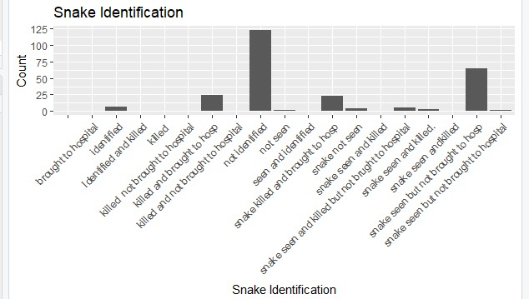

Figure 4: illustrates the number of morbidity cases due to snake bites from 2018 to 2024. It is evident that the number of morbidity cases drastically increased from 2018, reaching a peak in 2021. However, after 2021, there was a significant drop in the number of cases, reaching its lowest point in 2022 with around seven cases. Following this, the number of morbidity cases rose sharply in 2023 but did not exceed the levels observed between 2020 and 2021. From 2023 onwards, there was a substantial decline, continuing through the end of 2024.
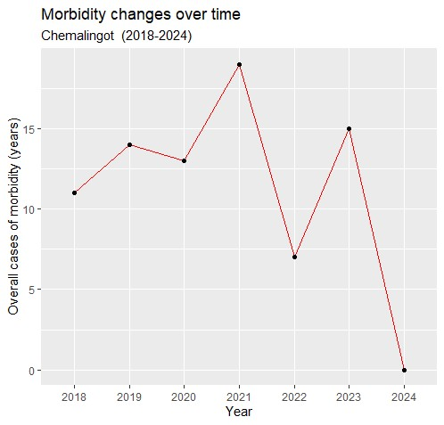
Figure 5: Figure showing trends on the cases of morbidity overtime

Figure 5: shows the number of morbidity cases due to snake bites from 2018 to 2024, stratified by gender. The graph indicates that in 2018, the number of morbidity cases was higher among males compared to females. In contrast, in 2019, the number of morbidity cases increased significantly among females, while it decreased among males. After 2019, the number of morbidity cases systematically increased until 2021, when it reached its peak. From 2021, there was a drastic drop in the number of cases through 2022. However, the number of cases then increased to a peak in 2023, before sharply declining to its lowest level in 2024.
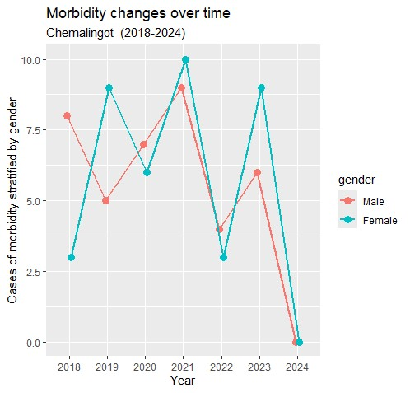
Figure 6: Figure showing trends on the cases of morbidity overtime stratified by gender
Determinants of factors associated with Morbidity due to Snake Bites among the study subjects in Chemalingot in Baringo County, Kenya.
This section will investigate the factors suspected of affecting morbidity resulting from snake bites among the study subjects. Table 4 presents the output from a multivariate regression model where morbidity status is the outcome variable of interest. Only the factors "duration of hospital stay" and "time taken to hospital" remained statistically significant. An increase in the duration of hospital stay by one unit was associated with a 0.090403 log unit increase in subject morbidity. Additionally, subjects who took more than 12 hours to reach the hospital had 1.102671 times the log odds of morbidity compared to those who took less than 12 hours. Although age remained statistically insignificant, it is clear that a one-unit increase in age decreases the likelihood of morbidity by -0.00285 log odds. A similar trend was observed for female gender, with a log odds of -0.01628.In additiotion to this we had to find the relationships and summary of distance to hospital.
summary(data$distance.to.hospital)
Min. 1st Qu. Median Mean 3rd Qu. Max.
1.00 3.00 10.00 13.17 18.00 84.00
The shortest distance to the hospital was 1 kilometer. This indicates that some individuals were relatively close to medical facilities as per the results .1st Quartile is 3.00, it is clear from the data that around 25% people are travelling to about 3 kilometers or less to reach the hospital were they seek medication,which gives an overview that most of the patients are around and not far from the hospital. The median distance is 10 kilometers, this is an indication that about 50% of those affected people travel about 10 kilometers or less.
The average distance to the hospital is approximately 13.17 kilometers. This shows that it is higher than the median, this may indicate that individuals may have travelled far distance making the average up to 3rd Quartile (3rd Qu.) 18.00.75% of patient are traveling 18 kilometers or less to be attended in the hospital at Chemalingot , this shows that distance to the hospital is a factor that has lead to increase in mobidity.
The longest distance travelled to the hospital was 40 kilometers, others are traveling from far to seek medication.This may affect the patient since the venom would spread further to the all body,showing a risk for timely treatment. Travel Distance Variability The distances to the hospital is changing with some patients are located close to hospital while others are far away.
The access to care in this area is low ,meaning that the presence of people walking over 10 kilometers to seek medication have challenges in accessing timely medical care, especially in areas which are far from the road or underserved areas. The longer the distances traveled by the patient will affect the outcome for the snakebite victims since delays in reaching hospital and late receiving of antivenom and treatment can lead to more death and even paralys the patient.
We need to study ways on how to improve access to medical facilities for snakebite victims,the place to be assisted first is remote areas by giving them mobile clinics or help community health workers with mortobikes for easy assistance. Emergency Response should be administered and Implemented to assist and to save those who are affected.

Table 4: Multivariate analysis of factors associate with snake bite morbidity among study subjects
Call:
glm(formula = morbidity ~ age.years + gender + Duration.of.Hosp.stay + hosp.time.ct2 + hosp.dist.ct + pre.med + bite.activity.ct, family = "binomial", data = snakebite.2)
Coefficients:

Estimate Std. Error z value Pr(>|z|)
(Intercept) -1.32218 0.441008 -2.998 0.00272 **
Age.years -0.00285 0.010165 -0.280 0.77937
Female gender -0.01628 0.306084 -0.053 0.95760
Duration of Hospital stay 0.09040 0.032402 2.790 0.00527 **
Time to hospital(>12 hours) 1.10267 0.516351 2.136 0.03272 *
Distance to hospital(>10 km) -0.54838 0.515963 -1.063 0.28786
Pre.medication (Yes vs. No*) -0.02613 0.329234 -0.079 0.93673
Snake bite activity (Leisure) -0.03344 0.361251 -0.093 0.92625
Snake bite activity (House cores) -0.30013 0.479612 -0.626 0.53146

---
Signif. codes: 0 ‘***’ 0.001 ‘**’ 0.01 ‘*’ 0.05 ‘.’ 0.1 ‘ ’ 1
(Dispersion parameter for binomial family taken to be 1) Null deviance: 290.80 on 238 degrees of freedom Residual deviance: 275.22 on 230 degrees of freedom
(27 observations deleted due to missingness)
AIC: 293.22
Number of Fisher Scoring iterations: 4
The reference categories are: male gender, no pre-medication after the snake bite, time taken to hospital (≤12 hours), distance to hospital (<10 km), and activity during the snake bite being heading.
Table 5 shows the results of both unadjusted and adjusted logistic regression models, with the output presented using odds ratios. At both the univariate and multivariate levels, age and gender remained statistically insignificant, as their 95% confidence intervals crossed the zero interval. Furthermore, the duration of hospital stay remained strongly significant at both levels. At the multivariate level, a one-unit increase in the duration of hospital stay increased the likelihood of morbidity by 9% (AOR = 1.09, 95% CI = 1.0331–1.1755). Furthermore, the duration of hospital stay remained strongly significant at both the univariate and multivariate levels. At the multivariate level, subjects who took more than 12 hours to the hospital were 3 times more likely to have morbidity than those that took less 12 hours(AOR = 3.01, 95% CI = 1.1497 - 8.9619). The time taken to reach the hospital was also a significant factor. Compared to subjects who took less than 12 hours to get to the hospital, those who took more than 12 hours were 3.0122 times more likely to experience morbidity. All other factors remained insignificant, as their 95% confidence intervals crossed the zero interval. However, an interesting and expected result is that subjects who had received pre-medication before being taken to the hospital had a 3% lower likelihood of morbidity compared to those who did not receive the pre-medication intervention.

Table 5: An unadjusted and adjusted logistic regression model of factors associated with snake bite morbidity status among the study subjects
 | Unadjusted OR |  | Adjusted OR
Factors | UOR | 95% CI | AOR | 95% CI
Age in years | 0.9974 2 | -1.0147 | 0.9972 | 0.9767 - 1.0167
Gender
Female | 1.1294 | 0.6668-1.9146 | 0.9839 | 0.5384 - 1.7936
Duration of hospital stay (days) | 1.0994 | 1.0393-1.1770 | 1.0946 | 1.0331- 1.1755
Time taken to hospital
Time (>12 hours) | 1.3758 | 0.8079-2.3404 | 3.0122 | 1.1497 - 8.9619
Distance to hospital
(km)
Distance (>10 km) | 1.1302 | 0.6588-1.9450 | 0.5779 | 0.1946 - 1.5163
Pre medication after snake bite
(Yes vs. no*) | 0.9263 | 0.5099-1.6465 | 0.9742 | 0.5046 - 1.8438
Activity during snake
bite
Leisure | 1.1149 | 0.5834-2.1936 | 0.9671 | 0.4808 - 1.9954
House cores | 0.8269 | 0.3421-1.9552 | 0.7407 | 0.2840 - 1.8844

To assess model performance for morbidity status related to snake bites among the study subjects in Chemalingot, Baringo County, Kenya.

4.4.1 Model performance using Receiver Operating Characteristic
Figures 7 and 8 display the Receiver Operating Characteristic (ROC) curves, which illustrate the trade-off between sensitivity and specificity resulting from model performance. It is evident that the curve is close to the top-left corner, indicating good model performance. The area under the ROC curve (AUC) measures the model's discriminative power, and Figure 8 shows that the AUC value is 0.65. This suggests that the model can reasonably predict and discriminate the morbidity status of study subjects due to snake bites in the study area.

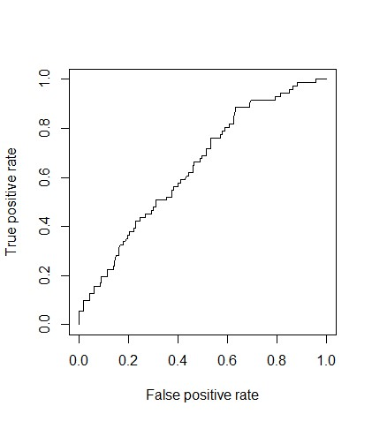
Figure 7: Graph of the overall display of ROC

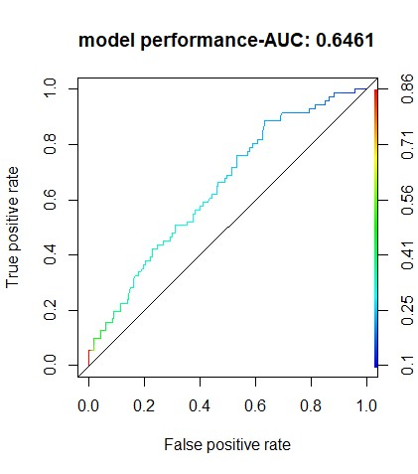
Figure 8: A graph of ROC with model performance

Model performance for snake morbidity using the cross-validation method
The cross-validation method estimates the out-of-sample accuracy, which is the percentage of correct classifications made by the model. The model's prediction accuracy was 0.697, or 69.7%, indicating a good fit.
Thus, the results of the model performance using the cross-validation technique is displayed below fit.control<- trainControl(method ="repeatedcv", number = 5,repeats = 10)
#fit.control.1<-as.data.frame(fit.control) set.seed(123) fit<- train(morbidity~age.years+gender+Duration.of.Hosp.stay+ + hosp.time.ct2+hosp.dist.ct+pre.med+bite.activity.ct, data = snakebite.4, method = "glm",
+ family = "binomial", na.action = na.omit,trControl = fit.control) fit Generalized Linear Model
266 samples
7 predictor
2 classes: '0', '1'
No pre-processing
Resampling: Cross-Validated (5 fold, repeated 10 times)
Summary of sample sizes: 190, 192, 191, 192, 191, 190,
Resampling results:
Accuracy

0.69707

DISCUSSION
Prevalence rate of morbidity due to snake bites among study subjects
In this study the overall prevalence rate of morbidity due to snake bites in chemalingot in Baringo County Kenya was estimated to be at 30 % among the study subjects. The variation of morbidity among gender relatively remained the same with females having a percentage of 15 % and male 14.7% respectively. This shows that the chances of a male subject being bitten by a snake is slightly higher when compared to the female gender. According to our research male do most of their activities in the wild and also walking late at night or early in the morning compared to female. This finding corroborates other studies which have been conducted in Asia and sub-saharan Africa where there high prevalence of snake bites due to snake human interactions (Ochola et al., 2019). Furthermore, the findings are similar to studies carried out in african countries like Nigeria and cameroon where male gender were identified to be highly bitten by snakes when compared to their female counterparts (Alcoba et al., 2020)
Also prevalence rate of morbidity varied significantly based on the time of the bite, with the highest rates occurring in the evening 38.2% and night 26.3%. This shows that snakes are at risk of biting people when darkness is approaching as from evening to night. At this moment a lot of activities is going on and people are not seeing the snakes hence bitten by the snake. The results obtained are similar to other studies conducted in Kenya and other sub-saharan Africa where snakes have been noted to visit homes during dry seasons to search for water and also other snake species like cobra are known to be active at night and research shows that they are usually close to homes where they hide in holes and bushes
(Tianyi et al., 2024).
The trend of snakebite morbidity overtime from 2018 to 2024 clearly shows that from the period 2018 male had high morbidity cases as compared to females and in the year 2019, the number of morbidity cases increased significantly among females, while it decreased among males. For many years male are majorly affected because of the nature of activities they are doing as a result of occupations such as hunting and farming in rocky areas during daytime. As from 2020 the number of morbidity cases systematically increased in a small margin until 2021, where it reached the maximal peak. From 2021, there was a drastic drop in the number of cases all the way to 2022.This is because they have gain knowledge on how to handle snakebites in the area. The number of cases then increases to a peak in 2023, before sharply declining to its lowest level in 2024.This is an indication that in the year 2018 people were not aware on how to be keen to avoid snakebites in Chemalingot. Also environmental factors has lead to increase in snakebites in chemalingot bringing a competition of water with the snakes along the terreins of chemalingot increasing the morbidity of snakebite (Ooms et al, 2021).
Determinants of Factors Associated With Morbidity Due To Snake Bites Among The Study Subjects In Chemalingot In Baringo County, Kenya.

At multivariate level, the only significant factors that were identified to affect morbidity due to snake bites were mainly duration of hospital stay" and "time taken to hospital". An increase in the duration of hospital stay by one unit was associated with a 0.090403 log unit increase in subject morbidity. This indication show that duration of hospital stay and time taken to hospital are the main factors associated with morbidity of snakebite in chemalingot in Addition, subjects who took more than 12 hours to reach the hospital had 1.102671 times the log odds of morbidity compared to those who took less than 12 hours. Although age remained statistically insignificant, it is clear that a one-unit increase in age decreases the likelihood of morbidity by -0.00285 log odds. A similar trend was observed for female gender, with a log odds of -0.01628.
Age even though not statistically significant was another important factor. According to the results above its clear that the most affected people are under the age of 20 years since the average mean of the snakebite incidence is 19.26 of age with a standard deviation of 15.30.This has a lot of indication :Young people play a lot and are active, they can enter into tall grasses without shoes while looking after the animals, agricultural activities, lack of good watch when climbing rocks because of the bad terrains in chemalingot,. Also these young people are economically productive in the community. The oldest snakebite patients is 84yrs while the youngest is 1 yrs.
The average days of hospital stay is four days with the median duration of three days. This durations is relatively small meaning that there is presents of enough labour personnel dealing with snakebites in Chemalingothospital. According to this analysis most of the patience were given ante snakebite venom (Asv) and released to go home.
Distance to the hospital was not a significant factor in this study kilometers from the hospital .The terrain of the place as made the distance to hospital to increase.Meaning the Geographical terrain is a factor which has lead to high morbidty in the region. Studies show that distance to a healthcare facility is an important factor for subjects seeking health care services as a result of snake bites both in developed and in most African developing countries (Christino et al., 2021 )

Assessing the model performance for morbidity status due to snake bites using both ROC and cross-validation methods
The Receiver Operating Characteristic (ROC) curves, which illustrate the trade-off between sensitivity and specificity resulting from model performance. It was in line that ROC is close to the top-left corner, indicating good model performance. The area under the curve (AUC) measured the model's
discriminative power which gave a value of 0.65. This suggests that the model can reasonably predict and discriminate the morbidity status of study subjects.
Furthermore, the cross-validation method displayed a classification accuracy level of 0.697 which was approximately 70 % indicating a good model fit.

Conclusion
The broad scope of this study was to find out associated factors for snake bites in chemalingot in baringo county, Kenya. The results obtained and have been described in chapter four and five shows that the specific objectives have been achieved. The major conclusions from the study is as follows;

- The prevalence rate of morbidity due to snake bites in chemalingot remain high at 30% and this is attributed to factors such as geographical terrain ,lack of knowledge of the locals on how to handle snakebites and also the distance to the hospital and time of stay in hospital.People should be given awareness on how to handle snakebites in the region and also to seak medication at the nearest health facility when accidentally bitten by a snake.
- Distance to the hospital and time of stay has come out clear as the main factors which has increased morbidity rate to 30%.Many people are coming from far seaking medication at chemalingot hospital .Due to this we suggest that we have mortobikes that will allow the experts of snakebites to go closer to the people and also to make awareness.This will ease the transportation to the hospital..
- Snakebite morbidity is high in the evening and night with 38.2% and 26.3% respectivly as others follow.Snakes are active and violent when darkness is there hence affecting the locals at that late hours when others are sleeping or walking. Due to this we suggest improvement of lighting in the households and also residents of the area to be advised to complete their work during daytime to avoid the harmful effects of snake bites.
- The study found out that household food security, household dietary diversity index and acute malnutrition status of under five years children was not significant but these factors still remain as key important indicators for maternal health.
- Factors like child health, maternal pregnancies, and trekking distance to water sources negatively affected malnutrition status among caregivers in the current study.
- Duration of hospital stay and time taken to the hospital were all important factors that significantly affected morbidity due to snake bites.
- The model performance with use of ROC and cross-validation methods performaed well in
discrimination the morbidity status of the study subjects.
Recommendations.
- Create more health awareness in the study region among the residents.This can be done by creating educational programs about snake species, emphasizing on how to recognize and avoid them.Also specicialist should be deployed to those prone areas for assistance and educate he locals about the snakebites incidence.

Limitation of the study
• The study was only conducted in one county in Kenya. The findings may not be generalized to other counties.

Acknowledgement
I would like to express my sincire gratitude to the University of Eldoret for the opportunity to pursue my Master of Science degree in Biostatistics. I am thankful for the support received from the staff in the Department of Mathematics and Computer Science, which helped me achieve my academic goals. I extend special thanks to my supervisors, Dr. Julius Koech and Dr. Samson Wangilah, for their dedication in assisting and guiding me throughout the duration of my thesis research and report writing. I also appreciate my parents and colleagues for their unwavering support during this period.

Ethical Approval and consent
Data was collected from Chemalingot Health Center after informing the hospital leadership and administration. Patients' names were de-identified, and the data was kept confidential with password protection. The study received permission and approval from the hospital administration, as well as from other bodies, including NACOSTI with permit Ref no: 697938 and the Ethical Approval Committee letter of Musinde muliro university of Kenya approval no:MMUST/ISERC/054/2024.

Disclaimer (Artificial intelligence)
Option 1:
Author(s) hereby declare that NO generative AI technologies such as Large Language Models (ChatGPT, COPILOT, etc.) and text-to-image generators have been used during the writing or editing of this manuscript.
Option 2:
Author(s) hereby declare that generative AI technologies such as Large Language Models, etc. have been used during the writing or editing of manuscripts. This explanation will include the name, version, model, and source of the generative AI technology and as well as all input prompts provided to the generative AI technology
Details of the AI usage are given below:
1.
2.
3.

REFERENCE
Pan African medical journal 2018:29:217, Geohealth.10.1029/2022GH00781
World Health Organization. List of Product Assessment Outcomes. In: WHO-Prequalification of Medical Products (IVDs, Medicines, Vaccines and Immunization Devices, Vector Control).
Available from: https://extranet.who.int/pqweb/vaccines/list-productassessment-outcomes-0. 21.
Harrison RA, Oluoch GO, Ainsworth S, Alsolaiss J, Bolton F, Arias A-S, et al. Preclinical antivenomefficacy testing reveals potentially disturbing deficiencies of snakebite treatment capability in East Africa. PLOS Neglected Tropical Diseases. 2017; 11: e0005969. 9.PLoSNegl Trop Dis. 2017; e0005745. https:// doi.org/10.1371/journal.pntd.0005745 PMID: 28692641 29.
Noutsos T, Currie BJ, Isoardi KZ, Brown SGA, Isbister GK. Snakebite-associated thrombotic microangiopathy: an Australian prospective cohort study [ASP30]. Clin10. Toxicol (Phila). 2022; 60: 205–213. https://doi.org/10.1080/15563650.2021.1948559 PMID: 34328386 30. Zuliani JP, Soares AM, Gutie´rrez JM. Polymorphonuclear neutrophil leukocytes in snakebite envenoming. Toxicon. 2020; 187: 188–197. https://doi.org/10.1016/j.toxicon.2020.09.006 PMID:
Nguyen, G. T. T., O'Brien, C., Wouters, Y., Seneci, L., Gallissà-Calzado, A., Campos-Pinto, I., ... & Ljungars, A. (2022). High-throughput proteomics and in vitro functional characterization of the 26 medically most important elapids and vipers from sub-Saharan Africa. GigaScience, 11, giac121.
Ochola, F. O., Okumu, M. O., Muchemi, G. M., Mbaria, J. M., &Gikunju, J. K. (2018). Epidemiology of snake bites in selected areas of Kenya. Pan African Medical Journal, 29(1),
Martins, S. B., Bolon, I., Alcoba, G., Ochoa, C., Torgerson, P., Sharma, S. K. & de Castañeda, R. R. (2022). Assessment of the effect of snakebite on health and socioeconomic factors using a One Health perspective in the Terai region of Nepal: a cross-sectional study. The Lancet Global Health, 10(3), e409e415.
Sutherland, S. K., & Coulter, A. R. (1977). Three instructive cases of tiger snake (Notechisscutatus) envenomation—and how a radioimmunoassay proved the diagnosis. Medical Journal of Australia, 2(6), 177-180.
Larson, P. S., Ndemwa, M., Thomas, A. F., Tamari, N., Diela, P., Changoma, M.,...& Kaneko, S. (2022). Snakebite victim profiles and treatment-seeking behaviors in two regions of Kenya:
results from a health demographic surveillance system. Tropical medicine and health, 50(1), 31.
Harrison, R. A., & Gutiérrez, J. M. (2016). Priority actions and progress to substantially and sustainably reduce the mortality, morbidity and socioeconomic burden of tropical snakebite.
Chaudhari, T. S., Patil, T. B., Paithankar, M. M., Gulhane, R. V., &Patil, M. B. (2014). Predictors of mortality in patients of poisonous snake bite: Experience from a tertiary care hospital in Central India. International journal of critical illness and injury science, 4(2), 101-107.
Habib, A. G., &Abubakar, S. B. (2011). Factors affecting snakebite mortality in north-eastern Nigeria. International Health, 3(1), 50-55.
Backhaus, K., Erichson, B., Gensler, S., Weiber, R., &Weiber, T. (2021). Multivariate analysis. Springer Books, 10, 978-3.
Borsboom, D., Deserno, M. K., Rhemtulla, M., Epskamp, S., Fried, E. I., McNally, R. J., ...&Waldorp, L. J. (2021). Network analysis of multivariate data in psychological science. Nature
Reviews Methods Primers, 1(1), 58. Deserno, M. K., Rhemtulla, M., Epskamp, S., Fried, E. I., McNally, R. J., ...&Waldorp, L. J. (2021). Network analysis of multivariate data in psychological science. Nature Reviews Methods Primers, 1(1), 58.
Chippaux J-P (2017). Snakebite envenomation turns again into a neglected tropical disease! J Venom Anim Toxins Incl Trop Dis. 2017;23:1–2.
Kung’u P. N, Chweya R. N And Gachohi, J. M (2023). Traditional remedies and other characteristics among human snakebite survivors in Baringo county, Kenya, 2010–2020: a case series. International Health; 15: 242–249.
Abdullah A, Yusuf N, Debella A,Eyeberu A, Deressa A, Bekele H,Ketema I, Abdulahi IM and Weldegebreal F (2022) Seasonal variation, treatment outcome, and its associated factors among the snakebite patients in Somali region, Ethiopia. Front. Public Health 10:901414. doi:
10.3389/fpubh.2022.901414.
Tianyi F-L, Oluoch GO, Otundo D, Ofwete R, Ngari C, Trelfa A, et al. (2024) Snakebite prevalence and risk factors in a nomadic population in Samburu County, Kenya: A community-based survey. PLoS Negl Trop Dis 18(1): e0011678. https://doi.org/10.1371/journal. pntd.0011678

