Outcomes of Humeral Shaft Fractures Treated with Platting in Adults: A Study from a Tertiary Care Center in India

ABSTRACT
Introduction: The Shaft Humerus fractures account for 3-5% of all fractures, with no obvious single best surgical method to manage this injury. Even today, both non-operative and operative methods can be used for the patients.
Operative methods curtail prolonged immobilization, provide early rehabilitation and excellent to a good outcome with due surgical complication risk.
Objective: This study evaluates the clinical and radiological outcome of shaft humerus fracture treated by platting in adults.
Study design: Retrospective study
Methods: We did a retrospective study of 60 cases presented to our institute with shaft humerus fracture between November 2023 to April 2025 with closed, extra articular shaft humerus fracture. Follow-up details of 1st week, 4th week, 3rd month, and 6th month were obtained from hospital records and clinical notes. No active follow-up was performed during the study period. Final functional outcome of the patients was assessed with DASH Score, and clinical outcome of the patient was evaluated with Constant-Murley scoring system.
Result: In our study, mean duration for satisfactory radiographic union was 12 weeks; Two patients developed post-operative surgical site infection, four patients had Delayed union, one patient had Non-union, and two patients had Radial nerve palsy. The mean duration of follow-up period was 6 months.
Conclusion: No single treatment option is superior in all circumstances for a particular fracture, and each case must be individualized. Platting has been shown to have better overall results compared to the interlocking nails in treatment of closed humeral shaft fractures.
Keywords: Humerus shaft fracture, open reduction, posterior approach

INTRODUCTION
The Shaft humerus fractures account for 3-5% of all fractures ^{[1]}. The incidence of these fractures has been increasing with the aging population ^{[2]}. These injuries occur in a bimodal age distribution affecting both young and old patients. Fragility-type fractures occur in elderly individuals; however, these injuries also occur in younger patients secondary to high energy trauma^{[3]}. Historically, non-operative management has been the preferred method for treating humeral shaft fractures, given the shoulder’s ability to compensate for angular and rotational malalignment ^{[4,5]}. Sarmiento popularized non-operative management with a functional brace in 1977 after swelling had abated following 1–2 weeks in a coaptation splint ^{[6.7]}. Both compression platting and intramedullary nailing was developed to improve functional outcomes. Plate fixation allows direct visualization, anatomical reduction and rigid fixation of the fracture, and facilitates identification, exploration, and protection of the radial nerve. It may lead to higher rates of wound infection, Iatrogenic nerve failure and mechanical failure in osteoporotic bones.

MATERIAL AND METHODS
This is a retrospective study for the result of Platting in shaft humerus fractures in adults, total 60 patients were evaluated, in the time frame of 18 months starting from November 2023 to April 2025 at Gujarat Adani Institute of Medical Sciences, Bhuj in the Department of Orthopedics. All the patients were classified as per the AO classification terminology (Image 1)^{[8]}.
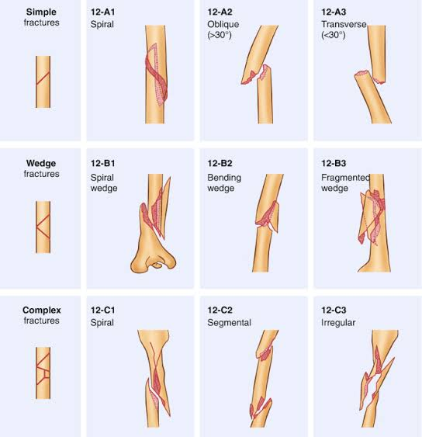

( Image 1: AO/ OTA classification for shaft humerus fractures)
Inclusion criteria:
- Age group 18-80 years
- Closed or Gustilo-Anderson type 1 open fracture of shaft humerus
- Treated with platting
Exclusion citeria:
- Polytrauma patients
- Patients having neurovascular deficit (Gustilo-Anderson type 3c)
- Pathological fractures

Follow-up details at 1st week, 4th week, 3rd month, and 6th month were obtained from hospital records and clinical notes. No active follow-up was performed during the study period. In the study majority of the patients belonged to the age group of 31-40, with a higher proportion of fractures in Males, more affected on Left side. The main mode of injury was Road traffic accident. Majority of the patients had AO Classification type 12A. The functional outcome of the patients was evaluated with DASH score (Disabilities of the Arm, Shoulder and Hand score) (Table 1) and clinical outcome of the patients was evaluated with Constant Murley scoring system .^{[9]}

 | DISABILITIES OF THE ARM, SHOULDER AND HAND
 |  | NO  DIFFICULTY | MILD  DIFFICULTY | MODERATE  DIFFICULTY | SEVERE  DIFFICULTY | UNABLE
1 | Open a tight or new jar | 1 | 2 | 3 | 4 | 5
2 | Write | 1 | 2 | 3 | 4 | 5
3 | Turn a key | 1 | 2 | 3 | 4 | 5
4 | Prepare a meal | 1 | 2 | 3 | 4 | 5
5 | Push open a heavy door | 1 | 2 | 3 | 4 | 5
6 | Place an object on a shelf above your head | 1 | 2 | 3 | 4 | 5
7 | Do heavy household chores | 1 | 2 | 3 | 4 | 5
8 | Garden or do yard work | 1 | 2 | 3 | 4 | 5
9 | Make a bed | 1 | 2 | 3 | 4 | 5
10 | Carry a shopping bag or briefcase | 1 | 2 | 3 | 4 | 5
11 | Carry a heavy object ( over 10 lbs) | 1 | 2 | 3 | 4 | 5
12 | Change a lightbulb overhead | 1 | 2 | 3 | 4 | 5
13 | Wash or blow dry your hair | 1 | 2 | 3 | 4 | 5
14 | Wash your back
15 | Put on a pullover sweater | 1 | 2 | 3 | 4 | 5
16 | Use a knife to cut food | 1 | 2 | 3 | 4 | 5
17 | Recreational activities which require little effort | 1 | 2 | 3 | 4 | 5
18 | Recreational activities in which you take some force or impact through your arm, shoulder or hand | 1 | 2 | 3 | 4 | 5
19 | Recreational activities in which you move your arm freely | 1 | 2 | 3 | 4 | 5
20 | Manage transportation needs | 1 | 2 | 3 | 4 | 5
21 | Sexual activities | 1 | 2 | 3 | 4 | 5

(Table 1: DASH Score, Disabilities of the Arm, shoulder and hand)

RESULTS
In this study, 58 patients who fulfilled our inclusion criteria were enrolled (n=58), [ Two patients had pre-operative radial nerve palsy,and thus not included in our study ].
Age (in years) | No. Of Patients | Percentage (%)
20-30 | 10 | 17.25
31-40 | 20 | 34.48
41-50 | 14 | 24.14
51-60 | 6 | 10 .34
61-70 | 5 | 8.62
71-80 | 3 | 5.17
Total | 58
(Table 2: Age group of patients in the study)
The average age was 46.1 years (range: min=22, max=80 years).

(Graph 1: Gender predisposition)
Fifty-two patients (89.65%) were male, and Six patients were (10.35%) female.
Dominant arm was involved in forty-two (72.41%) cases.

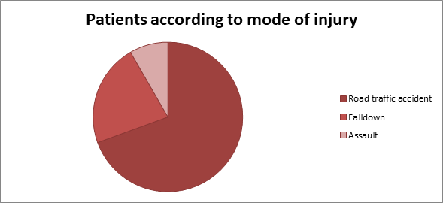
(Graph 2: Pie chart depicting the mode of injury)
Most common mode of injury was Road traffic accident, seen in forty patients (68.97%), followed by fall down either at home or at workplace in twelve patients (20.69%) and direct hit trauma (assault) in six patients (10.34%).

S. No. | AO Type | No. Of patients | Percentage
1 | 12 A1 | 8 | 13.79
2 | 12 A2 | 13 | 22.41
3 | 12 A3 | 12 | 20.69
4 | 12 B1 | 3 | 5.17
5 | 12 B2 | 9 | 15.52
6 | 12 B3 | 5 | 8.62
7 | 12 C1 | 4 | 6.90
8 | 12 C2 | 2 | 3.45
9 | 12 C3 | 2 | 3.45
 | Total | 58
(Table 3: Patient distribution according to AO classification)

According to AO Classification Thirty-four patients (58.62%) had 12A, Sixteen patients (27.59%) had 12B and Eight patients (13.79%) had 12C type of fracture.
In forty patients (68.97%) DCP was used, and rest eighteen patients (31.03%) were treated by LCP. Mean duration for satisfactory radiographic union was 12.1 weeks (range: min=8, max=20).

S.NO. | RATING | CONSTANT-MURLEY score (max 100 points) | NO. OF PATIENTS
1 | Excellent | 86-100 | 31(53.45%)
2 | Good | 71-85 | 23 (39.66%)
3 | Fair | 56-70 | 04 (6.89%)
4 | Poor | <56 | 00
(Table 4: Clinical outcome of the patient was evaluated with Constant Murley scoring system)
The clinical outcome of the patients was evaluated with Constant Murley scoring system, the mean post-operative Murley score was 82.6 + 8.4, with 53% of patients showing excellent outcome and 40% showing good outcome (Table 4).

S.NO. | DASH SCORE (max 300 points) | NO. OF PATIENTS
1. | 21-30 | 14 (24.14%)
2. | 31-40 | 10 (17.24%)
3. | 41-50 | 8 (13.79%)
4. | 51-60 | 5 (8.62%)
5. | 61-70 | 5 (8.62%)
6. | 71-80 | 4 (6.90%)
7. | 81-90 | 7 (12.07%)
8. | 91-100 | 4 (6.90%)
9. | 101-110 | 1 (1.72%)
( Table 5: Functional outcome of the patients was evaluated with DASH score)
The functional outcome of the patients was evaluated with DASH score (minimum score-21 and maximum score-105 for an individual patient), according to which more than fifty percentage of the patients (32 out of 58) had DASH score less than or equal to 50, and only one patient had DASH score more than 100.
The mean post-operative DASH score was 22.3 + 6.7, indicating minimal functional disability at final follow up.
Since pre-operative scores were not uniformly recorded in this retrospective study, statistical comparison and p-values could not be generated.
Two patients developed superficial surgical site infection post-operatively, four patients had delayed union, one patient had non-union, and two patients had radial nerve palsy. The mean duration of follow-up period was 6 months.

Complication:
Complication | No. of patients | Percentage
Infection | 2 | 3.45%
Radial nerve palsy | 2 | 3.45%
Delayed union (>16weeks) | 4 | 6.89%
Non-union | 1 | 1.72%
Implant failure | 0 | 0
(Table 6: Complications encountered during the study)

Every procedure, technique and surgery carries potential risk of complication with itself. In our study of platting in shaft humerus fracture, we encountered some of the short-term complications. Out of the 60 patients we studied in the 18 months, two patients had preoperative radial nerve palsy and thus were not included in the study (Exclusion criteria: Gustilo Anderson type 3c). Two patients developed Iatrogenic palsy, which recovered with medications over a period of time. Two patients developed post operative superficial surgical site infection which was managed with proper antibiotic coverage. Four patients had delayed union- two of them were elderly chronic smoker and the other improper fixation, one patient underwent non-union, and none of the patients developed implant failure.
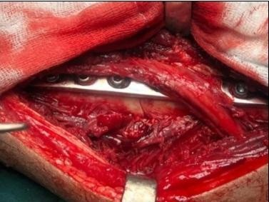
(Image 2: Intra-op picture of radial nerve dissection and humerus fracture fixation with Dynamic compression plate)

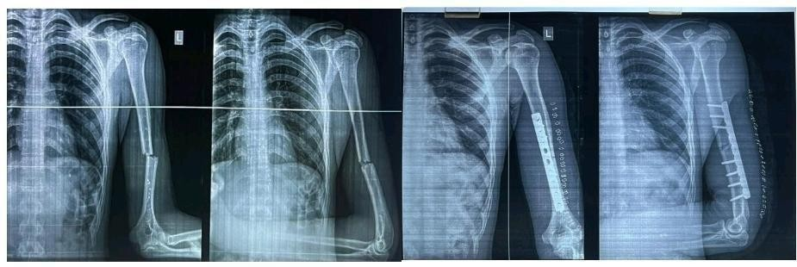
(Image 3: Pre-op and post-op xray of a patient treated by Platting)
LIMITATION
The present study is limited by its retrospective nature and lack of pre-operative Constant-Murley and DASH scores, which prevented statistical comparison (p-values). Future prospective studies with baseline and follow-up scoring will allow more robust statistical analysis.

DISCUSSION

Although there are several options for the treatment of humeral shaft fractures, including platting or intramedullary nailing, which of these provides the best outcome for patients is an area of active research. Intramedullary nail & plate are the two most commonly used surgical treatments. Interlocking nailing is preferable in comminuted, segmental and pathological fractures while platting may be the preferred option where radial nerve exploration is contemplated. Conventional platting techniques involve an extensive surgical approach for open reduction of fracture. Infection, non- union and radial nerve palsy are general concerns suggested in the platting group ^{[10]}. Restriction of shoulder movements and risk of delayed union have been suggested as concerns with the intramedullary techniques.
In a comparative study for the outcome of nailing v/s platting in shaft humerus fractures by Kiran Singisetti and others published in 2009, 36 patients were evaluated, twenty patients of interlocking nailing and sixteen patients of platting over a period of 3 years, they had higher rate of excellent and good results with the platting group.
In a retrospective study for the outcome of intramedullary nailing v/s locking compression plate in shaft humerus fractures by Ruipeng Zhang and others published in 2020, 211 patients were evaluated, 102 patients of interlocking nailing and 109 patients of plating over a period of 4.5 years, they obtained similar therapeutic results for humeral shaft fractures fixed with either IMN or LCP.
The higher rate of excellent and good result with platting, seen in our series was also cited in many other reports. In a recent study, no remarkable difference between the platting and nailing group was seen in terms of rate of union and functional outcome.

CONCLUSION
No single treatment option is superior in all circumstances for a particular fracture, and each case has to be individualized. Plating has been shown to have better overall results compared to the interlocking nails in treatment of closed humeral shaft fractures. A tendency for earlier union is seen with the plating group. Our early results are promising with platting group but long multicentric trials are warranted as there are multiple latest options available for fracture management.

Disclaimer (Artificial intelligence)

Option 1:

Author(s) hereby declare that NO generative AI technologies such as Large Language Models (ChatGPT, COPILOT, etc.) and text-to-image generators have been used during the writing or editing of this manuscript.

Option 2:

Author(s) hereby declare that generative AI technologies such as Large Language Models, etc. have been used during the writing or editing of manuscripts. This explanation will include the name, version, model, and source of the generative AI technology and as well as all input prompts provided to the generative AI technology

Details of the AI usage are given below:
1.
2.
3.

REFERENCES
- Li Y, Wang C, Wang M, Huang L, Huang Q. Postoperative malrotation of humeral shaft fracture after plating compared with intramedullary nailing. J Shoulder Elbow Surg. 2011;20(6):947-54. doi:10.12659/msm.924400
- Van de Wall BJM, Ochen Y, Beeres FJP, Babst R, Link BC, Heng M, et al. Conservative vs operative treatment for humeral shaft fractures: a meta-analysis and systematic review of randomized clinical trials and observation studies. J Shoulder Elbow Surg. 2020;29(7):1493-504. doi: 10.1016/j.jse.2020.01.072
- Zhao JG, Wang J, Meng XH, Zeng XT, Kan SL. Surgical interventions to treat humerus shaft fractures: a network meta-analysis of randomized controlled trials. PLoS One. 2017;12(3):e0173634. doi:10.1371/journal.pone.0173634
- An Z, Zeng B, He X, Chen Q, Hu S. Plating osteosynthesis of mid-distal humeral shaft fractures: minimally invasive versus conventional open reduction technique. Int Orthop. 2010;34(1):131-5. doi:10.1007/s00264-009-0753-x
- Chen Y, Qiang M, Zhang K, Li H, Dai H. Novel computer-assisted preoperative planning system for humeral shaft fractures: report of 43 cases. Int J Med Robot. 2015;11(2):109-19. doi:10.1002/rcs.1604
- Beeres FJP, van Veelen N, Houwert RM, Babst R, Link BC, Heng M, et al. Open plate fixation versus nailing for humeral shaft fractures: a meta-analysis and systematic review of randomised clinical trials and observational studies. Eur J Trauma Emerg Surg. 2022;48(4):2667-82. doi:10.1007/s00068-021-01728-7
- Hohmann E, Glatt V, Tetsworth K. Minimally invasive plating versus either open reduction and plate fixation or intramedullary nailing of humeral shaft fractures: a systematic review and meta-analysis of randomized controlled trials. J Shoulder Elbow Surg. 2016;25(10):1634-42. doi: 10.1016/j.jse.2016.05.014
- Keshav K, Baghel A, Kumar V, Neradi D, Kaustubh K, Mishra P. Is minimally invasive plating osteosynthesis better than conventional open plating for humeral shaft fractures? A systematic review and meta-analysis of comparative studies. Indian J Orthop. 2021;55(Suppl 2):283-303. doi:10.1007/s43465-021-00413-6
- Sargeant HW, Farrow L, Barker S, Kumar K. Operative versus non-operative treatment of humeral shaft fractures: a systematic review. Shoulder Elbow. 2020;12(4):229-42. doi:10.1177/1758573218825477
- Wang X, Chen Z, Shao Y, Ma Y, Fu D, Xia Q. A meta-analysis of plate fixation versus intramedullary nailing for humeral shaft fractures. J Orthop Sci. 2013;18(3):388-97. doi:10.1007/s00776-013-0355-8
11) Hassan M, Ikbal FM, Abdul Hakeem M, Janees MC. Functional outcome following fixation of fractures shaft of humerus-intramedullary nailing versus plate osteosynthesis: a comperative study. Int J Orthop Sci.2022;8:334-8.
12) K Ram Mohan, K Kishore Kumar,JVenkateshwarlu, el al,. “Comparative study of functional outcome of dynamic compression plating and interlocking nailing for fracture shaft of humerus in adults”/PJMS- 2021;11(1):89–98.

