External Fixation of Intertrochanteric Fractures in High-Risk Patients: A Case Series Demonstrating Safety and Early Ambulation

Abstract:

Hip intertrochanteric fractures are associated with significant morbidity and a substantial mortality risk, with a 15% to 30% death rate in the first year following the fracture. The standard treatment for these fractures is internal fixation, typically using devices such as the dynamic hip screw, intramedullary nails, or a proximal femoral plate. This study aimed to evaluate the clinical outcomes, including intraoperative blood loss, postoperative hip functionality, radiological results and complications in high-risk patients with intertrochanteric fractures treated with external fixation of the hip. This study strictly follows the ethical guidelines established by the National Orthopaedic Association. Twenty-two high-risk patients, classified by the anaesthetist as American Society of Anesthesiologists (ASA) grade 3 or 4 and considered unsuitable for conventional fracture fixation, were treated with hip external fixation at a single centre by the same surgeon from 2020 to 2023. The study group included 10 men and 12 women. All patients received regional anaesthesia, including a femoral nerve block (FNB) and lateral femoral cutaneous nerve block (LFCNB). The functional outcome was assessed using the Harris Hip Score, with an average score of 82.5 points, ranging from 60 to 98. Of the 22 total patients, 14 had excellent or satisfactory results, 5 had fair results, and 3 had poor outcomes. The overall complication rate was 31.5%. Two patients (9%) experienced pin tract infections, which were treated with antibiotics. Pin loosening occurred in one patient (4.5%), and varus malunion was observed in two patients (9%). The use of this external fixator device for treating trochanteric fractures is a safe, reliable, and minimally invasive alternative for managing intertrochanteric femoral fractures, particularly in elderly high-risk patients. However, larger studies with longer follow-up periods are necessary, as our series is limited by a small patient sample and a short follow-up duration.

Keywords: Hip intertrochanteric fractures, high-risk patients, femoral nerve block, lateral femoral cutaneous nerve block, fixator device

INTRODUCTION

Hip intertrochanteric fractures are the most common type of hip fracture¹ that
usually affects elderly with osteoporosis. These fractures typically occur due to a direct fall onto the greater trochanter or an indirect twisting injury. The incidence is gender and race dependent and varies from country to country due to variance in life span, social and cultural factors^{2,3}.Without surgical intervention, these fractures are associated with significant morbidity and a substantial mortality risk, with a 15% to 30% death rate in the first year following the fracture⁴ .Conservative treatment is generally considered unacceptable, as it has been linked to mortality rates as high as 60% ^{5,6,7}. The primary goal of surgical treatment is to enhance the patient's quality of life by enabling early mobilization and restoring their pre-injury health status.⁸

The standard treatment for these fractures is internal fixation, typically using devices such as the dynamic hip screw, intramedullary nails, or a proximal femoral plate. However, in “patients with comorbidities such as chronic heart failure, chronic kidney disease (CKD) chronic obstructive pulmonary disease (COPD), severe anemia or uncontrolled diabetes mellitus, the risk of anesthetic or postoperative complications is considerably higher”^{9,10,11} .In such cases, a specially designed external fixation device may be used under local anesthesia, sedation, or regional anesthesia.

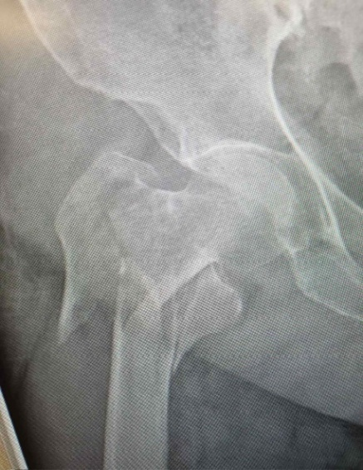

Figure 1. Intertrochanteric fracture
Compared to internal fixation, this procedure is faster and with less perioperative blood loss¹²⁻¹⁶. However, complications such as infection, broken pins, varus deformity, and femoral shortening can occur with external fixation for intertrochanteric fractures.^{17,18,19}
The aim of this study is to evaluate the clinical outcomes, including intraoperative blood loss, postoperative hip functionality, radiological results and complications in high-risk patients with intertrochanteric fractures treated with external fixation of the hip.

METHODS

Twenty-two high-risk patients, classified by the anesthetist as American Society of Anesthesiologists (ASA) grade 3 or 4 and considered unsuitable for conventional fracture fixation, were treated with hip external fixation at a single center by the same surgeon from 2020 to 2023. The study group included 10 men and 12 women, with a mean age of 86.0 years (range: 75–93 years). Twelve fractures occurred on the right side (54.5%) and 10 on the left side (45.4%). The fractures were categorized as 11 AO type A1 fractures, 8 AO type A2 fractures, and 3 AO type A3 fractures. Based on the Evan's classification, 9 cases were type I stable fractures, and 13 were type II, unstable or reversed obliquity fractures. The pre-fracture Harris Hip Score (HHS) (The maximum score possible is 100. Results can be interpreted with the following: <70 = poor result; 70–80 = fair, 80–90 = good, and 90–100 = excellent.) was verbally assessed upon hospital admission to allow for comparison of hip functionality before and after the procedure.The average HHS prior to surgery was 84.5 points with a range of 65 to 98. To quantify the intraoperative blood loss was used the gravimetric method.

Technique
An hour before surgery, broad-spectrum antibiotics were administered intravenously. All patients received regional anesthesia, including a femoral nerve block (FNB) and lateral femoral cutaneous nerve block (LFCNB).
The patients were placed supine on a traction table. The fractures were reduced using the Flynn maneuver by a gentle and sustained traction in-line with the femoral neck, with the hip flexed and externally rotated followed by extension and internal rotation. “The reduction was considered satisfactory if the neck-shaft angle was restored and the gap at the fracture site was less than 2 mm, as confirmed by an image intensifier in both planes” ²⁰ (Figure 2).
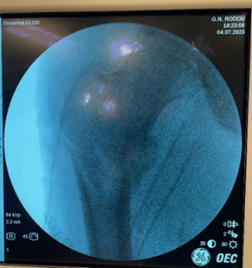
Figure 2. Fracture reduction

Under fluoroscopy guidance, the first Schanz’s pin with a compression device (6 mm) was percutaneously inserted across the fracture site at an angle of 130° to the shaft, along the axis of the femoral neck (Figures 3, 4).

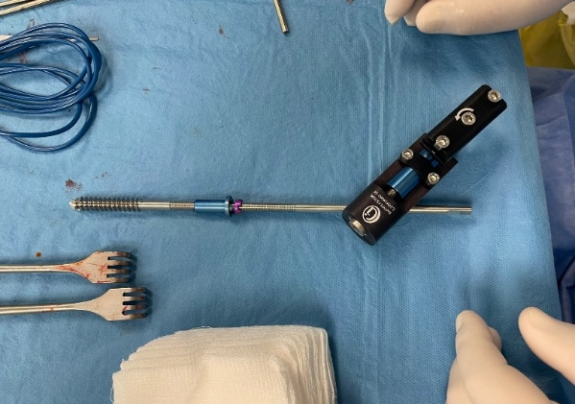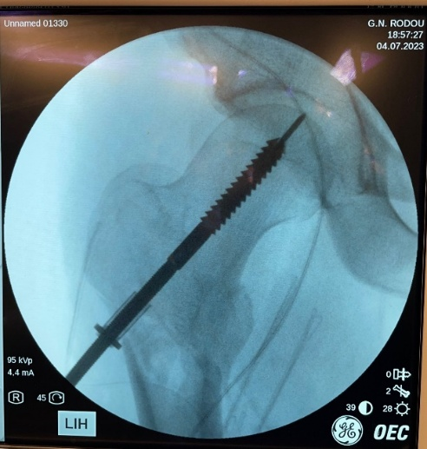
Figure 3. The external fixator device Figure 4. Schanz’s pin with a compression device

It is crucial that the first pin passes through the calcar region of the femur to enhance the mechanical stability of the construct. A second anti-rotation Schanz’s pin (5 mm) was then inserted just above the center of the neck and head .The pins were advanced 5–6 mm below the subchondral bone of the femoral head. Compression of the fracture was achieved using the first Schanz’s pin. Two additional threaded Schanz’s pins (5–6 mm) were placed into the femoral shaft, intercepting the opposite cortex. The pins were connected using a universal clamp and a tubular connecting rod (Figures 5, 6).

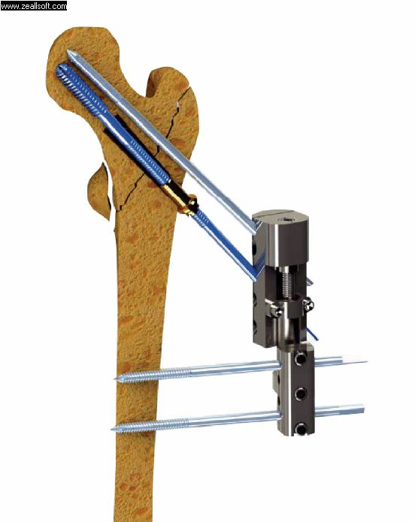 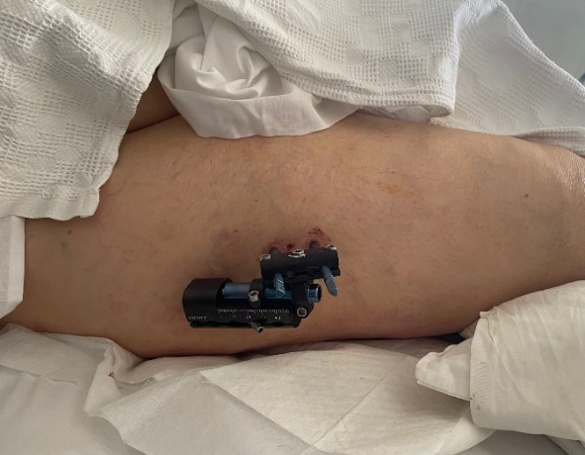 Figure 5. All pins inserted Figure 6 The pins are connected using a universal clamp
and a tubular connecting rod

Postoperative care

Antibiotics, analgesics and anticoagulants were given for 48 hours (Guidelines by the American Association for the Surgery of Trauma (AAST).
The typical hospital stay was five days (range: 2–10 days). Patients were required to return to the outpatient clinic for clinical and radiological examinations every 10 days during the first month, and then monthly thereafter. For stable fractures, patients were
instructed to begin weight-bearing the day after surgery. In cases of unstable fractures, depending on the patient’s overall health, partial weight-bearing with the assistance of a walker was recommended 4 to 12 weeks post-surgery. The external fixator was removed in the outpatient department.

Figure 7. Patient during post-operative
follow – up

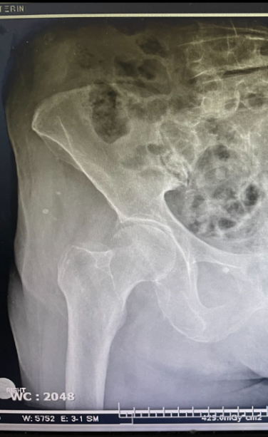

RESULTS

The functional outcome was assessed using the Harris Hip Score, with an average score of 82.5 points, ranging from 60 to 98. In our study, 8 patients were ambulatory at the time of discharge, with an average time to union of 11 weeks. By the 4-month follow-up, this number had increased to 16 patients. Of the 22 total patients, 14 had excellent or satisfactory results, 5 had fair results, and 3 had poor outcomes.

The mean operative time was 25 minutes, with a range of 20 to 35 minutes. The average intraoperative blood loss was 18 ml, ranging from 10 to 40 ml, with no intraoperative complications reported.
The mean time to union was 12 weeks (Figure 7), with a range of 8 to 18 weeks.
The overall complication rate was 31.5%. Two patients (9%) experienced pin tract infections, which were treated with topical antiseptics,saline wash and systemic antibiotics administration with a median healing time of 10 days.Pin loosening occurred in one patient (4.5%), and varus malunion was observed in two patients (9%). Knee stiffness caused by fixation of the fascia lata and vastus lateralis by the distal pins was seen in two patients (9%) and was managed with prolonged physiotherapy.(table 1)

Patients Available | 22 (10 men and 12 women)
Harris hip Score (mean) | 82.5 (Range 60-98)
Operative time (mean) | 25 minutes (Range 20-35 minutes)
Blood Loss (average) | 18 ml (Range 10-40 ml)
Radiographic union (mean) | 12 weeks (Range 8-18 weeks)
Complications | Overall rate 31.5%  -Pin Tract Infection 9%  -Pin Loosening 4.5%  -Varus Malunion 9%  -Knee Stifness 9%

Table 1. Functional outcomes of the patients

DISCUSSION
The mean operative time in the present study was 25 minutes which was similar to other studies and precisely by Vossinakis et al ^{14,}Kazakos et al ², and Boghdady et al ²¹.Dr. Naveed Bashir Wani's study resulted in a successful outcome with a total of 48 high-risk patients with closed reduction and external fixation under local anesthesia²²,^{23,24,}. Futhermore Suhail Afzal et al. used the external fixator in 12 patients with intertrochanteric fractures and achieved a good outcome and early mobilization with minimal loss of blood and the method was considered to be a safe and effective²⁵. The mean hospitalization time in our study was 5 days which is shorter than the average time recorded in published studies. No blood transfusion was required in any of the 22 patients included in this study , in accordance with other published studies²⁶. All fractures united with an average union time of 12 week which is consistent with the published average range (11 to 14 weeks) ²⁷⁻²⁹. The outcome of the intervention, assessed by the HHS, improved progressively and significantly during the follow up.This finding is comparable with other studies.^{30,31,32}
“Complications such as pin-tract infection, varus malunion and limb shortening were encountered in many studies. In similar studies, pin-tract infection has been reported in up to 60% of cases and varus malunion in 8 - 27.3 %” ³³. Knee stiffness was also observed in some patients with some types of external fixators^{34,35} Considerable disadvantage in our opinion is the inconvenience caused to the patient,especially when trying to turn to the side of the external fixator.

CONCLUSION
The use of this external fixator device for treating trochanteric fractures is a safe, reliable, and minimally invasive alternative for managing intertrochanteric femoral fractures, particularly in elderly high-risk patients. It offers many advantages, including minimal surgical trauma, reduced blood loss, short operative time, fewer anesthesia complications with the possibility of using local anesthesia, a short hospitalization, and the ease of device removal as an outpatient procedure. Additionally, it demonstrates comparable results and complication rates to more invasive techniques, such as the intramedullary nailing and the dynamic hip screw techniques. However, larger studies with longer follow-up periods are necessary, as our series is limited by a small patient sample and a short follow-up duration.

Ethical Approval and Consent:

This study strictly follows the ethical guidelines established by the national orthopaedic association. Informed consent was obtained from all participants, and their confidentiality was maintained throughout the study.
IRB and Ethics Committee approval was not necessary at the authors institution for
retrospective studies.

Disclaimer (Artificial intelligence)

Authors hereby declare that NO generative AI technologies such as Large Language Models (ChatGPT, COPILOT, etc.) and text-to-image generators have been used during the writing or editing of this manuscript.

References

[1] Beder, Mahmoud; El-Geoushy, Ali; and Abdel-all, Sameh (2022) "Percutaneous Fixation of Trochanteric Fracture Femur by External Fixator In High Risk Patients," Al-Azhar International Medical Journal: Vol. 3: Iss. 11, Article 8.
[2] Bucholz RW, Heckman JD, Court-Brown CM. Rockwood and Green’s Fractures in Adults; 6th Ed. (2006), Chap. 45, pp. 1794-823.
[3] Issam Al-Azzawi and Wamieth AJ Augla.A Comparative Study between Dynamic Hip Screw and External Fixation for Evans stable and unstable type I Intertrochanteric Femoral Fractures.Iraqi J. Comm. Med., April. 2016 (2)
[4] K.Kazakos,DN.Lyras,D.Verettas,V.Galanis, I.Psillakis, K.Xarchas, External fixation of intertrochanteric fractures in elderly high-risk patients.Acta Orthop Belg.2007; vol.73,pp.44–48.
[5] Bozgeyik and Kekeç.Pertrochanteric Fixator in High-Risk Patients
European Journal of Therapeutics 2018; 24(4): 204-9
[6] Gotfried Y, Frish E, Mendes DG, Roffman M. Intertrochanteric fractures in high risk geriatric patients treated by externalfixation. Orthopedics 1985; 6: 769-74.
[7] Kenzora JE, McCarthy RE, Lowell JD, Sledge CB. Hip fracture mortality: relation to age, treatment, preoperative illness, time of surgery
and complications. Clin Orthop Relat Res 1984; 186: 45-56.
[8] Baumgaertner MR. The pertrochanteric external fixator reduced
pain, hospital stay, and mechanical complications in comparison
with the sliding hip screw, J Bone Joint Surg Am 2002; 84: 1488
[9] Akçalı O, Kıter E, Kabaklıoğlu T, Araç Ş. The Leinbach hip prosthesis performed for hip fractures with impairment of femoral calcar. Acta Orthop Traumatol Turc 1998; 32: 116-9.
[10] Mahmoud MB., Ali ME, and Sameh AA. Percutaneous Fixation of Trochanteric Fracture Femur by External Fixator In High Risk Patients. AIMJ. 2022; Vol.3-Issue11 .48-53.
[11]Dhal A, Varghese M, Bhasin VB. External fixation of intertrochanteric fractures of the femur. J Bone Joint Surg Br 1991;73: 955-8.
[12] Davis TR, Sher JL, Horsman A, Simpson M, Porter BB, Checketts RG.Intertrochanteric femoral fractures. Mechanical failure after internal
fixation. J Bone Joint Surg Br 1990; 72 :26-31.
[13]. Leung KS, So WS, Shen WY, Hui PW. Gamma nails and dynamic hip screws for peritrochanteric fractures. A randomised prospective
208 study in elderly patients. J Bone Joint Surg Br 1992; 74: 345-51.
Bozgeyik and Kekeç. Pertrochanteric Fixator in High-Risk Patients Eur J Ther 2018; 24(4): 204-9
[14] Scarante S, Ranelluci M, Lavini F. The Dynamic Axial Fixator in the treatment of pertrochanteric fractures of the femur. Int J Orthop
Traum 1993; 3: 58-60.
[15] Dhal A, Singh SS. Biological fixation of subtrochanteric fractures by external fixation. Injury 1996; 27: 723-31.
[16] Vossinakis IC, Badras LS. The external fixator compared with the sliding hip screw for pertrochanteric fractures of the femur. J Bone Joint
Surg Br 2002; 84: 23-9.
[17] Moroni A, Faldini C, Pegreffi F, Hoang-Kim A, Vannini F, Giannini S. Dynamic hip screw compared with external fixation for treatment of
osteoporotic pertrochanteric fractures. A prospective, randomized
study. J Bone Joint Surg Am 2005; 87: 753-9.
[18] Diaz Jimenez M, Martin Galera R, Complex fractures of the upper
third of the femur treated with external fixation, Ender nailing,
blade plate and locked intramedullary nailing: a retrospective comparative study. Int J Orthop Traum 1993; 3: 69-71.
[19] Petsatodis G, Maliogas G, Karikis J, Christodoulou AG, Venetsanakis G, Sachinis N, et al. External fixation for stable and unstable intertrochanteric fractures in patients older than 75 years of age: a prospective comparative study. J Orthop Trauma 2011; 25: 218-23.
[20] Boghdady GW, Shalaby M (2007) Safety and reliability of external fixation for basicervical and intertrochanteric fractures in high-risk elderly patients. Strategies in trauma and limb reconstruction (Online) 2 (2-3):83-89. doi:10.1007/s11751-007-0025-5
[21] Kourtzis N, Pafilas D, Kasimatis G (2001) Management of pertrochanteric fractures in the elderly patients with an external fixation. Injury 32 Suppl 4:SD115-128
[22]Saif Bashar Abbas, Mustafa Habeeb Abdalhussein and Karam Safaa A.
External fixation of intertrochanteric femur fractures in elderly patients: Functional outcome.IJOR 2024; 6(1): 29-32
[23]Wani NB, Badoo AR. External fixation of intertrochanteric fractures in high-risk geriatric patients done under local anaesthesia. IOSR J Dent Med Sci. 2016;15(9):31-35.
[24] Saif Bashar Abbas and Abd Ali Muhsin.Functional outcome of external fixation of intertrochanteric femur fractures in elderly patients. IJOS 2024; 10(4): 295-298
[25]Afzal S, Mir MR, Farooq M, Ahmad S, Moulvi S. External fixation in the management of intertrochanteric fractures of femur. J Bone Joint Surg. Br. 2003;10(3):195-197
[26]Vossinakis IC, Badras LS. Management of pertrochanteric fractures
in high-risk patients with an external fixation. Int Orthop 2001; 25:
219-22.
[27] V.Patel RM, and Iesaka K. Comparison of a sliding hip screw with atrochanteric lateral support plate to an intramedullary hip screw for fixationo funstable intertrochanteric hip fractures : Acadaver study. J Trauma . 2004;56:791-4.
[28] Gotfried Y, Frish E, Mendes DG, et al. Intertrochanteric fractures in high risk geriatric patients treated by external fixation. Orthopedics. 1985;8 (6):769–74.
[29] Karn NK, Singh GK, Kumar P, et al. Managementof trochanteric fractures of the femur with external fixation in high-risk patients. IntOrthop.vol. 2009; 33:785–8.
[30]Tomak Y, Kocaoglu M, Piskin A, Yildiz C, Gulman B, Tomak L. Treatment of intertrochanteric fractures in geriatric patients with a modified external fixator. Injury. 2005;36:635-643. DOI: 10.1016/j.injury.2004.10.013
[31]Subasi M, Kesemenli C, Kapukaya A, Necmioglu S. Treatment of intertrochanteric fractures by external fixation. Acta Orthop Belg 2001; 67(5):468-74.
[32]Gani NU, Kangoo KA, Bashir A, et al. External fixation of “intertrochanteric” fractures. Orthopedic Reviews 2009; 1:e18
[33] Petsatodis G, Maliogas G, Karikis J, Christodoulou AG, Venetsanakis G, Sachinis N, Hatzokos I, Chalidis B (2011) External fixation for stable and unstable intertrochanteric fractures in patients older than 75 years of age: a prospective comparative study. Journal of orthopaedic trauma 25 (4):218-223. doi:10.1097/BOT.0b013e3181e9378a
.
.
[34]Tomak Y, Kocaoglu M, Piskin A, Yildiz C, Gulman B, Tomak L. Treatment of intertrochanteric fractures in geriatric patients with a modified external fixator. Injury. 2005;36(5):635-43. doi: 10.1016/j.injury.2004.10.013
[35]Alireza Moharrami,Mir Mansour Moazen Jamshidi, Soroush Alaeddini, Mazaher Ebrahimian. Amir Reza Mafi.A Current Concept Review for the Use of External Fixators in Elderly Patients with Intertrochanteric Fracture.J Orthop Spine Trauma. 2023 June; 9(2): 59-61.

