Five Years of the Ponseti Method in Cameroon: Outcomes from the National Clubfoot Care Program

Abstract
Introduction: Congenital clubfoot is a highly debilitating malformation. It is the most common malformation of the pelvic limb, with a frequency of 1 case per 100 live births. Its treatment was standardised in Cameroon in 2019. The clubfoot treatment in Cameroon used to involve costly and invasive surgeries with poor results (incomplete correction and stiffness). That is why the country adopted in 2019 the less invasive, affordable and effective Ponseti method.
Aim: This study was to determine the clinical presentation of treated clubfoot, the outcome of the Ponseti method and the local associated factors needing strategic actions.
Materials and methods: We conducted a cross-sectional study with retrospective data collection from January 1, 2019, to December 31, 2023. We reviewed all records of clubfoot cases in children aged two years or younger who were followed up in centres approved for the Ponseti method, completed by telephone calls and appointments. All children aged 0 to 2 years old presenting with a clubfoot were treated in a clubfoot clinic by the Ponseti method. The data were analysed using SPSS software version 26. The statistical significance level was set at p< 0.05, and the confidence interval was set at 95%.
Results: We had 445 children under the age of two and 691 clubfeet. There were 308 boys and 138 girls, giving a sex ratio of 2.23. An average of 5-7 weekly casts was required in 225 (50.6%) patients. Percutaneous tenotomy was necessary in 343 cases (77.1%). It was repeated in 11 cases (1.6%). Abduction foot braces were worn by 421 children, or 94.6%. The Iowa type was the most commonly used, with 413 cases (98.1%). The duration of wear was greater than 6 months in 80% of cases. In 272 cases (61.1%), there was no recurrence.
Factors associated with recurrence were: a distance of more than 25 km between home and the treatment centre (p=0.009), a high initial Pirani score (p=0.008), and home delivery (p=0.001).
Conclusion: Clubfoot in Cameroon is a national problem because all the 10 regions are concerned. Some regions lack clubfoot clinic and training is therefore needed for the new staff required. Old staff members also need continuous training and collaboration amelioration. A yearly national prospective follow up study will surely be more informative as well as studies on barriers. The results are encouraging, but the identified factors need emphasis.
Keywords : Congenital clubfoot, Ponseti method, Clubfoot clinic, National Clubfoot Care Program

Introduction
Congenital talipes equinovarus (CTEV), also known as clubfoot, is a common musculoskeletal entity that affects one to two per 1000 live births worldwide. Imaging modalities, including radiography, US, and MRI, have emerged as valuable tools for the diagnosis, treatment, and monitoring of CTEV (do Amaral e Castro et al., 2024; Bent, 2023). It. It is an orthopaedic malformation visible in the newborn baby, characterised by a foot deformity in an inward and downward position. With respect to the cause of the
deformity, a clubfoot can be referred to as an idiopathic type when there are no associated neurological conditions, such as spina bifida and arthrogryposis (Boakye et al., 2016). Its incidence is 1 to 2 cases per 1000 live births [1-4]. On a yearly basis, clubfoot affects about 174,000 children, and 90% of them are from low-resource countries [5, 6], like Cameroon.
The deformity comprises four components: a cavus or increase in the medial arch of the midfoot, an adductus of the metatarsus, a varus of the heel and an equinus of the ankle joint [7].
Untreated clubfoot results in stiffness, foot callus, pain, ulcers, and inability to wear normal shoes to play, go to school or work. Affected children generally walk barefoot with stigmatisation of the child and family, or wear special shoes [8-12].
The clubfoot treatment in Cameroon used to involve costly and invasive surgeries with poor results (incomplete correction and stiffness). That is why the country adopted in 2019 the less invasive, affordable and effective Ponseti method, indicated before the age of two years [2-4], which has not yet been evaluated.
Five years after implementation of this national directive, this study was to determine the clinical presentation of treated clubfoot, the outcome of the Ponseti method and the local associated factors needing strategic actions if any, to ameliorate the Cameroon Clubfoot Care program.

Methodology
This was a transversal descriptive and analytic study carried out for 5 years (1st January 2019-31st December 2023) in 16 (Figure 1) out of the 22 clubfoot clinics of the country. The data from the missing 6 clinics were unexploitable or unavailable for security reasons, and in new centres: Sajokah in Bafut, Bouda, Foumban, Etoug Ebe, Prohamdicam and Meskine.
All children aged 0 to 2 years old presenting with a clubfoot were treated in a clubfoot clinic by the Ponseti method. The Ponseti method consists of two phases. A correction phase, which generally lasts for 6 to 8 weeks, with weekly casting and Achilles’ tendon tenotomy, and a maintenance phase of 4 to 5 years using foot abduction braces. The braces are worn first, 23h/24 during 4-5months, then only at night for 4-5 years to avoid recurrence. Each clinic has at least 2 staff members trained for this technique and works with an orthopaedic surgeon for tenotomies. Data collection staff were also trained. The ethical clearance, reference IRB 2024-24, was obtained from the Institutional Review Board, and an authorisation was given by the Directors of hospitals where the data were collected. Informed consent was delivered before data collection. The data were collected from 1st January to 31st May 2024 from patients’ files, staff members, and completed with phone calls and onsite visits.
All hand-filled questionnaires were cross-checked before double entry. The data were analysed using SPSS software version 26. To highlight the association between variables, a nested case-control with bivariate and multivariate analysis was done. They were considered as Cases, all forms with partial or total relapse of any of the 4 characteristic deformities (cavus, adductus, varus, equinus) or any additional complication (supination, pain, stiffness). The Controls were good outcome cases with all 4 deformities completely corrected and free from any complications. Corrected odds ratios and p-values were obtained for each associated factor. The statistical significance level was set at p< 0.05, and the confidence interval was set at 95%.
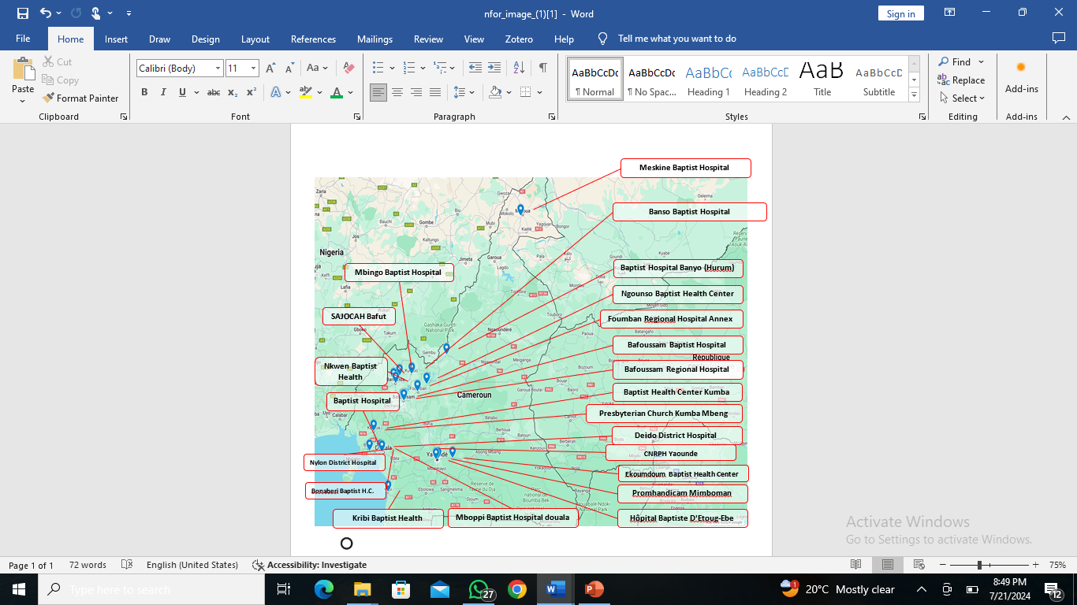
Figure 1: localisation of national clubfoot clinics in Cameroon (2024 version).
 | 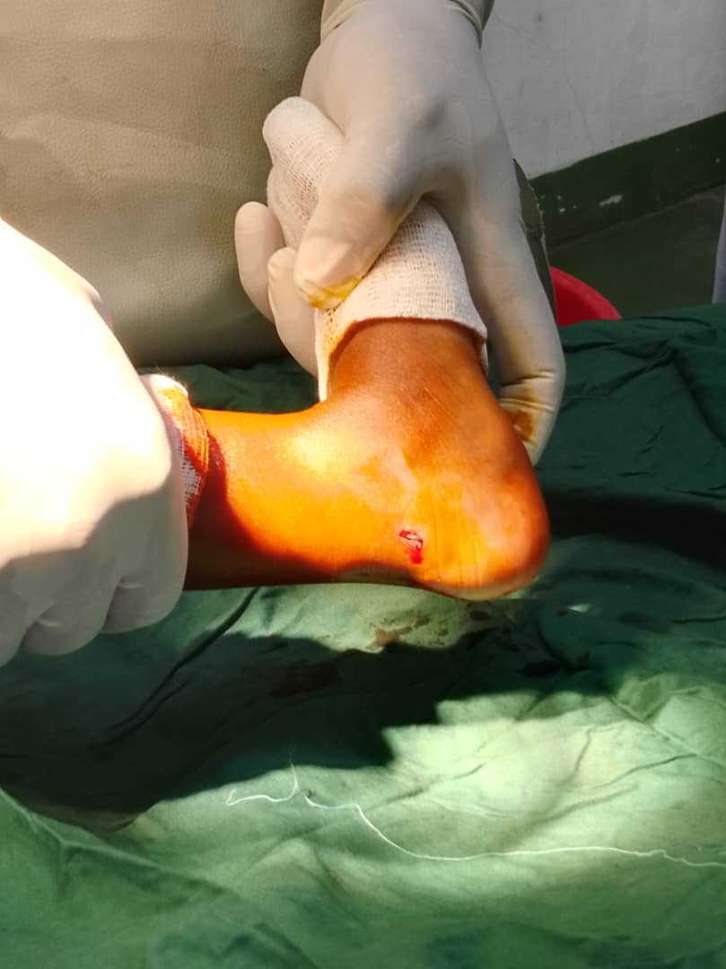
Before casting | Percutaneous Achilles’ tenotomy | Early results (3months)
Figure 2: clinical presentation before treatment, tenotomy and early results

Results
- Clinical presentation
A total of 445 children were treated for 691 cases of clubfoot in the 16 clubfoot centres from the 1st January 2019 to 31 December 2023. The clufoot was bilateral in 246 (53.3%), unilateral in 199 (44.7%), unilateral right in 107 (24.03%), and unilateral left in 92 (20.67%) children.
There were 308 males and 138 females, giving a sex ratio of 2.23. The most represented age range of children being corrected for clubfoot, at the beginning of the treatment, was 0 to 5 months with 304 children (68.8%), followed by the 6 to 12 months with 84 (18.9%), 12 to 18 months with 37(8.3%) and 18 to 24 months with 20(4,5%).
All children (100%), had this deformity from birth, and only 46/445(10.3%) had a family history of clubfoot. Clinical types found were: untreated with 358 (80.4%), complex with 79 (17.8%), recurrent with 6 (1,3%) and atypical with 2 (0.4%).
The initial mean Pirani score was 4.48+5.00 before treatment.
The majority of clinics are located in the Centre, Littoral, North West, and West regions, with 4 clinics (18.2%) each. The Regions without clinics referred their cases to regions with clinics. All the 10 regions of Cameroon were thus represented, the West being the first with 159 (35.7%), followed by the North West with 108 (24.3%), the South West with 75 (16.9%), the Littoral with 36(8.1%), the Centre with 27 (6,1%), the Adamaoua with 18 (4.0%), the South with 10 (2.2%), the Farth north with 5 (1.1%), the East with 4(0.9%) and the North Region with 3 cases (0.7%).
From the child’s home to the clinic, the mean distance was 19.13+ 14.38 kilometres, and those living more than 25 kilometres from the centre were the most represented with 198 (44.5%). The staff members had respectively 8/22(36.4%), 8/22(36,4%), and 2/22(0.1%) good, very good, and excellent knowledge of the Ponseti technique and 13/22(59.1%) of clinics had a staff that had the required skills in manipulation of the clubfoot. But only 6/22(27.3%) had good collaboration with the Health District (reporting, referral if difficult).
- Treatment and outcome
Treatment
Concerning the Ponseti method (Figure 2), 225(50.6%) had 5 to 7 casts, 62 (13.9%) had 5 or more casts, and 143(32.1%) had 1 to 4 casts. The above 10 cast group had 15 cases (3.4%). The tenotomy was done in 343 (77.1%) and repeated in 11 cases (3.3%). The foot abduction braces were Iowa in 413 (98.1%) and locally made Steenbeek braces in 8(1.9%).
The braces had been worn for 1-6 months in 84 (20%) cases, 7-12 months in 158 (37.5%), 13-18 months in 104 (24.7%), 19-24 months in 38(9%) and above 24 months in 37 (8.8%).
The good results
The good results (complete correction of the 4 deformities, Pirani score at 0, no complication, wearing normal shoes, walking and running without pain or stiffness) concerned 383 (86.1%). The mean Pirani evolved from 4.48 to 0.16+ 0.31.
Complications
Minor complications were registered for 62 (13.93%) cases with: skin rashes 31 (7%), pressure ulcers 21 (4.7%) and residual deformation 10(2.2%).
Lost to follow up
Lost to follow up was noted in 256 (57,5%): 22 (8.6%) during casting and 234 (52.58%) during bracing. The reasons given for lost to follow up were long distance from the clinic (28.5%), socio-political crisis (28.1%), relocation of the child (14.4%), lack of family support (12.9%), cultural belief (3.2%), medical disease and death of child (2%), cost of treatment (1.6%) and feeling that the child is already completely cured (1.6%).
Relapse
During onsite visits done from January to May 2024, relapse was absent in 272 (61.1%) and minor forms of relapse occurred in 173 (38.9%): Cavus in 0 (0%), Adductus in 40 (9%), Varus in 19 (4.3%), and Equinus in 34 (6.64%). The reasons for relapse were treatment adherence in 100 (22, 47%) and brace compliance in 73 (16.45%).
There was supination (walking with the lateral border of the foot) in 116 (26.1%), foot stiffness in 85 (19.1%) and 49 (11%) were referred for minimal invasive surgery: posterior release and anterior tibial button transfer. The rest of relapse were corrected by a few cast and repeated tenotomy if necessary.
Foot pain
There was a light pain in the foot, without limitation of activities in 42 cases (9.4%) and with sometimes a limitation of activities in 1 case (0.2%).
Foot stiffness
The foot stiffness was present in 85 (19.1%), and absent in 360 (80,9%).
Wearing normal shoes
After the Ponseti method, 129 (29%) always wear shoes normally, 272 (63.4%) children usually wear shoes normally, 43 (9.7%) sometimes and 1 (0.2%) had never worn normal shoes and was recast and operated.
Walking after Ponseti
During the onsite visit, 183 (41.1%) of patients were working normally, 249 (56%) moderately and 13 (2.9%) were not walking normally and referred for recasting or surgery.
Running and playing normally after Ponseti
After treatment, 282 (63,4%) of children could run and play normally
Treatment completion
Nine patients /445 (2.0%) completed the 5-year treatment.
- Factors associated with poor outcome
According to the table 1 below, after bivariate and multivariate analysis, we found that the following were associated to poor outcome: high initial Pirani score (cOR 1.27, CI 1.06-1.51, p=000); children aged 6 to 11 months at the beginning of the treatment, cOR 2.00, CI1.18-3.42, p=0.024); Children born at home (cOR1.96, CI1.28-3.00, p=0.002); child’s home at a distance above 25kilometres from the treatment centre (cOR1.43, CI 0.8-2.35, p=0.001); High Pirani score after casting (cOR1.90, CI 0.97-3.71, p=0.018); and been a male (cOR1.58, CI 0.99-2.50, p=0.015).
Discussion
This national study was conducted among children aged 0-2 years diagnosed with congenital clubfoot from 2019 to 2023 in 16 out of the 22 clubfoot clinics identified in various regions of Cameroon. The aim of our study was to characterise idiopathic congenital clubfoot, evaluate treatment and factors associated with relapse with the Ponseti technique in Cameroon. A total of 445 records of infants with clubfoot were included in this study, 307 males and 138 females. Concerning characterization of clubfeet in this study, 358 (80.4%) were characterized as untreated clubfoot. According to the affected side, most cases were bilateral, 246 (55.3%). The majority of participants were encountered in the west region, 159 (35.7%). In Cameroon, the average initial Pirani score was 4.48 (+/- 5.00) and the average concluding Pirani score was 0.16 (+/- 0.21); 225 infants (50.6%) had 5-7 casts, and tenotomy was performed in the majority of the cases, 343 (77.1%) and repeated in 11 (3.3%) cases. After treatment, 24 participants on 445 (4.4%) did not wear abduction braces. Lost to follow-up rate was 256/445 (57.45%). The relapse rate of 173/445 (38.9%). Factors associated with relapse were: high Pirani scores before casting (aOR:1.27, CI: 1.06-1.51, p=0.008); children aged 6-11 months (aOR: 2.00, CI: 1.88-3.42, P=0.011) and those born at home (aOR:1.96, CI: 1.28-3.00, 0.002).

Clinical characteristics
The majority of patients were male (68.9%), and most of the cases were bilateral (55.3%). This is similar to the results reported by previous local and haitian studies of Ghassi and al. in Bafoussam [13] and Qudsi and al. in Haiti [14], Atemkeng and al. in Yaoundé Cameroon [15] and Adegbehingbe and al. [16] where the male was more represented and the majority of cases were bilateral. Most of the clubfoot cases were recorded in the West region of Cameroon (35.7%), in line with a five-year local retrospective study by Ghassi et al. in Bafoussam, that showed a quit high number of clubfoot patients in the Western region [13]. This high number of cases in the west region could be explained by the increasing sensitisation and family cases being observed there.

Pirani score
From this study the average initial Pirani score was 4.48 (+/-5.00), the average final Pirani score was 0.16 (+/-0.21) and the tenotomy was performed on 77.1% participants. These findings are quite similar to those of other studies performed in Cameroon by Atemkeng et al. [15] with an initial Pirani of 5 and tenotomy performed on 78.38%. This is also similar to the findings of Ghassi et al. [13] where the initial Pirani scores for left and right foot were 4.9 (+/-0.9) and 4.9 (+/-1) before treatment, and 0.8 (/+-0.6) and 0.9( +/-0.5) after treatment, respectively. These similarities could be explained by the setting of the studies, which are the same because all cited studies were done in Cameroon. Furthermore, the centres considered for our study and the above-cited studies were centres accredited by the Cameroon Clubfoot Program, and so had one or more Physiotherapists trained in the Ponseti method. Therefore, adequate application of Ponseti’s method greatly reduces the Pirani score, similar to reports in literature [17]. Conversely, our results are different from those of Dibello et al. in Italy [18] where tenotomy was performed in 92.7% of clubfoot cases. This difference could be explained by differences in study design and settings. Furthermore, in the underdeveloped countries like Cameroon, where lack of adherence to surgery is usual no matter how less invasive it is [13].

Outcome
We found in this study a relapse rate of 38.9%, which is quite high compared to a review of clubfoot management after eight-year review in Pakistan (12.1%) by Ahmed and al [19]. This difference in the relapse between Cameroon and Pakistan could be explained by the study's settings and the study population and staff, which are different. On the other hand, the lost to follow-up rate in our study could be another explanation to this high rate of relapse in Cameroon. Lost to follow-up in our study was high with respect to that of Ahmed et al [19]. The relapses should have occurred because patients were lost to follow-up. This is not in line with the results obtained by the study of Ghassi and al. [13] among children treated by the Ponseti method 0 to 5 years in Bafoussam, where the relapse rate was 9.1%. This difference could be explained by the fact that our study was huge and considered all the recognised clubfoot treatment clinics in Cameroon, while the study of Ghassi et al. [13] focused only on urban centres in Bafoussam. Generally, the relapse rates are high in Cameroon. Lack of good collaboration encountered in the majority of clubfoot clinics (14 on 22, 63.6%) with the Health District for Clubfoot care could also explain such a high level of relapse in Cameroon. In fact, in our study, cases requiring more than 10 casts were not referred to a more integrated centre. In line with this report from a systematic review on the health determinants of accessibility to clubfoot treatment in low- and middle-income countries by Sharaf et al. [20], who showed a need for collaboration and a structured training program to improve the practitioners’ skills.

Factors associated with poor outcome
The factors significantly associated with relapses were: high Pirani score before casting (aOR:1.27, CI: 1.06-1.51), children aged 6-11 months at the beginning of the treatment (aOR: 2.00, CI: 1.88-3.42) and lastly, those children born at home (aOR:1.96, CI: 1.28-3.00). These results are in line with those by Qudsi et al. [14], where a high Pirani score before treatment was associated with relapse. This is also similar to a recent systematic review on factors associated with relapses of clubfoot [9] by Van Shelven et al., where it was reported that higher DiMeglio scores (OR = 1.9, CI 1.2–3.3) and lower education level of parents (OR = 1.8, CI 1.2–2.6), were associated with higher recurrence rates. Our study did not assess the level of education of the parents as a factor influencing relapses. Pirani scoring is the most used and most reported for children under 2 years old. High initial score translates a severe clubfoot which are more difficult to address and sometimes requires a higher number of casts which has been shown in literature as a predictive factor of relapse [10, 13]. Children aged 6-11 months were more likely to develop relapse. It could be explained by the parents’ negligence, accounting for inadequate bracing and relapse [12,21]. Finally, children born at home were more likely to have a relapse. This result could be explained by the fact that more often, children born at home could delay the diagnosis because, more often, in daily observations in Cameroon. These children usually are from rural, poor and undereducated families with strong cultural beliefs. The diagnosis is delayed induces a delay in the treatment, which was to commence as early as possible to have the best results [22, 23].
Limits and strengths
The main limit of our study is that it did not involve a prospective follow-up of these clubfoot cases which would have permitted a more precise estimate of the relapses and factors associated. Furthermore, we did not go to the communities (hospital based-study). Despite these limits, this multicentre study is the largest and has generated data that could help ameliorate the Cameroon Clubfoot Care (CCC) program, as it considered 16 out of 22 accredited clubfoot clinics across the country.
Conclusion
Clubfoot in Cameroon is a national problem because all 10 regions are concerned. Some regions lack a clubfoot clinic, and training is therefore needed for the new staff. Old staff members also need continuous training and collaboration amelioration.

Congenital talipes equinovarus is more frequent in boys and is mostly bilateral. The Ponseti method is locally effective in the hands of trained staff, in the treatment of clubfoot and can be continued and ameliorated during supervisions and training sessions and by using mass media sensitisation for early detection and referral at birth.

Factors associated with poor outcome to be considered in new strategies are: high initial Pirani score; children aged 6 to 11 months at the beginning of the treatment; children born at home; child’s home at a distance above 25kilometres from the treatment centre, which reduces adherence; high Pirani score after casting; and being a male child. A yearly national prospective follow up study will surely be more informative as well as studies on barriers.

Ethical Approval and Consent :
The ethical clearance, reference IRB 2024-24, was obtained from the Institutional Review Board, and an authorisation was given by the Directors of hospitals where the data were collected. Informed consent was delivered before data collection.

Disclaimer (Artificial intelligence)
Option 1:

Author(s) hereby declare that NO generative AI technologies such as Large Language Models (ChatGPT, COPILOT, etc.) and text-to-image generators have been used during the writing or editing of this manuscript.

Option 2:

Author(s) hereby declare that generative AI technologies such as Large Language Models, etc. have been used during the writing or editing of manuscripts. This explanation will include the name, version, model, and source of the generative AI technology and as well as all input prompts provided to the generative AI technology

Details of the AI usage are given below:
1.
2.
3.

REFERENCES
1. Liu Y, Zhao D, Zhao L, Li H, Yang X. Congenital Clubfoot: Early Recognition and Conservative Management for Preventing Late Disabilities. Indian J Pediatr. 2016;83(11):1266–74.
2. Gray K, Pacey V, Gibbons P, Little D, Frost C, Burns J. Interventions for congenital talipes equinovarus (clubfoot). Cochrane Database of Systematic Reviews. 2014;12(8): 16-56.
3. Cady R, Hennessey TA, Schwend RM. Diagnosis and Treatment of Idiopathic Congenital Clubfoot. Pediatrics. 2022;149(2) 1-9.
4. Jowett CR, Morcuende JA, Ramachandran M. Management of congenital talipes equinovarus using the Ponseti method: A systematic review. J Bone Joint Surg Br. 2011 Sep;93-B(9):1160–4.
5. Owen RM, Capper B, Lavy C. Clubfoot treatment in 2015: a global perspective. BMJ Glob Health. 2018;3(4): 1-7.
6. Owen RM, Kembhavi G. A critical review of interventions for clubfoot in low and middle-income countries: effectiveness and contextual influences. J Pediatr Orthop Part B. 2012 Jan;21(1):59–67.
7. Radler C, Mindler GT, Riedl K, Lipkowski C, Kranzl A. Midterm results of the Ponseti method in the treatment of congenital clubfoot. Int Orthop. 2013 Sep;37(9):1827–31.
8. Colburn M, Williams M. Evaluation of the treatment of idiopathic clubfoot by using the Ponseti method. J Foot Ankle Surg. 2003 Sep;42(5):259–67.
9. Yadavalli A, Hennrikus W, Reichenbach S. Outcomes of clubfoot treated with casting in Ghana. Cureus. 2021; 13(3):1-5.
10. López-Carrero E, Castillo-López JM, Medina-Alcantara M, Domínguez-Maldonado G, Garcia-Paya I, Jiménez-Cebrián AM. Effectiveness of the Ponseti Method in the Treatment of Clubfoot: A Systematic Review. Int J Environ Res Public Health. 2023 ;20(4):1-9.
11. Pirani S, Naddumba E, Mathias R, Konde-Lule J, Penny NJ, Beyeza T, et al. Towards Effective Ponseti Clubfoot Care: The Uganda Sustainable Clubfoot Care Project. Clin Orthop. 2009 May;467(5):1154–63.
12. Smythe T, Wainwright A, Foster A, Lavy C. What is a good result after clubfoot treatment? A Delphi-based consensus on success by regional clubfoot trainers from across Africa. Tsuchiya H, editor. PLOS ONE. 2017 Dec 21;12(12):1-9.
13. Ghassi TH, Chu Buh F, Atemkeng TF, Talla Kenmogne AF, Motba Ndjomou DN, Moulion Tapouh JR. Club foot management in the Bafoussam Baptist Healthcare center (BBHC), Cameroon: Treatment outcomes and the associated factors of relapse with the Ponseti’s technique. GSC Adv Res Rev. 2023 Mar 30;14(3):230–40.
14. Qudsi RA, Selzer F, Hill SC, Lerner A, Hippolyte JW, Jacques E, et al. Clinical outcomes and risk-factor analysis of the Ponseti Method in a low-resource setting: Clubfoot care in Haiti. PLoS ONE. 2019 Mar 14;14(3): 1-14.
15. Atemkeng TF , Wondjè FTF , Nguéné Nyemb AG, Necdem S and Nguifo ML. Clubfoot treatment by the Ponseti method in Yaounde, about a cohort of 74 cases. Int. J. Adv. Res. 2018 ; 6(11) 953-959.
16. Adegbehingbe OO, Asuquo JE, Joseph MO, Alzahrani M, Morcuende JA. The Heel Pad in Congenital Idiopathic Clubfoot: Implications of Empty Heel for Clinical Severity Assessment. Iowa Orthop J. 2015;35:169–74.
17. Alexander M, Ackman JD, Kuo KN. Congenital Idiopathic Clubfoot: Orthop Nurs. 1999 Jul;18(4):47-58.
18. Uganda Sustainable Clubfoot Care Project, Mathias RG, Lule JK, Waiswa G, Naddumba EK, Pirani S. Incidence of Clubfoot in Uganda. Can J Public Health. 2010 Jul;101(4):341–4.
19. Wallander H, Hovelius L, Michaelsson K. Incidence of congenital clubfoot in Sweden. Acta Orthop. 2006 Jan;77(6):847–52.
20. Sheik-Ali S, Navarro SM, Shaikh H, Keil EJ, Johnson W, Lavy C. The Health Determinants of Accessibility to Clubfoot Treatment in LMICs: A Global Exploration of Barriers and Solutions. Int J Matern Child Health AIDS. 2021;10(2):241–50.
21. Butt MN, Perveen W, Ciongradi CI, Alexe DI, Marryam M, Khalid L, et al. Outcomes of the Ponseti Technique in Different Types of Clubfoot—A Single Center Retrospective Analysis. Children. 2023 Aug 3;10(8):1340.
22. Chu A, Lehman WB. Treatment of Idiopathic Clubfoot in the Ponseti Era and Beyond. Foot Ankle Clin. 2015 Dec;20(4):555–62.
23. de Podesta Haje D, Maranho DA, Ferreira GF, Rocha Geded AC, Aroojis A, Queiroz AC, et al. Ponseti Method After Walking Age – A Multi-Centric Study of 429 Feet: Results, Possible Treatment Modifications and Outcomes According to Age Groups. Iowa Orthop J. 2020;40(2):1–12.
24. do Amaral e Castro, A., Peixoto, J. B., Miyahara, L. K., Akuri, M. C., Moriwaki, T. L., Sato, V. N., ... & Aihara, A. Y. (2024). Clubfoot: Congenital talipes equinovarus. RadioGraphics, 44(7), e230178.

25. Bent, M. A. (2023). Congenital Talipes Equinovarus (Clubfoot). In Orthopaedics for the Newborn and Young Child: A Practical Clinical Guide (pp. 47-60). Cham: Springer International Publishing.

26. Boakye, H., Nsiah, A., Thomas, A., & Bello, A. I. (2016). Treatment outcome of Ponseti method in the Management of Club Foot at Komfo Anokye teaching hospital, Ghana: a retrospective study. Archives of current research international, 3(2), 1-8.

