Outcomes of Arthroscopic-Assisted Latissimus Dorsi Transfer for Irreparable Posterosuperior Rotator Cuff Tears

Abstract
Introduction: Therapeutic options for the treatment of irreparable posterosuperior rotator cuff tears, particularly in younger, active patients, are limited. Arthroscopic-assisted transfer of the Latissimus Dorsi represents a promising treatment option.
Materials and Methods: We report a retrospective review of 17 patients. The results were evaluated with an average follow-up of 26 months using objective criteria (Constant score) and subjective measures (Subjective Shoulder Value (SSV), visual analog scale (VAS), satisfaction level).
Results: The study group consisted of 9 men and 8 women. The average age at the time of the intervention was 56.4 years (range: 44-66 years). At the last follow-up, the absolute Constant score had significantly improved, increasing from an average of 32.6 preoperatively to 64.3 postoperatively (P<0.001), with a significant improvement in all domains (P<0.001). Active anterior elevation increased from 95.29° to 141.17°, and the average improvement in external rotation (ER) was 14°. The VAS pain score decreased from 6.3 preoperatively to 1.8 postoperatively (P<0.001).
Subjectively, 77% of the patients reported being very satisfied or satisfied, and eight out of nine patients were able to resume their work.
Discussion and Conclusion: Arthroscopic-assisted transfer of the Latissimus dorsi tendon allows for satisfactory functional outcomes in young and active patients with posterosuperior rotator cuff injury. The results are similar to those reported in open surgery series.
However, identifying predictors of better outcomes is essential to facilitate patient selection.
Keywords: Rotator cuff; Irreparable posterosuperior tear; Latissimus Dorsi; Arthroscopic-assisted transfer.
Level of evidence: Retrospective study, level IV
Introduction
The definition of a large, non-repairable rotator cuff tear and its prevalence vary considerably in the literature [1,2]. The prevalence of irreparable posterosuperior lesions among these tears is not well known [3] but has been reported in 10-20% of the general population [4].
These massive posterosuperior tears can lead to loss of external rotation (ER) and active anterior elevation (AAE), thus resulting in a significant functional limitation.
When these tears cannot be repaired, therapeutic management is challenging, considering both pain and functional limitations, especially in younger, active patients [5]. Treatment options may include physical therapy [6], partial cuff repair with or without biceps tenotomy/tenodesis [7], superior capsular reconstruction, tuberoplasty [8], tendon transfers [9], as well as a reverse shoulder arthroplasty [10].
Arthroscopic debridement alone or in combination with long biceps tenotomy can help manage pain but does not restore shoulder function, with deteriorating postoperative outcomes over time [11]. Likewise, reverse shoulder arthroplasty is typically considered for older patients with glenohumeral joint involvement.
Therefore, tendon transfers have emerged as an appropriate treatment option, particularly the Latissimus Dorsi (LD) transfer [12], which has become an established procedure to restore function and reduce pain in younger, active patients after failed conservative treatment [5,13].
The objective of this study was to report the functional outcomes of arthroscopically assisted LD transfer and assess the role of various demographic, clinical, and radiological parameters.
Materials and Methods:
We present a single-center retrospective series of 17 patients with large, non-repairable posterosuperior rotator cuff tears treated with isolated Latissimus Dorsi (LD) transfer. These surgeries were performed by a single operator between January 2016 and December 2019, with a minimum follow-up period of 12 months. Epidemiological, clinical, and radiological data were analyzed.
Inclusion criteria for this study were as follows: shoulder pain and limited function in a young and active individual, confirmed large, non-repairable posterosuperior rotator cuff tear through magnetic resonance imaging (MRI), failure of conservative treatment with at least 6 months of physical therapy, no prior shoulder surgery, absence of neurological deficits, and a functional remaining rotator cuff muscles (atrophy <2).
Rotator cuff tear was considered irreparable if there was a stage Ill retraction according to Patte classification [14] and a fatty infiltration grade Ill or higher according to the Goutallier classification [15] in at least one of the two ruptured tendons.
Exclusion criteria included the presence of an irreparable subscapularis tear, glenohumeral joint arthritis exceeding grade 2 Hamada classification [16], a stiff shoulder (limited passive range of motion after 3 months of physical therapy), and an anterosuperior instability.
Statistical analysis was performed using IBM SPSS 22. Student's t-test was used for continuous variables, and the chi-square test was used for categorical variables. The significance threshold was set at 5%.
1. Surgical Technique:
Under general anasthesia and interscalene block, with the patient in the Beach Chair position, the surgical procedure was performed in two steps.
First Step: Harvesting the LD Tendon (figure 1)
A 5cm incision was made along the axillary border of the scapula. The LD was separated posteriorly from the teres major, and its neurovascular bundle was identified. Once the muscle was freed from its attachments, with the arm in internal rotation, the tendon's insertion on the humeral shaft was identified, and the tendon was then cut at its axillary insertion.
The LD tendon was sutured using two non-absorbable ORTHOCORD 2-0 sutures. Once the LD tendon was sutured, the muscular body was released subcutaneously to obtain a satisfactory length for the transfer. The final length of the tendon was assessed by passing it, with gentle manual traction, over the posterior edge of the acromion (at least 2 cm) with the arm in adduction.
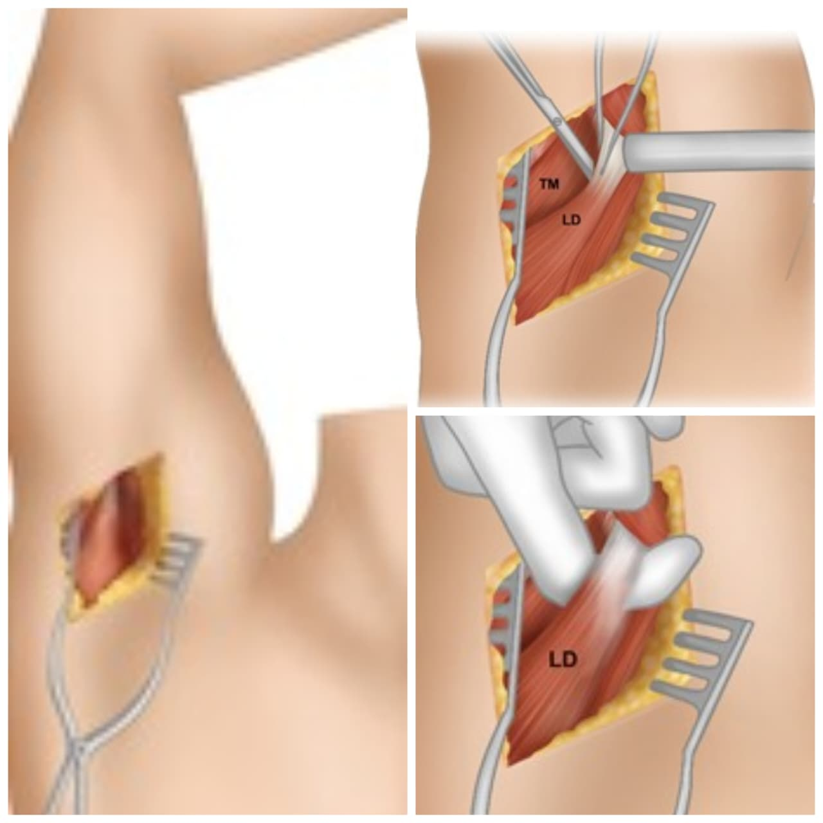
Figure 1: harvesting of the latissimus dorsi tendon
Second Step: LD Tendon Transfer (Arthroscopic Stage)
At this point, a diagnostic arthroscopy was performed in the glenohumeral and subacromial spaces. After inspecting the rotator cuff tear, the LD tendon was stretched across the superficial part of the triceps muscle and beneath the posterior deltoid head. The tendon was then secured between the insertion zones of the supraspinatus and infraspinatus muscles using two anchors (figure 2).
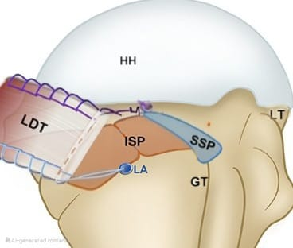
Figure 2: Final position of the LD tendon.
For the final step of the procedure, the subscapularis tendon was assessed and repaired if necessary.
2. Post-operative Protocol:
Immobilization in 45° abduction and 30° external rotation was maintained for 4 weeks.
Pendulum exercises were recommended as of day 1 post-op. Active exercises in a pain-free range of motion were allowed starting from the fourth week post-op. After 12 weeks, light manual work and sports activities were permitted.
The total duration of rehabilitation was six months.
3. Data Collection:
Patients were monitored through pre- and post-operative clinical and radiological examinations. All patients provided informed consent to participate in the study.
3.1. Clinical Evaluation:
All patients underwent a physical examination before surgery and at the last follow-up visit. The clinical evaluation included measuring shoulder joint range of motion with a goniometer and assessing muscle strength in abduction and external rotation using a digital dynamometer. The recorded joint range of motion included active anterior elevation (AAE), abduction, and external rotation in adduction (ER1) and at 90° (ER2).
Preoperative clinical evaluation included the Constant-Murley score [17], Subjective Shoulder Value (SSV) [18], and a pain score (VAS).
Postoperative assessment relied on the Constant-Murley score, SSV, VAS, and the patients' subjective satisfaction, categorized into four groups (very satisfied, satisfied, dissatisfied, and unsatisfied).
3.2. Radiological Evaluation:
All patients had pre- and post-operative shoulder X-rays (in neutral, internal, and external rotation) with an assessment of the subacromial space and glenohumeral osteoarthritis according to the Hamada classification [16]. Preoperative MRI was performed for all patients to evaluate tendon retraction as per Patte classification [14], fatty infiltration as per Goutallier classification [15], and muscle atrophy according to Thomazeau’s classification [11].
RESULTS
1. Study Group
The study group consisted of 9 men and 8 women. The average age at the time of the surgery was 56.4 years (range: 44-66). The right side was affected in 12 cases (70%), and the dominant arm was involved in 15 cases (88%) (Table 1).

Table 1: Demographic Characteristics of the Population
Variable | Value
Age (years) | 56,47 (44 - 66)
Sexe (M/F) | 9 (53%) / 8 (47%)
Professional activity (manual worker/sedentary) | 7 (41%) / 8 (47%)
Dominant member | 15 (88%)
Nine patients (53%) were actively employed at the time of the surgery, with seven occupying physically demanding occupations. In four cases, the injury was work-related. The average duration of symptoms before surgical intervention was 30 months (range: 10-84). The results were evaluated with an average follow-up of 26 months (range: 12-48).
2. Clinical Results
At the last follow-up, the absolute Constant-Murley score had significantly improved, increasing from an average of 32.6 to 64.3 postoperatively (P<0.001), with substantial improvement in all domains (P<0.001).
Improvement was mostly noted in regards to pain (82%), followed by activity (76%), strength (72%), and mobility (63%). The weighted Constant-Murley score increased from 41.3% to 81.3% (P<0.001).
It was more significant for patients with a preoperative active anterior elevation (AAE) of less than 80°. And a greater improvement was seen when fatty degeneration was inferior to Goutallier grade four, with a gain of 91% compared to 49% when degeneration was at grade four (p<0.08).
The average AAE significantly increased from 95.3° preoperatively to 141.2° postoperatively, resulting in a gain of 45.9° (P<0.0001).
A 40% gain was achieved in external rotation, with an average gain of 14° for external rotation ER1 (P<0.05), and 14.1° for external rotation ER2 (P<0.001).
Only one patient experienced worsening of external rotation deficit postoperatively.
The gain in ER and AAE was more significant when the preoperative AAE was low, though not statistically significant.
There was an improvement in strength in external rotation ER1 in 46% of cases, with an average gain of 2.2 kg in strength for external rotation ER2 (P<0.001).
Subjectively, eight patients (47%) were very satisfied, five (30%) were satisfied, three (18%) were dissatisfied, and one (5%) was unsatisfied. This self-reported satisfaction was independent of age, gender, and any potential association with a work-related incident.
The Subjective Shoulder Value (SSV) improved from 36.2% preoperatively to 67.6%
postoperatively (P<0.001). The visual analogue scale (VAS) pain score decreased from an average preoperative score of 6.3 points to 1.8 points postoperatively (P<0.001). (Table 2)

Table 2: Clinical Characteristics of the Population
Variable | Pre-operative | Post-operative | Improvement (%)
Rotation externe (RE1) | 21,17° | 35,58° | +40,5
Rotation externe (RE2) | 30,58° | 44,7° | +31,6
Élévation antérieure active (EAA) | 95,29° | 141,17° | +32,5
Abduction | 76,47° | 114,41° | +33,2
Force en abduction | 1,34 kg | 3,61 kg | +62,9
Constant absolu | 32,58 | 64,29 | +49,3
Constant pondéré | 41,28% | 81,28% | +49,3
EVA | 6,3 | 1,8 | -71,4

Eight out of nine patients were able to resume their work, including six patients with physically demanding occupations, two of whom benefitting from modified work duties.
3. Radiological Results
Analysis of standard X-rays showed worsening of glenohumeral osteoarthritis and reduction in the subacromial space. There was a significant reduction in the average subacromial space, from 5.85mm preoperatively to 4.71mm on last follow-up (P<0.001).
Preoperative glenohumeral osteoarthritis was classified as grade 1 in 6 patients and grade 2 in 11 patients. Osteoarthritis progression was observed in 8 shoulders (47%), but no postoperative radiological follow-up showed grade 4.
The average degree of preoperative and postoperative osteoarthritis according to Hamada classification was 1.64 and 2.11, respectively (P<0.001). (Table 3)

Table 3: Radiological Characteristics of the Population
Variable | Pre-operative (mean) | Post-operative (mean) | P-value
Espace sous acromial | 5,85 | 4,71 | <0,001
Stade Hamada et Fukuda | 1,64 | 2,11 | <0,001
However, there was no correlation between the clinical outcome (Constant-Murley score) and the radiological Hamada grade (P=0.113) neither the subacromial space (P=0.219).
MRI revealed a rupture of the supraspinatus and infraspinatus tendons in 15 cases and a rupture of all three tendons (supraspinatus, infraspinatus, and subscapularis) in 2 cases (12%).
The two subscapularis ruptures were considered significant (Lafosse grade |), and arthroscopic repair was performed concurrently at the time of tendon transfer. All ruptured tendons were retracted to the glenoid.
The average preoperative fatty degeneration index according to the Goutallier classification was 3.29 (grade 3-4) for the supraspinatus and 3.17 (grade 2-4) for the infraspinatus.
The two subscapularis tendon lesions found in the study did not significantly affect the objective and subjective outcomes.
4. Complications
One patient experienced a transient injury to the axillary nerve, which resolved spontaneously. This patient had a poor final follow-up result with a Constant-Murley score of 40 points (20 points preoperatively) and a pain score (VAS) of 6 points (8 points preoperatively). No infectious complications were noted in our case series.
DISCUSSION
Massive and irreparable posterosuperior rotator cuff tears, especially in young patients, remain a therapeutic challenge with a controversial choice of techniques[19].
Ever since the first documentation of latissimus dorsi (LD) tendon transfer by Gerber in 1988 [12], its encouraging results in terms of pain relief, active anterior elevation (AAE), and external rotation have led to an expansion of its use [13,21,22].
The advent of arthroscopically assisted LD tendon transfer [3,21] has demonstrated satisfactory clinical outcomes comparable to open LD tendon transfer [3,23].
Several modifications to the original technique have been described, including different means and sites of tendon fixation. Some studies have attached the LD tendon at the level of insertion of the infraspinatus tendon [24], while others have placed it at the level of the greater tuberosity with or without fixation of the subscapularis tendon [22].
In this study, we have opted for a more posterior site of insertion relative to the supraspinatus tendon insertion, as proposed by Herzberg et al [25]. This insertion site likely reduces the tension applied to the transferred tendon and, consequently, the risk of rupture.
Previous studies have analyzed the influence of gender and age on the outcomes of LD tendon transfer. In this study, the mean Constant-Murley score was slightly but not significantly higher in men. Results in the literature have been mixed [3,5].
Regarding age at the time of surgery, some authors have concluded that clinical outcomes are significantly related to age [13,26], but this was not found in this study, nor in the study conducted by Castricini et al. [4], where age appeared to be a non-significant factor for joint mobility and postoperative Constant-Murely score.
In this context, arthroscopically assisted LD tendon transfer may be indicated not only for young patients but also for older individuals (up to 66 years in this series).
The average postoperative AAE in this study was 141.2° with an average gain of 45.9°. These values are slightly lower than those reported by Valenti et al. [19] but higher than those of Weening et al.[27]
Functional prognosis was better when the preoperative AAE was low. In four of the patients with preoperative AAE less than 80°, the average increase was 75° (60° preoperatively to 135° postoperatively).
This observation suggests that patients with very low preoperative function, considered pseudo-paralytic by some authors, can benefit from the LD tendon transfer procedure. This was confirmed by the study of Petricciolli et al. [26], in which pseudo-paralytic shoulders regained sufficient active mobility. Conversely, according to Lannotti et al. [27], a significant decrease in preoperative mobility, especially AAE, constitutes a negative predictive factor, and a preoperative AAE less than 80° represents a relative contraindication [9,22,29].
In our study, the improvement in external rotation was 14° for RE1 and 31% for RE2. These results for RE1 are equivalent to those of El-Azab et al. [13] Thus, LD transfer is effective in regaining active external rotation [30,31], and the gain is more significant when the initial deficit is severe [4].
The weighted Constant score in our study improved from 41.3% to 81.3%. Our scores are higher than those found by Gerber et al. [30] (73%). However, our absolute Constant score of 64.29 was comparable to the scores reported by Castricini et al. [4] (69.5).
Subjectively, 77% of patients in our series were very satisfied or satisfied. These results are in line with the study by El-Azab et al. [13] This high satisfaction rate, with an SSV of 67.6%, is a consequence of the shoulder's improved functionality and consistent pain relief (mean preoperative EVA score of 6.3 points and postoperative score of 1.8 points). This indicates that arthroscopically assisted LD transfer can enhance the quality of life for these patients.
Several authors have studied the progression of arthritis and the reduction in the sub-acromial space [9,22]. Arthritis progression varied between studies, ranging from 23% to 50%, but it was generally limited to one stage in the Hamada classification [16]. Lichtenberg et al. [24] and Nove-Josserand et al. [29] showed arthritis progression in 50% and 46% of their patients, respectively.
Regarding the subacromial space, most authors noted a significant decrease at the final follow-up [26].
In our series, we observed arthritis progression in 47% of patients, with progression limited to one stage in all cases. The reduction in the mean subacromial space was significant. However, in most series, including ours, arthritis progression or the decrease in the subacromial space was not statistically associated with inferior clinical outcomes [22,26].
The influence of the functional integrity of the deltoid muscle [3,26], subscapularis [24,26,31], and teres minor [5,32] on the results remains controversial. Nevertheless, most authors agree that concomitant subscapularis injury negatively affects the LD transfer outcome [24,31].
In our series, the presence of two partial subscapularis lesions repaired during the procedure did not have a major impact on the results. This can be explained by the fact that none of our patients had a complete rupture, which remains a contraindication for the procedure for us and most authors [9,13,26].
The presence of a competent deltoid muscle was deemed necessary for the effectiveness of the transfer, as suggested by the majority of authors [33]. The work of Debeer et al. demonstrated that preserving the deltoid muscle's integrity with arthroscopy was the most important positive prognostic factor, emphasizing the muscle's importance in achieving a successful outcome.
The outcome of LD transfer was better when the fatty infiltration of the teres minor was <2 according to the Goutallier classification [32,34] and the atrophy was <2 according to the Thomazeau classification [29]. The integrity of the teres minor muscle appeared to be a necessary condition for the effectiveness of the transfer, and patients with a deficient teres minor were excluded from our study.
Documented complications of LD transfer included hematoma [33,35], infection , secondary LD tendon rupture, secondary subscapularis tendon rupture, and transient nerve paralysis [23,24,27,33-35]. In our study, only one case was observed of transient axillary nerve paralysis.
Given its minimally invasive nature and consistent functional outcomes, arthroscopic-assisted Latissimus Dorsi transfer should be considered a valuable treatment option in young, active patients with irreparable posterosuperior rotator cuff tears—especially where joint preservation is a primary goal.
Our study had several limitations: a small study group, a retrospective nature, no postoperative MRI was performed to evaluate the healing and integrity of the transferred tendon, no comparison with other procedures, and a relatively short follow-up period.
CONCLUSION
For young and active patients with irreparable posterosuperior rotator cuff tears, therapeutic options are limited. Arthroscopic-assisted LD tendon transfer is a promising treatment option that provides satisfactory results in terms of pain relief and function.
The clinical and radiological results of our study are similar to those published in series using open surgery. However, the identification of predictors of better outcomes is essential to facilitate patient selection and better meet their expectations.
Consent
As per international standards or university standards, patient(s) written consent has been collected and preserved by the author(s).
Disclaimer (Artificial intelligence)

Author(s) hereby declare that NO generative AI technologies such as Large Language Models (ChatGPT, COPILOT, etc.) and text-to-image generators have been used during the writing or editing of this manuscript.

References
1. Gerber C, Fuchs B, Hodler J. The results of repair of massive tears of the rotator cuff. J Bone Joint Surg Am. 2000 Apr;82(4):505–15.
2. Warner JJ. Management of massive irreparable rotator cuff tears: the role of tendon transfer. Instr Course Lect. 2001;50:63–71.
3. Grimberg J, Kany J, Valenti P, Amaravathi R, Ramalingam AT. Arthroscopic-assisted latissimus dorsi tendon transfer for irreparable posterosuperior cuff tears. Arthroscopy. 2015 Apr;31(4):599–607.e1.
4. Castricini R, Longo UG, De Benedetto M, et al. Functional status and failed rotator cuff repair predict outcomes after arthroscopic-assisted latissimus dorsi transfer for irreparable massive rotator cuff tears. J Shoulder Elbow Surg. 2016 Apr;25(4):658–65.
5. Moursy M, Schmalzl J, Kadavkolan AS, Bartels N, Lehmann LJ. Latissimus dorsi transfer for massive posterosuperior rotator cuff tears: what affects the postoperative outcome? J Shoulder Elbow Surg. 2019 Nov;28(11):2191–7.
6. Collin PG, Gain S, Nguyen Huu F, Ladermann A. Is rehabilitation effective in massive rotator cuff tears? Orthop Traumatol Surg Res. 2015 Jun;101(4 Suppl):S203–5.
7. Boileau P, Baqué F, Valerio L, Ahrens P, Chuinard C, Trojani C. Isolated arthroscopic biceps tenotomy or tenodesis improves symptoms in patients with massive irreparable rotator cuff tears. J Bone Joint Surg Am. 2007 Apr;89(4):747–57.
8. Scheibel M, Lichtenberg S, Habermeyer P. Reversed arthroscopic subacromial decompression for massive rotator cuff tears. J Shoulder Elbow Surg. 2004 May;13(3):272–8.
9. Gerber C, Rahm SA, Catanzaro S, Farshad M, Moor BK. Latissimus dorsi tendon transfer for treatment of irreparable posterosuperior rotator cuff tears: long-term results at a minimum follow-up of ten years. J Bone Joint Surg Am. 2013 Nov;95(21):1920–6.
10. Valenti P, Reinares F, Werthel JD. Arthroscopic-assisted latissimus dorsi tendon transfer for irreparable posterosuperior rotator cuff tears: functional outcomes and prognostic factors in 35 cases. Rev Chir Orthop Traumatol. 2015 Dec;101:e5.
11. Thomazeau H, Rolland Y, Lucas C, Duval JM, Langlais F. Atrophy of the supraspinatus belly: assessment by MRI in 55 patients with rotator cuff pathology. Acta Orthop Scand. 1996 Jan;67(3):264–8.
12. Gerber C, Vinh TS, Hertel R, Hess CW. Latissimus dorsi transfer for the treatment of massive tears of the rotator cuff: a preliminary report. Clin Orthop Relat Res. 1988 Jul;(232):51–61.
13. El-Azab HM, Rott O, Irlenbusch U. Long-term follow-up after latissimus dorsi transfer for irreparable posterosuperior rotator cuff tears. J Bone Joint Surg Am. 2015 Mar;97(6):462–9.
14. Patte D. Classification of rotator cuff lesions. Clin Orthop Relat Res. 1990 May;(254):81–6.
15. Goutallier D, Postel JM, Bernageau J, Lavau L, Voisin MC. Fatty muscle degeneration in cuff ruptures: pre- and postoperative evaluation by CT scan. Clin Orthop Relat Res. 1994 Jul;(304):78–83.
16. Fukuda H, Hamada K, Nakajima T, Yamada N, Tomonaga A, Goto M. Partial-thickness tears of the rotator cuff. Int Orthop. 1996 Jul;20(4):257–65.
17. Constant CR, Murley AH. A clinical method of functional assessment of the shoulder. Clin Orthop Relat Res. 1987 Jan;(214):160–4.
18. Gilbart MK, Gerber C. Comparison of the subjective shoulder value and the Constant score. J Shoulder Elbow Surg. 2007 Dec;16(6):717–21.
19. Valenti P, Kalouche I, Diaz LC, Kaouar A, Kilinc A. Results of latissimus dorsi tendon transfer in primary or salvage reconstruction of irreparable rotator cuff tears. Orthop Traumatol Surg Res. 2010 Apr;96(2):133–8.
20. Aoki M, Okamura K, Fukushima S, Takahashi T, Ogino T. Transfer of latissimus dorsi for irreparable rotator cuff tears. J Bone Joint Surg Br. 1996 Sep;78(5):761–6.
21. Castricini R, De Benedetto M, Orlando N, et al. Arthroscopic-assisted latissimus dorsi transfer for the management of irreparable rotator cuff tears: short-term results. J Bone Joint Surg Am. 2014 Jul;96(14):e119.
22. Grimberg J, Kany J. Latissimus dorsi tendon transfer for irreparable posterosuperior cuff tears: current concepts, indications, and recent advances. Curr Rev Musculoskelet Med. 2014 Mar;7(1):22–32.
23. Lehmann LJ, Mauerman E, Strube T, Laibacher K, Scharf HP. Modified minimally invasive latissimus dorsi transfer in the treatment of massive rotator cuff tears: a two-year follow-up of 26 consecutive patients. Int Orthop. 2010 Mar;34(3):377–83.
24. Lichtenberg S, Magosch P, Habermeyer P. Combined latissimus-dorsi transfer according to L’Episcopo compared to isolated transfer according to Herzberg: a matched-pair analysis. J Shoulder Elbow Surg. 2012 Nov;21(11):1499–507.
25. Urien JP. Potential excursion and relative tension of muscles in the shoulder girdle: relevance to tendon transfers. Clin Biomech. 1999;8(5):8.
26. Petriccioli D, Bertone C, Marchi G. Recovery of active external rotation and elevation in young active men with irreparable posterosuperior rotator cuff tear using arthroscopically assisted latissimus dorsi transfer. J Shoulder Elbow Surg. 2016 Sep;25(9):e265–75.
27. Weening AA, Willems WJ. Latissimus dorsi transfer for treatment of irreparable rotator cuff tears. Int Orthop. 2010 Dec;34(8):1239–44.
28. Iannotti JP, Hennigan S, Herzog R, Kella S, Kelley MJ, Leggin B, Williams GR. Latissimus dorsi tendon transfer for irreparable posterosuperior rotator cuff tears: factors affecting outcome. J Bone Joint Surg Am. 2006 Feb;88(2):342–8.
29. Nové-Josserand L, Costa P, Liotard JP, Safar JF, Walch G, Zilber S. Results of latissimus dorsi tendon transfer for irreparable cuff tears. Orthop Traumatol Surg Res. 2009 Apr;95(2):108–13.
30. Gerber C, Maquieira G, Espinosa N. Latissimus dorsi transfer for the treatment of irreparable rotator cuff tears. J Bone Joint Surg Am. 2006 Jan;88(1):113–20.
31. Werner CML, Zingg PO, Lie D, Jacob HAC, Gerber C. The biomechanical role of the subscapularis in latissimus dorsi transfer for the treatment of irreparable rotator cuff tears. J Shoulder Elbow Surg. 2006 Dec;15(6):736–42.
32. Costouros JG, Espinosa N, Schmid MR, Gerber C. Teres minor integrity predicts outcome of latissimus dorsi tendon transfer for irreparable rotator cuff tears. J Shoulder Elbow Surg. 2007 Dec;16(6):727–34.
33. D P, D S. Outcome of latissimus dorsi transfer for irreparable rotator cuff tears. Acta Orthop Belg. 2010 Aug;76(4):449–55.
34. Moursy M, Forstner R, Koller H, Resch H, Tauber M. Latissimus dorsi tendon transfer for irreparable rotator cuff tears: a modified technique to improve tendon transfer integrity. J Bone Joint Surg Am. 2009 Aug;91(8):1924–31.
35. Irlenbusch U, Bracht M, Gansen HK, Lorenz U, Thiel J. Latissimus dorsi transfer for irreparable rotator cuff tears: a longitudinal study. J Shoulder Elbow Surg. 2008 Jul;17(4):527–34

