Augmented osteosynthesis in fractures of the distal end of the femur in elderly patients: surgical technique, anatomical and functional results

ABSTRACT
Introduction: The term augmented osteosynthesis refers to the surgical management of a fracture by combining an osteosynthesis device with polymethyl methacrylate (PMMA), or by using two plates, or a nail and a plate to increase the stability of the construct.
Objective: The specific objectives were to describe the clinical and functional outcomes of patients operated with a locked distal femoral plate augmented with a standard viscosity acrylic cement, the radiological results and the complications encountered.
Patients and Method: This is a case series study with descriptive and analytical aims, conducted over a 5-year period from 1 January 2018 to April 2023. The AO/OTA classification was used for the radiological classification of fractures. Gait was assessed using the Parker score. Functional outcome of the knee was assessed using the MEGY functional score. Our study population consisted of 44 cases. The mean age of the patients was 80.66 years, with the [55-90] age group the most affected. Both sexes were represented, with female domination. Domestic accidents were responsible for 88.6% of fractures of the distal end of the femur in patients aged over 65. The left side was most affected in 72.7% of cases. Periprosthetic fractures accounted for 38.6% of fractures. A1 fractures were the most common (55%). The average waiting to operate time was 3 days. The Locked-compression distal, lateral femoral plate with polymethyl methacrylate ciment augmentation was used in all our patients. The mean operative time was two hours and 12 minutes.
Results: Physiotherapy was started early in 86.4% of patients. The mean time to consolidation was 6 months. The consolidation rate was 95.4%. Residual knee pain was the most common late complication (34.1%), followed by pseudarthrosis (13.6%), infection, reduction failure and implant rupture. The overall functional result was satisfactory in 93.2% of cases, very good in 43.2% and good in 34.1%.
Conclusion: Augmented osteosynthesis for distal femur fractures in elderly patients must combine stability, solidity, rapid act and immediate rehabilitation in order to achieve good consolidation and a good functional result and avoid early morbidities and mortalities.
Key words: fracture, distal femur, osteosynthesis, PMMA, elderly subjects, results

INTRODUCTION
Fractures of the distal end of the femur are severe injuries with high mortality in the elderly population [1]. They are serious due to the significant mortality they cause in this age group. Their frequency is estimated at 0.4% of all fractures and 3% of all femur fractures [2]. The context is usually high-energy trauma in young patients, and domestic accidents or low-energy trauma in elderly individuals [3]. The sex ratio is shifted, with a female predominance due to osteoporosis, and the affected population is increasingly older [4]. The mechanism is most often an indirect trauma on a flexed knee [4].
The term augmented osteosynthesis refers to the surgical management of a fracture by combining an osteosynthesis device with polymethyl methacrylate (PMMA), or by using two plates, or a nail and a plate to increase the stability of the construct. The use of cement in what is called augmented osteosynthesis was first experimented in 1958. However, it was Sir John CHARNLEY (1911–1982), a British surgeon, who popularized PMMA in orthopedics by using it to anchor a hip prosthesis [5]. In 1989, Schwartz used cement in distal radius fractures and reported a consolidation rate of around 95% [6].
Two major challenges arise with distal femur fractures: on one hand, poor bone quality, which compromises implant anchorage, and on the other hand, an uncertain prognosis due to the mortality associated with this type of fracture.
The specific objectives of this study were to describe the surgical technique used in patients operated with a locked distal femur plate and standard-viscosity acrylic cement, assess the anatomical results, evaluate the functional outcomes, and identify complications.
1-PATIENTS AND METHODS
Study Population
This was a single-center, single-surgeon continuous case series study conducted over a 5-years period from 2018 to 2023. It included 44 patients who underwent surgery for a distal femoral fracture and were followed up for a minimum of 12 months or more at the Grand Hôpital de l’Est Francilien (France).
The patients’ ages ranged from 53 to 107 years. Both sexes were represented, with 24 women and 20 men. The most frequent injury mechanism was domestic accidents.
Inclusion criteria
Patients aged over 65 years with extra or intra-articular distal femeral fractures (types A, B, C1, and C2 according to AO classification), treated surgically using an LCP plate and polymethyl methacrylate (PMMA) cement, with at least 12 months of follow-up were included.
Exclusion criteria
Patients with AO type C3 fractures, who died a few months after surgery, follow up of less than 12 months and those who were operated on for other reasons at the same time were excluded.
Study parameters
The parameters studied included: age, medical history, fracture type, associated lesions, time to management, time to consolidation, functional outcomes, and complications.

Surgical Technique

Type of anesthesia
Thirty-two patients underwent general anesthesia and twelve had regional anesthesia combined with a lower limb nerve block.
Patients were placed in the supine position with a bolster under the knee, or in a three-quarter position on a regular table under general anesthesia. A contralateral support was placed to stabilize the patient.
A lateral surgical approach was used. Open reduction was performed, followed by osteosynthesis using an LCP plate. Acrylic cement was injected after plate placement, either using a gun system or manually into the defect left after fracture reduction. The cement was placed specifically at the defect site.
Standard-viscosity cement with a hardening time of 12 minutes from mixing to application was used. Closure was done in layers, with a drain.
A postoperative control radiograph was performed immediately in the operating room.
- Post operative care
Postoperative care focused on rehabilitation, especially nursing care for the elderly. Rehabilitation could be initiated immediately or later, depending on the stability of the surgical construct.
Active-passive mobilization of the knee:
If the construct was deemed stable during surgery, immediate postoperative rehabilitation was carried out using:
- A continuous passive motion (CPM) machine for 1 to 2 hours, 3 times per day,
- Sitting position and transfer to a chair depending on pain, as early as 24 hours post-op,
- Authorization for non-weight-bearing ambulation using crutches or a walker for 3 months, followed by progressive weight-bearing.
Early rehabilitation was done using a CPM machine during hospitalization if the fixation was stable.

Functional evaluation used the MEGY score and Parker score (Table 1)
Table 1: Functional outcome according to MEGY score
Functional criteria
Functional criteria | 4 points | 3 points | 2points | 1 point
Mobility | Flexion>120° | Flexion between 90° and 120° | Flexion between 60° and 90° | Flexion<60°
Pain | No pain | Intermittent | With effort | Constant
Stability | Normal | Normal | Mild Instability | Severe instability
Walking | Normal | Limp on exertion | Permanent limp | Walking with cane
Overall evaluation:
- Very good: 15–16 Good: 11–14
- Moderate: 8–10 Poor: 4–7

2-RESULTS
2-1 Clinical Results
Patients were operated on after an average delay of 3 days, depending on their injuries and condition. The mean surgical time was 132.16 minutes ± 22.42. Average blood loss was 390.68 ± 40.77 ml (310m to 500ml).
Intraoperatively, bone defects were observed secondary to epiphyseal-metaphyseal impaction, with a maximum defect of 1.8 cm, which justified the use of PMMA cement to fill the gap.

2-2 Type of the fractures (Graph 1)

Graph 1: Distribution of patients according to AO classification
To note that 8 patients had a periprosthetic fracture.
Bone defect (cm): Intraoperatively, the bone defect was secondary to impaction following reduction. Evaluation was subjective, based on the surgeon’s intraoperative assessment.
An example of a pre and post-operative xrays is given in figure 1 to 4.

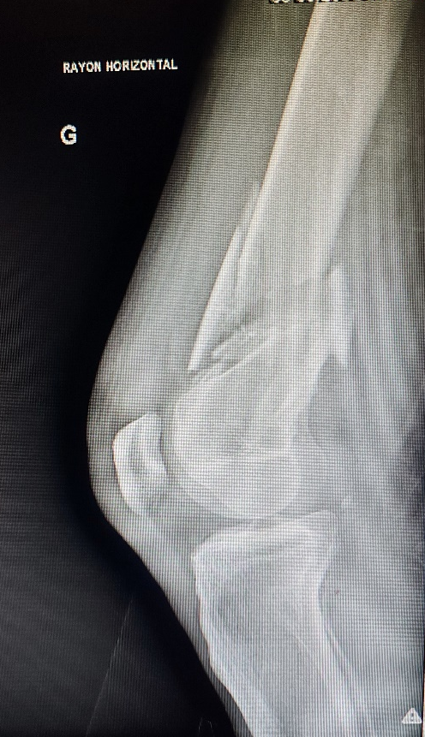
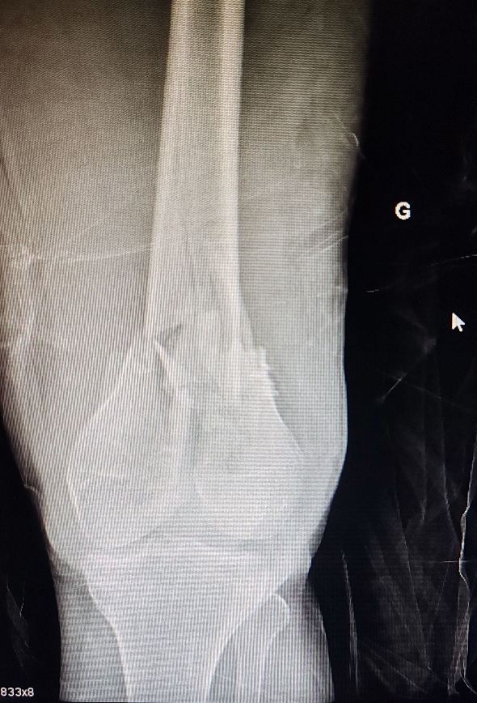

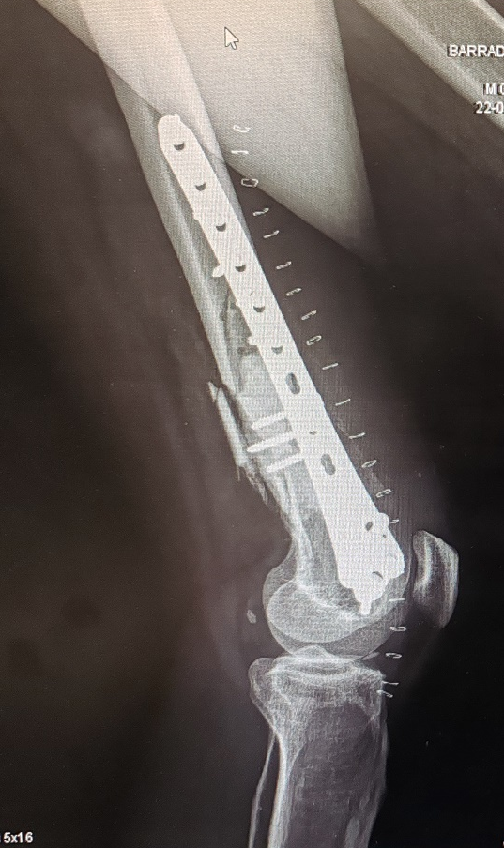
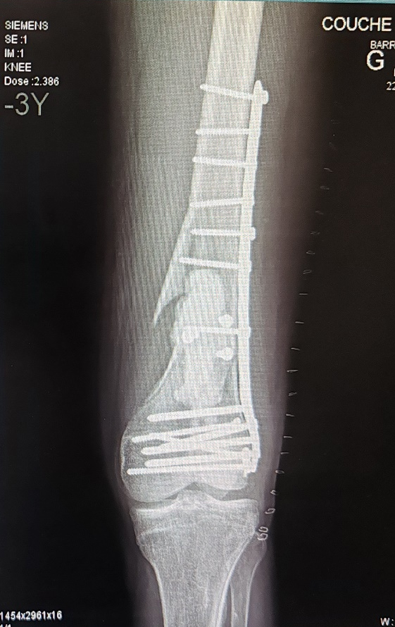

Figure 1:`Supracondylar and intercondylar fractures of the right distal femur in a 68-year-old patient. Osteosynthesis with a 10-hole right condylar locked plate with satisfactory alignment.

- Consolidation
The mean time to consolidation was 6 months (in 36% of cases) (graph 2).
In total, 42 patients achieved consolidation, including those who required revision surgery after 28 months or more. (Graph 2)

Graph 2: Distribution of patients according to consolidation time (in months)
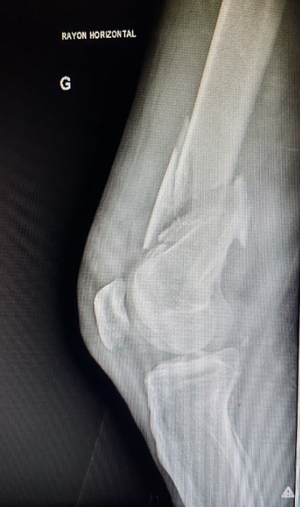
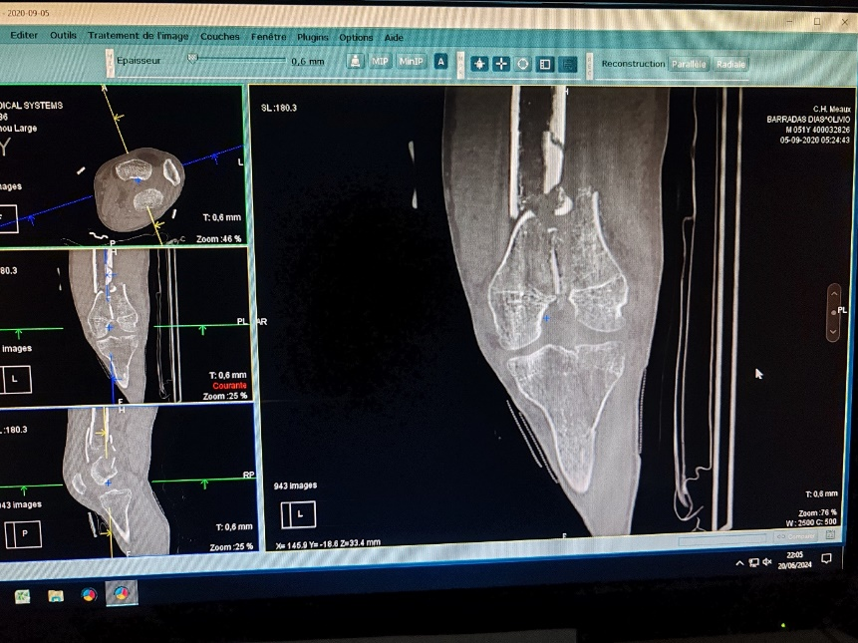
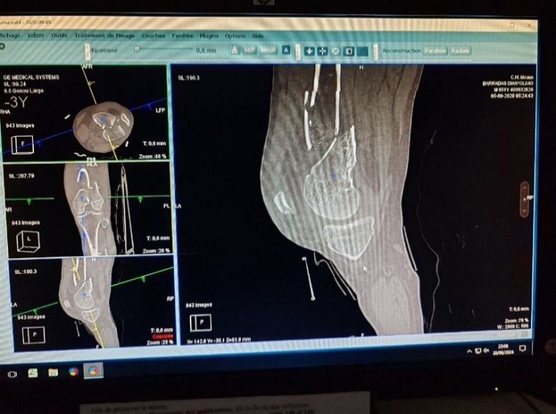
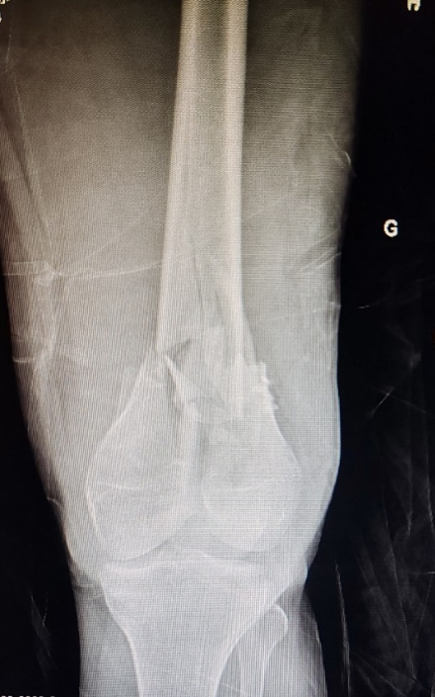
Figure 2: Anteroposterior and lateral X-rays and ct-scan of a 62 years old Patient showing an AO type C2 supracondylar and intercondylar fracture.

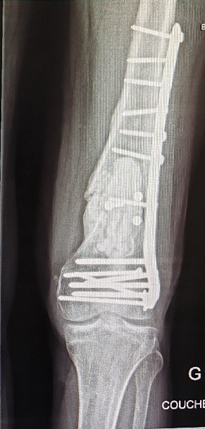
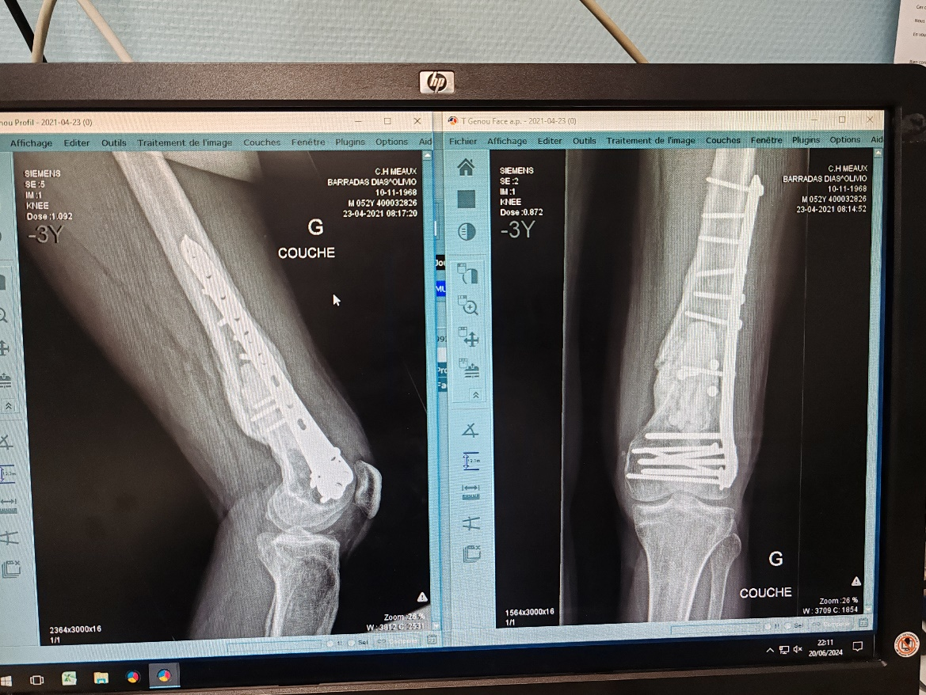
Figure 3: Anteroposterior and lateral control radiographs of the same patient (B.D., 62 years), at 12 months postoperative showing good consolidation.

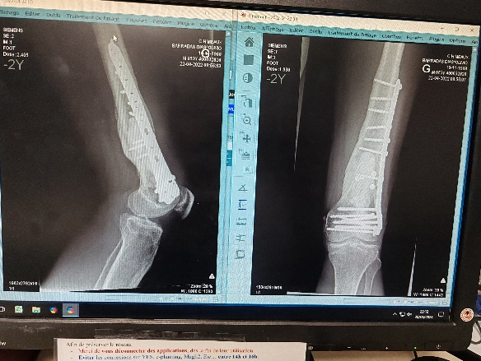

Figure 4: Control radiographs of the same patient at 24 months postoperative.
The fracture had consolidated.

2-3 Functional results
Early rehabilitation was initiated in 86.4% of the patients, with an average of 20 physical therapy sessions.
Postoperative knee mobility was generally satisfactory:
- Average flexion: 100°
- Extension: 5°
Table 2: Distribution of patients according to postoperative MEGY functional score
Functional result | Number of patients | Percentage
Very Good | 19 | 43,2%
Good | 15 | 34,1%
Moderate | 7 | 15,9%
Poor | 3 | 6,8%

Complications
Among the 44 patients, 8 experienced complications:
- 6 cases of pseudarthrosis (including 1 with implant rupture)
- 1 case of reduction failure
- 1 case of postoperative infection
Eight patients underwent revision surgery following these complications. Among them, 2 still failed to achieve consolidation. The same type of implants was used in the revisions.
The revision procedures were performed within a short period, typically before one year after the initial surgery.
3- Discussion
3-1 Therapeutic aspects
All patients were treated with a locked plate and cement. Intraoperative evaluation of the bone defect was subjective, based on the surgeon’s estimation of the defect length.
The indications for using cement were based on bone quality, and presence of a defect after debridement.
The cement used was Palacos R+G, with: One sachet per patient, 40.8 g of radiopaque polymer, 0.5 g of gentamicin.
This allowed for a consistent evaluation across the study population. The amount of cement used depended on the defect size and was not standardized. Thus, the use and quantity of PMMA were operator-dependent. Further studies could help establish preoperative criteria.
In 70.4% of cases, postoperative reduction quality was satisfactory. This rate is higher than that reported by Ehlinger et al., who found a 66.1% satisfactory outcome in their series [7]. This higher rate in our study may be due to:
- A single operator performing all surgeries,
- Use of intraoperative fluoroscopy for real-time reduction control.
A total of 40 patients achieved bone union within 9 to 26 months, resulting in a consolidation rate of 95.4%. This high rate can be explained by: Prompt surgical management, careful patient monitoring, enabling early revision in case of complications, our findings align with experimental studies by Eklem et al. (Turkey),PB Fontenot (Florida), and Michael G. [8,9,10].
In Germany, Katthagen JC et al. reported a consolidation rate of 91.6% [22]. In 2008, Schwartz (Germany) achieved a 95% consolidation rate in distal radius fractures, with only one complication (secondary displacement due to poor surgical technique) [6]. These findings support the hypothesis that cement adjunct may increase consolidation rates in metaphyseal fractures due to its osteoconductive effect.
The quality of reduction in the immediate postoperative period was satisfactory in 70.4% of cases, which is higher than the rate reported by Ehlinger et al., who found satisfactory results in 66.1% of cases in their series [7]. This high rate could be explained by the fact that there were not several surgeons operating on our patients and that endoscopic control allowed for intraoperative assessment of the reduction.
Some studies that have used bone cement in their research have shown the importance of this contribution to lesions where the bone is osteoporotic [11-16]. Forty patients had consolidated after 9 to 26 months, representing a consolidation rate of 95.4%. This high rate can be explained by the fact that the minimum treatment delay was 24 hours and that patients were well monitored, allowing them to be treated early in the event of complications. For patients who experienced complications, reoperation was rapid, occurring within a minimum of 72 hours after the check-up.

- Surgical procedure and incidents
In our study, management was rapid, with a minimum surgical delay of 24 hours, thanks to the availability of operating facilities — contributing to good outcomes. This matches results from Ely et al who reported a mean surgical delay of 3.8 days. In contrast, Kombaté et al. (Togo) had a delay of 21 days, which may explain their lower functional scores [17].
Intraoperative evaluation of the bone defect was subjective, meaning there is no standardized guideline for cement filling or quantity. This represents a study bias.
3-2 Functional Aspects
And as several experiments and studies [6,9,18-22] have proven, the use of cement in the synthesis of fractures in elderly people increases the strength of the assembly and thus contributes to consolidation.

The management goal was to:
- Restore anatomical alignment and articular congruence,
- Enable verticalization, prevent complications of prolonged bed rest,
- Support social reintegration, and
- Promote successful bone healing.
In our series, 38 patients began physical therapy immediately.
Rehabilitation protocol:
- Day 1–15: Knee mobilization up to 45°
- Day 15–30: 45° to 90°
- Day 30–60: 90° and beyond
The remaining 6 patients began rehabilitation after 2 weeks because the surgeon deemed the construct unstable despite augmented osteosynthesis. They wore a knee orthosis for 2 weeks before beginning therapy.
Overall functional results were satisfactory in 93.2% of patients.
Parker score:
- Preoperative autonomy score 4–6: 18%
- Postoperative autonomy score 4–6: 27%
This improvement was limited by comorbidities that kept patients bedridden.
Still, 72% had good autonomy postoperatively (Parker score 7–9).
In China, Yin et al. (2012) reported 82.3% functional success using augmented osteosynthesis in tibial plateau fractures [19].
In Germany, Katthagen JC et al. (2018) compared augmented vs. non-augmented locked plating of proximal humerus fractures in 24 cases.
They found no significant difference in Constant scores — average score of 73% [22].
In Togo, Kombaté et al. found AO/OTA type A2 fractures were most common (25%) all patients received locked condylar plates, rehabilitation began early in 87.5%, average consolidation time was 4 months [17].
Across studies, regardless of fracture comminution, locked plates were the common standard. Our study suggests cement improves functional outcomes and consolidation rates (95.4% and 93.2% respectively).
This high success rate in our study may be attributed to: early surgical intervention, adequate follow-up, prompt revision in case of complications, the use of cement.

Table 3: Overall Functional Outcome Comparison
 | OUR SERIES |  |  |  | MOROCCO  ELKHIMARI | CHINA  YIN
Good Functional Results (%) | 93,2% |  |  | 68,8% |  |  | 82,3%

  - Evolutionary Aspects
The complications observed in our series were: infection, pseudarthrosis, implant rupture, disassembly, and reduction failure.
A total of eight patients experienced complications, and six recovered after undergoing implant replacement, with healing occurring around 26 months later.
In our study, 13.6% of patients developed pseudarthrosis. By comparison, El Khimani et al. (2012, Morocco) reported a rate of 9%, but their therapeutic approach involved various implants without cement. Our higher rate may be attributed to the rigidity of the construct. The implant rupture case was likely due to the same rigidity: Only locked screws were used, making the construct too stiff, resulting in force transmission through the plate, which led to implant failure.
In Togo, Kombaté et al. [17] reported: residual knee pain as the most common late complication (62.5%), knee stiffness in 15.6% of cases.
In our series, 11.3% of patients had knee stiffness, likely due to: early rehabilitation, pre-existing early-stage osteoarthritis at admission.
Similarly, Lamraski (Belgium) [23] reported 11% knee stiffness in his series.
This confirms that functional outcomes depend on early management and appropriate postoperative follow-up.
The infection encountered in our series was a deep infection, requiring revision surgery with irrigation, implant removal, and placement of an external fixator.
To prevent pseudarthrosis, it would be preferable to use a combination of locked and non-locked screws when placing the plate, to avoid excessive rigidity in the construct. Schwartz et al. [6], in their work on augmented osteosynthesis for distal radius fractures, reported only two complications: one case of articular leakage, one case of secondary displacement, both attributed to poor surgical technique.
In France, Fernandez M et al.[20] also discussed augmented osteosynthesis, using a TFNA nail with injected cement for proximal femur fractures. They reported: one case of pseudarthrosis, one case of implant rupture, case of infection treated with external fixation.
These results highlight the importance of surgical technique in achieving satisfactory outcomes in augmented osteosynthesis.
We concur with Schwartz:
Anatomical and functional outcomes in osteosynthesis depend primarily on the timing of management and the surgical technique used.
Prognostic Factors
The poor prognostic factors in our study were mainly : The excessive rigidity of the construct (due to using only locked screws), which explains the higher rate of pseudarthrosis and implant rupture, and the patients’ comorbidities.
CONCLUSION
Augmented osteosynthesis in distal femur fractures in elderly patients yields satisfactory functional outcomes and increases the rate of bone consolidation.
To achieve these results, the surgical technique must combine:
- Timely operability,
- Mechanical stability,
- Construct robustness, and
- Early functional rehabilitation,
In order to ensure solid healing and favourable functional recovery.
Our findings confirm that cement increases the consolidation rate, particularly in metaphyseal fractures, through its osteoconductive effect.
While our results with a 95% success rate are consistent with existing literature, further improvements are still needed. We recommend: Multicenter studies involving other hospitals in France with larger sample sizes to generalize findings and provide a broader picture of therapeutic strategies and prognoses.
Comparative studies evaluating the use of cement versus no cement in this type of fracture, to help establish a standard consensus.
Ethical Approval and Consent:
Ethical approval was taken from the ethics committee in the hospital and Written informed consent was signed by all the patients, or the legal guardian in case of patients unable to gice their consent.
Disclaimer (Artificial intelligence)
Authors hereby declare that NO generative AI technologies such as Large Language Models (ChatGPT, COPILOT, etc.) and text-to-image generators have been used during the writing of this manuscript. However, AI tools have been used to help in the translation from Frensh to English languages.
COMPETING INTERESTS
Authors have declared that they have no known competing financial interests OR non-financial interests OR personal relationships that could have appeared to influence the work reported in this paper.

REFERENCES
1. Ehlinger M, Ducrot G, Adam P, Bonnomet F. Fracture of the lower end of the femur in adults. EMC–Surgical Techniques-Orthopedics-Traumatology 2013;8:1-11.
2. Chiron P. Fractures of the lower end of the femur in adults. EMC–Appar Locomotor 2009;1-14.
3. Henderson CE, Kuhl LL, Fitzpatrick DC, Marsh JL. Locking plates for distal femur fractures: is there a problem with fracture healing? Journal of orthopedic trauma 2011;25:S8-14.
4. Chorin E, Annweiler C, Legrand E, Bouvard B. Osteoporosis in the very elderly: what are the specific features? Revue du Rhumatisme Monographies 2019;86:242-7.
5. Charnley j. anchorage of the femoral head prosthesis to the shaft of the femur. The Journal of Bone and Joint Surgery. British volume 1960;42-B:28‑30.
6. Schwartz D, Bordei R. Use of cement use of phosphocalcium cement injectable in injectable in distal radius fracturesdistal radius fractures. 2008.
7. Ehlinger M, Ducrot G, Adam P, Bonnomet F. Distal femur fractures. Surgical techniques and a review of the literature. Orthopedics & Traumatology: Surgery & Research 2013;99:353-60.
8. Başcı O, Karakaşlı A, Kumtepe E, Güran O, Havıtçıoğlu H. Combination of anatomical locking plate and retrograde intramedullary nail in distal femoral fractures: comparison of mechanical stability. Joint Diseases and Related Surgery 2015;26:021‑6.
9. Fontenot PB, Diaz M, Stoops K, Barrick B, Santoni B, Mir H. Supplementation of Lateral Locked Plating for Distal Femur Fractures: A Biomechanical Study. Journal of Orthopedic Trauma 2019;33:642.
10. Kontakis MG, Giannoudis PV. Nail plate combination in fractures of the distal femur in the elderly: A new paradigm for optimum fixation and early mobilization? Injury 2023;54:288‑91.
11. Fontaine V, Grunberg M, Soret J, El-Youssef K, Gayet LE, Taberne R. Place of cementoplasty in articular fractures of the distal radius. About an anatomical study and application to arthroscopy. Revue de Chirurgie Orthopédique et Traumatologique 2018;104:70-5.
12. Sanchez-Sotelo J, Munuera L, Madero R. Treatment of fractures of the distal radius with a remodelable bone cement: A PROSPECTIVE, randomized study using norian srs. The Journal of Bone and Joint Surgery. British volume 2000;82-B:856‑63.
13. Pelissier PH, Masquelet AC, Bareille R, Pelissier SM, Amedee J. Induced membranes secrete growth factors including vascular and osteoinductive factors and could stimulate bone regeneration. Journal Orthopedic Research 2004;22:73-9.
14. Brodke D, O’Hara N, Devana S, Hernandez A, Burke C, Gupta J, et al. Predictors of deep infection after distal femur fracture: a multicenter study. Journal of Orthopaedic Trauma 2023;37:161-7.
15. Sanchez P, Chappelon I, Peyron PA, Colomb S, Baccino E. Acceleration of the aging process: a specificity of the assessment of bodily injury in the elderly. La Revue de Médecine Légale 2023;14:100369.
16. Grant KD, Busse EC, Park DK, Baker KC. Internal fixation of osteoporotic bone. JAAOS-Journal of the American Academy of Orthopaedic Surgeons 2018;26:166-74.
17. Kombate N, E A, Towoezim H, YY D, Ayouba G, Bakriga B, et al. Anatomical and functional results of distal femur fractures osteosynthesis using locked condylar plate in the elderly in Togo. International Journal of Orthopaedics Sciences 2023;9:94-6.
18. Dunne N, Tzagiollari A, Sahebalzamani M, Dunne TJ. Acrylic cements for bone fixation in joint replacement [Internet]. In: Joint Replacement Technology. Elsevier; 2021 [cited 2024 Oct 1]. page 213‑62.Available from: https://www.sciencedirect.com/science/article/pii/B9780128210826000212
19. Yin X, Li J, Xu J, Huang Z, Rong K, Fan C. Clinical assessment of calcium phosphate cement to treat tibial plateau fractures. Journal of Biomaterials Applications [Internet] 2012 [cited 2024 Oct 26]; Available from: https://journals.sagepub.com/doi/abs/10.1177/0885328212443295
20. Fernandez M, Di Francia R, Dubrana PF. Cemented augmentation of TFNA nails for the treatment of pertrochanteric fractures in patients over 65 years of age. [cited 2024 August 26];Available from: https://soo.com.fr/download/media/bcf/2aa/p07-fernandez-marie.pdf
21. Bayley E, Klezl Jr Z, Bommiredy R, Klezl Sr Z. Cement Augmentation of the Cervical Spine–a Technique Enhancing Stability of Anterior Cervical Plating. Acta Chir Orthop Traumatol Cech 2017;84:448‑52.
22. Katthagen JC, Lutz O, Voigt C, Lill H, Ellwein A. Cement augmentation of humeral head screws reduces early implant-related complications after locked plating of proximal humeral fractures. Obere extremitat 2018;13:123.
23. Lamraski G, Toussaint D, Bremen J. Surgical treatment of distal femoral fractures using extra-medullary osteosynthesis. Acta Orthopaedica Belgica 2001;67:32-41.

